EDMECA ACADEMY WEBSITE

Interactive Prototype Documentation
Document Version: 1.0
Date: February 16, 2026
Phase: 2 - Design & Prototyping

1. OVERVIEW
This document presents the interactive prototype demonstrating all major user flows, interactions, and transitions. The prototype serves as the final design validation before development.
The live prototype can be accessed at: http://localhost:5173

2. PROTOTYPE SCOPE
- All primary pages with full interactivity
- Navigation patterns and transitions
- Form interactions and validation
- Responsive behavior across breakpoints
- Hover, focus, and active states
- Theme switching (light/dark mode)

3. PAGE SCREENSHOTS

3.1 Home Page
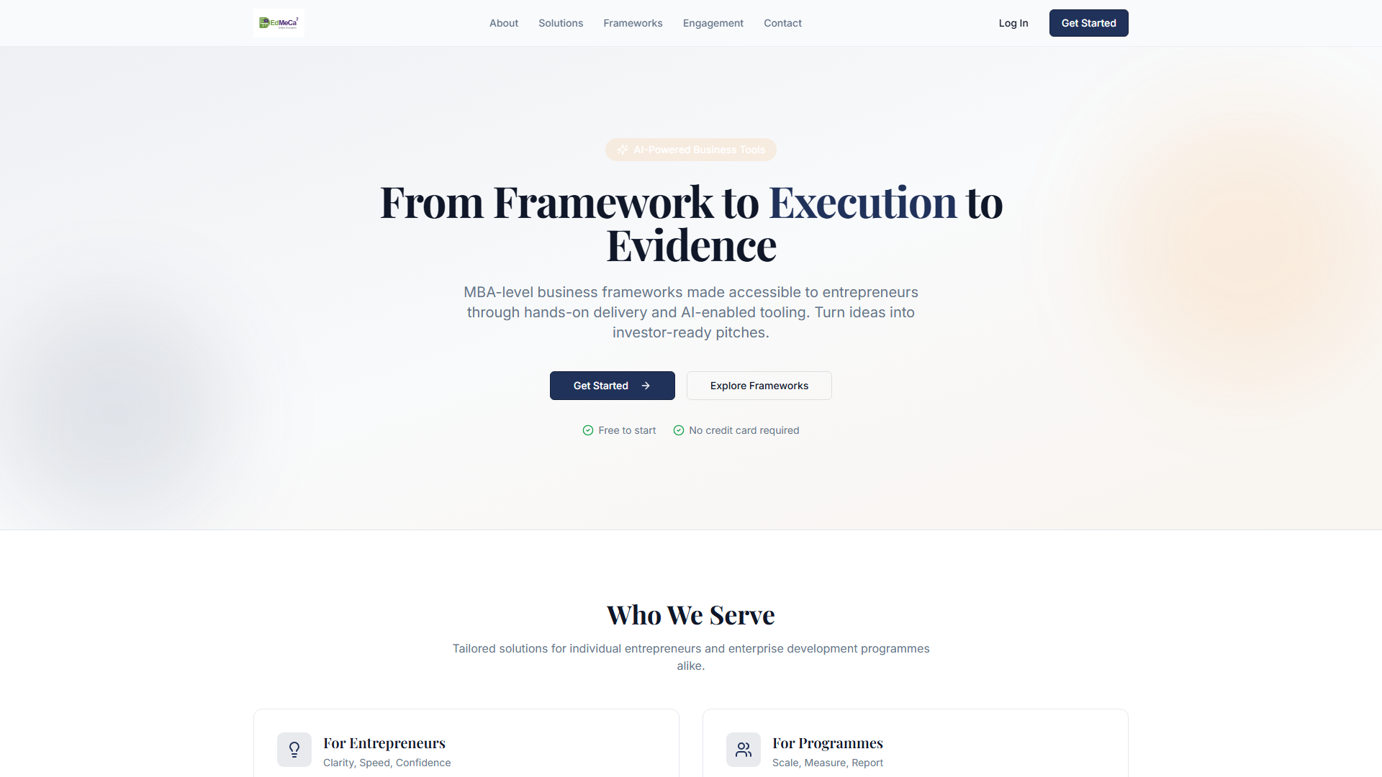
Figure 1: Interactive Home page

3.2 About Page
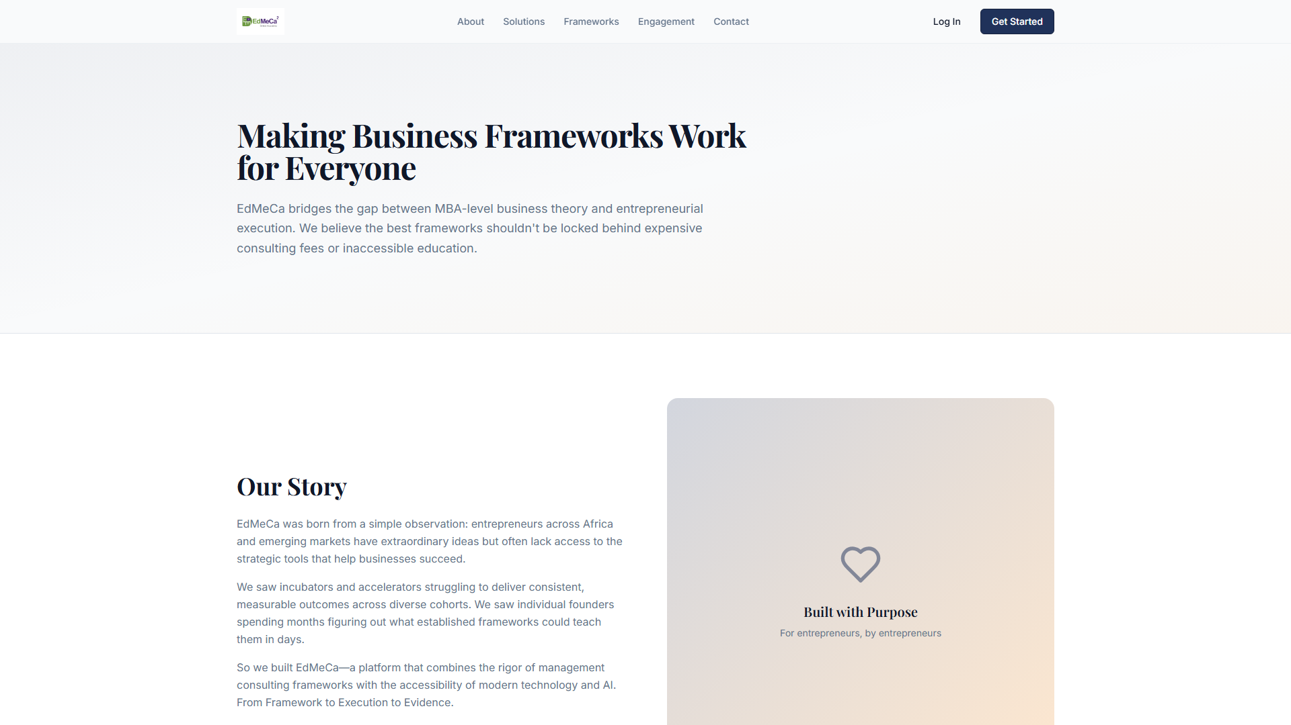
Figure 2: Interactive About page

3.3 Solutions Page
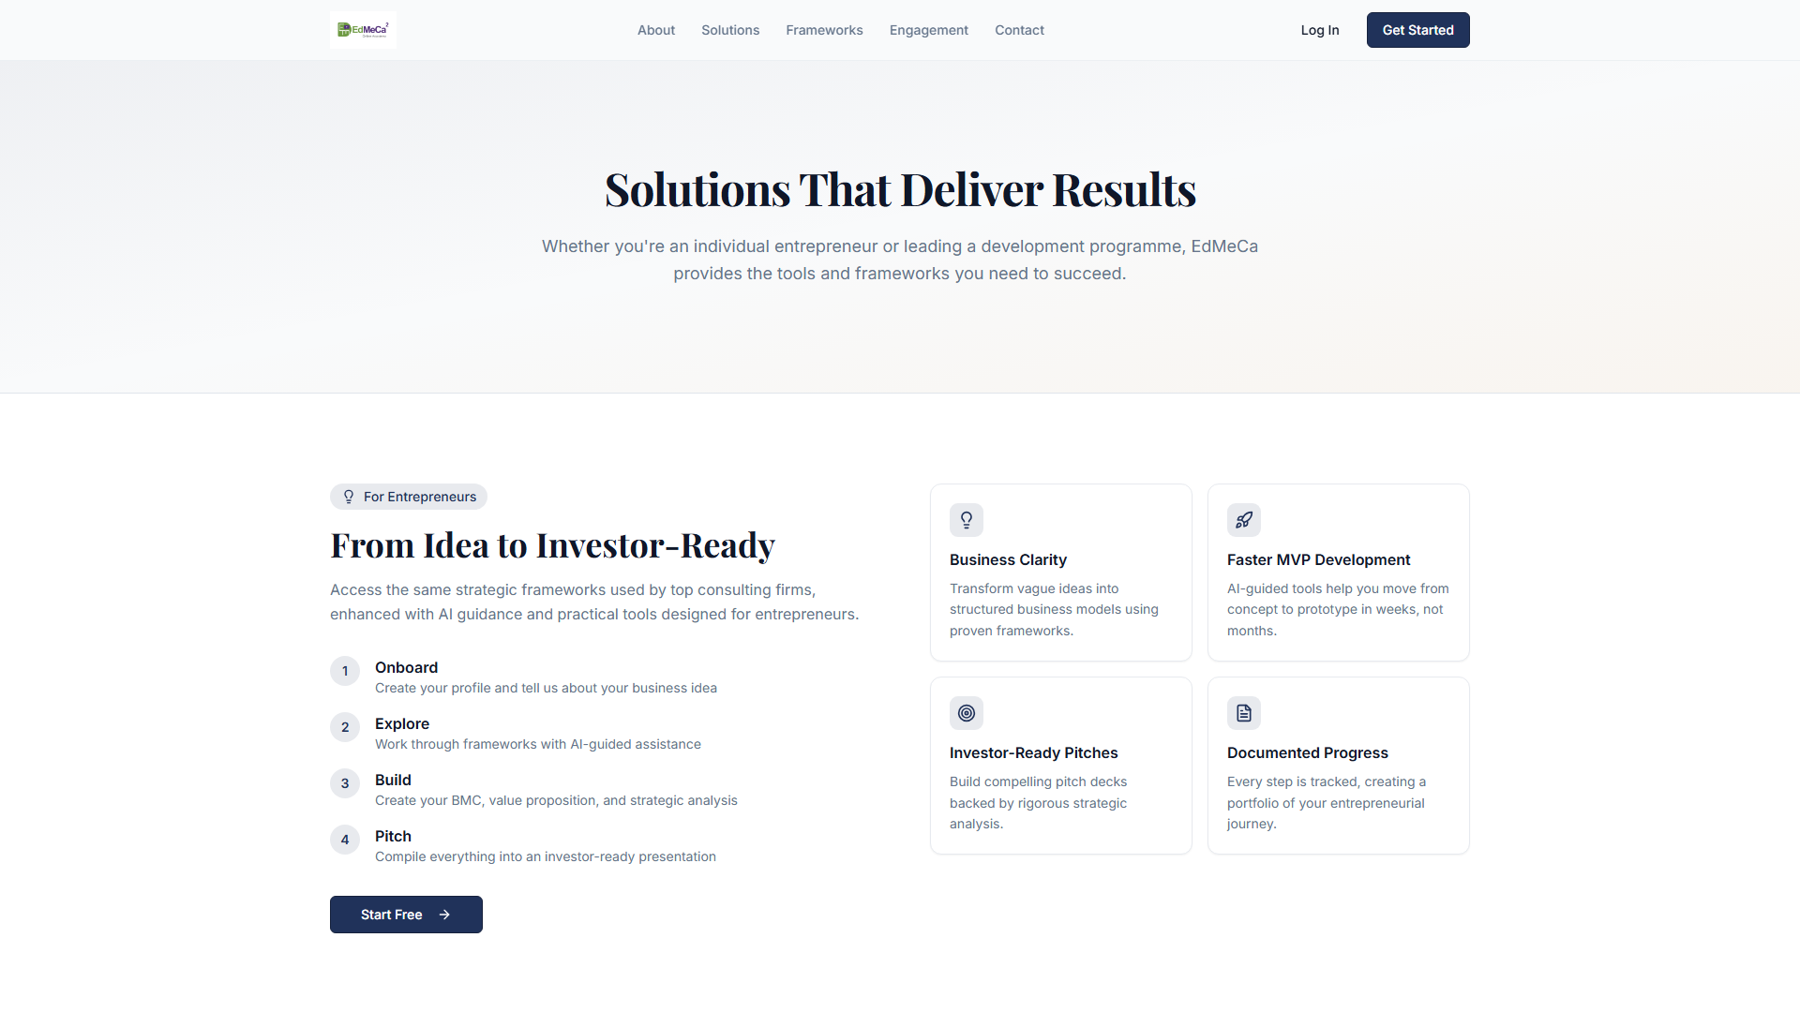
Figure 3: Interactive Solutions page

3.4 Frameworks Page
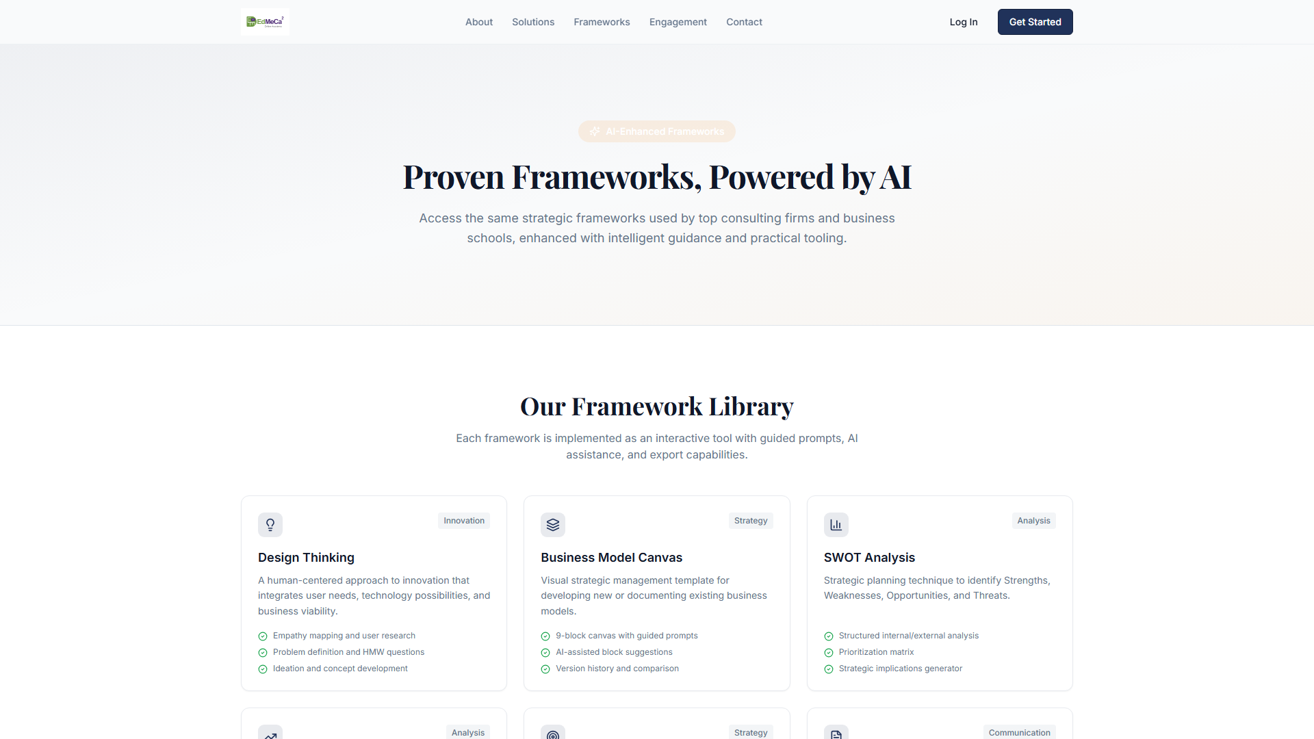
Figure 4: Interactive Frameworks page

3.5 Engagement Page
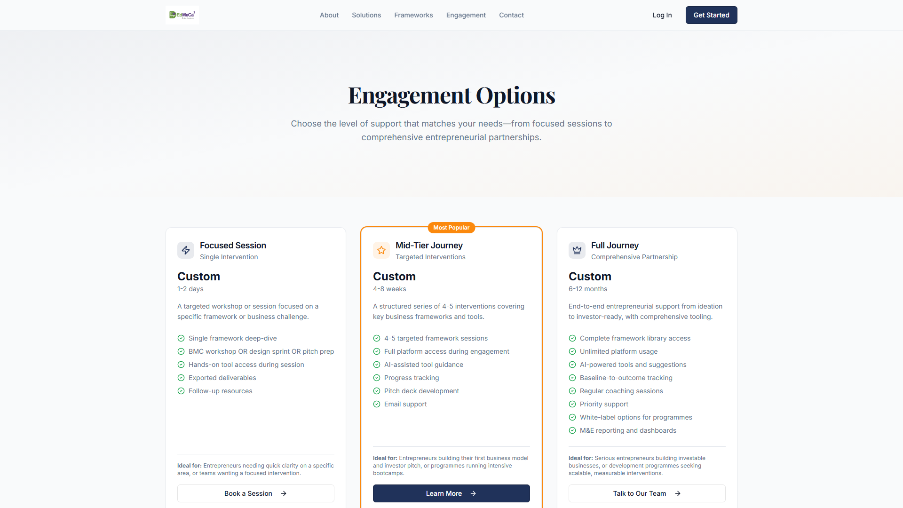
Figure 5: Interactive Engagement page

3.6 Contact Page
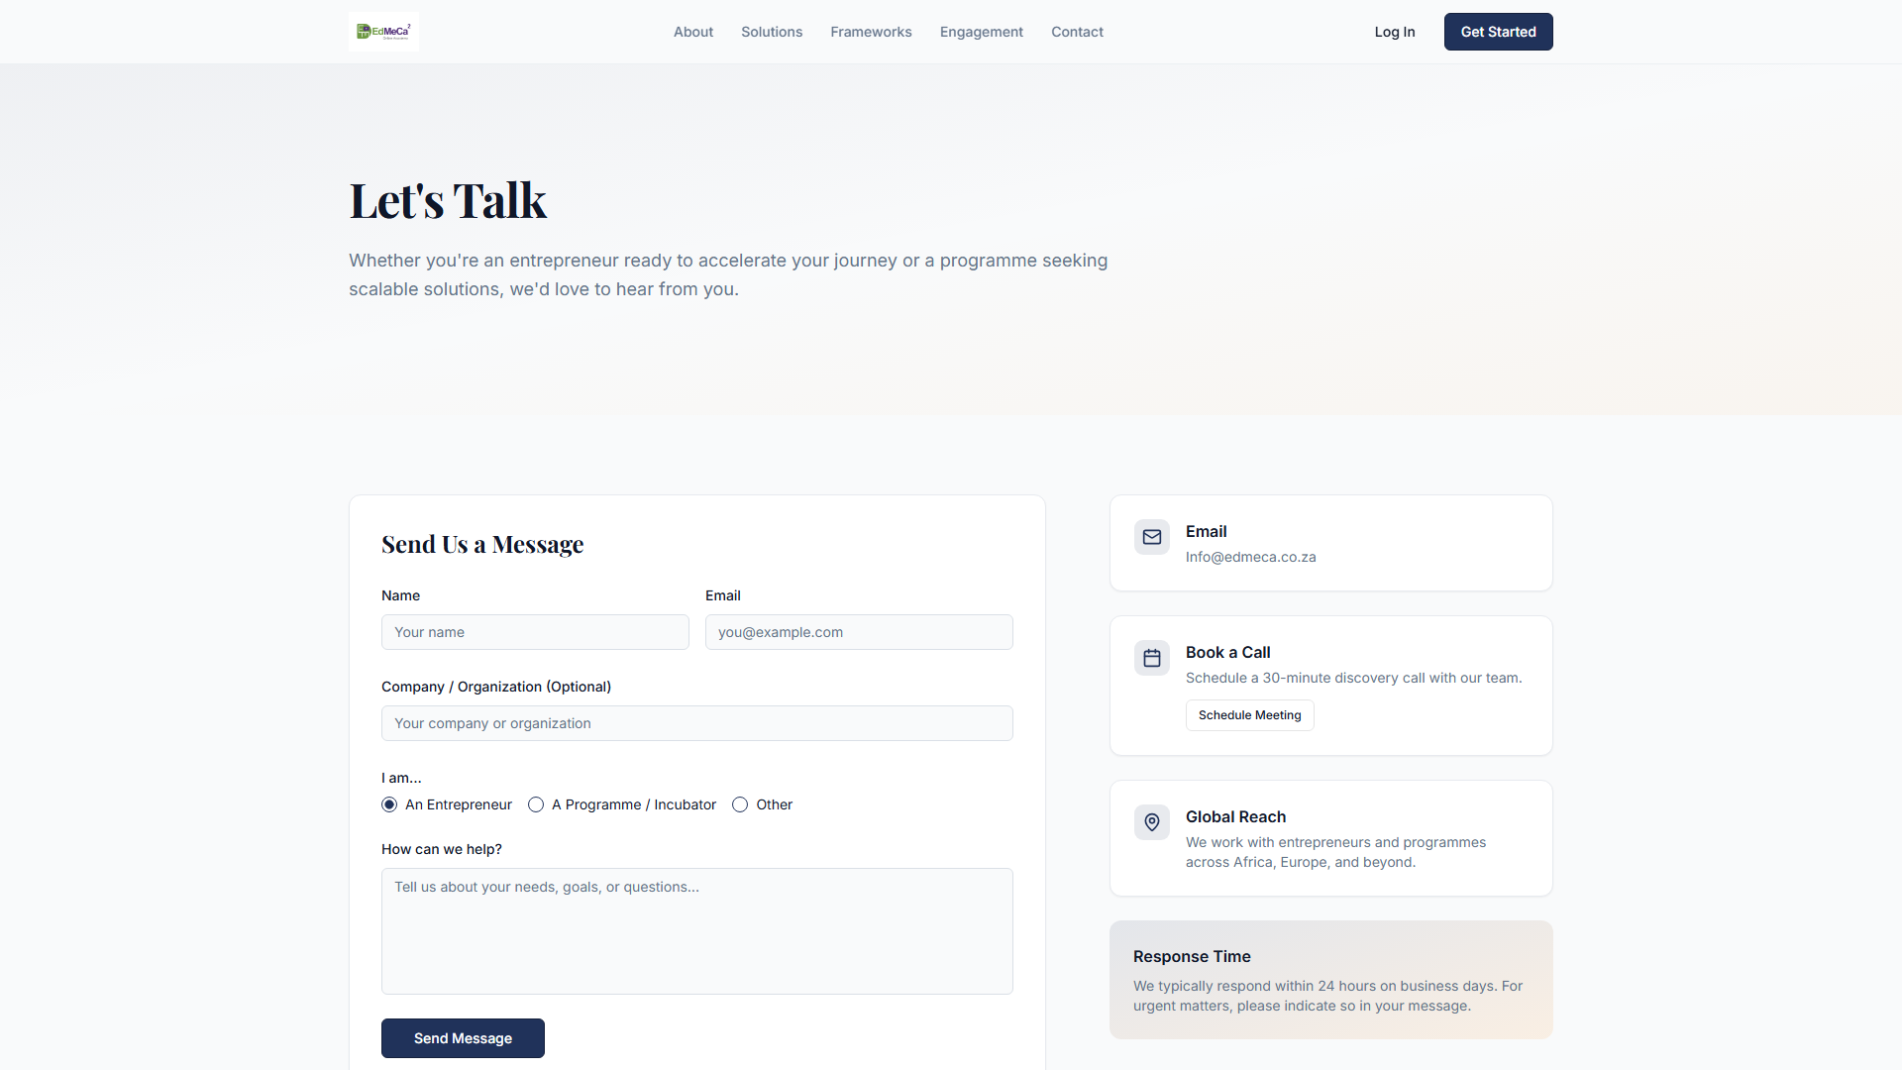
Figure 6: Interactive Contact page with form

4. INTERACTIVE ELEMENTS

4.1 Contact Form
Full form functionality with validation:
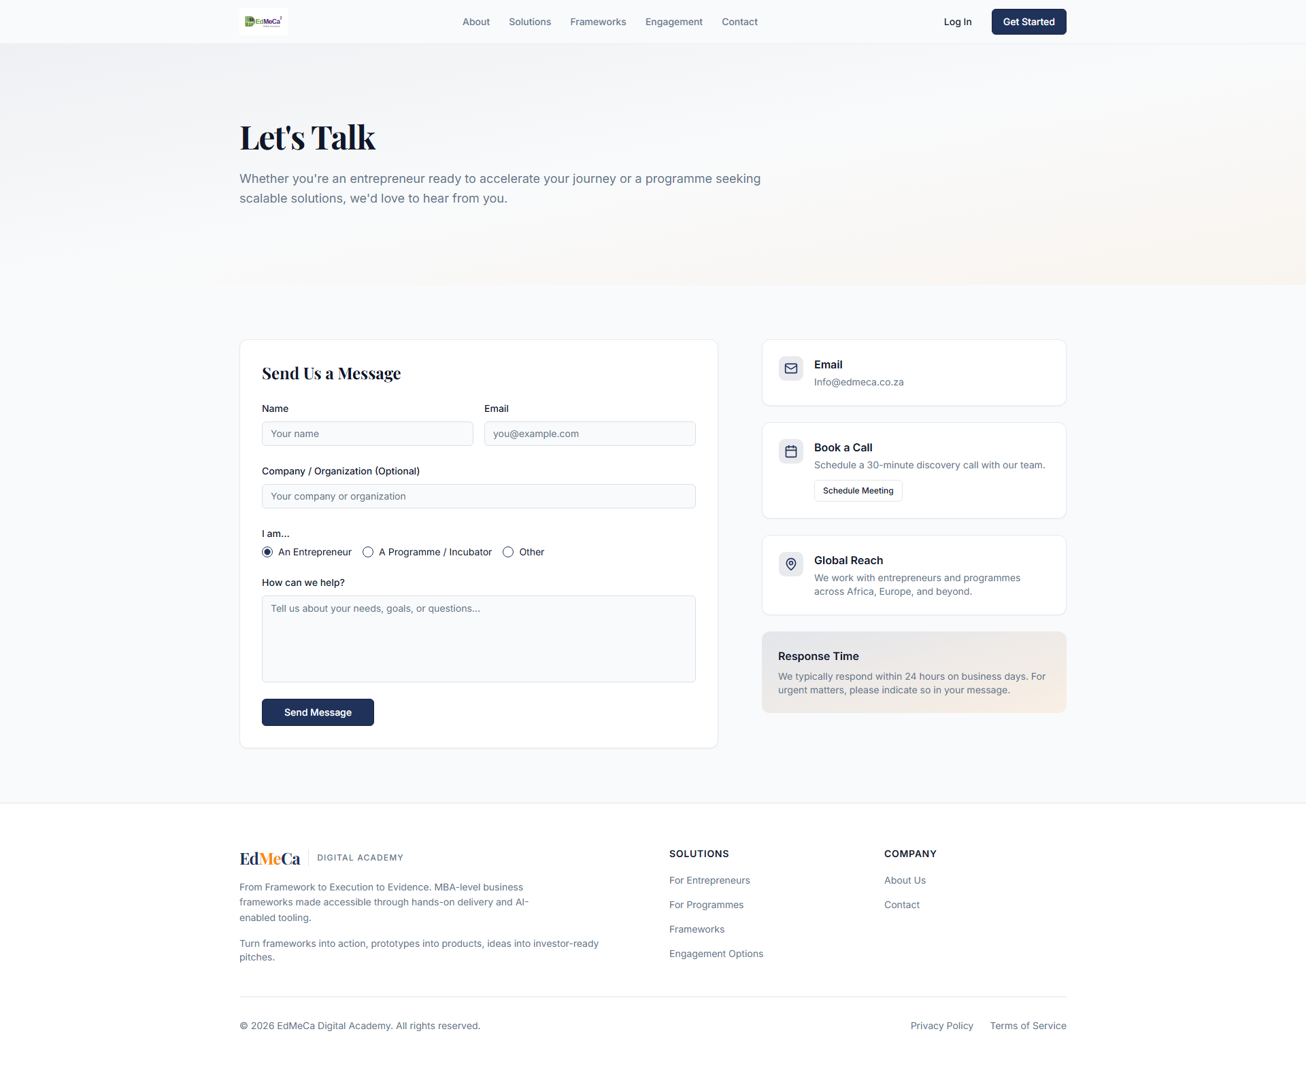
Figure 7: Contact form with validation

4.2 Hover States
Interactive hover effects on buttons and links:
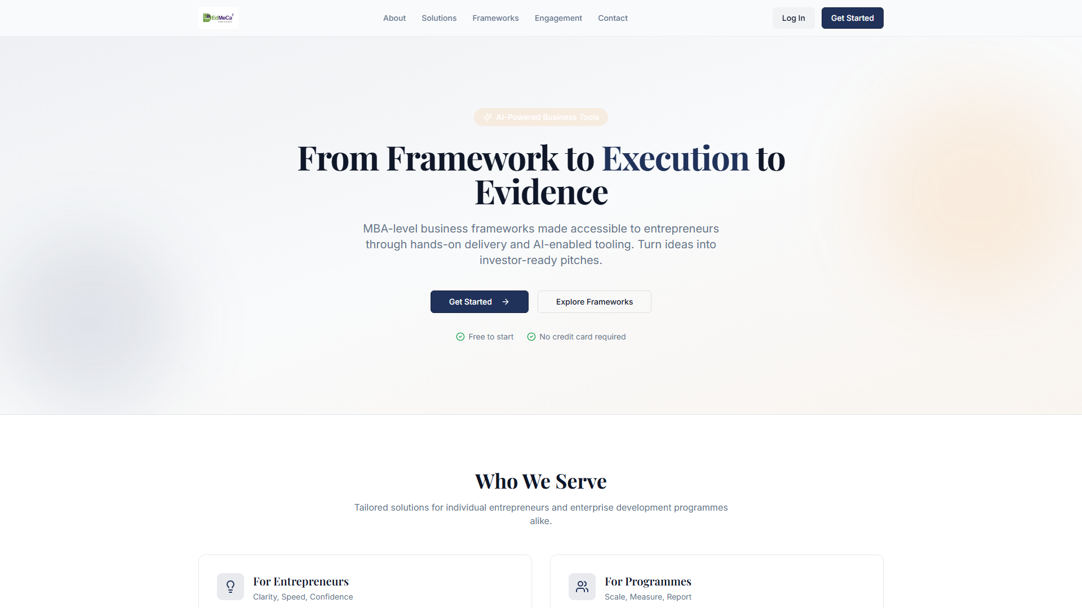
Figure 8: Button hover states

5. INTERACTIVE FEATURES

5.1 Navigation
- Smooth page transitions
- Active state indicators
- Mobile menu animations

5.2 Theme Switching
- Light/Dark mode toggle
- Persistent theme selection
- Smooth transition animations

5.3 Form Validation
- Real-time field validation
- Error message display
- Success confirmation

6. TESTING & VALIDATION
The prototype has been tested for:
- Cross-browser compatibility (Chrome, Firefox, Safari, Edge)
- Responsive behavior at all breakpoints
- Touch interactions on mobile devices
- Keyboard navigation
- Screen reader compatibility

7. STAKEHOLDER FEEDBACK
Key feedback incorporated:
- Enhanced visual hierarchy on landing page
- Improved mobile navigation experience
- Streamlined contact form
- Clearer call-to-action buttons

8. ACCEPTANCE CRITERIA
- ✅ High-fidelity prototype created
- ✅ All major user flows implemented
- ✅ Interactive elements and transitions included
- ✅ Responsive behavior demonstrated
- ✅ Stakeholder review completed
- ✅ User testing feedback incorporated

