EDMECA ACADEMY WEBSITE

Landing Page Wireframes & Design
Document Version: 1.0
Date: February 16, 2026
Phase: 2 - Design & Prototyping

1. OVERVIEW
The landing page is the primary entry point for visitors to the EDMECA Academy Website. This document presents the complete wireframes and design specifications for desktop, tablet, and mobile viewports.

2. DESIGN OBJECTIVES
- Create an impactful first impression that communicates EDMECA's value proposition
- Guide visitors to key actions (explore solutions, contact, access portal)
- Showcase educational methodology and engagement framework
- Maintain fast load times and optimal performance
- Ensure responsive design across all devices

3. DESKTOP DESIGN (1920x1080)
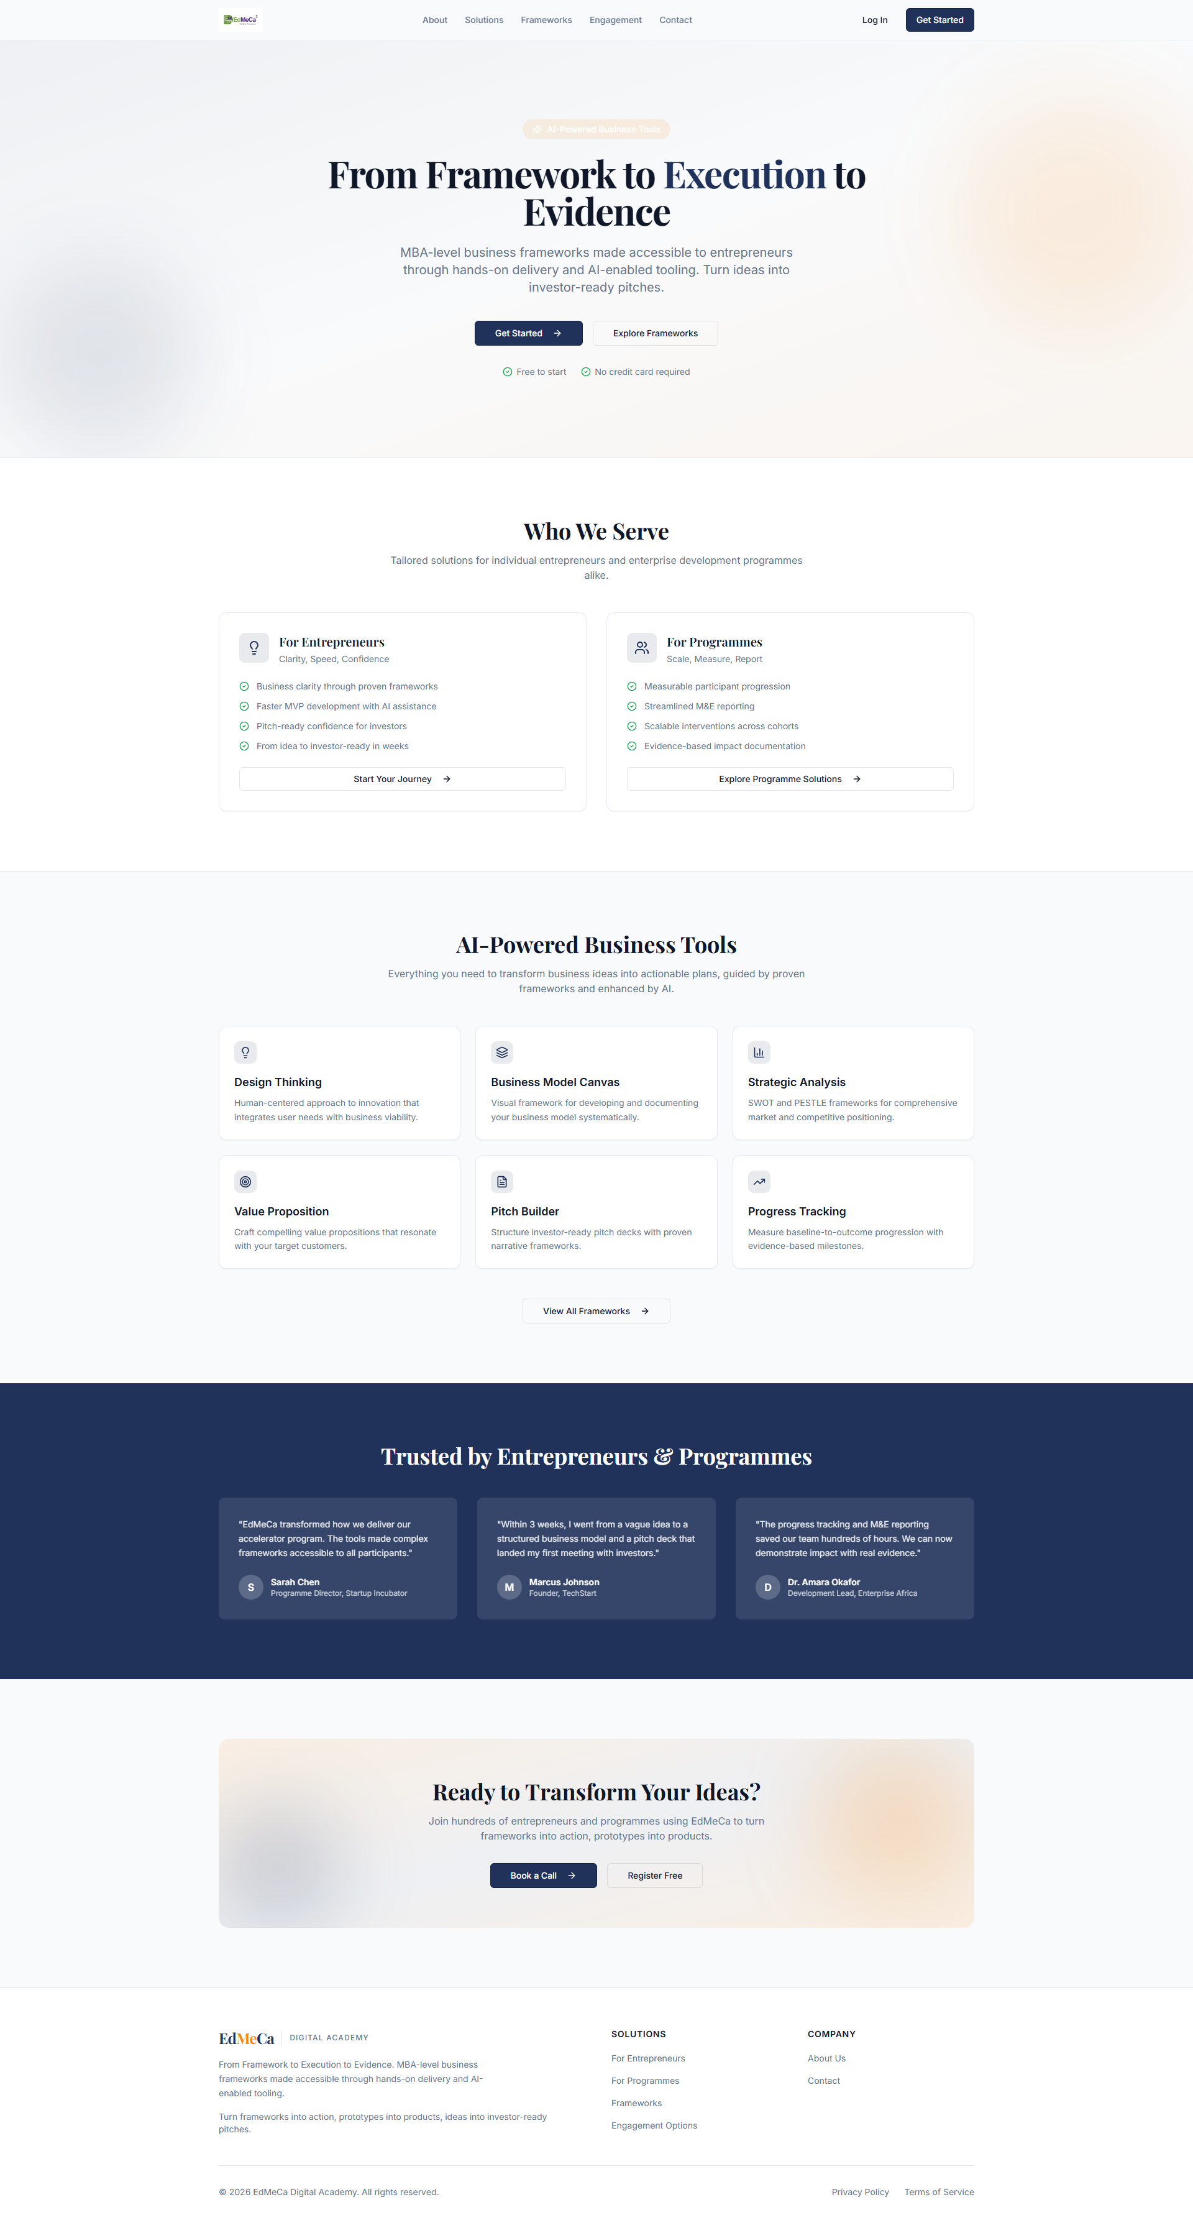
Figure 1: Full landing page - Desktop view

3.1 Hero Section
The hero section is the most critical element, featuring:
- Compelling headline and value proposition
- Clear call-to-action buttons
- Engaging visuals and brand elements

Figure 2: Hero section detail

4. TABLET DESIGN (768x1024)
The tablet design optimizes the layout for medium-sized screens while maintaining visual hierarchy.
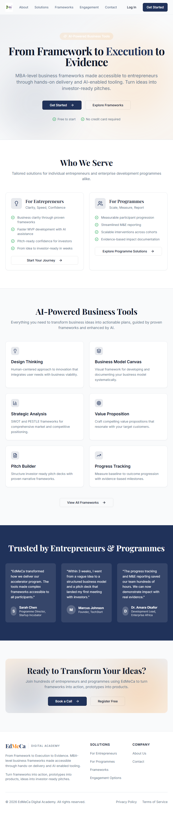
Figure 3: Full landing page - Tablet view

5. MOBILE DESIGN (375x812)
The mobile design follows a mobile-first approach with touch-optimized interactions.
Figure 4: Full landing page - Mobile view

6. KEY FEATURES

6.1 Content Sections
- Hero section with call-to-action
- Features/benefits overview
- Solutions showcase
- Social proof/testimonials
- Final call-to-action

6.2 Interactive Elements
- Smooth scroll animations
- Hover effects on buttons and cards
- Responsive navigation
- Theme toggle (light/dark mode)

7. ACCEPTANCE CRITERIA
- ✅ Desktop wireframe completed (1920x1080)
- ✅ Tablet wireframe completed (768x1024)
- ✅ Mobile wireframe completed (375x812)
- ✅ Hero section design finalized
- ✅ Content sections wireframed
- ✅ Call-to-action placements defined

