EDMECA ACADEMY WEBSITE

Learning Tools Interface Design
Document Version: 1.0
Date: February 16, 2026
Phase: 2 - Design & Prototyping

1. OVERVIEW
This document presents the interface designs for all learning tools and educational content pages including Solutions, Frameworks, and Engagement pages.

2. SOLUTIONS PAGE
The Solutions page showcases EDMECA's educational offerings and methodologies.
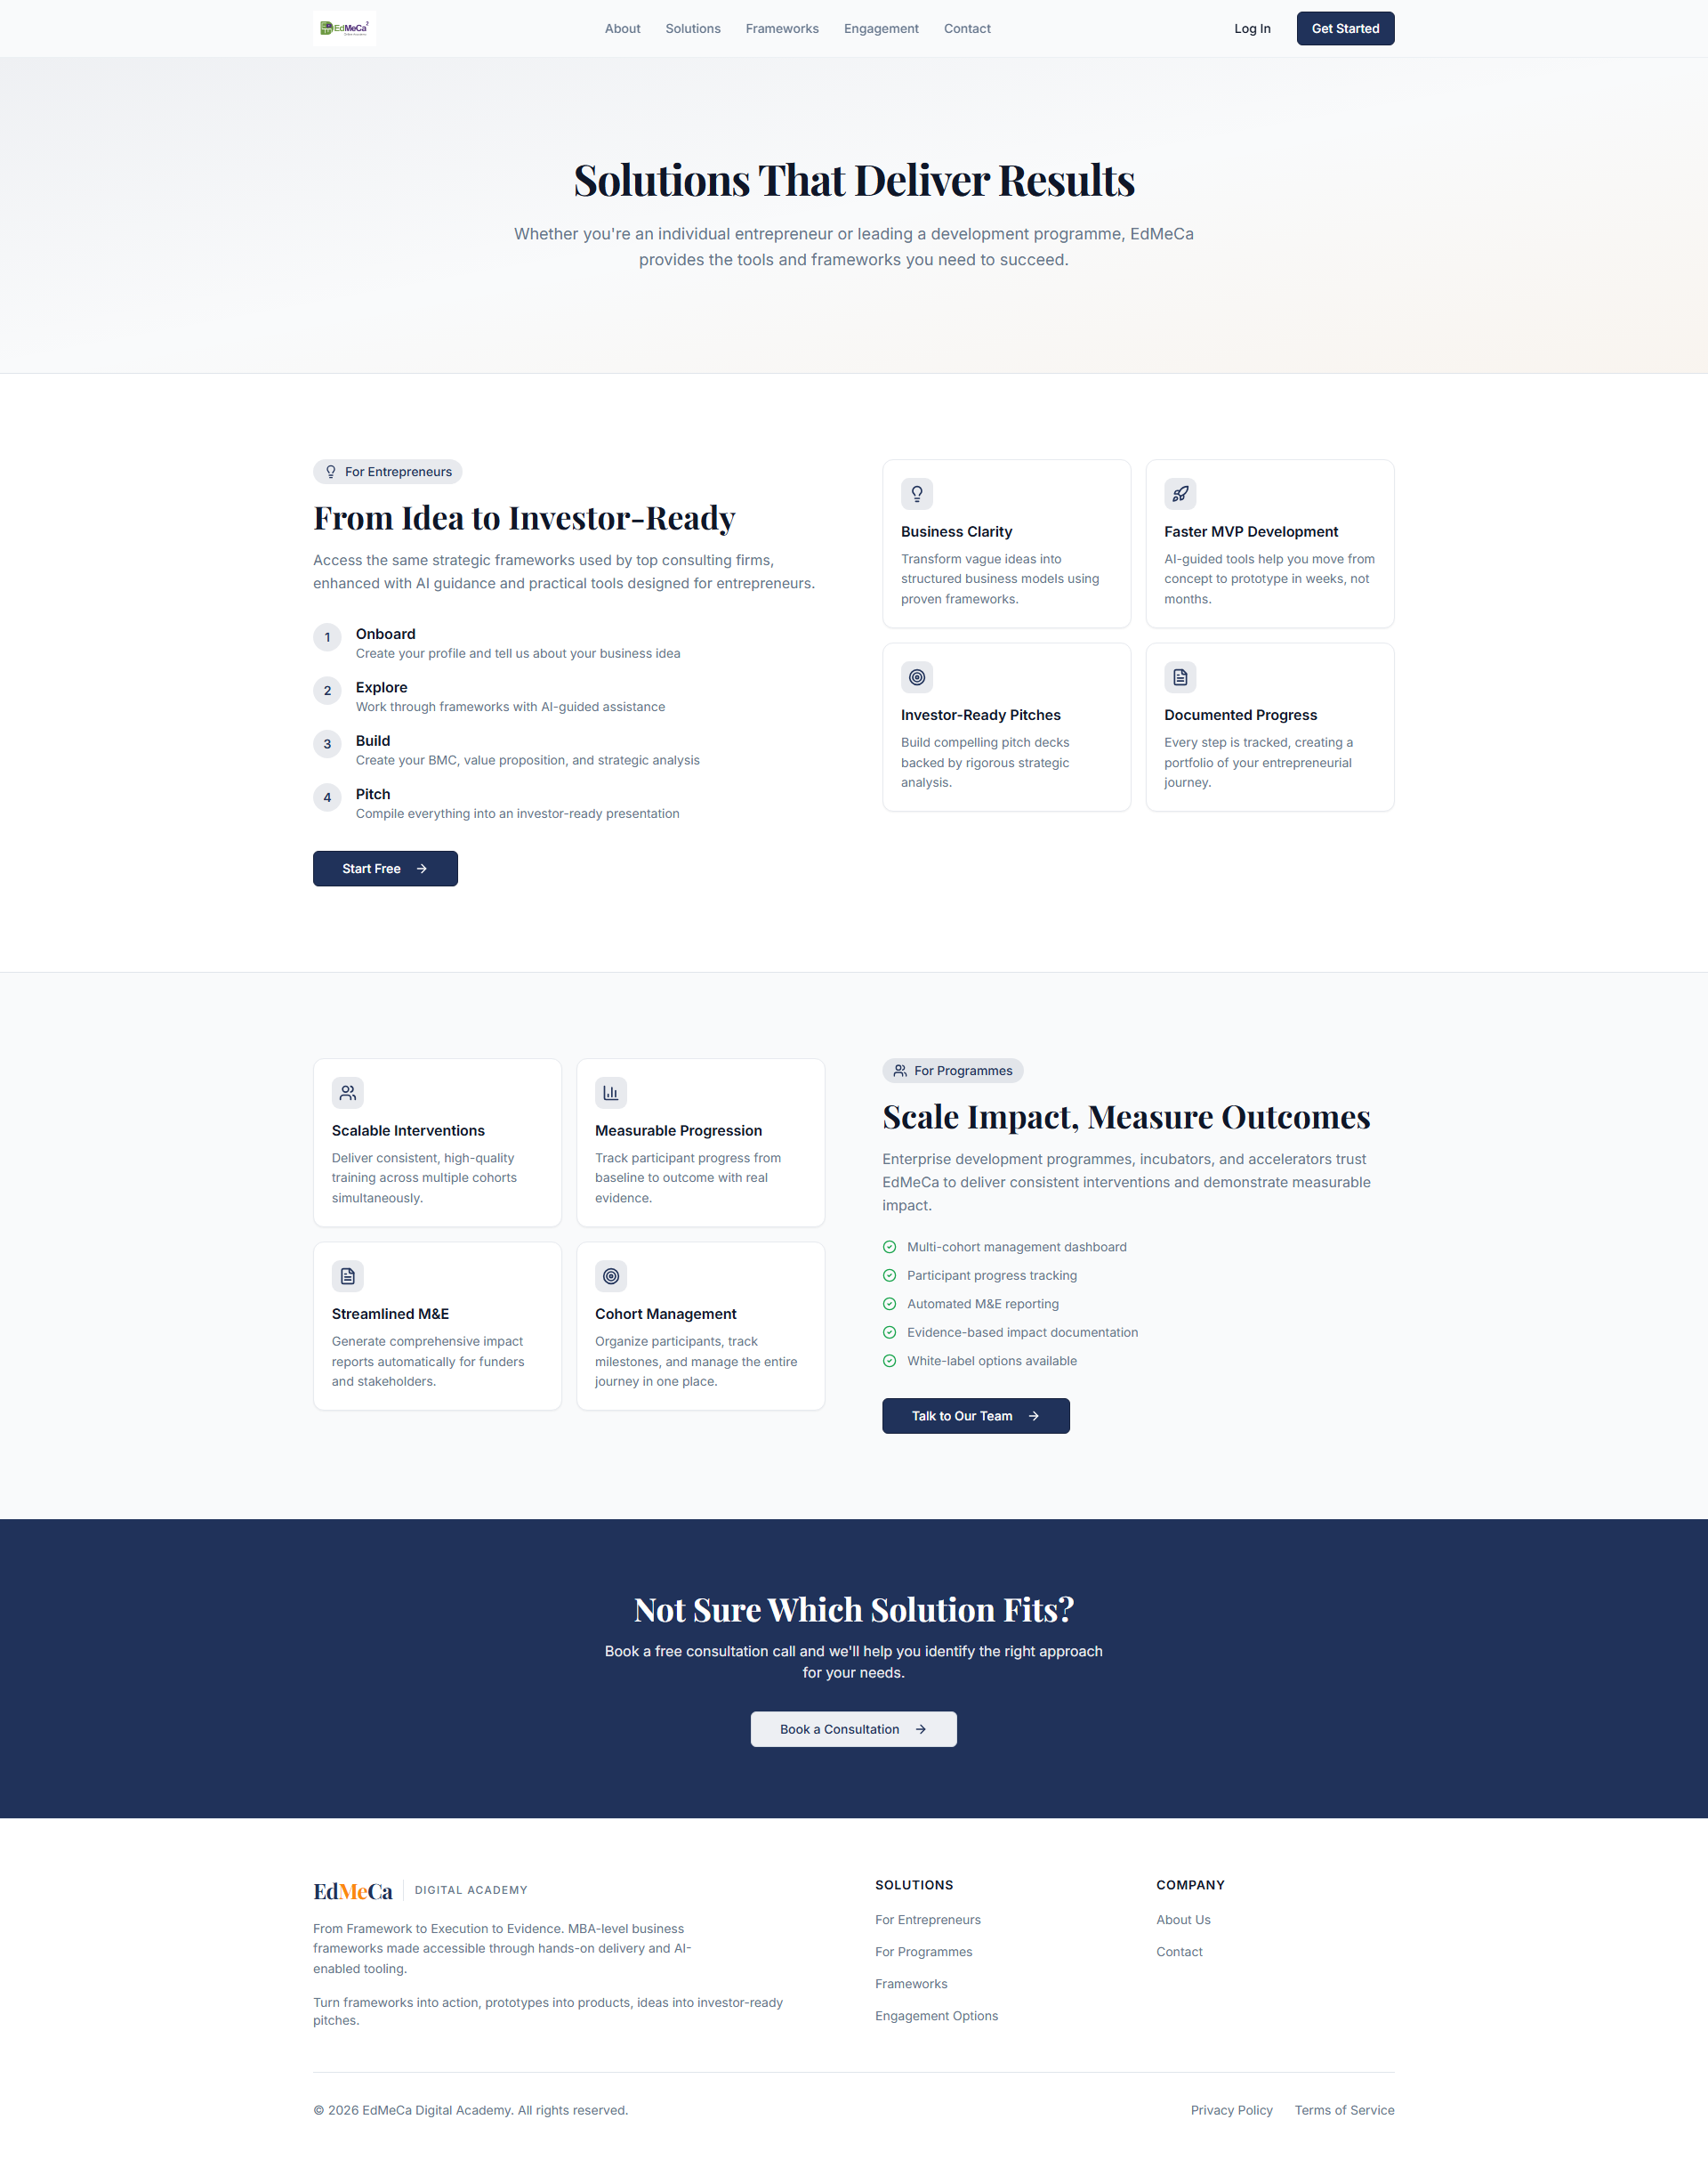
Figure 1: Solutions page layout

3. FRAMEWORKS PAGE
Educational frameworks and methodologies presentation.
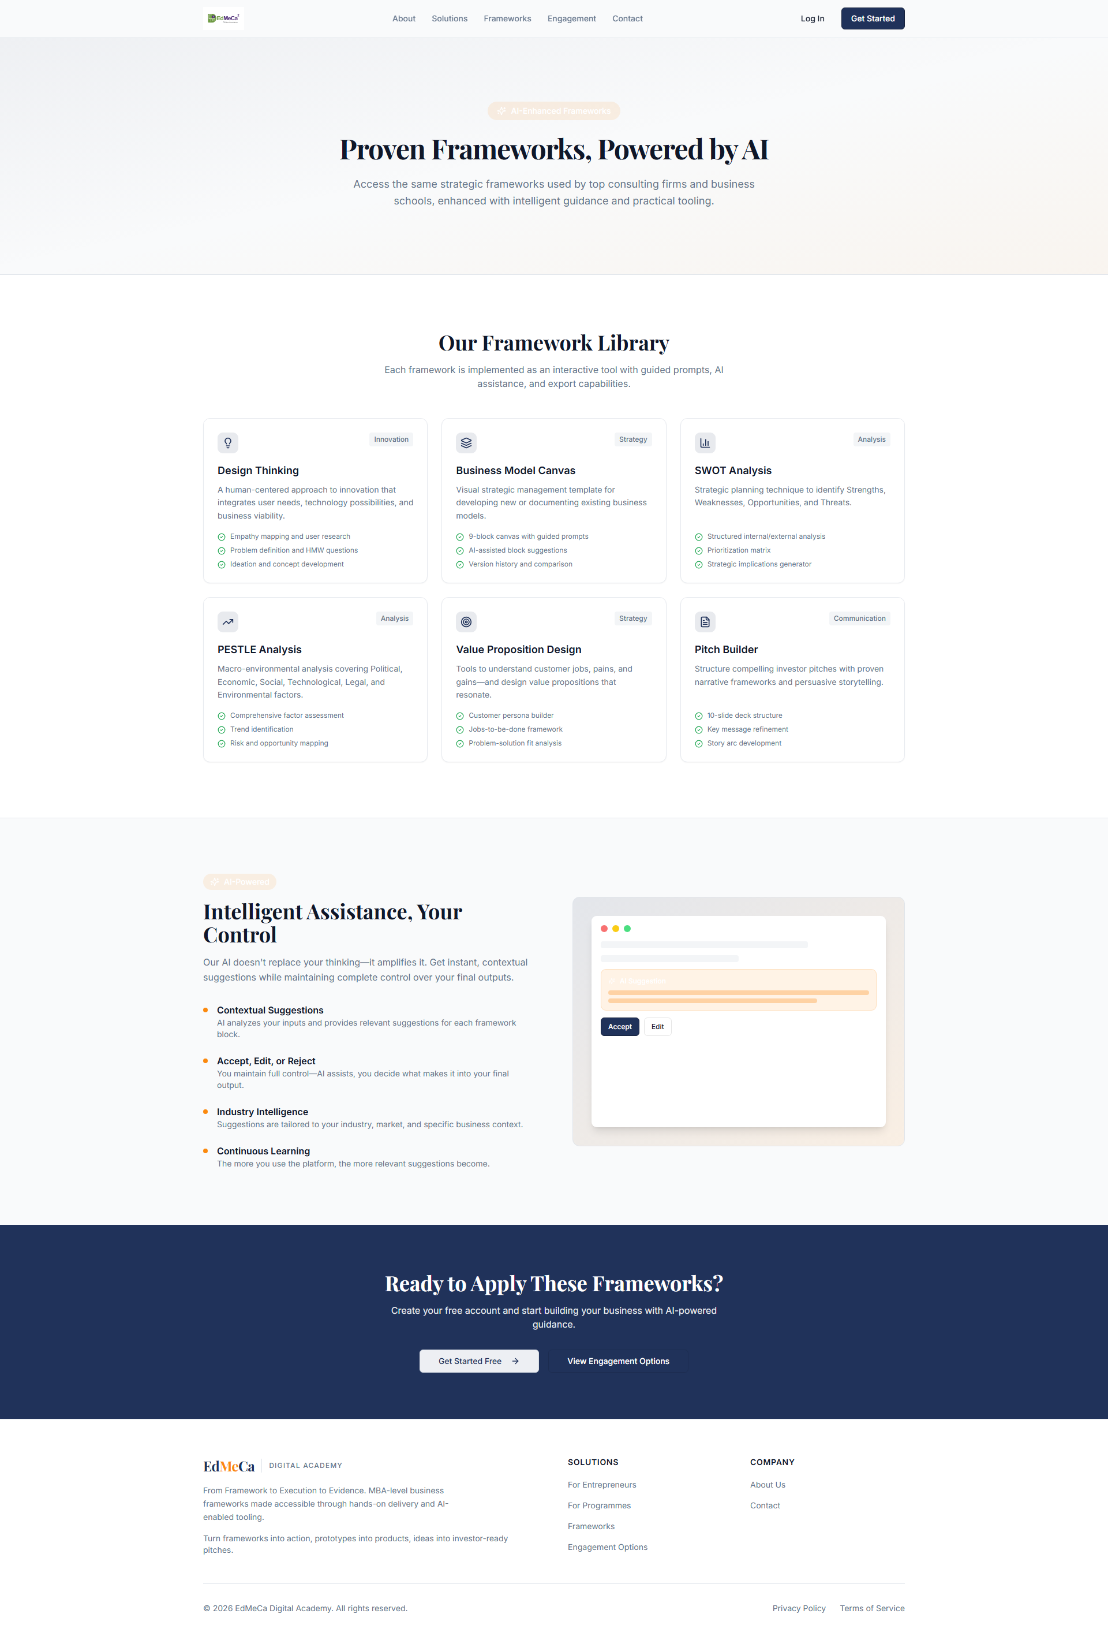
Figure 2: Frameworks page design

4. ENGAGEMENT PAGE
User engagement strategies and interactive learning approaches.
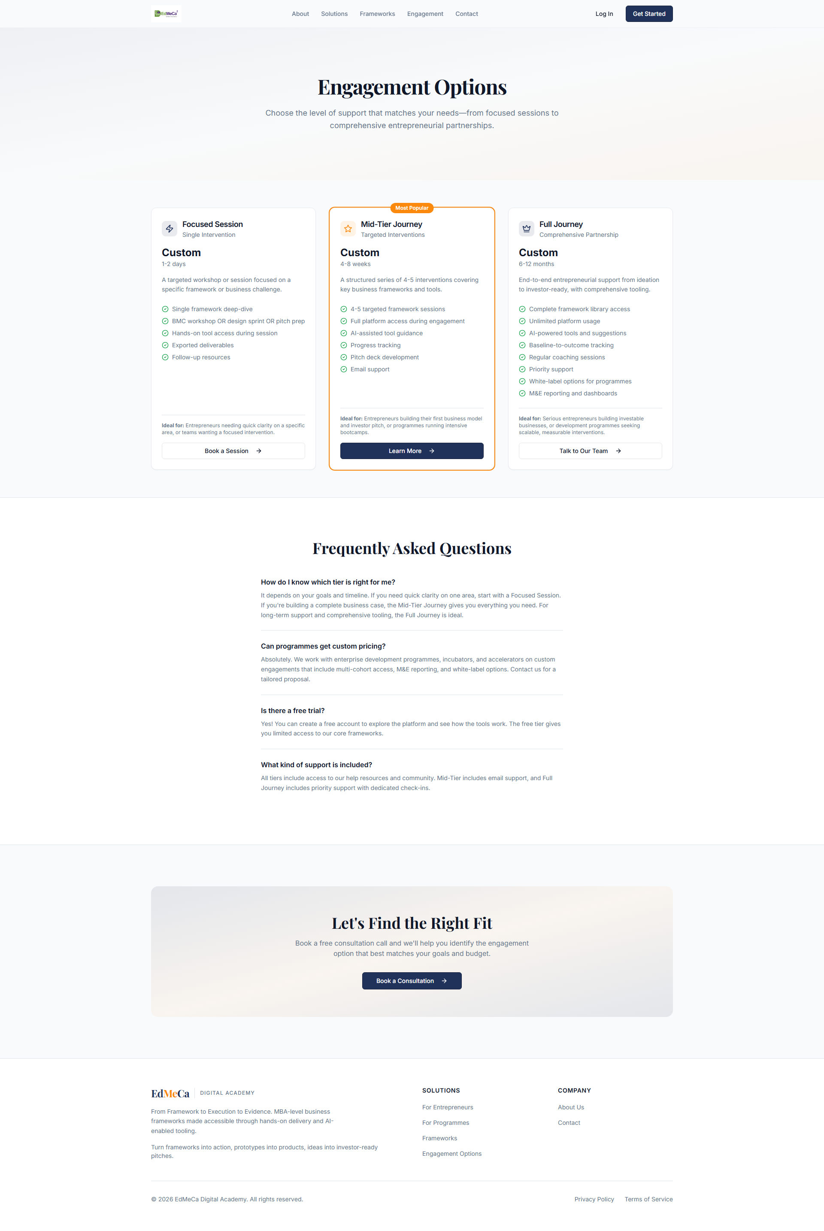
Figure 3: Engagement page interface

5. DESIGN FEATURES
- Clear content hierarchy and organization
- Visual elements for engagement frameworks
- Interactive demonstrations
- Responsive layouts for all devices
- Accessibility-compliant design

6. ACCEPTANCE CRITERIA
- ✅ Solutions overview page wireframe
- ✅ Solution detail page template
- ✅ Feature showcase sections designed
- ✅ Integration with learning tools visualized
- ✅ Responsive layouts for all breakpoints
- ✅ Content placeholder text provided

