EDMECA ACADEMY WEBSITE

Mobile Responsive Design Specifications
Document Version: 1.0
Date: February 16, 2026
Phase: 2 - Design & Prototyping

1. OVERVIEW
This document presents the comprehensive mobile responsive design strategy, ensuring optimal user experience across all device sizes and orientations.

2. RESPONSIVE BREAKPOINTS
- Mobile: 320px - 767px
- Tablet: 768px - 1023px
- Desktop: 1024px - 1440px
- Large Desktop: 1441px+

3. MOBILE NAVIGATION

3.1 Closed State

Figure 1: Mobile navigation - closed state

4. MOBILE PAGE LAYOUTS

4.1 Solutions Page - Mobile
Figure 2: Solutions page - mobile view

4.2 About Page - Mobile
Figure 3: About page - mobile view

4.3 Contact Page - Mobile

Figure 4: Contact page - mobile view

5. TABLET LAYOUT
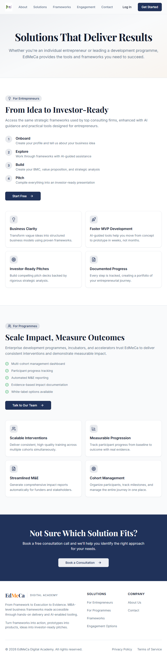
Figure 5: Tablet layout example

6. RESPONSIVE DESIGN PRINCIPLES
- Mobile-first design approach
- Touch-friendly interactive elements (44px minimum)
- Flexible layouts using CSS Grid and Flexbox
- Optimized images for different screen densities
- Performance-optimized for mobile networks

7. ACCEPTANCE CRITERIA
- ✅ Mobile-first design approach implemented
- ✅ Breakpoint designs (320px, 768px, 1024px, 1920px)
- ✅ Touch-friendly interactive elements (44px min)
- ✅ Responsive navigation patterns defined
- ✅ Performance-optimized image specifications
- ✅ Cross-device testing completed

