EDMECA ACADEMY WEBSITE

Portal Dashboard Design
Document Version: 1.0
Date: February 16, 2026
Phase: 2 - Design & Prototyping

1. OVERVIEW
The user portal provides authenticated users with access to learning tools, progress tracking, and educational resources. This document presents the dashboard and portal interface designs.

2. DASHBOARD LAYOUT
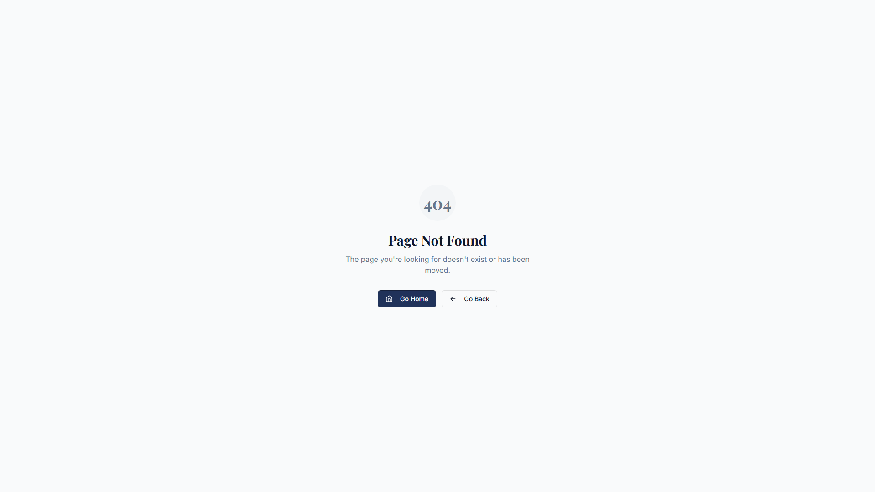
Figure 1: Portal dashboard interface

2.1 Key Components
- User profile and settings access
- Progress tracking dashboard
- Quick access to courses and resources
- Notifications and updates
- Learning tools integration

3. BUSINESS MODEL CANVAS TOOL
Integrated learning tool for business planning and strategy development.
Figure 2: Business Model Canvas tool interface

4. DESIGN PRINCIPLES
- Clear information hierarchy
- Intuitive navigation patterns
- Progress visualization
- Personalized user experience
- Seamless tool integration

5. ACCEPTANCE CRITERIA
- ✅ Dashboard layout designed
- ✅ Student progress visualization created
- ✅ Course access interface designed
- ✅ Resource library layout completed
- ✅ User profile section designed
- ✅ Navigation patterns established

