EDMECA ACADEMY WEBSITE

User Flow & Navigation Design
Document Version: 1.0
Date: February 16, 2026
Phase: 2 - Design & Prototyping

1. OVERVIEW
This document presents the comprehensive user flows and navigation design for the EDMECA Academy Website, ensuring intuitive user journeys and logical information architecture.

2. NAVIGATION STRUCTURE

2.1 Primary Navigation
Figure 1: Primary navigation header
Primary navigation includes:
- Home
- About
- Solutions
- Frameworks
- Engagement
- Contact
- Portal Access

2.2 Footer Navigation
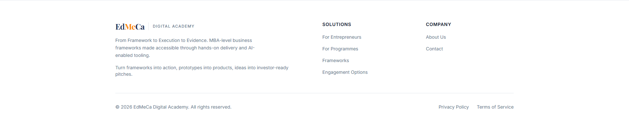
Figure 2: Footer navigation and links

3. PRIMARY USER FLOWS

3.1 Guest User Journey
New visitors exploring EDMECA Academy:
- Step 1: Land on homepage → Learn about EDMECA
- Step 2: Explore Solutions → Understand offerings
- Step 3: View Frameworks → Learn methodologies
- Step 4: Contact or Create Account → Engage
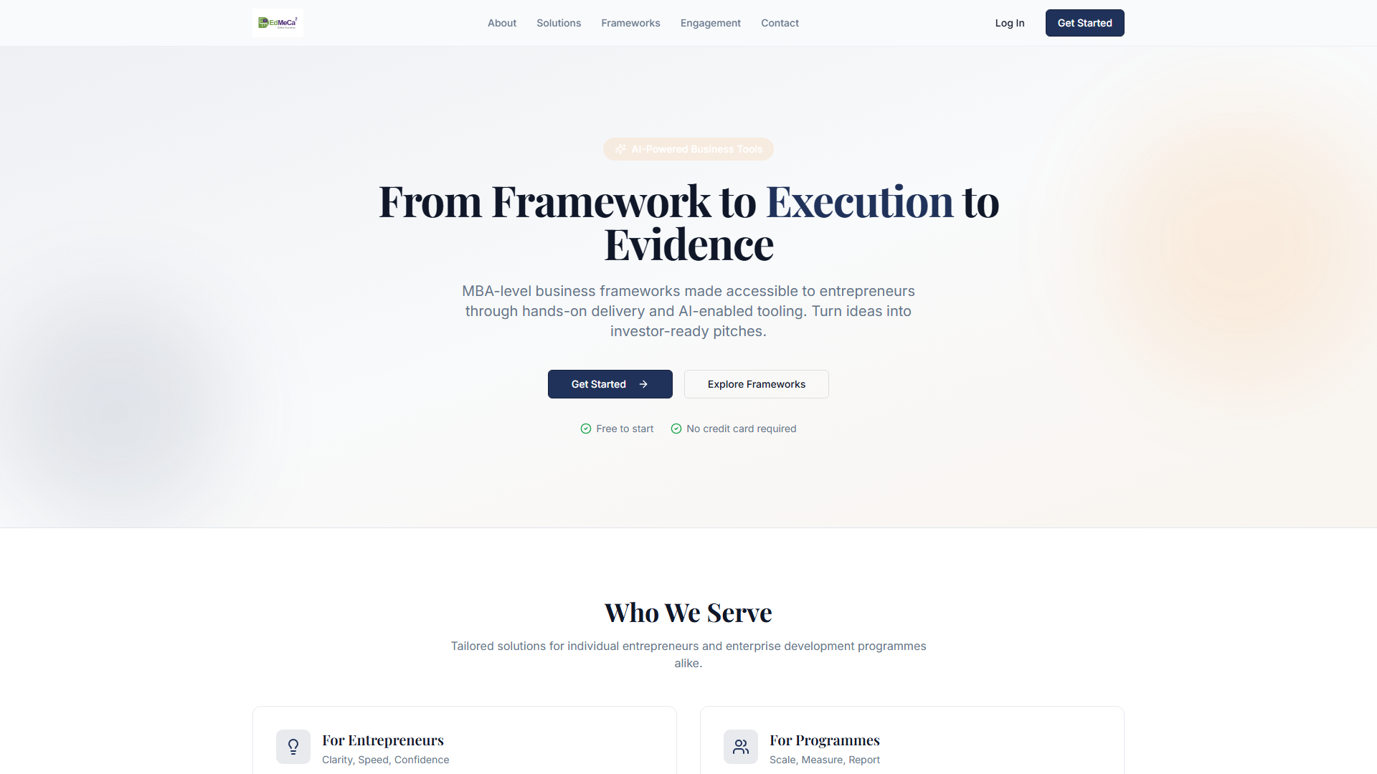
Figure 3: User flow Step 1 - Homepage
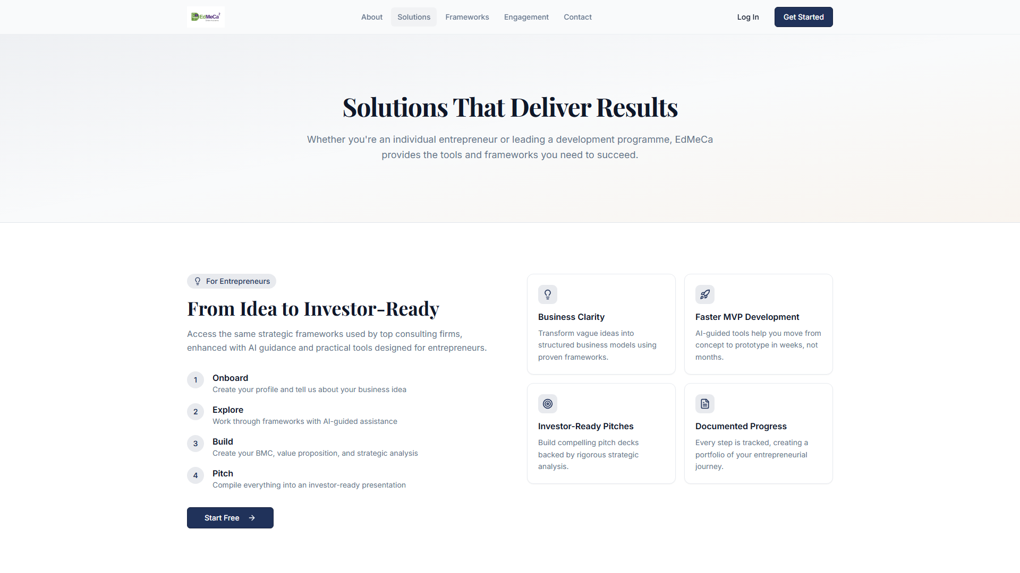
Figure 4: User flow Step 2 - Solutions page

3.2 Authenticated User Journey
- Login → Dashboard → Access Learning Tools
- View Progress → Continue Learning → Complete Modules
- Explore Resources → Download Materials

4. INFORMATION ARCHITECTURE
Hierarchical structure:
- Level 1: Main Pages (Home, About, Solutions, etc.)
- Level 2: Sub-sections within pages
- Level 3: Portal (requires authentication)
- Level 3.1: Dashboard, Tools, Resources

5. NAVIGATION PATTERNS

5.1 Desktop Navigation
- Persistent top navigation bar
- Hover states for dropdown menus
- Breadcrumbs for deep navigation

5.2 Mobile Navigation
- Hamburger menu for compact navigation
- Full-screen mobile menu overlay
- Touch-optimized menu items

6. ACCEPTANCE CRITERIA
- ✅ User journey maps created for all key flows
- ✅ Navigation patterns defined and documented
- ✅ Information architecture established
- ✅ User flow diagrams completed
- ✅ Navigation testing completed

