Screenshot_GOTO_OMSA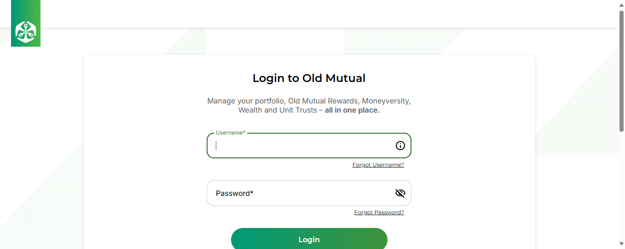
Screenshot_Navigate_LoginOMSA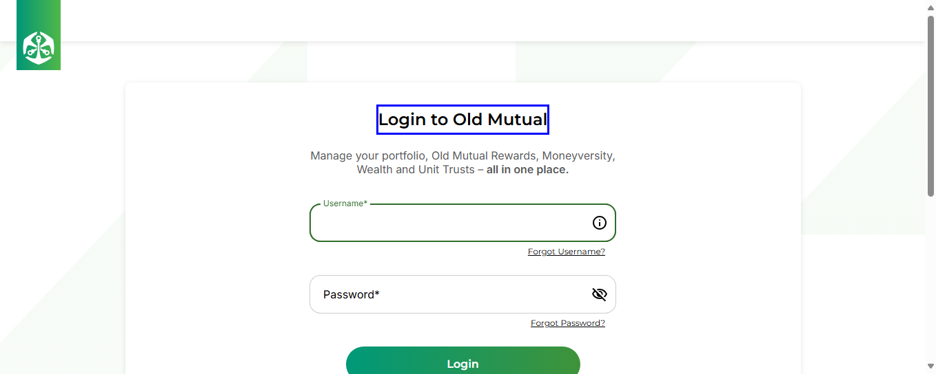
Screenshot_Enter_UserName-01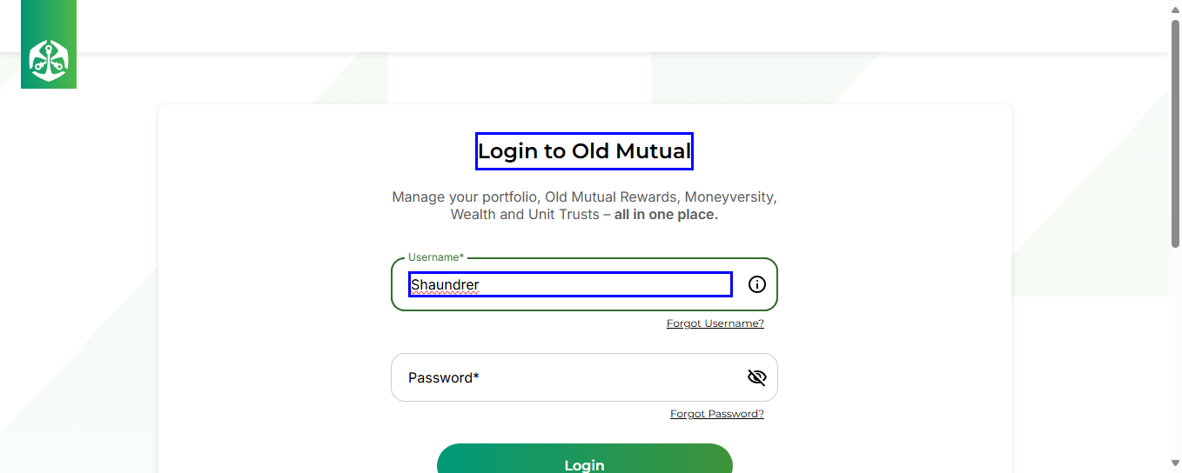
Screenshot_Enter_Password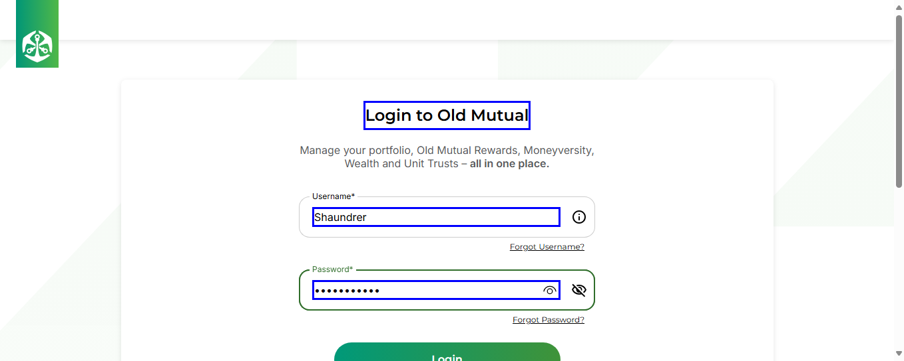
Screenshot_Click_LoginButton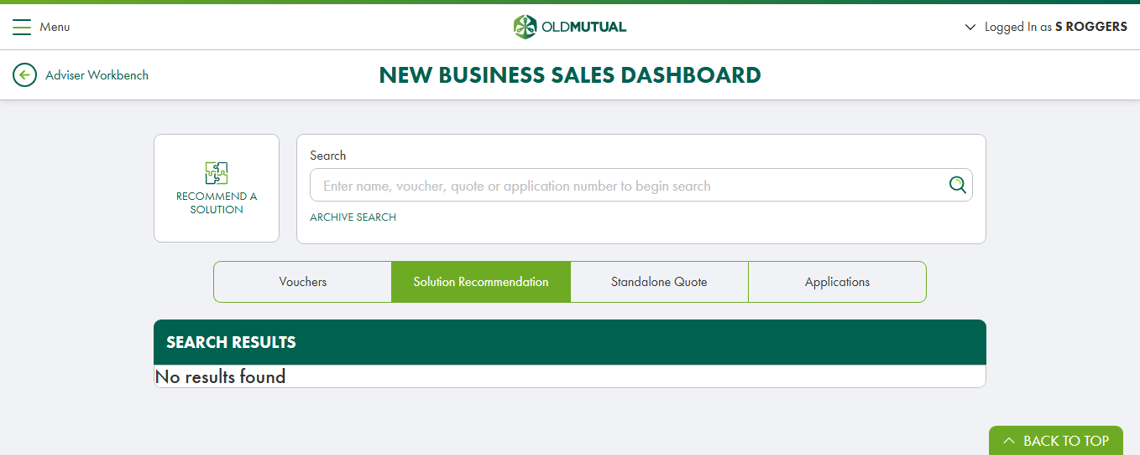
Screenshot_Navigate_ServiceDashBoardOpen
Screenshot_Click_CreateServiceRequest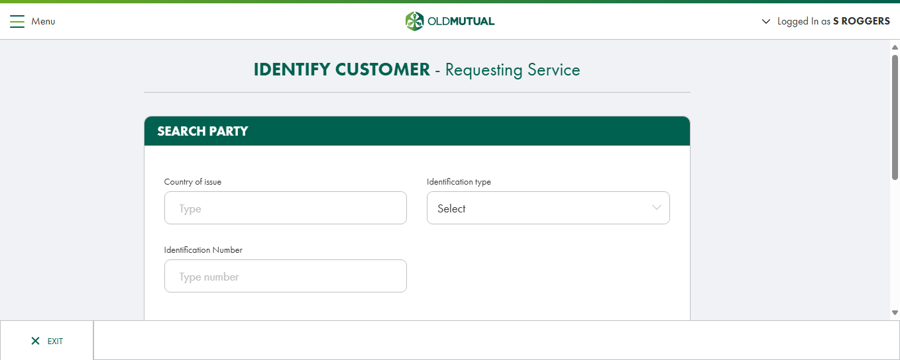
Screenshot_Navigate_IdentifyCustomer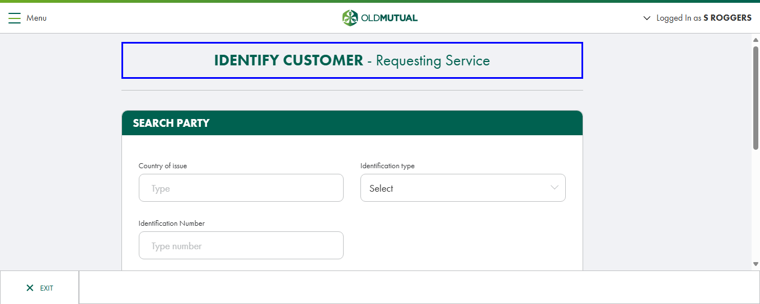
Screenshot_Select_IDTypeIC-01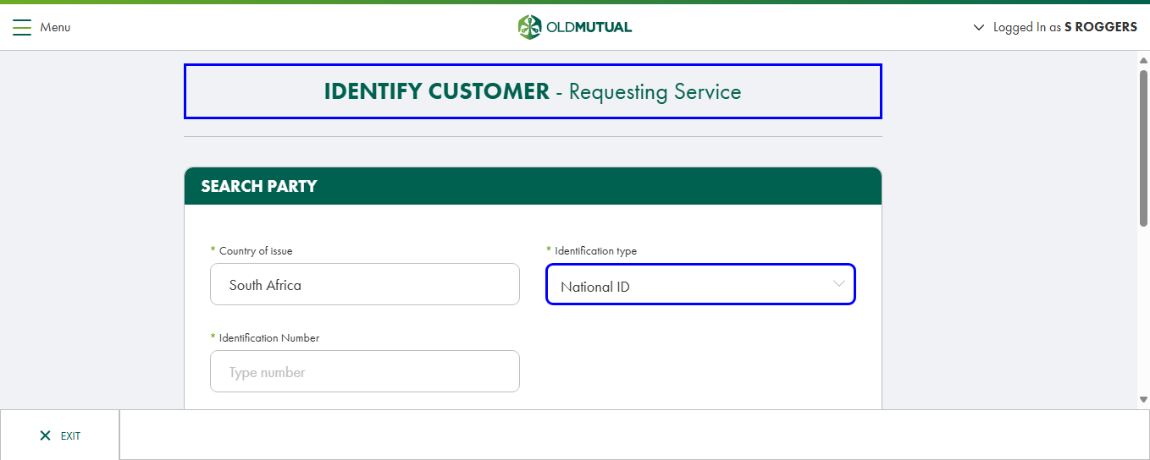
Screenshot_Enter_IdNumberIC-01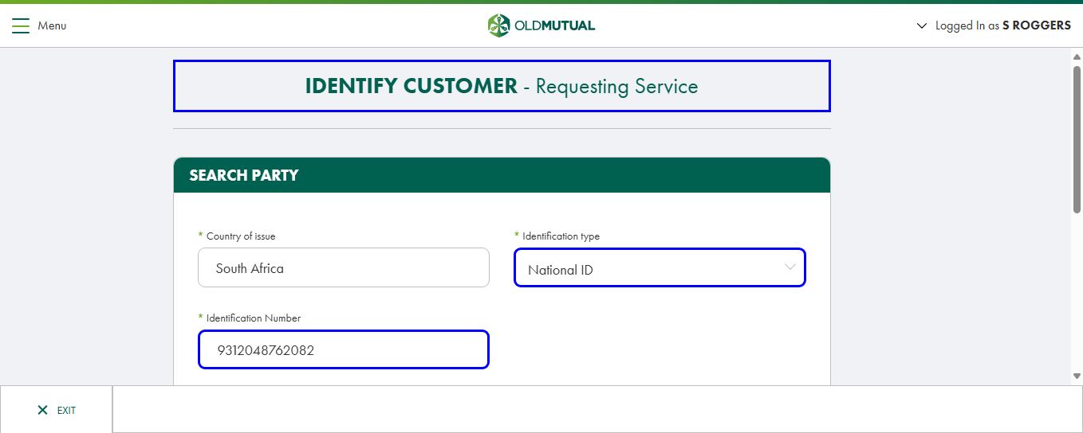
Screenshot_Click_SearchButton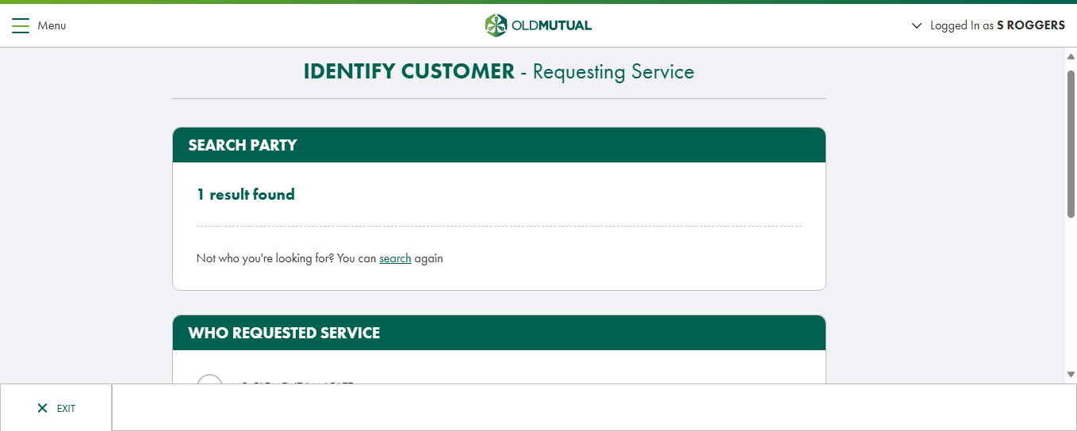
Screenshot_Navigate_IdentifyCustomer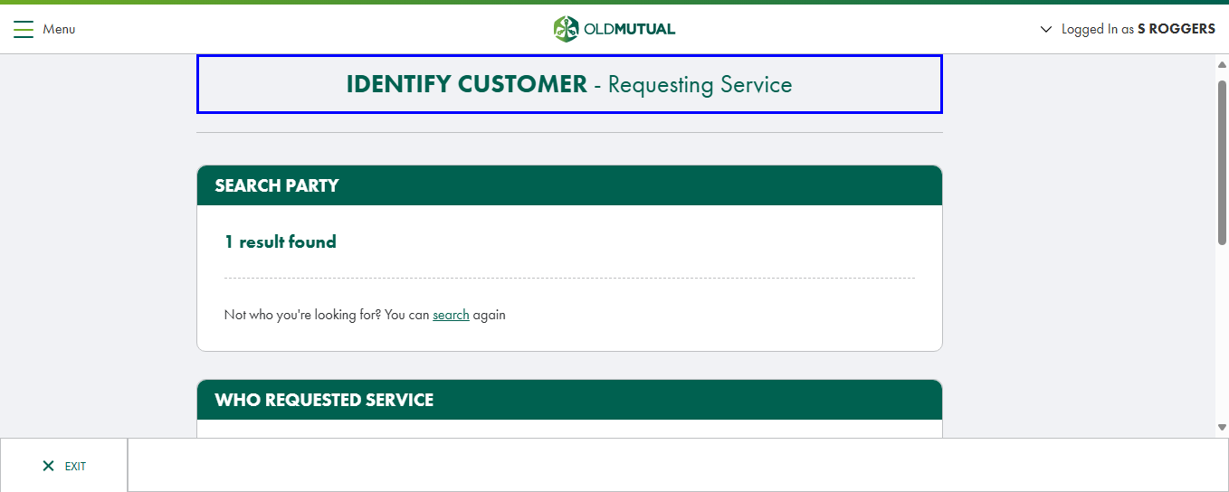
Screenshot_Click_ActOnBehalfOf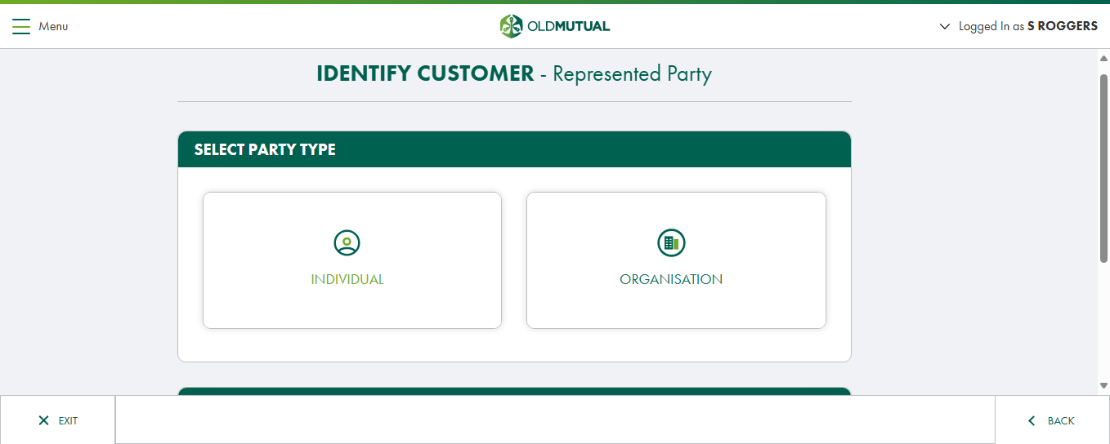
Screenshot_Click_IndividualTab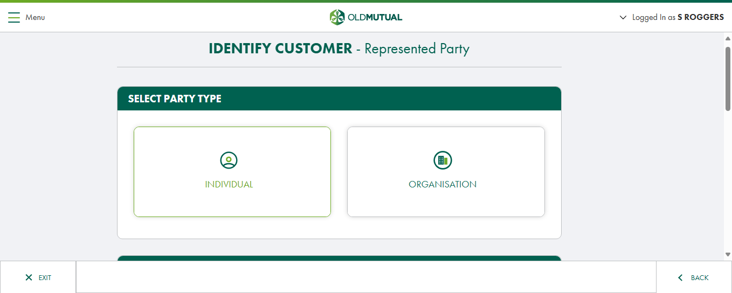
Screenshot_Click_Curator
Screenshot_Navigate_AuthenticateCustomer
Screenshot_Click_IAcceptDeclarRadio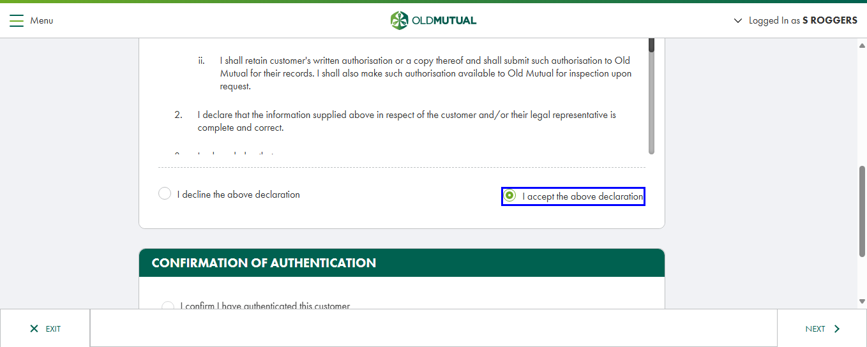
Screenshot_Click_IConfirmAuthCust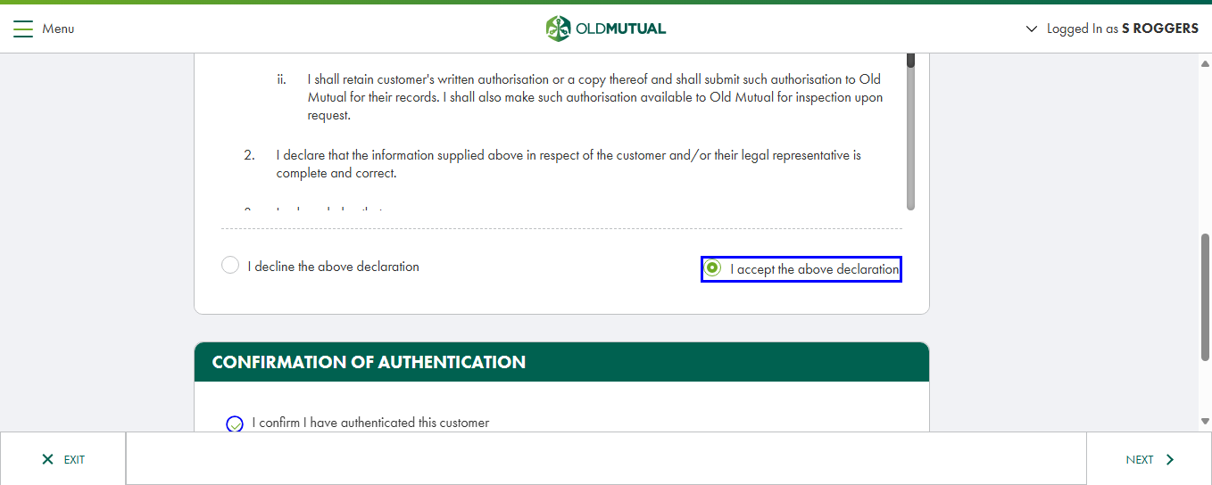
Screenshot_Click_NextAuthCust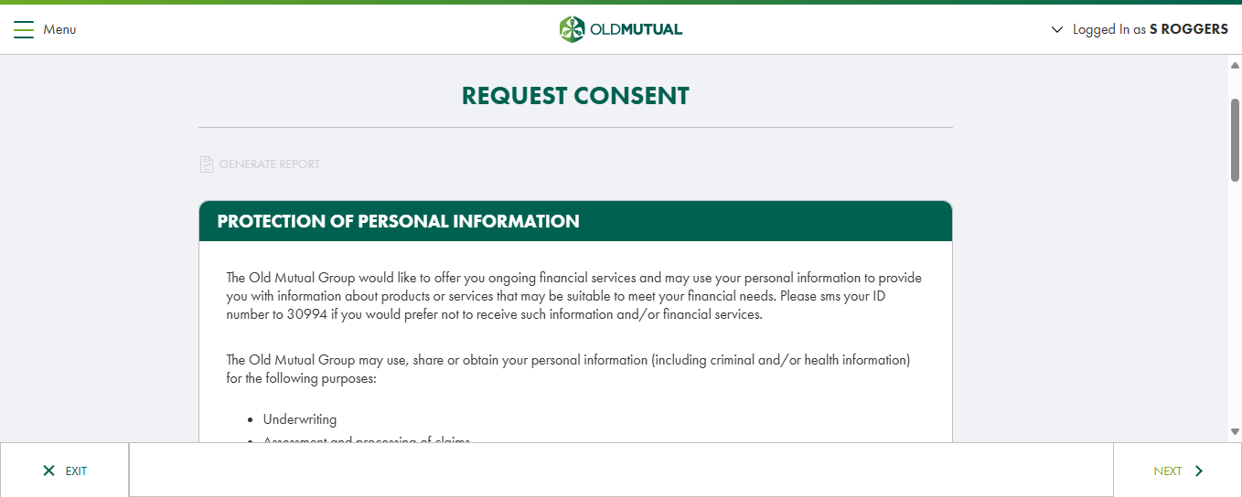
Screenshot_Navigate_RequestConsent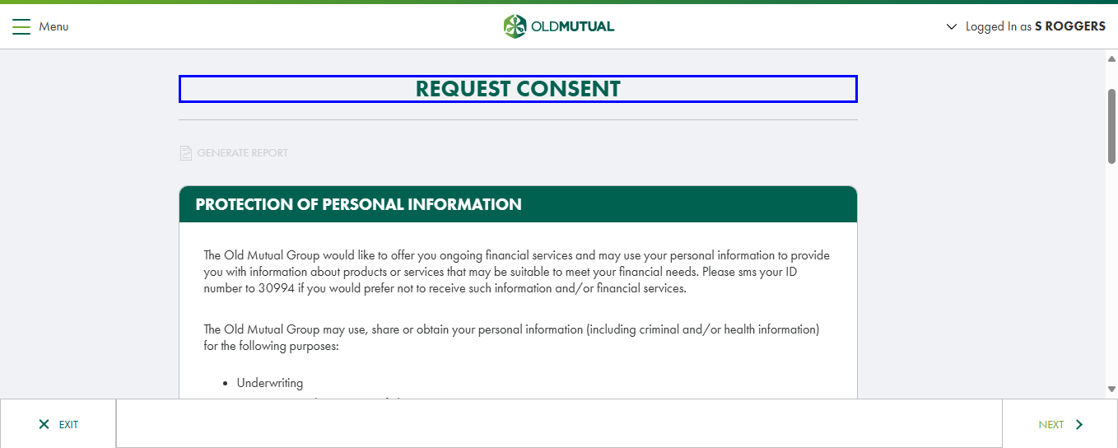
Screenshot_Click_PaperSignature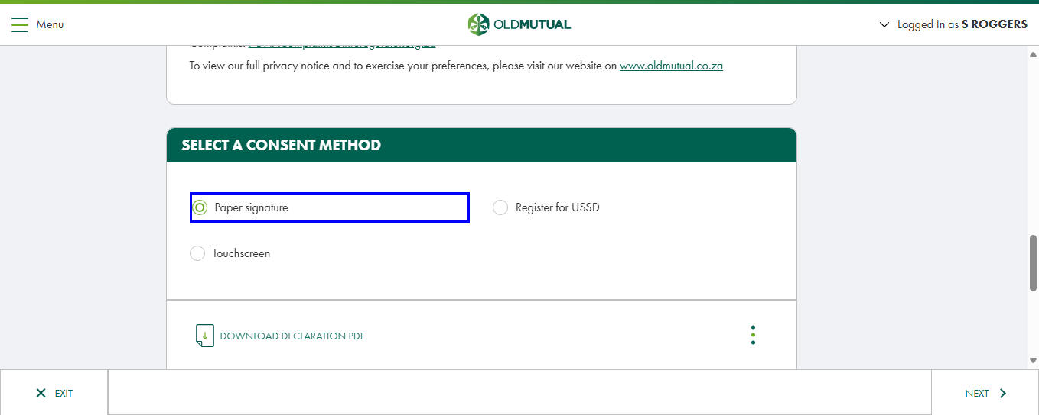
Screenshot_Click_3Dots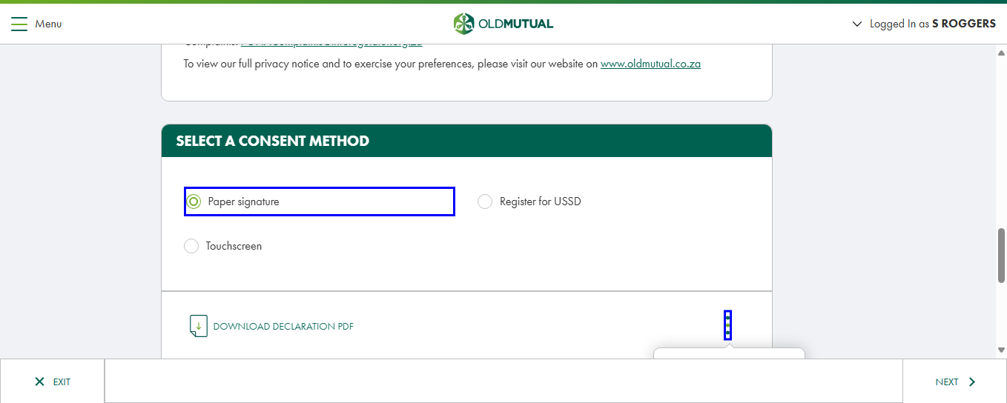
Screenshot_Click_UploadDoc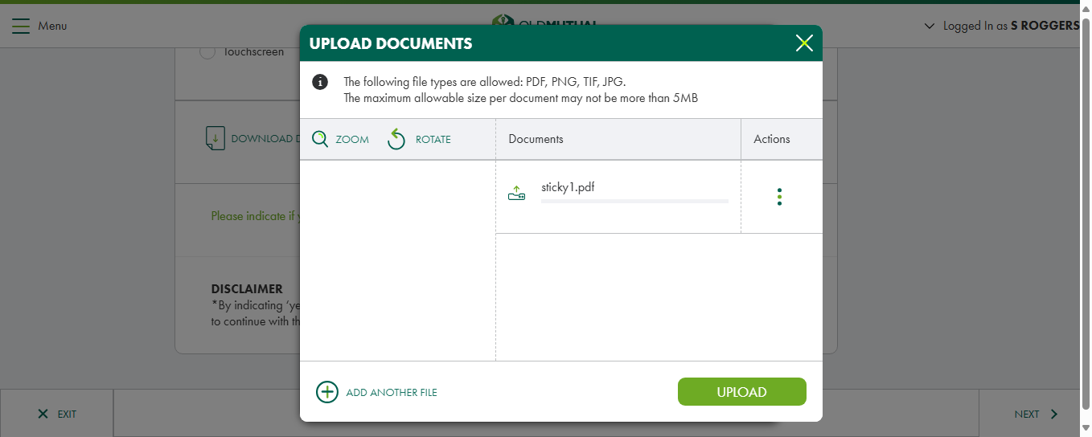
Screenshot_Click_UPLOADFile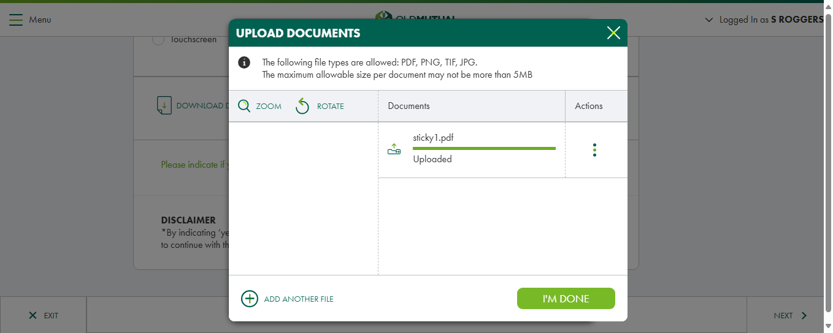
Screenshot_Click_IMDone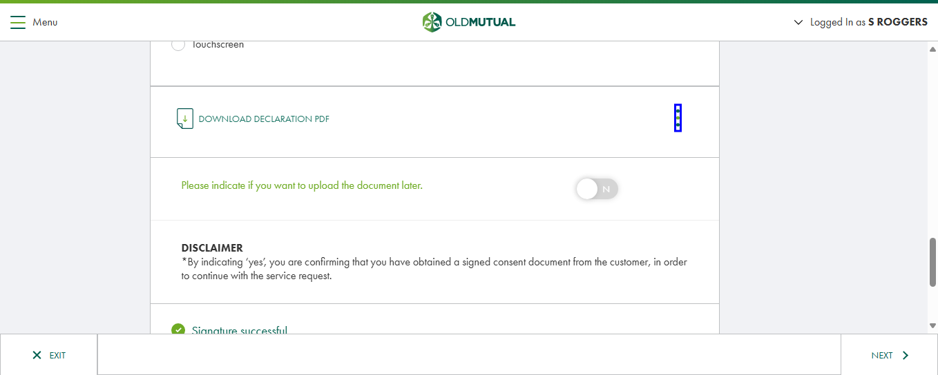
Screenshot_Click_NEXT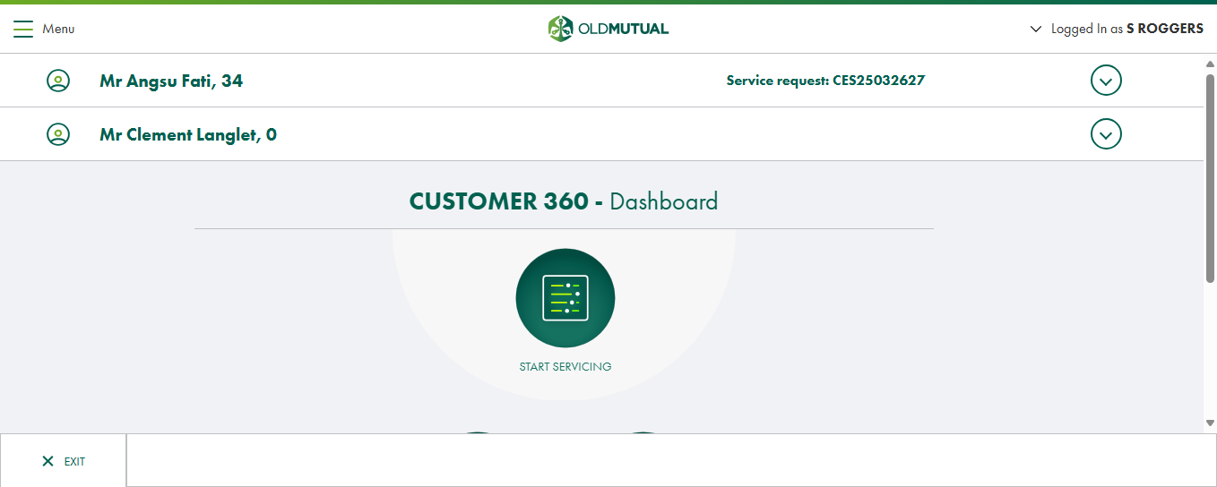
Screenshot_Navigate_360Dashboard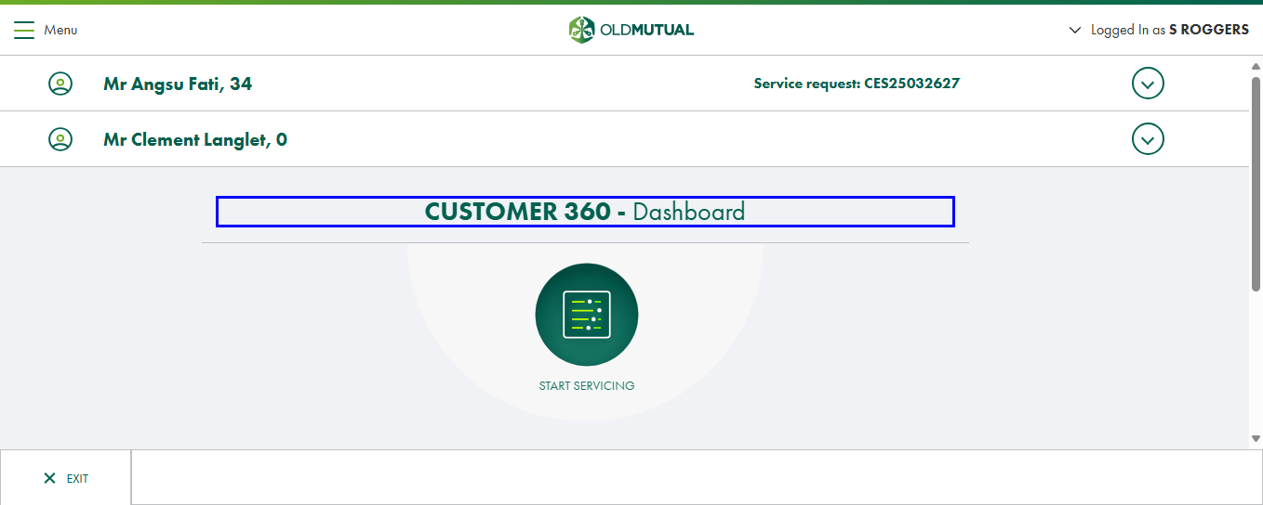
Screenshot_Click_StartServicingCust360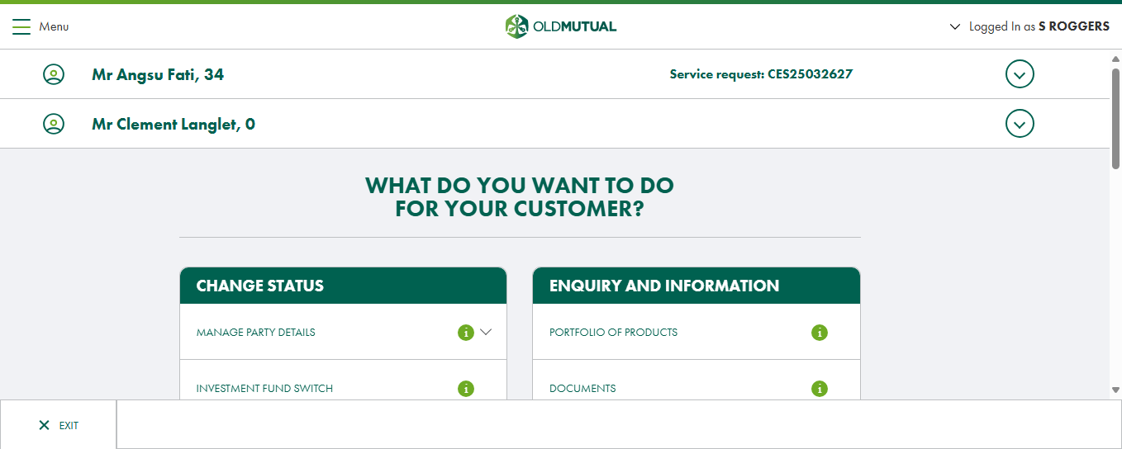
Screenshot_Navigate_ServiceOptionMenu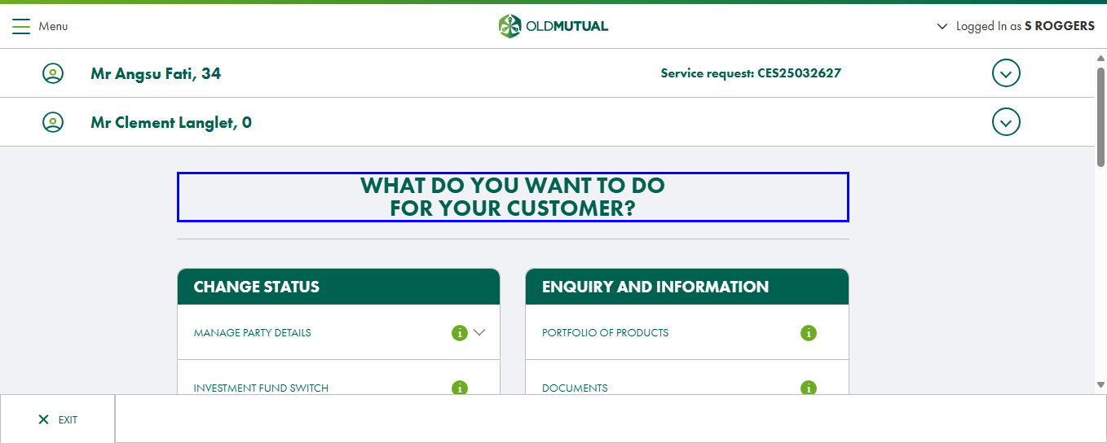
Screenshot_Click_FollowUp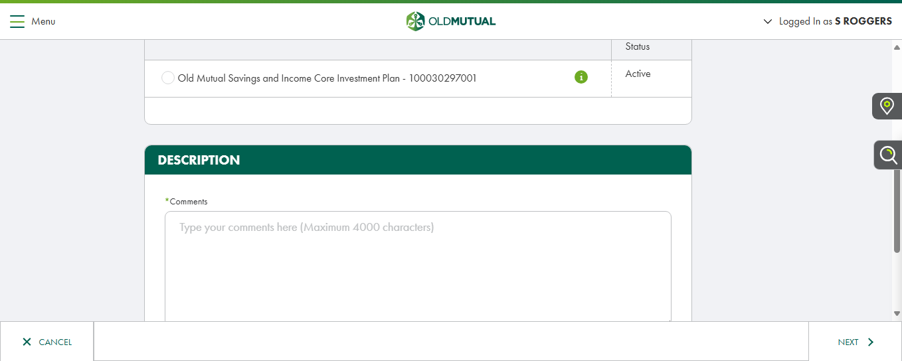
Screenshot_Navigate_SubmitFollowUp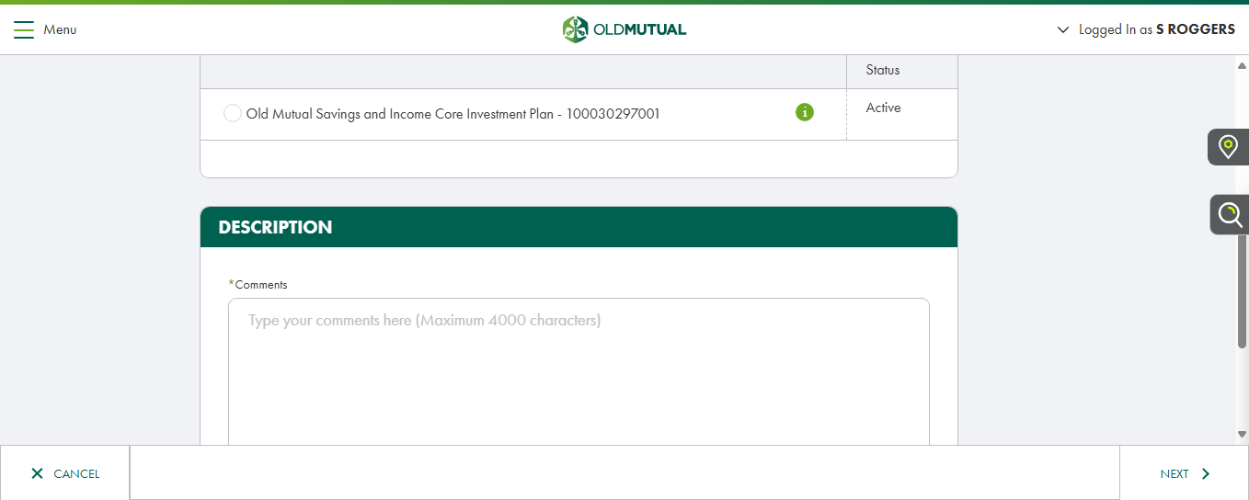
Screenshot_Click_Policy1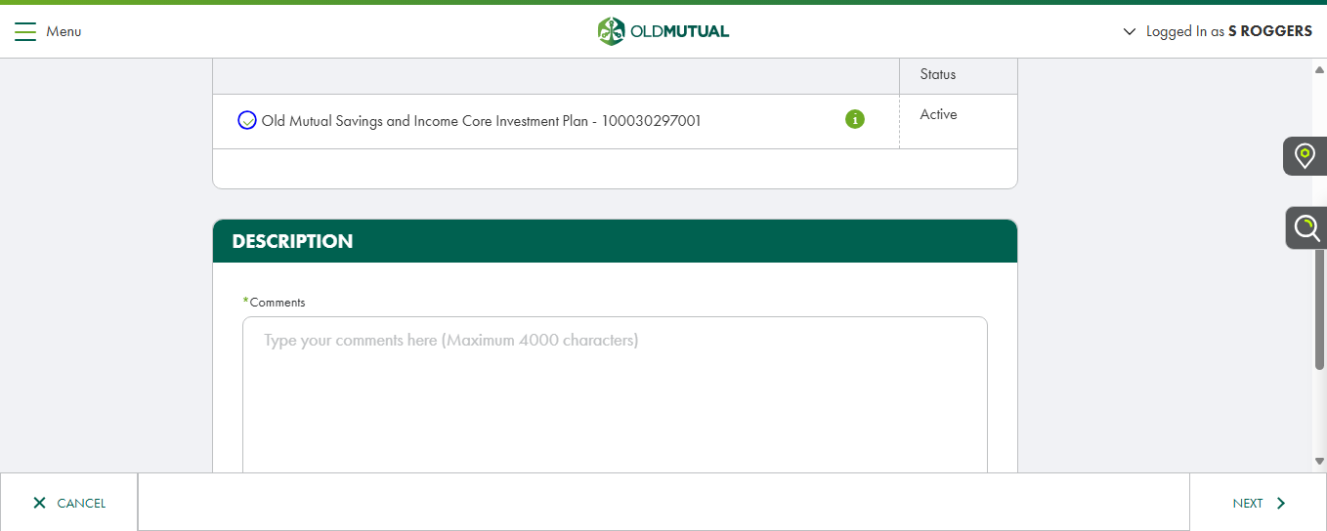
Screenshot_Enter_CommentsWebEdit-01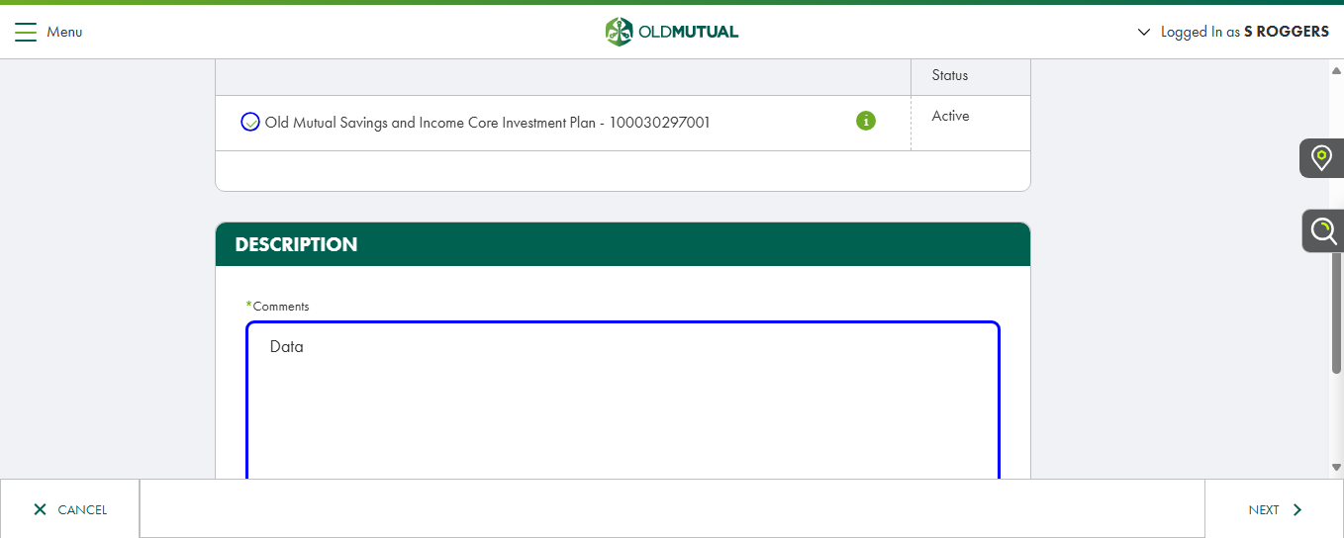
Screenshot_Click_NextButton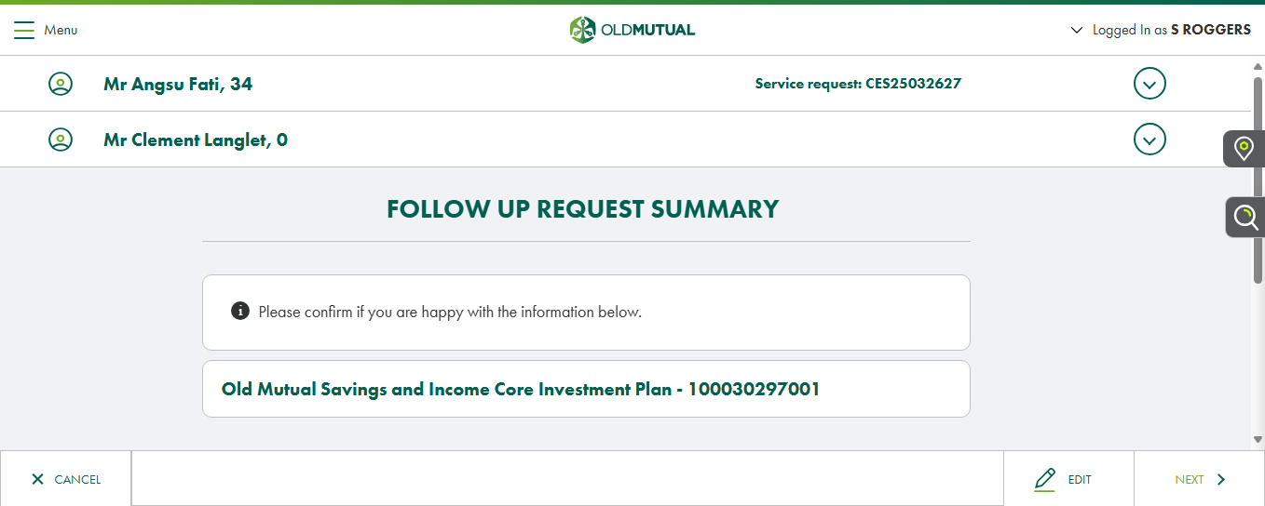
Screenshot_Navigate_FollowUpSummary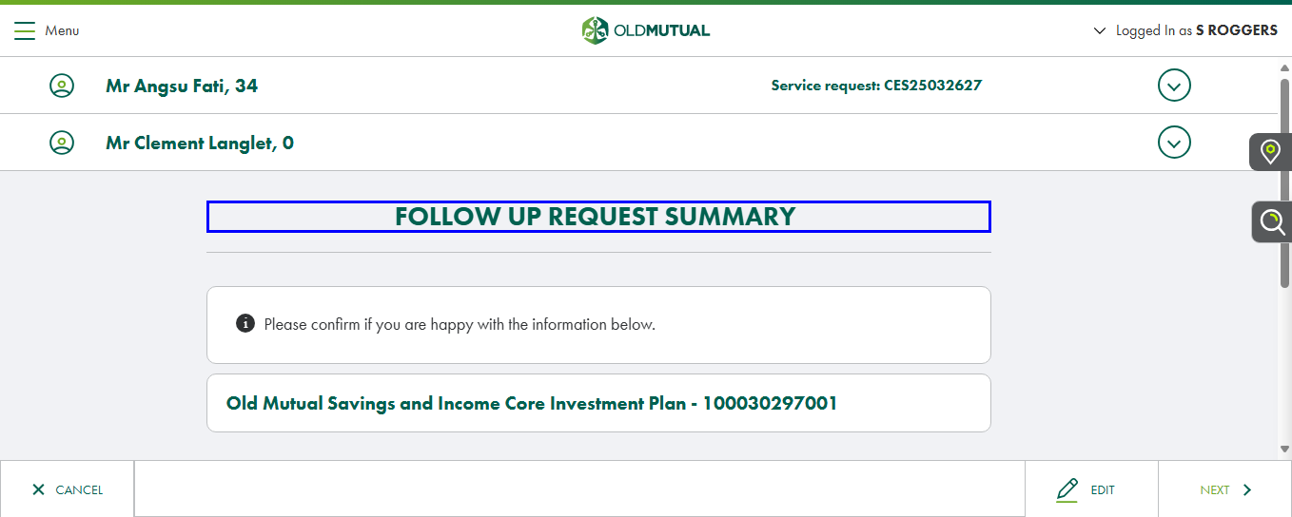
Screenshot_Click_NextButton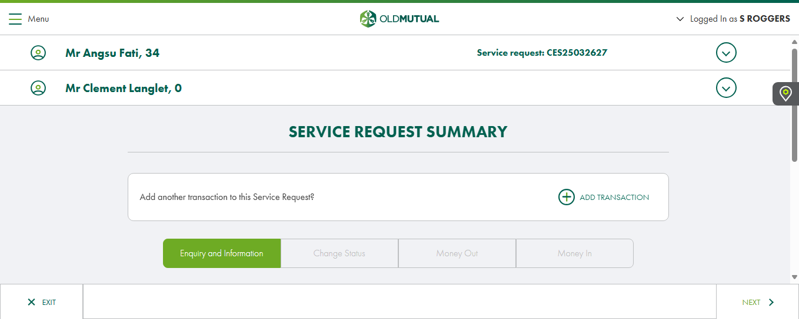
Screenshot_Navigate_SRS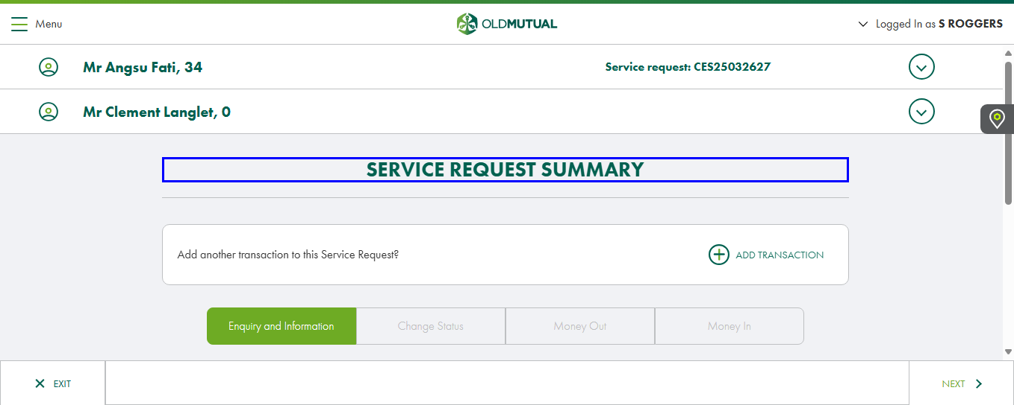
Screenshot_Check_FollowUp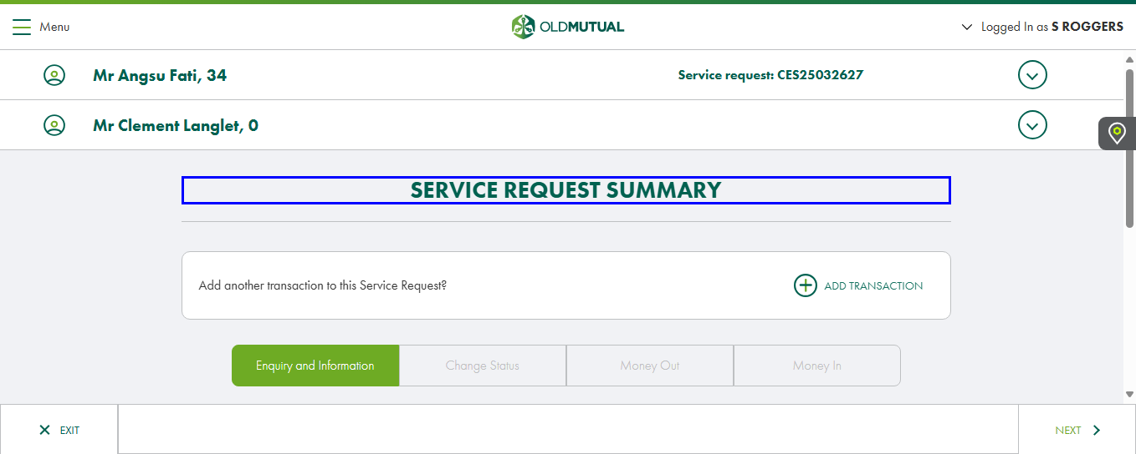
Screenshot_Click_ThreeDotsTransactionType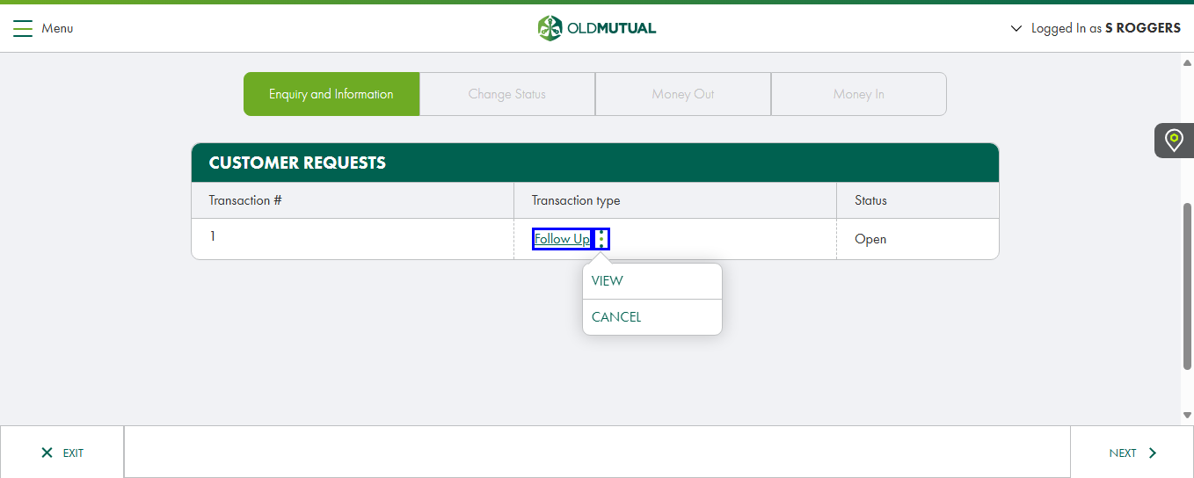
Screenshot_Click_CancelTransaction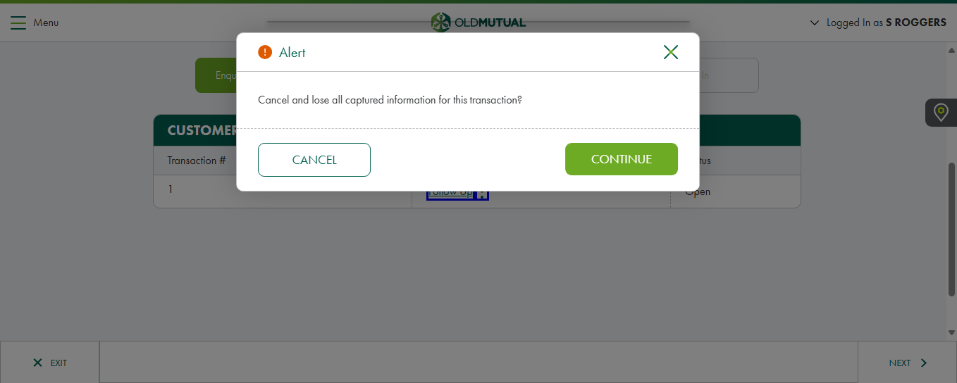
Screenshot_Click_ContinueTransaction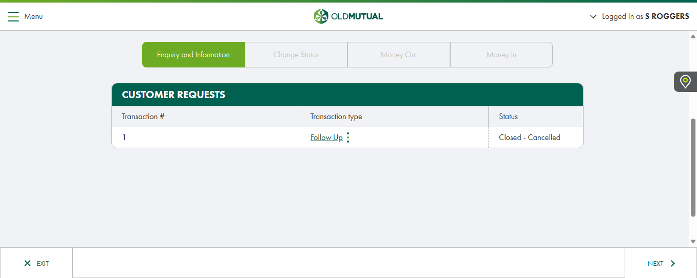
Screenshot_Navigate_SRS
Screenshot_Click_ThreeDotsTransactionType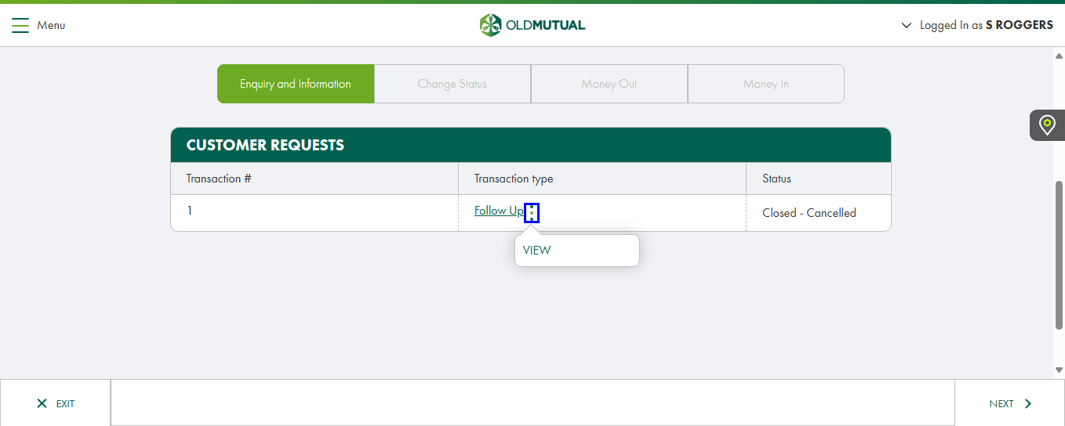
Screenshot_Click_FollowUp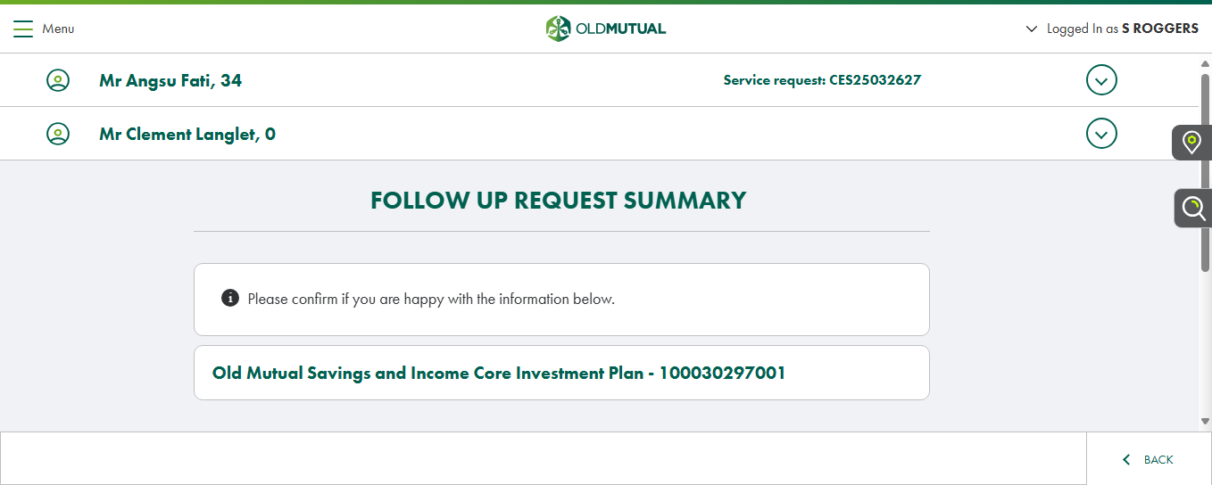
Screenshot_Navigate_FollowUpSummary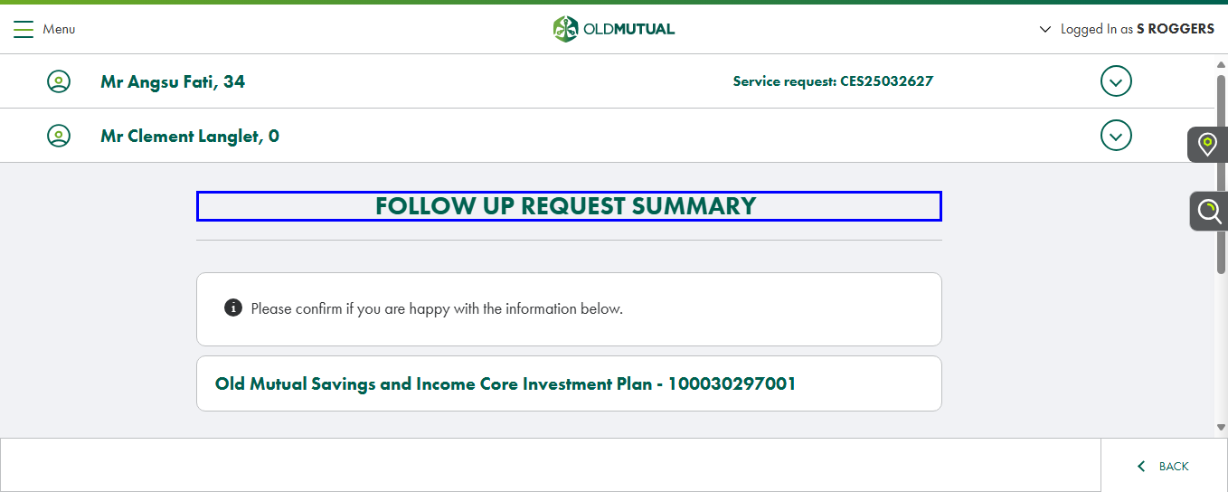
Screenshot_Click_BackButton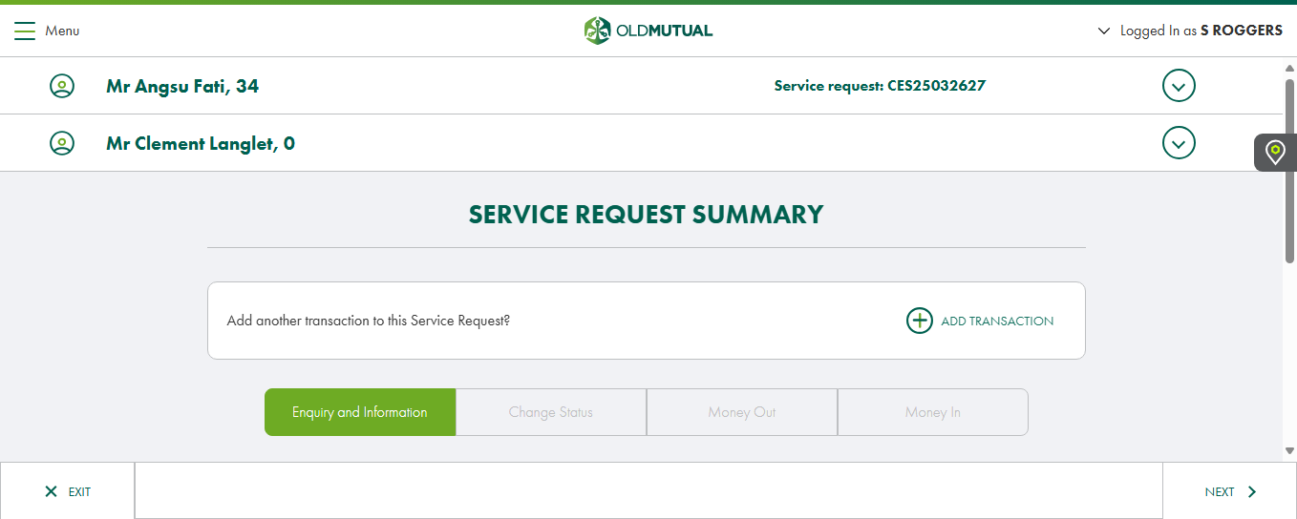
Screenshot_Navigate_SRS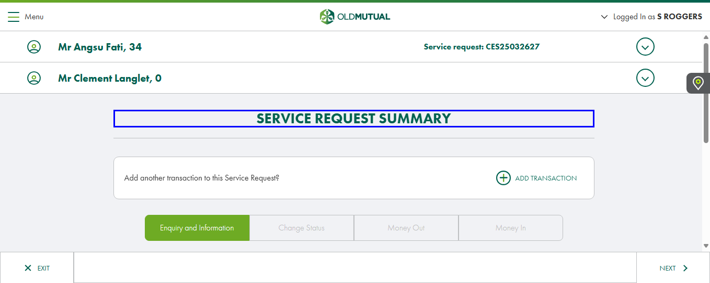
Screenshot_Click_Next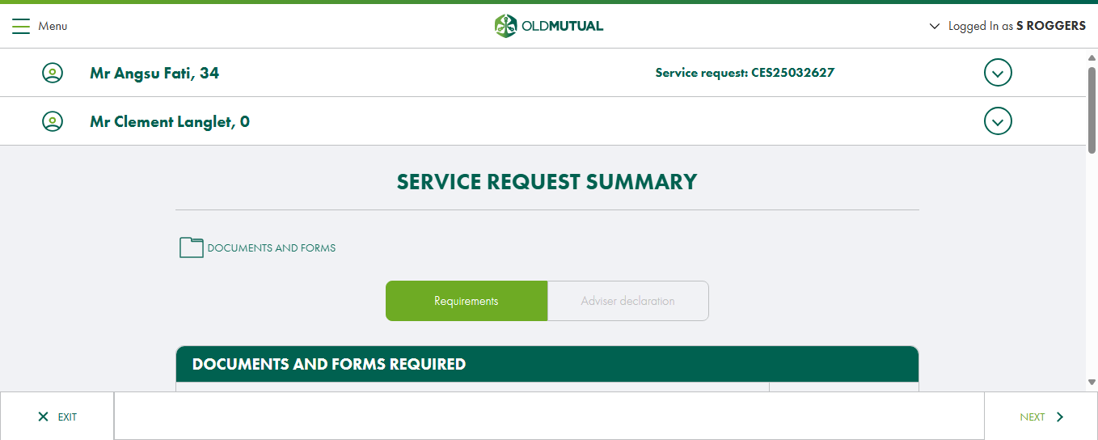
Screenshot_Navigate_SRS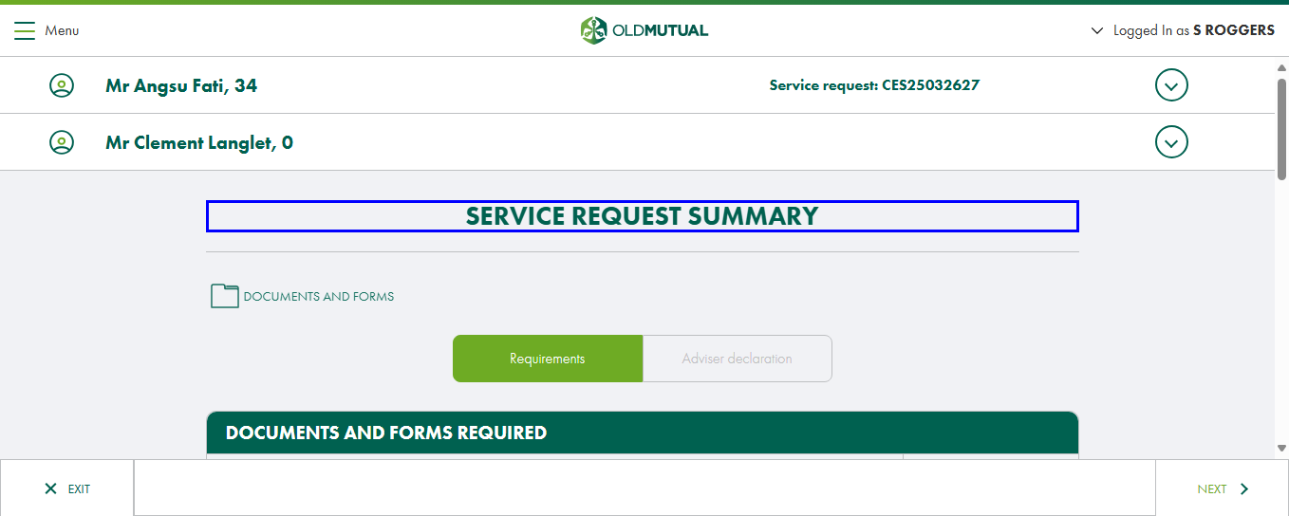
Screenshot_Click_Next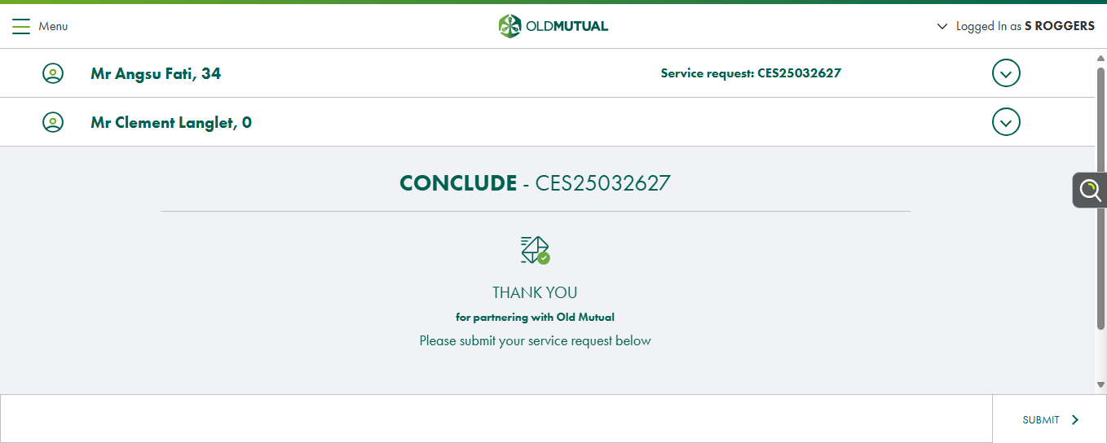
Screenshot_Navigate_Conclude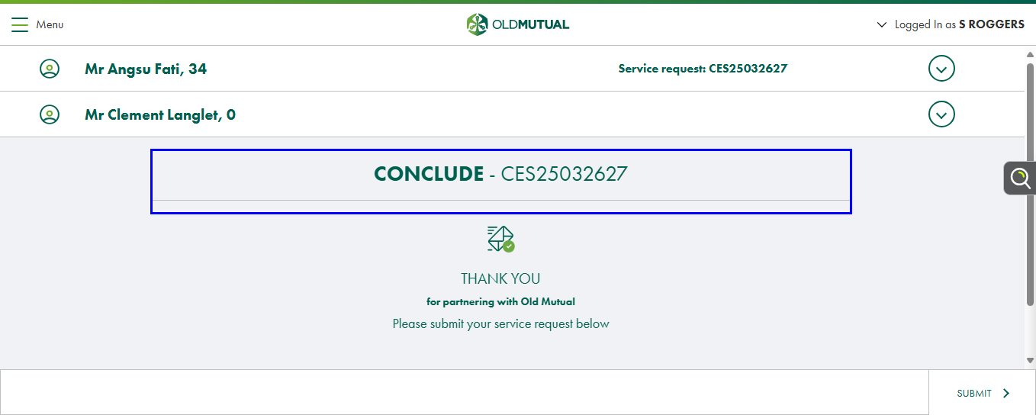
Screenshot_Click_Submit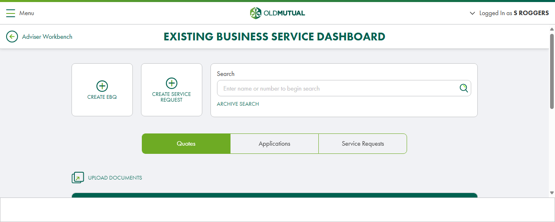
Screenshot_Navigate_ServiceDashboard