- In the logistic regression output, you found out that two variables’ P-value is 0. How do you know which variable is more significant to the target variable?
  - Look at the coefficients of the two variables in the logistic regression output. A larger absolute value of the coefficient indicates a stronger relationship with the target variable. Since when you exponentiate it, it will give a larger odds ratio. The odds ratio indicates how the odds of the target variable change with a one-unit increase in the explanatory variable.
  - Check the standard errors associated with the coefficients. A smaller standard error implies a more precise estimate of the coefficient
  - Check for multicollinearity between the two variables. If they are highly correlated, it may distort the significance of each variable. Calculate the VIF for each variable; a high VIF (>10) suggests multicollinearity issues.
  - Fit the model with each variable only. Check Residual Deviance to see the fitness of the model. A better fit when including a variable suggests it has more significance.

- In linear regression model, how do you check among variables collinearity problem?

Two methods, one is using correlation matrix, which is generating the table and find the pairwise correlation coefficient between all variables. We can evaluate the correlation coefficient r to determine whether there is a linear relationship between the two independent variables. r is a number between -1 and 1 (-1 ≤ r ≤ 1), if r is close to -1, then we say there is a negative correlation between the variables. If r is close to 0, then we say 2 variables are not correlated, if r is close to 1, we say there’s a positive linear relationship between the two. Usually we say if the absolute value of correlation coefficient is greater than 0.7, then there’s a sign of collinearity.

We can also use VIF (variance inflation factor) to address multi-collinearity problem. VIF = 1/(1-R^2), when r^2 is close to 1 and VIF is large. The higher the value of VIF the higher correlation between this variable and the rest. Usually we say VIF > 10 is a sign of multicollinearity.

- Assumptions of Linear Regression:
Y=XB + e where e~MVN(o, sigma^2)
- e~N(0,sigma^2)
- Mean of error is 0
- Var of error is constant
- Error terms are IID

How do you explain logistic regression to an executive?

It's a classification algorithm that is used where the target variable is of categorical nature. The main objective behind Logistic Regression is to determine the relationship between features and the probability of a particular outcome. For example, we wish to predict whether a student passes or fails in an exam given the number of hours spent studying as a feature, the target variable comprises two values pass/fail.

Describe high bias VS high variance in a model?

High bias model usually has low variance which mean the model does not fit the original data very well, but may have a better prediction power than the one with high variance and low bias. The high variance model usually has low bias which mean the model fit the original dataset very well. However, it will have a poor prediction power since there’s a high variance. This is usually associated with variance-bias trade off. The best model is that the one with low bias and low variance which is usually hard to find in real world modelling, so we might need to consider a tradeoff. Either sacrifice bias or sacrifice prediction power depend on your emphasis.
Also, usually, a low bias model is very complex and might cause overfitting. Low variance model tends to be simpler. Increase the complexity of the model which is adding more number of predictors will cause the model have lower bias and higher variance.

Bias = average of estimated value – true value
Variance = variability of estimated values under different training sample

What is Monte Carlo Simulation?
Monte Carlo Simulation is a computational algorithm that uses repeated random sampling like simulating a process thousands or millions of time to estimate the distribution of possible outcome values and mimic the operations of complex systems. The accuracy of the simulation results depends on the quality of the input data and the number of simulations run. More runs typically lead to more accurate outcomes but require more computational power and time.
For example, we can simulate many possible future paths for the stock price, considering the various factors, like volatility and interest rates. Each simulation will give us a different potential future stock price at a future date. After the simulations, we can take average of the price as the expected price or see the distribution of the prices.

What are Lasso Regression and Ridge Regression?

Both Lasso and Ridge regression are a type of linear regression that includes a regularization term and penalty in the loss function in order to handle multicollinearity and prevent overfitting.
When 𝜆=0: Ridge regression reduces to standard linear regression.
When 𝜆 is large: The penalty on the size of coefficients is large, forcing coefficients to shrink towards zero (only completely zero if it is Lasso regression).
A larger 𝜆 will bias the model more but may reduce variance, leading to better generalization on unseen data.

- Ridge
  - L2 norm
  - Lower weights for variables correlated with other variables in the model
- Lasso
  - L1 norm
  - Can perform variable selection since it can reduce coefficients to zero, so eliminate some variables.
  - Zero weights for variable with low explanatory power
- Lars
  - Opposite to Lasso and Ridge, start by zero weighting all variables and adding variables with most explanatory power

Time Series Model?
Used SKlearn and Scipy

  - SARIMA Model：
    - ACF plot has trend or slow decay: regular difference (d=1)
    - ACF plot has seasonal behavior: seasonal difference (D=1)
    - p: look at PACF cuts off after lag p
    - q: look at ACF cuts off after lag q
    - P: look at PACF cuts off after seasonal lag P
    - Q: look at ACF cuts off after seasonal lag Q
    - Python: pmdarima package auto_arima() to select reasonable p,q,d,P,Q,D
    - Assumptions:
      - time series is stationary, both in terms of trend and seasonality. If not stationary, do differencing first. Stationary means Mean, Variance and autocorrelation are constant over time
      - residuals are iid Normal with mean 0
      - Linear relationship between response variable and predictors
    - Ljung-Box and Jarque-Bera tests
      - Ljung-Box: determine whether there are significant autocorrelations in a time series.
        - H0: a series of residuals (or the time series itself) is independently distributed, meaning there is no autocorrelation at any lag.
      - Jarque-Bera: check whether a dataset or model residuals follow a normal distribution.
        - H0: residuals follow Normal

AB Test
In statistics, A/B testing involves splitting a sample into two groups to compare two versions of a variable. Group A (the control group) receives the original version, while Group B (the treatment group) gets the new version. Statistical tests, such as t-tests or chi-square tests, are then used to analyze the results and determine if there is a significant difference between the two groups.

Machine learning

import numpy as np
import pandas as pd
from sklearn.model_selection import train_test_split
from sklearn.linear_model import LinearRegression
from sklearn.metrics import mean_squared_error, r2_score

- Machine Learning
Supervised learning is a type of machine learning where the model is trained on a labeled dataset, meaning that the input data is paired with the correct output. The model learns to map inputs to outputs based on the provided labels.
- Linear Regression
  - Lasso
  - Ridge
  - Lars
- Logistic Regression
- Decision Trees
- Neural Networks
  - Black box
- Support Vector Machines (SVM)
  - The SVM algorithm identifies the hyperplane that best separates the classes in the training dataset. This hyperplane is chosen to maximize the margin between the two classes.
Unsupervised learning is a type of machine learning where the model is trained on data that does not have labeled outputs. The model tries to learn the underlying structure or patterns in the data without any explicit guidance.
- K-means Clustering
  - Suppose you have a dataset of customer purchase behaviors and want to segment them into three distinct groups (K=3). By applying K-means clustering, you can identify these groups based on similarities in their purchasing patterns

- Principal Component Analysis (PCA)
  - Reduce the number of variables by extracting common factors
  - Find the explanatory variable with the largest explanatory power

- t-Distributed Stochastic Neighbor Embedding (t-SNE)
  - visualizing high-dimensional data in lower dimensions (typically 2D or 3D).

numpy ( Math functions, log, exp… )
Pandas as pd (database)
pylab as plt (plot)
scipy as si (scientific functions, normal … )
sympy as sp （symbolic mathematics）
mplfinance as mpf (matplotlib finance) plotly.graph_objects as go
plotly.express as px

Neural network:

- Input layer -> several hidden layers -> output layer
- Each connection between neurons has an associated weight, which adjusts as learning proceeds. Biases are additional parameters that help the model make better predictions.
- Hidden layers are calculated by weighted the inputs and whether they pass certain bias (threshold) (return 0 or 1) and pass to the next layer.
- It can learn a non-linear function approximator for either classification or regression
- Back propagation:
  - When notice that the output is wrong, the program will go back to adjust the weights or change the values passed from the previous layer and try to make it give correct results.
- The cost of this process can be monitored by gradient descent (find the way with lowest cost)
- # of neurons should not be very close to the # of samples cause overfitting (means network fits too well on the training set, and maybe cause further bias for the test set)
- Noise-data such as outliers can cause fitting problem as well.
  - To evaluate different accepted margins of error for the samples, a coefficient “alpha” is defined in the model

- from sklearn.neural_network import MLPClassifier
  - To create the network will use the function MLPClassifier

# Creation of a NN with 2 in hidden layer
net = MLPClassifier(solver = 'lbfgs',activation ='tanh' ,hidden_layer_sizes=2,random_state= 1);

  - the function fit to train the network

# Training the net
net.fit(X,Y)

- from sklearn.model_selection import train_test_split
- import sklearn.model_selection
- from sklearn.metrics import accuracy_score
- from sklearn.metrics import classification_report

Autoencoder:
- is a type of deep learning network that is trained to replicate its input data
- two networks: an encoder and a decoder
  - encoder learns a set of features, known as a latent representation
  - decoder is trained to reconstruct the data based on these features
- autoencoder can then be applied to predict inputs not previously seen
- can be used on different data types, including images, time series, and text
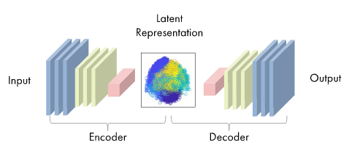
- Change the bottleneck_size larger will make the image clearer and less fuzzy

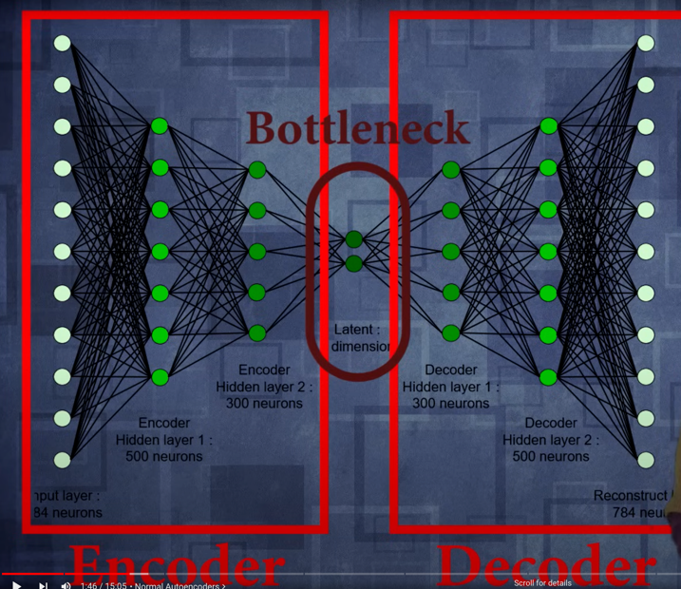

t-SNE:
- Transform higher dimension graph to lower dimension
- Calculate the similarity score for points and adjust them to make the clusters

Training, Validation, Testing:
- Training Data: Train the model (Non-fraud only)
- Validation: Tune the model (Non-fraud only)
- Test: Check performance (Both)

SVM:
- Support vector machine
- Get a hyperplane to separate the two categories (one group on one side of the plane)
- Supervised algorithm (from sklearn)
- One class SVM
  - Unsupervised
  - Outlier detection
  - Learns the boundary of normal points and the data outside marked as outliers
  - From Sklearn.svm import OneClassSVM

