
XCNAV EDITION
User Manual
Rev. 1.1 · 10.12.22
Android navigation computer for use in the cockpit
www.xcnav.de

Table of Contents
1. General Information 3
2. Home Screen 5
3. Apps 7
4. Settings 8
5. Connectors 8
6. Connecting Peripheral Devices 10
7. Configuration in XCSoar 13
8. Configuration in LK8000 13
9. Mounting and Electrical Connection 14
10. Technical Data 15
11. Warranty Terms 15
12. Certification 16
13. Limitation of Liability and CE Conformity 16
A. Appendix: Wiring Examples 17

1. General Information
The XCNAV Edition is a multifunction tool designed specifically for use in an aircraft. Thanks to its comprehensive connectivity, serial interfaces, touchscreen and the Android 11 operating system, the range of possibilities is virtually unlimited — beyond its main role as a NAV display for XCSoar, LK8000, SeeYou Naviter, SkyDemon, etc. Split-screen views even allow two apps to run in parallel. This makes the XCNAV Edition not only a great fit for gliders, but also a genuine alternative to established systems in the microlight sector.
Our high-quality, vibration-resistant display with BlanView technology cannot be compared to a conventional transmissive display. While conventional technology consumes a lot of power — and thus generates heat — to shine against sunlight, BlanView technology uses the incident sunlight itself to enhance readability and contrast. As a result, the XCNAV Edition achieves roughly 40–70% power savings compared with other systems on the market. Because virtually no heat is generated even at full brightness, an additional cooling fan can be dispensed with entirely.

1.1 Controls / Operation
1.1.1 Power On/Off
Since most instruments in the aircraft are already protected by a separate switch or circuit breaker, the XCNAV Edition has no additional on/off switch. As soon as supply voltage is applied, the XCNAV Edition starts up.
The XCNAV Edition can be shut down or restarted via the software button in the footer bar. This does not affect the power supply to instruments connected via S1 and S2. As long as voltage is present at the input, connected peripheral devices continue to be powered regardless of the XCNAV Edition's operating state. This allows an in-flight restart without interrupting, for example, the IGC recording of a connected FLARM.
1.1.2 Hardware Buttons
The XCNAV Edition features a 5-point touchscreen. Operation uses the same touch gestures familiar from smartphones — simple and intuitive. Even so, in certain situations it is helpful to access specific functions directly. For this purpose, the XCNAV Edition has 4 hardware buttons.
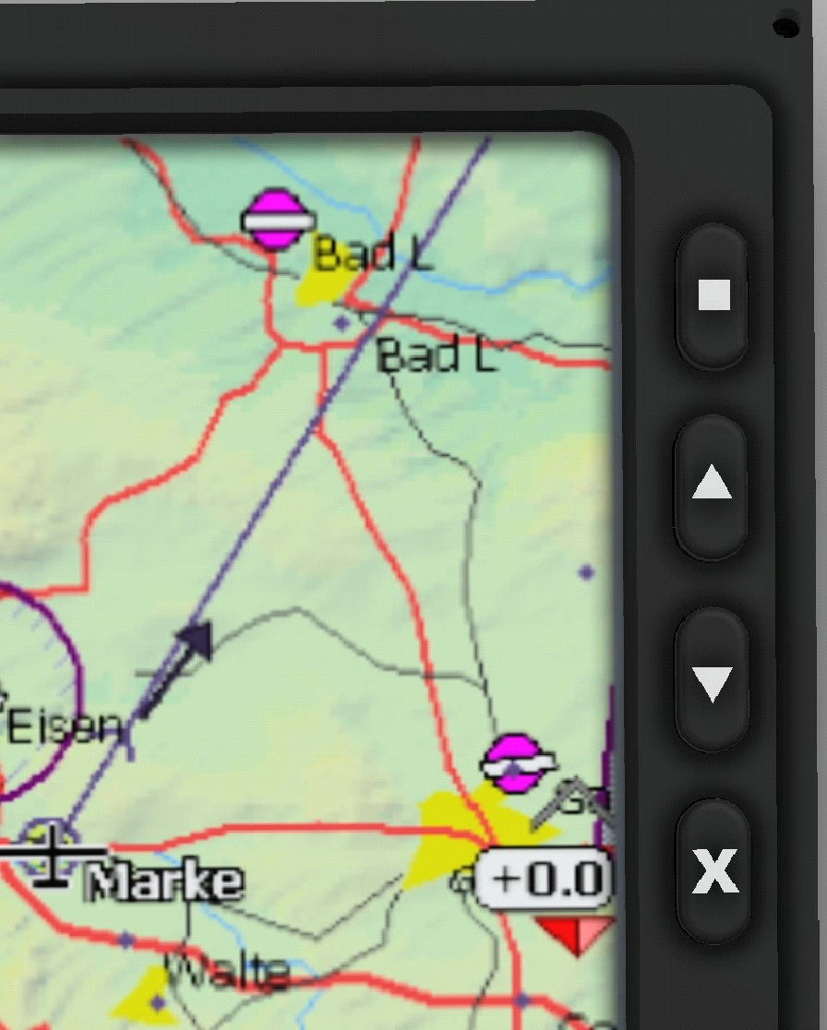
Fig. 1: Hardware buttons on the XCNAV Edition
Button | Function
■ (top) | Short: ENTER · Long: QUICKMENU in XCSoar
▲ / ▼ (arrow keys) | 1× short: up/down arrow (ZOOM in XCSoar and LK8000)  2× short: Volume +/-  Long: Screen brightness +/-
X | 1× short: ESC  2× short: Reset keypad controller  Long: XCSoar exit menu in XCSoar

1.2 Opening Settings
There are 2 ways to open the Android settings:
- Open Settings from the app overview: swipe from the bottom to the top of the home screen and select "Settings".
- Swipe down twice from the top edge of the screen. A gear icon now appears on the expanded Quick Access panel — tap it to open the settings.

1.3 Adjusting Screen Brightness
- Press and hold the hardware arrow keys (see 1.1.2) to bring up the brightness slider. The hardware buttons adjust brightness in 10 steps (one press & hold each) from 0 to 100%. Use the on-screen slider for finer adjustment.
- Swiping down twice from the top edge of the screen opens the expanded Quick Access menu, which also includes a brightness slider.

2. Home Screen
The home screen appears after the XCNAV Edition powers on. It can be individually customised and configured.

2.1 Navigation Bar
In addition to swipe gestures, the navigation bar is used to navigate the Android user interface. Its behaviour can be configured under "Settings" → "Display". These functions apply across all apps.
Important
While XCSoar or LK8000 is running, the navigation bar is hidden! Swiping up from the very bottom edge of the screen brings it back.
Icon | Function
Chevron down | Hide the navigation bar
Back arrow | Goes back one step/level (e.g. in menus)
Circle (Home) | Returns to the Android home screen
Square (App switcher) | Opens an overview of all open apps
Camera icon | Takes a screenshot. Can be shown/hidden under Settings → Screenshot
Speaker icon | Volume control
Power icon | Shuts down / restarts the XCNAV Edition

2.2 Status Bar and "Quick Access" Menu
The status bar is located at the top of the screen. It shows the time as well as the connection status of WiFi, LTE and BT, plus further app notifications.
Swiping down from the status bar opens the Quick Access panel. Here, functions such as WiFi and BT can be switched on and off — fields highlighted in green mark active services. Swiping down again expands the panel further; this is also where screen brightness can be adjusted. Tapping the gear icon opens the settings menu.

2.3 Changing the Wallpaper
Two XCNAV wallpapers are pre-installed on delivery, but you can also transfer your own images to the device to use as wallpaper (size 800 × 480 px). To choose a wallpaper: touch and hold any free area of the home screen → "Wallpapers" → "System Wallpapers" → select the desired image and confirm it as the home screen in the preview. A lock screen is not used in the XCNAV configuration.

2.4 Moving an App to the Home Screen
Swipe from the bottom to the top of the home screen to open the app overview. Press and hold an app icon to return to the home screen with a selection menu "Cancel" / "Uninstall". The app can now be placed on the home screen via drag-and-drop.
Apps placed in the bottom row are pinned as "Favourites" and remain there even when scrolling between different pages.

2.5 Widgets
Touch and hold any free area of the home screen, then select "Widgets". Widgets are small desktop programs — for example, a clock can be added to the home screen this way.

3. Apps
As delivered, only XCSoar or LK8000 (depending on the configuration ordered) is pinned to the footer of the home screen. Swiping from the bottom to the top of the screen opens the app overview, which lists all apps installed on the device.

3.1 Installing an App
Android offers 2 ways to install apps on the device:
- Google Play Store: this requires a Google account. The Play Store comes pre-installed on the XCNAV Edition. Apps can simply be selected and installed via the "Install" button.
- Installation via an APK (Android Package): an .apk file is an installation file for Android apps, offered for example by providers via websites such as GitHub, or by alternative app stores such as www.ApkPure.com. These apps often do not meet Google Play's strict — sometimes excessive — security requirements. Caution is always advised when installing an app via an APK; only install it if you are certain of the source. To do this, tap the downloaded .apk file in the "Download" folder and confirm the installation request.

3.2 Uninstalling / Deleting an App
Press and hold an app icon and drag it onto "Uninstall" in the menu that appears. In the pop-up dialog, confirm the deletion. Any app data can be kept by ticking the corresponding checkbox.

3.3 Auto-Starting an App After Boot
Android allows apps or services to start automatically after booting — useful when mainly one app is used for flying. As a default, we set the desired app to auto-boot at the factory.
To let an app start automatically: Settings → Apps/Notifications → See all apps → select the desired app, tap and hold it. Selecting "OK" in the menu that opens makes the app start automatically the next time the device boots. The auto-boot function can be disabled again via the three-dot menu in the top right corner by selecting "Clear boot application".

4. Settings
This manual primarily covers the settings relevant to operating the XCNAV Edition together with XCSoar and LK8000, and shows the default settings. A complete introduction to the Android system and its capabilities would not be productive here. More in-depth information can be found at www.android.com.

5. Connectors
The XCNAV Edition offers a range of external connectors that allow easy integration into an existing cockpit environment. The connectors most important for operation are located on the rear panel to enable a space-saving installation. Additional options are available on the side panel and can be used where space allows.

5.1 Rear-Panel Connectors
All connectors are individually protected by a self-resetting polyfuse rated at 500 mA.
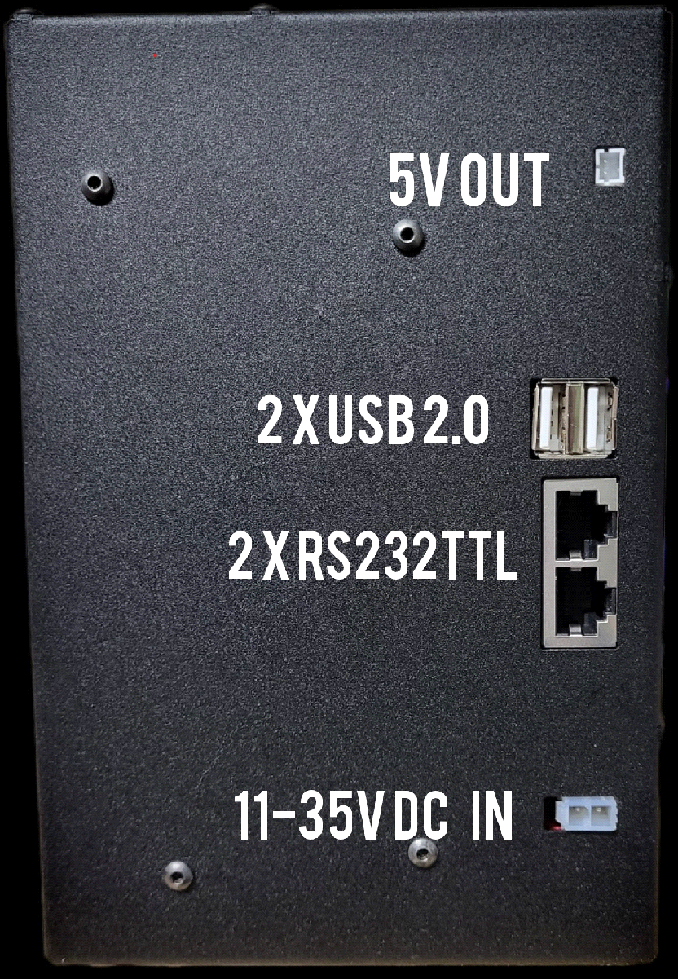
Fig. 2: Connectors on the rear of the XCNAV Edition
5.1.1 5V OUT
Connector for peripheral devices such as XCRemote or USB chargers. Note the polarity! Protected by an internal 0.5 A auto-fuse.
5.1.2 USB 2.0
2× USB 2.0, e.g. for the XCNAV GPS mouse, XCRemote, etc.
5.1.3 Connector S1
S1 is an RS232TTL-level connector for connecting varios, FLARM, loggers, etc., also protected up to 0.5 A. IGC-standard pinout:
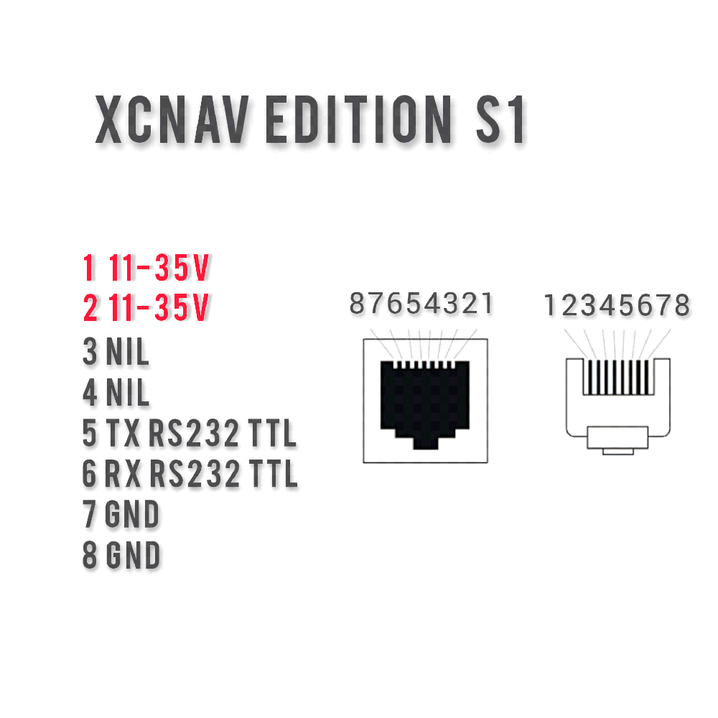
Fig. 3: S1 connector pinout
Pins 1 and 2 allow connected peripheral devices to be powered via the XCNAV Edition. Note that the connectors are rated and protected for a maximum of 0.5 A. A FLARM or an XCVario up to series '21 can therefore easily be connected with a 1:1 patch cable and will be powered and protected accordingly. If galvanic isolation with additional protection is required, a custom cable must be made up.
Caution
Since the XCVario from series '22 onward carries the CANBUS-High signal on pin 2, connecting it with a 1:1 cable could potentially damage the XCVario's CAN bus. The proprietary S2 interface is provided for this purpose. If an XCVario '22 or later must still be connected to XCNAV S1, the connecting cable must be modified.
In theory, the XCNAV Edition can also be powered via S1 and S2. Here too, the maximum rating of 0.5 A must be observed — with the device's own consumption of approximately 270 mA, this limit is quickly reached once several interfaces are active at the same time.
Caution
Pins 1 & 2 are directly connected to V IN, meaning they pass the input voltage through unregulated! When operating the XCNAV Edition on any electrical system other than 12 V, make sure that devices connected via S1 and S2 are rated for the corresponding voltage!
5.1.4 Connector S2
Connector S2 is identical to S1 except for the assignment of pin 2. On S2, pin 2 is unused, which ensures that an XCVario can simply be connected using a 1:1 patch cable.
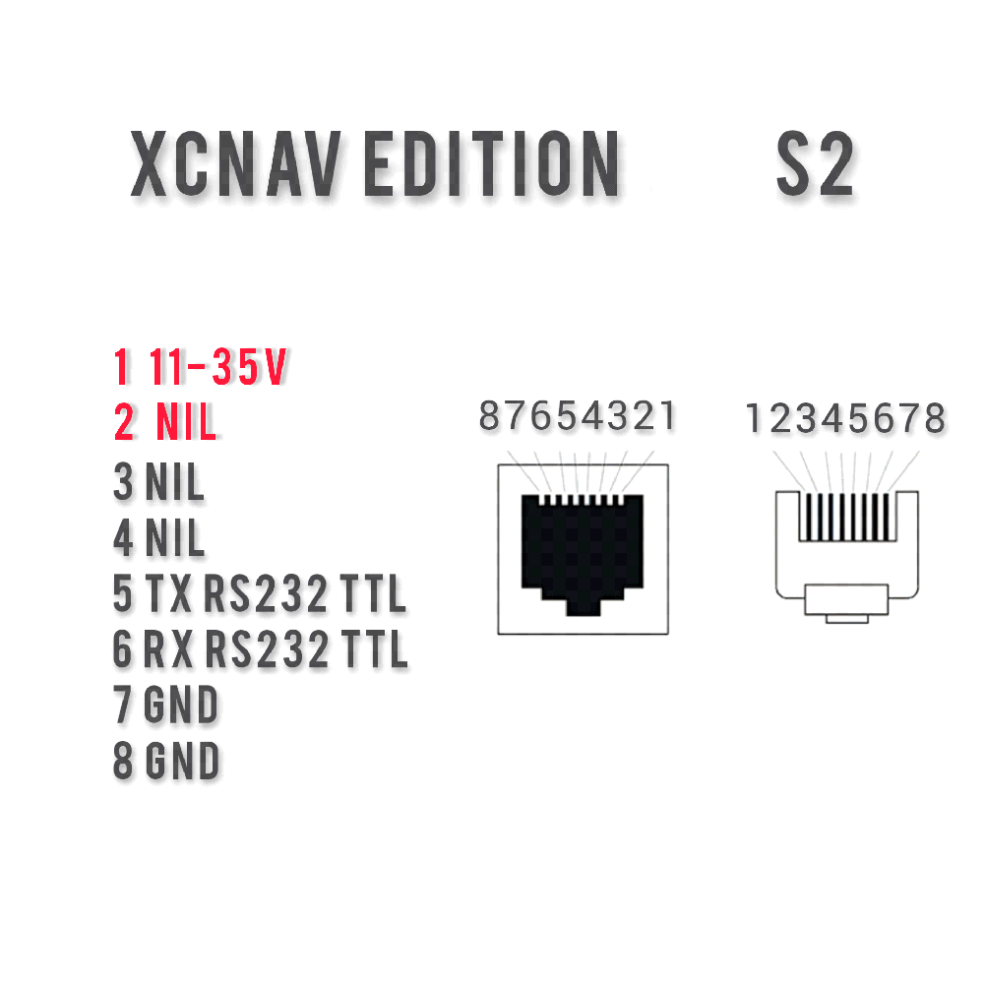
Fig. 4: S2 connector pinout
5.1.5 V In (11–35 V)
The XCNAV Edition operates reliably with a supply voltage of 11–35 V, allowing it to be used without issue in aircraft with a 24V electrical system. Note that the applied voltage is passed directly, i.e. unregulated, to S1 and S2!
The input is protected by a 3 A auto-fuse. Nonetheless, we recommend additional protection via a fuse or switch so that the XCNAV Edition can be isolated separately from the power circuit in the event of a malfunction.

5.2 Side-Panel Connectors
In addition to the essential connectors on the rear panel, the XCNAV Edition offers further connectors on the side panel that can be used where space and requirements allow.
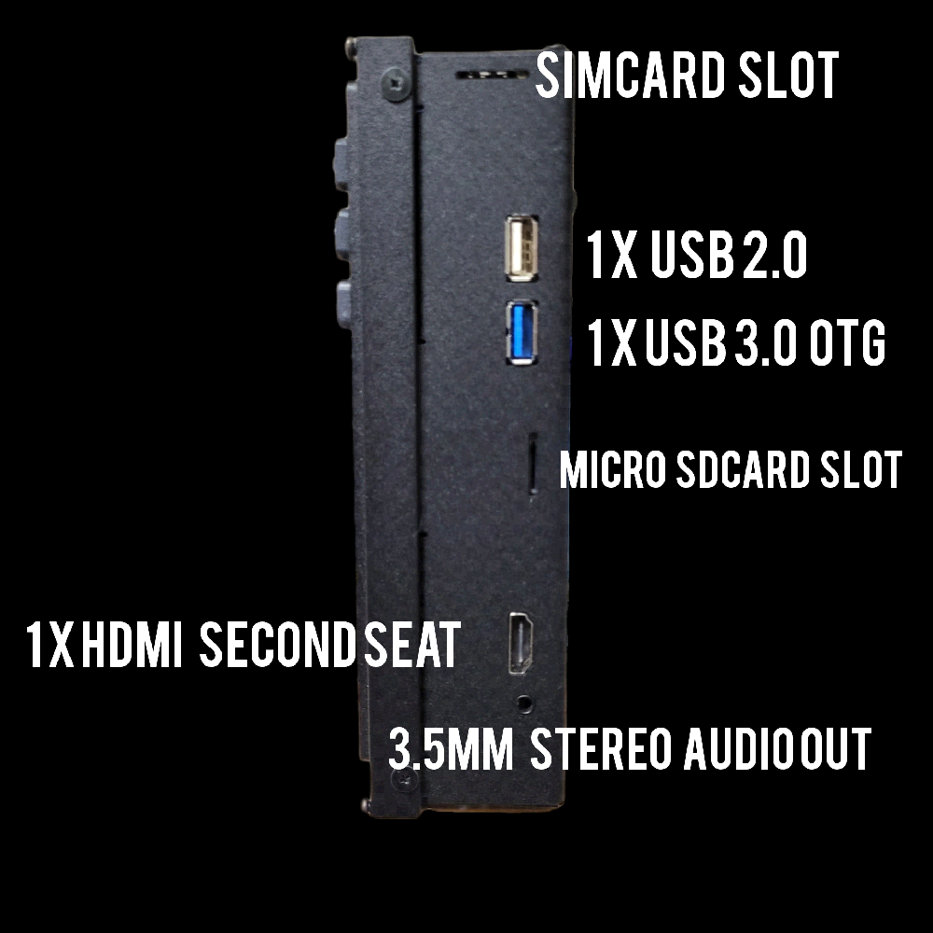
Fig. 5: Connectors on the side panel
5.2.1 SIM Card Slot
With its Edition, XCNAV reflects the trend of modern aviation navigation apps towards connectivity, featuring an integrated LTE modem. A MicroSIM is required for operation.
Since only small amounts of data are usually needed, we recommend using a prepaid SIM card, so you only pay for the period during which the card is actually used. Congstar, for example, offers 500 MB for €3 per month and 1 GB for €5, which proved sufficient in our tests.
Note
The online function is primarily intended for ground use during flight preparation and post-flight review. Use in flight can affect radio communication, like any mobile phone, depending on the installation position. We recommend enabling flight mode during flight.
5.2.2 USB Connectors
Two further USB connectors are located here: 1× USB 2.0 and 1× USB 3.0 (marked blue). All USB connectors are configured as USB host. USB 3.0 can transfer data at up to 4.8 GBit/s — ten times faster than USB 2.0 (max. 480 MBit/s) — and also operates in full duplex, meaning data can be transferred in both directions simultaneously. Maximum current has also been raised from 500 mA (USB 2.0) to 900 mA (USB 3.0), though maximum cable length for USB 3.0 is limited to 3 m (USB 2.0: up to 5 m). USB 3.0 is fully backward compatible with USB 2.0.
5.2.3 SD Card Slot
The XCNAV Edition supports microSD cards up to 128 GB. To insert or remove the card, press it against the spring mechanism to lock/unlock it.
5.2.4 HDMI Connector (2nd Seat)
Used to connect the video and audio signal of the future XCNAV 2nd Seat display.
5.2.5 Audio Out
3-watt stereo audio-out jack for a 3.5 mm headphone plug, for connecting an external speaker.

6. Connecting Peripheral Devices
Connecting the XCNAV Edition is straightforward: in principle, a physical connection to the aircraft's electrical system at up to 35 V is all that is required. Thanks to Bluetooth support, operation without any additional cable connection is also possible — up to 5 BT/BLE devices can be operated in parallel with the XCNAV Edition (e.g. PowerFLARM + XCRemote + XCVario + KRT2 via BT).
Thanks to the IGC-standard serial interface, non-Bluetooth devices can be connected via an RJ45 network cable; depending on the instrument, a modified cable may be required.
Note
The functions supported for connected peripheral devices depend primarily on the device drivers available in the app being used, not on how the XCNAV Edition itself works. For a properly functioning serial connection, make sure the same baud rate is set both in the app's configuration and on the peripheral device.

6.1 Connecting the XCVario
With the XCVario, a distinction must be made between the XCVario 20/21 versions and the '22 version. From XCVario 22 onward, pin 2 of S2 carries a CANBUS signal — for this reason, pin 2 on the XCNAV S2 interface is not assigned 12V, ensuring a direct connection with a 1:1 network cable. If an XCVario '22 must still be connected to XCNAV S1, the wire for pin 2 must be disconnected, or the optionally available splitter must be used, to avoid damaging the XCVario's CAN bus.
Connecting a standard cable to S1 or S2 automatically powers the XCVario via pin 1 (V IN) and pin 8 (GND) — protected by a self-resetting 0.5 A fuse. If galvanic isolation between XCNAV and XCVario is desired, the wire on pin 1/2 must be disconnected and the XCVario powered and protected separately via its supplied cable.
On the XCVario, "TWISTED" must be selected under Settings → System → S1/S2 → Twist RX/TX Pins.
Of course, the XCVario can also be connected to the XCNAV Edition via Bluetooth or WiFi. If a FLARM is connected via the XCVario, it is recommended (unless the XCVario's BT router function is being used for a second device) to establish an additional BT connection between the XCVario and XCNAV Edition, and to install this in the XCSoar settings as FLARM. This ensures declaration and FLARM download without any change to the XCSoar/LK8000 configuration.
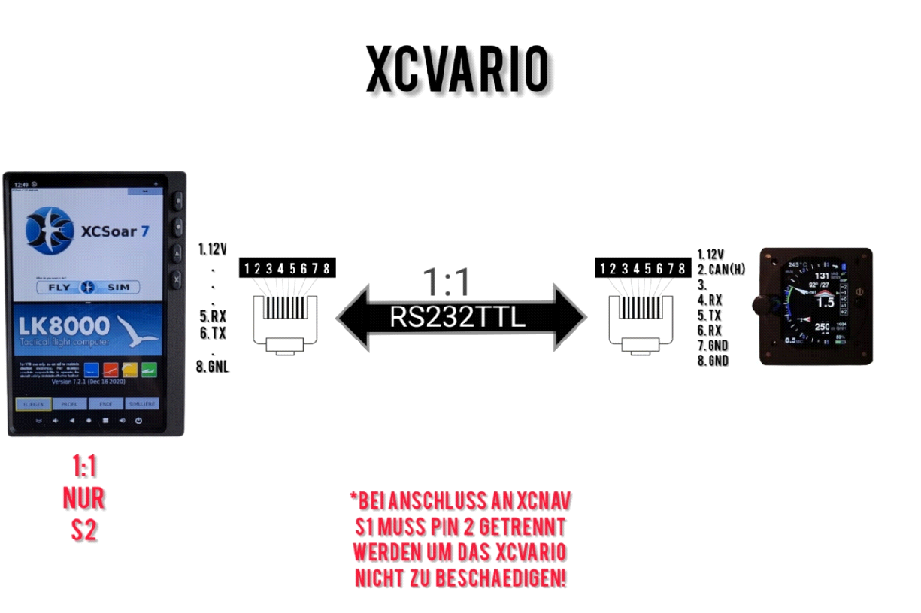
Fig. 6: Connecting the XCVario (1:1 RS232TTL)
How do I tell the series apart?
On version 22, the line "Bat Meter/CAN: OK/OK" is shown in the boot menu; this is not the case on version '21.

6.2 Connecting a FLARM
A FLARM with IGC-standard pinout can simply be connected with a 1:1 cable to either S1 or S2; the FLARM is then automatically powered. When using an XCVario, connecting via S1 to the XCVario with the supplied cable is recommended — FLARM data is then forwarded to the XCNAV Edition via the XCVario. Modern FLARM devices also provide data over Bluetooth.
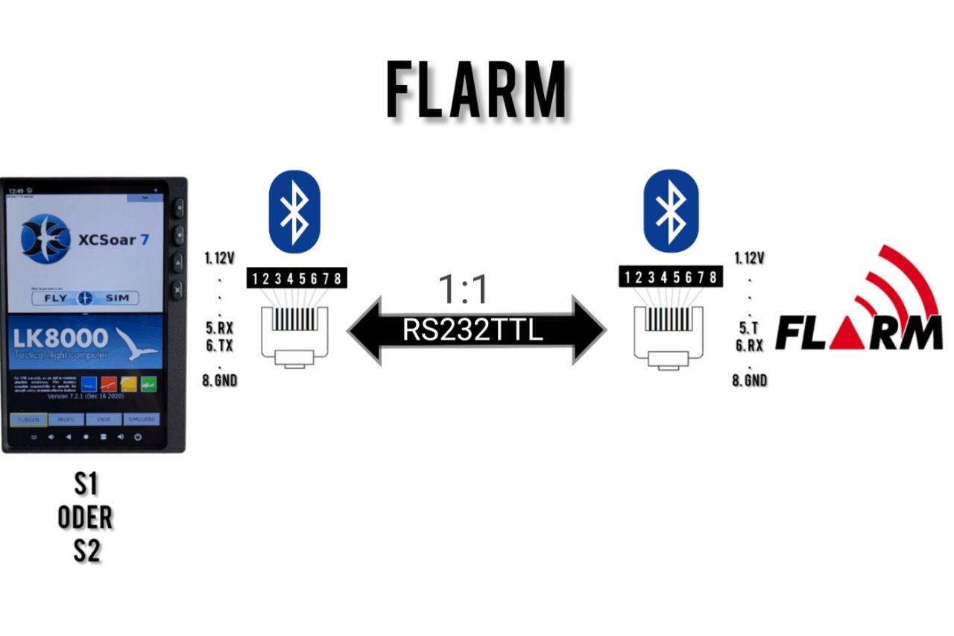
Fig. 7: Connecting a FLARM

6.3 Connecting an LX S8X/S10X
Connecting an LX vario requires a fully modified cable: the XCNAV RX pin must be connected to LX TX, and XCNAV TX to LX RX and GND. A Bluetooth connection is possible here as well.
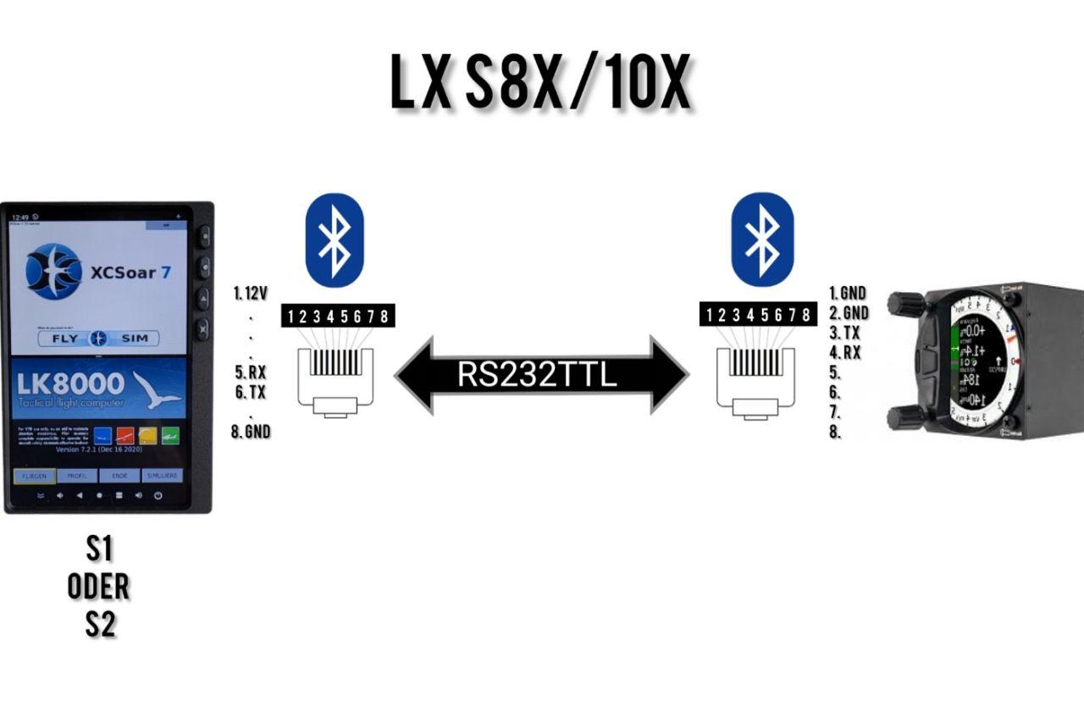
Fig. 8: Connecting an LX S8X/S10X

6.4 Connecting an LX EOS 57/80
The LX EOS also requires a modified cable. With the appropriate cable, it can be connected to either S1 or S2. The LX EOS also offers the option of a BT connection.
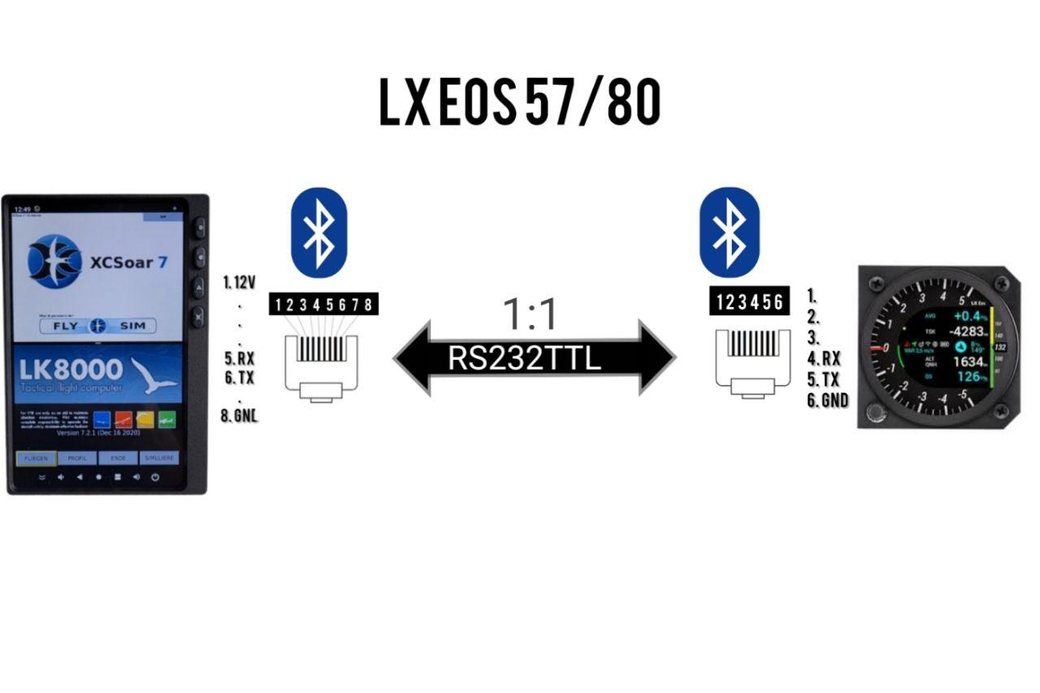
Fig. 9: Connecting an LX EOS 57/80

6.5 Connecting a KRT 2 Radio
A KRT2 can be connected to S1 or S2, allowing both the standby and active frequency to be set via XCSoar or LK8000. To do this, connect pin 8 of the XCNAV Edition (GND) to KRT2 GND (pin 1), as well as XCNAV pin 6 to pin 13, and XCNAV pin 5 (RX) to pin 2 (TX) on the KRT.
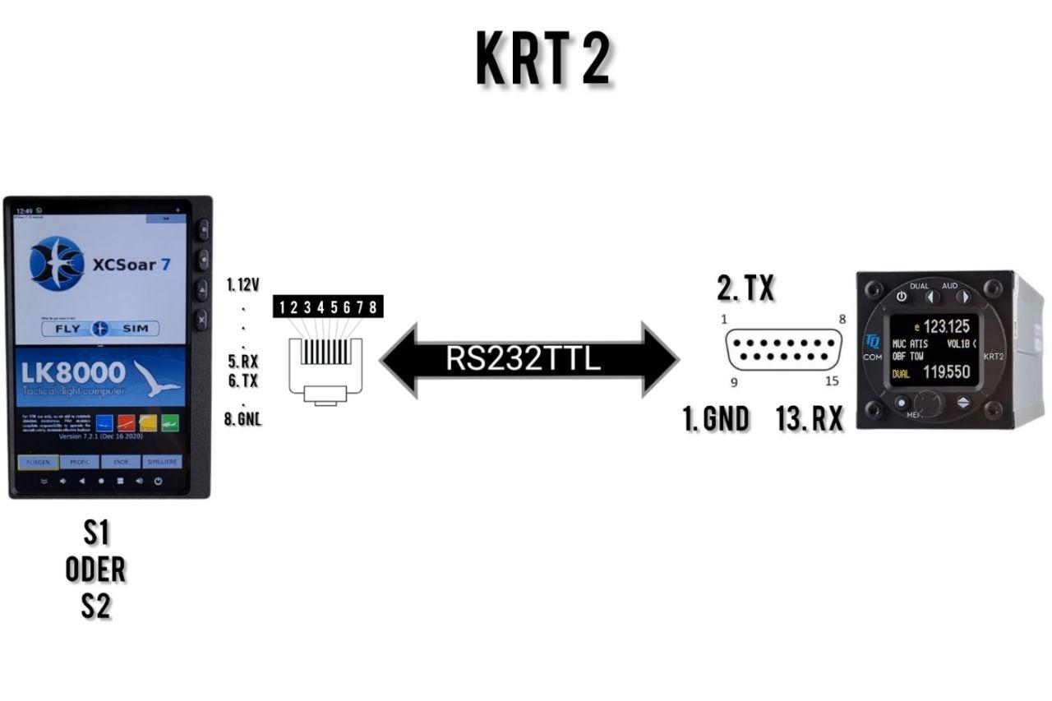
Fig. 10: Connecting a KRT 2 radio

6.6 Example Configuration: XCVario, XCRemote and KRT2
We recommend connecting the FLARM with the supplied XCVario cable to the vario at S1 (XCVario). The XCVario acts as a router here, forwarding FLARM data via cable, WiFi or Bluetooth (see the XCVario manual for configuration). The XCVario can then be connected at its remaining S2 interface with a 1:1 patch cable directly to S2 on the XCNAV Edition. For this, the RX/TX pin setting of interface S1 on the XCVario must be set to "TWISTED" under Settings → System → S1.
The XCRemote is paired via Bluetooth. The cable itself does not carry any XCRemote data — it is only used to power the BT stick controller with 5V or 3.3V. Any USB port or the 5V-OUT connector of the XCRemote can be used for this; a JST PH 2-pin connector must be crimped onto the power lead. We optionally offer this option when ordering the XCRemote.
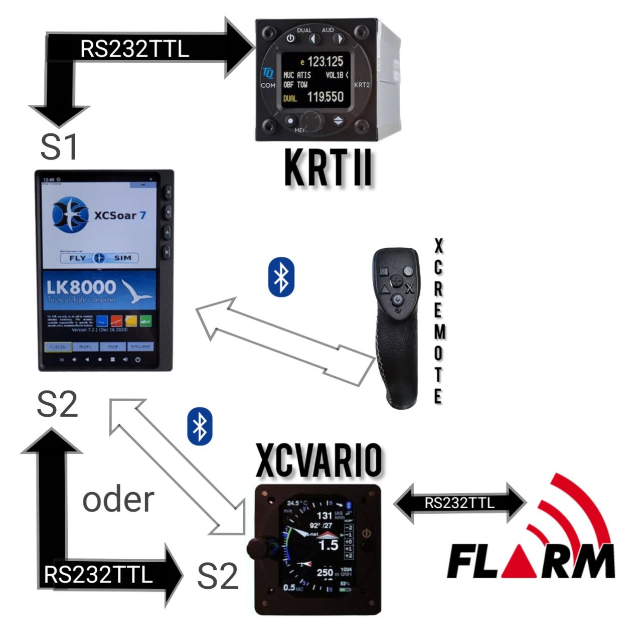
Fig. 11: Example configuration — XCVario, XCRemote and KRT2

7. Configuration in XCSoar

7.1 Connecting to S1 & S2
If a connected instrument or FLARM is to be used with XCSoar, it must be configured accordingly in the XCSoar settings. Main menu: "Config → NMEA devices".
- Select one of the 6 connector slots A–F and select "Edit". XCSoar prioritises from position A to F: if the same data arrives on 2 connectors (e.g. GPS position via FLARM on slot A and via logger on slot B), the first one in sequence is used. If the first source drops out, the backup source is used automatically.
- Under "Port", select S1 (XCNAV) or S2 (XCNAV) (see the marking on the rear of the XCNAV Edition).
- Select the driver of the connected instrument.
- Select the baud rate to match the baud rate set on the connected instrument — these must match.
- Confirm with OK.
- Under "Monitor", the incoming NMEA data stream can be viewed.
Caution – XCVario
If the S2F and XCVario control function is to be used via XCRemote (without a physical connection to the XCVario S2F cable), the XCVario must be configured on slot A or B.

7.2 Connecting via Bluetooth
First pair the desired device under "Connections" in the Android settings. Then select the Bluetooth device under "Port" and configure it as described above from step 3 onward.

8. Configuration in LK8000
To be completed in a future revision of this manual.

9. Mounting and Electrical Connection
For instrument panel layout planning, a .dxf file and an .stl file for a 3D-printed cutting template are available on our GitHub page. This template can be attached to the blank panel with double-sided tape to mark the panel cutout and mounting holes.
The XCNAV Edition is secured using the four M3×0.5 screws supplied. If using your own screws, ensure a maximum length of 9 mm for a 3 mm thick instrument panel.
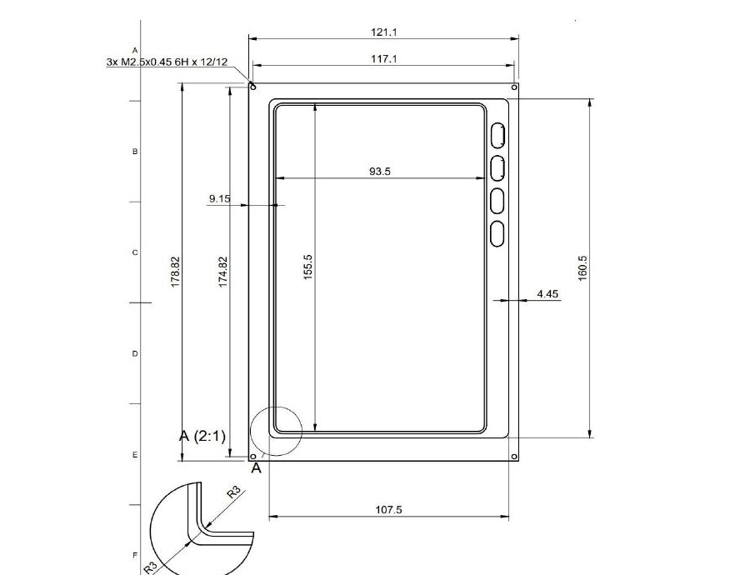
Fig. 12: Panel cutout and mounting holes (dimensions in mm)
Integrating the XCNAV Edition into the aircraft's electrical system is straightforward — use the supplied cable for this. The XCNAV Edition has an internal DC converter that allows an input voltage of up to 35 V.
Caution
The applied voltage is passed through unfiltered to pins 1 and 2 of S1 and pin 1 of S2. When connecting to an electrical system with an operating voltage higher than 12 V, make sure that peripheral devices connected to, and thereby powered via, S1 and S2 are compatible with the increased voltage.
V IN is internally protected by a self-resetting 3 A fuse. This is sufficient for safe operation. Nonetheless, we recommend using an additional circuit breaker or switch so that the device can be electrically isolated if needed. As soon as a supply voltage is present at V IN, voltage is also present at S1 and S2, regardless of the XCNAV Edition's operating state.

10. Technical Data
Feature | Specification
Overall dimensions | approx. 179 × 121 × 46.5 mm
Panel cutout dimensions | 160.5 × 108.5 mm
Screen dimensions | 156.5 × 94.5 mm
Resolution | 840 × 400 pixels
Display technology | Transflective / BlanView, highest contrast values
Viewing angle stability | 80 / 80 / 80 / 80
Display storage temperature | -40 °C to +95 °C
Display operating temperature | -30 °C to +85 °C
Internal GPS receiver | No
Internal pressure sensor | No
Operating system | Android 11
Storage | 16 GB ROM
Connectivity | WiFi · Bluetooth 4.1 · LTE modem
Power consumption | approx. 300 mAh / 12.5 V
Power supply | 11–35 volts

11. Warranty Terms
The manufacturer provides a two-year warranty from the date of purchase for the navigation system, covering the labour and material costs of repair. Within this period, components that fail under normal operating conditions will be repaired or replaced free of charge, provided the device is sent to the manufacturer free of charge.
The warranty does not cover damage caused by incorrect operation, misuse, accidents, unauthorised modifications or repairs, mechanical damage, heat exposure (e.g. due to a burning-glass effect from the canopy onto the display), inadequate maintenance, or demonstrably incorrect or faulty wiring.
Returns can be made within 14 days of the purchase date in accordance with German civil law (BGB). In this case, the device and accessories must be returned by the buyer to XCNAV UG; the cost of doing so is borne by the buyer.

12. Certification
For every instrument, the following applies: where equipment is part of the minimum equipment list or requires certification, it may only be installed if the supplier or manufacturer provides a document confirming proper verification of compliance with the relevant specification of the individual item of equipment — within EASA's scope, this is typically the EASA Form One.
For all other equipment, as well as standard parts, no corresponding verification or documentation is required (e.g. electric variometers, final glide computers, flight data recorders, navigation computers, additional antennas, batteries, cameras, additional pressure probes, bug wipers, etc.). This is governed in detail by EASA in AMC 21.A.303(c) 2:
AMC 21.A.303(c) Standard Parts
In this context a part is considered as a 'standard part' where it is designated as such by the design approval holder responsible for the product... For sailplanes and powered sailplanes, where it is a non-required instrument and/or equipment certified under the provision of CS 22.1301(b), if that instrument or equipment, when installed, functioning, functioning improperly or not functioning at all, does not in itself, or by its effect upon the sailplane and its operation, constitute a safety hazard. Examples of equipment which can be considered standard parts are electrical variometers, bank/slip indicators, total energy probes, final glide calculators, navigation computers, data loggers, bug-wipers and anti-collision systems.
Consequently, our navigation system does not require an EASA Form One and may be installed.
After installation, the aircraft's equipment list must be updated. Where the additional mass of 0.5 kg (XCNAV Edition & XCVario) or 0.35 kg (XCNAV Edition only) in the instrument panel results in a relevant shift in centre of gravity, a weighing must be carried out and the change approved. When installing an XCVario, a leak test of the pneumatic system must also be performed.

13. Limitation of Liability and CE Conformity
By purchasing the device, the customer agrees that no liability is accepted for any direct or indirect damages, claims for damages or consequential damages of any kind and on any legal basis arising from the use of the device.
The device is a purely tactical cross-country flight aid and therefore does not form part of the minimum instrumentation required for sailplanes, and must not, in case of doubt, be used as the primary source for controlling the aircraft, particularly during critical phases of flight. The certified primary instrumentation must be used for this purpose. The device therefore also does not require FAA or EASA certification.

CE Declaration of Conformity
DECLARATION OF CONFORMITY
XCVario, CEO Markus Immig, Köpkenstraße 6, 28203 Bremen, Germany, declares that, in its standard configuration, the XCNAV Edition hardware complies with the requirements of CE marking.
EMC compliance conforms to EN 301 489-3:2002-08 for a Class 3 SRD device (equipment type I).

Appendix: Wiring Examples
The following reference wiring diagrams show two typical configurations of the XCNAV Edition together with XCVario, ACD/air avionics collision-warning systems, and flap-position sensing for single-seaters.

A.1 Wiring: XCNAV – XCVario – ACD – air avionics
Connection diagram for two-seat operation with two XCVario units (master/slave), FLARM, an air avionics collision warning device, and two ACD displays. The CAN bus sensor must be connected exclusively to the master vario; the cable length between the Y-adapter splitter and the sensor should be kept as short as possible (max. 20 cm).
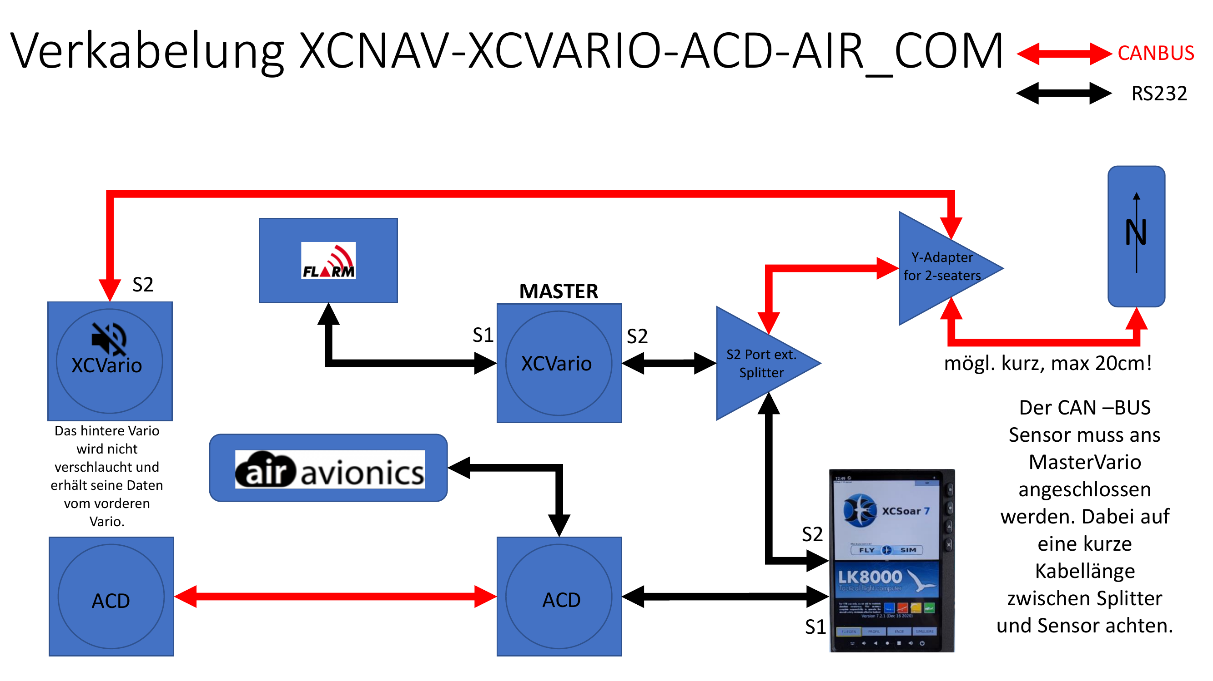
Fig. A1: Wiring XCNAV-XCVario-ACD-air avionics

A.2 Wiring: Single-Seater with Flap Sensor
Connection diagram for a wired configuration with XCVario, FLARM, CAN bus sensors (magnetic/flap) and a radio. For this configuration with a wired navigation device, the XCVario as well as the FLARM data must be routed from S1 to S2 (S1: S2-RS232 = Enable, S2: S1-RS232 = Enable). These settings are made in the S1 and S2 routing; all other ports are in principle not required, though it can be useful to leave the wireless settings on the XCVario and S1 enabled regardless, so that, if needed, a second device can still be paired wirelessly (e.g. in case of low power or a device failure on the wired unit). This also makes it possible to read out the IGC file wirelessly after the flight.
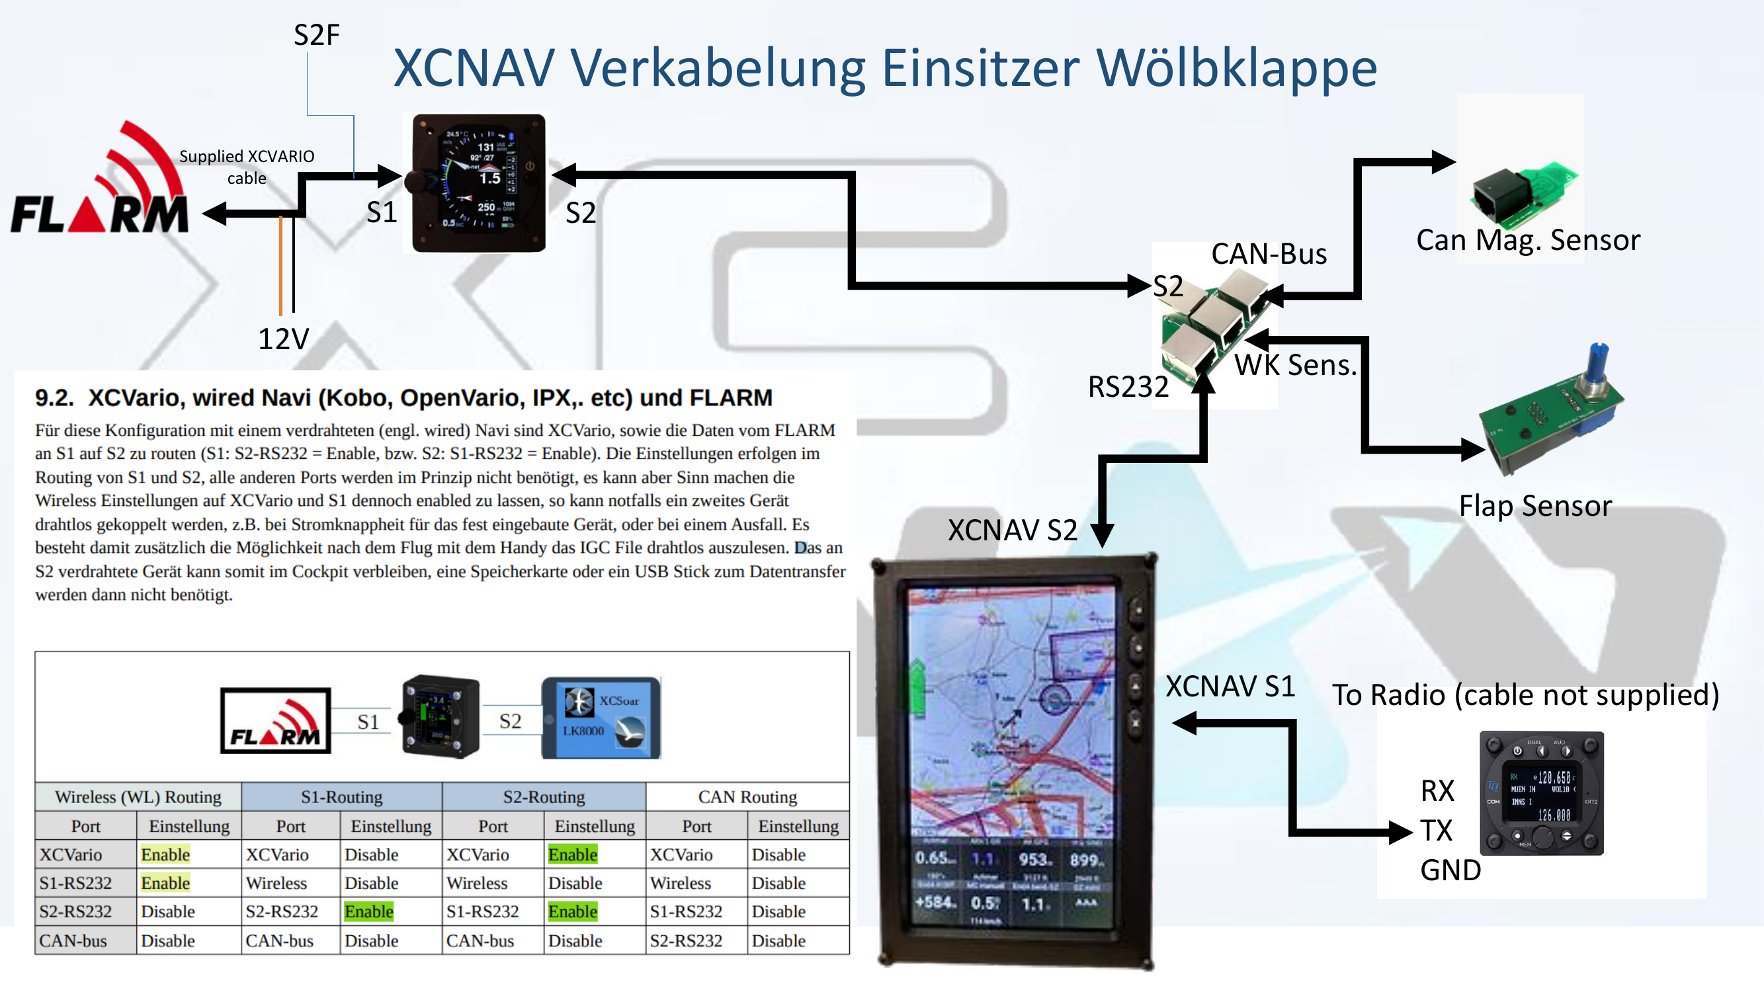
Fig. A2: XCNAV wiring — single-seater with flap sensor


www.xcnav.de
© XCNAV · XCNAV Edition User Manual Rev. 1.1

