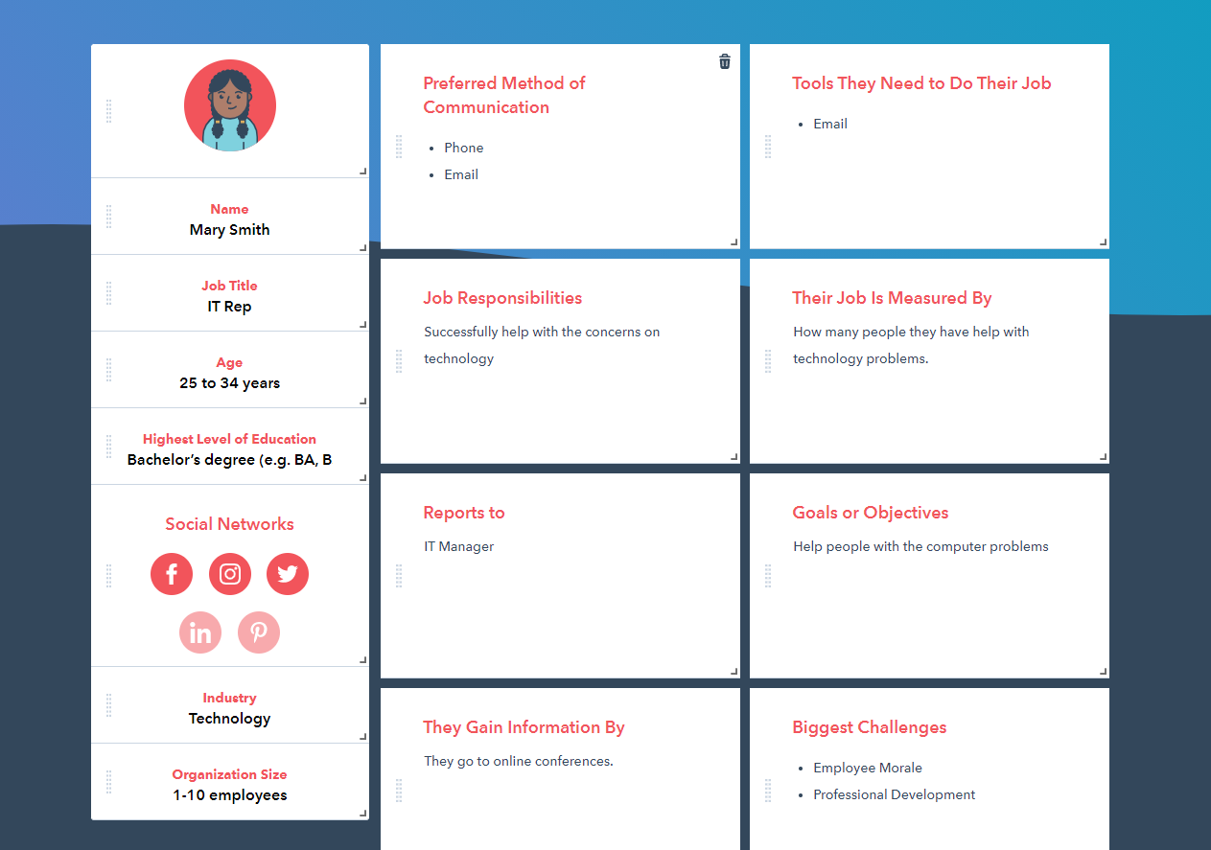

<https://www.hubspot.com/make-my-persona?persona=-MjVjg6SAhVyjcEq4Yf0>

**Scenario:**

While Mary has a year of programming experience and is an IT rep. She is also a graduate student trying to get her masters. She is having problems finding jobs or other internships in her field. She also wants to find other students who are in the field as well that can help her get new opportunities. Networking with them would also be a big factor as well.

**User Stories:**

As a graduate, I want to be able to navigate the website easily.

As a graduate, I want to be able to find opportunities using keywords.

As a graduate, I want to be able to connect with other users fast.

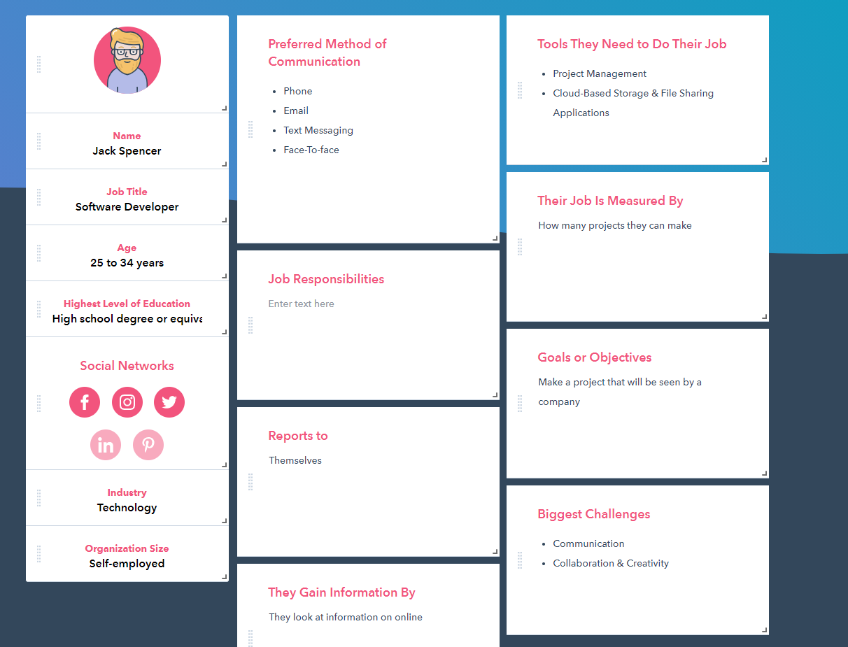

<https://www.hubspot.com/make-my-persona?persona=-MjVlDqckDkE2ei1Whbz>

**Scenario:**

Jack Spencer is a Senior in college with Three years of Software development experience. Even though he has a pretty good amount of experience, He has trouble finding jobs and internships. He wants to connect to others on a website that is specifically in his field. As well as find employers he can connect with to show his previous projects.

**User Stories:**

As a Senior, I want to be able to navigate the website easily.

As a Senior, I want to be able to find job offers.

As a Senior, I want to be able to find others by field, specifically Software development.

**Features:**

1. Look up jobs/internships with keywords.
2. Search for other users in the same field
3. Be able to network with others using a chat system.