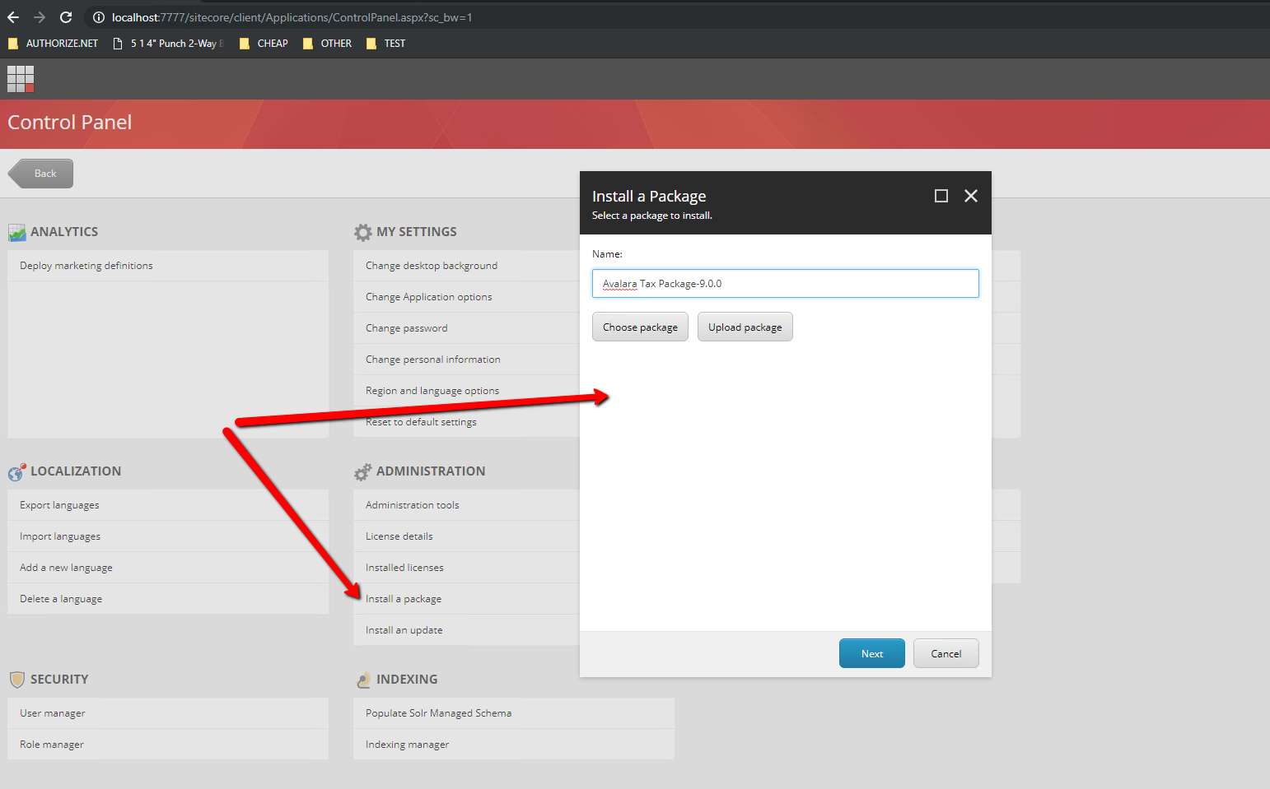

Installing Sitecore frontend package  
Figure 1.0   
  
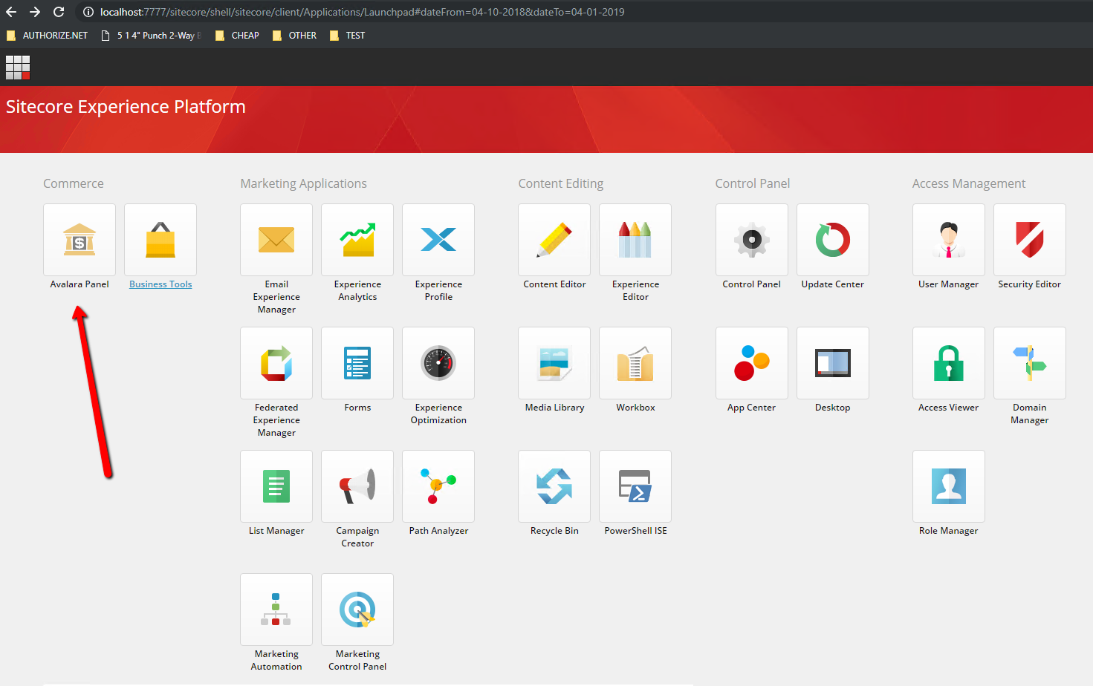

Avalara Panel Button

Figure 2.0

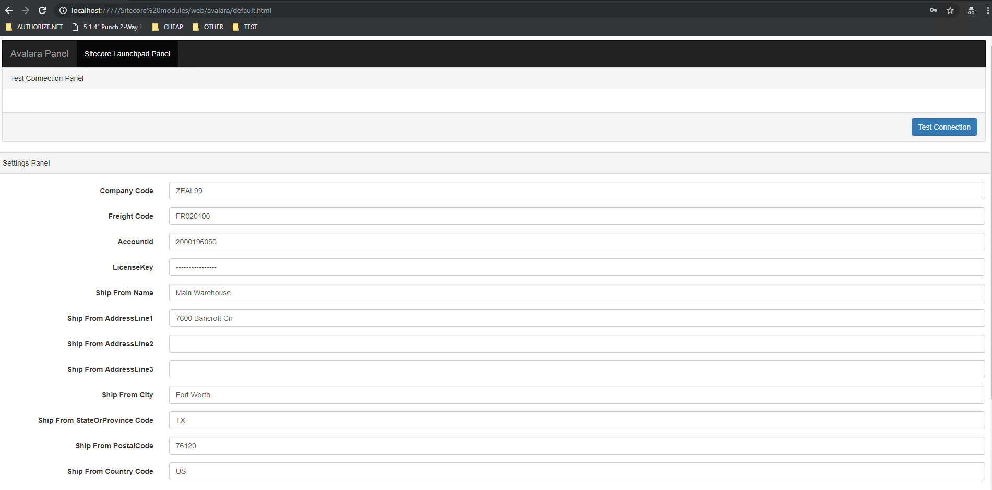

Avalara configuration form

Figure 3.0  
  
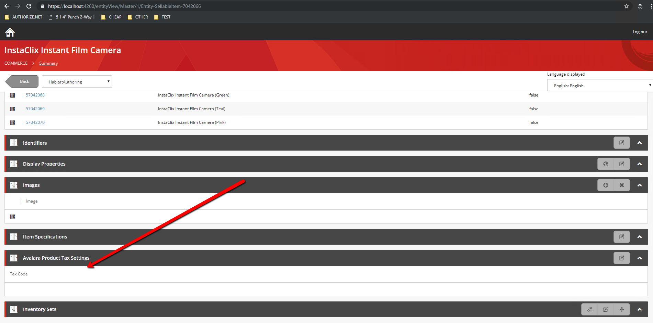

Tax code view for setting tax code on product level

Figure 4.0

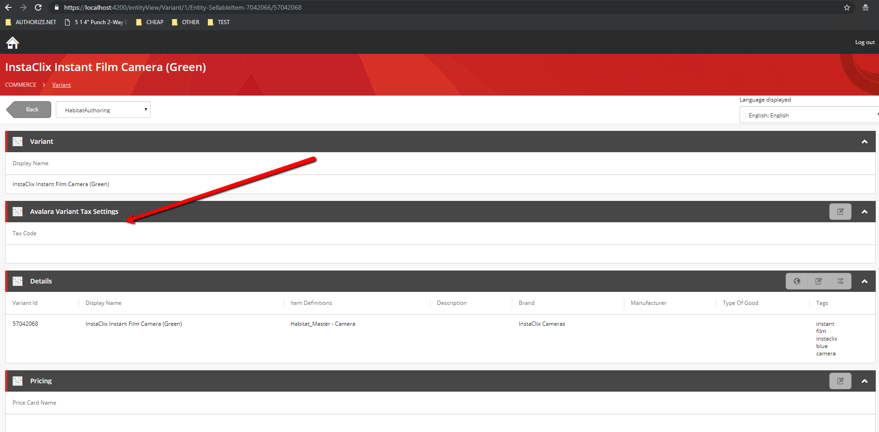

Tax code interface for setting tax code on a variant level.

Figure 5.0

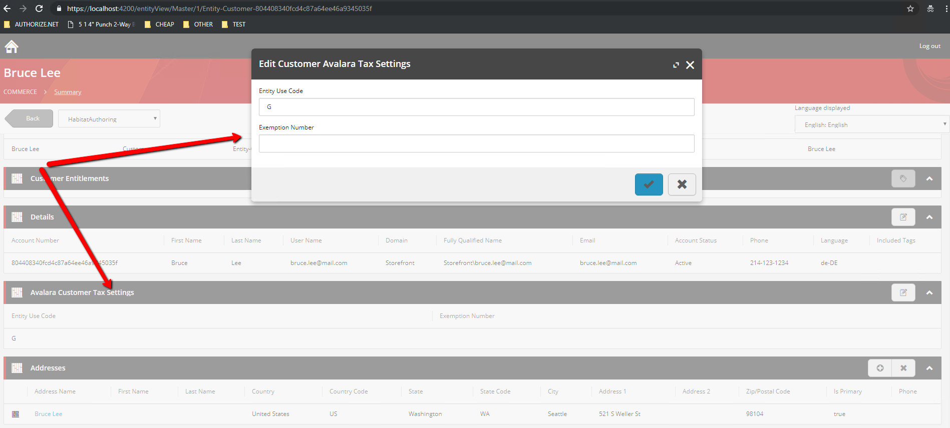

Interface for setting Entity Use Code or Excemption number on a customer profile.  
Figure 6.0