 

Avalara Tax Sitecore Commerce Plugin

AvaTax Plugin Admin Guide

Version: 2.0

**Prepared by:** XCentium

**Project Manager**: Balaji Thirumeninathan

**Date Created**: October 4, 2019

**Date Last Modified**: October 7, 2019

**Document Purpose**

The purpose of this document is to provide content authors with an insight on configuring Avalara Tax Plugin and related commerce content

**Document Approvers**

|  |  |  |
| --- | --- | --- |
| **Name** | **Project Role** | **Approval Date & Method** |
|  |  |  |
|  |  |  |
|  |  |  |
|  |  |  |

**Document Contributors**

|  |  |
| --- | --- |
| **Name** | **Project Role** |
|  |  |
|  |  |
|  |  |
|  |  |

**Version History**

|  |  |  |  |
| --- | --- | --- | --- |
| **Version #** | **Revision Date** | **Revised By** | **Change Descriptions** |
| 1.0 | 4/1/2019 | Balaji & Ola | Document created |
| 2.0 | 10/4/2019 | Balaji & Ola | 9.1.1 Release |
|  |  |  |  |
|  |  |  |  |

**Version History – Post Approval**

|  |  |  |  |  |
| --- | --- | --- | --- | --- |
| **Version #** | **CC#** | **Revision Date** | **Revised By** | **Change Descriptions** |
|  |  |  |  |  |
|  |  |  |  |  |

**Glossary of Terms**

|  |  |
| --- | --- |
| **Term/Acronym** | **Definition** |
| CMS | Content Management System |
| Sitecore | Web Content Management System |
| Item | Items are the basic building blocks of your Sitecore website |

Table of Contents

2 How to Install 3

3 Installing Sitecore frontend package 4

4 Avalara Panel Button 5

5 Avalara Configuration Panel Form 6

6 Product Setup 7

7 Variant Setup 8

8 Tax Excempt Customer Setup – Entity Use Code 8

# How to Install

1. Copy the Sitecore.Commerce.Plugin.Avalara project folder to your Sitecore Commerce Engine Solution and add it as a project
2. Add it as a dependency to your Sitecore Commerce Engine Project and deploy your commerce project as usual.

2a. under Sitecore.Commerce.Engine project, open the file named SitecoreServicesConfigurationExtensions.cs, look for a line with .Add<CalculateCartTaxBlock>() after that line, insert a line break and add .Add<UpdateCartTaxBlock>().After<CalculateCartTaxBlock>()

1. For the frontend interface, go to Sitecore package installer and install the package Avalara Tax Package-9.1.1.zip. See figure 1.0 on this document.
2. Login to Sitecore content editor, on the ribbon, click on Commerce and click Update Data Templates
3. Go to Sitecore Launch Pad, you will see a huge Avalara Panel button See figure 2.0 on this document . Click on it and it will take you to your configuration panel See figure 6.0 on this document.
4. Add all credentials and shipping address to the form on the panel and click save.
   1. You can configure the label text for a multilingual site by going to the path:  
      “/sitecore/system/Modules/Avalara/AvalaraSettings”. See figure 3.0 below.
   2. You can also personalize error messages text that shows up when there is an issue by going to the path: “/sitecore/system/Modules/Avalara/AvaTaxMessages”. See figure 4.0 below.
5. Click the "Test Connection button" If your configuration is all correct, you will get a response of success otherwise you will be notified of any issue. If you get success, all is set for your Tax calculation via AvaTax.
6. You are ready to start using it.

**Note:**

1. Remember to register with AVALARA and get your API connection details. Also activate your registration and set your AVALARA Nexus choices.
2. If you have any questions, comment or need us to help install, extend or adapt to your needs, do not hesitate to reach out to us at XCentium and ask about Sitecore Commerce Engine AVALARA Plugin.

# Installing Sitecore Frontend Package

Figure 1.0 : Installing the package

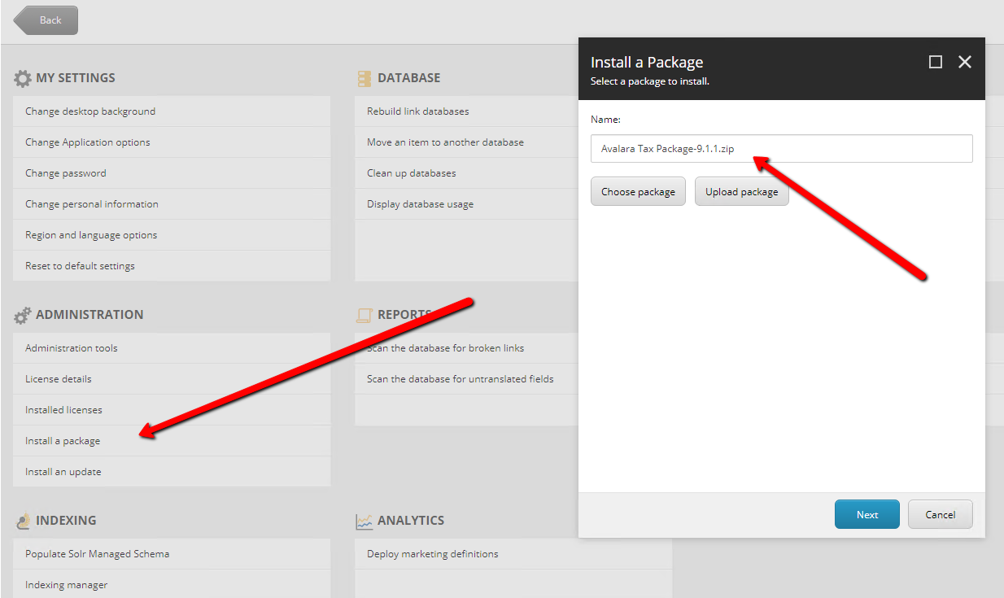

# Avalara Panel Button

Figure 2.0: AvaTax Control panel button

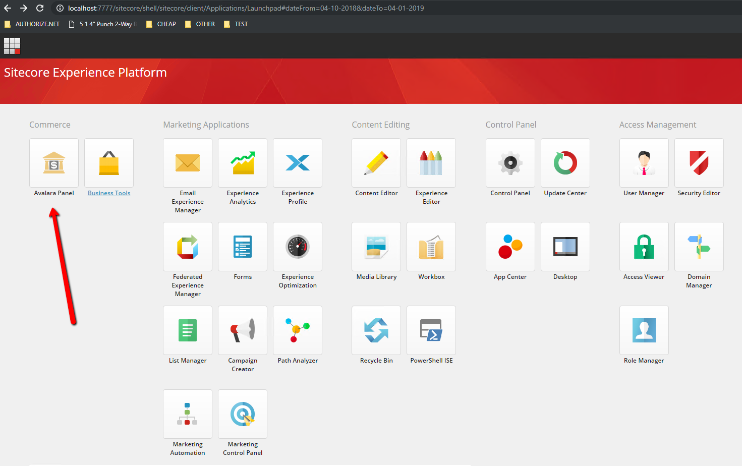

# Avalara Form LABELS SETTINGS

Figure 3.0: Configuration form labels settings.

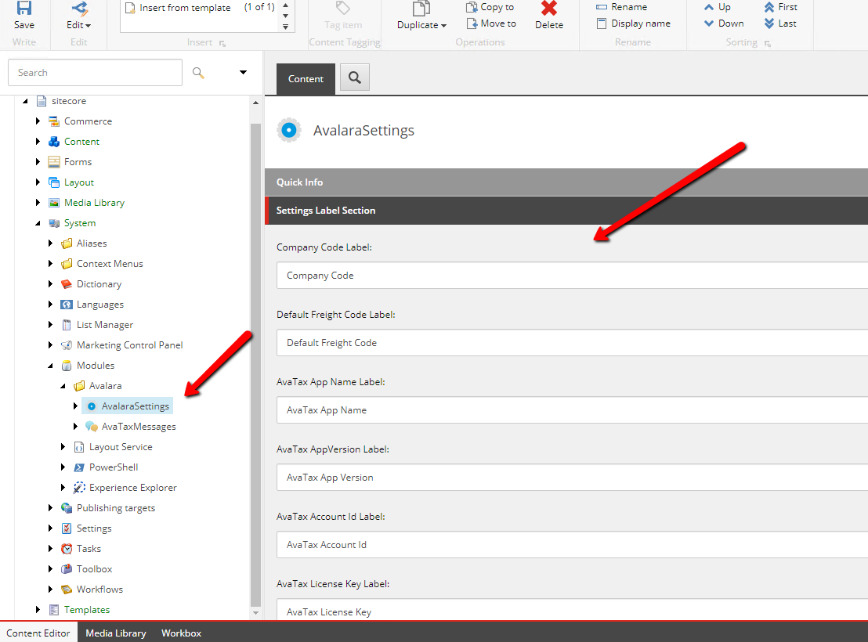

# Avalara Configuration ERROR MESSAGES SETTINGS

Figure 4.0: Error and notification form settings.

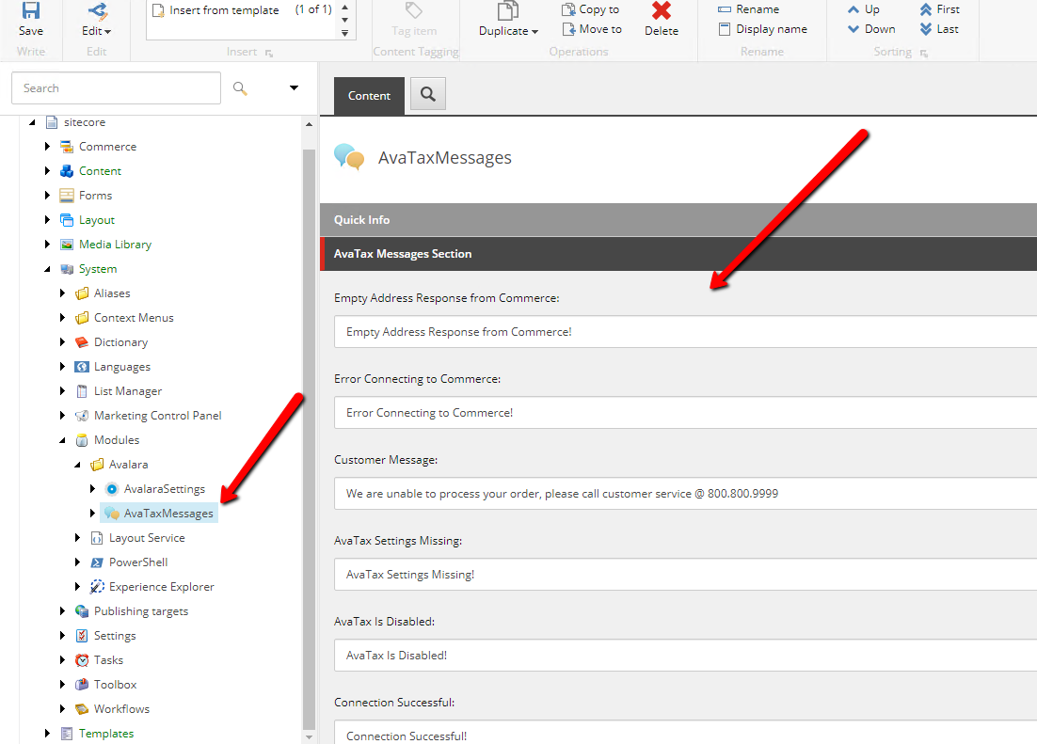

# Avalara Configuration Panel Form

Figure 5.0

