Project 2 gray paper

the gray paper should include at least 5 salient points from the code (including what challenges you encountered and how you solved the problems).

* Overall (menu on top of the website)

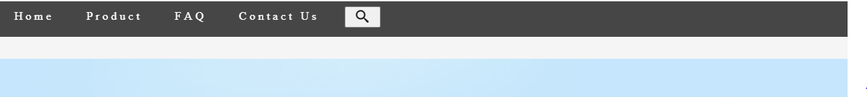

* + Connection or link to other html
  + Searching tool, by clicking on the icon will extent the text bar for visitor to type. Click it again will close the text bar. When typing in the text bar, a X appears on the most left of text bar, by clicking it will delete text you typed in.

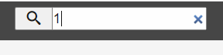

* Home html

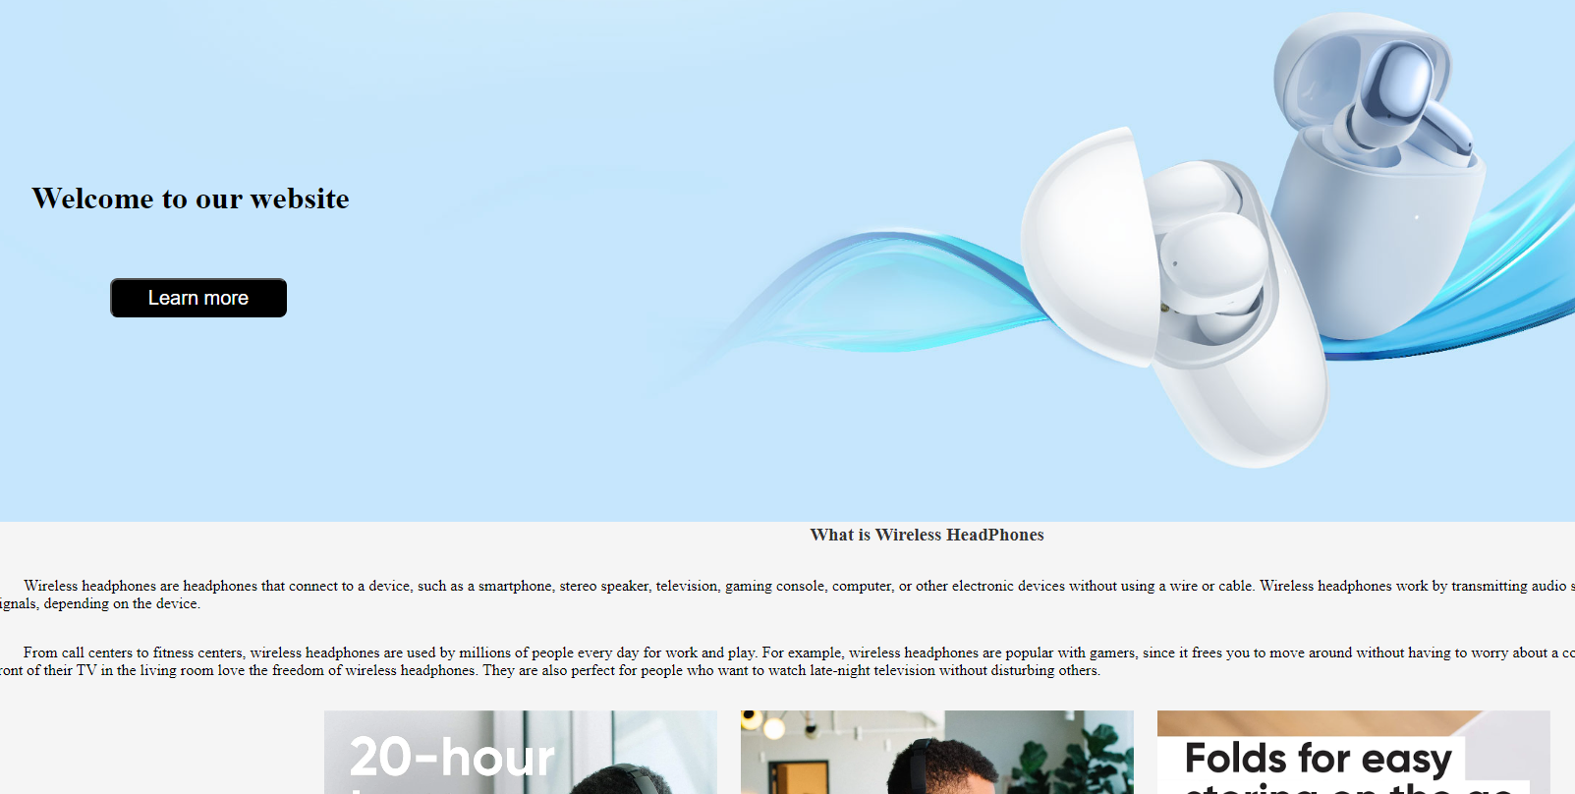

* + Positions of images
  + Button “Learn more” is a link to FAQ html, clicking it will direct to FAQ
* Product html

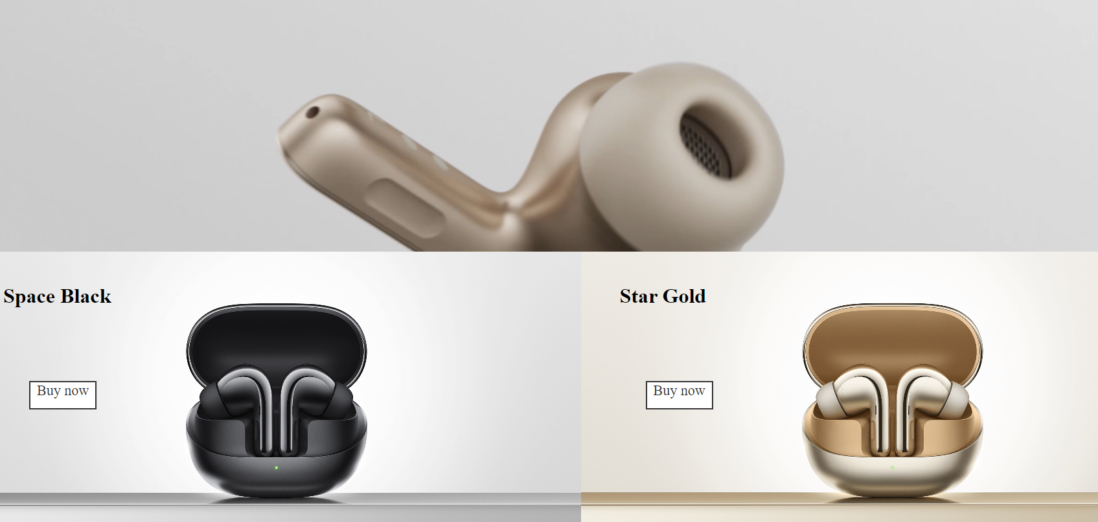

* + A video playing on top of the page
  + when move cursor and touches Image at the bottom will increase size and “buy now” button will turn into black.

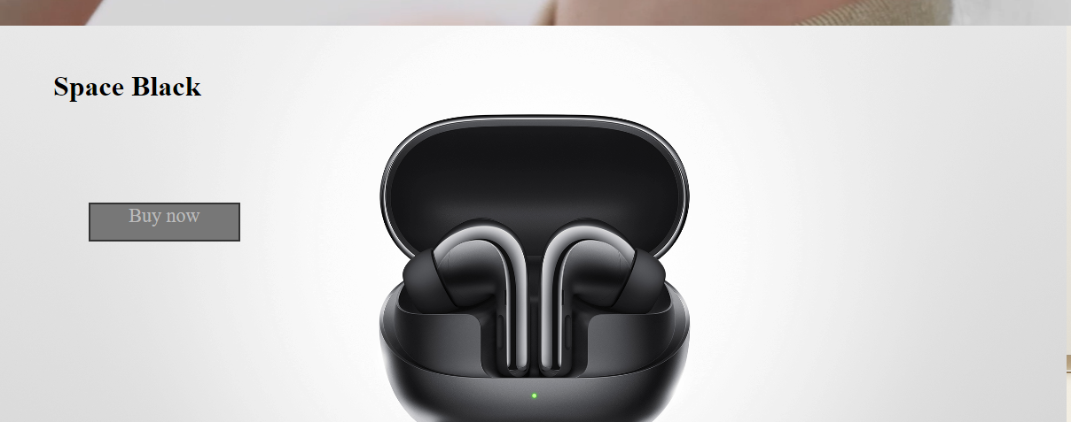

* FAQ html

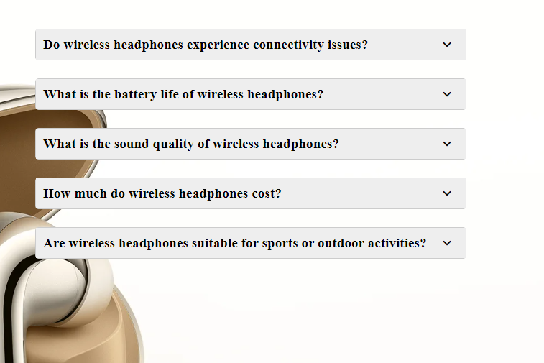

* + Includes many text boxes that can interact, by clicking the text box, an additional information about whatever question was on it will pop out.

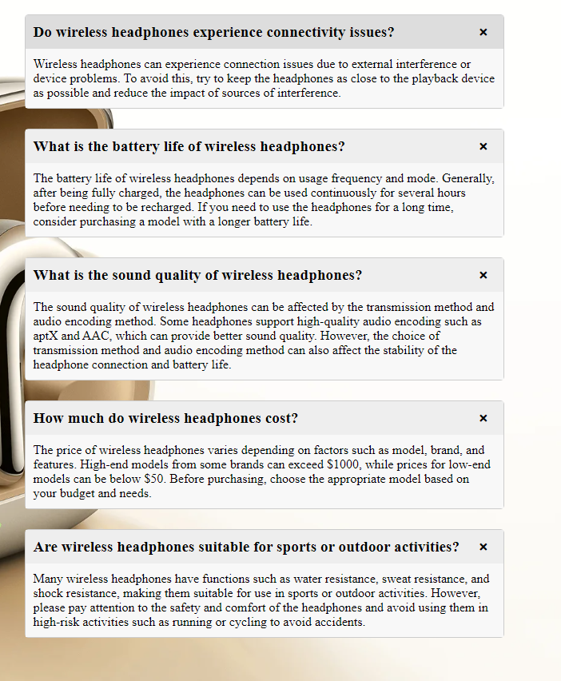

* Contact us

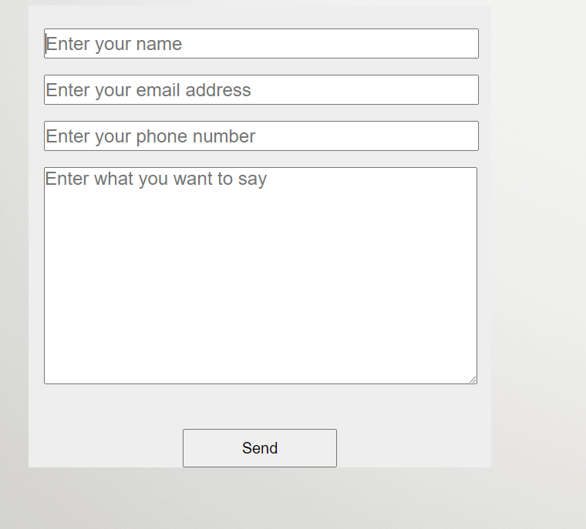

* + A form for visitor to type in, after typing and click send will download a txt file as record

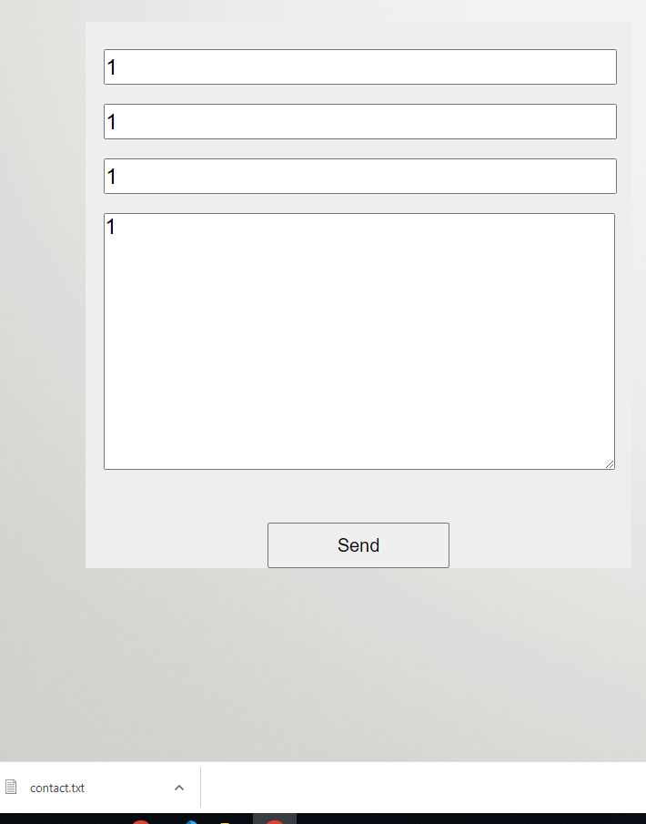

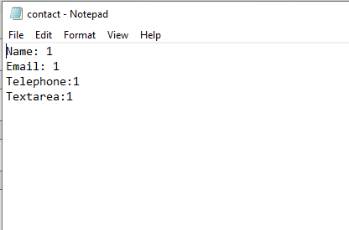

* Node.js

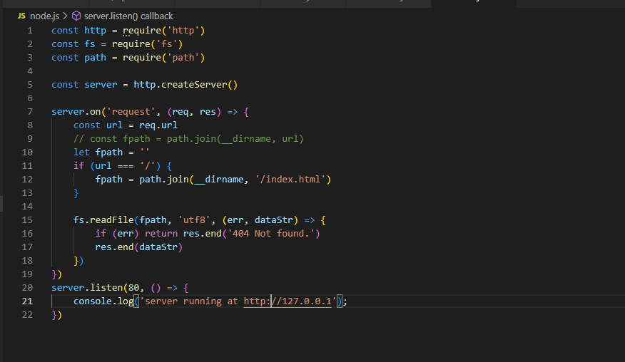

* + Create a server that can read file, return error 404 when there is nothing to read when request came.

The hardest part of the coding are always JavaScript. For all the unknow code that can achieve some kind of feature on website needs a bit of research online and a bunch of testing. Among all these I think the download file and save is the hardest one. After doing bunch of research, the download and save file is successful and represents a form of saving information.