**Kinect and USB Host Controller Documentation**

**Initial Situation**

The customer wants two Kinects to be put on the X-Copter. They are to provide 3D-Image data to map the surrounding locale of the X-Copter. To be able to communicate with two Kinects, two USB Host Controllers are needed. This is because one Kinect needs at least ~21 MB/s data transfer rate for 3D-Images at 640×480 pixels with 30 frames per second, which is too much for one controller to handle. 21 MB/s are divided into ~12MB/s for depth camera and 9 MB/s for color camera [1]. For proper 3D-Image data color- and depth camera have to work at the same time and can not be separated, which strikes out the option to save bandwidth with using only one camera at the time.

Kinect cameras will be connected via USB 2.0 plug to the USB-Controllers. For the Controllers to be able to communicate with the DE1-SOC system, an interface has to be implemented into the existing SOPC for communication between the devices. Real time 3D-Data processing will be the task of another external system with an Intel processor. Our customer stated that on a similar side project of him even an Intel I7 quad core processor is struggling with processing the data. For further information about hardware requirements of Kinect-Systems refer to [2].

**Requirements for the USB-Controller**

There are certain cut in stone requirements for the USB-Controller to work with Kinect and to fit in the design of our system:

- Must be available on the market

- Must not exceed the quantity of pins our system is able to offer

- Drivers for Linux have to be available

- Chip has to have outgoing pins to be solderable

- Full High-Speed data transfer rate of 480 MBit/s

- (Should be ULPI compatible if present Waveshare 3300-Transceivers are meant to be used)

**Common USB-Controller Packages**

There are three different common USB-Controller Packages that are solderable with the equipment available: QFN (Quad Flat No-leads package), LQFP (Low Profile Quad Flat Package) and TQFP (Thin Quad Flat Package). Information, advantages and disadvantages of these packages can be reviewed at [5]. QFN is harder to solder which is why QFP style packages are the preferred choice.

**Controllers that come into question**

Investigation about USB-Controllers lead to a list of four different controllers that will be evaluated further in this document. The first controller is one chosen from Frank Seifert for his Bachelor's Thesis: “Conception and realization of a control computer platform for a quadcopter flying model”[6]. He compared three different solutions for USB-Controller implementation into his system. His selection included the *ISP1362BD*, its successor the *ISP1761BE* and a *softcore FPGA* solution. Implementing the USB-Controller directly into the FPGA fell out of the question because of the high price for an USB-Controller IP-Core (prices circle around 5000€). Open Source IP Cores for USB Host Controllers are few, have a low set of features and are badly documented, which makes them less than optimal for this project. Frank Seifert also crossed out the ISP1761BE because of a higher pin count and no Linux drivers available at the time of writing his Bachelor's Thesis. His research led him to the believe that the ISP1362BD would be best suited for his endeavors.

Further research from our side showed that Linux Drivers are available for the ISP1761BE nowadays, which would make it a suitable choice for the project. Further investigation showed that the successor to the ISP1761BE, the SAF1761BE from NXP Semiconductors, is also available to purchase and supported with Linux drivers. The fourth and last USB Controller mentioned here is the FT313H(L/P) from Future Technology Devices International Ltd.

Cypress is a another company that is also offering a wide array of USB solutions, sadly they don't have USB 2.0 Host Controllers in their repertoire.

**Table: Comparison of USB-Controllers**

Illustration 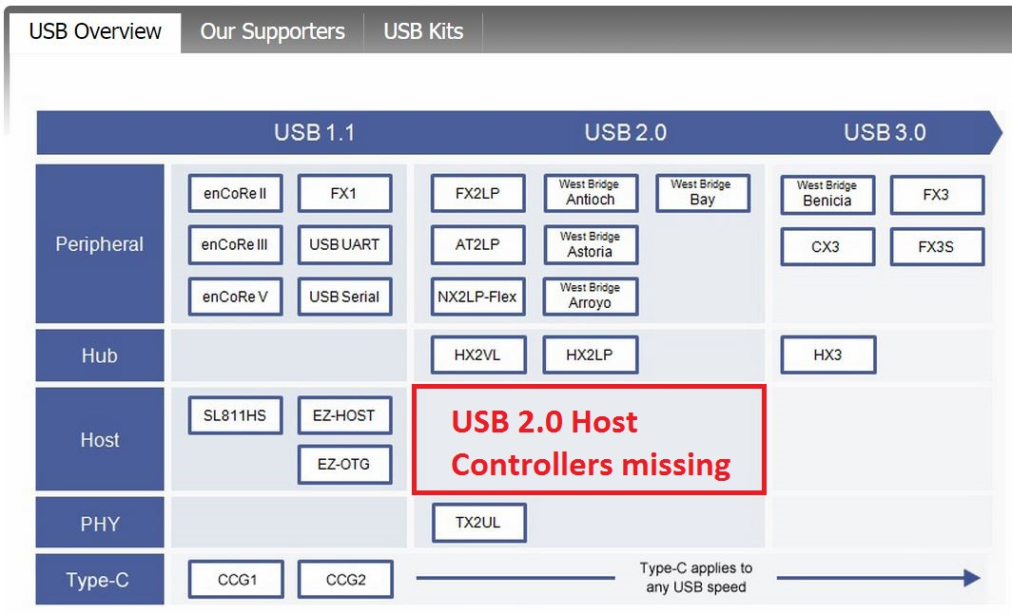1: Cypress USB offerings (http://www.cypress.com/fckImages/myresources/USBControllers_Overviewimg(1).jpg)

Chips with packages that are not solderable with the equipment at our disposal will not go into the equation.

|  |  |  |  |  |
| --- | --- | --- | --- | --- |
|  | **ISP1362BD** | **ISP1761BE** | **SAF1761BE** [3] | **FT313H(L/P)** [4] |
| **Date of production** | Rev. 04  12.2004 | Rev. 01  01.2005 | Rev.02  06.2012 | Ver.1.2  2013 |
| **Package** | LQFP64 | LQFP128 | LQFP128 | 64 LQFP  64 TQFP |
| **Driver for Linux** | yes | yes | yes | yes |
| **Transfer rate** | 96 Mbit/s | 480 Mbit/s | 480 Mbit/s | 480 Mbit/s |
| **RAM Memory** | unkn. | unkn. | unkn. | 48 KB |
| **ULPI compatible** | unkn. | unkn. | unkn. | unkn. |
| **Quantity of I/O Pins** | 27 Pins | 16Bit: 41 Pins  32Bit: 57 Pins | 16Bit: 41Pins  32Bit: 57 Pins | ? |
| **Info** | Discontinued | Discontinued | Available | Available |
| **Pros** | + Frank Seifert implemented this chip in his bachelor project | + speed  + similar to ISP1362BD | + speed  + similar to ISP1761BE | + speed  + 64 PIN package  + UMFT313EV Development Module available |
| **Cons** | - speed (too low for Kinect)  - not available | - not available | - used mainly in automotive systems  - no evaluation board | Unkn. As of time of writing |

**Conclusion**

The ISP1362BD is not suitable as an USB Controller for the use with Microsoft Kinects because of a transfer rate of only 96 Mbit/s which is Full Speed USB 2.0. Kinects need at least High Speed USB 2.0 with 480 Mbit/s. Furthermore the controller is not supported anymore and it is almost impossible to obtain those controllers on today's market.

The ISP1761BE does not make the cut either. Although it supports High Speed USB 2.0 and has Linux drivers, it has a larger footprint with its LQFP128 package and is also discontinued. Its successor the SAF1761 which is similar in features is mainly used in automotive systems which means that it is not available in the common consumer market.

Which leads us to the FT313H(L/P) which offers the best characteristics for our endeavors. It is still supported, offers Linux drivers. It has a relatively low footprint, is solderable with the tools at hand and comes in two packages: 64LQFP and64TQFP. It supports High Speed USB 2.0 transfer rates and can also be ordered with a development module.

**Internet Sources:**

1. <http://openkinect.org/wiki/FAQ>

2. <https://msdn.microsoft.com/en-us/library/jj131032.aspx>

3. http://www.nxp.com/products/automotive/multimedia/usb/SAF1761BE.html

4. http://www.ftdichip.com/Products/ICs/FT313H.html

5. <http://en.wikipedia.org/wiki/Quad_Flat_Package>

**Other Sources**

6. Bachelor Thesis Frank Seifert.pdf

**Illustrations:**