Wi-Fi connectivity

The X-Copter needs a wireless connection to transmit/receive data to/from ground station. The data consists of position, status, speed and further information about the current air situation. The basic configuration is a PC/Laptop and a Wi-Fi dongle (“Edimax” with a RTl8188 chip) plugged in the X-Copter DE1-SoC board (DE1). Both are connected with an access point (AP).

First step to solve this challenge was to establish a connection between the DE1 and the AP. The Wi-Fi dongle doesn’t work out of the box. To get the dongle working there were two possibilities. First one was to compile a Linux driver and the second was to edit the operating system.

The driver can be downloaded from the manufacturer’s website. It was necessary to cross-compile the driver on the host x86 system for the target platform with an ARMv7 architecture. It’s a big underpinning to understand the makefile(s) and it is often not clear how to fix an error. After failing the task this way it was decided to edit the operating embedded system and include the drivers in “Buildroot”.

Buildroot was used to generate the embedded Linux, the bootloader and the root filesystem. At first the right device driver cannot be found in the basic settings. After activating some other components, additional devices were added to the Wi-Fi driver list. Now the driver file can be loaded successful but there was an error with a missing firmware file. Adding the right firmware in Buildroot solved this issue. As a precaution all Ralink drivers were activated (.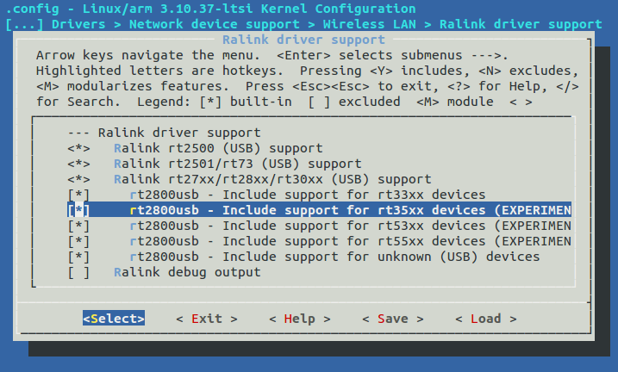

Afterwards a connection failed because the DMA coherent pool is too small. Setting the variable of the coherent pool to 4 Megabytes in UBoot solved the problem.

Now the basic settings are set and the DE1 can establish a wireless connection to the AP. The connection seems to be stable and it’s possible to send a ping signal to the DE1. At the moment the connection has to establish manually. In case of the time pressure it wasn’t possible to make a config file. In future the connection will establish automatically.