Stock Investments with SQL

Database Design and Development

Professor Wang

Team 6

Wilson Ung

Mateo Marcos

David Wei

Christopher Coniceak

Table of Contents

Project 1………………………………………………………………………………….2

Scenario………………………………………………………………………………….3

Identity Relationship Matrix…………………………………………………………….3

Business Rules………………………………………………………………………….3

ER Diagram……………………………………………………………………………...4

Tables & Attributes……..……………………………………………………………….5

Referential Integrity……………………………………………………………………..5

Functional Dependency Analysis……………………………………………………...5

Relational Schema after Normalization……………………………………………....5

Project 2………………………………………………………………………………….6

SQL DDL (Database Creation Script)…………………………………………………6

Database Structure……………………………………………………………………12

Database Entity Instances……………………………………………………………13

SQL Test Statements………………………………………………………………….16

Project 1

### Scenario

This simplified Investment Portfolio case study maintains information regarding clients that invest in stocks and mutual funds. Each client has a unique taxpayer identification number. A client may invest in stocks or mutual funds.

A stock is uniquely identified by its ticker, which is symbol on the stock exchange. The name of issue for a stock is the name of the company. A stock has a rating, which is an assessment of the stock. The principal business of a stock denotes the primary business from which the company obtains its revenue. There are several prices associated with a stock. Besides the current price of a stock, the high and low price ranges are recorded for the calendar year. The return value for a stock, which is the price appreciation, is recorded for the prior year and five-year period.

A mutual fund is also uniquely identified by a ticker symbol and has a fund name. The principal objective of the fund is also recorded (e.g. ‘G’ for growth, ‘I’ for income, and ‘S’ for stability). Similar to stocks, mutual funds record a current offering price and a high and low price range. A percent yield from investment income is also maintained. A mutual fund may be associated with at most one fund family.

A fund family has a unique identification number and the company’s name and address. A fund family, as its name implies, can have many associated mutual funds, but must have at least one mutual fund.

Based on the high level introduction to the Investment Portfolio enterprise, assume the following:

The characteristics of a client include a unique taxpayer identification number, a name, and an address. A client can invest in many stocks in many mutual funds.

The characteristics of a stock include the stock’s unique ticker on the stock exchange and additional descriptive properties that include the name of issue, a rating, the principal business, a high and low price range, the current price, and return values for the prior year and 5-year period.

The characteristics of a mutual fund include the mutual fund’s unique ticker and additional descriptive properties that include the name of the fund, its principal objective, the high and low price range, the current offering price, and the fund’s yield. A mutual fund may be associated with the most one fund family.

The characteristics of a fund family include a unique identification, a name, and a address. A fund family may have mutual funds and must be associated with at least one mutual fund.

### Relationship Matrix

|  |  |  |  |  |
| --- | --- | --- | --- | --- |
|  | Client | Stock | Mutual Fund | Family Fund |
| Client | --- | Bought by | Bought by | --- |
| Stock | Invests | --- | --- | --- |
| Mutual Fund | Invests | --- | --- | Has |
| Family Fund | --- | --- | Belong to | --- |

# Business Rules

The three pairs of relationships are further defined as the database business rules as follows:

One client may invest in one or more than one stock.

A stock may be bought by one or more than one client.

One client may invest in one or more than one mutual fund.

A mutual fund may be bought by one or more than one client.

One fund family must have one or more than one mutual fund.

One fund must belong to only one fund family.

# ER Diagram

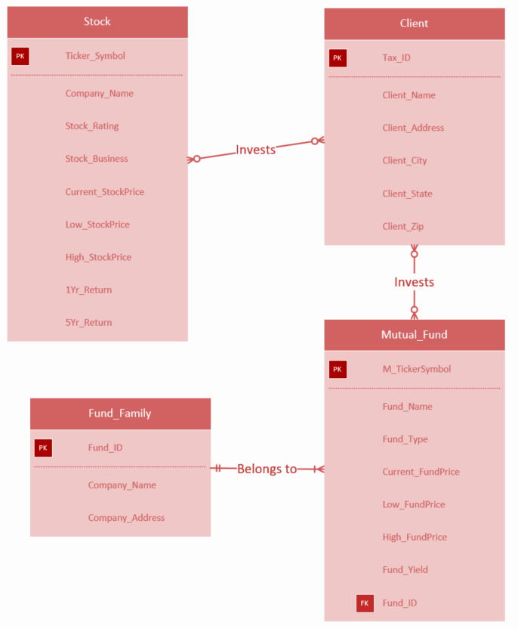

# Tables & Attributes

**Table Name: Client**

|  |  |  |  |  |  |
| --- | --- | --- | --- | --- | --- |
| Tax_ID (PK) | Client_Name | Client_Address | Client_City | Client_State | Client_Zip |

**Table Name: Stock**

|  |  |  |  |  |  |  |
| --- | --- | --- | --- | --- | --- | --- |
| Ticker_Symbol (PK) | Company_Name | Stock_Rating | Stock_Business | Stock_Price | One_Yr_Return | Five_Yr_Return |

**Table Name: Mutual_Fund**

|  |  |  |  |  |  |
| --- | --- | --- | --- | --- | --- |
| M_TickerSymbol (PK) | Fund_Name | Fund_Type | Fund_Price | Fund_Yield | Fund_ID (FK) |

**Table Name: Fund_Family**

|  |  |  |  |  |  |
| --- | --- | --- | --- | --- | --- |
| Fund_ID (PK) | Company_Name | Company_Address | Company_City | Company_State | Company_Zip |

**Table Name: Stock_Portfolio**

|  |  |  |
| --- | --- | --- |
| Tax_ID (PK)(FK) | Ticker_Symbol (PK)(FK) | NumOfShares |

**Table Name: Fund_Portfolio**

|  |  |  |
| --- | --- | --- |
| Tax_ID (PK)(FK) | M_TickerSymbol (PK)(FK) | M_NumOfShares |

# Referential Integrity

|  |  |
| --- | --- |
| FK (TableName.ColName) | PK(TableName.ColName) |
| Fund_Portfolio.Tax_ID | Client.Tax_ID |
| Fund_Portfolio.M_TickerSymbol | Mutual_Fund.M_TickerSymbol |
| Stock_Portfolio.Tax_ID | Client.Tax_ID |
| Stock_Portfolio.Ticker_Symbol | Stock.Ticker_Symbol |
| Mutual_Fund.Fund_ID | Fund_Family.Fund_ID |

Functional Dependency Analysis

**Full Dependency**

Tax_ID >> Client_Name, Client_Address

Ticker_Symbol >> Company_Name, Stock_Rating, Stock_Business, Stock_Price, One_Yr_Return, Five_Yr_Return

M_TickerSymbol >>Fund_Name, Fund_Type, Fund_Price, Fund_Yield, Fund_ID

Fund_ID >>Company_Name, Company_Address

Tax_ID, Ticker_Symbol >> NumOfShares

Tax_ID, M_TickerSymbol >> M_NumOfShares

# Relational Schema after Normalization

|  |  |  |  |
| --- | --- | --- | --- |
| Table Name | 1NF | 2NF | 3NF |
| Client | x | x | x |
| Stock | x | x | x |
| Mutual Fund | x | x | x |
| Fund Family | x | x | x |
| Stock_Portfolio | x | x | x |
| Fund_Portfolio | x | x | x |

Project 2

SQL DDL (Database Creation Script)

DROP TABLE Client CASCADE CONSTRAINTS ;

DROP TABLE Stock CASCADE CONSTRAINTS ;

DROP TABLE Fund_Family CASCADE CONSTRAINTS ;

DROP TABLE Mutual_Fund CASCADE CONSTRAINTS ;

DROP TABLE Fund_Portfolio CASCADE CONSTRAINTS ;

DROP TABLE Stock_Portfolio CASCADE CONSTRAINTS ;

CREATE TABLE Client

(Tax_ID VARCHAR2(11) NOT NULL,

Client_Name VARCHAR2(30) ,

Client_Address VARCHAR2(26) ,

Client_City VARCHAR2(13) ,

Client_State VARCHAR2(2) ,

Client_Zip NUMBER ,

CONSTRAINT CLIENT_PK PRIMARY KEY (Tax_ID));

CREATE TABLE Stock

(Ticker_Symbol VARCHAR2(4) NOT NULL,

Company_Name VARCHAR2(30) ,

Stock_Rating VARCHAR2(1) ,

Stock_Business VARCHAR2(25) ,

Current_StockPrice DECIMAL(6,2) ,

Low_StockPrice DECIMAL(6,2) ,

High_StockPrice DECIMAL(6,2) ,

One_Yr_Return DECIMAL(6,2) ,

Five_Yr_Return DECIMAL(6,2) ,

CONSTRAINT STOCK_PK PRIMARY KEY (Ticker_Symbol));

CREATE TABLE Fund_Family

(Fund_ID VARCHAR2(5) NOT NULL,

Company_Name VARCHAR2(30) ,

Company_Address VARCHAR2(30) ,

Company_City VARCHAR2(10) ,

Company_State VARCHAR2(2) ,

Company_Zip VARCHAR2(5) ,

CONSTRAINT FUND_FAMILY_PK PRIMARY KEY (Fund_ID));

CREATE TABLE Mutual_Fund

(M_TickerSymbol VARCHAR2(5) NOT NULL,

Fund_Name VARCHAR2(10) ,

Fund_Type VARCHAR2(15) ,

Current_FundPrice DECIMAL(6,2) ,

Low_FundPrice DECIMAL(6,2) ,

High_FundPrice DECIMAL(6,2) ,

Fund_Yield DECIMAL(4,2) ,

Fund_ID VARCHAR2(5) ,

CONSTRAINT MUTUAL_FUND_PK PRIMARY KEY (M_TickerSymbol),

CONSTRAINT MUTUAL_FUND_FK1 FOREIGN KEY (Fund_ID) REFERENCES Fund_Family(Fund_ID));

CREATE TABLE Fund_Portfolio

(Tax_ID VARCHAR2(11) NOT NULL,

M_TickerSymbol VARCHAR2(30) NOT NULL,

M_NumOfShares NUMBER ,

CONSTRAINT FUND_PORTFOLIO_PK PRIMARY KEY (Tax_ID, M_TickerSymbol),

CONSTRAINT FUND_PORTFOLIO_FK1 FOREIGN KEY (Tax_ID) REFERENCES Client(Tax_ID),

CONSTRAINT FUND_PORTFOLIO_FK2 FOREIGN KEY (M_TickerSymbol) REFERENCES Mutual_Fund(M_TickerSymbol));

CREATE TABLE Stock_Portfolio

(Tax_ID VARCHAR2(11) NOT NULL,

Ticker_Symbol VARCHAR2(30) NOT NULL,

NumOfShares NUMBER ,

CONSTRAINT STOCK_PORTFOLIO_PK PRIMARY KEY (Tax_ID, Ticker_Symbol),

CONSTRAINT STOCK_PORTFOLIO_FK1 FOREIGN KEY (Tax_ID) REFERENCES Client(Tax_ID),

CONSTRAINT STOCK_PORTFOLIO_FK2 FOREIGN KEY (Ticker_Symbol) REFERENCES Stock(Ticker_Symbol));

INSERT INTO Client (Tax_ID, Client_Name, Client_Address, Client_City, Client_State, Client_Zip)

VALUES ('000-00-0001', 'Selina Wong', '1355 S Hines Blvd', 'Gainesville', 'FL', 32601);

INSERT INTO Client (Tax_ID, Client_Name, Client_Address, Client_City, Client_State, Client_Zip)

VALUES ('000-40-4040', 'Christian Serna', '650 E Rosemead Blvd', 'Rosemead', 'CA', 91770);

INSERT INTO Client (Tax_ID, Client_Name, Client_Address, Client_City, Client_State, Client_Zip)

VALUES ('404-69-5522', 'Kevin Smith', '400 S 4th St NW', 'Washington', 'DC', 20591);

INSERT INTO Client (Tax_ID, Client_Name, Client_Address, Client_City, Client_State, Client_Zip)

VALUES ('500-50-5000', 'Victoria Hong', '1333 1/2 E Frontier Ave', 'Manhattan', 'NY', 10004);

INSERT INTO Client (Tax_ID, Client_Name, Client_Address, Client_City, Client_State, Client_Zip)

VALUES ('999-69-5000', 'Frank Zuniga', '450 E New Ave', 'Monterey Park', 'CA', 91754);

INSERT INTO Client (Tax_ID, Client_Name, Client_Address, Client_City, Client_State, Client_Zip)

VALUES ('777-11-8799', 'Scott Jones', '550 S Grand Ave', 'Los Angeles', 'CA', 90013);

INSERT INTO Client (Tax_ID, Client_Name, Client_Address, Client_City, Client_State, Client_Zip)

VALUES ('282-62-5799', 'Zion Wu', '11121 E Freemark Circle Dr', 'Seattle', 'WA', 97954);

INSERT INTO Client (Tax_ID, Client_Name, Client_Address, Client_City, Client_State, Client_Zip)

VALUES ('322-33-3221', 'Kaho Akiya', '550 N Ivory Coast Ave', 'Bellevue', 'WA', 98004);

INSERT INTO Stock (Ticker_Symbol, Company_Name, Stock_Rating, Stock_Business, Current_StockPrice, Low_StockPrice, High_StockPrice, One_Yr_Return, Five_Yr_Return)

VALUES ('AAPL', 'Apple Inc.', 'B', 'Consumer Electronics', 167.88, 164.47, 168.94, 160.68, 112.44);

INSERT INTO Stock (Ticker_Symbol, Company_Name, Stock_Rating, Stock_Business, Current_StockPrice, Low_StockPrice, High_StockPrice, One_Yr_Return, Five_Yr_Return)

VALUES ('CSCO', 'Cisco Systems Inc.', 'C', 'Network Equipment', 41.34, 40.72, 41.50, 35.63, 28.47);

INSERT INTO Stock (Ticker_Symbol, Company_Name, Stock_Rating, Stock_Business, Current_StockPrice, Low_StockPrice, High_StockPrice, One_Yr_Return, Five_Yr_Return)

VALUES ('VZ', 'Verizon Communications Inc.', 'C', 'Mobile Telecommunications', 47.22, 46.72, 47.62, 48.24, 49.05);

INSERT INTO Stock (Ticker_Symbol, Company_Name, Stock_Rating, Stock_Business, Current_StockPrice, Low_StockPrice, High_StockPrice, One_Yr_Return, Five_Yr_Return)

VALUES ('MSI', 'Motorola Solutions Inc.', 'B', 'Network Equipment', 105.27, 104.40, 106.42, 91.32, 71.97);

INSERT INTO Stock (Ticker_Symbol, Company_Name, Stock_Rating, Stock_Business, Current_StockPrice, Low_StockPrice, High_StockPrice, One_Yr_Return, Five_Yr_Return)

VALUES ('TMUS', 'T-Mobile US Inc.', 'C', 'Mobile Telecommunications', 60.06, 59.29, 60.18, 62.86, 41.60);

INSERT INTO Stock (Ticker_Symbol, Company_Name, Stock_Rating, Stock_Business, Current_StockPrice, Low_StockPrice, High_StockPrice, One_Yr_Return, Five_Yr_Return)

VALUES ('GOOG', 'Alphabet Inc.', 'A', 'Systems Software', 1013.91, 990.37, 1020.99, 991.53, 739.75);

INSERT INTO Stock (Ticker_Symbol, Company_Name, Stock_Rating, Stock_Business, Current_StockPrice, Low_StockPrice, High_StockPrice, One_Yr_Return, Five_Yr_Return)

VALUES ('MSFT', 'Microsoft Corp.', 'C', 'Systems Software', 89.58, 87.89, 90.05, 78.63, 53.22);

INSERT INTO Fund_Family (Fund_ID, Company_Name, Company_Address, Company_City, Company_State, Company_Zip)

VALUES ('JAN11' , 'Janus' , '3773 Cherry Creek North Dr.', 'Denver', 'CO', 80209);

INSERT INTO Fund_Family (Fund_ID, Company_Name, Company_Address, Company_City, Company_State, Company_Zip)

VALUES ('FIE22' , 'Fidelity' , '2300 Litton Ln.' , 'Herbron' , 'KY' , 41048);

INSERT INTO Fund_Family (Fund_ID, Company_Name, Company_Address, Company_City, Company_State, Company_Zip)

VALUES ('TRW55' , 'T Rowe Price' , '100 East Pratt St.' , 'Baltimore' , 'MD', 21202);

INSERT INTO Fund_Family (Fund_ID, Company_Name, Company_Address, Company_City, Company_State, Company_Zip)

VALUES ('ABN97' , 'ABN AMRO' , '208 S. LaSalle St., 4th Floor', 'Chicago', 'IL', 60604);

INSERT INTO Fund_Family (Fund_ID, Company_Name, Company_Address, Company_City, Company_State, Company_Zip)

VALUES ('GE777' , 'GE' , '3003 Summer St.', 'Stamford', 'CT', 06912);

INSERT INTO Mutual_Fund (M_TickerSymbol, Fund_Name, Fund_Type, Current_FundPrice, Low_FundPrice, High_FundPrice, Fund_Yield, Fund_ID)

VALUES ('JAGIX' , 'Janus' , 'Growth Fund' , 28.15 , 30.42 , 27.84 , -.23 , 'JAN11');

INSERT INTO Mutual_Fund (M_TickerSymbol, Fund_Name, Fund_Type, Current_FundPrice, Low_FundPrice, High_FundPrice, Fund_Yield, Fund_ID)

VALUES ('FEQIX' , 'Fidelity' , 'Equity_Income' , 48.07 , 55.11 , 42.46 , -1.53 , 'FIE22');

INSERT INTO Mutual_Fund (M_TickerSymbol, Fund_Name, Fund_Type, Current_FundPrice, Low_FundPrice, High_FundPrice, Fund_Yield, Fund_ID)

VALUES ('RPMGX' , 'T Rowe' , 'Mid-Gap Growth' , 37.84 , 40.06 , 36.18 , -1.18 , 'TRW55');

INSERT INTO Mutual_Fund (M_TickerSymbol, Fund_Name, Fund_Type, Current_FundPrice, Low_FundPrice, High_FundPrice, Fund_Yield, Fund_ID)

VALUES ('VERDX' , 'Veredus' , 'Growth Fund' , 15.74 , 19.88 , 15.74 , -13.91 , 'ABN97');

INSERT INTO Mutual_Fund (M_TickerSymbol, Fund_Name, Fund_Type, Current_FundPrice, Low_FundPrice, High_FundPrice, Fund_Yield, Fund_ID)

VALUES ('GEEQX' , 'GE US' , 'Equity Fund' , 26.02 , 28.12 , 25.92 , -3.24 , 'GE777');

INSERT INTO Fund_Portfolio (Tax_ID, M_TickerSymbol, M_NumOfShares)

VALUES ('000-00-0001' , 'JAGIX' , 640);

INSERT INTO Fund_Portfolio (Tax_ID, M_TickerSymbol, M_NumOfShares)

VALUES ('000-00-0001' , 'RPMGX' , 40);

INSERT INTO Fund_Portfolio (Tax_ID, M_TickerSymbol, M_NumOfShares)

VALUES ('000-40-4040' , 'VERDX' , 83);

INSERT INTO Fund_Portfolio (Tax_ID, M_TickerSymbol, M_NumOfShares)

VALUES ('000-40-4040' , 'RPMGX' , 100);

INSERT INTO Fund_Portfolio (Tax_ID, M_TickerSymbol, M_NumOfShares)

VALUES ('000-40-4040' , 'GEEQX' , 162);

INSERT INTO Fund_Portfolio (Tax_ID, M_TickerSymbol, M_NumOfShares)

VALUES ('404-69-5522' , 'FEQIX' , 200);

INSERT INTO Fund_Portfolio (Tax_ID, M_TickerSymbol, M_NumOfShares)

VALUES ('500-50-5000' , 'VERDX' , 10);

INSERT INTO Fund_Portfolio (Tax_ID, M_TickerSymbol, M_NumOfShares)

VALUES ('500-50-5000' , 'RPMGX' , 302);

INSERT INTO Fund_Portfolio (Tax_ID, M_TickerSymbol, M_NumOfShares)

VALUES ('999-69-5000' , 'JAGIX' , 116);

INSERT INTO Fund_Portfolio (Tax_ID, M_TickerSymbol, M_NumOfShares)

VALUES ('999-69-5000' , 'VERDX' , 5);

INSERT INTO Fund_Portfolio (Tax_ID, M_TickerSymbol, M_NumOfShares)

VALUES ('777-11-8799' , 'FEQIX' , 90);

INSERT INTO Fund_Portfolio (Tax_ID, M_TickerSymbol, M_NumOfShares)

VALUES ('777-11-8799' , 'RPMGX' , 140);

INSERT INTO Fund_Portfolio (Tax_ID, M_TickerSymbol, M_NumOfShares)

VALUES ('282-62-5799' , 'VERDX' , 640);

INSERT INTO Fund_Portfolio (Tax_ID, M_TickerSymbol, M_NumOfShares)

VALUES ('322-33-3221' , 'JAGIX' , 660);

INSERT INTO Fund_Portfolio (Tax_ID, M_TickerSymbol, M_NumOfShares)

VALUES ('322-33-3221' , 'RPMGX' , 860);

INSERT INTO Fund_Portfolio (Tax_ID, M_TickerSymbol, M_NumOfShares)

VALUES ('322-33-3221' , 'GEEQX' , 160);

INSERT INTO Stock_Portfolio (Tax_ID, Ticker_Symbol, NumOfShares)

VALUES ('000-00-0001' , 'AAPL' , 200);

INSERT INTO Stock_Portfolio (Tax_ID, Ticker_Symbol, NumOfShares)

VALUES ('000-00-0001' , 'VZ' , 9);

INSERT INTO Stock_Portfolio (Tax_ID, Ticker_Symbol, NumOfShares)

VALUES ('000-40-4040' , 'MSI' , 20);

INSERT INTO Stock_Portfolio (Tax_ID, Ticker_Symbol, NumOfShares)

VALUES ('404-69-5522' , 'MSI' , 29);

INSERT INTO Stock_Portfolio (Tax_ID, Ticker_Symbol, NumOfShares)

VALUES ('404-69-5522' , 'TMUS' , 60);

INSERT INTO Stock_Portfolio (Tax_ID, Ticker_Symbol, NumOfShares)

VALUES ('404-69-5522' , 'CSCO' , 80);

INSERT INTO Stock_Portfolio (Tax_ID, Ticker_Symbol, NumOfShares)

VALUES ('404-69-5522' , 'MSFT' , 100);

INSERT INTO Stock_Portfolio (Tax_ID, Ticker_Symbol, NumOfShares)

VALUES ('500-50-5000' , 'MSFT' , 10);

INSERT INTO Stock_Portfolio (Tax_ID, Ticker_Symbol, NumOfShares)

VALUES ('500-50-5000' , 'TMUS' , 10);

INSERT INTO Stock_Portfolio (Tax_ID, Ticker_Symbol, NumOfShares)

VALUES ('999-69-5000' , 'MSFT' , 3);

INSERT INTO Stock_Portfolio (Tax_ID, Ticker_Symbol, NumOfShares)

VALUES ('999-69-5000' , 'GOOG' , 209);

INSERT INTO Stock_Portfolio (Tax_ID, Ticker_Symbol, NumOfShares)

VALUES ('777-11-8799' , 'GOOG' , 192);

INSERT INTO Stock_Portfolio (Tax_ID, Ticker_Symbol, NumOfShares)

VALUES ('282-62-5799' , 'AAPL' , 69);

INSERT INTO Stock_Portfolio (Tax_ID, Ticker_Symbol, NumOfShares)

VALUES ('282-62-5799' , 'VZ' , 269);

INSERT INTO Stock_Portfolio (Tax_ID, Ticker_Symbol, NumOfShares)

VALUES ('322-33-3221' , 'VZ' , 99);

INSERT INTO Stock_Portfolio (Tax_ID, Ticker_Symbol, NumOfShares)

VALUES ('322-33-3221' , 'MSFT' , 35);

INSERT INTO Stock_Portfolio (Tax_ID, Ticker_Symbol, NumOfShares)

VALUES ('322-33-3221' , 'GOOG' , 49);

COMMIT;

Database Structure

**DESC CLIENT;**

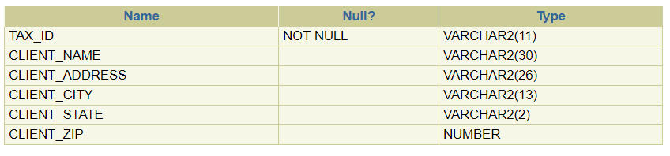

**DESC STOCK;**

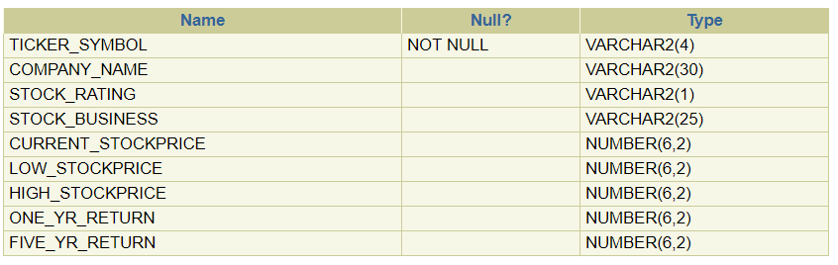

**DESC FUND_FAMILY;**

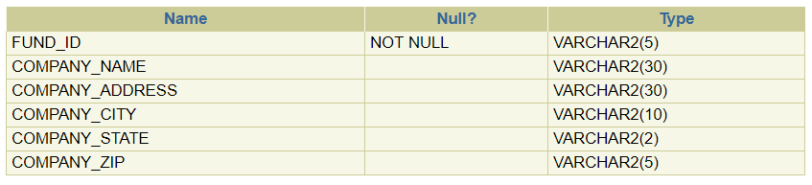

**DESC MUTUAL_FUND;**

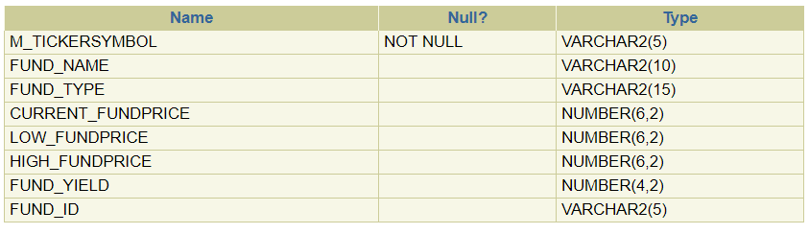

**DESC FUND_PORTFOLIO;**

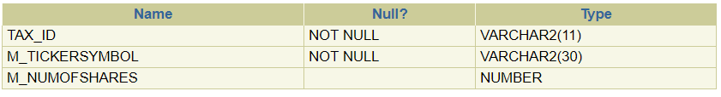

**DESC STOCK_PORTFOLIO**

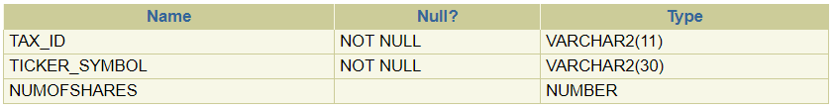

Database Entity Instances

**SELECT * FROM CLIENT;**

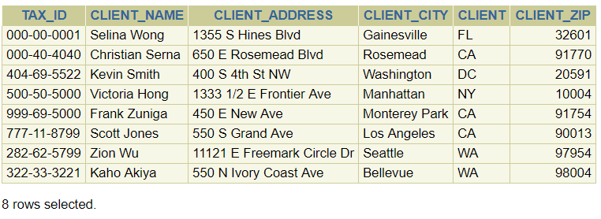

**SELECT * FROM STOCK;**

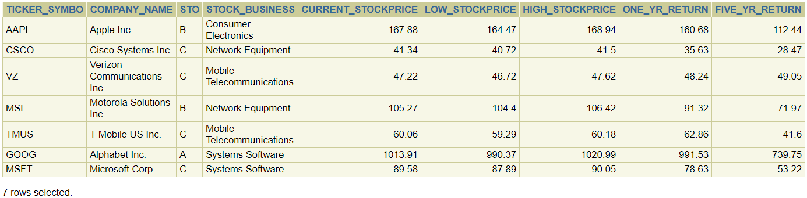

**SELECT * FROM FUND_FAMILY;**

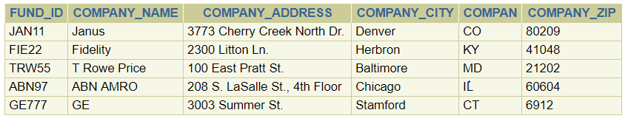

**SELECT * FROM MUTUAL_FUND;**

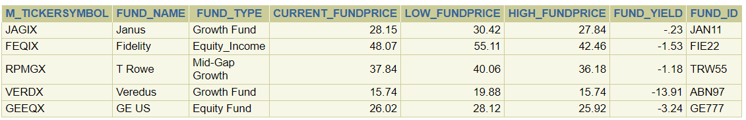

**SELECT * FROM FUND_PORTFOLIO;**

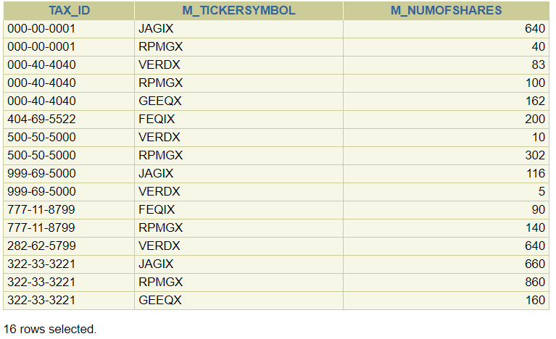

**SELECT * FROM STOCK_PORTFOLIO;**

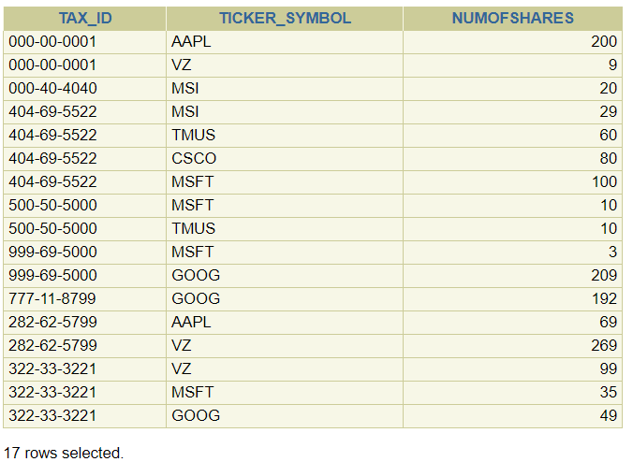

SQL Test Statements

**Change the zip code of client 000-00-0001 to client_zip 32505 and display the change.**

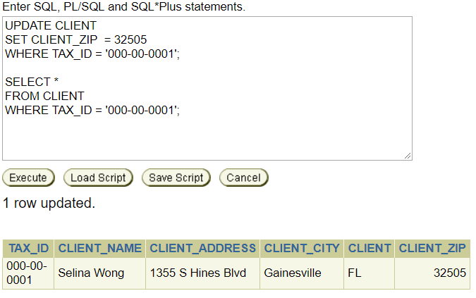

**Delete stock MSI, under tax ID 404-69-5522 and display the change.**

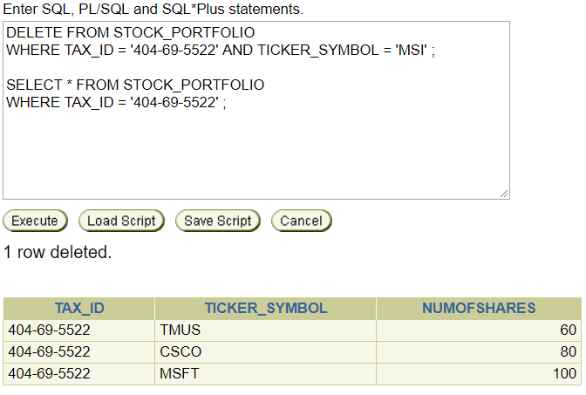

**Get the names of clients who invests in ticker symbol GOOG.**

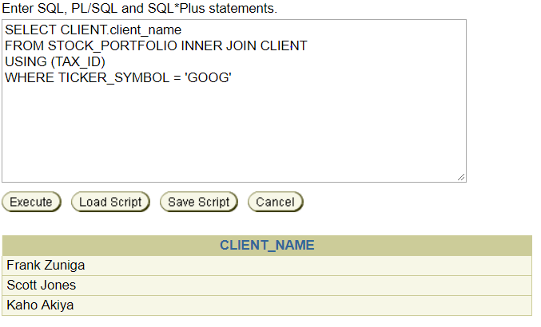

**Create View: Create a view for clients that are living in Los Angeles.**

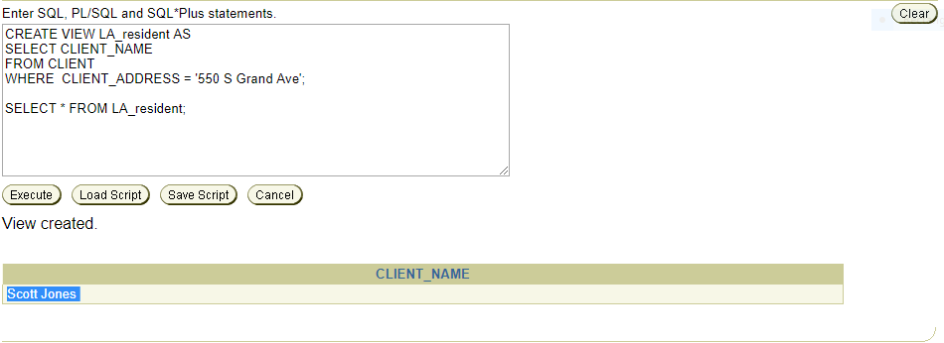

**Minimum, Maximum, and Average: Get the minimum, maximum, and average current stock prices for all stocks.**

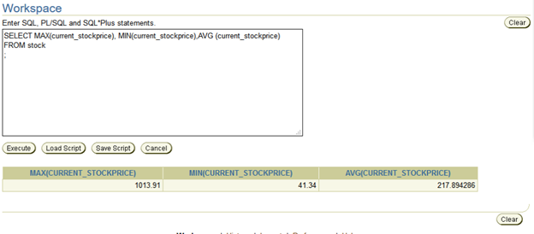

**Group by: List ticker symbols that has more than 2 clients investing in that stock.**

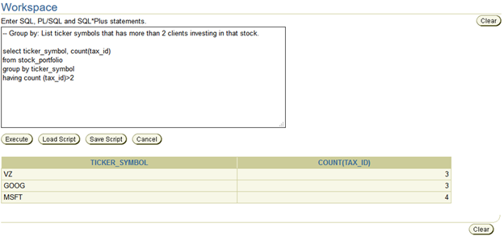

**Get client states which have more than 2 clients.**

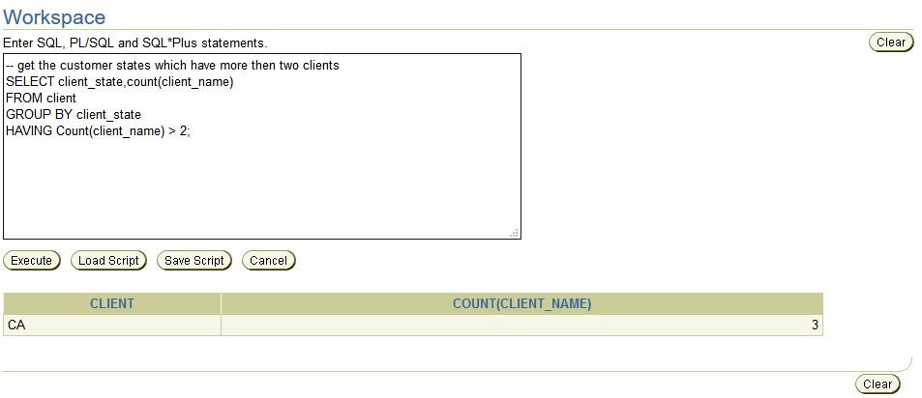

**List all current stock prices greater than $100.00 and current fund prices greater than $30.00 with their corresponding ticker symbols.**

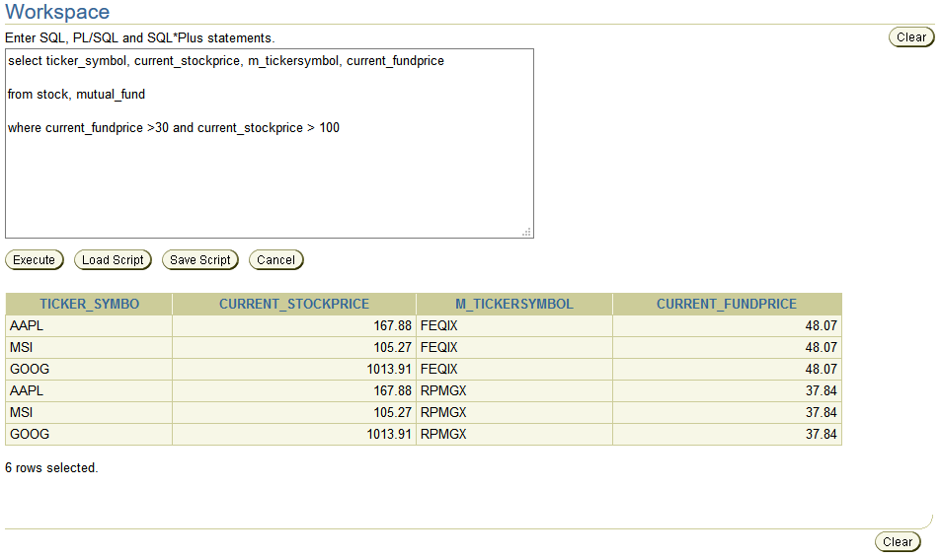

**List the company’s names, addresses, fund types, and current fund price of companies that share their name with a fund name**

