EPMS
Employee Performance Management System: Project Report
Name: Peerzada Moien U Zaman Enrolment No: A2305224084
Name: Saksham Ahluwalia Enrolment No: A2305224066
GitHub: https://github.com/XCubee/Employee-performance-management-system/tree/v3
(no config .ini api keys in github )

Problem Statement
Traditional employee performance management systems often rely on yearly reviews, lack regular feedback and do not provide enough transparency in the evaluation process. Employees may find it difficult to track their progress, understand their scores or raise concerns about unfair evaluations. Managers may also struggle to monitor employee workloads and assign tasks effectively. Therefore, there is a need for an Employee Performance Management System (EPMS) that makes performance tracking easier, improves communication between employees and managers, and ensures a fair, transparent and continuous review process.

1. About the Project
EPMS is a web application we developed to track employee performance and manage work. It has three types of logins: HR, Manager and Employee, each with a separate dashboard. Managers can assign goals and tasks, review employees and track their progress. Employees can check their marks and performance metrics and raise an appeal if they feel something is unfair. Our main aim was to make performance reviews more transparent and regular, rather than depending only on a yearly review.

2. What We Did
Before starting, we read some research papers on performance management to understand what makes a PMS effective. Based on these papers, we focused on fairness, regular feedback, clear goals and employee involvement. In the first two versions, we built the basic features like login, goals, reviews and feedback. In Version 3, we added employee profiles, manager approval for progress updates, a three-part marking system, a metrics page and an appeal system. We also improved task assignment by showing employee workload, skills and experience. We used Flask, Supabase, HTML, Jinja, Git and GitHub to build and manage the project.

Steps to Run
- Unzip the zip file
- pip install –r requirements.txt
- Initialize venv
- Python app.py
Note – The github doesn’t contain config.ini and does which contains the API keys
The zip file contains the API keys so pls unzip and use that for full functionality

Login credentials
Hr – sakshamahluwalia2802@gmail.com password – saksham
Manager-- sakshamahluwalia@gmail.com password – saksham
Employee – test@gmail.com password – test

STACK – HTML + PYTHON +SUPABASE(DB) for modularity in any device

3. Process Diagram
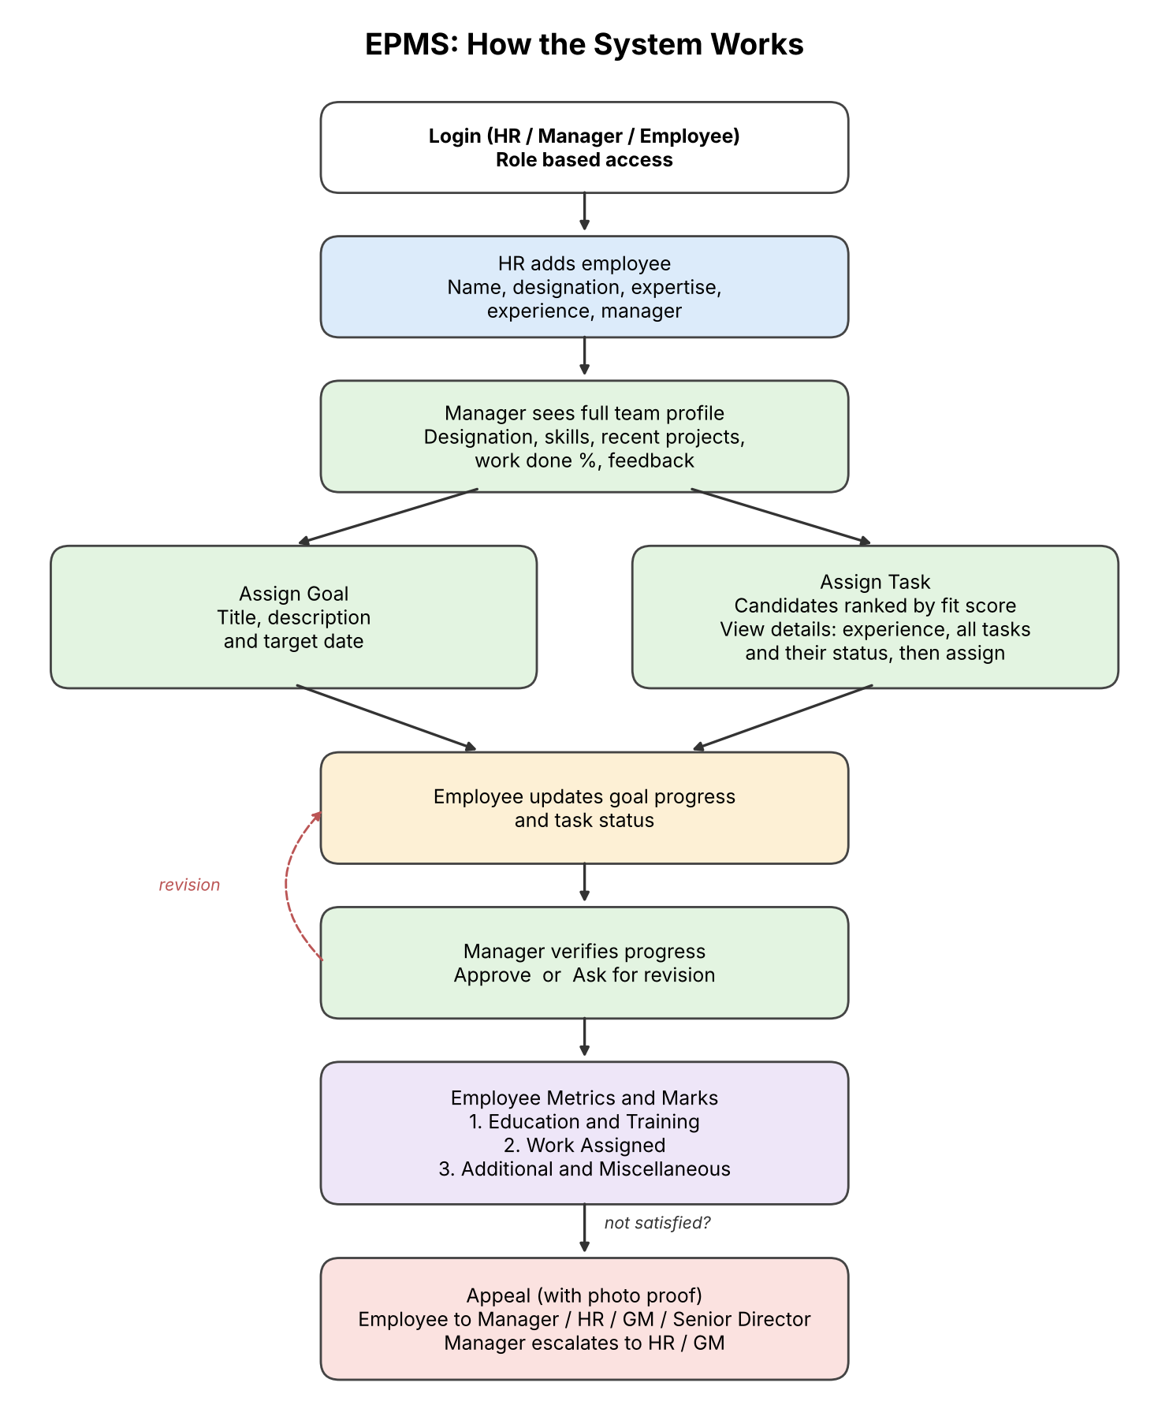
The flow is simple. HR adds an employee. The manager gives goals and tasks. The employee updates the work. The manager checks it and either approves it or sends it back. After that the marks and metrics show up for the employee, and if they are not happy with it, they can file an appeal.

4. Project Screenshots
Below are screenshots of the main pages, with a short note on what each page does.
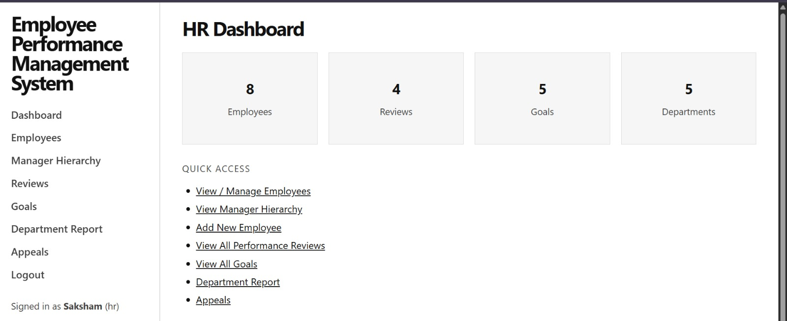
Figure 1: HR Dashboard
This is the first page HR sees after login. The cards on top show how many employees, reviews, goals and departments are there in the system. Below that, HR gets quick links to add employees, see the hierarchy, check reviews and handle appeals.
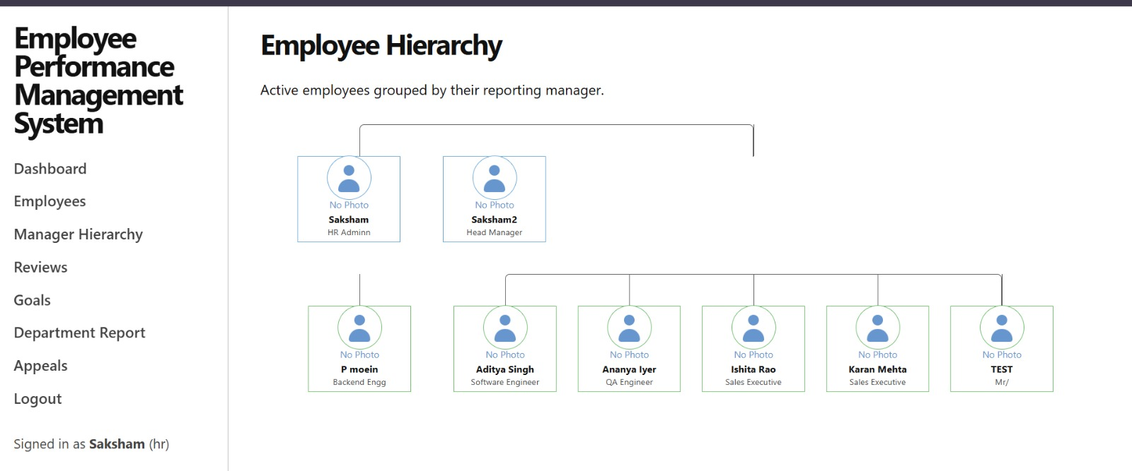
Figure 2: Employee Hierarchy
Here HR can see who reports to whom. Every employee is shown under their manager with their name and designation, so the structure of the team is clear in one look.
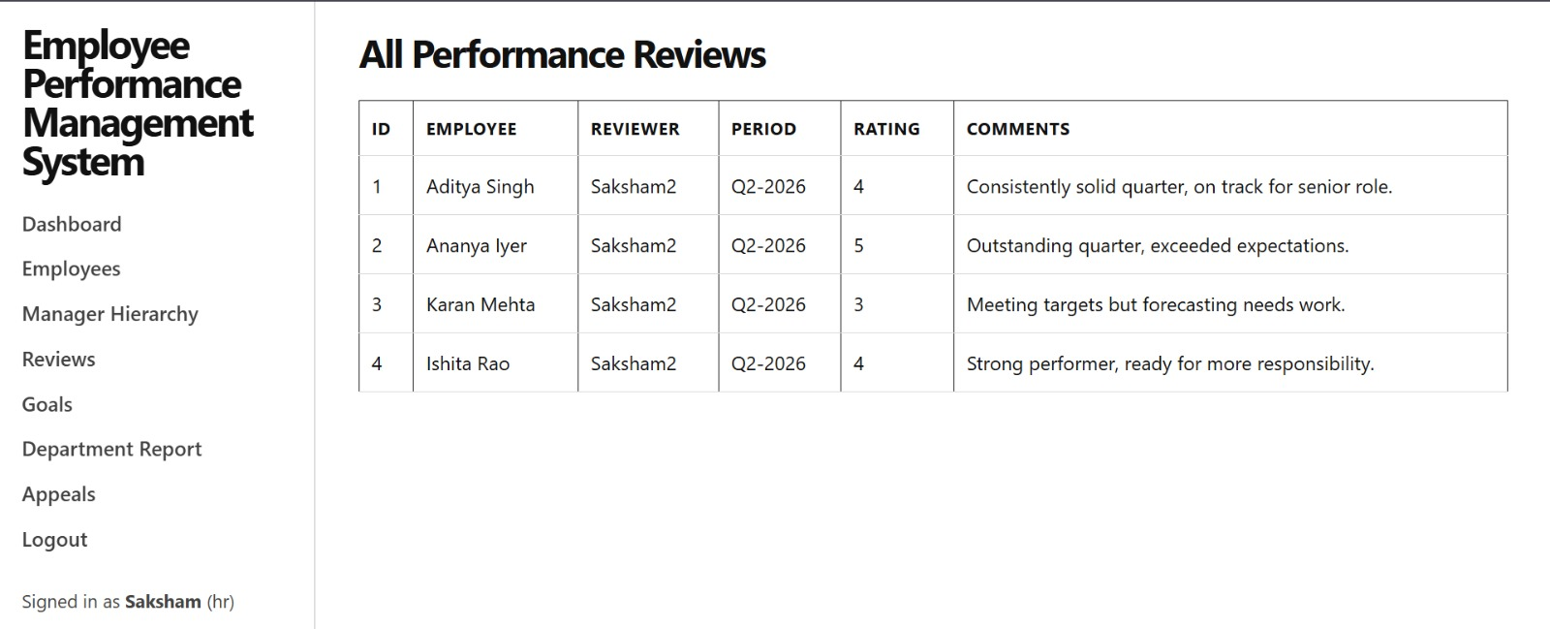
Figure 3: All Performance Reviews
This page lists every review given in the company. For each one, HR can see the employee, the person who reviewed them, the period, the rating out of 5 and the comments.
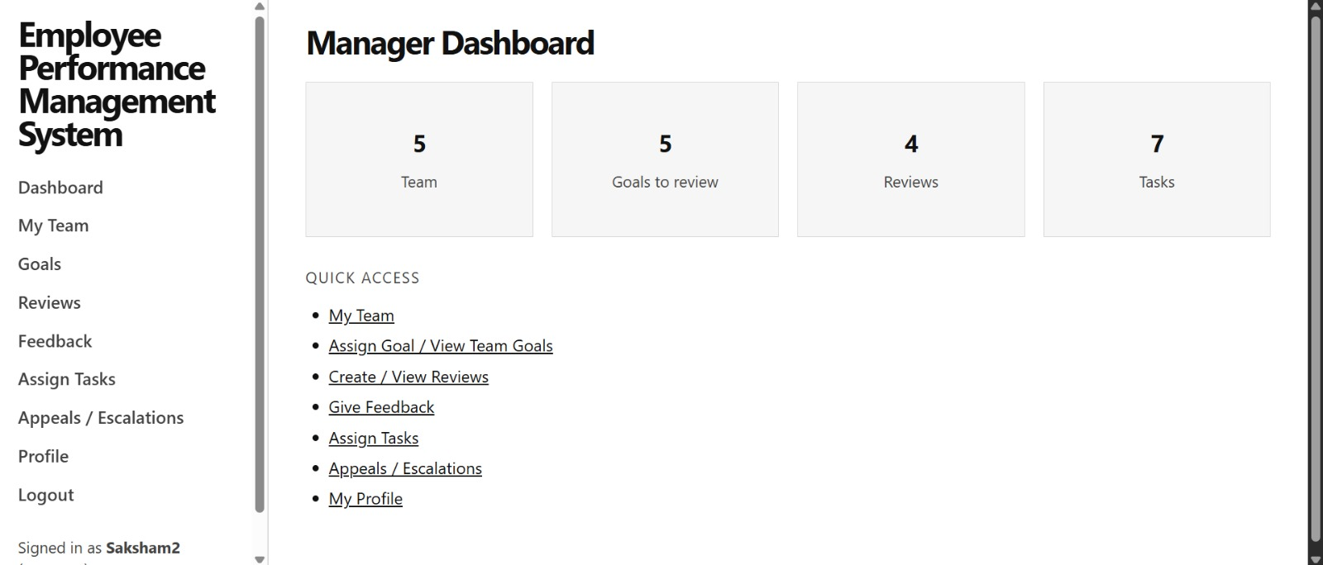
Figure 4: Manager Dashboard
When a manager logs in, they see their team size, goals waiting for review, reviews written and tasks given. The quick links take them to the main things they do daily.
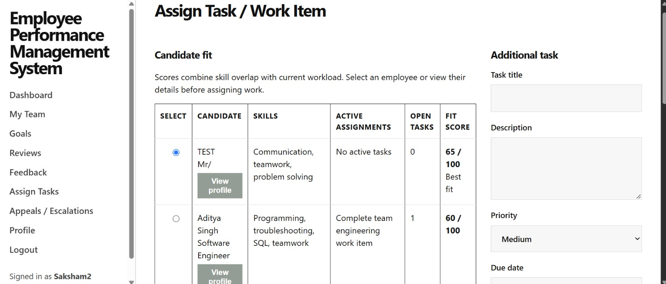
Figure 5: Assign Task
Before giving a task, the manager sees a list of team members with their skills, open tasks and a fit score out of 100. The person with the best fit comes on top. The "View profile" button shows more details about the person, and the form on the right is used to assign the task.
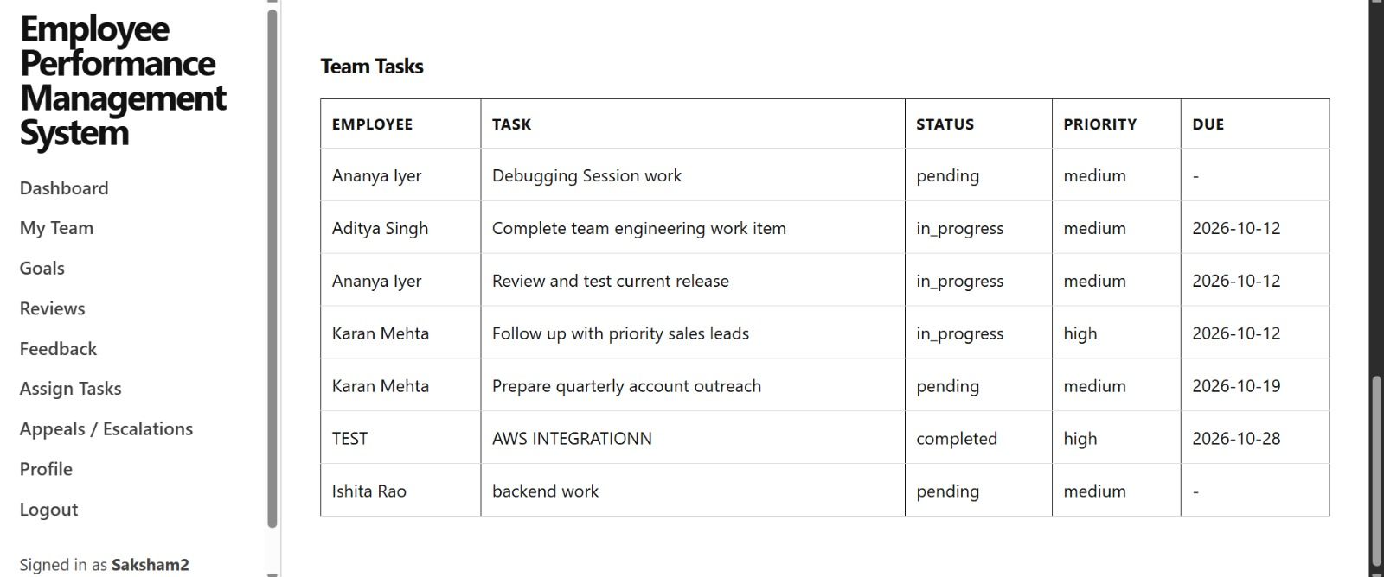
Figure 6: Team Tasks
This table shows all tasks given to the team. The manager can check who is doing what, the current status, priority and due date of each task.
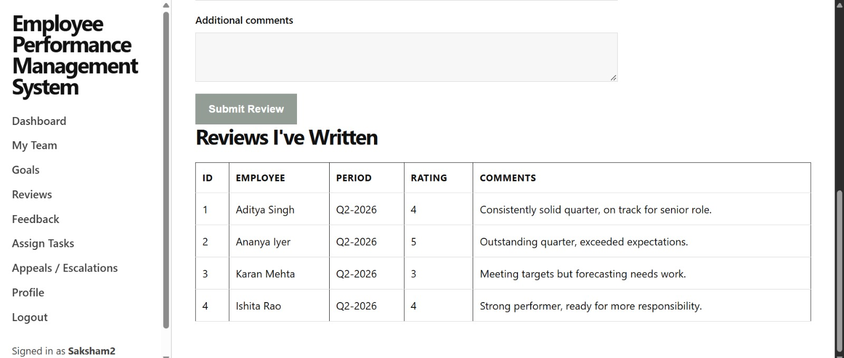
Figure 7: Writing Reviews
The manager fills a short form with rating and comments to review a team member. All reviews written by the manager are listed below the form.
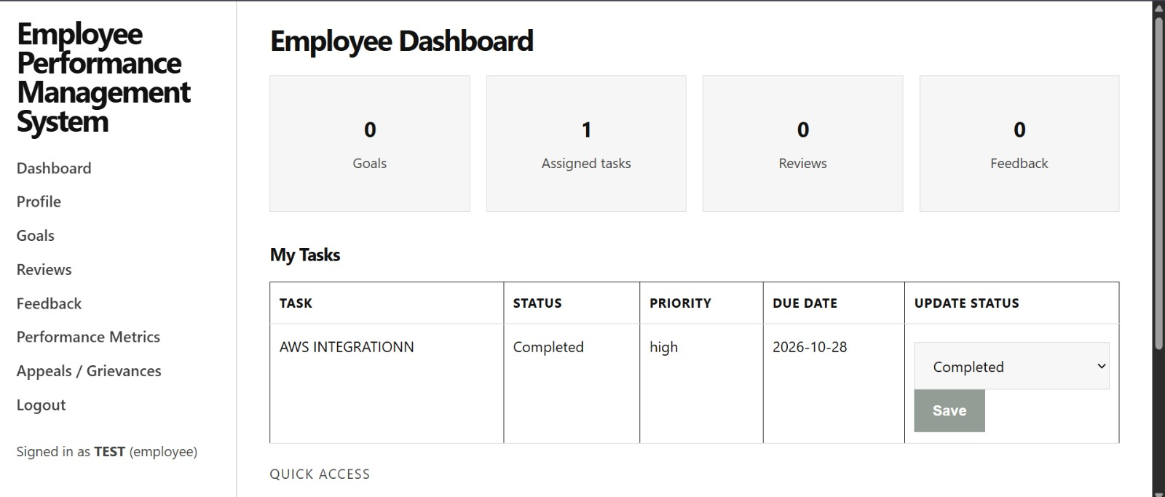
Figure 8: Employee Dashboard
The employee sees how many goals, tasks, reviews and feedback they have. Under "My Tasks" they can change the status of a task and click Save, so the manager knows the progress.
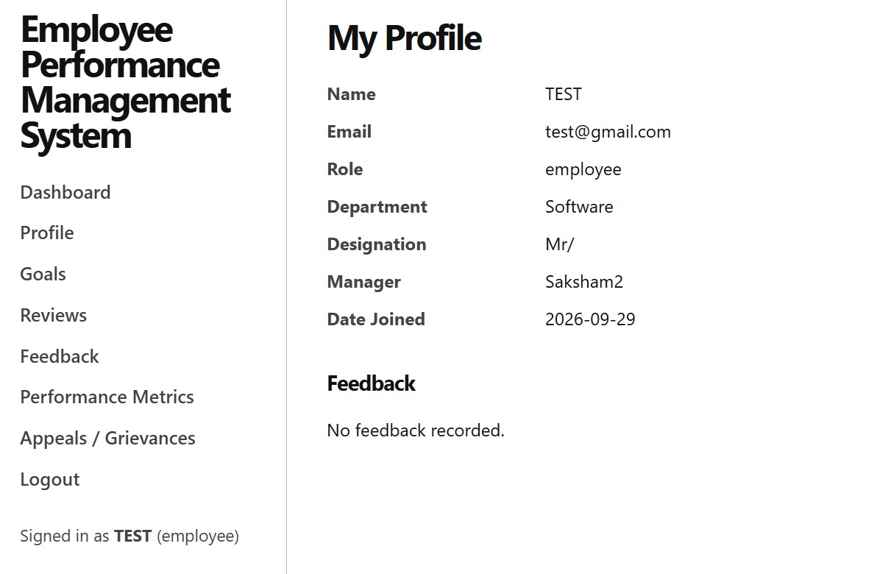
Figure 9: Employee Profile
This page shows the employee's own details like department, designation, manager and joining date. Any feedback from the manager also shows up here.

5. Summary and Result
We were able to build a working EPMS where HR, managers and employees each have their own access. In Version 3 most of our work went into making the system more fair and open for the employee. The table below shows how the points from the papers we read are handled in our project.
All the changes we planned for Version 3 are done and pushed to the v3 branch on GitHub.

6. Final Outcome
- We have a working web based EPMS with separate access for HR, managers and employees.
- Managers can look at a person's profile and current workload before giving them new work.
- Employees can see their marks, tasks, goals and feedback in one place.
- Progress only counts once the manager approves it, and employees have a proper way to raise complaints.

7. Future Work
- Add AI to help managers write feedback and to suggest training, while keeping employee data private and the results unbiased.
- Calculate marks fully from real data. Right now some default marks are estimated when HR has not entered them.
- Add notifications, feedback from teammates, self appraisal and charts that show progress over time.
- Make the site work better on mobile and switch to a stronger password hashing method like bcrypt.

8. References
Awan, S. H., Habib, N., Akhtar, C. S., & Naveed, S. (2020). Effectiveness of performance management system for employee performance through engagement. SAGE Open, 10(4). https://doi.org/10.1177/2158244020969383
Rahmita, S., Fahmy, R., & Syahrul, L. (2025). The building blocks of an effective performance management system: A comprehensive review. Journal of Management and Digital Business, 5(1), 13-34.
https://doi.org/10.53088/jmdb.v5i1.1512
Duda, J., Flynn, J., Cantrell, S., Scoble-Williams, N., & Sanford, A. (2025, March 23). Reinventing performance management processes won't unlock human performance. Here's what will. Deloitte Insights.
https://www.deloitte.com/us/en/insights/topics/talent/human-capital-trends/2025/employee-performance-management-optimization-effective-strategy.html

