Step 1 :
Versions :
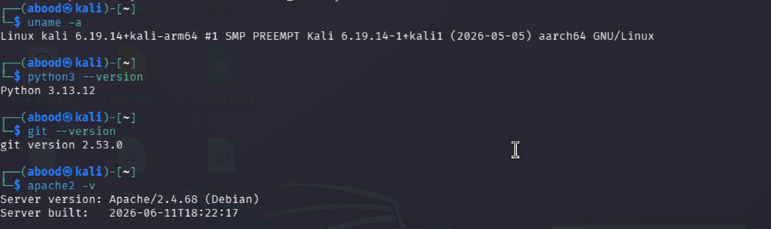

Directory :


Git init :
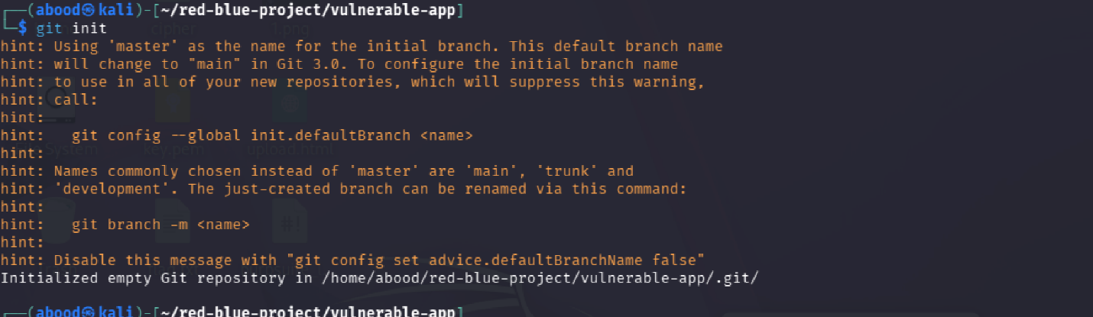

Step 2 :
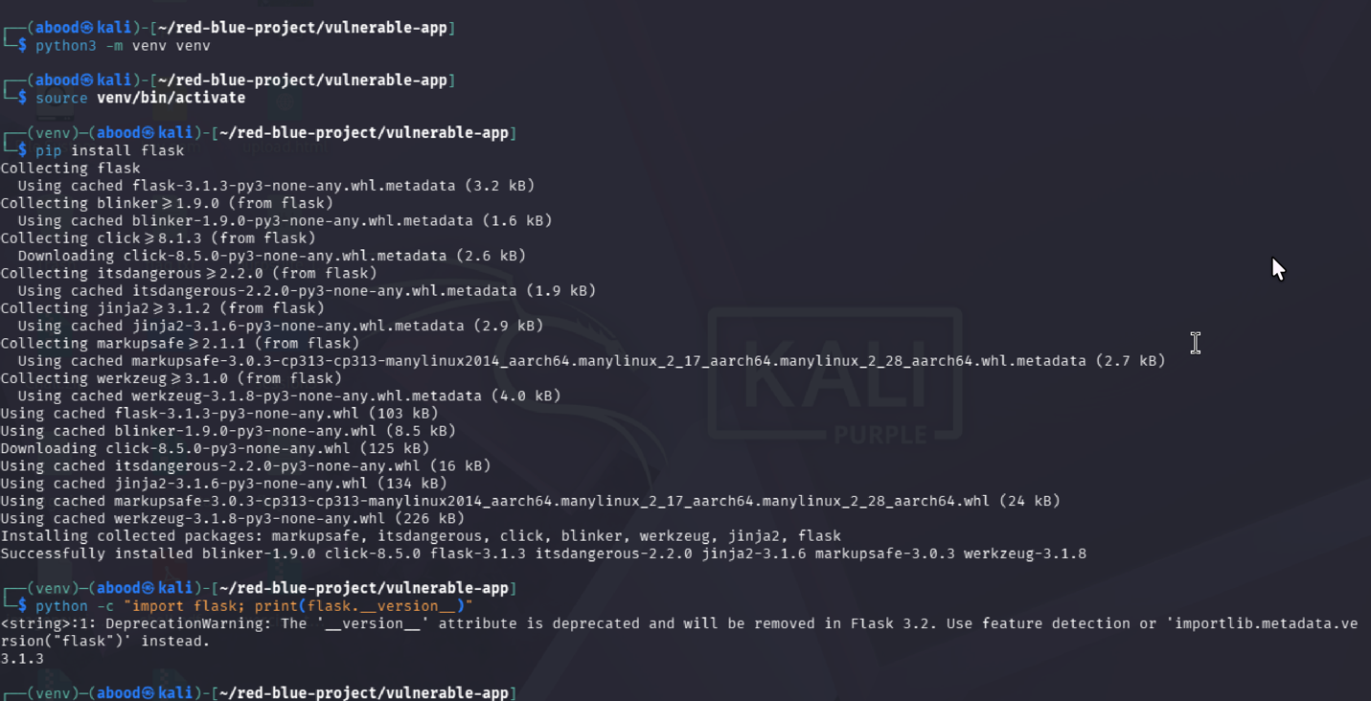

Step 3 :
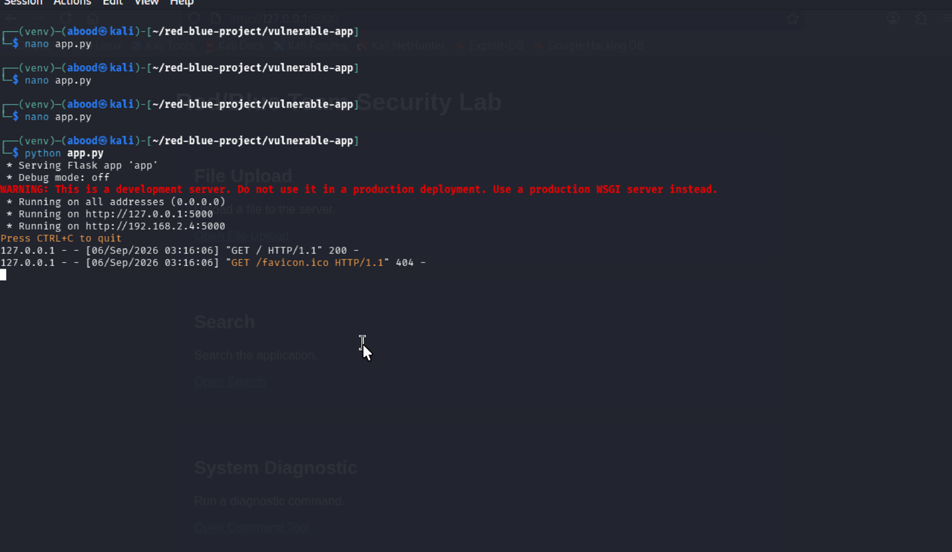
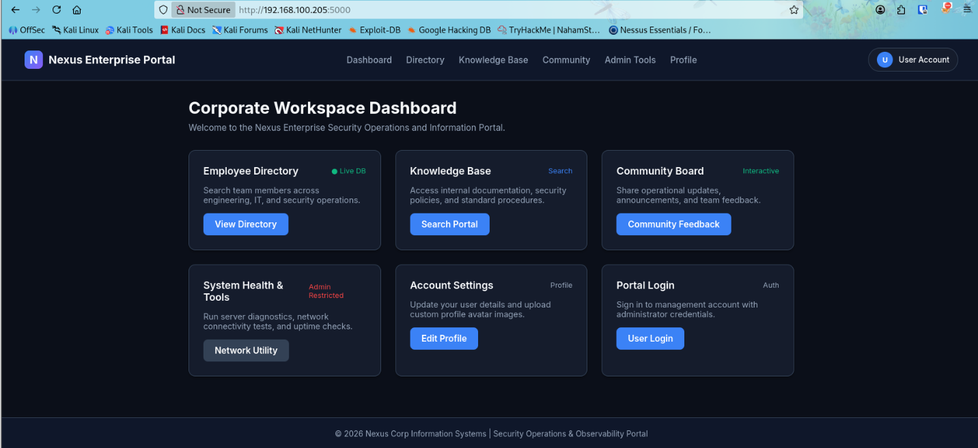

Step 4: logs
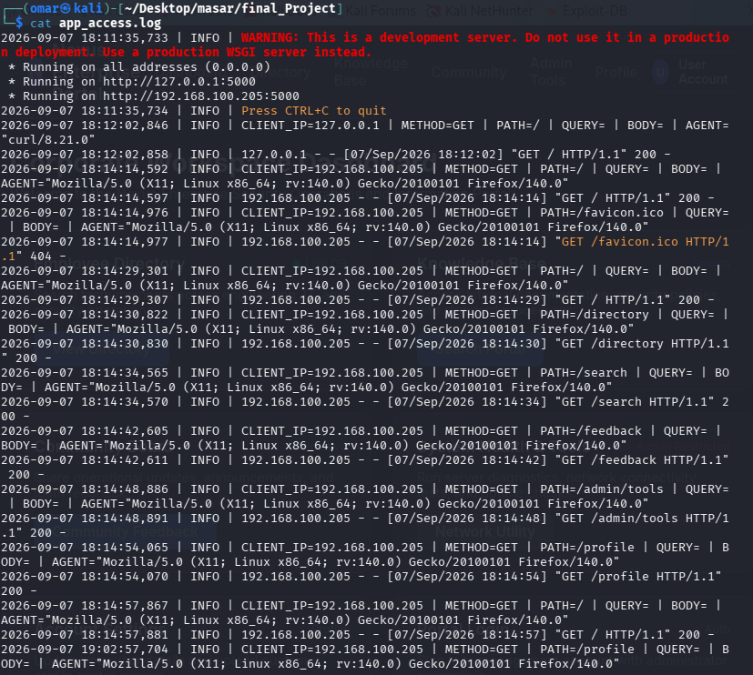

Log File Location
/home/omar/Desktop/masar/final_Project/app_access.log

SIEM Log Structure
Every HTTP request generates a structured log line formatted as follows:

YYYY-MM-DD HH:MM:SS,ms | INFO | CLIENT_IP=<ip> | METHOD=<method> | PATH=<path> | QUERY=<query> | BODY=<body_payload> | AGENT="<user_agent>"
Sample Log Entries Generated During Exploitation
1. File Upload Log Example:
2026-09-07 18:15:00,123 | INFO | CLIENT_IP=192.168.1.50 | METHOD=POST | PATH=/profile | QUERY= | BODY=FilesUploaded: ['webshell.py'] | AGENT="Mozilla/5.0"
2. Command Injection Log Example:
2026-09-07 18:16:10,456 | INFO | CLIENT_IP=192.168.1.50 | METHOD=POST | PATH=/admin/tools | QUERY= | BODY={'host': '127.0.0.1; id; uname -a'} | AGENT="Mozilla/5.0"
3. XSS Log Example:
2026-09-07 18:17:20,789 | INFO | CLIENT_IP=192.168.1.50 | METHOD=GET | PATH=/search | QUERY=q=%3Cscript%3Ealert%28%27XSS%27%29%3C%2Fscript%3E | BODY= | AGENT="Mozilla/5.0"
4. SQL Injection Log Example:
2026-09-07 18:18:30,912 | INFO | CLIENT_IP=192.168.1.50 | METHOD=POST | PATH=/login | QUERY= | BODY={'username': "admin' OR '1'='1", 'password': 'foo'} | AGENT="Mozilla/5.0"

Step 5: Apache
Enable proxy modules in Apache and creating the VirtualHost configuration file:
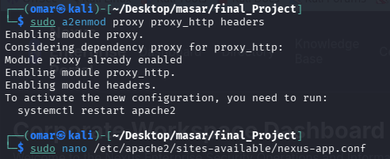
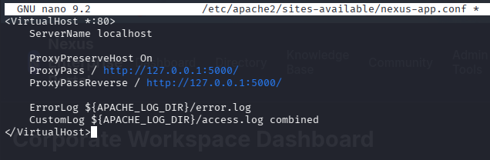
Activate the site and restart Apache:
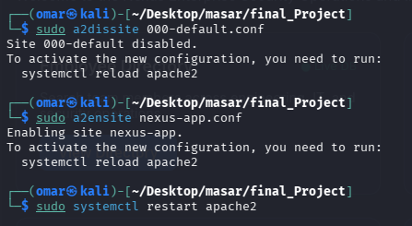
when anyone visits http://<VM1-IP>/ (default port 80), Apache serves the website and logs every request into /var/log/apache2/access.log.
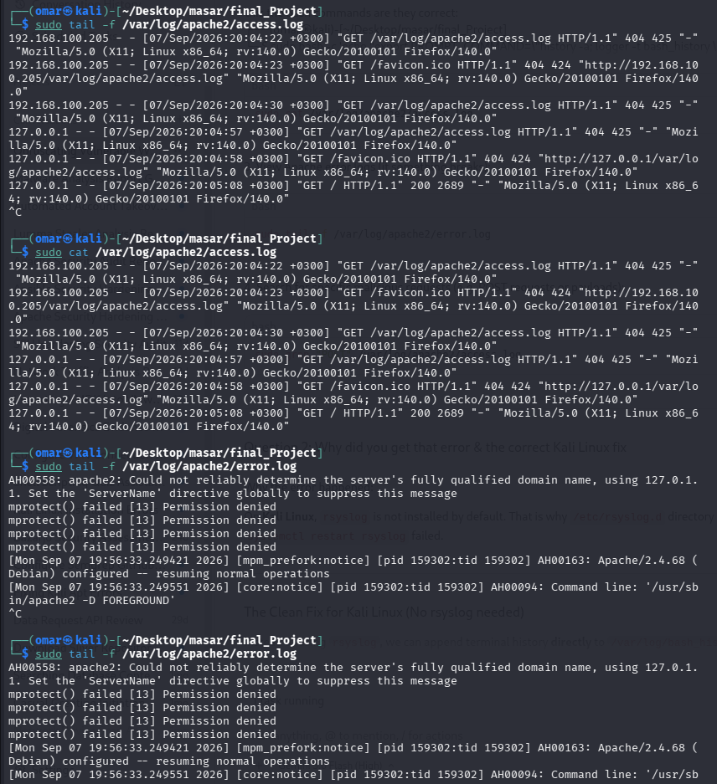

Step 6: Bash
Add history logger to bash configuration and then direct bash_history logs to /var/log/bash_history.log
Testing the bash logs system:
