# Tesla Stock Prices EDA

## **Correlation Matrix**, to understand the strength of relationships between data columns:

Figure 1, correlation matrix.

The correlation matrix shows that all daily price metrics are strongly interrelated, whereas trading volume plays the role of a bystander, showing little connection to price levels. For modeling and report writing, it is recommended to choose a primary price metric (such as closing price) and use trading volume only when interpreting exceptional events.

# **Tesla stock price evolution over time:**

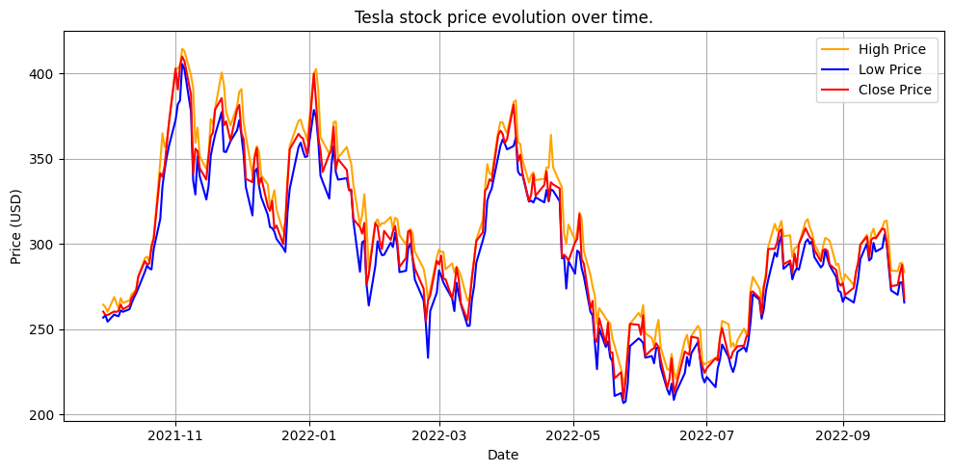

Figure 2, Tesla stock price evolution over time.

Figure 2 tracks Tesla stock price evolution over time (High, Low, Close) during the period from October 2021 to October 2022, and shows:

* A strong surge from around $260 to a peak of approximately $415 in November 2021, followed by a correction to around $300 by the end of the year.
* A significant decline during the first and second quarters of 2022, reaching a low of approximately $210 in May, influenced by global market conditions.
* A gradual recovery during the summer to around $250–260, followed by relative stability around $280–300 by the end of the period.

## **The average monthly closing price of Tesla stock:**

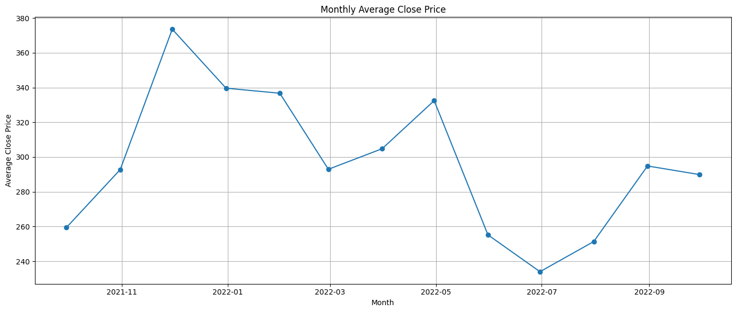

Figure 3, The average monthly closing price of Tesla stock.

The average monthly closing price rose sharply at the end of 2021 to around $374 USD, then gradually declined to a low of approximately $234 USD in July 2022, before experiencing a partial recovery and stabilizing around $260–280 USD in the following months.

## **Moving Average Crossover Signals (7-day and 30-day):**

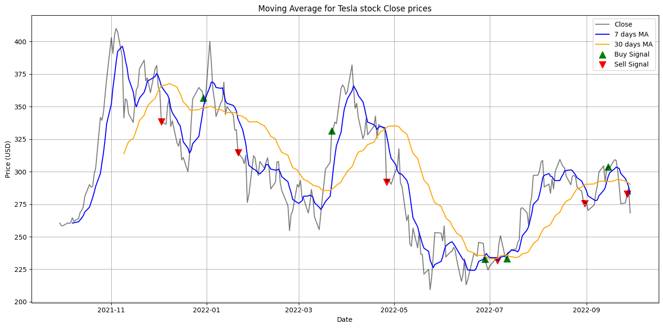

Figure 4, Moving Average Crossover Signals (7-day and 30-day)

Figure 4 displays two simple moving average (SMA) lines for short-term and long-term periods (SMA7 and SMA30) plotted over daily closing prices, with markers indicating Golden Cross moments (when SMA7 crosses above SMA30) and Death Cross moments (when SMA7 crosses below SMA30).

|  |  |  |
| --- | --- | --- |
| Crossover type | Date | Close price(USD) |
| Golden Cross | 15th Nov 2021 | 400 |
| Death Cross | 10th Jan 2022 | 310 |
| Golden Cross | 5th Apr 2022 | 260 |
| Death Cross | 20th May 2022 | 220 |
| Golden Cross | 1 Aug 2022 | 280 |

* **Golden Cross**: Indicates a short-term shift toward an upward trend, where the price recovers after the short-term moving average breaks above the long-term average.
* **Death Cross**: Suggests a potential start of a downward wave, as the short-term moving average drives the long-term moving average downward.

## **Distribution of Tesla's Daily Returns:**

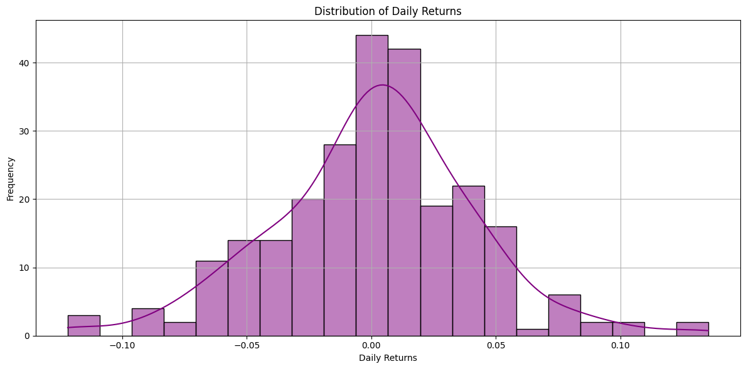

Figure 5, Distribution of Tesla's Daily Returns.

Figure 5 presents a histogram of the distribution of daily returns calculated based on the closing price (Close) during the period from October 2021 to October 2022. The data was divided into 50 bins to display the frequency density of different return values.

1. Distribution center:

* Mean: Approximately 0.001 (0.1%), indicating that the average daily return is slightly positive.
* Median: Very close to the mean, suggesting a relative balance between up and down days.

1. Dispersion and standard deviation:

* Standard deviation: Approximately 0.025 (2.5%), reflecting moderate to relatively high daily volatility.
* Half of the periods (between the first and third quartiles) fall within a relatively narrow volatility range around the mean.

1. Tails:

* The distribution shows longer side tails than a normal distribution, particularly on the negative side:
* Large negative return days (less than –5%) are more extreme than comparable positive days.
* This suggests a higher likelihood of sudden sharp downturns compared to unexpected upswings.

1. General overview:

* The distribution clustering around zero indicates that the market doesn't tend toward extreme daily rises or falls, except during exceptional events (earnings reports, official announcements).
* A slight rightward (positive) skew aligns with the mildly positive average daily return.

1. Summary:

* The daily return distribution centers around 0.1% with a standard deviation of 2.5%, showing longer downside tails compared to upside ones, indicating a higher likelihood of sharp downturns than sudden upswings.

## **The evolution of Tesla's daily trading volume:**

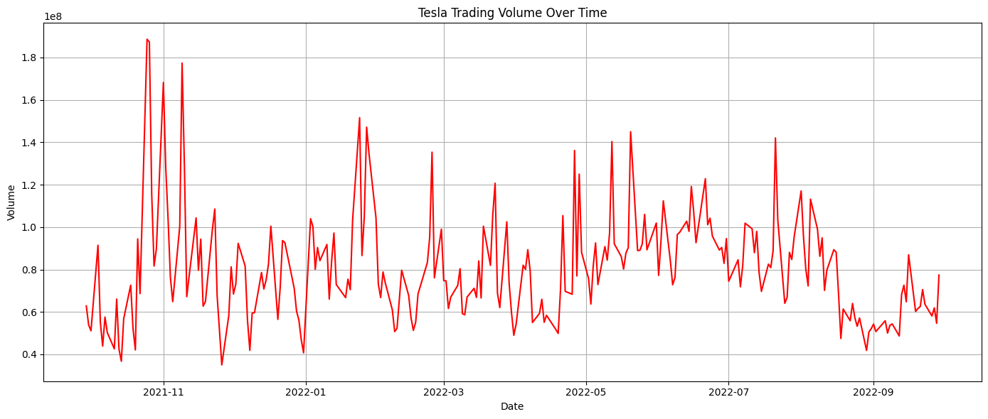

Figure 6, The evolution of Tesla's daily trading volume.

Figure 6 displays the curve of daily trading volume during the period from October 2021 to October 2022, with the time axis plotted horizontally and the number of shares traded daily (in millions) plotted vertically.

1. **General Average:**

* Average daily trading volume: approximately 80 million shares. This level represents the baseline around which most values fluctuate, with slight increases and decreases.

1. **Major Trading Peaks** Several notable peaks exceeding 150 million shares traded in a single day were observed, including:

* **Late October 2021**: Coincided with the announcement of Q3 results and the expansion of the Berlin factory.
* **November 2021**: A strong buying wave led to a price peak, accompanied by heightened trading activity.
* **May 2022**: Marked by a price peak followed by a correction, during which investors engaged in significant profit-taking.

1. **Quiet Periods:**

* **During the summer (June–August 2022), trading volume declined slightly, ranging between 50–70 million shares per day. This was accompanied by a decrease in speculative activity and a stronger focus on production data.**
* **This drop reflects a relatively stable phase in trading momentum.**

1. **Seasonal Volatility:**

* **Recurring Pattern A sharp increase in volume often occurs upon the release of financial news or earnings calls, followed by a gradual decline.**
* **Relationship with Volatility High-volume days are frequently accompanied by significant price surges or drops (as observed in the return distribution), underscoring volume’s role as an indicator of event intensity.**

1. **Summary:**

* **Figure 6 shows that the average daily trading volume centers around ~80 million shares, with peaks exceeding 150 million on days of major announcements and profit-taking. Activity declines during the summer to 50–70 million shares, reflecting seasonal slowdown, while high volume is typically associated with strong price movements.**

## **30‑Day Rolling Volatility of Tesla’s Closing Price:**

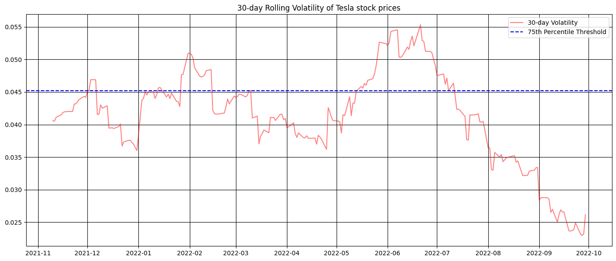

Figure 7, **30‑Day Rolling Volatility of Tesla’s Closing Price**

Figure 7 plots the rolling 30‑day volatility of Tesla’s daily closing returns over the period from October 2021 to October 2022. Volatility here is defined as the standard deviation of daily returns over the prior 30 trading days, indicating how much the stock price typically fluctuates month‑to‑month.

1. **Overall Volatility Level:**

* Annualized Volatility Estimate: By scaling the average 30‑day volatility (≈3%) by √252 trading days, Tesla exhibits roughly 40–45% annualized volatility, marking it as significantly more volatile than many blue‑chip stocks.
* Typical 30‑Day Volatility: Most readings fall between 2.5% and 3.5%, reflecting moderate to high month‑long price swings.

1. **Peak Volatility:**

* The highest spike reaches about 5.5% in late June 2022.
* This corresponds with Tesla’s trough near $210 and broader macroeconomic fears—rising interest rates and inflation—driving large daily price swings.
* A 5.5% daily volatility implies that over a month the price range was more than twice its usual breadth.

1. **Troughs and Stabilization Periods:**

* Volatility declines to about 2.7% by late September 2022, reflecting easing investor anxiety and more stable trading conditions.
* During mid‑summer (July–August 2022), volatility gradually falls from 5% to 3%, indicating a return to relative calm after the spring correction.

1. **Seasonal Patterns:**

* Spikes coincide with corrective phases (February–May 2022), when volatility routinely exceeded 4%.
* Lulls align with consolidation (August–September), with volatility dipping closer to its long‑term average.

1. **Summary**:

* Tesla’s 30‑day rolling volatility peaked at 5.5% in June 2022 amid sharp market downturns, then eased to 2.7% by late September. On an annualized basis, the stock shows roughly 40–45% volatility, with clear upticks during market corrections and declines during stabilization periods.

## **Cumulative Returns:**

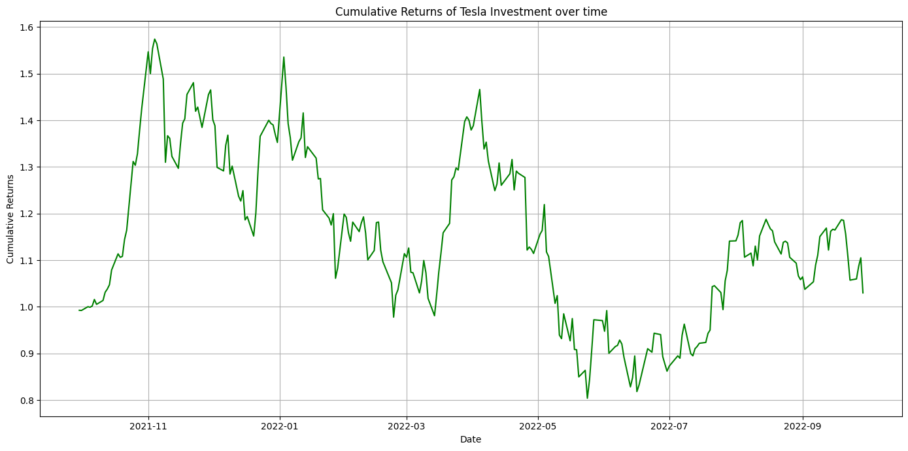

Figure 8, Cumulative Returns of Tesla Investment over time.

Figure 8 shows the **cumulative return** of a hypothetical $1.00 investment in Tesla’s closing price from October 2021 through October 2022.

1. **Initial Surge:**

* The investment value rises from **1.00** to approximately **1.57** by late November 2021, mirroring Tesla’s climb from around $260 to $415.

1. **Mid‑Period Correction:**

* Entering 2022, the value declines to **1.15** by mid‑January, then falls further to a **0.80** low by late May 2022, corresponding with the stock’s trough near $210.

1. **Partial Recovery:**

* After the May trough, the investment rebounds to roughly 1.00 by July 2022, as prices recover to around $260.

1. **End‑Period Stabilization:**

* From August through September 2022, cumulative returns stabilize in the 1.05–1.10 range, indicating a consolidation phase ahead of potential future moves.

1. **Summary:**

* Cumulative returns start at 1.00, peak near 1.57 in November 2021, drop to 0.80 in May 2022, and then partially recover to about 1.05–1.10 by the end of the period.

## **Average Cumulative Return by Month:**

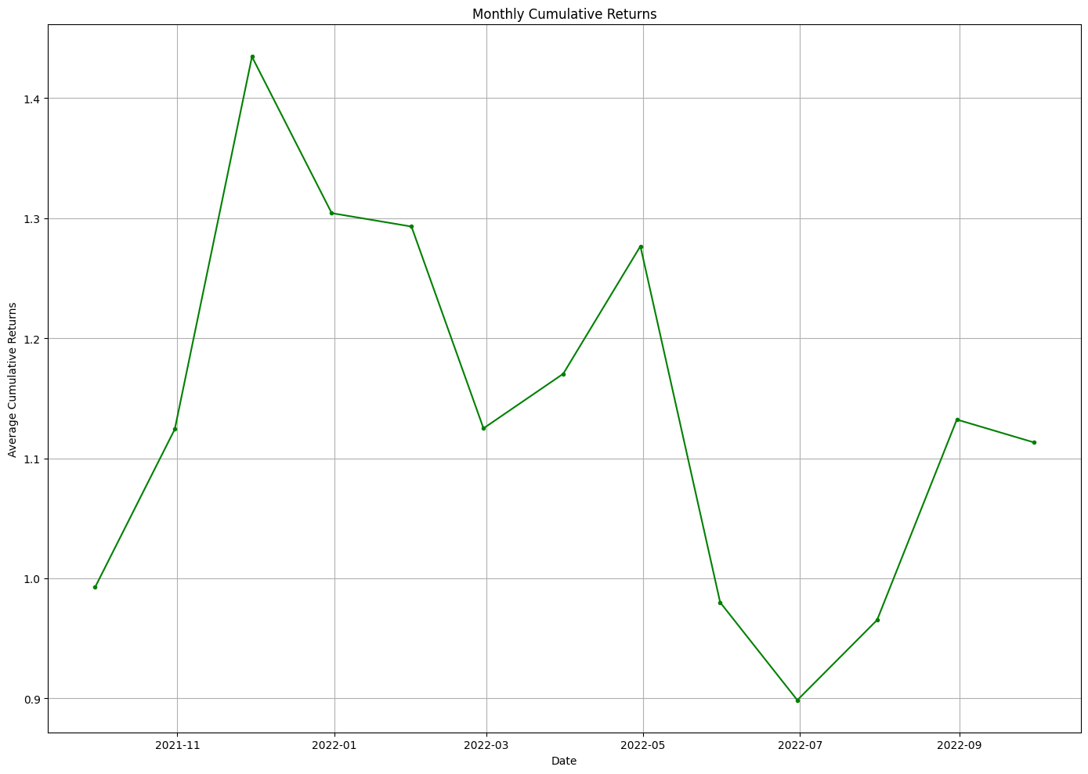

Figure 9, Average Cumulative Return by Month.

Figure 9 presents a bar chart of the average cumulative return of a hypothetical $1 investment in Tesla, broken down by calendar month over the period October 2021–October 2022. Each bar shows how much $1 would have grown or shrunk on average if held through that specific month across the sample.

1. **Strong Year‑End Performance:**

* **November 2021** and December 2021 show the highest monthly averages, around 1.20× and 1.15× respectively.
* This reflects the substantial rally that propelled the stock from roughly $260 to over $400 in Q4 2021.

1. **Gradual First‑Quarter Decline:**

* **January**2022 holds around 1.15×, but February dips to about 1.10× and March to 1.05×, indicating profit‑taking and the onset of broader market headwinds.

1. **Weakness in Late Spring:**

* **April 2022** averages near 1.00×, and May 2022 is the weakest, around 0.90×, coinciding with Tesla’s trough near $210 and macroeconomic concerns.

1. **Partial Summer Recovery:**

* **June and July 2022** rebound to roughly 0.95× and 1.00× respectively, showing an initial recovery.
* **August–September 2022** continue this trend with averages around **1.05×**, reflecting consolidation.

1. **October Trend:**

* **October 2022** holds near 1.06×, similar to September, suggesting stability heading into Q4.

1. **Summary:**

* **Month‑by‑month, Tesla’s** best average returns occur in Nov–Dec (≈1.15–1.20×), while May is the weakest (~0.90×). The sequence illustrates a strong year‑end rally, a mid‑spring pullback, and a modest summer recovery, supporting the idea of a seasonal tilt toward Q4.

## **Boxplot of Tesla’s Closing Prices:**

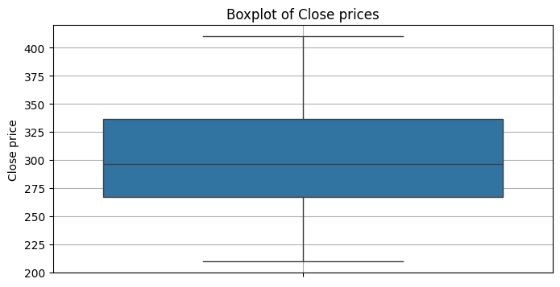

Figure 10, Boxplot of Tesla’s Daily Closing Prices.

Figure 10 presents a boxplot summarizing the distribution of Tesla’s closing prices from October 2021 to October 2022.

1. **Median (Q2):**

* The **bold line** inside the box lies at approximately $295, indicating that half of the closing prices are below $295 and half above.
* Notably, the median is closer to the lower edge of the box than to the upper edge, revealing a right‑skewed distribution: there are more days with moderately lower closing prices, while a smaller number of days with very high prices stretch the upper tail.

1. **IQR:**

* The box spans from the 25th percentile ($269) to the 75th percentile ($334), so the middle 50% of closing prices fall within this $65 range.

1. **Whiskers (Range without outliers):**

* The **lower whisker** extends down to around $209, matching the minimum observed close.
* The **upper whisker** reaches up to about $406, the maximum closing price in the dataset.

1. **Symmetry and Skew:**

* The **longer upper whisker** and off‑center median both confirm a moderate right skew, driven by a few high‐price spikes during the year.
* No individual points are plotted as outliers beyond the whiskers, suggesting the full observed range is treated as part of the typical variation.

## **Distribution of Close Prices:**

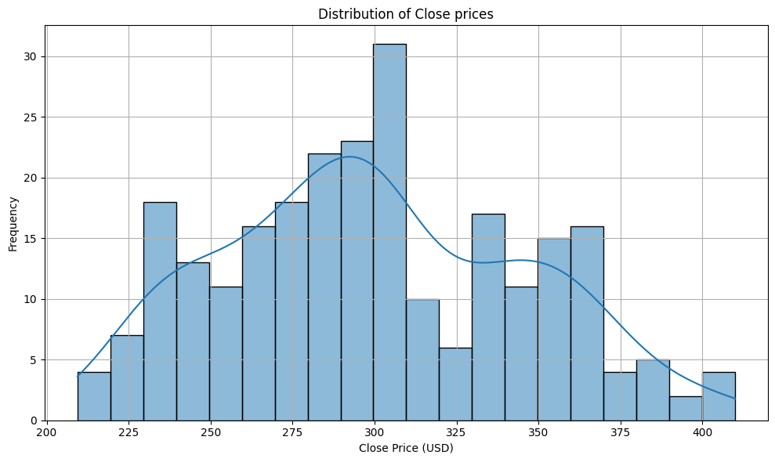

Figure 11, Distribution of Tesla’s Daily Closing Prices with Histogram & KDE.

Figure 11 overlays a histogram of Tesla’s daily closing prices (October 2021–October 2022) with a Kernel Density Estimate (KDE), revealing both **multiple peaks** (modes) and **asymmetric tails**. Below is a comprehensive breakdown.

1. **Number and Location of Peaks (Modes):**
2. **Peak 1 (~$230–$240):**

* Corresponds to the market trough around May 2022, when price dropped sharply into the low $200s.

1. **Peak 2 (~$270–$280):**

* Reflects a transitional phase during spring recovery (June–July 2022), when prices oscillated in the upper $200s.

1. **Peak 3 (~$295–$305) (Highest/Primary Mode):**

* The most frequent closing price cluster, capturing much of the mid‑period trading range.
* Encompasses 30+ trading days, indicating prolonged stability around $300.

1. **Peak 4 (~$350–$360):**

* A secondary high‑price cluster, representing shorter-lived rallies in late 2021 and occasional summer spikes.

In **Summary**, figure 11’s KDE reveals **four key price clusters** at $230–240, $270–280, $295–305 (primary), and $350–360. The distribution is **moderately right‑skewed**—the right tail extends further, indicating occasional high‑price spikes, while the left tail drops off steeply around the May 2022 trough. This multimodal pattern reflects several distinct market regimes throughout the year.