- K8s集群的安装
本实验采用腾讯云K8s集群服务（TKE）。
  - 创建集群
初始信息配置如下
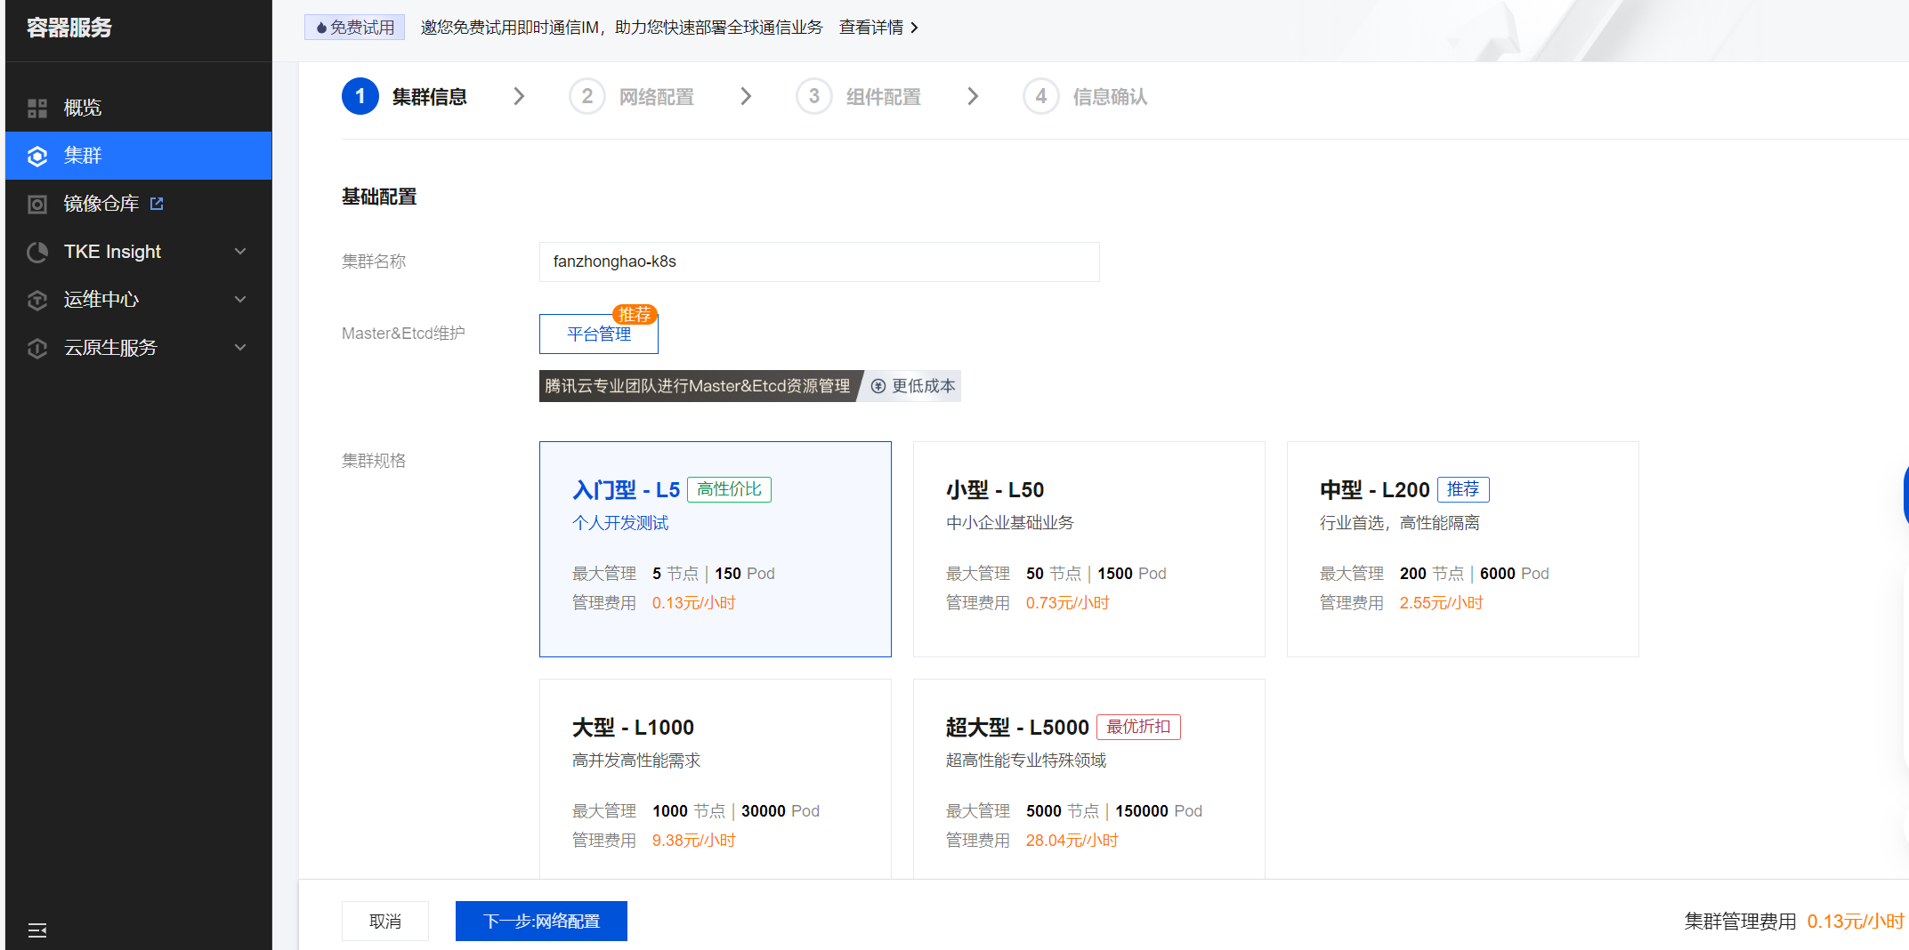
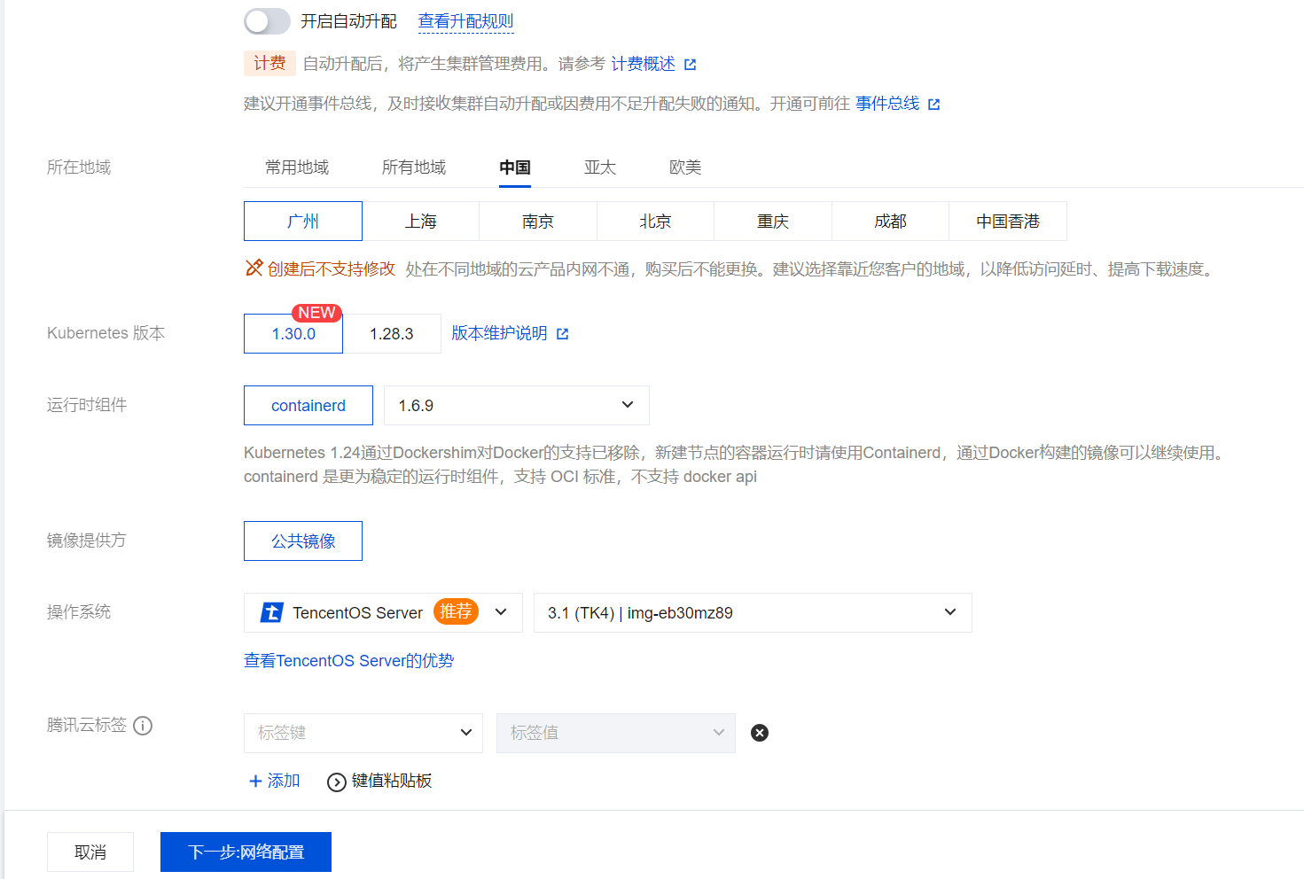
网络配置如下
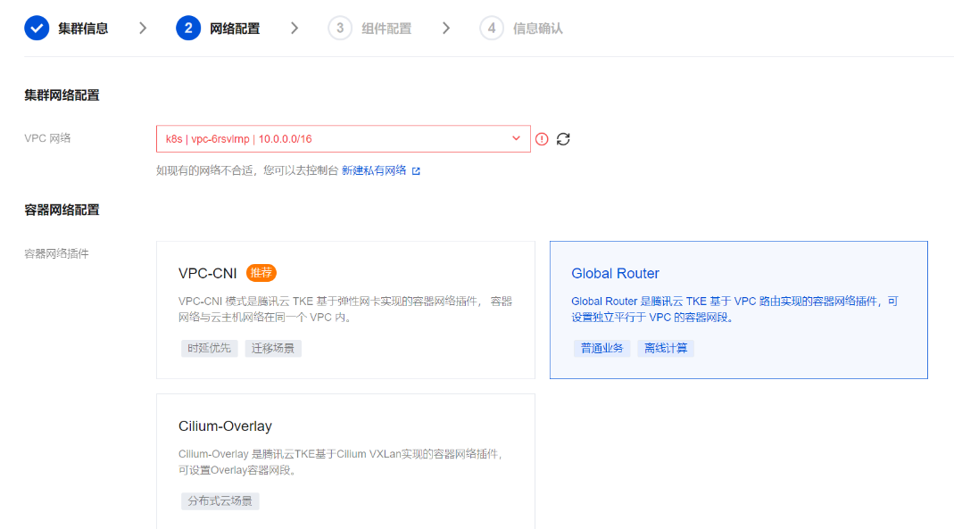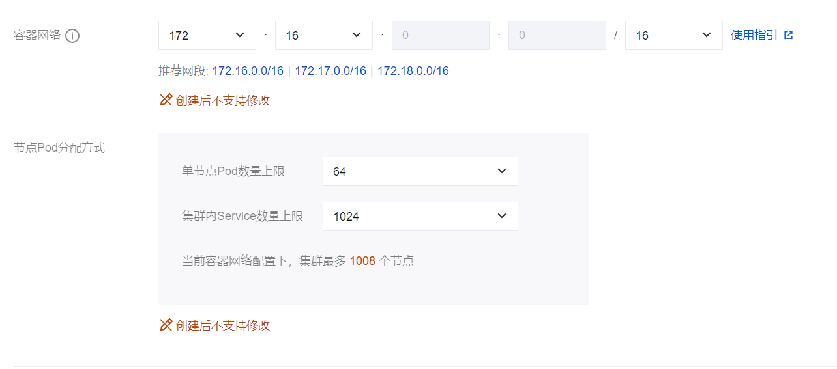
私有网络创建如下
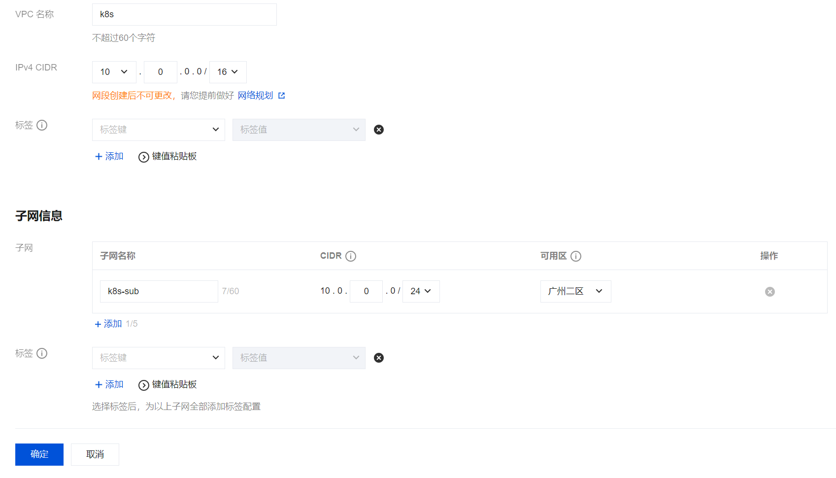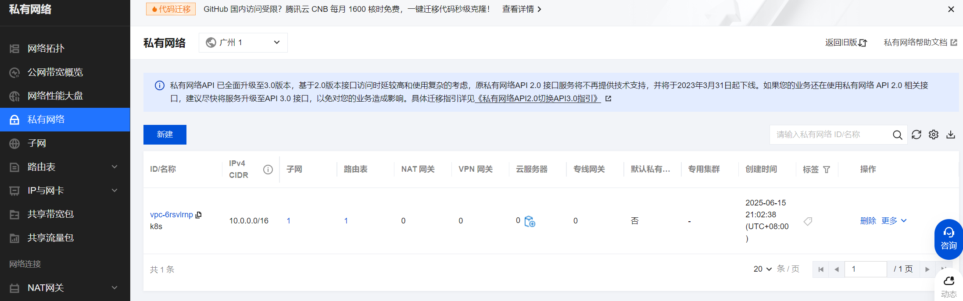

组件配置如下，此项直接默认配置。
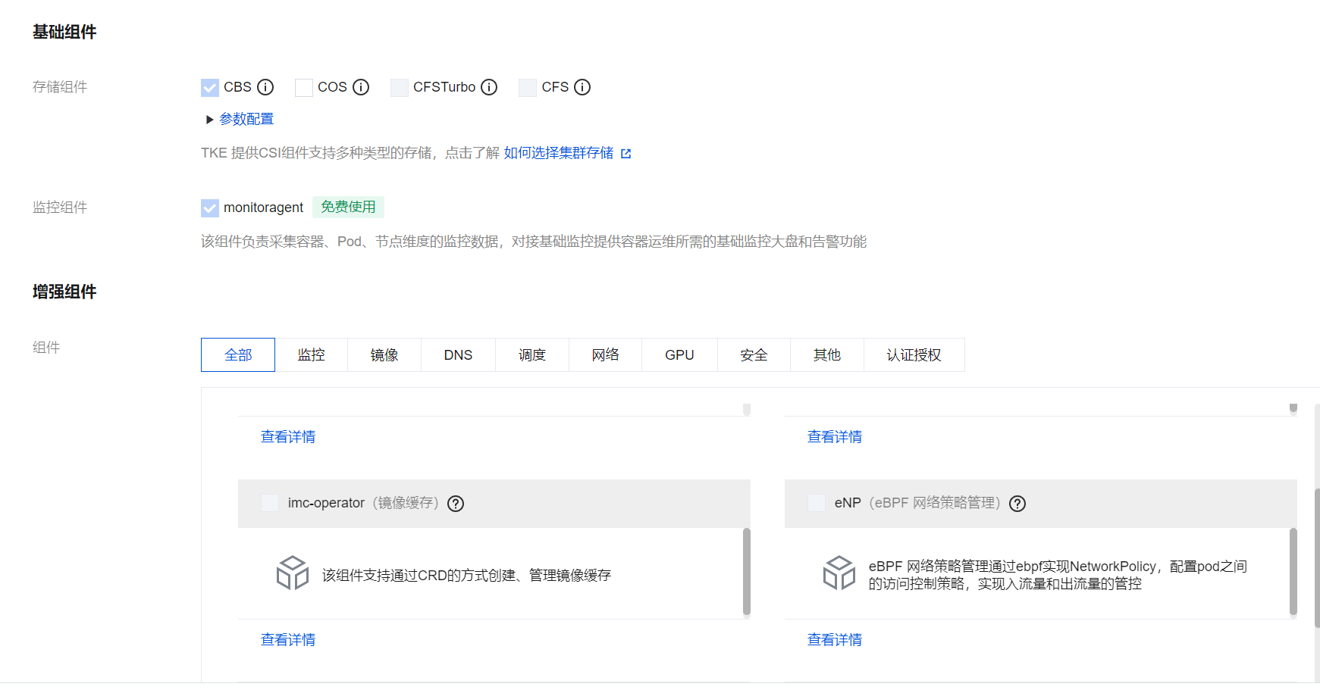
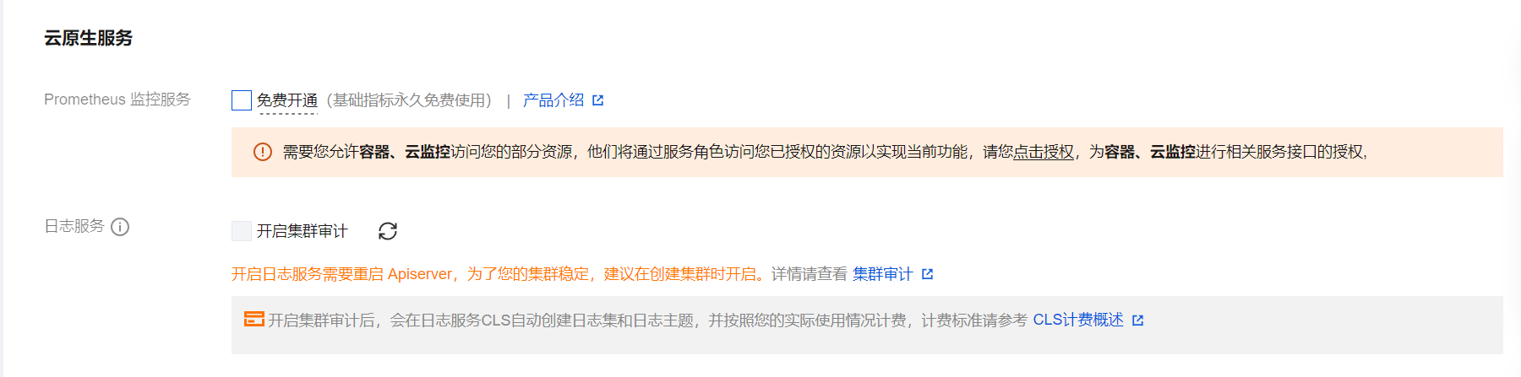
确认。
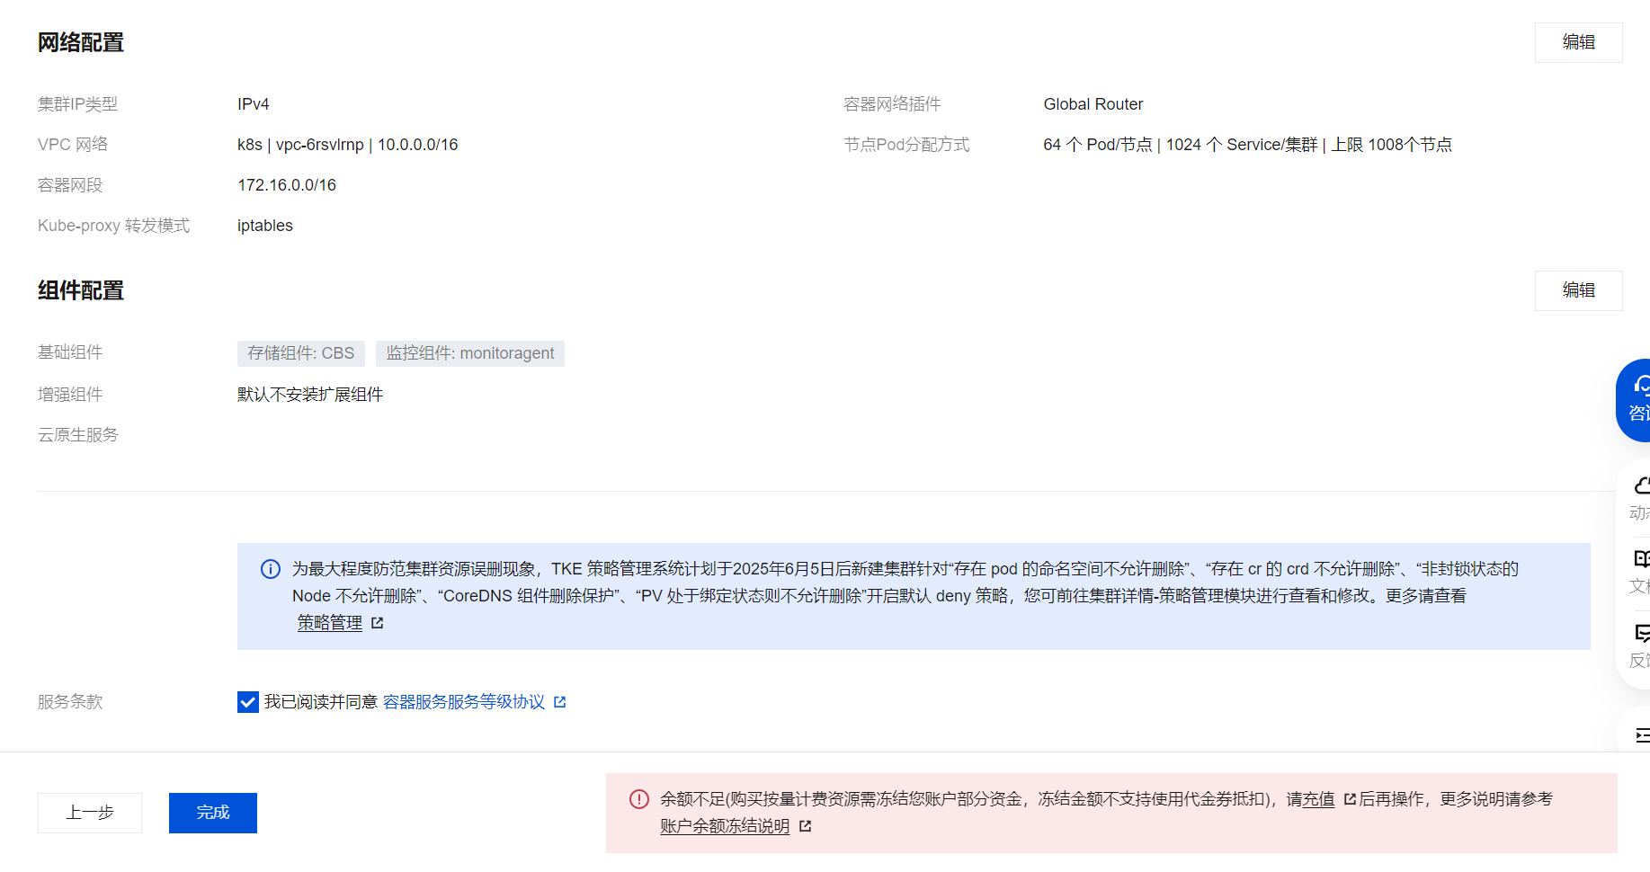

创建完成。
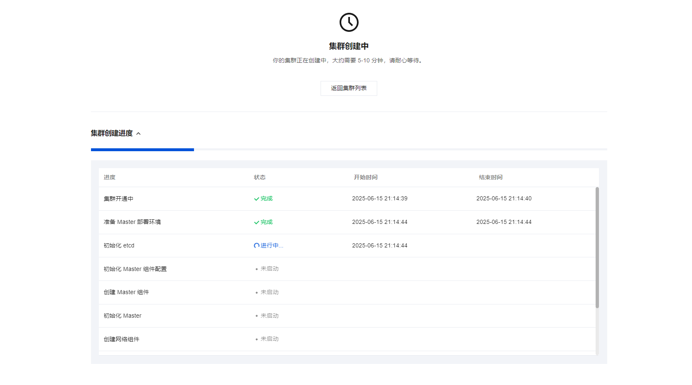
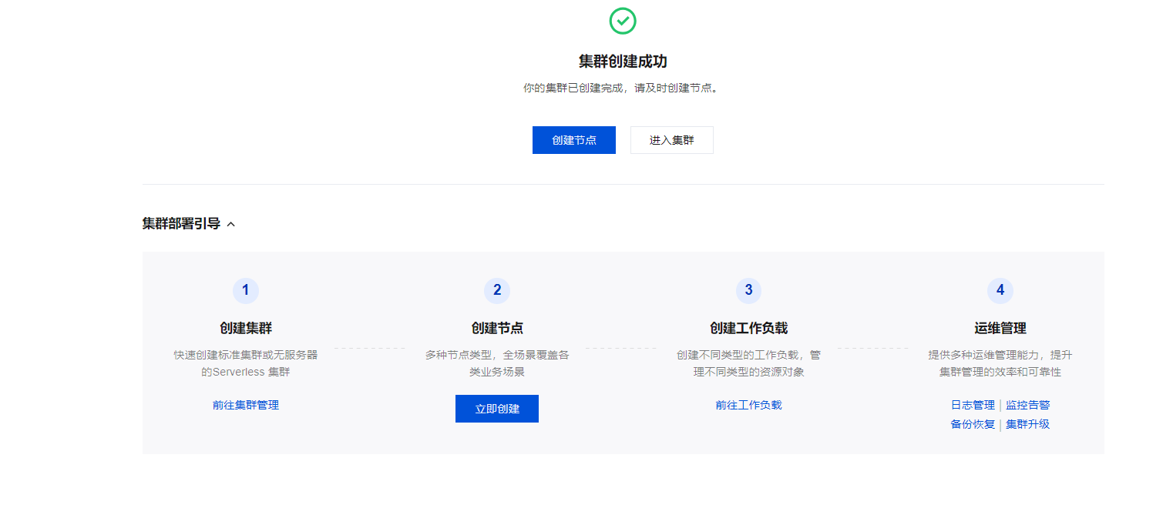
进入查看新创建的集群。
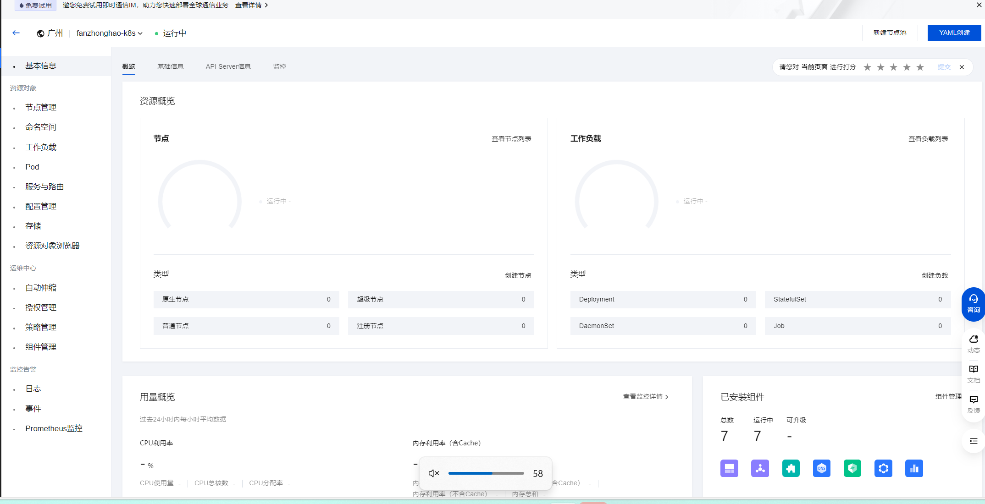
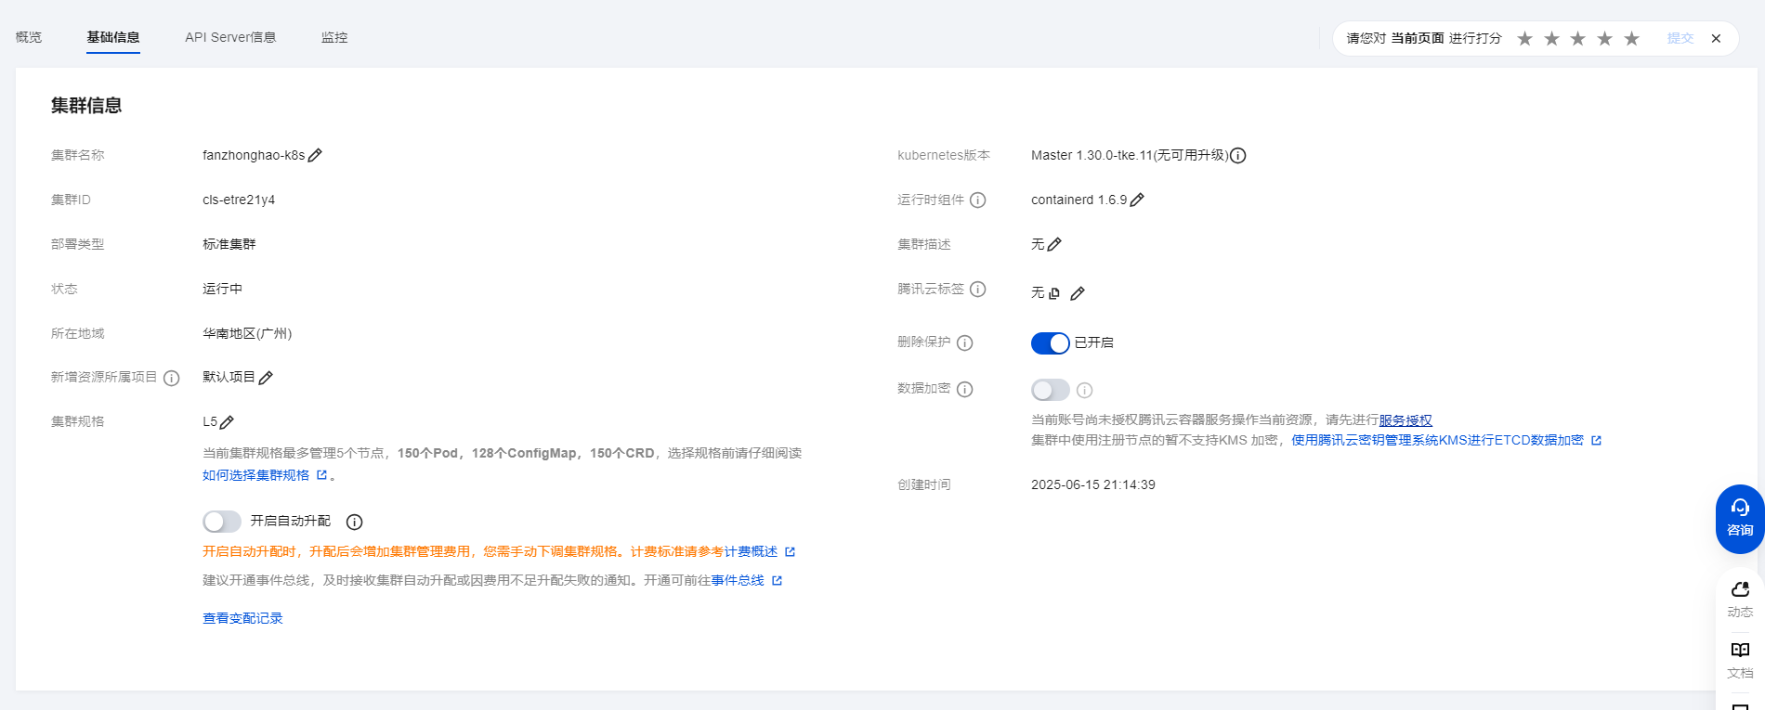
  - 创建节点
对私有网络配置有更新，如下所示。主要变化为添加了广州六区子网。
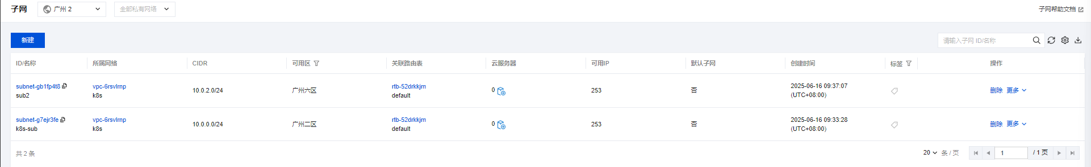
配置安全组策略如下
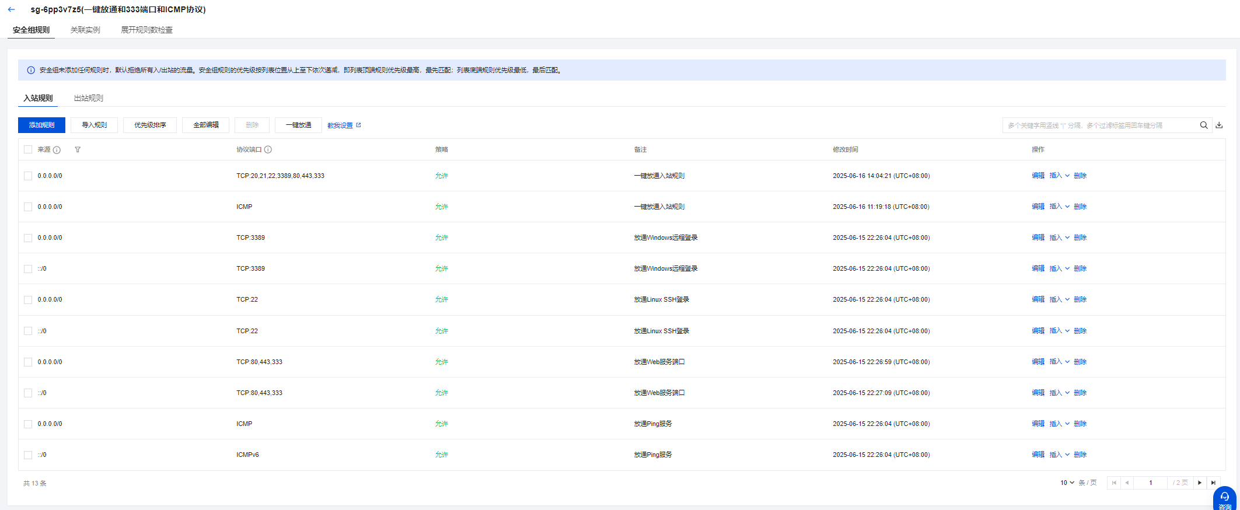
正式创建节点如下，使用此前创建的子网和安全组策略。获取免费公网IP。

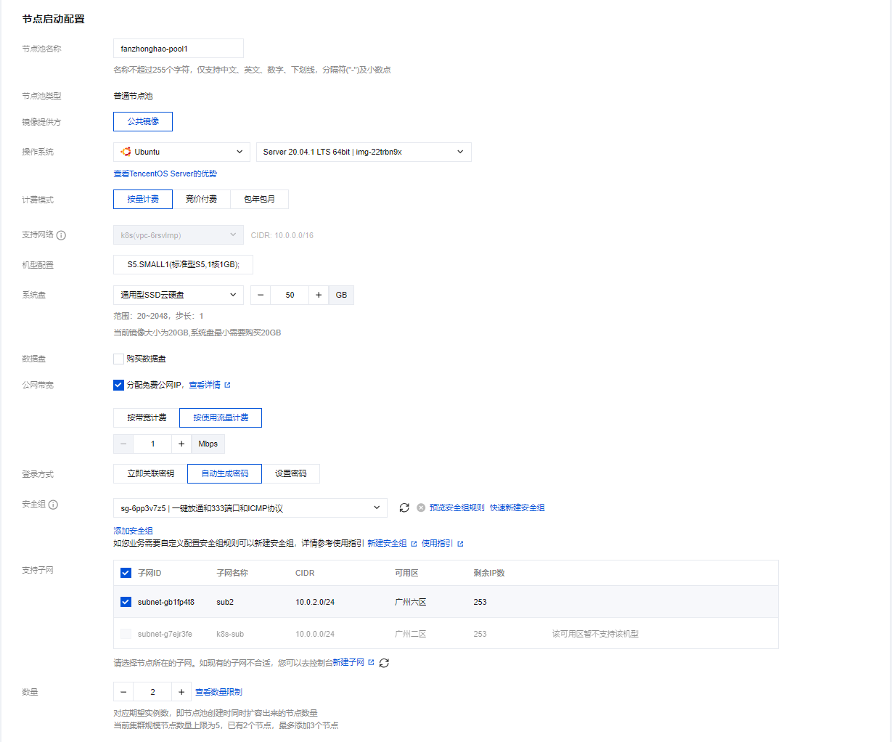
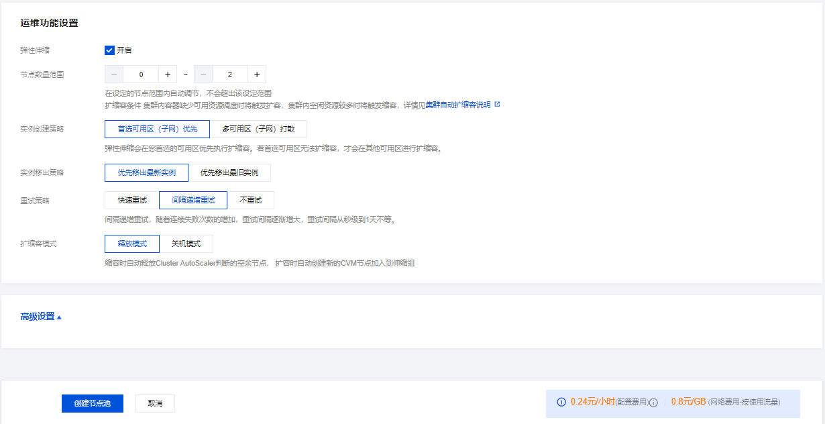
创建过程，与成功后初始配置如下图所示。
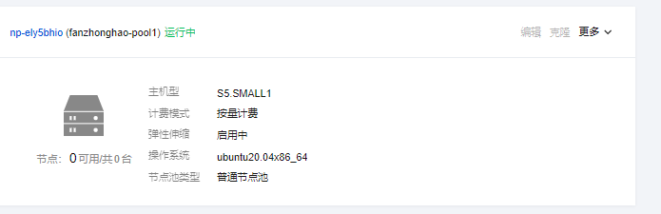
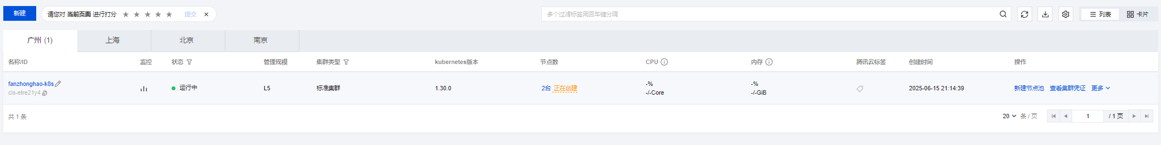
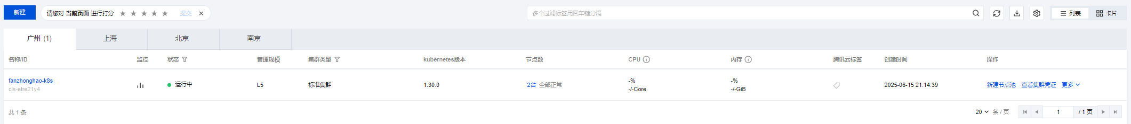
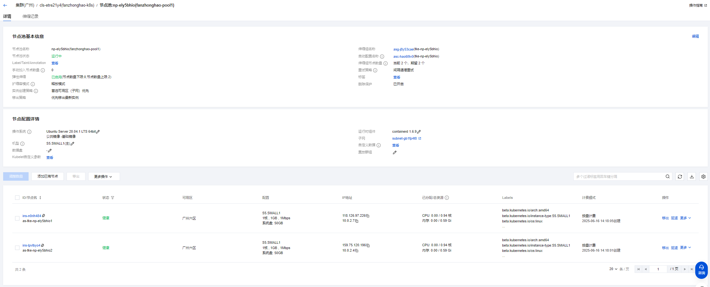

- K8s任务
首先SSH登陆此前创建的节点。
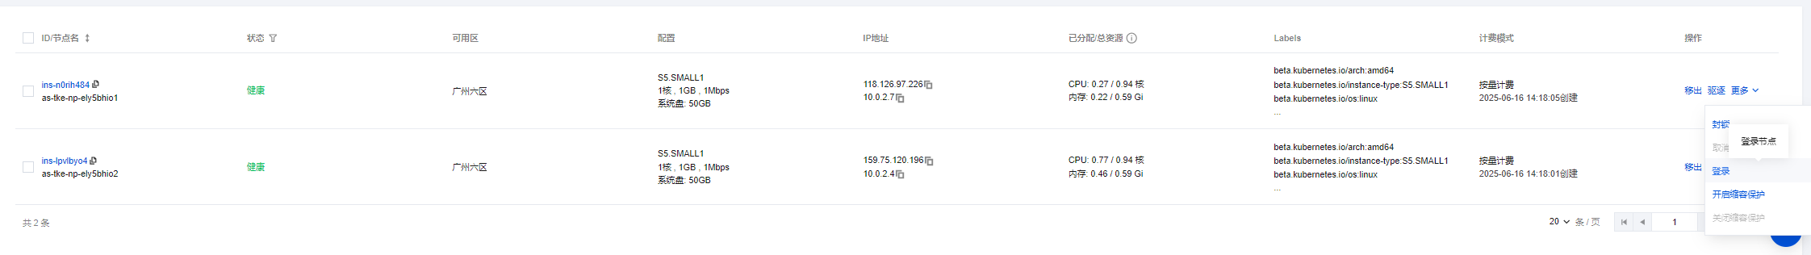
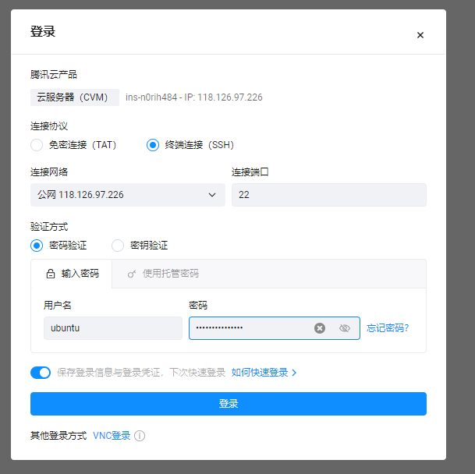

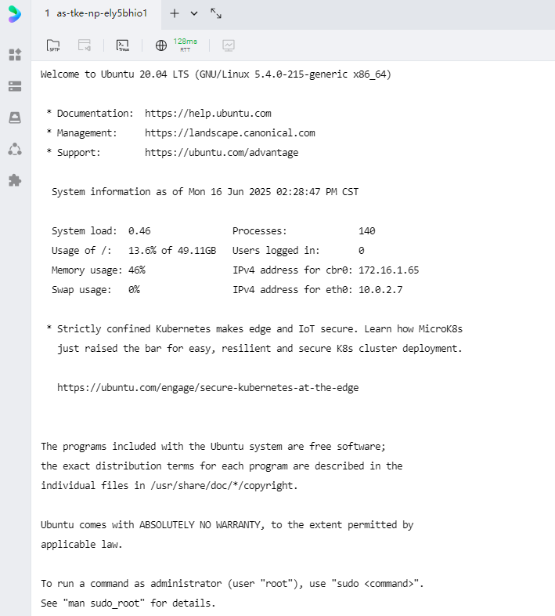

登录成功。Pod初始状态如下图。coredns、kube-proxy、tke-cni-agent等均为Kubernetes系统组件，默认命名空间未部署工作负载。
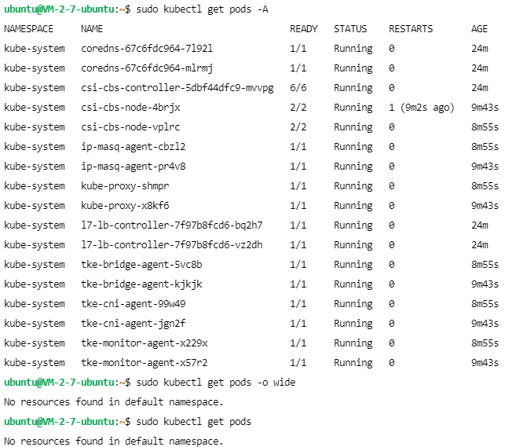
2.1 Create a pod with two containers by YAML.
- Create a YAML file with any name. The name of the pod is set to"last-2pod". The two containers are created based on the Nginx 1.16.1 and Tomcat 8.5.68 images.
- 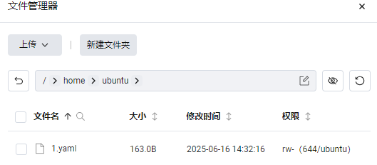
- 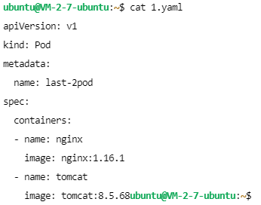
直接上传1.yaml。
- Apply your YAML file and list all pods.
- 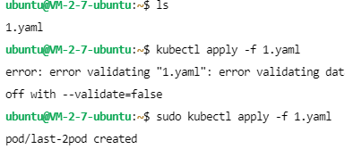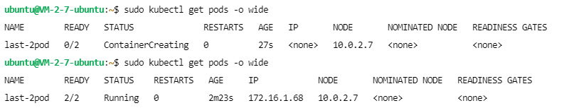
- Change the welcome page of the Nginx container with the sentence "This is Yourname-nginx in a pod. Thank you for using it".
- 修改前首先查看原始nginx页面
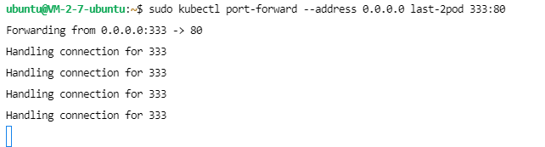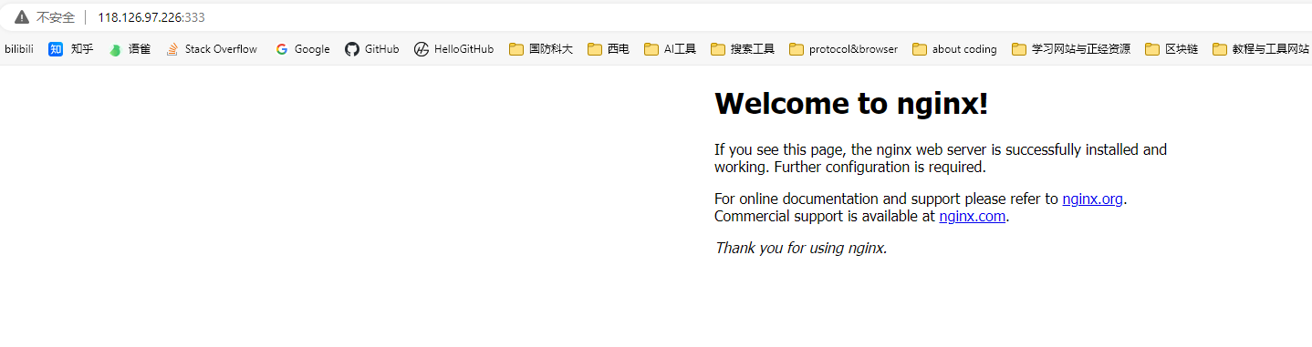
为默认页面。更改如下所示。
- 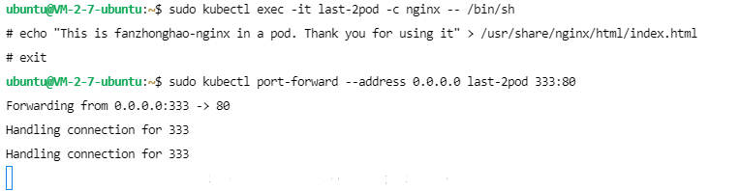
- Expose the port of Nginx to 333.
- 
- Visit this Nginx welcome page from your browser.
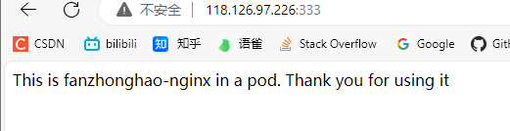
可见完成了更改。
2.2 Deployment and service.
- Create a deployment with the name of "final-dep" and 4 pods (replicas), based on the Nginx 1.16.1 image. List the pods.
- 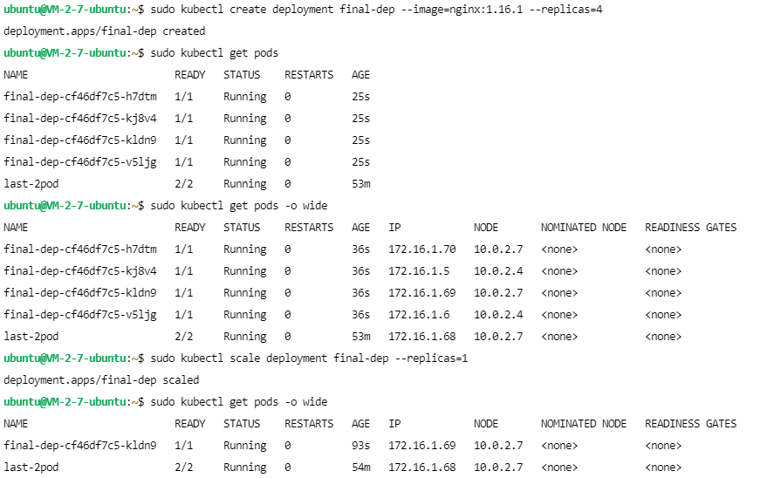
- Decrease the number of pods from 4 to 1.

- Change the welcome page of the remaining Nginx pod with the sentence "This is Yourname-last-nginx in a deployment. Thank you for using it".
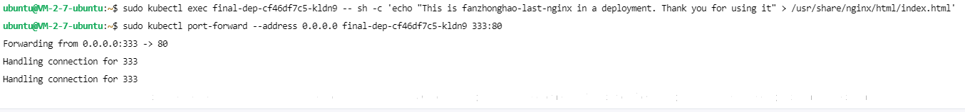
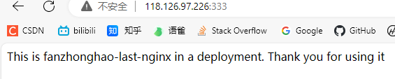
更改并进行了查看，完成更改。
- Increase the number of pods from 1 to 2.
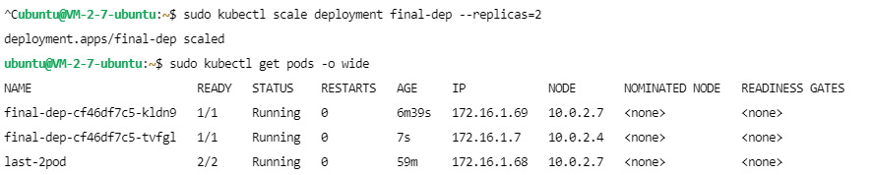
- Create a service of the deployment. Expose the target port 80 to port 8001, and further expose it to NodePort. List the services.
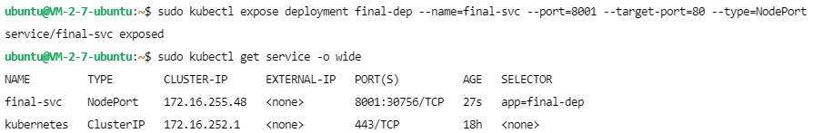
- Access the service many times (use either a browser or the curl command) to show that these requests have been redirected to the 2 pods of the deployment.
首先修改安全组策略，对外网开放30756 8001端口。
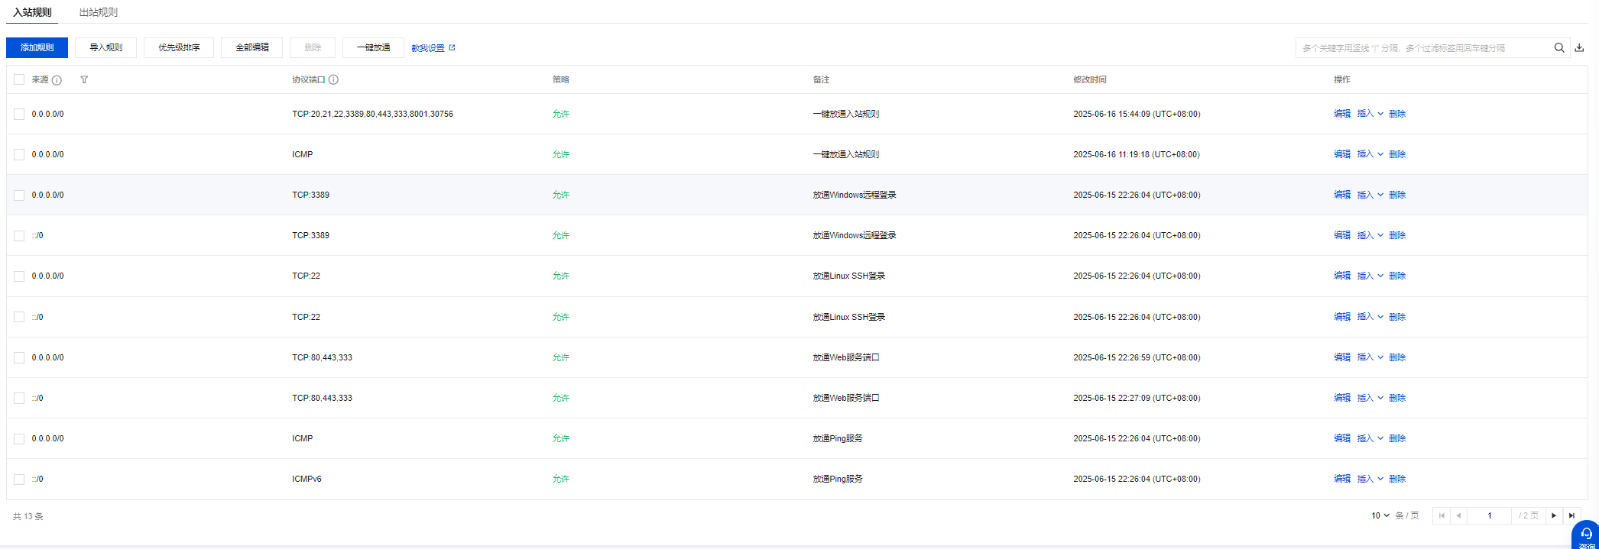
访问30756端口结果如下。
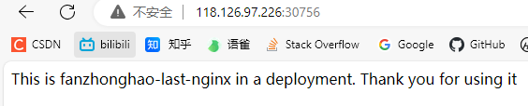

任务二创建的两个pod分别运行在集群内两个不同节点上
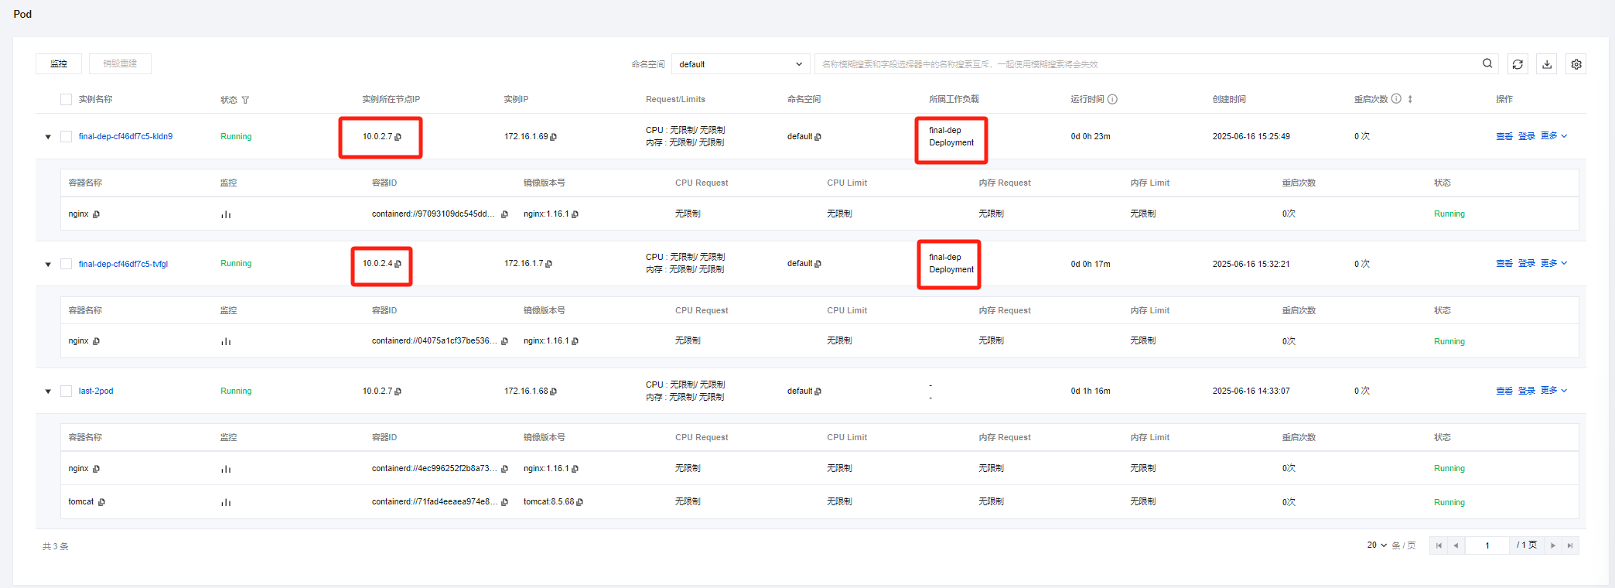
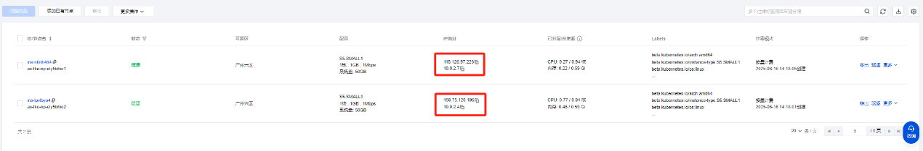
删除集群，实验结束。
