Caf@IITK — Software Architecture and Design Document
Campus Cafeteria Pre-Order and Pickup-Slot Platform
CS455 Software Engineering — Deliverable 1
Team XForce
Krishna Kumayu (230576) · Kshitij Gupta (230581) · Rudransh Verma (230881) · Shashi Bhidodiya (230956) · Suryansh Verma (231061)

Table of Contents
- Architecture Overview and Style
- System Structure — context, deployment, components, data model, interfaces
- Sequence Diagrams
- Design-Pattern Mapping
- Architectural Alternatives and Decision Records (ADRs)
- Cross-Cutting Concerns — concurrency, failure handling, security, observability, scalability, AI-agent boundaries
- Evaluation of LLM-Generated Recommendations
- Appendix A — NFR → Architectural Mechanism Traceability

1. Architecture Overview and Style

1.1 Purpose and scope
This document describes how Caf@IITK is built to meet SRS v2.0: the structure of the system, the key runtime interactions, the design patterns used, and the decisions — with their rejected alternatives — that shaped them. The expected readers are the development team, the course instructor and TAs, and anyone assessing a change request.

1.2 Architectural drivers
The architecture is shaped mainly by five quality attributes, in priority order.
# | Driver | Source | Architectural consequence
D1 | Correctness under contention — no portion or seat allocated twice, no partial changes | NFR-1 – NFR-7 | One relational database with ACID transactions and row locks; all allocation logic in one service; no external calls inside transactions
D2 | Failure containment — payment, crash, database and LLM failures leave the system consistent | NFR-14 – NFR-17, FR-33, FR-34 | Reserve → authorise → confirm with timed holds; a background sweeper; a payment outbox; agent isolated in a separate process
D3 | Bounded AI authority — the agent can only read and propose | FR-50 – FR-62, NFR-25 | Separate database role for the agent; tool registry; validation pipeline; human approval with re-validation
D4 | Security and auditability | FR-6, FR-7, FR-47 – FR-49, NFR-19 – NFR-30 | Central authentication/RBAC dependencies; ownership filters in repositories; append-only audit enforced by database grants
D5 | Testability and low operating cost | NFR-35 – NFR-43 | A modular monolith that runs as a few containers on free-tier instances; a pure pricing engine; injectable gateways

1.3 Architectural style
Caf@IITK is a modular monolith with a layered internal structure, deployed as two processes from one codebase plus a simulated external payment service:
- `caf-api` — the FastAPI application serving all HTTP requests. It is stateless, and multiple worker processes run behind gunicorn.
- `caf-worker` — the same codebase started in worker mode. It runs the time-based jobs (hold sweeper, auto-start of preparation, proposal expiry, payment outbox retries) and every Kitchen Planning Agent run. A PostgreSQL advisory lock ensures that only one worker instance is active (ADR-07).
- `mockpay` — a small, separate FastAPI service that simulates the payment provider over real HTTP, so timeouts and outages behave as they would with a real gateway (ADR-05).
Inside caf-api and caf-worker, code is organised into domain modules (identity, catalogue, inventory, slots, pricing, ordering, kitchen, proposals, audit, agent). Each module is layered:
HTTP router → application service → domain logic (pure where possible) → repository → PostgreSQL
(owns the transaction / unit of work)

Layer rules. Routers only parse, authenticate and delegate. Services own the transactions and never call the network while a transaction is open (NFR-6). Repositories are the only code that issues SQL. The pricing engine and the order state machine are pure and can be tested without a database (NFR-38). Why a modular monolith rather than microservices is recorded in ADR-01.

1.4 Technology stack
Layer | Technology | Notes
Client | Flutter Web (Dart), Riverpod, GoRouter, Dio, API client generated from OpenAPI | One codebase; Web is the primary target (NFR-33)
API | Python 3.12, FastAPI, Pydantic v2, SQLAlchemy 2.0, gunicorn + uvicorn workers | OpenAPI schema published automatically (NFR-39)
Worker | Same codebase; APScheduler inside a leader-locked process | ADR-07
Database | PostgreSQL 16 (Docker locally, Amazon RDS in deployment); Alembic migrations | Row locks, CHECK constraints, role grants
AI | Anthropic or OpenAI SDK with native tool calling; Pydantic models as tool/output schemas | Backend only (NFR-24)
Edge | nginx — TLS, static client files, /api reverse proxy
Ops | Docker Compose; GitHub Actions CI; structured JSON logs; Prometheus-format metrics

2. System Structure

2.1 System context
Figure 2.1 — System context
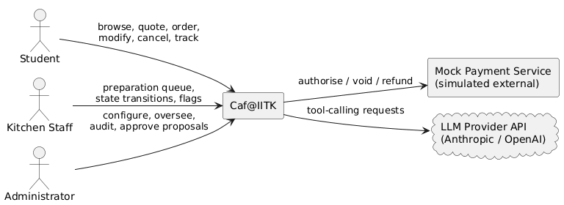

2.2 Deployment
Figure 2.2 — Deployment view
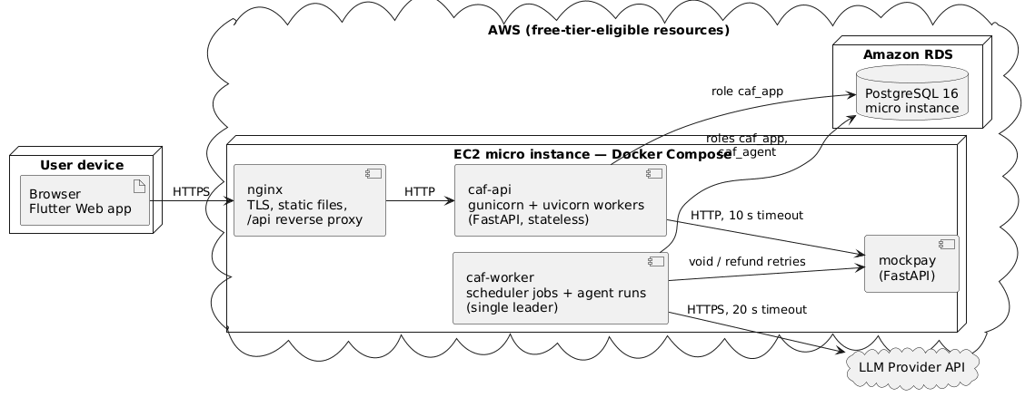
Element | Responsibility | Scaling / failure notes
nginx | TLS termination, serves the compiled Flutter Web bundle, proxies /api | Single instance
caf-api | All HTTP endpoints; order, kitchen and admin transactions | Stateless — worker count or instances can grow (NFR-13)
caf-worker | Hold sweeper (every P-SWEEP_INTERVAL), auto-prep, proposal expiry, payment outbox, agent runs | Exactly one active leader (advisory lock); a restarted worker takes over automatically
mockpay | Authorise, void, refund; configurable outcomes for failure tests (FR-41) | Test controls disabled when ENV=production
PostgreSQL | System of record; enforces CHECK constraints and role grants | Single instance; automated backups (RDS)
Local development | The same images plus a postgres:16 container, via Docker Compose | NFR-40

Database roles (least privilege, NFR-25, NFR-26):
Role | Used by | Privileges
caf_migrator | Alembic, at deploy time only | DDL
caf_app | caf-api, caf-worker jobs | SELECT/INSERT/UPDATE/DELETE on business tables; INSERT and SELECT only on audit_log
caf_agent | The LLM-driven part of an agent run (tool execution, proposal staging) | SELECT on the five agent_* read views; INSERT on proposals, agent_tool_calls, agent_llm_calls — no UPDATE or DELETE anywhere (NFR-25). Run bookkeeping (creating the agent_runs row, setting its status and report) is done by the worker's caf_app connection.

2.3 Backend components
Figure 2.3 — Backend component diagram
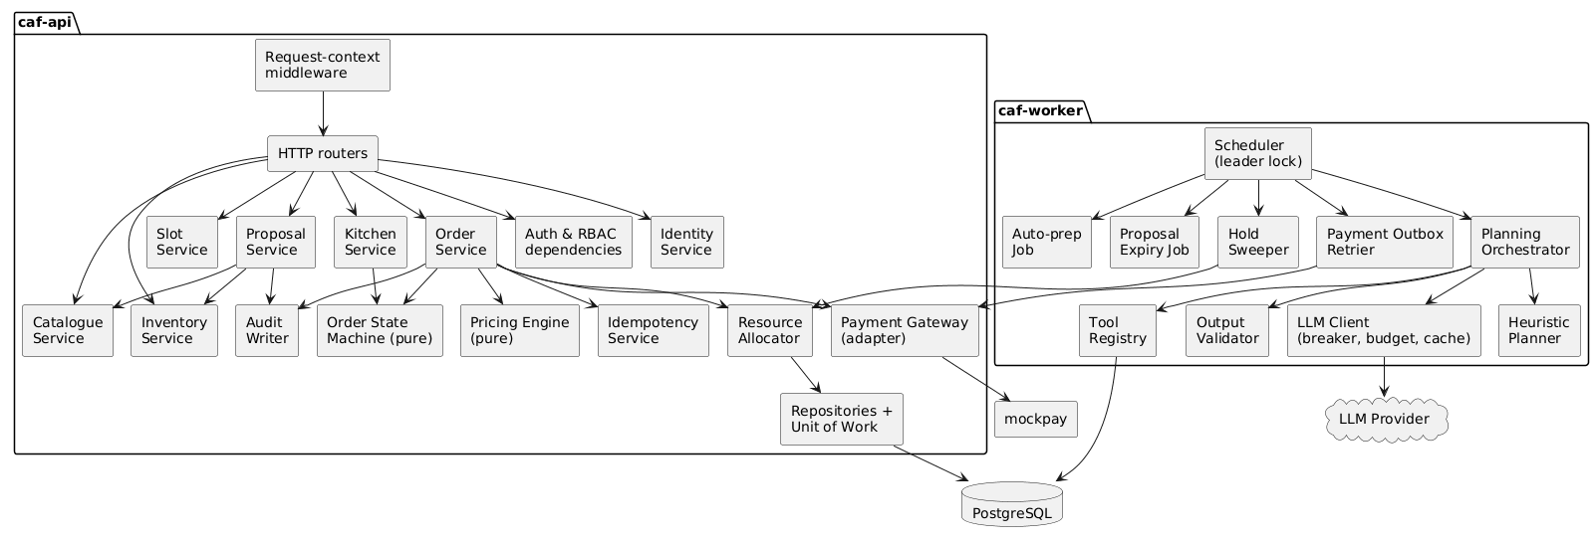
Component | Responsibility | Requirements
Request-context middleware | Assigns/propagates X-Request-ID, binds it to logs, measures latency | NFR-28, NFR-29
Auth & RBAC dependencies | JWT verification, require_role(...), current-user injection; rejections audited | FR-4 – FR-6, NFR-19
Identity Service | Registration, login, refresh rotation, staff accounts, deactivation | FR-1 – FR-4
Catalogue Service | Items, soft-delete, temporary-unavailable flag, orderability rule | FR-8 – FR-13
Inventory / Slot Services | Per-date inventory and slot configuration; reject reductions below allocation | FR-14 – FR-21
Pricing Engine | Pure function: (lines, prices, rules, slot, eligibility, subsidy usage) → breakdown | FR-24, NFR-38
Order Service | Place, modify and cancel use cases; owns the transactions; calls the payment gateway only between transactions | FR-29 – FR-40
Order State Machine | Table-driven legal transitions with guards and effects (Table 4.6-A) | FR-29
Resource Allocator | Locks rows in the canonical order (§6.1) and allocates or releases portions and seats | FR-16, FR-21, NFR-1 – NFR-4
Idempotency Service | Records and replays keyed requests; detects payload mismatch | FR-32, NFR-7
Kitchen Service | Queue query, kitchen transitions, prep-priority application | FR-42 – FR-44
Proposal Service | Approve/reject/expire; re-validate and apply under the Administrator's identity | FR-56, FR-57
Audit Writer | Writes audit rows inside the same transaction as the change | FR-47, FR-48
Payment Gateway | Adapter over mockpay (authorise/void/refund); refuses to run inside an open transaction | FR-33, FR-41, NFR-6
Scheduler + jobs | Leader-locked periodic jobs | FR-34, FR-44, FR-50, FR-56
Payment Outbox Retrier | Retries PENDING voids/refunds until acknowledged | FR-34, FR-39
Planning Orchestrator | Runs the tool-calling loop within limits; persists the report and proposals | FR-50 – FR-52, FR-62
Tool Registry | Whitelist of 8 tools; each maps to a read view (read-only) or a staged proposal | FR-51, FR-60
Output Validator | Schema, referential and bounds checks on every argument and output | FR-58
LLM Client | Provider adapter with timeout, circuit breaker, daily budget and response cache | FR-59, FR-64, NFR-42
Heuristic Planner | Deterministic forecast and proposals when the LLM cannot be used | FR-59

2.4 Client components
Figure 2.4 — Flutter client structure
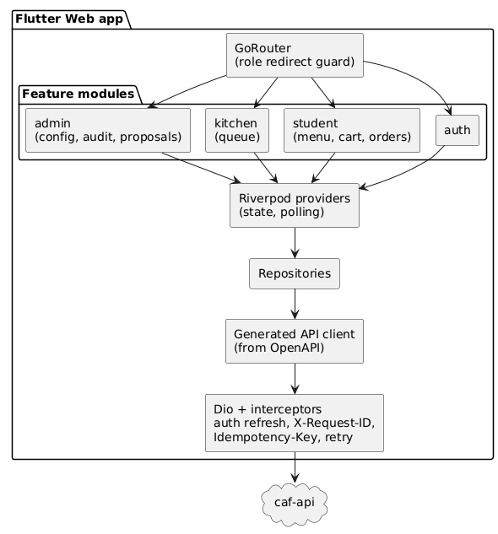
- Routing: after login, GoRouter's redirect sends the user to exactly one dashboard by role; role-scoped routes are unreachable for other roles (FR-5). The server still enforces every permission — the client guard is for usability only.
- Networking: Dio interceptors attach the access token (refreshing it once on 401), a fresh X-Request-ID per request, and an Idempotency-Key per user action. They retry create/modify/cancel at most 3 times with exponential back-off, reusing the same key (NFR-18).
- State: Riverpod providers poll order status every P-POLL while an order is active (FR-40), and poll the kitchen queue and utilisation views.

2.5 Data model
Figure 2.5 — Core data model (catalogue, capacity, ordering, payments)
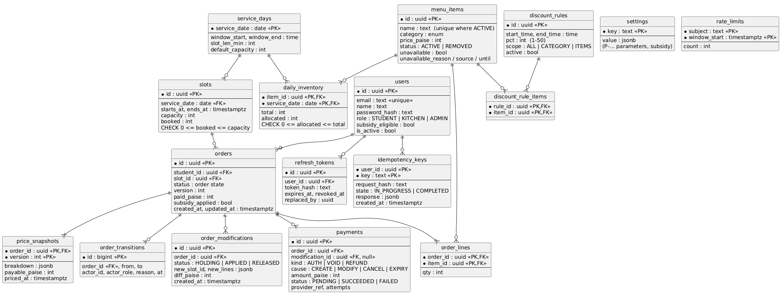
Figure 2.6 — Audit, agent and proposal data
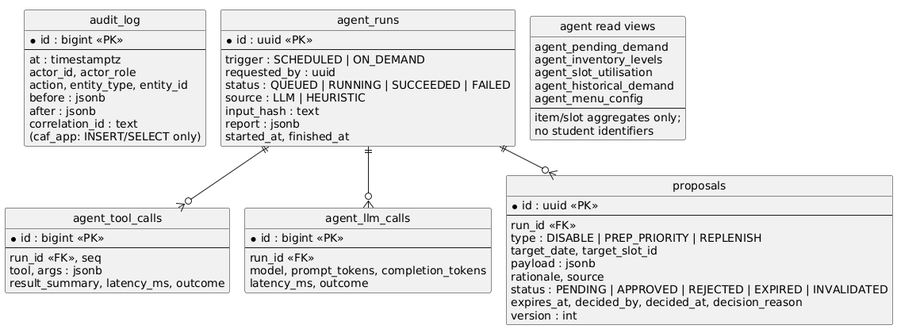
Key design choices in the data model
- Counters with CHECK constraints. daily_inventory.allocated and slots.booked are counters guarded by CHECK (0 <= allocated <= total) and CHECK (0 <= booked <= capacity). Even buggy application code cannot oversell or go negative (NFR-2; ADR-06).
- Versioned price snapshots. The (order_id, version) primary key makes snapshots append-only by construction (FR-27).
- Refund exactly once. A partial unique index UNIQUE (order_id) WHERE kind = 'REFUND' AND cause = 'CANCEL' makes a second cancellation refund impossible at the database level (FR-39). A modification refund is keyed by modification_id in the same way.
- Idempotency. The primary key (user_id, key) makes concurrent duplicates collide on insert; exactly one proceeds (NFR-7).
- Agent isolation. The agent sees data only through the five agent_* views, which aggregate by item and slot and expose no student identifiers (FR-51).
- Money is stored as integer paise throughout (FR-24).
- Shared counters for rate limits. Failed-login and request counters live in rate_limits (keyed by subject and minute), not in process memory, so NFR-21's limits hold however many API workers run (NFR-13).
- Parameters (Table 4.0-B of the SRS) and subsidy settings live in settings, so the Administrator can change them without a deployment (FR-23).

2.6 External interfaces (API surface)
All endpoints are under /api/v1, JSON over HTTPS, and documented by the generated OpenAPI schema.
Endpoint | Roles | Requirements
POST /auth/register · POST /auth/login · POST /auth/refresh · POST /auth/logout | public / any | FR-1, FR-4, NFR-19
GET /menu?date= · GET /slots?date= | Student, Kitchen, Admin | FR-13, FR-19
POST /quotes | Student | FR-25
POST /orders (header Idempotency-Key) | Student | FR-30 – FR-33
GET /orders · GET /orders/{id} | Student (own only) | FR-7, FR-28, FR-40
PATCH /orders/{id} · POST /orders/{id}/cancel | Student (own only) | FR-35 – FR-37
GET /kitchen/queue · POST /kitchen/orders/{id}/transitions | Kitchen, Admin | FR-42, FR-43
POST /items/{id}/flag · DELETE /items/{id}/flag | Kitchen, Admin | FR-11
/admin/items (POST, PATCH, DELETE = soft-delete) | Admin | FR-8 – FR-10
PUT /admin/inventory/{date}/{item} · PUT /admin/service-days/{date} · PATCH /admin/slots/{id} | Admin | FR-14 – FR-18
/admin/discount-rules · PUT /admin/subsidy · PUT /admin/users/{id}/eligibility | Admin | FR-22, FR-23
/admin/users (create, deactivate, reactivate) | Admin | FR-2, FR-3
GET /admin/orders · GET /admin/utilisation · POST /admin/orders/{id}/cancel | Admin | FR-38, FR-45, FR-46
GET /admin/audit | Admin | FR-49
POST /admin/agent/runs · GET /admin/agent/runs[/{id}] | Admin | FR-50, FR-63
GET /admin/proposals · POST /admin/proposals/{id}/approve · POST /admin/proposals/{id}/reject | Admin | FR-56, FR-57, FR-63
GET /health · GET /ready · GET /metrics | internal | NFR-31
mockpay: POST /authorise · POST /void · POST /refund · PUT /_control/outcome (non-production only) | caf-api / caf-worker | FR-41

3. Sequence Diagrams
The eight sequences below cover the critical use cases (UC-11, UC-12, UC-13, UC-25), the concurrency experiment, crash recovery, the agent run, and the security path.

3.1 SD-1 — Place order (UC-11)
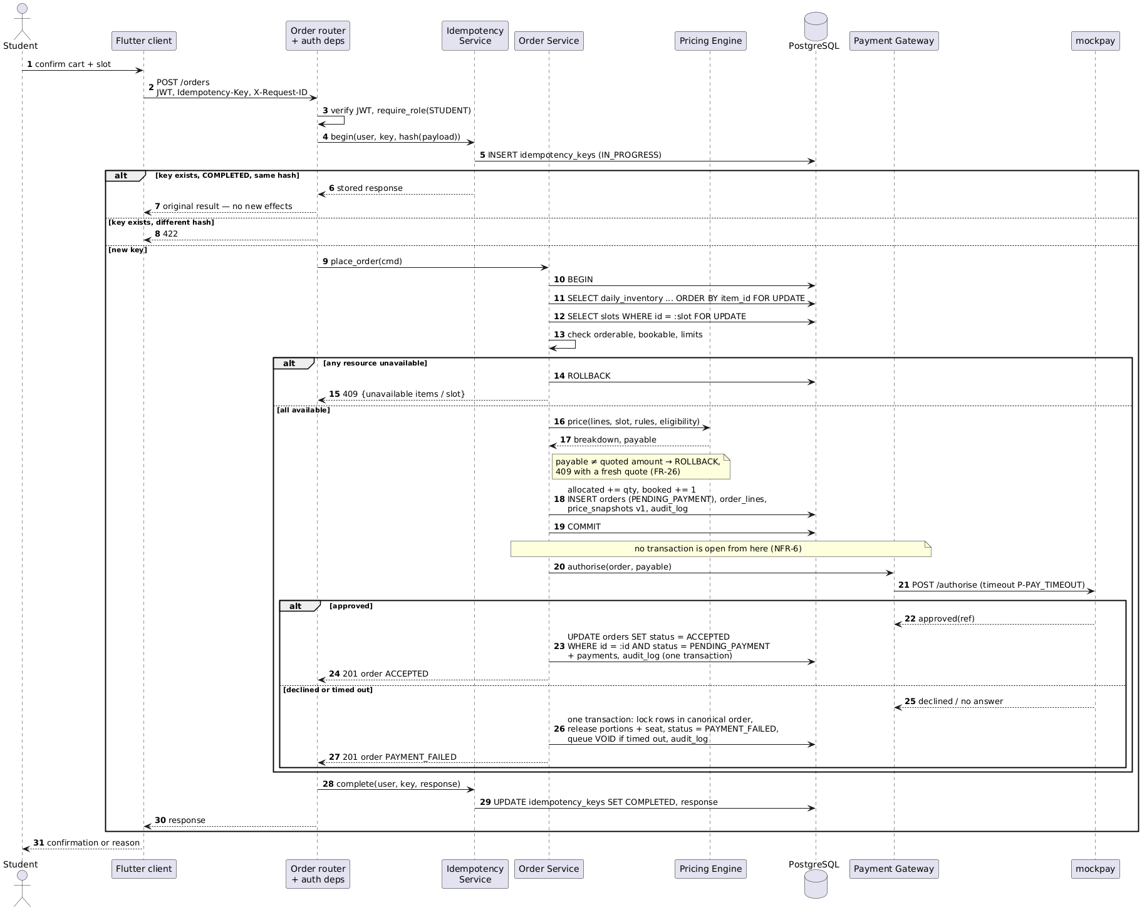

3.2 SD-2 — Two students race for the last seat (concurrency experiment)

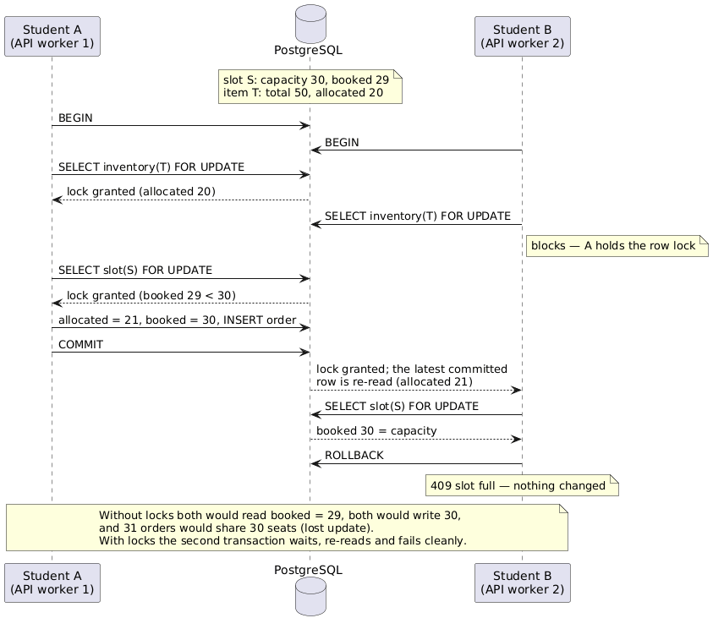

3.3 SD-3 — Modify order with a price increase (UC-12)
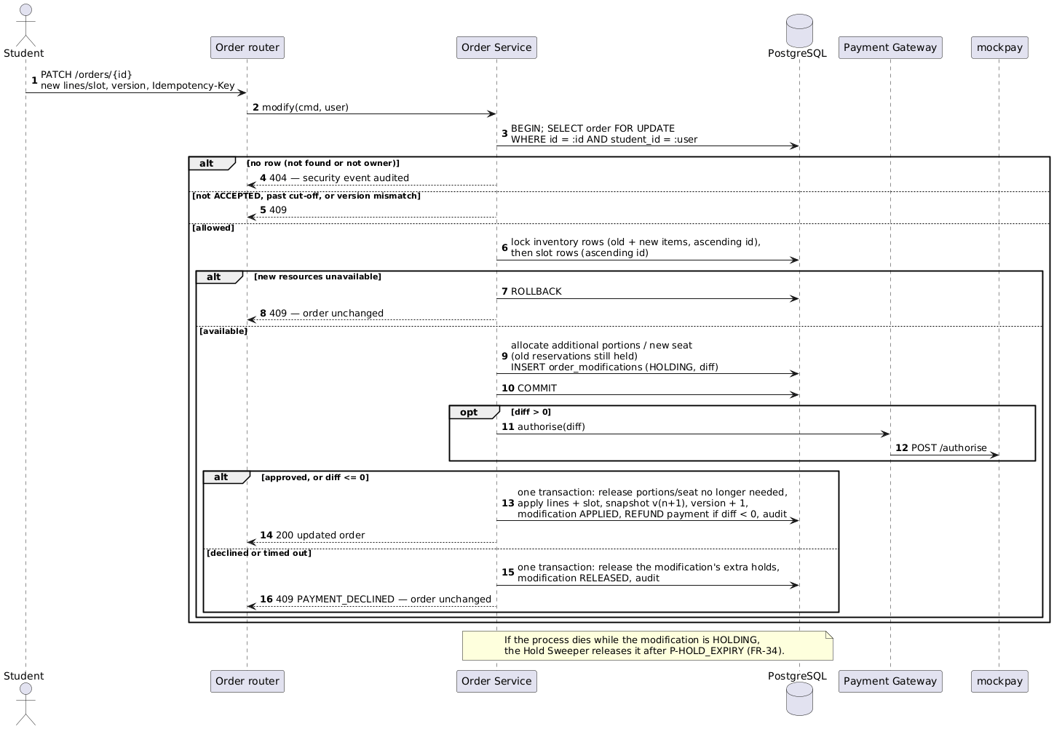

3.4 SD-4 — Cancel order with a refund through the outbox (UC-13)
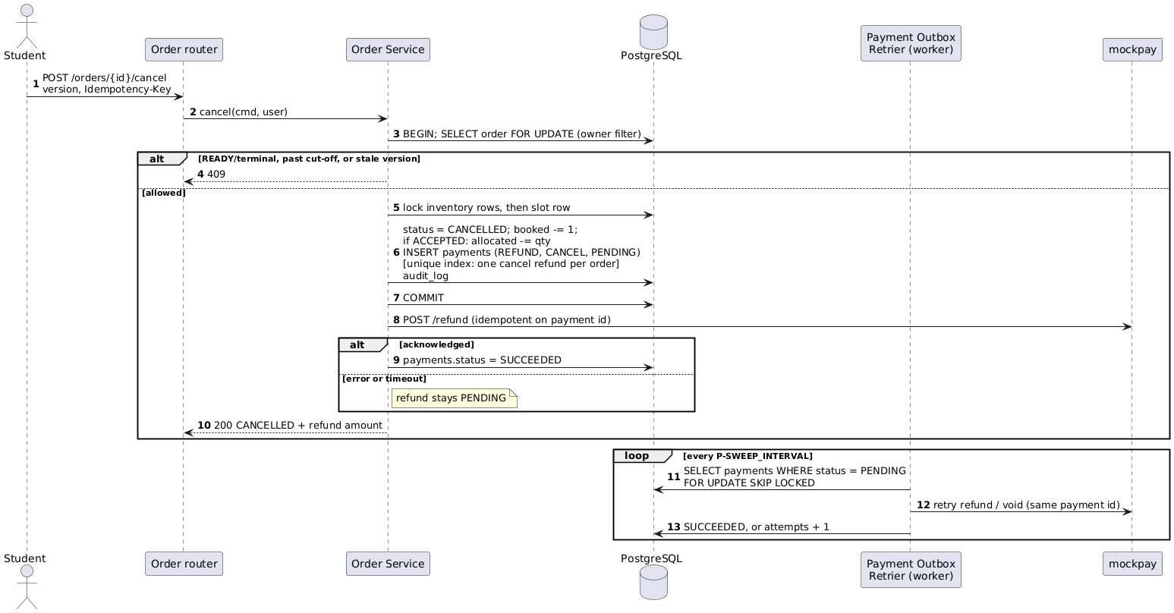

3.5 SD-5 — Crash recovery: expiring a stale hold and voiding a late payment
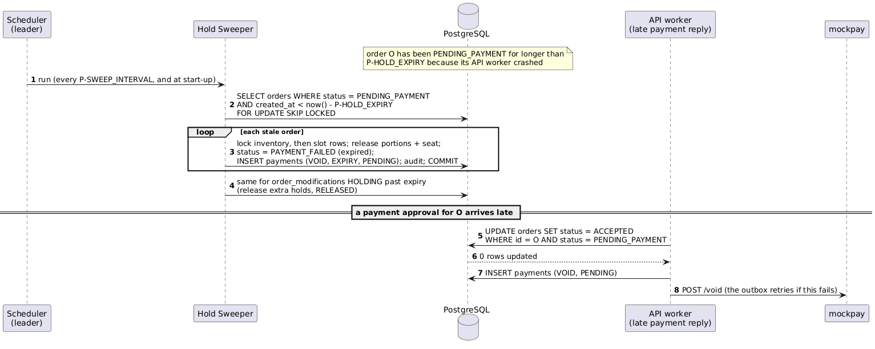

3.6 SD-6 — Kitchen Planning Agent run (UC-22, UC-23, UC-24)
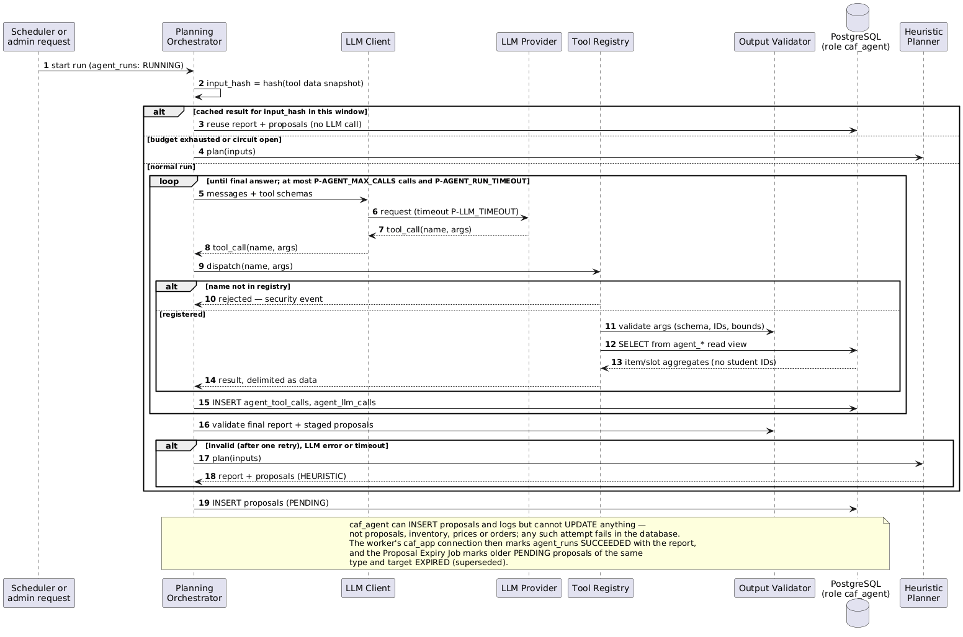

3.7 SD-7 — Administrator approves a replenishment proposal (UC-25)
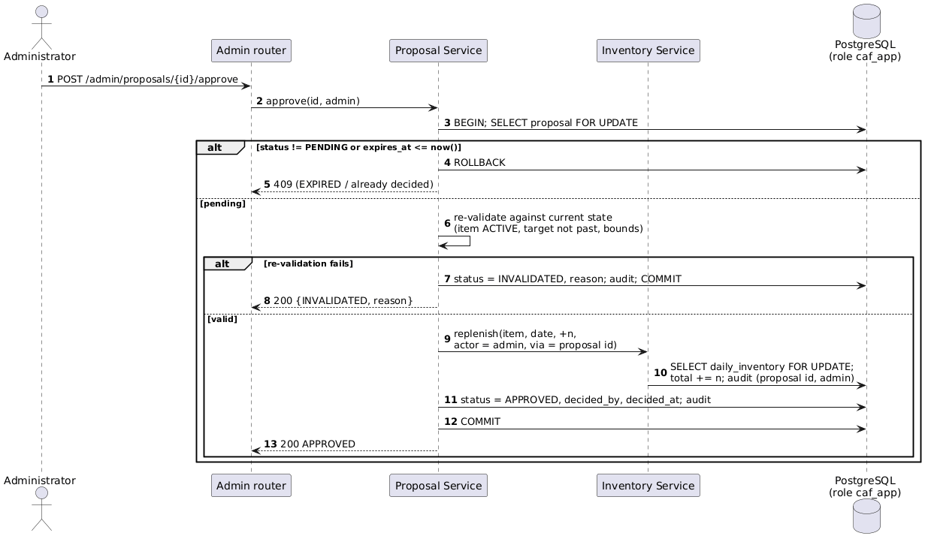

3.8 SD-8 — Authorisation and ownership check (security path)
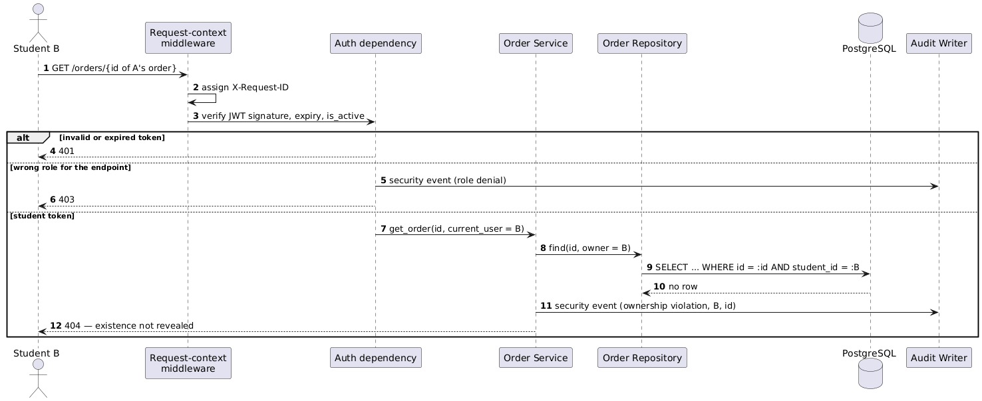

4. Design-Pattern Mapping
# | Pattern | Where it lives | Why it was chosen | Requirements
P1 | Layered architecture | Every backend module: router → service → repository | Keeps HTTP, transactions and SQL separate, so each is testable and the "no network inside a transaction" rule has one owner | NFR-6, NFR-35
P2 | Service Layer | OrderService, ProposalService, KitchenService, … | One place per use case that owns the transaction boundary and orchestrates domain logic | FR-30, FR-35, FR-37, FR-57
P3 | Repository | *Repository classes over SQLAlchemy | Isolates SQL; the ownership filter (student_id = :user) is built in, so it cannot be forgotten at call sites | FR-7, NFR-22
P4 | Unit of Work | SQLAlchemy Session scoped to one service call | All-or-nothing commits across inventory, slot, order, snapshot and audit rows | NFR-3, FR-30
P5 | Pessimistic lock with a lock hierarchy | ResourceAllocator (SELECT … FOR UPDATE in canonical order) | Serialises contention on hot rows and prevents deadlock | NFR-1, NFR-4
P6 | Optimistic Offline Lock | orders.version, checked under the row lock | Detects that a user acted on a stale view (e.g. kitchen started preparing) and rejects it with 409 rather than overwriting | NFR-5
P7 | State (table-driven) | OrderStateMachine — a transition table with guards and effects | Makes Table 4.6-A executable; illegal transitions are rejected centrally; unit-testable exhaustively | FR-29, FR-43
P8 | Strategy + Pipeline | PricingEngine: an ordered pipeline of rule steps (base → discount → subsidy → rounding); each discount scope is a strategy | New rules slot in without changing the order flow; the engine stays a pure function | FR-24, NFR-38
P9 | Adapter / Gateway | PaymentGateway (mockpay HTTP adapter, in-memory fake for tests); LLMClient (Anthropic/OpenAI adapters, scripted stub for tests) | External services are swappable; failure modes can be injected in tests | FR-41, FR-59
P10 | Idempotent Receiver | IdempotencyService + idempotency_keys table | Makes client retries and double-clicks safe | FR-32, NFR-7
P11 | Transactional Outbox | payments rows written in the business transaction; PaymentOutboxRetrier delivers them | A refund or void is never lost or duplicated, even if mockpay is down when the cancel commits | FR-34, FR-39
P12 | Command + Registry | Agent ToolRegistry: each tool is a command object with a Pydantic argument schema | Only registered commands can run; unknown tool names are rejected by construction | FR-51, FR-60
P13 | Specification / Policy gate | OutputValidator and ProposalService.revalidate — composable checks (schema, referential, bounds, freshness) | The same rules validate drafts and re-validate at approval time | FR-57, FR-58
P14 | Circuit Breaker + Fallback | LLMClient breaker; HeuristicPlanner fallback | Stops hammering a failing provider and keeps planning available | FR-59, NFR-17
P15 | Leader election (advisory lock) | Scheduler takes pg_try_advisory_lock at start-up | Guarantees one active sweeper and agent runner even if two workers start | FR-34, FR-50
P16 | Dependency Injection | FastAPI Depends for DB session, current user, require_role, gateways | RBAC is declared per endpoint; gateways are replaced by fakes in tests | FR-6, NFR-35
P17 | Repository + Provider (client) | Flutter repositories over the generated client; Riverpod providers | Widgets never call HTTP directly; state is testable with mocked repositories | NFR-36, NFR-39

5. Architectural Alternatives and Decision Records

5.1 Alternatives considered and rejected
# | Alternative | Why it was attractive | Why it was rejected
ALT-1 | Microservices (separate inventory, slot, order and pricing services) | Independent deployment and scaling; a familiar "modern" pattern | Creating an order must change inventory, slot, order and audit atomically. Splitting these across services replaces one ACID transaction with a distributed saga, weakening the central guarantee (NFR-1, NFR-3) for no benefit at this scale; it also multiplies deployment cost on the free tier.
ALT-2 | Flutter + Firebase / Firestore | Fastest to build; hosted auth and real-time updates | Firestore transactions are optimistic and retried under contention and cannot express row locks or multi-row CHECK constraints; the concurrency demonstration — the core of the project — would be weaker and harder to explain. (Also recorded in the proposal.)
ALT-3 | Redis atomic counters for inventory and seats (DECR / Lua scripts) | Very fast; naturally atomic per key | Allocation must be atomic *together with* the order, snapshot and audit rows in PostgreSQL. Two stores need dual-write reconciliation, and a crash between them oversells or leaks capacity. Kept only as a possible read cache (§6.5).
ALT-4 | SERIALIZABLE isolation with automatic retry | No explicit locking code; the database detects conflicts | Under a menu-release burst on one hot row, most transactions abort and retry, so latency and CPU spike exactly when load peaks. To be measured in the D3 concurrency experiment as a comparison, not used as the primary mechanism.
ALT-5 | Optimistic concurrency only (version check + retry on inventory/slot rows) | No blocking; simple to write | The same hot-row retry storm as ALT-4. It is kept for the orders row, where contention is low (P6).
ALT-6 | Agent with direct database access, restricted by prompt instructions | Simplest agent implementation | A prompt is not a security boundary: a hallucination or an injected instruction could mutate data. Rejected in favour of a structural boundary: a separate role, a tool registry and proposals only (ADR-04).
ALT-7 | Authorise payment first, then reserve | No holds to clean up if payment fails | The student could be charged for a meal that sells out a second later, forcing a refund after every lost race. Reserving first means payment happens only for resources already held.

5.2 Architecture Decision Records
ADR-01 — Modular monolith, deployed as `caf-api` + `caf-worker`
- Context: Correctness of order creation depends on one ACID transaction across several aggregates; the team is five people; hosting must stay on the free tier.
- Decision: A single codebase organised by domain module and layered internally, run as a stateless API process and a single-leader worker process.
- Alternatives: Microservices (ALT-1); a single process that also runs the jobs.
- Trade-offs: (+) one transaction boundary; simple deployment and debugging; cheap. (−) Modules share one database and one release cycle; boundaries must be enforced by code review and import rules rather than by the network.
- Consequences: Long-running and time-based work (LLM calls, sweeps) lives in the worker, so it can never block API workers (NFR-17).
- Requirements: NFR-1, NFR-3, NFR-13, NFR-17, NFR-43.
ADR-02 — Pessimistic row locks in a fixed hierarchy, with CHECK constraints and order versions
- Context: Many students target the same item and the same early slot within seconds (NFR-12); no double allocation is allowed.
- Decision: In READ COMMITTED isolation, lock rows with SELECT … FOR UPDATE in the order proposal → order → inventory (ascending item id) → slots (ascending slot id). Enforce CHECK constraints on the counters as a last line of defence. Use orders.version to reject stale user actions.
- Alternatives: SERIALIZABLE + retry (ALT-4); optimistic only (ALT-5); Redis counters (ALT-3); a conditional UPDATE … WHERE booked < capacity without explicit locks.
- Trade-offs: (+) Deterministic behaviour under contention; clear which resource was unavailable; deadlock-free by construction. (−) Throughput on one hot row is bounded by lock hold time, so transactions must stay short (no network calls, NFR-6). The conditional-update variant needs fewer round trips and is the leading candidate for the D3 performance optimisation.
- Requirements: NFR-1 – NFR-5.
ADR-03 — Reserve → authorise → confirm, with timed holds
- Context: Payment is an external call that may decline, time out or never answer; no network call may happen inside a transaction (NFR-6).
- Decision: Commit the reservation in PENDING_PAYMENT, call the gateway outside any transaction, then confirm (ACCEPTED) or release (PAYMENT_FAILED) in a second transaction guarded by WHERE status = PENDING_PAYMENT. A sweeper expires holds older than P-HOLD_EXPIRY; late approvals are voided. Modifications use the same pattern, holding old and new resources until the difference is settled.
- Alternatives: Authorise first (ALT-7); call the gateway inside the transaction (holds locks for up to 10 s and violates NFR-6).
- Trade-offs: (+) Locks are held for milliseconds; every failure path ends consistent. (−) Capacity is briefly held by orders that may not pay (bounded by P-HOLD_EXPIRY); an extra state and a background job are required.
- Requirements: FR-33, FR-34, FR-36, NFR-6, NFR-14, NFR-15.
ADR-04 — The agent's authority is enforced structurally
- Context: The LLM may hallucinate, emit malformed output or be manipulated by text it reads (AF-1 – AF-7).
- Decision: Agent runs connect as caf_agent, which can only read the five aggregate views and insert proposals and logs. The only callable tools are those in the registry. Every output passes schema, referential and bounds validation. Proposals take effect only through ProposalService, under an Administrator's identity, after re-validation.
- Alternatives: Prompt-only restrictions (ALT-6); the agent calling the public API with a service account (still needs scoped permissions, and is more moving parts).
- Trade-offs: (+) Even a fully compromised model cannot change prices, stock or orders. (−) More components (views, role, registry); the views must be kept in step with the schema.
- Requirements: FR-51, FR-57 – FR-61, NFR-25.
ADR-05 — Mock payment as a separate HTTP service
- Context: The failure scenarios (decline, timeout, outage) must be demonstrable and realistic (FR-41, brief §12).
- Decision: mockpay runs as its own container with configurable outcomes; caf-api talks to it through the PaymentGateway adapter with real network timeouts.
- Alternatives: An in-process fake (no real timeouts; failure tests would be simulated rather than real).
- Trade-offs: (+) Real timeouts and outages can be induced by stopping the container. (−) One more container on a small instance.
- Requirements: FR-33, FR-41, NFR-14.
ADR-06 — Counter columns rather than one row per portion or seat
- Context: Allocation must be fast and provably bounded.
- Decision: Keep allocated/booked counters with CHECK constraints; orders reference the slot and item quantities.
- Alternatives: Pre-create one row per seat or portion and claim a row with FOR UPDATE SKIP LOCKED.
- Trade-offs: (+) Few rows; a simple CHECK makes overselling impossible. (−) All orders for one item contend on one row (the hot-row effect) — acceptable at this workload and measurable in D3. Per-unit rows would spread contention and are the documented fallback if measurements demand it.
- Requirements: NFR-1, NFR-2, NFR-8.
ADR-07 — Single-leader worker using a PostgreSQL advisory lock
- Context: The sweeper, auto-prep, expiry and agent runs must not run twice concurrently; the API runs several worker processes.
- Decision: Run jobs only in caf-worker, which must hold pg_try_advisory_lock(<key>); a second instance idles until the lock is free. Every job is also idempotent (e.g. FOR UPDATE SKIP LOCKED, status-guarded updates).
- Alternatives: APScheduler inside every API worker (duplicate runs); an external queue such as Celery with Redis (more infrastructure).
- Trade-offs: (+) No extra infrastructure; the lock is released automatically if the worker dies. (−) Jobs have a single point of execution; a crashed worker delays jobs until restart (Docker restart policy).
- Requirements: FR-34, FR-44, FR-50, FR-56.
ADR-08 — Audit rows written in the same transaction as the change
- Context: The audit trail must be complete and trustworthy (FR-47, FR-48).
- Decision: AuditWriter inserts audit rows inside the business transaction; the caf_app role has no UPDATE/DELETE on audit_log.
- Alternatives: Asynchronous audit through an event bus or log shipping.
- Trade-offs: (+) Every committed change has its audit row, and every rolled-back change has none. (−) Slightly longer transactions; the audit table grows (archiving is out of scope).
- Requirements: FR-47, FR-48, NFR-26.

6. Cross-Cutting Concerns

6.1 Concurrency
- Isolation: PostgreSQL READ COMMITTED with explicit row locks. When a blocked SELECT … FOR UPDATE acquires a lock, PostgreSQL re-reads the latest committed version of the row, so the availability check always sees the current counters (SD-2).
- Lock hierarchy (every transaction acquires locks in this order and skips levels it does not need):
Level | Rows | Taken by
1 | proposals (one row) | Proposal approval / expiry
2 | orders (one row) | Modify, cancel, kitchen transitions, sweeper, payment confirmation
3 | daily_inventory (ascending item_id) | Create, modify, cancel, release, replenishment
4 | slots (ascending slot_id) | Create, modify, cancel, release, capacity change

- Defence in depth: (1) row locks, (2) CHECK constraints on counters, (3) the order version check, (4) status-guarded updates (WHERE status = …), (5) unique indexes for idempotency keys and refunds.
- Retries: transient 40P01 (deadlock) and 40001 (serialisation) errors are retried at most 3 times with jittered back-off (NFR-4).
- Verification: the concurrency harness (a Sprint 1 item) fires N concurrent requests at one item and slot against a real PostgreSQL (NFR-37) and asserts the NFR-1 counts. The same harness compares ADR-02 with ALT-4 and the conditional-update variant in D3.

6.2 Failure handling
Failure | Detection | Behaviour | Requirements
Payment declined | Gateway response | T3: release holds, PAYMENT_FAILED | FR-33
Payment timeout | 10 s client timeout | T3 plus a VOID in the outbox (it may have been authorised) | FR-33, FR-34
API process crashes mid-order | Order stuck in PENDING_PAYMENT | The sweeper expires it after P-HOLD_EXPIRY; a late approval is voided | FR-34, NFR-15
mockpay down during refund | Refund call fails | Refund stays PENDING; the outbox retries until acknowledged; never duplicated | FR-39
Database unavailable | Pool pre-ping / connection error | 503 + Retry-After within 5 s; /ready fails; the pool reconnects automatically | NFR-16
Deadlock / serialisation failure | SQLSTATE 40P01 / 40001 | Retry ≤ 3 times, then 503 | NFR-4
Duplicate / retried request | Idempotency key collision | Replay the stored response or 422 on a payload mismatch | FR-32
LLM timeout, error or invalid output | Timeout, exception, validator | One retry, then the heuristic; the circuit breaker opens after repeated failures | FR-58, FR-59
LLM budget exhausted | Daily counter | Heuristic only for the rest of the day | FR-59, NFR-42
Worker crashes | Advisory lock released | Docker restarts it; jobs are idempotent and resume | ADR-07
Concurrent proposal decisions | Proposal row lock | One succeeds, the other gets 409 | FR-56

6.3 Security
Threat (summary; full threat model in D3) | Control | Requirements
T1 — A student reads or changes another student's order (IDOR) | Ownership filter in the repository query; 404; audited | FR-7
T2 — Privilege escalation (a student or kitchen user calling admin actions) | require_role on every route; role taken from the verified JWT, never from the request body | FR-6
T3 — Token theft or replay | 15-minute access tokens; rotating, revocable refresh tokens (hashed at rest); HTTPS | NFR-19, NFR-27
T4 — Credential brute force | Login rate limit with counters shared in PostgreSQL (rate_limits); bcrypt/Argon2 hashing | NFR-20, NFR-21
T5 — Injection (SQL, mass assignment) | ORM bound parameters; Pydantic schemas with unknown fields forbidden | NFR-22
T6 — Prompt injection or agent misuse | caf_agent role, tool registry, validation, human approval | FR-60, FR-61, NFR-25
T7 — Secret leakage | Environment variables / secret store; CI secret scan; no LLM key in the client | NFR-24
T8 — Audit tampering | No UPDATE/DELETE grants on audit_log for caf_app | NFR-26
T9 — Information leakage through errors | A global exception handler returns a generic body + correlation ID | NFR-23

6.4 Observability
- Logs: structured JSON (timestamp, level, correlation ID, route, status, latency, internal user ID). Passwords, tokens and keys are removed by a logging filter (NFR-28, NFR-30).
- Correlation: the client sends X-Request-ID; the middleware generates one if absent and propagates it to logs, audit rows and agent logs, and returns it in the response (NFR-29).
- Business events: the audit log is the record of every consequential change; the agent tables record every run, tool call and LLM call.
- Metrics: /metrics in Prometheus format — request rate and latency per route, order outcomes, lock-wait time, agent runs and fallbacks. /health and /ready serve Docker health checks (NFR-31).

6.5 Scalability and performance
- Expected load (NFR-12): about 100 daily active users and 250–1,000 orders a day, peaking at 200 order attempts within 60 s of menu release. This is small for PostgreSQL; the constraint is contention on hot rows, not volume.
- Predicted bottleneck: at the menu-release burst, every order for the most popular item and the earliest slot serialises on two rows, so p95 latency grows with lock hold time × queue depth. This is the first candidate for the D3 bottleneck analysis.
- Optimisation candidates for D3:
- a conditional atomic UPDATE … WHERE allocated + :q <= total RETURNING to shorten lock hold time;
- caching the menu and slot reads (short TTL) to take read load off the database;
- connection-pool sizing (workers × pool size below RDS max_connections).
- Scaling path: caf-api is stateless (NFR-13), so more gunicorn workers or instances can be added behind nginx. The database is the single scaling limit, which is acceptable for one cafeteria.

6.6 AI-agent boundaries
Layer | Control | Stops
1. Credentials | Runs as caf_agent: SELECT on aggregate views, INSERT on proposals and logs only | Any direct mutation, even if every other layer fails (AF-4, AF-6)
2. Tool registry | 8 whitelisted tools; unknown names rejected; ≤ P-AGENT_MAX_CALLS calls, ≤ P-AGENT_RUN_TIMEOUT per run | Wrong tools, runaway loops (AF-4)
3. Data minimisation | Views expose item/slot aggregates only; free text passed as delimited data | Privacy leaks to the LLM; instruction injection (AF-6)
4. Validation | Schema, referential and bounds checks on arguments and outputs; one retry, then the heuristic | Hallucinated IDs, malformed or out-of-bounds output (AF-1 – AF-3)
5. Human approval | Administrator decision; re-validation at approval; expiry and supersession | Stale or unsafe proposals (AF-5)
6. Availability | Timeout, circuit breaker, budget, cache, heuristic fallback; runs isolated in caf-worker | LLM outage or cost overrun affecting ordering (AF-7)
7. Audit | Every run, tool call, LLM call and decision recorded | Unaccountable agent behaviour

7. Evaluation of LLM-Generated Recommendations
The architecture in this document was drafted with an LLM (Claude, in the Claude Code session recorded in the AI Engineering Log). The brief requires the team to evaluate at least three significant LLM recommendations, and to reject them with justification where appropriate. The table lists the recommendations the LLM actually made, with the caveats the LLM itself raised. The two right-hand columns are for the team to complete; add further rows from any other LLM you consulted.
# | LLM recommendation | LLM's stated rationale | Known risks / counter-arguments | Team decision | Team justification
R1 | Run the agent and all scheduled jobs in a separate single-leader caf-worker process (ADR-01, ADR-07) | Isolates slow LLM calls from API latency; guarantees single execution | Adds a process to deploy and monitor; single point of execution for jobs | *TO FILL* | *TO FILL*
R2 | Run mockpay as a separate HTTP service instead of an in-process fake (ADR-05) | Real timeouts make failure demos credible | Extra container on a micro instance; more setup for local tests | *TO FILL* | *TO FILL*
R3 | During a modification, hold old *and* new resources until the price difference is settled (ADR-03, FR-36) | Guarantees the order is never left with neither reservation | Temporarily consumes extra capacity; more complex than rejecting modifications that raise the price | *TO FILL* | *TO FILL*
R4 | READ COMMITTED + FOR UPDATE as the primary mechanism, rather than SERIALIZABLE or a conditional UPDATE (ADR-02) | Deterministic under hot-row contention; clear error reporting | The conditional-UPDATE variant may be faster; this should be measured, not assumed | *TO FILL* | *TO FILL*
R5 | Counter columns with CHECK constraints rather than per-seat/per-portion rows (ADR-06) | Simple; overselling impossible at the database level | Hot-row contention; per-unit rows with SKIP LOCKED spread contention | *TO FILL* | *TO FILL*
R6 | Transactional outbox for refunds and voids (P11) | Refunds are never lost or duplicated | Another job and table; eventual (not immediate) refund acknowledgement | *TO FILL* | *TO FILL*

Appendix A — NFR → Architectural Mechanism Traceability
NFR | Mechanism | Where
NFR-1, NFR-2 | Row locks + CHECK constraints on counters | ResourceAllocator; daily_inventory, slots (ADR-02, ADR-06)
NFR-3 | Unit of Work per use case; audit in the same transaction | Services (P4, ADR-08)
NFR-4 | Lock hierarchy; retry on 40P01/40001 | §6.1
NFR-5 | orders.version checked under the row lock | OrderService (P6)
NFR-6 | Gateways refuse to run while a session is in a transaction; reserve → authorise → confirm | PaymentGateway, LLMClient (ADR-03)
NFR-7 | idempotency_keys primary key | IdempotencyService (P10)
NFR-8 – NFR-12 | Short transactions; stateless API workers; optimisation candidates | §6.5
NFR-13 | No in-process state; all coordination in PostgreSQL | ADR-01
NFR-14, NFR-15 | Timed holds, sweeper, status-guarded confirmation, outbox | SD-5, ADR-03
NFR-16 | Pool pre-ping, 503 handler, readiness probe | §6.2
NFR-17 | Agent runs in caf-worker; breaker and fallback | ADR-01, P14
NFR-18 | Dio retry interceptor with a fixed idempotency key | §2.4
NFR-19 – NFR-23, NFR-27 | Auth dependencies, hashing, rate limiting, Pydantic, exception handler, nginx TLS/CORS | §6.3
NFR-24 | Environment/secret store; CI secret scan; backend-only LLM calls | §6.3
NFR-25 | caf_agent role and aggregate views | §2.2, ADR-04
NFR-26 | Grants on audit_log | §2.2, ADR-08
NFR-28 – NFR-31 | JSON logging, correlation middleware, /metrics, /health, /ready | §6.4
NFR-32 | The quote screen shows the breakdown and remaining seats; a 409 body names the unavailable items/slot | §2.6, SD-1
NFR-33, NFR-34, NFR-36, NFR-39 | Flutter Web client structure, generated API client | §2.4
NFR-35, NFR-37, NFR-38 | Layering, DI fakes, pure pricing engine, testcontainers | P1, P8, P16
NFR-40, NFR-41 | Same images and migrations via Docker Compose; CI pipeline | §2.2
NFR-42, NFR-43 | LLM budget and cache; micro instances | P14, §2.2
NFR-44, NFR-45 | CI checks and branch protection (Project Management report) | —

