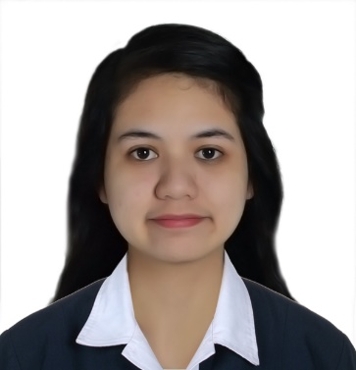**JEREMY A. AGAPAY**

Phase 7A Blk 4 Lot 32 Wednesday St. Corner Tuesday St. Pacita 1 San Vicente San Pedro, Laguna

(0917) 379 - 6629

[jeremy.agapay@yahoo.com](mailto:jeremy.agapay@yahoo.com)

**OBJECTIVE:**

Looking for a job and opportunity where I could practice my knowledge and develop my personality as a career person while utilizing my skills.

**PERSONAL DATA:**

**Age:** 20 years old

**Date of birth:** June 7, 1995

**Nationality:** Filipino

**Marital Status:** Single

**EDUCATIONAL BACKGROUND:**

**Tertiary: SAN PEDRO COLLEGE OF BUSINESS ADMINISTRATION**

Km. 30 Old National Highway Barangay Nueva City of San Pedro, Laguna

Bachelor of Science in Psychology

2011 – 2015

**Secondary: IMMACULATE HEART OF MARY SCHOOL**

Pacita 2 Guevara Subdivision San Pedro, Laguna

2006 – 2010

**Elementary: IMMACULATE HEART OF MARY SCHOOL**

Pacita 2 Guevara Subdivision San Pedro, Laguna

2001 – 2006

**ON THE JOB TRAININGS:**

Army Navy Burger + Burrito Inc.

74 Jupiter St. Bel-Air Village, Makati City

April – June 2014

St. Arabelle Child Center, Inc.

B36 L7 Sanggumay St. Elvinda Village, 4023 San Pedro, Laguna

June – August 2014

**SEMINARS ATTENDED**

“On becoming a Psychologist and Psychometrician”

August 20, 2014

“Stress Affecting Over-all Health Seminar”

January 14, 2015

“Acts of Man and Human Acts”

January 16, 2015

“Things Money Can’t Buy”

January 19, 2015

“Being a Winner”

January 21, 2015

“ASEAN Integration 2015: Building Opportunities for the New Asian”

January 26, 2015

“Life after Graduation”

January 28, 2015

“Improving Self-Esteem”

February 16, 2015

“Perspective of Professionalism and Competence: Mandate for Tomorrow’s Challenges”

February 18, 2015

**REFERENCES:**

**Contact number:**

Ms. Jesusa G. Villanueva (0927) 659 – 9201

St. Arabelle Child Center, Inc.

School Directress

Ms. Erlinda D. Loria (0932) 440 – 9201

Academic Officer, SPCBA

JEREMY A. AGAPAY

**Applicant’s Signature**