HA NOI UNIVERSITY OF SCIENCE AND TECHNOLOGY

SCHOOL OF INFORMATION AND COMMUNICATION TECHNOLOGY

*FINAL PROJECT QUERIES*

Subject: Car rental company database design

Database Lab

June, 2021

Group 3:

To Xuan Hung - 20194772

Lecturer:

Tran Viet Trung, Ph.D.

# SQL queries

1. Display customer id, his/her first name and last name of the customers with at least 1 cash payment, ordered by customer id in descending order.

SELECT c.customer_id, c.first_name, c.last_name FROM customers c, payments p

WHERE c.customer_id = p.customer_id AND payment_type LIKE ‘cash’

ORDER BY p.customer_id DESC;

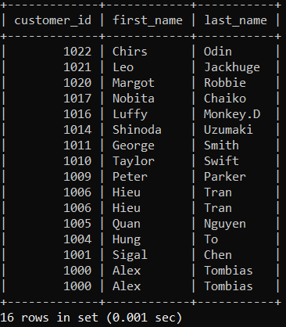

1. Display the manufacturer names and their car types if they produce at least one model of Sedan or SUV.

SELECT mn.manufacturer_name, c.car_type FROM manufacturers mn, models md, cars c

WHERE mn.manufacturer_id = md.manufacturer_id AND md.model_id = c.model_id AND car_type IN (‘SUV’, ‘Sedan’)

GROUP BY manufacturer_name, car_type;

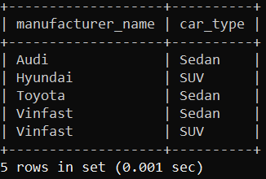

1. Display the first name, last name as full name and the rental time of the customers who rent a car for at least a month.

SELECT CONCAT(COALESCE(c.first_name, ‘’), ‘ ‘, c.last_name) AS full_name, TIMESTAMPDIFF(month, r.rental_date, r.return_date) AS month_rental_time FROM customers c, rental r

WHERE c.customer_id = r.customer_id

AND TIMESTAMPDIFF(month, r.rental_date, r.return_date) >= 1;

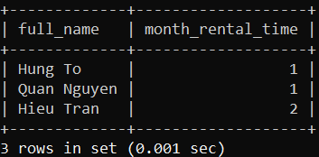

1. The company is organzing a special event in which customer can obtain a discount voucher depending on some conditions. Every time a customer rent a car, if the difference between rental date and date of birth is smaller than 1 month then the discount value will be 15%, if the difference is between 1 and 2 months then the discount value will be 10%, else the discount value will be 5%. Display the customer information includes customer id, first name, last name, date of birth and discount value as discount.

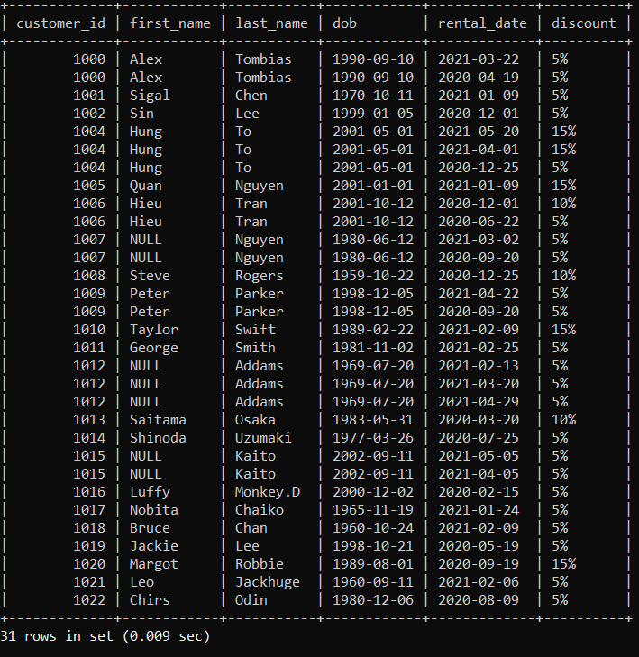

1. Display the customer id, first name and last name as full name, city name and the the number of stores available in the cities where the customers live.

SELECT c.customer_id, c.first_name, c.last_name, c.dob, r.rental_date,

CASE

WHEN ABS(DATE_FORMAT(c.dob, ‘%m’) - DATE_FORMAT(r.rental_date, ‘%m’)) <= 1 THEN ‘15%’

WHEN ABS(DATE_FORMAT(c.dob, ‘%m’) - DATE_FORMAT(r.rental_date, ‘%m’)) > 2 THEN ‘5%’

ELSE ‘10%’ END AS discount

FROM customers c, rental r

WHERE c.customer_id = r.customer_id;

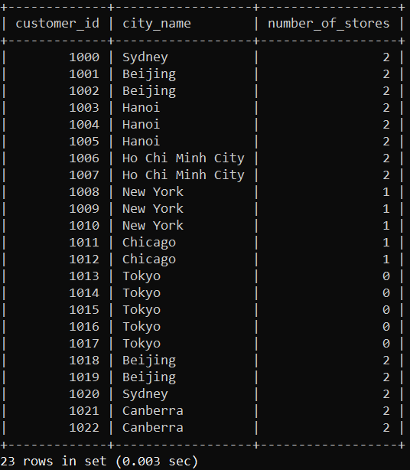

SELECT c.customer_id, CONCAT(COALESCE(c.first_name, ‘’), ‘ ‘, c.last_name) AS full_name, ci.city_name, COUNT(s.store_id) AS number_of_stores

FROM customers c LEFT JOIN (

addresses a LEFT JOIN cities ci

ON a.city_id = ci.city_id

LEFT JOIN stores s

ON ci.city_id = s. city_id

) ON c.address_id = a.address_id

GROUP BY c.customer_id;

1. Display the car id, car type and rating of the cars which have the largest number of rented times.

SELECT c.car_id, c.car_type, c.rating, COUNT(r.car_id) as number_of_times_rented

FROM cars c, rental r

WHERE c.car_id = r.car_id GROUP BY r.car_id

HAVING COUNT(r.car_id) >= ALL(select COUNT(car_id) FROM rental

GROUP BY car_id);

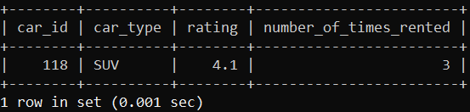

1. Display the information of the employees who have not been paid by their stores also display the information of those stores.

SELECT st.staff_id, st.first_name, st.last_name, st.email, st.salary, s.store_id, s.phone_number FROM stores s, staff st

WHERE s.store_id = st.store_id AND st.salary is null;

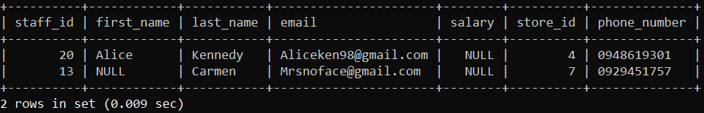

1. For ecouraging employees to work harder, the company decided to pay a bonus comission based on the total amount of rental cost a store achieves. The commission is calculated by taking the sum of total cost multiply by 10% then divided by the number of staff a store has. Display all the store id, staff id, salary, commision and the final salary.

SELECT s.store_id, st.staff_id, st.salary, SUM(total_cost)*0.1/COUNT(st.staff_id) AS revenue_commission, COALESCE(salary, 0) + SUM(total_cost)*0.1/COUNT(st.staff_id) AS final_salary

FROM staff st JOIN stores s

ON st.store_id = s.store_id JOIN cars c

ON c.store_id = s.store_id JOIN rental r

ON c.car_id = r.car_id

GROUP BY st.store_id, st.staff_id;

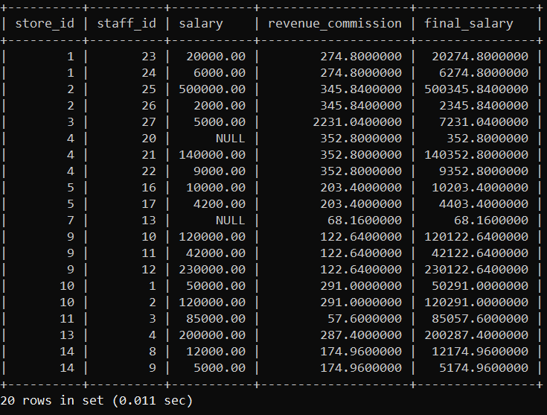

1. Display pairs of car ids in which the car id from the first column is rented with the cost per hour higher than that of the car id from the second column for every car within the same car type.

SELECT DISTINCT c1.car_type, c1.car_id, c2.car_id, r1.cost_per_hour, r2.cost_per_hour FROM cars c1 JOIN cars c2

ON c1.car_type = c2.car_type JOIN rental r1

ON r1.car_id = c1.car_id JOIN rental r2

ON r2.car_id = c2.car_id

WHERE r1.cost_per_hour > r2.cost_per_hour

ORDER BY c1.car_id;

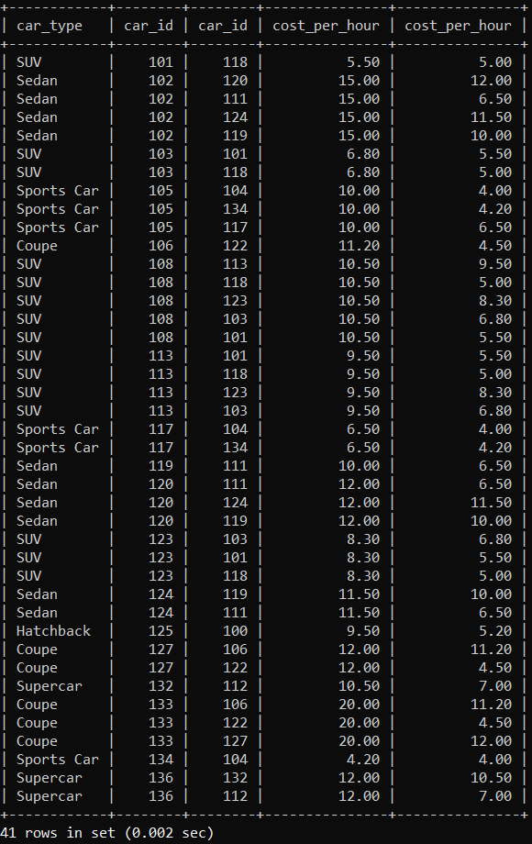

1. Display the country names and the quantity of the cars rented in those countries not count for ‘Sports Car’. The number of cars rented is ordered descdingly.

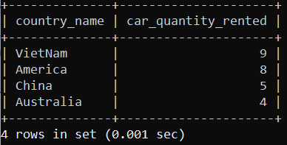

SELECT country_name, COUNT(r.car_id) AS car_quantity_rented FROM countries c, cities ci, stores s, cars ca, rental r

WHERE c.country_id = ci.country_id

AND ci.city_id = s.city_id

AND s.store_id = ca.store_id

AND ca.car_id = r.car_id

AND ca.car_type

NOT LIKE ‘Sports car’

GROUP BY country_name ORDER BY car_quantity_rented DESC;