B6x
Bluetooth 5.2 SoC
Datasheet
Specification

©2022
Disclaimer: Descriptions of specific implementations are for illustrative purpose only actual hardware implementation may differ.
。
Version History
Version | Date | Author(s) | Description
V1.0 | 2022.12.2 | Door | Initial
V1.1 | 2023.1.9 | Door | Modify font format
V1.2 | 2023.3.27 | Door | Update chip’s package type and pin num
V1.3 | 2023.6.27 | Door | Update chip’s package
V1.4 | 2023.6.30 | Door | Update chip’s package and electrical  characteristics
V1.5 | 2023.7.3 | Door | Update electrical characteristics
V1.6 | 2023.7.3 | Door | Update chip’s package
V1.7 | 2023.7.14 | Door | Update chip’s package
V1.8 | 2023.7.28 | Door | Update QFN20 Pins
V1.9 | 2023.8.24 | Door | Update QFN32 and QFN20 Package
V2.0 | 2023.10.20 | Door | Update GPIO’s description
V2.1 | 2023.11.17 | Door | Update SOP16’s package
V2.2 | 2024.1.10 | Door | Delete SOP8
V2.3 | 2024.1.16 | Door | Add eSOP8 Package
V2.4 | 2024.5.7 | Door | Update eSOP8’s Flash Size
V2.5 | 2024.5.10 | Door | Update I/O port characteristics
V2.6 | 2024.5.14 | Door | 1. Fixed the error that the TX/RX current in the electrical was reversed  2.Update Chip power off current
V2.7 | 2024.5.30 | Door | Update Electrical Specifications
V2.8 | 2024.6.11 | Door | Update QFN32 and QFN20 Package(add pin spacing)
V2.9 | 2024.10.10 | Door | Update QFN20 Package
V3.0 | 2024.10.29 | Door | Update Reference Design Cap_C1 Value
V3.1 | 2024.12.24 | Door | Update SPI Master and SPI Slave speed
V3.2 | 2025.1.10 | Door | Update chip’s operate temperature range
V3.3 | 2025.5.14 | Door | Add QFN32 with 512KB Flash
V3.4 | 2025.7.29 | Door | Update Electrical Specifications
V3.5 | 2025.12.5 | Door | Update QFN32 and QFN20 Package
V3.6 | 2025.12.30 | Door | Update eSOP8 Package
V3.7 | 2026.4.21 | Door | 1.Update maximum UART baud rate  2.Update capacitance value of C5 in reference design

Table of Contents
1 General Description 5
1.1 Overview 5
1.2 Features 5
1.3 Block Diagram 9
2 Pin Assignments 10
2.1 B6x QFN Package 10
2.1.1 QFN20-B63 10
2.1.2 QFN32-B66/B68 11
2.2 B6x SOP Package 12
2.2.1 SOP16-B62 12
2.3 eSOP8-B61 12
3 Peripheral Blocks 13
3.1 GPIO 13
3.2 Cross Switch Connect 13
3.3 UART 13
3.4 I2C 14
3.5 SPI Master 14
3.6 SPI Slave 15
3.7 Timer 15
3.8 ADC 16
3.9 Smart DMA 17
4 I/O Multiplexing and Cross Switch Connect 18
4.1 Multiplexed Signals 18
4.2 Cross Switch Connect Map 19
5 Electrical Specifications 20
6 Schematic 22
7 Ordering Information 23
8 Package Information 24
8.1 QFN20 3x3x0.75x0.4-P0.25 mm package 24
8.2 QFN32 4x4x0.75x0.4-P0.3 mm package 24
8.3 SOP16 package 25
8.4 eSOP8 package 25

General Description

Overview
B6x is a very low power, high performance and highly integrated Bluetooth 5.2 BLE + 2.4G Proprietary solution, designed for operation over the 2360 to 2520MHz ISM frequency band.
B6x is manufactured using advanced CMOS low leakage process, which offers highest integration, lowest power consumption, lowest leakage current and reduced BOM cost while simplifying the overall system design.

Features
- BT 5.2 + 2.4GHz-Proprietary SoC
  - Supported data rates: 1Mbps、2Mbps
  - -96 dBm sensitivity @1Mbps BLE mode
  - -92 dBm sensitivity @2Mbps BLE mode
  - TX power: -40 dBm to 6 dBm
  - Single-ended antenna output
  - Integrated balun
  - Support BLE Mesh
- RISC 32-bit MCU
  - High Performance (64MHz)
- SMART 8 Channels DMA Controller
- CACHE
  - CACHE Support Range：4KB
- USB
  - USB1.1 full speed：12Mbps
  - Supports up to 5 endpoints, and endpoints 1~4 support simultaneous sending and receiving
  - All endpoints’ FIFO depth is 64 bytes
- On-Chip Memory
  - 4KB ROM
  - Max 32KB SRAM
  - eSOP8(SIP 128KB QSPI FLASH)
  - SOP16(SIP 128KB QSPI FLASH)
  - QFN20(SIP 256KB QSPI FLASH)
  - QFN32(SIP 256KB/512KB QSPI FLASH)
- Clock Generation Unit
  - Crystal Oscillator Supporting 16MHz(XTAL)
  - Internal Resonant Crystal (IRC) 16MHz +/- 2%
  - Internal programmable Ultra Low Power RC(RC32K)
  - Internal HF DPLL48M/64M clock
  - Support external injection clock
- Real Time Clock (RTC)
  - Operates from Ultra Low Power Technology
  - Operates from Internal Ultra Low Power RC
- Watch Dog Timer
  - Operates from Internal Low Power WDT Crystal
- Flex Timer Module
  - Advanced 16-bit Counter/Timer (1X) (ATMR)
  - Common 16-bit Counter/Timer (1X) (CTMR)
4 channels Compare Match with PWM / Capture / Compare
  - Basic 16-bit Counter/Timer (1X) (BTMR)
- Serial Interfaces
  - UART (2X) support RS485/IrDA/ISO7816-3, Speed up to 3.76Mbps AHB
  - SPI Master(1X), speed up to 24Mbps
  - SPI Slave(1X), speed up to 32Mbps
  - I2C-bus (1X) compatible 2-wire master/slave,
Support Fast-mode with data rates up to 400Kbps
- Analog-Digital Converter
  - 10-bit ADC, 1Mbps , 10 input channels
  - MIC function，support 8K Sample rates
- General Purpose I/Os
  - Supports up to 20 GPIOs,
each GPIO supports interrupt and wake-up functions.
- Power Management Controller
  - Integrated Power-On-Reset (POR)
  - Integrated Low-Voltage-Detect (LVD) ，Default voltage threshold 1.65V
- Voltage range
- Operating voltage range: 1.8 V to 5.2 V (device-specific)
- Power Consumption
  - On-chip DC/DC and LDO regulators with automated low current modes
  - 44.7μA/MHz (@3.3V with 16M RC)
  - Deep sleep Mode，70 μA @3.3V
  - Power off Mode，1μA @3.3V
  - 7.2mA Tx peak current in BLE/2.4G mode (@1.8V 0dBm)
  - 10.3mA Rx peak current in BLE/2.4G mode (@1.8V)
- ESD 4500V
- Operating temperature range: -40 °C to 85 °C (-40 °C to 105 °C available upon order specification)

Block Diagram

Pin Assignments
This section describes the pin assignment for the different package types.

B6x QFN Package

QFN20-B63

QFN32-B66/B68

B6x SOP Package

SOP16-B62

eSOP8-B61

Peripheral Blocks

GPIO
The general-purpose input/output (GPIO) is configured as a control interface with up to 20 I/O pins (package-dependent). Up to 20 pins can be accessed and controlled through one port, and each GPIO can be accessed individually.
- 14 GPIO s(QFN20)
- 20 GPIOs (QFN32)
- 10 GPIOs (SOP16)
- 3 GPIOs(eSOP8)
- Configurable output drive strength
- Internal pull-up and pull-down resistors
- Wake-up from high or low level triggers on all pins
- Trigger interrupt on state changes on any pin

Cross Switch Connect
SPI/UART/I2C can be selected on all GPIOs

UART
- Full duplex asynchronous communication
- Support single-line half duplex communication
- 16-byte TX and RX FIFOs
- Support speed up to 3.76M bps
- Support auto-baudrate
- Support DMA
- Support CTS and RTS
- Support IrDA SIR, RS-485, ISO/IEC7816-3, LIN, Modbus

I2C
- Master and Slave modes
- Fast mode speed up to 400k bps
- 7-bit and 10-bit addressing mode
- 8-bit TX/RX Buffers
- Hardware PEC (Packet Error Checking) generation and verification with ack

SPI Master
The Serial Peripheral Interface (SPI) is a synchronous serial data communication protocol that operates in full duplex mode.
- Supports SPI Serial Peripheral Interconnect Master Protocol
- Support SPI different mode：0、1、2、3(with CPOL and CPHA)
- Support full duplex, receive only and transmit only mode
- Master Mode speed upto 24Mbps
- Provides separate 8-layer depth transmit and receive FIFO buffers
- Supports DMA transfer
- Support transmit over interrupt
- Support Configure MSB/LSB first

SPI Slave
The Serial Peripheral Interface (SPI) is a synchronous serial data communication protocol that operates in full duplex mode.
- Supports SPI Serial Peripheral Interconnect Master Protocol
- Support SPI different mode：0、1、2、3(with CPOL and CPHA)
- Support full duplex mode
- Slave Mode speed upto 32Mbps
- Provides separate 8-layer depth transmit and receive FIFO buffers
- Supports DMA transfer
- Support transmit over interrupt
- Support Configure MSB/LSB first

Timer
There are 3 Counters/Timers:
- Advanced Timer (x1): Support 4 Independent channels for Input capture, Output compare, PWM and Single pulse output; dead-time; break function; ETR function
- Common Timer (x1): Support 4 Independent channels for Input capture, Output compare, PWM and Single pulse output; ETR function
- Basic timer (x1): Support 4 Independent channels for Input capture, Output compare, PWM and Single pulse output

ADC
10-bit precision ADC with 10 input channels, sampling rate up to 1 Mbps.
- Support work clock can be divided by 1~ 1024
- Support hardware calibration mode
- Support single conversion mode or continuous mode
- Support the DMA read data function
- Support ATMR1 trigger SADC sampling mode
- Support Channel rotation function
- MIC function support 8K Sample rates
- Support measure power voltage
- Support up to 8 channels single end input
- Data width is 10-bit, and effective bit width is up to 9-bit

Smart DMA
- 8 Channels DMA
- each DMA channel has a programmable priority level
- each priority level arbitrates using a fixed priority that is determined by the DMA channel number
- supports multiple transfer types:
  - memory-to-memory
  - memory-to-peripheral
  - peripheral-to-memory
- the number of transfers in a single DMA cycle can be programmed from 1 to 1024

I/O Multiplexing and Cross Switch Connect

Multiplexed Signals
PIN |  |  |  | NAME | Default | Function 0 | Function 1 | Function 2 | Function 3 | Function Analog
eSOP  8 | SOP  16 | QFN  20 | QFN  32 |  |  | GPIO | CSC | SPECIAL | TIMER | Analog
 | 16 |  |  | GND | -- | -- | -- | -- | -- | --
 |  |  | 4 | VDD42 | -- | -- | -- | -- | -- | --
7 | 7 | 3 | 5,9 | VDD33^{①} | -- | -- | -- | -- | -- | --
8 | 1 | 5 | 7 | RFP | -- | -- | -- | -- | -- | --
 | 4 | 6 | 10 | RSTn/PA19 | RSTn | PA19 | CSC | -- | -- | --
 |  | 7 | 11 | PA18 | GPIO | PA18 | CSC | -- | CTMR_CH4 | --
 | 5 | 8 | 12 | PA17 | GPIO | PA17 | CSC | -- | CTMR_CH3 | --
 |  | 9 | 13 | PA16 | GPIO | PA16 | CSC | -- | CTMR_CH2 | ANAIO6
 |  |  | 14 | PA15 | GPIO | PA15 | CSC | -- | CTMR_CH1 | ANAIO5
 |  |  | 15 | PA14 | GPIO | PA14 | CSC | -- | ATMR_ETR | ANAIO4
 | 6 | 10 | 16 | PA13 | GPIO | PA13 | CSC | -- | ATMR_CH3N | ANAIO2
4 |  |  | 17 | PA12 | GPIO | PA12 | CSC | -- | ATMR_CH2N | ANAIO1
 |  |  | 18 | PA11 | GPIO | PA11 | CSC | -- | ATMR_CH1N | ANAIO0
 | 3 | 11 | 19 | PA10 | GPIO | PA10 | CSC | -- | ATMR_CH4P | ANAIO9
 | 2 | 12 | 20 | PA9 | GPIO | PA9 | CSC | -- | ATMR_CH3P | ANAIO8
 | 8 | 13 | 21 | PA8 | GPIO | PA8 | CSC | -- | ATMR_CH2P | ANAIO7
2 | 9 | 14 | 22 | PA7/DM^{②} | GPIO | PA7 | CSC | -- | ATMR_CH1P | ANAIO6
3 | 10 | 15 | 23 | PA6/DP^{③} | GPIO | PA6 | CSC | -- | ATMR_BK | ANAIO5
 |  |  | 24 | PA5 | GPIO | PA5 | CSC | -- | CTMR_CH4 | ANAIO4
 |  |  | 25 | PA4 | GPIO | PA4 | CSC | -- | CTMR_CH3 | ANAIO3
 |  | 16 | 26 | PA3/MICIN | GPIO | PA3 | CSC | -- | CTMR_CH2 | MICIN
 |  | 17 | 27 | PA2/MICBIAS^{④} | GPIO | PA2 | CSC | -- | CTMR_CH1 | ANAIO2
 | 11 | 18 | 28 | PA1/SWDIO | SWDIO | PA1 | CSC | SWDIO | CTMR_ETR | ANAIO1
 | 12 | 19 | 29 | PA0/SWCLK | SWCLK | PA0 | CSC | SWCLK | -- | ANAIO0
1 | 13 | 2 | 30 | VDD12 | -- | -- | -- | -- | -- | --
5 | 14 | 20 | 32 | XO16M_O | -- | -- | -- | -- | -- | --
6 | 15 | 1 | 1 | XO16M_I | -- | -- | -- | -- | -- | --
- The QFN32 package has two VDD33 pins: PIN5 is VDD33_1 and PIN9 is VDD33_2. VDD33_1 and VDD33_2 are connected internally.
- PA6 default as gpio, if you want it use as USB DP, you need to close IE, OE, PU, PD etc.…
- PA7 default as gpio, if you want it use as USB DM, you need to close IE, OE, PU, PD etc.…
- PA2 default as gpio, if you want it use as MICBIAS, you need to close IE, OE, PU, PD etc.…

NAME | EXPLANATION
PA00~PA19 | GPIOs (High Level)
SWCLK | Debug Clock Pin
SWDIO | Debug Data Pin (High Level)
DP | USB Data Positive
DM | USB Data Minus
MICBIAS | MIC output voltage
MICIN | MIC signal input
RFP | RF Antenna Posedge
XO16M_O | Crystal oscillator 16M Output
XO16M_I | Crystal oscillator 16M Input
CTMR_CH1~ CTMR_CH4 | 4 Channels Common Timer1 PWC Input / PWM Output
ATMR_ETR /CTMR_ETR | Advanced Timer/Common Timer External Trigger
ATMR_BK | Advanced Timer1 Break Input
ATMR_CH1P~ ATMR_CH4P | 4 Channels Advanced Timer Positive PWC Input / PWM Output
CSC | GPIO Function Multiplexing
AINIO0~AINIO9 | ADC Input
VDD12 | Digital core voltage output 1.2V
VDD33 | voltage input 3.3V
VDD42 | voltage input 4.2V

Cross Switch Connect Map
The Cross Switch Connect (CSC) controls the function of each GPIO pin in a highly flexible way by allowed to connect many functions like the UART, SPI, and I2C functions to any pin on GPIO Function 3. These functions are called movable functions and are listed in the following Table.

Electrical Specifications
Name | Parameter（Condition） | Min | Typical | Max | Unit
Power Supplies
VDD33 | 3.3v voltage input | 1.8 | 3.3 | 3.6 | V
VDD42 | 4.2v voltage input | 2.7 |  | 4.2 | V
TEMP | Temperature |  | -40 | 25 | 85
I/O port characteristics
VIH | High Level (VDD_{IN} = VDD33/VDD42/VDD50) |  | 0.7 |  | VDD33
VIL | Low Level (VDD_{IN} = VDD33/VDD42/VDD50) |  | 0.3 |  | VDD33
VOH | High Level (VDD_{IN} = VDD33/VDD42/VDD50) |  | 0.7 |  | VDD33
VOL | Low Level (VDD_{IN} = VDD33/VDD42/VDD50) |  | 0.3 |  | VDD33
Iout | GPIO output drive strength (VCCIO = 3.3V) |  | 3 | 6 | mA
R_{pu} | GPIO Weak pull-up equivalent resistor |  | 64 |  | KΩ
R_{pd} | GPIO Weak pull-down equivalent resistor |  | 68 |  | KΩ
R_{usb} | USB DP pull-up equivalent resistor |  | 1.5 |  | KΩ
Current Consumption
IVDD | Sleep Mode1  - The core and peripherals are powered down;  all register and SRAM data are lost.  - Only all GPIOs are supported for wake-up.  - After wake-up, the program starts execution from address 0. |  | 1 |  | uA
IVDD | Sleep Mode2  - The core and peripherals are powered down;  all register and SRAM data are lost.  - Supports wake-up via all GPIOs and RTC.  - After wake-up, the program starts execution from address 0. |  | 1.7 |  | uA
IVDD | Sleep Mode3  - The core and peripherals are powered down;  all register and SRAM data are lost.  - 8 KB of non-volatile SRAM retains data.  - Supports wake-up via all GPIOs and RTC.  - After wake-up, the program starts execution from address 0.  - Retains BLE, peripheral, and register data for fast restoration  of the pre-sleep state. |  | 2 |  | uA
IVDD | Sleep Mode4  - The core and peripherals remain powered on;  all register and SRAM data are preserved.  - Wake-up from all GPIOs and RTC is supported.  - After wake-up, program execution resumes from  the point where sleep occurred. |  | 70 |  | uA
IVDD | RX mode, BLE & 2.4G mode, 100% ON (@1.8V) |  | 7.2 |  | mA
IVDD | TX mode, BLE & 2.4G mode, 100% ON (@1.8V) |  | 10.3 |  | mA
IVDD | Advertising mode: interval 500ms (@1.8V 0dBm) |  | 51 |  | uA
IVDD | Link mode: interval 500ms (@1.8V) |  | 38 |  | uA
Normal RF Condition
FOP | Operating Frequency | 2360 |  | 2520 | MHz
FXTAL | Crystal Frequency |  | 16 |  | MHz

Schematic

Designator | Value | Description | Footprint
C1 | 10nF | Capacitor, X7R, ±10% | 0402
C2, C3 | NC
C4 | 2.2pF | Capacitor, X7R, ±10% | 0402
C5 | 10uF | Capacitor, X7R, ±10% | 0402
C6 | 100nF | Capacitor, X7R, ±10% | 0402
X1 | 16MHz | XTAL SMD 3225, 16MHz, Cl=9 pF, 40Ω, ±10ppm | Seam Seal 3225

Ordering Information

Ordering Code | FLASH (bytes) | Package | Size(mm) | Carrier Type | Pack Quantity
B61 | 128KB | eSOP8 | 4.9x3.9 | TUBE | 10000
B62 | 128KB | SOP16 | 9.9x3.9 | TUBE | 5000
B63 | 256KB | QFN20 | 3x3 | Tape and Reel | 5000
B66 | 256KB | QFN32 | 4x4 | Tape and Reel | 5000
B68 | 512KB | QFN32 | 4x4 | Tape and Reel | 5000

Package Information

QFN20 3x3x0.75x0.4-P0.25 mm package
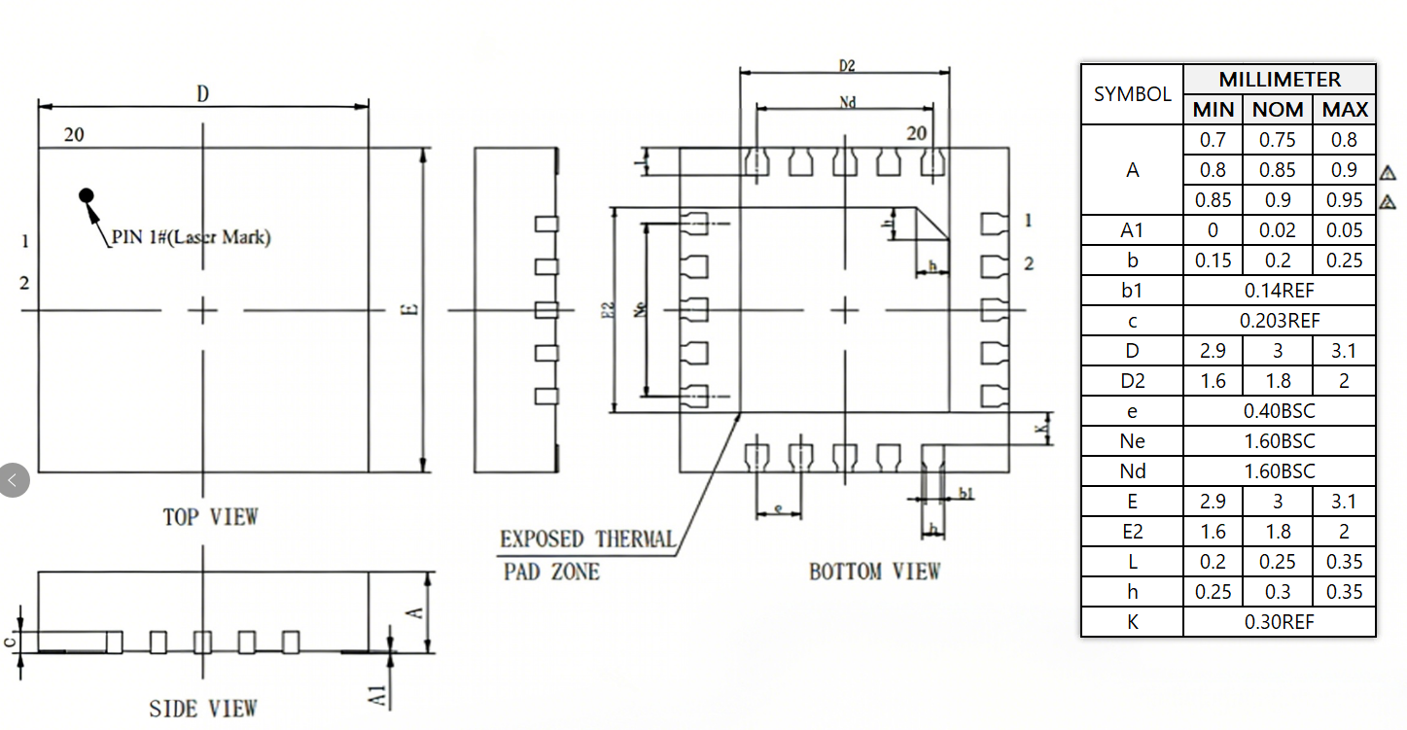

QFN32 4x4x0.75x0.4-P0.3 mm package
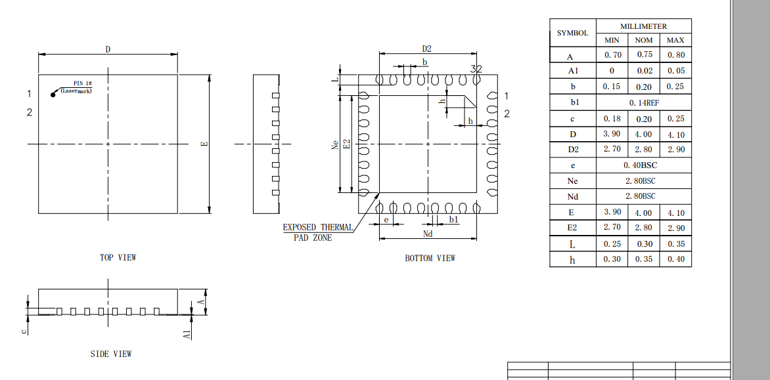

SOP16 package
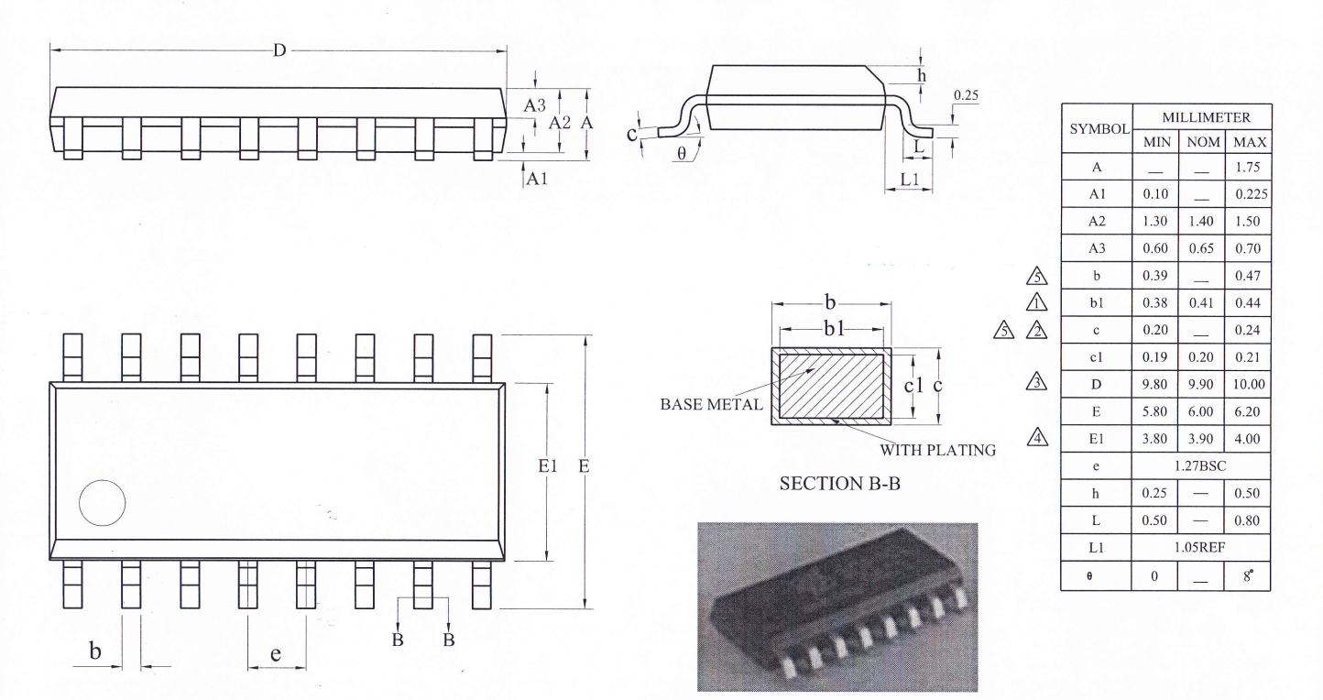

eSOP8 package
