**ECE 385**

**2021 FA**

**LAB 2**

**Data Storage**

Zhou Qishen, Xie Mu

**Introduction**

We designed and built a bit-serial logic operation processor by TTL method. The design utilized two 4-bit shift registers, several multiplexers, and some type of counter. The circuit have capability of calculating eight different functions and routing the results of those operations in 4 ways.

**Pre-Lab Question**

**Question 1.**

Simply one XOR gate:

**Question 2.**

Modular design has several advantages which can dramatically reduce the designing time. First, modular design makes the designing and testing stage much simpler. For each module, it has the capability to operate individually, which means one can run the module by giving right input even without the context of the circuit. Testers could take advantage of the property mentioned before by testing the module outside the original circuit to eliminate the disturbance of other part of the circuit. Moreover, modular design could make the product more logical. If everything is modular, the I/O standard or interface rules could be clearly defined, in order to track the data flow in the circuit; and the whole circuit can be built in a relation of tree, with masters and slaves, which have a great effect on maintenance and reader-friendliness.

**Operation Description**

**Loading A and B:** First LOAD A or LOAD B is set to high. Then AND LOAD with NOT EXECUTE, which ensure that it won’t load the data when executing. Finally, the data flow in the Register A and B.

**Computing & Routing:** For every off edge of the clock, if the control unit have received an EXECUTE signal, the computing module load the first bit of register and receive the signal from F, which indicate the operation desired. Then the result Y is calculated, XOR with F2 and then sent into routing unit, which will receive R signal. In the meantime, A and B is also sent into the routing unit. Based on R signal, the result Y will be sent back into the tail of the register to complete Computing & Routing step.

**Description of circuit**

**High Level Description**

**Register**: 2 4-bit shift register store the data.

**Control unit**: Run a state machine control the whole process and manage the I/O instruction

**Computing unit**: Receive function command and do operation matched

**Routing unit**: store A, B, F into right place in register by routing command

**High Level Block Diagram**

High Level Block Diagram

**State Machine**

**Design Steps**

**K-Map**

**Detailed Circuit Schematic**

Shift Reg

Computing Unit

Routing Unit

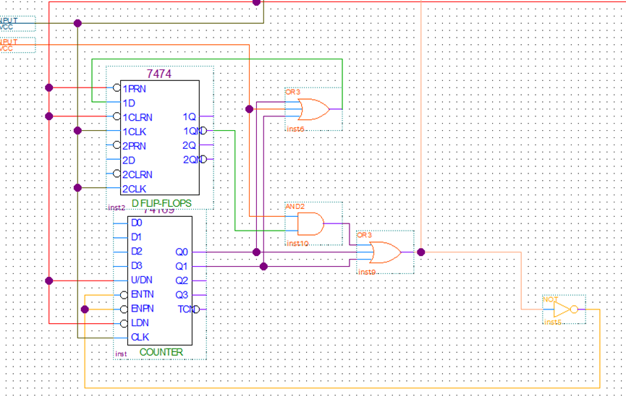

Control Unit

**Conclusion**

In conclusion, in this lab, we learnt how to use TTL to develop a simple processor, which contain a register, a control unit, a computing unit and a routing unit. The circuit also taught us a important lesson: don’t mess up with the order of output.