Designing a Jurisdiction-Aware RegTech Tool
——JurisFair BNPL Credit Monitor
Task 3 - Design Document
Student: TONG XIN（G2505218J）
Email: XIN021@e.ntu.edu.sg
Executive Summary
JurisFair BNPL Credit Monitor is a jurisdiction-aware compliance analytics prototype for Klarna-style BNPL / consumer credit decisions in the US and the EU. It does not make credit decisions. It monitors the outputs of a credit risk model, calculates whether applicants with similar predicted default risk receive different approval outcomes across audit groups, and then applies jurisdiction-specific US and EU rule configurations.
The project follows Task 3 Option C: Analytical Design with Quantitative Component. It uses synthetic data, trains an interpretable logistic regression model, applies a residual policy layer, maps denial reasons, calculates RAAD, AIR, FNR gap and PSI-related metrics, and runs sensitivity analysis under stress, distribution shift, credit tightening, missing audit data and jurisdictional misconfiguration.
- Tool architecture and workflow
Stage | Function | Compliance significance
Synthetic data generation | Create 20,000 BNPL-style applications split between US and EU portfolios. | Demonstrates tool logic without using real consumer data.
Credit risk model | Train logistic regression to predict 90-day default risk. | Interpretable predicted PD supports risk-adjusted comparisons.
Residual policy layer | Adjust predicted PD using policy factors such as legacy bureau score and device consistency. | Reflects that real systems mix model scores and policy rules.
Approval decision | Approve when effective PD is at or below the cutoff. | Creates the outcome variable for fairness monitoring.
Denial reason mapping | Map denials to model features and residual policy-layer drivers. | Supports US adverse-action review and EU traceability.
Metric layer | Calculate RAAD, |RAAD|, AIR, FNR gap, PSI and subgroup PSI. | Separates fairness, screening and drift signals.
Jurisdiction engine | Load US and EU thresholds and output actions from jurisdiction_rules.yaml. | Makes the same metric mean different things under different regimes.
Governance layer | Record model version, data version, rule version and human-review status. | Controls auditability, configuration risk and over-reliance on automation.
- Synthetic data and model design
The prototype generates 20,000 synthetic applications: 10,000 for the US portfolio and 10,000 for the EU portfolio. Variables include income, debt-to-income ratio, credit history length, prior late payments, existing Klarna balance, purchase amount, merchant category risk, thin-file flag, device consistency score, repayment history score, legacy bureau score, audit group, predicted default probability, approval outcome and denial reasons.
The audit_group variable is used only for compliance testing and is excluded from the model. Jurisdiction is also excluded from the model and used only by the rule engine. The synthetic design intentionally correlates the protected/vulnerable audit group with shorter credit history, thin-file status and other variables to simulate proxy risk. This is a demonstration of monitoring logic, not a claim about Klarna actual customers or compliance status.
- Core metric: Risk-Adjusted Approval Disparity
RAAD asks whether applicants with comparable predicted default risk receive different approval outcomes across audit groups. The tool first divides applicants into predicted-PD risk bands. Within each band it calculates approval rates for the reference group and the protected/vulnerable group. The band-level gap is ApprovalRate_reference,b minus ApprovalRate_protected,b. RAAD is the weighted average of these band-level gaps.
The final alerting logic applies thresholds to |RAAD|, not raw RAAD. The sign is retained only to identify the affected group. Positive RAAD means the protected/vulnerable group has lower risk-adjusted approval. Negative RAAD means the reference group has lower risk-adjusted approval. Both directions are monitored. RAAD is a review trigger, not a legal conclusion.
- Jurisdiction configuration layer

Configuration element | US mode | EU mode
Primary metric | |RAAD| | |RAAD|
Amber / red thresholds | 0.05 / 0.08 | 0.03 / 0.05
AIR threshold | 0.80 screening trigger; at least watch if below threshold. | 0.80 screening trigger supporting high-risk AI governance review.
PSI logic | Overall PSI is a monitoring signal; subgroup PSI is optional. | Overall PSI triggers subgroup-level drift decomposition; subgroup PSI gap above 0.05 escalates governance review.
Reason mapping | Specific adverse-action reason review under ECOA / Regulation B. | Traceability, auditability, technical documentation and human oversight.
Legal boundary | Not an automatic ECOA violation. | Not a final legal determination under the EU AI Act.

- Baseline quantitative output
Jurisdiction | |RAAD| | 95% CI | AIR | Overall PSI | Status | Tool output
US | 0.042 | [0.034, 0.050] | 0.694 | 0.000 | watch | Continue monitoring; check adverse action reason coverage
EU | 0.044 | [0.034, 0.050] | 0.705 | 0.000 | amber | High-risk AI bias monitoring review; update governance documentation and human oversight log
The baseline output demonstrates real jurisdiction awareness. The US portfolio has |RAAD| = 0.042 and status watch because |RAAD| is below the US amber threshold of 0.05 but AIR is below the 0.80 screening threshold. The EU portfolio has |RAAD| = 0.044 and status amber because the EU internal high-risk AI governance threshold is stricter at 0.03. The same approximate disparity therefore changes meaning when the jurisdiction configuration changes.
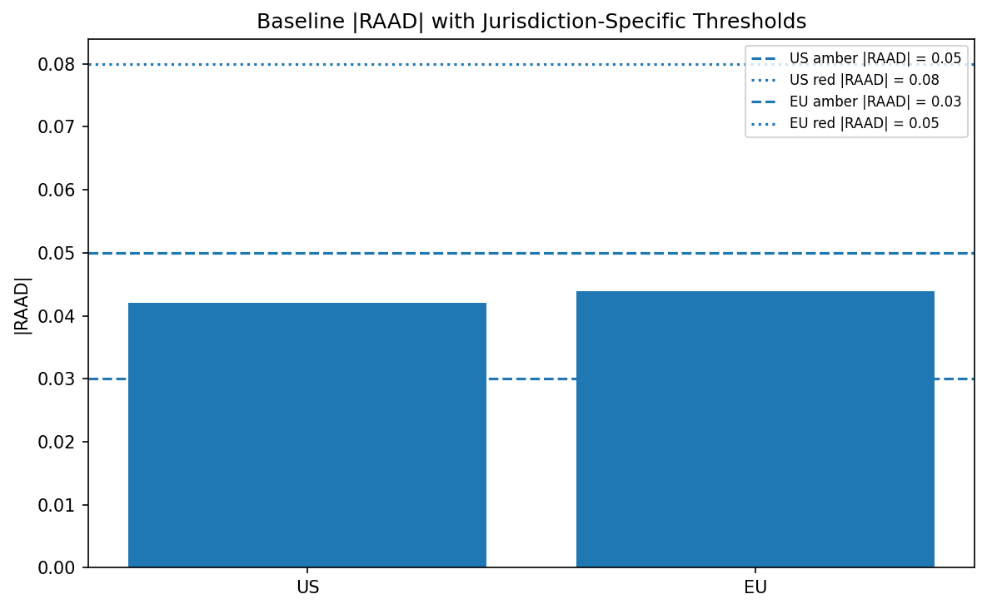
Figure 1. Baseline |RAAD| with jurisdiction-specific thresholds.
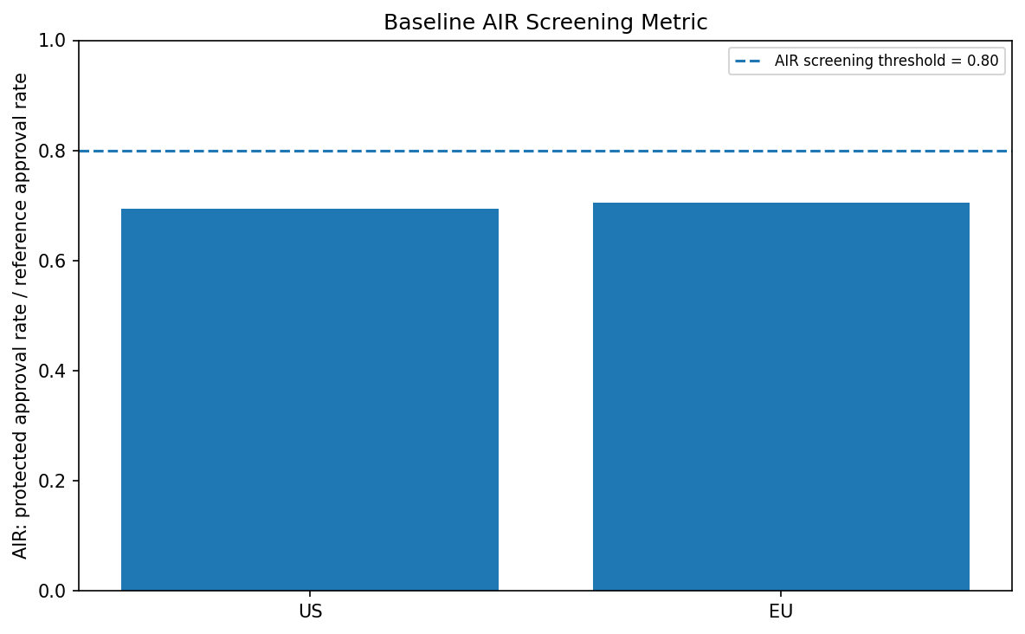
Figure 2. AIR is shown separately because it is a screening ratio, not the same scale as RAAD.
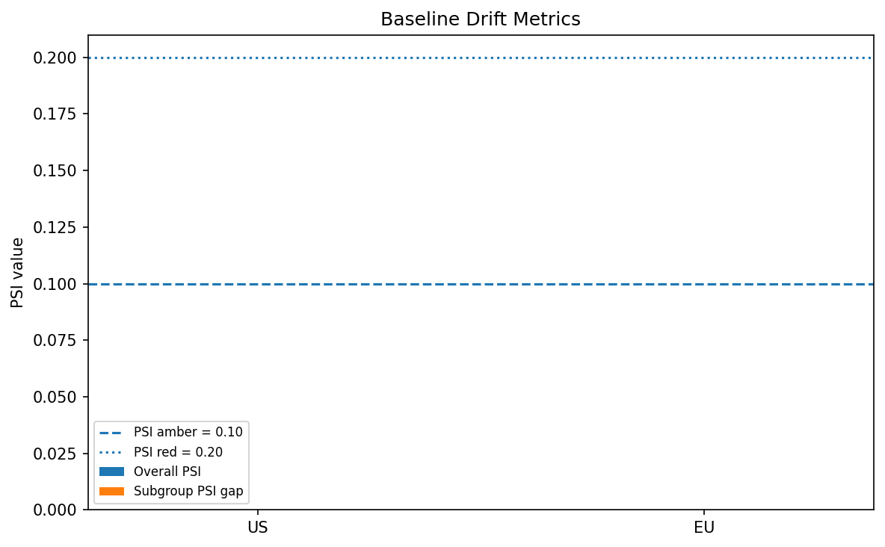
Figure 3. PSI is shown separately because it is a data-drift metric, not a fairness metric.

6. Sensitivity analysis
Scenario | US output | EU output | Interpretation focus
economic_stress | amber / |RAAD| 0.054 | amber / |RAAD| 0.047 | Stress raises risk, AIR deterioration and PSI drift; EU also triggers subgroup drift logic.
distribution_shift | watch / |RAAD| 0.042 | red / |RAAD| 0.057 | EU becomes red while US remains watch; this is the clearest jurisdiction-divergence scenario.
credit_tightening | amber / |RAAD| 0.062 | red / |RAAD| 0.063 | A tighter cutoff may reduce credit risk but increases outcome disparity and governance risk.
missing_audit_10pct | amber / |RAAD| 0.042 | amber / |RAAD| 0.045 | Missing audit data is treated as insufficient evidence, not a pass.
missing_audit_20pct | amber / |RAAD| 0.045 | amber / |RAAD| 0.046 | Higher missingness reinforces data-governance escalation.
missing_audit_30pct | amber / |RAAD| 0.041 | amber / |RAAD| 0.046 | Severe missingness undermines evidentiary confidence in fairness monitoring.
misconfig_eu_data_us_rules | watch / |RAAD| 0.042 | amber / |RAAD| 0.044 | EU data under US rules changes escalation logic and must be rerun.
misconfig_us_data_eu_rules | amber / |RAAD| 0.042 | amber / |RAAD| 0.044 | US data under EU rules escalates more aggressively and shows configuration risk.
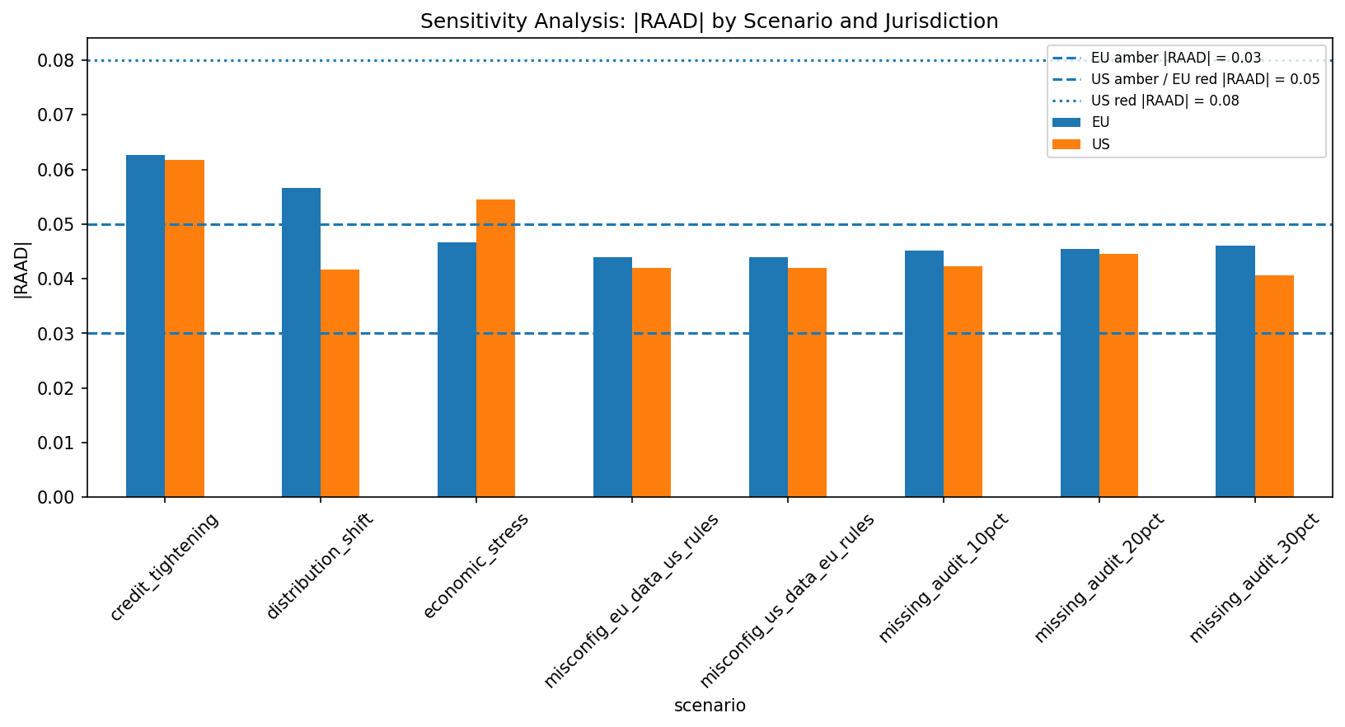
Figure 4. Sensitivity analysis: |RAAD| changes across stress, drift, credit-tightening, missing-data and misconfiguration scenarios.

7. Failure modes and boundaries
Failure mode | How it appears | Governance response
False positive | Metric flags a disparity that is not substantively meaningful. | Use CI, tiered statuses and human review rather than automatic legal conclusions.
False negative | A real disparity is missed because the metric is too narrow or audit data is incomplete. | Use |RAAD|, AIR screening, subgroup drift checks and missingness escalation.
Model drift | A model trained on baseline data performs differently under stress or shifted data. | Monitor PSI and reassess RAAD / FNR gap under fixed baseline model.
Jurisdictional misconfiguration | Wrong rule configuration is applied to the portfolio. | Flag misconfiguration, record versions and rerun under correct rules.
Over-reliance on automation | Management treats the tool output as legal judgement. | All red/amber outputs require accountable human review.

