[ Title ]  
  
Measurement data[ 19072900_Dip ]  
  
[ Name ]  
  
Report date[ 5/28/2025 1:57 PM ]  
  
  
  
  
  
  
  
  
  
  
  
  
  


======================================================================

Status

======================================================================

[ Measurement settings ]

Hardware

|  |  |
| --- | --- |
| Model | PQ3198 |
| Serial No. | 190222592 |
| Version | 1.01 |

Measured Line

|  |  |  |
| --- | --- | --- |
|  | CH123 | CH4 |
| Wiring | 3P3W3M | OFF |
| Frequency | 60Hz |  |
| Voltage Range | 600V | 600V |
| VT(PT) Ratio | 1 | 1 |
| Udin | 200V |  |
| Current Sensor | CT7044,CT9667(500A), CT9667(5KA),CT7045, CT7046 | CT7136,9661 |
| Current Range (Applied CT ratio) | 50A | 50A |
| CT Ratio | 1 | 1 |
| Sync Source | U1 |  |

Event Threshold

|  |  |
| --- | --- |
| Urms | Line - Line |
| PF | PF |
| THD | THD_F |
| Harmonics | U, I, P All Level |

Flicker

|  |  |
| --- | --- |
| Flicker | ΔV10 |

Recording

|  |  |
| --- | --- |
| Recording Items | Power && Harm |
| Trend Interval | 1min |
| Disp COPY Interval | OFF |
| Repeat Record | 1Day |
| Record Time | 00:00 - 00:00 |
| Maximum of events | 1000 |

[ Event Settings (Voltage, Current /Power /Others, Harmonics) ]

Voltage

|  |  |  |  |
| --- | --- | --- | --- |
|  |  | CH123 | CH4 |
| Frequency | Freq | 0.50Hz |  |
| Frequency 1 Wave | Freq_wav | 0.50Hz |  |
| U Swell | Swell | 110.00% |  |
| U Dip | Dip | 90.00% |  |
| Swell/Dip Slide |  | OFF |  |
| U Interrupt | Intrpt | 10.00% |  |
| U Transient | Tran | 100.0V | OFF |

|  |  |
| --- | --- |
| Hysteresis | 2% |

|  |  |  |  |
| --- | --- | --- | --- |
|  |  | CH123 | CH4 |
| U RMS High | Urms | OFF | OFF |
| Low | Urms | OFF | OFF |
| SENSE | Urms | OFF | OFF |
| U Peak | Upk | OFF | OFF |
| U DC Change |  |  | OFF |
| U THD | Uthd | 10.00% | OFF |
| Hharm U Component | UharmH | 20.00V | OFF |
| RevPhase Unbalance | Uunb | 3.00% |  |
| 0-Phase Unbalance | Uunb0 | OFF |  |

|  |  |  |
| --- | --- | --- |
| Compare U Wave | Wave | OFF |

Current

|  |  |  |  |
| --- | --- | --- | --- |
|  |  | CH123 | CH4 |
| Inrush Current | Inrush | 50.000A | OFF |
| I RMS High | Irms | OFF | OFF |
| SENSE | Irms | OFF | OFF |
| I Peak | Ipk | OFF | OFF |
| I DC Change |  |  | OFF |
| I THD | Ithd | OFF | OFF |
| Hharm I Component | IharmH | OFF | OFF |
| RevPhase Unbalance | Iunb | OFF |  |
| 0-Phase Unbalance | Iunb0 | OFF |  |
| K Factor | KF | OFF | OFF |

Power

|  |  |  |  |
| --- | --- | --- | --- |
|  |  | CH123 | sum |
| Active Power | P | OFF | OFF |
| Reactive Power | Q | OFF | OFF |
| Apparent Power | S | OFF | OFF |
| Power Factor | PF | OFF | OFF |

Others

|  |  |  |
| --- | --- | --- |
| Timer Event | Timer | OFF |
| External Event | Ext | OFF |
| After Event Occurs | After | 1s |

Harmonics

U harm

|  |  |  |  |  |  |  |  |  |  |  |  |
| --- | --- | --- | --- | --- | --- | --- | --- | --- | --- | --- | --- |
|  | CH123 | CH4 |  | CH123 | CH4 |  | CH123 | CH4 |  | CH123 | CH4 |
| 0 | OFF | OFF |  |  |  |  |  |  |  |  |  |
| 1 | OFF | OFF | 16 | OFF | OFF | 31 | OFF | OFF | 46 | OFF | OFF |
| 2 | OFF | OFF | 17 | OFF | OFF | 32 | OFF | OFF | 47 | OFF | OFF |
| 3 | OFF | OFF | 18 | OFF | OFF | 33 | OFF | OFF | 48 | OFF | OFF |
| 4 | OFF | OFF | 19 | OFF | OFF | 34 | OFF | OFF | 49 | OFF | OFF |
| 5 | OFF | OFF | 20 | OFF | OFF | 35 | OFF | OFF | 50 | OFF | OFF |
| 6 | OFF | OFF | 21 | OFF | OFF | 36 | OFF | OFF |
| 7 | OFF | OFF | 22 | OFF | OFF | 37 | OFF | OFF |
| 8 | OFF | OFF | 23 | OFF | OFF | 38 | OFF | OFF |
| 9 | OFF | OFF | 24 | OFF | OFF | 39 | OFF | OFF |
| 10 | OFF | OFF | 25 | OFF | OFF | 40 | OFF | OFF |
| 11 | OFF | OFF | 26 | OFF | OFF | 41 | OFF | OFF |
| 12 | OFF | OFF | 27 | OFF | OFF | 42 | OFF | OFF |
| 13 | OFF | OFF | 28 | OFF | OFF | 43 | OFF | OFF |
| 14 | OFF | OFF | 29 | OFF | OFF | 44 | OFF | OFF |
| 15 | OFF | OFF | 30 | OFF | OFF | 45 | OFF | OFF |

I harm

|  |  |  |  |  |  |  |  |  |  |  |  |
| --- | --- | --- | --- | --- | --- | --- | --- | --- | --- | --- | --- |
|  | CH123 | CH4 |  | CH123 | CH4 |  | CH123 | CH4 |  | CH123 | CH4 |
| 0 | OFF | OFF |  |  |  |  |  |  |  |  |  |
| 1 | OFF | OFF | 16 | OFF | OFF | 31 | OFF | OFF | 46 | OFF | OFF |
| 2 | OFF | OFF | 17 | OFF | OFF | 32 | OFF | OFF | 47 | OFF | OFF |
| 3 | OFF | OFF | 18 | OFF | OFF | 33 | OFF | OFF | 48 | OFF | OFF |
| 4 | OFF | OFF | 19 | OFF | OFF | 34 | OFF | OFF | 49 | OFF | OFF |
| 5 | OFF | OFF | 20 | OFF | OFF | 35 | OFF | OFF | 50 | OFF | OFF |
| 6 | OFF | OFF | 21 | OFF | OFF | 36 | OFF | OFF |
| 7 | OFF | OFF | 22 | OFF | OFF | 37 | OFF | OFF |
| 8 | OFF | OFF | 23 | OFF | OFF | 38 | OFF | OFF |
| 9 | OFF | OFF | 24 | OFF | OFF | 39 | OFF | OFF |
| 10 | OFF | OFF | 25 | OFF | OFF | 40 | OFF | OFF |
| 11 | OFF | OFF | 26 | OFF | OFF | 41 | OFF | OFF |
| 12 | OFF | OFF | 27 | OFF | OFF | 42 | OFF | OFF |
| 13 | OFF | OFF | 28 | OFF | OFF | 43 | OFF | OFF |
| 14 | OFF | OFF | 29 | OFF | OFF | 44 | OFF | OFF |
| 15 | OFF | OFF | 30 | OFF | OFF | 45 | OFF | OFF |

P harm

|  |  |  |  |  |  |  |  |  |  |  |  |
| --- | --- | --- | --- | --- | --- | --- | --- | --- | --- | --- | --- |
|  | CH123 | sum |  | CH123 | sum |  | CH123 | sum |  | CH123 | sum |
| 0 | OFF | OFF |  |  |  |  |  |  |  |  |  |
| 1 | OFF | OFF | 16 | OFF | OFF | 31 | OFF | OFF | 46 | OFF | OFF |
| 2 | OFF | OFF | 17 | OFF | OFF | 32 | OFF | OFF | 47 | OFF | OFF |
| 3 | OFF | OFF | 18 | OFF | OFF | 33 | OFF | OFF | 48 | OFF | OFF |
| 4 | OFF | OFF | 19 | OFF | OFF | 34 | OFF | OFF | 49 | OFF | OFF |
| 5 | OFF | OFF | 20 | OFF | OFF | 35 | OFF | OFF | 50 | OFF | OFF |
| 6 | OFF | OFF | 21 | OFF | OFF | 36 | OFF | OFF |
| 7 | OFF | OFF | 22 | OFF | OFF | 37 | OFF | OFF |
| 8 | OFF | OFF | 23 | OFF | OFF | 38 | OFF | OFF |
| 9 | OFF | OFF | 24 | OFF | OFF | 39 | OFF | OFF |
| 10 | OFF | OFF | 25 | OFF | OFF | 40 | OFF | OFF |
| 11 | OFF | OFF | 26 | OFF | OFF | 41 | OFF | OFF |
| 12 | OFF | OFF | 27 | OFF | OFF | 42 | OFF | OFF |
| 13 | OFF | OFF | 28 | OFF | OFF | 43 | OFF | OFF |
| 14 | OFF | OFF | 29 | OFF | OFF | 44 | OFF | OFF |
| 15 | OFF | OFF | 30 | OFF | OFF | 45 | OFF | OFF |

P harm (Phase)

|  |  |  |  |  |  |  |  |  |  |  |  |
| --- | --- | --- | --- | --- | --- | --- | --- | --- | --- | --- | --- |
|  | CH123 | sum |  | CH123 | sum |  | CH123 | sum |  | CH123 | sum |
| 0 | OFF | OFF |  |  |  |  |  |  |  |  |  |
| 1 | OFF | OFF | 16 | OFF | OFF | 31 | OFF | OFF | 46 | OFF | OFF |
| 2 | OFF | OFF | 17 | OFF | OFF | 32 | OFF | OFF | 47 | OFF | OFF |
| 3 | OFF | OFF | 18 | OFF | OFF | 33 | OFF | OFF | 48 | OFF | OFF |
| 4 | OFF | OFF | 19 | OFF | OFF | 34 | OFF | OFF | 49 | OFF | OFF |
| 5 | OFF | OFF | 20 | OFF | OFF | 35 | OFF | OFF | 50 | OFF | OFF |
| 6 | OFF | OFF | 21 | OFF | OFF | 36 | OFF | OFF |
| 7 | OFF | OFF | 22 | OFF | OFF | 37 | OFF | OFF |
| 8 | OFF | OFF | 23 | OFF | OFF | 38 | OFF | OFF |
| 9 | OFF | OFF | 24 | OFF | OFF | 39 | OFF | OFF |
| 10 | OFF | OFF | 25 | OFF | OFF | 40 | OFF | OFF |
| 11 | OFF | OFF | 26 | OFF | OFF | 41 | OFF | OFF |
| 12 | OFF | OFF | 27 | OFF | OFF | 42 | OFF | OFF |
| 13 | OFF | OFF | 28 | OFF | OFF | 43 | OFF | OFF |
| 14 | OFF | OFF | 29 | OFF | OFF | 44 | OFF | OFF |
| 15 | OFF | OFF | 30 | OFF | OFF | 45 | OFF | OFF |

======================================================================

Trend Chart  
Trend Period [7/29/2019 12:00:00 AM - 7/30/2019 12:00:00 AM]

======================================================================

[ Detailed Trend ]

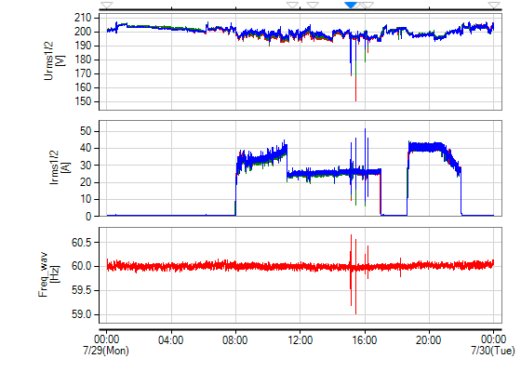

Urms1/2
[V] : U12 rms1/2 U23 rms1/2 U31 rms1/2  
Irms1/2
[A] : I1 rms1/2 I2 rms1/2 I3 rms1/2  
Freq_wav
[Hz] : Freq_wav

[ U / I ]

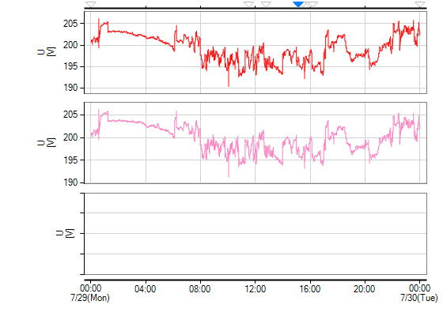

U
[V] : U12 rms AVG  
U
[V] : U23 rms AVG  
U
[V] :

[ Frequency ]

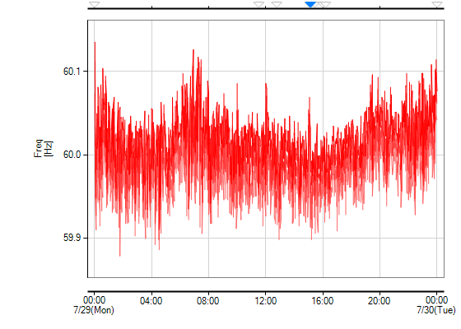

Freq
[Hz] : Freq MAX Freq AVG Freq MIN

[ Unbalance ]

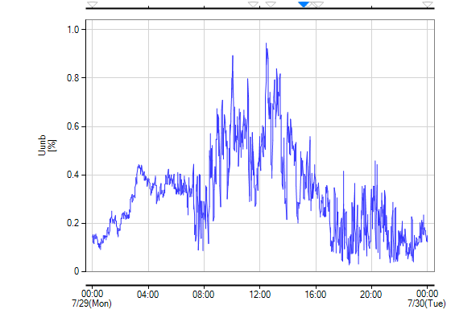

Uunb
[%] : Uunb AVG

[ Harmonics - Trend ]

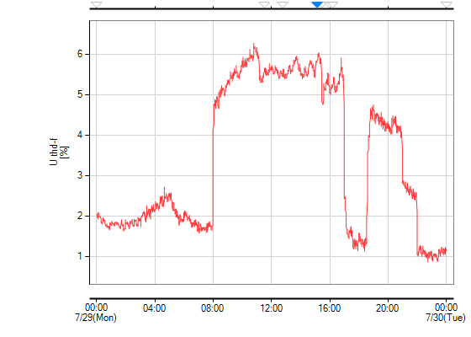

U thd-f
[%] : U12 thd-f AVG

[ Harmonics - Peak Level(0 - 25th) ]

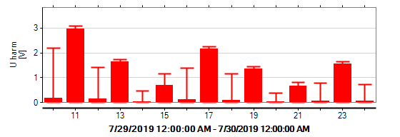

|  |  |  |  |  |  |  |
| --- | --- | --- | --- | --- | --- | --- |
| Order | U12 |  |  |  |  |  |
| AVGPeak | MAXPeak | AVGPeak | MAXPeak | AVGPeak | MAXPeak |
| THD | 6.27% | 7.47% |  |  |  |  |
| 2 | 0.18V | 2.61V |  |  |  |  |
| 3 | 1.81V | 8.60V |  |  |  |  |
| 4 | 0.55V | 7.24V |  |  |  |  |
| 5 | 10.30V | 10.82V |  |  |  |  |
| 6 | 0.52V | 6.20V |  |  |  |  |
| 7 | 4.61V | 5.37V |  |  |  |  |
| 8 | 0.23V | 1.92V |  |  |  |  |
| 9 | 0.75V | 2.37V |  |  |  |  |
| 10 | 0.18V | 2.18V |  |  |  |  |
| 11 | 2.96V | 3.08V |  |  |  |  |
| 12 | 0.14V | 1.41V |  |  |  |  |
| 13 | 1.65V | 1.73V |  |  |  |  |
| 14 | 0.05V | 0.47V |  |  |  |  |
| 15 | 0.70V | 1.14V |  |  |  |  |
| 16 | 0.11V | 1.40V |  |  |  |  |
| 17 | 2.17V | 2.24V |  |  |  |  |
| 18 | 0.10V | 1.16V |  |  |  |  |
| 19 | 1.35V | 1.43V |  |  |  |  |
| 20 | 0.03V | 0.38V |  |  |  |  |
| 21 | 0.67V | 0.81V |  |  |  |  |
| 22 | 0.06V | 0.78V |  |  |  |  |
| 23 | 1.55V | 1.66V |  |  |  |  |
| 24 | 0.06V | 0.73V |  |  |  |  |
| 25 | 1.23V | 1.31V |  |  |  |  |

[ Harmonics - Peak Level(26 - 50th) ]



|  |  |  |  |  |  |  |
| --- | --- | --- | --- | --- | --- | --- |
| Order | U12 |  |  |  |  |  |
| AVGPeak | MAXPeak | AVGPeak | MAXPeak | AVGPeak | MAXPeak |
| THD | 6.27% | 7.47% |  |  |  |  |
| 26 | 0.03V | 0.33V |  |  |  |  |
| 27 | 0.39V | 1.02V |  |  |  |  |
| 28 | 0.06V | 0.71V |  |  |  |  |
| 29 | 0.91V | 0.94V |  |  |  |  |
| 30 | 0.05V | 0.60V |  |  |  |  |
| 31 | 1.02V | 1.07V |  |  |  |  |
| 32 | 0.03V | 0.25V |  |  |  |  |
| 33 | 0.36V | 0.92V |  |  |  |  |
| 34 | 0.04V | 0.52V |  |  |  |  |
| 35 | 0.57V | 0.70V |  |  |  |  |
| 36 | 0.04V | 0.38V |  |  |  |  |
| 37 | 0.66V | 0.68V |  |  |  |  |
| 38 | 0.02V | 0.21V |  |  |  |  |
| 39 | 0.41V | 0.66V |  |  |  |  |
| 40 | 0.03V | 0.38V |  |  |  |  |
| 41 | 0.61V | 0.68V |  |  |  |  |
| 42 | 0.02V | 0.27V |  |  |  |  |
| 43 | 0.44V | 0.52V |  |  |  |  |
| 44 | 0.02V | 0.24V |  |  |  |  |
| 45 | 0.37V | 0.49V |  |  |  |  |
| 46 | 0.03V | 0.28V |  |  |  |  |
| 47 | 0.53V | 0.68V |  |  |  |  |
| 48 | 0.02V | 0.18V |  |  |  |  |
| 49 | 0.38V | 0.47V |  |  |  |  |
| 50 | 0.02V | 0.20V |  |  |  |  |
| H | 1.84V | 2.05V |  |  |  |  |

[ Flicker ]

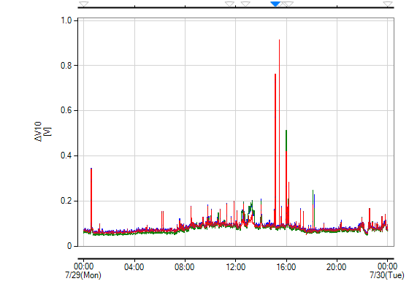

dV10
[V] : U12 1min U23 1min U31 1min

[ Power ]

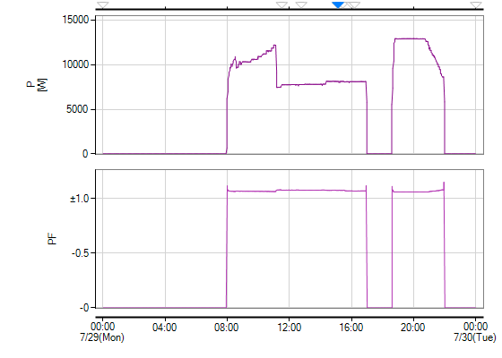

P
[W] : P sum AVG  
PF : PF sum AVG

[ Energy ]

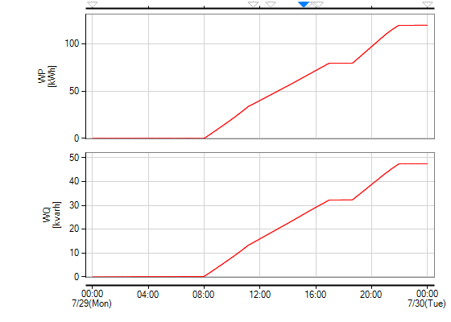

WP
[kWh] : WP+  
WQ
[kvarh] : WQlag

[ Demand ]

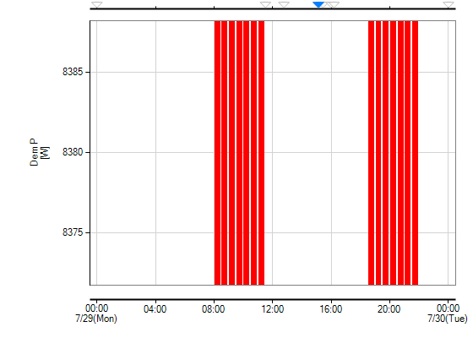

Dem P
[W] : Dem P+

======================================================================

Event List  
[Event All / View by date / 7/29/2019 - 7/29/2019]

======================================================================

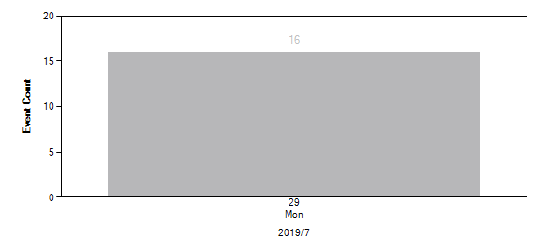

[ 7/29/2019 ]

No.1 - 61

|  |  |  |  |  |  |  |  |  |
| --- | --- | --- | --- | --- | --- | --- | --- | --- |
| No. | Time | Event | I/O | CH | Level | Duration | Worst | Info |
| 1 | 00:00:00.006 | Start |  |  |  |  |  |  |
| 2 | 00:00:00.205 | After |  |  |  |  |  |  |
| 3 | 00:00:00.405 | After |  |  |  |  |  |  |
| 4 | 00:00:00.605 | After |  |  |  |  |  |  |
| 5 | 00:00:00.805 | After |  |  |  |  |  |  |
| 6 | 00:00:01.004 | After |  |  |  |  |  |  |
| 7 | 11:30:31.476 | Tran | IN | CH1 | -103.6V | 159 ms | -103.6V | OUT:No.8 |
| 8 | 11:30:31.635 | Tran | OUT | CH1 |  |  |  | IN:No.7 |
| 11:30:31.635 | After |  |  |  |  |  |  |
| 9 | 11:30:31.835 | After |  |  |  |  |  |  |
| 10 | 11:30:32.035 | After |  |  |  |  |  |  |
| 11 | 11:30:32.235 | After |  |  |  |  |  |  |
| 12 | 11:30:32.435 | After |  |  |  |  |  |  |
| 13 | 11:30:59.831 | Tran | IN | CH3 | 100.4V | 26 ms | -100.4V | OUT:No.14 |
| 14 | 11:30:59.857 | Tran | OUT | CH1 |  |  |  | IN:No.13 |
| 11:30:59.857 | After |  |  |  |  |  |  |
| 15 | 11:31:00.057 | After |  |  |  |  |  |  |
| 16 | 11:31:00.257 | After |  |  |  |  |  |  |
| 17 | 11:31:00.457 | After |  |  |  |  |  |  |
| 18 | 11:31:00.657 | After |  |  |  |  |  |  |
| 19 | 12:45:53.338 | Tran | IN | CH3 | -103.6V | 17 ms | -103.6V | OUT:No.20 |
| 20 | 12:45:53.355 | Tran | OUT | CH3 |  |  |  | IN:No.19 |
| 12:45:53.355 | After |  |  |  |  |  |  |
| 21 | 12:45:53.555 | After |  |  |  |  |  |  |
| 22 | 12:45:53.755 | After |  |  |  |  |  |  |
| 23 | 12:45:53.955 | After |  |  |  |  |  |  |
| 24 | 12:45:54.156 | After |  |  |  |  |  |  |
| 25 | 15:05:30.939 | Dip | IN | CH3 | 179.32V | 75 ms | 176.75V | OUT:No.25 |
| 15:05:31.014 | Dip | OUT | CH3 | 185.17V |  |  | IN:No.25 |
| 26 | 15:05:31.095 | After |  |  |  |  |  |  |
| 27 | 15:05:31.295 | After |  |  |  |  |  |  |
| 28 | 15:05:31.495 | After |  |  |  |  |  |  |
| 29 | 15:05:31.694 | After |  |  |  |  |  |  |
| 30 | 15:05:31.894 | After |  |  |  |  |  |  |
| 31 | 15:07:43.865 | Freq_wav | IN |  | 60.660Hz | 17 ms | 60.660Hz | OUT:No.32 |
| 32 | 15:07:43.879 | Dip | IN | CH2 | 178.18V | 103 ms | 167.59V | OUT:No.32 |
| 15:07:43.982 | Dip | OUT | CH1 | 187.25V |  |  | IN:No.32 |
| 15:07:43.882 | Freq_wav | OUT |  | 59.611Hz |  |  | IN:No.31 |
| 15:07:43.966 | Freq_wav | IN |  | 59.174Hz | 17 ms | 59.174Hz | OUT:No.32 |
| 15:07:43.983 | Freq_wav | OUT |  | 60.359Hz |  |  | IN:No.32 |
| 15:07:43.882 | After |  |  |  |  |  |  |
| 33 | 15:07:44.082 | After |  |  |  |  |  |  |
| 34 | 15:07:44.282 | After |  |  |  |  |  |  |
| 35 | 15:07:44.482 | After |  |  |  |  |  |  |
| 36 | 15:07:44.683 | After |  |  |  |  |  |  |
| 37 | 15:08:48.694 | Dip | IN | CH1 | 179.13V | 67 ms | 177.05V | OUT:No.37 |
| 15:08:48.761 | Dip | OUT | CH1 | 186.19V |  |  | IN:No.37 |
| 38 | 15:08:48.894 | After |  |  |  |  |  |  |
| 39 | 15:08:49.094 | After |  |  |  |  |  |  |
| 40 | 15:08:49.294 | After |  |  |  |  |  |  |
| 41 | 15:08:49.494 | After |  |  |  |  |  |  |
| 42 | 15:08:49.694 | After |  |  |  |  |  |  |
| 43 | 15:26:14.926 | Dip | IN | CH1 | 179.80V | 67 ms | 149.78V | OUT:No.43 |
| 15:26:14.993 | Dip | OUT | CH1 | 184.59V |  |  | IN:No.43 |
| 15:26:14.960 | Freq_wav | IN |  | 58.990Hz | 17 ms | 58.990Hz | OUT:No.43 |
| 15:26:14.977 | Freq_wav | IN |  | 60.572Hz | 16 ms | 60.572Hz | OUT:No.43 |
| 15:26:14.977 | Freq_wav | OUT |  | 60.572Hz |  |  | IN:No.43 |
| 15:26:14.993 | Freq_wav | OUT |  | 60.294Hz |  |  | IN:No.43 |
| 44 | 15:26:15.026 | After |  |  |  |  |  |  |
| 45 | 15:26:15.226 | After |  |  |  |  |  |  |
| 46 | 15:26:15.427 | After |  |  |  |  |  |  |
| 47 | 15:26:15.627 | After |  |  |  |  |  |  |
| 48 | 15:26:15.827 | After |  |  |  |  |  |  |
| 49 | 15:59:34.921 | Dip | IN | CH2 | 177.61V | 67 ms | 177.61V | OUT:No.49 |
| 15:59:34.988 | Dip | OUT | CH2 | 183.88V |  |  | IN:No.49 |
| 15:59:34.935 | Inrush | IN | CH3 | 51.406A | 9 ms | 51.406A | OUT:No.49 |
| 15:59:34.944 | Inrush | OUT | CH3 | 8.588A |  |  | IN:No.49 |
| 50 | 15:59:35.041 | After |  |  |  |  |  |  |
| 51 | 15:59:35.241 | After |  |  |  |  |  |  |
| 52 | 15:59:35.441 | After |  |  |  |  |  |  |
| 53 | 15:59:35.641 | After |  |  |  |  |  |  |
| 54 | 15:59:35.841 | After |  |  |  |  |  |  |
| 55 | 16:11:08.250 | Tran | IN | CH3 | 106.7V | 209 ms | 106.7V | OUT:No.57 |
| 56 | 16:11:08.259 | After |  |  |  |  |  |  |
| 57 | 16:11:08.459 | Tran | OUT | CH3 |  |  |  | IN:No.55 |
| 16:11:08.459 | After |  |  |  |  |  |  |
| 58 | 16:11:08.659 | After |  |  |  |  |  |  |
| 59 | 16:11:08.859 | After |  |  |  |  |  |  |
| 60 | 16:11:09.059 | After |  |  |  |  |  |  |
| 61 | 23:59:59.840 | Stop |  |  |  |  |  |  |

======================================================================

Event Data  
[Event All / View by date / 7/29/2019 - 7/29/2019]

======================================================================

[ 7/29/2019 ]

No.1 - 6

|  |  |  |  |  |  |  |  |
| --- | --- | --- | --- | --- | --- | --- | --- |
| Time | Event | I/O | CH | Level | Duration | Worst | Info |
| 00:00:00.006 | Start |  |  |  |  |  |  |
| 00:00:00.205 | After |  |  |  |  |  |  |
| 00:00:00.405 | After |  |  |  |  |  |  |
| 00:00:00.605 | After |  |  |  |  |  |  |
| 00:00:00.805 | After |  |  |  |  |  |  |
| 00:00:01.004 | After |  |  |  |  |  |  |

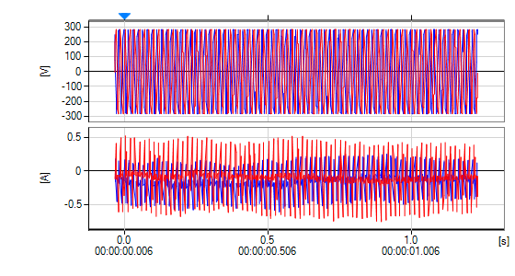

[V] : U12 U31  
[A] : I1 I3

No.7 - 12

|  |  |  |  |  |  |  |  |
| --- | --- | --- | --- | --- | --- | --- | --- |
| Time | Event | I/O | CH | Level | Duration | Worst | Info |
| 11:30:31.476 | Tran | IN | CH1 | -103.6V | 159 ms | -103.6V | OUT:No.8 |
| 11:30:31.635 | Tran | OUT | CH1 |  |  |  | IN:No.7 |
| 11:30:31.635 | After |  |  |  |  |  |  |
| 11:30:31.835 | After |  |  |  |  |  |  |
| 11:30:32.035 | After |  |  |  |  |  |  |
| 11:30:32.235 | After |  |  |  |  |  |  |
| 11:30:32.435 | After |  |  |  |  |  |  |

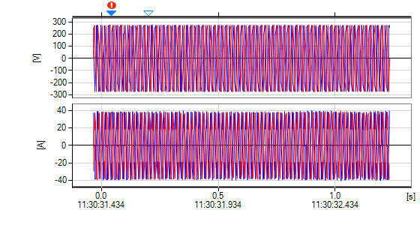

[V] : U12 U31  
[A] : I1 I3

Transient Waveform

No.7 Tran Transient Waveform [ Duration: 159ms / Count: 1 / Worst: -103.6V (1.0 μs) ]

Tran IN

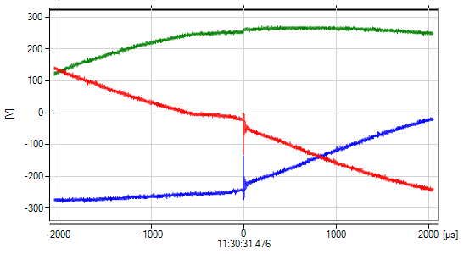

[V] : U12 U23 U31

Tran WORST



[V] : U12 U23 U31

No.13 - 18

|  |  |  |  |  |  |  |  |
| --- | --- | --- | --- | --- | --- | --- | --- |
| Time | Event | I/O | CH | Level | Duration | Worst | Info |
| 11:30:59.831 | Tran | IN | CH3 | 100.4V | 26 ms | -100.4V | OUT:No.14 |
| 11:30:59.857 | Tran | OUT | CH1 |  |  |  | IN:No.13 |
| 11:30:59.857 | After |  |  |  |  |  |  |
| 11:31:00.057 | After |  |  |  |  |  |  |
| 11:31:00.257 | After |  |  |  |  |  |  |
| 11:31:00.457 | After |  |  |  |  |  |  |
| 11:31:00.657 | After |  |  |  |  |  |  |

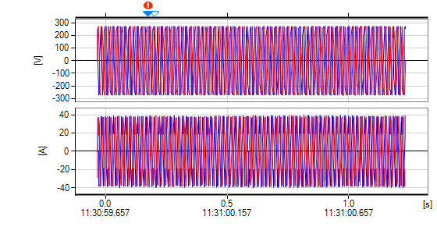

[V] : U12 U31  
[A] : I1 I3

Transient Waveform

No.13 Tran Transient Waveform [ Duration: 26ms / Count: 1 / Worst: -100.4V (1.0 μs) ]

Tran IN

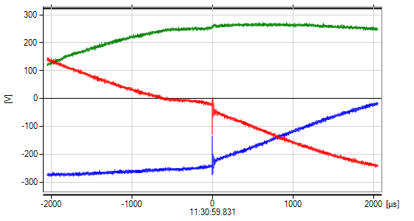

[V] : U12 U23 U31

Tran WORST

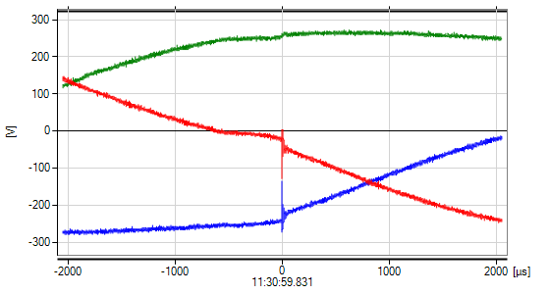

[V] : U12 U23 U31

No.19 - 24

|  |  |  |  |  |  |  |  |
| --- | --- | --- | --- | --- | --- | --- | --- |
| Time | Event | I/O | CH | Level | Duration | Worst | Info |
| 12:45:53.338 | Tran | IN | CH3 | -103.6V | 17 ms | -103.6V | OUT:No.20 |
| 12:45:53.355 | Tran | OUT | CH3 |  |  |  | IN:No.19 |
| 12:45:53.355 | After |  |  |  |  |  |  |
| 12:45:53.555 | After |  |  |  |  |  |  |
| 12:45:53.755 | After |  |  |  |  |  |  |
| 12:45:53.955 | After |  |  |  |  |  |  |
| 12:45:54.156 | After |  |  |  |  |  |  |

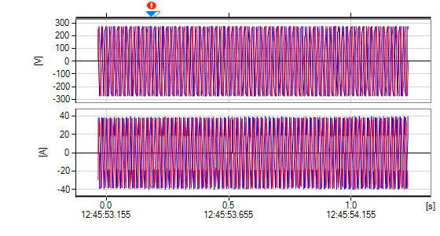

[V] : U12 U31  
[A] : I1 I3

Transient Waveform

No.19 Tran Transient Waveform [ Duration: 17ms / Count: 1 / Worst: -103.6V (1.0 μs) ]

Tran IN

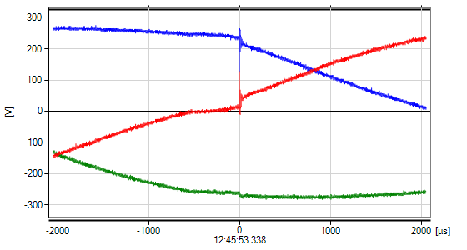

[V] : U12 U23 U31

Tran WORST



[V] : U12 U23 U31

No.25 - 30

|  |  |  |  |  |  |  |  |
| --- | --- | --- | --- | --- | --- | --- | --- |
| Time | Event | I/O | CH | Level | Duration | Worst | Info |
| 15:05:30.939 | Dip | IN | CH3 | 179.32V | 75 ms | 176.75V | OUT:No.25 |
| 15:05:31.014 | Dip | OUT | CH3 | 185.17V |  |  | IN:No.25 |
| 15:05:31.095 | After |  |  |  |  |  |  |
| 15:05:31.295 | After |  |  |  |  |  |  |
| 15:05:31.495 | After |  |  |  |  |  |  |
| 15:05:31.694 | After |  |  |  |  |  |  |
| 15:05:31.894 | After |  |  |  |  |  |  |

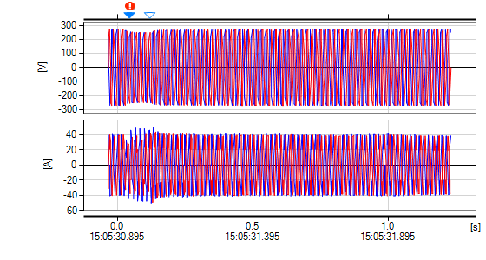

[V] : U12 U31  
[A] : I1 I3

Event Trend Data(Dip/Swell/Interrupt/Inrush/RVC)

No.25 Dip Event Trend Data [ Duration: 75ms / Worst: 176.75V ]

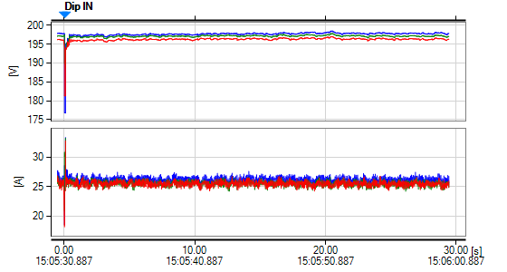

[V] : U12 rms1/2 U23 rms1/2 U31 rms1/2  
[A] : I1 rms1/2 I2 rms1/2 I3 rms1/2

No.31 - 36

|  |  |  |  |  |  |  |  |
| --- | --- | --- | --- | --- | --- | --- | --- |
| Time | Event | I/O | CH | Level | Duration | Worst | Info |
| 15:07:43.865 | Freq_wav | IN |  | 60.660Hz | 17 ms | 60.660Hz | OUT:No.32 |
| 15:07:43.879 | Dip | IN | CH2 | 178.18V | 103 ms | 167.59V | OUT:No.32 |
| 15:07:43.982 | Dip | OUT | CH1 | 187.25V |  |  | IN:No.32 |
| 15:07:43.882 | Freq_wav | OUT |  | 59.611Hz |  |  | IN:No.31 |
| 15:07:43.966 | Freq_wav | IN |  | 59.174Hz | 17 ms | 59.174Hz | OUT:No.32 |
| 15:07:43.983 | Freq_wav | OUT |  | 60.359Hz |  |  | IN:No.32 |
| 15:07:43.882 | After |  |  |  |  |  |  |
| 15:07:44.082 | After |  |  |  |  |  |  |
| 15:07:44.282 | After |  |  |  |  |  |  |
| 15:07:44.482 | After |  |  |  |  |  |  |
| 15:07:44.683 | After |  |  |  |  |  |  |

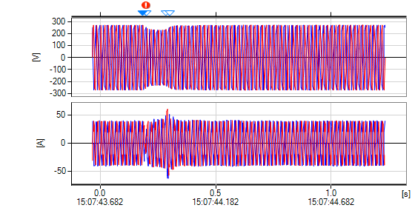

[V] : U12 U31  
[A] : I1 I3

Event Trend Data(Dip/Swell/Interrupt/Inrush/RVC)

No.32 Dip Event Trend Data [ Duration: 103ms / Worst: 167.59V ]

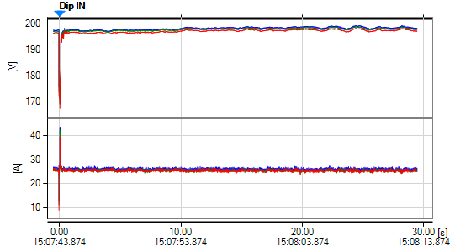

[V] : U12 rms1/2 U23 rms1/2 U31 rms1/2  
[A] : I1 rms1/2 I2 rms1/2 I3 rms1/2

No.37 - 42

|  |  |  |  |  |  |  |  |
| --- | --- | --- | --- | --- | --- | --- | --- |
| Time | Event | I/O | CH | Level | Duration | Worst | Info |
| 15:08:48.694 | Dip | IN | CH1 | 179.13V | 67 ms | 177.05V | OUT:No.37 |
| 15:08:48.761 | Dip | OUT | CH1 | 186.19V |  |  | IN:No.37 |
| 15:08:48.894 | After |  |  |  |  |  |  |
| 15:08:49.094 | After |  |  |  |  |  |  |
| 15:08:49.294 | After |  |  |  |  |  |  |
| 15:08:49.494 | After |  |  |  |  |  |  |
| 15:08:49.694 | After |  |  |  |  |  |  |

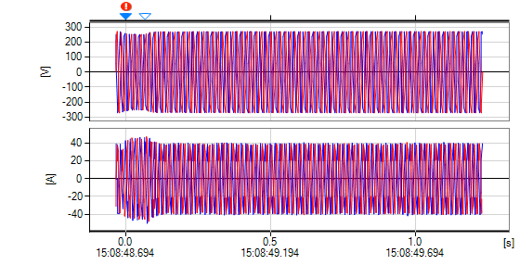

[V] : U12 U31  
[A] : I1 I3

Event Trend Data(Dip/Swell/Interrupt/Inrush/RVC)

No.37 Dip Event Trend Data [ Duration: 67ms / Worst: 177.05V ]

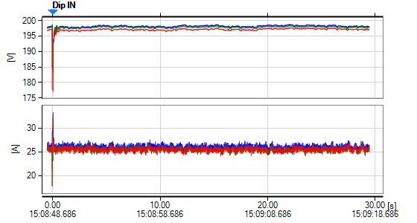

[V] : U12 rms1/2 U23 rms1/2 U31 rms1/2  
[A] : I1 rms1/2 I2 rms1/2 I3 rms1/2

No.43 - 48

|  |  |  |  |  |  |  |  |
| --- | --- | --- | --- | --- | --- | --- | --- |
| Time | Event | I/O | CH | Level | Duration | Worst | Info |
| 15:26:14.926 | Dip | IN | CH1 | 179.80V | 67 ms | 149.78V | OUT:No.43 |
| 15:26:14.993 | Dip | OUT | CH1 | 184.59V |  |  | IN:No.43 |
| 15:26:14.960 | Freq_wav | IN |  | 58.990Hz | 17 ms | 58.990Hz | OUT:No.43 |
| 15:26:14.977 | Freq_wav | IN |  | 60.572Hz | 16 ms | 60.572Hz | OUT:No.43 |
| 15:26:14.977 | Freq_wav | OUT |  | 60.572Hz |  |  | IN:No.43 |
| 15:26:14.993 | Freq_wav | OUT |  | 60.294Hz |  |  | IN:No.43 |
| 15:26:15.026 | After |  |  |  |  |  |  |
| 15:26:15.226 | After |  |  |  |  |  |  |
| 15:26:15.427 | After |  |  |  |  |  |  |
| 15:26:15.627 | After |  |  |  |  |  |  |
| 15:26:15.827 | After |  |  |  |  |  |  |

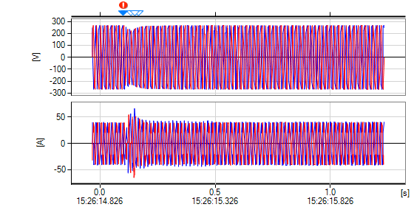

[V] : U12 U31  
[A] : I1 I3

Event Trend Data(Dip/Swell/Interrupt/Inrush/RVC)

No.43 Dip Event Trend Data [ Duration: 67ms / Worst: 149.78V ]

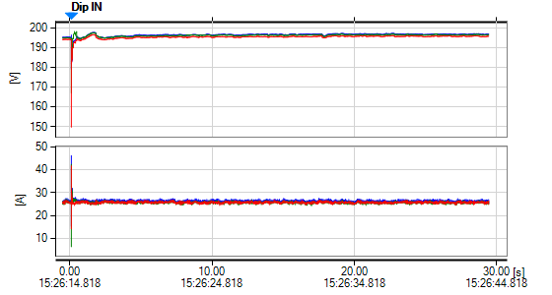

[V] : U12 rms1/2 U23 rms1/2 U31 rms1/2  
[A] : I1 rms1/2 I2 rms1/2 I3 rms1/2

No.49 - 54

|  |  |  |  |  |  |  |  |
| --- | --- | --- | --- | --- | --- | --- | --- |
| Time | Event | I/O | CH | Level | Duration | Worst | Info |
| 15:59:34.921 | Dip | IN | CH2 | 177.61V | 67 ms | 177.61V | OUT:No.49 |
| 15:59:34.988 | Dip | OUT | CH2 | 183.88V |  |  | IN:No.49 |
| 15:59:34.935 | Inrush | IN | CH3 | 51.406A | 9 ms | 51.406A | OUT:No.49 |
| 15:59:34.944 | Inrush | OUT | CH3 | 8.588A |  |  | IN:No.49 |
| 15:59:35.041 | After |  |  |  |  |  |  |
| 15:59:35.241 | After |  |  |  |  |  |  |
| 15:59:35.441 | After |  |  |  |  |  |  |
| 15:59:35.641 | After |  |  |  |  |  |  |
| 15:59:35.841 | After |  |  |  |  |  |  |

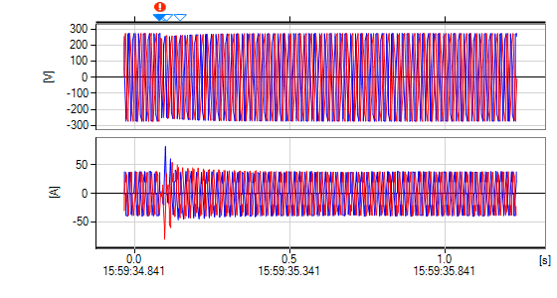

[V] : U12 U31  
[A] : I1 I3

Event Trend Data(Dip/Swell/Interrupt/Inrush/RVC)

No.49 Dip Event Trend Data [ Duration: 67ms / Worst: 177.61V ]

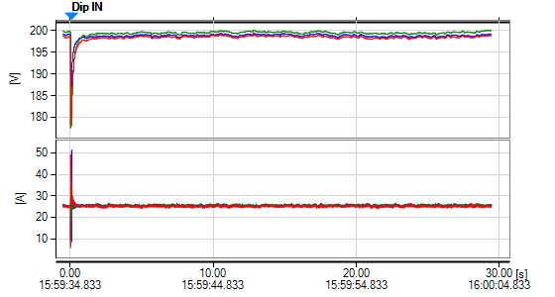

[V] : U12 rms1/2 U23 rms1/2 U31 rms1/2  
[A] : I1 rms1/2 I2 rms1/2 I3 rms1/2

No.55 - 60

|  |  |  |  |  |  |  |  |
| --- | --- | --- | --- | --- | --- | --- | --- |
| Time | Event | I/O | CH | Level | Duration | Worst | Info |
| 16:11:08.250 | Tran | IN | CH3 | 106.7V | 209 ms | 106.7V | OUT:No.57 |
| 16:11:08.259 | After |  |  |  |  |  |  |
| 16:11:08.459 | Tran | OUT | CH3 |  |  |  | IN:No.55 |
| 16:11:08.459 | After |  |  |  |  |  |  |
| 16:11:08.659 | After |  |  |  |  |  |  |
| 16:11:08.859 | After |  |  |  |  |  |  |
| 16:11:09.059 | After |  |  |  |  |  |  |

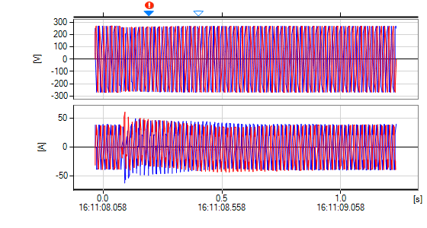

[V] : U12 U31  
[A] : I1 I3

Transient Waveform

No.55 Tran Transient Waveform [ Duration: 209ms / Count: 2 / Worst: 106.7V (1.5 μs) ]

Tran IN

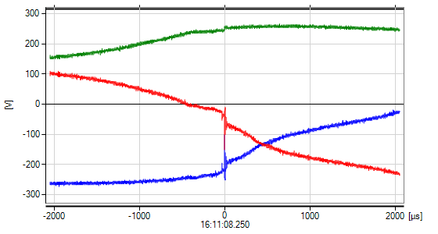

[V] : U12 U23 U31

Tran WORST



[V] : U12 U23 U31

No.61

|  |  |  |  |  |  |  |  |
| --- | --- | --- | --- | --- | --- | --- | --- |
| Time | Event | I/O | CH | Level | Duration | Worst | Info |
| 23:59:59.840 | Stop |  |  |  |  |  |  |

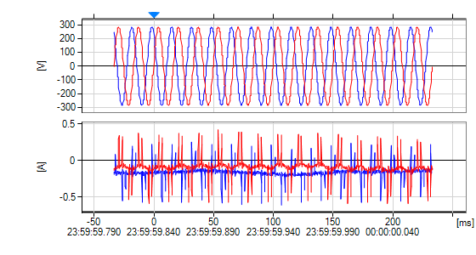

[V] : U12 U31  
[A] : I1 I3