Remotely sensing cities
2021-01-07

1 Introduction
You can label chapter and section titles using {#label} after them, e.g., we can reference Chapter 1. If you do not manually label them, there will be automatic labels anyway, e.g., Chapter 3.
Figures and tables with captions will be placed in figure and table environments, respectively.
par(mar = c(4, 4, .1, .1))
plot(pressure, type = 'b', pch = 19)
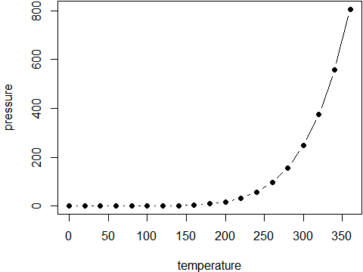
Figure 1.1: Here is a nice figure!
Reference a figure by its code chunk label with the fig: prefix, e.g., see Figure 1.1. Similarly, you can reference tables generated from knitr::kable(), e.g., see Table 1.1.
knitr::kable(
head(iris, 20), caption = 'Here is a nice table!',
booktabs = TRUE
)
Table 1.1: Here is a nice table!
Sepal.Length | Sepal.Width | Petal.Length | Petal.Width | Species
5.1 | 3.5 | 1.4 | 0.2 | setosa
4.9 | 3.0 | 1.4 | 0.2 | setosa
4.7 | 3.2 | 1.3 | 0.2 | setosa
4.6 | 3.1 | 1.5 | 0.2 | setosa
5.0 | 3.6 | 1.4 | 0.2 | setosa
5.4 | 3.9 | 1.7 | 0.4 | setosa
4.6 | 3.4 | 1.4 | 0.3 | setosa
5.0 | 3.4 | 1.5 | 0.2 | setosa
4.4 | 2.9 | 1.4 | 0.2 | setosa
4.9 | 3.1 | 1.5 | 0.1 | setosa
5.4 | 3.7 | 1.5 | 0.2 | setosa
4.8 | 3.4 | 1.6 | 0.2 | setosa
4.8 | 3.0 | 1.4 | 0.1 | setosa
4.3 | 3.0 | 1.1 | 0.1 | setosa
5.8 | 4.0 | 1.2 | 0.2 | setosa
5.7 | 4.4 | 1.5 | 0.4 | setosa
5.4 | 3.9 | 1.3 | 0.4 | setosa
5.1 | 3.5 | 1.4 | 0.3 | setosa
5.7 | 3.8 | 1.7 | 0.3 | setosa
5.1 | 3.8 | 1.5 | 0.3 | setosa
You can write citations, too. For example, we are using the bookdown package (Xie 2021) in this sample book, which was built on top of R Markdown and knitr (Xie 2015).

2 Literature Review
Here is a review of existing methods.

3 Methods
We describe our methods in this chapter.

4 Applications
Some significant applications are demonstrated in this chapter.

4.1 Example one

4.2 Example two

5 Final Words
We have finished a nice book.

6 Conclusion
Xie, Yihui. 2015. Dynamic Documents with R and Knitr. 2nd ed. Boca Raton, Florida: Chapman; Hall/CRC. http://yihui.name/knitr/.
———. 2021. Bookdown: Authoring Books and Technical Documents with r Markdown. https://github.com/rstudio/bookdown.

