Small Language Model Improvement with Distillation and Neural Cache
DASE7506 MP1 Small Language Model Challenge
WangXinzhe
Student ID u3036801008
26 September 2026

Abstract
This report improves the supplied GPT baseline under the fixed WikiText 2 protocol. The final predictor uses a 6 layer rotary Transformer with RMSNorm and SwiGLU, then adds two core mechanisms: self-distillation from a model trained only on the supplied training split, and a strictly causal neural cache that is reset for every 256 token evaluation window. At 19,200 updates, the architecture without either mechanism obtains 1.55637 validation bits per byte. Distillation alone reaches 1.49356, cache alone reaches 1.49256, and their combination reaches 1.44406 validation BPB. After model selection was frozen, the same checkpoint obtained 1.4615442689258094 BPB on the complete test split. The combined predictor remains inside all measured evaluation limits at 4.484 times baseline validation CPU time, 1.790 GiB peak RAM, and 25.08 MiB of inference assets.

Main findings
Evidence | Result | Interpretation
Initial baseline | 2.07108 BPB | Reference 1,200 update model
Equal target architecture comparison | 1.69939 to 1.55637 | Architecture improves BPB by 0.14302
Core mechanism ablation | 1.55637 to 1.44406 | Combined gain is 0.11231 BPB
Frozen full-test result | 1.4615442689258094 BPB | Value submitted to course website
Resource compliance | 4.484x CPU 1.790 GiB 25.08 MiB | All measured limits pass
All model selection and mechanism comparisons use the validation split. The full-test result is reported only as the final frozen-checkpoint score and was not used to revise the method.

1 Task and contribution
The course fixes the data, BPE 2048 tokenizer, causal 256 token evaluation windows, and the bits per byte scoring rule. The objective is to reduce BPB while keeping CPU scoring time at or below five times the supplied baseline, peak evaluation RAM below 4 GiB, and uncompressed inference assets below 64 MiB. Training length and architecture may change, but all learning must use the supplied training text and model selection must use validation data.

Baseline and improved architecture
Component | Supplied GPT | Improved model
Blocks and width | 4 blocks width 128 | 6 blocks width 288
Attention | 4 heads | 6 heads with causal SDPA
Position | Learned absolute embedding | Rotary position embedding
Normalization | LayerNorm | RMSNorm
Feed forward network | 4x GELU MLP | SwiGLU with width 768
Regularization | None | Residual dropout 0.2
Initialization | Standard deviation 0.02 | Depth scaled residual outputs
Parameters | 1,088,256 | 6,565,536 without cache
The larger architecture allocates the available inference budget to representation capacity. RoPE expresses relative position directly in query and key rotations, RMSNorm removes the mean subtraction used by LayerNorm, and SwiGLU adds a learned gate inside the feed forward block. The output projection shares weights with the token embedding. Residual output matrices are initialized with standard deviation 0.02 divided by the square root of twice the depth, which reduces activation growth at initialization.

Measured architecture gain
A 19,200 update run of the supplied architecture gives 1.69939 BPB at the final step. With the same seed, batch size, context, optimizer family, number of updates, and 157,286,400 processed targets, the improved architecture without distillation or cache gives 1.55637 BPB. The 0.14302 BPB reduction isolates the benefit of the architecture and training recipe from additional training data exposure.

2 Core mechanisms

Self distillation
The teacher is the validation-selected checkpoint from the no-cache improved model at update 18,400. It was trained from random initialization on the supplied training split with seed 17. During student training the teacher is fixed in evaluation mode and receives the same causal training prefix as the student. The student objective is L equals one minus alpha times hard label cross entropy plus alpha times T squared KL from the teacher distribution to the student distribution. The experiments use alpha 0.5 and temperature T 1.0.
The soft distribution contains information about plausible alternatives beyond the observed next token. This regularizes the student toward a smoother target while retaining a 0.5 weight on the ground-truth label. The teacher is used only during training, so distillation does not change the student's inference parameters, assets, or CPU scoring path.

Causal neural cache
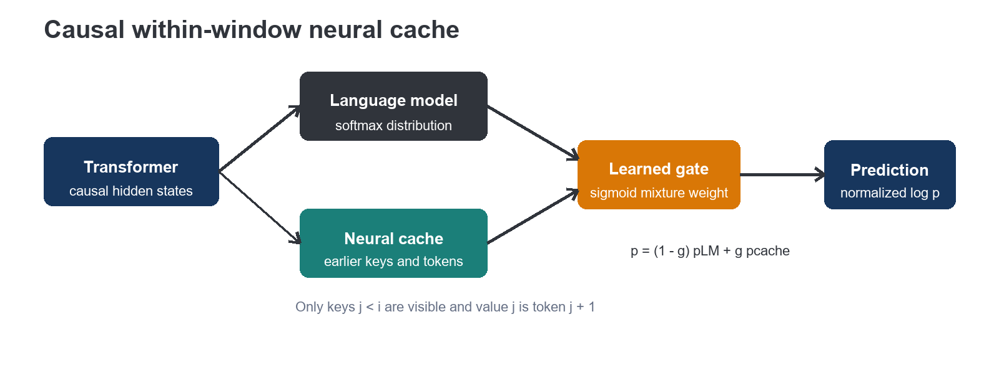
Figure 1 The base distribution and within-window cache are combined by a learned gate
The cache normalizes final hidden states and compares each query with earlier hidden keys. A strict lower triangular mask permits key j only when j is smaller than query position i. Key j stores token j plus 1; therefore the newest token retrieved for query i is token i, which is already in the observed prefix. Similarity weights are divided by a learned temperature bounded between 0.05 and 0.50 and accumulated into a vocabulary distribution.
A learned sigmoid gate mixes the language model and cache probabilities. Its bias starts at minus 2.5 so early training relies mostly on the base model. The cache is local to one forward call and contains no persistent state. It resets between windows and examples, satisfying the course rule that evaluation windows are independent and no state crosses a boundary.

3 Experimental protocol

Data and scoring
All runs use the supplied WikiText 2 text and fixed BPE 2048 tokenizer. Training samples random 257 token spans and predicts the final 256 tokens. Validation scoring covers 376,599 targets and 1,148,007 UTF 8 bytes in independent causal windows. Final test scoring covers 428,405 targets and 1,292,013 UTF 8 bytes. BPB is summed negative log base 2 probability divided by the raw byte count. Development decisions use validation only; the test split is used once for the submitted score.

Controlled settings
Setting | Value
Random seed | 17
Updates and batch size | 19,200 updates batch 32
Targets per run | 157,286,400
Context and vocabulary | 256 tokens 2,048 tokens
Optimizer | AdamW beta1 0.9 beta2 0.95 weight decay 0.1
Learning rate | 0.001 peak 100 update warmup cosine decay to 0.0001
Gradient clipping | Global norm 1.0
Training precision | FP32 on NVIDIA GeForce GTX 1660 Ti
Distillation | alpha 0.5 temperature 1.0

Experiment matrix
Run | Distillation | Cache | Selection step | Best validation BPB
No mechanisms | No | No | 18,400 | 1.55441
Cache only | No | Yes | 16,000 | 1.49206
Distillation only | Yes | No | 19,200 | 1.49356
Both mechanisms | Yes | Yes | 19,200 | 1.44406
The four runs differ only in the two core mechanisms. Main causal claims use the final update for all four runs, so every comparison has identical processed targets. Validation-selected results are reported separately because their selected steps differ.

4 Main results
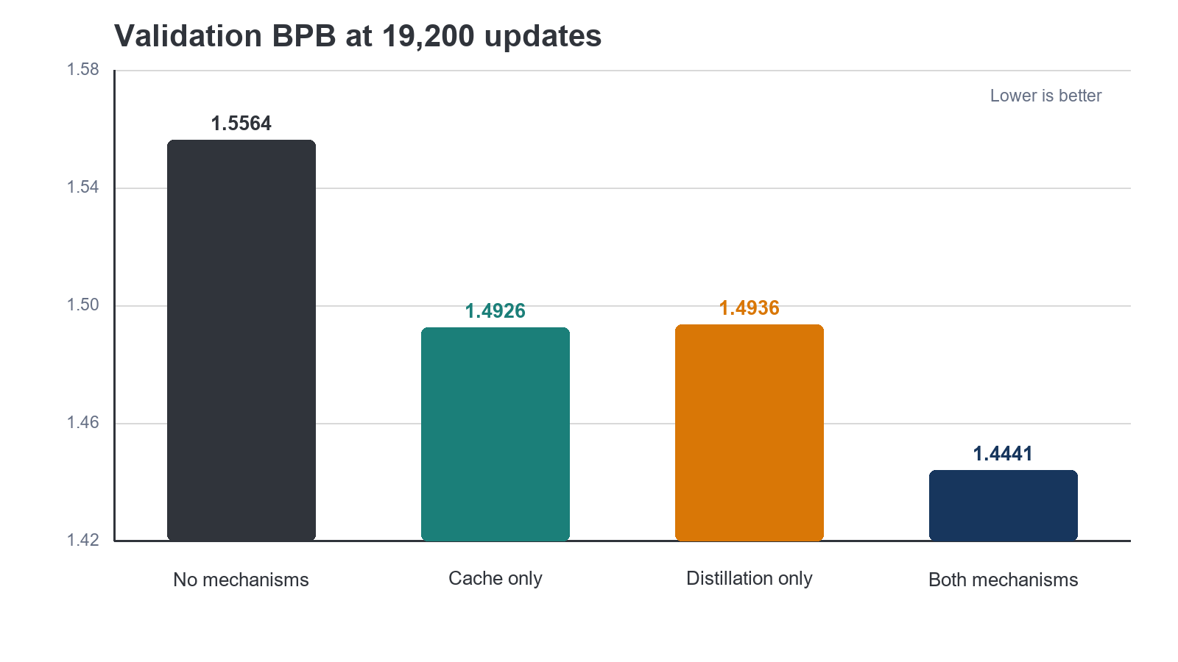
Figure 2 Fixed-step comparison with equal training targets
Distillation | Cache | BPB at 19,200 | Gain from no mechanisms
No | No | 1.55637 | reference
No | Yes | 1.49256 | 0.06380
Yes | No | 1.49356 | 0.06281
Yes | Yes | 1.44406 | 0.11231
Both mechanisms produce similar standalone gains. Cache lowers BPB by 0.06380 without distillation, while distillation lowers it by 0.06281 without cache. Combining them lowers BPB by 0.11231, a 7.22 percent reduction from the no-mechanism architecture. The final validation BPB of 1.44406 is 0.62703 below the initial 1,200 update course baseline, although that larger comparison also includes more capacity and training.

Interaction between mechanisms
Cache adds 0.04950 BPB of improvement when distillation is already active, and distillation adds 0.04851 when cache is already active. These conditional gains remain substantial but are smaller than the standalone gains. The positive 0.01430 BPB interaction term indicates diminishing returns: both methods improve the probability assigned to plausible continuations, so part of their benefit overlaps rather than adding independently.

5 Training dynamics and mechanism analysis
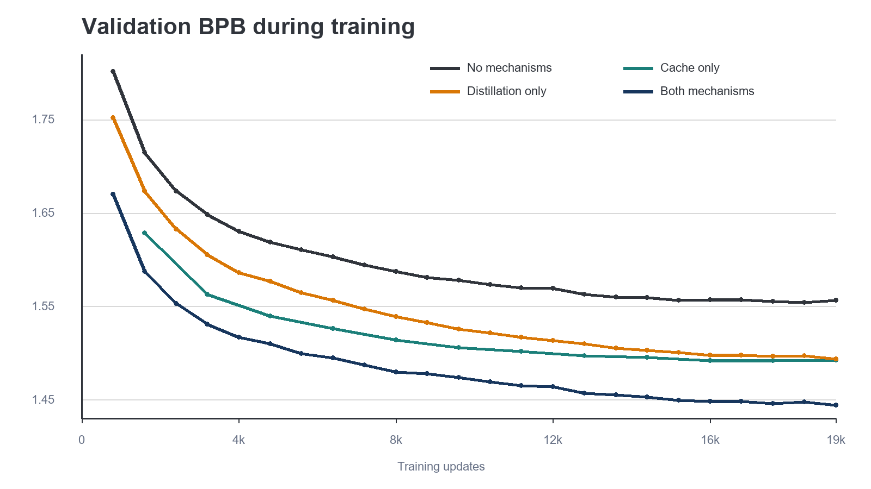
Figure 3 Validation trajectories for the four controlled runs
The cache improves the model throughout training rather than only at the final checkpoint. At update 12,800, cache-only BPB is 1.49750 compared with 1.56318 for the no-mechanism run. At the same update, distillation-only BPB is 1.51013 and the combined model is 1.45706. The combined curve continues to improve through update 19,200, supporting selection of the final checkpoint.

Why the cache helps
WikiText contains repeated names, entities, and topical vocabulary inside a 256 token window. The parametric head must represent these patterns in fixed weights, while the cache can directly reuse a recent token after matching a similar hidden context. Because the gate is learned at every position, the model can suppress the cache when repetition is unhelpful.

Why distillation helps
A one-hot label treats every incorrect token equally. The teacher distribution distinguishes reasonable alternatives from implausible ones and stabilizes training with a smoother target. The teacher and student share the same architecture, so this is self-distillation rather than compression from a larger model. Its gain is therefore best interpreted as optimization and regularization rather than transfer of external knowledge.

Failure modes and tradeoffs
The cache can overemphasize accidental repetition and adds an O(L squared) similarity matrix plus a vocabulary scatter. Distillation nearly doubles training forward computation because the teacher must score every batch. The observed overlap between their gains also means that further generations of self-distillation may yield smaller improvements.

6 Efficiency and compliance

Evaluation resource limits
Constraint | Measured result | Course limit | Status
CPU FP32 scoring time | 38.95 s 4.484x baseline | at most 5x | Pass
Peak CPU evaluation RAM | 1.790 GiB | at most 4 GiB | Pass
Inference assets | 25.08 MiB | at most 64 MiB | Pass
CPU time is measured on the same four-thread machine and split for both models: 8.686 seconds for the supplied baseline and 38.952 seconds for the final predictor. The resulting 4.484 times ratio leaves about 10.3 percent of the permitted timing budget. RAM and assets have wider margins. The timing result is the tightest constraint and should be reproduced on the submitted software stack. The later full-test reproduction took 43.159 seconds; it is reported separately and is not divided by the validation baseline time because the two splits contain different target counts.

Training and search cost
Run | Direct train time | Processed targets | GPU peak reserved
Long supplied baseline | 11.6 min | 157,286,400 | 0.68 GB
No mechanisms teacher | 62.1 min | 157,286,400 | 1.82 GB
Cache only | 71.0 min | 157,286,400 | 2.20 GB
Distillation only | 80.9 min | 157,286,400 | 2.18 GB
Both mechanisms | 85.1 min | 157,286,400 | 2.51 GB
The recorded runs account for 5.32 hours of direct training, including the 1,200 update initial CPU baseline. The two distilled runs reuse the same no-mechanism teacher, but reuse does not erase its 3,726.8 second training cost. For checkpoint ancestry, the final model therefore depends on the teacher's 157,286,400 targets plus its own 157,286,400 targets.

Data and causal compliance
The teacher and all students learn only from the supplied training text. Validation is used for checkpoint selection; no validation or test targets are cached. Predictions at position i use only the prefix through i, and all cache tensors are created inside the current forward call. The tokenizer, data files, evaluator, context length, and scoring rule remain unchanged.

7 Reproduction and conclusion

Training command (method record only)
python train.py --implementation student --config configs\student_long_cache.json ^
--device cuda --precision fp32 --seed 17 --steps 19200 --batch-size 32 ^
--eval-every 800 --teacher-checkpoint runs\student-long-s17\checkpoint.pt ^
--distill-alpha 0.5 --distill-temperature 1.0 ^
--run-dir runs\student-cache-distill-s17
This command records training provenance; it is not needed to reproduce the submitted score.

Frozen checkpoint test reproduction
python evaluate.py ^
--checkpoint runs\student-cache-distill-s17\checkpoint.pt ^
--device cpu --precision fp32 --threads 4 ^
--split test --output reproduced_test_cpu_fp32.json
python -m unittest discover -s tests -v
This no-training command produced test BPB 1.4615442689258094, token perplexity 21.226944720949717, 428,405 scored targets, and 1,292,013 UTF 8 bytes. The value submitted to the course website is the JSON bpb field, not token perplexity and not the 1.4440572213535412 validation BPB. The test result was obtained only after freezing the method and was not used to revise it.

Checkpoint identity
Artifact | SHA256 or identifier
Final checkpoint | 9e7ae095e6a3da3589cf3e6857b058e08d7bac00a7022d9e82d50bb00e38a44c
Student implementation | 68a9fdb1c678ec5ad0306b02115b8accb15fd0577f4dad9ad527d65cf77acec1
Evaluator | 128bcb2dab0be0d427505bddb4671e3ab3a8f78e114be79a689c0f9029af133d
Tokenizer | 020d1bc6aa4449c4f352b2e03d0e0fb4f39287f15297705e421b1fa7d817262e
Protocol | 7506-mp1-wt2-v2

Conclusion
The controlled 2 by 2 experiment supports both proposed mechanisms. Distillation and the causal cache each reduce validation BPB by about 0.063 when used alone, and the combined model reaches 1.44406 at equal training targets. The mechanisms have partially overlapping effects, but each still contributes about 0.049 BPB in the presence of the other. The frozen checkpoint obtains 1.4440572213535412 validation BPB and 1.4615442689258094 full-test BPB. The latter is the submitted course score. The final predictor satisfies the measured CPU time, memory, and asset limits, with CPU timing as the main remaining margin risk.

AI assistance disclosure
Substantive AI assistance was used to discuss architecture and experiment choices, implement optional training mechanisms, and draft and format this report. I verified the configurations, checkpoint metadata, numerical results, resource measurements, and compliance claims against the repository code and experiment logs.

References
1 DASE7506 MP1 Small Language Model Challenge guide and code README 2026
2 Merity S Xiong C Bradbury J and Socher R Pointer Sentinel Mixture Models 2016
3 Vaswani A et al Attention Is All You Need 2017
4 Su J et al RoFormer Enhanced Transformer with Rotary Position Embedding 2021
5 Zhang B and Sennrich R Root Mean Square Layer Normalization 2019
6 Shazeer N GLU Variants Improve Transformer 2020
7 Hinton G Vinyals O and Dean J Distilling the Knowledge in a Neural Network 2015
8 Grave E Joulin A and Usunier N Improving Neural Language Models with a Continuous Cache 2017

