11300A Bioinformatics
Homework 1
Due Date: Oct. 31, 2023

- Write a report describing Cell, DNA, RNA, Proteins and discussing their relations, from information point of view.

Cell: Cells are the basic structural and functional units of life, which contain the nucleus, ribosomes and so on, providing the essential environment for the transcription and translation. In the nucleus, there are DNA, RNA and proteins. Without the cells, the DNA can’t live.

DNA: DNA carries genetic information, which is necessary for the synthesis of proteins, and is a long, double-stranded helical structure composed of nucleotides. And DNA’s nucleotide consists of a sugar molecule, a phosphate group and one of four nitrogenous bases: adenine (A), thymine (T), cytosine (C), or guanine (G). And the combination of these 4 nitrogenous bases construct the significance information in the DNA.

RNA: RNA is similar to the DNA, but it is a little difference from with the DNA. That is the base uracil(U) replaces thymine (T) in DNA. Besides, RNA can work as enzyme and the messenger, which carries genetic information from DNA in the nucleus to ribosomes to synthesize the proteins.

Protein: Proteins are large, complex molecules composed of amino acids, which usually are the production of the expression of the information in the DNA with the assistance of the RNA.
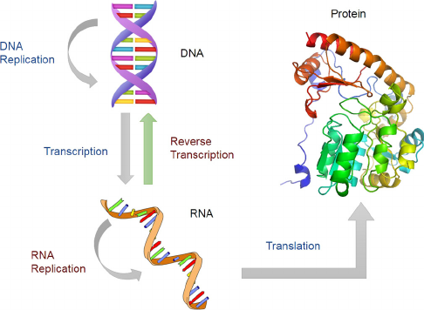
Relations:

圖表 1Flow-of-information-among-DNA-RNA-and-protein
DNA contains the genetic information necessary for the synthesis of proteins. The process of protein synthesis involves two main steps: transcription and translation. During transcription, a portion of the DNA sequence is copied into a complementary RNA molecule called messenger RNA (mRNA). This mRNA molecule carries the genetic instructions from DNA to the ribosomes, the cellular structures where proteins are synthesized. In translation, the ribosomes "read" the mRNA sequence and assemble the corresponding amino acids in the correct order, forming a protein.

Qin, Yiming & Yalamanchili, Hari & Qin, Jing & Yan, Bin & Wang, Junwen. (2015). The Current Status and Challenges in Computational Analysis of Genomic Big Data. Big Data Research. 36. 10.1016/j.bdr.2015.02.005.

