|  |  |
| --- | --- |
| A picture of a winding road and trees  XISD 5319  POE | ST10101860 – NOKWETHEMBA CELE  ST10101933 –ZWELAKHE NKOSI |

Team Member Allocation:

**Project Manager:** Zwelakhe Nkosi

**Software Developer Lead:** Zwelakhe Nkosi

**Business Analyst:** Nokwethemba Cele

**Organisation Identification**: Apply Pressure Shoe cleaners

**Project Plan**: Digitizing Laundry Services**Introduction**:The purpose of this project plan is to outline the implementation of a digital app for companies that provide laundry and shoe cleaning services. The app will allow customers to book and pay for their laundry shoe cleaning services online, providing a convenient collection and delivery system. This plan will cover various aspects, including the problem domain, business processes, system requirements, functions of the app system, stakeholders, and their functions, as well as inputs, outputs, and processing components.**Problem Domain**:The traditional laundry service industry often relies on in-person or phone-based bookings, which can be time-consuming and inconvenient for customers. By digitizing the process, we aim to provide a seamless experience for customers to book and pay for laundry services online, as well as offer a collection and delivery service through a single app. This will enhance customer convenience, streamline operations, and increase the overall efficiency of the laundry service companies.

User Profile after creation

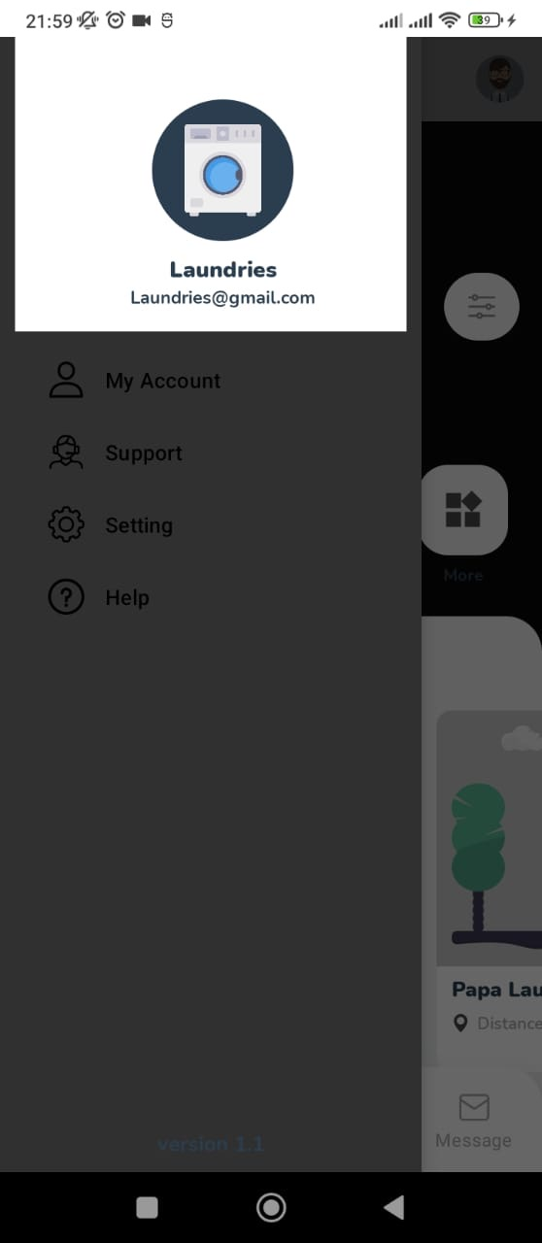

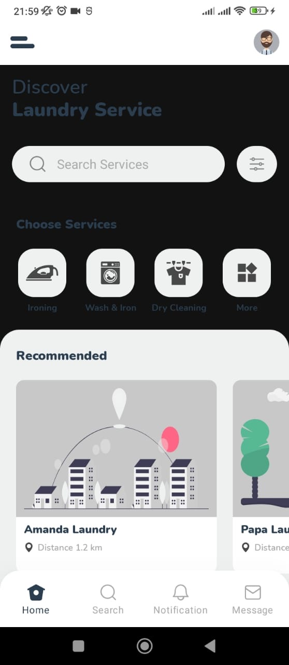

App Home Page

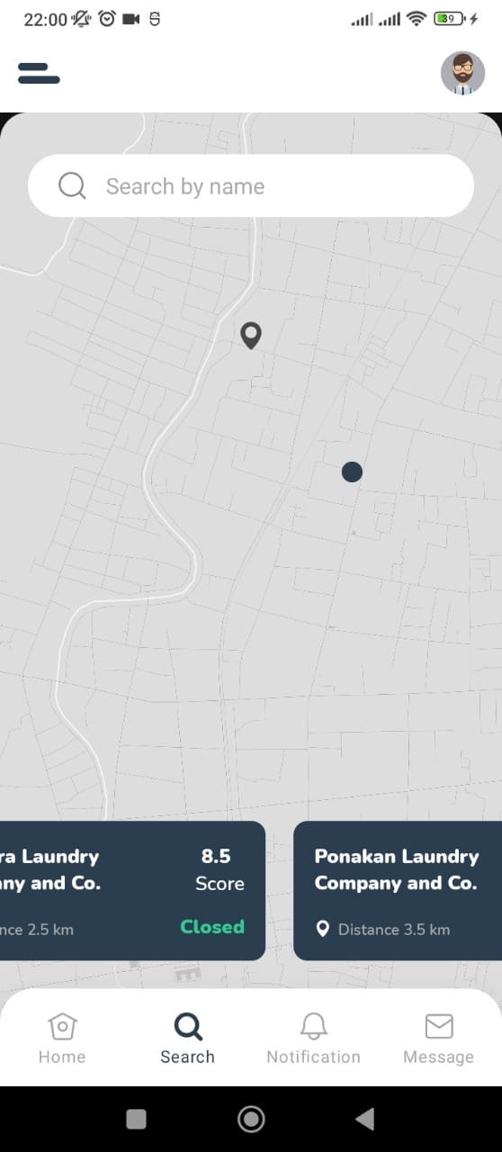Laundry location search

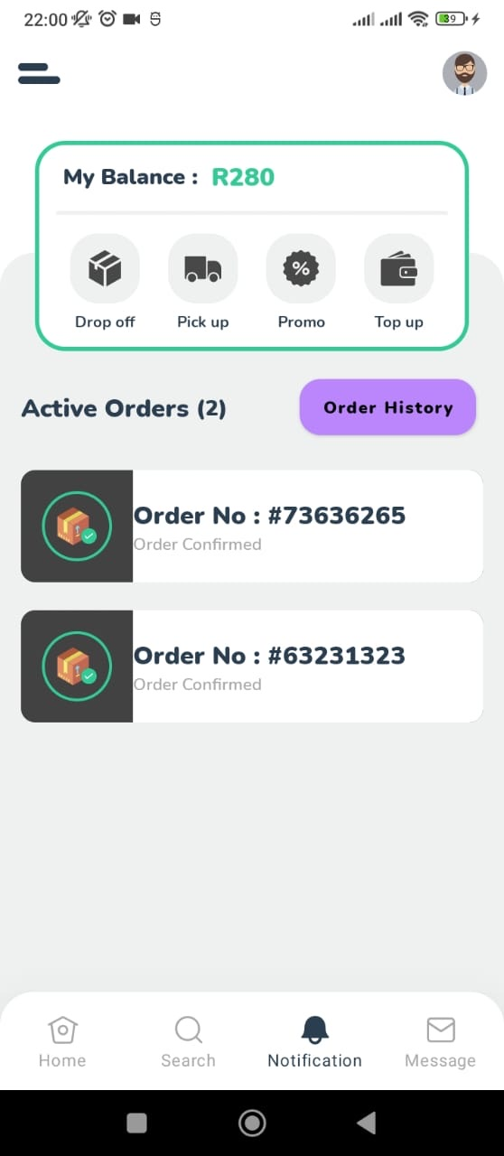 Order summary

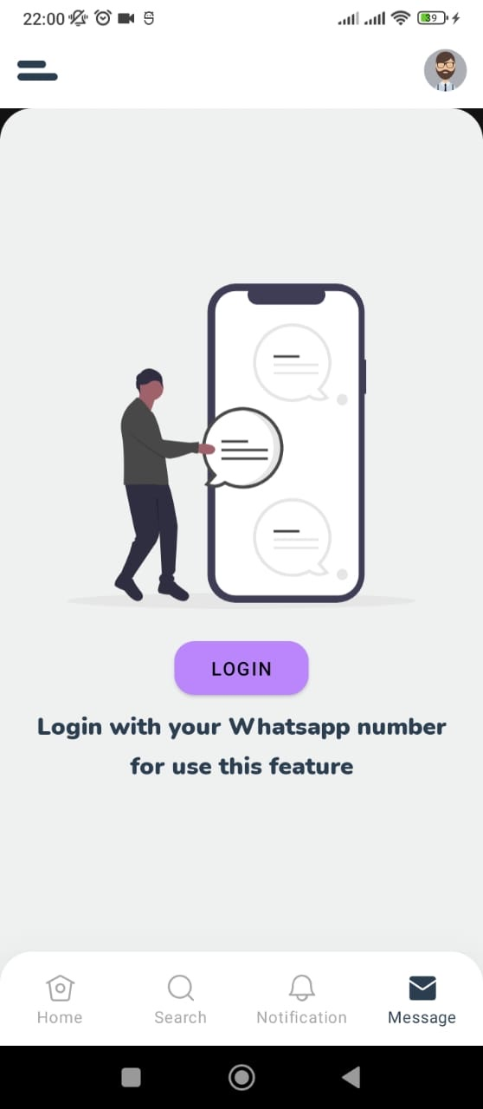 Message the company

Website

