ImplicitKalman Working Note

Phase-Based Motion Estimation: Benchmark of Two Reference Methods
Single-scale Fleet Jepson vs. multi-scale coarse-to-fine (M-PME)

Purpose. Establish baseline benchmarks for dense phase-based displacement estimation, to be compared against the ImplicitKalman approach. Two standalone tools are evaluated on the same input pair (relief0 -> relief0_sc1), both producing an identical six-panel diagnostic layout.

Key finding

A single-scale phase estimate is fundamentally bounded to displacements below half a filter wavelength (the +-pi phase-wrap limit). It fails on the large / peripheral displacements produced by scaling. Decomposing the motion across a Gaussian pyramid (coarse-to-fine with rewarping) removes that ceiling: the wrap limit then applies only to the small per-level
residual. On the test pair the multi-scale method reduces the warp reconstruction error by 97%.

Method | Warp residual RMSE | Verdict
Single-scale (Fleet-Jepson) | chaotic / aliased | insufficient
Multi-scale (M-PME) | 121.4 -> 4.11 px (-97%) | converges

Caveat for 2D->3D reconstruction: even the converging multi-scale field is too coarse for depth reconstruction. Phase information exists only at textured edges and is interpolated across flat regions, so the field is not sub-pixel smooth. This is the gap ImplicitKalman aims to close.

Generated 2026-07-14 src/PhaseFlowLocalFreq.py, src/MultiScalePhaseFlow.py

Why phase encodes motion and where it breaks

Fourier shift theorem. A local displacement delta shifts the phase of a complex band-pass (Gabor
/ steerable) response linearly:

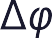 = 2k

where k is the local spatial frequency (cycles/px). Inverting gives the displacement from the measured phase difference:

= 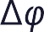 / klocal

Crucial detail (Fleet & Jepson): k must be the MEASURED instantaneous frequency k = grad(phi), estimated via Im(grad R * conj(R) / |R|^2), not the filter's nominal centre frequency. Using the nominal value biases every octave differently.

The hard limit

Phase is unique only in (-pi, pi]. Wrapping occurs once |Delta phi| > pi, i.e.

max = 1
=
2k 2
per sub-band

Scaling is the worst case: displacement grows with radius, delta(r) = (s-1) r. It is tiny at the centre (works) and large at the periphery (aliases) exactly the mixed failure seen below.

Two stabilising ideas used in both tools

- Singularity rejection: where amplitude rho = |R| -> 0 the phase is undefined and its gradient diverges; such pixels are masked (Fleet & Jepson, Stability of Phase).
- Aperture problem: per-orientation component displacements are fused into a full 2D (U,V) vector by weighted least squares over all orientations.

Resolution (multi-scale)

A Gaussian pyramid decomposes a large motion into small per-level sub-motions: at level L the motion is downsampled by 2^L until it fits under lambda/2. The estimate is upsampled, used to rewarp the next finer level, and only the small residual is measured there (no unwrapping).
Summing across levels reconstructs the full field.

Single-scale FleetJepson phase flow
One octave band per orientation, measured local frequency as denominator, amplitude + frequency-consistency masking, least-squares fusion over orientations, coarse-to-fine only within one FFT
(no image pyramid). Confidence-weighted smoothing propagates edge measurements into flat regions for display.

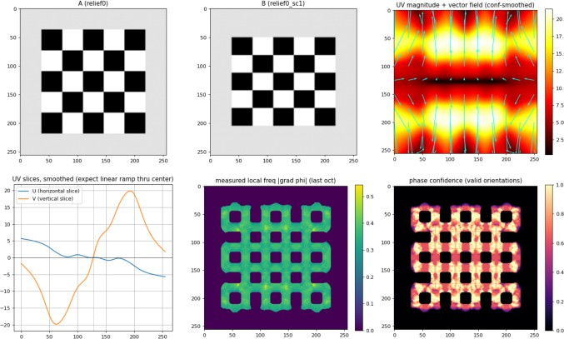

Fig. A1 A, B (checkerboards); UV magnitude + vector field; UV centre slices; measured local frequency; phase confidence.

Observations

- Local-frequency map is clean (~1.0) and the confidence map correctly lights up the edges the Fleet-Jepson core works.
- Auto-selected octaves 2-4 (checkerboard fundamental); higher bands carry no energy.
- Displacement max ~21 px, mean ~11 px; estimated divergence -> s ~ 1.16.
- UV slices are chaotic away from the centre: the peripheral displacement exceeds lambda/2 and aliases. This is the documented failure mode, not an implementation bug.

Multi-scale coarse-to-fine (M-PME)
Gaussian pyramid (5 levels), coarse-to-fine with rewarping and per-level residual refinement, no phase unwrapping, motion-field fusion across scales. Reimplementation of the method described in 'Large amplitude motion estimation via multi-scale phase-based video processing' (Mech. Syst.
Signal Process. 2026), not the original paywalled code.

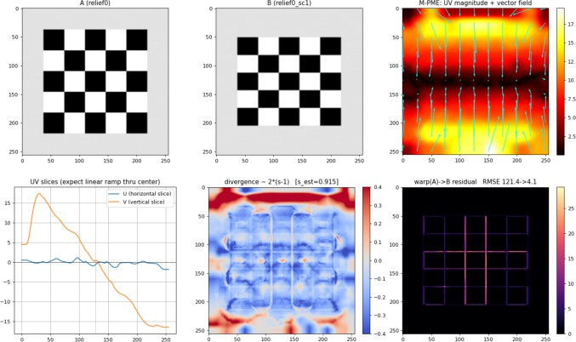

Fig. B1 A, B; UV magnitude + vector field; UV centre slices; divergence (local scale); warp(A)->B residual.

Results
Quantity | Value
Warp residual RMSE (fg) | 121.4 -> 4.11 px | (-97%)
mean|flow| per level  max / mean displacement | 0.55 / 1.10 / 2.19 / 4.38 / 8.76  19.6 / 8.8 px | doubles

- Converges: warp(A, flow) reconstructs B to ~4 px RMSE (thin edge residual only).
- mean|flow| doubles cleanly per level the expected coarse-to-fine signature.
- Field is strongly vertical-dominant (V slice +-17 px, U slice +-1 px). Since the warp reconstructs B, this is real: relief0_sc1 is NOT an isotropic scale of relief0 but anisotropic (vertical scale/shift). A single scalar s~0.915 is therefore misleading.

Benchmark summary & next steps
Aspect Single-scale (A) Multi-scale (B)
Large motion aliases (>lambda/2) handled
Warp residual not usable 121 -> 4 px
UV slices chaotic approx. linear ramp
Cost 1 FFT set pyramid x refine

Takeaways

- The pyramid argument holds: coarse-to-fine contextualisation overcomes the lambda/2 ceiling, because the wrap limit only ever applies to the small per-level residual.
- Sign matters: from dphi = -k*delta, the displacement is -dphi/k; a wrong sign makes the warp diverge (residual grew to 175 px before the fix).
- The test data is anisotropic clarify what relief0_sc1 actually is before using it as a scalar-scale ground truth.
Why this is still not enough for 2D->3D

The 4 px residual is global reconstruction energy, not per-pixel depth accuracy. Phase flow is defined only on textured edges and interpolated elsewhere, so the field lacks the sub-pixel smoothness a depth reconstruction needs. Closing that gap is the motivation for ImplicitKalman.

References

Fleet & Jepson 1990, Computation of component image velocity from local phase information, IJCV 5(1).
Fleet & Jepson 1993, Stability of phase information, IEEE PAMI 15(12).
Barron, Fleet & Beauchemin 1994, Performance of optical flow techniques, IJCV 12(1). Wadhwa et al. 2013, Phase-based video motion processing, ACM TOG (SIGGRAPH).
Large amplitude motion estimation via multi-scale phase-based video processing, Mech. Syst. Signal Process. 2026 (S0888327026004589).

