BENCHMARK WHITEPAPER · MOTION ESTIMATION FOR 3D

The Affine Ceiling
Formal motion estimation is sharp on affine motion and blind at depth.

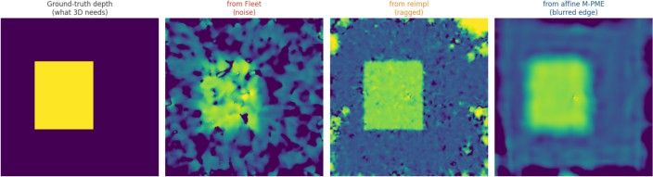

Depth reconstructed from each method's optical flow under a perspective Z-dolly. Ground truth is crisp; every phase-based method including the affine state of the art blurs, frays, or destroys the depth boundary. That boundary is what 3D reconstruction is made of.

ABSTRACT

Motion estimation is the front end of 3D reconstruction. We benchmark how well formal, non-probabilistic phase-based methods recover it, against pixel-exact ground truth, across three implementations of increasing fidelity from single-scale Fleet-Jepson to a faithful port of the 2026 affine multi-scale method (M-PME). The result splits cleanly: affine motion (translation, rotation, scale) is solved to sub-pixel accuracy at large magnitude, overturning the folklore that formal methods only handle small motion; but on the non-affine, per-pixel, discontinuous motion of a real 3D scene, every method blurs or destroys the depth boundary reconstruction depends on. The ceiling is not motion size it is the affine assumption.
KEY FINDINGS

Affine motion (scale, rotation) is solved to sub-pixel accuracy, even at large magnitude.
Non-affine depth motion: every method blurs or destroys the depth boundary.
The ceiling is the affine assumption, not the size of the motion.

AUTHOR
Felix Schaller
VERSION
Draft v0.2 · 2026-07-28
STATUS
Working note pre-publication
ORGANISATION
FelixSchallerCOM
CONTACT
inquiry@felixschaller.com
SOURCE
reproducible · src/benchmark_*.py

ImplicitKalman working note · Draft v0.2 · Generated 2026-07-28

BACKGROUND

Related work: three decades of phase-based motion
The idea that local phase encodes motion is old and deep. This note stands on it; the credit belongs to the people below, and so does the map of where it breaks.

Fleet & Jepson, 1990 component velocity.
They showed that the output phase of a band-pass (Gabor) filter is far more stable under changes in contrast, scale and illumination than its amplitude, and that the temporal evolution of that phase yields a component of image velocity the projection of motion onto the filter's orientation. Combining orientations resolves the aperture problem. This is the theoretical spine every method here still rests on [1].

Jepson & Fleet, 1991; Fleet & Jepson, 1993 where it fails.
The same authors mapped the failure modes with unusual honesty: phase singularities points in scale-space where the response amplitude vanishes and phase becomes undefined and wildly unstable and a stability criterion to detect and discard them. This is why every serious implementation, ours included, carries a confidence measure and a singularity mask [2][3].

Gautama & Van Hulle, 2002 dense, real-time phase flow.
Recursive temporal filtering and a formalized phase-constancy constraint turned phase into a dense optical-flow method the direct ancestor of the windowed least-squares fit in the 2026 method benchmarked here [5].

Wadhwa, Rubinstein, Durand & Freeman (MIT), 2013 motion magnification.
The most visible modern descendant. Built on the complex steerable pyramid, it manipulates the local phase of each sub-band to MAGNIFY tiny, invisible motions a pulse in a wrist, the sway of a building without ever computing an explicit flow field. Beautiful, widely used work. It
is also the clearest statement of the wall: the phase-motion relation is only linear for small displacements, so magnification is bounded they derive the limit explicitly and pushing past a fraction of the sub-band wavelength produces exactly the aliasing the theory predicts. Their follow-ups (the Riesz pyramid for speed; later large-motion variants) trade quality for range but do not remove the wall [6].
The hurdles, in one list. Every method above meets the same four: (1) phase wrapping beyond
+-pi the lambda/2 ceiling; (2) singularities where amplitude vanishes; (3) temporal aliasing from the filter's frequency tuning; and (4) the aperture problem. The 2026 M-PME method is the current best answer to (1) a Gaussian pyramid that keeps each level's residual under the
wall while inheriting the classical answers to (2)-(4) [7]. What none of them addresses is motion that is not locally affine. That is where this note begins.

TIMELINE

1990

Fleet & Jepson
1991

singularities
2002

Gautama-VanHulle
2013

MIT magnif.
2026

M-PME · LingBot

Two ways to estimate motion
Learned monocular models are advancing fast. Robbyant's LingBot-Map (Ant Group), for one, reconstructs 3D scenes from a single RGB camera in real time streaming, end-to-end, ~20 FPS, open-source [8]. Impressive engineering, and formal hand-derived algorithms do not currently keep up on raw capability. But it is a trained neural network: probabilistic by construction no error bound, no repeatable output, no provable worst case. For a photo app, fine. Under functional-safety standards ISO 26262, DO-178C, IEC 62304 it is disqualifying.
This work takes the opposite stance: formal, non-probabilistic estimation, derived from signal theory rather than trained from data. Every output is reproducible and analyzable. The open question is not whether it can be trusted it is whether it is accurate enough. Specifically: accurate enough for 3D.
02 THE SINGLE-SCALE LIMIT

A limit you can derive on paper

Phase-based estimation reads displacement from the phase shift of a band-pass filter. The Fourier shift theorem makes that shift linear in the displacement:
= 2 k
max =
/2
phase is unique only in (-pi, pi];
past half a wavelength it wraps

Beyond half a filter wavelength the phase aliases and the answer is silently wrong [1][3]. A single-scale method therefore has a hard ceiling and it is small. But it is not fundamental: a multi-scale pyramid pushes it away.
03 THREE IMPLEMENTATIONS

From a hard ceiling to none

Fleet (single-scale). One octave band, measured local frequency, singularity masking. Bounded to delta < lambda/2 our reference for the limit.
Reimpl (no paper). Multi-scale Gaussian pyramid, per-pixel translation, rewarping built before reading the source paper.
M-PME (faithful). The 2026 method of Li et al. [7]: a Gaussian pyramid with an AFFINE 6-parameter motion model fit over a window (Farnebaeck-style), confidence weighting, four Gabor directions, coarse-to-fine. Scale and rotation ARE affine it models them exactly.

How the pyramid beats the wall.
Downsampling halves the motion. At a coarse enough level even a large displacement drops under lambda/2 and can be read without wrapping; warping the finer level by that estimate leaves
only a small residual, read the same way, and so on down to full resolution. The wall never disappears each level simply stays below it. This is the whole trick, and it is why 'formal methods only do small motion' has not been true for years.
The next two sections put the three head to head against pixel-exact ground truth: first on pure affine motion (a scaling), then on the non-affine motion of a real 3D scene. The gap between those two results is the subject of this note.

Sub-pixel on large scaling
We warp a broadband texture by an exactly known scaling a fronto-parallel plane under a Z-dolly is precisely a scaling and sweep the magnitude, measuring the median endpoint error (EPE) against the pixel-exact ground-truth flow.

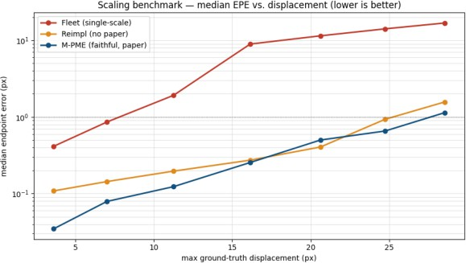
Fig. 1 Median EPE vs. displacement (log scale). Single-scale fails past ~11 px; both multi-scale methods stay sub-pixel; the affine M-PME is cleanest.
max displacement |  | Fleet | Reimpl | M-PME
4 px |  | 0.41 | 0.11 | 0.03
11 | px | 1.91 | 0.20 | 0.12
16 | px | 8.93 | 0.27 | 0.25
25 | px | 14.11 | 0.93 | 0.66
29 | px | 16.82 | 1.57 | 1.14

Table 1 median EPE (px) lower is better.

The intuition that 'formal methods only do small motion' is false. A multi-scale, affine, coarse-to-fine method solves large scaling and rotation to sub-pixel accuracy because scale and rotation are exactly affine, and the affine model represents them with no residual. Single-scale, by contrast, degrades linearly with displacement, exactly as the lambda/2 wall predicts. The ceiling is not motion size. It is the affine assumption and real scenes break it.

Real depth is not affine and it shows

A real scene is not a single plane. Move the camera along Z over a near object in front of a far background, and the optical flow is depth-dependent, with a DISCONTINUITY at the object's edge. That violates the affine-per-window assumption every method here relies on. Ground truth flow AND depth is exact, built from the depth map and the known camera step; from each method's recovered flow we invert the same geometry back to a depth map.
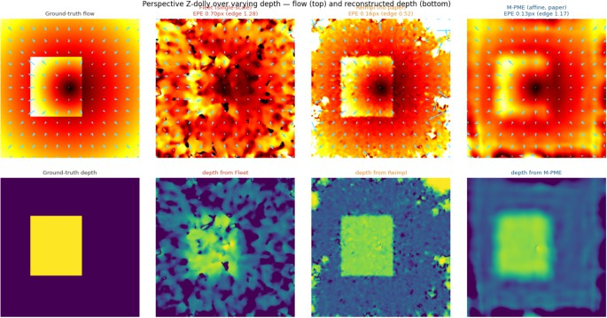
Fig. 2 Perspective Z-dolly over a two-plane scene. Top: recovered flow. Bottom: depth reconstructed from that flow. GT depth is a crisp step; Fleet returns noise, the reimplementation frays, the affine M-PME blurs the boundary away.
On the smooth, locally-affine plane regions all methods do fine median EPE 0.13-0.70 px.
At the depth edge they break: EPE jumps 4-9x. The affine M-PME is WORSE at the edge (1.17 px) than the simpler reimplementation (0.52 px) its large window averages across the discontinuity, the very place 3D structure lives.
The reconstructed depth is unusable: noise (Fleet), ragged edges (reimpl), or a blurred step where 3D needs a crisp one (M-PME).
This is the failure that matters. A depth map with soft, wandering boundaries yields a 3D model with soft, wandering surfaces walls that bleed into floors, objects fused with their background. For a robot deciding where the table ends, or a vehicle deciding where the curb is, a blurred boundary is not a small error: it is the wrong answer at the one place where accuracy is non-negotiable.

Localization is solved. Dense reconstruction is not.
Two objections greet any claim that 3D perception is unsolved: 'camera-only SLAM already works' and 'learned models already reconstruct scenes from a phone.' Both are true and neither closes the gap. They sit on opposite sides of a hard line.

Sparse geometry solved, deployed, certifiable.
Feature-based visual and visual-inertial SLAM is mature. ORB-SLAM3 [9] tracks a handful of keypoints across frames, triangulates them, and refines the camera trajectory by bundle adjustment real-time, on a phone, robust to dirt and glare. It ships commercially for camera-only localization, e.g. Main Street Autonomy's Pose Engine [10]. But note what it returns: a 6-DoF pose and a SPARSE cloud of feature points a few thousand, not a surface. And a single camera carries an inherent scale ambiguity: it recovers geometry only up to an unknown scale factor, resolvable solely with an IMU, a known dimension, or GNSS.

Dense reconstruction the learned land-grab.
The dense problem a depth at every pixel is where the field has moved, and it has moved to learning. NAVER's DUSt3R [11] regresses dense pointmaps from an uncalibrated image pair; MASt3R [12] adds metric scale and matching; VGGT [13] (CVPR 2025) makes it feed-forward over hundreds of views in under a second; Robbyant's LingBot-Map [8] productizes it as real-time streaming. The results are genuinely impressive and, being trained networks, probabilistic:
no bound, no repeatable worst case.

The tell nobody trusts the prior alone.
The most revealing signal is what comes next. The 2025-26 follow-ups immediately bolt classical geometry back onto the learned prior 'probabilistic geometric fusion' of VGGT priors for robust dense SLAM, collaborative dense SLAM with learned reconstruction priors. A field confident in its dense output would not re-introduce optimization and fusion to
stabilize it. The learned map is a strong guess that still needs a geometric spine.

So the landscape has two camps and a wall between them: sparse geometry that is certifiable but not dense, and dense learning that is dense but not certifiable. The sheer volume of
2024-26 work is the proof the problem is real and open everyone is pushing on it. What nobody has shipped is dense reconstruction that is at once accurate at the depth boundary and formally guaranteed. That is the gap this note is about.

Sharp on affine. Blind at depth.

Every method here is sharp on affine motion and blind at the depth boundary. For 3D reconstruction, that boundary is the whole point.

The two halves of this benchmark bracket the state of formal motion estimation. On affine motion translation, rotation, scale it is genuinely solved, to sub-pixel accuracy, at large magnitude. On the non-affine, per-pixel, discontinuous motion of a real 3D scene, it produces flow that looks plausible in aggregate but destroys exactly the depth edges reconstruction depends on.
That is the gap. The probabilistic models that handle real scenes cannot be certified; the formal methods that can be certified cannot yet resolve depth. Neither is usable for safety-critical 3D as it stands.

Outlook

We are building a formal, non-probabilistic method designed to stay sharp exactly where these blur crisp at the depth boundary, accurate enough per pixel to drive 3D reconstruction. This note is the baseline it will be measured against.
METHOD NOTE
Controlled synthetic scenes with pixel-exact ground truth (broadband texture; scaling and two-plane Z-dolly). EPE is the median over a central crop, excluding the focus-of-expansion core. M-PME is our faithful reimplementation of the described method. All figures reproducible from source.

REFERENCES

- D. J. Fleet & A. D. Jepson. Computation of component image velocity from local phase information. Int. J. Computer Vision 5(1), 1990.
- A. D. Jepson & D. J. Fleet. Phase singularities in scale-space. Image and Vision Computing 9(5), 1991.
- D. J. Fleet & A. D. Jepson. Stability of phase information. IEEE Trans. PAMI 15(12), 1993.
- J. L. Barron, D. J. Fleet & S. S. Beauchemin. Performance of optical flow techniques. Int. J. Computer Vision 12(1), 1994.
- T. Gautama & M. M. Van Hulle. A phase-based approach to the estimation of the optical flow field. IEEE Trans. Neural Networks 13(5), 2002.
- N. Wadhwa, M. Rubinstein, F. Durand & W. T. Freeman. Phase-based video motion processing. ACM Trans. Graphics (SIGGRAPH), 2013.
- M. Z. Li, Z. T. Yan, G. Liu & Z. Mao. Large amplitude motion estimation via multi-scale phase-based video processing. Mech. Syst. Signal Process. 253 (2026) 114301.
- Robbyant (Ant Group). LingBot-Map: streaming 3D reconstruction from monocular RGB video. 2026. arXiv:2604.14141; github.com/Robbyant/lingbot-map.
- C. Campos, R. Elvira, J. J. Gomez Rodriguez, J. M. M. Montiel & J. D. Tardos. ORB-SLAM3: accurate visual, visual-inertial and multi-map SLAM. IEEE T-RO 37(6), 2021.
- Main Street Autonomy. Pose Engine targetless, camera-only 6DoF localization. mainstreetautonomy.com/docs/pose-engine.
- S. Wang, V. Leroy, Y. Cabon, B. Chidlovskii & J. Revaud (NAVER). DUSt3R: geometric 3D vision made easy. CVPR 2024.
- V. Leroy, Y. Cabon & J. Revaud (NAVER). Grounding image matching in 3D with MASt3R. ECCV 2024. arXiv:2406.09756.
- J. Wang, M. Chen, N. Karaev, A. Vedaldi, C. Rupprecht & D. Novotny. VGGT: visual geometry grounded transformer. CVPR 2025. arXiv:2503.11651.

