2026.1.14广汉

【900句考到的范围】
900句不到 500
【陆空通话呼号和特情】
CES728
【OPI话题和图片】
- If you met one captain you don’t like/hard to communicate, how do you deal with?
- During takeoff, which flap position should you set?
What are consequences if you extend flaps over altitude limitation?
Airspeed - separation - near miss
What may cause you extend flaps over altitude limitation?
Human error: forget, workload, fatigue / jam, hydraulic retract
- Will your company encourage to save fuel? In your opinion, does pilot play an important role on saving fuel? What may cause fuel contamination?
- What are reasons for ditching? What preparation should you make before ditching? What’s your aircraft ditching procedure?

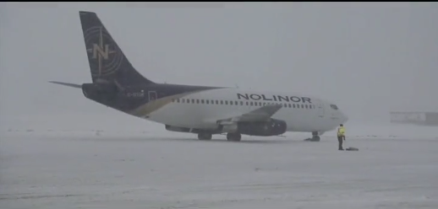
考官疑问：
- What should you pay attention to under such weather?
- What’s your company’s deicing procedure?

2026.3.19国航北京/飞院广汉

【通话】
SIA123/223 bird strike after takeoff, return to airport
ACA331 helicopter and avoidance, dangerous goods on fire, emergency descent to ventilate smoke, forced landing
AFR939

【OPI】
1. What are the differences of flying above water/sea and flying above land?
2. where is the location of your compass?
3. when should a pilot use magnetic compass?
4. What is complicated airport? What is short and narrow runway?
5. Can you tell me the procedure when your aircraft is ditching?
6. What is CFIT?
7. What is SOP? What is the objective of SOP?
8. Outside of your cockpit, what emergency equipment can be used after a ditching? （图片）
The Evacuation Slides / Slide-Rafts float
Life Vests、Flashlights、Megaphones
9. What is GNSS?
10. What should pilots do if the cargo door opens during flight or takeoff?
11. What factors may cause the cargo door to open?
12. If your aircraft is struck by lightning, is it going to be dangerous?
13.fatigue and duty time:
- What’s your company’s maximum allowable duty time?
- How can pilot mitigate fatigue in long haul flight?
- How do you deal with fatigue under extended duty time(eg. delay)?
- What facilities can help us to prevent pilots overload?
- What can company do to prevent pilot overwork?
14. What emergency equipment does your aircraft have? Vest
15. What is CRM?
16. What do you know about the anti-ice system in an aircraft? （图片）
17.How to avoid misunderstanding during radio communication?
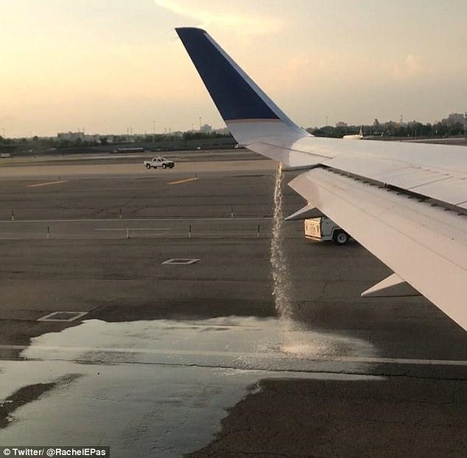
考官提问:
What is the danger of fuel leak/spillage/overspill?
What are the reasons of this incident?

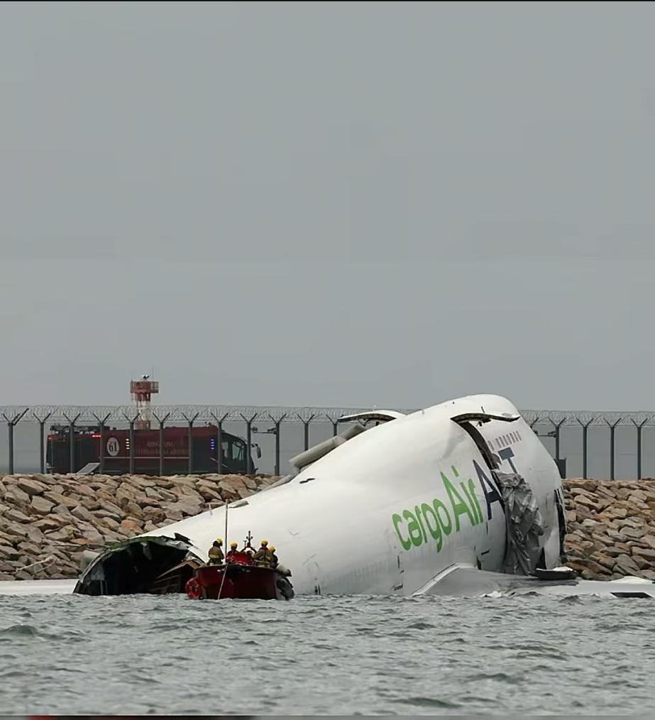

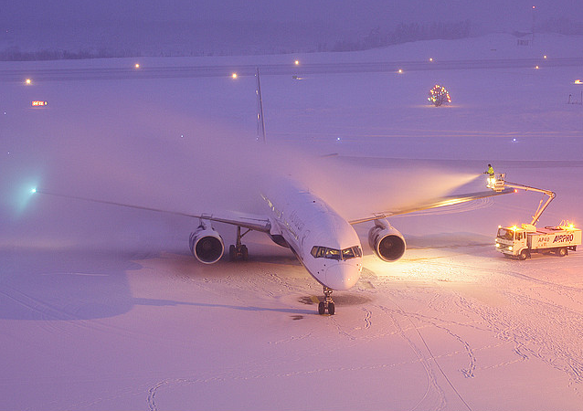

补充2026.3.19飞院/上海
【通话】
AFR332 toxic fume, divert to Frankfurt, radio check

【OPI】
1.Can you summarize the new general aviation regulations?
2. What is CDL?
3. What is VFR? What is IFR? Pilotage
4. What equipment do you need to operate within RVSM airspace?
5. If your autopilot is failed in RVSM airspace what will you do?
6. Where can you get information about restricted area?
Charts / NOTAM - ATC / CAAC
7. What are the differences between restricted area and forbidden area?
8. If passenger insists to change seat, how do you deal with condition?
9. Holding pattern
- When will you join the holding pattern?
- How to join the holding pattern?
- How do you know the holding speed of your holding pattern?
- Would you perform the standard holding pattern or make an orbit over a waypoint?
- Who will carry out ramp inspections?
What will be checked by CAAC authority inspector on the aircraft? What questions may be asked during ramp inspections?
How do you deal with the authority inspection?
- What is hold-over time?
How to calculate the hold-over time?
- For passengers, what kind of behaviors will be considered as unlawful interference?
What will you do if you encounter unlawful interference?
- Is similar callsign dangerous for the operation?
What will you do if you have a similar callsign with another aircraft?

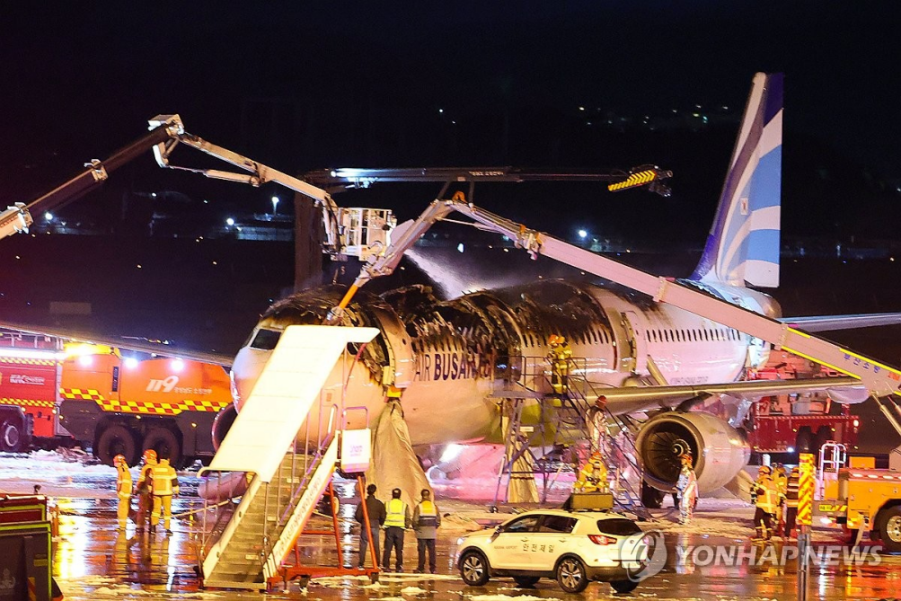
考官提问:
What factors caused this accident?
Do you think this is an evacuation or disembarkation?

2026.4.1深航深圳
【通话】
CSN542 bomb, large unmanned balloon, hole on the wing,control surfaces damage

【OPI】
- What factors will cause altitude deviation? How does a pilot avoid altitude deviation?
- What is stall? How to recover from a stall?
- What is short and narrow runway? What are the risks when landing on a short and narrow runway?
- What is VASI light? What is PAPI light?

考官提问:
If ice build up on wings, is it going to be dangers?
What is hold-over time?

2026.4.2中飞院
【900句考到的范围】
前500
520左右

【陆空通话呼号和特情】
SIA323, ATIS抄收，特别长
UAL835
CSN3523

【OPI话题和图片】
- How can ground temperature affect aircraft performance?
- How to optimize efficiency of using aircraft performance?
- What factors will affect aircraft performance?
- What is short and narrow runway?
- What is restricted area? And what is danger area?
- If there are different opinions between crew members, how do you deal with such condition? SOP
- What’s your company’s fuel policy? Does pilot play an important role on saving fuel?
- What’s your landing performance assessment procedure?
- What is CDFA?
- How to use portable fire extinguisher? How to use engine fire extinguisher?
- Why is lightning strike dangerous?
- Are you interested in any new type of equipment?
- Last year: Do you know anything about new Civil Aviation Law published in last year?
- Jet aircraft
- What is stall? How to recover from stall?

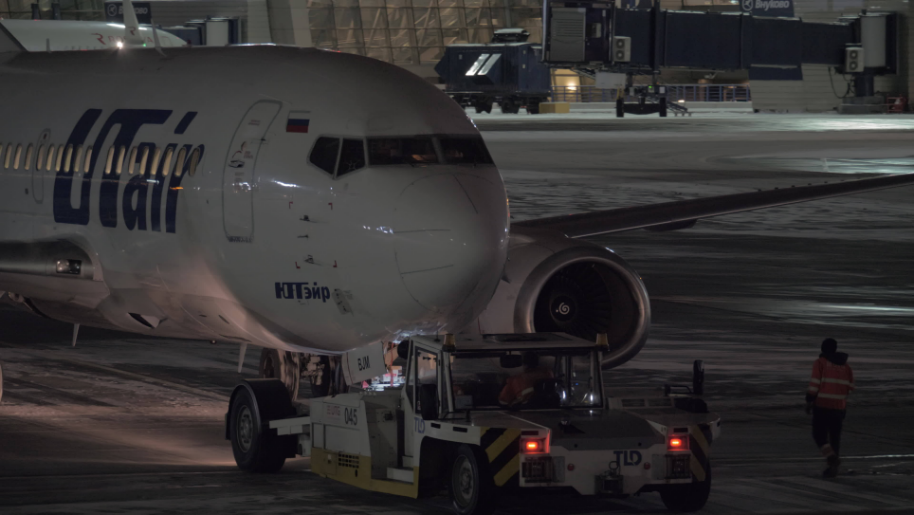
- What can you see from picture?
- What should you pay attention about during pushback?

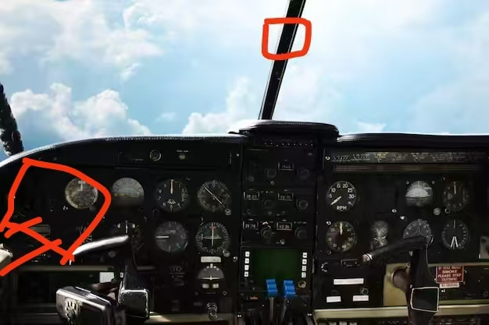
- Is this a commercial flight or a training flight? Why do you think it’s a training flight? Glass cockpit EFIS
- What instruments can you see in the cockpit?
- Where is the compass located on this aircraft, and when is it used?
- Based on the instruments and equipment, how would you assess the aircraft’s performance?
- Is the aircraft advanced or not? How do you think of this aircraft performance?

2026.4.10 国航北京
【通话】
KLM88 overweight luggage, low electrical power, skid off runway, nosewheel bog in mud, passenger stairs and tug
【OPI】
1. What should be careful about if you takeoff or landing at coastal airport?
2. Do you think situation awareness is important? How to improve situation awareness?
3. What will China’s aviation industry be like in 10 years from now? Do you think China aviation industry has developed a lot from last year?
4. What factors will cause an aircraft to overrun the runway? How to avoid this situation. Flaps brakes - high speed SA length braking action

2026.4.14 首航北京
【900句】
500句以内 500左右，第七句I see wildfire…
【通话】
KLM88 overweight luggage, low electrical power, skid off runway, nosewheel bog in mud, passenger stairs and tug
QFA432 smoke from APU of B747 ahead, sandstorm, engine fail, priority landing
CES2151 tow bar, wind check, engine fail due bird strike
SIA123 change runway due wind exceed limitation, engine fail due bird strike, PAN
【OPI】
1. What is AI? Do you think AI changes your life?
2. How does bird strike endanger our flight safety? How to avoid bird strike? Why does bird activity become more and more frequent?
3. Is lightning strike dangerous? How to avoid lightning strike?
Structure electric NVG coumm
4. Can you give me some examples of dangerous goods? Does your company provide any training on dangerous goods? What will be trained?
Class simulator lighter
Do you think this training is important?
5. How many takeoffs and landings did you make? How many flight hours have you accumulated?
6. Have you ever accepted any recurrent training? How long does it take to complete a recurrent training?
Half year 1-2day
Do you think recurrent training is important?
- Why lithium battery is not allowed to use onboard?
Short circuit rapid charging high temp
- Is it dangerous if a passenger brings a lighter onboard?
8. What is situation awareness? How to improve situation awareness?
9. How does PF and PM execute checklist and share tasks during flight?

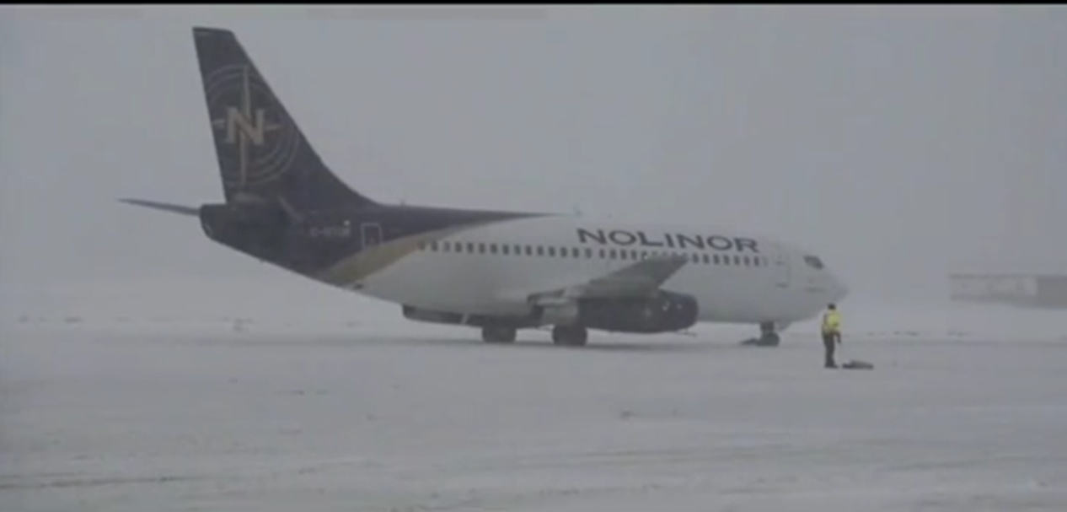

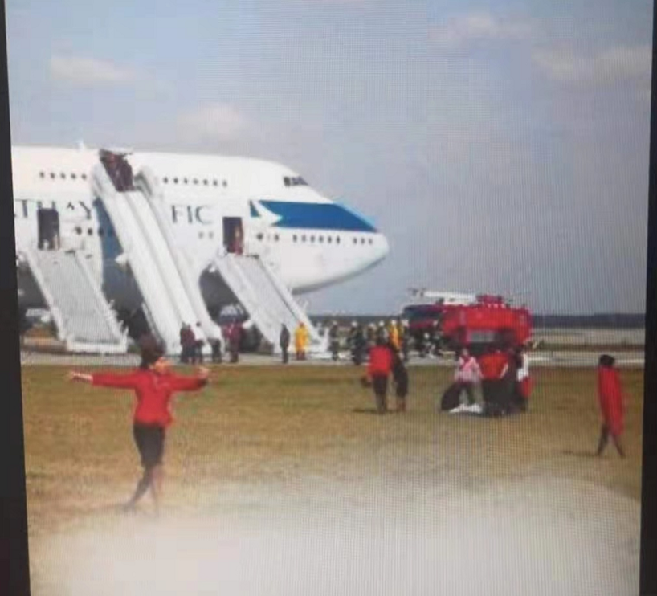
Deploy slide
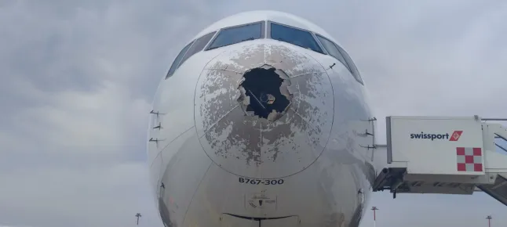

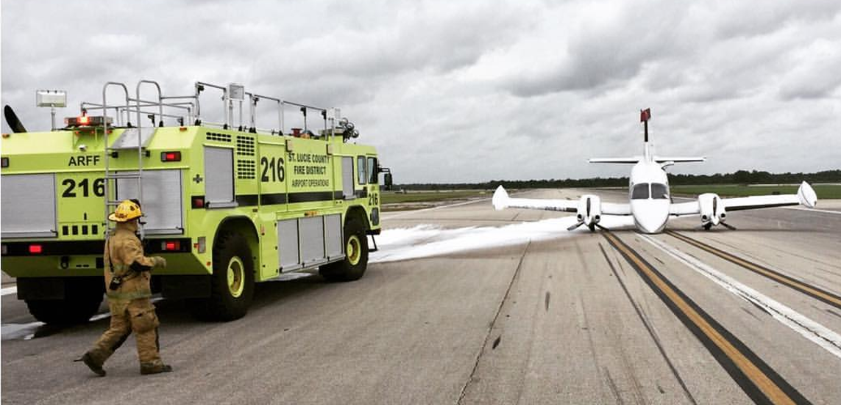

2026.4.15首航北京
【通话】
CCA937 two passengers missing, engine intermittent noise
【OPI】
1. What will China’s aviation industry be like in 10 years from now?
2. Do you think China aviation industry has developed a lot from last year?
3. What is GPS?
4. What are the differences between traditional navigation and GPS navigation?
5. What is the definition of short and narrow runway? 1800 45
6. Is it dangerous when landing on a short and narrow runway?
7. If your aircraft veer off runway, what are the possible consequence?
Tyre damage - collision injury
- How to avoid veering off runway?
Skill SA pre-flight cross wind - go around
9. Do you know any aircraft manufactured by China?
10. Why is lightning strike dangerous to our flight?
11. How does a pilot avoid lightning strike?

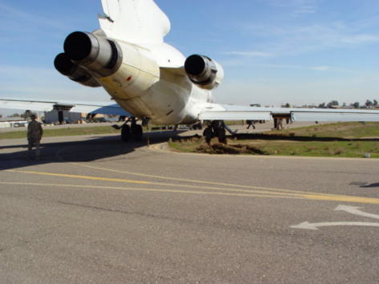
Bog in mud

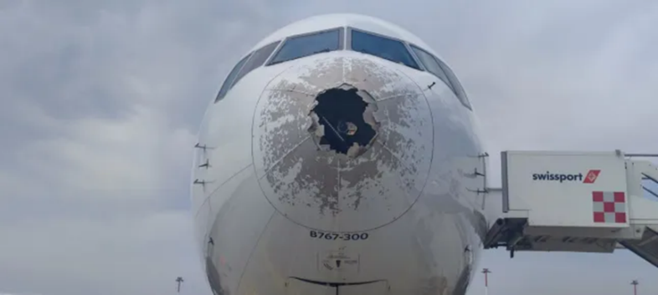
Hail trace

2026.4.16中飞院
【900句考到的范围】
400＋
500左右
550左右
550
480
最后一句580，第一组有287
400+
550左右
500左右
662和700多
718
699
660
最长的728，剩下500左右
600左右
最长708，其余四五百
最后四个都600以后
后四句600以后，782最长
630以后

【陆空通话呼号和特情】
CES769乘客在飞机上开紧急出口
CSN542气球
csn6682 发电机故障 液压油泄漏
AFR896 颠簸，积冰
ACA939 RW incursions
CSN542 炸弹，起飞后unmanned bollon
sin123鸟击一发失效
CSN817 ，TCAS RA climb，RW36R进近PAPI灯不可见
afr893 一发失效，备降别的机场

【OPI话题和图片】
- Green aviation
How to carry out sustainable aviation?
Can you give me some specific examples of daily green operations?
- Can you tell me some names of dangerous goods? Does your company have any requirements on transporting dangerous goods? Have you accepted any dangerous goods training? If you find suspicious luggage on board, what should you do?
BOMB 7700 bomb disposal experts
- Why are lithium batteries dangerous on board?
Short circuit charge overheating
If lithium batteries catch fire, how do you deal with it?
- What should you pay attention to during visual landing? What requirements are needed during visual flight? What can help visual flight?
Descent path
Airspeed attitude
Smooth landing flare
VASI
- What new technologies, new equipment, new type of aircraft are you interested in? How can technology affect our flight?
- How do you think of the development of aviation industry in next decade? What can pilot do to deal with new technology in next decade? What difficulties will aviation industry face in the future?
- Where is the location of your compass? When should a pilot use magnetic compass?
- In flight, if ATC informs you that they receive an anonymous call saying there’s a bomb on board your aircraft, what would you do? Does your company have any specific procedures about a bomb situation?
- If you encounter radar failure, what should you do?
- What does dispatcher do? What kinds of information do you need from dispatcher during operation?
- What will you do if you have to make a ditching? What’s your company ditching procedure?
- If you encounter electrical system failure, what should you do? How many electric power are there on your aircraft? battery
- What else emergency condition do you know? How to deal with emergency condition?
- How do you obtain weather information if on board weather radar failure? What information can weather radar provide to pilot?
Moisture - cloud size - thermal - distance
What’s the function of weather radar? When will you use weather radar?
- What factors should pilot consider during landing in heavy rain?
VIS windshield runway condition, braking action ENG performance lift drag
- What are the differences between daytime flight and night time flight?
- CDFA, What are the differences between CDFA and precision approach?
- What’s your company’s fuel policy? What's your opinion on pilot’s responsibility to save fuel? Why does pilot play an important role in saving fuel? Will high altitude affect fuel consumption? Fuel emergency, How to make fuel check? Dump
- How does wake turbulence threaten flight safety? How to avoid wake turbulence?
- Do you know any automation system in the cockpit? Please name a few of them. How reliable are those system?
- Land on snow: If you land on a snow contaminated runway, what should you consider?
- What type of aircraft are you flying now? Single piston ENG retract/fixed seat
- Can you tell me some training which can ensure flight safety? How to guarantee training quality? Oral simulator
- When will pilot make emergency descent?
- What’s the function of oxygen system? When to use oxygen mask?
- During the flight, if side window is opened, how do you deal with it? What are the reasons for side window being opened?
- Why is weather a major factor concerning flight safety?
- Who should fill logbook? What’s the use of logbook?
- What kind of emergency equipment do you have in the cockpit?
- What is CPDLC? How do you operate CPDLC to enforce control orders in the event of a two-way radio failure?
- Force landing, what should pilot prepare before force landing? How to make a successful force landing?
- What is CFIT? Why is CFIT sometimes happen? How do we avoid CFIT in general?
- Will you do briefing before the flight? What preparation should pilot make before the flight?
- Where do you have your training? What’s your favorite training subject?
- SOP, How to operate with SOP?
- Do you think standard callout procedure is important? Do you know the standard callout procedure during approach?
- Is the hydraulic system important to flight operations? How many hydraulic systems are there on your aircraft? What are the functions of the hydraulic system? When one hydraulic system fails, will it affect the flight safety? When there is a fluid leak, what will you do?
- If your captain is incapacitated, what will you do? How do we avoid incapacitation? What are the reasons of crew incapacitation?
- Do all flight crew members eat the same food on board? Is it necessary to security check the catering staff?
- What do you know about the deicing system in an aircraft? What are the differences between deicing and anti-icing?
- If you encounter radio failure, what should you do?
- What preparations should you make before divert to alternate airport?
- What do you know about C919?
- Can you tell me when it is necessary to execute emergency evacuation? How fast should you execute the emergency evacuation? If you decide to carry out emergency evacuation after landing, what preparations should you make before landing?
- What is Missed Approach? When should the pilot commence MA? How to commence a MA? Can you describe the standard MA procedure in your A/P? Do you think it’s necessary to have a standard MA procedure?
- What is situational awareness? Can loss of situational awareness lead to accidents? Would you give some suggestions to pilots to improve their situational awareness?
- What’s the duties of PF and PM? Who is responsible to initiate a check? How do the flight crew members cooperate with each other to carry out cross check?
- If you encounter tire burst, what should you do?
- How often do you have your recurrent training? How many hours are you required to complete each time? Do you think it’s necessary for pilots to have recurrent training? What training subjects do you review in your recurrent training?
- What’s your company’s maximum allowable duty time? How can pilot mitigate fatigue in long haul flight? How do you deal with fatigue under extended duty time(eg. delay)? What facilities can help us to prevent pilots overload? What can company do to prevent pilot overwork?
- Pilot fatigue
How can you know you are in a overload condition? And what are the signs of fatigue?
- What facilities are required in the operation of RVSM? What would you do if the auto-pilot fails when you are operating in RVSM?
- If passenger insists to change seat, how do you deal with condition? What’s the influence of this?
- What is TCAS? How does it work?
- How to make a safe and stable approach?
- Do you know anything about new Civil Aviation Law published in last year?
- How do you get the loading sheet? What’s the use of loading sheet? What kinds of information are included in the loading sheet?

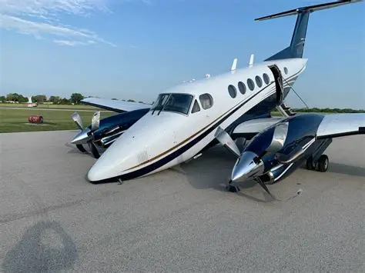

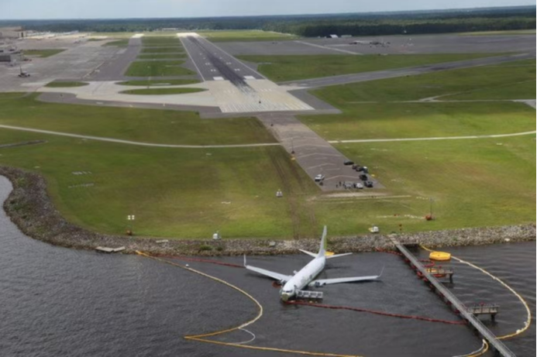

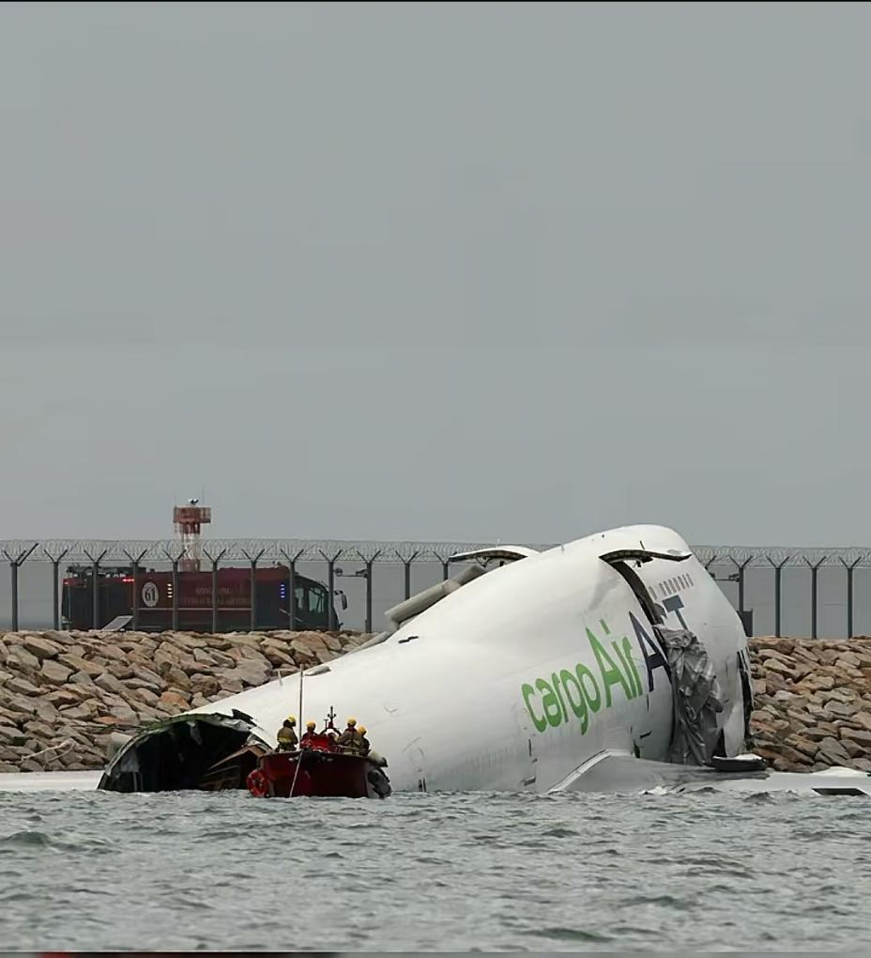

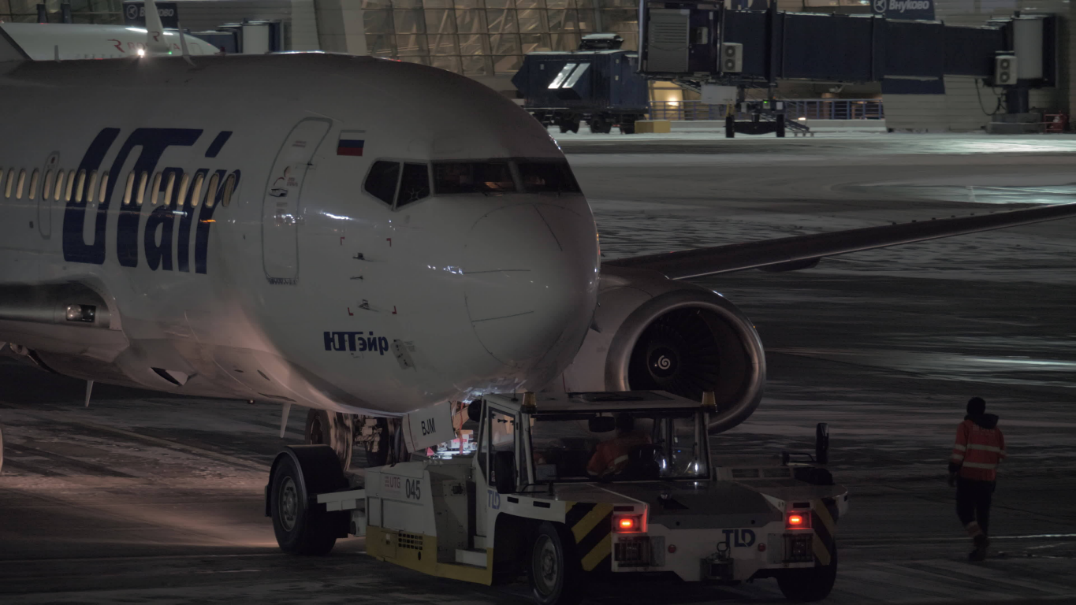

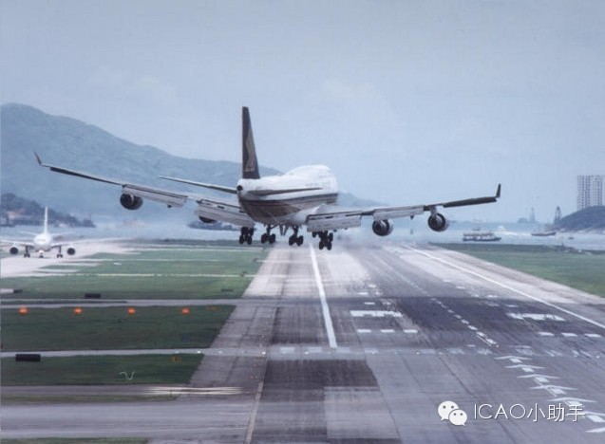

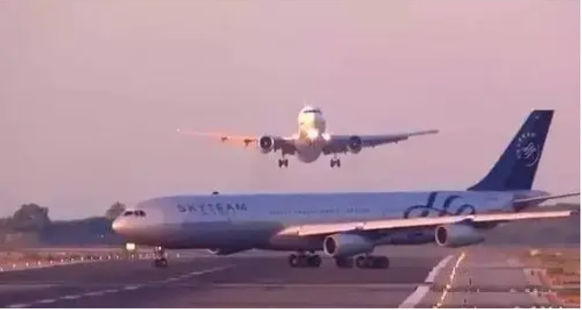

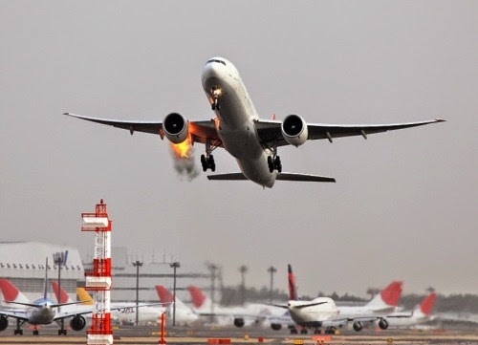

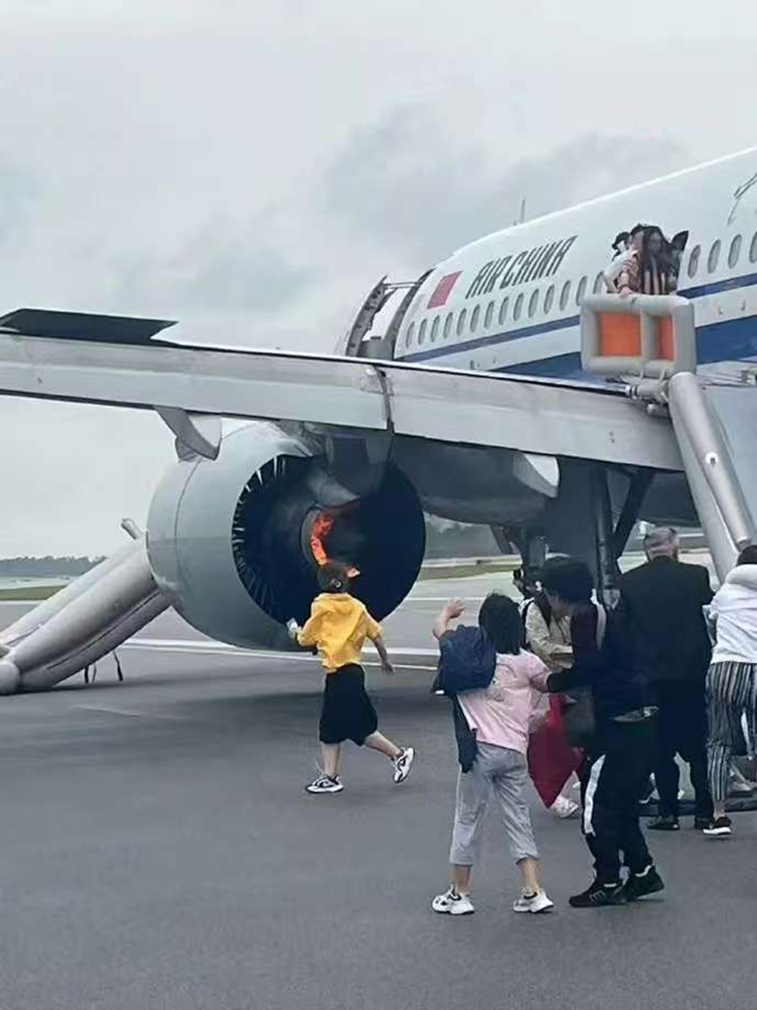

2026.4.28中飞院
【900句考到的范围】
550左右，最后一句625
800左右
500左右
500左右
500左右
500左右
500左右
600之前
一句600多 其他都500前
650左右
500以内
550
500以内
500以内，最后一句663
550以内
500以内
500左右
500左右
500左右
550以内，最后一句668
500左右
最后一句434
550以内
600句左右
550句以内
600句以内
700句左右
600句左右
最后一句594

【陆空通话呼号和特情】
SIA123 拖车杆坏了，风向袋wind check，顺风超限换跑道，鸟击
AFR941
cca527 雷暴
ACA517左发失效；由于天气vor改为盲降
JAL220，传话，另一架飞机无线电失效盲发，鸟击吸入发动机，发动机失效
BAW120. 由于啥啥复飞换跑道啥啥
更换巡航高度，减跑道起飞，起落架，拖车
csn3523
日本220
更换巡航高度，积雨云绕飞，
AFR332
CES728
CE769
UNL831
SIA852中断起飞
SIA315
积冰
UAL182
CES529
襟翼卡阻，长跑道落地
SIS497
CSN817
UAL831
JAL602
QFA701
CSN817
CSN3201
CE5227
BAW931生病旅客延误，发动机起火中断起飞
csn557

【OPI话题和图片】
- Have you heard about any accidents of ground collision?
Why does ground collision sometimes happen?
If you collide with a ground truck while taxiing, what would you do?
In your opinion, how can we reduce ground collision incidents?
- Does your aircraft have stall warning? What is it like?
How do you recover from stall?
What are the reasons of stall?
Why is stall dangerous to flight?
What can a pilot do to prevent a stall?
- What’s the objective of SOP?
What factors and conditions may affect the compliance with SOPs?
What training does your company provide to address and improve strict adherence to SOPs?
Have you performed any SOPs in your flight?
- How can pilot and cabin crew cooperate in emergency evacuation?
- How to perform a stable approach?
- What do you do during preflight preparation?
What will you do in the briefing room?
- Could you tell me about your company’s fuel policy?
If you encounter fuel leakage, what should you do?
What are reasons for fuel contamination?
Rainy day
Does high altitude consume more fuel or low altitude consume more?
- What is GNSS? What are included in GNSS?
What’s the difference between GNSS(satellite navigation) and conventional navigation?
- What kind of runways may be considered as short and narrow runways?
Will it be dangerous to take off and land on it?
If you overrun or veer off the runway, what will be the consequence?
- When will you call MAYDAY/distress? When will you call PANPAN/urgency? What are the differences?
- How can pilot mitigate fatigue in long haul flight?
- Could you introduce your company’s alcohol control policy?
- What is CFIT?
Why is CFIT sometimes happen?
How do we avoid CFIT in general?
- What are key factors affecting ice accretion?
- Is simulator training necessary to pilot?
- Do you know anything about TCAS? What does TCAS refer to?
Is your aircraft equipped with TCAS? Could you explain how your TCAS works?
How can we avoid mid air collision?
- Why is severe turbulence dangerous? If you encounter severe turbulence, what should you do?
- What challenges will you face during the approach?
- If your landing gear malfunctioned, what should yo do? How to execute belly landing?
- What should you pay attention to in winter operations? What should yo consider about in summer operations?
- Do you think China aviation industry has developed a lot from last year?
What challenges has China aviation industry faced?
How can pilot adapt the development?
- Are you interested in any new technologies or new type of aircraft?
How can these new technologies and equipment influence our flight?
Will AI be helpful in the cockpit?
- What training subjects do you have in flight school? Which one is the most difficult one?
- Do you know any automation system in the cockpit? Please name a few of them. How reliable are those system?
- What is RVSM? Why we need RVSM?
What qualifications or facilities are required in the operation of RVSM?
What would you do if the auto-pilot fails when you are operating in RVSM?
- Is lightning strike dangerous? How to avoid lightning strike?
- Can you tell me some landing technique?
- What do you know about the deicing system in an aircraft?
If you need to operate on contaminated runway, what should you consider?
- Under what situations that a pilot has to make PA?
If your first officer is incapacitated, is it necessary to make PA? How will you tell this situation to the cabin crew?
- How many electrical power sources are there on board?
When do pilots need to use external power?
- Do you think the ground security has improved in the last decade?
Is it important for airports to strengthen the security check at the airport?
- What type of aircraft you are flying?
- If you encountered tire burst, what should you do?
- Have you ever encountered any emergency condition? How do you deal with it?
- Do you make landing performance assessment for each flight?
What factors should you consider when making the performance assessment?
Would you please introduce the procedure of landing performance assessment of your flying aircraft?
- Could you introduce some warning systems in your aircraft?
- What’s your company ditching procedure?
- What is CDFA?
What are the differences between CDFA and precision approach?
- When will pilot choose to dump fuel?
- What’s the job of dispatcher?
- Who should fill loading sheet? What information should you fill?
- How to improve safety margin in communication between pilot and ATC?
- How to ensure flight safety in more and more crowded airspace?
- What kind of emergency equipment do you have in the cockpit?
- What is Missed Approach?
When should the pilot commence MA?
How to commence a MA?
Can you describe the standard MA procedure in your A/P?
- What’s your company’s maximum allowable duty time?
How do you deal with fatigue under extended duty time(eg. delay)?
- If crosswind is marginal around your standard, what will you do?
What should flight crew pay attention to when they encounter strong crosswind during landing?
Do you think crosswind landing is very dangerous? Why?
If you need to do a crosswind landing, what will you do?
- If you encounter hijack, what should you do?
- When will airport commence flow control?
- What’s your company safety policy?
- What’s your company refueling procedure?
- What is GNSS?
Do you prefer GPS navigation or conventional navigation?
- Can you tell me some names of dangerous goods?
What are the contents of dangerous goods training?
If you encounter dangerous goods leakage, what will you do?
Does your company have any requirements on transporting dangerous goods?
- What should you pay attention to if you need to land in a rainy day?
- Do you know any automation system in the cockpit? Please name a few of them. How reliable are those system?
- What should pilot prepare before force landing? How to make a successful force landing?
- What does HUD stand for?
When will pilots use HUD?
Can HUD be used to lower the landing minimum? Please describe it.
- After you make an overweight landing, will you submit report to your company? What should you report?
- Before landing at high elevation airport, what preparations should a pilot make?
- How can you know you are in a overload condition? And what are the signs of fatigue?
- What is RNP? What is RNAV? What’s the key difference between them?

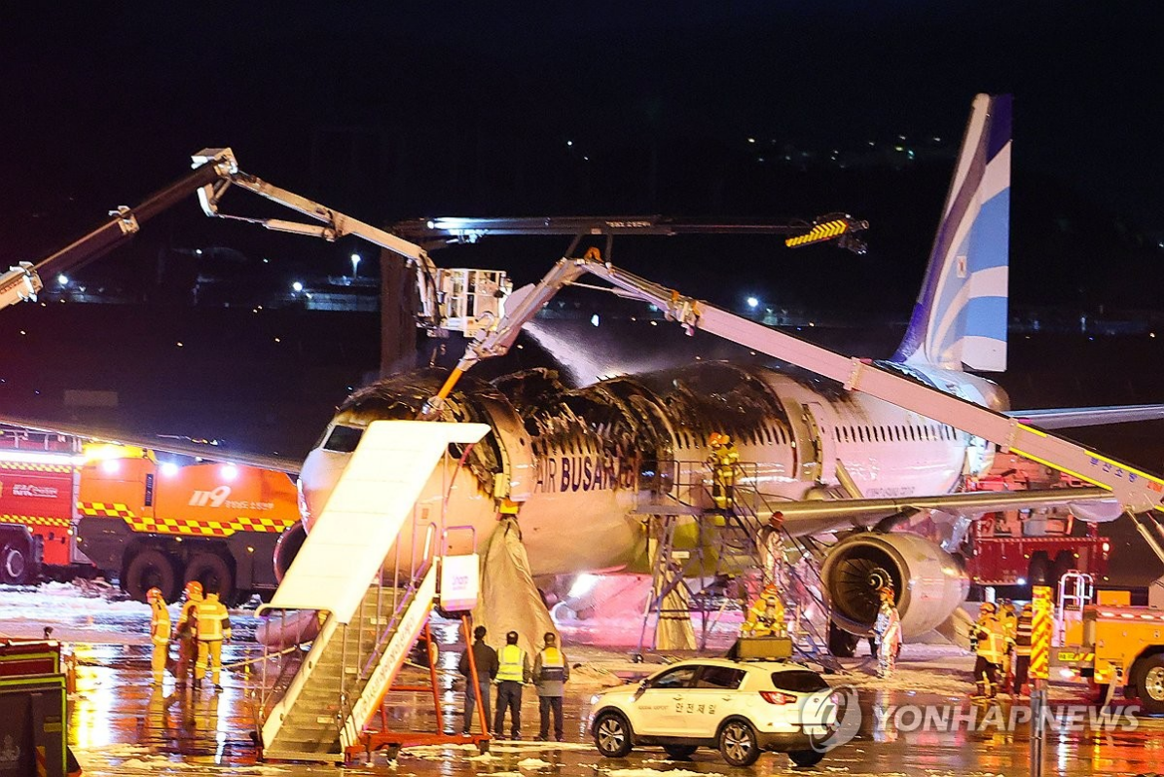

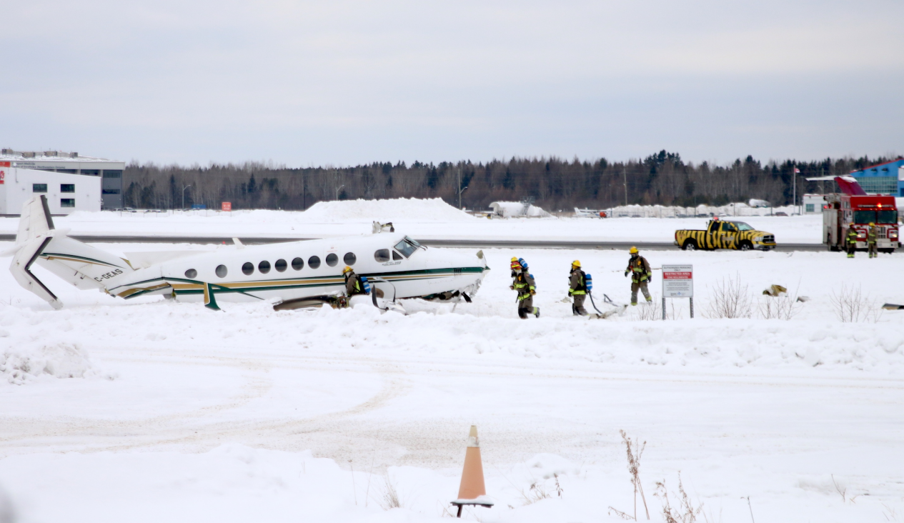

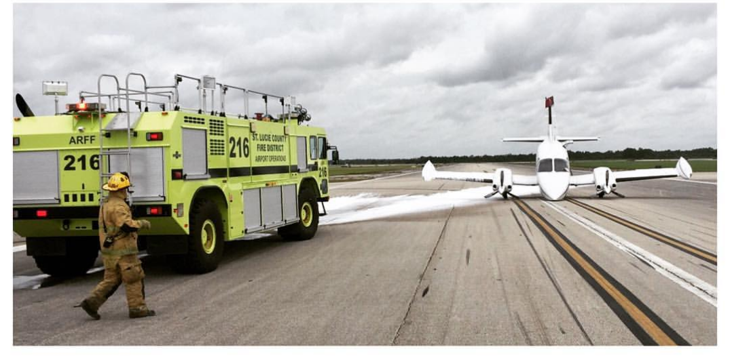
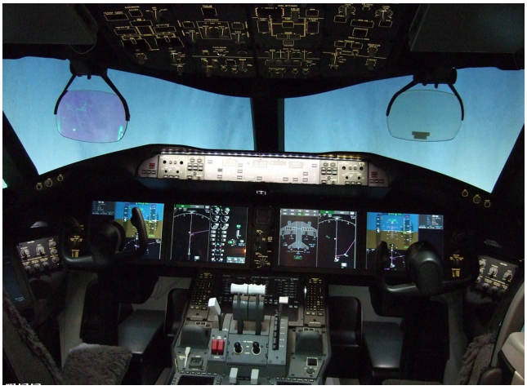

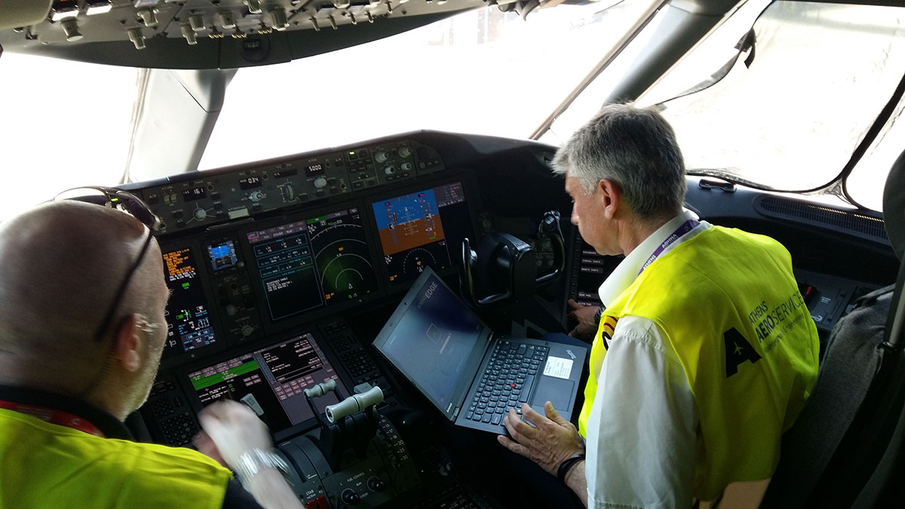
Why are the maintenance personnel in the cockpit?
After flight: maintenance/inspection
How can pilot and maintenance personnel work together to ensure flight safety?
Log book

2026.5.15广汉

【900句考到的范围】
580以内，一句700左右
650以内
【陆空通话呼号和特情】
AFR896
CSN769
【OPI话题和图片】
- Fuel policy
What’s your company’s fuel policy? What's your opinion on pilot’s responsibility to save fuel? Why does pilot play an important role in saving fuel? Will high altitude affect fuel consumption? Fuel emergency, How to make fuel check?
- What is GNSS? What are included in GNSS?
What’s the difference between GNSS(satellite navigation) and conventional navigation?
- How does bird strike endanger our flight safety? How to avoid bird strike?
- If your aircraft is struck by lightning, is it going to be dangerous?
- fatigue and duty time:
a.What’s your company’s maximum allowable duty time?
b.How can pilot mitigate fatigue in long haul flight?
c.How do you deal with fatigue under extended duty time(eg. delay)?
d.What facilities can help us to prevent pilots overload?
e.What can company do to prevent pilot overwork?
- Have you ever encountered any emergency condition? How do you deal with it?
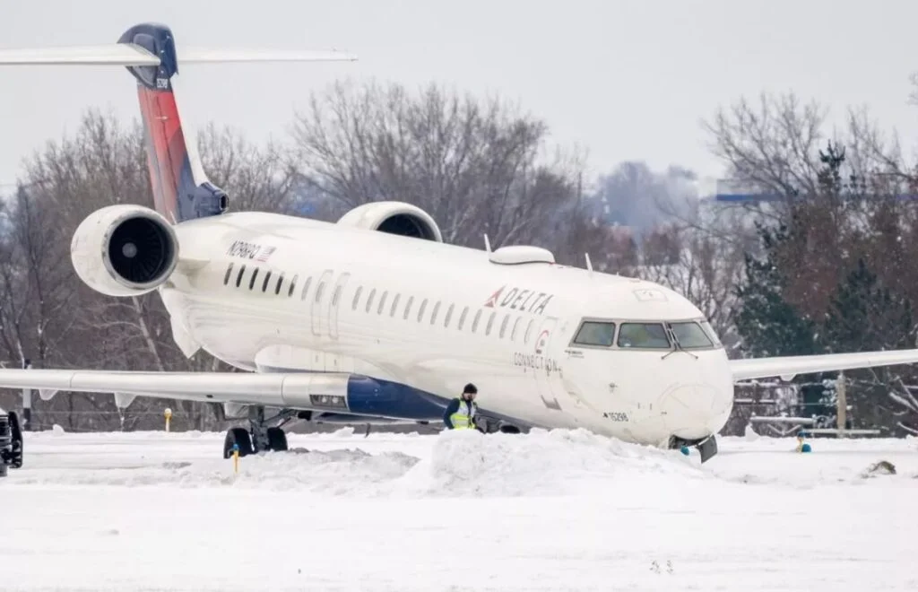
Propeller blade

2026.5.29广汉

【900句考到的范围】
600左右
考到622句
620左右

【陆空通话呼号和特情】
CES5118
AFR168
CES565

【OPI话题和图片】
- Which one is more difficult? Takeoff or landing? Why?
- What maintenance item should pilot check?
- What is wake turbulence? Is it dangerous? How to avoid wake turbulence?
- duty time
- What’s your company’s maximum allowable duty time?
- How can pilot mitigate fatigue in long haul flight?
- How do you deal with fatigue under extended duty time(eg. delay)?
- What facilities can help us to prevent pilots overload?
- What can company do to prevent pilot overwork?
- If you encounter conflicting traffic, What should you do?
- Can lighter be taken on board? (lithium battery)
- Have you ever encountered lightning during flight? What’s the hazard of lightning strike? Under what weather conditions does lightning strike more likely occur?
- How to execute walk around inspection? What part should you check? If you find something unusual, what should you do?
- What’s reason for ditching? What’s your company ditching procedure? How do crew member cooperate with each other in the ditching?
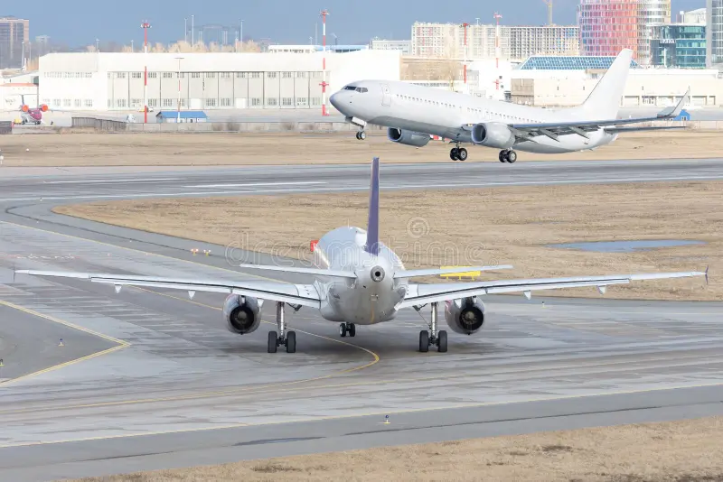

【额外补充】
- What is PBE? How to use it?
- Green aviation:
- How to carry out sustainable aviation?
- Can you give me some specific examples of daily green operations?
- What is SAF?
- What is FOI? Is it dangerous?
- readback
- What is readback?
- Do you think readback is important? Why?
- What information should you readback during departure (or landing)?

2026.6.11广汉

【900句考到的范围】
590
600
前500句
675
600前
前600句
600左右
600前
650前

【陆空通话呼号和特情】
BAW931，地面有一名乘客受伤，延迟起飞。
csn557
ces556
CES769
QFA432
QFA160
U403，除冰和雷暴
u835—乘客受伤因为飞机机动
气球 炸弹

【OPI话题和图片】
- What’s your favorite part in the flight? Which one is the most difficult part for you? Why?
- Have you encountered any emergency condition?
- When will you execute emergency descent?
- What are differences between MAYDAY and PANPAN?
- Are you interested in any new type of aircraft or new technology?
- What is EBT?
- What should you pay attention to in winter operations?
- When will pilot choose to have deicing? What’s aircraft configuration in the deicing procedure?
- What is the difference between deicing fluid and anti-ice fluid?
- What’s the objective of SOP? What has your company done to ensure pilot follow SOP?
- What is CDFA? What is the difference between CDFA and precision approach?
- Have you ever experienced turbulence in flight? How to recover from turbulence?
- What is FOD? How can FOD influence flight safety?
- If you veered off the taxiway, what should you do?
- Duty time:
a.What’s your company’s maximum allowable duty time?
b.How can pilot mitigate fatigue in long haul flight?
c.How do you deal with fatigue under extended duty time(eg. delay)?
d.What facilities can help us to prevent pilots overload?
e.What can company do to prevent pilot overwork?
- What preparation will you have before flight?
- Why is lightning strike dangerous?
- What’s your company ditching procedure? What should cabin crew do after ditching?
- What are reasons for altitude deviation? How to avoid?
- What are reasons for runway excursion? How to avoid?
- Can you list out some emergency equipment on aircraft?
- What equipment should pilot check before landing according to checklist?
- What is MEL? When should pilot check MEL?
- What is PBE? How to use it?
- What is STAR?
- What’s your airport holding procedure? How to join the holding pattern?
- How can PF and PM cooperate to do cross check?
- What is minimum fuel?
- What is QAR? Does your company use QAR properly?
- What is TCAS? How does it work?
- What is ADS-B?
- Where do you have the initial flight training?
- What is Maintenance Logbook? What items should the flight crew check on the maintenance logbook?
- What is CFIT? How can we avoid?
- If pilot loses situation awareness, what will happen? How can we improve situation awareness?
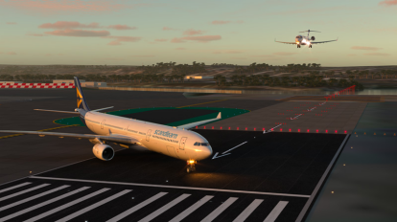
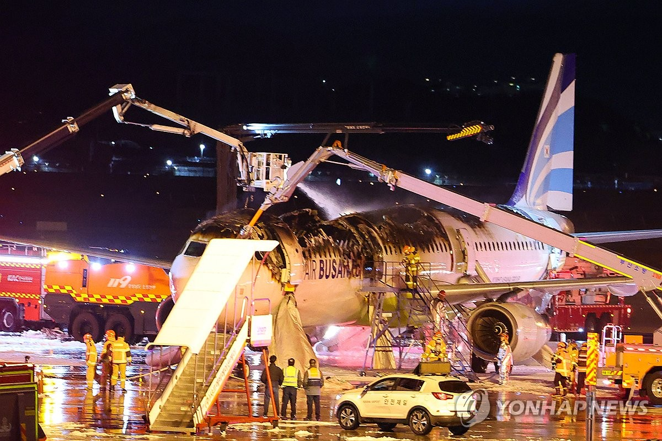
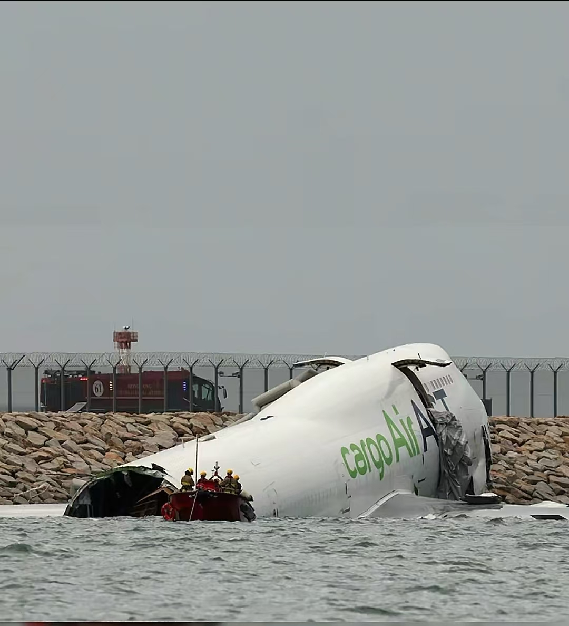
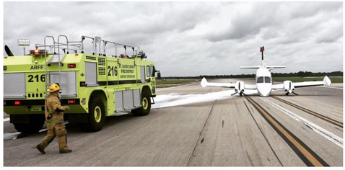
What’s the reason for this accident?
How to check landing gear?
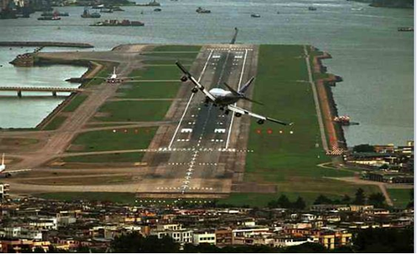
After landing, if you veer off the runway, what should yo do?

