Q1

Q2

|  |  |
| --- | --- |
| # cat | Copy the input and show it as output. |
| 1 more | Viewing the file |
| 2 cp | Copy the file and directory |
| 3 mv | Move or rename the file and directory |
| 4 rm | Remove the file and directory |
| 5 ls | Show the directory and file under current directory |
| 6 mkdir | Make directory if it does not exist |
| 7 cd | Change to target directory |
| 8 pwd | Show current directory |
| 9 rmdir | Remove the directory if it is empty |
| 10 whoami | Show the user id. |

Q3

Q4

Q5

1. $cal 4 $cal 52 $cal 1752 $cal 1952 $cal 2004 $cal 2005
2. Yes, the command works fine both leap and non-leap year because the February in calendar of 2004 has 29 days while the February in calendar of 2005 has only 28 days.
3. The calendar of 1752 has 355. The British changed the original Julian calendar to the Gregorian calendar. As a result, the September 3 was skipped to September 13 and 11 days were missing in 1752.

Q6

1. What is the name of your operating system?

Linux

1. What is the domain name of your computer system?

cis-lclient02

1. What CPU is in your computer system?

X86_64

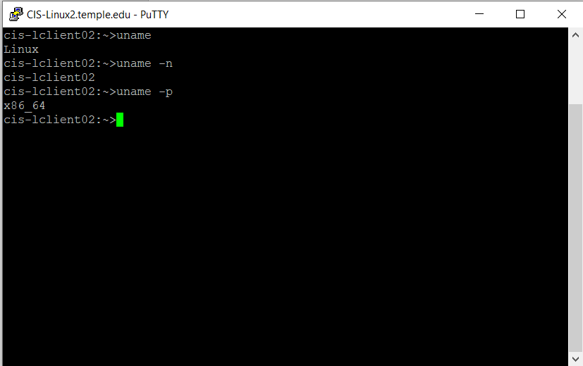

Q7

1. How many users are currently using your UNIX system?

Only one user which is me.

Q8

