**计算机图形学实验**

**姓 名：谢俊杰**

**学 号：20201060337**

**专 业：计算机科学与技术**

**教 师：钱文华**

实验一 示例程序生成直线段实验

时间：2022年3月16日

地点：信息学院2202

1. 实验内容：
2. 安装OpenGL
3. 通过示例程序生成直线段
4. 实验目的：

通过实验掌握下列知识:

（1）OpenGL glut的安装；

（2）OpenGL编程初步；

（3）熟悉OpenGL glut下的编程框架；

（4）使用OpenGL绘制点线等图元。

1. 实验代码：

#include <windows.h>

#include <gl/glut.h>

#include <math.h>

#define GL_PI 3.1415f

void init(void)

{

glClearColor(1.0, 1.0, 1.0, 1.0);

glMatrixMode(GL_PROJECTION);

gluOrtho2D(0.0, 200.0, 0.0, 150.0);

}

void lineSegment(void)

{

glClear(GL_COLOR_BUFFER_BIT);

glColor3f(0.0, 0.4, 0.2);

glBegin(GL_LINES);

glVertex2i(180, 15);

glVertex2i(10, 145);

glEnd();

glFlush();

}

int main(int argc, char** argv)

{

glutInit(&argc, argv);

glutInitDisplayMode(GLUT_SINGLE | GLUT_RGB);

glutInitWindowPosition(50, 100);

glutInitWindowSize(400, 300);

glutCreateWindow("An Example OpenGL Program");

init();

glutDisplayFunc(lineSegment);

glutMainLoop();

return 0;

}

4、实验结果：

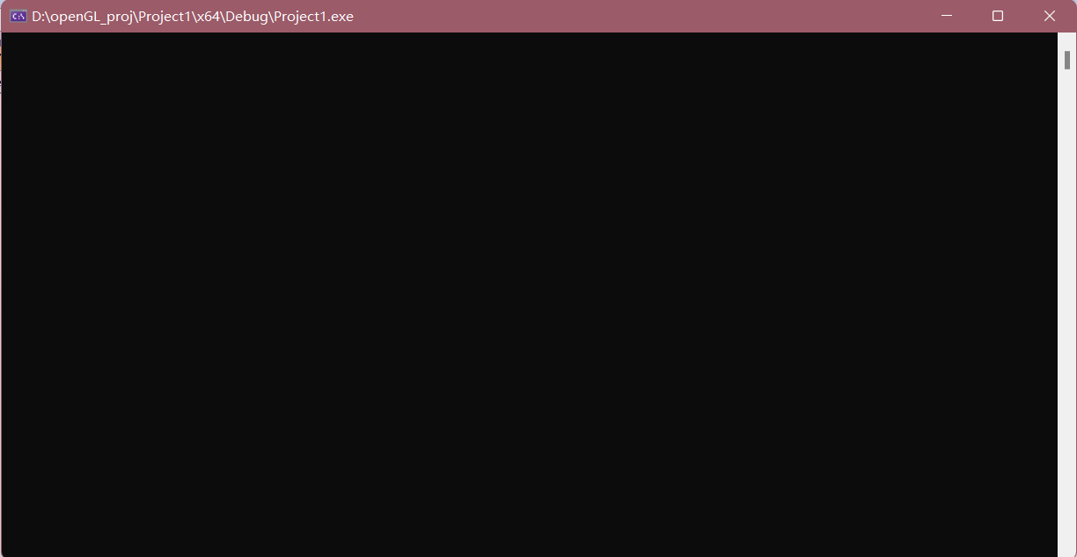

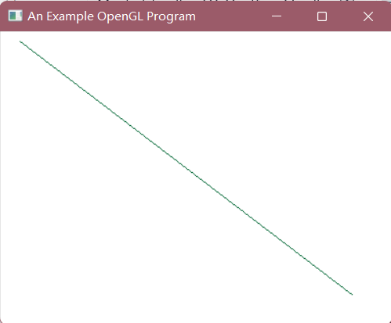

实验二 DDA直线生成算法

时间：2022年3月23日

地点：信息学院2202

1、实验内容：

熟悉OPENGL，通过DDA、中点算法生成直线段

2、实验目的：

装OPENGL，能编写代码运行，参考课本代码

3、实验代码：

#include <gl/glut.h>

#include <stdio.h>

#include <stdlib.h>

int size;

int color;

void lineDDA(int x0, int y0, int x1, int y1) {

int x, dx, dy, y;

float m;

dx = x1 - x0;

dy = y1 - y0;

m = dy / dx;

y = y0;

switch (color){

case 0:

glColor3f(1, 0, 0);

break;

case 1:

glColor3f(0, 1, 0);

break;

case 2:

glColor3f(0, 0, 1);

break;

case 3:

glColor3f(1, 1, 0);

break;

case 4:

glColor3f(0, 1, 1);

break;

case 5:

glColor3f(1, 0, 1);

break;

case 6:

glColor3f(1, 1, 1);

break;

default:

printf("无效的输入！\n");

}

glPointSize(size);

for (x = x0; x <= x1; x++) {

glBegin(GL_POINTS);

glVertex2i(x, (int)(y + 0.5));

glEnd();

y = y + m;

}

}

void myDisplay(void) {

glClear(GL_COLOR_BUFFER_BIT);

lineDDA(10, 10, 200, 300);

glBegin(GL_LINES);

glColor3f(1.0, 0.0f, 0.0f);

glVertex2f(100.0, 0.0);

glEnd();

glFlush();

}

void Init() {

glClearColor(0.0, 0.0, 0.0, 0.0);

glShadeModel(GL_FLAT);

}

void Reshape(int w, int h) {

glViewport(0, 0, (GLsizei)w, (GLsizei)h);

glMatrixMode(GL_PROJECTION);

glLoadIdentity();

gluOrtho2D(0.0, (GLdouble)w, 0.0, (GLdouble)h);

}

int main(int argc, char** argv) {

printf("请输入画线颜色：\n");

printf("0_红；1_绿；2_蓝；3_黄；4_青；5_玫瑰；6_白\n");

scanf_s("%d", &color);

printf("请输入画线宽度：\n");

scanf_s("%d", &size);

glutInit(&argc, argv);

glutInitDisplayMode(GLUT_RGB | GLUT_SINGLE);

glutInitWindowPosition(100,100);

glutInitWindowSize(400, 400);

glutCreateWindow("DDALine");

Init();

glutDisplayFunc(myDisplay);

glutReshapeFunc(Reshape);

glutMainLoop();

return 0;

}

1. 实验结果：

程序执行后，所显示的界面如下图所示：

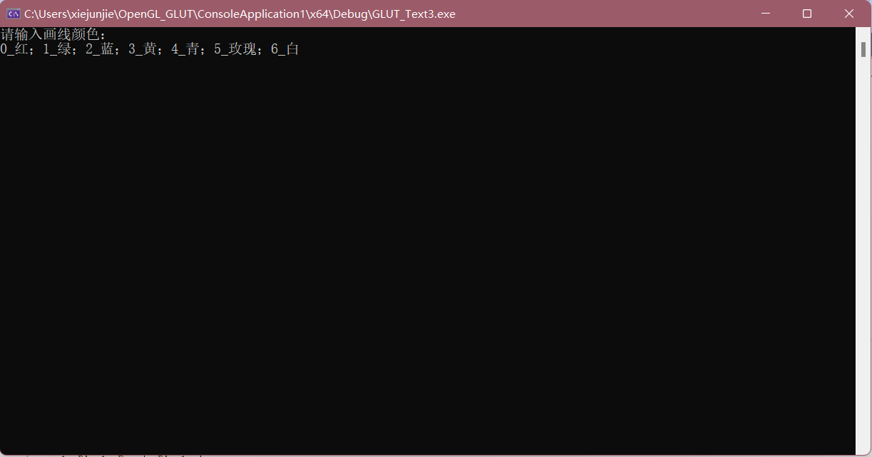

如下图所示，依次输入各个颜色所指示的编号，所画直线宽度为5：

红色：

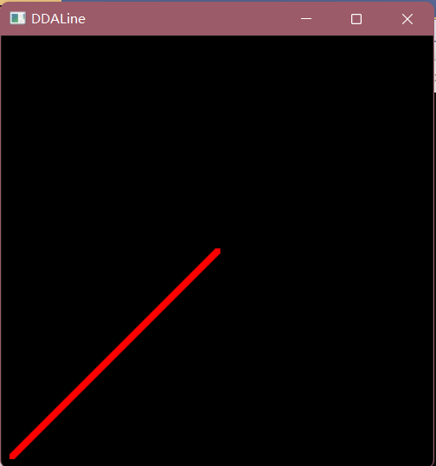

绿色：

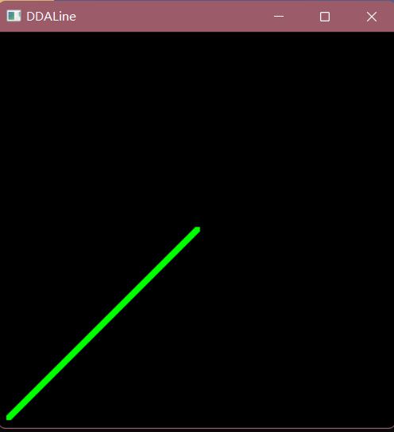

蓝色：

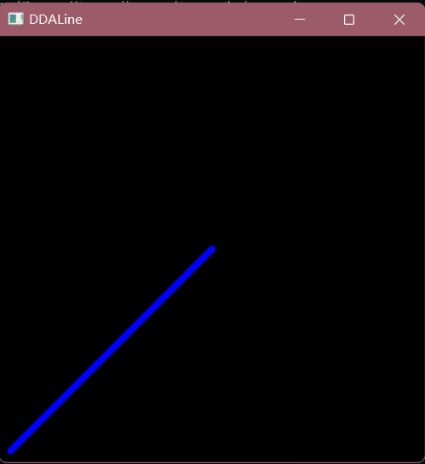

实验三 Bresenham算法、改进Bresenham算法生成直线段

实验时间：

实验地点：

1. 实验内容：

熟悉OPENGL，通过Bresenham中点、改进Bresenham算法生成直线段

1. 实验目的：

安装OPENGL，能编写代码运行，参考课本代码。

1. 实验代码：

#include<gl/glut.h>

#include<algorithm>

using namespace std;

float window_size = 800;

int numbers = 20;

int xs = -115, ys = -119, xe = 35, ye = 59;

void InitEnvironment() //对环境进行初始化操作

{

glClearColor(0.0, 0.0, 0.0, 0);

glClear(GL_COLOR_BUFFER_BIT);

glMatrixMode(GL_MODELVIEW);

glLoadIdentity();

gluOrtho2D(-numbers, numbers, -numbers, numbers);

}

void draw_point(float x, float y) {

glColor3f(0.5, 0.5, 0.5);

glRectf(x, y, x + 1, y + 1);

}

void draw_point2(float x, float y) {

draw_point(x, y);

glPointSize(8);

glColor3f(0.0, 0.0, 1.0);

glBegin(GL_POINTS);

glVertex3f(x, y, 0.0);

glEnd();

glFlush();

}

void Bresenhamline(int x0, int y0, int x1, int y1) {

//支持各种斜率，支持两点颠倒

int x, y, dx, dy;

float k, e;

dx = x1 - x0, dy = y1 - y0;

if (dy == 0) {//平行坐标轴

x = min(x0, x1);

for (int i = 0; i <= abs(dx); i++) {

draw_point(x, y0);

x++;

}

return;

}

if (dx == 0) {//斜率不存在

y = min(y0, y1);

for (int i = 0; i <= abs(dy); i++) {

draw_point(x0, y);

y++;

}

return;

}

k = float(dy) / float(dx);

x = x0, y = y0;

if (k >= 0) {

e = -0.5;

x = min(x0, x1);

y = min(y0, y1);

}

else {

e = 0.5;

x = min(x0, x1);

y = max(y0, y1);

}

if (0 <= k && k <= 1) {

for (int i = 0; i <= abs(dx); i++) {

draw_point(x, y);

x++, e += k;

if (e >= 0) { y++; e--; }

}

}

else if (k > 1) {

k = float(dx) / float(dy);

for (int i = 0; i <= abs(dy); i++) {

draw_point(x, y);

y++, e += k;

if (e >= 0) { x++; e--; }

}

}

else if (-1 <= k && k < 0) {

for (int i = 0; i <= abs(dx); i++) {

draw_point(x, y);

x++, e += k;

if (e <= 0) { y--; e++; }

}

}

else if (k < -1) {

k = float(dx) / float(dy);

for (int i = 0; i <= abs(dy); i++) {

draw_point(x, y);

y--, e += k;

if (e <= 0) { x++; e++; }

}

}

}

void myDisplay(void) {

//绘制坐标系

glColor3f(1.0, 1.0, 0);

for (int i = 1; i < numbers * 2; i++) {

glBegin(GL_LINES);

glVertex2f(-numbers + i, -numbers);

glVertex2f(-numbers + i, numbers);

glVertex2f(-numbers, -numbers + i);

glVertex2f(numbers, -numbers + i);

glEnd();

}

glColor3f(1.0, 0, 0);

glBegin(GL_LINES);

glVertex2f(-numbers, 0);

glVertex2f(numbers, 0);

glVertex2f(0, -numbers);

glVertex2f(0, numbers);

glEnd();

Bresenhamline(xs, ys, xe, ye);

//绘制初始直线

glBegin(GL_LINES);

glColor3f(1.0, 0.0, 0.0);

glVertex2f(xs, ys); glVertex2f(xe, ye);

glEnd();

glFlush();

}

int main(int argc, char* argv[])

{

glutInit(&argc, argv); //初始化

glutInitDisplayMode(GLUT_RGB | GLUT_SINGLE);

glutInitWindowPosition(100, 100);

glutInitWindowSize(window_size, window_size);

glutCreateWindow("Bresen算法画直线");

InitEnvironment(); //初始化

glutDisplayFunc(&myDisplay); //回调函数

glutMainLoop(); //持续显示，当窗口改变会重新绘制图形

return 0;

}

1. 实验结果：

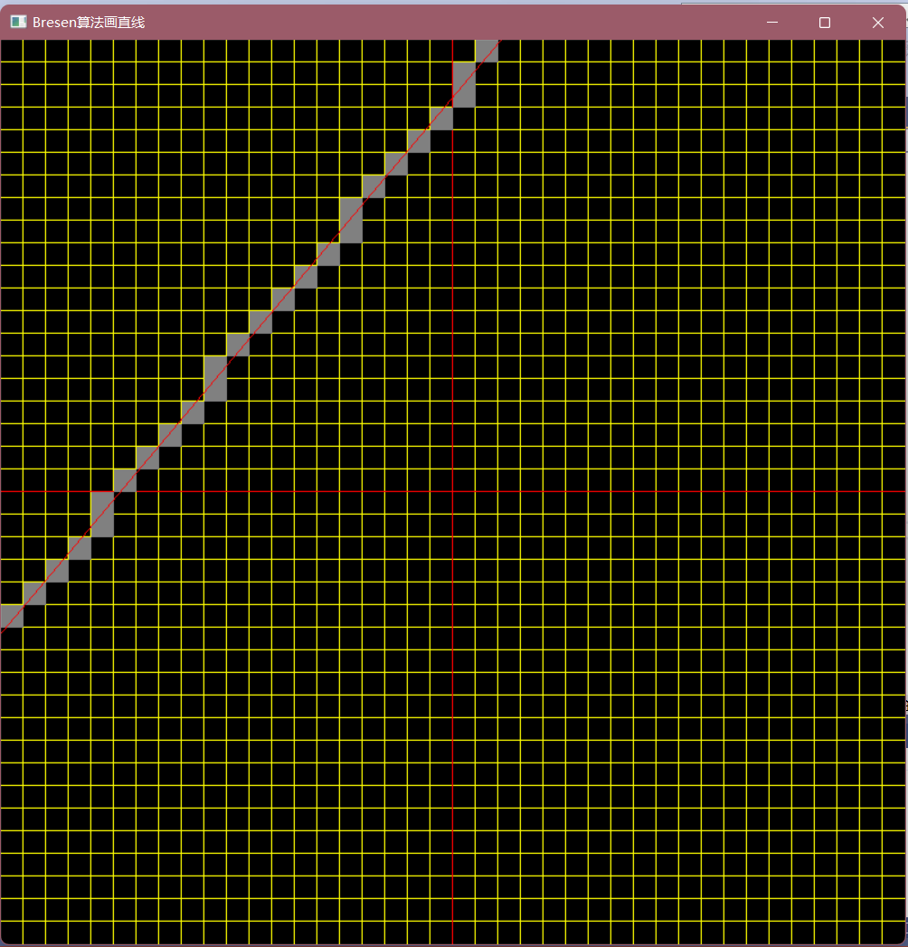

实验四 填充算法实验

1. 实验内容：（1）教材P66，填充六边形

（2）使用opengl，用扫描线填充算法填充多边形

1. 实验目的：验证扫描线填充算法，指定任意的多边形边数填充多边形
2. 实验代码：

（1）填充六边形

#include <gl/glut.h>

#include <math.h>

#include <stdlib.h>

const double TWO_PI = 6.2831853;

GLsizei winWidth = 400, winHeight = 400;

GLuint regHex;

class screenPt {

private:

GLint x, y;

public:

screenPt() {

x = y = 0;

}

void setCoords(GLint xCoord, GLint yCoord) {

x = xCoord;

y = yCoord;

}

GLint getx() const {

return x;

}

GLint gety() const {

return y;

}

};

static void init(void) {

screenPt hexVertex, circCtr;

GLdouble theta;

GLint k;

circCtr.setCoords(winWidth / 2, winHeight / 2);

glClearColor(1.0, 1.0, 1.0, 0.0);

regHex = glGenLists(1);

glNewList(regHex, GL_COMPILE);

glColor3f(1.0, 0.0, 0.0);

glBegin(GL_POLYGON);

for (k = 0; k < 6; k++) {

theta = TWO_PI * k / 6.0;

hexVertex.setCoords(circCtr.getx() + 150 * cos(theta), circCtr.gety() + 150 * sin(theta));

glVertex2i(hexVertex.getx(), hexVertex.gety());

}

glEnd();

glEndList();

}

void regHexgon(void) {

glClear(GL_COLOR_BUFFER_BIT);

glCallList(regHex);

glFlush();

}

void winReshapeFcn(int newWidth, int newHeight) {

glMatrixMode(GL_PROJECTION);

glLoadIdentity();

gluOrtho2D(0.0, (GLdouble)newWidth, 0.0, (GLdouble)newHeight);

glClear(GL_COLOR_BUFFER_BIT);

}

void main(int argc, char** argv) {

glutInit(&argc, argv);

glutInitDisplayMode(GLUT_SINGLE | GLUT_RGB);

glutInitWindowPosition(100, 100);

glutInitWindowSize(winWidth, winHeight);

glutCreateWindow("Reshape_Function & Display_List Example");

init();

glutDisplayFunc(regHexgon);

glutReshapeFunc(winReshapeFcn);

glutMainLoop();

}

(2)填充多边形

#include <gl/glut.h>

#include <windows.h>

const int POINTNUM = 7; //多边形点数.

/******定义结构体用于活性边表AET和新边表NET***********************************/

typedef struct XET

{

float x;

float dx, ymax;

XET* next;

}AET, NET;

/******定义点结构体point******************************************************/

struct point

{

float x;

float y;

}

polypoint[POINTNUM] = { 250,50,550,150,550,400,250,250,100,350,100,100,120,30 };//多边形顶点

void PolyScan()

{

/******计算最高点的y坐标(扫描到此结束)****************************************/

int MaxY = 0;

int i;

for (i = 0; i < POINTNUM; i++)

if (polypoint[i].y > MaxY)

MaxY = polypoint[i].y;

/*******初始化AET表***********************************************************/

AET* pAET = new AET;

pAET->next = NULL;

/******初始化NET表************************************************************/

NET* pNET[1024];

for (i = 0; i <= MaxY; i++)

{

pNET[i] = new NET;

pNET[i]->next = NULL;

}

glClear(GL_COLOR_BUFFER_BIT); //赋值的窗口显示.

glColor3f(1.0, 0.0, 0.0); //设置直线的颜色红色

glBegin(GL_POINTS);

/******扫描并建立NET表*********************************************************/

for (i = 0; i <= MaxY; i++)

{

for (int j = 0; j < POINTNUM; j++)

if (polypoint[j].y == i)

{ //一个点跟前面的一个点形成一条线段，跟后面的点也形成线段

if (polypoint[(j - 1 + POINTNUM) % POINTNUM].y > polypoint[j].y)

{

NET* p = new NET;

p->x = polypoint[j].x;

p->ymax = polypoint[(j - 1 + POINTNUM) % POINTNUM].y;

p->dx = (polypoint[(j - 1 + POINTNUM) % POINTNUM].x - polypoint[j].x) / (polypoint[(j - 1 + POINTNUM) % POINTNUM].y - polypoint[j].y);

p->next = pNET[i]->next;

pNET[i]->next = p;

}

if (polypoint[(j + 1 + POINTNUM) % POINTNUM].y > polypoint[j].y)

{

NET* p = new NET;

p->x = polypoint[j].x;

p->ymax = polypoint[(j + 1 + POINTNUM) % POINTNUM].y;

p->dx = (polypoint[(j + 1 + POINTNUM) % POINTNUM].x - polypoint[j].x) / (polypoint[(j + 1 + POINTNUM) % POINTNUM].y - polypoint[j].y);

p->next = pNET[i]->next;

pNET[i]->next = p;

}

}

}

/******建立并更新活性边表AET*****************************************************/

for (i = 0; i <= MaxY; i++)

{

//计算新的交点x,更新AET

NET* p = pAET->next;

while (p)

{

p->x = p->x + p->dx;

p = p->next;

}

//断表排序,不再开辟空间

AET* tq = pAET;

p = pAET->next;

tq->next = NULL;

while (p)

{

while (tq->next && p->x >= tq->next->x)

tq = tq->next;

NET* s = p->next;

p->next = tq->next;

tq->next = p;

p = s;

tq = pAET;

}

//(改进算法)先从AET表中删除ymax==i的结点****************************************/

AET* q = pAET;

p = q->next;

while (p)

{

if (p->ymax == i)

{

q->next = p->next;

delete p;

p = q->next;

}

else

{

q = q->next;

p = q->next;

}

}

//将NET中的新点加入AET,并用插入法按X值递增排序**********************************/

p = pNET[i]->next;

q = pAET;

while (p)

{

while (q->next && p->x >= q->next->x)

q = q->next;

NET* s = p->next;

p->next = q->next;

q->next = p;

p = s;

q = pAET;

}

/******配对填充颜色***************************************************************/

p = pAET->next;

while (p && p->next)

{

for (float j = p->x; j <= p->next->x; j++)

glVertex2i(static_cast<int>(j), i);

p = p->next->next;//考虑端点情况

}

}

glEnd();

glFlush();

}

void init(void)

{

glClearColor(1.0, 1.0, 1.0, 0.0);

//窗口的背景颜色设置为白色

glMatrixMode(GL_PROJECTION);

gluOrtho2D(0.0, 600.0, 0.0, 450.0);

}

void main(int argc, char* argv)

{

glutInit(&argc, &argv); //I初始化 GLUT.

glutInitDisplayMode(GLUT_SINGLE | GLUT_RGB); //设置显示模式：单个缓存和使用RGB模型

glutInitWindowPosition(50, 100); //设置窗口的顶部和左边位置

glutInitWindowSize(400, 300); //设置窗口的高度和宽度

glutCreateWindow("An Example OpenGL Program"); //创建显示窗口

init(); //调用初始化过程

glutDisplayFunc(PolyScan); //图形的定义传递给我window.

glutMainLoop(); //显示所有的图形并等待

}

1. 实验结果：

（1）填充六边形实验代码运行结果

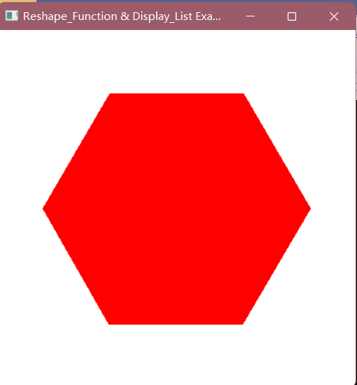

（2）填充多边形实验代码运行结果

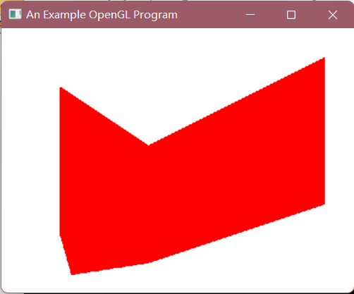

实验五 圆扫描转换和种子点填充实验

1. 实验内容：
2. 圆的扫描转换
3. 种子点填充
4. 实验目的：
5. 输入圆的半径，画出圆
6. 输入多边形，种子点位置，填充多边形
7. 实验代码：
8. 圆的扫描转换

#include <GL/glut.h>

void circle(int x, int y, int x0, int y0) {

glVertex2f(x0 + x, y0 + y);

glVertex2f(x0 + y, y0 + x);

glVertex2f(x0 + y, y0 - x);

glVertex2f(x0 + x, y0 - y);

glVertex2f(x0 - x, y0 - y);

glVertex2f(x0 - y, y0 - x);

glVertex2f(x0 - y, y0 + x);

glVertex2f(x0 - x, y0 + y);

}

void Breseham(int x0, int y0, double r) {

int x = 0;

int y = (int)r;

int d = int(3 - 2 * r);

glColor3f(0.0, 1.0, 0.0);

glBegin(GL_POINTS);

while (y >= x) {

circle(x, y, x0, y0);

if (d < 0)

d += 4 * x + 6;

else {

d += 4 * (x - y) + 10;

y--;

}

x++;

}

glEnd();

}

void display(void)

{

glClearColor(0.0, 0.0, 0.0, 0.0);

glClear(GL_COLOR_BUFFER_BIT);

Breseham(500, 500, 200.0);

glFlush();

}

int main(int argc, char* argv[])

{

glutInit(&argc, argv);

glutInitDisplayMode(GLUT_RGB | GLUT_SINGLE);

glutInitWindowSize(800, 800);

glutCreateWindow("Text5.1");

gluOrtho2D(0, 1000, 0, 1000);

glutDisplayFunc(display);

glutMainLoop();

return 0;

}

1. 种子点填充算法

#include <iostream>

#include<GL/glut.h>

#include <windows.h>

using namespace std;

int n;

struct vertex {

float ver_x;

float ver_y;

};

typedef struct XET {

float x;

float dx, ymax;

XET* next;

}AET, NET;

struct point {

float x;

float y;

};

vertex* ver;

int c = 0;

void input(GLint button, GLint state, GLint x, GLint y) {

if (button == GLUT_LEFT_BUTTON && state == GLUT_DOWN) {

ver[c].ver_x = x;

ver[c].ver_y = y;

cout << "第" << c + 1 << "个点为：" << x << " " << y << endl;

c++;

}

}

void keyFromBoard() {

for (int i = 0; i < n; i++) {

int x, y;

cin >> x >> y;

ver[i].ver_x = x;

ver[i].ver_y = y;

}

}

void fillwith() {

int MaxY = 0;

int i;

for (i = 0; i < n; i++) {

if (ver[i].ver_y >= MaxY) {

MaxY = ver[i].ver_y;

}

}

AET* pAET = new AET;

pAET->next = NULL;

NET* pNET[1024];

for (i = 0; i <= MaxY; i++) {

pNET[i] = new NET;

pNET[i]->next = NULL;

}

glClear(GL_COLOR_BUFFER_BIT);

glColor3f(0.9, 0.5, 0.6);

glBegin(GL_POINTS);

for (i = 0; i < MaxY; i++) {

for (int j = 0; j < n; j++) {

if (ver[j].ver_y == i) {

if (ver[(j + 1 + n) % n].ver_y > ver[j].ver_y) {

NET* p = new NET;

p->x = ver[j].ver_x;

p->ymax = ver[(j + 1 + n) % n].ver_y;

p->dx = (ver[(j + 1 + n) % n].ver_x - ver[j].ver_x) / (ver[(j + 1 + n) % n].ver_y - ver[j].ver_y);

p->next = pNET[i]->next;

pNET[i]->next = p;

}

if (ver[(j - 1 + n) % n].ver_y > ver[j].ver_y) {

NET* p = new NET;

p->x = ver[j].ver_x;

p->ymax = ver[(j - 1 + n) % n].ver_y;

p->dx = (ver[(j - 1 + n) % n].ver_x - ver[j].ver_x) / (ver[(j - 1 + n) % n].ver_y - ver[j].ver_y);

p->next = pNET[i]->next;

pNET[i]->next = p;

}

}

}

}

glClear(GL_COLOR_BUFFER_BIT);

glColor3f(0.0, 0.0, 0.0);

glBegin(GL_POINTS);

for (i = 0; i <= MaxY; i++) {

AET* p = new AET;

p = pAET->next;

AET* n = new AET;

//将新边表中的活性边按照从左到右的顺序排序

if (pNET[i]->next && pNET[i]->next->next) {

if (pNET[i]->next->dx > 0) {

NET* t = new NET;

t = pNET[i]->next;

n = pNET[i]->next->next;

t->next = NULL;

n->next = NULL;

pNET[i]->next = n;

n->next = t;

}

}

//更新活性边表中的活性边x坐标的值

while (p) {

p->x = p->x + p->dx;

p = p->next;

}

p = pAET->next;

n = pAET;

//删掉扫描线高度等同于ymax的废弃点

while (p) {

if (p->ymax == i) {

n->next = p->next;

free(p);

p = n->next;

}

else {

p = p->next;

n = n->next;

}

}

//插入新点，按照顺序插入

p = pAET->next;

n = pAET;

NET* a = new NET;

a = pNET[i]->next;

if (a) {

NET* b = new NET;

b = a;

while (b->next) {

b = b->next;

}

if (!pAET->next) {

pAET->next = a;

}

else {

while (p) {

if (a->x < p->x) {

b->next = p;

n->next = a;

break;

}

if (!p->next) {

p->next = a;

break;

}

n = n->next;

p = p->next;

}

}

}

//填充2

p = pAET->next;

while (p && p->next) {

for (float j = p->x; j <= p->next->x; j++) {

glVertex2i(static_cast<int>(j), i);

}

p = p->next->next;

}

}

glEnd();

glFlush();

}

int init(void) {

glClearColor(0.0, 1.0, 1.0, 0.0);//画完图形后的背景颜色

glMatrixMode(GL_PROJECTION);

//gluOrtho2D(x1, x2, y1, y2)窗口会显示在二维坐标内x1<x<x2,y1<y<y2这个区域的点

gluOrtho2D(0.0, 600.0, 0.0, 450.0);//窗口的显示的值的范围

cout << "输入要显示的多边形共有几个顶点" << endl;

cin >> n;

cout << "键盘输入为1，鼠标输入为2，你的选择是：" << endl;

int x;

cin >> x;

return x;

}

int main(int argc, char* argv) {

glutInit(&argc, &argv);//初始化 GLUT 库

glutInitDisplayMode(GLUT_SINGLE | GLUT_RGB);//指定一个颜色为RGE显示的窗口或者单缓冲区窗口

glutInitWindowPosition(50, 100);//设置窗口位置，50: 距离屏幕左边的像素数。100：距离屏幕上边的像素数

glutInitWindowSize(400, 300); //设置窗口大小

glutCreateWindow("种子点填充算法");//设置窗口的标题

int x = init();

ver = (vertex*)malloc(sizeof(vertex) * n);//输入顶点以（x,y）格式

if (x == 1) {

keyFromBoard();

}

else if (x == 2) {

//鼠标左点击

for (int i = 0; i < n; i++) {

glutMouseFunc(input);//鼠标点击时会调用该方法

}

}

glutDisplayFunc(fillwith);

glutMainLoop();

}

实验六 二维几何变换实验

1. 实验内容

教材P161，二维几何变换算法（平移、比例、旋转、对称）

1. 实验目的

验证二维几何变换，熟悉变换矩阵

1. 实验代码

#include <GL/glut.h>

#include <stdlib.h>

#include <math.h>

GLsizei winWidth = 600, winHeight = 600;

GLfloat xwcMin = 0.0, xwcMax = 225.0;

GLfloat ywcMin = 0.0, ywcMax = 225.0;

class wcPt2D {

public:

GLfloat x, y;

};

typedef GLfloat Matrix3x3[3][3];

Matrix3x3 matComposite;

const GLdouble pi = 3.14159;

void init(void) {

glClearColor(1.0, 1.0, 1.0, 1.0);

}

void matrix3x3SetIdentity(Matrix3x3 matIdent3x3) {

GLint row, col;

for (row = 0; row < 3; row++)

for (col = 0; col < 3; col++)

matIdent3x3[row][col] = (row == col);

}

void matrix3x3PreMultply(Matrix3x3 m1, Matrix3x3 m2) {

GLint row, col;

Matrix3x3 matTemp;

for (row = 0; row < 3; row++)

for (col = 0; col < 3; col++)

matTemp[row][col] = m1[row][0] * m2[0][col] + m1[row][1] * m2[1][col] + m1[row][2] * m2[2][col];

for (row = 0; row < 3; row++)

for (col = 0; col < 3; col++)

m2[row][col] = matTemp[row][col];

}

void translate2D(GLfloat tx, GLfloat ty) {

Matrix3x3 matTransl;

matrix3x3SetIdentity(matTransl);

matTransl[0][2] = tx;

matTransl[1][2] = ty;

matrix3x3PreMultply(matTransl, matComposite);

}

void rotate2D(wcPt2D pivotPt, GLfloat theta) {

Matrix3x3 matRot;

matrix3x3SetIdentity(matRot);

matRot[0][0] = cos(theta);

matRot[0][1] = -sin(theta);

matRot[0][2] = pivotPt.x * (1 - cos(theta)) + pivotPt.y * sin(theta);

matRot[1][0] = sin(theta);

matRot[1][1] = cos(theta);

matRot[1][2] = pivotPt.y * (1 - cos(theta)) - pivotPt.x * sin(theta);

matrix3x3PreMultply(matRot, matComposite);

}

void scale2D(GLfloat sx, GLfloat sy, wcPt2D fixedPt) {

Matrix3x3 matScale;

matrix3x3SetIdentity(matScale);

matScale[0][0] = sx;

matScale[0][2] = (1 - sx) * fixedPt.x;

matScale[1][1] = sy;

matScale[1][2] = (1 - sy) * fixedPt.y;

matrix3x3PreMultply(matScale, matComposite);

}

void transformVerts2D(GLint nVerts, wcPt2D* verts) {

GLint k;

GLfloat temp;

for (k = 0; k < nVerts; k++) {

temp = matComposite[0][0] * verts[k].x + matComposite[0][1] * verts[k].y + matComposite[0][2];

verts[k].y = matComposite[1][0] * verts[k].x + matComposite[1][1] * verts[k].y + matComposite[1][2];

verts[k].x = temp;

}

}

void triangle(wcPt2D* verts) {

GLint k;

glBegin(GL_TRIANGLES);

for (k = 0; k < 3; k++)

glVertex2f(verts[k].x, verts[k].y);

glEnd();

}

void displayFcn(void) {

GLint nVerts = 3;

wcPt2D verts[3] = { {50.0,25.0},{150.0,25.0},{100.0,100.0} };

wcPt2D centroidPt;

GLint k, xSum = 0, ySum = 0;

for (k = 0; k < nVerts; k++) {

xSum += verts[k].x;

ySum += verts[k].y;

}

centroidPt.x = GLfloat(xSum) / GLfloat(nVerts);

centroidPt.y = GLfloat(ySum) / GLfloat(nVerts);

wcPt2D pivPt, fixedPt;

pivPt = centroidPt;

fixedPt = centroidPt;

GLfloat tx = 0.0, ty = 100.0;

GLfloat sx = 0.5, sy = 0.5;

GLdouble theta = pi / 2.0;

glClear(GL_COLOR_BUFFER_BIT);

glColor3f(0.0, 0.0, 1.0);

triangle(verts);

matrix3x3SetIdentity(matComposite);

scale2D(sx, sy, fixedPt);

rotate2D(pivPt, theta);

translate2D(tx, ty);

transformVerts2D(nVerts, verts);

glColor3f(1.0, 0.0, 0.0);

triangle(verts);

glFlush();

}

void winReshapeFcn(GLint newWidth, GLint newHeight) {

glMatrixMode(GL_PROJECTION);

glLoadIdentity();

gluOrtho2D(xwcMin, xwcMax, ywcMin, ywcMax);

glClear(GL_COLOR_BUFFER_BIT);

}

void main(int argc, char** argv) {

glutInit(&argc, argv);

glutInitDisplayMode(GLUT_SINGLE | GLUT_RGB);

glutInitWindowPosition(50, 50);

glutInitWindowSize(winWidth, winHeight);

glutCreateWindow("Geometic Transformation Sequence");

init();

glutDisplayFunc(displayFcn);

glutReshapeFunc(winReshapeFcn);

glutMainLoop();

}

1. 实验结果

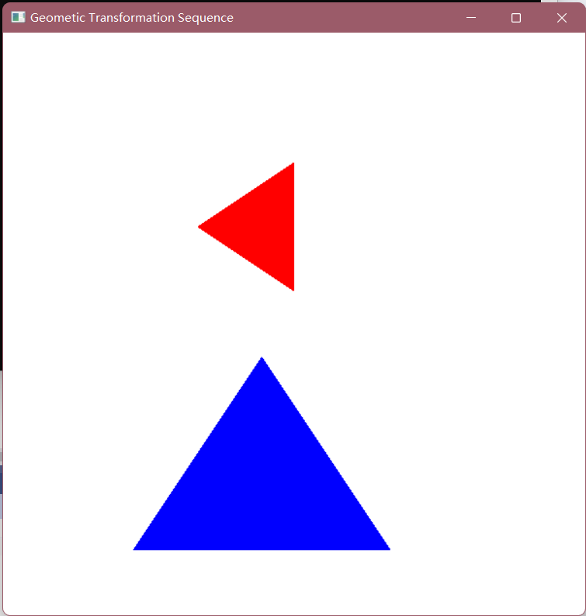

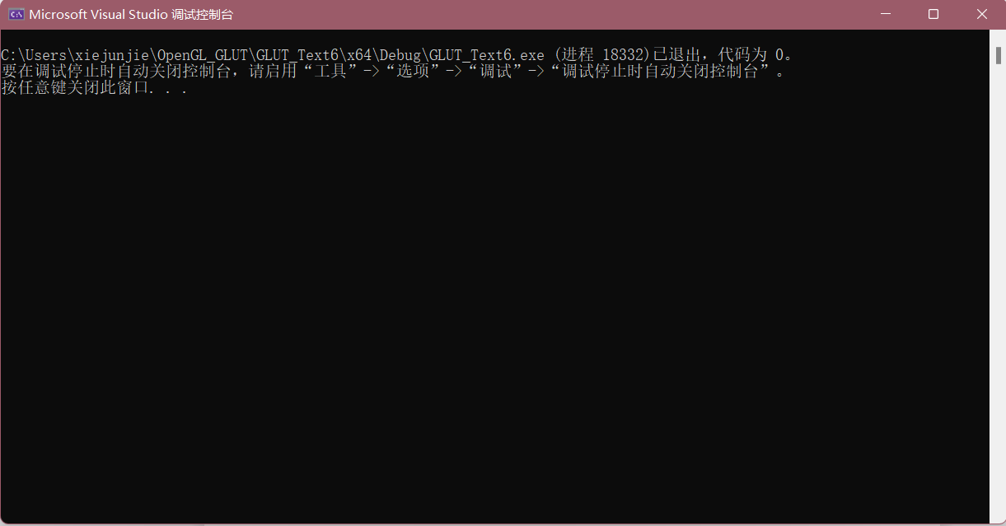

实验七 GLUT鼠标函数实验

1. 实验内容
2. 教材P458，GLUT鼠标函数；
3. 使用opengl，实现任一反走样技术。
4. 实验目的

调用鼠标函数完成相应功能，2-3个程序。

1. 实验代码

（1）

#include <gl/glut.h>

GLsizei winWidth = 400, winHeight = 300;//初始化窗口的尺寸

void init(void) {

glClearColor(0.0, 0.0, 1.0, 1.0);//将窗口颜色设置为蓝色

glMatrixMode(GL_PROJECTION);

gluOrtho2D(0.0, 200.0, 0.0, 150.0);

}

void displayFcn(void) {

glClear(GL_COLOR_BUFFER_BIT);

glColor3f(1.0, 0.0, 0.0);

glPointSize(3.0);

}

void winReshapeFcn(GLint newWidth, GLint newHeight) {

glViewport(0, 0, newWidth, newHeight);

glMatrixMode(GL_PROJECTION);

glLoadIdentity();

gluOrtho2D(0.0, GLdouble(newWidth), 0.0, GLdouble(newHeight));

winWidth = newWidth;

winHeight = newHeight;

}

void plotPoint(GLint x, GLint y) {

glBegin(GL_POINTS);

glVertex2i(x, y);

glEnd();

}

void mousePtPlot(GLint button, GLint action, GLint xMouse, GLint yMouse) {

if (button == GLUT_LEFT_BUTTON && action == GLUT_DOWN) {

plotPoint(xMouse, winHeight - yMouse);

}

glFlush();

}

void main(int argc, char** argv) {

glutInit(&argc, argv);

glutInitDisplayMode(GLUT_SINGLE | GLUT_RGB);

glutInitWindowPosition(100, 100);

glutInitWindowSize(winWidth, winHeight);

glutCreateWindow("Mouse Plot Points");

init();

glutDisplayFunc(displayFcn);

glutReshapeFunc(winReshapeFcn);

glutMouseFunc(mousePtPlot);

glutMainLoop();

}

（2）

#include <gl/glut.h>

#include <stdio.h>

#include <stdlib.h>

GLsizei winWidth = 400, winHeight = 300;

GLint ptCtr = 0;

class scrPt {

public:

GLint x, y;

};

void init(void) {

glClearColor(0.0, 0.0, 1.0, 1.0);

glMatrixMode(GL_PROJECTION);

gluOrtho2D(0.0, 200.0, 0.0, 150.0);

}

void displayFcn(void) {

glClear(GL_COLOR_BUFFER_BIT);

}

void winReshapeFcn(GLint newWidth, GLint newHeight) {

glViewport(0, 0, newWidth, newHeight);

glMatrixMode(GL_PROJECTION);

glLoadIdentity();

gluOrtho2D(0.0, GLdouble(newWidth), 0.0, GLdouble(newHeight));

winWidth = newWidth;

winHeight = newHeight;

}

void drawLineSegment(scrPt endPt1, scrPt endPt2) {

glBegin(GL_LINES);

glVertex2i(endPt1.x, endPt1.y);

glVertex2i(endPt2.x, endPt2.y);

glEnd();

}

void polyline(GLint button, GLint action, GLint xMouse, GLint yMouse) {

static scrPt endPt1, endPt2;

if (ptCtr == 0) {

if (button == GLUT_LEFT_BUTTON && action == GLUT_DOWN) {

endPt1.x = xMouse;

endPt1.y = winHeight - yMouse;

ptCtr = 1;

}

else {

if (button == GLUT_RIGHT_BUTTON) {

exit(0);

}

}

}

else {

if (button == GLUT_LEFT_BUTTON && action == GLUT_DOWN) {

endPt2.x = xMouse;

endPt2.y = winHeight - yMouse;

drawLineSegment(endPt1, endPt2);

}

else {

if (button == GLUT_RIGHT_BUTTON) {

exit(0);

}

}

}

glFlush();

}

void main(int argc, char** argv) {

glutInit(&argc, argv);

glutInitDisplayMode(GLUT_SINGLE | GLUT_RGB);

glutInitWindowPosition(100, 100);

glutInitWindowSize(winWidth, winHeight);

glutCreateWindow("Draw Interactive Polyline");

init();

glutDisplayFunc(displayFcn);

glutReshapeFunc(winReshapeFcn);

glutMouseFunc(polyline);

glutMainLoop();

}

（3）

#include <GL/glut.h>

#include <stdio.h>

static float rotAngle = 0.;

void init(void)

{

GLfloat values[2];

glGetFloatv(GL_LINE_WIDTH_GRANULARITY, values);

printf("GL_LINE_WIDTH_GRANULARITY value is %3.1f\n", values[0]);

glGetFloatv(GL_LINE_WIDTH_RANGE, values);

printf("GL_LINE_WIDTH_RANGE values are %3.1f %3.1f\n", values[0], values[1]);

glEnable(GL_LINE_SMOOTH);

glEnable(GL_BLEND);

glBlendFunc(GL_SRC_ALPHA, GL_ONE_MINUS_SRC_ALPHA);

glHint(GL_LINE_SMOOTH_HINT, GL_DONT_CARE);

glLineWidth(1.5);

glClearColor(0.0, 0.0, 0.0, 0.0);

}

void display(void)

{

glClear(GL_COLOR_BUFFER_BIT);

glColor3f(0.0, 1.0, 0.0);

glPushMatrix();

glRotatef(-rotAngle, 0.0, 0.0, 0.1);

glBegin(GL_LINES);

glVertex2f(-0.5, 0.5);

glVertex2f(0.5, -0.5);

glEnd();

glPopMatrix();

glColor3f(0.0, 0.0, 1.0);

glPushMatrix();

glRotatef(rotAngle, 0.0, 0.0, 0.1);

glBegin(GL_LINES);

glVertex2f(0.5, 0.5);

glVertex2f(-0.5, -0.5);

glEnd();

glPopMatrix();

glFlush();

}

void reshape(int w, int h)

{

glViewport(0, 0, w, h);

glMatrixMode(GL_PROJECTION);

glLoadIdentity();

if (w <= h)

gluOrtho2D(-1.0, 1.0, -1.0 * (GLfloat)h / (GLfloat)w, 1.0 * (GLfloat)h / (GLfloat)w);

else

gluOrtho2D(-1.0 * (GLfloat)w / (GLfloat)h, 1.0 * (GLfloat)w / (GLfloat)h, -1.0, 1.0);

glMatrixMode(GL_MODELVIEW);

glLoadIdentity();

}

void keyboard(unsigned char key, int x, int y)

{

switch (key)

{

case 'r': case 'R':

rotAngle += 20.;

if (rotAngle >= 360.0) rotAngle = 0.0;

glutPostRedisplay();

break;

case 27:

exit(0);

break;

default:

break;

}

}

int main(int argc, char** argv)

{

glutInit(&argc, argv);

glutInitDisplayMode(GLUT_SINGLE | GLUT_RGB);

glutInitWindowSize(400, 300);

glutCreateWindow("OpenGL反走样技术");

init();

glutReshapeFunc(reshape);

glutKeyboardFunc(keyboard);

glutDisplayFunc(display);

glutMainLoop();

return 0;

}

1. 实验结果

（1）

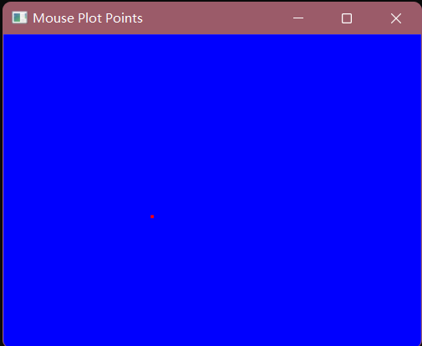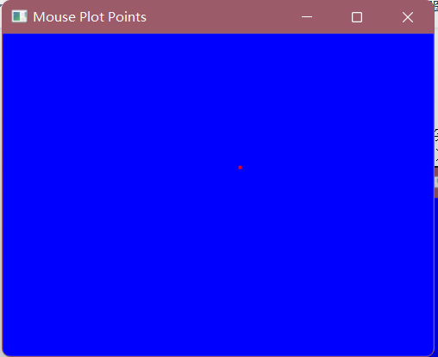

（2）

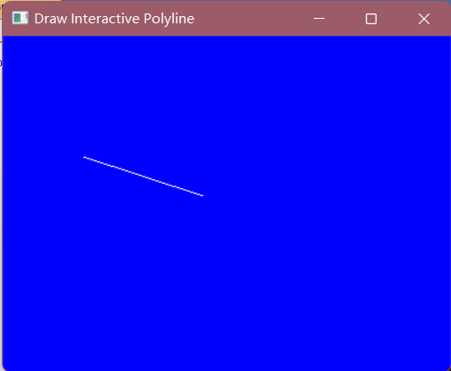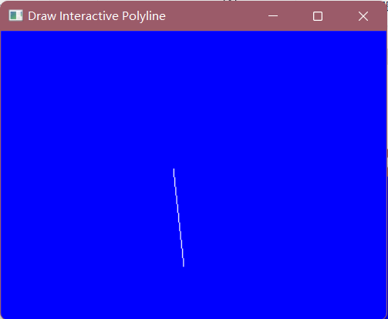

（3）

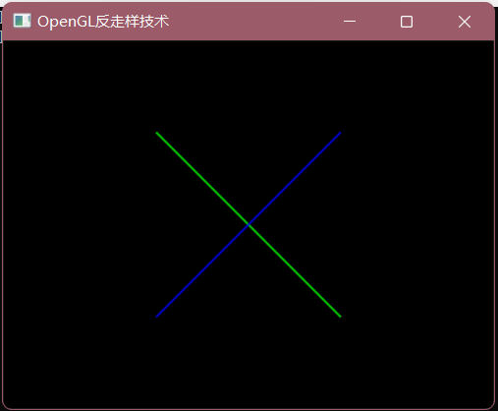

实验八 二维图像裁剪实验

1. 实验内容

（1）使用OpenGL，用Cohen-Sutherland线段裁剪算法对直线段进行裁剪

1. 实验目的

验证Cohen-Sutherland算法，从键盘输入任意的直线段，用指定的裁剪窗口裁剪直线段。

1. 实验代码

#include <gl/glut.h>

#include <math.h>

#include<stdio.h>

class wcPt2D{

public:

GLfloat x, y;

};

const GLint winLeftBitCode = 0x1;

const GLint winRightBitCode = 0x2;

const GLint winBottomBitCode = 0x4;

const GLint winTopBitCode = 0x8;

inline GLint round(const GLfloat a) {

return GLint(a + 0.5);

}

inline int inside(int code) {

return int(!code);

}

inline int reject(int code1, int code2) {

return int(code1 & code2);

}

inline int accept(int code1, int code2) {

return int(!(code1 | code2));

}

GLubyte encode(wcPt2D pt, wcPt2D winMin, wcPt2D winMax) {

GLubyte code = 0x00;

if (pt.x < winMin.x)

code = code | winLeftBitCode;

if (pt.x > winMax.x)

code = code | winRightBitCode;

if (pt.y < winMin.y)

code = code | winBottomBitCode;

if (pt.y > winMax.y)

code = code | winTopBitCode;

return (code);

}

void swapPts(wcPt2D* p1, wcPt2D* p2) {

wcPt2D tmp;

tmp = *p1;

*p1 = *p2;

*p2 = tmp;

}

void swapCodes(GLubyte* c1, GLubyte* c2) {

GLubyte tmp;

tmp = *c1;

*c1 = *c2;

*c2 = tmp;

}

void draw_pixel(int ix, int iy) {

glBegin(GL_POINTS);

glVertex2i(ix, iy);

glEnd();

}

void lineDDA(int x0, int y0, int x_end, int y_end, double a, double b, double c) {

glColor3f(a, b, c);

int dx = x_end - x0;

int dy = y_end - y0;

int steps, k;

float xIncrement, yIncrement, x = x0, y = y0;

if (abs(dx) > abs(dy))

steps = abs(dx);

else

steps = abs(dy);

xIncrement = float(dx) / float(steps);

yIncrement = float(dy) / float(steps);

draw_pixel(round(x), round(y));

for (k = 0; k < steps; k++) {

x += xIncrement;

y += yIncrement;

draw_pixel(round(x), round(y));

}

}

void lineClipCoSuth(wcPt2D winMin, wcPt2D winMax, wcPt2D p1, wcPt2D p2) {

GLubyte code1, code2;

GLint done = false, plotLine = false;

GLfloat m;

while (!done) {

code1 = encode(p1, winMin, winMax);

code2 = encode(p2, winMin, winMax);

if (accept(code1, code2)) {

done = true;

plotLine = true;

}

else {

if (reject(code1, code2))

done = true;

else {

if (inside(code1)) {

swapPts(&p1, &p2);

swapCodes(&code1, &code2);

}

if (p2.x != p1.x)

m = (p2.y - p1.y) / (p2.x - p1.x);

if (code1 & winLeftBitCode) {

p1.y += (winMax.x - p1.x) * m;

p1.x = winMax.x;

}

else {

if (code1 & winRightBitCode) {

p1.y += (winMax.x - p1.x) * m;

p1.x = winMin.x;

}

else {

if (code1 & winBottomBitCode) {

if (p2.x != p1.x)

p1.x += (winMin.y - p1.y) / m;

p1.y = winMin.y;

}

else {

if (code1 & winTopBitCode) {

if (p2.x != p1.x) {

p1.x += (winMax.y - p1.y) / m;

}

p1.y = winMax.y;

}

}

}

}

}

}

}

if (plotLine)

lineDDA(round(p1.x), round(p1.y), round(p2.x), round(p2.y), 0.0, 0.0, 1.0);

}

void display() {

glClear(GL_COLOR_BUFFER_BIT);

wcPt2D winMin, winMax, p1, p2, q1, q2, t1, t2, m1, m2;

winMin.x = 80;

winMin.y = 100;

winMax.x = 290;

winMax.y = 500;

lineDDA(80, 100, 80, 450, 1.0, 0.0, 0.0);

lineDDA(80, 100, 290, 100, 1.0, 0.0, 0.0);

lineDDA(290, 100, 290, 450, 1.0, 0.0, 0.0);

lineDDA(80, 450, 290, 450, 1.0, 0.0, 0.0);

p1.x = 0;

p1.y = 0;

p2.x = 400;

p2.y = 400;

q1.x = 0;

q1.y = 0;

q2.x = 100;

q2.y = 400;

t1.x = 100;

t1.y = 400;

t2.x = 400;

t2.y = 400;

m1.x = 300;

m1.y = 200;

m2.x = 100;

m2.y = 400;

lineClipCoSuth(winMin, winMax, p1, p2);

lineClipCoSuth(winMin, winMax, q1, q2);

lineClipCoSuth(winMin, winMax, t1, t2);

lineClipCoSuth(winMin, winMax, m1, m2);

lineDDA(300, 200, 100, 400, 0.0, 0.0, 1.0);

lineDDA(0, 0, 100, 400, 0.0, 0.0, 1.0);

lineDDA(100, 400, 400, 400, 0.0, 0.0, 1.0);

lineDDA(0, 0, 400, 400, 0.0, 0.0, 1.0);

glFlush();

}

void init() {

glClearColor(0.8, 1.0, 1.0, 1.0);

glPointSize(1.0);

glMatrixMode(GL_PROJECTION);

glLoadIdentity();

gluOrtho2D(0.0, 500.0, 0.0, 500.0);

glViewport(0, 0, 200, 500);

}

void main(int argc, char** argv) {

glutInit(&argc, argv);

glutInitDisplayMode(GLUT_SINGLE | GLUT_RGB);

glutInitWindowPosition(50, 100);

glutInitWindowSize(400, 300);

glutCreateWindow("Cosen-Sutherland裁剪算法");

init();

glutDisplayFunc(display);

glutMainLoop();

}

1. 实验结果

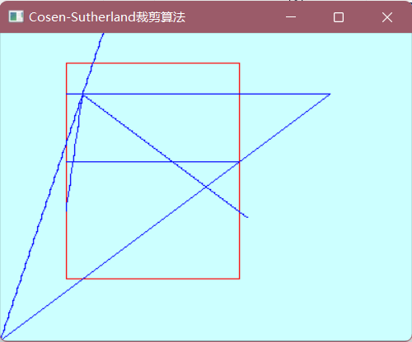

实验九 三维图形几何变换实验

1. 实验内容

教材P222，三维图形旋转、缩放变换、平移变换、错切变换、对称变换等任意变换。

1. 实验目的

调用函数完成三维图形几何变换。

1. 实验代码

#include<gl/glut.h>

#include<math.h>

GLfloat xwcMin = 0.0, xwcMax = 225.0;

GLfloat ywcMin = 0.0, ywcMax = 225.0;

class wcPt2D {

public:

GLfloat x, y, z;

};

typedef float Matrix4x4[4][4];

Matrix4x4 matRot;

void matrix4x4SetIdentity(Matrix4x4 matIdent4x4) {

GLint row, col;

for (row = 0; row < 4; row++) {

for (col = 0; row < 4; col++) {

matIdent4x4[row][col] = (row == col);

}

}

}

void matrix4x4PreMultiply(Matrix4x4 m1, Matrix4x4 m2) {

GLint row, col;

Matrix4x4 matTemp;

for (row = 0; row < 4; row++) {

for (col = 0; col < 4; col++) {

matTemp[row][col] = m1[row][0] * m2[0][col] + m1[row][1] * m2[1][col] + m1[row][2] * m2[2][col] + m1[row][3] * m2[3][col];

}

}

for (row = 0; row < 4; row++) {

for (col = 0; col < 4; col++) {

m2[row][col] = matTemp[row][col];

}

}

}

void translate3D(GLfloat tx, GLfloat ty, GLfloat tz) {

Matrix4x4 matTransl3D;

matrix4x4SetIdentity(matTransl3D);

matTransl3D[0][3] = tx;

matTransl3D[1][3] = ty;

matTransl3D[2][3] = tz;

matrix4x4PreMultiply(matTransl3D, matRot);

}

void rotate3D(wcPt2D p1, wcPt2D p2, GLfloat radianAngle) {

Matrix4x4 matQuaternionRot;

GLfloat axisVectLength = sqrt((p2.x - p1.x) * (p2.x - p1.x) + (p2.y - p1.y) * (p2.y - p1.y) + (p2.z - p1.z) * (p2.z - p1.z));

GLfloat cosA = cos(radianAngle);

GLfloat oneC = 1 - cosA;

GLfloat sinA = sin(radianAngle);

GLfloat ux = (p2.x - p2.x) / axisVectLength;

GLfloat uy = (p2.y - p2.y) / axisVectLength;

GLfloat uz = (p2.z - p2.z) / axisVectLength;

translate3D(-p1.x, -p1.y, -p1.z);

matrix4x4SetIdentity(matQuaternionRot);

matQuaternionRot[0][0] = ux * ux * oneC + cosA;

matQuaternionRot[0][1] = ux * uy * oneC - uz * sinA;

matQuaternionRot[0][2] = ux * uz * oneC + uy * sinA;

matQuaternionRot[1][0] = uy * ux * oneC + uz * sinA;

matQuaternionRot[1][1] = uy * uy * oneC + cosA;

matQuaternionRot[1][2] = uy * uz * oneC - ux * sinA;

matQuaternionRot[2][0] = uz * ux * oneC - uy * sinA;

matQuaternionRot[2][1] = uz * uy * oneC + ux * sinA;

matQuaternionRot[2][2] = uz * uz * oneC + cosA;

matrix4x4PreMultiply(matQuaternionRot, matRot);

translate3D(p1.x, p1.y, p1.z);

}

void init() {

glClearColor(0.8, 1.0, 1.0, 1.0);

glPointSize(1.0);

glMatrixMode(GL_PROJECTION);

glLoadIdentity();

gluOrtho2D(0.0, 500.0, 0.0, 500.0);

glViewport(0, 0, 200, 500);

}

void displayFcn(void) {

matrix4x4SetIdentity(matRot);

}

void winReshapeFcn(GLint newWidth, GLint newHeight) {

glMatrixMode(GL_PROJECTION);

glLoadIdentity();

gluOrtho2D(xwcMin, xwcMax, ywcMin, ywcMax);

glClear(GL_COLOR_BUFFER_BIT);

}

void main(int argc, char** argv) {

glutInit(&argc, argv);

glutInitDisplayMode(GLUT_SINGLE | GLUT_RGB);

glutInitWindowPosition(50, 100);

glutInitWindowSize(400, 300);

glutCreateWindow("示例");

init();

glutDisplayFunc(displayFcn);

glutMainLoop();

}

1. 实验结果

实验十 着色及建模实验

1. 实验内容
2. 使用OpenGL，片元着色器着色，教材P523；
3. 使用OpenGL，教材P541，颜色编码建模显示。
4. 实验目的
5. 验证片元着色器算法，获得着色结果；
6. 调用函数完成颜色建模编码显示。
7. 实验代码

（1）

#include <gl/glut.h>

varying vec3 light,view;

uniform sampler2D textureID;

float height(vec3 color) {

float avg = (color.r + color.g) / 2.0;

return mix(avg, .5, .985);

}

vec3 modNormal(vec3 color) {

vec2 d0 = vec2(0, 0.001);

vec2 d1 = vec2(-0.000866, -0.0005);

vec2 d2 = vec2(0.000866, -0.0005);

vec2 p0 = point + d0;

vec2 p1 = point + d1;

vec2 p2 = point + d2;

float h0 = height(vec3(texture2D(textureID, p0)));

float h1 = height(vec3(texture2D(textureID, p1)));

float h2 = height(vec3(texture2D(textureID, p2)));

vec3 v0 = vec3(d0, h0);

vec3 v1 = vec3(d1, h0);

vec3 v2 = vec3(d2, h0);

return normalize(vec3(cross(v1 - v0, v2 - v0)));

}

void main() {

vec4 base = texture2D(txtureID, gl_TexCoord[0].st);

vec3 bump = modNormal(gl_TexCoord[0].st);

vec4 color = gl_LightSource[0].ambient * base;

float NdotL = max(dot(bump, light), 0.0);

color += NdotL * (gl_LightSource[0].diffuse * base);

gl_FragColor = color;

}

（2）

#include <gl/glut.h>

GLsizei winWidth = 500, winHeight = 500;

GLfloat xComplexMin = -2.00, xComplexMax = 0.50;

GLfloat yComplexMin = -1.25, yComplexMax = 1.25;

GLfloat complexWidth = xComplexMax - xComplexMin;

GLfloat complexHeight = yComplexMax - yComplexMin;

class complexNum {

public:

GLfloat x, y;

};

struct color { GLfloat r, g, b; };

void init(void) {

glClearColor(1.0, 1.0, 1.0, 0.0);

}

void plotPoint(complexNum z) {

glBegin(GL_POINTS);

glVertex2f(z.x, z.y);

glEnd();

}

complexNum complexSquare(complexNum z) {

complexNum zSquare;

zSquare.x = z.x * z.x - z.y * z.y;

zSquare.y = 2 * z.x * z.y;

return zSquare;

}

GLint mandelSqTransf(complexNum z0,GLint maxIter) {

complexNum z = z0;

GLint count = 0;

while ((z.x * z.x + z.y * z.y <= 4.0) && (count < maxIter)) {

z = complexSquare(z);

z.x += z0.x;

z.y += z0.y;

count++;

}

return count;

}

void mandelbrot(GLint nx, GLint ny, GLint maxIter) {

complexNum z, zIncr;

color ptColor;

GLint iterCount;

zIncr.x = complexWidth / GLfloat(nx);

zIncr.y = complexHeight / GLfloat(ny);

for (z.x = xComplexMin; z.x < xComplexMax; z.x += zIncr.x) {

for (z.y = yComplexMin; z.y < yComplexMax; z.y += zIncr.y) {

iterCount = mandelSqTransf(z, maxIter);

if (iterCount >= maxIter)

ptColor.r = ptColor.g = ptColor.b = 0.0;

else if (iterCount > (maxIter / 8)) {

ptColor.r = 1.0;

ptColor.g = 0.5;

ptColor.b = 0.0;

}

else if (iterCount > (maxIter / 10)) {

ptColor.r = 1.0;

ptColor.g = 0.0;

ptColor.b = 0.0;

}

else if (iterCount > (maxIter / 20)) {

ptColor.r = 0.0;

ptColor.g = 0.0;

ptColor.b = 0.5;

}

else if (iterCount > (maxIter / 40)) {

ptColor.r = 1.0;

ptColor.g = 1.0;

ptColor.b = 0.0;

}

else if (iterCount > (maxIter / 100)) {

ptColor.r = 0.0;

ptColor.g = 0.3;

ptColor.b = 0.0;

}

else {

ptColor.r = 0.0;

ptColor.g = 1.0;

ptColor.b = 1.0;

}

glColor3f(ptColor.r, ptColor.g, ptColor.b);

plotPoint(z);

}

}

}

void displayFcn(void) {

GLint nx = 1000, ny = 1000, maxIter = 1000;

glClear(GL_COLOR_BUFFER_BIT);

mandelbrot(nx, ny, maxIter);

glFlush();

}

void winReshapeFcn(GLint newWidth, GLint newHeight) {

glViewport(0, 0, newHeight, newHeight);

glMatrixMode(GL_PROJECTION);

glLoadIdentity();

gluOrtho2D(xComplexMin, xComplexMax, yComplexMin, yComplexMax);

glClear(GL_COLOR_BUFFER_BIT);

}

void main(int argc, char** argv) {

glutInit(&argc, argv);

glutInitDisplayMode(GLUT_SINGLE | GLUT_RGB);

glutInitWindowPosition(50, 50);

glutInitWindowSize(winWidth, winHeight);

glutCreateWindow("Mandelbrot Set");

init();

glutDisplayFunc(displayFcn);

glutReshapeFunc(winReshapeFcn);

glutMainLoop();

}

1. 实验结果

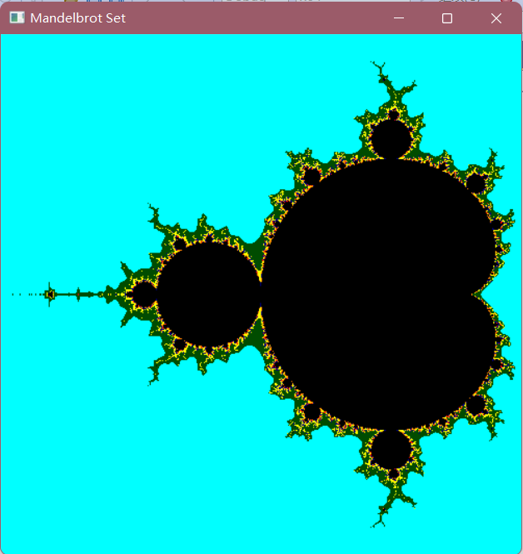

实验十一 OpenGL下图形的交互控制实验

1. 实验内容

使用OpenGL，完成鼠标、键盘交互操作

1. 实验目的

熟悉鼠标、键盘操作

1. 实验代码

#include<gl/glut.h>

#include<stdio.h>

GLsizei winWidth = 500, winHeight = 500;

char sixel;

float thera = 0;

float x = 0, y = 0, z = 0;

void init(void) {

glClearColor(1.0, 1.0, 1.0, 0.0);

}

void displayWirePolyhedra(float x, float y, float z, float thera) {

glClear(GL_COLOR_BUFFER_BIT);

glColor3f(0.0, 0.0, 1.0);

gluLookAt(5.0, 5.0, 5.0, 0.0, 0.0, 0.0, 0.0, 1.0, 0.0);

glScalef(1.0, 1.0, 1.0);

glTranslatef(1.0, 2.0, 0.0);//下一个图形坐标

glutSolidTeapot(1.5);

//glutWireTeapot(1.5);//放大倍数

glScalef(1.0, 1.0, 1.0);//缩放比

glTranslatef(-1.0, -5.0, 0.0);//下一个图形坐标

glRotatef(thera, x, y, z);

glutWireTeapot(1.5);

//glutSolidTeapot(2.0);

glFlush();

}

void display() {

displayWirePolyhedra(x, y, z, thera);

}

void winReshapeFcn(GLint newWidth, GLint newHeight) {

glViewport(0, 0, newWidth, newHeight);

glMatrixMode(GL_PROJECTION);

glFrustum(-1.0, 1.0, -1.0, 1.0, 2.0, 20.0);

glMatrixMode(GL_MODELVIEW);

glClear(GL_COLOR_BUFFER_BIT);

}

void main(int argc, char** argv) {

glutInit(&argc, argv);

glutInitDisplayMode(GLUT_SINGLE | GLUT_RGB);

glutInitWindowPosition(100, 100);

glutInitWindowSize(winWidth, winHeight);

glutCreateWindow(" ");

init();

printf_s("请选择绕拿一个轴旋转x,y,z \n");

scanf_s("%c", &sixel);

getchar();

if (sixel == 'x') {

x = 1.0;

y = 0.0;

z = 0.0;

printf_s("请输入旋转的角度\n");

scanf_s("%f", &thera);

}

else if (sixel == 'y') {

x = 0.0;

y = 1.0;

z = 0.0;

printf_s("请输入旋转的角度\n");

scanf_s("%f", &thera);

}

else if (sixel == 'z') {

x = 0.0;

y = 0.0;

z = 1.0;

printf_s("请输入旋转的角度\n");

scanf_s("%f", &thera);

}

else {

printf_s("输入有误\n");

}

glutDisplayFunc(display);

glutReshapeFunc(winReshapeFcn);

glutMainLoop();

}

1. 实验结果

实验十二 三维观察变换

1. 实验内容
2. 使用OpenGL，完成投影变换等实验；
3. 教材P264
4. 实验目的

熟悉三位观察相关内容

1. 实验代码

（1）

#include<gl/glut.h>

GLint winWidth = 600, winHeight = 600;

GLfloat x0 = 100.0, y0 = 50.0, z0 = 50.0;

GLfloat xref = 50.0, yref = 50.0, zref = 0.0;

GLfloat Vx = 0.0, Vy = 1.0, Vz = 0.0;

GLfloat xwMin = -40.0, ywMin = -60.0, xwMax = 40.0, ywMax = 60;

GLfloat dnear = 25.0, dfar = 125.0;

void init(void) {

glClearColor(1.0, 1.0, 1.0, 0.0);

glMatrixMode(GL_MODELVIEW);

gluLookAt(x0, y0, z0, xref, yref, zref, Vx, Vy, Vz);

glMatrixMode(GL_PROJECTION);

glFrustum(xwMin, xwMax, ywMin, ywMax, dnear, dfar);

}

void displayFcn(void) {

glClear(GL_COLOR_BUFFER_BIT);

glColor3f(0.0, 1.0, 0.0);

glPolygonMode(GL_FRONT, GL_FILL);

glPolygonMode(GL_BACK, GL_LINE);

glBegin(GL_QUADS);

glVertex3f(0.0, 0.0, 0.0);

glVertex3f(100.0, 0.0, 0.0);

glVertex3f(100.0, 100.0, 0.0);

glVertex3f(0.0, 100.0, 0.0);

glEnd();

glFlush();

}

void reshapeFcn(GLint newWidth, GLint newHeight) {

glViewport(0, 0, newWidth, newHeight);

winWidth = newWidth;

winHeight = newHeight;

}

void main(int argc, char** argv) {

glutInit(&argc, argv);

glutInitDisplayMode(GLUT_SINGLE | GLUT_RGB);

glutInitWindowPosition(50, 50);

glutInitWindowSize(winWidth, winHeight);

glutCreateWindow("Perspective View of A Square");

init();

glutDisplayFunc(displayFcn);

glutReshapeFunc(reshapeFcn);

glutMainLoop();

}

（2）

#include <stdlib.h>

#include <GL/glut.h>

float theta = 0.0;

void drawPyramid() //该金字塔在以原点为中心，边长为2的立方体范围内

{

glBegin(GL_TRIANGLES);

glColor3f(1.0f, 0.0f, 0.0f); //前面为红色

glVertex3f(0.0f, 1.0f, 0.0f); //前面三角形上顶点

glVertex3f(-1.0f, -1.0f, 1.0f); //前面三角形左顶点

glVertex3f(1.0f, -1.0f, 1.0f); //前面三角形右顶点

glColor3f(0.0f, 1.0f, 0.0f); //右面为绿色

glVertex3f(0.0f, 1.0f, 0.0f); //右面三角形上顶点

glVertex3f(1.0f, -1.0f, 1.0f); //右面三角形左顶点

glVertex3f(1.0f, -1.0f, -1.0f); //右面三角形右顶点

glColor3f(0.0f, 0.0f, 1.0f); //背面为蓝色

glVertex3f(0.0f, 1.0f, 0.0f); //背面三角形上顶点

glVertex3f(1.0f, -1.0f, -1.0f); //背面三角形左顶点

glVertex3f(-1.0f, -1.0f, -1.0f); //背面三角形右顶点

glColor3f(1.0f, 1.0f, 0.0f); //左面为黄色

glVertex3f(0.0f, 1.0f, 0.0f); //左面三角形上顶点

glVertex3f(-1.0f, -1.0f, -1.0f); //左面三角形左顶点

glVertex3f(-1.0f, -1.0f, 1.0f); //左面三角形右顶点

glEnd();

glBegin(GL_POLYGON); //金字塔底面正方形

glColor3f(0.5f, 0.5f, 0.5f); //底面为灰色

glVertex3f(-1.0f, -1.0f, 1.0f);

glVertex3f(1.0f, -1.0f, 1.0f);

glVertex3f(1.0f, -1.0f, -1.0f);

glVertex3f(-1.0f, -1.0f, -1.0f);

glEnd();

}

void display()

{

glClear(GL_COLOR_BUFFER_BIT | GL_DEPTH_BUFFER_BIT); //清空颜色和深度缓存

glMatrixMode(GL_MODELVIEW);

glLoadIdentity();

//gluLookAt(2.0, 2.0, 2.0, 0.0, 0.0, 0.0, 0.0, 1.0, 0.0);

glTranslatef(0.0f, 0.0f, -5.0f);

glRotatef(theta, 0.0f, 1.0f, 0.0f);

drawPyramid();

glutSwapBuffers();

}

void reshape(int w, int h) //重绘回调函数，在窗口首次创建或用户改变窗口尺寸时被调用

{

glViewport(0, 0, w, h);

glMatrixMode(GL_PROJECTION);

glLoadIdentity();

//glFrustum(-1.0, 1.0, -1.0, 1.0, 3.1, 10.0);

//gluPerspective(45,1,0.1,10.0);

glOrtho(-2.0, 2.0, -2.0, 2.0, 2.0, 10.0);

}

void init()

{

glClearColor(1.0, 1.0, 1.0, 1.0);

glEnable(GL_DEPTH_TEST); //启动深度测试模式

}

void myKeyboard(unsigned char key, int x, int y)

{

if (key == 'a' || key == 'A')

theta += 5.0;

if (key == 's' || key == 'S')

theta -= 5.0;

if (key == 'c' || key == 'C')

exit(0);

if (theta > 360) theta -= 360;

if (theta < 0) theta += 360;

glutPostRedisplay(); //重新调用绘制函数

}

int main(int argc, char** argv)

{

glutInit(&argc, argv);

glutInitDisplayMode(GLUT_DEPTH | GLUT_DOUBLE | GLUT_RGB);

glutInitWindowSize(500, 500);

glutInitWindowPosition(0, 0);

glutCreateWindow("金字塔---A键:顺时针旋转,S键:逆时针旋转,C键:退出");

glutReshapeFunc(reshape); //指定重绘回调函数

glutDisplayFunc(display);

glutKeyboardFunc(myKeyboard); //指定键盘回调函数

init();

glutMainLoop();

}

1. 实验结果

（1）

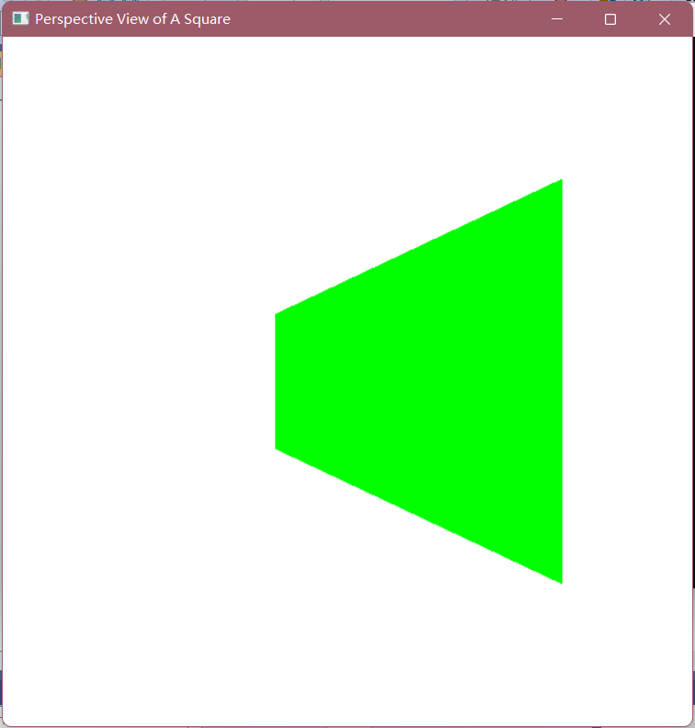

（2）

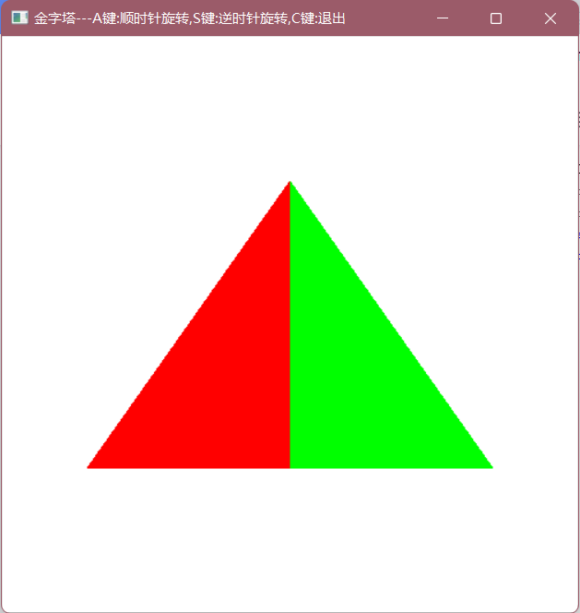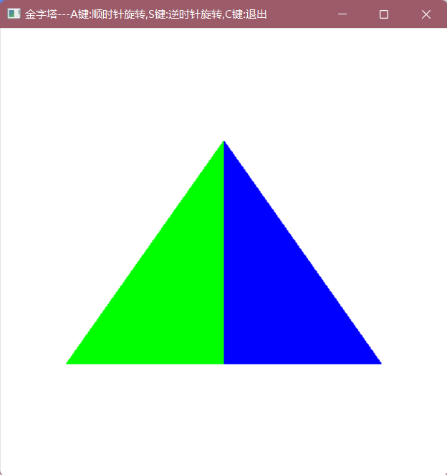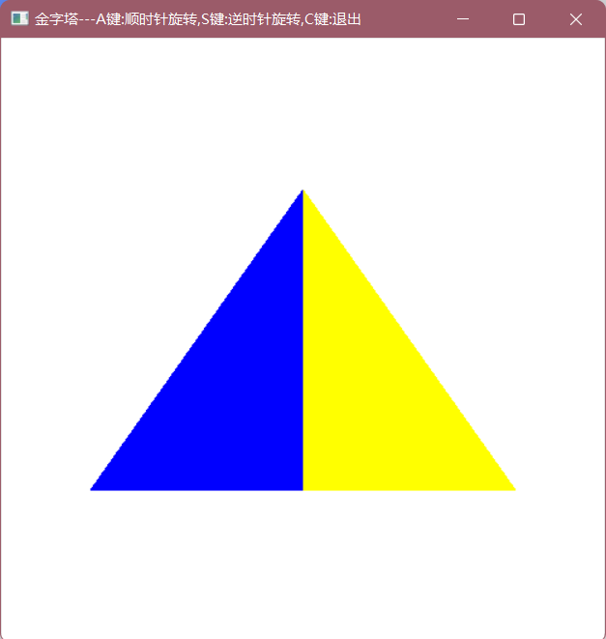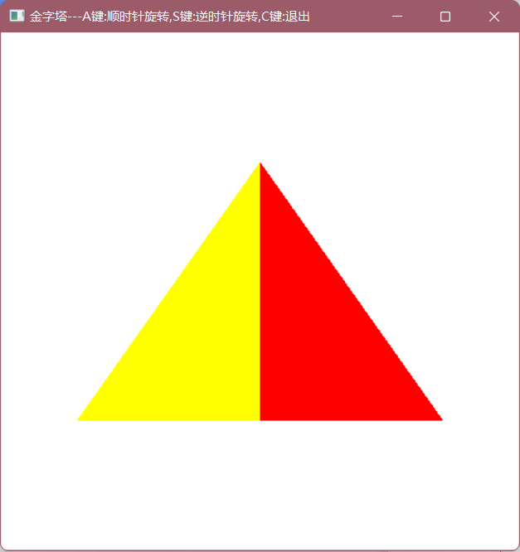

实验十三 三维线框图实验

1. 实验内容

生成多面体线框图，教材P300

1. 实验目的

熟悉三维观察相关内容

1. 实验代码

（1）

#include <gl/glut.h>

GLsizei winWidth = 500, winHeight = 500;

void init(void) {

glClearColor(1.0, 1.0, 1.0, 0.0);

}

void displayWirePolyhedra(void) {

glClear(GL_COLOR_BUFFER_BIT);

glColor3f(0.0, 0.0, 1.0);

gluLookAt(5.0, 5.0, 5.0, 0.0, 0.0, 0.0, 0.0, 1.0, 0.0);

glScalef(1.5, 2.0, 1.0);

glutWireCube(1.0);

glScalef(0.8, 0.5, 0.8);

glTranslatef(-6.0, -5.0, 0.0);

glutWireDodecahedron();

glTranslatef(8.6, 8.6, 2.0);

glutWireTetrahedron();

glTranslatef(-3.0, -1.0, 0.0);

glutWireOctahedron();

glScalef(0.8, 0.8, 1.0);

glTranslatef(4.3, -2.0, 0.5);

glutWireIcosahedron();

glFlush();

}

void winReshapeFcn(GLint newWidth, GLint newHeight) {

glViewport(0, 0, newWidth, newHeight);

glMatrixMode(GL_PROJECTION);

glFrustum(-1.0, 1.0, -1.0, 1.0, 2.0, 20.0);

glMatrixMode(GL_MODELVIEW);

glClear(GL_COLOR_BUFFER_BIT);

}

void main(int argc, char** argv) {

glutInit(&argc, argv);

glutInitDisplayMode(GLUT_SINGLE | GLUT_RGB);

glutInitWindowPosition(100, 100);

glutInitWindowSize(winWidth, winHeight);

glutCreateWindow("Wire-Frame Polyhedra");

init();

glutDisplayFunc(displayWirePolyhedra);

glutReshapeFunc(winReshapeFcn);

glutMainLoop();

}

（2）

#include<gl/glut.h>

GLsizei winWidth = 500, winHeight = 500;

void init(void) {

glClearColor(1.0, 1.0, 1.0, 0.0);

}

void wireQuadSurfs(void) {

glClear(GL_COLOR_BUFFER_BIT);

glColor3f(0.0, 0.0, 1.0);

gluLookAt(2.0, 2.0, 2.0, 0.0, 0.0, 0.0, 0.0, 0.0, 1.0);

glPushMatrix();

glTranslatef(1.0, 1.0, 0.0);

glutWireSphere(0.75, 8, 6);

glPopMatrix();

glPushMatrix();

glTranslatef(1.0, -0.5, 0.5);

glutWireCone(0.7, 2.0, 7, 6);

glPopMatrix();

GLUquadricObj* cylinder;

glPushMatrix();

glTranslatef(0.0, 1.2, 0.8);

cylinder = gluNewQuadric();

gluQuadricDrawStyle(cylinder, GLU_LINE);

gluCylinder(cylinder, 0.6, 0.6, 1.5, 6, 4);

glPopMatrix();

glFlush();

}

void winReshapeFcn(GLint newWidth, GLint newHeight) {

glViewport(0, 0, newWidth, newHeight);

glMatrixMode(GL_PROJECTION);

glOrtho(-2.0, 2.0, -2.0, 2.0, 0.0, 5.0);

glMatrixMode(GL_MODELVIEW);

glClear(GL_COLOR_BUFFER_BIT);

}

void main(int argc, char** argv) {

glutInit(&argc, argv);

glutInitDisplayMode(GLUT_SINGLE | GLUT_RGB);

glutInitWindowPosition(100, 100);

glutInitWindowSize(winWidth, winHeight);

glutCreateWindow("Wire-Frame Quadric Surfaces");

init();

glutDisplayFunc(wireQuadSurfs);

glutReshapeFunc(winReshapeFcn);

glutMainLoop();

}

1. 实验结果

（1）

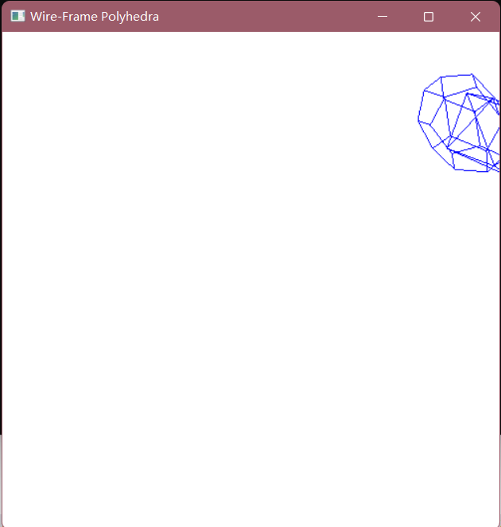

（2）

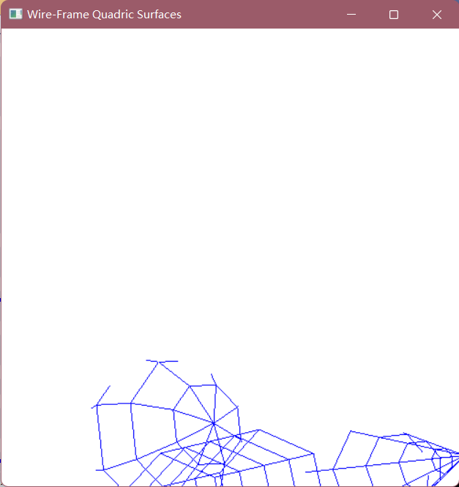

实验十四 曲线曲面生成实验

1. 实验内容

生成曲面或者曲线，教材P323

1. 实验目的

熟悉Bezier，样条等相关内容

1. 实验代码

#include <gl/glut.h>

#include <stdlib.h>

#include <math.h>

GLsizei winWidth = 600, winHeight = 600;

GLfloat xwcMin = -50.0, xwcMax = 50.0;

GLfloat ywcMin = -50.0, ywcMax = 50.0;

class wcPt3D {

public:

GLfloat x, y, z;

};

void init(void) {

glClearColor(1.0, 1.0, 1.0, 1.0);

}

void plotPoint(wcPt3D bezCurvePt) {

glBegin(GL_POINTS);

glVertex2f(bezCurvePt.x, bezCurvePt.y);

glEnd();

}

void binomialCoeffs(GLint n, GLint* C) {

GLint k, j;

for (k = 0; k <= n; k++) {

C[k] = 1;

for (j = n; j >= k; j--)

C[k] *= j;

for (j = n - k; j >= 2; j--)

C[k] /= j;

}

}

void computeBezPt(GLfloat u, wcPt3D* bezPt, GLint nCtrlPts, wcPt3D* ctrlPts, GLint* C) {

GLint k, n = nCtrlPts - 1;

GLfloat bezBlendFcn;

bezPt->x = bezPt->y = bezPt->z = 0.0;

for (k = 0; k < nCtrlPts; k++) {

bezBlendFcn = C[k] * pow(u, k) * pow(1 - u, n - k);

bezPt->x += ctrlPts[k].x * bezBlendFcn;

bezPt->y += ctrlPts[k].y * bezBlendFcn;

bezPt->z += ctrlPts[k].z * bezBlendFcn;

}

}

void bezier(wcPt3D* ctrlPts, GLint nCtrlPts, GLint nBezCurvePts) {

wcPt3D bezCurvePt;

GLfloat u;

GLint* C, k;

C = new GLint[nCtrlPts];

binomialCoeffs(nCtrlPts - 1, C);

for (k = 0; k <= nBezCurvePts; k++) {

u = GLfloat(k) / GLfloat(nBezCurvePts);

computeBezPt(u, &bezCurvePt, nCtrlPts, ctrlPts, C);

plotPoint(bezCurvePt);

}

delete [ ] C;

}

void displayFcn(void) {

GLint nCtrlPts = 4, nBezCurvePts = 1000;

wcPt3D ctrlPts[4] = { {-40.0, -40.0, 0.0}, { -10.0, 200.0, 0.0 }, { 10.0, -200.0, 0.0 }, { 40.0,40.0,0.0 } };

glClear(GL_COLOR_BUFFER_BIT);

glPointSize(4);

glColor3f(1.0, 0.0, 0.0);

bezier(ctrlPts, nCtrlPts, nBezCurvePts);

glFlush();

}

void winReshapeFcn(GLint newWidth, GLint newHeight) {

glViewport(0, 0, newHeight, newHeight);

glMatrixMode(GL_PROJECTION);

glLoadIdentity();

gluOrtho2D(xwcMin, xwcMax, ywcMin, ywcMax);

glClear(GL_COLOR_BUFFER_BIT);

}

void main(int argc, char** argv) {

glutInit(&argc, argv);

glutInitDisplayMode(GLUT_SINGLE | GLUT_RGB);

glutInitWindowPosition(50, 50);

glutInitWindowSize(winWidth, winHeight);

glutCreateWindow("Bezier Curve");

init();

glutDisplayFunc(displayFcn);

glutReshapeFunc(winReshapeFcn);

glutMainLoop();

}

1. 实验结果

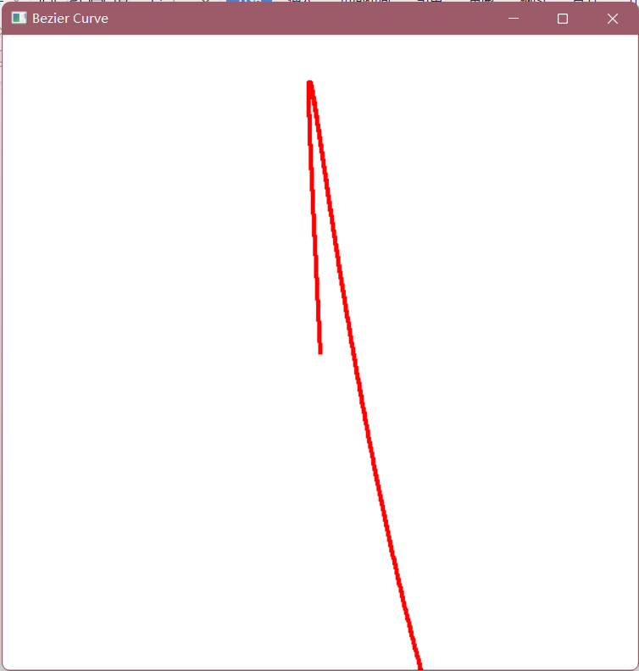

实验十五