Iowa State University

Ecology, Evolution, and Organismal Biology

**of science and technology**

**November 11, 14**

Dear Editor,

Following an initial pre-submission enquiry we are delighted to submit a full manuscript entitled “Persistence of sub-genomes in paleopolyploid cotton after 60 million years of evolution.” We would very much appreciate your feedback regarding suitability for publication in *Nature Plants*. We believe the manuscript will be of interest to your broad readership, particularly those interested in plant genome evolution, whole genome duplication and paleogenomics.

The role of gene duplication as an evolutionary force has long been recognized, particularly in plants, and in this manuscript we examine the role of duplicate gene retention and loss in shaping the modern genome of cotton. We demonstrate that despite 60 million years of evolution the sub-genomes of paleopolyploid cotton are still easily distinguishable via several genomic characteristics including transposable element (TE) content, GC content, targeting by siRNAs, and a bias in the rate of gene fractionation (duplicate gene loss after whole genome duplication). Our data stand in contrast to other high profile reports, in other taxa, by extending the evolutionary time over which these signatures can be detected, suggesting that hitherto, the long term impact of bias fractionation has not been fully appreciated.

Furthermore, and contrary to previous hypotheses and analyses, we demonstrate that positional down-regulation of genes by transposable elements is absent in the genome of cotton and is therefore unlikely to be the primary driver of biased fractionation. Given that whole genome duplication is such a pervasive force in the evolution of plants this advance is important to the field of plant genome evolution and paleogenomics. Our data suggest a modification to current understanding of gene loss following ancient whole genome duplication is needed and we propose an alternative mechanism as a driver of biased fractionation.

We hope that you will consider our manuscript suitable for publication in *Nature Plants* and we look forward to hearing your thoughts.

Thank you for your time and consideration.

Sincerely,

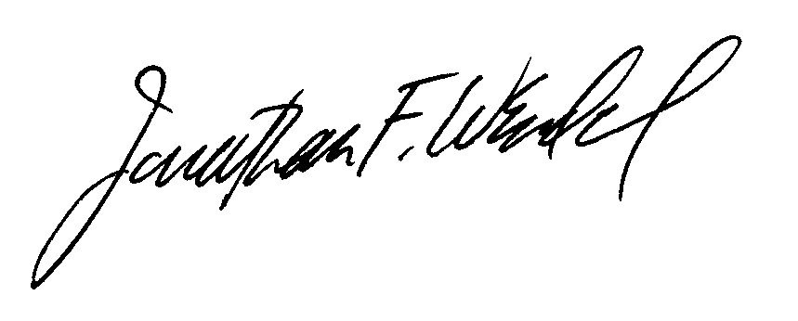

Jonathan F. Wendel ([jfw@iastate.edu](mailto:jfw@iastate.edu); 515-294-7172)

Distinguished Professor and Chair

Department of Ecology, Evolution, & Organismal Biology

Iowa State University, Ames, IA 50011