Final Report
Full Unit – Final Report

Single-Agent and Multi-Agent Search in Maze Game

Hijithan Arunthavarajah

A report submitted in part fulfilment of the degree of
BSc (Hons) in Computer Science
Supervisor: Farid Shahandeh

Department of Computer Science
Royal Holloway, University of London

Declaration
This report has been prepared on the basis of my own work. Where other published and unpublished source materials have been used, these have been acknowledged.

Word Count: 8272, (6299 excluding Bibliography and Appendix)

Student Name: Hijithan Arunthavarajah

Date of Submission: 13/12/2024

Signature: HIJITHAN
Table of Contents
Abstract 3
Project Specification 4
Chapter 1: Introduction 6
1.1 Project Overview 6
1.2 Aims and Objectives 6
Chapter 2: Background and Theory 7
2.1 Path Finding Approaches 7
2.2 Design Patterns 12
2.3 Resources and Framework 12
Chapter 3: Software Engineering Principles 13
3.1 Version Control 13
3.2 Testing 13
3.3 Checkstyle 14
Chapter 4: Requirements Analysis 15
4.1 Use Cases 15
4.2 Functional Requirements 20
4.3 Non-Functional Requirements 21
Chapter 5: Development 22
5.1 UML Class Diagram 22
5.2 Algorithm Implementations 27
Chapter 6: Summary and Conclusion 30
Chapter 7: Bibliography 31
Chapter 8: Appendix 33
8.1 Diary 33
Abstract
The agents within a maze-solving environment problem have a rich background in the computing world, becoming one of the fundamental concepts in the field of AI [1]. Today, this concept is used in various real-world applications, such as autonomous vehicles, navigation systems and rescue operations. This report aims to discuss some well-known path-finding algorithms in a maze game environment and compare how they perform with one another in terms of space and time as we increase the maze's scalability and complexity. From the algorithms chosen, we should expect noticeable changes in performance, especially as we scale them up.
BFS and DFS are fundamental traversal algorithms initially presented in this report, where BFS is always able to find the shortest path, unlike DFS, making it faster in most cases. However, it usually uses more memory because it queues vertices at every level, which only gets larger the deeper it goes. Though BFS can find the shortest path, it cannot find the most optimal one if adversarial elements are introduced. Uniform Cost Search will start considering the cost to find the optimal path, making it faster but more memory intensive as it stores all paths explored.
By the end of this interim report, we will have the motivation to develop the second phase of this project, such as A star search and then the introduction of enemies, which in turn means the development of min-max, alpha-beta, and expectimax agents.

Project Specification

First Term (Interim Deliverables)
- Design different maze models, we mainly want a small, medium and large maze.
- Give the player different movement options/animations such as: idle, walk and climb.
- Add slow tiles to the game, which slow player movement.
- Add a score counter.
- To save memory, store mazes in a csv file and load a particular maze into memory when in use.
- Implement a algorithm to randomise movement, this can also be a good algorithm to give to adversaries when they are initially implemented.
- Implement DFS/BFS path finding algorithms and compare how they perform against one another in terms of speed and memory, and on different maze sizes.
- Implement UCS which calculates the cost of the path to find the most optimal one. For example, if there is a slow tile then the cost should be +3 but if it’s a normal tile then it should be +1.

Todo Second Term (Final Deliverables)
- Implement A star search to help guide the agent and avoid exploring unnecessary paths we can use two different heuristics functions one where it calculates the Manhattan distance and another calculating the diagonal distance between the current grid the agent is in and the target grid.
- Add a new game mode where every cell contains a diamond and it’s the agent’s job to collect them all. NOTE: algorithms implemented thus far will not work for this new game mode, however the algorithms mentioned in points 3 and 4 will. Therefore, I will only compare between those two.
- Implement a greedy search algorithm where the Manhattan distance of the closet diamond to the agent.
- Implement a new version of the A* algorithm which works as normal except I will use the minimal spanning tree as my heuristic, that will find the cost of visiting all remaining diamonds based on the shortest path between.
- Add adversaries to the game, which will initially move around the map at random. In this case will make turn the agent into a reflex one. NOTE: As the previous algorithms have not got enemies in them, I will not compare those with the ones mentioned in points 5 -8. They will have their own comparisons.
- Implement a min-max agent where the agent and adversary look at the possible grids it can travel too and passes this to the evaluation function. The evaluation function will be calculated by subtracting the distance of the goal to the agent from the distance of the adversary to the agent. The distances will be calculated using the Manhattan method. Therefore, in this scenario the agent is the maximiser while the adversary is the minimiser.
- Now we need to improve min-max with alpha-beta pruning agent. Implement the alpha beta pruning algorithm. I will use the logic I have implemented in the min max agent but modify it to do some pruning as well.
- Next implement the expectimax agent. This will also use the same logic as the min-max algorithm but with a few changes. I will purposely randomise the adversary choices from time to time, meaning it will not always choose the optimal choice. For the agent, I will implement a function that will recursively explore possible outcomes of all moves then instead of choosing the most optimal outcome it will calculate the average score and go for that choice.

Introduction

Project Overview
This interim report will outline the progress with the single-Agent and Multi-Agent maze game project. The maze game will feature an agent/player with a clear objective: to collect diamonds randomly generated within the maze. Once all the diamonds have been collected, new ones will regenerate, creating a continuous challenge for the agent. The more diamonds the agent collects, the higher its score will be. However, the game will also present adversarial elements such as slow blocks that will add complexity to the agent’s task to get the optimal path. Currently four algorithms have been implemented which are: random movement, BFS, DFS and UCS.

Aims and Objectives
As mentioned earlier, the maze-solving environment problem is an important concept in various real-world applications, such as autonomous vehicles, navigation systems, and rescue operations. However, although this concept is extremely important, some may find it challenging or overwhelming to understand as there are so many path-finding approaches, with some having a lot of complexity. This project aims to visualise path-finding algorithms in an "engaging" maze environment to help users understand the types of path-finding approaches and how they work and differ. To make the maze "engaging," I have made the game look visually appealing using 2D-pixel art (credits given in the project's README) and animations.
I will also analyse the various path-finding agents and compare how well they do against each other in terms of space and time across different maze environments. It is important to note that comparisons will be split into sections to keep things fair. For example, comparing a BFS path-finding agent with an alpha-beta agent wouldn't be fair. The alpha-beta agent will be in a maze with enemies, spending time trying to avoid them, while BFS will simply find the path and go to it.

Background and Theory

Path Finding Approaches
For the first half of the project, I have researched 3 path finding algorithms, that I will be using for this maze game project.
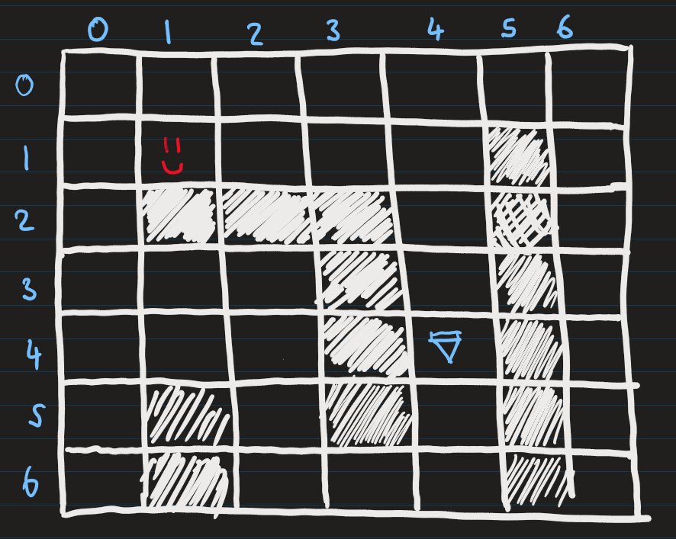
Figure 1.1: Maze with a player and diamond

DFS
With DFS, it will always traverse through one path in a maze and go down that path until it reaches the end. If it's a dead end, it will keep backtracking one space until it can find another route [2]. The algorithm will repeat this process until it reaches the goal. One problem with this algorithm is that it can go down an infinite path, meaning it will never get the goal state. Although the mazes generated in this project don't have such a path, I thought it's still worth considering. It also contains a visited list to avoid cycles.
To clarify how DFS works in a maze, let's take a look at an example. In the following example (Figure 1.1), the face represents the agent, and the diamond represents the goal. In DFS, a stack will be initialised in the background, and a data structure will be created to store which vertices have been visited. For this example, the movement priority will be (Left, Down, Right, Up) but you can design this however you want.
You can see that in the example below (Figure 1.2), the DFS agent eventually reaches the goal. Notice that on the vertex (0,6), it reaches a dead end and must backtrack upwards until it finds an unvisited node. You can also see this in the stack (Figure 1.3), where it backtracks and removes values. It eventually finds an unvisited vertex at (0,4) and moves rightwards to complete it. The end stack is shown in Figure 1.4.
Also, DFS does not find the shortest path in this instance. It took the longer route. However, in some instances, it can, for example, if I set the movement priority for the algorithm as (Right, Down, Left, Up). So, using DFS does not guarantee the shortest path will be found.

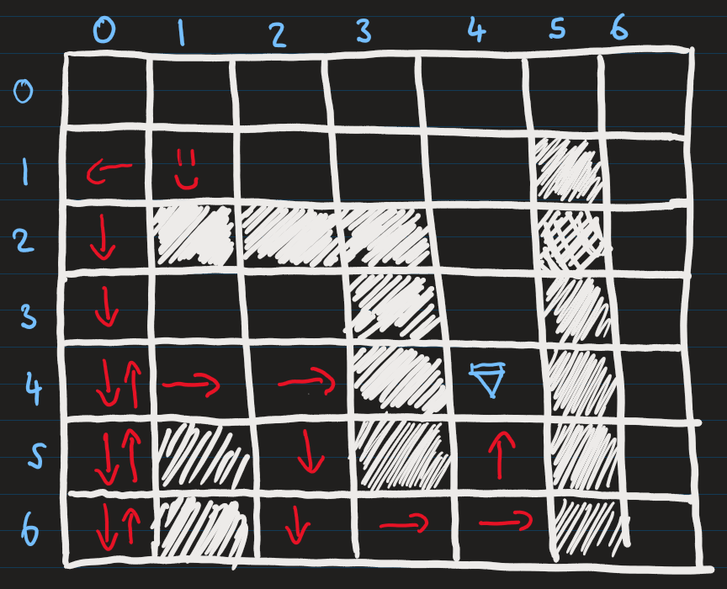
Figure 1.2 DFS finds the goal
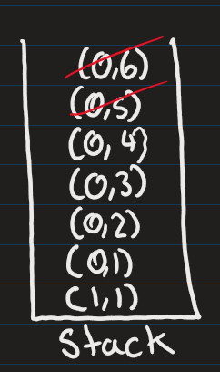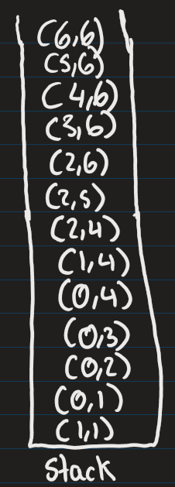
Figure 1.3 DFS stack backtracking Figure 1.4 DFS stack once it reaches the goal
The complxity of the algorithm will be O(V + E) where V is the number of verticies and E is the number adjacent connections between the vertices and the space complexity will be O(V) [3], as in the worst case it will visit every vertex and evey edge for each vertex.

BFS
Now, let's look at another similar algorithm called Breadth-First Search BFS, unlike DFS, which tunnels through one path. BFS will explore the maze layer by layer. Instead of a stack, it will use a queue and still have a visited list.
Let's take a closer look at how this works. We'll use the same maze (Figure 1.1) and movement priority. The algorithm begins by checking the neighbours of the current position and adding them to the queue. Once the neighbours are added, the algorithm removes the current position from the queue and moves on to the next vertex at the front of the queue. This process repeats until the goal state is reached.
In Figure 1.5, you can see areas shaded in grey, which represents the vertices the algorithm had visited; you can also see in Figure 1.6 the end queue with all the vertices that were put in the queue and a red slash to indicate the ones that were popped.
This time, the algorithm has found the shortest path, as seen with the red arrows in Figure 1.5; in fact, BFS will always find the shortest path [2] because a layer-by-layer approach traverses every path possible.
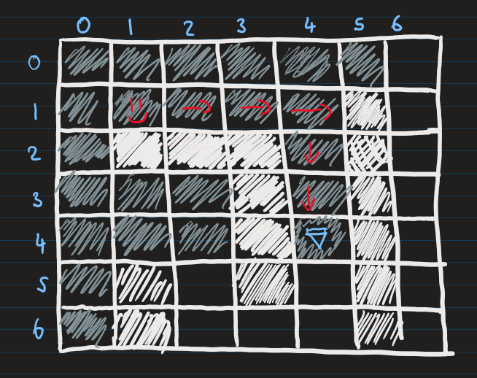
Figure 1.5 BFS finds the goal
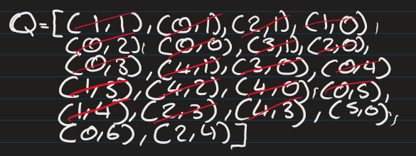
Figure 1.6 Queue used in BFS
The time and space complexity of BFS is the same as DFS, as at worst case it will have to visit all vertices at each level of the graph [3].

UCS
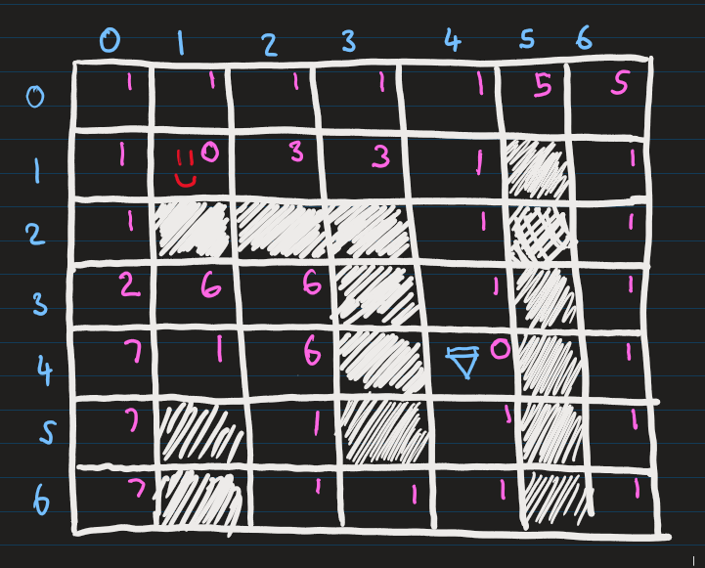
Figure 1.8 Maze map with costs

While Breadth-First Search (BFS) guarantees to find the shortest path in terms of the number of steps [4], it does not always find the most optimal path when additional factors, like costs or adversarial elements, are introduced. For instance, if an enemy slows the agent down on certain paths, BFS will not account for this slowdown. This limitation motivates the introduction of costs in the maze. As shown in Figure 1.8, a cost of 1 represents paths without adversarial elements, while a cost greater than 1 reflects the presence of such obstacles.

We use the Uniform Cost Search (UCS) algorithm to handle costs effectively. UCS operates similarly to BFS, expanding outward layer by layer but with a key difference: the data structure used to manage the frontier. While BFS uses a normal queue, UCS uses a priority queue which tracks the vertices and cumulative cost to reach each vertex. The priority queue ensures that nodes with the lowest cost are processed first.

Let's explore an example to understand how UCS works. Figure 1.10 illustrates the state of the priority queue and the visited list at different search stages. At stage 8, for instance, the algorithm evaluates vertex (2,0). From here, it could move downward to vertex (2,1) with a cost of 5. However, the priority queue already contains a cheaper path to (2,1), costing 3. Since UCS always prioritizes the lowest-cost path, it ignores the more expensive downward option.
As shown in Figure 1.9, this approach leads UCS to select the optimal path rather than the shortest path when costs are considered. The grey areas in the figure represent the maze parts that were visited during the search.

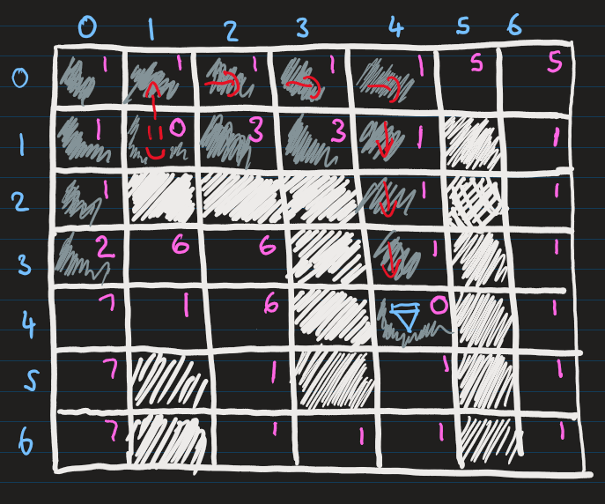

Figure 1.9 UCS finds the goal

The space and time complecity of the unifrom cost search algorithm will be O(b⌈C∗/ϵ⌉) [5], lets break this down. Let's say that every node has b branches coming out of it, and we stop at some level k, where this is the level the goal state will be in.

So we will have:
1 + b + b^2 + ....... + b^k = O(b^k)

Now, to calculate k, let's assume that C is the total cost of reaching the goal and, let's say, ϵ is the incremental step size or progress you make toward the goal at each step. So k is basically the number of steps needed to reach the goal state. So we can do C/ϵ to get the number of increments to fully cover C, but we also need to add one because the step was 0 at the start, so we end with C/ϵ + 1. This results in the space and time complexity that was mentioned above.
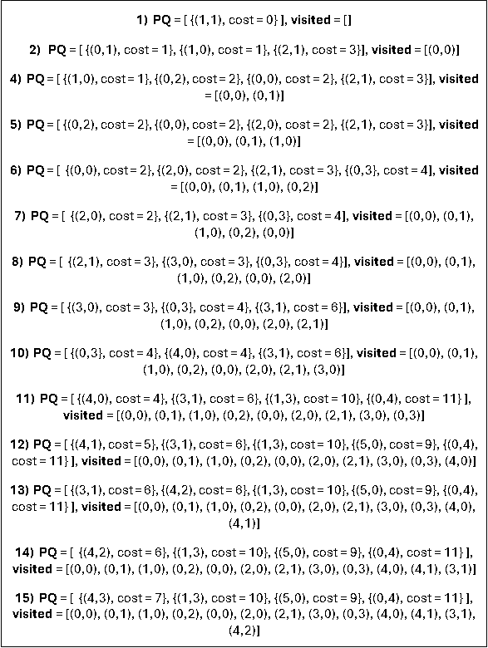

Figure 1.10 UCS finds the goal

Design Patterns
I have used a few design pattern concepts as I've been developing the maze game. I integrated design patterns, as they offer a shared vocabulary and framework for developers and designers to communicate, document, and explore potential design alternatives [7]. Here, I will explain the concepts of some design patterns that I have consciously used.

State Pattern
The State Pattern is a behavioural design pattern involving two key components: context and state objects. The context object holds an instance of the state object [8], which defines the different behaviours of the context object. When the state changes, the context alters its behaviour accordingly.
To illustrate this, imagine a character in a maze game. The context would be the character, and the state object would represent the character's movement (such as "RIGHT" or "CLIMB"). If the state object is set to "RIGHT," the character's behaviour would change to move rightward. If the state is "CLIMB," the character's behaviour would change to move vertically upward.
I chose to integrate the state pattern into my work because it avoids unnecessary conditional if statements and makes the code more extensible, allowing me to easily apply modifications without conflicting existing implementations.

Observer Pattern
The Observer Pattern is another behavioural design pattern that allows for a one-to-many dependency between objects [9]. The key concepts in the observer pattern are the Subject (Observable), Observer, and Concrete Observer. The Subject is the object being observed, and it maintains a list of Observers. It notifies these Observers when its state changes. The Observer is the object interested in the changes in the Subject's state and performs an action whenever the Subject changes.
My favourite example of the Observer Pattern can be seen on YouTube. Imagine a YouTube channel (the Subject) with many subscribers (the Observers). Without the Observer Pattern, subscribers must constantly check for new videos. However, with the Observer Pattern, a notification system can be implemented. When a YouTuber uploads a new video (i.e., the Subject changes its state), the system automatically notifies all the subscribers (the Observers).
I decided to use the Observer Pattern in my application because it allows for decoupling, meaning that the Subject doesn't need to know anything about the Observers. This makes the system more flexible and maintainable. Since the Observers do not require direct modification when the Subject changes, the system is more straightforward to update without breaking existing functionality.

Resources and Framework
For this project, I have chosen Pygame, a widely used Python library for creating 2D games and graphical simulations. Pygame helps me create straightforward and effective visualizations, like grid-based mazes and agent movement, which will allow me to remain focused on the main task, developing agents that perform pathfinding. Its flexibility makes it a great choice for showcasing single and multi-agent pathfinding algorithms.
I have also acquired various online open-source assets including maze images, agent sprites and blocks. Again, this allows me to focus more on the development of the pathfinding algorithms, as I will be using premade assets instead of spending a week or 2 creating them from scratch.

Software Engineering Principles

Version Control
I understand the importance of version control for this and most independent projects because although I'm working alone, it mitigates risks such as unexpected hardware failures or data loss that could jeopardize my work. To safeguard my project, I utilized Git and GitLab to manage and store my source code. However, simply using Git is not enough, and best practices must be followed to maintain a clear and organized development history.

To achieve this, I followed standards such as writing clear and descriptive commit messages, using branching effectively, and breaking changes into smaller, incremental commits over time rather than batching them in one go. This approach benefits both myself and others who may be interested in the project, as it provides a clear record of how the codebase evolved.

Whenever I work on a new feature, I will create a branch for it, ensuring the main branch always remains stable. For commit messages, I aimed to follow a consistent style inspired by the Conventional Commits standard [6]. While I did not adhere to every standard aspect, I adopted key conventions such as labelling commits with prefixes like feat for new features, test for test cases, and ci for CI/CD pipeline updates. Following these conventions makes my commit history consistent, organized, and easy to read.

Testing
Testing was a challenge for me at the beginning of the term, but by the end (as reflected in my commit history), I had successfully transitioned to using Test-Driven Development (TDD). I plan to continue refining and applying this approach in the next term.
In my project plan, I initially committed to using TDD from the start. However, once I began working on the project, I realized it was much harder to implement than I anticipated, mainly due to the significant amount of GUI logic involved. Given my uncertainty about how to approach testing effectively in this context, I decided to adopt a "Test After Development" approach instead.

With Test After Development, I wrote tests immediately after completing a feature, such as an algorithm. This approach proved helpful early on because I clearly understood what needed to be tested, allowing me to write tests relatively quickly. However, I soon encountered its drawbacks because writing tests after finishing a rewarding task like developing a new feature would feel like a chore, making it challenging to stay consistent. Also, I noticed that this approach introduced bias into my tests as I would subconsciously focus on confirming that my implementation worked rather than testing for edge cases or failures.

Despite these drawbacks, I'm glad I started with Test After Development. It helped me build confidence and become more comfortable writing tests for this project, which ultimately allowed me to transition to TDD by the end of the term. It also helped improve my ability to test the GUI, something that would have been difficult to accomplish earlier in the process when I lacked a clear understanding of how the application would take shape.

Looking back, this gradual progression helped me grow as a developer. While Test After Development was helpful in getting started, I've now embraced TDD as a more robust and effective approach, and I plan to continue using it moving forward.

Checkstyle
During the development of my project, I aimed to follow a coding standard to ensure my code remains consistent and maintainable. I adopted Flake8 check styling to achieve this because it enforces Python coding conventions (PEP 8) and helps catch potential issues early. I installed the Flake8 Checkstyle plugin to VSCode to visually identify areas where my code does not adhere to the standards. Additionally, I integrated Flake8 as a stage in my GitLab pipeline to automate and maintain code quality.

Requirements Analysis
I have written out the requirements analysis for term 1, outlining plans for use cases and functional and non-functional requirements.

Use Cases

Use Case 1
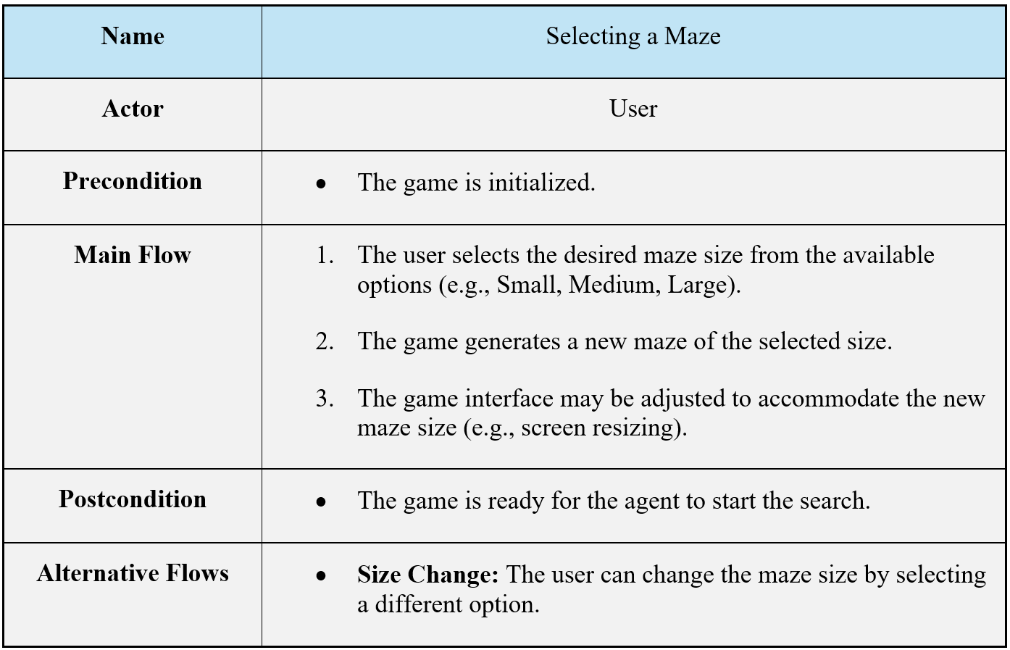
This use case was successfully implemented.

Use Case 2
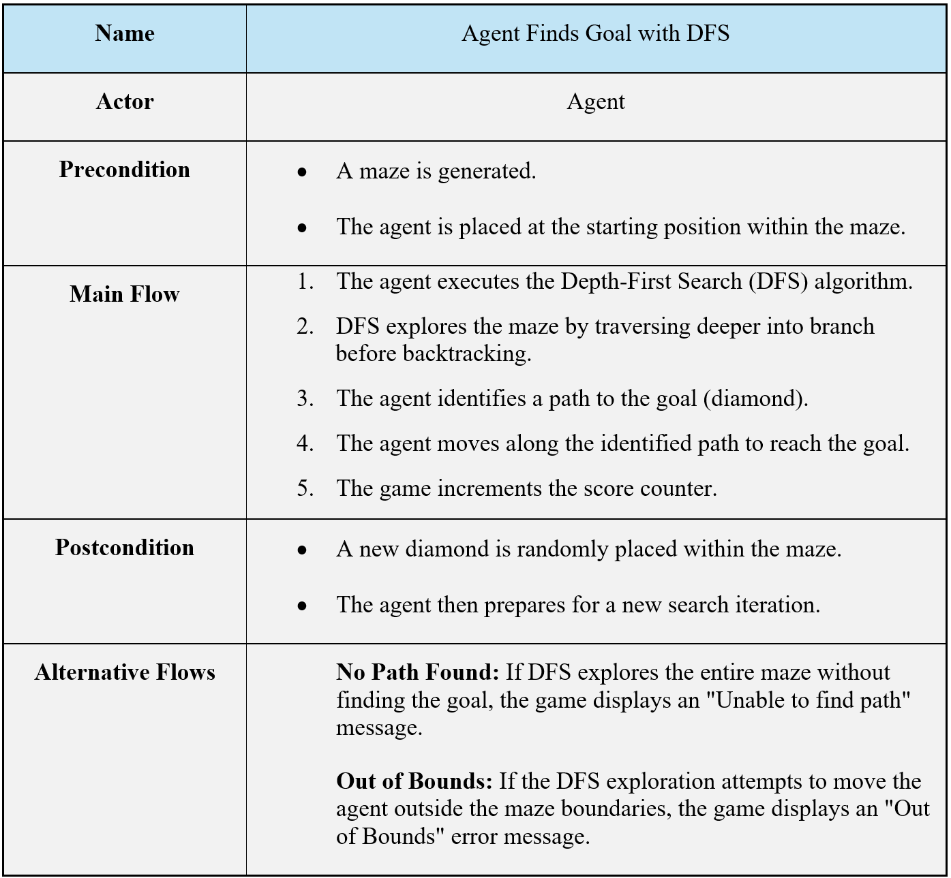
This use case was successfully implemented.

Use Case
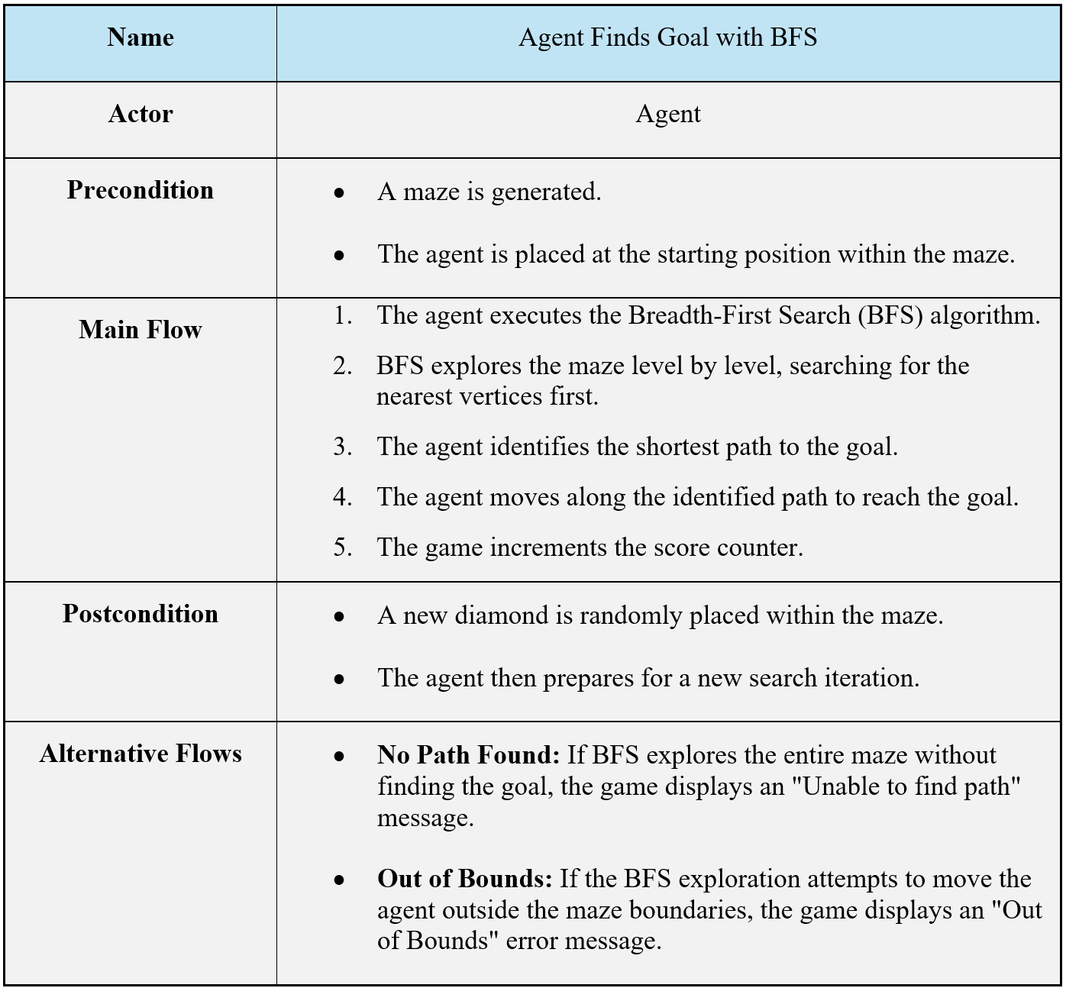
This use case was successfully implemented.

Use Case 4
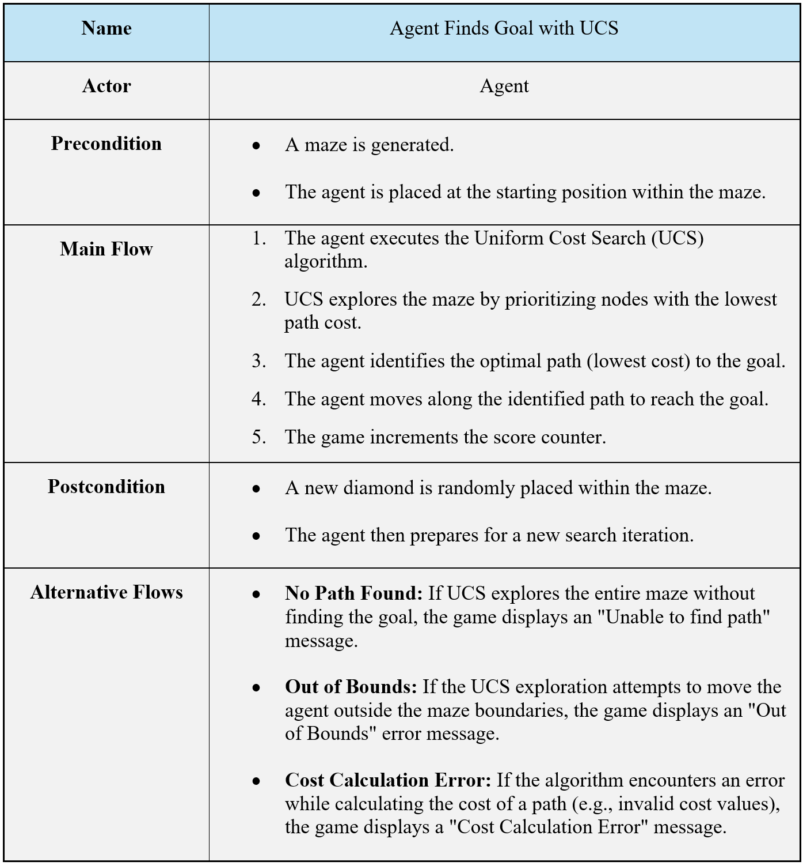
This use case was successfully implemented.

Use Case 5
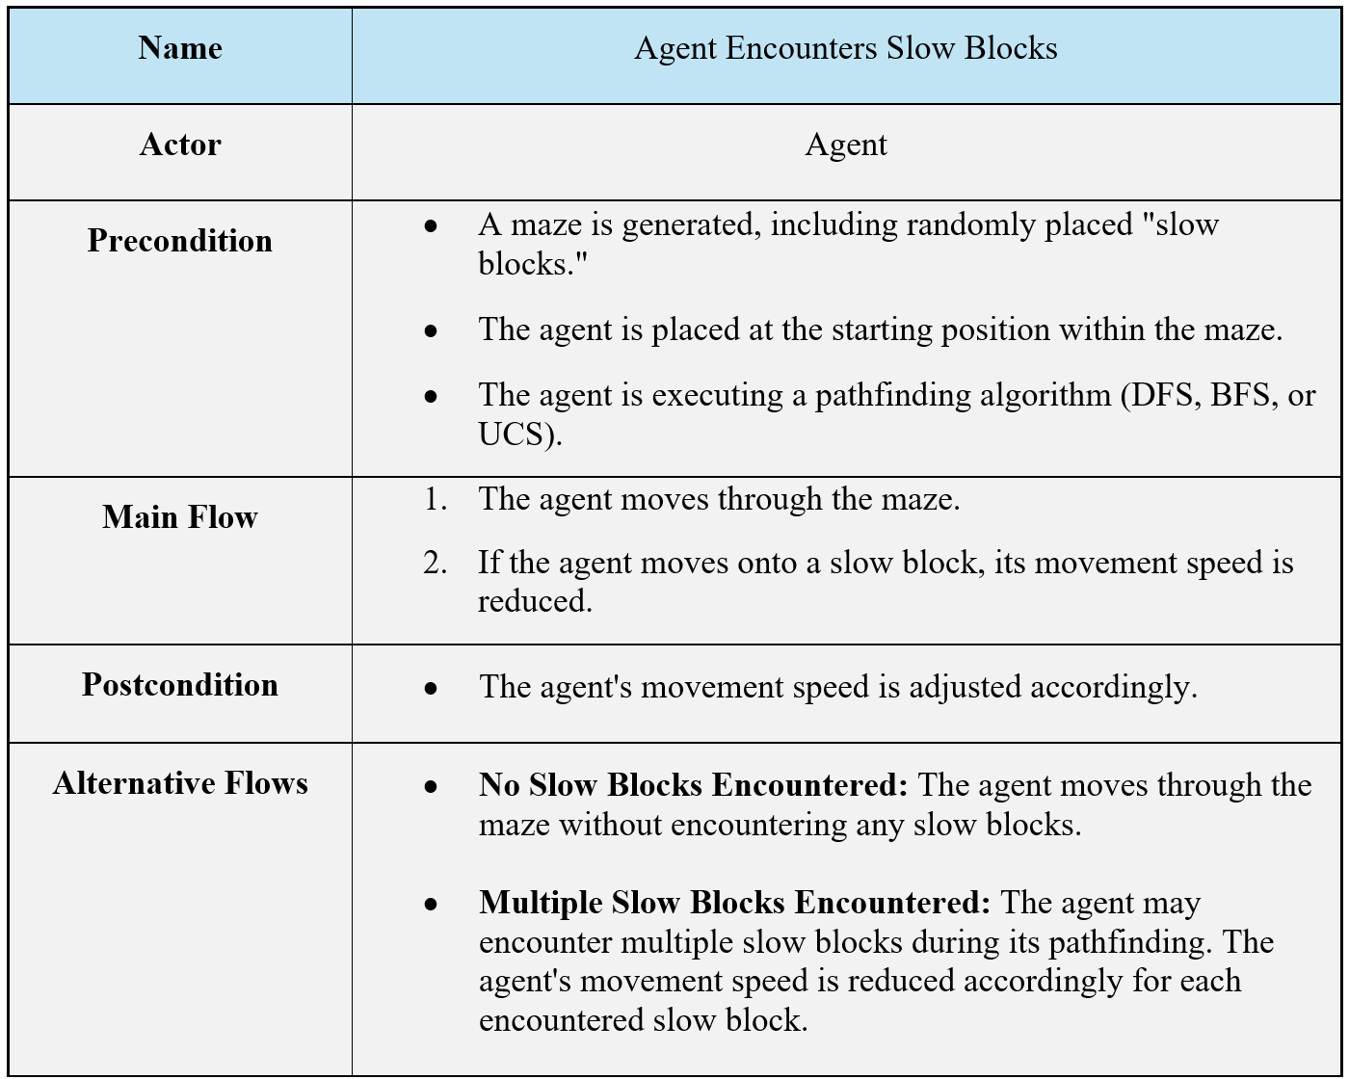
This use case was successfully implemented

Use Case 6
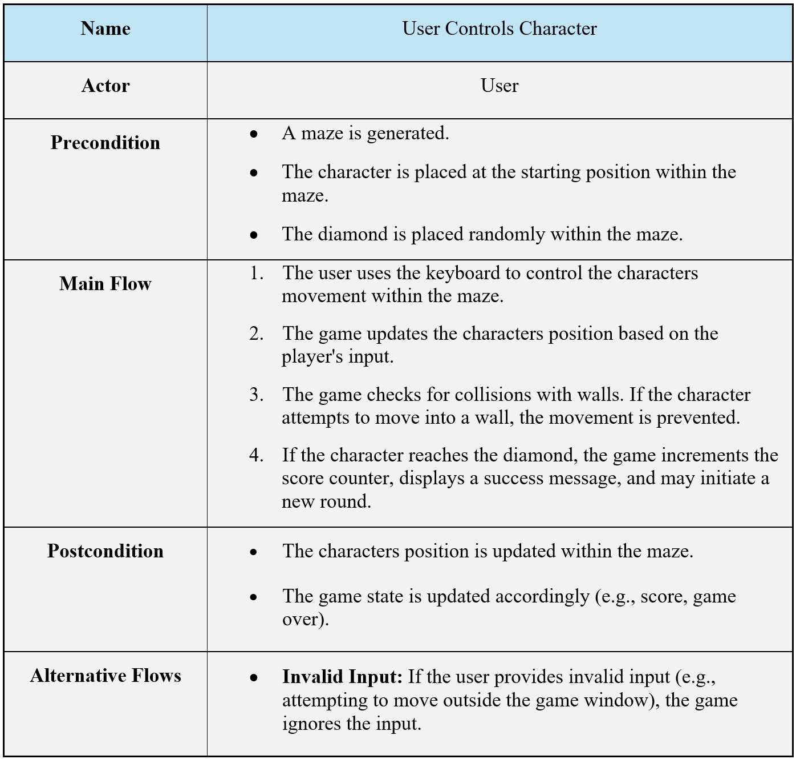
This use case was partially implemented. The functionality exists; however, it requires code modifications to fully utilize this feature.

Use Case 7
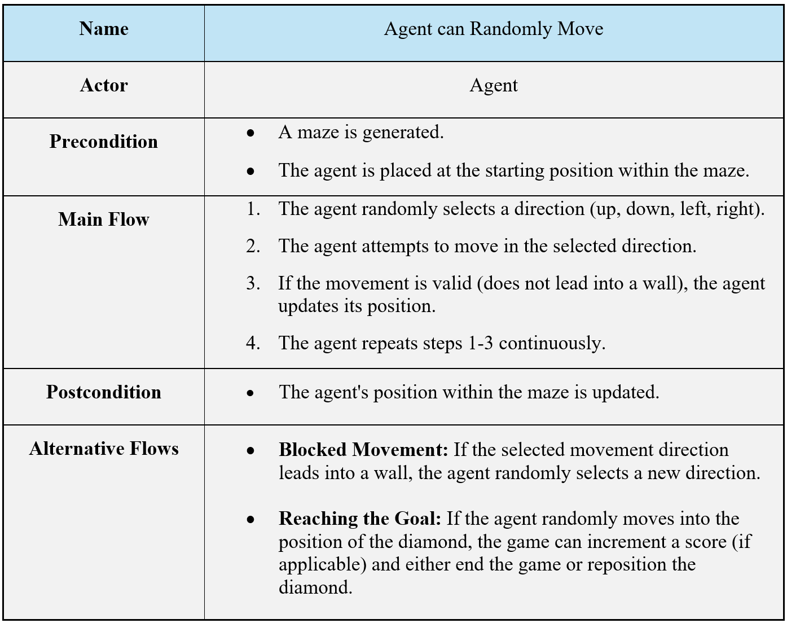
This use case was successfully implemented

Use Case 8
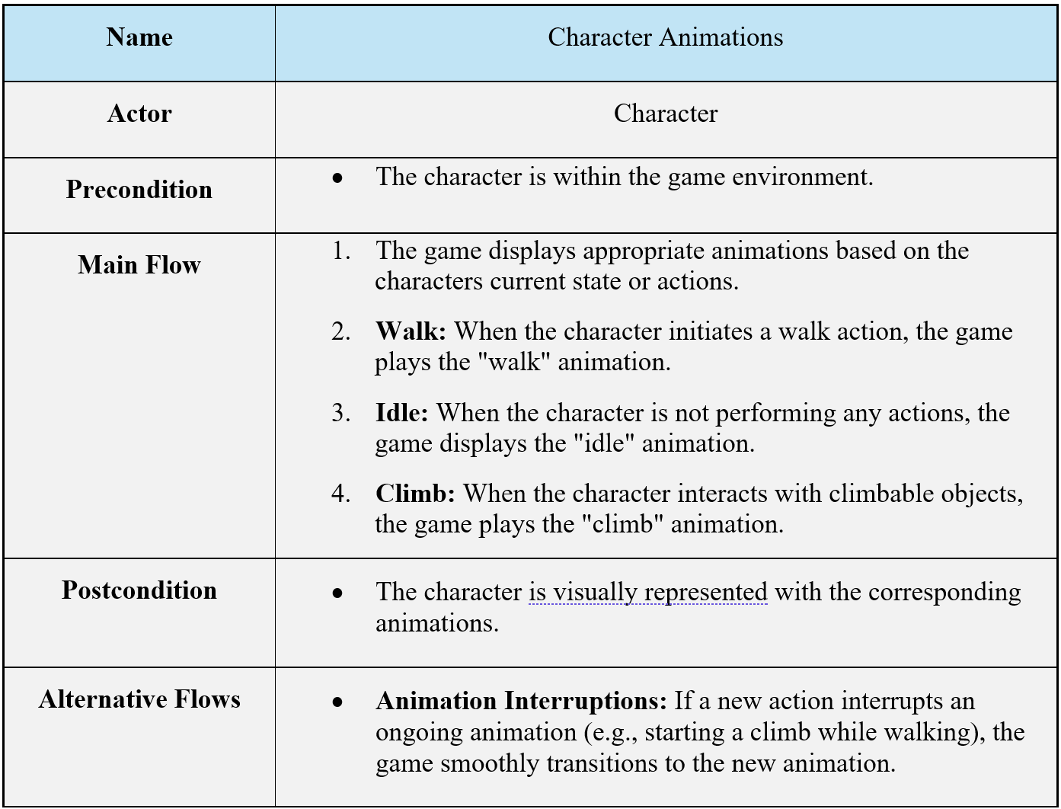
This use case was successfully implemented

Use Case 9
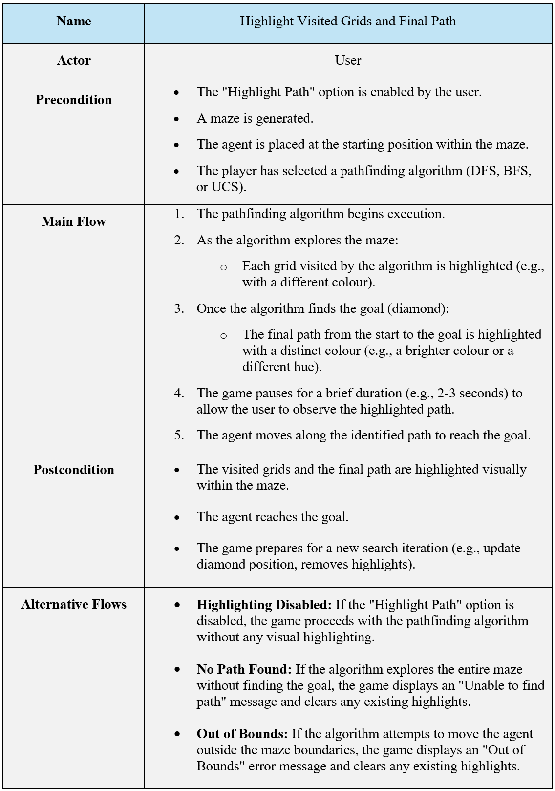
This use case was successfully implemented

Functional Requirements
This section outlines the specific features and capabilities the maze game system must have, focusing on the core functionalities and any user interactions.

List of Functional Requirements
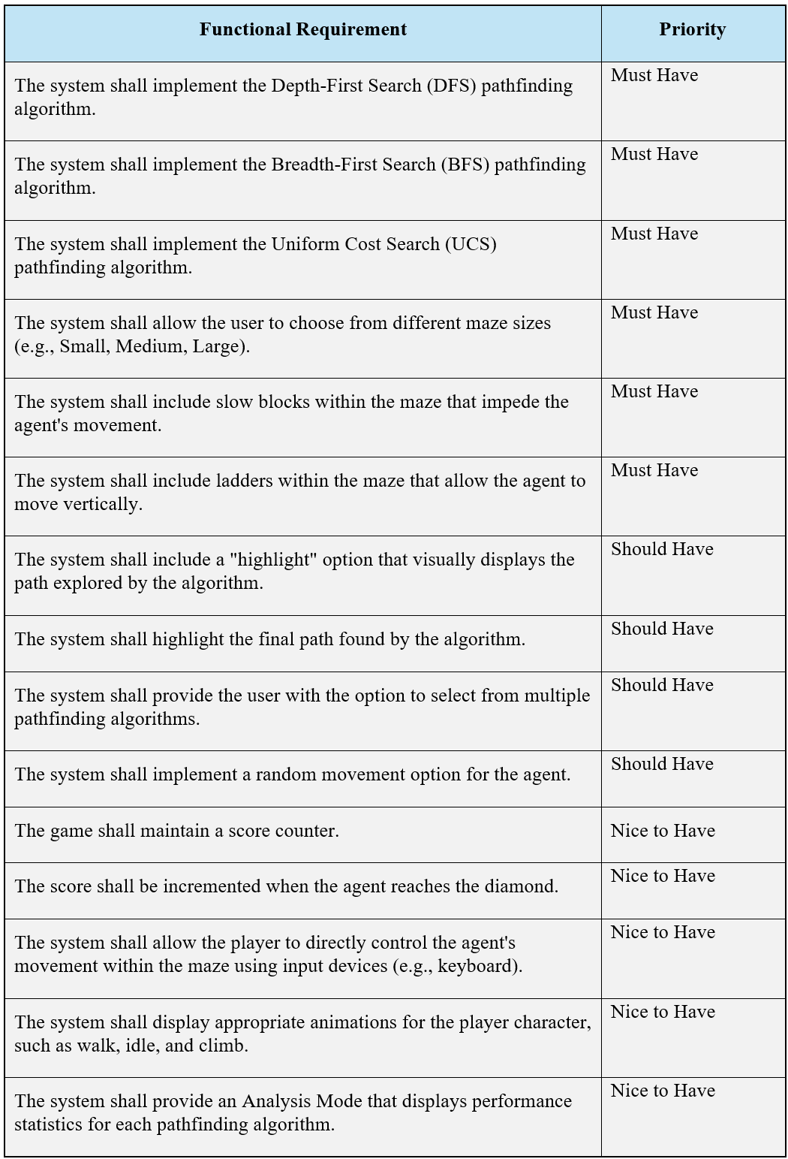

Implementation Status of Functional Requirements
All functional requirements have been met, except two that were only partially met; these are in the Nice-to-Have priority. The first is that the user can control the game with a keyboard, and the second is the analysis mode. They are partially met for the same reasons I mentioned in use case 6.

Non-Functional Requirements
Non-functional requirements define the quality attributes the software system must meet. They describe "how" the system should perform, rather than "what" it should do.

List of Non-Functional Requirements
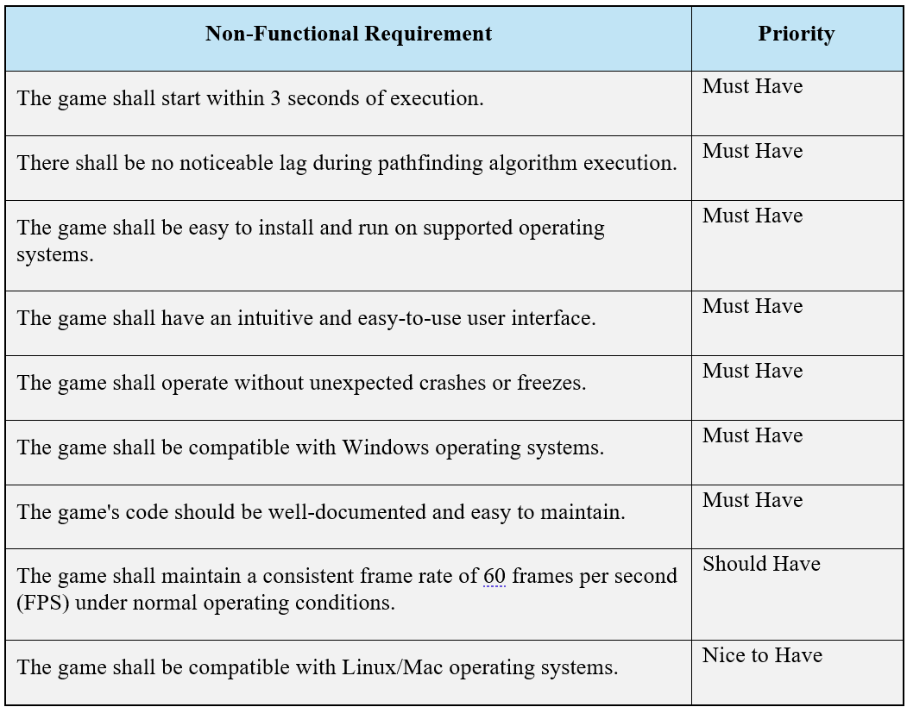

Implementation Status of Non-Functional Requirements
Most of the requirements have been fulfilled; however, there are two exceptions:
- "The game shall be compatible with Linux/Mac": While I believe the game is compatible, I have not tested it on these platforms, so I cannot confidently confirm that this requirement has been met.
- "The game shall operate without unexpected crashes": I encountered occasional unexpected crashes during development. There is still a corner case crash or freeze in the game that I have yet to resolve.

Development

UML Class Diagram
The UML Diagram for this system is quite complex. To maintain clarity and avoid visual clutter, Figure 2.1 presents a high-level overview of the classes and their relationships. This simplified diagram excludes attributes and methods for better readability.
Figure 2.1 also contains the three core classes within the application: Computer, World, and CharacterAnimationManager. I will now decompose and review the UML diagram in more detail to facilitate a deeper understanding of their interactions.
In the diagrams, a red colour next to a member or function indicates it is private, while green signifies it is public.
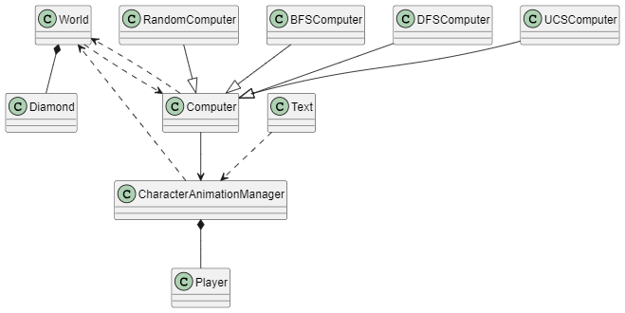
Figure 2.1 The Whole UML Class Diagram with no Functions/Attributes
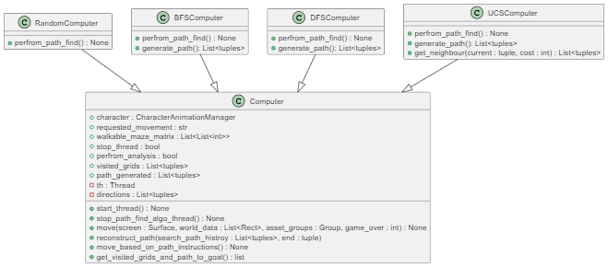
Figure 2.2 UML of Computer Class

Computer Class
This class represents the agent, which can take various forms. As shown in Figure 2.2, the Computer class has several child classes inheriting from it, like BFSComputer and DFSComputer, each implementing its respective algorithm.
You'll notice that the RandomComputer class doesn't have a generate_path() function, which makes sense since it moves around randomly and isn't designed to locate a diamond specifically.
The UCSComputer class includes an extra function compared to the other child classes, called get_neighbour(). This function is used to retrieve the cost of each neighbour for every vertex it processes.

CharacterAnimationManager Class
Before discussing CharacterAnimationManager, let's start with the Player class. This class represents an animation instance for a specific player. For example, a character that can be in the states of idle, walking, and climbing would require three different instances of the Player class to represent each animation.

The CharacterAnimationManager class includes a dictionary called animation_actions. When the set_char_animation() function is called, it creates an instance of the Player class and assigns it the input for the specific animation. As a result, the CharacterAnimationManager maintains a dictionary containing all animation instances. Based on movement inputs, either from the computer or the user, the manager determines which animation instance to activate.
The Player class is only initialized within the animation manager, establishing a composition relationship between the two.

Additionally, the Text class has a minor dependency on the CharacterAnimationManager. Its only requirement is access to the score variable, which it uses to display the score on the top right corner of the game screen through its draw() function.

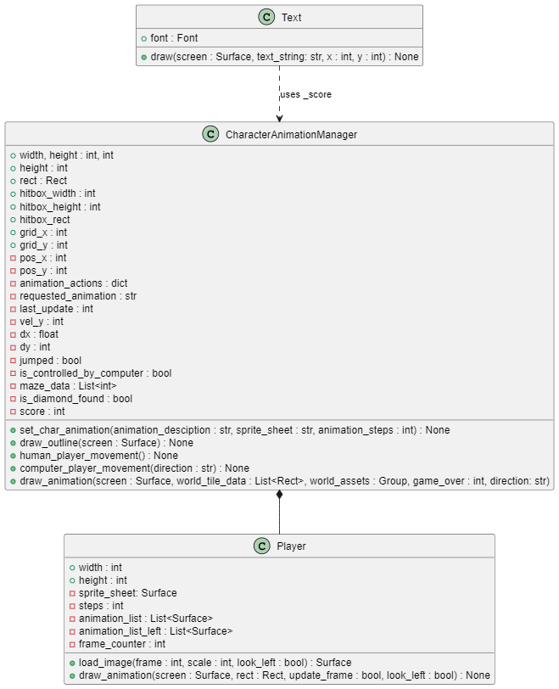
Figure 2.3 UML of CharacterAnimationManager Class
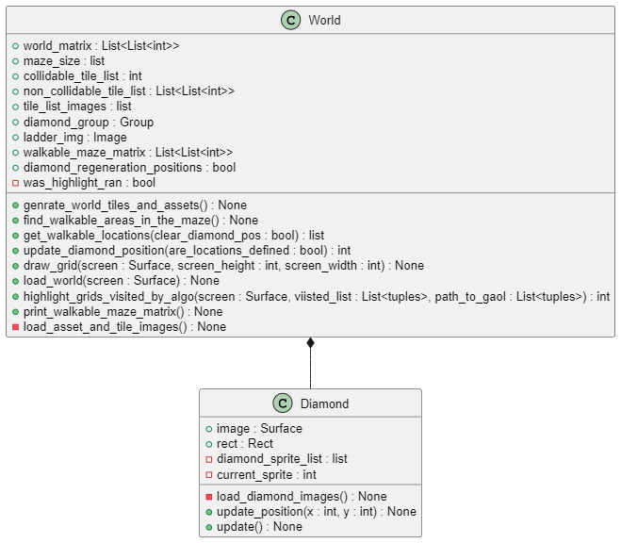
Figure 2.4 UML of World Class

World Class
The World class takes a matrix as input and converts it into a usable maze for Pygame. This is done by iterating through each grid in the matrix and transforming it into the appropriate asset based on its number. For example, a grid containing the number 3 will be converted into a ladder.
Also as shown in Figure 2.4, there is also a composition relationship involved here with the Diamond and World class, as the Diamond class is only instantiated by the World class. When the matrix is processed, whenever the number 2 is encountered, an instance of the Diamond class is created.

Relationships Between the Core Classes
To conclude, let's look at the relationships between the core classes, as illustrated in Figure 2.5.
The Computer class, also known as the agent, has an instance of the CharacterAnimationManager class to control the movements it wants the character to perform. This creates an association dependency between the two classes.
Additionally, the Computer class interacts with several members of the World class in some of its functions. For instance, the move() function takes world_data as an argument, corresponding to the collidable_tile_list member of the World class. This, therefore, establishes a dependency relationship between the two.
The World class calls the highlight_grids_visited_by_algo() function to visualize what a particular algorithm is doing behind the scenes. For this to work, it relies on the visited_grids and path_generated member variables from the Computer class, creating another dependency relationship.
When handling movement with the CharacterAnimationManager, we can't allow free movement. For instance, movement through walls should be restricted. To enforce this, the draw_animation() function takes world_tile_data, which corresponds to collidable_tile_list from the World class as an argument. This variable helps determine where the character can move. As a result, this also creates a dependency relationship.
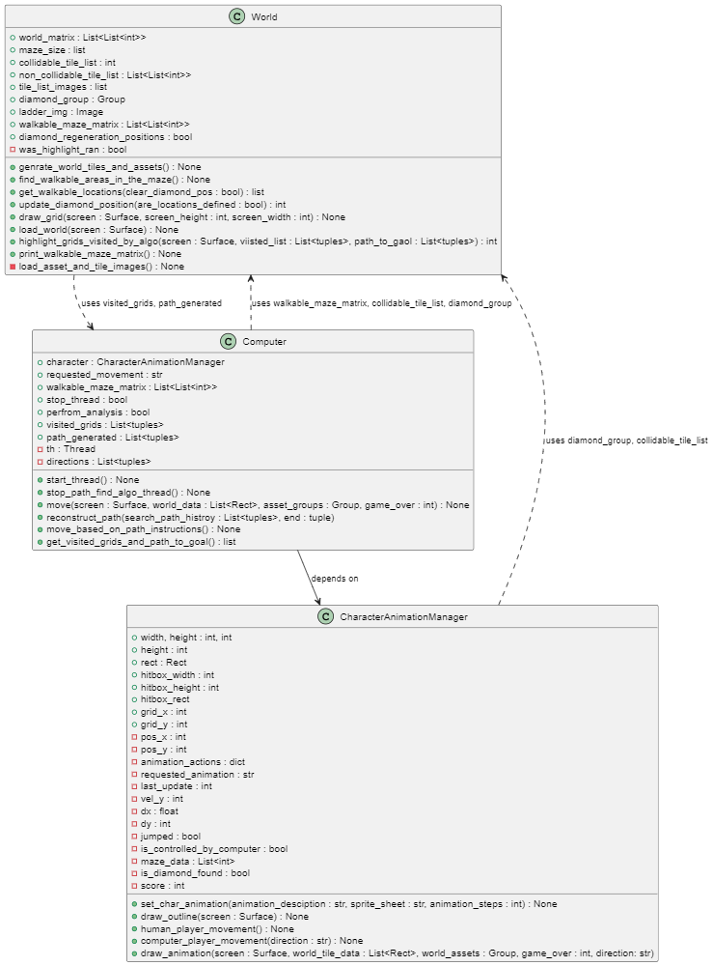
Figure 2.5 UML Relationship Between Core Classes

Algorithm Implementations
This section provides a technical overview of the implemented algorithms, examining their code structure and the specific techniques employed.

Threading
All the algorithms implemented so far utilize threading, so before proceeding, I will explain the software architecture I have developed for this.
To clarify, the game loop runs on the main thread, while a separate child thread executes the algorithm, determining and outputting the necessary movements. You might have noticed in the UML diagram (e.g., Figure 2.5) that there is a private thread attribute in the Computer class. This is to ensure that all subclasses of the Computer class inherit the threading logic.
The threading functionality is implemented using Python’s built-in threading library. The thread is initialized with the Computer class constructor, having the member variable named th.
self.th = threading.Thread(target=self.perfrom_path_find)
Now this does not start the thread, it just instantiates it. The thread only starts once the following function is called:
def start_thread(self) -> None:
""" Start the path find thread. """
self.th.start()
This function does not get called by any class; instead, the game loop in main.py will call it. There is a similar function for the stop thread; again, it gets called in the game loop of main.py when the user wants to close the application.

Design Patterns with Threading
In Section 2.2, I mentioned that I have used some design patterns in this application. Here, I will explain a major example where both the Observer and State Design Patterns have been applied.
I created a diagram (Figure 3.1) to complement my following explanation. To start, the Computer class has a member variable called requested_movement. Why is this important? This variable serves as the core of the threading architecture I have developed. The main thread executes the line:
computer.move()
It does not concern itself with what is happening behind the scenes (i.e., we are abstracting complex logic); it simply instructs the agent to move the character through the maze.
Within the move() function, there is a single line:
character.draw_animation(<some_arguments>, requested_movement)
This function moves the character based on the value of requested_movement. For example, if the value is "RIGHT", the character will move rightward. The main thread does not care how the value of requested_movement is updated; as long as it receives a valid movement instruction, it will operate accordingly.
The next question is: How is the value of requested_movement determined?
A separate child/algorithm thread manages this. The child thread calls a function named move_based_on_path_instructions(), which invokes generate_path()—the function implementing the algorithm. The output of generate_path() provides the path for the agent to follow. Using this path and the character's current coordinates will determine the value of requested_movement at any given moment.
So, this implementation demonstrates the following patterns:
- State Design Pattern: The requested_movement variable represents the states the character can be in, such as idle, move left, move right and climb. Therefore, the character's behaviour is determined by its current, which is controlled by requested_movment.
- Observer Design Pattern: The requested_movement variable acts as a shared state that is observed and modified by the child/algorithm thread. The modifying thread will observe the character's position and environment and update the value accordingly. Meanwhile, the main thread will continuously act based on the current value of requested_movement. This decoupling allows the main thread to remain oblivious to underlying logic while the child/algorithm thread updates the state as the character interacts with the maze.
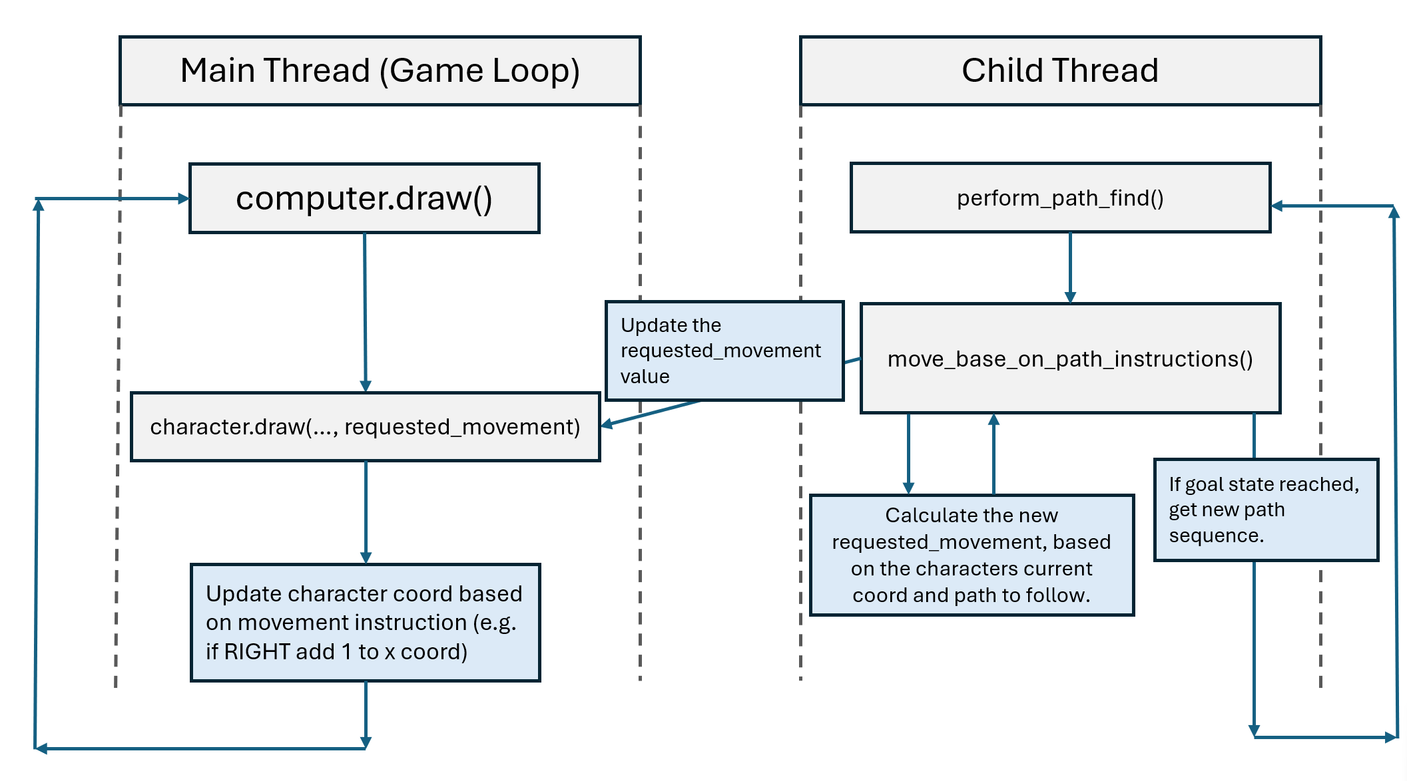
Figure 3.1 Coordination Between the Main and Child Threads for Character Movement

DFS/BFS Implementation
As mentioned earlier, the heart of each algorithm lies in its respective generate_path() function. For the DFS algorithm, I used three data structures to track the algorithm's progress:
- A stack
- A visited list
- And a search_path_history dictionary.
The purposes of the stack and visited list were already explained in Section 2.1.1; what's interesting is search_path_history. My BFS implementation is very similar, but instead of a stack, it uses a queue. Again, the interesting part is search_path_history, so although I’m talking in the context of DFS, similar principles apply to BFS.
DFS iterates through the stack, and within the loop, it examines the neighbours of the current grid/vertex. At the end of the loop, the following check is performed:
if(self._walkable_maze_matrix[next_grid[0]][next_grid[1]]!=0 and next_grid not in visited):
stack.append(next_grid
search_path_history[next_grid] = current
This ensures that if the neighbouring grid is walkable (i.e., its value is not zero) and hasn't been visited, it gets added to the stack, and the search_path_history dictionary stores the current grid as the predecessor of the new grid.
This step is crucial as it allows the algorithm to trace how it reached each vertex, which is essential for reconstructing the final path.

UCS Implementation
The implementation of UCS differs slightly from that of BFS and DFS. Its functionality relies on three key data structures: a fringe (priority queue), a costs dictionary, and a came_from dictionary. The role of the priority queue has already been discussed in Section 2.1.3, and the came_from dictionary operates similarly to search_path_history. However, the costs dictionary is particularly noteworthy.
The costs dictionary is structured as follows:
costs = {vertex: cheapest_cost_from_start_to_vertex}
Unlike the visited list in BFS/DFS, which only tracks vertices, the costs dictionary stores both the vertex and the cheapest cost to reach it from the start. This approach allows the algorithm to reconsider a vertex if it has managed to later on find a cheaper path to it.
The process of retrieving a vertex's neighbours is also worth mentioning. UCS uses its own function, get_neighbour, which takes the current vertex and corresponding cost as inputs and iterates through its neighbours.
If a neighbour corresponds to a non-walkable grid (value 0), it is skipped:
if (neighbour_grid_vlaue == 0):
continue
If the neighbour corresponds to free space (value 1) or a ladder (value 3), the cost is incremented by 1:
if (neighbour_grid_vlaue == 1 or neighbour_grid_vlaue == 3):
new_cost = cost + 1
If the neighbour corresponds to a slow block (value 4), the cost increases by 3:
elif (neighbour_grid_vlaue == 4):
new_cost = cost + 3
This approach ensures that UCS calculates the optimal path cost by considering the nature of each grid or vertex while traversing the graph.

Professional Issues

Ethical Use of External Resources
I wanted to implement images and animations for the maze game to keep my game engaging. I tried making my pixel art from scratch but quickly realised it's not my area of speciality. I like to learn new skills, and creating pixel art would've been fun. However, I had to manage my time effectively to complete the project within the deadline, and learning to make pixel art would've taken a significant portion of my time. So, instead, I acquired various online open-source assets, including maze images, character sprites and blocks. This allows me to focus more on developing the pathfinding algorithms, as I will be using premade assets instead of spending a week or 2 creating them from scratch. I made sure to credit any assets I have used in the README of my project.

Summary and Conclusion
In this report, I have demonstrated how I successfully completed all tasks outlined for the first term in the project specification. I have also provided the following: A requirements analysis in Chapter 4, detailing the use cases and the functional and non-functional requirements that have been met.
Reflecting on this term, the main challenge I faced was incorporating TDD. However, as discussed in Section 3.2, transitioning from a Test-After-Development approach initially allowed me to gradually and comfortably adopt a TDD workflow.
The next steps involve beginning work on the second term/final deliverables. This includes implementing the A* search algorithm and introducing adversaries, which will lead the way to developing a new set of algorithms. I want to conclude this report by outlining the motivation and plan for the second-term deliverables.
UCS has limitations because it's an uninformed algorithm[10]; it will have to explore unknown places with little guidance other than following the path with the lowest current cost. It will explore many grids where most will likely not lead to the goal, which wastes space and time. A star algorithm will solve this issue by using a heuristic to help guide it to the goal. The algorithm is essentially UCS, but with the addition of a heuristic, and if "done correctly", we should see an improvement in time and space and achieve the optimal path. In this case, the heuristic is "done correctly" if admissible (it will never overestimate the true cost [11]). Some strategies can achieve this, such as the Manhattan distance, which calculates the distance between a particular grid and a target grid.
Inserting adversaries in the game completely changes how we think about this problem; a normal agent isn't sufficient because it's simply trying to find an optimal solution in a maze without thinking about the actions of adversaries. There are strategic agents that deal with this problem and will discuss, but comparison with normal/strategic agents is not possible because they work in different environments. Comparisons, therefore, will be split into two separate groups.
Once the strategic agent finds that a randomly moving adversary is approaching, it must perform some action to avoid it. With a simple reflex agent, we can use its condition-action rule to observe the current state of the environment and then react accordingly. However, more is needed because a simple reflex agent does not have a goal [12]. It's just observing the environment, which is not helpful for our maze game, which is to collect all the diamonds. A goal-based agent [12] will solve this problem. It works like a reflex agent but with the addition of planning (i.e. finding a route to Diamond); in this case, the goal-based agent will use an A-star search for the planning stage. So we should have the goal-based agent running like an A* search, but when it spots an adversary, it will run away and plan another route.
Let's assume that the adversary is not randomly moving and uses some sophisticated logic to move around the map. This can be achieved with a min-max search agent, which is where each player (the agent and advisory) “attempts to minimise their prospective loss (penalty) while maximising the damage of their opponent” [13]. This algorithm will rely on recursive backtracking, meaning we would see an exponential increase in the depth of the min-max tree [13]. An alpha-beta agent will be beneficial in this case because it will prune any unwanted branches, so we should expect faster time with this agent compared to the min max. If the adversary makes sub-optimal solutions, then the alpha-beta and min-max agents won't work as it assumes the adversary is always choosing the optimal choice. An Expectimax agent can reason with imperfect agents/adversaries [14]. We can achieve this by exploring all possible outcomes at a particular grid and calculating/choosing the average score. I expect that with this approach, the agent will make the correct move most of the time.

Bibliography
[1] Kivelevitch, E.H. & Cohen, K., 2010. Multi-Agent Maze Exploration. Journal of Aerospace Computing, Information, and Communication, p. 391. Available at: https://www.researchgate.net/publication/257655885_Multi-Agent_Maze_Exploration [Accessed 2 October 2024]
[2] Elkari, B., Ourabah, L., Sekkat, H., Hsaine, A., Essaïouad, C., Bouargane, Y. & El Moutaouakil, K., 2021. Exploring Maze Navigation: A Comparative Study of DFS, BFS, and A Search Algorithms. Journal of Software Engineering and Computational Intelligence, pp. 762. Available at: http://www.iapress.org/index.php/soic/article/view/1939/1093 [Accessed 2 October 2024]
[3] Tech Sauce, 2021. Time Complexity and Space Complexity of DFS and BFS Algorithms. [online] Available at: https://techsauce.medium.com/time-complexity-and-space-complexity-of-dfs-and-bfs-algorithms-671217e43d58#:~:text=Breadth%20First%20Search%20%E2%80%94%20Space%20Complexity&text=In%20summary%2C%20the%20time%20complexity,)%2C%20in%20the%20worst%20case [Accessed 29 November 2024]
[4] Natarajan, S.P. & Mohan, A., 2009. A vision-based path planning on a distance map and its cellular array VLSI architecture. Proceedings of the IEEE International Symposium on Industrial Electronics (ISIE). Abstract available at: https://doi.org/10.1109/isie.2009.5214085. [Accessed 3 December 2024]
[5] Pathak, M.J., Patel, R.L. & Rami, S.P., 2018. Comparative Analysis of Search Algorithms. International Journal of Computer Applications, p. 40. Available at: https://www.researchgate.net/publication/333262471_Comparative_Analysis_of_Search_Algorithms [Accessed 3 October 2024]
[6] Conventional Commits 2020, Conventional Commits v1.0.0, 2024, https://www.conventionalcommits.org/en/v1.0.0/. [Accessed 3 December 2024]
[7] Gamma, E., Helm, R., Johnson, R. & Vlissides, J. 1993, Design patterns: Abstraction and reuse of object-oriented design, ECOOP’93—Object-Oriented Programming, p. 4. Available At: , https://cseweb.ucsd.edu/~wgg/CSE210/ecoop93-patterns.pdf. [Accessed 10th December 2024]
[8] Refactoring.Guru, 2024. State Design Pattern. [online] Available at: https://refactoring.guru/design-patterns/state [Accessed 10th December 2024].
[9] S. B. Lee, S. Y. Kwon, and H. R. Kim, 2010. A Study of Design Patterns in UML, Section II: Observer Pattern. IEEE Xplore. [online] Available at: https://ieeexplore.ieee.org/document/5982228 [Accessed 10th December 2024].
[10] Yan, Y., 2023. Research on the A Star Algorithm for Finding Shortest Path. Beijing-Dublin International College at BJUT, Beijing University of Technology, p. 154. Available at: https://www.researchgate.net/publication/370573811_Research_on_the_A_Star_Algorithm_for_Finding_Shortest_Path [Accessed 4 October 2024]
[11] Ouardi, A. & Mestari, M., 2023. Generating A-Star Algorithm Admissible Heuristics Using a Dynamic Dataloader on Neural Networks, Enhanced With Genetic Algorithms, on a Distributed Architecture. IEEE Access, p. 18356. Available at: https://www.researchgate.net/publication/368903314_Generating_A-Star_Algorithm_Admissible_Heuristics_Using_a_Dynamic_Dataloader_on_Neural_Networks_Enhanced_With_Genetic_Algorithms_on_a_Distributed_Architecture [Accessed 4 October 2024]
[12] Russell, S. & Norvig, P., 1995. Artificial Intelligence: A Modern Approach. 1st ed. Prentice-Hall, Inc. pp. 40-43. Available at: https://people.eecs.berkeley.edu/~russell/aima1e/chapter02.pdf [Accessed 5 October 2024].
[13] Shevtekar, S.S., Malpe, M. & Bhaila, M., 2023. Analysis of Game Tree Search Algorithms Using Minimax Algorithm and Alpha-Beta Pruning. Department of Computer Technology, Pune Institute of Computer Technology, Maharashtra, India, pp. 330-331. Available at: https://www.researchgate.net/publication/366169407_Analysis_of_Game_Tree_Search_Algorithms_Using_Minimax_Algorithm_and_Alpha-Beta_Pruning [Accessed 6 October 2024]
[14] Erdmann, J., 2013. Towards a Characterization of Chance in Games: The Case of Two-Player Zero-Sum Games with Perfect Information. Lehrstuhl für Mathematische Optimierung, Institut für Angewandte Mathematik, Fakultät für Mathematik und Informatik, Friedrich-Schiller-Universität, Jena, Germany, p. 5. Available at: https://www.researchgate.net/publication/237474023_Towards_a_Characterization_of_Chance_in_Games_The_Case_of_Two-Player_Zero-Sum_Games_with_Perfect_Information [Accessed 6 October 2024]

Appendix

Diary

Week 1
- I have been researching the project and making a rough plan for what I will do this year.

Week 2
- I have created the maze for the game, adding different tile types.
- I've also added character animations and movement. The animations I have added are idle, walk and jump.

Week 3
- Add collision detection with the character and the maze.
- A diamond is added to the game; the game will pause when the character collides with the diamond.

Week 4
Updates on Game
- Added logic so that diamonds can respawn randomly when the player collides with them; on top of this, I have added a score counter which increments every time the player collides with a diamond.
- I want to keep character movement strictly within four directions (up, down, left, right) because future algorithms I have planned will be easier to implement. If I allow the player to jump, they can perform movements outside the four directions I had intended. So, I plan to remove the jump functionality and replace it with a climbing movement instead.
- I have put ladders into the game, where players can climb up and down the ladder. This meant that I also added some climbing sprite animations for the player.
- I created a text class where I can pass in some text, and then in the main game loop, I call a function defined in the Text class to output it to the screen.
Updates on Algorithm
- The first algorithm for the agent has been implemented, where it will randomly move around the map.
- To implement the random pathfinding algorithm, I created a separate thread to randomly calculate the character's movement and then send the instruction to the character object on the main thread.
Refactor
- I have also begun to document the code; the code that has been documented so far is under world.py and text.py.

Week 5
Updates on Algorithm
- I have implemented the first real algorithm (BFS) the character will use to get to a diamond.
- When the diamond re-spawns, I have ensured the BFS algorithm will automatically start finding a path to the new diamond location.
- I have split the computer class into child classes; these will represent their algorithms—for example, BFSComputer and RandomComputer.
Testing
- I have written two test cases, one of which checks if there is a diamond in the maze.
- The other test checks if the BFS algorithm generates the expected path to the target.
Problems/Potential Issues
- There was an issue with threading because after I closed the main application, a child thread doing pathfinding kept running. To solve this, I added a function into computer.py, and when called, it should terminate any threads it had called.
- The BFS algorithm now finds a path; once a path is found, the character can move. I'm not sure if this will cause problems, but for now, this is how I have implemented it.
- When BFSComputer is running, the game is lagging. I'm pretty sure this is an issue related to the thread generated for pathfinding. Also, when RandomComputer is running, there is no noticeable lag.

Week 6
Updates to Algorithm
- I have implemented DFS.
Updates to Game
- I have added slow blocks to the game; these are tiles the user can walk on top of but will slow down their movement speed from 1 to 0.5.
- I added slow blocks to prove that pathfinding algorithms like BFS/DFS can find the shortest path but not the optimal one. It motivates people to work on a new pathfinding algorithm.
Problems and Fixes
- When I put the slow tiles into the game, there were a lot of bugs which had to be resolved this week.
- Firstly, the computer search algorithms threw errors after adding the slow blocks. This is because the walkable maze function was not appropriately generated, as it did not consider the addition of the slow blocks, leaving gaps (zeros) in the matrix. So, in most cases, finding a path was impossible. To fix this, I added an if statement to check for the slow blocks during generation.
- Then, the next issue I encountered was the movement, which I couldn't decrease from 1 to something like 0.5. This is because pygame.rect.x and pygame.rect.y do not accept float values. Passing float values will convert them into integers, meaning the player will stop (rounds down to 0) or continue working at normal speed (rounds up to 1). I figured out a "hacky" solution on to resolve this issue. Instead of changing the x/y values of the Rect, I can update its centre coordinates, allowing for decimal input. But then this caused issues with collisions, it was as if the character was walking through the maze. This is because I also had to change and update the hitbox Rect and manipulate its centre values.

Week 7
Updates on Game
- I created a medium-sized maze.
Updates on Algorithm
- Now that the game has slow tiles, different paths will have different costs. This means a new algorithm is needed to consider these factors, and the one I have implemented is Uniform Cost Search.
Problems and Fixes
- My implementation of UCS was initially problematic, as it did not find the most optimal path. I know this because I deliberately made a slow and fast path, and it will always go for the slow one because it was shorter in distance. This is because, up until now, the algorithm was checking the tiles over it and not under it. Everything had been working fine before because the tile values were all 1, but now that I had added slow tiles with a value of 2, I could spot this mistake.
Testing
- I have written test cases for the medium-size maze, testing the three path algorithms developed so far and seeing if they generate the expected path to the goal.

Week 8
Updates on Game
- I created a large maze, but the game window had to shrink a little to make the game look aesthetically pleasing, as there were some empty gaps around the maze.
Problems and Fixes
- Because the array size for the large maze was bigger than the others, the player's position was outside the maze (not in the game window). Therefore, I had to reposition the player's start coord to fix this.
Testing
- I have written tests for BFS, DFS, and UCS to see if it can generate a path in a large maze.
- I wrote another test for UCS to see if it would choose the faster path over the slower one.
Interim Report
- I have begun writing my interim report. I have written the abstract for now.

Week 9
GitLab Pipeline
- I have set up a pipeline on GitLab containing a build and testing stage.
- The build stage will create the mazes used for the game, and the testing stage will run all tests under the testing directory.
Interim Report
- I have written the project spec and overview.
- I have written aims and objectives.
- I have written background knowledge for DFS.
8.1.10 Week 10
GitLab Pipeline
- I have included a check style stage in the pipeline where the code must follow the Python flake8 style.
Problems and Fixes
- The algorithms crashed after it reached the diamond, so it wasn’t automatically finding a path for the new generated diamond. This is because when refactoring my code to follow the flake8 style, I accidentally removed a line that handles the generation of a new diamond.
Testing
- I have written a test to check if the algorithms can produce a path when the start state is a goal state.
Interim Report
- For background and theory, I have added information about BFS.
8.1.11 Week 11
Updates on the Game
- I have added a highlighter function highlighting the explored nodes from the currently in-use algorithm, which is coloured in red, and then the final path generated, which is coloured in blue.
- I have also added CLI logic to my application, which takes flags like size, algo, and highlight.
- I have developed some analysis "tools" which will output the time it took for a certain algo to run, the nodes visited and the final node distance from the start to the goal state.
Problems and Fixes
- The small and medium mazes had a lot of space surrounding them. When I tried to reduce the matrix size (i.e., eliminate all the unnecessary 1's causing the unwanted space), it would throw an out of index error.
- This error is because I set the pygame screen's width and height to be only compatible with the large maze. To fix this problem, I added conditional statements to adjust the screen size based on the maze size.
Testing
- I have added tests for the CLI; a new test file was needed for this called test_cli.py.
- I also learned how GUI testing works, so a new test file was created for this called test_find_path_gui.py. However, there is little time now for this term to do more GUI testing; I will either continue during Christmas break or the second term with this.
8.1.12 Week 12
Interim Report
- This week, I spent time finishing my interim report.

