Interim Report
Full Unit – Interim Report

Single-Agent and Multi-Agent Search in Maze Game

Hijithan Arunthavarajah

A report submitted in part fulfilment of the degree of
BSc (Hons) in Computer Science
Supervisor: Farid Shahandeh

Department of Computer Science
Royal Holloway, University of London

Declaration
This report has been prepared on the basis of my own work. Where other published and unpublished source materials have been used, these have been acknowledged.

Word Count:

Student Name: Hijithan Arunthavarajah

Date of Submission:

Signature: HIJITHAN
Table of Contents
Abstract 3
Project Specification 4
Chapter 1: Introduction 5
1.1 How to use this template 5
Chapter 2: Styles in Word 6
Chapter 3: Page Layout & Size 8
Chapter 4: Headings 9
4.1 Second Level Headings 9
4.2 A Word on Numbering 9
Chapter 5: Presentation issues 10
5.1 Figures, Charts and Tables 10
5.2 Source Code 10
Chapter 6: Table of Contents and References 11
Chapter 7: Project Information and Rules 12
Bibliography 13

Abstract
The agents within a maze-solving environment problem have a rich background in the computing world, becoming one of the fundamental concepts in the field of AI [1]. Today, this concept is used in various real-world applications, such as autonomous vehicles, navigation systems and rescue operations. This report aims to discuss some well-known path-finding algorithms in a maze game environment and compare how they perform with one another in terms of space and time as we increase the maze's scalability and complexity. From the algorithms chosen, we should expect noticeable changes in performance, especially as we scale them up.
BFS and DFS are fundamental traversal algorithms initially presented in this report, where BFS is always able to find the shortest path, unlike DFS, making it faster in most cases. However, it usually uses more memory because it queues vertices at every level, which only gets larger the deeper it goes. Though BFS can find the shortest path, it cannot find the most optimal one if adversarial elements are introduced. Uniform Cost Search will start considering the cost to find the optimal path, making it faster but more memory intensive as it stores all paths explored.
By the end of this interim report, we will have the motivation to develop the second phase of this project, such as A star search and then the introduction of enemies, which in turn means the development of min-max, alpha-beta, and expectimax agents.

Project Specification

First Term (Interim Deliverables)
- Design different maze models, we mainly want a small, medium and large maze.
- Give the player different movement options/animations such as: idle, walk and climb.
- Add slow tiles to the game, which slow player movement.
- Add a score counter.
- To save memory, store mazes in a csv file and load a particular maze into memory when in use.
- Implement a algorithm to randomise movement, this can also be a good algorithm to give to adversaries when they are initially implemented.
- Implement DFS/BFS path finding algorithms and compare how they perform against one another in terms of speed and memory, and on different maze sizes.
- Implement UCS which calculates the cost of the path to find the most optimal one. For example, if there is a slow tile then the cost should be +3 but if it’s a normal tile then it should be +1.

Todo Second Term (Final Deliverables)
- Implement A star search to help guide the agent and avoid exploring unnecessary paths we can use two different heuristics functions one where it calculates the Manhattan distance and another calculating the diagonal distance between the current grid the agent is in and the target grid.
- Add a new game mode where every cell contains a diamond and it’s the agent’s job to collect them all. NOTE: algorithms implemented thus far will not work for this new game mode, however the algorithms mentioned in points 3 and 4 will. Therefore, I will only compare between those two.
- Implement a greedy search algorithm where the Manhattan distance of the closet diamond to the agent.
- Implement a new version of the A* algorithm which works as normal except I will use the minimal spanning tree as my heuristic, that will find the cost of visiting all remaining diamonds based on the shortest path between.
- Add adversaries to the game, which will initially move around the map at random. In this case will make turn the agent into a reflex one. NOTE: As the previous algorithms have not got enemies in them, I will not compare those with the ones mentioned in points 5 -8. They will have their own comparisons.
- Implement a min-max agent where the agent and adversary look at the possible grids it can travel too and passes this to the evaluation function. The evaluation function will be calculated by subtracting the distance of the goal to the agent from the distance of the adversary to the agent. The distances will be calculated using the Manhattan method. Therefore, in this scenario the agent is the maximiser while the adversary is the minimiser.
- Now we need to improve min-max with alpha-beta pruning agent. Implement the alpha beta pruning algorithm. I will use the logic I have implemented in the min max agent but modify it to do some pruning as well.
- Next implement the expectimax agent. This will also use the same logic as the min-max algorithm but with a few changes. I will purposely randomise the adversary choices from time to time, meaning it will not always choose the optimal choice. For the agent, I will implement a function that will recursively explore possible outcomes of all moves then instead of choosing the most optimal outcome it will calculate the average score and go for that choice.

Introduction

Project Overview
This interim report will outline the progress with the single-Agent and Multi-Agent maze game project. The maze game will feature an agent/player with a clear objective: to collect diamonds randomly generated within the maze. Once all the diamonds have been collected, new ones will regenerate, creating a continuous challenge for the agent. The more diamonds the agent collects, the higher its score will be. However, the game will also present adversarial elements such as slow blocks that will add complexity to the agent’s task to get the optimal path. Currently four algorithms have been implemented which are: random movement, BFS, DFS and UCS.

Aims and Objectives
As mentioned earlier, the maze-solving environment problem is an important concept in various real-world applications, such as autonomous vehicles, navigation systems, and rescue operations. However, although this concept is extremely important, some may find it challenging or overwhelming to understand as there are so many path-finding approaches, with some having a lot of complexity. This project aims to visualise path-finding algorithms in an "engaging" maze environment to help users understand the types of path-finding approaches and how they work and differ. To make the maze "engaging," I have made the game look visually appealing using 2D-pixel art (credits given in the project's README) and animations.
I will also analyse the various path-finding agents and compare how well they do against each other in terms of space and time across different maze environments. It is important to note that comparisons will be split into sections to keep things fair. For example, comparing a BFS path-finding agent with an alpha-beta agent wouldn't be fair. The alpha-beta agent will be in a maze with enemies, spending time trying to avoid them, while BFS will simply find the path and go to it.

Background and Theory

Path Finding Approaches
For the first half of the project, I have researched 3 path finding algorithms, that I will be using for this maze game project.
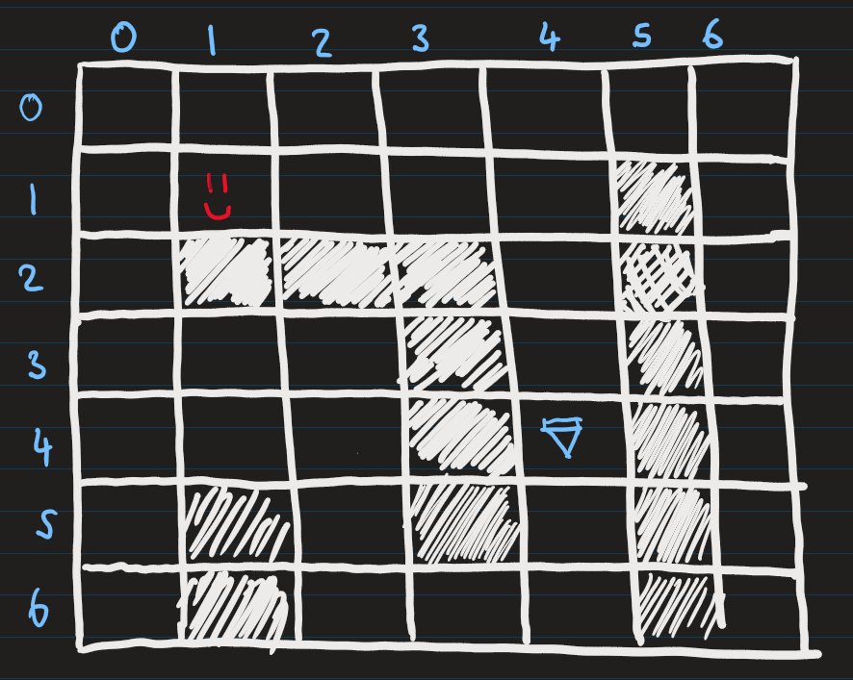
Figure 1.1: Maze with a player and diamond

DFS
With DFS, it will always traverse through one path in a maze and go down that path until it reaches the end. If it's a dead end, it will keep backtracking one space until it can find another route [2]. The algorithm will repeat this process until it reaches the goal. One problem with this algorithm is that it can go down an infinite path, meaning it will never get the goal state. Although the mazes generated in this project don't have such a path, I thought it's still worth considering. It also contains a visited list to avoid cycles.
To clarify how DFS works in a maze, let's take a look at an example. In the following example (Figure 1), the face represents the agent, and the diamond represents the goal. In DFS, a stack will be initialised in the background, and a data structure will be created to store which vertices have been visited. For this example, the movement priority will be (Left, Down, Right, Up) but you can design this however you want.
You can see that in the example below (Figure 1.2), the DFS agent eventually reaches the goal. Notice that on the vertex (0,6), it reaches a dead end and must backtrack upwards until it finds an unvisited node. You can also see this in the stack (Figure 1.3), where it backtracks and removes values. It eventually finds an unvisited vertex at (0,4) and moves rightwards to complete it. The end stack is shown in Figure 1.4.
Also, DFS does not find the shortest path in this instance. It took the longer route. However, in some instances, it can, for example, if I set the movement priority for the algorithm as (Right, Down, Left, Up). So, using DFS does not guarantee the shortest path will be found.

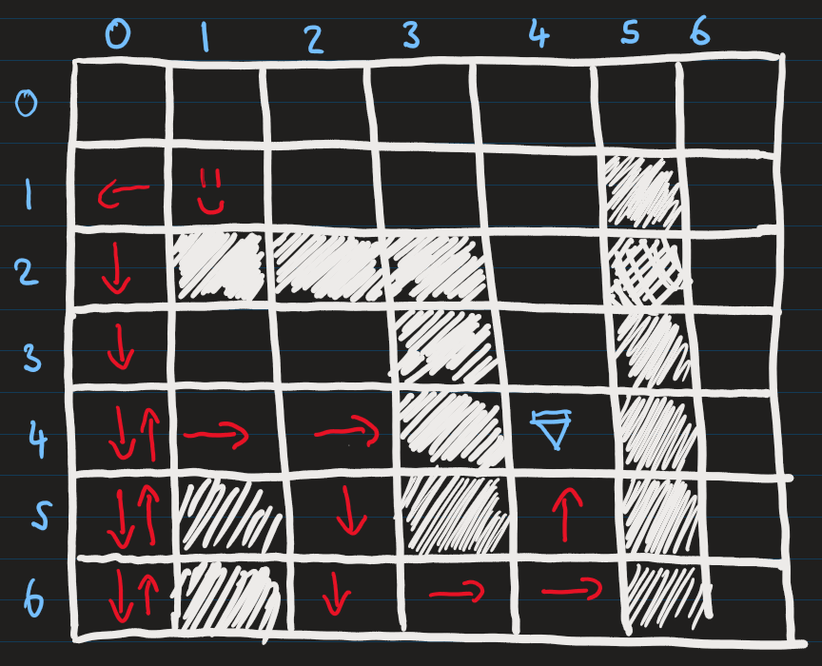
Figure 1.2 DFS finds the goal
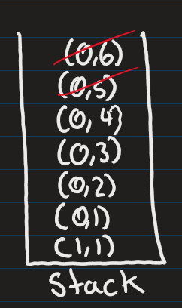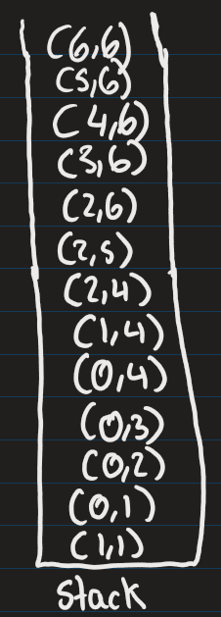
Figure 1.3 DFS stack backtracking Figure 1.4 DFS stack once it reaches the goal
The complxity of the algorithm will be O(V + E) where V is the number of verticies and E is the number adjacent connections between the vertices and the space complexity will be O(V) [3], as in the worst case it will visit every vertex and evey edge for each vertex.

BFS
Now, let's look at another similar algorithm called Breadth-First Search BFS, unlike DFS, which tunnels through one path. BFS will explore the maze layer by layer. Instead of a stack, it will use a queue and still have a visited list.
Let's take a closer look at how this works. We'll use the same maze (Figure 1.1) and movement priority. The algorithm begins by checking the neighbours of the current position and adding them to the queue. Once the neighbours are added, the algorithm removes the current position from the queue and moves on to the next vertex at the front of the queue. This process repeats until the goal state is reached.
In (figure), you can see areas shaded in grey, which represents the vertices the algorithm had visited; you can also see in (figure) the end queue with all the vertices that were put in the queue and a red slash to indicate the ones that were popped.
This time, the algorithm has found the shortest path, as seen with the red arrows in Figure 1; in fact, BFS will always find the shortest path [2] because a layer-by-layer approach traverses every path possible.
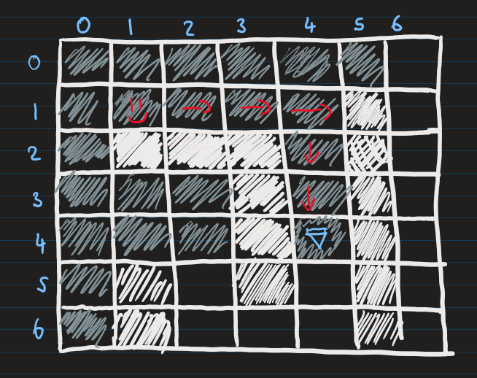
Figure 1.5 BFS finds the goal
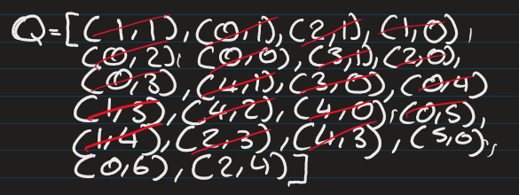
Figure 1.6 Queue used in BFS
The time and space complexity of BFS is the same as DFS, as at worst case it will have to visit all vertices at each level of the graph [3].

UCS
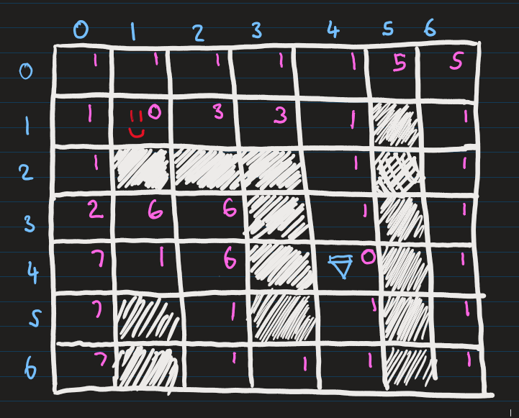
Figure 1.8 Maze map with costs

While Breadth-First Search (BFS) guarantees to find the shortest path in terms of the number of steps [4], it does not always find the most optimal path when additional factors, like costs or adversarial elements, are introduced. For instance, if an enemy slows the agent down on certain paths, BFS will not account for this slowdown. This limitation motivates the introduction of costs in the maze. As shown in Figure 1.8, a cost of 1 represents paths without adversarial elements, while a cost greater than 1 reflects the presence of such obstacles.

We use the Uniform Cost Search (UCS) algorithm to handle costs effectively. UCS operates similarly to BFS, expanding outward layer by layer but with a key difference: the data structure used to manage the frontier. While BFS uses a normal queue, UCS uses a priority queue which tracks the vertices and cumulative cost to reach each vertex. The priority queue ensures that nodes with the lowest cost are processed first.

Let's explore an example to understand how UCS works. Figure 1.10 illustrates the state of the priority queue and the visited list at different search stages. At stage 8, for instance, the algorithm evaluates vertex (2,0). From here, it could move downward to vertex (2,1) with a cost of 5. However, the priority queue already contains a cheaper path to (2,1), costing 3. Since UCS always prioritizes the lowest-cost path, it ignores the more expensive downward option.
As shown in Figure 1.9, this approach leads UCS to select the optimal path rather than the shortest path when costs are considered. The grey areas in the figure represent the maze parts that were visited during the search.

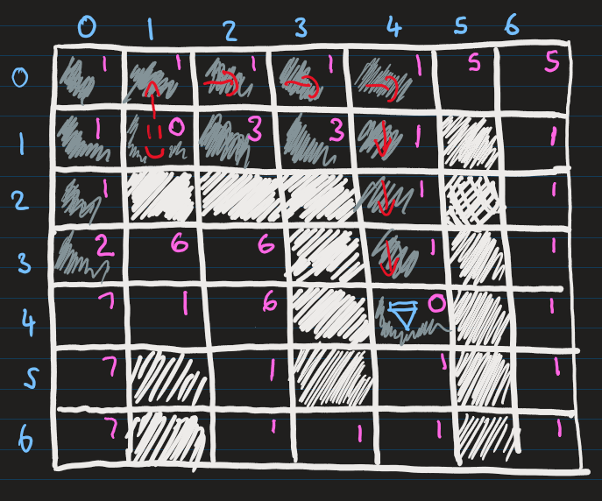

Figure 1.9 UCS finds the goal

The space and time complecity of the unifrom cost search algorithm will be O(b⌈C∗/ϵ⌉) [5], lets break this down. Let's say that every node has b branches coming out of it, and we stop at some level k, where this is the level the goal state will be in.

So we will have:
1 + b + b^2 + ....... + b^k = O(b^k)

Now, to calculate k, let's assume that C is the total cost of reaching the goal and, let's say, ϵ is the incremental step size or progress you make toward the goal at each step. So k is basically the number of steps needed to reach the goal state. So we can do C/ϵ to get the number of increments to fully cover C, but we also need to add one because the step was 0 at the start, so we end with C/ϵ + 1. This results in the space and time complexity that was mentioned above.
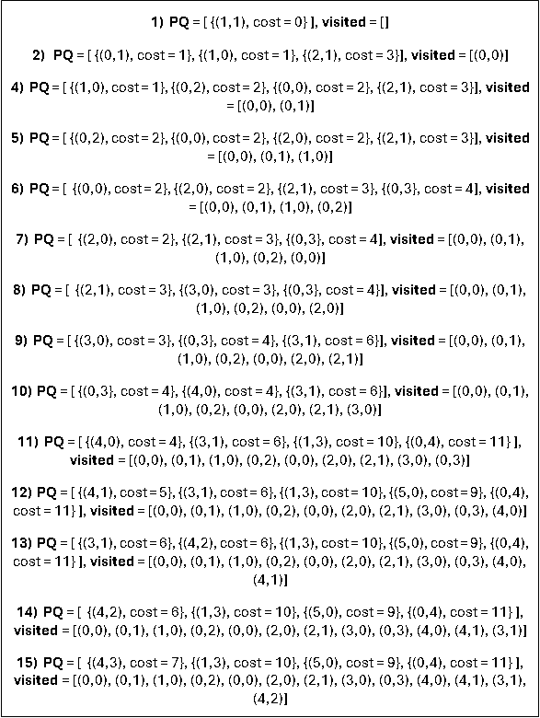

Figure 1.10 UCS finds the goal

Resources and Framework
For this project, I have chosen Pygame, a widely used Python library for creating 2D games and graphical simulations. Pygame helps me create straightforward and effective visualizations, like grid-based mazes and agent movement, which will allow me to remain focused on the main task, developing agents that perform pathfinding. Its flexibility makes it a great choice for showcasing single and multi-agent pathfinding algorithms.
I have also acquired various online open-source assets including maze images, agent sprites and blocks. Again, this allows me to focus more on the development of the pathfinding algorithms, as I will be using premade assets instead of spending a week or 2 creating them from scratch.

Software Engineering Principles

Version Control
I understand the importance of version control for this and most independent projects because although I'm working alone, it mitigates risks such as unexpected hardware failures or data loss that could jeopardize my work. To safeguard my project, I utilized Git and GitLab to manage and store my source code. However, simply using Git is not enough, and best practices must be followed to maintain a clear and organized development history.

To achieve this, I followed standards such as writing clear and descriptive commit messages, using branching effectively, and breaking changes into smaller, incremental commits over time rather than batching them in one go. This approach benefits both myself and others who may be interested in the project, as it provides a clear record of how the codebase evolved.

Whenever I work on a new feature, I will create a branch for it, ensuring the main branch always remains stable. For commit messages, I aimed to follow a consistent style inspired by the Conventional Commits standard (https://www.conventionalcommits.org/en/v1.0.0/). While I did not adhere to every standard aspect, I adopted key conventions such as labelling commits with prefixes like feat for new features, test for test cases, and ci for CI/CD pipeline updates. Following these conventions makes my commit history consistent, organized, and easy to read.

Testing
Testing was a challenge for me at the beginning of the term, but by the end (as reflected in my commit history), I had successfully transitioned to using Test-Driven Development (TDD). I plan to continue refining and applying this approach in the next term.
In my project plan, I initially committed to using TDD from the start. However, once I began working on the project, I realized it was much harder to implement than I anticipated, mainly due to the significant amount of GUI logic involved. Given my uncertainty about how to approach testing effectively in this context, I decided to adopt a "Test After Development" approach instead.

With Test After Development, I wrote tests immediately after completing a feature, such as an algorithm. This approach proved helpful early on because I clearly understood what needed to be tested, allowing me to write tests relatively quickly. However, I soon encountered its drawbacks because writing tests after finishing a rewarding task like developing a new feature would feel like a chore, making it challenging to stay consistent. Also, I noticed that this approach introduced bias into my tests as I would subconsciously focus on confirming that my implementation worked rather than testing for edge cases or failures.

Despite these drawbacks, I'm glad I started with Test After Development. It helped me build confidence and become more comfortable writing tests for this project, which ultimately allowed me to transition to TDD by the end of the term. It also helped improve my ability to test the GUI, something that would have been difficult to accomplish earlier in the process when I lacked a clear understanding of how the application would take shape.

Looking back, this gradual progression helped me grow as a developer. While Test After Development was helpful in getting started, I've now embraced TDD as a more robust and effective approach, and I plan to continue using it moving forward.

UML Class Diagram
The UML Diagram for this system is quite complex. To maintain clarity and avoid visual clutter, Figure 2.1 presents a high-level overview of the classes and their relationships. This simplified diagram excludes attributes and methods for better readability.
Figure 2.1 also contains the three core classes within the application: Computer, World, and CharacterAnimationManager. I will now decompose and review the UML diagram in more detail to facilitate a deeper understanding of their interactions.
In the diagrams, a red colour next to a member or function indicates it is private, while green signifies it is public
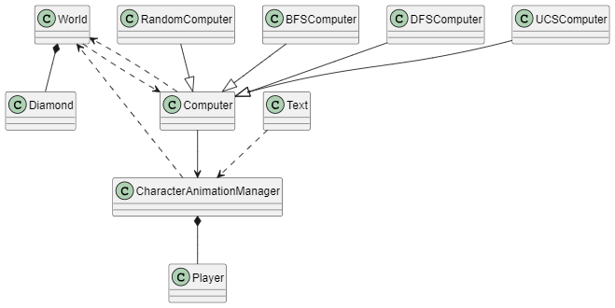
Figure 2.1 The Whole UML Class Diagram with no Functions/Attributes
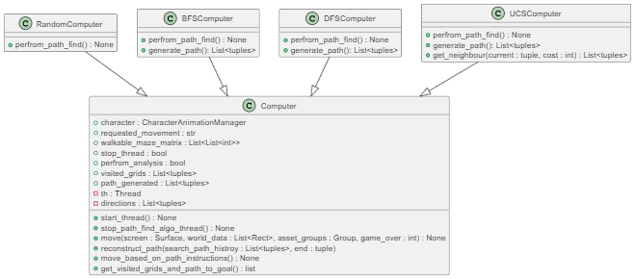
Figure 2.2 UML of Computer Class

Computer Class
This class represents the agent, which can take various forms. As shown in Figure 2.2, the Computer class has several child classes inheriting from it, like BFSComputer and DFSComputer, each implementing its respective algorithm.
You'll notice that the RandomComputer class doesn't have a generate_path() function, which makes sense since it moves around randomly and isn't designed to locate a diamond specifically.
The UCSComputer class includes an extra function compared to the other child classes, called get_neighbour(). This function is used to retrieve the cost of each neighbour for every vertex it processes.

CharacterAnimationManager Class
Before discussing the animation manager class, let's start with the Player class. This class represents an animation instance for a specific player. For example, a character that can be in the states of idle, walking, and climbing would require three different instances of the Player class to represent each animation.

The CharacterAnimationManager class includes a dictionary called animation_actions. When the set_char_animation() function is called, it creates an instance of the Player class and assigns it the input for the specific animation. As a result, the animation manager maintains a dictionary containing all animation instances. Based on movement inputs, either from the computer or the user, the manager determines which animation instance to activate.
The Player class is only initialized within the animation manager, establishing a composition relationship between the two.

Additionally, a text class has a minor dependency on the character animation manager. Its only requirement is access to the score variable, which it uses to display the score on the top right corner of the game screen through its draw() function.

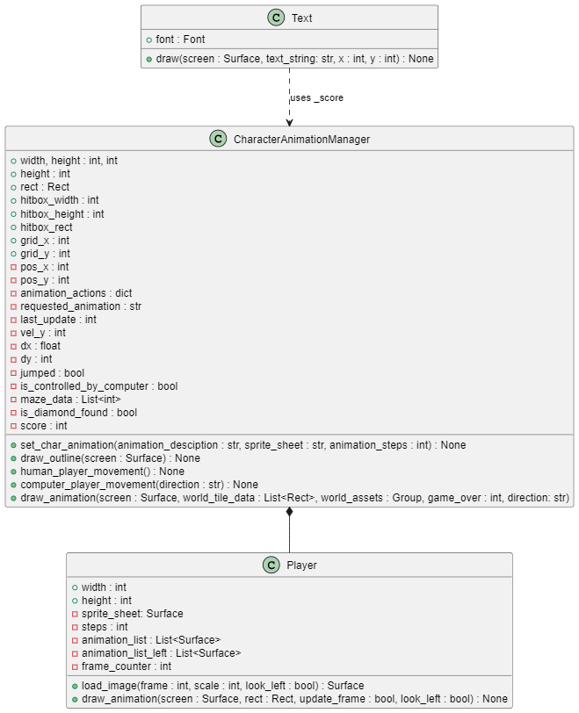
Figure 2.3 UML of CharacterAnimationManager Class
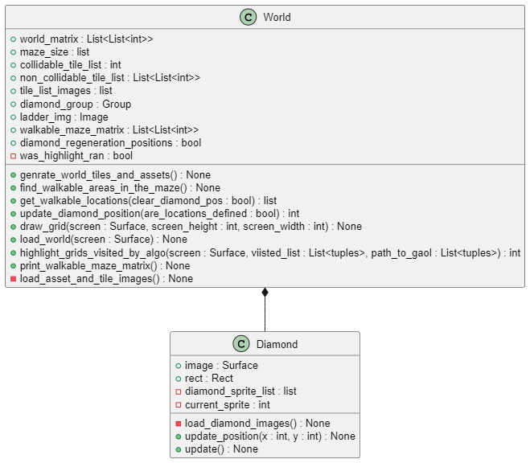
Figure 2.4 UML of World Class

World Class
The World class takes a matrix as input and converts it into a usable maze for Pygame. This is done by iterating through each grid in the matrix and transforming it into the appropriate asset based on its number. For example, a grid containing the number 3 will be converted into a ladder.
Also as shown in Figure 2.4, there is also a composition relationship involved here with the Diamond and World class, as the Diamond class is only instantiated by the World class. When the matrix is processed, whenever the number 2 is encountered, an instance of the Diamond class is created.

Relationships Between the Core Classes
To conclude, let's look at the relationships between the core classes, as illustrated in Figure 2.5.
The Computer class, also known as the agent, has an instance of the CharacterAnimationManager class to control the movements it wants the character to perform. This creates an association dependency between the two classes.
Additionally, the Computer class interacts with several members of the World class in some of its functions. For instance, the move() function takes world_data as an argument, corresponding to the collidable_tile_list member of the World class. This, therefore, establishes a dependency relationship between the two.
The World class calls the highlight_grids_visited_by_algo() function to visualize what a particular algorithm is doing behind the scenes. For this to work, it relies on the visited_grids and path_generated member variables from the Computer class, creating another dependency relationship.
When handling movement with the CharacterAnimationManager, we can't allow free movement. For instance, movement through walls should be restricted. To enforce this, the draw_animation() function takes world_tile_data, which corresponds to collidable_tile_list from the World class as an argument. This variable helps determine where the character can move. As a result, this also creates a dependency relationship.
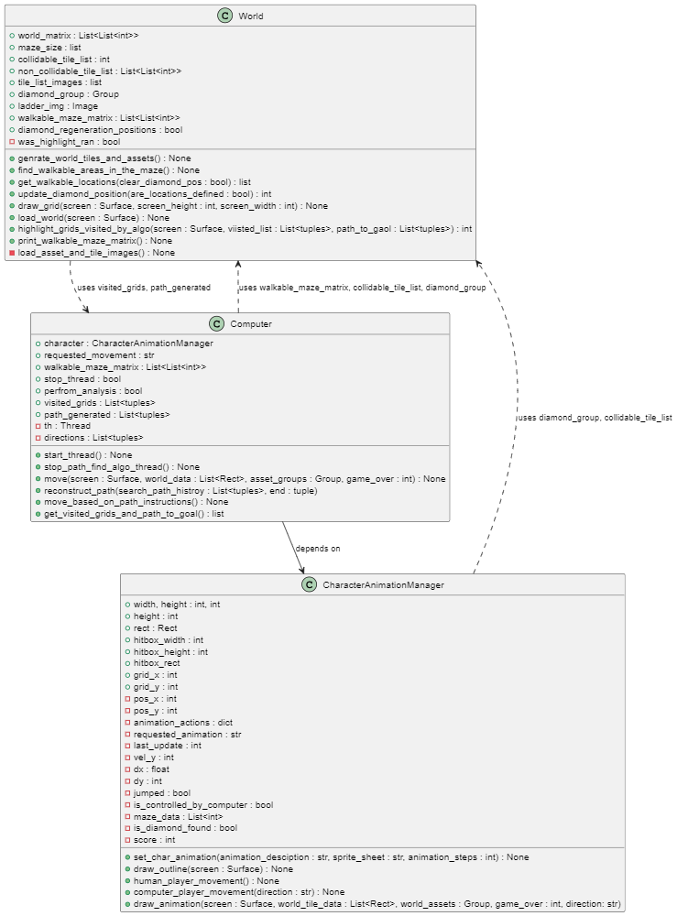
Figure 2.5 UML Relationship Between Core Classes

Requirements Analysis

Use Cases

Use Case 1
Name | Selecting a Maze
Actor | User
Precondition | - The game is initialized.
Main Flow | - The user selects the desired maze size from the available options (e.g., Small, Medium, Large).  - The game generates a new maze of the selected size.  - The game interface may be adjusted to accommodate the new maze size (e.g., screen resizing).
Postcondition | - The game is ready for the agent to start the search.
Alternative Flows | - Size Change: The user can change the maze size by selecting a different option.

Use Case 2
Name | Agent Finds Goal with DFS
Actor | Agent
Precondition | - A maze is generated.  - The agent is placed at the starting position within the maze.
Main Flow | - The agent executes the Depth-First Search (DFS) algorithm.  - DFS explores the maze by traversing deeper into branch before backtracking.  - The agent identifies a path to the goal (diamond).  - The agent moves along the identified path to reach the goal.  - The game increments the score counter.
Postcondition | - A new diamond is randomly placed within the maze.  - The agent then prepares for a new search iteration.
Alternative Flows | No Path Found: If DFS explores the entire maze without finding the goal, the game displays an "Unable to find path" message.  Out of Bounds: If the DFS exploration attempts to move the agent outside the maze boundaries, the game displays an "Out of Bounds" error message.

Use Case 3
Name | Agent Finds Goal with BFS
Actor | Agent
Precondition | - A maze is generated.  - The agent is placed at the starting position within the maze.
Main Flow | - The agent executes the Breadth-First Search (BFS) algorithm.  - BFS explores the maze level by level, searching for the nearest vertices first.  - The agent identifies the shortest path to the goal.  - The agent moves along the identified path to reach the goal.  - The game increments the score counter.
Postcondition | - A new diamond is randomly placed within the maze.  - The agent then prepares for a new search iteration.
Alternative Flows | - No Path Found: If BFS explores the entire maze without finding the goal, the game displays an "Unable to find path" message.  - Out of Bounds: If the BFS exploration attempts to move the agent outside the maze boundaries, the game displays an "Out of Bounds" error message.

Use Case 4
Name | Agent Finds Goal with UCS
Actor | Agent
Precondition | - A maze is generated.  - The agent is placed at the starting position within the maze.
Main Flow | - The agent executes the Uniform Cost Search (UCS) algorithm.  - UCS explores the maze by prioritizing nodes with the lowest path cost.  - The agent identifies the optimal path (lowest cost) to the goal.  - The agent moves along the identified path to reach the goal.  - The game increments the score counter.
Postcondition | - A new diamond is randomly placed within the maze.  - The agent then prepares for a new search iteration.
Alternative Flows | - No Path Found: If UCS explores the entire maze without finding the goal, the game displays an "Unable to find path" message.  - Out of Bounds: If the UCS exploration attempts to move the agent outside the maze boundaries, the game displays an "Out of Bounds" error message.  - Cost Calculation Error: If the algorithm encounters an error while calculating the cost of a path (e.g., invalid cost values), the game displays a "Cost Calculation Error" message.

Use Case 5
Name | Agent Encounters Slow Blocks
Actor | Agent
Precondition | - A maze is generated, including randomly placed "slow blocks."  - The agent is placed at the starting position within the maze.  - The agent is executing a pathfinding algorithm (DFS, BFS, or UCS).
Main Flow | - The agent moves through the maze.  - If the agent moves onto a slow block, its movement speed is reduced.
Postcondition | - The agent's movement speed is adjusted accordingly.
Alternative Flows | - No Slow Blocks Encountered: The agent moves through the maze without encountering any slow blocks.  - Multiple Slow Blocks Encountered: The agent may encounter multiple slow blocks during its pathfinding. The agent's movement speed is reduced accordingly for each encountered slow block.

Use Case 6
Name | Player Controls Agent
Actor | Agent
Precondition | - A maze is generated.  - The agent is placed at the starting position within the maze.  - The diamond is placed randomly within the maze.
Main Flow | - The player uses the keyboard to control the agent's movement within the maze.  - The game updates the agent's position based on the player's input.  - The game checks for collisions with walls. If the agent attempts to move into a wall, the movement is prevented.  - If the agent reaches the diamond, the game increments the score counter, displays a success message, and may initiate a new round.
Postcondition | - The agent's position is updated within the maze.  - The game state is updated accordingly (e.g., score, game over).
Alternative Flows | - Invalid Input: If the player provides invalid input (e.g., attempting to move outside the game window), the game ignores the input.

Use Case 7
Name | Agent can Randomly Move
Actor | Agent
Precondition | - A maze is generated.  - The agent is placed at the starting position within the maze.
Main Flow | - The agent randomly selects a direction (up, down, left, right).  - The agent attempts to move in the selected direction.  - If the movement is valid (does not lead into a wall), the agent updates its position.  - The agent repeats steps 1-3 continuously.
Postcondition | - The agent's position within the maze is updated.
Alternative Flows | - Blocked Movement: If the selected movement direction leads into a wall, the agent randomly selects a new direction.  - Reaching the Goal: If the agent randomly moves into the position of the diamond, the game can increment a score (if applicable) and either end the game or reposition the diamond.

Use Case 8
Name | Player Animations
Actor | User/Character/Player
Precondition | - The player is within the game environment.
Main Flow | - The game displays appropriate animations based on the player's current state or actions.  - Walk: When the player initiates a walk action, the game plays the "walk" animation.  - Idle: When the player is not performing any actions, the game displays the "idle" animation.  - Climb: When the player interacts with climbable objects, the game plays the "climb" animation.
Postcondition | - The player's character is visually represented with the corresponding animations.
Alternative Flows | - Animation Interruptions: If a new action interrupts an ongoing animation (e.g., starting a climb while walking), the game smoothly transitions to the new animation.

Use Case 9
Name | Highlight Visited Grids and Final Path
Actor | User
Precondition | - The "Highlight Path" option is enabled by the user.  - A maze is generated.  - The agent is placed at the starting position within the maze.  - The player has selected a pathfinding algorithm (DFS, BFS, or UCS).
Main Flow | - The pathfinding algorithm begins execution.  - As the algorithm explores the maze:  - Each grid visited by the algorithm is highlighted (e.g., with a different colour).  - Once the algorithm finds the goal (diamond):  - The final path from the start to the goal is highlighted with a distinct colour (e.g., a brighter colour or a different hue).  - The game pauses for a brief duration (e.g., 2-3 seconds) to allow the user to observe the highlighted path.  - The agent moves along the identified path to reach the goal.
Postcondition | - The visited grids and the final path are highlighted visually within the maze.  - The agent reaches the goal.  - The game prepares for a new search iteration (e.g., update diamond position, removes highlights).
Alternative Flows | - Highlighting Disabled: If the "Highlight Path" option is disabled, the game proceeds with the pathfinding algorithm without any visual highlighting.  - No Path Found: If the algorithm explores the entire maze without finding the goal, the game displays an "Unable to find path" message and clears any existing highlights.  - Out of Bounds: If the algorithm attempts to move the agent outside the maze boundaries, the game displays an "Out of Bounds" error message and clears any existing highlights.

Functional Requirements
This section outlines the specific features and capabilities the maze game system must have, focusing on the core functionalities and any user interactions.
Functional Requirement | Priority
The system shall implement the Depth-First Search (DFS) pathfinding algorithm. | Must Have
The system shall implement the Breadth-First Search (BFS) pathfinding algorithm. | Must Have
The system shall implement the Uniform Cost Search (UCS) pathfinding algorithm. | Must Have
The system shall allow the user to choose from different maze sizes (e.g., Small, Medium, Large). | Must Have
The system shall include slow blocks within the maze that impede the agent's movement. | Must Have
The system shall include ladders within the maze that allow the agent to move vertically. | Must Have
The system shall include a "highlight" option that visually displays the path explored by the algorithm. | Should Have
The system shall highlight the final path found by the algorithm. | Should Have
The system shall provide the user with the option to select from multiple pathfinding algorithms. | Should Have
The system shall implement a random movement option for the agent. | Should Have
The game shall maintain a score counter. | Nice to Have
The score shall be incremented when the agent reaches the diamond. | Nice to Have
The system shall allow the player to directly control the agent's movement within the maze using input devices (e.g., keyboard). | Nice to Have
The system shall display appropriate animations for the player character, such as walk, idle, and climb. | Nice to Have
The system shall provide an Analysis Mode that displays performance statistics for each pathfinding algorithm. | Nice to Have

Non-Functional Requirements
Non-functional requirements define the quality attributes the software system must meet. They describe "how" the system should perform, rather than "what" it should do.
Non-Functional Requirement | Priority
The game shall start within 3 seconds of execution. | Must Have
There shall be no noticeable lag during pathfinding algorithm execution. | Must Have
The game shall be easy to install and run on supported operating systems. | Must Have
The game shall have an intuitive and easy-to-use user interface. | Must Have
The game shall operate without unexpected crashes or freezes. | Must Have
The game shall be compatible with Windows operating systems. | Must Have
The game's code should be well-documented and easy to maintain. | Must Have
The game shall maintain a consistent frame rate of 60 frames per second (FPS) under normal operating conditions. | Should Have
The game shall be compatible with Linux/Mac operating systems. | Nice to Have

Diary
The diary in my repository provides comprehensive information and incorporating it entirely into the report would increase the word count by around 1500. Instead, I will highlight and summarize the main points from each week's activities in the report. For further details, the full diary is available in the repository. Most weeks involved significant testing and bug fixing, which I have not included here but can be found in the original diary.

Week 1
- I have been doing research for the project and making a rough plan of what I will be doing this year.

Week 2
- I have created the maze for the game, adding different tile types.
- I added character animations and movement. The animations I have added are idle, walk and jump.

Week 3
- Add collision detection with the character and the maze.
- Add a diamond into the game; the game will pause when the character collides with the diamond.

Week 4
- Added logic such that the diamond respawns when the player collides with it.
- Added a score counter.
- Added a random movement algorithm.
- Removed jump functionality and replaced it with a climb to keep the player's movement in 4 directions (top, down, left and right).
- Add climb animation for the player.
- Add ladders into the games for the player to climb.
- Create a text class, which is used to output the score.

Week 5
- I have implemented the first path-finding algorithm (BFS) the character will use to get to a diamond.
- When the diamond re-spawns, I have ensured the BFS algorithm will automatically start finding a path to the new diamond location.

Week 6
- I have implemented DFS.
- I have added slow blocks to the game; these are tiles the user can walk on top of but will slow down their movement speed from 1 to 0.5.

Week 7
- I implemented the uniform cost search algorithm.
- I added a medium size maze.

Week 8
- I spent time writing up my interim report. For now, it's just the abstract.
- I have created a large maze.

Week 9
- I have written the project specifications, aims and objectives, and overview for the interim report. I have also written background theory for DFS.
- I have set up a pipeline on GitLab containing a build and test stage.

Week 10
- I have finished talking about the algorithms for background and theory in the interim report.
- I have included the flake8 check style as a stage in the pipeline.

Week 11
- I have incorporated CLI functionality into my application, allowing it to accept flags such as size, algo, and highlight.
- Additionally, I implemented a highlighter feature that visually marks the nodes explored by the active algorithm in red while the final path is displayed in blue.
- I also developed analysis tools that provide insights such as the time a specific algorithm takes to execute, the number of nodes visited, and the final distance from the starting node to the goal state.

Week 12
- This week I spent time finishing my interim report and practicing for presentation.

Bibliography
[1] Kivelevitch, E.H. & Cohen, K., 2010. Multi-Agent Maze Exploration. Journal of Aerospace Computing, Information, and Communication, p. 391. Available at: https://www.researchgate.net/publication/257655885_Multi-Agent_Maze_Exploration [Accessed 2 October 2024]
[2] Elkari, B., Ourabah, L., Sekkat, H., Hsaine, A., Essaïouad, C., Bouargane, Y. & El Moutaouakil, K., 2021. Exploring Maze Navigation: A Comparative Study of DFS, BFS, and A Search Algorithms. Journal of Software Engineering and Computational Intelligence, pp. 762. Available at: http://www.iapress.org/index.php/soic/article/view/1939/1093 [Accessed 2 October 2024]
[3] Tech Sauce, 2021. Time Complexity and Space Complexity of DFS and BFS Algorithms. [online] Available at: https://techsauce.medium.com/time-complexity-and-space-complexity-of-dfs-and-bfs-algorithms-671217e43d58#:~:text=Breadth%20First%20Search%20%E2%80%94%20Space%20Complexity&text=In%20summary%2C%20the%20time%20complexity,)%2C%20in%20the%20worst%20case [Accessed 29 November 2024]
[4] Natarajan, S.P. & Mohan, A., 2009. A vision-based path planning on a distance map and its cellular array VLSI architecture. Proceedings of the IEEE International Symposium on Industrial Electronics (ISIE). Abstract available at: https://doi.org/10.1109/isie.2009.5214085. [Accessed 3 December 2024]
[5] Pathak, M.J., Patel, R.L. & Rami, S.P., 2018. Comparative Analysis of Search Algorithms. International Journal of Computer Applications, p. 40. Available at: https://www.researchgate.net/publication/333262471_Comparative_Analysis_of_Search_Algorithms [Accessed 3 October 2024]

