NETWORKS AND COMMUNICATION LAB(CSE 1004)

NAME:MIRTUNJAY KUMAR
REG.NO:16BCE1179
SLOT:L1+L2
PROF.:DEIVANAI K

1. Write a client server Chat program using TCP socket.

CLIENT.C

#include <sys/types.h>
#include <sys/socket.h>
#include<stdio.h>
#include<netinet/in.h>
#include<string.h>
#include<stdlib.h>

int main()
{
struct sockaddr_in servaddr;
char buf[100];
char str[100];
servaddr.sin_addr.s_addr=htonl(INADDR_ANY);
servaddr.sin_family=AF_INET;
servaddr.sin_port=htons(2000);

//socket
int s;
s=socket(AF_INET,SOCK_STREAM,0);
if(s)
printf("Socket Created\n") ;
else
printf("Socket not Created\n");
//socket done

//listening
int conn=connect(s,(struct sockaddr*)&servaddr,sizeof(servaddr));

if(conn<0)
printf("Connect Failed\n");
else
printf("Connected \n");
while(strcmp(buf,"bye")!=0)
{
printf("\nenter your message:");
gets(buf);
send(s,buf,strlen(buf),0);
recv(s,str,30,0);
printf("\nreply is:%s",str);
int i;
for(i=0; i<strlen(str); i++)
str[i] = ' ';

for(i=0; i<strlen(buf); i++)
buf[i] = ' ';

}
//strcpy(buf,ctime(80));
//send(s,buf,strlen(buf),0);
}

OUTPUT:
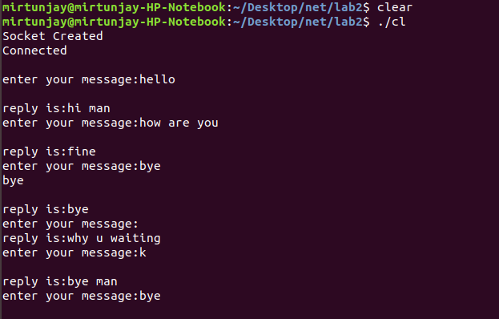

SERVER.C
#include <sys/types.h>
#include <sys/socket.h>
#include<stdio.h>
#include<netinet/in.h>
#include <arpa/inet.h>
#include <unistd.h>
#include<string.h>
#include<stdlib.h>

int main()
{
struct sockaddr_in servaddr,caddr;
servaddr.sin_addr.s_addr=htonl(INADDR_ANY);
servaddr.sin_family=AF_INET;
servaddr.sin_port=htons(2000);
char buf[100],str[100];
//socket
int s;
s=socket(AF_INET,SOCK_STREAM,0);
if(s)
printf("Socket Created\n") ;
else
printf("Socket not Created\n");
//socket done

int sd2;

sd2=bind(s,(struct sockaddr*) &servaddr,sizeof(servaddr));

if(sd2<0)
printf("Can't Bind\n");
else
printf("Binded\n");

//listening
int lis=listen(s,5);
int csize=sizeof(caddr);
int acc=accept(s, (struct sockaddr *) &caddr,&csize);

if(acc<0)
printf("Can't Accept\n");
else
{
printf("Accepted\n");
printf("Client address : %s\n",inet_ntoa(caddr.sin_addr));

}

while(recv(acc,buf,30,0)&&strcmp(buf,"bye")!=0)
{

printf("\n%s\n",buf);
printf("\nenter your reply:");
gets(str);
send(acc,str,strlen(str),0);
int i;
for(i=0; i<strlen(str); i++)
str[i] = ' ';
for(i=0; i<strlen(buf); i++)
buf[i] = ' ';

}

close(s);
close(sd2);
}

OUTPUT:
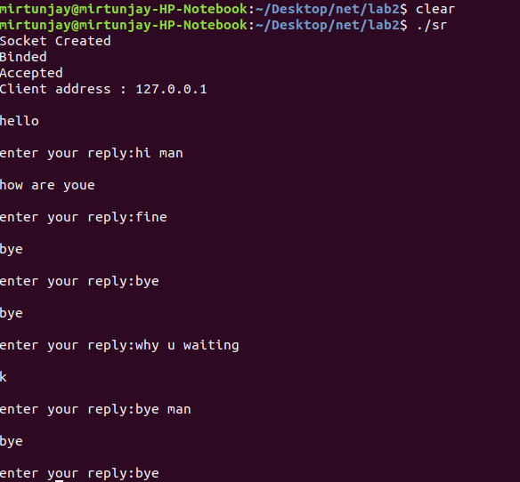

2. Write a client server program using UDP socket to sent "VIT University" message from client and "An opportunity to learn and grow" message from server.

UDP CLIENT.C
#include <stdio.h>
#include <sys/socket.h>
#include <netinet/in.h>
int main()
{
int PORT=2000;
char msg[1024];
struct sockaddr_in addr;
socklen_t addr_size;

int fd = socket(AF_INET, SOCK_DGRAM, 0);
if(fd<0)
{
printf("Error, Port not created\n");
}
else
{
printf("Port created\n");
}

addr.sin_port = htons(PORT);
addr.sin_family = AF_INET;
addr.sin_addr.s_addr = htons(INADDR_ANY);

addr_size= sizeof(addr);
while(1)
{
printf("You : ");
fgets(msg,1024,stdin);
sendto(fd,msg,1024,0,(struct sockaddr *)&addr,addr_size);
recvfrom(fd,msg,1024,0,NULL, NULL);
printf("Server : %s",msg);
}
}

OUTPUT:
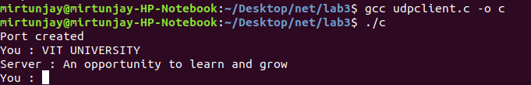

UDPSERVER.C

#include <stdio.h>
#include <string.h>
#include <sys/socket.h>
#include <netinet/in.h>
#include <arpa/inet.h>
int main()
{
int PORT=2000;
char msg[1024];
struct sockaddr_in addr;
socklen_t addr_size;

int fd = socket(AF_INET, SOCK_DGRAM, 0);
if(fd <0)
{
printf("Error, Port not created\n");
}
else
{
printf("Port created\n");
}

addr.sin_port = htons(PORT);
addr.sin_family = AF_INET;
addr.sin_addr.s_addr = htonl(INADDR_ANY);

int bd = bind(fd, (struct sockaddr *)&addr,sizeof(struct sockaddr_in) );
if(bd <0)
{
printf("Error binding socket\n");
}
else
{
printf("Successfully bound to port %u\n", PORT);
}
addr_size = sizeof(addr);
while(1)
{
recvfrom(fd,msg,1024,0,(struct sockaddr *)&addr, &addr_size);
printf("Client (%d) : %s",ntohs(addr.sin_port),msg);
printf("You : ");
fgets(msg,1024,stdin);
sendto(fd,msg,1024,0,(struct sockaddr *)&addr,addr_size);
}
}

OUTPUT:

