NAME:MIRTUNJAY KUMAR
REG.NO:16BCE1179
Network communication
Lab exercise - 05 Feb 18
slot: l1-l2

QUESTION:Write a time server program. The Time server gives time to its clients. The client may be any computer
in lab 406. The time server responds as "Welcome to VIT Time server - Current Date/Time is 5 th Feb,
09:12 Hrs.
The admin can terminate the Time server by sending the message " Terminate TS".

UTIL.H(HEADER FILE)

#include "util.h"
#include <stdio.h>
#include <stdlib.h>
#include <time.h>
#include <string.h>

char* getTimeStamp(){
time_t t = NULL;
char* message = "1172 time server running: ";
char* temp = ctime(&t);
char* ret = (char*)malloc(sizeof(char)*(strlen(message)+strlen(temp))+1);
strcpy(ret, message);
strcat(ret, temp);
return ret;
}

int main(){
int PORT = 5000;
int type = 1; // TCP
const char* QUIT_MESSAGE = "quit";
Create(type);
Configure(PORT);
Bind();
Listen();
printf("Listening on port %d\n", PORT);
Accept();
printf("Client connected.\n");
Recv();
while(1){
if(strlen(buffer)==0||strcmp(buffer, QUIT_MESSAGE)==0){
printf("Exiting.\n");
Send("quit");
break;
}
char* toSend = getTimeStamp();
printf("Received: %s\n", buffer);
printf("Sending: %s\n", toSend);
Send(toSend);
Recv();
}
Close();
printf("Connection closed.\n");
return 0;
}

SERVER.C

#include "util.h"
#include <stdio.h>

int main(){
int PORT = 5000;
char serv_addr[15];
printf("Enter IP address of server: ");
scanf("%s", serv_addr);
const char* QUIT_MESSAGE = "quit";
int type = 1;
char input_buffer[100];
Create(type);
ConfigureC(PORT, serv_addr);
Connect();
printf("Send quit to terminate.\n");
while(1){
printf(">");
scanf("%s", input_buffer);
Send(input_buffer);
Recv();
if(strcmp(buffer, QUIT_MESSAGE)==0){
printf("Disconnected.\n");
break;
}
printf("Received: %s\n", buffer);
}
Close();
return 0;
}

SERVER.C

#include "util.h"
#include <stdio.h>
#include <stdlib.h>
#include <time.h>
#include <string.h>

char* getTimeStamp(){
time_t t = NULL;
char* message = "1172 time server running: ";
char* temp = ctime(&t);
char* ret = (char*)malloc(sizeof(char)*(strlen(message)+strlen(temp))+1);
strcpy(ret, message);
strcat(ret, temp);
return ret;
}

int main(){
int PORT = 5000;
int type = 1; // TCP
const char* QUIT_MESSAGE = "quit";
Create(type);
Configure(PORT);
Bind();
Listen();
printf("Listening on port %d\n", PORT);
Accept();
printf("Client connected.\n");
Recv();
while(1){
if(strlen(buffer)==0||strcmp(buffer, QUIT_MESSAGE)==0){
printf("Exiting.\n");
Send("quit");
break;
}
char* toSend = getTimeStamp();
printf("Received: %s\n", buffer);
printf("Sending: %s\n", toSend);
Send(toSend);
Recv();
}
Close();
printf("Connection closed.\n");
return 0;
}

OUTPUT:

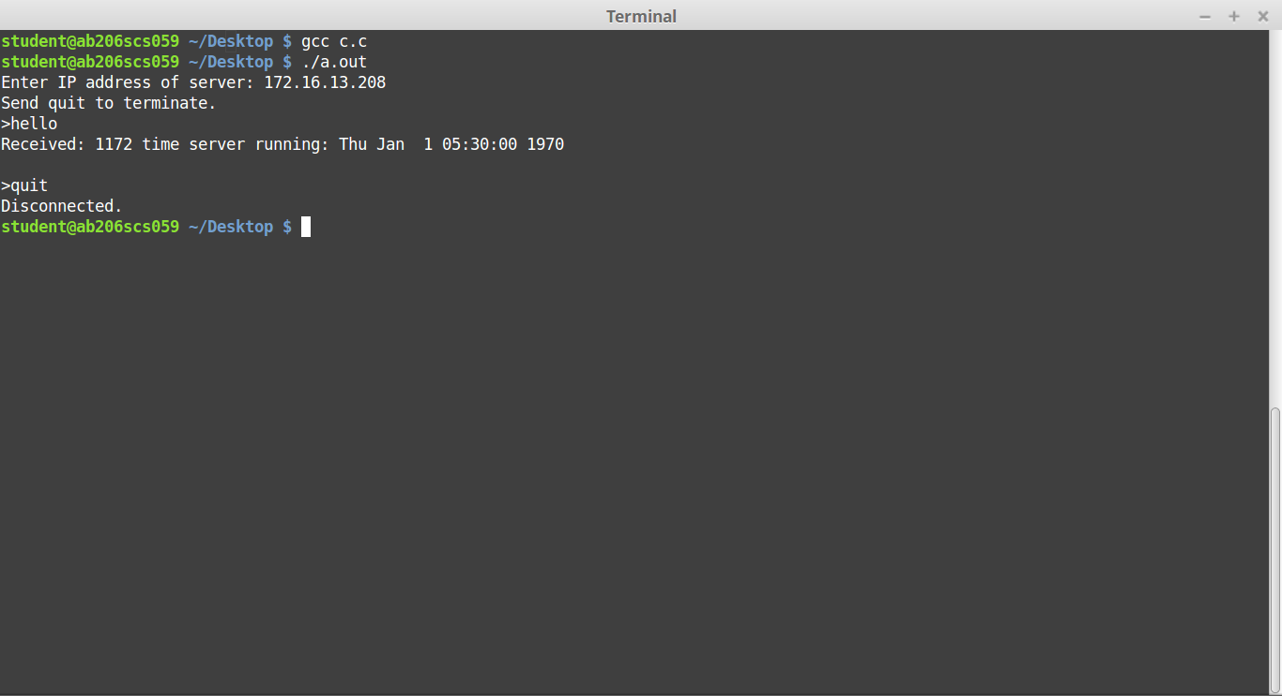

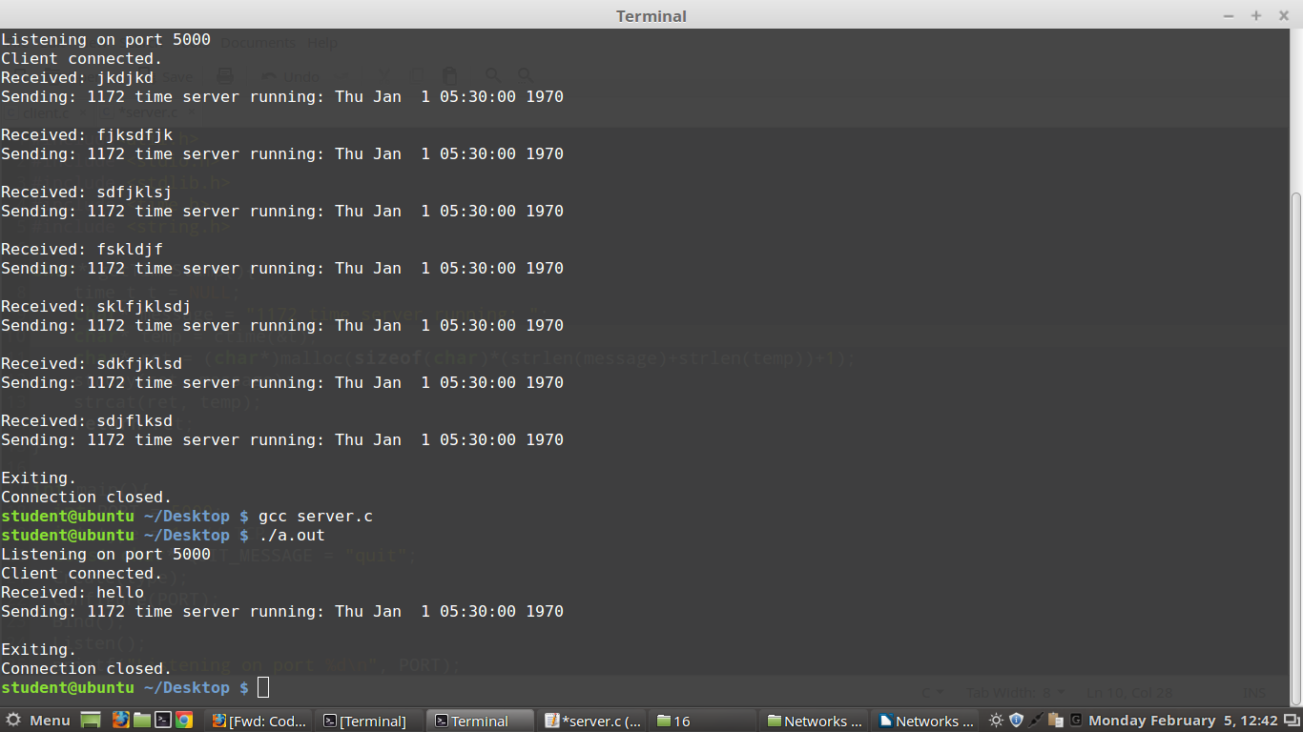

UDP PROGRAM:

CLIENT.C

#include <stdio.h>
#include <sys/socket.h>
#include <netinet/in.h>
#include <string.h>

int main(){
int PORT = 8080;
int clientS, portNum, nBytes;
char msg[1024];
struct sockaddr_in serverAddr;
socklen_t addr_size;

clientS = socket(PF_INET, SOCK_DGRAM, 0);

serverAddr.sin_family = AF_INET;
serverAddr.sin_port = htons(PORT);
serverAddr.sin_addr.s_addr = inet_addr("192.168.43.30");

addr_size = sizeof serverAddr;

printf("What do you want from the Time Server\n");
fgets(msg,1024,stdin);

nBytes = strlen(msg) + 1;

sendto(clientS,msg,nBytes,0,(struct sockaddr *)&serverAddr,addr_size);
nBytes = recvfrom(clientS,msg,1024,0,NULL, NULL);

printf("%s\n",msg);
printf("Do you want to Terminate? ");
fgets(msg,1024,stdin);
nBytes = strlen(msg) + 1;
sendto(clientS,msg,nBytes,0,(struct sockaddr *)&serverAddr,addr_size);

}

SERVER.C

#include <stdio.h>
#include <time.h>
#include <string.h>
#include <sys/socket.h>
#include <netinet/in.h>
int main()
{
time_t x;
int PORT = 8085;
int s, k;
char msg[1024];
char time1[1024];
x = time(NULL);
strcpy(time1,ctime(&x));
struct sockaddr_in serverAddr, clientAddr;
struct sockaddr_storage serverStorage;
socklen_t addr_size, client_addr_size;
int i;

s = socket(PF_INET, SOCK_DGRAM, 0);

serverAddr.sin_family = AF_INET;
serverAddr.sin_port = htons(PORT);
serverAddr.sin_addr.s_addr = htons(INADDR_ANY);

bind(s, (struct sockaddr *) &serverAddr, sizeof(serverAddr));

addr_size = sizeof serverStorage;
char vit[1024] = "Welcome to VIT Time Server - ";

while(1){
k = recvfrom(s,msg,1024,0,(struct sockaddr *)&serverStorage, &addr_size);
printf("Message from Client: %s\n",msg);
sendto(s,strcat(vit,time1),1024,0,(struct sockaddr *)&serverStorage,addr_size);
if(strcmp(msg,"Terminate TS")){
close(s);
break;
}}
}

OUTPUT:
SERVER OUTPUT:
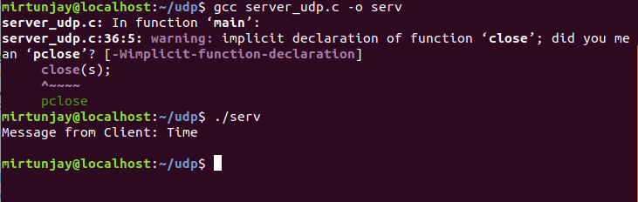

CLIENT.C

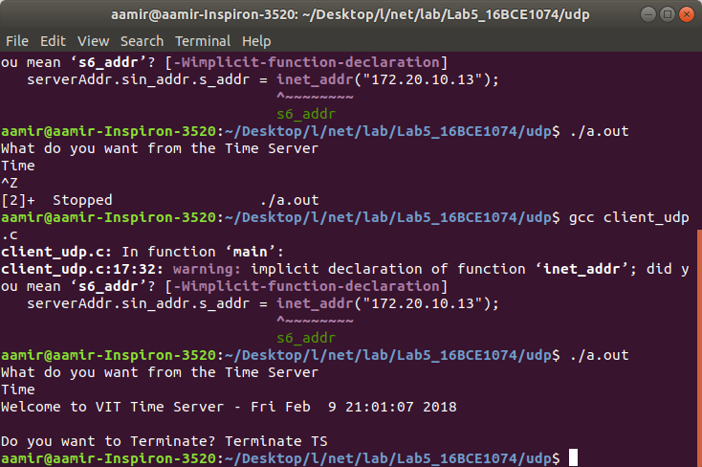

CLIENT.C

