NAME :MIRTUNJAY KUMAR
REG NO: 16BCE1179
PROF.: DEVNAI K

1: Compute CRC12 for string “CRC” send by client,and reply to the client.

CLIENT.C

#include <stdio.h>
#include <string.h>
#include <sys/socket.h>
#include <netinet/in.h>
#include <stdlib.h>
#include <limits.h>
#include <errno.h>

char *stringToBinary(char *s)
{
if (s == NULL) {
return NULL;
}
size_t slen = strlen(s);
errno = 0;
char *binary = malloc(slen * CHAR_BIT + 1);
if (slen == 0) {
*binary = '\0';
return binary;
}
char *ptr;
char *start = binary;
int i;
for (ptr = s; *ptr != '\0'; ptr++) {
for (i = CHAR_BIT - 1; i >= 0; i--, binary++) {
*binary = (*ptr & 1 << i) ? '1' : '0';
}
}
*binary = '\0';
binary = start;
return binary;
}

void main() {
int PORT = 7786;
char msg[1024];
struct sockaddr_in addr;
int i,j,keylen,msglen;
char *input;
input = stringToBinary("CRC");
char key[30],temp[30],quot[100],rem[30],key1[30],temp1[30];
printf("Enter Key: ");
gets(key);
keylen=strlen(key);
msglen=strlen(input);
strcpy(key1,key);
for (i=0;i<keylen-1;i++) {
input[msglen+i]='0';
}
for (i=0;i<keylen;i++)
temp[i]=input[i];
for (i=0;i<msglen;i++) {
quot[i]=temp[0];
if(quot[i]=='0')
for (j=0;j<keylen;j++)
key[j]='0'; else
for (j=0;j<keylen;j++)
key[j]=key1[j];
for (j=keylen-1;j>0;j--) {
if(temp[j]==key[j])
rem[j-1]='0'; else
rem[j-1]='1';
}
rem[keylen-1]=input[i+keylen];
strcpy(temp,rem);
}
strcpy(rem,temp);
printf("\nQuotient is ");
for (i=0;i<msglen;i++)
printf("%c",quot[i]);
printf("\nRemainder is ");
for (i=0;i<keylen-1;i++)
printf("%c",rem[i]);
for (i=0;i<keylen-1;i++) {
input[msglen+i]=rem[i];
}
printf("\nFinal data is: ");
for (i=0;i<msglen+keylen-1;i++)
printf("%c",input[i]);
int s = socket(AF_INET, SOCK_STREAM, 0);
if(s<0)
{
printf("Error, Port not created\n");
}
else
{
printf("Port created\n");
}

addr.sin_port = htons(PORT);
addr.sin_family = AF_INET;
addr.sin_addr.s_addr = htons(INADDR_ANY);

int con=connect(s, (struct sockaddr *) &addr, sizeof(struct sockaddr_in));
if(con<0)
{
printf("Connection failed\n");
}
else
{
printf("Connected to port %d\n\n",PORT);
}

send(s , strcat(stringToBinary("CRC"),rem) , 1024 , 0);
recv(s , msg , 1024 , 0);
printf("Server : %s",msg);
}

SERVER.C

#include <stdio.h>
#include <string.h>
#include <sys/socket.h>
#include <netinet/in.h>
#include <arpa/inet.h>

int main()
{
time_t x;
int PORT=7786;
char msg[1024];
struct sockaddr_in addr;
int s = socket(AF_INET, SOCK_STREAM, 0);
if(s<0)
{
printf(" Socket not created\n");
}
else
{
printf("Socket created\n");
}

addr.sin_port = htons(PORT);
addr.sin_family = AF_INET;
addr.sin_addr.s_addr = htonl(INADDR_ANY);

int bind_var = bind(s, (struct sockaddr *)&addr,sizeof(struct sockaddr_in) );
if(bind_var <0)
{
printf("Error binding socket\n");
}
else
{
printf("Successfully bound to port %u\n", PORT);
}

int ls = listen(s,5);
if(ls<0)
{
printf("Listening Failed\n");
}
else
{
printf("Listening to socket \n");
}

int length = sizeof(struct sockaddr_in);
int accept_var = accept(s, (struct sockaddr *)&addr,&length);
if(accept_var == -1)
{
printf("Accept Failed\n");
}
else
{
printf("Accepted the socket \n");
}
recv(accept_var , msg , 1024 , 0);
printf("Client : Data Received - %s",msg);
int i,j,keylen,msglen;
char *error;
char input[100], key[30],temp[30],quot[100],rem[30],key1[30];
printf("\nEnter Key: ");
fgets(key,1024,stdin);
keylen=strlen(key);
msglen=strlen(input);
strcpy(key1,key);
for (i=0;i<keylen-1;i++) {
input[msglen+i]='0';
}
for (i=0;i<keylen;i++)
temp[i]=input[i];
for (i=0;i<msglen;i++) {
quot[i]=temp[0];
if(quot[i]=='0')
for (j=0;j<keylen;j++)
key[j]='0'; else
for (j=0;j<keylen;j++)
key[j]=key1[j];
for (j=keylen-1;j>0;j--) {
if(temp[j]==key[j])
rem[j-1]='0'; else
rem[j-1]='1';
}
rem[keylen-1]=input[i+keylen];
strcpy(temp,rem);
}
strcpy(rem,temp);
for (i=0;i<keylen-1;i++){
if(rem[i]==48){
error = "No Error\n";
}
else{
error = "Error\n";
break;
}
}
send(accept_var , error, 1024 , 0);
}

OUTPUT:
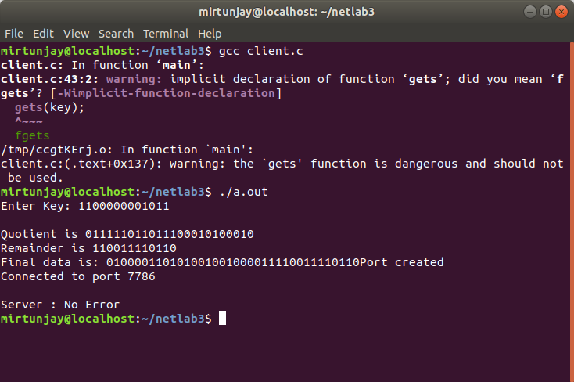

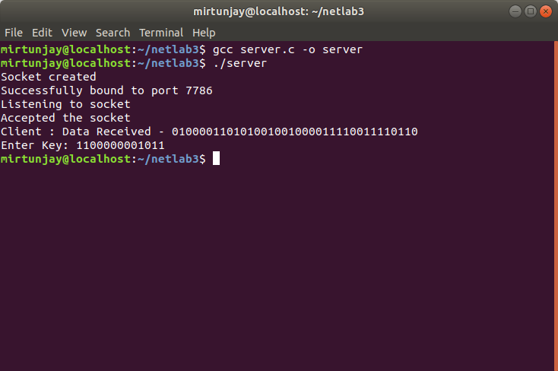

2:2a. Find the Checksum for First blocks and sent to the server,

CLIENT.C

#include <stdio.h>
#include <string.h>
#include <sys/socket.h>
#include <netinet/in.h>
#include <stdlib.h>

int main(){
int PORT = 7786;
char msgC[1024];
struct sockaddr_in addr;
long sum=0;
int n, c, k, size, i, frame, l, m, o, y;
int j;
char msg[200],msg1[200],msg2[200],msg3[200],msg4[200],msg5[200];
for(y=0;y<5;y++){
j=0;
printf("Enter number of Frames\n");
scanf("%d",&frame);
for(i=0;i<frame;i++){
printf("Enter an integer in decimal number system and it's size\n");
scanf("%d%d", &n, &size);
for (c = size-1; c >= 0; c--){
k = n >> c;
if (k & 1)
msg[j++]='1';
else
msg[j++]='0';
}
}
msg[32]='\0';
//printf("%s\n", msg);
char *ptr;
long ret;
ret = strtol(msg, &ptr, 2);
// printf("%ld\n",ret);
sum+=ret;
//printf("%ld\n",sum);
}
//printf("%ld\n",sum);
int s = socket(AF_INET, SOCK_STREAM, 0);
if(s<0){
printf("Error, Port not created\n");
}
else{
printf("Port created\n");
}

addr.sin_port = htons(PORT);
addr.sin_family = AF_INET;
addr.sin_addr.s_addr = htons(INADDR_ANY);

int con=connect(s, (struct sockaddr *) &addr, sizeof(struct sockaddr_in));
if(con<0){
printf("Connection failed\n");
}
else{
printf("Connected to port %d\n\n",PORT);
}
char foo[30];
sprintf(foo, "%ld", sum);
send(s , foo, 1024 , 0);
}

SERVER.C

#include <stdio.h>
#include <stdlib.h>
#include <string.h>
#include <sys/socket.h>
#include <netinet/in.h>
#include <arpa/inet.h>

int main(){
int PORT=7786;
char sender[1024];
struct sockaddr_in addr;
int s = socket(AF_INET, SOCK_STREAM, 0);
if(s<0){
printf(" Socket not created\n");
}
else{
printf("Socket created\n");
}

addr.sin_port = htons(PORT);
addr.sin_family = AF_INET;
addr.sin_addr.s_addr = htonl(INADDR_ANY);

int bind_var = bind(s, (struct sockaddr *)&addr,sizeof(struct sockaddr_in) );
if(bind_var <0){
printf("Error binding socket\n");
}

else{
printf("Successfully bound to port %u\n", PORT);
}

int ls = listen(s,5);
if(ls<0){
printf("Listening Failed\n");
}
else{
printf("Listening to socket \n");
}

int length = sizeof(struct sockaddr_in);
int accept_var = accept(s, (struct sockaddr *)&addr,&length);
if(accept_var == -1){
printf("Accept Failed\n");
}
else{
printf("Accepted the socket \n");
}

int j=0;
int remainder=0;
recv(accept_var , sender, 1024, 0);
char *ptr;
long seme;
seme = strtol(sender,&ptr,10);
char prin[32];
for (j = 31; j>=0; j--){
remainder = seme%2;
if(remainder==1)
prin[j] = '1';
else
prin[j] = '0';
seme=seme/2;
}
prin[32]='\0';
printf("Client : Data Received (Checksum) - %s",prin);
printf("\n");
}

OUTPUT:
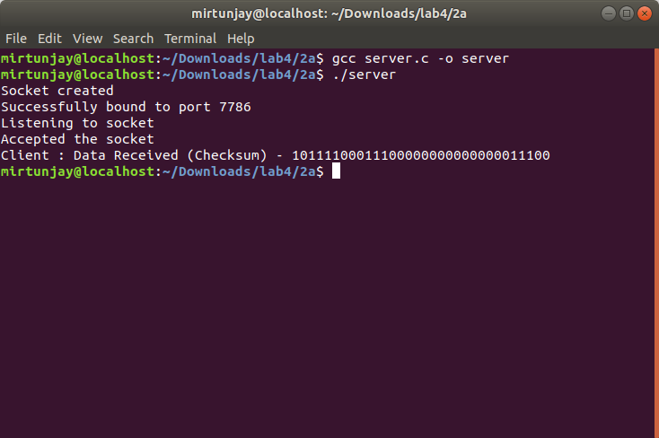

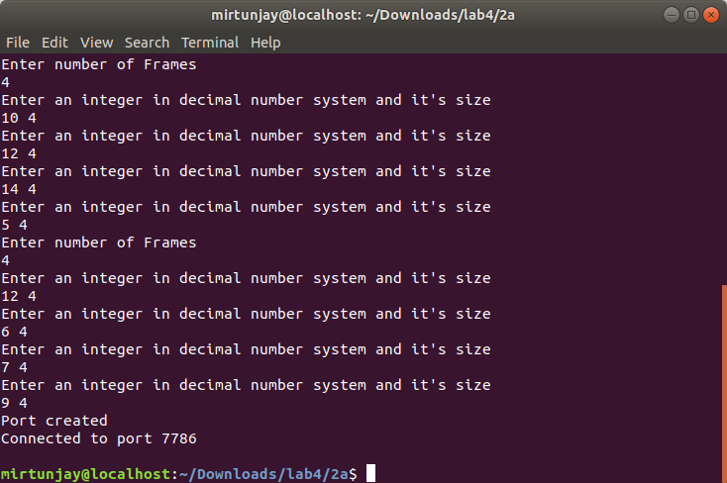

2b. Server computes the checksum for second blockand replies to the client

OUTPUT:

