Homework2 Report

**Represent digits '3' in 2D**

1.convert data from the UCI Optical Recognition of Handwritten Digits Data Set

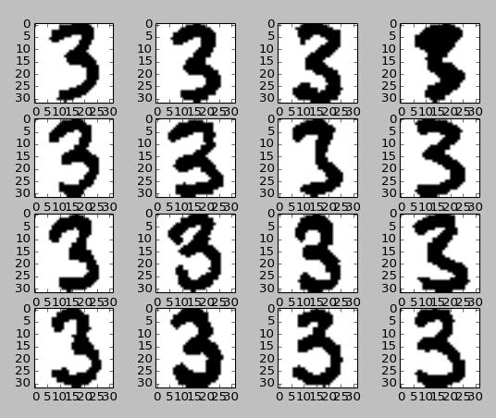

2.perform PCA over all digit '3' with 2 components

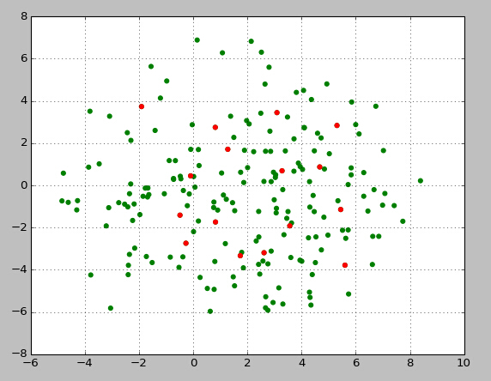

3.plot the PCA results as below (also in page #12 of PCA)

