Analysis and Design

of Information Systems: Exam #1

**Task 1**: Prepare DFD diagrams of Airport Support System.

1. DFD context diagram
   1. At least 4 entities
   2. One process
   3. At least 6 data flow

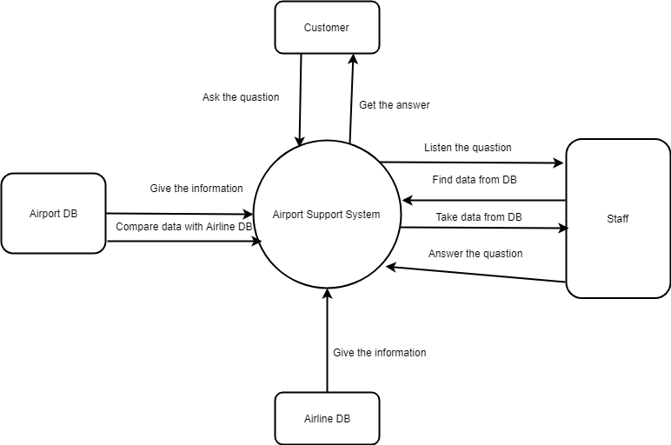

1. DFD level 0
   1. At least 4 entity
   2. At least 6 processes
   3. At least 10 data flow

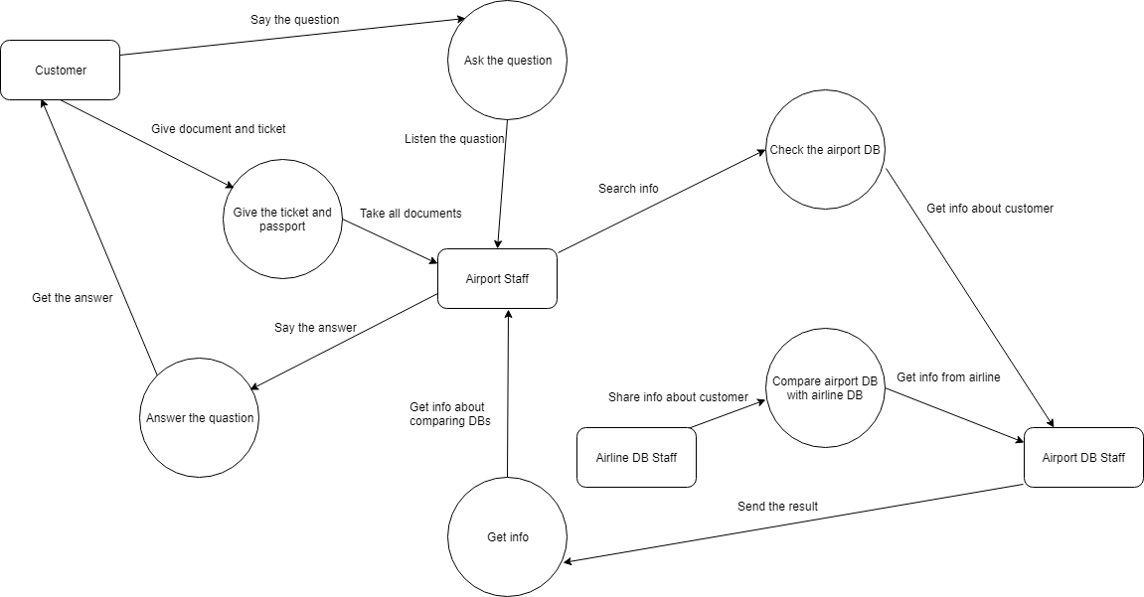

**Task 2**: Prepare 3 functional requirements per each DFD process level 0 from previous task

1.1 (Ask) Say the question

1.1.1 The customer must have at least one question to ask staff

1.1.2 The airport staff must to listen all the words the customer said

1.1.3 The airport staff must answer to all customer’s question

1.2 Give the ticket and password

1.2.1 The customer must give exactly his password and his ticket

1.2.2 The staff must take all the documents customers gives

1.2.3 The staff must be sure that these documents exactly are customer’s

1.3 Check the Airport DB

1.3.1 The staff must send a request to Airport DB exactly by the customer’s info

1.3.2 The airport DB staff must get info about customer form their database

1.3.3 The airport DB staff must get info about customer from the staff’s request

1.4 Compare airport DB with airline DB

1.4.1 The airport DB staff must send the request to airline DB

1.4.2 The airline DB staff must send all info about customer to airport DB

1.4.3 The airport DB staff must compare info from airport and from airline

1.5 Get info

1.5.1 The airport DB staff must send the result after comparing to the staff

1.5.2 The staff must get the info about comparing two databases

1.5.3 The staff must download this info to the computer like backup

1.6 Answer the question

1.6.1 The staff must compare all information he has

1.6.2 The staff must answer to the customer as concisely as possible

1.6.3 The staff must not forget to bring all the documents back to the customer

**Task 3**: Prepare ERD diagrams for descriptions of Airport Support System.

1. At least 5 entities
2. At least 7 relationships
3. At least 2 attributes per entity
4. Cardinalities per each relationship

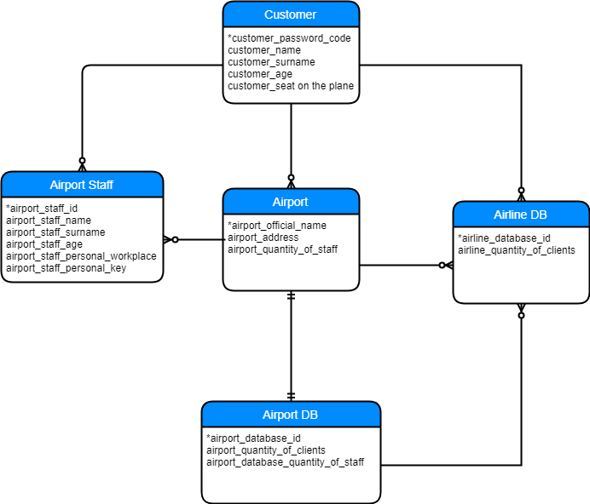

Deliver your solution as a word document and upload it to MS Team Platform.