Software Engineering Lab: Exam #1

Create following diagrams for Airport Support System.

**Task 1**: Use case diagram

1. At least 3 use cases
2. At least 4actors
3. At least 2 extend relationship between two use cases
4. At least 1 include relationship between two use cases
5. Describe 1 use case with table description.

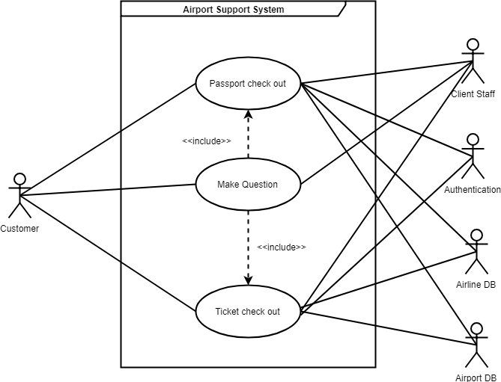

|  |
| --- |
| Make Question |
| Brief description: The customer asks the quastion(‘s) to the Airport Staff |
| Actors: Customer, Staff |
| Preconditions: There must be at least one quastion customer wants ask Staff |
| Basic flow of event:  1) The customer has some problems  2) The customer asks the Staff  3) The Client Staff tries to solve the problem and answer the client |
| Extensions: |
| Post-conditions: The customer find solution of his problem by Staff helping |
| Special requirements: The customer must have with him ticket and password |

**Task 2**: Class diagram

1. At least 5 classes
2. All classes are specified with name, attributes with data types, methods
3. Attributes defined
4. At least 1 aggregation
5. At least 1 composition
6. Member access modifiers attached
7. Multiplicity added

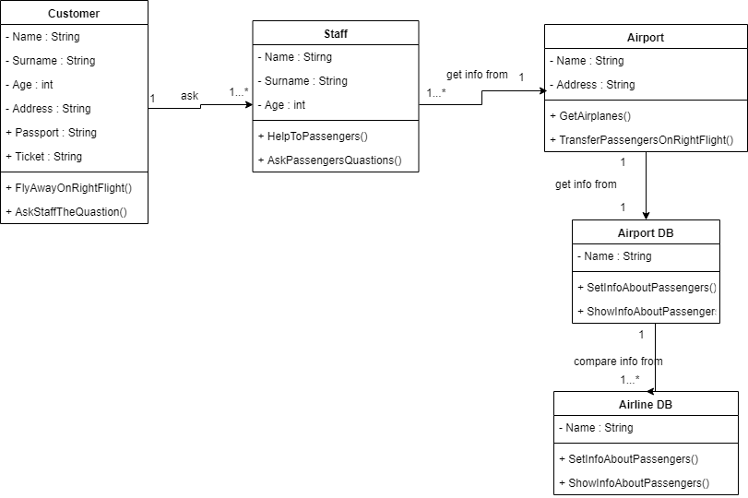

**Task 3:** Sequence diagram for student registration in Airport Support System.

1. At least 3 defined lifelines
2. At least 8 numerated sequence messages

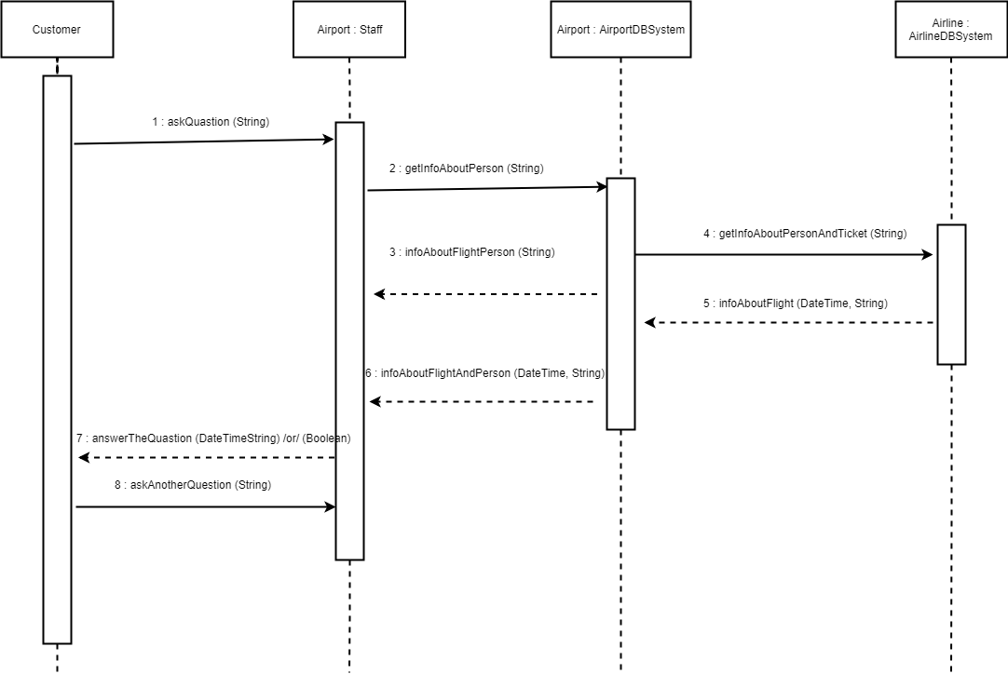

Deliver your solution as a word document and upload it to MS Team Platform.