Ex. 5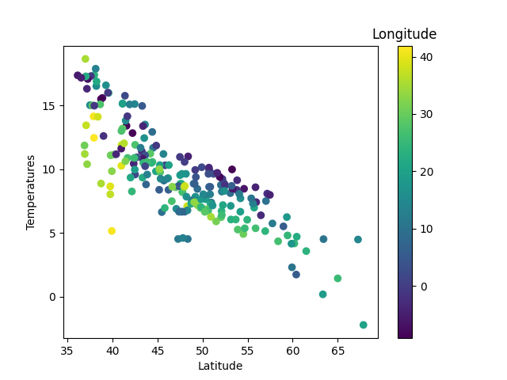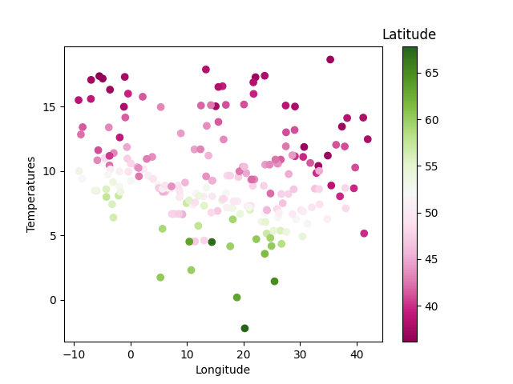

Ex. 6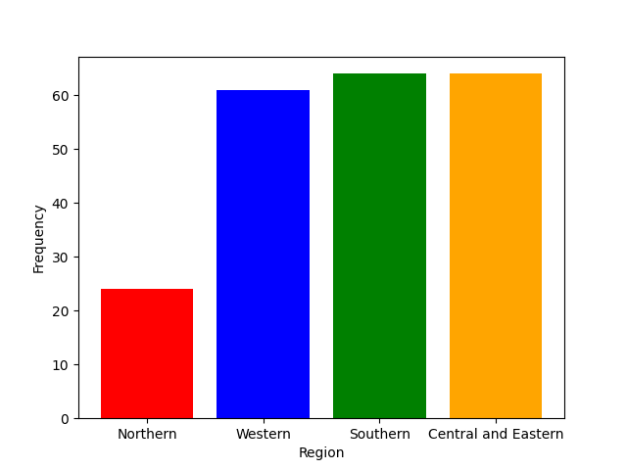

Ex. 8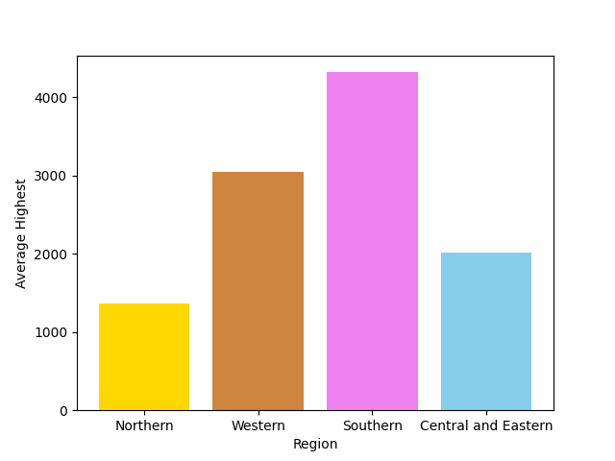

Ex 9.

a) The temperature tend to decrease.

b) Their have no patter at all.

c) The temperature tend to increase.

d) As I did some research, it can be seen that as the latitude increases, it’s relative with the decrease in temperature and when the longitude is increasing it didn’t affect the temperature change, but highest, though it is on the increasing pattern but highest point is not always define that the temperature will be higher too meaning they’re other factor as well.