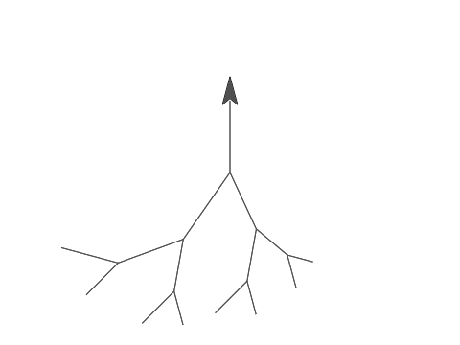What happen if you change the size value to -100?

The tree will invert.

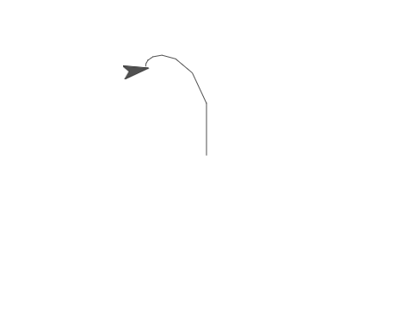What happen if you change the input level to be -4?

The loop will never stop.

To produce a tree below, what are the values for levels, the two turn degrees, and the two constant multipliers for size during recursive calls.

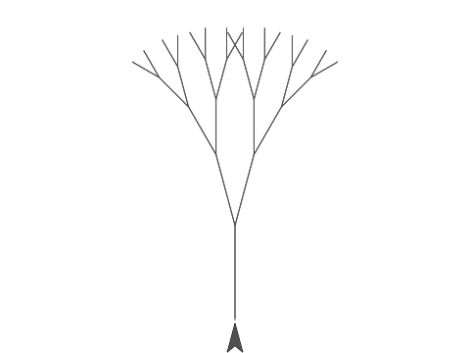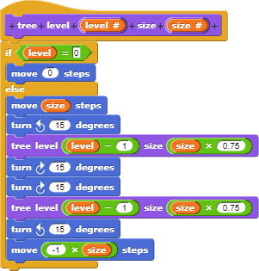 level = 5, two turn degrees = 15, size = 0.75 around this.

What modification you have to make to the original code to produce the above H-tree?

Modification the two turn degrees to 90 and the two constant multipliers for size to 0.70.

import turtle  
  
def tree_draw(level, size):  
 if level == 0:  
 return  
 turtle.forward(size)  
 turtle.left(90)  
 tree_draw(level - 1, size*0.70)  
 turtle.right(90)  
 turtle.right(90)  
 tree_draw(level - 1, size*0.70)  
 turtle.left(90)  
 turtle.forward(-1*size)  
  
turtle.speed(0)  
turtle.setheading(90)  
turtle.pensize(4)  
turtle.color('green')  
tree_draw(10, 200)  
  
turtle.done()

