NerdSEQ

Hybrid Tracker Sequencer, Synthesizer
and Toolbox

User Manual
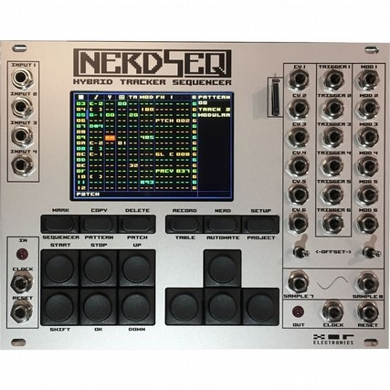
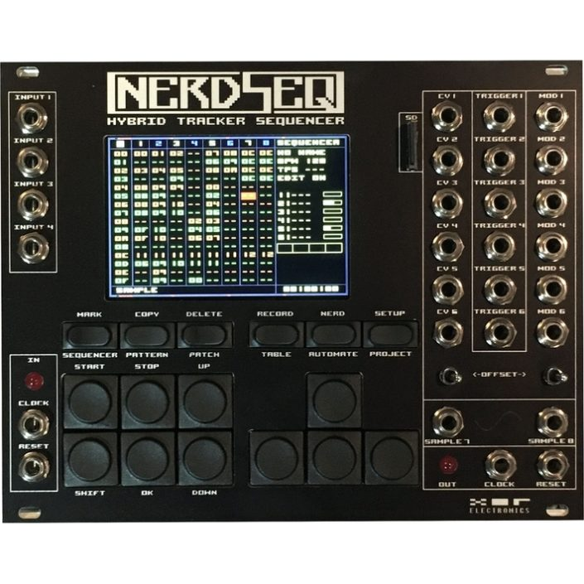

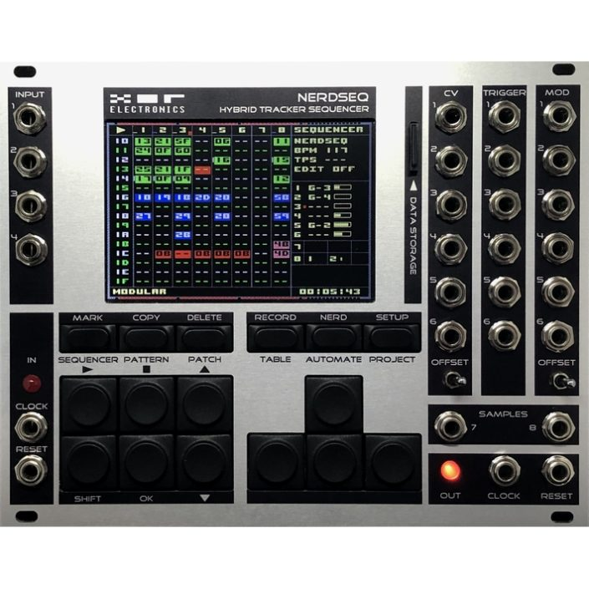

Please be aware that this is an ever growing manual. Save the trees by not printing it out!
Content
Introduction 3
Technical Specification 5
Firmware Features 6
Basic Overview 8
Getting Started 9
Numbers, Values and Tracker basics 9
Buttons and Navigation 12
General Screen information 15
Sequencer Screen 17
Pattern Screen 21
Patch Screen 52
Current Values Screen 53
Table Screen 56
Automator screen 60
Envelope screen 67
Project screen 70
Setup Screen 72
Track Assign Screen 75
Track Setup Screen 76
Sample / Wave / Synthesis 82
Load Sample window 88
The Nerd Screen / Menu 90
Recording / Live Input / Midi Input 92
User Interface Screen 98
Expander Modules 98
NSA Firmware Update Screen 104
Launchpad Integration 105
Tips & Tricks, FAQ 108
Firmware update 110
Disclaimer 111

Introduction

The NerdSEQ is a Tracker based sequencer, synthesizer and modulation generator for Eurorack systems.

It consist 6 Tracks for the CV/Trigger/Gate generation of 18 outputs (12 CV + 6 Trigger/Gate). There are 2 audio tracks with each 2 dedicated audio parts for sampling/synthesis sequencing. Furthermore the audio part can act also as a waveform oscillator or FM synthesizer. Different modulation functions like LFO, Envelopes and more can be generated for internal and external use. Dedicated clock/reset inputs and outputs are available for different clock types. 4 free assignable CV inputs can be used for live manipulation or CV/Gate recording.

The sequencer itself is inspired by old module trackers like Fasttracker2(PC), OctaMED(Amiga), LittleSoundDJ(Gameboy) and Little Piggy Tracker(Multiple Platforms)….. These to name only a few, there are many more inspirations.
It contains many very powerful functions for sequencing like an advanced live ability, patternlength up to 64 steps, chaining, poly-rhythmic tracks, groove, glide, retrigger, flexible trigger/gate/step lengths, patches, special effects, probability, tables and more. The audio tracks contain special functionality for sample playing, pitching, sample effects, retrigger and many more, as well as a synthesizer engine to create waveforms or act as a 4 Operator Synthesizer. Samples can be loaded from a dedicated SD card available on the front panel. The sequencer is able to make loops (as in many loops) and full songs (even multiple songs on one project, depending on complexity, usage of patterns etc.) Patterns can be started and stopped independent from the tracks, which allows flexible clip-style sequencing. Projects can be saved and loaded on/from the microSD card.
All editing is implemented in a very easy way (at least I tried to make it so). So every screen or edit option can be accessed through one key or Shift + Key. No complex submenus from submenus or menu diving is needed. I also try to prevent that as much as possible for future updates.
Additional expanders allow Midi recording and sequencing, the connection of a Sega Gamepad for controlling and up to 64 more Trigger/Gate/CV outputs and modulators.

Front overview NerdSEQ (Grey/Silver Frontpanel):

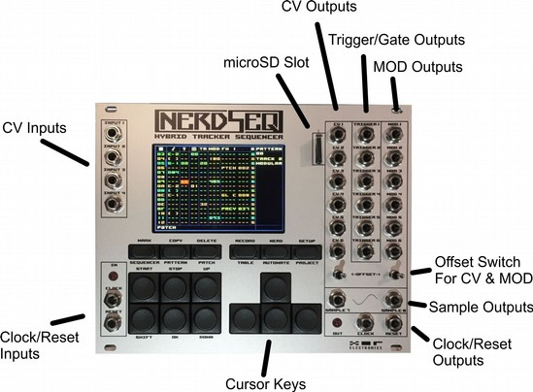

Technical Specification

Power consumption:
- ~190mA (3.2”display) on the +12Volt Rail (~150mA with the 3.5” display)
- ~32mA on the -12 Volt Rail
- +5 Volt Rail is not connected

Hardware:
- Grey / Silver, Black or combined Grey/Black Frontpanel
- Colour Graphics IPS display with a resolution of 480 x 320 pixels
- 10 full size and 6 half size buttons
- 28 mini-Jack (mono), 4 CV Inputs (range 0..10 Volt) , Clock+Reset Inputs(5 Volt), 12 CV outputs (Range -5 Volt /+5 Volt or 0 Volt / +10 Volt), 6 Trigger/Gate Outputs (5 Volt),
2 Audio outputs (-5 Volt/+5 Volt, AC coupled), Clock + Reset Output (5 Volt)
- 2 toggle switches to change the offset of the CV voltages
- 2 LEDs to indicate clocks
- microSD connector accessible on frontpanel
- 10 pin boxed bus connector (power)
- Expander connector (12 pin boxed) for IO-Expander (Midi In/Out + Sega Gamepad connector) (Expander must be ordered seperately)
- Expander connector (14 pin boxed) for special Nerdseq extensions like output Expanders to allow up to 64 more outputs, the NSA (Nerd Sound Adapter) which are dedicated cartridges including full synthesizers. Those are totally integrated in the Nerdseq sequencer.

Tracker:
- 6 CV/Trigger/Gate tracks for 12 CV and 6 Trigger/Gate outputs (with expander up to 64 additional outputs)
- 2x2 sample tracks for 2 sample/oscillator/synthesizer outputs (mono)
- 239 Sequencer rows
- 175 Patterns with each 64 (and less) Steps
- 176 Patches
- 32 Tables with 16 (and less) steps
- 8 Automation slots
- 12 Sample slots
- 190kB Sample memory (4 seconds with 44.1 kHz/8 Bit/Mono or more with lower samplerate)
- Audio support for samples, waveforms, synthesis
- Sample support for RAW 8 bit mono and WAV 8/16 bit, Mono/Stereo
- Projects as many as the SD card can hold
- With expanders drum-matrix with euclidean editing, envelopes, LFO’s...

Firmware Features
- 8 Tracker tracks can be controlled independently, synchronised and not synchronised
- CV outputs can generate 1V/Oct, 1.2V/Oct and Volt/Hz octave ranges
- ‘Endless’ Pattern chaining
- Euclidean input for Rhythm composing (currently only with Trigger16 Expander)
- Probability (0..100% with 1% resolution) for a sequencer row or for dedicated functions: CV, Mod, Trigger/Gate, Tables, Samples and FX (which can contain every feature)
- Patterns with Note Scaled input, Patch selection, Trigger/Gate w retrigger, delayed triggers etc, CV Modulation manipulation, Groove, Fine pitch, Glide, Glide quantisation, Table selection
- Multiple direct FX possibilities per pattern per step
- Groove per step per pattern to create different step lengths, shuffle and weird rhythmic with the possibility to create poly-rhythmic tracks
- Patches with all wanted functions directly accessible
- Tables (sequencer in the sequencer) for Transpose, scaling and all possible functions, different speed/note scales and sources, synchronised and not synchronised to the main sequencer clock, randomisation functions
- Automation slots to assign different automations (like LFO, Envelopes, Noise, Randomness..etc) freely connect to internal and external parameters via a modulation matrix
- 8 ADSR Envelopes with rich setup, source and destination functionality
- Project management
- Sample management
- Clock Source can be Internal, 1/16 via Clock input, 24ppqn, Midi Clock, DinSync
- Clock Outputs can be 1/16, DIN-Sync , Midi Clock
- Track dividers / multipliers (/32,/16,/8, /7,/6,/5,/4,/3,/2, *2,*3,*4,*5,*6,*7,*8)
- All Modular tracks can be manipulated from other Modular tracks
- Advanced Ratcheting settings (via Tables)
- Trigger functions with different timings for ON/OFF, OFF/ON (delayed gate), Retriggering
- Gate length can be as short or long as needed (much shorter than steplength possible)
- advanced Mark + Copy + Paste functions to copy marked parts within or between patterns
- Sample/Wave/Synth pitch in note scale
- Audio effects like Volume, Fine Pitch, Retrigger, Backwards, Bitcrush, Distortion, Offset, Wavefolder, Audio Delay...
- Waveform oscillator generates multiple waveforms on the audio outputs.
- 4 Operator FM synthesis between waveforms with dedicated FM synth functions
- Flexible Live player to switch between different patterns (clips) on different tracks.
- Live mode to trigger, mute, solo patterns
- Live editing while playing including pattern creation, manipulation, recording, nearly all functions accessible while playing
- pattern cloning
- patch cloning
- Free record routing for CV and Midi input
- free routing of CV inputs to different functions
- Midi sequencing and recording including 4x polyphonic Notes per track, Velocity, CC, Pitchbend, Program Change, Channel and Polyphonic Aftertouch, NRPN and more
- Expander support to get up to 64 more outputs and/or extra functionality

Basic Overview

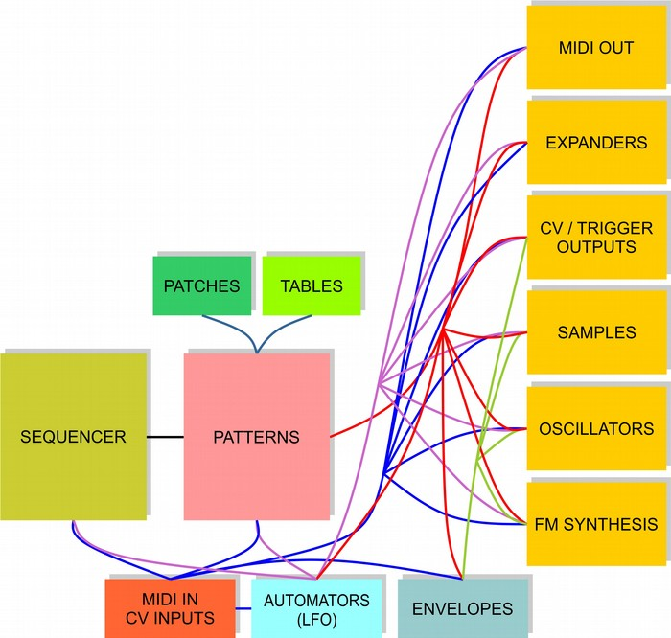

The upper sketch shows a basic relation between the several function blocks of the NerdSEQ.
Note that several functions can manipulate each other as well which helps to create complex sequences. In the most basic way, the sequencer selects a pattern to play on a track. This pattern sequences the notes/triggers etc. into one of it’s destinations (eg CV/Gate outputs or Samples…).
On top of that these sequences can be for example further manipulated by the Automators or the Tables. Some functions can also be routed to outputs without the use of any sequence. For example, an envelope can be routed directly to a CV/MOD output. The envelope itself can then again be triggered/gated by a sequence, a table, CV inputs or other sources.

Getting Started

To get started, insert the SD Card, connect the power cable properly. Take care that the red line is connected to the -12Volt Rail on the Bus. Power on the System.
First there will be a splash screen followed by the current Firmware version number.
After that the system is checking if any NSA (Nerd Sound Adapter) are connected.
With connected NSA expanders it will show the type of the expanders and the Firmware version. Channels that are not connected are shown as ‘Not Found’.
Be aware that the Midi expander is not going to be detected. It works in a different way than the NSA expanders and will just be usable ‘out of the box’.

Then the SD card is being checked if it is correctly initialised, reading the calibration settings. And at last, it will show if a Gamepad is detected (through the IO-Expander).

The startup is now ready and an empty sequencer screen will show up, waiting for you to get started!

Attention, if the Splash screen the text or the background light appears to be weird somehow, then it is a good indication that there is something wrong with the power. (For example, not enough power -> Voltages are too low / not enough current). Check your supply, disconnect some other modules to be sure your supply has enough power. (And be sure the NerdSEQ is working properly)

Next there will be a guide through some basics, related to values which you find back in most trackers. Then there will be some basic information about Trackers and after that information about the navigation with the NerdSEQ.

Numbers, Values and Tracker basics
The history of trackers goes back to the late 80’s when some people developed a new way of creating music by inserting music scores in a different way. It is mostly recognized by people as a way to program music instead of composing, because of the input of the music data. This is actually not really the case, once you know some of the basics it is composing all the way!
Trackers are often used to play samples (in a note scale) on different tracks as well as to control the soundchips of old homecomputers directly. The workflow is different from other score based or maybe piano roll based sequencing.
With most of the trackers the workflow goes from up to down, the sequencing running from the top to the bottom. There you will find different columns and rows. Each row shows a step in the sequence and the main columns are dedicated to the tracks and subcolumns to different commands. Each track consists mostly the same kind of sub columns. (Modern trackers allow different kind of tracks and sub-columns). Getting to the subcolumns there is often a subcolumn for the music note, one for the volume and sometimes one for a special command. Sometimes there are additional columns, depending on what tracker it is. Music notes are mostly filled in with their real note, followed by the octave. For example:
“C-3” means Note C on octave 3.
“F-5” means Note F on octave 5.
“D#2” is the note D sharp on octave 2 (half tone higher than D-2)
The exact look of the notes can differ between the trackers. With the NerdSEQ the notes are filled in like in the example.
Other values of the subcolumns like the volume are often shown as a hexadecimal numerical value.
I will explain only the very basics of it. Refer to the footnotes for detailed information.

We count and calculate usually in a base 10 system, we count like this: 0,1,2,3,4,5,6,7,8,9,10,11,12,13,14,15,16,17,18…….On every 10th number (10 overflow) the left digit increases. On every 100th number the left and the second left digit increases..etc.
In a hexadecimal system the base is 16 and so with every 16th number the left digit will increase. The numbers itself are also represented differently. A hexadecimal count goes like this:
0,1,2,3,4,5,6,7,8,9,A,B,C,D,E,F,10,11,12,13,14,15,16,17,18,19,1A,1B…….
So instead of getting to the 10, letters are used to show the hexadecimal values until the 16th number which will create the overflow for the digit on the left.

The decimal compared to the hexadecimal will show you the corresponding numbers:

Dec | Hex |  | Dec | Hex |  | Dec | Hex
0 | 0 |  | 16 | 10 |  | 32 | 20
1 | 1 |  | 17 | 11 |  | 33 | 21
2 | 2 |  | 18 | 12 |  | 34 | 22
3 | 3 |  | 19 | 13 |  | 35 | 23
4 | 4 |  | 20 | 14 |  | 36 | 24
5 | 5 |  | 21 | 15 |  | 37 | 25
6 | 6 |  | 22 | 16 |  | 38 | 26
7 | 7 |  | 23 | 17 |  | 39 | 27
8 | 8 |  | 24 | 18 |  | 40 | 28
9 | 9 |  | 25 | 19 |  | 41 | 29
10 | A |  | 26 | 1A |  | 42 | 2A
11 | B |  | 27 | 1B |  | 43 | 2B
12 | C |  | 28 | 1C |  | 44 | 2C
13 | D |  | 29 | 1D |  | 45 | 2D
14 | E |  | 30 | 1E |  | 46 | 2E
15 | F |  | 31 | 1F |  | 47 | 2F

So in a hexadecimal system the number after 9F goes to A0 and after a FF to 100.
The Nerdseq uses also the hexadecimal system to show most of the values.
Furthermore, some trackers can show all content on one screen while some have to scroll to get to other content and some have to switch to a different screen to get to the other content.
As the NerdSEQ only has a small display, the information is split logically into different screens.
I will explain those later.
There is much more about trackers, check the links for more information. I would also suggest to check some tutorials about ‘LittleSoundDJ’ as it is the most similar to the tracker of the NerdSEQ.
Though there are some major differences, it gives a clue about how to work with dedicated screens.

Buttons and Navigation
To navigate, change to other screens, edit values and more you use the Buttons.
On the top line there are 6 ‘half’ buttons which are used to switch to other screens.
Pressing only the buttons the following screens can be arrived:
- Sequencer → For the main sequencing and pattern order, song structure etc.
- Pattern → The pattern data where all the notes, gates and effects are
- Patch → Is for either the stored patches (macros), the current values of the recent track or the track setup.
- Table → Tables are like a sequencer in the sequencer which can run synchronized or independent from the main sequence. It is able to manipulate the main sequence in multiple ways.
- Automate → Automators / Modulators which can manipulate many parameters through LFO’s etc. With this button a 2nd screen for the envelopes can also be accessed. (pressing the automator button switches between the automator or the envelope screen)
- Project → For all project related settings
You can reach those screens by pressing the corresponding buttons. (One footnote here, you can’t enter the pattern screen if there was no pattern created first).

Those button have also a 2nd function which can be reached by pressing the Shift key together (followed) by the other keys. Those are:
MARK - To start the marking of content on the screens
COPY – Copy earlier marked content
DELETE – Delete current value or marked content
RECORD – to start/stop recording
NERD – use for different functions (like a context menu)
SETUP – Enter the Setup screen for non-project related general settings

Further there are the buttons on the bottom left:
START – Start sequencer or trigger a pattern
STOP – Stop a pattern (stop the sequencer in combination with SHIFT). If the sequencer is stopped, then SHIFT+STOP executes a ‘Stop All Sounds’ function where all Gates are reset, all Notes stopped and a Reset signal generated if the clock output is a regular modular clock.
Also for the audio tracks, pressing the stop button on one of these while this track is stopped will also stop all sound for this track.
For the stop sequencer function (SHIFT+STOP) a security function is available which forces you to press STOP a second time while holding the SHIFT button. In that case a notification will appear on the screen and you can avoid the sequencer stop if the buttons were pressed unintended.
This feature can be enabled/disabled in the → Setup Screen
SHIFT - Get to the 2nd function of buttons or edit functionality
OK – Create a new pattern / patch / table, Enter pattern (depends on setting). Enter/Accept, Pre-listen Note, Clone patterns, patches and tables in combination with the SHIFT button
UP – Page up for 16 steps → move the cursor 16 rows up
DOWN – Page down for 16 steps → move the cursor 16 rows down

Lastly, the cursor keys are on the right.
Note that there are also some other combinations of the keys in different screens which will be explained later on.

For simple navigation you use the cursor keys:
Cursor up/down/left/right for simple navigation and scrolling
In most screens you can move your cursor and navigate like this. For example, in the sequencer screen you change the Row by using cursor up/down and change the Track/Column by using cursor left/right.
Using the cursor keys combined with the Shift key allows mostly some editing, as here explained for the pattern screen:
SHIFT + CURSOR LEFT -> Decrease (-) value by 1 (value or semitone for notes)
SHIFT + CURSOR RIGHT -> Increase (+) value by 1 (value or semitone for notes)
SHIFT + DOWN/UP -> Decrease/Increase value by:
- 1 octave for notes
- 16 ($10) for regular values which can be < FF (255)
64 ($40) for values which can be > FF (255)
- 10 for FX types
- Depending on the types, other values are possible

So changing values is always in the smallest step by using SHIFT+CURSOR LEFT/RIGHT and in bigger steps by using SHIFT+CURSOR UP/DOWN

Additionally, if the Editsteps are enabled (Setup Screen):
The cursor will automatically move down by the amount of editsteps if inserted by using SHIFT + CURSOR UP on an empty field in the Pattern Screen.

With SHIFT + DELETE you can delete/empty values
The button OK is mostly used to create new Patterns or Patches and to enter or agree/start a menu option

Mute/Unmute track: Using the shortcut SHIFT+DOWN+START mutes or unmutes the current track if in the Sequencer or Pattern screen. Mute does release the gate and keeps the CV voltage, but won’t play anything else on the muted track until it is unmuted. It will sequence through though while muted and the Break command is still working. So for example 16 step patterns will stay 16 step even if muted.
Solo/Unsolo track: Using SHIFT + UP + START solos the current track. That means all tracks will be muted and the current track unmuted if needed. Unsoloing will unmute all tracks. Also, unmuting other tracks or muting the solo track will release the solo function.
For fast unmuting all tracks you can press SHIFT + UP + START for the solo function twice and all tracks are unmuted directly.
While in the → Pattern screen you can hold the PATTERN button and use the cursor keys to navigate between patterns (in the order of the sequencer arrangement)
While in the → Table screen you can hold the TABLE button and use the cursor Up and down keys to navigate between the tables.

Note the same Mute/Solo functions can be used with the Trigger16 Expander when on the pattern screen.

General Screen information
As mentioned before the main workflow is split into different screens.
The main screen is the Sequencer screen. From there you sequence the Patterns. You can sequence each of the 176 patterns from each track if they are from the same type.
From the pattern you can access the different patches, tables, automations and/or samples.
Not directly dedicated to the sequencing are the Project and the Setup screen. Below a hopefully simple view of the Sequencer → Patterns → Patch/Table/Automate/Sample relations.
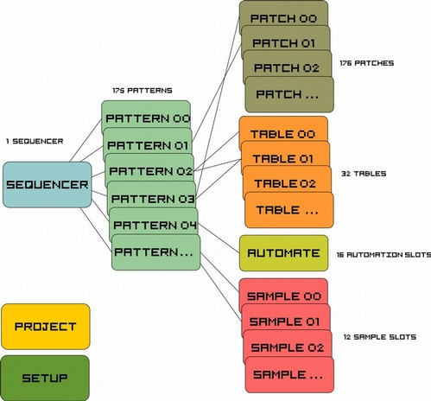

Basic relations between the different Screens/Functions

Note that you can mostly freely use all patches, tables, automations or samples from the same or different patterns. Also here, some are limited to the type which I will describe now. Depending on which track the pattern is created in, it is locked to the type of the track (not to the track itself). For example, if you create a pattern on a CV/Trigger/Gate track, then you can use it on any of the 6 CV/Trigger/Gate Tracks, but not on the audio tracks.
The same goes for a pattern created on an audio track, it can be used on the 2 audio tracks, but not on the 6 CV/Trigger/Gate Tracks. The editor prevents this. The reason for this is that the different types have some common but mostly different parameters which are not interchangeable. The same is true for a track that is dedicated to an expander. The patterns that are created in the expander track (eg More Triggers 16 expander) are not compatible with the CV/Gate patterns or the audio patterns and vice versa.
The same goes for the patches which are then also locked to the type of the pattern.

Sequencer Screen

In the sequencer screen you have different Rows and Columns. For the Columns there are 2 types. One for the indication of the row, and the others are the actual Tracks of the sequencer.
Each track is dedicated to one output channel -> Track 1 for CV1, Trigger1 and MOD1
With the NerdSEQ, by default, there are 6 CV/TRIGGER/MOD tracks and 2 Audio tracks (with each audio track being able to play 2 samples or waveforms simultaneously, so 4 samples/waveforms in total at any one time).

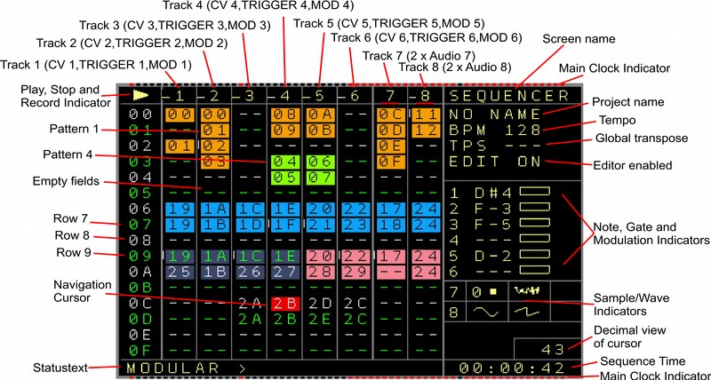Figure 1: Sequencer Screen

The sequencer screen is for the general sequencing of the patterns. From here islands or chains of patterns are combined to build up loops or songs. The first column show the row numbers. Those go from 00 to FE (254 rows). The screen scrolls down on navigation. You can always see 16 rows in the sequencer screen. The next 8 columns show the available tracks. Some are empty ( to be recognized by a ‘--’. And some patterns are filled in. So for example on Track 1, the first row shows a 00 which means that Pattern 00 is being set to this spot. The other numbers relate to different patterns. You also see that Pattern 00 is filled in in both Track 1 and Track 2. That’s possible because those tracks are from the same type. More of the same pattern number below each other would play the same pattern multiple times.
Another possibility is the ‘**’ in a sequencer field which represents a function to stop a track.
This can either be used in a sequence so when the player reaches the ‘**’ it will stop the track (not the sequencer). Starting a ‘**’ manually will stop the track. This can be used to start only several tracks/patterns in a row or to stop multiple tracks.

You navigate in the Sequencer Screen with the Cursor keys. Depending on whether ‘Navigation Wrap’ is enabled the cursor will wrap back to the begin from the most right position, or not.
You can start playing a row by pressing start. The selected pattern, or the first (top) assigned pattern will start to play. So only one track starts to play. If you want to start the whole row, press SHIFT+ START.
SHIFT+ STOP stops the player. Initiates a reset pulse on the reset outputs and resets all gates. (And if enabled in the settings, resets all Effect Values).
While playing, pressing start on another selected pattern will trigger the pattern to play after the last pattern of the same column finished it’s sequence. Pressing START 2 times, will trigger the next pattern faster, after an amount of steps, set up by the Project setting ‘Live Quantize’, derived from the main 64 step clock. You can see the next point of the starting point on the top and bottom Main Clock Indicator.
STOP, stops the pattern after it’s finished and no other pattern on this track is being played after that. STOP twice finishes the pattern play immediately on this track.
Also if STOP is being pressed when the sequencer is not running, a note off is sent to all midi devices as a new reset-pulse Is being generated on the reset output.
SHIFT + START while the player is playing triggers the whole row to be played next.
Chained patterns (next under each other) are automatically chained and play after each other and from the chain begin again once the chain ends.

You can create a new pattern by pressing the OK Button on an empty field. The created pattern gets a new pattern-number and the new pattern itself will be empty. If you press OK on a filled in sequencer field, you either enter the filled in pattern or nothing happens, depending on the setting. You can clone a pattern by pressing SHIFT+OK when with the cursor on a pattern number. The content of the pattern will then be completely cloned into a new pattern.
If you want to re-use a used pattern you got to use SHIFT – CURSOR RIGHT for it and browse to the wanted pattern number via SHIFT + CURSOR LEFT/RIGHT.
To enter a Pattern, move the cursor to the desired pattern slot and press either the PATTERN button or the OK button (if that is enabled in the Setup). → More info about that in the ‘Pattern Screen’ section.

Every Sequencer Screen position can have it’s own color. This to be able to recognize patterns or blocks faster. The colors can be applied in the Nerd Screen for either one position or a marked block.

Additionally, if ‘Edit Mode’ is disabled, a special live play function allows to jump directly to the same step on another selected pattern. By pressing the OK button (or SHIFT+OK for the whole row) the sequencer will jump directly to the pattern that the cursor points to. Be aware that the sequencer will still jump to the pattern that was supposed to play next after the ‘direct-jump’ pattern/s has been finished.

On the right you see the Project Name, the Tempo, the current Global Transpose and if the editor is enabled. The editor can be disabled, so no unwanted pattern changing or manipulation can happen while for example playing live (as in triggering patterns live) or giving a demonstration. Right in the middle, there are indicators for the recent played music notes, the gate/trigger state and the modulation state for the 6 CV/Gate tracks. Below are the 4 audio tracks which indicate the recently playing samples or waveforms.
On the Bottom, you can see a Status text, mostly filled with some useful information. Here is shown mostly what kind of type the recent Track is. When a pattern name is filled in, it shows the name when navigating over it.
On the bottom right you can see the time from starting playing.

Copy, Delete in the Sequencer Screen
There are facilities to copy or delete sequencer content. For that there are the 3 Buttons Mark, Copy and Delete.
Mark is used to mark an area which should be copied or deleted, Copy to copy/insert a previously marked area to another row/column and Delete to empty or delete the marked area (or to delete/empty the recent cursor position).

To Copy a block:
Press SHIFT+MARK on the begin position which should be copied (Screen border colour should change to indicate the Mark mode)
Move the cursor to the end position of the desired area.
Press SHIFT+MARK again. Mark mode is released again, the marked block is being saved.
Now go to the Destination position with the Cursor.
there are 2 possibilities to copy.
1 Press SHIFT+COPY and the before saved block is being copied to the recent position. (Overwrites content of the Block)
2 Press SHIFT+DOWN (Not cursor down)+COPY and the before saved block is being inserted to the recent position. The involved rows will move down behind the copied/inserted area.
Be aware that when copying onto an incompatible Track Type (eg copying a modular synth track to a audio track) the destination will not be copied and will stay untouched. This to avoid problems caused by track incompatibilities.

To delete:
To delete/empty only the current cursor position press SHIFT+DELETE to empty the recent position or SHIFT+UP+DELETE to really delete the position and move the following rows one up.

To delete a block:
Press SHIFT+MARK on the begin position which should be emptied/deleted (Screen border colour should change to indicate the Mark mode)
Move the cursor to the end position of the desired area.
You can choose between Emptying or Deleting the marked block
1 Emptying: Press SHIFT+DELETE to empty the marked block.
2 Deleting: Press SHIFT+UP+DELETE to delete the marked block. All rows beneath the marked block will move up and fill the deleted space.

Keep in mind that deleted patterns are still available and filled with content. To completely delete a pattern and free it's space again, you would need to use the Compact commands in the Project Screen.

Pattern Screen

The Pattern screen is the screen where you actually fill in your notes or data to sequence. Depending on which Track you selected there are different pattern screen functions.

Pattern Screen (CV/Gate Tracks)
Below you see the Pattern Screen for a CV/Trigger/Mod pattern.
The CV/Trigger/Mod patterns have the following Columns:
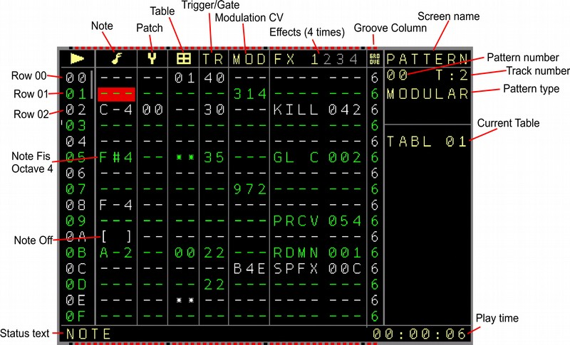
Figure 2: Pattern Screen (Internal CV/Gate Track)

Notes, Patch, Table, Trigger, Mod, FX1..4 and Groove

- Notes: To enter music notes ( C-4 for Note C in octave 4; D#5 for Note ‘Dis or d-sharp’ in octave 5) [ ] is the lowest ‘note’ and it is for note off. In case the Autogate function (→Setup Screen) is turned on, then the Gate is ON when a note is being played and the Gate is OFF when a Note off occurs. The Gate will also automatically go to Off and On again if no note off was set but a new note is playing, this to retrigger a new note. The Off time can be set up also in the Setup Screen. If a trigger is filled in on the same row, then the auto-gate function is disabled for this row as the trigger will overrule.
You can pre-listen a note by using the OK button. (Works also in combination with SHIFT)
It is also possible to pre-listen your sequence by holding the OK button and scrolling up/down. If a note value is filled in on the same step in the MOD column, then this note will be updated as well. (Allows ‘duo-phonic’ pre-listen)
Also if the setting ‘Auto Fill in Trigger’ is enabled, then a trigger of 20ms is automatically inserted when inserting a note. This to get a fast result editing feeling when live programming sequences.

- Patch can select a patch which is loaded before a note plays. With it you can change patches with every sequencer step. Press OK to create a new patch. Press SHIFT + OK on a filled in patch to Clone the filled in patch into a new patch. Enter the Patch with the PATCH button. → More on patches in the Patch section

- Table is to select a table to transpose notes or effects. Those have a different (or same) time scale than the normal sequencer steps and can create nice arpeggio sounds or fast or slow changing effects. (see → Table screen to find out what tables are capable of).
A table number in the column will start the table and it can be stopped using the table stop command in the same column below table 00 showing as the two asterisks ‘**’. Tables can be entered using the table button. If a table is not initialized yet, then it will be either automatically initialized by entering the table, or you can create a new table using the OK button. Initialized tables got the normal row colour, while uninitialized tables are ‘greyed out’ (have the colour of a muted track)
Pressing SHIFT+OK on a used table position will clone the selected table into a new one.

- Trigger, turn the trigger output on/off (repeatable). As it has multiple functions, the values in this field have several meanings:

If the 2nd digit is zero and the first has a value:
10 triggers very shortly ON/OFF (5ms)
20 triggers ON/OFF with a longer ON (10ms)
30 triggers ON/OFF with an even longer ON time (15ms)
….. up to F0

If the 1st digit is zero and the 2nd digit has a value it has a (inverted) function which results in a delayed gate:
01 triggers OFF/ON shortly (delayed gate, 5ms delay)
02 triggers OFF/ON with a longer OFF time (delayed gate, 10ms delay)
03 triggers OFF/ON with an even longer OFF time (delayed gate, 15ms delay)
….. up to 0F
Keep in mind that you might want to reset the trigger again in the new row or before by using the kill command.

If both the 1st and the 2nd digit have a value then the trigger will repeat.
The first digit is for the trigger length where again 1 is the shortest trigger and F the longest. Trigger/Pause times are equal here. The 2nd digit is for the amount of repetitions, where 1 is one repetition (2 trigger pulses) and F are 15 repetitions (16 trigger pulses).
22 triggers ON/OFF/ON/OFF/ON/OFF fast (10ms pulses)
23 triggers ON/OFF/ON/OFF/ON/OFF/ON/OFF fast (10 ms pulses)
52 triggers ON/OFF/ON/OFF slower (25ms pulses)
Furthermore there are 3 special function numbers with which you can manipulate the trigger to be set or reset. It acts as a gate then.
00 Turns output OFF ( = reset Gate)
FE Turns output ON ( = set Gate)
FD Toggles the output. So if it was on, then it’ll be off and the other way around
A trigger in the trigger column overrules the auto-gating function of a note if in the same row.
All trigger functions from the trigger column are showed in the statusbar as well.

Pressing OK on a trigger value will ‘fire’ the trigger.

Triggers can also have a fixed delay per track. That means that a trigger in the Trigger column will always delay by x milliseconds. That to be sure all external gear can handle the Trigger together with a wanted CV signal and will not use a probably non-valid CV value.
More on the delay-settings in the track-setup menu.

Be aware that the trigger/gate of each output can be inverted by default. So a turned ON Gate can have 0 Volt and a turned off Gate can have +5 Volt. The Trigger/Gate inversion can be enabled in the Track Setup.

See the chart below for a graphical explanation of the trigger handling.

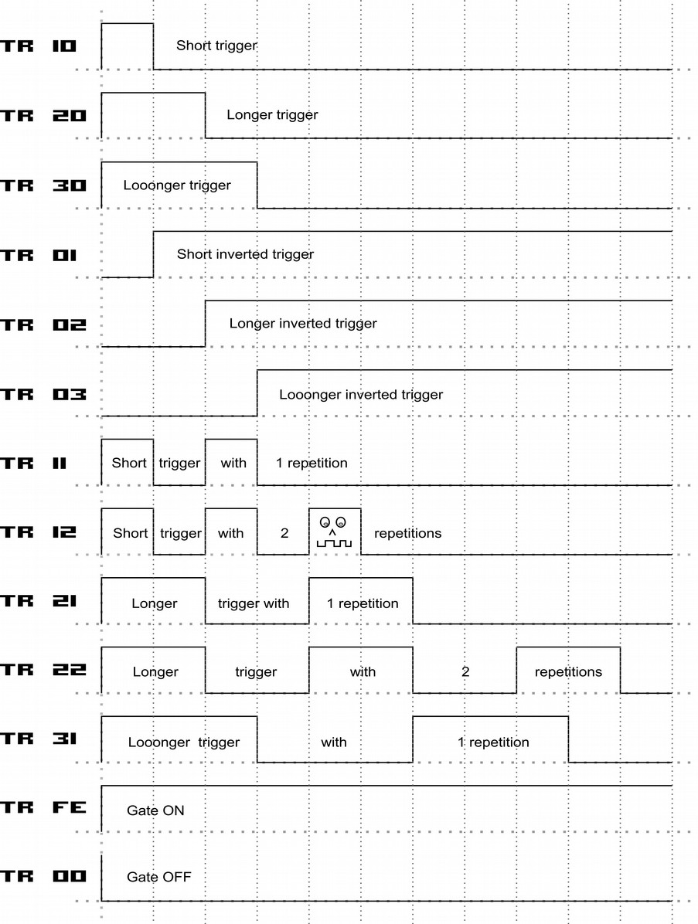

- MOD changes the Modulation output of the track to a value 000 - FFF (range from 0 - 10 Volt or -5/+5 Volt). Furthermore, the MOD output can also Generate Note-scaled values. Behind FFF the note scaling begins from C-0 to A#9. Using the SHIFT+OK button combination the values can quickly be toggled between 000, 800, C-0, C-4 and C-8.
You can ‘pre-listen’ a Mod note value by pressing OK. This will change the MOD value directly to the note or value. If also a note in the note column is filled in, this will also be changed and a trigger is generated. With this a kind of ‘duophonic’ pre-listen is possible. When using the cursor keys Up/Down additionally a sequence can be pre-listened by scrolling through it.
- FX there are several special effects and parameters that can be changed (a growing list) For now there are the following effects for the modulation tracks:
  - PTCH → Pitch: Changes the CV pitch in fine steps. 40 is the middle point = no change. 41 and higher changes the pitch higher and 3f and lower change the pitch lower. The pitch will stay until a new note is triggered
- GL C → Glide CV: Lets the Note glide to the next note.
- GLCS → Glide CV steps: changes the steps for the glide. Higher steps can generate a quantize effect (tip: higher steps need also a higher Glide CV value )
- MOD → Modulate, changes the MOD CV output, same as the MOD column
- GL M → Glide MOD: Lets the Mod output voltage glide to the next selected value in the sequencer
- GLMS → Glide MOD steps: same like for Notes but then for the MOD output
- TRIG → Trigger Triggers the trigger output, same as the trigger column but without auto-gating overrule
- CV1..6 → changes the CV of the CV outputs 1 .. 6. So you can manipulate all CV outputs from every track
- TRG1..6 → Trigger 1..6 Triggers for the outputs 1...6 So you can manipulate every Trigger output from every channel
- MOD1..6 → Modulate 1..6 changes the CV of the MOD outputs. Also with this you can manipulate every of the 6 MOD outputs from each track
- PRCV → Probability percentage for the Note column. Sets the percentage of the probability mode for the music notes. The Probability mode can skip notes, based on the probability percentage. (1% .. 99%). The chance of probability is based on each step. For example with 75%, if every note is set with 100 steps and those 100 steps are being played, then only 75 notes would be played/changed (average). A probability value of 0 or 64 (100 decimal) will turn the probability off. This also affects the automatic gate setting for the notes. So if the recent note is skipped then the gate is also not being set automatically. You can override this by using the Trigger values instead.
- PRTR → Probability percentage for the Trigger column. This affects any value from the trigger column but no general gating issued by the note gating. The functionality is the same as described for the Note probability.
- PRMD → Probability percentage for the MOD output. The same probability functionality as described before but then for the values in the MOD column.
- PRTB → Probability percentage for the Table column. The same probability functionality as described before but then for the values in the Table column.
- PRF1 → Probability percentage for the FX1 effect column. Here every kind of effect parameter from the FX1 column can be involved in the probability.
- PRF2 → Probability percentage for the FX2 effect column. Here every kind of effect parameter from the FX2 column can be involved in the probability.
- PRF3 → Probability percentage for the FX3 effect column. Here every kind of effect parameter from the FX3 column can be involved in the probability.
- PRF4 → Probability percentage for the FX4 effect column. Here every kind of effect parameter from the FX4 column can be involved in the probability.
- ASL0..ASL7 → Automator settings for Automator slots 0 ..7. Here you can change manipulate all automator settings for each slot. Depending on which type of automator you assigned to a slot you can change the value. The 3 Value digits have special functions as following:
X00, The first digit (X) is the function of the automator, so if you for example assigned a LFO to this automator, the first digit is being used to decide which LFO setting should be changed. ( eg: Start,Stop, Reset, Speed, Offset, Invert, Amplitude etc..). The 2nd 2 digits 0XX is for the value (scaled to 255 values).
- ENV1..8 → Envelope settings or actions for the local envelopes 1..8.
The first digit (combined with the latter ones) defines one of the following functions:
100 → Set Envelope Gate
101 → Reset Envelope Gate
102 → Trigger Envelope Gate
103 → Toggle Envelope Gate (if it was set then it resets and the other way around)
2xx → Set the attack value
2xx → Set the attack peak
4xx → Set the decay
5xx → Set the sustain
6xx → Set the release
7xx → Set the offset
800 → Set the type to ‘One shot’
801 → Set the type to AD-SR
802 → Set the type to Loop
- PROW → Set the probability for the whole sequencer row
- RDMN → Random next FX value. The next FX value will be overruled by a random value if the randomvalue is 1..4 for the 4 FX columns. If the randomvalue is 000, then a random FX will get a random value!
- PATC → Same as patch column. Calls a patch.
- TABL → Same as table column. Selects/Starts a Table.
- STSP → Start sequencer pattern. Here you can select any position on the sequencer screen that should start to play next. It works in the same way as the start button. It’s toggling between start on the zero cross of the mainclock or start on the next queue point. The First digit X00 is for the track where zero is for the whole row and 1..8 for the sequencer tracks. The 2nd two digits 0XX are for the row number in the sequencer screen.
- SCLK → Select track clock. Here you can set the different dividers and multipliers for the current track. Possible settings are from 000 to 010:
/7, /6, /5, /3, /32, /16, /8, /4, /2, Normal clock, *2, *4, *8, *3, *5, *6, *7
This order is chosen on purpose as mostly base2 dividers and multipliers are used around the regular clock. (See track setup)
- SPFX → Special FX command. Contains some non-value special functions:
000 → No function
001 → Stop Track at the end of the Pattern
002 → Stop Track immediately
003 → Stop Song immediately
004 → Set Clock Output
005 → Reset Clock Output
006 → Pulse Clock Output
007 → Set Clockreset Output
008 → Reset Clockreset Output
009 → Pulse Clockreset Output
00A → Reset all FX values of the track
00B → Reset all FX values of all tracks
00C → Jump to a random position in the same pattern (within the patternlength)
00D → Resync Track to the mainclock (synchronizes on the zero cross of the mainclock)
00E → Resync All tracks to the mainclock (synchronizes on the zero cross of the mainclock)
00F → Avoid transpose for the Track
010 → Allow transpose for the Track
011 → Create a table tick. This is for the current running table on the track and can be used to proceed with the next table step.
- BPM → Changing the main Tempo to the desired Beats Per Minute
- BASE: Basenote transposes all following notes from the recent pattern with the value of the basenote > 00 is higher, < FF is lower . The transposition lasts until the end of the pattern.
- KILL: Stops the note before the next step, with it you can create really short gates/triggers or every possible gate timing.
As an additional function a value of 0 doesn’t trigger the note. To be used for a note change only without a new triggering/gating.
- BRK: Break/Jump/Repeat: Resets (breaks) the pattern sequencer to the begin. With this you can regulate your amount of steps in the sequencer for each pattern. (up to 64 steps). The second function is a repeat of the pattern for a X amount of times. Then you fill in a value with the break (below 100) and the pattern repeats. The third function is to jump to a row in the same pattern. To use the jump function, set the first digit to 1. The last 2 digit are the pattern row to jump to.
Examples:
BRK 000 → Breaks the pattern and starts with the next pattern if selected
BRK 003 → Repeats the same pattern (till the break) 3 times, so it plays the pattern 4 times until it continues with the next pattern.
BRK 108 → Jumps with the player to row/position 8 in the same pattern.

All jump, break and repeat functions are being cancelled if a new pattern is being selected to be played next.
- Groove → changes the amount of substeps per pattern step (can be used to change the steplength). 6 is a normal and preset value (equals the resolution of 24ppqn) but finer resolutions can be generated by higher values. The preset value can be changed in the setup screen (Default Groove Ticks) and so new patterns can get a different default groove. Also a shuffle/groove effect can be created by changing the groove in an interval like 5/7/5/7/5/7. Also you can let the different patterns run away from each other by using ifferent groove settings which affect the general timings of a step.

Pattern Screen (Audio Tracks)
The audio tracks have different columns. This is because the samples or waveforms don’t have CV settings or modulation outputs. However they have other relevant parameters like volume or the selected sample. Also the parameter set for the FX columns is different compared to the CV tracks.
To use the samples you have to load samples into one of the 12 sample slots. Use either the Load Sample function in the Nerd Menu (SHIFT+NERD on an audio track in the sequencer screen or in the pattern screen of an audio track). See the → Load Sample Window. Samples are loaded into the memory then. The sample memory is limited to 190kB which means over 4 seconds of sampling with 44100khz, 8bit Mono. However, samples with a lower resolution end up in longer samples. Choose your balance between sample quality and sample length.
Besides the samples, different waveforms can be played/ started to run like an oscillator. These waveforms can be pitched, played just like a regular sample, except for that the waveforms will run basically endlessly (unless stopped or another effect like envelopes are routed on them). Beside of being an oscillator, these can be setup to act also as a 4 Operator FM synthesizer (Details in the → Sample / Wave / Synthesis part of the manual).
Another feature is that each audio track/pattern can consist 2 different sequences. So 2 samples/waveforms can be sequenced and played at the same time. Also both parts can have different FX and groove settings, so they can run kind of independent. However if one part of the pattern is finished then the other part will finish as well and both will be re-synchronized again to be played in the next pattern. In the screen you can always see one of the 2 pattern parts. On the complete left the 1st part of the pattern and if you navigate to the right after the groove, the 2nd part will appear with the same possible functions.

Let’s first explain the pattern audio screen for the samples/waves/synth:
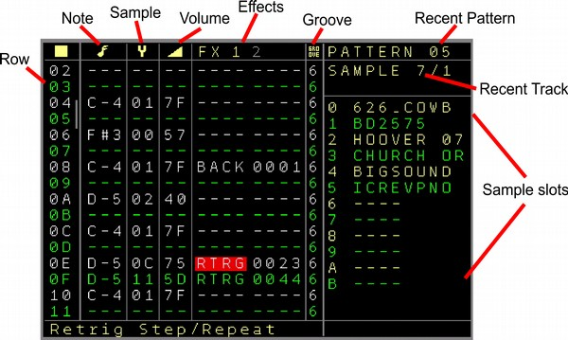Figure 3: Pattern Screen (Audio Track)
First’ly again the sequencer row (up to 64).
Then the following columns:
- Note : To fill in the musical notes. It changes the pitch of the sample/wave in note scale. To trigger a sample/wave a note must be filled in. In the screenshot it is the Basenote is C-4 which represents the original sample speed. A note on means also ‘ Gate on’ which can be used in combination with the envelopes to be able to also trigger an envelope when the sample/wave is triggered.
To stop a sample/wave you can use also the brackets here (below lowest note / Delete on empty note field) [ ]
This will directly stop the sample or wave audio and also releases the gate.
Next to the note off there is also the ‘Gate Off’ function ( below the note off function / delete on a note-off field) ‘ ***’ . This keeps the sample or waveform playing but does set a connected envelope into it’s release phase (if the envelope is set to AD-SR mode).
Note that the envelope is not retriggered if it was not either finished or the gate was released.
- Sample / Waveform: Fill in the number of the sample slot. So for example, if you want to play sample slot 1 (626 SD2 which is the 2nd snaredrum sample of the famous Roland Drum computer TR-626) then you would need to fill in 01 here since the sample is loaded into the first sample slot. The waveforms are available from Sample number 12 to 17 (0C..11).
The different waveforms are as the following:
12 (0C) : Sine
13 (0D) : Triangle
14 (0E) : Ramp
15 (0F) : Sawtooth
16 (10) : Pulse
17 (11) Noise.
The waveforms are starting once played and will only stop on either a Note Off of a stop all sounds command. Be aware that the Oscillator function is not a true replacement for analogue oscillators, but for many applications they will do the job well.
- Volume: sets the volume of the sample/waveform. Where 7F (127) is the average value for a sample ( -2.5 to +2.5 volt max on the output) you can also increase the volume until FF (255) (-5 to +5 volt max on the output. Be aware that when using a 2nd sample in the same track which is possible would lead to a clipping here, since the samples are additionally mixed together like with regular mixers. So to be safe with 2 samples you would like to stay beneath 7F for both. The volume can also be set in a column with out a sample, to manipulate an already playing sample volume.
- FX ( 2 FX columns for each sample ): You can add different FX parameters to further manipulate the sample. These parameters are:
  - FPTC → Fine pitch a sample. Changes the pitch of the recent playing sample. While value 0x40 is the base value which equals to the same pitch as the sample, higher values will pitch the sample higher and lower values will pitch the sample lower. A new triggered sample will reset the fine pitch values.
  - RTRG → Retrigger sample. Restarts the sample after a dedicated time multiple times:
The 1st digit here is the time delay when the samples will be retriggered again and the 2nd digit is the amount of repetitions. A retrigger will also retrigger an eventually connected envelope.
A value of 0000 for the retrigger will also retrigger or start a connected envelope.
  - BCSH → Bitcrush. Is a digital effect which lowers the bitrate of the sample (floating point precision). When using the bitcrush, the bitcrush setting stays on until it is being set to zero again. This works as a channel effect like a knob where you turn it on by turning the potmeter to the right 01..FF and turn it off again by turning the potmeter to the most left position again (00).
  - DIST → Distortion. Adds a simple digital distortion effect (floating point precision) to the recent sample. Also here, it stays on until you turned it off again.
  - WFLD → Wavefolder effect. Folds the waveform/sample.
  - BACK → Is a multi function FX.
If there is a sample playing currently then this is used to play the sample backwards.
xxx1 → Plays it backwards. Can also be used in the middle of a sample to change the playing order.
xxx0 → Plays the sample normal
If a waveform is playing then the following functions can be activated:
xx00 → No Modulation/Function
xx01 → Hardsync with the other waveform of the same track. So if a waveform is also playing on the other part of the track, then the current waveform is being reset on a zero cross of the other waveform. This can be used on both sides to manipulate both waveforms.
xx02 to xx10 → FM modulation of the current playing waveform. While the current playing waveform is the carrier, other waveforms/operators/samples can be used as the modulator(s). This allows to create up to 4 Operator FM synthesizer configurations.
The following configurations can be selected: FM from OP1, OP2, OP3, OP4, OP1+2, OP2+3, OP3+4, OP1+3, OP2+4, OP1+4, OP1+2+3, OP2+3+4, OP1+3+4, OP1+2+4, OP1+2+3+4
x0xx → The current audio output of the sample/wave part is not muted/silenced
x1xx → The current audio output of the sample/wave part is muted/silenced. Use this if you for example use the waveform only as modulator and you don’t want to hear it in the output. Internally the audio signal can still be used for the modulations.
0xxx → Notes play normal for the current sample/wave part
1xxx to 4xxx → Will copy the notes from the selected source (OP/Wave 1..4). This allows one to play the same notes or a transposition of the notes from the source. Important for harmonic FM modulations or bigger sounds when mixing waveforms.
  - OFFS → Set the sample offset to the scaled value.
In combination with the Pulsewave waveform, this defines also the Pulswidth ratio. Where 0 means 50:50. Other setting can go to 0:100 (001) or 100:0 (FFF) ratios of the pulsewave pulsewidth.
  - TABL → Start/assign table to the pattern part. So you can use the tables also for samples. The numbers show the selected table. A table that has already been assigned is shown in the regular colour. Tables that are not assigned/used yet are greyed out (the ‘mute’ colour). You can assign them to an audio track by either press the OK button or by pressing the TABLE button. With the TABLE button the table screen is also directly entered, so the selected table can be edited. Note that tables generated in the audio tracks also can use the FX from the audio tracks.
A table number higher than 31 will set a ‘Stop Table’ command, shown by ‘STOP’.
  - PROB → Add probability to the pattern part. It adds the probability of a sample to be played ( or stopped) with a given percentage. Same as the Note probabilities for the CV outputs. (see description there) Both pattern parts can have a different probability setting. Also here it is a setting that you can turn on by using the probability but you have to turn it off again yourself.
  - PRF1 → Add probability for the FX1 parameter+value. Same as the probability setting but then it gives a probability to the first FX parameter. This way you can add probability to every parameter.
  - PRF2 → Add probability for the FX2 parameter+value. Same as the probability setting but then it gives a probability to the first FX parameter. This way you can add probability to every parameter.
  - TRIG → Fire the triggers from tracks 1..6. While the 1st two digits define the triggers 1..6, the 2nd two digits define the type/value of the triggers. These use the same trigger functions as the regular trigger columns.
  - NOTE → Changes the note of the set up CV/MOD output. The destinations are CV1..6 and MOD1..6. The 2nd digit sets the Output and the last 2 digits the Note value.
  - VOLT → Changes the pitch/voltage of the set up CV/MOD output. The destinations are CV1..6 and MOD1..6. The 1st digit sets the Output and the last 3 digits the pitch value.
  - DELY → Delay settings for the track. This functions contains again multiple settings:
0100 – Delay Type: Short Highest quality. Best quality but short delay time
0101 – Delay Type: Lo-Fi. Lower quality but longer delay time
0102 – Delay Type: More Lo-Fi. Lowest quality but longest delay time
0103 – Delay Type: Fast. High quality, very short time for flanger effects
02xx – Delay Time
03xx – Delay Input send. Is the input volume for the delay
04xx – Delay feedback. Is the volume/amount of the delay feedback
  - GLID → Changes the Glide
  - PROW → Probability for the sequencer row. Keep in mind that the whole audio row of the track is affected and not only a part of it.
  - SETW → Set/change the current sample/waveform. An eventually inserted sample/wave in the sample/wave column will overrule this FX command.
  - ASL0..7 → Automator Slot settings. (same as for CV-Gate patterns, check there for details)
  - ENV1..8 → Local Envelope settings. (same as for CV-Gate patterns, check there for details)
  - STSP → Start sequencer pattern. Here you can select any position on the sequencer screen that should start to play next. It works in the same way as the start button. It’s toggling between start on the zero cross of the mainclock or start on the next queuepoint. The First digit X00 is for the track where zero is for the whole row and 1..8 for the sequencer tracks. The 2nd two digits 0XX are for the row number in the sequencer screen.
  - SCLK → Select track clock. Here you can set the different dividers and multipliers for the current track. Possible settings are from 000 to 010:
/7, /6, /5, /3, /32, /16, /8, /4, /2, Normal clock, *2, *4, *8, *3, *5, *6, *7
This order is chosen on purpose as mostly base2 dividers and multipliers are used around the regular clock. (See track setup)
  - LSMP → ‘Nearly’ seamless load of a complete sample block. A sampleblock (content of all 12 sampleslots) can be replaced by that. → More on that in the project screen section where sampleblocks can be generated.
  - SPFX → Special FX functions, (same as for CV-Gate patterns, check there for details)
  - BPM → Changing the main Tempo to the desired Beats Per Minute
  - KILL → (2do) Stops a sample at a given time. So resolutions between steps are possible
  - BRK → Break/Jump : Breaks (stops) the pattern. By that you can create shorter steps than the standard 64 steps. (eg 16 steps or 7 or so..). Be aware that BRK stops both parts of the pattern. So also when working with different timings in one pattern, the pattern will completely be broken and resynchronised with the next pattern.
The second function is to jump to a row in the same pattern. To use the jump function, set the first digit to 1. The last 2 digits are the pattern row to jump to. So for example BRK 105 will jump to row 5. Or BRK 110 jumps to row 10 (or 16 decimal). BRK 000 (or any value lower 100) will only activate the Break function. Be aware that the jump/repeat functions work only on the first FX column for sample 1 of the track.

- Groove: Also here the groove settings for the step. Standard is 6 but different length of the step can be set by that. See the groove explanation on the normal pattern groove section.
A particularity here is that one pattern has 2 groove settings so you can have different settings for the 2 parts of the pattern.

Basic usage:
To add a sample to the slot, you open the sample-slot window by pressing the PATCH button when you are in a sample pattern. The sample-slot window is described later on in this document.

Pressing OK (and maybe scrolling up/down) on the sample notes can be used to ‘pre-view’ the sample with the note-pitch. This function is similar to the note-prelisten in the modular pattern screens.
Waveforms can be mixed or synchronised and even manipulated from the automators.

Pattern Screen (Midi tracks)
If a track is assigned to Midi, then the midi pattern screen is used. The screen is here split up to different pages. You move the cursor further to the right to get to the next pages.

Page 1:
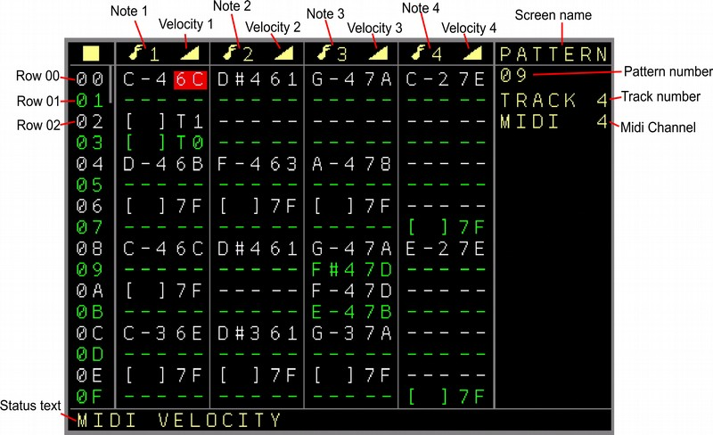Figure 4: Pattern Screen (Midi Track, 1st Page)

First again the sequencer row (up to 64).
- 4 Note columns where each Note columns has the Note Value and a Velocity value. The Velocity (mostly volume) can be from 00 (Note off) to 7F. So 4 voice polyphonic midi sequencing per track is possible. Additionally also notes for the local CV, MOD and Trigger/Gate outputs can be filled in here. You can get to these when a note is filled in. In the Velocity column, if you press SHIFT+OK, then it swaps to the local CV/Gate Functions. Pressing SHIFT+OK again will bring you back to the velocity values.
The alternative values for the velocity do control always the local CV/Gate track but do not affect Midi data. Regular Velocity does affect the Midi Data. The CV/Gate/MOD velocity values have the following functions (together with the Note or Note off):

Local (track) CV Output functions:
A → Does only a note change on the CV output. No gate change if a note is filled in. Gate off if a note off is filled in.
A0 → Does a note change while turning the Gate OFF
A1 → Does a note change while turning the Gate ON
A2 → Does a note change while doing a trigger of 10ms (like trigger 20)
A8 → Does a note change while doing a trigger of 40ms (like trigger 80)
AT → Does a note change while toggling the current Gate state
Local (track) MOD Output functions:
B → Does only a note change on the MOD output. No gate change if a note is filled in. Gate off if a note off is filled in.
B0 → Does a note change while turning the Gate OFF
B1 → Does a note change while turning the Gate ON
B2 → Does a note change while doing a trigger of 10ms (like trigger 20)
B8 → Does a note change while doing a trigger of 40ms (like trigger 80)
BT → Does a note change while toggling the current Gate state
Local (track) Trigger/Gate functions:
T → Gate On if a note is filled in but note is ignored. Gate off if Note off is filled in, but note change is ignored.
T0 → Gate OFF without note change.
T1 → Gate ON without note change.
T2 → Trigger of 10ms (like trigger 20) without note change.
T8 → Trigger of 40ms (like trigger 80) without note change.
TT → Toggling the current Gate state without note change.
Local CV/MOD functions, regardless of current track:
C1 → Note change on CV 1 Output (no Gate change)
C2 → Note change on CV 2 Output (no Gate change)
C3 → Note change on CV 3 Output (no Gate change)
C4 → Note change on CV 4 Output (no Gate change)
C5 → Note change on CV 5 Output (no Gate change)
C6 → Note change on CV 6 Output (no Gate change)
M1 → Note change on MOD 1 Output (no Gate change)
M2 → Note change on MOD 2 Output (no Gate change)
M3 → Note change on MOD 3 Output (no Gate change)
M4 → Note change on MOD 4 Output (no Gate change)
M5 → Note change on MOD 5 Output (no Gate change)
M6 → Note change on MOD 6 Output (no Gate change)

Page 2:
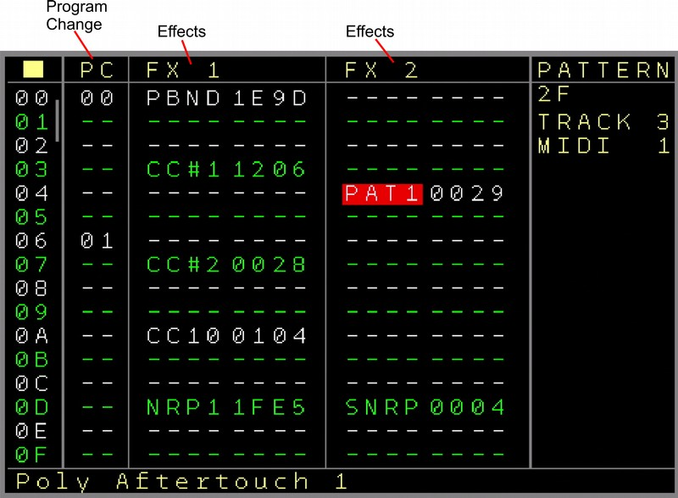Figure 5: Pattern Screen (Midi Track, 2nd Page)

First again the sequencer row (up to 64).
- PC → Program Change. Sends a program change command to the midi channel. If the ‘On Change’ setting in the Midi track setup is enabled, then it will only be sent on change. Some Midi-Devices need a long time until the Program Change is ready and stop playing then. So the function sends only when it really changes and minimizes midi gear hickup then.
- FX1..2 → 2 FX columns with the following functions:
- PBND → Pitchbend. Sets the pitchbend, where 2000 is the middle value (eg pitchbend not used), 3FFF is maximum (Pitchbend wheel full UP) and 0000 is minimum (Pitchbend Wheel down)
- CC#1..CC#8 → Midi CC (Controller Change) messages. Sends controller changes to the controllers which are set up in the midi track settings. The last 2 digits 00XX are for the value. (7F maximum). If the First digit X000 is set to one, then the 2nd digit 0X00 sets the Midi Channel. With this it is possible to send CC values also to other channels than the Midi Channel which is set up for the track. Some devices receive main data on one channel and other parameters via CC on other channels. If the first digit X000 is reset to 0, then the midi channel which is setup up for the track is used.
- CC9..CC16 → Free assignable Midi CC. As the Midi controller numbers for CC#1..8 are fixed and must be set up in the track settings. These controllers can be freely assigned.
The first 2 digits XX00 set the controller type/number and the 2nd two digits the value.
The main difference to the first 8 controllers is that the first 8 controllers can be used also for the automators and other channels while the controllers 9..16 can freely be assigned in the sequence.
- CATC → Channel Aftertouch. Sends extra aftertouch settings valid for the whole channel (mostly used with most midi implementations)
- PAT1..4 → Polyphonic Aftertouch. Sends extra Aftertouch settings per note. Where 1..4 is the note column which should be addressed. The values are valid from 00 to 7F.
Polyphonic aftertouch is often not implemented as it generates a much larger amount of midi traffic CC.
- NRP1..4 → Sets NRPN controllers. These act mostly like higher resolution CC if implemented by the midi device. The NRPN Controller number is being set in the midi track setup screen and the value can be form 0000 to 3FFF then. Be aware that NRPN message sends up to 4 times the amount of midi data compared to a normal CC message. So handle with care to avoid a midi traffic jam (especially in combination with automators).
- SNRP → Sets the controller type of NRPN4. With this NRPN4 can be used as a flexible controller. The controller type number can be up to 3FFF.
- All further parameters are exactly the same as for the local CV/Gate tracks and so all functions of the local tracks can still be used.... with one exception:
- KILL → Kills the note (sends a note off) after a set up time. Where the first digit X000 points to the Note in the note column which should be killed (0 is for all notes and 1..4 for notes 1..4) the 2nd three digits 0XXX are used for the time until the note stops. Small amounts can generate very short note times (shorter than steps).

Page 3:
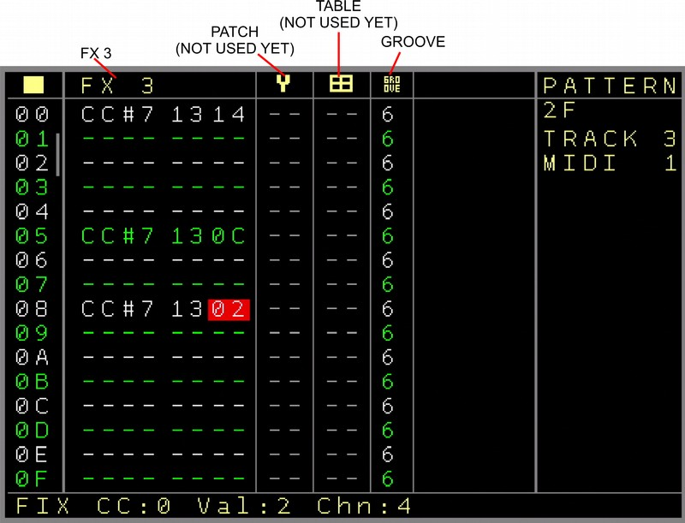Figure 6: Pattern Screen (Midi Track, 3rd Page)
First again the sequencer row (up to 64).
- FX3 → Same FX as in Page 2
- Patch → Column to set a patch. ( Not implemented yet for midi, so greyed out)
- Table → Set a table ( not implemented yet for midi, so greyed out)
- Groove → Apply groove settings just as for the other tracks (see CV/Gate Pattern screen for description)

Specials for the Midi tracks:
A track can be set up to a channel (multiple tracks can have the same channel, but be wise with crossing notes). On top of that, CC values 1..8 can also be send to other channels.
A setting (in midi track settings) allows the notes of the first note column to be sent via midi but also to the local CV/Gate outputs. Where a note on sets the gate and a note off resets the gate.
Pressing the OK button on the Note Columns will prelisten all notes in the row. Navigating UP/DOWN let the notes play while navigating.

Pattern Screen (‘More Triggers 16’ tracks)

This pattern screen is only available with a connected ‘More Triggers 16’ expander. You must assign a track to be used together with the expander in the ‘Track Assign’ screen. (See Track Assign screen)
As the pattern values don’t fit on one screen with this one, it is split into 3 pages.

Page 1:

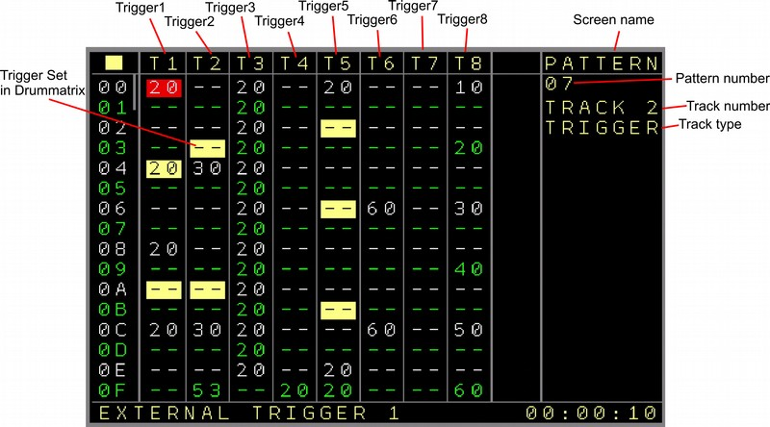Figure 7: Pattern Screen (Trigger16 Track, 1st Page)

First again the sequencer row (up to 64).
Then the following columns:
- TR1 .. TR8 Are the columns for the first 8 trigger outputs. The values are exactly the same as on the local Trigger columns. (see CV/Gate Pattern screen for explanation)
As a side note, this can also be the Columns TR9 .. TR16. You can setup in the track settings to use the 2nd part of the 16 outputs.
The trigger part is highlighted if a trigger is set up in the drum matrix for the same trigger position.

Page 2:

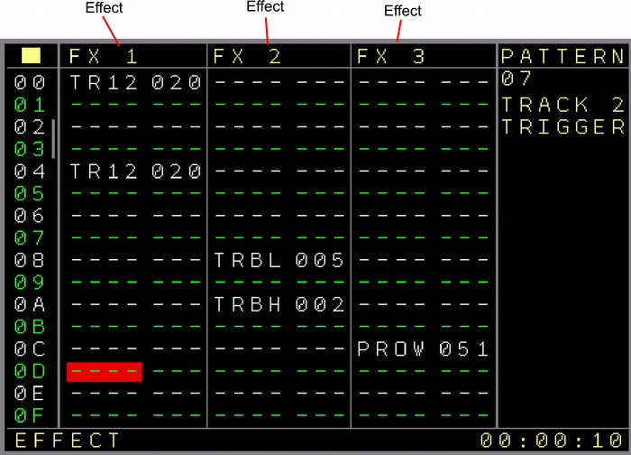Figure 8: Pattern Screen (Trigger16 Track, 2nd Page)

First of course again the sequencer row (up to 64).
- FX1 .. FX3 → FX columns dedicated to the More Triggers 16 expander with the following parameters:
- TR1 .. TR16 → Trigger values, same as the regular trigger values
- TRBL → Trigger Binary Value Low, set the binary value for the first 8 Trigger outputs. The triggers are set or reset depending on the value. This could be used for some cool dividers.
- TRBH → Trigger Binary Value High, set the binary value for the second 8 Trigger outputs (9..16). The triggers are set or reset depending on the value.
- TRAO → All Triggers/Gates Off
- NOTE → Plays or changes the note on the local CV+Gate output. If the first digit is 0, then only a note change will be send to the CV output. If the first digit is 1, then a trigger (set up in the track setup → Matrix Trigger) is also sent together with the note. The filled in notes can currently be seen in the statusbar. (subject to change)
- All further parameters are exactly the same as for the local CV/Gate tracks and so all functions of the local tracks can still be used. The only difference are the probability settings which belong now to several trigger outputs and FX.

Page 3:

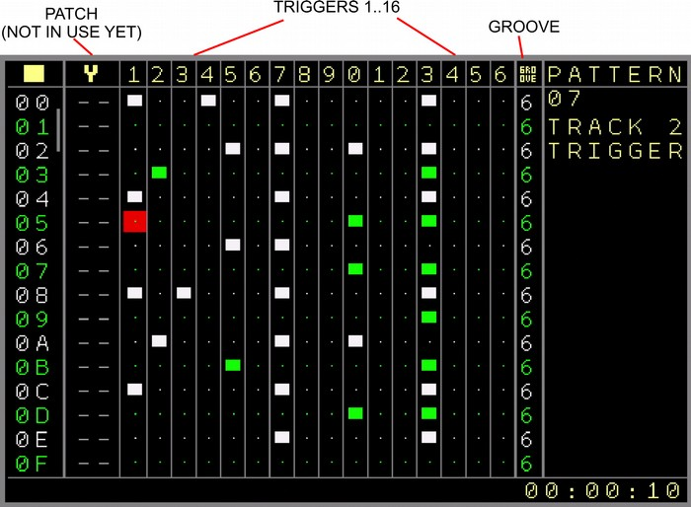Figure 9: Pattern Screen (Trigger16 Track, 3rd Page)

First of course again the sequencer row (up to 64).
- Patch → Set patches for all FX parameters. (Not implemented yet, so greyed out)
- DrumMatrix → 16 columns for the 16 outputs. This is a classic view where you can set and reset triggers in a matrix for all 16 outputs.
- Groove → Groove settings as known from the other tracks (see CV/Gate pattern screen for further explanation

Special usage:
The triggers in the drum-matrix can be enabled with SHIFT+CURSOR RIGHT and disabled with SHIFT+CURSOR LEFT or via SHIFT+DELETE. The whole row can be deleted using the mark functions.
Note that the drummatrix counts as one column currently, so it’s not possible to do any copy + paste actions on only a few drum-matrix columns. All these actions are always for a whole drum-matrix row. The kind of triggers can be set up in the track settings screen.

Values filled in on Page1 or Page 2 override the possible drum-matrix trigger on the used trigger. So if for example Trigger 3 is enabled in the drum-matrix and the drum-matrix triggers are set to 20. And if on Page 1 the Trigger 3 is set to the value 52 in the same row, then the 52 overrules the 20.

The Triggers can also be muted or soloed. To mute a Trigger your cursor must be on either a trigger column in the first page or on the drum-matrix. Pressing SHIFT+DOWN+START will mute/unmute the trigger. Pressing SHIFT+UP+START will Solo or unsolo the Trigger. When unsolo-ing all triggers will be unmuted as well. The function works the same as muting and solo-ing for the regular tracks.

Drum-Matrix patterns can be moved per trigger. Using SHIFT+OK+CURSOR DOWN moves the currently selected trigger column in the drum-matrix one step down. Triggers that shift out of the last row will be inserted in the first row. Using SHIFT+OK+CURSOR UP moves the current selected trigger column in the drum-matrix one step up. Triggers that shift out of the first row will be inserted in the last row.

Beside setting different trigger points in the drum-matrix manually, a different input mode is available. Drum triggers can be inserted in a ‘Euclidean Rhythm’ style. The idea is to add an amount of triggerpoints where the pauses between the triggers is as equal as possible. For example, if a pattern has 64 steps and an amount of 16 triggers should be filled in, then the spacing/pause between each trigger will be 4 steps long/ every trigger will be inserted every 4 positions.
So it is possible to insert 0 to 64 triggers and the triggerpoints and pause is automatically calculated and inserted in the selected triggercolumn of the drum-matrix.
By using SHIFT+OK+LEFT, the amount of triggers is decreased and the euclidean rhythm is inserted. By using SHIFT+OK+RIGHT, the amount of triggers is increased and the euclidean rhythm is inserted. Note that the counting starts at the cursor position, so if the cursor is for example on the 7th row, then the euclidean counting starts from the 7th row to the last row and wraps around and continues on rows 0..6. The euclidean function will also consider the selected patternlength in it’s calculations.
Also it is important to know that current inserted triggerpoints of the triggercolumn will be overwritten by the euclidean input. On the other hand, columns that were inserted in the euclidean way can be edited further to get different results.

Using the move and euclidean functions on the drum matrix is a fast way to create interesting drum rhythms on the fly.
If the Trigger 16 Track is set up to Piano Roll mode, then each drum trigger column represents a note which depends on the chosen basenote in the track setup. So if the basenote is set to C-2 then the most left trigger column is C-2, next to it C#2, D-2 and so on. You can see on top of the pattern view the coloured sharp and flat notes, based on the base note. A filled in trigger plays the note on the local CV track and fires a trigger on local trigger output. The trigger settings are the same that are used for the Drum-Matrix. Note that the drum-matrix triggers are also firing with that. If you want to avoid the drum-matrix to fire as well in piano roll mode, then use a basenote higher than the highest note (B-8), then you can choose all basenotes again but the additional output on the drum-matrix is turned off.

Pattern Screen (‘CV 16’ tracks)

This pattern screen is only available with a connected ‘More CV 16’ expander. You must assign a track to be used together with the expander in the ‘Track Assign’ screen. (See Track Assign screen)
As the pattern values don’t fit on one screen with this one, it is split into 3 pages.

The CV16 or ‘More CV16’ Expander adds some more flexible screens and functions which need some additional explanation compared to the regular screens.
To get as many functions as possible within the given columns and user interface, multiple functions can be assigned from the same column in the first 6 columns. Also each column can be assigned to a different destination. The destinations can be set in the CV16 Setup Screen

Destinations for the first 6 columns can be one of the CV16 outputs (1..16), the local CV/MOD outputs of the track (TCV or TM), CV1to CV6 (LC1..LC6) or MOD1..6 (LM1//LM6). So within the 6 CV16 columns also all CV/MOD outputs can be manipulated in Notes and Pitch. Even the Triggers/Gates can be manipulated from here as well with a limited set of available Gates/Triggers (Gate On/Off/Toggle, Trigger 20ms and 40ms).
Besides the destinations of the CV setup, different CV types can be used in all of the 6 columns. If the tracks are set up to use one of the CV16 outputs, then the following features can be used:
Notes, Pitch, Trigger/Gate, Envelopes ( Attack/Sustain/Release) , LFO ( Sine, Triangle, Sawtooth, Ramp, Square, Noise, Random).

Page 1:
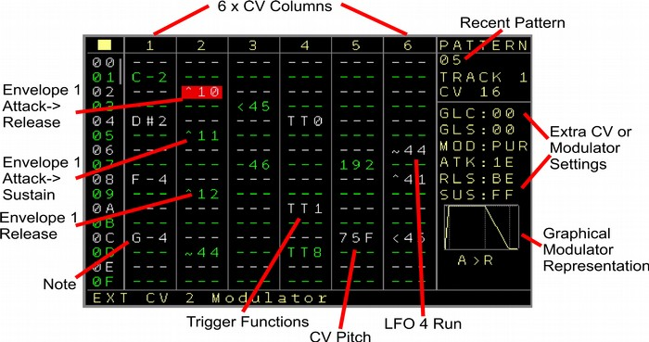Figure 10: Pattern Screen (CV16 Track, 1st Page)

Columns 1..6:
If regular notes are filled in then the assigned outputs will change the voltage to the note value. (if no modulator is running on that output) Depending of the offset switched the Voltage for Note C-0 is either 0 Volt or -5 Volt. After the highest note C-A (as in, scroll the note-value further than note C-A) the modulators can be set up. To fit everything into the columns a special definition of the numbers is used. Starting with the first of 2 digits, the left digit defines the modulator number.
The right digit defines the modulator type. The the following types are available:
0 → Envelope Attack > Release (column also marked with a ‘^’ )
1 → Envelope Attack > Sustain (column also marked with a ‘^’ )
2 → Envelope Release (column also marked with a ‘^’ )
3 → Envelope Loop (column also marked with a ‘^’ )
4 → LFO Start/Continue (column also marked with a ‘~’ )
5 → LFO Reset (column also marked with a ‘<’ )
6 → Stop Modulators (column also marked with a ‘-’ )

Here are some examples of the values:
Filled in the first column which is assigned to CV2:
^10 → Envelope 1 start as Attack/Release on output CV2
^11 → Envelope 1 start as Attack/Sustain on output CV2
^12 → Envelope 1 starting release phase on output CV2
^13 → Envelope 1 set to loop (repeating attack/release) on output CV2
~14 → Start/continue LFO1 on output CV2
~34 → Start/continue LFO3 on output CV2
<55 → Reset LFO5 on output CV2
So for example Envelope 2 is a different modulator than LFO2. The numbers decide just which function you want to start on which column/CV output.
The same LFO or Envelope can run on multiple CV outputs also on different stages.
Another example for another column which is assigned to CV12:
~24 → Start continue LFO2 on output CV12.
-16 → Stop modulator on output CV12. In fact the modulator number is not relevant here, The column / CV output is being released from the running modulator and returns to it’s original note/pitch.

Furthermore, above the modulator numbers a set of Triggers/Gates can bet set.
So if you scroll beyond the modulators the following options are available:
The first set is for the trigger/gate output of the current track
TT0 → Gate Off for the local Trigger/Gate output of the track.
TT1 → Gate On for the local Trigger/Gate output of the track.
TTT → Toggle Gate for the local Trigger/Gate output of the track.
TT2 → Trigger of 10ms for the local Trigger/Gate output of the track.
TT8 → Trigger of 40ms for the local Trigger/Gate output of the track.
The 2nd set is for the destination of the column. If the column is assigned to CV 1..6, then the destinations are the local trigger/gate outputs 1..6. If they are set up for the local track 1..6, then these are also automatically assigned to 1..6. All other assignments use the current track.
Assuming the Column uses CV3 as destination:
TD0 → Gate Off for the Trigger/Gate output 3.
TD1 → Gate On for the Trigger/Gate output 3.
TDT → Toggle Gate for the Trigger/Gate output 3.
TD2 → Trigger of 10ms for the Trigger/Gate output 3.
TD8 → Trigger of 40ms for the Trigger/Gate output 3.

Lastly, besides the trigger settings are the pitch settings of the assigned outputs.
These operate like the normal pitches from 000 to FFF which represents 0 to 10 volt (-5/+5).
As a sidenote, the pitch values are scaled, so not all 4095 (FFF) values are avaliable. In fact you will find out that instead 3908 different values are only available, where over the whole range some numbers are skipped. In general use you will not notice it at all. The voltages are very fine so the skip of one value is not audible. If you really rely on that anyway, then you still have the full range with 4095 values available through the FX columns.

As a fast browsing option, you can also use SHIFT+OK to directly jump between Notes, Modulators, Triggers, Pitches and an empty value.

On the right side of the screen you find the current settings of the selected column. These can differ depending on which kind of destination is selected for the column, but also on which type you are currently with the cursor.
These are not only visible but also possible to directly edit. By pressing the PATCH button your cursor toggles from the left column side to the right side. The settings can then be edited as usual using SHIFT+UP/DOWN/LEFT/RIGHT.

If the destination is a CV output of the expander then you have the following settings:
GLC → Glide Speed
GLS → Glide Steps
MOD → Modulation pure or added
If you selected a modulator then you get the additional settings of the modulator. For an envelope these are:
ATK → Attack value of the selected envelope
RLS → Release value of the selected envelope
SUS → Sustain value of the selected envelope
For a LFO these are:
TYP → The type of the selected LFO (eg Sine, Sawtooth etc)
SDP → The speed of the selected LFO
AMP → The amplitude of the selected LFO
Pressing PATCH again will bring you back to the regular column editing.

You can see on top of the screen, if and what kind of modulations are active on that output.
On the right bottom side you see a graphical representation of the currently selected modulator (if the cursor is on it).
Also while editing, press OK to prelisten the current sequencer row.

Page 2:
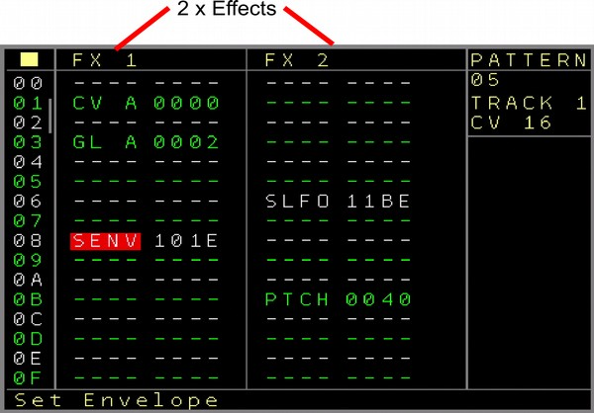Figure 11: Pattern Screen (CV16 Track, 2nd Page)
On the second page there are 2 FX columns. These have mostly some special coding for the 4 digits which will be explained for each function. Also for all CV16 functions, details/help is available in the statusbar, so you should be able to work with all of them without checking the manual again.
The following FX functions are available:
CV A to CV H → Change the CV value. The most left digit Xxxx defines the CV output 1 to 16 and the three right side digits xXXX define the CV value/pitch from 000 to FFF.
NT A to NT H → Change the Note. The 2nd left digit xXxx defines the CV output 1 to 16 and the two right digits xxXX define the note value.
GL A to GL H → Glide settings for the 16 CV outputs. The first digit Xxxx defines the CV output. The second digit xXxx defines if it should be the Glide Speed (0) or the Glide Steps (1) setting. The 2 digits on the right xxXX are the value of the selected settings from 00 to FF. Be aware that the current settings will be filled in automatically when starting to edit.
ST A to ST H → Start Modulator. With this you can start(or stop) any modulator on any CV output.
The 2nd digit from the left xXxx defines the CV output 1..16. The third digit from the left xxXx defines the Modulator number 1..8. And the most right digit xxxX defines the type of modulator.
These are: 0: Attack→Release Envelope, 1: Attack→Sustain Envelope, 2: Release Envelope, 3: Loop Envelope, 4: Start/Continue LFO, 5: Reset LFO, 6: Stop modulator
SENV → Set Envelope Parameter. Used to change envelope parameters from the playing sequencer. The settings here are for the first digit from the left Xxxx: the Envelope number. The 2nd digit from the left xXxx defines which envelope parameter is affected 0: Attack, 1: Release, 2: Sustain. And the 2 digits on the right xxXX define the value. Note that the current Envelope settings are automatically filled in.
SLFO → Set LFO parameter. With this you can change the settings of one of the 8 LFO.
The first digit from the left Xxxx is the LFO number. The second digit xXxx is for which setting to be changed: 0: Type, 1: Speed, 2: Amplitude. The last 2 digits xxXX are for the value of the setting.
SADD → Set modulation for the CV output 1..16 to pure or add setting. Here the 3rd digit from the left xxXx defines the CV output number. The last digit xxxX defines if the modulator should be added (Set to 1) to the current pitch or be pure (Set to 0)
PH 1 to PH8 → are placeholders for future FX and currently unused.

All further parameters are exactly the same as for the local CV/Gate tracks and so all functions of the local tracks can still be used. The only difference are the probability settings which now belong to several CV outputs and FX.

The Probability settings are defined as the following:
CV1, CV2, CV3, CV4, CV5+6, FX1, FX2, FX3.

Page 3:
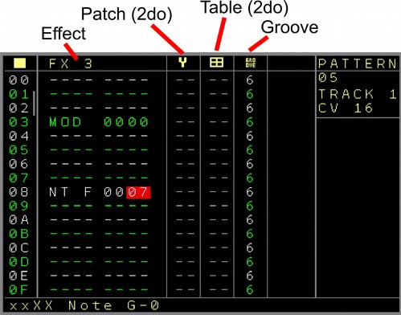Figure 12: Pattern Screen (CV16 Track, 3rd Page)

The 3rd page contains the 3rd FX column which has the same settings as the former 2 FX columns.
Next to it are the Patch and Table settings. Both are not implemented for the CV16 expander yet.
At last the groove settings which works in the same way as the groove settings from the normal CV/Gate tracks.

Basic Pattern screen functions
Now we return to the general pattern functions which are valid for all pattern types.

If ‘Navigation Wrap’ is enabled in the settings, then the cursor will jump back to the top when the end is reached below, the same applies if the cursor reached the most right position it will go back to the most left position, and vice versa.

Using the Nerd Menu, you can also name a pattern.

In the setup menu you can change the highlighting period (eg every 4th row is highlightend)

Extra editing features if not marked:
Remove the current row and shift everything below the row one up: SHIFT+UP+DELETE
Insert an empty row and shift everything below the current row one down: SHIFT+DOWN+DELETE

You can browse between different patterns by holding the PATTERN button and using the cursor keys. This will navigate between the patterns as they are arranged on the sequencer screen.
PATTERN + CURSOR LEFT/RIGHT will browse through the sequencer row/tracks and select any available pattern there to be edited directly. And PATTERN + CURSOR UP/DOWN will browse through the patterns on the same track as they are lined up in the sequencer screen.

There are several facilities to copy or delete pattern content. For that there are the 3 Buttons Mark, Copy and Delete.
Mark to mark an area which should be copied or deleted (use SHIFT+DOWN to mark all), Copy to copy/insert a before copied area to another row/column and Delete to empty or delete the marked area (or to delete/empty the recent cursorposition).

To Copy a block:
Press SHIFT+MARK on the first position which should be copied (Screen border colour should change to indicate the Mark mode)
Move the cursor to the last position of the desired area ( Press SHIFT+DOWN to mark all )
Press SHIFT+MARK again. Mark mode is released again, the marked block is being saved.
Now go to the Destination position with the Cursor.
there are 2 possibilities to copy.
1st Press SHIFT+COPY and the before saved block is being copied to the current position. (Overwrites content of the Block)
2nd Press SHIFT+DOWN (Not cursor down)+COPY and the before saved block is being inserted to the current position. The involved rows will move down behind the copied/inserted area.
You can also copy in between different patterns and from/to compatible column types (eg from notes to notes...)

To delete:
To delete/empty only the current cursor position press SHIFT+DELETE to empty the current position or SHIFT+UP+DELETE to really delete the position and move the following rows one up.
To delete a block:
Press SHIFT+MARK on the begin position which should be emptied/deleted (Screen border colour should change to indicate the Mark mode)
Move the cursor to the end position of the desired area.
You can choose between Emptying or Deleting the marked block
1 Emptying: Press SHIFT+DELETE to empty the marked block.
2 Deleting: Press SHIFT+UP+DELETE to delete the marked block. All rows beneath the marked block will move up and fill the deleted space.

Copy and paste actions can be made between all compatible columns, regardless of the type or where they are. Notes to Notes, Triggers to Triggers, Grooves to Grooves etc.
FX columns can only be copied to the same kind of Track type.

To copy for example a note part from a CV/Gate track to the 2nd note part of a Midi Track you mark the note part in the CV/Gate Track. And in the Midi Track you go to the 2nd note part where it should be copied and press SHIFT+COPY.
The same goes for all compatible fields. They must match also for the markings.

Note columns usually set a note and can also set a note off. A note off can be set either below the lowest note, or by using the delete (SHIFT+DELETE) function. If the field is empty, then a note off will be inserted. Else the field is being cleared. This is a toggle function.

Patch Screen

Patches are presets that can be set on every sequencer step. The patch types consist all FX types that the assigned Track (and in this case the modular output) is capable of. So when a value is entered in the patch column and the sequencer passes the row, all active values of this patch will be set.
Sometimes people call this a macro. In general this contains your knob positions which can be called back at any time if wanted.
You can enter the patch screen from the pattern screen.
The 2nd column in the modular pattern screen is for the patches. You either need to press OK to generate a new patch or select an available patch. Navigate to the patch number and press the patch button.
You will find the patch screen with on the left side the different functions/parameters and on the right side, the selected parameter value (kind of progressbar covered by the current and maximum value. Those can also be switches which show the ON/OFF position then. In the case that there is a diagonal line in the value field, then this parameter will not be changed/touched when the patch is being called.

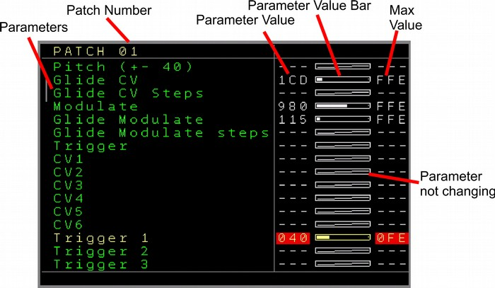Figure 13: Patch Screen

You can navigate up/down and change the values with shift left-right-up-down.
To disable a value so it is not changing the parameter when the patch is being called you use SHIFT+DELETE.

You can prelisten the current selected FX/Function by pressing SHIFT+OK.
This screen is currently only available for the CV/Gate tracks.

Current Values Screen
The current values screen shows the recent values/settings of the current track.
It can be accessed from the sequencer or the pattern screen (if not on the patch column and not on CV16 Pattern screen) by pressing the PATCH button.
The screen is updating live and all values can directly be manipulated by selecting the needed parameter and change the value by using SHIFT+ UP/DOWN/LEFT/RIGHT
Your current value will be overruled if the sequencer is running and the value is being changed by the sequencer. Beside the parameter change, some values can also be started/triggered with this feature. For this you use the OK button to start/trigger the parameter/function.

Be aware that the current settings are the real settings without any post-modulations.

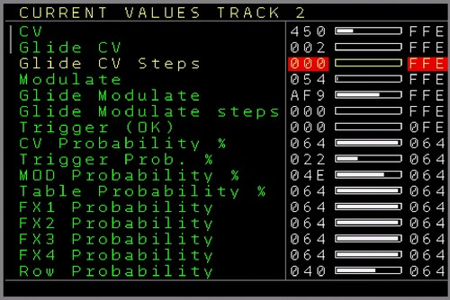Figure 14: Current Values Screen

Current values of a CV/TRIGGER/MOD track:
CV → Current CV value (not the note value)
Glide CV → Current Glide setting for the CV
Glide CV Steps → Current Glide steps setting for the CV
Modulate → Current MOD value
Glide Modulate → Current Glide setting for the MOD
Glide Modulate steps → Current Glide steps setting for the MOD
Trigger (OK) → Current/Last trigger setting. Can be triggered with the OK button
CV Probability % → Current Probability setting for the CV
Trigger Prob. % → Current Trigger Probability setting
MOD Probability % → Current Probability setting for the MOD
Table Probability % → Current Table Probability setting
FX1 Probability → Current FX1 Probability setting
FX2 Probability → Current FX2 Probability setting
FX3 Probability → Current FX3 Probability setting
FX4 Probability → Current FX4 Probability setting
Row Probability → Current Row probability setting

Current values for the audio tracks:
Note 1 Probability % → Current probability settings for the note of the first sample/waveform
FX 1>1 Probability % → Current FX1 Probability setting for the first sample/waveform
FX 1>2 Probability % → Current FX2 Probability setting for the first sample/waveform
Note 2 Probability % → Current probability settings for the note of the second sample/waveform
FX 2>1 Probability % → Current FX1 Probability setting for the second sample/waveform
FX 2>2 Probability % → Current FX2 Probability setting for the second sample/waveform
ROW Probability % → Current Row Probability setting for the whole sequencer row

Current values of a Trigger16 track:
CV → Current CV value of the local track
Glide CV → Current Glide setting for the CV of the local track
Glide CV Steps → Current Glide steps setting for the CV of the local track
Modulate → Current MOD value of the local track
Glide Modulate → Current Glide setting for the MOD of the local track
Glide Modulate steps → Current Glide steps setting for the MOD of the local track
Trigger (OK) → Current/Last trigger setting for the local Trigger. Can be triggered with the OK button
TR1+2 Probability % → Current probability setting for Trigger column 1+2 (including drum-matrix)
TR3+4 Probability % → Current probability setting for Trigger column 3+4 (including drum-matrix)
TR5+6 Probability % → Current probability setting for Trigger column 5+6 (including drum-matrix)
TR7+8 Probability % → Current probability setting for Trigger column 7+8 (including drum-matrix)
FX1 Probability % → Current FX1 Probability setting
FX2 Probability % → Current FX2 Probability setting
FX3 Probability % → Current FX3 Probability setting
Row Probability % → Current Row probability setting

Current values of a CV16 track:
CV → Current CV value of the local track
Glide CV → Current Glide setting for the CV of the local track
Glide CV Steps → Current Glide steps setting for the CV of the local track
Modulate → Current MOD value of the local track
Glide Modulate → Current Glide setting for the MOD of the local track
Glide Modulate steps → Current Glide steps setting for the MOD of the local track
Trigger (OK) → Current/Last trigger setting for the local Trigger. Can be triggered with the OK button
CV1 Probability % → Current probability setting for CV column 1
CV2 Probability % → Current probability setting for CV column 2
CV3 Probability % → Current probability setting for CV column 3
CV4 Probability % → Current probability setting for CV column 4
CV5+6 Probability % → Current probability setting for CV column 5+6
FX1 Probability % → Current FX1 Probability setting
FX2 Probability % → Current FX2 Probability setting
FX3 Probability % → Current FX3 Probability setting
Row Probability % → Current Row probability setting

Current values of a Midi track:
CV → Current CV value of the local track
Glide CV → Current Glide setting for the CV of the local track
Glide CV Steps → Current Glide steps setting for the CV of the local track
Modulate → Current MOD value of the local track
Glide Modulate → Current Glide setting for the MOD of the local track
Glide Modulate steps → Current Glide steps setting for the MOD of the local track
Trigger (OK) → Current/Last trigger setting for the local Trigger. Can be triggered with the OK button
Note 1 Probability % → Current probability setting for Midi Note 1
Note 3 Probability % → Current probability setting for Midi Note 3
Note 2 Probability % → Current probability setting for Midi Note 2
Note 4 Probability % → Current probability setting for Midi Note 4
FX1 Probability % → Current FX1 Probability setting
FX2 Probability % → Current FX2 Probability setting
FX3 Probability % → Current FX3 Probability setting
Row Probability % → Current Row probability setting

Table Screen
A Table is kind of a sequencer in the sequencer. So inside the regular sequencer you can start an additional table sequencer to manipulate your current pattern sequence or create new sequences for different purposes. Tables are also able to create their own sequences. Table sequences are maximum 16 steps long (but they can be chained so longer table sequences are possible) and can be started from the table column within a CV/Gate track via the Table FX command. Tables are currently available for the internal CV/Gate and the audio tracks.

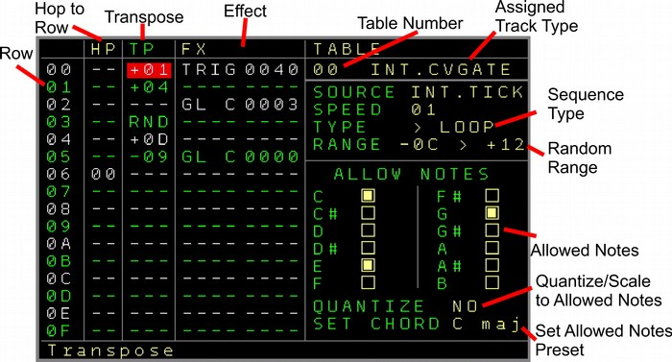Figure 15: Table Screen

A table sequence can run synchronized to the main sequencer, can free run without any relation to the sequencer tempo, can be clocked through the CV inputs, can be clocked through the automators or specially clocked from the sequencer with a FX command. Additionally different time dividers/multiplicators can change the table timings. Also a table sequencer can run with different sequencing directions/functions, forward, backward or pingpong.
Use tables to create advanced arpeggios for your main sequence, for different kind of ratcheting (eg. doubles, triplets etc..), special gating sequences, randomization, scaling, effects and much more…

A table screen has the following columns:
- HP → Hop. Here you fill in to which row the sequencer should jump (hop). So for the example in the picture, there is a 00 filled in on row 03. Which means when the sequencer passes row 03 it will jump back to 00. Note that it doesn’t play the row with the hop but jumps directly to the new row and plays it. In this case it will be a 3 step sequence (one shot) or it will iterate between the 3 steps if the loop setting is endless or restart.
Besides the ability to enter the row to jump to, there are 2 additional special commands.
RU → Random upper jump. Jumps to a random position higher than the last RU command.
So if a RU would be filled in on row 05, then it would jump to a random position between 00 and 04. Multiple RU commands can be added and the RU on the highest row defines the jump ‘range’.
RD → Random jump. This one jumps directly to any random position within the 16 rows.
The RD and RU commands can be found by either entering a value below 00 or by pressing delete multiple times (toggles between functions)
- TP → Transpose. This transposes the selected note of the current track by several semitones. Where ‘---’ means that there is no transpose, +1 would transpose 1 semitone higher +2, 2 semitones higher etc.
On the other side, every thing below will transpose by the semitones lower. So -1 for 1 semitone, -2 for 2 semitones etc…
Next to the transpose by semitones there are the following special commands which you can reach by pressing SHIFT+DELETE multiple times (toggles between functions):
RND → Randomize the current table row position. This will generate a random transposition. Combined with this function is the ‘RANGE’ setting which sets the lowest and the highest random value. With this you can limit the range to octaves or whatever range you choose. A random semitone transposition will then be chosen at the RND point.
>>> → This is a special command and it overwrites the current note by a note selected in the allowed notes part on the right side. Every >>> always takes the next possible allowed note. So you have for example 3 notes filled in as allowed, C#, E and A.
The first >>> would play C#, the second >>> would play E and the last one would play A. It is possible to create fixed arpeggio chords regardless of the main note playing.
- FX → Effect parameters. All the possible effect parameters can be added here to enable full manipulation by using the tables. All FX values of the current track type are available. Use this for example if you want to create a ratchet effect for your notes by choosing the trigger as FX and placing these in the order of sequencing to play doubles, triplets etc. Using the Table FX another table can be started which can facilitate table chaining and can be used if 16 Table steps are not enough).

Source → Defines the timing source for the sequence.
INT. Tick: The sequence ‘clock’ is derived from the internal main sequencer ticks. (6 ticks/step)
INT. Time: uses the tables own clock. It can run faster than the Int. Tick, but it has no relation to the main clock tempo / bpm
PTN-SFX: The table clock gets it’s ticks from the FX functions of a regular pattern (SPFX 0011)
AUTOMAT 0..7: The table clock gets it’s ticks from one of the automators. A tick is generated by the zero crossing of an automator.
CV IN 1..4: The table clock gets it’s ticks from a rising edge of the selected CV input.

Speed → is the multiplicator/divider.
A setting of 1 will trigger the next step in the table sequence with every clock. A setting of 6 will trigger the next step every 6th tick which is the same standard speed for a regular step in the main sequencer. So with lower settings the table sequence will run faster while higher settings will let it run slower.
Type → Defines the type of the sequencing itself:
> Resync: the table runs forward endlessly in a loop but is being restarted every time the sequencer passes the table command. It stops when the table is being stopped or when the complete sequencer is stopped. It does continue to run if only the track is stopped.
> Loop: the table runs forward in a loop but is not being restarted by the table command. It stops when the table is being stopped or when the complete sequencer is stopped. It does continue to run if only the track is stopped.
> Once The table runs forward and only 1 time and stops then
< Resync: Same as the forward Resync, but the sequence runs backwards.
< Loop: Same as the forward Loop, but the sequence runs backwards
< Once: Same as the forward Once, but the sequence runs backwards (starts from end or first HP)
>< Loop1: The table runs in a ping pong loop. If it would be set like in the example picture, it would run the following sequence: 00,01,02,01,00,01,02… and so on
>< Loop2: The table runs in a ping pong loop. If it would be set like in the example picture, it would run the following sequence: 00,01,02,02,01,00,00,01,02,02,01,00… and so on
>< Once: Runs the ping pong sequence as in Loop1, but only once ( 00,01,02,01,00 ).

Range, as mentioned before, defines the transposing range of random values. Change the lower value with SHIFT + LEFT/RIGHT and the higher value with SHIFT + UP/DOWN.
The part below adds a special scaling to the transpositions. While transposed to a note, it can also be fixed to one of the allowed notes. It will choose then the nearest note of the allowed instead of the transposed note. The way it chooses the nearest note can be changed in the Quantize setting. The allowed notes can each be selected by SHIFT + RIGHT/UP or deselected by SHIFT + LEFT/DOWN.
Quantize setting:
NO: Notes are not quantized to the allowed notes. Normal regular transposition with all possible notes is set.
UP: The next higher note of the allowed notes is taken. For example if the new note after transposition is a E-5 and the allowed notes are C, F# and A then the note will be scaled to the next upper → F#5 note.
LOW: The next lower note of the allowed notes is taken. For example if the new note after transposition is a E-5 and the allowed notes are C, F# and A then the note will be scaled to the next lower → C-5 note.
COIN: The coin decides randomly if either the next higher or the next lower note will be chosen.

Finally the SET CHORD function can set the allowed notes directly to the chosen Chord by pressing the OK button. The allowed notes change then to the chord settings. Holding the OK button while changing the chord will result in a direct change of the allowed notes.

Table Presets:
For ease of use, many standard tables can be inserted as a preset. Use the → Nerd Menu in the table screen (SHIFT+NERD) to get to the presets. Choose one and press OK, it will be inserted into the current table.
The following presets are available:
Empty: Clears the content of the table
Random: Inserts a random transpose sequence with also a hop 00 on a random step. The random transposition range is selected by the Range (lowest and highest transposition note)
Doubles: Inserts FX commands to create a double (ratcheting) for the main sequence. This creates a double trigger/gate (or envelope trigger) for the main sequence in a step. As a result, a note is then equally 2 times triggered in one step. Note that this preset also changes the table clock and type settings so the timing and sequence is correct.
Triplets: Same as doubles, but this inserts 3 equal trigger/gates for a step so triplets can be played.
The following are standard chords with 3 or more notes:
Triads → Major, Minor, Diminished, Diminished 5th , Augmented, Suspended 4th , Suspended 2nd
7th Chords → Dominant 7th , Minor 7th , Major 7th , Minor Major 7th , Suspended 7th , Augmented 7th , Augmented Major 7th , 7th Augmented 9th , Half Diminished 7th , Diminished 7th , 7th Diminished 5th , 7th flat 9

6th Chords → 6th , Minor 6
9th Chords → 9th , Minor 9th , Major 9th , 9th Diminished 5th
11th Chord
13th Chord

Another Nerd menu function in the table screen is Release Table. This will empty and release a table from a track type, so it can be newly assigned.

Use the ‘Compact Tables’ command to release all unused tables automatically. Keep in mind that tables with content (something in the transpose, hop or fx column) will not be released. This isz to avoid the deletion of prepared tables which are temporarily not used. To release those anyway, you need to release them from the Nerd menu in the table screen.

You can simple navigate between all tables by holding the TABLE button in the table screen and CURSOR UP/DOWN.

Next to the sequencer row you can see the table animation which shows on which step the table is playing right now on the available tracks. This gives also an orientation on how the sequence is running.

Automator screen
The Automator screen contains up to 8 possible slots for Generators / Modulators / Effects / Manipulators. An Automator can currently be an LFO, Envelope, or a CV Input. You can assign an Automator to any of 8 Slots. The output of the automator can be routed to several functions, outputs and more through a modulation matrix. In the matrix there are the 8 Tracks as destinations and in the matrix you can decide which of the setting / function / output of the track should be modulated by the automator. Be aware that Automators can also generate negative values (eg the lower curve of a sinewave LFO) and for most destinations the values are scaled added depending on the destinations maximum value.

Figure 16: Automator Screen

In the top part of the screen are the 8 slot – rows. From the left the slot number, followed by the assigned function (empty if no function is assigned to the slot). Next is the indication whether this slot/function is running or not. The 8 tracks next to it define to which function of the track the output is ‘routed’. In the picture you can see that the LFO in slot 0 is routed to the MOD output of Track 3. In fact, in the picture an LFO is modulating the Physical MOD3 output. In the middle of the screen you can see the animation of the currently selected automator.
The lower part shows possible settings of an automator. The screenshot shows the LFO with all it’s settings.

For the current version these are the following automator functions:
- LFO
- Envelope
- CV Input

The destinations in the modulation matrix for the CV/Gate tracks are:
- CV Output → modulates the function onto the CV output
- MOD Output → modulates the function onto the MOD output)
- Trigger Length → overrules the next trigger setting with a ON/OFF trigger where the length of the trigger is decided by the Automator output (10 .. F0)
- Delayed Trigger/Gate length → overrules the next trigger setting with a OFF/ON trigger / gate where the length of the delay is decided by the Automator output (01 .. 0F)
- FX1..FX4 Overrule → Overrules the next FX of the defined FX column by the value of the automator
- CV Glide → Manipulates the Glide setting for the CV output
- CV Steps → Manipulates the Glide Steps setting for the CV output
- MOD Glide → Manipulates the Glide setting for the MOD output
- MOD Steps → Manipulates the Glide Steps setting for the MOD output
- CV/Trigger/MOD/Table/FX1..4/Row Probability → Manipulates the probability settings for the defined FX
- Step Overrule → Overrules the current step in the currently playing pattern. This is an experimental function.

The destinations for the audio tracks 7+8 are:
- Pitch → Modulates the pitch of the current playing sample/wave for either the first or the 2nd sample/wave in the pattern screen
- Volume → Modulates the Volume
- Bitcrush → Modulates the bitcrush settings
- Distortion → Modulates the distortion settings
- Position → Manipulates the current sample offset/position (funny timestretching effects are possible with that). In combination with a pulsewave, it modulates the pulsewidth
- Wavefold → Manipulates the wavefold settings of the sample/waveform
- Overrule FX1..4 → Overrules the next FX value
- Probability % → Manipulates the probability settings for the Samples 1/2
- Probability FX → Manipulates the probability settings for the defined FX
- Probability Row → Manipulates the probability settings for the whole track row
- Overrule Steps → Overrules the current step in the current playing pattern part. This is an experimental function.

All audio destinations are for either the 1st or for the 2nd sample/wave of an audio track except for the row probability which is for both.

The destinations in the modulation matrix for the Midi assigned tracks are:
- Pitchbend → Sends pitchbend data to the midi device.
- CC1..8 → Sends CC data to the controller numbers which are set up in the midi track settings
- NRPN1..4 → Sends NRPN data to the controller numbers which are set up in the midi track settings
- Note overrule → Not implemented yet
- The rest are the same as a regular CV/Gate track, except for that the probabilities are set to the midi note and fx groups.
Be aware that Automation data to Midi can generate a huge amount of data which might be too much for your midi device to work properly or generate a midi data traffic jam and so other important data can be missed. It depends on the device and on the amount of data that is being produced. For that reason there is a setting in the midi track settings which allows to reduce the generated midi data from automators. With it the data can be throttled from 100% to 50%, 25%, 10%, and 5%. It is advisable to apply the lowest acceptable value. Mostly settings of around 10% are more than good enough for nice modulations. But of course it always depends on what is being controlled and the automation data that is generated.

The destinations in the modulation matrix for the ‘More Triggers 16’ expander assigned tracks are:
- Trigger 1..4 Length → Overrules the next trigger (trigger of the expander) setting where the length of the trigger is decided by the Automator output (10 .. F0)
- Delayed Trigger/Gate 1..4 length → overrules the next trigger (of the expander) setting with a OFF/ON trigger / gate where the length of the delay is decided by the Automator output (01 .. 0F)
- Triggers Galore → Sends triggers (the triggers are as set up in track setup) to the trigger outputs of the current position of the Automator output.
- Triggers Square 8 → Uses the Automator output to set and reset Trigger output 8 (or 16 if swapped). If the Automator output is higher than 0 then the output is being set and if lower 0 than the output is reset. Only applies to outputs 8 or 16!
- The rest are the same as a regular CV/Gate track, except for that the probabilities are set to the trigger output groups.

The destinations for the CV16 tracks are:
- CV 1..16 → Modulates the funtion onto the CV outputs 1..16
- Column 1 Probability → Probability for Column 1 of the pattern screen
- Column 2 Probability → Probability for Column 2 of the pattern screen
- Column 3 Probability → Probability for Column 3 of the pattern screen
- Column 4 Probability → Probability for Column 4 of the pattern screen
- Column 5+6 Probability → Probability for Column 5+6 of the pattern screen
- FX1..3 Probability → Probability for the FX1..3 column
- FX1..3 Overrule → Overrules the values of the FX1..3 column
- Envelope 1..8 Attack/Sustain/Release → Modulates the envelope settings
- LFO 1..8 Type/Speed/Amplitude → Modulaes the LFO settings
- Local CV → Modulates the local CV output of the track-setup
- Local MOD → Modulates the local MOD output of the track-setup
- Local Glide (CV/MOD) → Modulates the local glide settings
- Row Probability → Modulates the probability of the complete pattern row

You can change the Slot and Modulation settings by using SHIFT + LEFT/RIGHT.
Start and Stop toggle by pressing OK
Start by using SHIFT + CURSOR RIGHT
Stop by using SHIFT+ CURSOR LEFT

To get to the automator settings you can either press OK on the automator function or use the DOWN button. To get back you use the UP button.

In the automator settings you can navigate between the settings and change values with SHIFT + LEFT/RIGHT. For the LFO, if the cursor is on the RST field, then a LFO reset can be triggered by pressing OK.
Automator functions

The following automator functions are currently implemented:
- LFO
A low frequency oscillator with several waveforms and many parameters. The LFO is continuously running but can be started/stopped through the slot start/stop.
There are 2 ways to manipulate the parameters of the LFO. 1st by using the Slot editor below in the automation screen. And 2nd through the Automator slot manipulation commands in the FX column of the sequencer.
LFO Parameters and characteristics:
- Waveforms: Sine, Triangle, Sawtooth, Pulse, White Noise, Pink Noise

- Clock sources:
- Free running
- Slow → Same as free running, except for that the speed is 100 times slower.
- Tick → Clock is synchronized to the sequencer ticks. If speed it set to 1, then one LFO waveform cycle has the same length as one pattern while the LFO advances with every tick.
-Pattern → Clock is synchronized to the pattern rows. If speed it set to 1, then one LFO waveform cycle has the same length as one pattern while the LFO changes with every pattern row (derived from main clock). The effect is kind of a stepped LFO
-Slot 0..7 → The clock is derived from the output of another slot. While the speed parameter works as a divider. This can be used to achieve a Frequency Modulation (FM) while the frequency is modulated from another slot.
- STP-MUL → Advances the LFO waveform with every mainclock sequencer step with a multiplier. The Multiplier is being set in the Speed function.
- STP-DIV → Advances the LFO with every sequencer step divided by the divider which is set up in the speed field.
- TCK-MUL → Same as step, but mainly with a higher resolution with ticks.
- TCK-DIV → Also the same but with a divider.
- STP-SLT → Advances a step on the LFO based on the zero cross of another slot (which could be for example an external CV clock)
- Speed: Defines the speed / frequency of the LFO. If the clock is set to Tick, Pattern or Slot, then the speed value acts as a divider. Note that the speed for the noise waveforms has a different scale than the ones for the periodic waveforms.
- Amplitude (AMP): Defines the Range / Amplitude of the LFO. The value goes to F7 which is the max amplitude. Slot0..Slot7 can be defined as the source for the range. With that you can achieve Amplitude Modulation (AM).
- Offset: Adds or subtracts a DC Offset to the LFO waveform.
- Invert: Inverts the LFO Waveform
- Bit: Resolution of the LFO waveform. 1 bit to 12 bit
- Phase: Sets the Phase/Offset of the waveform. So when the LFO is started/reset it will start from this point in the waveform. In combination with the pulse wave it decides the pulsewidth.
- Rst X: Reset waveform resets the waveform to the start of the waveform or to be more precise, to the point of the phase of the waveform. Where reset X doesn’t have a source and can be reset only by pressing OK on the function or from the sequencer automator FX functions (ASLx 101). You can further set the Rst X value from 0 to 7 which means that the reset will additionally be triggered by another Slot. To reset the Reset input needs a transition from at least 0 to 200 which is ca. 0,5 volt if derived from the 10 Volt range. Internally it means that the output of another Slot must have been 0 or lower and go to output values óf 200 and higher. By using a CV input as another slot automator, one can reset the LFO from an external source.

- CV Input
These automators use the CV inputs as their source to route it to any of the automator destinations or to another slots. This can be used to manipulate many internal values of the sequencer by an external source.
The following settings are available for the CV inputs:
- Input → Chooses the CV input 1..4
- Offset → Adds of subtracts a DC Offset to the CV Input
- Invert → Inverts the CV Input signal.
- Amplitude (AMP) → Defines the Range / Amplitude of the input. A value of F7 will use the full CV input range of 0 to 10 Volt. Furthermore, the outputs of the Automator slots 1..8 can be used to manipulate the Range/Amplitude.
- Bit → Resolution/Quantisation of the CV Input. 1 bit to 12 bit

- Envelope
The envelope automator function can manipulate and route the envelopes through the automator functions and modulation matrix. Note that this is not an envelope generator within the automators, but it rather uses the output of the integrated envelopes of the NerdSEQ to route into the automators. With this the envelopes can be additionally manipulated and will also get the resolution of the automators (within the automators only, the normal envelope works as is). Use this to achieve some special effects with the usual envelopes or to route them in a different way through the modulation matrix. You can see the current curve of the selected envelope on the bottom right. You need to use the envelope screen to edit the envelopes curve.

The following settings are available for the Envelopes:
- Input → Chooses which envelope ( 1..8 ) should be used
- Offset → Adds of subtracts a DC Offset to the Envelope
- Invert → Inverts the envelope curve.
- Amplitude (AMP) → Defines the Range / Amplitude of the Envelope. A value of F7 will use the full Envelope range. Further the outputs of the Automator slots 1..8 can be used to manipulate the Range/Amplitude.
- Bit → Resolution/Quantisation of the Envelope. 1 bit to 12 bit

Please note, that the Automators LFOs or Envelopes can never replace a true analogue or digital LFO/Envelope module. The Automators have a limited resolution with all it’s side effects compared to those. However, they are still great modulation sources for any internal and external modulations.

Envelope screen

The NerdSEQ has also an envelope generator included which is capable of the generating 8 different ADSR envelopes. Each envelope got has functions to manipulate it’s curve and behaviour. To start the envelope, several internal and external sources can be used in flexible ways. Many internal functions and all external CV and MOD outputs can be set as destinations.
You can enter the envelope screen by pressing the AUTOMATE button when in the automator screen (the AUTOMATE button toggles between the automate and the envelope screen).
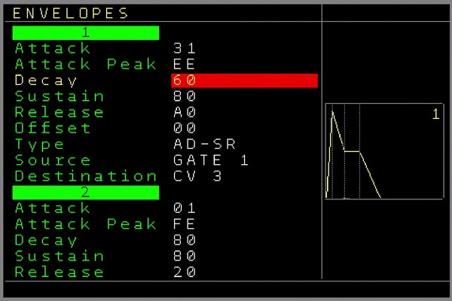Figure 17: Envelope Screen
In the envelope screen you can navigate between the 8 envelopes within it’s function. Using the UP/DOWN Button will jump directly to the next envelope. To change parameters use the usual SHIFT LEFT/RIGHT/UP/DOWN. All settings except of the Sources and Destinations will immediately be active. The Source and destinations will only be activated when pressing either the OK button on them or when leaving the envelope screen.

The following functions are available for each envelope:
Attack → Defines the Attack speed.
Attack Peak → Defines the maximum amplitude level of the attack phase.
Decay → Defines the decay speed.
Sustain → Defines the amplitude level of the sustain phase.
Release → Defines the release speed
Offset → Defines the start and the end level of the envelope. The Attack phase starts from this level and will either rise or fall to the Attack peak level. The Release phase ends on the offset level (also either by rising or falling, depending on the sustain level). Use the Offset to create more complex envelope curves, but be aware that an envelope will end on the offset level and it will stay there. Possibly a VCA may ‘stay open’ depending on the offset level and any waveforms can still be audible after the release phase if the offset is not set to zero.
Type → Defines way the envelope runs.
One Shot: Here the envelope only needs to be triggered/gated once and it will run the ADSR phases in one go: Attack → Decay → Sustain Level → Release. There is no pause at the sustain level and the release is being started directly after the decay phase reached the sustain level.
AD-SR: This will start the envelope with a Gate (or virtual gate generated internally → sources) signal and it stays in the sustain phase (after decay reached the sustain level) until the gate is released again. Keep also in mind here, if the gate was set, the release phase will be started immediately when the gate is reset. So if any phase was not finished, it will directly continue to release.
Loop: The envelope will keep looping (one flow as in the one shot way) the envelope as long as the gate is set.
Source: Defines the source from which the envelope can be triggered / gated.
Gate 1..6 will derive the trigger/gate from the tracks 1..6. ( for example, when playing a note on the track, a gate is (also) being set for the envelope, a note off will release the envelope if in AD-SR mode.
T7 Audio1,2 and T8 Audio 3,4: The start of a waveform or sample on track 7 or 8 (audio part 1,2,3,4) will ‘gate’ the envelope. If the sample is finished the gate is released.
A special reset gate command (***) in the note column of an audio track can release the gate before the sample/waveform is finished, which will start the release phase of the envelope while the sample continues to play.
A special note off command ( [ ] ) in the note column of an audio track can stop playback of the sample/waveform before it is finished and simultaneously start the release phase of the envelope if in AD-SR mode.
CV IN 1,2,3,4: The CV inputs can be used to set/reset the gate for the envelope.
ENV1..8 Start: The start of the selected envelope will also start this envelope. This can be used to have multiple envelopes start at the same time.
ENV1..8 End: When the selected envelope is finished, it will start this envelope. With that chained envelopes can be created.
Clone ENV 1..8: This will exactly clone the generated envelope so you can use it for multiple destinations. Note that all envelope curve settings have no effect here.
Destination: Defines the destination which the envelope should use/manipulate.
CV 1..6: The envelope will be routed to the CV outputs 1..6
MOD 1..6: The envelope will be routed to the MOD outputs 1..6
Volume 1..4: The envelope will act as a VCA on the selected audio channel (eg on samples/waves)
Pitch 1..4: The envelope will overrule the pitch of the selected audio channel
Bitcrush 1..4: The envelope will overrule the bitcrush of the selected audio channel
Distort 1..4: The envelope will overrule the distortion of the selected audio channel
Wavefold 1..4: The envelope will overrule the wavefold of the selected audio channel

The Source and the Destination settings can be activated by pressing either the OK button or by leaving the envelope screen. SHIFT+DELETE on them will set them to ‘none’.
If routed through an automator, more manipulation of the envelope is available and these can then also be routed through all automator destinations. Keep in mind that the rate (as in processing-rate/resolution) of the envelope will degrade to the automators processing rate.
Besides the fixed sources, an envelope can also be gated through FX commands.
You can see an animation of the current selected envelope stages when it is running.

Project screen
The project screen contains some project related functions which can be different for each project. Its’ settings will be loaded and saved when loading/saving a project.
The following menu items are available:

Tempo Change the global tempo between 1 to 500 BPM. (SHIFT + LEFT to decrease, SHIFT + RIGHT to increase).
Additionally it contains a Nudge function. Nudging is what a DJ does…..or used to do ;-) ….to synchronize records with each other by pushing or shortly slowing down the record. Holding SHIFT+OK and then CURSOR UP/DOWN, will roughly nudge the sequencer forward and backward and with CURSOR LEFT/RIGHT it will finely nudge the sequencer forward and backward.
Transpose Change the global transpose in semitones/octaves higher and lower the regular pitch. When changing the values with SHIFT+CURSOR LEFT/RIGHT, then the new transpose value will be set on a zero transition of the sequencer if it is running. Pressing OK will change the transpose value immediately. Holding OK while SHIFT+ CURSOR LEFT/RIGHT will also change the transpose immediately.
Load Menu Opens a file browser to load a project
Save As Save a project
Load Sample opens the sample-slot window.
Load Sampleblock and
Save Sampleblock are used to load and save complete sample blocks. A sample block are all 12 sampleslots together. Here you can recall the whole block (eg replace all samples in one go). This can also be loaded nearly seamlessly while running a sequence using a command in the sample FX.
Sampleblock 000 is not supported, so every sampleblock must at least be named 1 and higher.

Track Assign enters the → Track Assign screen. This is used to assign different track types to the tracks. For example a regular CV/Gate track can be set to be a Midi track, Trigger16 etc type.

Clock IN For the Main clock input setting. Those are:
- Internal - Sequencer runs from the internal clock at 24ppqn internally
- Mod. Clock24 - Sequencer runs from the Clock/Reset input with a resolution of 24ppqn
- Mod. Clock - Sequencer runs from the Clock/Reset input with 1/16 resolution
- Midi - Sequencer runs from external Midi Clock as follower (IO Expander module needed)
- DIN-Sync – Sequencer runs from external DIN-Sync signals while the clock input is the Din-Sync clock signal and the reset input is the Din-Sync run/start/stop signal. The continue signal is not supported.
Clock Out For the clock output settings. Those are:
- MOD 1/16 → Standard modular clock with 1 clock per step
- DINSYNC24 → outputs 6 clocks per step. Same as DIN SYNC (Reset is high if started and low if stopped)

With a IO-Module and Midi-Clock sending is enabled, a standard Midi-Clock/Start/Stop is also being send.

Edit Mode On/OFF. Avoids editing while for example playing live or demonstrating. No patterns can be changed when edit is off. However, playing live is still possible. Some extra functions with live playing are enabled when edit is turned off.

Live Queue points Amount of steps when a new pattern is being started (derived from main 64 step clock). So normally when triggering a new pattern it will be started when the old pattern sequence is finished. With the live quantisation, which you can enable by pressing start twice to trigger a new pattern, the new pattern will start from the next Live Queue point. You can see the live queue points on the top and the bottom of the sequencer in the main clock bar.
Input / Record Settings Screen to set up all inputs (CV and Midi) for recording or live manipulation → Record / Live Input
Midi clock out Decides wherever the midi clock/ start/stop is being sent or not.
Main clock Decides the amount of the main clock steps. It defines also the maximum length a pattern is playing. While the standard is 64 steps, less steps can be used for different rhythmic variations.
New Project Choose if you want to start with a new empty Project. All values are reset to the default values.

Setup Screen

Here you set up the non-project related settings. Most settings will be automatically saved and loaded on power-up.

- Compact Sequencer → Clears and releases unused Patterns
- Compact Tables → Clears and releases unused and empty Tables. A release of unused but not empty tables must be done with the special Nerd Menu Function in the table sceen.
- Compact Patch → Clears and releases unused Patches
- Key Press Delay - Time until the Key is being repeated
- Key Hold Repeat - how fast a key is being repeated (after the Key press delay)
- Navigation Wrap – Enable/Disable if the cursor should wrap back when reached the begin of end of a row/column
- Edit Steps → Decides how many steps the cursor should jump down after entering a value using SHIFT + UP in the pattern screen. Value 0 turns the editsteps off.
- Auto Fill-In Trigger → When enabled, a trigger of 40 is automatically inserted when inserting a new note
- Reset FX on Seq stop → When enabled, all FX / Current values of the effects will be automatically reset / turned off if the sequencer is being stopped
- Row Highlighting amount → Every X row in the pattern screen is highlighened
- Pattern Scroll - Turn on/off scrolling in pattern. Scrolling is a nice visual gimmick but makes editing while playing very difficult.
- New Pattern Length → Defines the default patternlength of a newly created pattern
- Default Groove Settings → Defines the default groove for new created patterns.
- Show Decimal Value – Shows the decimal value for most important hex values
- Screensaver → Amount of time in minutes unused with stop sequencer after the screensaver starts
- OK to enter Pattern → Enables automagically entering the pattern when pressing OK on a pattern number on the sequencer screen
- Confirm Seq. Stop → Enable confirmation to really stop the sequencer when prompted to stop with pressing SHIFT+STOP.
- Auto Gate on Note → Turn On/Off autogating. CV/Gate track: If a Note is filled in in the pattern screen but no trigger then the Autogate function will automatically set the Gate with the note. The gate can be reset again with a Note Off. On note changes the gate will be low for a specified amount of micro/milliseconds until it will be set again. A value entered in the trigger column always overrules the autogate function. If it’s turned off then no gate is generated, except if it is entered in the Trigger columns or through other ways, not automatically on a note.
- Auto Gate Timeout → If Autogate is turned on, then this sets the time the gate is off until it goes on again between notes.
- User Interface Setup - Set up own colorscheme and change font → User Interface Screen
- Calibrate - Calibration and testing of all inputs and outputs. The Nerdseq is ‘factory’ calibrated and setting are saved on a EEprom. For a proper calibration you need a good multimeter, though for most cases a normal cheap 3,5 or 4 digit multimeters will do the job. You also need a small screwdriver to change the potmeters on the backside. The factory calibration is made with a precision of 0.001 Volt in the 10 Volt range.
Using Page Up/Down will jump over the different sections, so you can jump from the CV calibration to the Trigger test and at last to the manual input calibration.

To start a calibration you proceed the following:
  - Go to the calibration settings, choose the 2nd row: OUT CV1 Offset
Set this parameter to 10, which will give you a small range lower than 10 for the calibration. Now connect the multimeter with the CV1 output. Set the CV Offset switch to the right position (below the CV outputs). Your multimeter should now be calibrated to exact 0 Volt by using Potentiometer POTI 2 on the rear of the module (the one closest to the centre). Once it is calibrated to 0 Volt, you change the Offset switch for CV to the left position which lets you calibrate the -5 Volt offset. For this you use the Potentiometer POTI 1 to calibrate the -5 Volt offset. When calibrated, check again the 0 Volt and the -5 Volt position to be sure they are correct.
  - Now you don’t need to touch the potentiometers any more so the nerdseq can be placed back in the rack. Switch the CV and MOD offset back to the right position (0 Volt).
  - Go to the next menu row OUT CV1 Range (10 V). Change the value until it is exactly (or very close to) 10 Volt.
  - Now connect the Multimeter to the MOD1 output and choose the next row in the menu OUT MOD1 Offset (0V). Change the value until the multimeter measures closest to 0 Volt. For your information, there is a possibility that you can’t reach the exact 0 Volt point. Since the resolution of the Nerdseq is 10/4095 values, the finest voltage resolution is 0.0024 volt. So the value closest to 0 with a slight difference in the 3rd and 4th digits is absolutely OK.
  - Now choose the next Menu Row OUT MOD1 RANGE (10V) and change the setting until you measure exactly or very close to 10 Volt at the MOD1 output.
  - Connect your multimeter to the next output CV2 and choose the next row in the menu OUT CV2 Offset (0 V) and change the values again to get the 0 Volt.
  - Proceed with the measuring until you calibrated all CV and MOD outputs.
  - Next you can auto calibrate your inputs (after all outputs are calibrated well). For that you only have to connect the CV1 Output with the CV1 input. The CV2 output with the CV2 input, the CV3 output with the CV3 input and the CV4 output with the CV4 input. Choose Auto Calibrate Inputs which gives you a small explanation about what to do. Press OK to start the automatic input calibration.
  - Next you could test all the other outputs. The menu settings show you the expected voltages for the outputs.
  - In the top row you can find an extra save calibration option. In general the calibration settings will auto-save when you leave the calibration screen. A manual save is also possible in between.
  - Sample testing for audio output 7 and 8 will turn on a sine waveform which can be tested on the outputs.

  - beside to the autocalibrate function for the inputs, you can manually calibrate the input together with the voltage source (for example a CV keyboard) you are using. For that it makes most sense to follow these steps:
Of course, connect the CV input that you want to calibrate with your source.
Play a low note on the source (for example C-1). Choose the offset of the CV input row (Input X 1V). In the status bar you can read which note the NerdSEQ is measuring. Change the offset until the note matches the low note you played. Try to reach the note, the number next to it should as close as possible to zero. Play a very high note on the keyboard (for example C-8). Go to the range position of the calibration and change it until the status bar shows the note. Also here try to get the value as close as possible to zero. Repeat this a few times until the offset and range are as fine as possible.
Do the same for the other inputs. The CV inputs are matching the source then.
Without a source you can also use the CV outputs 1..4 again connected to the CV inputs 1..4 and manually calibrate. The outputs will automatically be set to either C-1 / 1V or C-9 / 9 Volt as the calibration reference. The result will most probably be the same as the auto-calibration.

- Save with Backups -> Generates a backup with each saving. So with every saving backups are being saved on the SD card. Needs the double time to save...but saves lives!
- Autoload last project → Loads the last saved project on the NerdSEQ startup automatically
- Load Settings Backup -> In the unlikely case of a problem with the EEprom (or you swap a NerdSEQ) you can load the backup of the settings from the SD Card. Be sure to backup your SD Card from time to time (works only when Debug is ON)
- NSA Firmware update → Opens the Firmware update screen for the expanders (Nerd Sound Adapter) → See NSA Firmware update screen
- Debug - > turn on some debug output
- Soft Reset -> Resets the Nerdseq when needed (works only when Debug is ON)

Track Assign Screen
In the track assign screen you can assign the different track types such as CV/Gate, Midi or Trigger16 to one of the first 6 tracks. You can enter the track assign screen from the project screen.
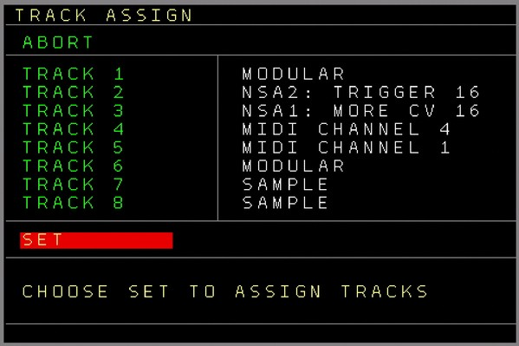Figure 18: Track Assign Screen
There are 8 rows which show the 8 tracks. The default setting for the first 6 tracks is as a CV/Gate track. The last 2 are the audio (sample) tracks and this can’t be changed at the moment.
You can change the type of the first 6 tracks using SHIFT+ CURSOR LEFT/RIGHT. Then you can choose between the CV/Gate function, NSA1,2,3,4 (and if there are expanders connected, then it will show the recognized expander on the NSA Channel number) and Midi.
One expander can also be assigned to multiple tracks.
If you are ready with the assignment then you choose SET and the tracks will be assigned.
Be aware that if there were already any patterns on a track on the sequencer screen and the new assignment is from a different tracktype, then the patterns will be removed from that track and from the automator destinations. Also undo data and the clipboard is emptied. The patterns are not deleted, so you could still use them on another compatible track. A sequencer compact will delete these if they are unused patterns.
So if you want to keep the patterns or some content, you might need to copy them first in order to preserve your data.
If a track is or was assigned already then you can also enter the track setup screen of the track here by using the OK button.

Track Setup Screen
Here you can change track and track type specific settings. Some settings are common to all tracks and some are specific so here is an explanation of the different types.
You can enter the track setup screen in the following ways:
- via the Nerd Menu on the sequencer screen
- via Track Assign screen
- by pressing the PATCH button while in the current values screen (pressing PATCH twice from the sequencer screen or in most parts of the pattern screen gets you to the Track Assign screen).
Track Setup (CV/Gate Track)
- Track Clock → Change clock dividers or multipliers of the track. If the player is playing then the change applies at the end of the pattern. If it is not playing, the change is applied directly. Change using SHIFT+CURSOR LEFT/RIGHT
- Transpose → Allow or avoid the transposing of the track. This is for the global- and the track transpose.
- Trigger Delay → Delays the Trigger from the Trigger column (compared to the CV change of the track). This is useful for modules which don’t sample the CV voltage correctly after the raising edge of the trigger. A value of 0 means that the triggers have no delay.
- Trigger Setting → Either Normal or Inverted. when Normal is selected the Triggers Gate behave normal (Off = 0 Volt, On = 5 Volt). If Inverted is selected, the Trigger/Gate output is inverted → Off = 5 Volt, On = 0 Volt.
- Voltage Setting → Defines the type of voltage output:
- 1V/Oct
- 1.2V/Oct (Buchla scaling)
- Hz/Volt (old analogue synth scaling)
Be aware that the 1.2V/Oct and Hz/Volt scales are only tested theoretically by measuring but not with real hardware. (It is reported to work though) Also it is possible that you need other Trigger levels than those which the NerdSEQ produces. For this you would have to convert the normal trigger out levels using inverters, amplifiers and by changing the offset.

Track Setup ( Audio Track )
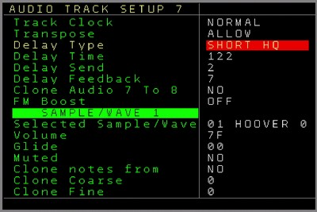Figure 19: Track Setup Screen (Audio Track)
- Track Clock → See track setup of the CV/Gate track.
- Transpose → Allow or avoid the transposing of the track. This is for the global and the track transpose.
For all following values, see the → Sample Wave Functions part of the manual for details
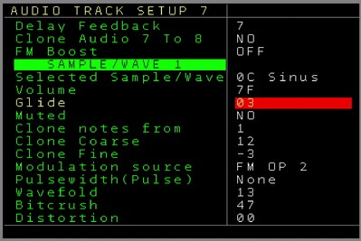Figure 20: Track Setup Screen (Audio Track Sample/Wave part)

- Delay Type → Sets the type of the audio delay for the track.
- Delay Time → Sets the amount/time of the delay buffer
- Delay Send → Sets the amount of the input amplitude for the delay
- Delay Feedback → Sets the amount of the delay feedback
- Clone Audio 7 to 8 → Clones and overwrites the audio stream of Track 7 into Track 8. The audio stream is grabbed and included before the delay in the audio chain.
- FM boost → Global setting for the FM intensity
Sample Wave setting for the parts 1,2,3,4: (values can be edited here)
- Selected Sample/Wave → Is the current selected sample/waveform
- Volume → Volume/Amplitude of the Sample/Wave
- Glide → Glide settings for the sample/wave part
- Muted → Sets if the audio output of this part should be muted or not (signal can still be used for modulations)
Clone Notes from → Selects if the notes should be cloned from the source. With this multiple waves/samples can be sequenced from one source
Clone Coarse → If notes are cloned, this sets the note transpose/offset in semitones
Clone Fine → If notes are cloned, this sets the fine-tune for the main note.
Modulation Source → Selects if the current audio should be either FM modulated by one or more other waves/samples or Hardsynced to another waveform
Pulsewidth (Pulse) → This determines the pulsewidth of the pulsewave in case that the current waveform is set to ‘Pulse’
Wavefold → Sets the current wavefolding amount for the current sample/wave part
Bitcrush → Sets the bitcrush settings for the current sample/wave part
Distortion → Sets the distortion settings for the current sample/wave part
You can use the UP / DOWN button to switch between all 4 Wave/Sample settings (for both audio tracks)

Track Setup ( Midi )
- Track Clock → See track setup of the CV/Gate track.
- Midi Channel → Set the Midi track to a midi channel so (nearly) all generated Midi data from that track is routed to that channel.
- Note Offset → Main transpose/offset for Midi notes. This is used to match with all midi devices. The Offset is added to the main transposes and can be either positive or negative -Record voices → Maximum amount of Midi voices that can be recorded in a Midi Track. (Setting 1 .. 4). So if the setting is for example set to 2, only the first 2 columns are available for Midi recording and the last 2columns stay untouched.
- Clone to Modular → If enabled, the midi notes and note off from the first note column is also being sent/cloned to the local CV and gate output of the track. Midi on sets the Gate and the CV value to the note and Note off (also with kill) resets the gate again.
- Transpose → Allow or avoid the transposing of the track. This is for the global and the track transpose.
- Program Change → If set to Always then all program change events are sent. If set to ‘On Change’ then it is only sent if the program number changes. Some midi devices need quite some time until the program/patch is completely recalled and might timeout for a while. The setting is to minimize any possible problems/glitches.
- Control Change 1..8 → Sets the Controller (CC) number for the first 8 CC FX values. These can be used for either different midi channel support for CC’s but also for the automators as destination.
- NRPN 1..4 → Sets the NRPN-Controller (CC) number for the 4 NRPN FX values. These can then be accessed from the FX columns and also from the automators as destination.
- Automation Limit → Limits the amount of data that is generated by the automator and sent to the Midi destinations Pitchbend, CC and NRPN. The settings are 100%, 50%, 25%, 10% and 5%. Keep the settings as low as accepteable to minimize Midi data overflows.
Track Setup ( More Triggers 16 )
A ‘More Triggers 16’ expander is needed to enter this screen.
- Track Clock → See track setup of the CV/Gate track.
- Swap Outputs → Swaps the first row 1..8 of the trigger expander outputs with the second row 9..16. This is implemented because the limited column count of a track, so one can decide which columns to choose for direct access. Expanders can be assigned to multiple tracks. This can be for example the first 8 triggers on one track and the last 8 triggers on another track. Beside that, the other outputs are always available through the FX column and can be triggered on the Drum-Matrix.
- Matrix Trigger → Sets the trigger type for the drum-matrix. Here all trigger types (same as regular trigger types) can be filled in and the drum matrix triggers uses these setting then.
- Transpose → Allow or avoid the transposing of the track. This is for the global and the track transpose.
- PR → Piano Roll function. Enables a (vertical) monophonic piano roll function. If turned on, you can set a Basenote or a Basenote without a trigger. Now all triggers entered in the Drum-Matrix will also play a note on the local CV/Gate track, beginning with the basenote on the first trigger and then semitones up until the last trigger. The Notes can be played with either the local track trigger or not (in the setting after the highest basenote). The ‘Black’ and ‘White’ keys like on a piano are marked in Piano Roll Mode on top with the 16 triggers in the matrix.
- Firmware Update → Enters the NSA update screen. NSA-Expanders are smart devices and can get firmware updates for new functions or bugfixes as well. (See NSA Firmware update screen)
- Test Trigger 1..16 → Here the Trigger/Gate outputs can be tested (0 Volt = Off, 5 Volt = On). The LED should also be on or off corresponding with the voltages.
Track Setup (More CV16 Expander)
A CV16 Expander is needed to enter this screen.
For all settings be aware that some settings belong to the NSA channel of the expander and some are per track. The selections are marked in the previous colours.
- Track Clock → See track setup of the CV/Gate track.
- Transpose → Allow or avoid the transposing of the track. This is for the global and the track transpose.
- Record Voices: Sets the amount of voices which can be recorded from Midi. The following settings are currently available: 1..6, will use midi recording into the amount of columns. So if set to 3 then only the left 3 columns are used to record the midi notes.
1..5 + ENV8: Also 1 to 5 columns can be used to record notes, additionally on the last column, the envelope data is filled in as well. The rules are then with a polyphonic midi stream: If the first note is pressed, Envelope 8 is filled in as Attack/Sustain envelope on the field next to the highest possible selected note column. If the last note is released from the keyboard, then a release for Envelope 8 is filled in. For example, if you set up 2 voices + envelope, then the envelopes are always filled in on the 3rd column.
Furthermore there are the 2x2 and 3x3 record voices which allow full polyphonic note + envelope generation. Here Notes are filled in the first 2 or 3 columns and on the following 2 or 3 columns the envelopes which belong to each note are filled in.
Destination 1..6: Defines the destination for the columns 1..6. The following destinations are available:
EXT CV1..CV16: the CV outputs on the expander.
TRACK CV: The CV output on the NerdSEQ of the current track.
LOC CV1..CV6: The NerdSEQ CV outputs 1..6.
TRACK MOD: The MOD output on the NerdSEQ of the current track.
LOC MOD1..6: The NerdSEQ MOD outputs 1..6.

- Glide 1..16 → Set the Glide Speed and Steps for each CV output.

- Modulation 1..16 → Set the behaviour of the modulations onto the current pitch/note. In pure, only the modulators are routed to the output. In add, the modulator is added to the current pitch/note.
- Envelope 1..8 Settings → Attack, Release, Sustain. A graphical representation of the Envelope shape is being drawn on the screen.
- LFO 1..8 Settings → LFO Type (Sine, Triangle, Sawtooth, Ramp, Square, Noise and Random) plus the Speed and Amplitude
- Firmware Update → Enters the NSA Firmware update screen.
- Get Calibration → Requests the calibration settings for the selected expander. After Nerdseq successfully received relevant data from the expander, the values are presented in the fields below. With a multimeter connected to the CV outputs you can calibrate each output. Select CV 1 __ 0 V. The multimeter should now read 0 Volt. If not, change the values in the right hand field until it best matches 0 volt.
Now Select CV 1 __ 10V . You should now measure 10 Volt at CV output 1. If not, change the value in the right hand field until it best matches 10 volt.
Proceed for all outputs if needed. The Calibration settings are automatically saved 10 seconds after the last CV value has been changed/calibrated, so be sure you don’t turn off your system before having a 10 second pause!

Sample / Wave / Synthesis

The Audio Tracks are capable of playing samples and acting as oscillators, generating synthesizer sounds. Each of the four audio parts can be used for a different purpose, so sample playing, running oscillators and synthesizing can be used together. Every part has its own processing (Wavefolder, Bitcrush, Distortion) and mixing (Volume, Mute).
The final audio signals are routed through a (lofi) delay unit before it finally arrives at the Sample output jack on the frontpanel.
The audio signal after the volume process can further be used to Frequency Modulate one or more of the 4 oscillators/operators. This enables FM synthesis generation.
The pre-delay audio signal of audio track 7 can also be routed to overwrite the audio track 8 pre-delay part. It allows to have the same audio on both audio 7 and audio 8 outputs and in combination with different delay settings for both, a nice stereo effect can be generated.
Every unit and part of the audio flow can be manually manipulated in the → Track Setup of the audio tracks or modulated through the automators, envelopes and from the sequence.

See the diagram below for the internal audio flow and routing.

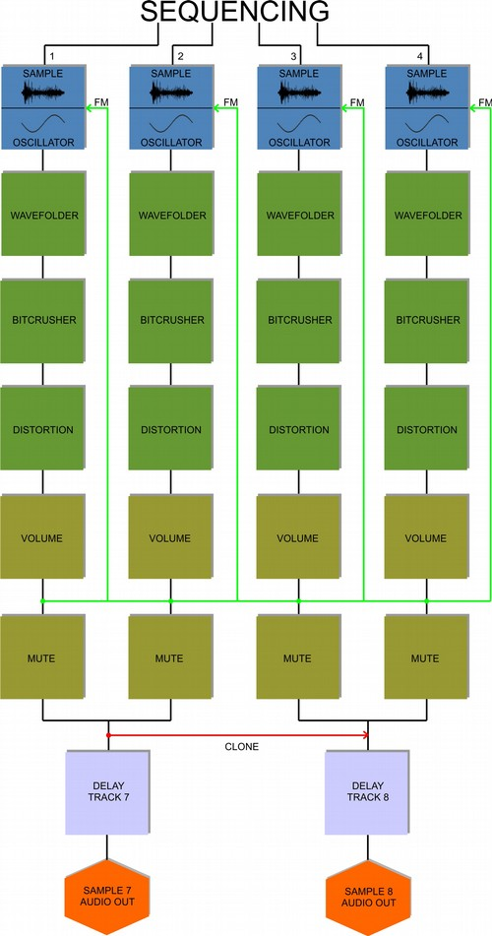

Sample Playback

Any audio part can be used to play back any previously loaded samples. These can be pitched and manipulated from the sequencer. Samples are internally using an 8bit resolution. To get the best audio results and lowest conversion noise, samples should be normalized well.

Synthesis

Beside of samples, each audio part contains of it own oscillator / operator. Each oscillator can generate sine, triangle, ramp, sawtooth, pulse and noise. Once an oscillator is started, it keeps running until it is stopped, either with the note-off function in the sequencer, or a manual stop. You can also cut the volume to silence them or apply an envelope to the volume. 2 oscillators can be played at the same time on one audio output, since each track has 2 audio parts. These can be separately sequenced from each other or the sequenced notes can be cloned so both parts play exactly the same notes. The cloned 2nd oscillator notes can be detuned by either semitones/octaves or finely de-tuned to get a wider soundscape. Different waveforms are also possible here.
The pulse wave has an additional setting to change the pulsewidth.
Both Oscillators (per track) can be hard-synced to each other. For each oscillator / wave 3 processing effects are available: Wavefold, Bitcrush and Distortion.
Each oscillator can also be Frequency Modulated by any other of the oscillators (or itself) and thus be used an FM operator. By connecting multiple operators to each other, acting as modulators and carriers, a wide range of FM sounds can be generated.
So for example Operator 1 (Carrier) van be modulated by Operator 2 and 3 (modulators), while Operator 3 can itself be modulated by Operator 1 or others. Many different 4 Operator FM algorithms can be created in that way. The volume of the operator acts as the ‘modulation index’ then. Note that the Modulator signal to modulate other operators is taken after the several processing options (Wavefold → Bitcrush → Distortion) and the volume process in the audio flow. This allows additional effects and variations for the modulations. Not only waves but also Samples can be used as Modulators (not as carriers). The better normalized the sample is the more effect it will have on the modulations.
Operators can also be muted so you can’t hear them in the modulated signal.
Also, the note cloning function can be used for proper key tracking of the operators. Transposing / Detuning them adds new harmonics to the sound.
Nearly all parameters from all operators/oscillators can also be controlled by the automators, envelopes or the sequencer.

Examples of generating typical FM synthesis:

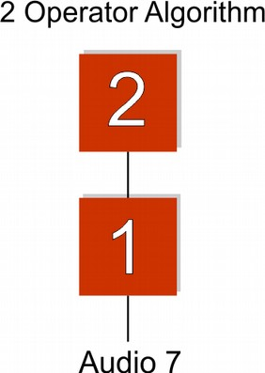
- Go to the → Track Setup screen for the audio tracks
- Choose Sample/Wave 1
- Set Modulation Source to FM OP2 (which means this operator is being modulated by Operator 2)
- Choose Sample/Wave 2
- Set Muted to yes (otherwise you will hear the sound of oscillator/operator 2 on the audio output)
- Set Clone notes from to 1 (So the key is the same as the one from Operator 1. This will keep things harmonic in the first place)
- Make a sequence in the pattern screen while audio 1 is set to one of the waveforms (sine for the classic FM sounds)
- Play the sequence. Play around a bit with the Volume and the Clone coarse of Operator 2. OP2 will automatically start with a sine. This can of course be changed.

For now it is more a FM oscillator. Lets apply some envelopes to get a real FM synth voice:
- First you may want to set the volume of Operator 2 to a high value, because this makes the envelope more effective.
- Go to the Envelope screen (double tap AUTOMATOR button)
- Choose envelope 1. Set to ‘One Shot’ (for now).
- Set the Source to T7 Audio 1 (where each note on of track 7 audio 1 will trigger the envelope)
- Set the Destination to Volume 1 (which then acts as a VCA for Operator 1)
- Press the OK button so the source/destination will be activated
- Change the envelope settings so the envelope sounds nice with your sequence
- Choose envelope 2. Set to ‘One shot’ as well. Set source to ENV1 Start (so it will always be triggered when envelope 1 is being triggered. (There are multiple ways to have it triggered by the first sample/wave/audio).
- Set the destination to Volume 2 (which then also acts as a VCA for Operator 2. The effect is, that it defines the ‘modulation index’ or the ‘deepness’ of the modulation).
- change the envelope parameters so they match the first envelope nicely
- to create more percussive sounds, you can set envelope 2 destination to Pitch 2.
The audio can be heard from audio/sample output 7. Since only 2 operators are used, you could add a 2nd version of it, the same with operator 3 and 4 (with it’s own envelopes). This will then output on sample/audio output 8. If you want them both to output from one audio output, then make this algorithm with operator 1+3 and Operators 2 + 4 instead. Turn off the mute of operator 2 and you will have a duophonic 2 operator synth on one audio output.

- Choose Sample/Wave 1 and set Modulation Source to FM OP2+4 (which means Operator 1 is being modulated by Operators 2 and 4)
- Choose Sample/Wave 2 and set Modulation Source to FM OP 3
- Mute Sample/Wave 4 if you don’t want to hear it from audio output 8
- set Clone notes to 1 on operators 2,3 and 4
(of course you don’t have to clone the notes from operator 1, but you would need to add an extra sequence for these non-cloned operators to achieve sequenced FM, which is really great for cool FM sounds, effects and music).
- again apply envelopes as needed.

If you clone the notes, nice additional variations can be created by using different ‘Clone coarse’ and ‘Clone fine’ settings.

Many different algorithms can be employed like this. Feeding operators back into the chain can generate nice unexpected results. Using the FM boost setting will create stronger FM sounds.

Keep in mind that when building algorithms, the audio from operators 1 + 2 will always be audible on audio output 7 and operators 3 + 4 on output 8 (unless muted).
This is visualized in the following algorithm where 3 operators are routed directly to the audio output. Since operators 1+2 will sound on audio output 7 here and Operator 3 on audio output 8, you would need to use an external mixer and mix audio output 7+8.

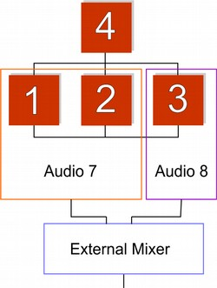

As for release V1.22, there are no algorithm or instrument presets, but these are planned with high priority for a later firmware.

Delay

Each audio track also has a delay unit (echo) as a last stage before the audio output.
The delay is a lo-fi delay implementation with 4 different timing possibilities:
- Short HQ → best quality but very short delay
- Lofi → lower quality, lower samplingrate but longer delay time
- More Lofi → lowest quality and samplingrate, but longest delay time
- Fast → Good quality, very short time (flanger kind of effect)
Additional delay parameters are:
- Delay time (where 0 is the shortest and 255 is the longest)
- Delay send → is the volume of the input (and so output) signal into the delay unit
- Delay feedback → is the intensity of the feedback into the delay unit. A setting of 15 means there is no loss in the volume and the delay signal stays in the delay-loop at full volume.
Note that because of the nature of the delay implementation (the delay time setting changes the size of the delay buffer) a change in the delay time can create audible artefacts, caused by old delay data in the delay buffer.

The delay settings can be changed in the → Track Setup screen for audio 7 and 8 or through the sequencer FX command.

Both audio outputs can have different delay settings and by cloning audio 7 to 8, you can create a nice stereo delay effect if these delay settings are only slightly different. Use the audio output 7 for the left and output 8 for the right channel then (or the other way around of course).

All current settings are saved and loaded with the project.

Load Sample window

The sample-slot window is used to add samples to the 12 slots.
Supported sample formats are:
- RAW 8bit unsigned
- WAV wave files in 8 or 16 bit, mono and stereo
Use the cursor up/down to navigate between the 12 slots. Press OK on one slot to open the file browser and choose a sample, press OK again to load the selected file into the slot. If there is not enough memory available it won’t load the sample. This also happens if there is too much fragmentation with the samples. Repeatedly loading, reloading and deleting samples can generate fragmentation. considering the limited memory and the embedded situation it is very tricky to defragment samples in real-time on the fly, so this is not implemented yet. For now in most cases it will refuse to load the sample and in some rare situations it can cause a reset!
So if the samples are extensively replaced, I suggest saving the project more regularly. Also in live situations I wouldn’t recommend extensive loading/reloading of samples. However, when powering on and reloading the project, the sample memory is automatically de-fragmented. Same if loading a sampleblock, the loaded data is de-fragmented.
Want to use longer samples? Use the old tracker tricks of using higher pitched samples and playing them back at a lower pitch setting which increases the sample time in favour of sample quality.
Sample-rate changing will be included in one of the next versions.

Samples can also be pre-listened by pressing SHIFT+LEFT (audio output 7) or SHIFT+RIGHT (audio output 8) in the sample browser. With this longer samples can be pre-listened. Keep in mind that while pre-listening a sample the navigation is turned off. Pre-listen can be stopped by pressing SHIFT+LEFT/RIGHT again. A pre-listen action halts all other samples playing on that audio track. However, the sequencer can run while pre-listening.

Below is the sample-slot window with 4 loaded slots:

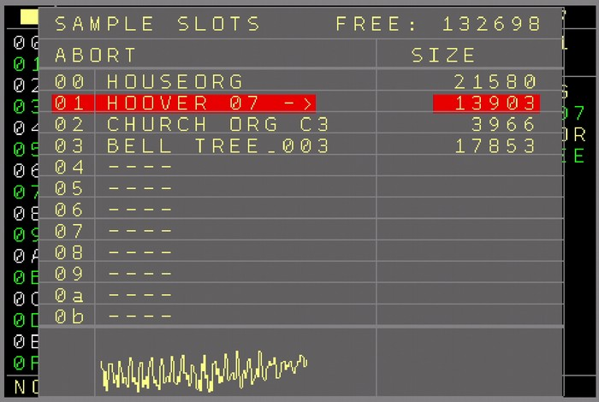Figure 21: Load Sample Window

The Nerd Screen / Menu
The Nerd button opens a special function menu. Depending on the current position of the cursor, Sequencer or pattern screen and if a block is marked or not, different choices are available to manipulate the selection.
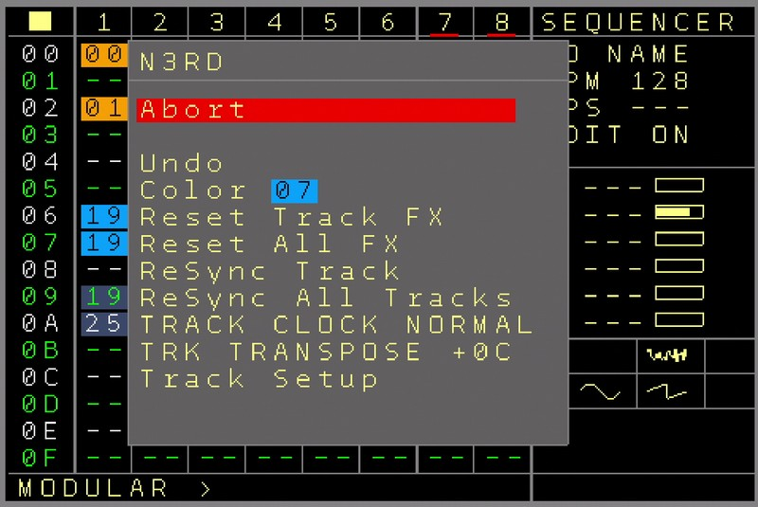Figure 22: Nerd Screen/Menu
The current functions can be found in the sequencer screen:
If nothing is marked:
- Undo → The latest change in the sequencer screen can be undone so iif you accidentally deleted something it can be recovered. Keep in mind that only the last edit can be undone.
- Color → Sets the background color of the current cursor point. Change the color using SHIFT+CURSOR LEFT/RIGHT
- Reset Track FX → Resets all FX / Current values of the tracks
- Reset All FX → Resets all FX / Current values of all tracks
- Resync Track – Resynchronizes the Track to the mainclock on the clock zero crossing
- Resync All – Resynchronizes all Tracks to the mainclock on the clock zero crossing
- Track Clock → Change clock dividers or multipliers of the track. If the player is playing then the changes are applied at the end of the pattern. If it is not playing, the changes are applied directly. Change using SHIFT+CURSOR LEFT/RIGHT
- Track Transpose → Changes the current transpose of the track. ( +- semitones). The transpose only works if track transposing is allowed in the → Track Setup
- Track Setup → Enters the track setup screen for the current track. (see → Track Setup screens)

If an area or field is marked:
- Color → Sets the color of the marked area. Change the color using SHIFT+CURSOR LEFT/RIGHT
Transpose Notes +1 → Transposes the notes (CV and MOD) in the pattern up by one semitone.
Transpose Notes -1 → Transposes the notes (CV and MOD) in the pattern down by one semitone.
Transpose Notes +12 → Transposes the notes (CV and MOD) in the pattern up by one octave.
Transpose Notes -12 → Transposes the notes (CV and MOD) in the pattern down by one octave.

The current functions in the pattern screen:
If nothing is marked:
- Undo The last change in the pattern screen (this pattern, not from others) will be reverted.
- Randomize value : Randomizes the current value if possible
- Reset Track FX → Resets all FX / Current values of the track
- Stop all Sound → will stop all sounds/gates, midi, modulators of the current track. When pressed while holding SHIFT, then all sounds of all tracks are being stopped.
- Edit Pattern Name → Opens a texteditor to add/ change the name of the current pattern
- Pattern Length → Sets the length of the current pattern between 1..64 steps. The sequencer will play the pattern only for the selected amount of steps. Also all jump and random jump functions will end up being within the selected length. SHIFT + CURSOR LEFT/RIGHT will increase/decrease by 1 step and SHIFT+CURSOR UP/DOWN will browse between these standard step amounts: 64,32,16,8,4,2,1
As you can change this value while the sequencer plays, it is possible to get ‘out of sync’ for the current track when changing the length. You can press the OK button to re-synchronize the track directly to the mainclock. Also changing the length while holding the OK button will directly re-synchronise the track while changing the length. Use this to create nice drum/synth fills in your live set.
This will currently work only well with regular groove settings and if there is no clock scale running on the track.
A default patternlength for new patterns can be set up in the Setup menu.
- Track Setup → Enters the setup screen for the current track

If a block is marked:
Transpose +1 - Transposes the marked notes one semitone up
Transpose -1 - Transposes the marked notes one semitone down
Transpose +12 - Transposes the marked notes one octave up
Transpose -12 - Transposes the marked notes one octave down
Shift UP/Down – Using SHIFT + CURSOR UP/DOWN will shift the marked parts up and down including a wrap over.
Flip Rows – Flips the order of the marked parts around, up is down and down is up
Randomize Row order – Randomizes the order of the marked parts.
Randomize Values – Randomizes the marked values, if possible

Recording / Live Input / Midi Input

The Nerdseq has recording facilities with flexible recording sources as well as live manipulations through the CV/Gate inputs or via Midi. Recording can currently be done step-based. So only values for each step are being recorded. The needed parameters can be initialized in the project screen → Input/Record Setup.
The recording/ Live input screen is split in 3 main parts.

Live Input with the 1..4 Input definitions→ Assign the CV inputs to manipulate several destinations live.
5 menu items are available here:
- Live Input ON/OFF → Enable general Live input for the CV inputs. If turned OFF then the live input and so the assigned CV input parameters are disabled.
- Input 1..4 → While the CV inputs are the sources (0..10 Volt for CV and 0..5 Volt for Gates/triggers), the destinations can be set on the right side.
Possible Destinations are:
Transpose T1...T8 → Transposes the CV outputs of tracks 1..8 live while the CV input is quantized to note scaling. The middle point for the transposition is C-5 (5 Volt input), which means no transposition. Voltages below will transpose the output down and voltages over 5 Volt will transpose up. Note that transpose must be allowed (track settings) for the tracks to take effect.
Transpose All → same as track transpose, but it affects all tracks together (only tracks that allow transposing)
Pass to CV, MOD, TRIGGER 1..6 → The voltage of the CV input is passed (and overwriting) the CV, MOD output. If trigger is set up as destination, then a threshold will determine either a Trigger on or a trigger Off. As this is a realtime process, normally sequenced notes or triggers will not pass to the outputs any more.
Quantize to CV, MOD, TRIGGER MOD 1..6→ The voltage of the CV input is quantized to note scaling and output to the destinations CV 1..6 or MOD 1..6. This is also a live pass- through and it overwrites sequencing and other CV/MOD output values continuously. If Trigger is set up as destination, then a threshold will determine either a Trigger ON or a Trigger OFF.
Position X/Y/Start/Stop → ‘Etch A Sketch’ moving of the cursor in the sequencer screen.
‘Position X’ moves the cursor in the sequencer screen horizontally between the Tracks 1..8. The lowest CV value will position the cursor on Track 1, while the highest CV value will position it on Track 8, the rest linear in between.
‘Position Y’ moves the cursor vertically between the rows on the sequencer screen. The lowest CV values will position the cursor on Row 00 while the highest CV values will position the cursor on row FE. Other voltages linear in between the rows.
‘Position Start’ A trigger / gate on the CV input starts the pattern on the cursor position as next.
‘Position Stop’ A trigger / gate on the CV input initiates a stop of the track/pattern on the cursor position.
Sample 7..8 Gate → Plays the last set/used sample on Track 7..8 if the gate is set.
Sample 7..8 Pitch → Defines the note of the sample which is being played through the Sample/Gate function.
Sample 7..8 Offset → Defines the start/offset position of the sample which is being played through the Sample/Gate function. (can be used to start different slices of the sample)
Sample 7..8 Slot → Defines the sample slot which is being played through the Sample/Gate function. If not defined, then the last played sample will play.

As explained earlier, if Live Input is turned off, then the input settings have no effect.
Destination types can be changed using SHIFT+CURSOR LEFT/RIGHT and destination numbers (eg tracks 1..8) can be changed using SHIFT+CURSOR UP/DOWN.

Input 1..4 Recording → Assign the CV inputs for recording
CV 1..6 Note → Records a note into the current playing step. Records only if in record mode and a pattern is playing on the track of the selected CV. The notes are filled in on change.
MOD 1..6 → Records a modulation value into the currently playing step. Records only if in record mode and a pattern is playing on the track of the selected MOD. Modulation values are entered on any change in voltage detected.
GATE 1..6 → Records Gates into the trigger column current playing step. FE for Gate ON and 00 for Gate OFF. Records only if in record mode and a pattern is playing on the track of the selected Gate.
TRIGGER 1..6 → Records triggers into the trigger column current playing step. Fills in a 40 as trigger value if a trigger happened on the CV input.
CV NOTE + GATE 1..6 → Records CV notes + Gates into the current playing step. It fills in a note only if a new Gate happened. This choice uses always 2 inputs, so the CV input below the current one is automatically chosen for being the Gate input. Additionally the Gate input detection can be delayed, so also sources which have a slew on the CV can record well (where the CV value is not stable yet when the Gate arrives) .
The delay value can be changed below the input setting.
This is the best choice if you want to record CV + Gate from a source like a keyboard.
It can only be used on the Input settings 1,2 and 3, as it always needs 2 inputs.
CV NOTE + TRIGGER 1..6 → Same as the CV NOTE + GATE 1..6 except for that here triggers are detected and recorded.

CURSOR CV → In combination with CURSOR GATE on another input. Records a note on the current cursor position. This places a note if in the pattern screen on the Note column if a new gate happened on the current cursor position. A Gate on (FE in the Trigger column) is being added, too. If the Gate is released on the same step, then the Gate on is being replaced by a trigger of 40. The cursor can be moved to another step and if the gate is being released there, a gate off (trigger column 00) is filled in.
If holding the gate for more than 1 second on the same step, then the note and the trigger value of the cursor will be deleted.
The sequencer doesn’t have to play or be in record mode. Edit Mode must be enabled though for it to work.
This allows editing notes in the pattern screen from a CV/Gate keyboard.

SAMPLE PITCH 7..8 → Selects the sample / note that should be recorded.

SAMPLE SLOT 7..8 → Selects the sample slot that should be used for a sample note record.

SAMPLE GATE 7..8 → Records Notes (defined by SAMPLE PITCH) with the selected Sample slot (defined by SAMPLE SLOT) into the current playing step. Records only if in record mode when a pattern is playing on the selected sample track. It fills in a note only if a new Gate happened. If no slot is selected, then the last slot is being used.

Midi Input/Record settings → Assign Midi Channels for live manipulation, recording and extra functions
MIDI DATA INPUT → Enables / Disables the general Midi data input (not clocks). This needs to be enabled to use the further Midi input functions.
MIDI STEP CHANNEL → Choose a Midi channel that is used to edit notes directly in the pattern screen. To use it, the cursor must be on the note column of the pattern screen. Playing a note (for example on a midi keyboard) will insert a note at the cursor position. If the note is released on the same step as the note on, then a trigger (kill for midi tracks) is being inserted for a short note. If the note is released on another step, then a note off is being inserted. Holding the note for more than 1 second will remove the note at the cursor position.
The sequencer doesn’t have to play or be in record mode. Edit Mode must be enabled though for it to work. This allows to edit notes in the pattern screen from a Midi keyboard.
MIDI IN Offset → As the Midi standard is pretty vague about which frequency for example a C on octave 3 should play and different manufacturers and use different octave offsets, this setting can be used to flexibly change the Midi note input offset, so the octaves always match well, regardless of the Midi input device. The setting can have a positive and negative offset.
MIDI CHANNEL 1..16 → Select several destinations for live and recording for a midi channel input. The following functions are currently available:
TRACK 1..8 Input → Use the dedicated Midi channel to play a track (like a Midi→CV converter). Notes are routed to the CV Note, Note On/OFF go to the Trigger output On/OFF and the modulation wheel is routed to the MOD output. Pitch bend bends the pitch of the destination track if possible.
For Midi tracks, the Midi data is passed through into the track midi channel.
For Trigger16 Tracks, all 16 Trigger outputs can be played through Midi notes, starting from note C-3. NOTE ON sets the Trigger and NOTE OFF resets the Trigger output.
For audio Tracks, the sample is being played on NOTE ON and stopped on NOTE OFF. The volume is defined by the velocity. Additionally the sample slot being played can be changed through the program change Midi command (0..11 for the 12 slots).
TRACK 1..8 Transpose → Transposes the destination track (quantized to notes). Where note C-4 is the middle position which means no transposition. Higher notes transpose up and lower notes transpose the destination down. Be aware that the transpose only works if track transpose is allowed for the destination tracks.
TRACK 1..8 Record → Live records into the destination tracks. Note on fills in a note on the current recording step. If the Note was released on the same step, then a F0 is filled in on the trigger column. If the note is released on another step, then a note off is being inserted.
For audio tracks, the note is filled in, the velocity defines the sample volume. The last used sample slot is used for recording, the sample slot can be changed by using a program change command.
For TRIGGER16 tracks, triggers can be directly recorded into the drum-matrix. Starting from note C-3 all 16 drum-matrix values can be inserted in with a note on command. The 8 notes higher than that will be added in the regular trigger columns.
For CV16 tracks, up to 6 voices can be recorded at the same time or is set up, up to 5 voices plus a dedicated envelope. The type of recording is set up in the CV16 Setup screen.

For Midi Tracks, polyphonic Midi recording is possible. Up to 4 notes at the same time can be recorded as well as all Midi parameters like Program Change, Midi CC, Pitchbend, Aftertouch… Keep in mind that midi data will only be recorded as long as there is space in the FX column. If all 3 FX columns are filled in already, then the recording of the additional data is being ignored for this step.
Transpose ALL → Transposes all tracks Where note C-4 is the middle position which means no transposition. Higher notes transpose up and lower notes transpose the destination down. Be aware that the transpose only works if track transpose is allowed for the destination tracks.
CC Mapping → A set of Midi-Controllers is mapped directly to functions inside the NerdSEQ.
The CC Mapping is not implemented yet but scheduled for the next version.
LAUNCHPAD MINI/MK2/PRO/MK3 PRO → Set up this midi channel for being used with the different Launchpad Models. For this Midi In and out of this channel is being dedicated to the launchpad.
More info on the → launchpad section.
If Midi is enabled, a little information about the incoming Midi data will be shown at the top of the screen. It will show if a Note on or Note off command is being received on the channel. This can be used to check if the input works generally.

Once the recording sources/destinations are set up, you can press SHIFT+RECORD to enable recording. The selected pattern will start to play with recording enabled at the same time. You can then also start other patterns afterwards which are involved in the recording OR start the patterns first and press SHIFT+RECORD afterwards when you want to start recording.
SHIFT+RECORD will stop the recording while the pattern keeps playing. Stopping the sequencer (SHIFT+STOP) will also turn recording off.
Recorded values will be directly routed to the corresponding outputs as well. So looped recording/playing of a kind is possible.
To record from Midi you need the Midi/IO-Expander.
If in Record mode the values can be deleted ‘on the fly’ by pressing and holding the TABLE (Record without shift) button while in the pattern screen. Any notes that are played while holding TABLE will be deleted from the currently playing sequencer step.

User Interface Screen
This screen is dedicated to change the user interface colours and Font. There are 6 different Fonts available ranging from Solid to Geek.
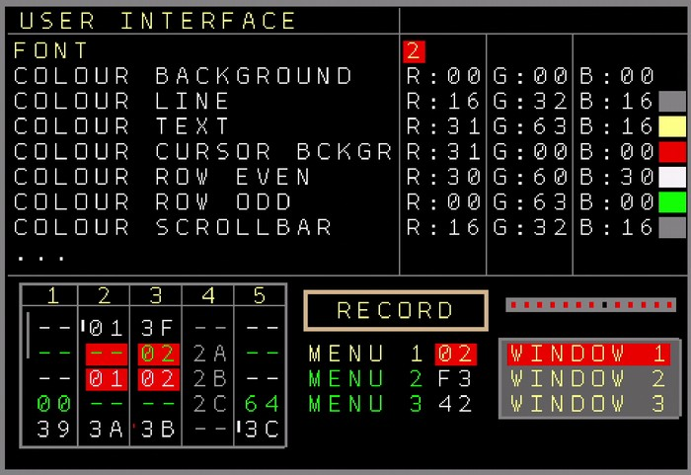Figure 23: User Interface Setup Screen
As for the Colours, you can change the following User Interface colours:
- Background, Lines, Text, Cursor Background, Even Rows, Odd Rows, Scrollbar, Play Cursor, Record frame, Muted Text, Windows Fill, Windows Lines, Clock Bars
All colours can be edited in their Red, Green and Blue components. On the right side you can view the selected colour values as well as examples of how the colours would look on the screen.
Use the Save option to save the font and colour settings so they are recalled after a power cycle.
The Reset Colour option resets the colours to the original colour scheme.

Expander Modules
There are several expander modules which enhance the functionality of the Nerdseq.
At this point 3 expander modules are available:
- IO-Expander. It enhances the Nerdseq with a Midi-In, Midi Out (DIN5) port and a connector for a Sega Gamepad controller.
The Midi functionality is for clocking in and output, to play and record from Midi (Midi→CV Conversion) and also polyphonic multi channel midi recording and sequencing.
A Sega Gamepad (Sega Genesis 6 Button Controller), which can be used for navigation, editing and live playing can be connected to the Gamepad Connector. For now there is only a basic definition of the buttons, but it will be customizable in the future so one can assign each button to a function.
The IO-Expander is connected to the back side of the Nerdseq (PAD-Midi) with a 12 pole IDC ribbon cable

NSA (Nerd Sound Adapter) Expanders
You can use up to 4 NSA expanders with one NerdSEQ. All NSA Expanders are connected to the NSA port of the NerdSEQ, either directly or daisy chained from one to the next expander.
Please be aware that you should never connect/disconnect an expander in a powered system. The expanders / NerdSEQ could suffer from electrostatic peaks when connected while the power is on!!

The current available expanders are:
- More Triggers 16 → Adds 16 more triggers/gates to the NerdSEQ. Next to all known trigger/gate functions there are many new functions and a nice drum-matrix screen when connected.

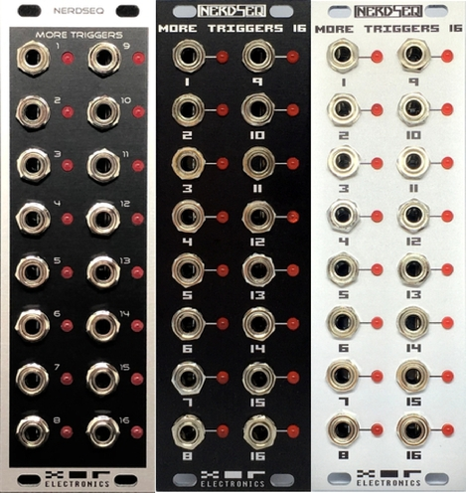Figure 24: Trigger16 Expanders

- More CV16 Expander → Adds 16 more CV outputs for Notes, Pitches as well as 8 Envelopes and 8 LFO’s which can be routed to any of the outputs. Additional effects per CV output.

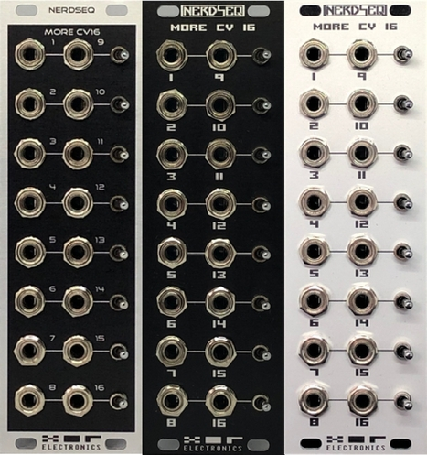Figure 25: CV16 Expanders

Each output can generate Notes and Pitches from 0 to 10 Volt ( -5 / +5 Volt).
While the Notes can be used for polyphonic sequencing, all other modulations and pitches can be used to control many destinations. As in general with the expanders, they can be assigned to multiple tracks.

Additional to the notes the following effects/modulators can be applied for each output:

Glide:
For each CV output there are Glide settings. These work just like the glide setting on the NerdSEQ itself with the 2 parameters Speed and Steps.
The Speed decides how fast the glide is and the steps is the resolution of each speed iteration. To get snappy glides from one note to the other you increase the steps a bit and keep the speed on a low value. The glide is per CV output and a pitch/note glides in the assigned speed/steps to the new note. The glide settings can be changed in the track setup or from the FX columns.

Modulators:
There are 16 modulators in total, 8 Envelopes and 8 LFO’s. Each can be used on all outputs of the CV16 expander. So you can assign every Envelope to every output of the CV16 expander. The same for the LFO’s.
As example, you can assign Envelope 2 to the CV outputs 1 and 4. Envelope 4 to CV14. LFO 2 to CV2 and CV7. And so on… You could even assign one Envelope to 15 or all 16 outputs and start them all on different times. Keep in mind that per CV output there can be only 1 Modulator active. So both, Envelope and LFO on one CV output are not valid. The latest started Modulator will stop the previous one.
Each modulator has dedicated functions and settings (each 8 times) which are:

Envelope: Since this is a ASR Envelope, each envelope has Attack, Sustain and Release as setting.
Every Envelope can be set/started into different stages:
Attack → Release : ‘Fires’ the envelope going through it’s attack phase and when it reaches the sustain voltage level, the Release phase starts.
Attack → Sustain: ‘Fires’ the envelope going through it’s attack phase and it reaches the sustain voltage level it holds that level until the released phase is started.
Release: Starts the release phase from the current sustain level.
Loop: ‘Fires’ the envelope going through it’s attack phase and when reached the sustain voltage goes directly into the Release phase and loops this endless.

The Attack/Release times go from 20 milliseconds to ~14 Minutes. The Sustain voltage can be set up from 0 to 10 Volts in 255 steps.

LFO:
Each of the 8 LFOs have 3 settings for waveform, Speed and Amplitude.
The possible waveforms are: Sine, Triangle, Sawtooth, Ramp, Square, Noise and Random.
The random waveform is special as it contains all waveforms except for noise and it changes between them randomly at a random moment. So it can switch between triangle to ramp and then to sine and so on at various times. The speed changes the wave iterations between 0.0011 Hz (~14min) and 21.8 Hz. The Amplitude from 0 to 10 Volt (-5/+5 bipolar) in 255 steps, while the smaller ranges got a finer resolution.
The LFO’s can be started and will run endlessly. There is also a command which resets the LFO, so the waveform starts over.

For each CV output there is an additional setting to decide if the Modulator (Envelope or LFO) should be pure or added to the current Note/Pitch.
So in case of the setting being pure, the following rules are valid for the modulators:
Envelope:
The ASR (Attack Sustain Release) Envelope starts with 0 Volt (-5V) it’s attack phase until it reaches the Sustain Voltage. If it’s full sustain = 255/FF then this is 10 Volt(5V). If the release phase is finished the voltage is 0 Volt again.
LFO:
The LFO midpoint with the pure setting on the CV output is 5 Volt (0V). So the LFO will swing between 0 and 10 Volt ( -5/+5V) at full amplitude.

If the CV output is set to ADD then the Modulator voltage is being added to the current pitch or note value. The Modulators will act as bipolar modulators. In this case the following rules apply, assuming for example the Note C-2 → 2 Volt (-3V):
Envelope:
Starting the Attack phase from 0 Volt (-5V), because it is lower than the lowest possible voltage. To the sustain phase (if sustain is set to full) to 7 Volt (2V) and back to zero after the release to the lowest value. Note C-5 would output the full range of the envelope and higher values would place the offset to a higher value.
LFO:
The LFO swings bipolar around the note/pitch value. Depending on the amplitude setting the bipolar LFO swing has values from plus/minus 5 Volt to millivolts around the current pitch value.

Once a modulator is started it will stay active until it is being stopped by the sequence or the user.
In case of the CV outputs which are set to pure, any note values have no effect.
A modulator can be stopped with the appropriate command in the pattern screen for the CV output or in the pattern Nerd Menu → Stop all sound. If modulators are stopped, the original Note/pitch value/voltage will return to the CV output.
Besides the sequencing, the CV expander can also be a destination for live recording or playing through the CV inputs or Midi. For now from the CV input, 1 CV note can be recorded together with an Envelope (With the settings of Envelope #8). In case of a Gate-On at the CV inputs, an Envelope with the Attack→Sustain phase is entered the CV16 columns together with the Note. On a Gate Off, the Release Phase is entered.
If the recorded input is a Midi signal, then flexible settings can be set to achieve polyphonic recording.
So the input settings can be from 1 up to 6 CV notes polyphonic or 1 to 5 CV notes plus the Envelope. All these are filled in to the CV16 columns. If the envelope function is activated for it, then also Envelope #8 is used. When multiple keys are pressed, the envelope will run through Attack→Sustain on the first note and starts the release phase when releasing the last note.
Another setting is the 2x2 or 3x3 polyphonic recording. In this mode a 2 or 3 voice polyphonic recording and envelope generation is possible. In case of the 2x2 mode, up to 2 notes at the same time will be entered in the first 2 columns, while the next 2 columns set the envelopes for these notes. So Column 3 envelope is for Note 1 in column 1 and Column 4 envelope is for Note 2 on column 2. If the 3x3 mode is active, then it records up to 3 notes + each an envelope, where the first 3 columns are the notes and the next 3 columns the envelopes for the corresponding notes. It is possible to get full 3 voice polyphony with this per track.

Please keep in mind that the Glide, Envelopes and LFO can never fully replace real analogue Slews, Envelopes or LFO’s. But they are definitely a very good addition for many applications.

Not yet available expanders, but coming soon:
- More Trigger/CV Mix → 6 more CV + 2 more triggers per expander
- Dualchord → 2 seperate audio oscillators with each 1 trigger and 4 voice polyphony
- I2C → Allows the integration and control of follower modules like the ER-301 and others without using patchcables
- Video → Adds HDMI and composite video output and a computer keyboard input for real tracker feeling
- Midi-USB → Adds midi USB which allows the direct connection of the Launchpads and more

NSA Firmware Update Screen
As the NSA-Expanders are smart devices with their own microcontroller it is possible that any Firmware might need an update for new functions or bugfixes. This can easily be updated through the NerdSEQ.
The NSA update screen has the following functions:
- Rescan NSA → This will try to rescan connected expanders. This might be needed after a firmware update or if it was not recognized correctly in the begin, or if you don’t know which firmware is running on it. Be aware that expanders should only be connected while the power is off.
- NSA Address → Set the channel of the expander that needs to be updated. It must match the channel which is selected with the jumper on the rear side of the expander.
- NSA Type → The type is entered automatically when an expander detected. otherwise it will be filled in when loading a firmware file
- Firmware File → Opens a file browser to select a firmware file for the update. For the update one must copy the firmware file into the /firmware folder of the SD card. All .nxp files are possible update files.
- Update Now → If all was fine, then update now can be selected. It will check if the connected expander type is correct and more information. On succes it will start to flash the firmware. Do not remove the SD Card or power off the NerdSEQ/Expander while updating. And do not worry if that happens either. If an expander is unresponsive in normal operation, you can try to flash it again. Just remove the power of the expander and connect it. Now you got less than a second to press the Update now button and it will flash the expander again.
If an update is executed succesfully then it will be indicated and Nerdseq rescans all NSA. Here you can check the new version number. If something went wrong an error message is shown and Nerdseq does not rescan the expanders. Try again or check out what the issue is.
Sometimes it might be also be necessary to power cycle the expander before it is recognized by Nerdseq after flashing, even though if it showed a success message.

Launchpad Integration
A special feature is the integration of the Novation Launchpad (LP). It offers display and control of several of the NerdSEQ screens and functions. Currently it works for the Launchpad Mini, MK2, Launchpad Pro and Launchpad Pro MK3. For the Mini and MK2 special USB-Converters are needed, which will be available as a special USB-Expander at some point. The Mini MK3 has not been tested yet, but the Launchpad Pro can already be used over regular MIDI, using the Midi ports on the Midi-IO Expander.
Beware that the LP integration is still Beta and incomplete and will be enhanced in future versions. I decided to release it already as it is mostly working well and it is very usable. (and initially on request of the Forum users, so please take it now ‘as is’)
To use the LP Pro, connect the Midi Out of the Expander with Midi in of the LP and Midi Out of the LP with Midi in on the expander.
The LP functionality can be enabled/set up in the Input/Record settings. Set Midi Channel 1 to LP Pro. Also don’t forget to enable Midi Data input. Beware that the LP also listens to other Midi Channels than Channel 1 and so Midi sequencing on channels 1..4 might interfere with the Launchpad. You can still sequence other external gear of course using a midi-thru box on the Midi-Out of the expander.
The Launchpad is now already set up and will show the same colours as the sequencer screen, once you enter the sequencer screen again. It only really makes sense to use the LP integration with colours as you can recognise the parts very easy on the NerdSEQ screen and the LP Pads. The LP will show the upper 8 rows of the Sequencer screen and follows the scrolling of the screen.
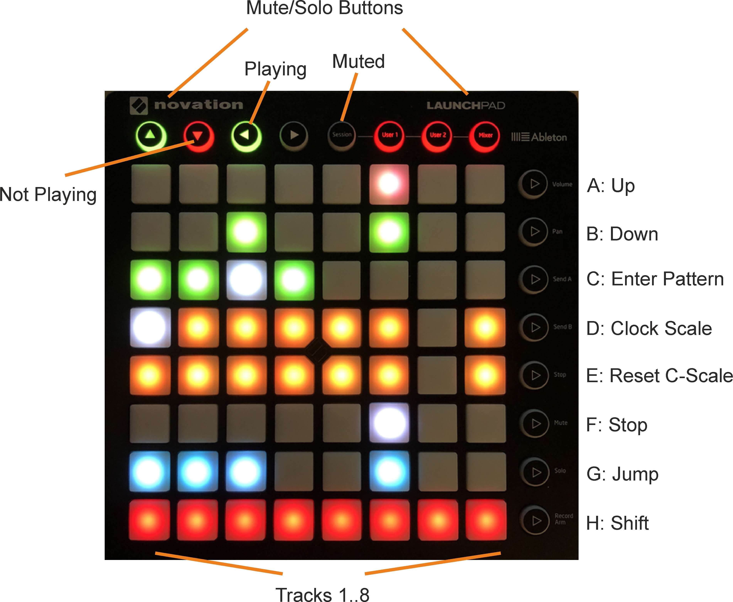
The following pictures show the Launchpad next to the sequencer screen of the NerdSEQ. As you can see the colours match on both, so you can easily recognize your pattern arrangements when using colours.
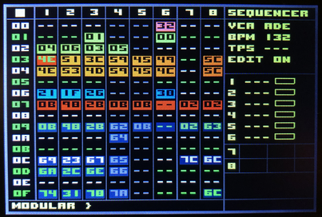

Next to the matching colour arrangement, you can see which tracks / patterns are playing. The current playing patterns are animated and indicated as white pads. Also the current clock position is shown as a white pad in the matrix.
The Pads in the matrix can be used to start the sequencer, start the pattern or to select the next pattern to play (same as the start button when on a pattern). While holding the SHIFT button and selecting a pattern in the matrix, the whole row will be started or selected to start next. (beware that for the LP explanation the SHIFT button is the one on the LP (Button H) and not the one on the NerdSEQ) Also this is the same function as if using SHIFT+START with the normal NerdSEQ keys. The Matrix Pads/Buttons also have more functions when combined with the buttons to the right.
The top row of the LP show the Mute/Solo buttons for the Tracks 1..8 as well as the current state of the buttons/tracks. Here green means the track is playing. Red means the track is not playing. And black or no colour at all indicates that the track is muted. You can Mute/Unmute the track by pressing one of the 8 top buttons. Combined with the SHIFT button you can Solo/Unsolo the track.
With Buttons A and B you can scroll Up and Down in the sequencer screen. Using the A or B together with SHIFT, you can scroll a Page (16 rows) up and down.
Button C combined with a Pattern pad from the Matrix will enter the Pattern.
Button D combined with a track from the matrix (column 1..8) will change the track clock scale (after the pattern is finished) in direction Dividers → Multipliers.
/7 → /6 → /5 → /3 → /32 → /16 → /8 -> /4 → /2 → Normal → *2 → *4 → *8 → *3 → *5 → *6 → *7
Together with the SHIFT buttons the clock scale will change in direction Multipliers → Dividers.
*7 → *6 → *5 -> *3 → *8 → *4 → *2 → Normal → /2 → /4 → /8 → /16 → /32 → /3 → /5 → /6 → /7
Button E combined with a Track from the matrix will set the track clock to normal (after the pattern has finished)
Button F combined with a Track from the Matrix will select the track to stop when the pattern is finished. Pressing it twice will stop the track immediately. (same function as regular STOP button)
SHIFT + F + a button in the matrix will stop the sequencer.
Button G combined with a button in the matrix will perform a jump to the new pattern if the selected track is playing. The jump is from the currently playing pattern to the selected pattern on the same step. (same function as using the OK button on the NerdSEQ if edit is turned off)
Together with the SHIFT button, the whole row will jump to the newly selected pattern row.
Keep in mind that these are only temporary jumps. If the pattern is finished, it will jump back to the original playing pattern.

Within patterns (either selected with the LP or with the NerdSEQ), the LP will have different functions.
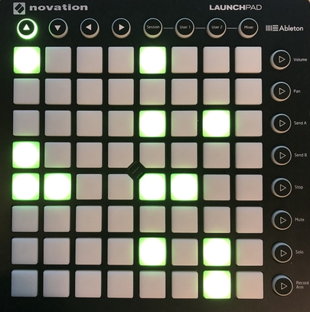Figure 26: Pattern Screen -> CV/Gate Track
In a Pattern Screen of a CV/Gate track you can insert or remove triggers. The matrix shows all 64 steps and by pressing a button you can insert or remove a trigger. Tapping Button H (SHIFT) will insert a trigger on the current playing position. In the top row you can see which track is selected.
Pressing the most top right button will move you back to the sequencer screen. (Subject to be changed)
The Trigger16 Pattern Screen shows the current drum-matrix for the first 8 or the 2nd 8 tracks, depending on whether the triggers are swapped or not. So columns 1..8 show drum-matrix triggers 1..8.
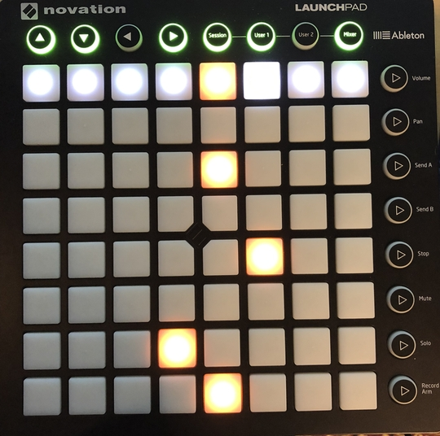Figure 27: Pattern Screen -> Trigger16 Track

Within the columns you can set or reset the drum matrix triggers for the current 8 steps. The buttons on the right define the steps that are selected to be edited. So top is 1..8, 2nd is 9..16, 3rd is 17..24 and so on. The top button row is to mute/solo the triggers.
Please keep in mind that the Trigger16 layout for the LP will change in a future release!!
Other patterns (like from the audio tracks) are not implemented yet.

Once more a reminder: The Launchpad integration is incomplete and subject to be changed in the future. A smart USB-Expander will be released in the future which allows connection of the LP via USB and it will add some additional functionality to complete the implementation.

Tips & Tricks, FAQ
Some general tips and tricks, general pitfalls and beginner issues are described here. Be sure to register to the XOR Forum for further informations, questions and more tips and tricks.
- Notes do automatically set the Gate on the trigger output. So there is no need to add anything to the trigger column for that. Reset the gate again by adding a [ ] on another step in the note column (note off) or the kill command with a value for shorter gates. However, you can of course use the trigger commands to overrule the automatic gating or turn the autogate feature off in the setup.
- An expander never adds more tracks to the NerdSEQ. The amount of tracks is fixed to 6 regular tracks and 2 audio tracks. The 6 regular tracks can be assigned to the expanders and provide additional functionality when assigned and all functions of the local tracks will still be available!! It is not possible to assign the expanders to the sample tracks.
- Probability is a major function which you can set to a certain percentage. It works for all coming steps and not only for the one step where it’s being activated.
- If you want to add a shuffle effect to a pattern, use the groove column. Alternate every row with the values 7,5,7,5 ….or even 8, 4,8,4… for a stronger shuffle (use MARK and COPY for faster editing)
- Editing the groove or adding a break while playing can get you out of the main synchronisation. This is because the pattern(s) keep playing with the odd setting that you set at the point the sequencer was passing by, but the next setting which makes the groove equal again hasn’t been played. You can re-synchronise the pattern by stopping that pattern and start it again. Just keep it in mind because that’s a possibility if your patterns are off at some point after editing.
- Midi controller 78 will turn off all notes

Firmware update

A new firmware can be reliably flashed into the nerdseq to fix bugs and add new features (and there will be a lot of new features!)
For that you need to put a new firmware file onto the SD card in the \firmware folder. Be sure the file is named ‘nerdseq.hex’. Check the troubleshoot on the forum if you have issues downloading the file with your browser.
When powering on the Nerdseq (or after a software reset from the settings screen), you have to press and hold these 3 buttons (best pressed before powering up or just after the software reset):
SHIFT, COPY and CURSOR UP. ( Not the UP button!!! )
Keep holding the buttons until the bootloader appears, then release the buttons. Nerdseq will check for the file for consistency, shows the new software version and asks if it should be flashed. Press SHIFT if you want it to be flashed. Once Nerdseq has finished flashing you must check the status and press SHIFT again to start up the new version. The screen will show if the flashing was succesful. It is possible for the Progressbar and the percentage to go over the 100%. Don’t worry about that, if Nerdseq indicates succesful flashing then the update went well!
That’s it. If the flashing is interrupted for some reason (power, SD card removal), then you can simply do it again (after power up). Entering the Bootloader mode after power up should work at all times!
It is possible that the firmware upgrade mode shows an SD card error. This can happen if the SD card was not recognized well first try, keep holding the keys and it will usually work well on the next try which will follow automatically. No worries here, just try it again.

Disclaimer

This manual is made with the best effort to get it complete and correct. However, there can still be issues and incorrect or incomplete content. Also please note that the manual is always related to the latest stable Firmware Version of the NerdSEQ. There is an archive of manuals for older versions. One can not claim any features added by mistake in this manual. In advance I want to apologize for any problems that might come up by incorrect content or maybe wrong interpretations.
I appreciate any help to improve manual, so please inform me if something might be unclear or can be done better. In the end, I am a software developer, inventor and musician and the manual is just one of the many things I have to do.
Also I, XOR Electronics take no responsibility to any damage that occur to any gear or other possessions, the NerdSEQ or your body by using the Nerdseq. Please use and handle it with the common sense.

Thanks for understanding and happy tracking!
Thomas Margolf

https://nl.wikipedia.org/wiki/Moduletracker
https://en.wikipedia.org/wiki/FastTracker_2
https://en.wikipedia.org/wiki/OctaMED
http://www.littlesounddj.com/lsd/
http://littlegptracker.com/
https://en.wikipedia.org/wiki/Music_tracker
https://en.wikipedia.org/wiki/Hexadecimal
https://en.wikipedia.org/wiki/Gamepad#/media/File:Sega-Genesis-6But-Cont.jpg

