NerdSEQ

Hybrid Tracker Sequencer, Synthesizer
and Toolbox

User Manual
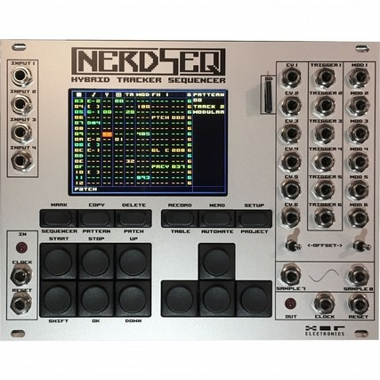
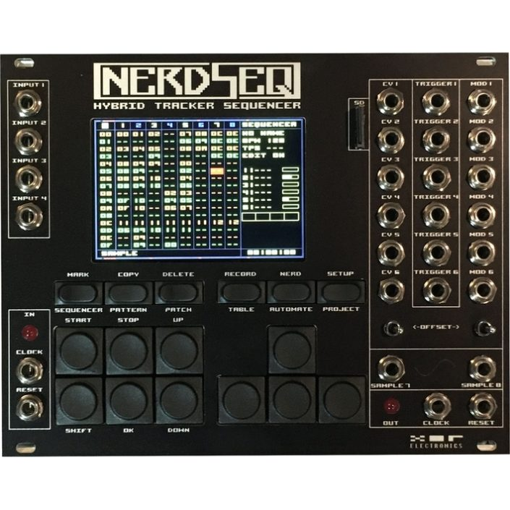

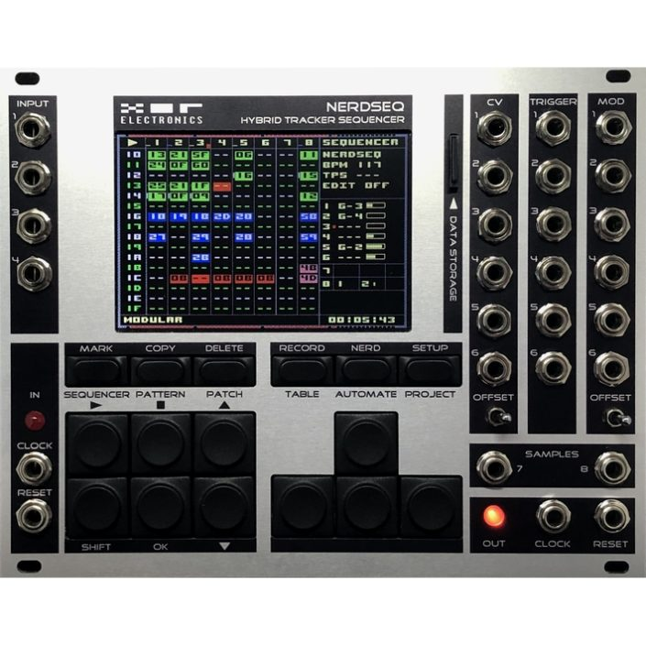

Please be aware that this is an ever growing manual. Save the trees by not printing it out!
Content
Introduction 4
Technical Specification 6
Firmware Features 6
Basic Overview 9
Getting Started 10
Numbers, Values and Tracker basics 10
Buttons and Navigation 13
General Screen information 16
Sequencer Screen 17
Tracks / Patterns 22
Track Assign Screen 23
Track Setup Screen 24
Basic Pattern Screen and editing functions 26
Modular Track 29
Pattern Screen 29
Track Setup 45
Audio Track 47
Pattern Screen 47
Track Setup 55
Midi track 57
Pattern Screen 57
Track Setup 63
Trigger 16 Track 65
Pattern Screen 65
Track Setup 69
CV 16 Track 71
Pattern Screen 74
Track Setup 81
CV16 Calibration 83
Dualchord Track 84
Pattern Screen 84
Track Setup 87
I2C / Multi-functional Track 94
Pattern Screen 94
Track Setup 98
Video Track / Video Shader Functions 106
Video Project Screen / Track Setup 107
Pattern Screen 113
Technical/Developer Shader Information 116
Video (Hardware) Setup Screen 119
Patch Screen 121
Current Values Screen 122
Table Screen 126
Automator screen 132
Envelope screen 142
Project screen 145
Setup Screen 148
Sample / Wave / Synthesis 151
Load Sample window 156
Nerd Screen / Menu 158
Input / Record Setup Screen (CV Inputs/Gamepad) 161
Midi / I2C Setup Screen 165
Random Ranges Screen 170
Scale Screen 171
Mapping Screen 174
Mapping Sources (list) 178
Mapping Sources (detailed) 180
Mapping Destinations (list) 189
Mapping Destinations (detailed) 194
Variable Screen 207
User Interface Screen 208
Sega Gamepad Settings 208
Midi Expander 210
Midi-IO Expander 210
2HP TRS-A Midi-Expander 211
Multi-IO Midi & I2C Expander 211
Multi-IO and I2C Additional Installation guide 212
Multi-IO Functionality 215
ART Add-On for the Multi-IO 218
Sega Gamepad Expander (for Multi-IO or standalone) 219
NSA (Nerd Sound Adapter) Expanders 220
More Triggers 16 220
CV16 221
More Video-IO 222
Video Expander USB Keyboard functionality 223
Dualchord 225
Expander Firmware Update Screen 228
Launchpad Integration 229
Calibration 233
Tips & Tricks, FAQ, PANIC 235
Firmware update 236
Cheat Sheet 237
Disclaimer 238

Introduction

The NerdSEQ is a Tracker based sequencer, synthesizer and modulation generator for Eurorack systems.
It consist of 8 Tracks which can be used for CV/GATE, Midi, I2C sequencing and more.
In the basic configuration the first 6 Tracks are being used for the CV/Trigger/Gate generation of 18 outputs (12 CV + 6 Trigger/Gate). The other 2 tracks are audio tracks with 2 dedicated audio parts each for sampling/synthesis sequencing. Furthermore the audio part can also act as a waveform oscillator or FM synthesizer. All tracks can be also set to alternative functionality which can be Midi (using one of the Midi Expanders), More CV outputs (using the CV16 Expander), More Trigger outputs (using the Trigger16 Expander), I2C (using the Multi-IO Expander), Multi-Oscillator (using the Dualchord Expander) or for the Video-Synthesizer (using the Video expander) sequencing. Different modulation functions like LFOs, Envelopes and many more complex functions can be generated for internal and external use. Dedicated clock/reset inputs and outputs are available for different clock types. 4 free assignable CV inputs can be used for live manipulation or CV/Gate recording. An advanced modulation matrix which allows also algorithmic functionality (kind of a scripting) can be used to connect all kind of internal and external signals with each other.

The sequencer itself is inspired by old module trackers like Fasttracker2(PC), OctaMED(Amiga), LittleSoundDJ(Gameboy) and Little Piggy Tracker(Multiple Platforms)….. These to name only a few, there are many more inspirations.
It contains many very powerful functions for sequencing like an advanced live ability, pattern length up to 64 steps, chaining, poly-rhythmic tracks, groove, glide, retrigger, flexible trigger/gate/step lengths, patches, special effects, probability, advanced timelines, tables and much more. The audio tracks contain special functionality for sample playing, pitching, sample effects, retrigger and many more effects, as well as a synthesizer engine to create waveforms or act as a 4 Operator FM Synthesizer. Samples can be loaded from a dedicated SD card available on the front panel. The sequencer is able to make loops (as in many loops) and full songs (even multiple songs on one project, depending on complexity, usage of patterns etc.) Patterns can be started and stopped independently per track, which allows flexible clip-style sequencing. Projects can be saved and loaded on/from the microSD card.
All editing is implemented in a very easy way (at least I tried to make it so). So every screen or edit option can be accessed through one key or Shift + Key. No complex submenus from submenus or menu diving is needed. I also try to prevent that as much as possible for future updates.
Additional expanders allow Midi recording and sequencing, the connection of a Sega Gamepad for controlling, up to 64 more Trigger/Gate/CV outputs, virtual Patchcables using I2C, sequencing for ART modules by TipTop, flexible 8 voice oscillator and screen cloning and video synthesis onto a composite or HDMI screen.

In general you can get very deep with the NerdSEQ, they are so many features that it might be overwhelming and there is a good chance that not everything is easily to understand in the first place. You don’t have to use everything and can start simple of course and explore more and more features on the way. Also the chances are high that when you are busy and ask yourself if the NerdSEQ is able to do this or that, then it is very often possible to do. And that also often in multiple ways. It is definitely useful to get through the manual or at least read the parts that are interesting for you. The XOR forum is the place to go to get help for any questions. This is also always the first and best place you should use. Many things have been asked and answered already and your question might be in there, too. And if not, feel free to ask.
So don’t get scared, you got a very powerful tool in front of you and it gets only as deep as you want it to get.
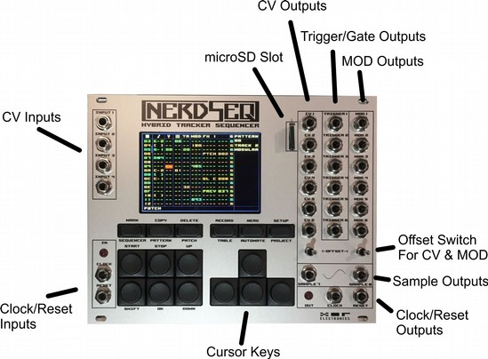
Front overview NerdSEQ (Grey/Silver Frontpanel):

Technical Specification

Power consumption:
- ~150mA with the 3.5” display (all models after 2018), ~190mA/+12Volt rail (old 3.2”display)
- ~32mA on the -12 Volt rail
- +5 Volt rail is not connected

Hardware overview:
- Grey / Silver, Black or combined Grey/Black Frontpanel
- Colour Graphics IPS wide angle display with a resolution of 480 x 320 pixels
- 10 full size and 6 half size buttons
- 28 mini-Jack (mono), 4 CV Inputs (range 0..10 Volt) , Clock+Reset Inputs(5 Volt), 12 CV outputs (Range -5 Volt /+5 Volt or 0 Volt / +10 Volt), 6 Trigger/Gate Outputs (5 Volt),
2 Audio outputs (-5 Volt/+5 Volt, AC coupled), Clock + Reset Output (5 Volt)
- 2 toggle switches to change the offset of the CV voltages
- 2 LEDs to indicate clocks
- microSD connector accessible on frontpanel
- 10 pin boxed bus connector (power)
- Expander connector (12 pin boxed) for Midi Expander Modules
- Expander connector (14 pin boxed) for special NerdSEQ extensions. (NSA)

Firmware Features
- Tracker style sequencer
- 8 Tracker tracks can be controlled independently, synchronised and not synchronised
- Polyphonic sequencing per track
- 254 Sequencer rows
- 175 Patterns with each 64 (and less) Steps
- 144 Patches
- 32 Tables with 16 (and less) steps
- As many Projects as the SD card can hold
- CV outputs can generate 1V/Oct, 1.2V/Oct and Volt/Hz octave ranges
- ‘Endless’ Pattern chaining
- Euclidean input for Rhythm composing
- Drummatrix with up to 16 drum-trigger points at the same time per track
- Probability (0..100% with 1% resolution) for a sequencer row or for dedicated functions: CV, Mod, Trigger/Gate, Tables, Samples and FX (which can contain every feature)
- Patterns with Note Scaled input, Patch selection, Trigger/Gate w retrigger, delayed triggers etc, CV Modulation manipulation, Groove, Fine pitch, Glide, Glide quantisation, Table selection...
- Multiple direct FX possibilities per pattern per step
- Groove per step per pattern to create different step lengths, shuffle and weird rhythmic with the possibility to create poly-rhythmic tracks
- Patches with all wanted functions directly accessible
- Tables (sequencer in the sequencer) for Transpose, scaling and all possible functions, different speed/note scales and sources, synchronised and not synchronised to the main sequencer clock, randomisation functions
- 8 Automation slots to assign different automations (like LFO, Envelopes, Noise, Randomness..etc) freely connect to internal and external parameters via a modulation matrix
- 8 ADSR Envelopes with rich setup, source and destination functionality
- Project management
- Sample management
- Clock Source can be Internal, 1/16 via Clock input, 24ppqn, Midi Clock, DinSync
- Clock Outputs can be 1/16, DIN-Sync , Midi Clock
- Track dividers / multipliers (/32,/16,/8, /7,/6,/5,/4,/3,/2, *2,*3,*4,*5,*6,*7,*8)
- All Modular tracks can be manipulated from other tracks
- Multiple Playback types per track (forward, backward, pingpong, random, snake, spiral, even, odd and more...)
- Advanced Ratcheting settings
- Trigger functions with different timings for ON/OFF, OFF/ON (delayed gate), Retriggering
- Gate length can be as short or long as needed (much shorter than step length possible)
- advanced Mark + Copy + Paste functions to copy marked parts within or between patterns
- 2x2 sample parts for each 2 sample/oscillator/synthesizer outputs (mono)
- 12 Sample slots
- 180kB Sample memory (4 seconds with 44.1 kHz/8 Bit/Mono or more with lower samplerate)
- Sample support for RAW 8 bit mono and WAV 8/16 bit, Mono/Stereo
- Sample/Wave/Synth pitch in note scale
- Audio effects like Volume, Fine Pitch, Retrigger, Backwards, Bitcrush, Distortion, Offset, Wavefolder, Audio Delay...
- Waveform oscillator generates multiple waveforms on the audio outputs.
- 4 Operator FM synthesis between waveforms with dedicated FM synth functions
- Flexible Live player to switch between different patterns (clips) on different tracks.
- Live mode to trigger, mute, solo patterns
- Live editing while playing including pattern creation, manipulation, recording, nearly all functions accessible while playing
- pattern cloning
- patch cloning
- free record routing for CV and Midi input
- free routing of CV inputs to different functions
- Midi sequencing and recording including 4x polyphonic Notes per track, Velocity, CC, Pitchbend, Program Change, Channel and Polyphonic Aftertouch, NRPN and more
- Expander support to get up to 64 more outputs and/or extra functionality
- Video Expander to get the NerdSEQ screen onto a Monitor/TV/Beamer
- Video Synthesis with the use of shaders (with Video Expander)
- Advanced note scaling with many scale presets and user scales
- Modulation Matrix, Mapping where all features can be modulated to each other
- Mapping allows also for scripting and algorithmic creations
…. and many more features.

Basic Overview

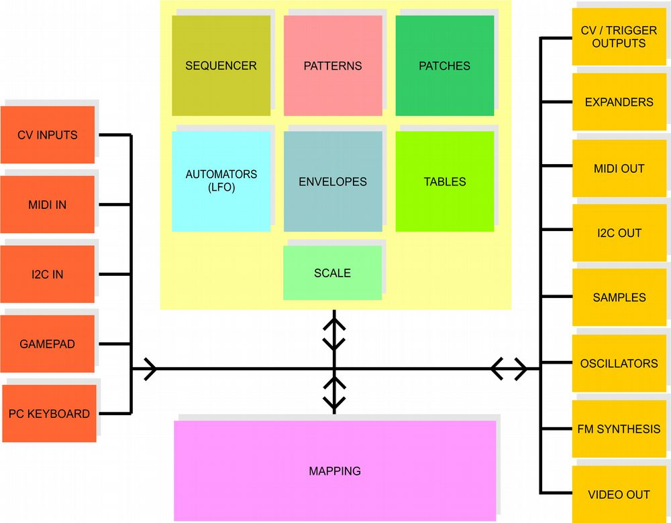

The upper sketch shows a basic relation between the several function blocks of the NerdSEQ.
Note that several functions can manipulate each other as well which helps to create complex sequences. In the most basic way, the sequencer selects a pattern to play on a track. This pattern sequences the notes/triggers etc. into one of it’s destinations (eg CV/Gate outputs or Samples…).
On top of that these sequences can be for example further manipulated by the Automators or the Tables. Some functions can also be routed to outputs without the use of any sequence. For example, an envelope can be routed directly to a CV/MOD output. The envelope itself can then again be triggered/gated by a sequence, a table, CV inputs or other sources. On top of it the Mappings block can access and manipulate all of the blocks in all directions. In the easiest way one would maybe map a midi CC to a CV output..up to complex algorithmic processing with multiple blocks.

Getting Started

To get started, insert the SD Card, connect the power cable properly. Take care that the red line is connected to the -12 Volt Rail on the power-bus.
First there will be a splash screen followed by the current Firmware version number.
After that the system is checking if any NSA (Nerd Sound Adapter) are connected.
With connected NSA expanders it will show the type of the expanders and the Firmware version of the expanders as well. Channels that are not connected are shown as ‘Not Found’.
The Midi-IO and the TRS-A Midi expander are not being detected but just work.
The Multi-IO need to be enabled in the → Setup Screen once and will be detected from then on, showing it’s Firmware version numbers.

The same for the Video Expander. You got to enable it in the → Setup Screen (clone mode) and then it will show up as the 4th NSA and detected (needs Video Expander Firmware V3.0 or higher).

Then the SD card is being checked if it is correctly initialised.

The startup sequence is now ready and an empty sequencer screen will show up, waiting for you to get started!

Attention, if the Splash screen the text or the background light appears to be weird somehow, then it is a good indication that there is something wrong with the power. (For example, not enough power -> Voltages are too low / not enough current). Check your supply, disconnect some other modules to be sure your supply has enough power. (And be sure the NerdSEQ is working properly)

Next there will be a guide through some basics, related to values which you can find back in most trackers followed by some basic information about Trackers and the navigation with the NerdSEQ.

Numbers, Values and Tracker basics
The history of trackers goes back to the late 80’s when some people developed a new way of creating music by inserting music scores in a different way. It is mostly recognized by people as a way to program music instead of composing, because of the input of the music data. This is actually not really the case, once you know some of the basics it is composing all the way!
Trackers are often used to play samples (in a note scale) on different tracks as well as to control the sound chips of old home computers directly. The workflow is different from other score based or maybe piano roll based sequencing.
With most of the trackers the workflow goes from up to down, the sequencing running from the top to the bottom. There you will find different columns and rows. Each row shows a step in the sequence and the main columns are dedicated to the tracks and subcolumns to different commands. Each track consists mostly of the same kind of sub columns. (Modern trackers allow different kind of tracks and sub-columns). Getting to the subcolumns there is often a subcolumn for the music note, one for the volume and sometimes one for a special command. Sometimes there are additional columns, depending on what tracker it is. Music notes are mostly filled in with their real note, followed by the octave. For example:
“C-3” means Note C on octave 3.
“F-5” means Note F on octave 5.
“D#2” is the note D sharp on octave 2 (half tone higher than D-2)
The NerdSEQ allows also to display ‘Flat’ note values on demand (and selectable per track). Instead of a “D#2’ the same note would be displayed as a ‘Eb2’.
The exact look of the notes can differ between the trackers. With the NerdSEQ the notes are filled in like in the example.
Other values of the subcolumns like the volume are often shown as a hexadecimal numerical value.
I will explain only the very basics of it. Refer to the footnotes for detailed information.

We count and calculate usually in a base 10 system, we count like this: 0,1,2,3,4,5,6,7,8,9,10,11,12,13,14,15,16,17,18…….On every 10th number (10 overflow) the left digit increases. On every 100th number the left and the second left digit increases..etc.
In a hexadecimal system the base is 16 and so with every 16th number the left digit will increase. The numbers itself are also represented differently. A hexadecimal count goes like this:
0,1,2,3,4,5,6,7,8,9,A,B,C,D,E,F,10,11,12,13,14,15,16,17,18,19,1A,1B…….
So instead of getting to the 10, letters are used to show the hexadecimal values until the 16th number which will create the overflow for the digit on the left.

The decimal compared to the hexadecimal will show you the corresponding numbers:

Dec | Hex |  | Dec | Hex |  | Dec | Hex
0 | 0 |  | 16 | 10 |  | 32 | 20
1 | 1 |  | 17 | 11 |  | 33 | 21
2 | 2 |  | 18 | 12 |  | 34 | 22
3 | 3 |  | 19 | 13 |  | 35 | 23
4 | 4 |  | 20 | 14 |  | 36 | 24
5 | 5 |  | 21 | 15 |  | 37 | 25
6 | 6 |  | 22 | 16 |  | 38 | 26
7 | 7 |  | 23 | 17 |  | 39 | 27
8 | 8 |  | 24 | 18 |  | 40 | 28
9 | 9 |  | 25 | 19 |  | 41 | 29
10 | A |  | 26 | 1A |  | 42 | 2A
11 | B |  | 27 | 1B |  | 43 | 2B
12 | C |  | 28 | 1C |  | 44 | 2C
13 | D |  | 29 | 1D |  | 45 | 2D
14 | E |  | 30 | 1E |  | 46 | 2E
15 | F |  | 31 | 1F |  | 47 | 2F

So in a hexadecimal system the number after 9F goes to A0 and after a FF to 100.
The NerdSEQ uses also the hexadecimal system to show most of the values.
Furthermore, some trackers can show all content on one screen while some have to scroll to get to other content and some have to switch to a different screen to get to the other content.
As the NerdSEQ only has a small display, the information is split logically into different screens.
I will explain those later.
There is much more about trackers, check the links for more information. I would also suggest to check some tutorials about ‘LittleSoundDJ’ as it is the most similar to the tracker of the NerdSEQ.
Though there are some major differences, it gives a clue about how to work with dedicated screens.

Buttons and Navigation
To navigate, change to other screens, edit values and more you use the Buttons.
On the top line there are 6 ‘half’ buttons which are used to switch to other screens:

- SEQUENCER → For the main sequencing and pattern arrangement, song structure etc.
- PATTERN → The pattern data where all the notes, gates and effects are.
- PATCH → Is for either the stored patches (macros), the current values of the recent track or the track setup.
- TABLE → Tables are like a sequencer in the sequencer which can run synchronised or independent from the main sequence. It is able to manipulate the main sequence in multiple ways.
- AUTOMATE → Automators / Modulators which can manipulate many parameters through LFO’s etc. With this button a 2nd screen for the envelopes can also be accessed. (pressing the Automator button toggles between the Automator or the envelope screen)
- PROJECT → For all project related settings. Toggles also with the Video Expander Project screen if a Video Expander with at least Firmware V3.0 is installed.

Good to know, before you can enter the Pattern, Table or Patch screens at least one Pattern, Table or Patch must be created.

The same buttons got also a 2nd function which can be reached by pressing the SHIFT key together (followed) by the other keys. Those are:
MARK - To start the marking of content on the screens. Press again to copy the marked values to the clipboard.
COPY – Copy earlier marked (or cut) content into the new position (also to copy marked values into the clipboard)
DELETE – Delete current value or marked content (acts also as a cut function for marked values)
RECORD – to start/stop recording
NERD – use for different functions (like a context menu) (Pressing SHIFT+NERD twice will bring you in most cases to the Mapping screen)
SETUP – Enter the Setup screen for non-project related general settings

Further there are the buttons on the bottom left:
START – Start sequencer or trigger/cue a pattern
STOP – Stop a pattern (stop the sequencer in combination with SHIFT). If the sequencer is stopped, then SHIFT+STOP executes a ‘Stop All Sounds’ function where all Gates are reset, all Notes stopped and a Reset signal generated if the clock output is a regular modular clock.
Also for the audio tracks, pressing the stop button on one of these while this track is stopped will also stop all sound for this track.
For the stop sequencer function (SHIFT+STOP) a security function is available which forces you to press STOP a second time while holding the SHIFT button. In that case a notification will appear on the screen and you can avoid the sequencer stop if the buttons were pressed unintended.
This feature can be enabled/disabled in the → Setup Screen
SHIFT - Get to the 2nd function of buttons or edit functionality
UP – Page up for 16 steps → move the cursor 16 rows up
DOWN – Page down for 16 steps → move the cursor 16 rows down

Lastly, the cursor keys are on the right.
Note that there are also some other combinations of the keys in different screens which will be explained later on.

For simple navigation you use the cursor keys:
Cursor up/down/left/right for simple navigation and scrolling
In most screens you can move your cursor and navigate like this. For example, in the sequencer screen you change the Row by using cursor up/down and change the Track/Column by using cursor left/right.
Using the cursor keys combined with the Shift key allows mostly some editing, as here explained for the pattern screen:
SHIFT + CURSOR LEFT -> Decrease (-) value by 1 (value or semitone for notes)
SHIFT + CURSOR RIGHT -> Increase (+) value by 1 (value or semitone for notes)
SHIFT + DOWN/UP -> Decrease/Increase value by:
- 1 octave for notes
- 16 ($10) for regular values which can be < FF (255)
64 ($40) for values which can be > FF (255)
- 10 for FX types
- Depending on the types, other values are possible

So changing values is always in the smallest step by using SHIFT+CURSOR LEFT/RIGHT and in bigger steps by using SHIFT+CURSOR UP/DOWN
Additionally, if the Editsteps are enabled (Setup Screen):
The cursor will automatically move down by the amount of edit steps if inserted by using SHIFT + CURSOR UP on an empty field in the Pattern Screen.

With SHIFT + DELETE you can delete/empty values
The button OK is mostly used to create new Patterns or Patches and to enter or agree/start a menu option

SHIFT+MARK starts the ‘Mark-Mode’ within the Pattern or Sequencer screen. In the mark-mode you can select a block using the navigation buttons (navigating with SHIFT changes the start-point and without SHIFT the endpoint of the block). Press SHIFT+MARK again to exit the mark-mode and copy the marked values to the clipboard. They are more functions with the mark-mode or MARK-Button which are related to other functionality and described in their specific part of the manual.

Mute/Unmute track: Using the shortcut SHIFT+DOWN+START mutes or unmutes the current track if in the Sequencer or Pattern screen. Mute does release the gate and keeps the CV voltage, but won’t play anything else on the muted track until it is unmuted. It will sequence through though while muted and the Break command is still working. So for example 16 step patterns will stay 16 step even if muted.
Solo/Unsolo track: Using SHIFT + UP + START solos the current track. That means all tracks will be muted and the current track unmuted if needed. Unsoloing will unmute all tracks. Also, unmuting other tracks or muting the solo track will release the solo function.
For fast unmuting all tracks you can press SHIFT + UP + START for the solo function twice and all tracks are unmuted directly.
Note the same Mute/Solo functions can be used with the drummatrix of a I2C/Multi track or the trigger16 expander.
While in the → Pattern screen you can hold the PATTERN button and use the cursor keys to navigate between patterns (in the order of the sequencer arrangement)
While in the → Table screen you can hold the TABLE button and use the cursor Up and down keys to navigate between the tables.

General Screen information

As mentioned before the main workflow is split into different screens.
The main screen is the Sequencer screen which shows basically your track arrangements with the patterns. From there you sequence the patterns. You can sequence each of the 176 patterns from each track if they are from the same type (patterns can be different depending on the tracktype. For example a Modular track got its strength in sequencing the CV/Gate outputs and their modulations while a Midi track is specialised in polyphonic Midi sequencing. They are 8 different pattern/track types with each their own sequencing benefits:
Modular, Audio, Midi, Trigger16, CV16, Dualchord, I2C/Multifunctional, Video.
Each pattern got it’s own Pattern screen where you can find the note values, FX and much more... aka the main sequencing. Patterns can also execute patches (like macros) or tables (sequencer in the sequencer) on each step. These also got own Patch and Table screens to set them up. They are in total 144 patches and 32 tables available.
A pattern is locked to its tracktype and can be re-used on other tracks of the same type but not on other tracks with a different tracktype. The editor prevents the selection of ‘unallowed’ patterns on a track. Tables and Patches are also related to the tracktype and the execution will be ignored (or limited) on other tracktypes.
Each tracktype got its own track-setup screen to be able to setup the track specific functions.
There is also a screen to show and change the basic current values of a track manually.
A context menu called the Nerd Menu can be opened on many places to fast execute or change different functions/values.
The Project screen got project related settings. There you can load/save your projects, change some of the global settings like global transpose or the project BPM. It got also entry points to other project related screens like the Scale screen for all your quantisation needs, Track assign screen, midi routing with the Midi Setup / I2C Screen or clock input/output settings. They are more...The settings in the Project screen are loaded and saved with the project.
The Setup screen got the main editor, functionality and hardware related settings that you usually change only once or at least not often. There you can also calibrate or update the expander firmwares. The settings are automatically stored into the hardware and survive a power-off.
The Automator screen is one of the side-screens for modulations and it contains LFOs and other modulation sources as well as a basic modulation matrix from which you can manipulate many track related destinations with the LFO / Envelope (automator/modulator) results.
Talking about envelopes they are also 8 ADSR envelopes which can be accessed in the Envelope Screen.
Another major command-center are the mappings which can be set up in the Mapping Screen. There you can combine all kind of internal and external parameters and either just connect them in a mod-matrix style or add some algorithmic manipulation up to generative things/manipulations.

Generally even though they are many screens and some menus, you are mostly busy on the Sequencer or the Pattern screen. Important screens are also mostly accessible via just one button or a double button press.

Sequencer Screen

The sequencer screen is the main screen which shows mainly the pattern arrangement and all tracks in one screen. You get to the Sequencer screen by pressing the SEQUENCER button.
In the sequencer screen you have different Rows and Columns. For the Columns there are 2 types. One for the indication of the row, and the others are the actual Tracks of the sequencer.
Each track is dedicated to one output channel -> Track 1 for CV1, Trigger1 and MOD1
With the NerdSEQ, by default, there are 6 CV/TRIGGER/MOD tracks and 2 Audio tracks (with each audio track being able to play 2 samples or waveforms simultaneously, so 4 samples/waveforms in total at any one time).
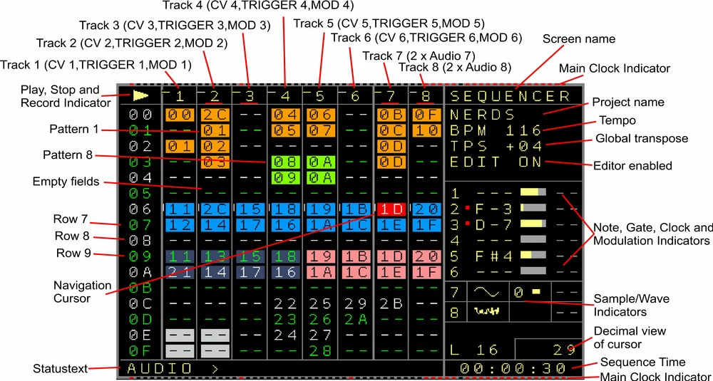Figure 1: Sequencer Screen

The sequencer screen is for the general sequencing of the patterns. From here islands or chains of patterns are combined to build up loops or songs. The first column show the row numbers. Those go from 00 to FE (254 rows). The screen scrolls down on navigation. You can always see 16 rows in the sequencer screen. The next 8 columns show the available tracks. Some are empty ( to be recognized by a ‘--’. And some patterns are filled in. So for example on Track 1, the first row shows a 00 which means that Pattern 00 is being set to this spot. The other numbers relate to different patterns. You also see that Pattern 00 is filled in in both Track 1 and Track 2. That’s possible because those tracks are from the same type. More of the same pattern number below each other would play the same pattern multiple times.
Another possibility is the ‘**’ in a sequencer field which represents a function to stop a track.
This can either be used in a sequence so when the player reaches the ‘**’ it will stop the track (not the sequencer). Starting a ‘**’ manually will stop the track. This can be used to start only several tracks/patterns in a row or to stop multiple tracks.

You navigate in the Sequencer Screen with the Cursor keys. Depending on whether ‘Navigation Wrap’ is enabled the cursor will wrap back to the begin from the most right position, or not.
You can start playing a row by pressing start. The selected pattern, or the first (top) assigned pattern will start to play. So only one track starts to play. If you want to start the whole row, press SHIFT+ START.
SHIFT+ STOP stops the player. Initiates a reset pulse on the reset outputs and resets all gates. (And if enabled in the settings, resets all Effect Values).
While playing, pressing start on another selected pattern will trigger the pattern to play after the last pattern of the same column finished it’s sequence (Normal Launch Mode) or on a zero cross of the mainclock (Sync Launch Mode). Pressing START two times, will trigger the next pattern faster, after an amount of steps, set up by the Project setting ‘Live Cue-points’, derived from the main clock steps. You can see the next point of the starting point on the top and bottom Main Clock Indicator.
STOP, stops the pattern after it’s finished and no other pattern on this track is being played after that. STOP twice finishes the pattern play immediately on this track.
Also if STOP is being pressed when the sequencer is not running, a note off is sent to all midi devices as a new reset-pulse Is being generated on the reset output.
SHIFT + START while the player is playing triggers the whole row to be played next.
Chained patterns (next under each other) are automatically chained and play after each other and from the chain begin again once the chain ends.
You can also Mark multiple tracks pressing SHIFT+MARK and when pressing either the START or STOP button the selection will start or stop the tracks in the same launch way. (start will use the first marked row).

You can create a new pattern by pressing the OK Button on an empty field. The created pattern gets a new pattern-number and the new pattern itself will be empty. If you press OK on a filled in sequencer field, you either enter the filled in pattern or nothing happens, depending on the setting. You can clone a pattern by pressing SHIFT+OK when with the cursor on a pattern number. The content of the pattern will then be completely cloned into a new pattern. SHIFT+DOWN+OK does also clone the current pattern into a new pattern but the new pattern and the cursor will be placed in the row below (If there is any content in that row below it will be overwritten by the cloned pattern number).
If you are in mark mode (SHIFT+MARK) and press SHIFT+OK, then it will clone the complete marked area (as long as they are free patterns available, you can free up unused patterns using the Compact sequencer function in the → Setup Screen).

If you want to re-use a used pattern you got to use SHIFT + CURSOR RIGHT for it and browse to the wanted pattern number via SHIFT + CURSOR LEFT/RIGHT.
To enter a Pattern, move the cursor to the desired pattern slot and press either the PATTERN button or the OK button (if that is enabled in the Setup). → More info about that in the ‘Pattern Screen’ section.

Every Sequencer Screen position can have it’s own color. The idea is to be able to recognize patterns or blocks faster. The colors can be applied in the Nerd Screen for either one position or a marked block.

Additionally, if ‘Edit Mode’ is disabled, a special live play function allows to jump directly to the same step on another selected pattern. By pressing the OK button (or SHIFT+OK for the whole row) the sequencer will jump directly to the pattern that the cursor points to. Be aware that the sequencer will still jump to the pattern that was supposed to play next after the ‘direct-jump’ pattern/s has been finished.

On the right you see the Project Name, the Tempo, the current Global Transpose and if the editor is enabled. The editor can be disabled, so no unwanted pattern changing or manipulation can happen while for example playing live (as in triggering patterns live) or giving a demonstration. Right in the middle, there are indicators for the recent played music notes, the gate/trigger state and the modulation state for the 6 CV/Gate tracks. They are also additional indicators if a track uses a different clock (multiplicator/divider or track decoupled from the Clock (EX)) or if another than the default playback order is playing on a track (numbers highlighed). Below are the 4 audio tracks which indicate the recently playing samples or waveforms followed by the decimal view of several values (if enabled). Left from it the pattern length of a selected pattern (cursor on a pattern) is shown.
On the Bottom, you can see a Status text, mostly filled with some useful information. Here is shown mostly what kind of type the recent Track is. When a pattern name is filled in, it shows the name when navigating over it.
On the bottom right you can see the time from starting playing.

Copy, Delete in the Sequencer Screen
There are facilities to copy or delete sequencer content. For that there are the 3 Buttons Mark, Copy and Delete.
Mark is used to mark an area which should be copied or deleted, Copy to copy/insert a previously marked area to another row/column and Delete to empty or delete the marked area (or to delete/empty the recent cursor position).

To Copy a block:
Press SHIFT+MARK on the begin position which should be copied (Screen border colour should change to indicate the Mark mode)
Move the cursor to the end position of the desired area. The start position of the mark can be changed when holding the SHIFT button when navigating.
Press SHIFT+MARK again (or SHIFT+COPY). Mark mode is released again, the marked block is being saved into the clipboard.
Now go to the Destination position with the Cursor.
there are 2 possibilities to copy.
1 Press SHIFT+COPY and the before saved block is being copied to the recent position. (Overwrites content of the Block)
2 Press SHIFT+DOWN (Not cursor down)+COPY and the before saved block is being inserted to the recent position. The involved rows will move down behind the copied/inserted area.
Be aware that when copying onto an incompatible Track Type (eg copying a modular synth track to a audio track) the destination will not be copied and will stay untouched. This to avoid problems caused by track incompatibilities.

To delete:
To delete/empty only the current cursor position press SHIFT+DELETE to empty the recent position or SHIFT+UP+DELETE to really delete the position in the column and move the following rows one up.
With SHIFT+DOWN+DELETE an empty spot is generated and the column is shifting one row down.
To delete a block:
Press SHIFT+MARK on the begin position which should be emptied/deleted (Screen border colour changes to indicate the Mark mode)
Move the cursor to the end position of the desired area.
You can choose between Emptying or Deleting the marked block
1 Emptying: Press SHIFT+DELETE to empty the marked block.
2 Deleting: Press SHIFT+UP+DELETE to delete the marked block. All rows beneath the marked block will move up and fill the deleted space.
Delete marked values will also copy the marked block into the clipboard so the delete function can also be used for a cut + paste function.
Keep in mind that deleted patterns are still available and filled with content. To completely delete a pattern and free it's space again, you would need to use the Compact commands in the → Setup Screen.

Tracks / Patterns

Each of the 8 possible tracks (technically the 8 columns in the sequencer screen) can be dedicated to sequence specific destinations. You would for example use a Midi track-type to be able to create (polyphonic) Midi sequences, while you would use a Modular track-type for dedicated CV and Gate sequence purposes. Each tracktype is specialized to emphasise the possibilities of the selected destinations. The possible destinations per track are:
- CV/Gate (Modular track) which got dedicated functions for the local CV and Gate outputs.
- Samples / Oscillators / FM Synth (Audio track) got features to play samples or waveforms or to build a FM Synthesizer
- Midi (Midi track) got it’s strength in polyphonic Midi sequencing and Midi effects, controllers etc. You need the → Midi Expander (they are 3 different types) to be able to do Midi sequencing.
- Trigger16 is a special tracktype for the → More Triggers 16 expander and it got special trigger columns and a drummatrix to trigger up to 16 different drums / triggers per track
- CV16 for the → CV16 expander got 16 more CV outputs that can be sequenced or manipulated in a polyphonic way as well as own envelopes and lfos
- Dualchord for the → Dualchord expander which got dedicated columns and commands to sequence up to 8 time paraphonic waveforms of the Dualchord multi-oscillator.
- Multi/I2C which is a combination of different destination types. As the name already shows it does allow all the possible I2C sequencing but far beyond that it can be used for many different purposes including most of the other tracktype destination (eg CV, Midi, Triggers…). It got also a drummatrix just like a Trigger16 track but here each of the drummatrix columns can be assigned to either trigger outputs, Midi, I2C and more.
- Video for the → More Video-IO expander which got all functionality for advanced video synthesis.

By default the tracks 1 to 6 are set up as Modular tracks and tracks 7 and 8 are set up as audio tracks. To change the assignment you use the Track Assign screen which you can access from the Project Screen ( Project Screen → Track Assign Screen ).

Track Assign Screen

In the track assign screen you can assign the different track types such as CV/Gate, Midi or Trigger16 to one of the tracks. You can enter the track assign screen from the project screen.
PROJECT SCREEN → TRACK ASSIGN
It shows 8 rows which belong to the 8 tracks. The types of the tracks can be changed by using SHIFT+ CURSOR LEFT/RIGHT. This allows you to choose between the Modular tracktype (Only for Tracks 1..6), NSA1,2,3,4 → and if there are expanders connected, then it shows the recognised expander type (Trigger16, CV16, Dualchord, Video) together with the NSA Channel number, Midi and as last I2C/Multi. Tracks 7+8 doesn’t allow you to choose a modular track but instead you can select these to be audio tracks (samples, oscillators, FM Synth) or the NSA, Midi or I2C tracktypes.
Good to know: One NSA expander can also be assigned to multiple tracks.
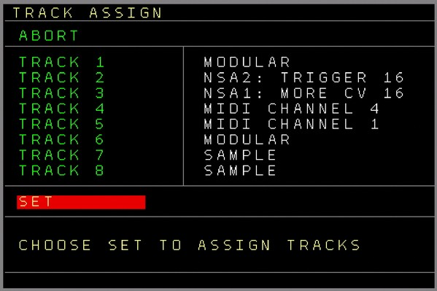
Figure 2: Track Assign Screen
If you are ready with the assignment then you choose SET, press OK and the tracks will be assigned.
Be aware that if there were already any patterns on a track on the sequencer screen and the new assignment is of a different track type, then the patterns will be removed from that track and from the Automator destinations. Also the undo data and the clipboard are emptied. The patterns are not deleted, so you could still use them on another compatible track. A ‘sequencer compact’ will delete these if they are unused patterns. If you want to keep the patterns or some content, you might need to copy (or export) them first in order to preserve your data.
If a track is or was assigned already then you can also enter the track setup screen of the track here by using the OK button.

Track Setup Screen
Here you can change the track and track type specific settings. Some settings are common to all tracks (e.g. Track Clock, Pattern Order etc..) and some are specific to the track type (e.g. Column Destinations, Oscillator settings etc).
You can enter the track setup screen in the following ways:
- via the → Nerd Screen / Menu on the sequencer screen
- via → Track Assign Screen (press the OK button on one of the already assigned tracks)
- by pressing the PATCH button while in the → Current Values Screen (pressing PATCH twice from the → Sequencer Screen or in most parts of the pattern screen gets you to the Track Setup screen).

The track type specific settings are explained as a sub-set of the pattern screen explanations.

These are the common settings which are available for all tracktypes:

- Track Clock → Change clock dividers or multipliers of the track. If the player is playing then the change applies at the end of the pattern. If it is not playing, the change is applied directly. Change using SHIFT+CURSOR LEFT/RIGHT
The Track Clock can be set to the following Multiplies/Dividers: /7,/6,/5,/3,/32,/16,/8,/4,/2,Normal, *2,*4,*8,*3,*5,*6,*7
The lowest setting called Mapping will decouple a Track from the Mainclock and the track clocks/ticks can be fed from a Mapping Destination ( TRACK → Track X → TICK ). Here you can feed the track manually with ticks from any source like the CV inputs, Midi/I2C or any parameter from the NerdSEQ. Every Mapping source can be a source for the ticks. Check the → Mapping Screen for the possibilities.
- Transpose → Allow or avoid the transposing of the track. This is for the global- and the track transpose.
- Scale → Set either to the global scaling (define the global scale in the → Scale Screen / Settings or you can select to avoid the scaling so any scale setting got no effect on the tracks playback/edit. It is also possible to select one of the 89 different scalings/user scale just for the track.
- Trigger Delay → Delays the Trigger on the local Trigger output with a fixed or a random time (compared to the CV change of the track). Depending on the setting Setup Screen→Trigger Delay reach this applies only to the trigger column or to all generated triggers.
This is useful for modules which don’t sample the CV voltage correctly after the raising edge of the trigger. A value of 0 means that the triggers have no delay.
After the highest delaytime (of 16.9ms), 16 random ranges can also be chosen as a variable trigger delay time. Use these to achieve a humanization effect. (Press OK on one of the random ranges to enter the → Random Ranges Screen and change the range).
This setting is only functional on tracks 1..6.
- Trigger Setting → Either Normal or Inverted. when Normal is selected the Triggers Gate behave normal (Off = 0 Volt, On = 5 Volt). If Inverted is selected, the Trigger/Gate output is inverted → Off = 5 Volt, On = 0 Volt.
This setting is only functional on tracks 1..6.
- Voltage Setting → Defines the type of voltage output:
- 1V/Oct
- 1.2V/Oct (Buchla scaling)
- Hz/Volt (old analogue synth scaling)
Be aware that the 1.2V/Oct and Hz/Volt scales are only tested theoretically by measuring but not with real hardware. (It is reported to work though) Also it is possible that you need other Trigger levels than those which the NerdSEQ produces. For this you would have to convert the normal trigger out levels using inverters, amplifiers and by changing the offset.
This setting is only functional on tracks 1..6.
- Random FX1..4 → Enables randomized values for the selected FX. If turned on and a range selected, all FX values in the selected FX will play with random values within the selected ranges. This can be also enabled/disabled with the Random FX command (RDMN) from the FX list. Press OK to get to the → Random Ranges Screen and change the ranges.
Note that some tracktypes got only 2 or 3 FX columns and so also only 2 or 3 Random FX settings.

Basic Pattern Screen and editing functions

The following general pattern functions are valid for all pattern types.
- Navigate with the cursor keys to left/right for the columns and up/down for the rows
- If ‘Navigation Wrap’ is enabled in the settings, then the cursor will jump back to the top when the end is reached below, the same applies if the cursor reached the most right position it will go back to the most left position, and vice versa.
- START starts or cues the current pattern
- SHIFT+START starts or cues the whole row of the sequencer screen (if you entered the pattern screen on the 2nd row of the sequencer screen, then the 2nd row is affected)
- Using the Nerd Menu (SHIFT+NERD), you can also name a pattern.
- In the setup menu you can change the highlighting period (e.g. every 4th row is highlighted)

- Extra editing features if not marked:
Remove the current row and shift everything below the row one up: SHIFT+UP+DELETE
Insert an empty row and shift everything below the current row one down: SHIFT+DOWN+DELETE

- You can browse between different patterns by holding the PATTERN button and using the cursor keys. This will navigate between the patterns as they are arranged on the → Sequencer Screen.
PATTERN + CURSOR LEFT/RIGHT will browse through the sequencer row/tracks and select any available pattern there to be edited directly. And PATTERN + CURSOR UP/DOWN will browse through the patterns on the same track as they are lined up in the sequencer screen.

- If on a FX command, you can open the FX Selector by pressing the OK button.
A menu appears with a selection of all possible ‘effects’ for this track type. You select an effect with the OK button and it will be filled in into the FX command column.

- There are several facilities to copy, delete or manipulate pattern content. For that there are the 3 Buttons MARK, COPY and DELETE. (use these alternate Button functions while the SHIFT button is pressed)
MARK to mark an area which should be copied, manipulated or deleted (use SHIFT+DOWN to mark all), COPY to copy/insert a before copied area to another row/column and DELETE to empty or delete the marked area (or to delete/empty the recent cursor position). A delete will also copy the deleted values to the clipboard, so it is possible to use it as a Cut + Paste function.
To Copy a block:
Press SHIFT+MARK on the first position which should be copied (Screen border colour should change to indicate the Mark mode)
Move the cursor to the last position of the desired area ( Press SHIFT+DOWN to mark all )
The start position of the mark can be changed when holding the SHIFT button when navigating.
Press SHIFT+MARK (or SHIFT+COPY) again. Mark mode is released again, the marked block is being saved into the clipboard.
Now go to the Destination position with the Cursor.
there are 2 possibilities to copy.
1st Press SHIFT+COPY and the before saved block is being copied to the current position. (Overwrites content of the Block)
2nd Press SHIFT+DOWN (Not cursor down)+COPY and the before saved block is being inserted to the current position. The involved rows will move down behind the copied/inserted area.
You can also copy in between different patterns and from/to compatible column types (eg from notes to notes...)
To delete:
To delete/empty only the current cursor position press SHIFT+DELETE to empty the current position or SHIFT+UP+DELETE to really delete the position and move the following rows one up.
To delete a block:
Press SHIFT+MARK on the begin position which should be emptied/deleted (Screen border colour should change to indicate the Mark mode)
Move the cursor to the end position of the desired area.
You can choose between Emptying or Deleting the marked block
1 Emptying: Press SHIFT+DELETE to empty the marked block.
2 Deleting: Press SHIFT+UP+DELETE to delete the marked block. All rows beneath the marked block will move up and fill the deleted space.
Delete marked values will also copy the marked block into the clipboard so the delete function can also be used for a cut + paste function.

Copy and paste actions can be made between all compatible columns, regardless of the type or where they are. Notes to Notes, Triggers to Triggers, Grooves to Grooves etc.
FX columns can only be copied to the same kind of Track type.
To copy for example a note part from a CV/Gate track to the 2nd note part of a Midi Track you mark the note part in the CV/Gate Track. And in the Midi Track you go to the 2nd note part where it should be copied and press SHIFT+COPY.
The same goes for all compatible fields. They must match also for the markings.

To empty/clear a complete pattern:
Pressing SHIFT+MARK+DELETE in an unmarked situation will remove all pattern content.

To change multiple values of a marked block:
Multiple values of a marked block can be changed at the same time. While in mark mode press SHIFT+OK+CURSOR UP/DOWN to increase/decrease the marked values in higher steps and SHIFT+OK+CURSOR LEFT/RIGHT to increase/decrease the marked values in lower steps.
Note that this function will not work with the FX, Table and Patch columns.

To move values of a marked block to other rows:
Marked blocks can be moved up/down to different rows using the following button combo on marked values: SHIFT+OK+UP will move the block one row up. The overlapping content will move automatically to the first row below the marked block. The start position of a block can’t move ‘higher’ than pattern row 00.
SHIFT+OK+DOWN will move the block one row down. The overlapping content will move automatically to the first row higher than the marked block. The end position of a marked block can’t move lower then pattern row 63.

- Loop marked parts: Marked rows on the pattern screen can be looped by pressing the START button (while in mark mode). The marked area loops until either another part is marked and started for loop or until the start button is pressed again to release the loop mode. SHIFT+START can start the loop for all patterns on the same sequencer row.
Be aware that the mainclock keeps running normally and that looped parts are not re-synchronised automatically with the mainclock but just loop what has been marked. (re-syncing is of course always possible)

- Note columns usually set a note and can also set a note off. A note off can be set either below the lowest note, or by using the delete (SHIFT+DELETE) function. If the field is empty, then a note off will be inserted. Else the field is being cleared. This is a toggle function.
- SHIFT+OK on Note or MOD fields let the values toggle fast between some presets and the last value (for CV/GATE notes in the following ‘sequence’: [ ], C-0, C-4, C-8, RN0, ---. For a CV/Gate MOD field: 000, 800, C-0,C-4,C-8,R 0, RN 0, ---)

Modular Track
A Modular Track (also known as CV/Gate Track) is the default track to sequence the CV, MOD and Trigger/Gate outputs. Each track is basically assigned to a fixed set of CV/Gate outputs:
Track 1→ CV1, TRIGGER1, MOD1 | Track 2→ CV2, TRIGGER2, MOD2 and so on…
While the basic columns are assigned to the outputs by default, they are also many ways to sequence/manipulate all other outputs and functions from the same track as well.
A modular track can be used for tracks 1..6.

Pattern Screen

The patterns of a Modular Track got the following Columns:

Row, Note, Trigger, Mod, Patch, Table, FX1..4 and Groove
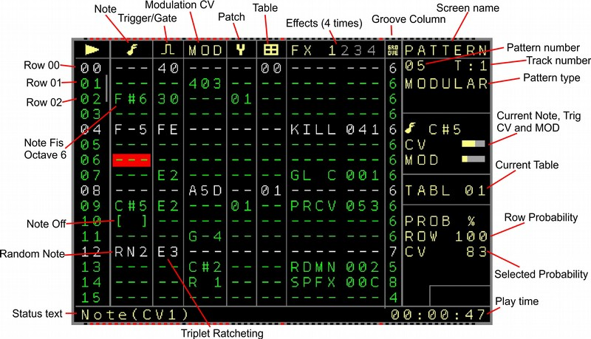
Figure 3: Pattern Screen (Modular Track)
- Row, shows the visible 16 rows and is not selectable
- Note: To enter music notes ( C-4 for Note C in octave 4; D#5 for Note ‘Dis or d-sharp’ in octave 5) [ ] is the lowest ‘note’ and it is for note off. In case the Autogate function → Setup Screen is turned on, then the Gate is ON when a note is being played and the Gate is OFF when a Note off occurs. The Gate will also automatically go to Off and On again if no note off was set but a new note is playing, this to retrigger a new note. The Off time can be set up also in the Setup Screen. If a trigger is filled in on the same row, then the auto-gate function is disabled for this row as the trigger will overrule.
You can pre-listen a note by using the OK button. (Works also in combination with SHIFT)
It is also possible to pre-listen your sequence by holding the OK button and scrolling up/down. If a note value is filled in on the same step in the MOD column, then this note will be updated as well. (Allows ‘duo-phonic’ pre-listen)
Also if the setting ‘Auto Fill in Trigger’ is enabled, then a trigger (default trigger type defined in the → Setup Screen ) is automatically inserted when inserting a note. This is to get a fast result editing feeling when live programming sequences. If ‘ Auto Remove Trigger’ is enabled then a trigger on the same row is automatically removed when a note is being deleted.
Behind Note C-A there are 16 possible random ranges to select. The selections are marked RN0 → RNF and with these a random note will play within the selected range. (Pressing the OK button on a random command will bring you to the → Random Ranges screen. There you can change the range.
Use SHIFT+OK on the note column to browse through different content:
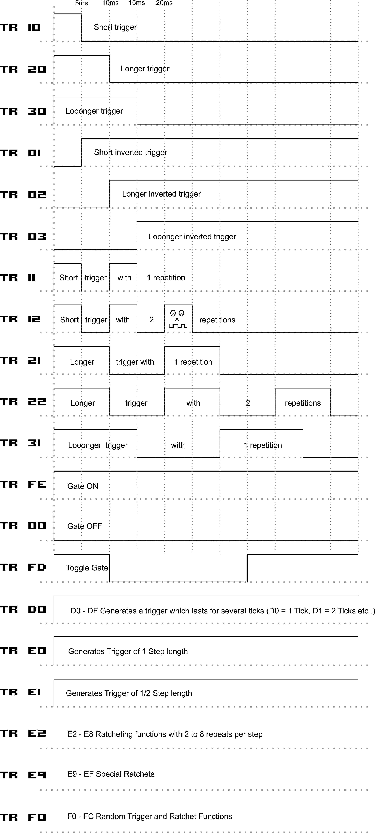
Figure 4: Trigger Functions
C-0, C-4, C-8, RN0, ---, [ ]

- Trigger, turn the trigger output on/off (repeatable). As it has multiple functions, the values in this field have several meanings:

If the 2nd digit is zero and the first has a value:
10 triggers very shortly ON/OFF (5ms)
20 triggers ON/OFF with a longer ON (10ms)
30 triggers ON/OFF with an even longer ON time (15ms)
….. up to D0

If the 1st digit is zero and the 2nd digit has a value it has a (inverted) function which results in a delayed gate:
01 triggers OFF/ON shortly (delayed gate, 5ms delay)
02 triggers OFF/ON with a longer OFF time (delayed gate, 10ms delay)
03 triggers OFF/ON with an even longer OFF time (delayed gate, 15ms delay)
….. up to 0F
Keep in mind that you might want to reset the trigger again in the new row or before by using the kill command.

If both the 1st and the 2nd digit have a value then the trigger will repeat.
The first digit is for the trigger length where again 1 is the shortest trigger and F the longest. Trigger/Pause times are equal here. The 2nd digit is for the amount of repetitions, where 1 is one repetition (2 trigger pulses) and F are 15 repetitions (16 trigger pulses).
22 triggers ON/OFF/ON/OFF/ON/OFF fast (10ms pulses)
23 triggers ON/OFF/ON/OFF/ON/OFF/ON/OFF fast (10 ms pulses)
52 triggers ON/OFF/ON/OFF slower (25ms pulses)
Furthermore there are special function numbers with which you can manipulate the trigger outputs to generate ratcheting, BPM related trigger/gate lengths or to be set or reset.

00 Turns output OFF ( = reset Gate)
D0 Trigger 1 Tick long
D1 until DF Trigger 2 to 16 ticks long
E0 One step long Gate
E1 Ratcheting 1x (Half a step Gate)
E2 Ratcheting 2x (Duplets)
E3 Ratcheting 3x (Triplets)
E4 Ratcheting 4x (Quadruplet)
E5 Ratcheting 5x (Quintuplet)
E6 Ratcheting 6x (Sextuplet)
E7 Ratcheting 7x (Septuplet)
E8 Ratcheting 8x (Octuplet)
E9 Odd ratcheting 1x (half a step gate starting with a low level)
EA Odd ratcheting 2x
EB Odd ratcheting 3x
EC Odd ratcheting 4x
ED Special Ratcheting ‘ high low low high 1001’ within one step
EE Special Ratcheting ‘low low high high high high 001111’ within one step
EF Special Ratcheting ‘high high low low high high 110011’ within one step
F0 Random trigger length within selected random range 0 (see random ranges)
F1 Random trigger length within selected random range 1
F2 Random trigger length within selected random range 2
F3 Random trigger length within selected random range 3
F4 Random ratcheting within selected random range 0
F5 Random ratcheting within selected random range 1
F6 Random ratcheting within selected random range 2
F7 Random ratcheting within selected random range 3
F8 Random trigger length / ratcheting combination within selected random range 0. Lower random percentages do triggers with several lengths and higher percentages do ratchets.
F9 Random trigger length / ratcheting combination within selected random range 1.
FA Random trigger length / ratcheting combination within selected random range 2.
FB Random Gate within the selected random range 0. This will randomly either set or reset the gate depending on the random settings. Higher percentages will more likely set the gate and lower percentages will more likely reset the gate.
FC Random everything from the trigger possibilities within the selected random range 0. This maps all trigger commands from 00 to FE to the 100% and depending on the random selection chooses one of it.
FD Toggles the output. So if it was on, then it’ll be off and the other way around
FE Turns output ON ( = set Gate)

A trigger in the trigger column overrules the auto-gating function of a note if in the same row. All trigger functions from the trigger column are shown in the statusbar as well.
Please note that the triggers on a Trigger16 Expander don’t support the special functions D0 → FC currently. These will be included with a future Trigger16 Firmware update.

Pressing OK on a trigger value will ‘fire’ the trigger.

SHIFT+OK and releasing the buttons toggles between the default trigger value, FE, 00 and ‘--’.

Pressing SHIFT+OK on a trigger with a random selection will bring you to the → Random Ranges Screen.

Another input possibility is to insert Euclidean patterns into the trigger sequences.
For that you need to use the buttons SHIFT+OK+CURSOR LEFT/RIGHT to increase or decrease the euclidean pattern amount. The Euclidean input fills with the default trigger type which is defined in the → Setup Screen. The maximum amount of inserted euclidean triggers is limited to the pattern length and all trigger types are spread equally into the sequence also based on the pattern length.
Using SHIFT+OK+CURSOR UP/DOWN the trigger column can be directly shifted either up or down while the values are wrapping around. The shifting is also applied within the pattern length.
Pressing ‘SHIFT+DELETE’ on an empty trigger column will toggle between inserting a 00 (Gate Off) or an empty trigger column.

Triggers can also have a fixed or random (within a range) delay per track. That means that a trigger in the Trigger column will always delay by x milliseconds. That to be sure all external gear can handle the Trigger together with a wanted CV signal and will not use a probably non-valid CV value. It also can be used to add a random or defined microtiming element to the gates / triggers.
More on the delay-settings in the track-setup menu.
Be aware that the trigger/gate of each output can be inverted by default. So a turned ON Gate can have 0 Volt and a turned off Gate can have +5 Volt. The Trigger/Gate inversion can be enabled in the Track Setup.

- MOD → changes the Modulation output of the track to a value 000 - FFF (range from 0 - 10 Volt or -5/+5 Volt). Furthermore, the MOD output can also Generate Note-scaled values. Behind FFF the note scaling begins from C-0 to A#9.
After that the random functions begin with R 0 to R F which generates a random pitch within the selected range. After that they are the random note functions from RN0 to RNF which also selects random notes within the selected range.
You can ‘pre-listen’ a Mod note value by pressing OK. This will change the MOD value directly to the note or value. If also a note in the note column is filled in, this will also be changed and a trigger is generated. With this a kind of ‘duophonic’ pre-listen is possible. When using the cursor keys Up/Down additionally a sequence can be pre-listened by scrolling through it.
Note: If one of the random functions is selected, then the OK button will bring you to the Random Ranges Screen.
Using the SHIFT+OK button combination the values can quickly be toggled between 000, 800, C-0, C-4, C-8, R 0, RN0 and ---.

- Patch can select a patch which is executed before a note plays. A patch is kind of a macro or a multifunction preset. It allows you to manipulate many FX functions at the same time from every step. Press OK to create a new patch. Press SHIFT + OK on a filled in patch to Clone the filled in patch into a new patch. SHIFT+DELETE will remove the patch from the pattern field. (It will not delete/erase the patch. The same patch is still aligned and can be used.) Enter the → Patch Screen with the PATCH button. More on patches in the Patch Screen description.

- Table allows to select a table to transpose notes or effects. Those have a different (or same) time scale than the normal sequencer steps and can create nice arpeggio sounds or fast or slow changing effects. (see → Table Screen to find out what tables are capable of).
A table number in the column will start the table and it can be stopped using the table stop command in the same column below table 00 showing as the two asterisks ‘**’. Tables can be entered using the table button. If a table is not initialized yet, then it will be either automatically initialized by entering the table, or you can create a new table using the OK button. Initialized tables got the normal row colour, while uninitialized tables are ‘greyed out’ (have the colour of a muted track)
Pressing SHIFT+OK on a used table position will clone the selected table into a new one.
SHIFT+DELETE will toggle between ‘--’ and ‘**’ .

- FX → the FX column allows to add or change several effects/functions for the track, the sequencer or the modulators. You would use the FX columns for example to enable a glide setting to your CV output or to change the probability setting.
Beside several effects also most of the general track functions for CV/Triggering etc can be started/manipulated within the FX as well. Some FX Effects/Functions act like a knob while others execute a function one time or change settings. If you for example choose one which acts like a knob (like glide or probabilities) then it’s setting the knob position when played from the sequencer and the knob position stays until it’s being set to another position again. Keep in mind that if you delete any FX function on any position in the patterns, its value/knob is not going to be reset to its initial/zero position. You would need to do that either in a sequence, in the Current Values screen, in the Automator Screen or wherever the function is located. The advantage here is that a function can stay as long as you want without using space for each step in the FX column. Also functions that last longer than patterns play are easily possible with this. Other FX functions like for example TRIG just produce a trigger one time.
Functions which act like knobs are marked in the descriptions below.
You can select a FX type using SHIFT+CURSOR UP/DOWN or through the FX Selector menu. To open the FX Selector you press the OK button on the FX command column. A menu appears with a selection of all possible ‘effects’ for this track type. You select an effect with the OK button and it will be filled in into the FX command column.
Additionally you can set a function in the ‘→ setup screen → Play editing FX’ to skip the playback of the current editing FX (when with the cursor on it). This is to avoid the unintended playback or change of functions while editing. The FX Selector and the FX skip function on editing is available for all track types.
Each track type got it’s own list of effects. See the available effects for a CV/Gate Track below:
  - PTCH → Pitch: Changes the CV pitch in fine steps. 40 is the middle point = no change. 41 and higher changes the pitch higher and 3f and lower change the pitch
lower. The pitch will stay until a new note is triggered

- GL C → Glide CV: Lets the Note glide to the next note.
- GLCR → Glide CV Resolution: changes the resolution for the glide. Higher values can generate a quantize effect (tip: a higher resolution need also a higher Glide CV value )
To get a ‘snappy’ glide result you set the GLCR to something like 6 – 15 and finetune with the GL C settings with low values.
- MOD → Modulate, changes the MOD CV output, same as the MOD column.
The MOD values can generate pitches from 000 to FFF ( 5V → +5V / 0V → 10V ). With values higher than FFF the notes C0 to B-9 can be selected.
- GL M → Glide MOD: Lets the Mod output voltage glide to the next selected value in the sequencer
- GLMR → Glide MOD Resolution: same like for Notes but then for the MOD output
- TRIG → Trigger Triggers the trigger output, same as the trigger column but without auto-gating overrule.
- CV1..6 → changes the CV of the CV outputs 1 .. 6. So you can manipulate all CV outputs from every track. The CV values can generate pitches from 000 to FFF ( 5V → +5V / 0V → 10V ). With values higher than FFF the notes C0 to B-9 can be selected.
- TRG1..6 → Trigger 1..6 Triggers for the outputs 1...6 So you can manipulate every Trigger output from every channel.
- MOD1..6 → Modulate 1..6 changes the CV of the MOD outputs. Also with this you can manipulate every of the 6 MOD outputs from each track.
The MOD values can generate pitches from 000 to FFF ( 5V → +5V / 0V → 10V ). With values higher than FFF the notes C0 to B-9 can be selected.
- PRCV → Probability percentage for the Note column. Sets the percentage of the probability mode for the music notes. The Probability mode can skip notes, based on the probability percentage. (0% .. 100%). The chance of probability is based on each step. For example with 75%, there is a 75% chance that this step is executed or not, doesn’t matter if there is something filled into this step. A probability value of 0 will play this type never. A value of 64 ( 100% ) will play it always.
The probability also affects the automatic gate setting for the notes. So if the recent note is skipped then the gate is also not being set automatically. You can override this by using the Trigger values instead. For a combined CV+Trigger probability you might want to use the PROW commands which will then include both functions.
- PRTR → Probability percentage for the Trigger column. This affects any value from the trigger column but no general gating issued by the note gating. The functionality is the same as described for the Note probability.
- PRMD → Probability percentage for the MOD output. The same probability functionality as described before but then for the values in the MOD column.
- PRTB → Probability percentage for the Table column. The same probability functionality as described before but then for the values in the Table column.
- PRF1 → Probability percentage for the FX1 effect column. Here every kind of effect parameter from the FX1 column can be involved in the probability.
- PRF2 → Probability percentage for the FX2 effect column. Here every kind of effect parameter from the FX2 column can be involved in the probability.
- PRF3 → Probability percentage for the FX3 effect column. Here every kind of effect parameter from the FX3 column can be involved in the probability.
- PRF4 → Probability percentage for the FX4 effect column. Here every kind of effect parameter from the FX4 column can be involved in the probability.
- ASL0..ASL7 → Automator settings for Automator slots 0 ..7. (→ Automator screen) Here you can change manipulate all Automator settings for each slot. Depending on which type of Automator you assigned to a slot you can change the value. The 3 Value digits have special functions as following:
X00, The first digit (X) is the function of the Automator, so if you for example assigned a LFO to this Automator, the first digit is being used to decide which LFO setting should be changed. ( eg: Start,Stop, Reset, Speed, Offset, Invert, Amplitude etc..). The 2nd 2 digits 0XX is for the value (scaled to 255 values except for n*STEP and STEP Clock functions).
This is partly a knob setting, depending on the function.
- ENV1..8 → Envelope settings and actions for the local envelopes 1..8.
(→ Envelope screen)
The first digit (combined with the latter ones) defines one of the following functions:
100 → Set Envelope Gate
101 → Reset Envelope Gate
102 → Trigger Envelope Gate
103 → Toggle Envelope Gate (if it was set then it resets and the other way around)
2xx → Set the attack value
2xx → Set the attack peak
4xx → Set the decay
5xx → Set the sustain
6xx → Set the release
7xx → Set the offset
800 → Set the type to ‘One shot’
801 → Set the type to AD-SR
802 → Set the type to Loop
This is partly a knob setting, depending on the selected function.
- PROW → Set the probability for the whole sequencer row. Be aware that the last FX4 is excluded from the row probability so it is always possible to disable/change the row probability or other effects again from the sequence.
- PCRD → Play a chord on the current step. This works if a basenote is filled in the Note column and it plays the selected chord on the shown CV outputs. Usually the current selected track is the base note and base CV output and the additional needed notes for the chord are played on the additional CV outputs (to maximum CV6). So as example if Play Chord with Minor 6th is used on Track 4, then CV4 and CV5 will both play the (2 note) Chord based on the basenote used in the note column. The status-field will show also that CV4-5 are used. If the amount of Chord notes exceeds CV6 then the latter notes are ignored. You can see the maximum notes that the chord will play in the status- field. Eg: Track 4 is selected to play chord ‘7th diminished’ then the status field will show 4-7(6) because output CV6 is the maximum one and 7 is ignored. You might want to play this chord on another lower track then. The following chords are available: Minor 2nd, Major 2nd, Minor 3rd, Major 3rd, Perfect 4th, Diminished 5th/Tritone, Perfect 5th, Minor 6th, Major 6th, Minor 7th, Major 7th, Triad Major, Triad Minor, Triad Diminished, Triad Diminished 5th, Triad Diminished Augmented , Triad Suspended 4th, Triad Suspended 2nd, 7th Dominant, 7th Minor, 7th Major, 7th Minor Major, 7th Suspended, 7th Augmented, 7th Augmented Major, 7th Augmented 9th, 7th Half Diminished, 7th Diminished, 7th Diminished 5th, 7th Diminished Flat 9, 6th, 6th Minor, 9th, 9th Minor, 9th Major, 9th Diminished 5th, 11th
- FX+* → Add or multiply a value to the last used effect. This effect will remember a last value from the selected FX and adds or multiplies a value to/with it. The effect is being updated then as well. For example if the last used effect was a MOD change to value 300, and the FX was set to add 10 to this, a new MOD change to 310 would be initiated. Now the 310 is the last known value. FX+* functions can be called multiple times and works so with the results of the last changed values. If you multiply for example to the last FX value, lets say again to the just changed MOD effect (which was 310 now) and a multiply of 1.5 (hex value 0F, the multiply range goes from 0.1 to 25.5), then the current MOD value would be multiplied by 1.5 and changed again. The result here is 498 (values in hex) and the MOD is being updated again.
The calculations can be processed to work only up to the maximum effect value or to overflow.
The first digit defines the affected FX column, the type of calculation and if it should overflow or not. ( an overflow occours if the new value is higher than the highest value (or lower then the lowest, depending on the calculation type) of the effect. For example, if the maximum value of the effect is FF (255), and the current value is FE (254) and the calculation would be ‘ADD 0A (10dec) with overflow’ then the result would be 8. )
0XX Add value XX to the last FX1 Effect (no overflow)
1XX Add value XX to the last FX2 Effect (no overflow)
2XX Add value XX to the last FX3 Effect (no overflow)
3XX Add value XX to the last FX4 Effect (no overflow)
4XX Add value XX to the last FX1 Effect (with overflow)
5XX Add value XX to the last FX2 Effect (with overflow)
6XX Add value XX to the last FX3 Effect (with overflow)
7XX Add value XX to the last FX4 Effect (with overflow)
8XX Multiply XX (0.1 – 25.5) with the last FX1 Effect (no overflow)
9XX Multiply XX (0.1 – 25.5) with the last FX2 Effect (no overflow)
AXX Multiply XX (0.1 – 25.5) with the last FX3 Effect (no overflow)
BXX Multiply XX (0.1 – 25.5) with the last FX4 Effect (no overflow)
CXX Multiply XX (0.1 – 25.5) with the last FX1 Effect (with overflow)
DXX Multiply XX (0.1 – 25.5) with the last FX2 Effect (with overflow)
EXX Multiply XX (0.1 – 25.5) with the last FX3 Effect (with overflow)
FXX Multiply XX (0.1 – 25.5) with the last FX4 Effect (with overflow)
- FX-/ → Subtract / Divide with/from last FX value.
This works just as the multiply/add function except for that here subtraction and division being used.

The MOD and CV FX commands in the Modular tracks got also a special function in combination with the ADD/SUB/MUL/DIV functions. If the MOD or CV value have been used as a pitch before (values 000 – FFF) then they stay pitch values and FFF would be the maximum pitch value for the calculations. If they have been used as notes then the calculations are only happening for notes and the results are also notes then.

- RDMN → Random FX values. This can either overrule the next selected FX value or enable a general random overrule of FX values within a selected range.
They are 16 different ranges to choose from (→ Random Ranges Screen).
The first digit selects the type of the function:
0XX Random next FX value
1XX Enable random for the FX column. This will overrule all FX commands in the selected FX column within the selected range until it’s being turned off again)
2XX Disable random for the selected FX column
The 2nd digit defines the selected range from 0 to 15
X0X Selects Range 0
X1X Selects Range 1 etc…
The 3rd digit defines which FX is affected:
XX0 a random FX 1..4 is selected for the random functionality
XX1 FX1 is selected for the random functionality
XX2 FX2 is selected for the random functionality
XX3 FX3 is selected for the random functionality
XX4 FX4 is selected for the random functionality

Pressing the OK button in the FX value will bring you directly to the → Random Ranges Screen

- PATC → Same as patch column. Calls a patch.
- TABL → Same as table column. Selects/Starts/Stops a Table.
- STSP → Start sequencer pattern. Here you can select any position on the sequencer screen that should start to play next. It works in the same way as the start button. It’s toggling between start on the zero cross of the mainclock or start on the next cue point. The First digit X00 is for the track where zero is for the whole row and 1..8 for the sequencer tracks. The 2nd two digits 0XX are for the row number in the sequencer screen.
- CBPB → Combined Playback FX
This is a multifunction FX to change the clock settings, playback order, transpositions and to execute live jumps between patterns.
The first digit defines the functions:
0XX Change the clock type after the end of the current playing pattern. The new pattern will play with the new clock setting.
Here you can set the different dividers and multipliers for the current track. Possible settings are from 000 to 010:
/7, /6, /5, /3, /32, /16, /8, /4, /2, Normal clock, *2, *4, *8, *3, *5, *6, *7
This order is chosen on purpose as mostly base2 dividers and multipliers are used around the regular clock. (See track setup)
The first digit got an additional function to either let the new clock change with a new pattern (after the end of the current playing pattern) or to force to the new clock setting directly.
1XX Same as 0XX but it changes the clock immediately. Use this with caution as this might cause an un-synchronized pattern if being called somewhere in the middle of a pattern.
If it’s being set on the first step then the new clock setting will run properly synchronized within this pattern. (Depending on if the last pattern was synchronized)
This works regardless of the running pattern order. This command on the first step will always been fetched before.
2XX Playback Order. This defines how a track should play its pattern. The default setting is ‘Forward’ where the sequence in the track runs regular from step 0 to 63 (or less). If used with the 2XX setting then the new playback order will be activated after the current pattern is finished.
Other settings are:
Backward: Plays the pattern from the last (depending on pattern length) to the first position / step.
PingPong: Plays the pattern forward and backward
RND Keep: Random Keep. Chooses a random order once and keeps this same order playing until it is changed.
RND Refresh: Random Refresh. Choses a new random order each time a pattern is finished.
With both random settings all steps within the pattern length are always played!
Even-Odd: Plays first the even steps and then the odd steps
3rd: Plays every 3rd step
4th: Plays every 4th step
5th: plays every 5th step
ROW E-O: Row even/odd. Plays first the even rows (4 - 8 steps for each row depending on the pattern length) and then the odd rows
UP/DOWN: Will play in a Up/Down order (on a 8x8 / 4x4 grid)
SPIRAL: Will play in a spiral order outside in (on a 8x8 / 4x4 grid)
SPIRAL<>: Will play in a spiral order outside in and inside out (on a 8x8 / 4x4 grid)
1ST-Last: Will play the first step, then the last step then the 2nd step then the 2nd last step etc…
10325476: Will play in the numbered order (step 1, step 0, step 3, step 2 etc…
00112233: Plays each step twice (within the pattern length)
CRAB: Plays Step 0 then Step 1 then Step 0 again then Step 2, then 0 again etc…
DRUNK: Plays the regular order but mostly a step before or ahead or double...
3XX Playback Order now: Same as the 2XX command except that the new playback order is directly active. If it’s being set on the first step then the new playback order will always be active, regardless of the current running pattern order.
4XX Transpose track. Transposes the track (same as track settings) up or down. The middle value (no transposition) is 40.
5XX Global Transpose. Changes the global transpose setting (same as project settings) up or down. The middle value (no transposition) is 40.
6XX Swing: Changes the Swing settings (same as project settings) when the main clock is set to internal. The middle value (no swing) is 40.
7XX Track Jump: Jumps immediately to another pattern in the same track (if available) defined by the row (XX) on the sequencer screen. The sequence will continue on the same steps just in another pattern. After the pattern is finished the original patterns will continue to play. This is the same performance function as when using the OK button on a pattern in the sequencer screen when the Edit-Mode is disabled.
8XX Row Jump: Same as 7XX but then for the complete sequencer row. (where possible)
This is partly a knob setting, depending on the selected function.
9XX TR Delay: Changes the Track setup setting for the Trigger delay
AXX Set Track Scale: Sets the Track scale or selected global scale to one of the scales.
BXX Set Global Scale: Sets the Global Scale to one of the scales.
CXX Set the current used scale keynote.

- SPFX → Special FX command. Contains some non-value special functions:
000 → No function
001 → Stop Track at the end of the Pattern
002 → Stop Track immediately
003 → Stop Song immediately
004 → Set Clock Output
005 → Reset Clock Output
006 → Pulse Clock Output
007 → Set Clockreset Output
008 → Reset Clockreset Output
009 → Pulse Clockreset Output
00A → Reset all FX values of the track
00B → Reset all FX values of all tracks
00C → Jump to a random position in the same pattern (within the patternlength)
00D → Resync Track to the mainclock (synchronizes on the zero cross of the mainclock)
00E → Resync All tracks to the mainclock (synchronizes on the zero cross of the mainclock)
00F → Avoid transpose for the Track
010 → Allow transpose for the Track
011 → Create a table tick. This is for the current running table on the track and can be used to proceed with the next table step.
012 → Sync Clock. Force synchronize the current pattern to the mainclock directly.
- BPM → Changing the main Tempo to the desired Beats Per Minute
- XMAP → Execute / Check a Mapping row from the → Mapping Screen.
This function is split into 3 functions.
0XX - The selected Mapping row (XX selects the mapping row 00-45) will be executed once. This can be used to execute any possible function in that mapping row. For example set a variable or to start an algorithm from the mappings. You can avoid that the row won’t be executed from the mappings itself by adding a CTRL>XXMP>1RW command in the mapping row before. This allows also to create a sequence only by XMAP rows which are going to be executed by the sequencer. Please check the → Mapping Screen for more information. Be aware that the selected row will be completely executed, regardless if the source changed or not.
1XX – The selected mapping (XX selects the mapping row 00-45) will be executed once like with 0XX but the result of the executed mapping row will let the current pattern row play or not. A result of 0 will not play rest of the pattern row and any other number will play it normally. Any further FX columns will be included in this condition as well. This can be also applied from a patch.
2XX - The selected mapping (XX selects the mapping row 00-45) will NOT be executed but only its current row result will be used to decide if the current pattern row should further be played or not in the same way as the 1XX command.
Generally the conditional 1XX and 2XX commands allow for a kind of ‘conditional triggers’.
- BASE: Basenote transposes all following notes from the recent pattern with the value of the basenote > 00 is higher, < FF is lower . The transposition lasts until the end of the pattern.
- KILL: Stops the note before the next step, with it you can create really short gates/triggers or every possible gate timing.
As an additional function a value of 0 doesn’t trigger the note. To be used for a note change only without a new triggering/gating.
- BRK: Break/Jump/Repeat: Resets (breaks) the pattern sequencer to the begin. With this you can regulate your amount of steps in the sequencer for each pattern. (up to 64 steps). The second function is a repeat of the pattern for a X amount of times. Then you fill in a value with the break (below 100) and the pattern repeats. A repeat value of FF (255) is special and lets the pattern repeat endlessly.
The third function is to jump to a row in the same pattern. To use the jump function, set the first digit to 1. The last 2 digit are the pattern row to jump to.

Examples:
BRK 000 → Breaks the pattern and starts with the next pattern if selected
BRK 003 → Repeats the same pattern (till the break) 3 times, so it plays the pattern 4 times until it continues with the next pattern.
BRK 108 → Jumps with the player to row/position 8 in the same pattern.

All jump, break and repeat functions are being cancelled if a new pattern is being selected to be played next.
- Groove → changes the amount of substeps per pattern step (can be used to change the step length). 6 is a normal and the main preset value (equals the resolution of 24ppqn = 6 ticks per step) but finer resolutions can be generated by higher values. The preset value can be changed in the setup screen (Default Groove Ticks) and so new patterns can get a different default groove. Also a shuffle/groove effect can be created by changing the groove in an interval like 5/7/5/7/5/7. Also you can let the different patterns run away from each other by using different groove settings which affect the general timings of a step.

The groove difference indicator is shown if the total amount of groove ticks doesn’t match the pattern length and the main groove tick setting.

The general playback of a Modular pattern row is using the following order:
Patch > FX1 > FX2 > FX3 > FX4 > Table > MOD > Trigger + CV
So parameters changed in FX1 for example will affect FX2 already and so on.

(Modular Track)

Track Setup

Track Setup Screen
- Track Clock → Change clock dividers or multipliers of the track. If the player is playing then the change applies at the end of the pattern. If it is not playing, the change is applied directly. Change using SHIFT+CURSOR LEFT/RIGHT
The Track Clock can be set to the following Multiplies/Dividers: /7,/6,/5,/3,/32,/16,/8,/4,/2,Normal, *2,*4,*8,*3,*5,*6,*7
The lowest setting called Mapping will decouple a Track from the Mainclock and the track clocks/ticks can be fed from a Mapping Destination ( TRACK → Track X → TICK ). Here you can feed the track manually with ticks from any source like the CV inputs, Midi/I2C or any parameter from the NerdSEQ. Every Mapping source can be a source for the ticks. Check the → Mapping Screen for the possibilities.
- Transpose → Allow or avoid the transposing of the track. This is for the global- and the track transpose.
- Scale → Set either to the global scaling (define the global scale in the → Scale Screen / Settings or you can select to avoid the scaling so any scale setting got no effect on the tracks playback/edit. It is also possible to select one of the 89 different scalings/user scale just for the track.
- Trigger Delay → Delays the Trigger on the local Trigger output with a fixed time(compared to the CV change of the track). Depending on the setting Setup Screen→Trigger Delay reach this applies only to the trigger column or to all generated triggers.
This is useful for modules which don’t sample the CV voltage correctly after the raising edge of the trigger. A value of 0 means that the triggers have no delay.
After the highest delaytime (of 16.9ms), 16 random ranges can also be chosen as a variable trigger delay time. Use these to achieve a humanization effect. (Press OK on one of the random ranges to enter the → Random Ranges Screen and change the range).
- Trigger Setting → Either Normal or Inverted. when Normal is selected the Triggers Gate behave normal (Off = 0 Volt, On = 5 Volt). If Inverted is selected, the Trigger/Gate output is inverted → Off = 5 Volt, On = 0 Volt.
- Voltage Setting → Defines the type of voltage output:
- 1V/Oct
- 1.2V/Oct (Buchla scaling)
- Hz/Volt (old analogue synth scaling)
Be aware that the 1.2V/Oct and Hz/Volt scales are only tested theoretically by measuring but not with real hardware. (It is reported to work though) Also it is possible that you need other Trigger levels than those which the NerdSEQ produces. For this you would have to convert the normal trigger out levels using inverters, amplifiers and by changing the offset.
- Random FX1..4 → Enables randomized values for the selected FX. If turned on and a range selected, all FX values in the selected FX will play with random values within the selected ranges. This can be also enabled/disabled with the Random FX command (RDMN) from the FX list. Press OK to get to the → Random Ranges Screen and change the ranges.
- Midi - MOD → Defines the source for the MOD Column (and MOD Output) function for recording or input via Midi. The settings are either CC value 1 (Modwheel on a midi Keyboard) movements, the velocity of the note or the result of a mapping row if it has been defined for Midi input in the → Midi / I2C Setup Screen and the mapping destination.
- Midi Poly Tracks → Defines if a track should act as a monophonic (1) or as the basis of a polyphonic (2+) track if it played or recorded from midi. In case of a polyphonic track, the amount of voices will be spread on the higher tracks. So for example if it is Track 2 and the amount of Poly tracks is 3, then Track 2, 3 and 4 will be combined as a polyphonic group. Midi data played on track 2 will be split up then on the 3 tracks, depending on the amount of voices played. Also the MOD/Velocity setting of Track 2 is valid then for the other tracks. This works for the local CV/Gate Tracks. All other track types are begin ignored. The aximum Track number is 6, so all higher Tracks than 6 in the polyphonic groups are gnored s well. (Which would allow a 6 voice polyphonic behaviour if Track is set up for 6 oices). ch of the polyphonic grouped tracks get it’s own CV/Gate/MOD per voice which llows for mple also to connect independent Envelopes to it.

Audio Track

Pattern Screen
The audio tracks have different columns. This is because the samples or waveforms don’t have CV settings or modulation outputs. However they have other relevant parameters like volume or the selected sample. Also the parameter set for the FX columns is different compared to the CV tracks.
To use the samples you have to load samples into one of the 12 sample slots. Use either the Load Sample function in the Nerd Menu (SHIFT+NERD on an audio track in the sequencer screen or in the pattern screen of an audio track) or press OK in the sample column. See the → Load Sample window. Samples are loaded into the memory then. The sample memory is limited to 190kB which means over 4 seconds of sampling with 44100khz, 8bit Mono. However, samples with a lower resolution end up in longer samples. Choose your balance between sample quality and sample length.
Besides the samples, different waveforms can be played/ started to run like an oscillator. These waveforms can be pitched, played just like a regular sample, except for that the waveforms will run basically endlessly (unless stopped or another effect like envelopes are routed on them). Beside of being an oscillator, these can be setup to act also as a 4 Operator FM synthesizer (Details in the → Sample / Wave / Synthesis part of the manual).
Another feature is that each audio track/pattern can consist 2 different sequences. So 2 samples/waveforms can be sequenced and played at the same time. Also both parts can have different FX and groove settings, so they can run kind of independent. However if one part of the pattern is finished then the other part will finish as well and both will be re-synchronized again to be played in the next pattern. In the screen you can always see one of the 2 pattern parts. On the complete left the 1st part of the pattern and if you navigate to the right after the groove, the 2nd part will appear with the same possible functions.
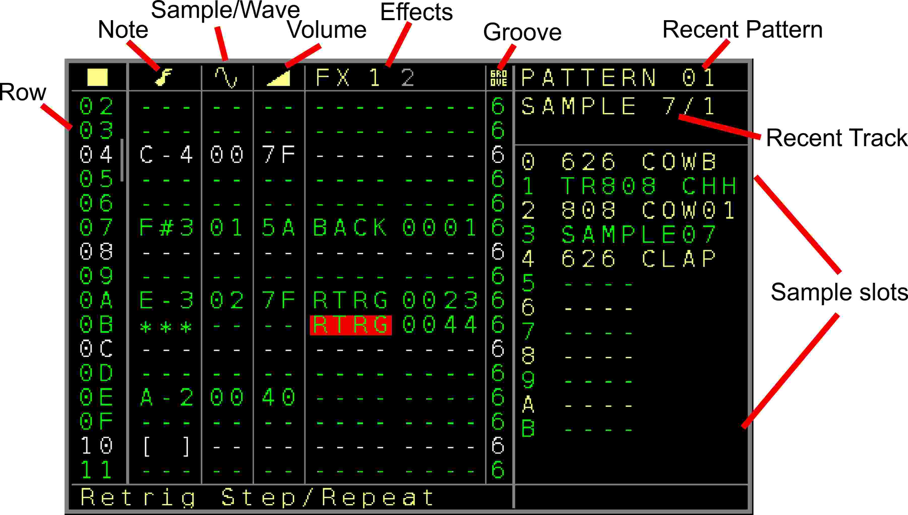Figure 5: Pattern Screen (Audio Track)
Let’s first explain the pattern audio screen for the samples/waves/synth:
First the sequencer column to indicate the 16 visible rows.
Then the following columns:
- Note : To fill in the musical notes. It changes the pitch of the sample/wave in note scale. To trigger a sample/wave a note must be filled in. In the screenshot it is the Basenote is C-4 which represents the original sample speed. A note on means also ‘ Gate on’ which can be used in combination with the envelopes to be able to also trigger an envelope when the sample/wave is triggered.
To stop a sample/wave you can use also the brackets here (below lowest note / Delete on empty note field) [ ]
This will directly stop the sample or wave audio and also releases the gate. Next to the note off there is also the ‘Gate Off’ function ( below the note off function / delete on a note-off field) ‘ ***’ . This keeps the sample or waveform playing but does set a connected envelope into it’s release phase (if the envelope is set to AD-SR mode).
Note that the envelope is not retriggered if it was not either finished or the gate was released.
After the highest note, 16 Random (RN0 → RNF) ranges can be selected which generate a random note within the selected random range. Pressing the OK button here will bring you to the → Random Ranges Screen.
- Sample / Waveform: Fill in the number of the sample slot. So for example, if you want to play sample slot 1 (626 SD2 which is the 2nd snaredrum sample of the famous Roland Drum computer TR-626) then you would need to fill in 01 here since the sample is loaded into the first sample slot. The waveforms are available from Sample number 12 to 17 (0C..11).
The different waveforms are as the following:
12 (0C) : Sine
13 (0D) : Triangle
14 (0E) : Ramp
15 (0F) : Sawtooth
16 (10) : Pulse
17 (11) Noise.
Furthermore the values R0 to RF are available which can randomly select a sample or waveform based on the random ranges 0-15.
The waveforms are starting once played and will only stop on either a Note Off of a stop all sounds command. Be aware that the Oscillator function is not a true replacement for analogue oscillators, but for many applications they will do the job well.
Pressing the OK button on the Sample/Waveform column will lead you to the → Load Sample window and OK on the Random Range selection will bring you to the → Random Ranges Screen screen.
- Volume: sets the volume of the sample/waveform. Where 7F (127) is the average value for a sample ( -2.5 to +2.5 volt max on the output) you can also increase the volume until FF (255) (-5 to +5 volt max on the output. Be aware that when using a 2nd sample in the same track which is possible would lead to a clipping here, since the samples are additionally mixed together like with regular mixers. So to be safe with 2 samples you would like to stay beneath 7F for both. The volume can also be set in a column without a sample, to manipulate an already playing sample volume.
- FX ( 2 FX columns for each sample ): You can add different FX parameters to further manipulate the sample. These parameters are:
  - FPTC → Fine pitch a sample. Changes the pitch of the recent playing sample. While value 0x40 is the base value which equals to the same pitch as the sample, higher values will pitch the sample higher and lower values will pitch the sample lower. A new triggered sample will reset the fine pitch values.
  - RTRG → Retrigger sample. Restarts the sample after a dedicated time multiple times:
The 1st digit here is the time delay when the samples will be retriggered again and the 2nd digit is the amount of repetitions. A retrigger will also retrigger an eventually connected envelope.
A value of 0000 for the retrigger will also retrigger or start a connected envelope.
  - BCSH → Bitcrush. Is a digital effect which lowers the bitrate of the sample (floating point precision). When using the bitcrush, the bitcrush setting stays on until it is being set to zero again. This works as a channel effect like a knob where you turn it on by turning the potmeter to the right 01..FF and turn it off again by turning the potmeter to the most left position again (00).
  - DIST → Distortion. Adds a simple digital distortion effect (floating point precision) to the recent sample. Also here, it stays on until you turned it off again.
  - WFLD → Wavefolder effect. Folds the waveform/sample.
  - BACK → Is a multi function FX.
If there is a sample playing currently then this is used to play the sample backwards.
xxx1 → Plays it backwards. Can also be used in the middle of a sample to change the playing order.
xxx0 → Plays the sample normal
If a waveform is playing then the following functions can be activated:
xx00 → No Modulation/Function
xx01 → Hardsync with the other waveform of the same track. So if a waveform is also playing on the other part of the track, then the current waveform is being reset on a zero cross of the other waveform. This can be used on both sides to manipulate both waveforms.
xx02 to xx10 → FM modulation of the current playing waveform. While the current playing waveform is the carrier, other waveforms/operators/samples can be used as the modulator(s). This allows to create up to 4 Operator FM synthesizer configurations.
The following configurations can be selected: FM from OP1, OP2, OP3, OP4, OP1+2, OP2+3, OP3+4, OP1+3, OP2+4, OP1+4, OP1+2+3, OP2+3+4, OP1+3+4, OP1+2+4, OP1+2+3+4
x0xx → No change to the mute/silenced attribute of the sample/wave part.
x1xx → The current audio output of the sample/wave part is muted/silenced. Use this if you for example use the waveform only as modulator and you don’t want to hear it in the output. Internally the audio signal can still be used for the modulations.
x2xx → The current audio output of the sample/wave part is not muted/silenced
0xxx → Notes play normal for the current sample/wave part
1xxx to 4xxx → Will copy the notes from the selected source (OP/Wave 1..4). This allows one to play the same notes or a transposition of the notes from the source. Important for harmonic FM modulations or bigger sounds when mixing waveforms.
  - OFFS → Set the sample offset to the scaled value.
In combination with the Pulsewave waveform, this defines also the Pulswidth ratio. Where 0 means 50:50. Other setting can go to 0:100 (001) or 100:0 (FFF) ratios of the pulsewave pulsewidth.
  - TABL → Start/assign table to the pattern part. So you can use the tables also for samples. The numbers show the selected table. A table that has already been assigned is shown in the regular colour. Tables that are not assigned/used yet are greyed out (the ‘mute’ colour). You can assign them to an audio track by either press the OK button or by pressing the TABLE button. With the TABLE button the → Table Screen is also directly entered, so the selected table can be edited. Note that tables generated in the audio tracks also can use the FX from the audio tracks.
A table number higher than 31 will set a ‘Stop Table’ command, shown by ‘STOP’.
  - PATC → Execute the selected Patch → Patch Screen
  - PROB → Add probability to the pattern part. It adds the probability of a sample to be played ( or stopped) with a given percentage. Same as the Note probabilities for the CV outputs. (see description there) Both pattern parts can have a different probability setting. Also here it is a setting that you can turn on by using the probability but you have to turn it off again yourself.
  - PRF1 → Add probability for the FX1 parameter+value. Same as the probability setting but then it gives a probability to the first FX parameter. This way you can add probability to every parameter.
  - PRF2 → Add probability for the FX2 parameter+value. Same as the probability setting but then it gives a probability to the first FX parameter. This way you can add probability to every parameter.
  - TRIG → Fire the triggers from tracks 1..6. While the 1st two digits define the triggers 1..6, the 2nd two digits define the type/value of the triggers. These use the same trigger functions as the regular trigger columns.
  - NOTE → Changes the note of the set up CV/MOD output. The destinations are CV1..6 and MOD1..6. The 2nd digit sets the Output and the last 2 digits the Note value.
  - VOLT → Changes the pitch/voltage of the set up CV/MOD output. The destinations are CV1..6 and MOD1..6. The 1st digit sets the Output and the last 3 digits the pitch value.
  - DELY → Delay settings for the track. This functions contains again multiple settings:
0100 – Delay Type: Short Highest quality. Best quality but short delay time
0101 – Delay Type: Lo-Fi. Lower quality but longer delay time
0102 – Delay Type: More Lo-Fi. Lowest quality but longest delay time
0103 – Delay Type: Fast. High quality, very short time for flanger effects
02xx – Delay Time
03xx – Delay Input send. Is the input volume for the delay
04xx – Delay feedback. Is the volume/amount of the delay feedback
  - GLID → Changes the Glide
  - PROW → Probability for the sequencer row. Keep in mind that the whole audio row of the track is affected and not only a part of it. The last FX is excluded from the probability, so it can be used to reset the probability setting from the sequence.
  - SETW → Set/change the current sample/waveform. An eventually inserted sample/wave in the sample/wave column will be overruled by this FX command.
  - RDMN → Random FX. Random next FX value or enable general FX random overrule within the range selection. This function is the same as the RDMN function for CV/Gate tracks. Press OK here to enter the → Random Ranges Screen.
  - +*-/ → Add/Multiply/Subtract/Divide. Is also the same as the ADD/SUB functions for a CV/Gate track with the exception that from this FX all 4 calculations can be done.
The first 2 digits define the calculation type and for which FX this should apply:
00XX → 03XX Add and update the amount of XX to the last known FX 1-4 without overflow
04XX → 07XX Add and update the amount of XX to the last known FX 1..4 with overflow
08XX → 0BXX Multiply and update the last known FX 1..4 value with value XX (0.1 → 25.5) without overflow
0CXX → 0FXX Multiply and update the last known FX 1..4 value with value XX (0.1 → 25.5) with overflow
10XX → 13XX Subtract and update the amount of XX from the last known FX 1-4 without overflow
14XX → 17XX Subtract and update the amount of XX from the last known FX 1..4 with overflow
18XX → 1BXX Divide and update the last known FX 1..4 value with value XX (0.1 → 25.5) without overflow
1CXX → 1FXX Divide and update the last known FX 1..4 value with value XX (0.1 → 25.5) with overflow
  - ASL0..7 → Automator Slot settings. (same as for CV-Gate patterns, check there for details)
  - ENV1..8 → Local Envelope settings. (same as for CV-Gate patterns, check there for details)
  - STSP → Start sequencer pattern. Here you can select any position on the sequencer screen that should start to play next. It works in the same way as the start button. It’s toggling between start on the zero cross of the main clock or start on the next cue point. The First digit X00 is for the track where zero is for the whole row and 1..8 for the sequencer tracks. The 2nd two digits 0XX are for the row number in the sequencer screen.
  - CBPB → Combined Playback FX
Same as the -> CBPB settings in a Modular CV/Gate Track.
  - LSMP → ‘Nearly’ seamless load of a complete sample block. A sample block (content of all 12 sample slots) can be replaced by that. More on that in the → Project screen section where sample blocks can be generated.
  - SPFX → Special FX functions.
Same as the → CBPB settings in a Modular CV/Gate Track.
  - BPM → Changing the main Tempo to the desired Beats Per Minute
  - XMAP → Same as the → XMAP settings in a Modular CV/Gate Track.
  - KILL → (2do) Stops a sample at a given time.
  - BRK → Break/Jump : Breaks (stops) the pattern. By that you can create shorter steps than the standard 64 steps. (eg 16 steps or 7 or so..). Be aware that BRK stops both parts of the pattern. So also when working with different timings in one pattern, the pattern will completely be broken and resynchronised with the next pattern. If a value is filled into the lower digits then the pattern will repeat with the inserted amount (e.g. a 002 will repeat the pattern until the break 2 times = Will play it 3 times). A repeat value of 255 will repeat the pattern endlessly.
The second function is to jump to a row in the same pattern. To use the jump function, set the first digit to 1. The last 2 digits are the pattern row to jump to. So for example BRK 105 will jump to row 5. Or BRK 110 jumps to row 10 (or 16 decimal). BRK 000 (or any value lower 100) will only activate the Break function. Be aware that the jump/repeat functions work only on the first FX column for sample 1 of the track.

- Groove: Also here the groove settings for the step. Standard is 6 but different length of the step can be set by that. See the groove explanation on the normal pattern groove section.
A particularity here is that one pattern has 2 groove settings so you can have different settings for the 2 parts of the pattern.
The groove difference indicator is shown if the total amount of groove ticks doesn’t match the pattern length and the main groove tick setting.

Basic usage:
To add a sample to the slot, you open the → Load Sample window by pressing either the PATCH button when you are in a sample pattern or by pressing OK when on the sample column.

Pressing OK (and maybe scrolling up/down) on the sample notes can be used to ‘pre-view’ the sample with the note-pitch. This function is similar to the note-prelisten in the modular pattern screens.
Waveforms can be mixed or synchronised and even manipulated from the Automators.

The general playback of an Audio pattern row is using the following order:
FX1 > FX2 > Volume 1 > Note 1 > FX3 > FX4 > Volume 2 > Note 2
So FX Settings in FX1 would already affect FX2 etc…

(Audio Track)

Track Setup

Track Setup Screen
- Track Clock → See track setup of the → Track Setup.
- Transpose → Allow or avoid the transposing of the track. This is for the global and the track transpose.
- Scale → See track setup of the → Track Setup.
- Random FX1..4 → Enables randomized values for the selected FX. If turned on and a range selected, all FX values in the selected FX will play with random values within the selected ranges. This can be also enabled/disabled with the Random FX command (RDMN) from the FX list. Press OK to get to the → Random Ranges Screen and change the ranges.

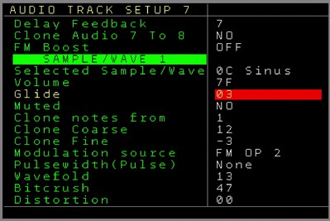
Figure 6: Track Setup Screen
(Audio Track Sample/Wave part)
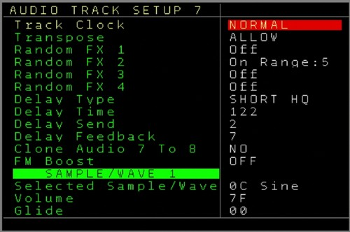
Figure 7: Track Setup Screen (Audio Track)

For all following values, see the → Sample / Wave / Synthesis part of the manual for details where you can find also a description of the usage.
- Delay Type → Sets the type of the audio delay for the track.
- Delay Time → Sets the amount/time of the delay buffer
- Delay Send → Sets the amount of the input amplitude for the delay
- Delay Feedback → Sets the amount of the delay feedback
- Clone Audio 7 to 8 → Clones and overwrites the audio stream of Track 7 into Track 8. The audio stream is grabbed and included before the delay in the audio chain.
- FM boost → Global setting for the FM intensity
Sample Wave setting for the parts 1,2,3,4: (values can be edited here)
- Selected Sample/Wave → Is the current selected sample/waveform
- Volume → Volume/Amplitude of the Sample/Wave
- Glide → Glide settings for the sample/wave part
- Muted → Sets if the audio output of this part should be muted or not (signal can still be used for modulations)
Clone Notes from → Selects if the notes should be cloned from the source. With this multiple waves/samples can be sequenced from one source
Clone Coarse → If notes are cloned, this sets the note transpose/offset in semitones
Clone Fine → If notes are cloned, this sets the fine-tune for the main note.
Modulation Source → Selects if the current audio should be either FM modulated by one or more other waves/samples or Hardsynced to another waveform
Pulsewidth (Pulse) → This determines the pulse width of the pulse wave in case that the current waveform is set to ‘Pulse’
Wavefold → Sets the current wavefolding amount for the current sample/wave part
Bitcrush → Sets the bitcrush settings for the current sample/wave part
Distortion → Sets the distortion settings for the current sample/wave part
You can use the UP / DOWN button to switch between all 4 Wave/Sample settings (for both audio tracks)

Midi track

Pattern Screen
If a track is assigned to Midi, then the midi pattern screen is used. You can assign a track to be used for Midi in the → Track Assign Screen.
A Midi track can be used to sequence any external Midi Synth/Module etc. in a polyphonic way. To sequence Midi one of the Midi-Expanders is needed.
The midi screen is here split into different pages. You move the cursor further to the right to get to the next pages.
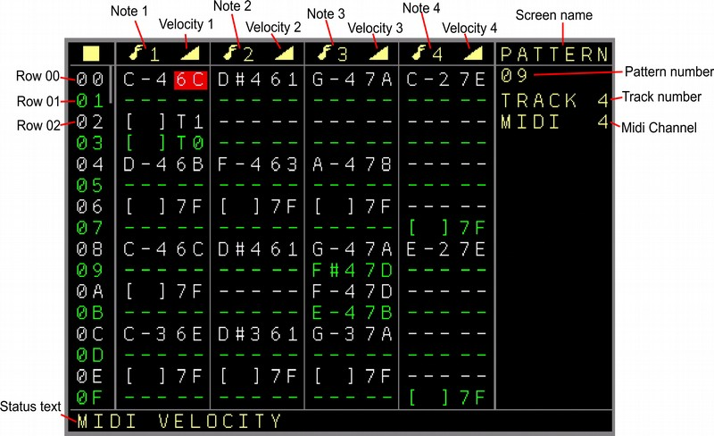Figure 8: Pattern Screen (Midi Track, 1st Page)

First the sequencer column to indicate the 16 visible rows.
- 4 Note columns where each Note columns has the Note Value and a Velocity value. If any overrule channel is turned on for a column, then you can see the channel assignment on the top next to the music note.
The notes reach from C-0 to C-A. Further than note C-A they are 16 random range settings RN0 → RNF which can be used to generate a random note within the selected range. Pressing the OK Button on these will bring you to the → Random Ranges Screen. Random notes work also with the chord function.
The Velocity column (mostly volume) can have velocity values from 00 (Note off) to 7F ( 0-127). The Velocity column contains also some additional functions to generate slides (for many monophonic midi synthesizers) or to sequence the local CV/Gate outputs instead. If you press SHIFT+OK in the Velocity column (with a corresponding note) then it will toggle between the additional/alternative functions.
Her an overview of the functions (together with the Note or Note off):

Local (track) CV Output functions:
A → Does only a note change on the CV output. No gate change if a note is filled in. Gate off if a note off is filled in.
A0 → Does a note change while turning the Gate OFF
A1 → Does a note change while turning the Gate ON
A2 → Does a note change while doing a trigger of 10ms (like trigger 20)
A8 → Does a note change while doing a trigger of 40ms (like trigger 80)
AT → Does a note change while toggling the current Gate state
Local (track) MOD Output functions:
B → Does only a note change on the MOD output. No gate change if a note is filled in. Gate off if a note off is filled in.
B0 → Does a note change while turning the Gate OFF
B1 → Does a note change while turning the Gate ON
B2 → Does a note change while doing a trigger of 10ms (like trigger 20)
B8 → Does a note change while doing a trigger of 40ms (like trigger 80)
BT → Does a note change while toggling the current Gate state
Local (track) Trigger/Gate functions:
T → Gate On if a note is filled in but note is ignored. Gate off if Note off is filled in, but note change is ignored.
T0 → Gate OFF without note change.
T1 → Gate ON without note change.
T2 → Trigger of 10ms (like trigger 20) without note change.
T8 → Trigger of 40ms (like trigger 80) without note change.
TT → Toggling the current Gate state without note change.
Local CV/MOD functions, regardless of current track:
C1 → Note change on CV 1 Output (no Gate change)
C2 → Note change on CV 2 Output (no Gate change)
C3 → Note change on CV 3 Output (no Gate change)
C4 → Note change on CV 4 Output (no Gate change)
C5 → Note change on CV 5 Output (no Gate change)
C6 → Note change on CV 6 Output (no Gate change)
M1 → Note change on MOD 1 Output (no Gate change)
M2 → Note change on MOD 2 Output (no Gate change)
M3 → Note change on MOD 3 Output (no Gate change)
M4 → Note change on MOD 4 Output (no Gate change)
M5 → Note change on MOD 5 Output (no Gate change)
M6 → Note change on MOD 6 Output (no Gate change)
Random Velocity Functions (for Midi notes)
R0 to RF → Use a random velocity within the selected random range. Pressing the OK button will bring you to the → Random Ranges Screen.
VA to VP → Use velocity values from the Variables → Variable Screen
Slide functions (for Midi notes) for Monophonic synthesizers which support a slide/glide/tie function which means that the new note will be played first and then the old one being stopped. That flow is different from the regular flow where always the last note is being stopped first before the new note plays.
S1 to S9 → Midi Slide to the new Note with Velocity 10% (S1) to 90% (S9)
S0 → Midi slide with a velocity of 100% (equal to 7F/127).
SA to SH → Midi slide with a random velocity defined by Random Range 0-7

Page 2:
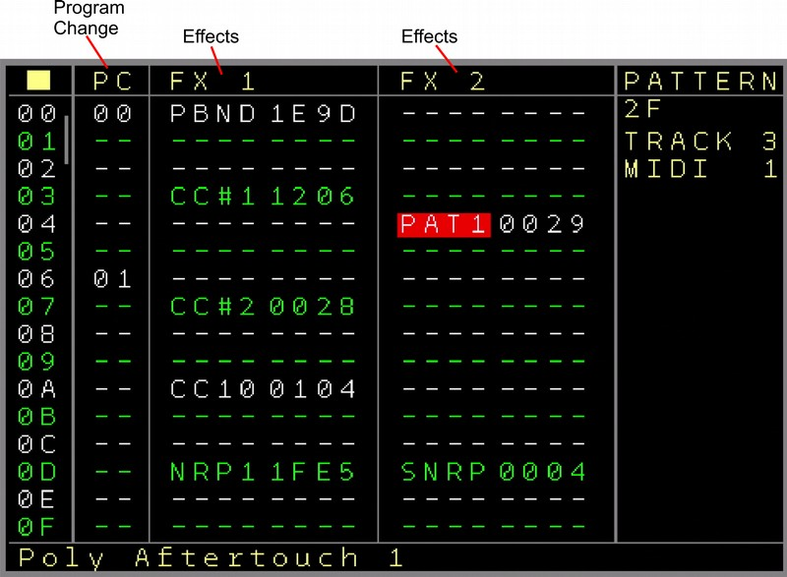Figure 9: Pattern Screen (Midi Track, 2nd Page)

First the sequencer column to indicate the 16 visible rows.
Depending on the used Midi gear, settings might act like knobs.

- PC → Program Change. Sends a program change command to the midi channel. If the ‘On Change’ setting in the Midi track setup is enabled, then it will only be sent on change. Some Midi-Devices need a long time until the Program Change is ready and stop playing then. So the function sends only when it really changes and minimizes midi gear hickup then. You can press the OK button to directly send the program change / prelisten.
- FX1..2 → 2 FX columns with the following functions:
- PBND → Pitch bend. Sets the pitch bend, where 2000 is the middle value (eg pitch bend not used), 3FFF is maximum (Pitch bend wheel full UP) and 0000 is minimum (Pitch bend Wheel down)
- CTL1..CTL8 → Midi Control preset messages for CC and Program change. Sends controller changes to the controllers which are set up in the midi track settings. The last 2 digits 00XX are for the value. (7F maximum). If the First digit X000 is set to one, then the 2nd digit 0X00 sets the Midi Channel. With this it is possible to send CC values also to other channels than the Midi Channel which is set up for the track. Some devices receive main data on one channel and other parameters via CC on other channels. If the first digit X000 is reset to 0, then the midi channel which is setup up for the track is used.
Additionally the Control Preset can be set to Program change in the setup screen. The meaning of the digits is the same as with the control changes but it will produce program change messages.
- CC A..CC H→ Free assignable Midi CC. As the Midi controller numbers for CC#1..8 are fixed and must be set up in the track settings. These controllers can be freely assigned.
The first 2 digits XX00 set the controller type/number and the 2nd two digits the value.
The main difference to the first 8 controllers is that the first 8 controllers can be used also for the Automators and other channels while the controllers 9..16 can freely be assigned in the sequence.
- CATC → Channel Aftertouch. Sends extra aftertouch settings valid for the whole channel (mostly used with most midi implementations)
- PAT1..4 → Polyphonic Aftertouch. Sends extra Aftertouch settings per note. Where 1..4 is the note column which should be addressed. The values are valid from 00 to 7F.
Polyphonic aftertouch is often not implemented as it generates a much larger amount of midi traffic CC.
- NRP1..4 → Sets NRPN controllers. These act mostly like higher resolution CC if implemented by the midi device. The NRPN Controller number is being set in the midi track setup screen and the value can be form 0000 to 3FFF then. Be aware that NRPN message sends up to 4 times the amount of midi data compared to a normal CC message. So handle with care to avoid a midi traffic jam (especially in combination with Automators).
- SNRP → Sets the controller type of NRPN4. With this NRPN4 can be used as a flexible controller. The controller type number can be up to 3FFF.
-PCRD → Plays a chord within the Midi columns. Depending on the selected chord they are 2 to 4 notes used. The First note in the midi note columns defines the basenote of the chord. Within the midi note columns you can see how many notes are used for the chord. This will play then the notes on these columns. Please be aware that a chord of multiple notes needs also multiple note-off commands. These can be either inserted also via the regular note off commands or also by using the same chord but use a note-off in the first note column.
Available chords for Midi are: Minor 2nd, Major 2nd, Minor 3rd, Major 3rd, Perfect 4th,
Diminished 5th/Tritone, Perfect 5^{th,} Minor 6th, Major 6th, Minor 7th, Major 7th, Triad Major, Triad Minor, Triad Diminished, Triad Diminished 5th, Triad Diminished Augmented, Triad Suspended 4th, Triad Suspended 2nd, 7th Dominant, 7th Minor, 7th Major, 7th Minor Major, 7th Suspended, 7th Augmented, 7th Augmented Major, 7th Augmented 9th, 7th Half Diminished, 7th Diminished, 7th Diminished 5th ,7th Diminished Flat 9th, 6th, 6th Minor, 9th, 9th Minor, 9th Major, 9th Diminished 5th ,11th.
- +*-/ → Add, Multiply, Subtract, Divide last FX. Same as the function in a modular track.
- VELO → Velocity overrule. This command can either overrule the Velocity value of one of the Midi note Columns or it can Add/Subtract from the last known velocity if it is being used by a table. Using this command in a table can create nice Midi Delay or Fading effects. While the first digit defines which columns should be affected, the 2nd digit sets the functionality: Overrule, Subtract, add. The last 2 digits define either the overrule velocity value or the subtract/add amount.

All further parameters are exactly the same as for a Modular CV/Gate Track → FX column and so all functions of the local tracks can still be used.... with the following exceptions:
- KILL → Kills the note (sends a note off) after a set up time. Where the first digit X000 points to the Note in the note column which should be killed (0 is for all notes and 1..4 for notes 1..4) the 2nd three digits 0XXX are used for the time until the note stops. Small amounts can generate very short note times (shorter than steps).
Page 3:
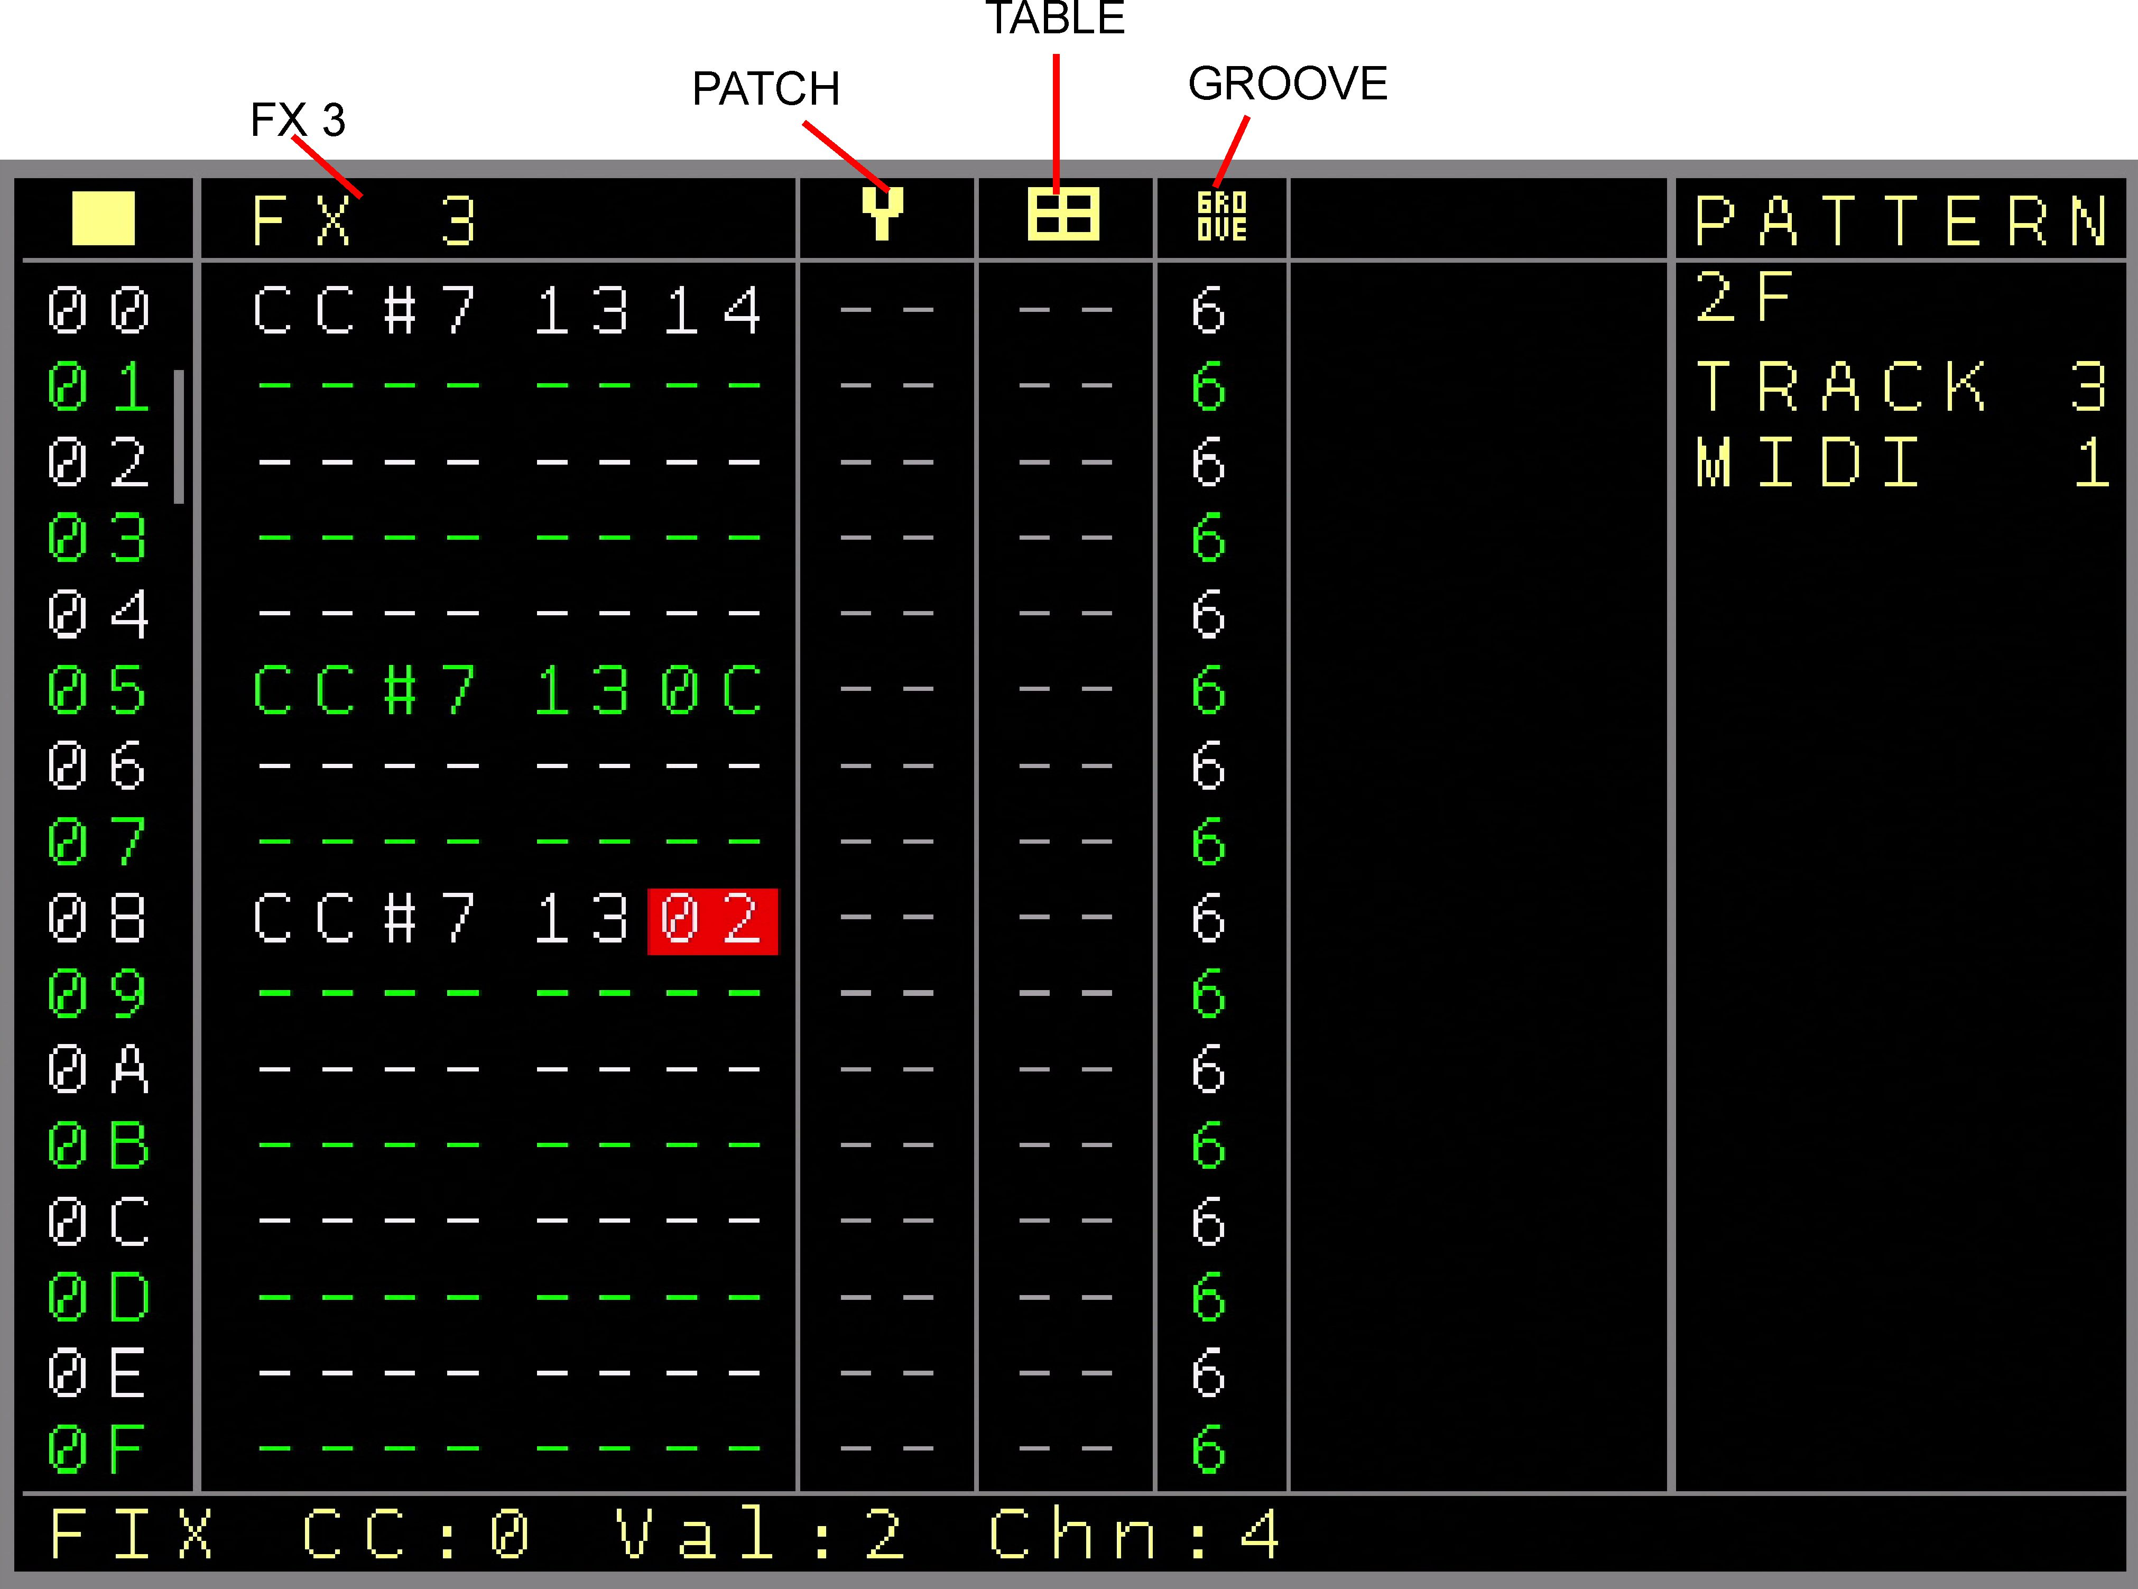
Figure 10: Pattern Screen (Midi Track, 3rd Page)

First the sequencer column to indicate the 16 visible rows.
- FX3 → Same FX as in Page 2
- Patch → Column to set a patch. The function is the same as with the local CV/Gate tracks. OK creates a new patch on an empty spot. SHIFT+OK clones a patch. Greyed out patchnumbers are either empty or already used by other track types. OK on a patchnumer will enter the → Patch Screen
- Table → Set a table. You can create a new table by pressing the OK button. By pressing SHIFT+OK on a current table you can clone the currently selected table into a new table. Selecting ** here (the highest value) is the ‘stop table’ command.
- Groove → Apply groove settings just as for the other tracks (see CV/Gate Pattern screen for description)

Specials for the Midi tracks:
A track can be set up to a channel (multiple tracks can have the same channel, but be wise with crossing notes). On top of that, CC values 1..8 can also be send to other channels.
A setting (in midi track settings) allows the notes of the first note column to be sent via midi but also to the local CV/Gate outputs. Where a note on sets the gate and a note off resets the gate.
Pressing the OK button on the Note Columns will pre-listen all notes in the row. Navigating UP/DOWN let the notes play while navigating.

The general playback of a Midi pattern row is using the following order:
Patch > Program Change > FX1 > FX2 > FX3 > Midi Notes 1,2,3,4 > Aftertouch
So parameters changed in FX1 for example will affect FX2 already and so on.
The probability settings can be applied to the Note columns 1..4, To the FX columns 1..3 and the whole row.

(Midi Track)

Track Setup

Track Setup Screen
- Track Clock → See track setup of the → Track Setup.
- Transpose → Allow or avoid the transposing of the track. This is for the global and the track transpose.
- Scale → See track setup of the → Track Setup.
- Loc.Trigger Delay → See track setup of the → Track Setup.
- Random FX1..3 → Enables randomized values for the selected FX. If turned on and a range selected, all FX values in the selected FX will play with random values within the selected ranges. This can be also enabled/disabled with the Random FX command (RDMN) from the FX list. Press OK to get to the → Random Ranges Screen and change the ranges.
- Base Midi Channel → Set the Midi track to a midi channel so the generated Midi data from that track is routed to that channel. (if not overruled otherwise) Midi Channels 1-16 can be selected for the regular Midi-IO and TRS-A Expanders. Midi Channels 1-16 for TRS, USB-Host and USB-Device can be selected with the Multi-IO Expander.
- Overrule Column 2,3,4 → Usually all notes from the 4 midi note columns will be played on the base midi channel. This can be overruled so the selected columns can sequence on another channel.
The extended channel selection is only available with the ->Multi-IO Midi & I2C Expander
- Note Offset → Main transpose/offset for Midi notes. This is used to match with all midi devices. The Offset is added to the main transposes and can be either positive or negative
-Record Columns → Select the amount of Midi voices that can be recorded in a Midi Track.
The first 4 settings (1, 1+2, 1+2+3, 1+2+3+4) select how many columns are used for midi recording (which defines also the recording polyphony.
The latter settings (2, 3, 4) define that the recording should be monophonic into the selected column.

So if the setting is for example set to 1+2, only the first 2 columns are available for Midi recording and the other 2 columns stay untouched.
- Clone to Modular → If enabled, the midi notes and note off from the first note column is also being sent/cloned to the local CV and gate output of the track. Midi on sets the Gate and the CV value to the note and Note off (also with kill) resets the gate again. The Velocity value will be output onto the MOD output of the track.
- Program Change → If set to ALWAYS then all program change events are sent. If set to ON CHANGE then it is only sent if the program number changes. Some midi devices need quite some time until the program/patch is completely recalled and might timeout for a while. This setting is to minimize any possible problems/glitches.
If it is set to ALWAYS PRE then it will always be sent but also in advance (5 steps earlier if possible) if the program change of the next playing pattern is placed in the first row (pre fetch). Please note that if you initiate a pattern change after these steps then the program change send happened already. This is a convenient feature for Elektron (and possibly other) gear which need the program change one bar in advance to be able to react on it on time.
- Automation Limit → Limits the amount of data that is generated by the Automator and sent to the Midi destinations Pitch bend, CC and NRPN. The settings are 100%, 50%, 25%, 10% and 5%. Keep the settings as low as acceptable to minimize Midi data overflows.
- Control Preset 1..8 → Sets the Controller (CC) number for the first 8 CC FX values or selects this Control Preset to be used for additional Program Change messages. These can be used for either different midi channel support for CC’s but also for the Automators as destination.
- NRPN 1..4 → Sets the NRPN-Controller (CC) number for the 4 NRPN FX values. These can then be accessed from the FX columns and also from the Automators as destination.

Trigger 16 Track

Pattern Screen
This pattern screen is only available with a connected ‘More Triggers 16’ expander. You must assign a track to be used together with the expander in the → Track Assign Screen.
As the pattern values don’t fit on one screen with this one, it is split into 3 pages.

Page 1:
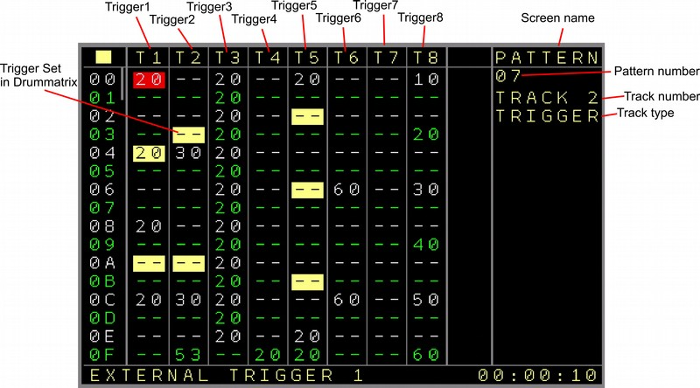Figure 11: Pattern Screen (Trigger16 Track, 1st Page)

First the sequencer column to indicate the 16 visible rows.

Then the following columns:
- TR1 .. TR8 Are the columns for the first 8 trigger outputs. The values are exactly the same as on the local Trigger columns. (see CV/Gate Pattern screen for explanation)
As a side note, this can also be the Columns TR9 .. TR16. You can setup in the track settings to use the 2nd part of the 16 outputs.
The trigger part is highlighted if a trigger is set up in the drum matrix for the same trigger position.

Page 2:

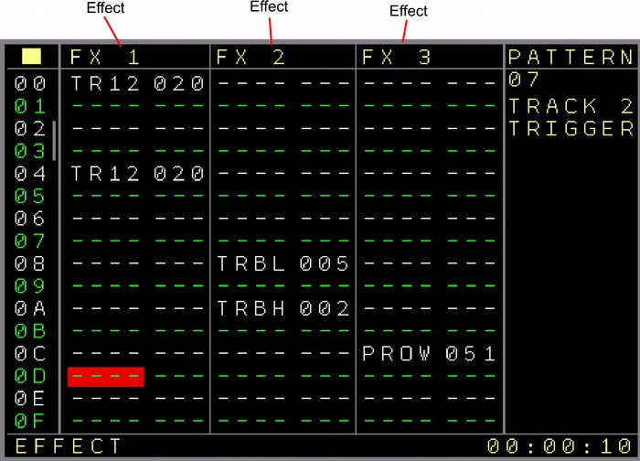Figure 12: Pattern Screen (Trigger16 Track, 2nd Page)

First the sequencer column to indicate the 16 visible rows.
- FX1 .. FX3 → FX columns dedicated to the More Triggers 16 expander with the following parameters:
- TR1 .. TR16 → Trigger values, same as the regular trigger values
- TRBL → Trigger Binary Value Low, set the binary value for the first 8 Trigger outputs. The triggers are set or reset depending on the value. This could be used for some cool dividers.
- TRBH → Trigger Binary Value High, set the binary value for the second 8 Trigger outputs (9..16). The triggers are set or reset depending on the value.
- TREF → Trigger extra effects. Some additional trigger functions:
All Triggers/Gates Off: turns all Trigger/Gate outputs off.
Swap Outputs: Off/On. Swaps if on the 8 trigger columns to be triggers 9..16 (same as the track setup setting but then from the sequence).
Toggle Swap Outputs: Toggles the columns between being 1..8 or 9..16
- NOTE → Plays or changes the note on the local CV+Gate output. If the first digit is 0, then only a note change will be send to the CV output. If the first digit is 1, then a trigger (set up in the track setup → Matrix Trigger) is also sent together with the note. The filled in notes can currently be seen in the status bar. (subject to change)
- All further parameters are exactly the same as for a Modular CV/Gate FX column and so all functions of the local tracks can still be used. The only difference are the probability settings which belong now to several trigger outputs and FX.
PR12 belongs to the columns 1+2 (Trigger outputs 1+2 or 9+10)
PR34 belongs to the columns 3+4 (Trigger outputs 3+4 or 11+12)
PR56 belongs to the columns 5+6 (Trigger outputs 5+6 or 13+14)
PR78 belongs to the columns 7+8 (Trigger outputs 7+8 or 15+16)
The outputs for the columns are decided using the swap track function.
Additionally the same outputs on the drum-matrix are affected.

Page 3:

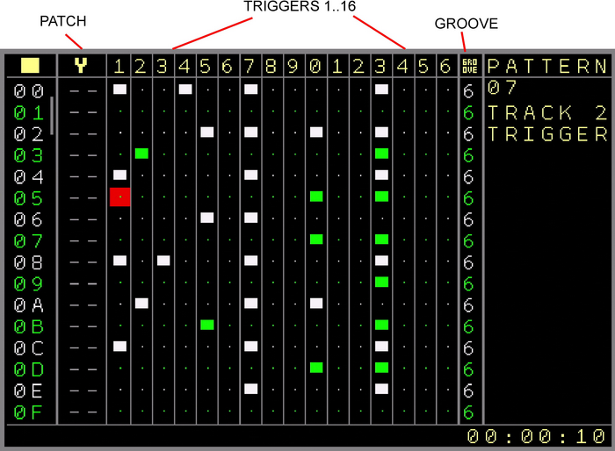Figure 13: Pattern Screen (Trigger16 Track, 3rd Page)

First the sequencer column to indicate the 16 visible rows.
- Patch → Set patches for all FX parameters. Same usage as the Patch column in a CV/Gate track.
- DrumMatrix → 16 columns for the 16 outputs. This is a classic view where you can set and reset triggers in a matrix for all 16 outputs.
- Groove → Groove settings as known from the other tracks (see CV/Gate pattern screen for further explanation

Special DrumMatrix usage:
The triggers in the drum-matrix can be enabled with SHIFT+CURSOR RIGHT and disabled with SHIFT+CURSOR LEFT or via SHIFT+DELETE. The whole row can be deleted using the mark functions.
Note that the drum matrix counts as one column currently, so it’s not possible to do any copy + paste actions on only a few drum-matrix columns. All these actions are always for a whole drum-matrix row. The kind of triggers can be set up in the track settings screen.
You can copy DrumMatrix rows between the Trigger16 tracks and the Multifunctional/I2C Tracks.

Values filled in on Page1 or Page 2 override the possible drum-matrix trigger on the used trigger. So if for example Trigger 3 is enabled in the drum-matrix and the drum-matrix triggers are set to 20. And if on Page 1 the Trigger 3 is set to the value 52 in the same row, then the 52 overrules the 20.

The Triggers can also be muted or soloed. To mute a Trigger your cursor must be on either a trigger column in the first page or on the drum-matrix. Pressing SHIFT+DOWN+START will mute/unmute the trigger. Pressing SHIFT+UP+START will Solo or unsolo the Trigger. When unsolo-ing all triggers will be unmuted as well. The function works the same as muting and solo-ing for the regular tracks.
SHIFT+OK and releasing the buttons toggles between the default trigger value, FE, 00 and ‘--’.

Drum-Matrix patterns can be moved per trigger. Using SHIFT+OK+CURSOR DOWN moves the currently selected trigger column in the drum-matrix one step down. Triggers that shift out of the last row will be inserted in the first row. Using SHIFT+OK+CURSOR UP moves the current selected trigger column in the drum-matrix one step up. Triggers that shift out of the first row will be inserted in the last row.

Beside setting different trigger points in the drum-matrix manually, a different input mode is available. Drum triggers can be inserted in a ‘Euclidean Rhythm’ style. The idea is to add an amount of trigger points where the pauses between the triggers is as equal as possible. For example, if a pattern has 64 steps and an amount of 16 triggers should be filled in, then the spacing/pause between each trigger will be 4 steps long/ every trigger will be inserted every 4 positions.
So it is possible to insert 0 to 64 triggers and the trigger points and pause is automatically calculated and inserted in the selected trigger column of the drum-matrix.
By using SHIFT+OK+LEFT, the amount of triggers is decreased and the euclidean rhythm is inserted. By using SHIFT+OK+RIGHT, the amount of triggers is increased and the euclidean rhythm is inserted. Note that the counting starts at the cursor position, so if the cursor is for example on the 7th row, then the euclidean counting starts from the 7th row to the last row and wraps around and continues on rows 0..6. The euclidean function will also consider the selected pattern length in it’s calculations.
Also it is important to know that current inserted trigger points of the trigger column will be overwritten by the euclidean input. On the other hand, columns that were inserted in the euclidean way can be edited further to get different results.
Pressing OK on a selected Trigger (Trigger columns or drum-matrix) will pre-listen that trigger. SHIFT+DOWN+OK on the 8 trigger columns will pre-listen the whole trigger row.

Using the move and euclidean functions on the drum matrix is a fast way to create interesting drum rhythms on the fly.
If the Trigger 16 Track is set up to Piano Roll mode, then each drum trigger column represents a note which depends on the chosen basenote in the track setup. So if the basenote is set to C-2 then the most left trigger column is C-2, next to it C#2, D-2 and so on. You can see on top of the pattern view the coloured sharp and flat notes, based on the base note. A filled in trigger plays the note on the local CV track and fires a trigger on local trigger output. The trigger settings are the same that are used for the Drum-Matrix. Note that the drum-matrix triggers are also firing with that. If you want to avoid the drum-matrix to fire as well in piano roll mode, then use a basenote higher than the highest note (B-8), then you can choose all basenotes again but the additional output on the drum-matrix is turned off.

The general playback of a Trigger16 pattern row is using the following order:
Patch > FX1 > FX2 > FX3 > Trigger Columns 1-8 > Drummatrix 1-16
So parameters changed in FX1 for example will affect FX2 already and so on.

(Trigger 16 Track)

Track Setup

A ‘More Triggers 16’ expander is needed to enter this screen.
- Track Clock → See track setup of the → Track Setup.
- Transpose → Allow or avoid the transposing of the track. This is for the global and the track transpose.
- Scale → See track setup of the → Track Setup.
- Loc.Trigger Delay → See track setup of the → Track Setup.
- Random FX1..3 → Enables randomized values for the selected FX. If turned on and a range selected, all FX values in the selected FX will play with random values within the selected ranges. This can be also enabled/disabled with the Random FX command (RDMN) from the FX list. Press OK to get to the → Random Ranges Screen and change the ranges.
- Swap Outputs → Swaps the first row 1..8 of the trigger expander outputs with the second row 9..16. This is implemented because the limited column count of a track, so one can decide which columns to choose for direct access. Expanders can be assigned to multiple tracks. This can be for example the first 8 triggers on one track and the last 8 triggers on another track. Beside that, the other outputs are always available through the FX column and can be triggered on the Drum-Matrix.
- Matrix Trigger → Sets the trigger type for the drum-matrix. Here all trigger types (same as regular trigger types) can be filled in and the drum matrix triggers uses these setting then.
- PR → Piano Roll function. Enables a (vertical) monophonic piano roll function. If turned on, you can set a Basenote or a Basenote without a trigger. Now all triggers entered in the Drum-Matrix will also play a note on the local CV/Gate track, beginning with the basenote on the first trigger and then semitones up until the last trigger. The Notes can be played with either the local track trigger or not (in the setting after the highest basenote). The ‘Black’ and ‘White’ keys like on a piano are marked in Piano Roll Mode on top with the 16 triggers in the matrix.
- Firmware Update - Enters the → Expander Firmware Update Screen. NSA-Expanders are smart devices and can get firmware updates for new functions or bugfixes as well. (See NSA Firmware update screen)
- Test Trigger 1..16 → Here the Trigger/Gate outputs can be tested (0 Volt = Off, 5 Volt = On). The LED should also be on or off corresponding with the voltages.

CV 16 Track

The CV16 expander adds 16 additional CV outputs to the NerdSEQ which can be used as additional note, pitch or modulation outputs. To be able to control the additional outputs a dedicated pattern screen and setup is available. Also one expander can be assigned to multiple tracks so each track uses its own dedicated outputs.
Several columns, and the FX in a pattern can play notes or change the pitches. Also the automators and mappings can manipulate the several CV16 outputs/functions.
Additional to the notes the following effects/modulators can be applied for each CV16 output:

Glide:
For each CV output there are glide settings. These work just like the glide setting on the Modular tracks of the NerdSEQ itself with the 2 parameters speed and resolution.
The speed decides how fast the glide is and the resolution defines the quantisation of each speed iteration. To get snappy glides from one note to the other you increase the resolution a bit and keep the speed on a low value. The glide is per CV output and a pitch/note glides in the assigned speed/resolution to the new note. The glide settings can be changed in the track setup or from the FX columns.

Modulators:
They are 16 modulators in total, 8 Envelopes and 8 LFO’s. Each can be used on all outputs of the CV16 expander. So you can assign every Envelope to every output of the CV16 expander. The same for the LFO’s.
As example, you can assign Envelope 2 to the CV outputs 1 and 4. Envelope 4 to CV14. LFO 2 to CV2 and CV7. And so on… You could even assign one Envelope to 15 or all 16 outputs and start them all on different times. Keep in mind that per CV output there can be only 1 Modulator active. So both, Envelope and LFO on one CV output are not valid. The latest started Modulator will stop the previous one.
Each modulator has dedicated functions and settings (each 8 times) which are:

Envelope: Since this is a ASR Envelope, each envelope has Attack, Sustain and Release as setting.
Every Envelope can be set/started into different stages:
Attack → Release : ‘Fires’ the envelope going through it’s attack phase and when it reaches the sustain voltage level, the Release phase starts.
Attack → Sustain: ‘Fires’ the envelope going through it’s attack phase and it reaches the sustain voltage level it holds that level until the released phase is started.
Release: Starts the release phase from the current sustain level.
Loop: ‘Fires’ the envelope going through it’s attack phase and when reached the sustain voltage goes directly into the Release phase and loops this endless.

The Attack/Release times go from 20 milliseconds to ~14 Minutes. The Sustain voltage can be set up from 0 to 10 Volts in 255 steps.

LFO:
Each of the 8 LFOs have 3 settings for waveform, Speed and Amplitude.
The possible waveforms are: Sine, Triangle, Sawtooth, Ramp, Square, Noise and Random.
The random waveform is special as it contains all waveforms except for noise and it changes between them randomly at a random moment. So it can switch between triangle to ramp and then to sine and so on at various times. The speed changes the wave iterations between 0.0011 Hz (~14min) and 21.8 Hz. The Amplitude from 0 to 10 Volt (-5/+5 bipolar) in 255 steps, while the smaller ranges got a finer resolution.
The LFO’s can be started and will run endlessly. There is also a command which resets the LFO, so the waveform starts over.

For each CV output there is an additional setting to decide if the Modulator (Envelope or LFO) should be pure or added to the current Note/Pitch.
So in case of the setting being pure, the following rules are valid for the modulators:
Envelope:
The ASR (Attack Sustain Release) Envelope starts with 0 Volt (-5V) it’s attack phase until it reaches the Sustain Voltage. If it’s full sustain = 255/FF then this is 10 Volt(5V). If the release phase is finished the voltage is 0 Volt again.
LFO:
The LFO midpoint with the pure setting on the CV output is 5 Volt (0V). So the LFO will swing between 0 and 10 Volt ( -5/+5V) at full amplitude.

If the CV output is set to ADD then the Modulator voltage is being added to the current pitch or note value. The Modulators will act as bipolar modulators. In this case the following rules apply, assuming for example the Note C-2 → 2 Volt (-3V):
ADD for the Envelope:
Starting the Attack phase from 0 Volt (-5V), because it is lower than the lowest possible voltage. To the sustain phase (if sustain is set to full) to 7 Volt (2V) and back to zero after the release to the lowest value. Note C-5 would output the full range of the envelope and higher values would place the offset to a higher value.
ADD for the LFO:
The LFO swings bipolar around the note/pitch value. Depending on the amplitude setting the bipolar LFO swing has values from plus/minus 5 Volt to millivolts around the current pitch value.

Once a modulator is started it will stay active until it is being stopped by the sequence or the user.
In case of the CV outputs which are set to pure, any note values have no effect.
A modulator can be stopped with the appropriate command in the pattern screen for the CV output or in the pattern Nerd Menu → Stop all sound. If modulators are stopped, the original Note/pitch value/voltage will return to the CV output.
Besides the sequencing, the CV expander can also be a destination for live recording or playing through the CV inputs or Midi. For now from the CV input, 1 CV note can be recorded together with an Envelope (With the settings of Envelope #8). In case of a Gate-On at the CV inputs, an Envelope with the Attack→Sustain phase is entered the CV16 columns together with the Note. On a Gate Off, the Release Phase is entered.
If the recorded input is a Midi signal, then flexible settings can be set to achieve polyphonic recording.
So the input settings can be from 1 up to 6 CV notes polyphonic or 1 to 5 CV notes plus the Envelope. All these are filled in to the CV16 columns. If the envelope function is activated for it, then also Envelope #8 is used. When multiple keys are pressed, the envelope will run through Attack→Sustain on the first note and starts the release phase when releasing the last note.
Another setting is the 2x2 or 3x3 polyphonic recording. In this mode a 2 or 3 voice polyphonic recording and envelope generation is possible. In case of the 2x2 mode, up to 2 notes at the same time will be entered in the first 2 columns, while the next 2 columns set the envelopes for these notes. So Column 3 envelope is for Note 1 in column 1 and Column 4 envelope is for Note 2 on column 2. If the 3x3 mode is active, then it records up to 3 notes + each an envelope, where the first 3 columns are the notes and the next 3 columns the envelopes for the corresponding notes. It is possible to get full 3 voice polyphony with this per track.

Please keep in mind that the Glide, Envelopes and LFO can never fully replace real analogue Slews, Envelopes or LFO’s. But they are definitely a very good addition for many applications.

Pattern Screen
This pattern screen is only available with a connected ‘More CV 16’ expander. You must assign a track to be used together with the expander in the Track Assign Screen
As the pattern values don’t fit on one screen with this one, it is split into 3 pages.

The CV16 or ‘More CV16’ Expander adds some more flexible screens and functions which need some additional explanation compared to the regular screens.
To get as many functions as possible within the given columns and user interface, multiple functions can be assigned from the same column in the first 6 columns. Also each column can be assigned to a different destination. The destinations can be set in the CV16 Setup Screen

Destinations for the first 6 columns can be one of the CV16 outputs (1..16), the local CV/MOD outputs of the track (TCV or TM), CV1to CV6 (LC1..LC6) or MOD1..6 (LM1//LM6). So within the 6 CV16 columns also all CV/MOD outputs can be manipulated in Notes and Pitch. Even the Triggers/Gates can be manipulated from here as well with a limited set of available Gates/Triggers (Gate On/Off/Toggle, Trigger 20ms and 40ms).
Besides the destinations of the CV setup, different CV types can be used in all of the 6 columns. If the tracks are set up to use one of the CV16 outputs, then the following features can be used:
Notes, Pitch, Trigger/Gate, Envelopes ( Attack/Sustain/Release) , LFO ( Sine, Triangle, Sawtooth, Ramp, Square, Noise, Random, Triggers on the CV16 output (from CV16 firmware V1.2 and higher)).
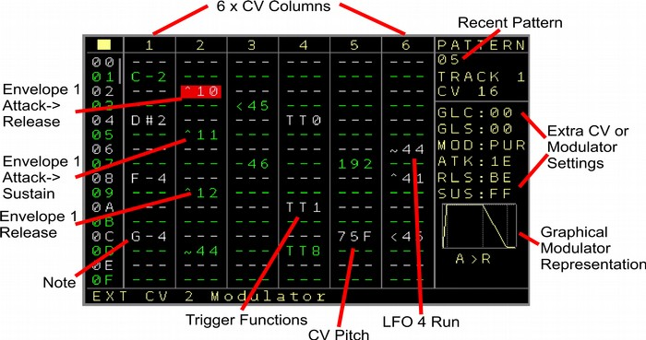Figure 14: Pattern Screen (CV16 Track, 1st Page)
Page 1:

Columns 1..6:
If regular notes are filled in then the assigned outputs will change the voltage to the note value. (if no modulator is running on that output) Depending of the offset switched the Voltage for Note C-0 is either 0 Volt or -5 Volt. After the highest note C-A (as in, scroll the note-value further than note C-A) the modulators can be set up. To fit everything into the columns a special definition of the numbers is used. Starting with the first of 2 digits, the left digit defines the modulator number.
The right digit defines the modulator type. The the following types are available:
0 → Envelope Attack > Release (column also marked with a ‘^’ )
1 → Envelope Attack > Sustain (column also marked with a ‘^’ )
2 → Envelope Release (column also marked with a ‘^’ )
3 → Envelope Loop (column also marked with a ‘^’ )
4 → LFO Start/Continue (column also marked with a ‘~’ )
5 → LFO / Envelope Reset (column also marked with a ‘<’ )
6 → Stop Modulators (column also marked with a ‘-’ )

Here are some examples of the values:
Filled in the first column which is assigned to CV2:
^10 → Envelope 1 start as Attack/Release on output CV2
^11 → Envelope 1 start as Attack/Sustain on output CV2
^12 → Envelope 1 starting release phase on output CV2
^13 → Envelope 1 set to loop (repeating attack/release) on output CV2
~14 → Start/continue LFO1 on output CV2
~34 → Start/continue LFO3 on output CV2
<55 → Reset LFO5 on output CV2
So for example Envelope 2 is a different modulator than LFO2. The numbers decide just which function you want to start on which column/CV output.
The same LFO or Envelope can run on multiple CV outputs also on different stages.
Another example for another column which is assigned to CV12:
~24 → Start continue LFO2 on output CV12.
-16 → Stop modulator on output CV12. In fact the modulator number is not relevant here, The column / CV output is being released from the running modulator and returns to it’s original note/pitch.
Envelope stages continue from the current ‘voltage’, so if a release phase was not finished and an envelope is started again it will continue with the attack phase from the current release level. Use the reset command to completely reset and restart an envelope.

With CV16 Firmware V1.2 or higher the CV16 outputs can also generate simple triggers. For this the one shot LFO-Curve TRIG is implemented. This will generate a Trigger with a dedicated amplitude and length (speed setting) on the CV16 output. A speed setting of 00 will reset the Trigger/Gate and a speed setting of FF will set the Gate to the specified amplitude.

Furthermore, above the modulator numbers a set of Triggers/Gates can bet set.
So if you scroll beyond the modulators the following options are available:
The first set is for the trigger/gate output of the current track
TT0 → Gate Off for the local Trigger/Gate output of the track.
TT1 → Gate On for the local Trigger/Gate output of the track.
TTT → Toggle Gate for the local Trigger/Gate output of the track.
TT2 → Trigger of 10ms for the local Trigger/Gate output of the track.
TT8 → Trigger of 40ms for the local Trigger/Gate output of the track.
The 2nd set is for the destination of the column. If the column is assigned to CV 1..6, then the destinations are the local trigger/gate outputs 1..6. If they are set up for the local track 1..6, then these are also automatically assigned to 1..6. All other assignments use the current track.
Assuming the Column uses CV3 as destination:
TD0 → Gate Off for the Trigger/Gate output 3.
TD1 → Gate On for the Trigger/Gate output 3.
TDT → Toggle Gate for the Trigger/Gate output 3.
TD2 → Trigger of 10ms for the Trigger/Gate output 3.
TD8 → Trigger of 40ms for the Trigger/Gate output 3.
Next are 2 sets to generate randomness.
First there is RN0 to RN7 which generates a note within the selected range 0-7.
Then there is R 0 to R 7 which generates a pitch within the selected range 0-7.
Pressing the OK button on the random commands will bring you to the → Random Ranges Screen.

Lastly are the pitch settings of the assigned outputs.
These operate like the normal pitches from 000 to FFF which represents 0 to 10 volt (-5/+5).
As a sidenote, the pitch values are scaled, so not all 4095 (FFF) values are available. In fact you will find out that instead only 3892 different values are available, where over the whole range some numbers are skipped. In general use you will not notice it at all. The voltages are very fine so the skip of one value is not audible. If you really rely on that anyway, then you still have the full range with 4095 values available through the FX columns.
It is also possible to use the Trigger16 expander from within a CV16 track. For that you set up one or multiple Trigger16 outputs of a Trigger16 expander as the column destinations on the → Track Setup.
Now, instead of the pitch commands the values 00 – FE can be used to control the Trigger16 expander output with its usual trigger commands. Additional the Trigger Destination commands TD0, TD1, TDT, TD2 and TD8 in the same column can be used to control the Trigger16 outputs.

As a fast browsing option, you can also use SHIFT+OK to directly jump between Notes, Modulators, Triggers, Pitches and an empty value.

On the right side of the screen you find the current settings of the selected column. These can differ depending on which kind of destination is selected for the column, but also on which type you are currently with the cursor.
These are not only visible but also possible to directly edit. By pressing the PATCH button your cursor toggles from the left column side to the right side. The settings can then be edited as usual using SHIFT+UP/DOWN/LEFT/RIGHT.

If the destination is a CV output of the expander then you have the following settings:
GLC → Glide Speed
GLR → Glide Resolution
MOD → Modulation pure or added
If you selected a modulator then you get the additional settings of the modulator. For an envelope these are:
ATK → Attack value of the selected envelope
RLS → Release value of the selected envelope
SUS → Sustain value of the selected envelope
For a LFO these are:
TYP → The type of the selected LFO (eg Sine, Sawtooth etc)
SPD → The speed of the selected LFO
AMP → The amplitude of the selected LFO
Pressing PATCH again will bring you back to the regular column editing.

You can see on top of the screen, if and what kind of modulations are active on that output.
A ‘^’ means an active envelope. A ‘~’ means and active LFO. If the modulation is set to pure then no note will be played anymore on that output/column until the modulation (Envelope or LFO) is being stopped and the output is released again for any other function such as Notes. There is one exception for this behaviour. If the setting ‘pure overrule’ is enabled, then a new note will disable the modulation. Also a SHIFT+STOP on a stopped sequencer will disable any CV16 modulations.
On the right bottom side you see a graphical representation of the currently selected modulator (if the cursor is on it).
Also while editing, press OK to prelisten the current sequencer row.

Page 2:
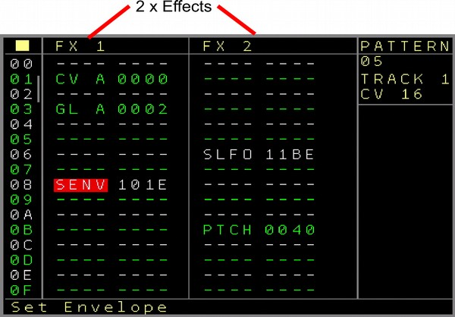Figure 15: Pattern Screen (CV16 Track, 2nd Page)

On the second page there are 2 FX columns. These have mostly some special coding for the 4 digits which will be explained for each function. Also for all CV16 functions, details/help is available in the statusbar, so you should be able to work with all of them without checking the manual again.
The following FX functions are available:
CV A to CV H → Change the CV value. The most left digit Xxxx defines the CV output 1 to 16 and the three right side digits xXXX define the CV value/pitch from 000 to FFF.
NT A to NT H → Change the Note. The 2nd left digit xXxx defines the CV output 1 to 16 and the two right digits xxXX define the note value.
GL A to GL H → Glide settings for the 16 CV outputs. The first digit Xxxx defines the CV output. The second digit xXxx defines if it should be the Glide Speed (0) or the Glide Resolution (1) setting. The 2 digits on the right xxXX are the value of the selected settings from 00 to FF. Be aware that the current settings will be filled in automatically when starting to edit.
ST A to ST H → Start Modulator. With this you can start(or stop) any modulator on any CV output.
The 2nd digit from the left xXxx defines the CV output 1..16. The third digit from the left xxXx defines the Modulator number 1..8. And the most right digit xxxX defines the type of modulator.
These are: 0: Attack→Release Envelope, 1: Attack→Sustain Envelope, 2: Release Envelope, 3: Loop Envelope, 4: Start/Continue LFO, 5: Reset LFO, 6: Stop modulator
SENV → Set Envelope Parameter. Used to change envelope parameters from the playing sequencer. The settings here are for the first digit from the left Xxxx: the Envelope number. The 2nd digit from the left xXxx defines which envelope parameter is affected 0: Attack, 1: Release, 2: Sustain. And the 2 digits on the right xxXX define the value. Note that the current Envelope settings are automatically filled in.
SLFO → Set LFO parameter. With this you can change the settings of one of the 8 LFO.
The first digit from the left Xxxx is the LFO number. The second digit xXxx is for which setting to be changed: 0: Type, 1: Speed, 2: Amplitude. The last 2 digits xxXX are for the value of the setting.
SADD → Set modulation for the CV output 1..16 to pure or add setting. Here the 3rd digit from the left xxXx defines the CV output number. The last digit xxxX defines if the modulator should be added (Set to 1) to the current pitch or be pure (Set to 0)
PROW → Probability for the whole row except for the last FX column.
PCRD → Play Chord. Plays a chord on multiple CV outputs. xXxx selects the column and start CV for the Basenote. For example, if set to 2xxx then the 2nd column is used for the basenote and the selected CV for this column is also defined for the first note of the chord. All additional CV based on this are used then for the Chord. For example, imagine a chord is selected with 4 notes. And the column uses CV6. The Chord will be played then on CV6, CV7, CV8 and CV9. So the chord is not related to the other columns. Even more, multiple chords can be played at the same time on one step using more chord fx commands with other base-column selections.
XxXX defines the selected chord (different chord use 2 to 6 notes). The following chords are available: Minor 2nd, Major 2nd, Minor 3rd, Major 3rd, Perfect 4th, Diminished 5th/Tritone, Perfect 5th, Minor 6th, Major 6th, Minor 7th, Major 7th, Triad Major, Triad Minor, Triad Diminished, Triad Diminished 5th, Triad Diminished Augmented , Triad Suspended 4th, Triad Suspended 2nd, 7th Dominant, 7th Minor, 7th Major, 7th Minor Major, 7th Suspended, 7th Augmented, 7th Augmented Major, 7th Augmented 9th, 7th Half Diminished, 7th Diminished, 7th Diminished 5th, 7th Diminished Flat 9, 6th, 6th Minor, 9th, 9th Minor, 9th Major, 9th Diminished 5th, 11th
PH 1 to PH8 → are placeholders for future FX and currently unused.

All further parameters are exactly the same as for the → FX column of the Modular CV/Gate tracks and so all functions of the local tracks can still be used. The only difference are the probability settings which now belong to several CV outputs and FX.

The Probability settings are defined as the following:
CV1, CV2, CV3, CV4, CV5+6, FX1, FX2, FX3.

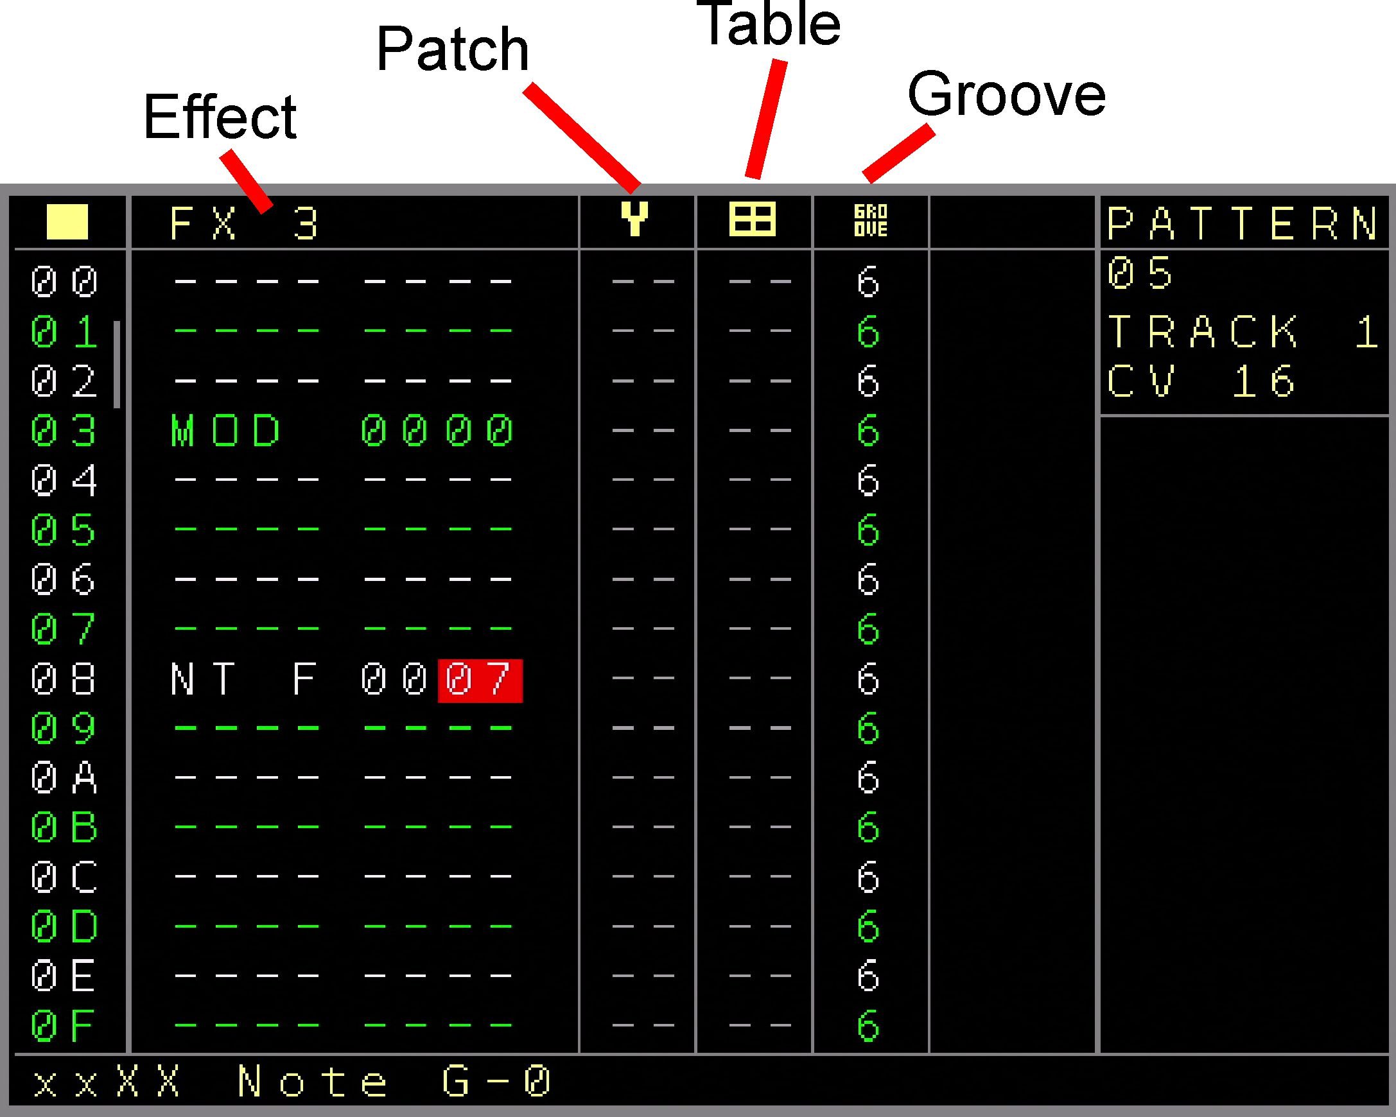Figure 16: Pattern Screen (CV16 Track, 3rd Page)
Page 3:

The 3rd page contains the 3rd FX column which has the same settings as the former 2 FX columns.
Next to it are the Patch and Table settings. The Patch function works in the same way as for the local CV/Gate tracks and so all FX parameters of a CV16 expander can be manipulated from the patches. The same is valid for the Table column. With both, the Patch and Table columns you can create a new Patch/Table by pressing the OK button and clone into a new Patch/Table by pressing SHIFT+OK on a selected Patch/Table.
The last to the right is the groove column which works in the same way as the groove column from the normal CV/Gate tracks.

The general playback of a CV16 pattern row is using the following order:
Patch > FX1 > FX2 > FX3 > CV Columns 1-6
So parameters changed in FX1 for example will affect FX2 already and so on.

(CV16 Track)

Track Setup

Track Setup Screen
A CV16 Expander is needed to enter this screen.
For all settings be aware that some settings belong to the NSA channel of the expander and some are per track. The selections are marked in the previous colours.
- Track Clock → See track setup of the → Track Setup.
- Transpose → Allow or avoid the transposing of the track. This is for the global and the track transpose.
- Scale → See track setup of the → Track Setup.
- Loc.Trigger Delay → See track setup of the → Track Setup.
- Random FX1..3 → Enables randomized values for the selected FX. If turned on and a range selected, all FX values in the selected FX will play with random values within the selected ranges. This can be also enabled/disabled with the Random FX command (RDMN) from the FX list. Press OK to get to the → Random Ranges Screen and change the ranges.
- Record Voices: Sets the amount of voices which can be recorded from Midi. The following settings are currently available: 1..6, will use midi recording into the amount of columns. So if set to 3 then only the left 3 columns are used to record the midi notes.
1..5 + ENV8: Also 1 to 5 columns can be used to record notes, additionally on the last column, the envelope data is filled in as well. The rules are then with a polyphonic midi stream: If the first note is pressed, Envelope 8 is filled in as Attack/Sustain envelope on the field next to the highest possible selected note column. If the last note is released from the keyboard, then a release for Envelope 8 is filled in. For example, if you set up 2 voices + envelope, then the envelopes are always filled in on the 3rd column.
Furthermore there are the 2x2 and 3x3 record voices which allow full polyphonic note + envelope generation. Here Notes are filled in the first 2 or 3 columns and on the following 2 or 3 columns the envelopes which belong to each note are filled in.
If a column is set up to be a Trigger16 destination then Gates/Triggers will be filled in instead of the envelopes.

- Pure Overrule: Defines if a modulator in Pure Mode should be stopped again when a note is filled in and play.
- Destination 1..6: Defines the destination for the columns 1..6. The following destinations are available:
EXT CV1..CV16: the CV outputs on the expander.
TRACK CV: The CV output on the NerdSEQ of the current track.
LOC CV1..CV6: The NerdSEQ CV outputs 1..6.
TRACK MOD: The MOD output on the NerdSEQ of the current track.
LOC MOD1..6: The NerdSEQ MOD outputs 1..6.
TRIGGER16 1..16 NSA 1..4: Outputs 1 to 16 of a Trigger16 expander ( Adres/Channel 1 to 4)

- Glide 1..16 → Set the Glide Speed and Resolution for each CV output.

- Modulation 1..16 → Set the behaviour of the modulations onto the current pitch/note. In pure, only the modulators are routed to the output. In add, the modulator is added to the current pitch/note.
- Envelope 1..8 Settings → Attack, Release, Sustain. A graphical representation of the Envelope shape is being drawn on the screen.
- LFO 1..8 Settings → LFO Type (Sine, Triangle, Sawtooth, Ramp, Square, Noise and Random. Additionally the ‘LFO’ type ‘Trigger’ can be selected if the CV16 firmware uses version V1.2 or higher) plus the Speed and Amplitude
- Firmware Update → Enters the NSA Firmware update screen.

CV16 Calibration
- Get Calibration → Requests the CV16 calibration settings for the selected expander. After the NerdSEQ successfully received relevant data from the expander, the values are presented in the fields below. With a multimeter connected to the CV outputs you can calibrate each output.
With the CV16 Firmware lower than V1.2 you will receive 2 settings per output. You can calibrate these using the following instruction:
Select CV 1 __ 0 V. The multimeter should now read 0 Volt. If not, change the values in the right hand field until it best matches 0 volt.
Now Select CV 1 __ 10V . You should now measure 10 Volt at CV output 1. If not, change the value in the right hand field until it best matches 10 volt.
Proceed for all outputs if needed. The Calibration settings are automatically saved 10 seconds after the last CV value has been changed/calibrated, so be sure you don’t turn off your system before having a 10 second pause!

With CV16 Firmware V1.2 or higher the 11 point calibration is enabled which allows a more accurate calibration for each octave.
You will receive 11 calibration points for the Voltages 0 to 10 Volt. For each output to calibrate you first choose the CV1 __ 0 Volt setting and change the calibration values until you measure the closest to 0 Volt on your multimeter. Then the same for the 10 Volt setting.
On this position you can choose if the settings from 9 Volt to 1 Volt should be filled in automatically interpolated between the 0 and 10 volt setting (use SHIFT+OK then).
Now you fine-tune each octave changing the values down to 1 Volt.
Repeat for all outputs. Also here the settings are saved into the CV16 automatically after 10 seconds of pause/idle.

Dualchord Track

Pattern Screen

This pattern screen is only available with a connected ‘Dualchord’ expander. You must assign a track to be used together with the expander in the → Track Assign Screen
As the pattern values don’t fit on one screen with this one, it is split into 4 pages.
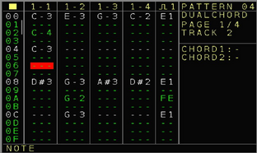
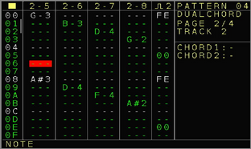
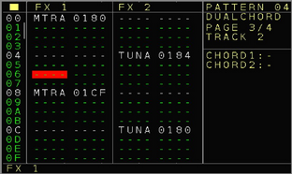
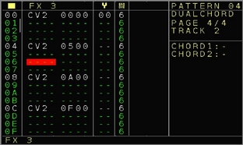

On the first page they are 4 columns to fill in music notes. These columns use the 4 oscillators of the first output of the Dualchord (In the default configuration. The oscillator assignment to the oscillators is flexible). Note values from C-0 to C-A can be inserted here as well as a Note off [ ] which turns the oscillator completely off. Furthermore RN0 to RNF allows to randomly choose notes within the selected random range. Pressing OK here will get you to the → Random Ranges Screen where you can define the note-range. In general if a filled in note plays, then the oscillator will be started if it was not running yet. You can stop the oscillator with a note off [ ] or by pressing SHIFT+STOP with a stopped sequencer (which stops all sounds and so also the oscillators). Next to the 4 note columns there is the trigger column for the first trigger output on the Dualchord Expander. (also here in the default configuration, this can be changed to the other trigger output of the Dualchord or to the local trigger outputs). Here all trigger commands are possible that are also available in a local CV/Gate track. See the description of the different trigger-types here → Trigger.

On the next page you find the exact same layout but then for the next 4 oscillators 5-8 and the 2nd trigger output (in the default configuration). The functionality is the same.

Page 3+4 got the 3 possible FX columns with the following FX functions:
NT A..D → Play note where the first digit Xxxx selects the oscillator 1-8 and on the right part the note can be selected (C-0 to C-A)
PT A..D → Set the oscillator to the selected pitch where the first digit Xxxx selects the oscillator again and the next 3 digits xXXX define the pitch frequency where 000 is the lowest frequency and FFF the highest frequency.
GL A..D → Changes the glide setting for an oscillator where the 2nd digit xXxx selects the oscillator and the last 2 digits xxXX select the glide intensity.
VL A..D → Changes the main velocity of an oscillator where the 2nd digit xXxx selects the oscillator and the last 2 digits xxXX select the velocity amount
MTRA..D → Triangle velocity (mix) for the selected oscillators where the 2nd digit xXxx selects the oscillator and the last 2 digits xxXX select the Triangle wave velocity.
MSIA..D → Sine velocity (mix) for the selected oscillators where the 2nd digit xXxx selects the oscillator and the last 2 digits xxXX select the Sine wave velocity.
MSAA..D → Sawtooth velocity (mix) for the selected oscillators where the 2nd digit xXxx selects the oscillator and the last 2 digits xxXX select the Sawtooth wave velocity.
MPUA..D → Pulse velocity (mix) for the selected oscillators where the 2nd digit xXxx selects the oscillator and the last 2 digits xxXX select the Pulse wave velocity.
PWMA..D → Pulsewidth for the selected oscillator (affects only the pulse wave) where the 2nd digit xXxx selects the oscillator and the last 2 digits xxXX select the pulsewidth (00 is a ratio of 100/0, 80 is a ratio of 50/50 and FF is a ratio of 0/100)
TUNA..D → Detune the selected oscillator where the 2nd digit xXxx selects the oscillator and the last 2 digits xxXX select the detuning (00 detunes with -128, 80 means ‘no detune’ and FF is a detune of +127). The detuning will stay until changed.
LFOA..F → Changes the LFO settings of the internal Dualchord LFOs where the first digit Xxxx selects the LFO. The 2nd digit xXxx selects the function of the LFO to be changed:
x0xx: LFO Amplitude 0-100% (x0XX)
x1xx: LFO Speed where the values (x1XX) 00 → 0C select the synchronized LFO speeds: 128, 64, 32, 16, 8, 4, 2, 1 Steps and 2,3,4,5,6 times per step. Values from 0D to FF define the free running speed from slow to fast.
x2xx: LFO Offset. A value (x2XX) of 00 is a negative LFO offset, a value of 80 is the middle point and a value of FF is for the positive offset.
x3xx: LFO Phase. Changes the LFO waveform start position where a value (x3XX) of 00 means a 0 degree phase-start, 80 is an 180 degree phase-start and FF a 360 degree phase-start (same as 0 degrees)
x4xx: Set the LFO Destination (see the dualchord track setup for possible destinations)
CLON → Clone Dualchord outputs settings where the 2nd digit (xXxx) selects the function:
x100: Turns the stereo clone function off
x101: Sets clone to stereo de-phase
x102: Sets clone to stereo detune
x2XX: Set the intensity of the stereo clone function.
MRPH → Morph settings where the 2nd digit (xXxx) defines the function:
x1XX: Set the morph waveforms function for oscillators 1-4 (see the Dualchord track setup for possible morph settings)
x2XX: Change the waveforms of the oscillators 1-4 within the morph setting
x3XX: Set the morph waveforms function for oscillators 5-8 (see the Dualchord track setup for possible morph settings)
x4XX: Change the waveforms of the oscillators 5-8 within the morph setting
CTUN → Set the detune spread intensity for the oscillators 1-4 (x1XX) and oscillators 5-8 (x2XX)
TRG1, TRG2 → Set the Dualchord Trigger function where the last 2 digits (xxXX) define the trigger type as described here: Trigger
KNBA..D → Define the knob destination for the Dualchord Knobs A to C. (see the Dualchord track setup for the available knob destinations)
PCRD → Play Dualchord chord presets. The 2nd digit defines the output of the Dualchord and the last 2 digits define the selected chords which can use from 2 to 4 oscillators. The base-note is derived from the 1st or the 5th oscillator. You can see also in the status line which oscillators are being used. The note columns show also the use of additional oscillators for the chord. These can be overwritten with alternative notes on demand. The chords can be defined with the last 2 digits (xxXX). (see the Dualchord track setup for the available chords at the ‘Part Mode’ settings. See here a list of the included chords together with the amount of used oscillators:
2xMinor 2nd, 2xMajor 2nd, 2xMinor 3rd, 2xMajor 3rd, 2xPerfect 4th, 2xDim 5th, 2xPerfect 5th, 2xMinor 6th, 2xMajor 6th, 2xMinor 7th, 2xMajor 7th, 3xTriad Major, 3xTriad Minor, 3xTriad Dim, 3xTri Dim 5th, 3xTri Dim Aug, 3xTri Sus 4th, 3xTri Sus 2nd, 4x7th Dom, 4x7th Minor, 4x7th Major, 4x7th MinMaj, 4x7th Sus, 4x7th Aug, 4x7th Aug Maj, 4x7th Half Dim, 4x7th Dim, 4x7th Dim 5th, 4x6th, 4x6th Minor, 4xMinor 2nd, 4xMajor 2nd, 4xMinor 3rd, 4xMajor 3rd, 4xPerfect 4th, 4xDim 5th, 4xPerfect 5th, 4xMinor 6th, 4xMajor 6th, 4xMinor 7th, 4xMajor 7th, 4xTriad Major, 4xTriad Minor, 4xTri Dim, 4xTri Dim 5th, 4xTri Dim Aug, 4xTri Sus 4th and 4xTri Sus 2nd.
Set → Set Preset / Part Mode. If the first 2 digits are 00 (00xx) then it selects the preset with the 2nd 2 digits (1..4) . If the first 2 digits are 01 or 02 (for part 1 and part 2) then you can change the mode for the selected part. 01Xx or 02xx. The available partmodes are explained here: → Part 1 Mode

All further parameters are exactly the same as for the → FX column of the Modular CV/Gate tracks and so all functions of the local tracks can still be used. The only difference are the probability settings which belong to the dualchord columns:
Column 1, Column 2, Column 3, Column 4, Trigger Column 1, FX1, FX2, FX3 and Row

On the 4th page there is, next to the 3rd FX column, also a ‘Patch’ and the ‘Groove’ column. Both work also in the same way as a local CV/Gate track.
On the right side you can see which preset chords (Part Modes) are currently selected for the Dualchord outputs.

The general playback of a Dualchord pattern row is using the following order:
Patch > FX1 > FX2 > FX3 > Note Columns 1-4 and 5-8, Trigger1, Trigger 2.

(Dualchord Track)

Track Setup
Track Setup Screen
In the Track Setup screen for the Dualchord you can change the general track behaviour, Midi input settings which are related to the Dualchord, the several Modes and the Oscillator, LFO and Knob settings and assignments.
A Dualchord Expander is needed to enter this screen and a Track has to be assigned to the Dualchord. As with all Track Setup screens you can either enter it from the → Nerd Screen / Menu or by pressing the PATCH button twice, or from the → Track Assign Screen by pressing OK on the assigned Dualchord track.
For all settings be aware that some settings belong to the NSA channel of the expander and some are per track.
- Track Clock → See track setup of the → Track Setup.
- Transpose → Allow or avoid the transposing of the track. This is for the global and the track transpose.
- Scale → See track setup of the → Track Setup.
- Loc.Trigger Delay → See track setup of the → Track Setup.
- Random FX1..3 → Enables randomized values for the selected FX. If turned on and a range selected, all FX values in the selected FX will play with random values within the selected ranges. This can be also enabled/disabled with the Random FX command (RDMN) from the FX list. Press OK to get to the → Random Ranges Screen and change the ranges.
- Record/Play Voices → Sets the amount of voices which can be played and recorded from Midi. Basically this will route the monophonic or polyphonic Midi Notes to one or multiple oscillators/columns and adds selected attributes.
Each of the settings is available with 2 attributes. First the involved note columns of the Dualchord tracks and second the attribute if the Trigger column should be filled in as well or not. The rules if the trigger column is being used are that on the ‘Note On’ of the first note a trigger ‘Gate on’ (FE) is being inserted. And on the last released note ‘Note Off’ a ‘Gate off’ (00) is being inserted in the trigger column. In case that the note on and off appeared on the same step, then the default trigger type is being inserted instead.
As for the column selections, they are many different combinations for the Midi input possible (all with and without triggers):
Columns: | 1 | 2 | 3 | 4 | 1+2 | 1+2+3 | 1+2+3+4 | 2+3 | 2+3+4 | 3+4 | 5 | 6 | 7 | 8 |
5+6 | 5+6+7 | 5+6+7+8 | 6+7 | 6+7+8 | 7+8 | 1+2+3+4+5+6+7+8
For example 1+2 would mean that you can press 2 Midi notes at the same time and these will be routed to the Dualchord columns 1 and 2. The columns 3 and 4 are not affected by the midi input then.
Note that with a Midi ‘note on’ the selected oscillator starts if it was stopped before.

- Rec/Play Note Off → This setting belongs also to the Rec/Play voices setting and here you can define if an oscillator should stop again on a ‘note off’ or if it should keep running (default). If the setting is enabled then a ‘note off’ ‘[ ]’ will also be inserted into the columns if you are recording.

-Column Setup → With these you can define different destinations to the 8 possible note and the 2 trigger columns. A use case would be if you want to use 2 different tracks with the Dualchord. One where the first 4 columns + trigger point to the first 4 oscillators (and so the first oscillator and trigger output jacks on the Dualchord). On another track you could define that the first columns should point to oscillators 5-8 and the 2nd trigger for the 2nd output jacks.
The possible destinations for the Note columns 1..8 are: Oscillators 1..4 (Output 1), Oscillators 5..8 (Output 2). For the Trigger columns you can choose between both trigger outputs on the Dualchord, the trigger output of the current track (tracks 1-6) and the local trigger outputs 1..6.
-DC Sound Settings
Here you can select one of the 4 possible presets for the Dualchord settings. Each preset holds all dualchord settings which allows you to create 4 different sounds. The presets / dualchord settings are global and not per track. The current preset is always the one you can edit.
The export and import preset functions allow to load/save single presets to/from the NerdSEQ SD card. This will always affect the current active preset. Presets are loaded and saved with the project.

The next block defines the general Oscillator Modes / Dualchord functions:
-Clone Out 1 to 2 → Defines if and how the first output should be also cloned to the 2nd output. With this you can create a stereo field if one output is connected to the left and another to the right channel of your mixer. Other use cases where you just mix both outputs are possible as well to enhance the oscillator variation. You can choose between the following settings:
None: Output cloning is disabled
Stereo Dephase: The waves of the first output are cloned to the 2nd output while the 2nd output got a phase-shift from 0 to 360 degrees (defined with the Clone Depth setting). This will generate a fixed stereo field.
Stereo Detune: The waves of the first output are cloned to the 2nd output while waves of the 2nd output are slightly detuned (detune amount defined with the Clone Depth setting). This creates a kind of a moving stereo field.
Please note that the best stereo effect is being achieved by using lower octave notes.
The waves of the 2nd output can still be manipulated but will be overruled again if any note or setting of the first wave is being changed. The change of the phase/detune amounts are also (kind of) slow updates so the manipulations of the oscillators of output 2 are not audible.
- Clone Depth → Defines the intensity for the Stereo Phase or Stereo Detune effects.
- Part 1 Mode → These are the oscillator modes for the first output. Here you can define if oscillators should be independent or play together with many presets. The available modes are:
Normal: Each of the oscillators 1..4 works independent.
4x Note: Oscillators 1..4 are connected together and if a note on oscillator 1 is being started or changed then oscillators 2,3 and 4 will start/change as well like oscillator 1 with the same note. So if you play the note C-3 on oscillator one, then note C-3 will also play on the other oscillators. If you add detuning per oscillator (or the detune spread) then the oscillators will be detuned from each other and generate a ‘wider/thicker’ sound. You could create a ‘supersaw’ a-like sound with that. The other oscillators can still be separately manipulated but each note on oscillator 1 will apply to all and overrules them. There is no synchronisation between the oscillators and only a note-off would re-sync the oscillators.
2x Note |0|-1|: Oscillator 1 and 2 are connected together like with 4x Note except for that the 2nd oscillator will play 1 octave lower.
3x Note |0|-1|+1|: Oscillator 1,2 and 3 are connected together like with 4x Note except for that the 2nd oscillator will play 1 octave lower and the 3rd oscillator 1 octave higher.
4x Note |0|-1|+1|0| and 4x Note |0|-2|-1|1| act in the same way as before with oscillators using different octaves
2x Note 5th: Oscillators 1 and 2 are connected while oscillator 2 plays 5 semitones higher
4x Note 5th: Oscillators 1..4 are connected together with oscillator 2 playing 5 semitones higher, oscillator 3 playing 1 octave lower and oscillator 4 playing 7 semitones lower
2x Note 7th: Oscillators 1 and 2 are connected while oscillator 2 plays 7 semitones higher
4x Note 7^{th:} Oscillators 1..4 are connected together with oscillator 2 playing 7 semitones higher, oscillator 3 playing 1 octave lower and oscilator 4 playing 5 semitones lower
The following mode settings involve 2 to 4 oscillators in the same way but then for chords where the following chords are available (2x, 3x and 4x are the numbers of oscillators used):
2xMinor 2nd, 2xMajor 2nd, 2xMinor 3rd, 2xMajor 3rd, 2xPerfect 4th, 2xDim 5th, 2xPerfect 5th, 2xMinor 6th, 2xMajor 6th, 2xMinor 7th, 2xMajor 7th, 3xTriad Major, 3xTriad Minor, 3xTriad Dim, 3xTri Dim 5th, 3xTri Dim Aug, 3xTri Sus 4th, 3xTri Sus 2nd, 4x7th Dom, 4x7th Minor, 4x7th Major, 4x7th MinMaj, 4x7th Sus, 4x7th Aug, 4x7th Aug Maj, 4x7th Half Dim, 4x7th Dim, 4x7th Dim 5th, 4x6th, 4x6th Minor, 4xMinor 2nd, 4xMajor 2nd, 4xMinor 3rd, 4xMajor 3rd, 4xPerfect 4th, 4xDim 5th, 4xPerfect 5th, 4xMinor 6th, 4xMajor 6th, 4xMinor 7th, 4xMajor 7th, 4xTriad Major, 4xTriad Minor, 4xTri Dim, 4xTri Dim 5th, 4xTri Dim Aug, 4xTri Sus 4th and 4xTri Sus 2nd.
- Morph Waves 1234 → These are the combined morph settings for the 4 oscillators. With this you can morph between the 4 possible waveforms while all waveform combinations are possible. For example:
Sine ↔ Pulse
Sawtooth ↔ Sine
Pulse ↔ Sawtooth ↔ Triangle
Sine ↔ Sawtooth ↔ Triangle ↔ Pulse
...and so on. All possible combinations of 2, 3 and 4 morph waveforms are available in this settings. With the Morph Amount setting the actual morph position can be defined:
- Morph Amount 1234 → This parameter (0 – 255 / 0-100%) defines the morph position of the selected waveform. As an example, if the ‘Morph Waves’ setting would be set to
PULSE ↔ SAW then an amount of 0 / 0% would change the waveforms to be a pulse- wave. When set to 127 / 50% then the waveforms would be a mix of the pulse and the sawtooth wave. At 255 / 100% it would be a pure sawtooth wave.
In the same way the morph amount would morph between the selected waveforms. This can be applied also to a LFO or to a knob or controlled from the FX/Mappings to get many ‘moving’ variations of the different waveforms.
Note that this will always overrule the wave-settings of each oscillator since it acts as a kind of a ‘preset’. Also the individual waveform settings will be also overruled by an enabled morph setting on project load.
- Detune Spread 1234 → This will detune all of the 4 oscillators with the ratios of
| -1 | 0 | +1 | +2 |. You can use this to get an immediate ‘wide’ of ‘thick’ effect to for example 4x the same note oscillators. The spread ranges from subtle to strong audible detuning.

The following 4 settings are exactly like the ones before except for that they apply to oscillators 5 to 8 of the 2nd output.

Wave 1 – 4 Setup (and Wave 5 – 8 Setup)
This block contains all the individual settings for each oscillator:
- Lock Wave1 (5) to 1234 (5678) → With this setting enabled all changes to oscillator 1 (or 5) will also automatically apply to the other 3 oscillators (2,3,4 or 6,7,8) of the same output.
The other oscillators can still be edited but every change again on oscillator 1 (5) does overrule that change again. If disabled then each waveform can be edited independent.
The following settings are available for all 8 oscillators:
- Wave X Velocity → Changes the main volume of the oscillator
- Wave X Glide → Glide setting which defines the speed that a pitch needs to change from one note to another note. Snappy and slow glides are possible.
- Wave X Detune → Fine detune of the current pitch (positive and negative). Note that the detune setting stays until it is being set to 0 again.
- Wave X Triangle → Defines the mix of the triangle waveform in the oscillator
- Wave X Sine → Defines the mix of the sine waveform in the oscillator
- Wave X Saw → Defines the mix of the sawtooth waveform in the oscillator
- Wave X Pulse → Defines the mix of the pulse waveform in the oscillator
- Wave X Pulsewidth → Defines the pulse-width / ratio of the pulse waveform

KNOB Setup defines the functions that you can assign to each of the 4 knobs on the Dualchord. Please be aware that the Knobs on the Dualchord don’t feedback into the NerdSEQ and so only Dualchord internal parameters can be changed with the knobs.
- Knob X Enabled → Enables or disables the current function of the knob. Use it when you want to change the knob destination to not overrule any settings.
- Knox B Destination → Sets the destination of the knob. The following destinations (which are the same functions before and further described) are available:
‘LFO1..8 Speed’ uses 2 different knob modes depending on the LFO speed setting itself. If the LFO is set to any of the synchronized speed settings e.g. 64 steps or 3 per step or so then the knob will change between 128 step, 64 step…. 4,5,6 per step, and if the LFO is set to any of the ‘freerun’ settings then the knob will use the free running speeds, LFO1..8 Amplitude, LFO1..8 Offset, LFO1..8 Phase, Stereo Deepness, Wave 1..8 PWM, Wave 1234 PWM, Wave 5678 PWM, Wave 1..8 Detune, Out1 and Out2 Detune (which is waves 1..4 and 5..8 detune), Out1 and Out2 Spread (is the detune spread setting), Wave 1..8 and 1234/5678 Triangle Sine Saw Pulse, Wave 1..8 and 1234/5678 Morph, Wave 1..8 and 1234/5678 Glide, Wave 1..8 Velocity.

LFO Setup defines the attributes of the 8 LFOs and the functions that you can assign as a LFO destination.
- LFO X Enabled: Enables or disables the selected LFO
Good to know: If you are with the cursor on this menu-entry and the LFO is enabled, then you can see the actual ‘flow’ of the LFO on the 1st LED of the Dualchord. With this you can get a visual indication of its speed.
- LFO X Destination: Sets the destination of the LFO. The following destinations (which are the same functions before and further described) are available:
Stereo Deepness, Wave 1..8 PWM, Wave 1234 PWM, Wave 5678 PWM, Wave 1..8 Detune, Out1 and Out2 Detune (which is waves 1..4 and 5..8 detune), Out1 and Out2 Spread (is the detune spread setting), Wave 1..8 and 1234/5678 Triangle Sine Saw Pulse, Wave 1..8 and 1234/5678 Morph, Wave 1..8 and 1234/5678 Glide
- LFO Speed: Sets the LFO speed. 2 types of LFO speeds are possible: Synchronized LFOs where the LFO wave takes a selected amount of sequencer steps: 128, 64,32,16,8,4,2,1 steps. Or it would run 2,3,4,5 or 6 times per step. The speed is derived from the main-clock of the NerdSEQ and will be resynchronized on every zero-cross of the NerdSEQ main-clock.
The 2nd option are the free-running speeds which are not synchronized in any way.
- LFO Amp: Sets the amplitude of the LFO
- LFO Offset: Sets the offset of the LFO. While a LFO usually swings around positive and negative values (bipolar) based on the zero point, with the offset it can be changed to get either a positive or a negative offset. You could find here your ‘sweet spots’ for the destination.
- LFO Phase: Defines the phase of the LFO. It either defines the starting point 0-360 degrees / 0-255 with a free running LFO or if the LFO is synchronized then it would define the synchronisation point of the LFO wave.

Things to know:
- Please note that the LFOs and the Knobs changes the values directly in the Dualchord and there is no feedback to the current state of the manipulated value on the NerdSEQ itself.
- when loading a project which uses a Dualchord then the following priority order is valid:
All individual Wave settings
Detune Spread settings
Morph Mode settings
LFO settings
Knob settings
That means, the individual wave settings might be overruled by the morph settings if morph is enabled.

I2C / Multi-functional Track

Pattern Screen
This pattern screen is available with and without the Multi-IO Expander. You must assign a track to be used together with the expander in the → Track Assign Screen

The I2C / Multi track is a multi-purpose track types which allows the sequencing of much more than only I2C gear. They are also destinations for all Local CV/Gates, Trigger16 Expander, Midi and more, so it makes it a flexible polyphonic track with up to 6 columns for notes and the well known Drum-Matrix from the Trigger16 Expander.

As the pattern values don’t fit on one screen with this one, it is split into 3 pages.

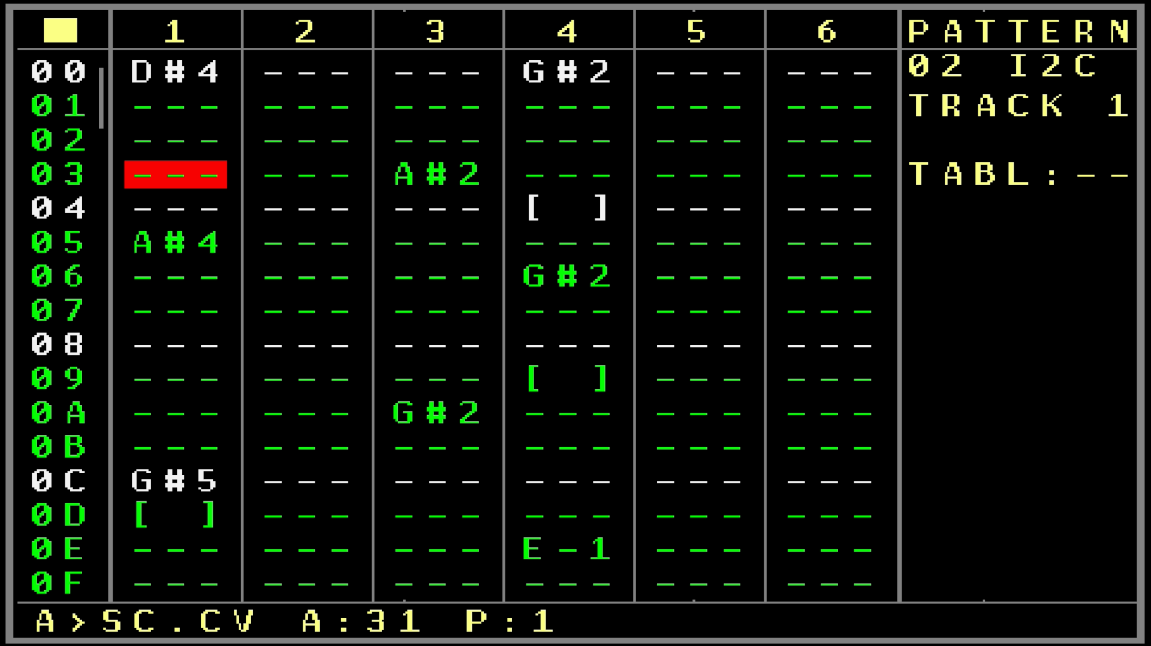
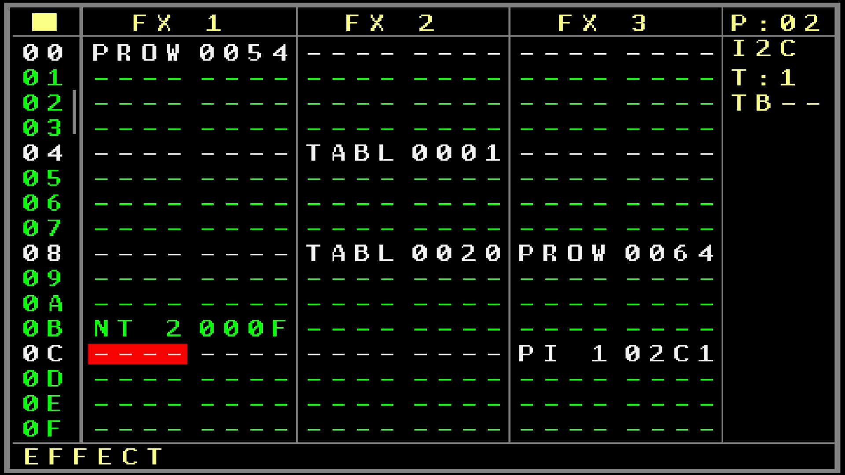
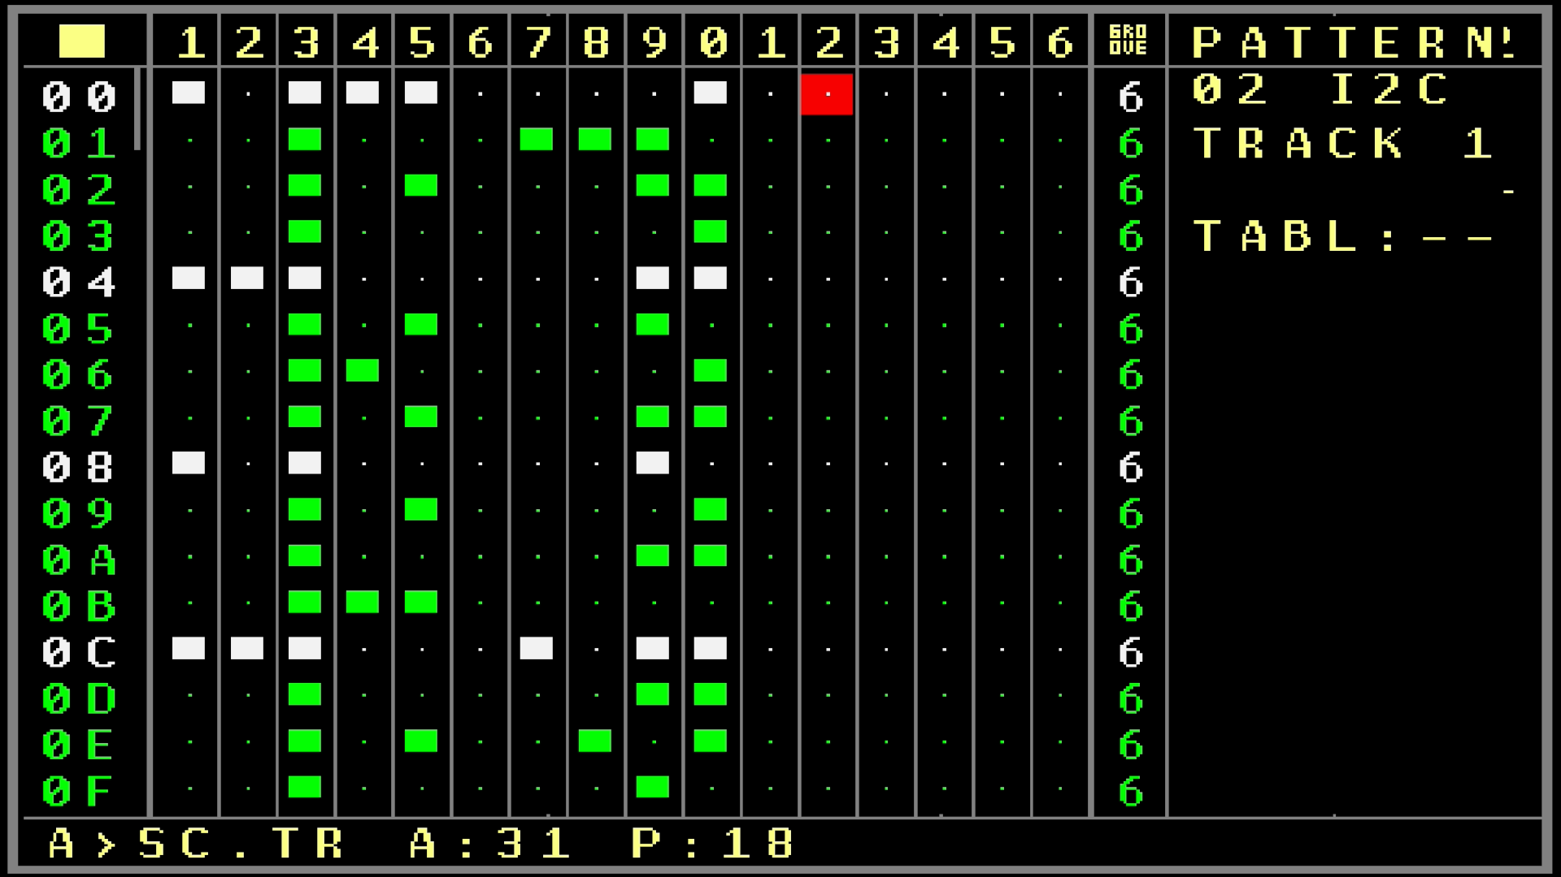

To get as many functions as possible within the given columns and user interface, multiple functions can be assigned from the same column in the first 6 columns. Also each column can be assigned to a different destination. The destinations can be set in the → Track Setup
Destinations for the first 6 columns can be the following: I2C with commands for the ER301, Just Friends, distingEX or custom commands. Other destinations are the CV/MOD/Gate outputs of the NerdSEQ including a Note On/Off behaviour. Also the Triggers/Gates can be manipulated from here as well with a limited set of available Gates/Triggers (Gate On/Off/Toggle, Trigger 20ms and 40ms).
Destinations for the Drummatrix can be: ER301, Just Friends, distingEX. Custom I2C commands, Midi Notes, Midi CC and the Trigger outputs of the NerdSEQ and the Trigger16 Expander. Many functions can act as a Trigger while others can also have a Gate behaviour which can last through multiple steps.

See below the description of the different screens within a I2C/Multi Pattern:
Page 1:

Columns 1..6:
The 6 columns are usually used to play notes or pitches but got also more functionalities for the sequencing. Please keep in mind that not every destination can play notes or produce Gates.

--- → Is an empty column
[ ] → Is a note off for that column. Depending on the destination it will release the Gate or sends and I2C command to release a Gate
C-0 to B-9 Selects the Note to play, will also set the Gate depending on the destination
M1 to M16 → Execute the command/function defined by the drummatrix destinations 1-16
CA1 to CA 8 → Executes the I2C Custom Commands 1 to 8 on I2C Port A but without any payload. Also the address for this will be derived from the custom address and not defined by the destination.
CB1 to CB 8 → Same as before but for I2C Port B
TT0 → Gate Off for the local Trigger/Gate output of the track.
TT1 → Gate On for the local Trigger/Gate output of the track.
TTT → Toggle Gate for the local Trigger/Gate output of the track.
TT2 → Trigger of 10ms for the local Trigger/Gate output of the track.
TT8 → Trigger of 40ms for the local Trigger/Gate output of the track.
The 2nd set is for the destination of the column. If the column is assigned to CV 1..6, then the destinations are the local trigger/gate outputs 1..6. If they are set up for the local track 1..6, then these are also automatically assigned to 1..6. All other assignments use the current track.
Assuming the Column uses CV3 as destination:
TD0 → Gate Off for the Trigger/Gate output 3.
TD1 → Gate On for the Trigger/Gate output 3.
TDT → Toggle Gate for the Trigger/Gate output 3.
TD2 → Trigger of 10ms for the Trigger/Gate output 3.
TD8 → Trigger of 40ms for the Trigger/Gate output 3.
Next are 2 sets to generate randomness.
First there is RN0 to RN7 which generates a note within the selected range 0-7.
Then there is R 0 to R 7 which generates a pitch within the selected range 0-7.
Pressing the OK button on the random commands will bring you to the → Random Ranges Screen.

Lastly are the pitch settings of the assigned outputs.
These operate like the normal pitches from 000 to FFF which represents a 0 to 10 volt (-5/+5) range depending on the destination.
As a sidenote, the pitch values are scaled, so not all 4095 (FFF) values are available. In fact you will find out that instead only 3915 different values are available, where over the whole range some numbers are skipped. In general use you will not notice it at all. The voltages are very fine so the skip of one value is not audible. If you really rely on that anyway, then you still have the full range with 4095 values available through the FX columns.

As a fast browsing option, you can also use SHIFT+OK to directly jump between Note Off, The Notes, Matrix, Custom, Triggers, Random, Pitches and an empty spot.

If one of the columns is ‘ gated’ (eg a note plays) then it will highlight the column number on top of the screen.
Also while editing, press OK to prelisten the current sequencer row.

Page 2:
On the second page there are 3 FX columns. These have mostly some special coding for the 4 digits which will be explained for each function. Also for all I2C functions, details/help is available in the statusbar, so you should be able to work with all of them without checking the manual again.
The following FX functions are available:
PI 1 to PI 6 → Change the Pitch value of the destination defined by columns 1-6. The pitch can be selected from 000 to FFF ( 0 – 4095).
NT 1 to NT 6 → Change the Note of the destination defined by columns 1-6. Value 0 is a Note off and then C-0 to B-9 can be selected.
PROW → Probability for the whole row except for the last FX column.
PCRD → Play Chord. This function is currently not implemented
+*-/ → Are the Add, Subtract, Multiply and Divide functions where the last used FX value will first be calculated with the arithmetic functions and then executed again.
XXXX The First 2 Digits define the Type of calculations. 00 – 03 Add the selected FX until the max value is reached. 04 – 07 Add with overflow. 08 – 0B Multiply by X.X until a maximu value. 0C – 0F Multiply by X.X with overflow. From 10 – 17 the same with subtract and from 18 – 1F are the divide functions by X.X. An overflow will occur if the result exceeds FFF (4095).
All further parameters are exactly the same as for the FX of the Modular CV/Gate tracks and so all functions of the local tracks can still be used. The only difference are the probability settings which now belong to several CV outputs and FX.
T16A and T16B → Sends a selected trigger command to the Trigger16 Expander. The first digit XXXX defines the Expander Channel (NSA Channels 1-4), the 2nd XXXX the Trigger output and the last 2 digits XXXX define the type of the Trigger.
The further FX functions are the same → FX column as for a regular Modular CV/Gate Track

Page 3 contains mainly the DrumMatrix which allows the triggering of Drums or Events.
It is splitted into 16 columns and the Filled in and not Filled in parts define the trigger of a drum, send of a Midi Note or CC, I2C Command etc. You can select the destination for each column in the → Track Setup

The editing functions are the same as for the Trigger16 Expander, so please refer to the → DrumMatrix description.
Another speciality is that beside the triggering which is just a one shot trigger some destination supports also Gating. With that the Gate of a destination is being set if the spot in the DrumMatrix is filled in and a Gate off appears on the next empty spot. So if you for example set the drummatrix rows 02,03 and 04 and got the spot 05 empty again then the gate will be set on 02 and will be reset again after row 04. This is interesting if you got for example a Midi Drum which is defined as a trigger on one column but the same drum defined as a gate on the other column. You could play short triggers all the time then and sometimes via the gate with can make the sound last longer. This depends of course of the capability of the destination.
You can copy DrumMatrix rows between the Multifunctional/I2C tracks and the Trigger16 tracks.

The probability settings are defined as the following but they are subject to be changed in the future:
Column 1,2,3 Column 4,5,6 Matrix 1, Matrix 2, Matrix 3, FX1, FX2, FX3, Row
Each of the 16 drummatrix columns in a I2C/Multi track can be independently muted (the same like with a Trigger16 drummatrix). Choose the column and press SHIFT+DOWN+START to mute/unmute the column and SHIFT+UP+START to solo/unsolo the column.

At last the groove settings which works in the same way as the groove settings from the normal Modular CV/Gate tracks.

The general playback of a I2C pattern row is using the following order:
Patch > FX1 > FX2 > FX3 > Columns 1-6 > DrumMatrix 1-16
So parameters changed in FX1 for example will affect FX2 already and so on.

(I2C / Multifunctional Track)

Track Setup

Track Setup Screen
The I2C Multi Track is a multifunctional Tracktype which allows sequencing into all kind of destinations like I2C, Midi, CV, Triggers. The setup of the destinations is described here:
- Track Clock → See track setup of the → Track Setup.
- Transpose → Allow or avoid the transposing of the track. This is for the global and the track transpose.
- Scale → See track setup of the → Track Setup.
- Loc.Trigger Delay → See track setup of the → Track Setup.
- Random FX1..3 → Enables randomized values for the selected FX. If turned on and a range selected, all FX values in the selected FX will play with random values within the selected ranges. This can be also enabled/disabled with the Random FX command (RDMN) from the FX list. Press OK to get to the → Random Ranges Screen and change the ranges.
- Record Voices: Sets the amount of voices which can be recorded/played from Midi. The following settings are currently available: 1..6, will use midi recording/play into the amount of columns. So if set to 3 then only the left 3 columns are used to record / play the midi notes. The playback and note arrangement is defined in a round robin rotation.
Destination 1..6 sets the destination of the 6 Columns in the pattern screen. These are:
I2C Destinations (for all I2C destinations the Address (0 - 127), the I2C Connections (A or B) and the Port can be selected ( 0 – 128)) and the local CV/Gate outputs. In this description both ports for the I2C are named at the same time as A/B but both are their own setting. Also the naming is mainly derived from the Teletype naming with some changes in the length plus some new commands have been added.

First the destinations for the Orthogonal Devices ER301 SC stands for Sound Computer. It uses usually address 31 hex and the ports from 1-100. (Note that the ER301 got an offset in the naming of the ports. While it starts with port 1, in reality Port 0 is being send. The NerdSEQ handles this internally.
A/B-SC.CV → SC.CV command sets the CV Value of the port (with slew).
A/B-SC.CVGA → SC.CV command sets the CV Value of the port (with slew) plus the Gate On/Off (SC.TR) of the same port..
A/B-SC.CVTR → SC.CV command sets the CV Value of the port (with slew) plus a Trigger (SC.PULSE) of the same port..
A/B-SC.CVSE → SC.CV.SET command sets the CV Value of the port (without slew)
A/B-SC.CVSL → SC.CV.SLEW command sets the Slew for the port
A/B-SC.TR → SC.TR Sets only the Gate of the port on a Note on, and a gate off on note off.
A/B-SC.CVNG → SC.CV command sets the CV Value of the port (without slew) plus the Gate On/Off (SC.TR) of the same port..
A/B-SC.CVNT → SC.CV command sets the CV Value of the port (without slew) plus a Trigger (SC.PULSE) of the same port..

Notes on the ER301 usage:
- at least Firmware 0.5.03 must be used for a reliable I2C reception
- You got to enable the teletype support and get 2 new units, a CV and a TR unit. These can be used to receive the I2C Data from the NerdSEQ. Use the 3.3V pullup with it, especially when there is no other I2C gear connected on this lines.

The following destinations are for the Just Friends from Whimsical Raps and its Just Type implementation. Be sure to get through this since it has the description of all the functions below. The JF usually uses port 0x70, the outputs can be addressed using the ports 0-6 while port 0 is for all outputs and port 1 is IDENTITY and 6 is 6N (JF users know what I am talking about). Please note that I never tested it with the JF myself, but via someone else. If you are a hardcore JF user with Teletype knowledge and you miss something or it doesn’t work as expected, let me know.
A/B-JF.TR → JF.TRIGGER Sets only the Gate of the port on a Note on, and a gate off on note off.
A/B-JF.RMOD → JF.RMODE Set the RUN state (Note on is activate Run Mode, Note off = Off)
A/B-JF.RVLT → JF.RUN Set the RUN voltage (Notes or Pitches can define Min/Max)
A/B-JF.SHFT → JF.SHIFT Shifts the transposition of Just Friends
A/B-JF.VTR→ JF.VTR Trigger Channel with Velocity. Pitch 0 or note off is low state.
A/B-JF.MODE→ JF.MODE Activates Synthesis or Geode modalities.
Note for the following Synth / Geode commands which only work if the JF is in MODE = 1.
It is not necessary to send that command as the NerdSEQ will send it upfront one time if one of the following commands for the synthesis is being ‘played’: It will stay in MODE = 1 until Mode has been reset using the JF.MODE Command.
A/B-JF.VOXL→ JF.VOX Plays a note (on/off) with a 33% level/velocity on the selected port.
A/B-JF.VOXM→ JF.VOX Plays a note (on/off) with a 66% level/velocity on the selected port.
A/B-JF.VOXH→ JF.VOX Plays a note (on/off) with a 100% level/velocity on the selected port.
A/B-JF.PTCH→ JF.PITCH Plays a note/pitch without level/velocity triggering on the selected port.
A/B-JF.TICK→ JF.TICK Clock Geode with a stream of divisions ticks per measure. (values or notes 1-48 for the divisions and 49 – 255 for the BPM)
The following 2 commands are double commands and need to be next to each other in 2 columns (left side VOX1 and right side VOX2 since the VOX parameter for this needs 2 values). Both commands are needed for an execution.
The VOX command for Geode: “Create a stream of rhythmic envelopes on the named channel. The stream will continue for the count of repeats at a rhythm defined by divs.”
A/B-JF.VOX1→ JF.VOX Divs, Divides the measure into this many segments
A/B-JF.VOX2→ JF.VOX Repeats, Number of times to retrigger the envelope

A/B-JF.QT→ JF.QT Quantize Geode events to divisions of a measure.

Next are the commands for the distingEX by Expert Sleepers. The address can be set within the distingEX I2C Settings.
A/B-EX.CO→ EX.CONTROLLER Set the I2C Controller to a value. The controllers (port) can be mapped in the disting to any algorithm parameter.
A/B-EX.PARA→ EX.PARAMETER Change the parameter value of the current Algorithm to the exace value
A/B-EX.PV→ EX.PARAMETER Range Change the parameter value of the current Algorithm to the range value (0...16384 scaled from the Pitch 0-4095 value in the NerdSEQ)
A/B-EX.PRST→ EX.PRESET Load preset
A/B-EX.VP→ EX.VOX.PITCH Set voice pitch for the specified voice
A/B-EX.V→ EX.VOX.VELO Triggers the Voice (Gate on/Off current note) with a Velocity
A/B-EX.VPL→ EX.VOICE Plays a Note (Note On/Off) with a 33% Velocity
A/B-EX.VPM→ EX.VOICE Plays a Note (Note On/Off) with a 66% Velocity
A/B-EX.VPH→ EX.VOICE Plays a Note (Note On/Off) with a 100% Velocity

The next destinations are to control/play the ART modules by TipTop audio . It requires the ART-Add-On and the Multi-IO Expander. The ART-Add-On is a low-cost, 2HP add on (features 2 ART ports) to the Multi-IO. The implementation allows the polyphonic control/play of the current (and future) ART modules and have been successfully tested (6 voice polyphonic) with the following setup: NerdSEQ → Multi-IO → ART-Add-ON → Vortex6→Octostages/Poly Envelope→Octopass Polyfilter→ Octogain
In the 2nd column the Port/Output of the ART module can be defined.
The following ART functions are available:
ART LOW → Note ON/OFF with a 30% velocity.
ART MID → Note ON/OFF with a 60% velocity.
ART HI → Note ON/OFF with a 100% velocity.
ART RND → Note ON/OFF with a random velocity defined by a random range selection.
ART MW → Modwheel controller
ART PORTA → Portamento controllers
ART PC → Program Change
ART PB → Pitchbend
Please note that not all ART commands are available/implemented with all ART receivers/modules.

More I2C destinations will follow up in the future. But you can also create your own I2C commands which could be already used with a non-supported I2C follower.
These Custom commands can be defined in this setup menu and can be called also as a destination. The editing custom commands will be described further below (another I2C /Multi menu item). Here they are destination items which can be used to ‘fire’ these custom commands.
A/B-CUSTM → Plays a selected custom command (but adds a 2 byte payload, like the selected note in the sequence or a pitch value). So if you have for example a 5 byte custom command then the 2 bytes will be added. You select the custom command by the number next to the address.

The next destination is for the Local CV/Gate outputs:
CV-MOD → Local CV/Gate output functions
The 2nd column defined the function and the 3rd column the selected outputs.
For the outputs you can choose between the outputs 1-6 on the NerdSEQ and ‘LOCAL’ uses the outputs of the current track (if one of the tracks 1-6).
Functions:
CVGA → CV+GATE Changes the CV to the note or pitch and sets/resets the Gate
CVTR → CV+Trigger Changes the CV to the note or pitch and fires a default trigger
MDGA → MOD+GATE Changes the MOD output to the note or pitch and sets/resets the Gate
MDTR → MOD+Trigger Changes the MOD output to the note or pitch and fires a default trigger
CV → Only changes the CV to the note or pitch
MOD → Only changes the MOD output to the note or pitch

MAPPING → Overwrite a selected mapping row from the sequence. In the → Mapping Screen the selected row must be set to GLOB → SEQV as a source.

Next they are the Matrix Destinations which can be used with the 16 Drummatrix trigger/gate points. Most I2C Matrix Destinations are build up in a similar way as the Column destinations using an Address and a Port. The commands are ‘fired’ from the drummatrix sequencing.

ER301 Destinations:
A/B-SC.TR → SC.PULSE sends a Pulse to the selected port.
A/B-SC.GA → SC.TR sends a Gate to the selected port.A filled in field in the matrix sends a gate on which will stay on until the next empty field.

Just Friends Destinations:
A/B-JF.TR → JF.TR Sends a Gate on directly followed by a Gate off which results in a Trigger Pulse.
A/B-JF.GATE → SC.TR sends a Gate to the selected port. A filled in field in the matrix sends a gate on which will stay on until the next empty field.

DistingEX Destinations:
A/B-EX.TRGL → EX.TV Will send a Note on (eg Trigger a Sample) with a velocity of 33%.
A/B-EX.TRGM → EX.TV Will send a Note on (eg Trigger a Sample) with a velocity of 66%.
A/B-EX.TRGH → EX.TV Will send a Note on (eg Trigger a Sample) with a velocity of 100%.
A/B-EX.GATL → EX.TV Will send a Note on (eg Gate a Sample) with a velocity of 33%. A filled in field in the matrix sends a gate on which will stay on until the next empty field.
A/B-EX.GATM → EX.TV Will send a Note on (eg Gate a Sample) with a velocity of 66%. A filled in field in the matrix sends a gate on which will stay on until the next empty field.
A/B-EX.GATH → EX.TV Will send a Note on (eg Gate a Sample) with a velocity of 100%. A filled in field in the matrix sends a gate on which will stay on until the next empty field.

A/B-CUSTOM → Sends the defined custom commands but without an added payload. Port defines the selected custom command.

MIDI NOTL, MIDI NOTM, MIDI NOTH→ Sends a Midi Note On only with the defined Note to the defined Channel/Midi Port with a velocity of 33%(L), 66%(M), 100%(H)
MIDI NOTR → Sends a Midi Note On only with the defined note and a random velocity. The random value is derived from the Random Ranges and the drummatrix number defines which range is selected. For example if the 2nd drummatrix column is used then it will use Random Range 1 (starting from 0). You can press OK here to get to the → Random Ranges Screen.

MIDI TRGL, MIDI TRGM, MIDI TRGH→ Sends a Midi Note On and Off with the defined Note to the defined Channel/Midi Port with a velocity of 33%(L), 66%(M), 100%(H)
MIDI TRGR → Sends a Midi Note On and Off with the defined note and a random velocity. The random value is derived from the Random Ranges and the drummatrix number defines which range is selected. For example if the 2nd drummatrix column is used then it will use Random Range 1 (starting from 0). You can press OK here to get to the → Random Ranges Screen.
MIDI GATL, MIDI GATM, MIDI GATH → Sends a Midi Note On of Note off with a velocity of 33%(L), 66%(M), 100%(H). A filled in field in the matrix sends a gate on which will stay on until the next empty field.
MIDI GATR→ Sends a Midi Note On of Note off with a random velocity. The random value is derived in the same way as for MIDI TRGR. A filled in field in the matrix sends a gate on which will stay on until the next empty field.
MIDI CCL, MIDI CCM, MIDI CCH → Sends a Midi CC on the selected controller number with the value of 33%(L), 66%(M) or 100%(H)
MIDI CCR → Sends a Midi CC on the selected controller number with a random value. The random value is derived in the same way as for MIDI TRGR.
TRIG1-6 → Sends a Trigger (type selected with the Matrix Trig option below) on the selected Trigger output
T16 → Sends a Trigger (type selected with the Matrix Trig option below) on the selected Trigger of the Trigger16 Expander (defined by NSA channel and output number)
XMAP → Executes the selected → Mapping Screen row from the Matrix. Be aware that the row will always be completely executed, regardless if the source changed or not.

To speed up editing the destinations and mostly the same kind of destinations on like different ports only you can press SHIFT+MARK to copy a destination row and SHIFT+COPY to copy it to another destination row.

Continuing with the Setup positions:
Matrix Trig → Defines the type of the trigger which the Matrix is sending out when using one of the Local or Trigger16 Destinations

Custom CMD 1-8 → This are custom I2C commands which can be defined by the user. If a I2C follower or a specific command is not supported by the NerdSEQ then you can define your own custom command by creating your own byte combinations. The maximum amount of the packets is 7 bytes + the address which is automatically added on the Column or Matrix definition. Also if played from a column an additional payload of 2 bytes with the value from the sequence will be added to the signal chain. The first field defines the amount of bytes which should be send and the bytes can be filled in then. As a simple example, if you want to generate the Pulse command for the ER301 which should be used in the drum Matrix. The length would be 2, the command for Pulse if 05 and the Port would be the second byte (keep in mind that the ER301 got an offset for the port, so you would use Port 00 which would be recognized by Port 1 on the ER301.
For the Custom Command it would look like the following then: 2 – 05 00
In the Matrix you choose the selected Custom command which would send out the ER301 trigger then from the Drummatrix. If the Custom Command is selected as one of the 6 Column destinations then an additional 2 bytes will be automatically added as an extra payload for the note pitch or value.

Cstm Adr → Defines a default address which is being used if the Custom Command is being executed from one of the 6 columns but the destination was not set to a I2C destination.

Video Track / Video Shader Functions

In combination with the Video Expander (VEX) they are many possibilities to generate video animations/synthesis. The VEX supports the GLSL Shader Language (OpenGL ES 2.0) and is capable of running thousands+ of amazing shader animations (including your own custom ones).
Additional to the basic shader interface inputs (time, resolution, mouseXY) the NerdSEQ integration allows additionally up to 16 modulation inputs and the alpha channel input (transparency mixer between the animation and the NerdSEQ screen). Those additional inputs require that the shadercode itself is updated to use them. Some technical details for that are provided later on. All inputs that can manipulate the shader animations, including the basic ones, can be manually manipulated or modulated by dedicated Shader-Envelopes (up to 8 per shader) and Shader-LFO (up to 8 as well per shader). This could be for example the animation time could run forward and backward just by the use of a Shader-LFO (SLFO) or the X position of the animation could be manipulated by a Shader-Envelope (SENV) which is internally triggered by one of the NerdSEQ trigger outputs. And of course as mentioned the parameters/modulators can be manipulated from the sequence, automators or the mappings as well.
8 possible shader animations can be used per NerdSEQ project. You can compare this with regular sample slots. You got 8 sample (shader) slots and each slot got also it’s own settings (including it’s own SENV and SLFO settings). And you can switch from one to another sample (shader) animation on-the-fly or cued and activated on the sequencer mainclock zero cross just like with patterns. One difference with samples though is that shader animations are running ‘endless’ and usually you switch to another shader or you turn them off.
The shader animations, which are usually only small files, can be loaded from the NerdSEQ SD Card or with a USB Stick used in the VEX. All animations are automatically copied into the VEX Memory itself and can run also without the USB-Stick then. They are big communities on the internet of people who create and provide shader animations and so they are thousands of animations available. Many of them can run without any modification (depending on the platform you got them from). Some need to be modified in order to run and some need too much resources and are not compatible with the VEX (e.g. shader animations are created on high end computers with State of the Art GPUs. They just need too much CPU power which can’t be provided by a small embedded system like the NerdSEQ with the VEX.) Many animations can’t run on the highest resolution for the same reasons but a resolution reduction can help to get the animations still running smoothly while still looking cool, also with lower resolutions. Also a reduction of the frames per second (FPS) does help here. However, despite of the hardware limitations they are still many (endless) possibilities and cool real-time animations possible.
The VEX (from version V3.0) got already 8 stock shaders integrated which can be directly started and manipulated. All of these can be replaced by other shaders of course.
The entry to manage the shaders and its settings is the Video Project Setup Screen.

Video Project Screen / Track Setup

With an enabled VEX you can press the PROJECT button twice to enter the Video Project Screen. (The PROJECT button toggles between the regular Project screen and the Video Project Screen)
You can also access the Video Project Screen from a Video Track by entering its Track Setup (Nerd Menu or press PATCH twice). In that case also track related functionality is available in the Video Project Screen. Please be aware that there is also the Video Setup screen (Setup → Video Setup) which does contain all the non-project related Video Settings that you are mostly only change once or never!
The Video Project Screen contains all project related video settings and it loads and saves them with the project.
Once in the screen it shows the current VEX Firmware version and right from that the current Frames Per Second.
Below are the track related settings which are the same as the basic settings of a regular track setup: → Track Setup Screen
Then there is the ‘Video Set/Mode block which got the following settings:
- Video Mode→Cue Here you can see the current running shader 1..8 followed by its shader name or ‘Clone’ if no shader is running as well as the next cued shader (or clone). You can change the cued shader (SHIFT+CURSOR LEFT/RIGHT) which will be activated on the next sequencer main clock zero cross if the sequencer was started, or it will start it when the sequencer starts. The cued shader can also be started directly by pressing the OK button. You can start and stop the shaders even if the shader functions in the following settings are turned off (so you are still able to stop it manually if needed) .
- Shader Functions Turn the shaderfunctions on or off. This setting will enable the further settings for the shaders. Be aware that if it is enabled then all shader settings are loaded and saved with the project. Loading projects with shaders takes a bit longer (depending on the shaders) than loading projects without shaders. So if you don’t use any animation in your project then you want to turn the shader functions off.
Next are the shader settings. These can be only accessed if the former ‘Shader Functions’ are turned on. You can always see which shader you are editing in the 2nd row of the screen. Generally it is possible to have another (or no) shader running while editing another. Please be aware that if you manually start another shader then this shader will automatically be the editing shader.
Every setting and parameter can be manipulated also from the sequencing in a video track, from the mappings and by the automators of a video track.

The following settings are available in the ‘Shader Settings’ block:
- Edit Shader This allows you to change the shader (SHIFT+CURSOR LEFT/RIGHT) you want to edit (remember you got 8 shader slots with each its own settings) but also replace it with another shader. If you press OK then the file browser will open and provides you some sources and options. (See below this topic)
- Resolution Changes the resolution of the shader. Press OK to activate the new resolution. Important: The real resolution depends on the HDMI screen and its settings you connected (or the regular PAL/NTSC resolution if you are using the composite output). The percentage in the resolution settings is a percentage of the real resolution. For example if you got a HDMI screen connected which uses 1080p as the real resolution, and the percentage is at 50% then the resolution for the animation would be 540p. Keep in mind that the real resolution output is still 1080p to the screen, only the shader-animation resolution is ‘downscaled’. This setting is important as a lower resolution significantly increases the performance of the animation. (1080p = 103680000 pixel calculations per second @ 50fps vs. 720p= 46080000 pixel calculations per second @50fps).
Most shader animations will not be able to use the 100% (@1080p) resolution and reach the expected Frames Per Second (FPS). In that case you will see that the FPS on the top right part of the screen is lower than the desired FPS and red if a permanent CPU overload is happening on the VEX. You always want to keep the resolution as low as possible while maintaining the desired FPS. A good advice would be to always be 3 – 5 % lower with the resolution than the point when the FPS are ‘stable’.
This overhead is important to be able to process also all other functions that the VEX got to do (eg. NerdSEQ Screen, Envelopes, LFOs, communication with the NerdSEQ, USB Keyboard).
If you press SHIFT+OK then the resolution will be saved into the shaderfile and the loading and preview will be based on that resolution next time.
Be aware that the screen at your workspace can be a different screen than the one you use to play live for example (Beamer etc.) and the real resolution might be different. This can cause performance/quality issues with your animations. So it is a good advice to adjust/check the animations when you change the connected screens.

- Time Source changes the source of the animation time. This is usually just a clock that starts from 0.0 seconds and keeps running/increasing (seconds from animation start). The animation uses this time to calculate it’s current ‘animation-position’ in the timeline. If the setting is set to ‘Regular’ then the normal linear time will be used for the animation.
Further settings are Regular + SENV1..8 which uses the regular time but additionally the results of the selected shader envelope are added. In that case the time could run faster when the envelope is in its attack phase and slows down on the release phase until it runs normal again (The envelope settings allow also to run negative and that can be added to the time as well so it can run also negative which lets the animation run ‘backwards’).
With Regular+SENV1+2 and Regular+SENV1+2+3 more envelopes can be involved in the time manipulation.
The same goes for Regular + LFO1..8 where the internal LFOs are added (in a bipolar way) to the time. Regular+LFO1+2 and Regular+LFO1+2+3 are available, too to increase the timing complexity.
The settings ‘SENV1..8 only’ , ‘SENV1+2 only’ and ‘SENV1+2+3 only’ moves the timeline only by the current state of the selected shader envelopes and not by the increasing time any more. If the envelope is idle then the animation would be paused.
The same rule applies for SLFO1..8 only, SLFO1+2 only and SLFO1+2+3 only. Here the timeline is set by the current state of the LFO(s). For example a regular bipolar sine LFO would move the animation forward and backward in time.
- Time Extra Amp manipulates the ‘timesource’ additionally with a fixed or dynamic amplification/multiplication value (positive and negative). This setting got 2 parameters. If the setting on the left (move there with the cursor keys) is set to ‘Free’ then the value on the right is the multiplicator of the time. The value 1.0 would be the regular time, higher values increase the time/speed and lower values decrease it until at 0 the time would ‘pause’. Further more the multiplicator can be negative and so the time would decrease instead. The multiplicators go from -20.0 to + 20.0.
The following other settings for the left part are available:
CV/MOD 1..6 OUT → Multiply the time by the current value of the selected CV/MOD output. (0 volt would be a multiplication by -20.0, 5 Volt would be a multiplication by 0 and 10 volt would be a multiplication by +20.0.
TRIGGER 1..6 OUT → Will either multiply the time by 0 (Trigger/gate off) or 1.0 (Trigger/Gate on). This causes the animation to either stop or run with its original ‘speed’ depending on the state of the selected Trigger/Gate output.
CV1..4 IN → Multiply the time by the current value of the selected CV Input. (same values as with the CV/MOD outputs)
Automator 0..8 → Time multiply derived from the automators (bipolar)
S-Envelope 1..8 / S-Env1+2, S-Env1+2+3 → Time multiply derived from the internal VEX envelopes or envelope combinations
S-LFO 1..8 / S-LFO1+2, S-LFO1+2+3 → Time multiply derived from the internal LFO’s or LFO combinations
- Frames Per Second This setting defines the frames per second that the animation should run with. Everything higher than 25 fps is usually fine for the human eye. You can set the value up to 60 fps (40fps is the default value). The shader animation tries to run the animation with the desired FPS. In case that the animation is not able to achieve the desired FPS the animation will be ‘played’ with a lower FPS. You can see this on the top right FPS indicator when the color changes to red. Please lower the resolution and/or the desired FPS then. It is important to keep the desired vs. achieved FPS the same so all other processing is still working properly. Please see also the resolution topic about that.
Also please be aware that this is the animation FPS and not the real FPS that depends on the screen you connected. The real FPS is not affected with this setting.
- Alpha Defines the mix between the real NerdSEQ screen and the animation. In the free mode the value of 1.0 will show the animation completely and a value of 0 will show the NerdSEQ screen completely. This setting depends on the fact if the shader supports it. See the technical facts about the shaders for more info. Also if you only want to see the animation then an alpha value of 1.0 is preferred as it will improve the animation performance.
The alpha value can also be defined by the CV/Mod outputs and inputs, Trigger/Gate, Automators, S-Envelopes and S-LFOs. The settings are the same as with the time extra amp.
- Position X / Y These 2 settings define the offset of the horizontal or vertical axis for the animation. This setting does also only work if the shader supports it (mouseX/Y).
Beside the free setting ( +- 1.0000) the X/Y position can also be defined by the CV/Mod outputs and inputs, Trigger/Gate, Automators, S-Envelopes and S-LFOs.

The next main chapter are the modulators. They are up to 16 different modulators possible per shader. Modulators are the parameters that can manipulate the shaders. The type and amount of parameters depends completely on the shader itself and if these are supported by the shader.
- Amount Modulations Defines the amount of modulator entries. This amount will automatically be detected when the shader loads and it represents the amount of available
modulation parameters.
- Modulation 1..16 (if available) Sets the selected modulation value. This is the main manipulator for the shader animations. Also here the values can be changed in the ‘free’ setting or defined by the CV/Mod outputs and inputs, Trigger/Gate, Automators, S-Envelopes and S-LFOs.

The VEX got its own A/R envelopes which can be used to manipulate/modulate the shaders in a flexible way. They are up to 8 envelopes with its own settings available per shader.
- Amount of Envelopes This sets the amount of envelopes visible in the menu settings (this to avoid too many menu entries). For each of the up to 8 envelopes they are the following settings:
- Envelope Type Defines the type of the envelope:
ASR Oneshot: Attack/Sustain/Release which is triggered as a oneshot. Retriggering will restart the envelope.
ATK-HOLD-REL: Attack Hold Release the envelope. This will start the envelope in the attack phase on a gate until the Sustain level and will enter the release phase when the gate is being released again
ASR Loop: The Envelope will run its Attack/Sustain/Release phases in a loop as long as the Gate is on.
- Envelope Source Sets the source that should trigger/gate the envelope. You can select the local Triger/Gate output as a source for the envelopes or use another selected envelope as the source and the current one will be triggered once the selected envelope is finished (chained envelopes). Of course, the envelopes can also be triggered/gated from the mappings and by sequencer commands.
- Envelope Attack Defines the attack time for the envelope (0 – 255)
- Envelope Sustain Defines the sustain level for the envelope (0 – 255) This value creates bipolar results and so envelopes can be also inverted.
- Envelope Release Defines the release time for the envelope (0 – 255)
- Envelope Offset Defines the idle offset level (creates also bipolar results) (0 - 255)
Good to know: You can manually ‘fire’ the envelope by pressing OK on the Attack/Sustain/Release/Offset settings.

They are also 8 possible LFO available per shader as the modulation sources.
These can be free running or synchronized with the NerdSEQ mainclock.
- Amount of LFOs Defines the visible amount of the LFO settings in the menu.
- SLFO Setting Defines if the Shader LFO should be turned off, free-running or synchronized to the NerdSEQ mainclock
- SLFO Wave Select the LFO waveform: Sine, Triangle, Positive/Negative Sawtooth
- SLFO Speed Defines the speed/frequency of the LFO. In the free running setting the speed goes from 1ms (0) to 100ms(255). (check values). In the synronized setting the following speeds can be selected: 128, 64,32,16,8,4,2,1 steps and 2,3,4,5,6 times per step.
- SLFO Amplitude Defines the amplitude of the LFO
- SLFO Offset Defines the offset of the LFO.
- SLFO Phase Defines the phase of the LFO. (e.g. starting point with a synchronized LFO)

The Shader Envelopes and LFOs are dedicated to the shaders and can’t be used for regular NerdSEQ modulations. But they can be used for all kind of shader modulations.
All 8 shaders got their own set of envelopes and lfos.
SHIFT+DELETE will reset the selected column to its init value.

Load custom shaders / Replace a shader

If you pressed OK on the setting ‘Edit Shader’ in the Video Project Screen you can load/replace custom shaders into the shaderslots as well as some other file related functions.
The file browser starts up and you can navigate like this:
OK to enter a (sub) folder / function. On a shader in the file system it will load/replace the shader into the slot and exit the file browser.
CURSOR + LEFT to go back to the last folder or exit if you are in the main folder.
SHIFT+CURSOR RIGHT to preview a shader while staying in the file-browser. Please be aware that the shader does currently also replace the shader in that slot.
The following entries are available in the main/root folder of the file browser:
- NERDSEQ SD opens the file browsing of the NerdSEQ SD card ( /shaders ). The browsing on the NerdSEQ SD card is very fast but it lacks the alphabetically order but uses the order of the file as they are on the file system. Previewed / Loaded shaders will automatically be copied onto the VEX SD Card.
- VIDEO INTERN Is the VEX SD Card and it shows the filebrowser for the files that are located there. The screen refresh is here a bit slower but the files are sorted alphabetically.
You can delete files from the SD Card of the VEX by pressing SHIFT+DELETE. (The shader will not be deleted but moved to the backup folder)
- VIDEO USB You can use a USB-Stick on the VEX USB port. The shaderfiles must be located at the root (or subfolders) of the USB Stick. Also here the browsing is a bit slower but the files are sorted alphabetically. All loaded/previewed files are being copied to the VEX SD Card automatically. Press SHIFT+DELETE to delete shaders from the USB drive.
- COPY ALL FROM NERDSEQ SD This function will copy all shaderfiles that are located in the /shaders folder of the NerdSEQ SD Card onto the VEX SD Card.
- COPY ALL FROM VIDEO USB This function will copy all shaderfiles that are located on the root of the inserted USB Stick onto the VEX SD Card.

(Video Track)

Pattern Screen

A Video-Track provides sequencing functions for the video synthesizer capabilities provided by the Video Expander (VEX). A Video pattern is just like regular patterns, for example a Modular or Midi pattern. They got different columns and instead of filling in music notes you would fill in video / shader commands like setting the modulators, switching to other shaders or change the timings of the video shader animation.

You must assign a track (and of course need a running VEX) to be able to create a Video Track→ Track Assign Screen.

In a new pattern you can find these columns:
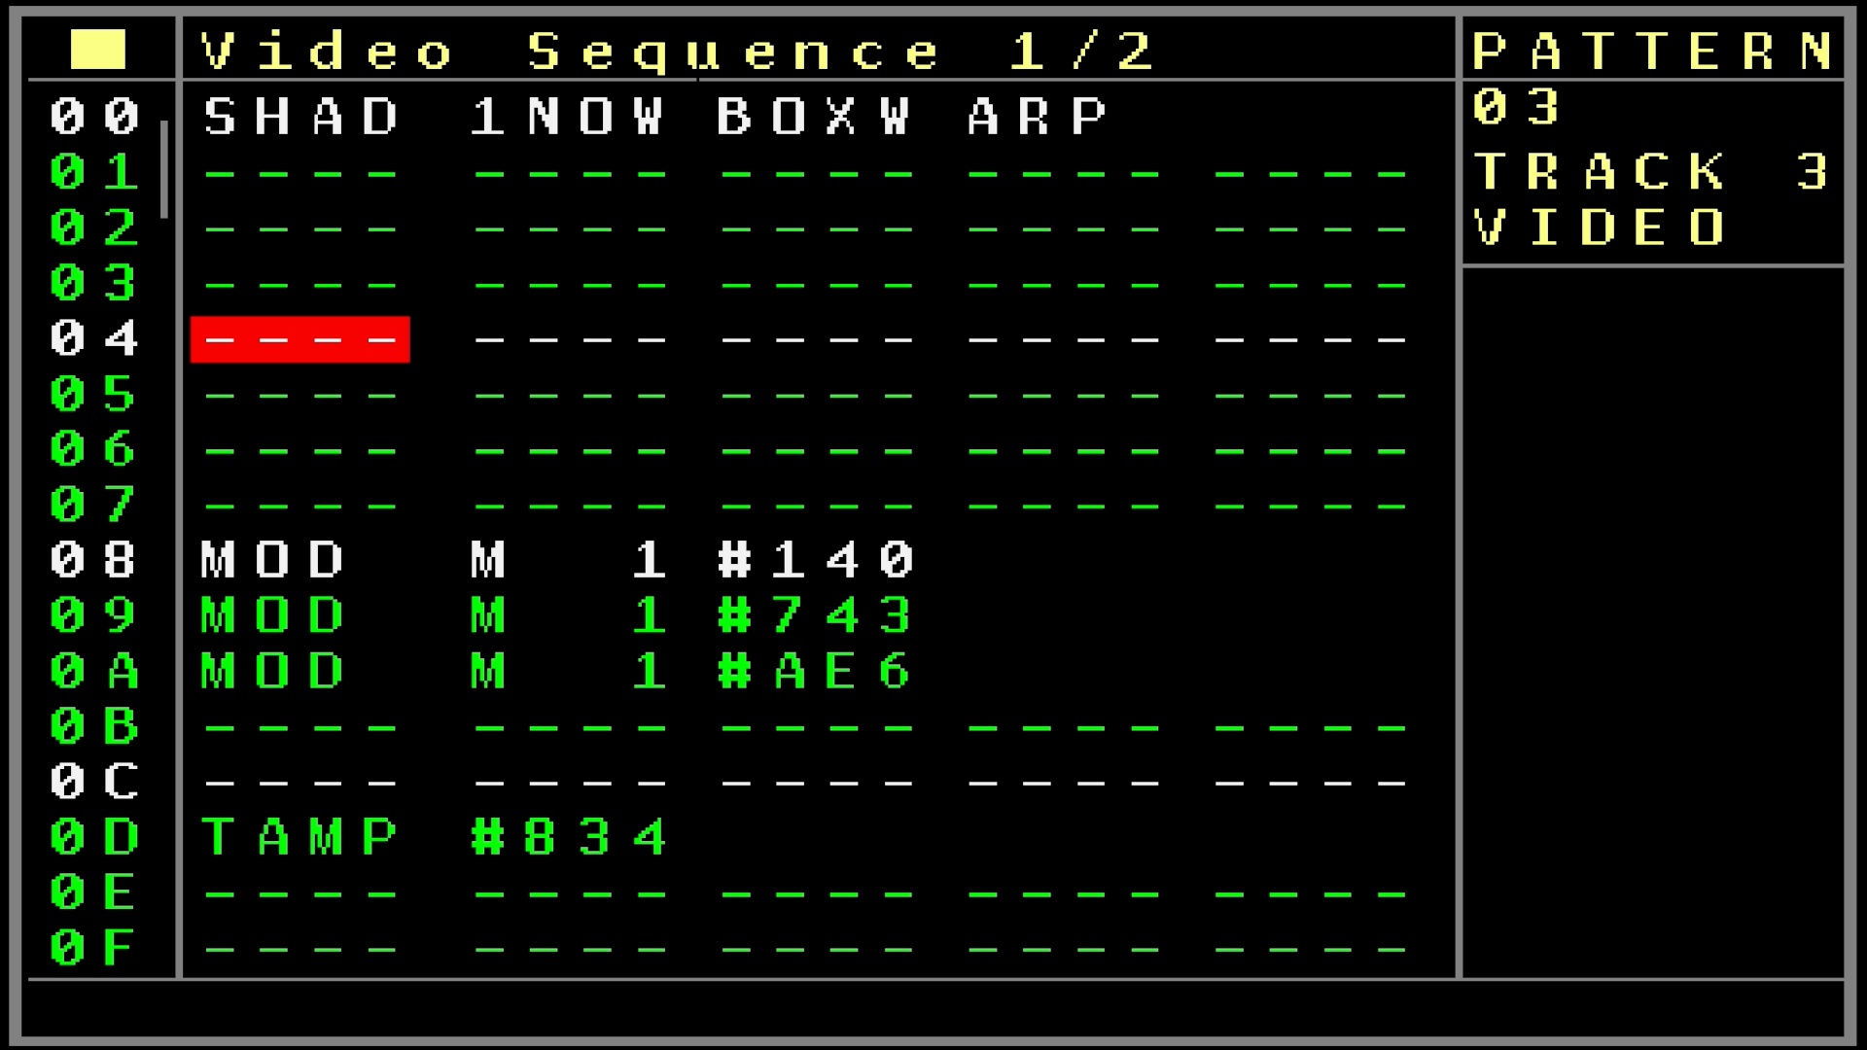
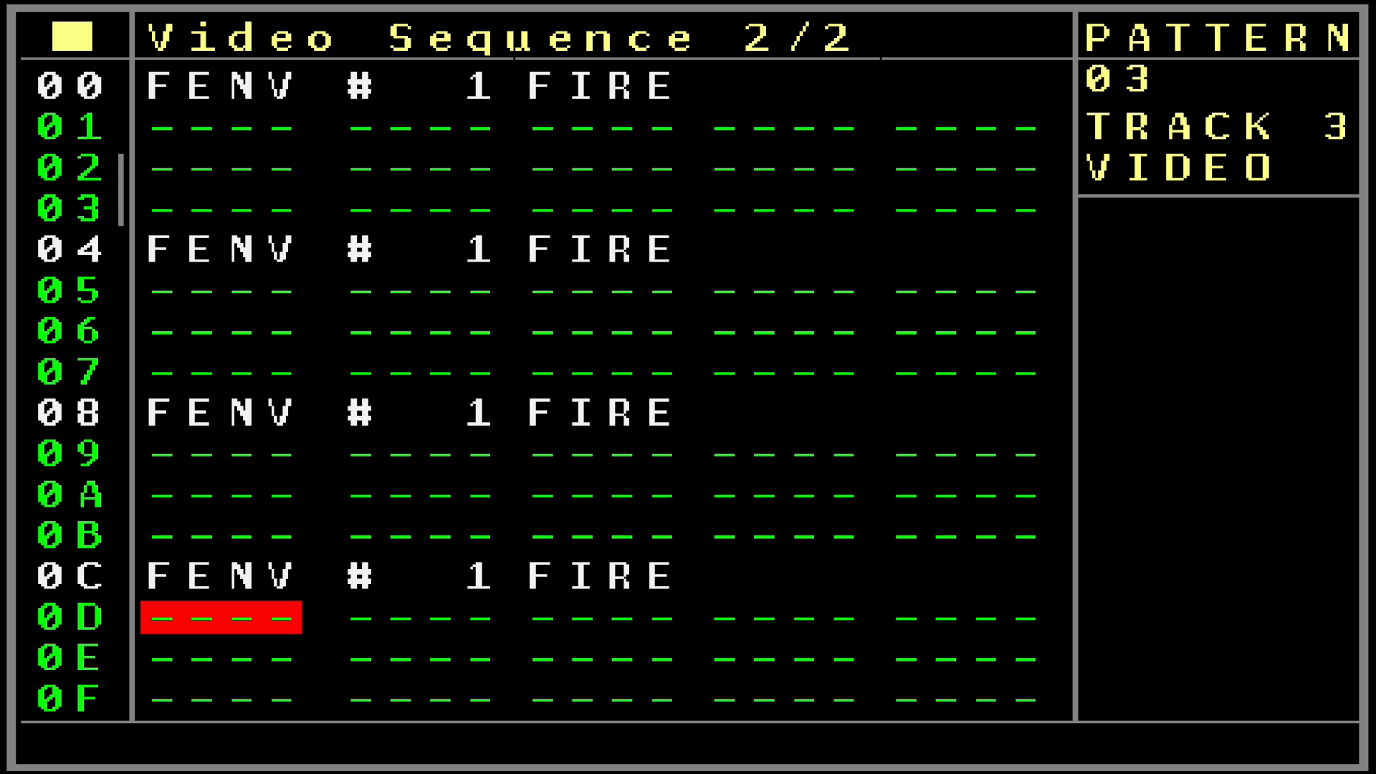
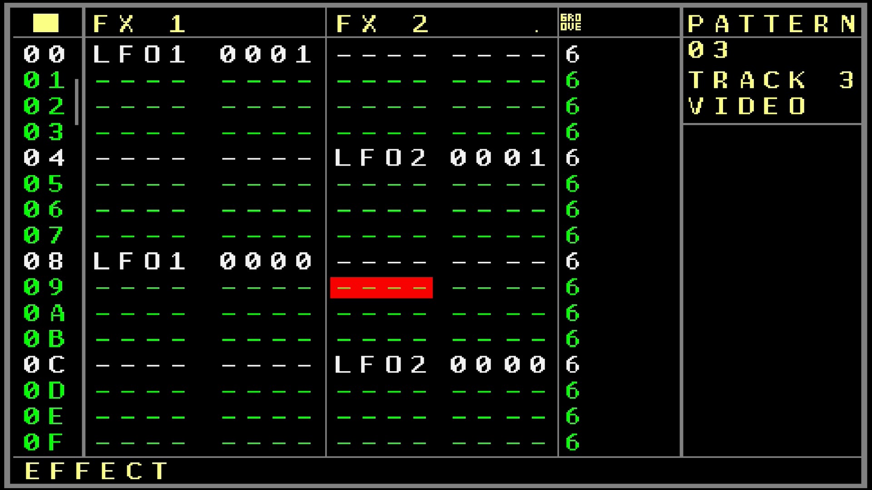

- First the sequencer column to indicate the 16 visible rows.
- The next 5 columns are combined columns for each 1 Video command. They do need 1-5 columns for their parameters and so you are mostly able to edit multiple columns for the command. The 2nd column always defines the command:
- SHAD Start/Stop the selected shader cued or directly. The settings show either ‘OFF’ to turn the shader off (return to the screen clone) or one of the 8 shaderslots. The additional column shows if the shader should be stopped/starten directly ‘NOW’ or cued ‘CUE’. Cued means that the desired function will be active on the sequencer zero cross.
- MOD Sets the selected Modulator of the current shader to a value. You can change the modulator in the 3rd column to one of the 16 possible modulators and the value in the 4th column. The statusline shows the real value that the modulator will receive in the +-1.000 range. Of course only the modulators that the shader supports will show any effect on sequencing. Others will just be ignored.
- POS Sets the X/Y position for the current shader (if supported by the shader). The 3rd column defines the X or Y position and the 4th column the value. (Statusbar for +- 1.000 range)
- TAMP Sets the multiplicator for the time amplification (has effect if the Time Amp is set to free) with the multiplicators from -20.00 to +20.00
- APLH Sets the alpha mix (transparency) of the shader (if supported)
- FENV Is the fire envelope command. The 3rd column defines which shader enveloped should be started ‘fired’ and with the 4th column you can either set or reset the envelope gate, or just fire it.
- SENV Sets the shader envelope Attack, Sustain and Release settings.
- LFOA Is the first part for the shader LFO settings with the waveform, speed and amplitude settings
- LFOB Is the 2nd part for the shader LFO settings that include the Offset and the Phase of the selected shader LFO
- FPS Sets the Frames Per Second for the current running shader-animation
- RESO Sets the resolution for the current running shader (use with caution as described in the video project settings)

Right after these commands they are the classic commands to generate simple primitive graphics. These graphics and text are drawn on the basic surface which is the same surface that clones the general NerdSEQ screen. So you could use transparency between the shaders and the graphics/text.
Please be aware that these commands are still experimental!

MODE → This setting switches between the regular cloning of the screen or to a surface where only graphics drawn by the following commands are shown.
COL → Change the color (RGB) of text foreground, background or the ‘pens’.
Set X/Y → Set position to X/Y for text, shapes or pens
SPEN and PEN are not integrated properly at the moment
LINE → Draw a line from one X/Y coordinate to another X/Y coordinate
CRCL → Draw a circle with radius (Filled and not filled) to the X/Y coordinate
RECT → Draw a rectangle from the top left X/Y to the bottom right X/Y coordinates
BAR → Draw a filled rectangle from the top left X/Y to the bottom right X/Y coordinates
FILL → Fill screen with a defined color
SFNT → Set font, fontsize (with backgroundcolor or transparent)
TEXT → Draw text (4 letters max now, since they are 2 command columns you can for now draw 8 letters per step per track)
SURF → Add or Sub color from surface. (could be used to generate a fade to color/fade out effect)
The further commands are currently not implemented.

They are 2 sets of these columns/functions available per pattern. If you scroll to the right you can get to the 2nd screen which show the 2nd possibility to add these commands.
Further to the right you reach the last parts which contains 2 FX columns and the groove column.
Description of the FX commands:
SHAD → Start or stop shaders either directly ‘NOW’ or cued with the zero-cross of the mainclock
MD 1..16 → Set the modulation value for the shaders where the first digit defines either the current running shader or a selection of shader 1..8. The last 3 digits define the modulation value
POSX/POSY → Set the shader position. The first digit defines again the shader and the last the value.
TIME → Sets the time amplify/multiplicator. First digit = shader select. Last digits: Multiplification
ALPH → Sets the alpha/transparency for the shader (1st digit=shader select).
ENV1..8 → Envelope settings for the shader (1st digit=shader select). The 2nd digit defines the functions:
0 = Gate ON/OFF/Fire, 1 = Attack, 2 = Sustain, 3 = Release, 4= Offset, 5 = Source, 5 = Type. The last 2 digits define the values.
LFO1..8 → LFO settings for the shader (1st digit = shader select). The 2nd digit defines the functions:
0 = Type: Off/Free running/Synchronized , 1 = waveform (sine, triangle, pos.sawtooth, neg.sawtooth), 2 = Speed, 3 = Amplitude, 4 = Offset, 5 = Phase
FPS → Frames per second
RESO → Resolution (1st digit = shader select). Handle with care as described in the video project setup.

Nearly all commands from the first 2 screens as well as the FX commands that involve the shader functions do work like a knob which means that if you change a value then it stays on this value until you change it again.
All further parameters are exactly the same as for the FX commands of the Modular CV/Gate tracks and so all functions of the local tracks can still be used. The only difference are the probability settings which do belong to the Video Columns 1 and 2 and the FX probability.

Groove → Apply groove settings just as for the other tracks (see CV/Gate Pattern screen for description)

The general playback of a Video pattern row is using the following order:
FX1 > FX2 > Columns on screen 1 > Columns on screen 2

Technical/Developer Shader Information

As described before the shaders support the OpenGL ES 2.0 standard and the GLSL language (which is basically c with dedicated GPU accelerated functions) .
The file format for your own shaders got to be “filename.frag” while I suggest to use short filenames so they are still readable in the NerdSEQ screen fields.
If you use only a ‘fragment’ shader then a default ‘vertex’ shader will be included. But you can also use your own vertex shaders by using the same filename for the vertex shader with the .vert extension → “filename.vert”
A basic sketch for this standard (as in the easiest shader program) would be as the following:

#ifdef GL_ES
precision mediump float;
#endif

uniform vec2 u_resolution;
uniform vec2 u_mouse;
uniform float u_time;

void main()
{
vec2 st = gl_FragCoord.xy/u_resolution.xy;
gl_FragColor = vec4(st.x,st.y,0,1.0);
}

Note that these variables/definitions are important (and often different in other OpenGL versions/implementations):
uniform vec2 u_resolution;
uniform vec2 u_mouse;
uniform float u_time;
The variables/vectors are named with the ‘u_’ prefix like ‘u_resolution’ or ‘u_time’. Be aware that for example shadertoys variables got the ‘i’ as a prefix like ‘iTime’, iResolution’...and so on. You would need to change these into the ‘u_’ prefix

The Main function must be defined like this:
void main() or void main(void)
And these got no ‘IN’ or ‘OUT’ function parameters like with other OpenGL definitions.
The fixed IN (fragment coordinates) and OUT (pixel color) definitions use fixed names:
gl_FragCoord
gl_FragColor
Also here you might need to change to these depending on the shader.

The NerdSEQ/VEX implementation uses the following standard variables/vectors/uniforms:

uniform vec2 u_resolution; (Resolution % based on the screen)
uniform vec2 u_mouse; (Position X / Y values from -1.0 to + 1.0)
uniform float u_time; (Time elapsed since shader start but can be manipulated using the shader time commands)

Additionally to these ‘standard’ parameters the NerdSEQ got these additional input variables to allow a deeper manipulation:
uniform float u_alpha; → use this to define the alpha/transparency between the shader and the regular NerdSEQ screen/graphics.
This value goes from 0 (NerdSEQ screen only) to 1.0 (shader only).
You would usually use it like this in the output parameter:
gl_FragColor = vec4(red,green,blue,u_alpha);

uniform float u_modulator1;
…
uniform float u_modulator16;
These are the input variables that can be manipulated through the NerdSEQ sequences and settings. This floating point value got a range from -1.000 to +1.000.
Please be aware that the highest number of ‘u_modulator’ will be used as the amount of available modulators in the Video Project Screen.
In case you are interested to develop your own shader-animations then I suggest this great little tutorial video which covers a general explanation about the basics as well as a full development guide to a nice running shader: https://youtu.be/f4s1h2YETNY?si=5Hnxege8Y48gYPWu
Also this online book helps you through the begin and gets deep later on: https://thebookofshaders.com/
At last, an easy way to develop your shaders and try them directly in the browser would be the online-editor from the book of shaders: https://thebookofshaders.com/edit.php
There you can edit and test on-the-fly and the shaders are likely to work also with the VEX (depending of course on the shader itself, processing power etc).

Good to know: Avoid ‘for’ loops with many loop iterations as these increment the processing time and might cause performance issues. Especially ‘for’ loops that would loop many ten/hundred times will most likely not work properly with the VEX. If there are syntax errors in the shadercode then the VEX does it’s best to show you the error and line where the error occurred.
Be sure you rename every shader iteration with a postfix like dance1, dance2.. etc because if you loaded dance1 already and just change the code and load it again it will not update the shader on the VEX but keeps using the old one. Renaming it will assure that it will compile into a new fresh memory/gpu space. Only a power-cycle/reset of the vex will remove
If you use shaders that you downloaded somewhere then you should be aware that there might be some licenses involved that allow/deny any commercial/noncommercial use or sharing. Often the type of license is integrated in the shadercode or mentioned on the site you got them from.
Please share your creations on the XOR Userforum so more people can enjoy/use them.

Video (Hardware) Setup Screen

The Video Setup screen does set up the Video Expander (VEX) Hardware. (Mainly video modes, screen adjustments etc).
To get there you enter the Setup screen and select ‘Video Expander’. If the setting is set to ‘USB’ or ‘Clone’ then you can enter the Video Setup Screen by pressing OK.
The following settings which are automatically saved on the VEX are available:
Scaling Setting → This sets the kind of scaling / aliasing / interpolation of the video pixels. Use this to get a better/sharper screen when using with composite. The following settings are possible: Nearest (which is the default for HDMI), Sinc, Blackman, No Side Lobes, Half 1st Side Lobe, Hamming, Hamming 3PI, Hamming 5PI.
Please be aware that these settings got also impact on the HDMI video. Also if you especially want to run shaders which should be in ‘pixel’ style with a low resolution then you should stick with nearest as all others would interpolate in a way between the pixels.
Overscan Left/Right/Up/Down → Adds or removes the amount of pixels to/from the left/right/up/down while stretching/shrinking the real screen content. If your screen output is partly out of the screen or maybe in a wrong horizontal/vertical ratio or position then you can use this to apply the needed correction to get the screen as it should look like. (Like many HDMI screens got a 16:9 ratio and the NerdSEQ screen will be horizontally stretched then to fill the whole screen which might look a bit ugly with wide strechted letters. You might want to add Left and Right overscan then to adjust that then.)
Please be aware that the shader animations are not affected by the overscan settings.
Force HDMI → HDMI is always enabled regardless of if a screen is connected or not. Be aware that if no screen is connected, then a different resolution might be automatically selected and used.
HDMI Safe Mode → If turned off, then the upper settings will affect the screen behaviour. If turned on, then HDMI standard settings with a 640x480 resolution are applied. This can be used for basic testing in case you don’t get a picture on the screen.
HDMI Boost → Use this if you need a stronger HDMI signal (for example if you use very long cables and the default setting doesn’t work as expected). Keep it to default (which is setting 4) if you just connect a screen with a normal short cable. Values go from 1 (lowest signal) to 11 (strongest signal for very long cables). We give no warranty and take no responsibility for any damage happened to your HDMI screen if you used too strong signals.
HDMI Resolution Group → If set to auto detect then the VEX will try to use the setting of your HDMI screen that the VEX received on startup. Furthermore they are the CEA and DMT settings which are 2 groups for different screen resolutions. These will force the HDMI screen to work with the selected resolution (if possible). If the Group is set to CEA or DMT then the Mode can be selected with the following setting:
HDMI Resolution Mode → Depending on the group different resolution settings can be selected. Please check this document to see all possible screen resolutions:
https://github.com/XORElectronics/nerdSEQ_docs
Note that most probably not all resolutions are possible with your HDMI Monitor/Beamer.
The selected resolution affect also your shader performance.
Composite Mode → Choose the video system of your used TV/Monitor: Normal NTSC, Japanese NTSC, Normal PAL (default), Brazilian PAL, Progressive NTSC, Progressive PAL
Composite Aspect → Select the aspect Ratio for the composite signal: 4:3 (default), 14:9, 16:9
Save and Restart → Press OK to save the settings. The settings will be stored in both the Video Expander and the NerdSEQ. The Video Expander will be then restarted with the new settings.

Patch Screen

Patches are presets that can be set on every sequencer step. The patch types consist all FX types that the assigned Track is capable of. So when a value is entered in the patch column and the sequencer passes the row, all active values of this patch will be set.
Sometimes people call this a macro. In general this contains your knob positions which can be called back at any time if wanted. Patches are available for all track types. You can enter the patch screen from the pattern screen by pressing the PATCH button. The column with the tuning fork is for the patches. The Audio tracks don’t have a Patch column but here, just like also with all other tracktypes the patches can be created, selected or cloned from the FX column. On the patch column or the track fx Patch type you either press OK to generate a new patch or select an available patch. With SHIFT+OK a Patch can be cloned into a new patch. To enter the patch screen you navigate to the patch number and press the patch button (or OK if enabled). You will get then to the patch screen with on the left side the different functions/parameters and on the right side, the selected parameter value (kind of progress bar covered by the current and maximum value. On top of this part you can always see also the decimal value as well. In the middle is either a ‘progress bar’ which shows the current selected value of the ‘effect’. If there is no progress bar then this effect is disabled and will be ignored when the patch is being executed. Your Patch can so contain and manipulate only selected effects but will keep others untouched.
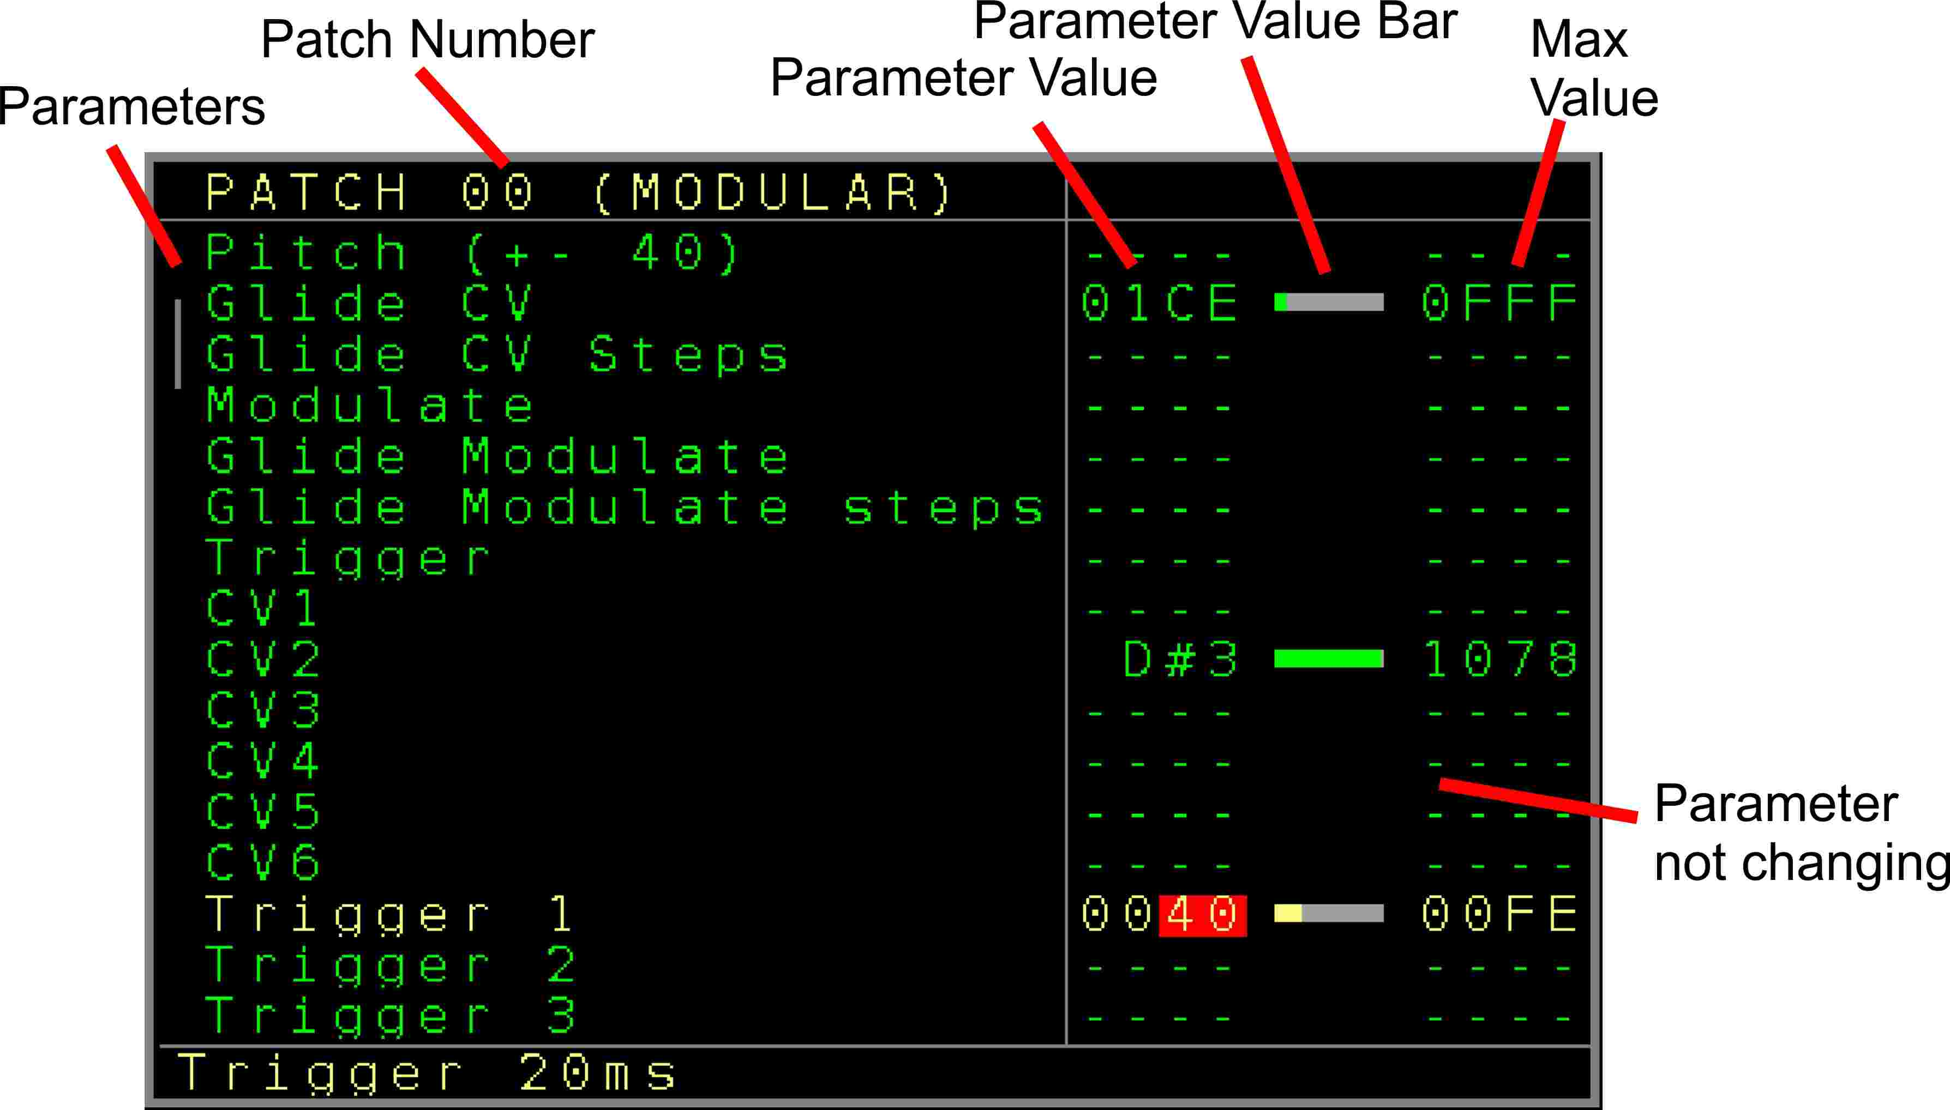
Figure 17: Patch Screen

You can navigate up/down and change the values with SHIFT LEFT/RIGHT/UP/DOWN.
To disable a value so it is not changing the parameter when the patch is being called you use SHIFT+DELETE.

You can pre-listen the current selected FX/Function by pressing OK. Use SHIFT+OK to pre-listen the complete patch. Not all patch effects can be pre-listened as they rely on the current playback.

In the → Nerd Screen / Menu ( SHIFT+NERD ) you can choose to add a patch name which helps to identify different patches.

Current Values Screen
The current values screen shows the recent values/settings of the current track.
It can be accessed from the → Sequencer Screen or the → Tracks / Patterns (if not on the patch column and not on CV16 Pattern screen) by pressing the PATCH button.
The screen is updating live and all values can directly be manipulated by selecting the needed parameter and change the value by using SHIFT+ UP/DOWN/LEFT/RIGHT
Your current value will be overruled if the sequencer is running and the value is being changed by the sequencer. Beside the parameter change, some values can also be started/triggered with this feature. For this you use the OK button to start/trigger the parameter/function.

Be aware that the current settings are the real settings without any post-modulations.

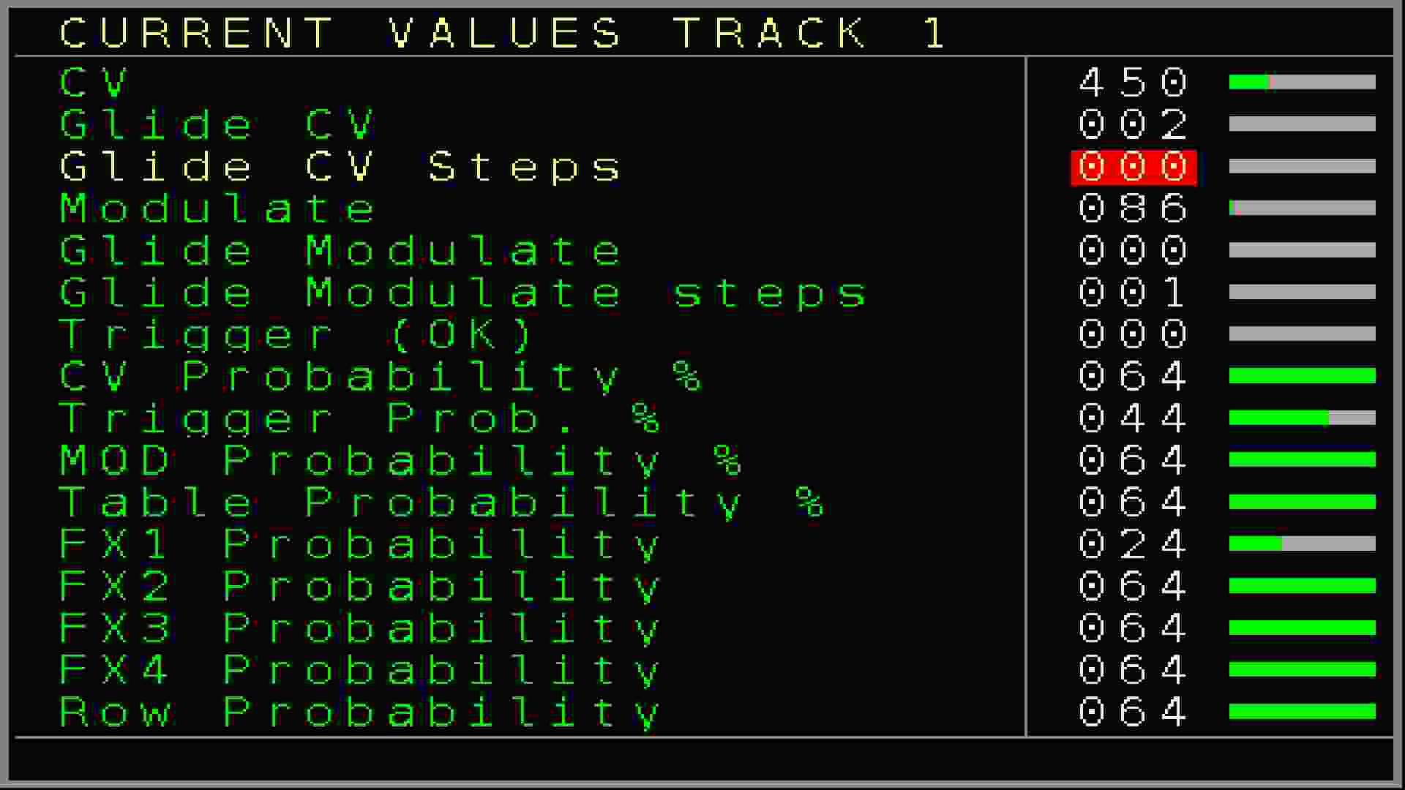Figure 18: Current Values Screen

Current values of a CV/TRIGGER/MOD track:
CV → Current CV value (not the note value)
Glide CV → Current Glide setting for the CV
Glide CV Resolution → Current Glide Resolution setting for the CV
Modulate → Current MOD value
Glide Modulate → Current Glide setting for the MOD
Glide Modulate Resolution → Current Glide Resolution setting for the MOD
Trigger → Current/Last trigger setting. Can be triggered with the OK button
CV Probability % → Current Probability setting for the CV
Trigger Prob. % → Current Trigger Probability setting
MOD Probability % → Current Probability setting for the MOD
Table Probability % → Current Table Probability setting
FX1 Probability → Current FX1 Probability setting
FX2 Probability → Current FX2 Probability setting
FX3 Probability → Current FX3 Probability setting
FX4 Probability → Current FX4 Probability setting
Row Probability → Current Row probability setting

Current values for the audio tracks:
Note 1 Probability % → Current probability settings for the note of the first sample/waveform
FX 1>1 Probability % → Current FX1 Probability setting for the first sample/waveform
FX 1>2 Probability % → Current FX2 Probability setting for the first sample/waveform
Note 2 Probability % → Current probability settings for the note of the second sample/waveform
FX 2>1 Probability % → Current FX1 Probability setting for the second sample/waveform
FX 2>2 Probability % → Current FX2 Probability setting for the second sample/waveform
ROW Probability % → Current Row Probability setting for the whole sequencer row

Current values of a Trigger16 track:
CV → Current CV value of the local track
Glide CV → Current Glide setting for the CV of the local track
Glide CV Resolution → Current Glide Resolution setting for the CV of the local track
Modulate → Current MOD value of the local track
Glide Modulate → Current Glide setting for the MOD of the local track
Glide Modulate Resolution → Current Glide Resolution setting for the MOD of the local track
Trigger → Current/Last trigger setting for the local Trigger. Can be triggered with the OK button
TR1+2 Probability % → Current probability setting for Trigger column 1+2 (including drum-matrix)
TR3+4 Probability % → Current probability setting for Trigger column 3+4 (including drum-matrix)
TR5+6 Probability % → Current probability setting for Trigger column 5+6 (including drum-matrix)
TR7+8 Probability % → Current probability setting for Trigger column 7+8 (including drum-matrix)
FX1 Probability % → Current FX1 Probability setting
FX2 Probability % → Current FX2 Probability setting
FX3 Probability % → Current FX3 Probability setting
Row Probability % → Current Row probability setting

Current values of a CV16 track:
CV → Current CV value of the local track
Glide CV → Current Glide setting for the CV of the local track
Glide CV Resolution → Current Glide Resolution setting for the CV of the local track
Modulate → Current MOD value of the local track
Glide Modulate → Current Glide setting for the MOD of the local track
Glide Modulate Resolution → Current Glide Resolution setting for the MOD of the local track
Trigger → Current/Last trigger setting for the local Trigger. Can be triggered with the OK button
CV1 Probability % → Current probability setting for CV column 1
CV2 Probability % → Current probability setting for CV column 2
CV3 Probability % → Current probability setting for CV column 3
CV4 Probability % → Current probability setting for CV column 4
CV5+6 Probability % → Current probability setting for CV column 5+6
FX1 Probability % → Current FX1 Probability setting
FX2 Probability % → Current FX2 Probability setting
FX3 Probability % → Current FX3 Probability setting
Row Probability % → Current Row probability setting

Current values of a Midi track:
CV → Current CV value of the local track
Glide CV → Current Glide setting for the CV of the local track
Glide CV Resolution → Current Glide Resolution setting for the CV of the local track
Modulate → Current MOD value of the local track
Glide Modulate → Current Glide setting for the MOD of the local track
Glide Modulate Resolution → Current Glide Resolution setting for the MOD of the local track
Trigger → Current/Last trigger setting for the local Trigger. Can be triggered with the OK button
Note 1 Probability % → Current probability setting for Midi Note 1
Note 3 Probability % → Current probability setting for Midi Note 3
Note 2 Probability % → Current probability setting for Midi Note 2
Note 4 Probability % → Current probability setting for Midi Note 4
FX1 Probability % → Current FX1 Probability setting
FX2 Probability % → Current FX2 Probability setting
FX3 Probability % → Current FX3 Probability setting
Row Probability % → Current Row probability setting

Current values of a I2C/Multi track:
CV → Current CV value of the local track
Glide CV → Current Glide setting for the CV of the local track
Glide CV Resolution → Current Glide Resolution setting for the CV of the local track
Modulate → Current MOD value of the local track
Glide Modulate → Current Glide setting for the MOD of the local track
Glide Modulate Resolution → Current Glide Resolution setting for the MOD of the local track
Trigger → Current/Last trigger setting for the local Trigger. Can be triggered with the OK button
COL1 Probability % → Current probability setting for Column 1
COL2 Probability % → Current probability setting for Column 2
MATRIX1 Probability % → Current probability setting for Matrix Column 1
MATRIX2 Probability % → Current probability setting for Matrix Column 2
MATRIX3 Probability % → Current probability setting for Matrix Column 3
FX1 Probability % → Current FX1 Probability setting
FX2 Probability % → Current FX2 Probability setting
FX3 Probability % → Current FX3 Probability setting
Row Probability % → Current Row probability setting

Current values of a Dualchord track:
CV → Current CV value of the local track
Glide CV → Current Glide setting for the CV of the local track
Glide CV Resolution → Current Glide Resolution setting for the CV of the local track
Modulate → Current MOD value of the local track
Glide Modulate → Current Glide setting for the MOD of the local track
Glide Modulate Resolution → Current Glide Resolution setting for the MOD of the local track
Trigger → Current/Last trigger setting for the local Trigger. Can be triggered with the OK button
COL1 Probability % → Current probability setting for Column 1
COL2 Probability % → Current probability setting for Column 2
COL3 Probability % → Current probability setting for Column 3
COL4 Probability % → Current probability setting for Column 4
Col Trigger Probability % → Current probability setting for Trigger Column 1
FX1 Probability % → Current FX1 Probability setting
FX2 Probability % → Current FX2 Probability setting
FX3 Probability % → Current FX3 Probability setting
Row Probability % → Current Row probability setting
The probability settings are always shown in the range of 0 – 100% here.

Table Screen
A Table is a kind of a sequencer in the sequencer. It can run next to your main pattern of the track and can be used for different purposes like generating arpeggios, generative sequences, manipulation of the main pattern, special ratcheting, off-step manipulation or FX execution, special gating sequences and much more...
Tables are also able to create their own sequences. A table sequences is basically 16 or less steps long (but they can be chained so longer table sequences are possible) and can be started from the table column within a CV/Gate, Midi and C16 track and via the Table FX command for all track-types.
All tracks can run their own table flexible switch / start / stop them.
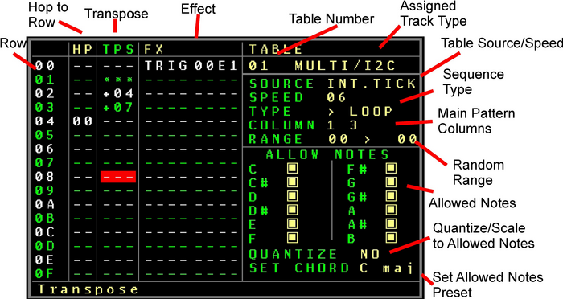
Figure 19: Table Screen

A table sequence can run synchronised to the main sequencer, can be free running without any relation to the sequencer tempo, can be clocked through the CV inputs, through the Automators, by the mappings or from the sequencer with a FX command. Additionally different time dividers and multipliers can change the table timings. Also a table sequencer can run with different sequencing directions/functions, forward, backward or pingpong. There can be only one running table per track. If you use different tables in your sequence on one track the table position will continue to run in the looping modes. Only the one-shot or resync tables will be reset to zero on table change. Multiple column of the main pattern can be used for transposition (note columns) or triggering (Trigger 16 columns). The used/affected columns of the pattern sequence can be set up per table. More info about that in the transpose column description.

A table screen has the following columns:
- HP → Hop. Here you fill in to which row the sequencer should jump (hop). So for the example in the picture, there is a 00 filled in on row 06. Which means when the sequencer passes row 06 it will jump back to 00. Note that it doesn’t play the row with the hop but jumps directly to the new row and plays it. In this case it will be a 6 step sequence (one shot) or it will iterate between the 6 steps if the loop setting is endless or restart.
Besides the ability to enter the row to jump to, there are 2 additional special commands.
RU → Random upper jump. Jumps to a random position higher than the last RU command.
So if a RU would be filled in on row 05, then it would jump to a random position between 00 and 04. Multiple RU commands can be added and the RU on the highest row defines the jump ‘range’.
RD → Random jump. This one jumps directly to any random position within the 16 rows.
The RD and RU commands can be found by either entering a value below 00 or by pressing SHIFT+DELETE multiple times (toggles between functions)
- TPS / TRG → Transpose / Trigger. This column got a different functionality depending on the tracktype. For a Trigger16 track it is being used to define the trigger it should play.
You can choose then between *** which means there should be no trigger/retrigger and the values 00 to FE which define the trigger/retigger type which are the same as in the trigger columns of a Trigger16 Track.
For all other tracktypes it will transpose the current playing note(s). As for the transposition it transposes the selected note of the current track by several semitones (in combination with one or multiple Note columns). Where ‘---’ means that there is no transpose, +1 would transpose 1 semitone higher +2, 2 semitones higher etc.
On the other side, every thing below will transpose by the semitones lower. So -1 for 1 semitone, -2 for 2 semitones etc…
While CV values and oscillator pitches are just being changed with the transposition, a Midi note will always be re-triggered since there is no such thing as note change with midi without a new Note Off and Note On. A Midi table will also always retrigger if there is no transposition defined like this: ‘---’.
Next to the ‘transpose by semitones’ functionality other special commands can be reached by pressing SHIFT+DELETE multiple times (toggles between functions):
RND → Randomize. This will generate a random transposition. Combined with this function is the ‘RANGE’ setting which sets the lowest and the highest random value range. With this you can limit the range to octaves or whatever range you choose. A random semitone transposition will then be chosen at the RND point.
>>> → This is a special command and it overwrites the current note by a note selected in the allowed notes part on the right side. Every >>> always takes the next possible allowed note. So you have for example 3 notes filled in as allowed, C#, E and A.
The first >>> would play C#, the second >>> would play E and the last one would play A. It is possible to create fixed arpeggio chords regardless of the main note playing.
*** → Avoid a retrigger. This command is available for Midi tables which will then not retrigger on this row.
The Transpose/Trigger column in combination with the selected/enabled columns will affect the following pattern columns (by tracktype):
Modular: Note and MOD (if used with notes) columns
Audio: Note1 and Note 2 columns
Midi: Midi Note columns 1,2,3 and 4
Multifunctional/I2C: Pattern columns 1 to 6 (if used with notes)
CV16: The 6 CV16 columns/destinations (if used with notes)
Trigger16: The first 6 Trigger columns (1-6 or 9-14 if swapped)
Video: There is no transpose functionality for the Video Columns
- FX → Effect parameters. All the possible effect parameters can be added here to enable full manipulation by using the tables. All FX values of the current track type are available. Use this for example if you want to create a ratchet effect for your notes by choosing the trigger as FX and placing these in the order of sequencing to play doubles, triplets etc.
With the Table FX another table can be started which allows table chaining if 16 Table steps are not enough.
Pressing the OK button on the FX command will bring you to the FX Selector menu where you can comfortably select the needed FX from a list.

Source → Defines the timing source for the sequence.
INT. Tick: The sequence ‘clock’ is derived from the internal main sequencer ticks. (6 ticks/step)
INT. Time: uses the tables own clock. It can run faster than the Int. Tick, but it has no relation to the main clock tempo / bpm
PTN-MAP: The table clock gets it’s ticks from the FX functions of a regular pattern (SPFX 0011) or from the mappings.
AUTOMAT 0..7: The table clock gets it’s ticks from one of the Automators. A tick is generated by the zero crossing of an Automator.
CV IN 1..4: The table clock gets it’s ticks from a raising edge of the selected CV input.

Speed → is the multiplier/divider.
A setting of 1 will trigger the next step in the table sequence with every clock. A setting of 6 will trigger the next step every 6th tick which is the same standard speed for a regular step in the main sequencer. So with lower settings the table sequence will run faster while higher settings will let it run slower.
Type → Defines the type of the sequencing itself:
> Resync: the table runs forward endlessly in a loop but is being restarted every time the sequencer passes the table command. It stops when the table is being stopped or when the complete sequencer is stopped. It does continue to run if only the track is stopped.
> Loop: the table runs forward in a loop but is not being restarted by the table command. It stops when the table is being stopped or when the complete sequencer is stopped. It does continue to run if only the track is stopped.
> Once The table runs forward and only 1 time and stops then
< Resync: Same as the forward Resync, but the sequence runs backwards.
< Loop: Same as the forward Loop, but the sequence runs backwards
< Once: Same as the forward Once, but the sequence runs backwards (starts from end or first HP)
>< Loop1: The table runs in a ping pong loop. If it would be set like in the example picture, it would run the following sequence: 00,01,02,01,00,01,02… and so on
>< Loop2: The table runs in a ping pong loop. If it would be set like in the example picture, it would run the following sequence: 00,01,02,02,01,00,00,01,02,02,01,00… and so on
>< Once: Runs the ping pong sequence as in Loop1, but only once ( 00,01,02,01,00 ).
Column → Defines which (note) columns should be affected by functions of the table transpose column. Up to 6 columns can be selected. The columns refer to the columns in the main pattern. A Midi track for example got 4 note columns which you can manipulate individual with the column setting in the table.
Range → as mentioned before, defines the transposing range of random values. Change the lower value with SHIFT + LEFT/RIGHT and the higher value with SHIFT + UP/DOWN.
The part below adds a special scaling to the transpositions. While transposed to a note, it can also be fixed to one of the allowed notes. It will choose then the nearest note of the allowed instead of the transposed note. The way it chooses the nearest note can be changed in the Quantize setting. The allowed notes can each be selected by SHIFT + RIGHT/UP or deselected by SHIFT + LEFT/DOWN.
Quantize setting:
NO: Notes are not quantized to the allowed notes. Normal regular transposition with all possible notes is set.
UP: The next higher note of the allowed notes is taken. For example if the new note after transposition is a E-5 and the allowed notes are C, F# and A then the note will be scaled to the next upper → F#5 note.
LOW: The next lower note of the allowed notes is taken. For example if the new note after transposition is a E-5 and the allowed notes are C, F# and A then the note will be scaled to the next lower → C-5 note.
COIN: The coin decides randomly if either the next higher or the next lower note will be chosen.

Finally the SET CHORD function can set the allowed notes directly to the chosen Chord. The Chord note can be changed using SHIFT +UP/DOWN and the chord type (Major, Minor, diminished, 7th) can be changed using SHIFT LEFT/RIGHT. The selected chord can be activated by pressing the OK button. The allowed notes change then to the chord settings. Holding the OK button while changing the chord will result in a direct change of the allowed notes. The value of the SET CHORD function is just a kind of preset which sets the allowed notes. Every kind of chord value can be filled in there while the allowed notes show something different. It always needs the OK button for the SET CHORD to be activated.
Nerd Menu / Table Presets:
For ease of use, many standard tables can be inserted as a preset. Use the → Nerd Screen / Menu in the table screen (SHIFT+NERD) to get to the presets. Navigate down to the option Preset > xxxxx
Choose one using SHIFT+LEFT/RIGHT and press OK, it will be inserted into the current table.
The following presets are available:
Empty: Clears the content of the table
Random: Inserts a random transpose sequence with also a hop 00 on a random step. The random transposition range is selected by the Range (lowest and highest transposition note)
Doubles: Inserts FX commands to create a double (ratcheting) for the main sequence. This creates a double trigger/gate (or envelope trigger) for the main sequence in a step. As a result, a note is then equally 2 times triggered in one step. Note that this preset also changes the table clock and type settings so the timing and sequence is correct.
Triplets: Same as doubles, but this inserts 3 equal trigger/gates for a step so triplets can be played.
The following are standard chords with 3 or more notes:
Triads → Major, Minor, Diminished, Diminished 5th , Augmented, Suspended 4th , Suspended 2nd
7th Chords → Dominant 7th , Minor 7th , Major 7th , Minor Major 7th , Suspended 7th , Augmented 7th , Augmented Major 7th , 7th Augmented 9th , Half Diminished 7th , Diminished 7th , 7th Diminished 5th , 7th flat 9

6th Chords → 6t^{th}, Minor 6
9th Chords → 9th , Minor 9th , Major 9th , 9th Diminished 5th
11th Chord
13th Chord

Edit Table Name: Enter this to open the on-screen keyboard and enter a name for the table. A table name will appear on the top right position.
Release Table: This will empty and release a table from a track type, so it can be newly assigned.

Good to know: Use the ‘Compact Tables’ command in the → Setup Screen to release all unused tables automatically. Keep in mind that tables with content (something in the transpose, hop or fx column) will not be released. This is to avoid the deletion of prepared tables which are temporarily not used. To release those anyway, you need to release them in the → Nerd Screen / Menu from the table screen.
You can simply navigate between all tables by holding the TABLE button in the table screen and CURSOR UP/DOWN.

Next to the sequencer row you can see the table animation which shows on which step the table is playing right now on the available tracks. This gives also an orientation on how the sequence is running.

Good to know:
- You can create nice FX effects by using the Add/Sub/Mul/Div commands and let these calculations happen on a table base. For audio this can create a time-stretching or granular effects.
- For a Midi track a special Velocity Overrule FX has been added which dan create Midi Delay or fading effects in combination with the Midi retriggering of a table and a decrementing or incrementing Velocity FX

Automator screen
The Automator screen contains up to 8 possible slots for Generators / Modulators / Effects / Manipulators. An Automator can currently be an LFO, Envelope, or a CV Input. You can assign an Automator to any of 8 Slots. The output of the Automator can be routed to several functions, outputs and more through a modulation matrix. In the matrix there are the 8 Tracks as destinations and in the matrix you can decide which of the setting / function / output of the track should be modulated by the Automator. Be aware that automators can also generate negative values (e.g. the lower curve of a sine-wave LFO) and for most destinations the values are scaled added depending on the destinations maximum value.
Figure 20: Automator Screen

On the top part of the screen are the 8 slot – rows. From the left the slot number, followed by the assigned function (empty if no function is assigned to the slot). Next is the indication whether this slot/function is running or not. The 8 tracks next to it define to which function of the track the output is ‘routed’. In the picture you can see that the LFO in slot 0 is routed to the MOD output of Track 3. In fact, in the picture an LFO is modulating the Physical MOD3 output. In the middle of the screen you can see the animation of the currently selected Automator.
The lower part shows possible settings of an Automator. The screenshot shows the LFO with all it’s settings.

For the current version these are the following Automator functions:
- LFO
- Envelope
- CV Input/Output

The destinations in the modulation matrix for the CV/Gate tracks are:
- CV Output → modulates the function onto the CV output
- MOD Output → modulates the function onto the MOD output)
- Trigger Length → overrules the next trigger setting with a ON/OFF trigger where the length of the trigger is decided by the Automator output (10 .. C0)
- Delayed Trigger/Gate length → overrules the next trigger setting with a OFF/ON trigger / gate where the length of the delay is decided by the Automator output (01 .. 0F)
- FX1..FX4 Overrule → Overrules the next FX of the defined FX column by the value of the Automator
- CV Glide → Manipulates the Glide setting for the CV output
- CV Resolution → Manipulates the Glide Resolution setting for the CV output
- MOD Glide → Manipulates the Glide setting for the MOD output
- MOD Resolution → Manipulates the Glide Resolution setting for the MOD output
- CV/Trigger/MOD/Table/FX1..4/Row Probability → Manipulates the probability settings for the defined FX
- Step Overrule → Overrules the current step in the currently playing pattern. This is an experimental function.
- Gate → Sets or resets the gate of the selected track. If the automator value is higher than 0 then it Sets and if the automator value is lower than 1 then it resets the Gate.
- Trigger → Nearly the same as Gate, but instead of gating only a trigger is generated on the low-high iteration

The destinations for the audio tracks 7+8 are:
- Pitch → Modulates the pitch of the current playing sample/wave for either the first or the 2nd sample/wave in the pattern screen
- Volume → Modulates the Volume
- Bitcrush → Modulates the bitcrush settings
- Distortion → Modulates the distortion settings
- Position → Manipulates the current sample offset/position (funny time stretching effects are possible with that). In combination with a pulse wave, it modulates the pulse width
- Wavefold → Manipulates the wavefold settings of the sample/waveform
- Overrule FX1..4 → Overrules the next FX value
- Probability % → Manipulates the probability settings for the Samples 1/2
- Probability FX → Manipulates the probability settings for the defined FX
- Probability Row → Manipulates the probability settings for the whole track row
- Overrule Steps → Overrules the current step in the current playing pattern part. This is an experimental function.

All audio destinations are for either the 1st or for the 2nd sample/wave of an audio track except for the row probability which is for both.

The destinations in the modulation matrix for the Midi assigned tracks are:
- Pitchbend → Sends pitch bend data to the midi device.
- CC1..8 → Sends CC data to the controller numbers which are set up in the midi track settings
- NRPN1..4 → Sends NRPN data to the controller numbers which are set up in the midi track settings
- Note overrule → Not implemented yet
- The rest are the same as a regular CV/Gate track with the following exceptions
- probabilities are set to the midi note and fx groups.
- Local Gate and Local Trigger as destination are not included (yet)

Be aware that Automation data to Midi can generate a huge amount of data which might be too much for your midi device to work properly or generate a midi data traffic jam and so other important data can be missed. It depends on the device and on the amount of data that is being produced. For that reason there is a setting in the midi track settings which allows to reduce the generated midi data from Automators. With it the data can be throttled from 100% to 50%, 25%, 10%, and 5%. It is advisable to apply the lowest acceptable value. Mostly settings of around 10% are more than good enough for nice modulations. But of course it always depends on what is being controlled and the automation data that is generated.

The destinations in the modulation matrix for the ‘More Triggers 16’ expander assigned tracks are:
- Trigger 1..4 Length → Overrules the next trigger (trigger of the expander) setting where the length of the trigger is decided by the Automator output (10 .. F0)
- Delayed Trigger/Gate 1..4 length → overrules the next trigger (of the expander) setting with a OFF/ON trigger / gate where the length of the delay is decided by the Automator output (01 .. 0F)
- Triggers Galore → Sends triggers (the triggers are as set up in track setup) to the trigger outputs of the current position of the Automator output.
- Triggers Square 8 → Uses the Automator output to set and reset Trigger output 8 (or 16 if swapped). If the Automator output is higher than 0 then the output is being set and if lower 0 than the output is reset. Only applies to outputs 8 or 16!
- The following destinations are the same as a regular CV/Gate track with the following exceptions
- probabilities are set to the tigger output and fx groups.
- Local Gate and Local Trigger as destination are not included (yet)
- Trigger 1..16 Gate – Sets a gate on the defined Trigger16 output if higher than 0, else it resets the gate
- Trigger 1..16 Trigger – Generates a Trigger on the defined Trigger16 output with every low – high iteration

The destinations for the CV16 tracks are:
• CV 1..16 → Modulates the function onto the CV outputs 1..16
• Column 1 Probability → Probability for Column 1 of the pattern screen
• Column 2 Probability → Probability for Column 2 of the pattern screen
• Column 3 Probability → Probability for Column 3 of the pattern screen
• Column 4 Probability → Probability for Column 4 of the pattern screen
• Column 5+6 Probability → Probability for Column 5+6 of the pattern screen
• FX1..3 Probability → Probability for the FX1..3 column
• FX1..3 Overrule → Overrules the values of the FX1..3 column
• Envelope 1..8 Attack/Sustain/Release → Modulates the envelope settings
• LFO 1..8 Type/Speed/Amplitude → Modulates the LFO settings
• Local CV → Modulates the local CV output of the track-setup
• Local MOD → Modulates the local MOD output of the track-setup
• Local Glide (CV/MOD) → Modulates the local glide settings
• Row Probability → Modulates the probability of the complete pattern row
• Local Gate → Sets and resets the local gate of the track

The destinations for the I2C tracks are:
- Column 1-6 Destination → Sends the data to the destination defined for Column 1-6 of the track
- Matrix 1-16 Destination Gate → Sets or resets a Gate (zero cross) to the destination defined for the Matrix 1-16 of the track
The following column probabilities are not implemented properly yet for this version:
- Column 1 Probability
- Column 2 Probability
- Column 3 Probability
- Column 4 Probability
- Column 5+6 Probability
- FX1, FX2, FX3 Probability
- FX1, FX2, FX3 Overrule
- Local CV
- Local MOD
- Local CV Glide
- Local CV Resolution
- Local MOD Glide
- Local MOD Resolution
- Row Probability

The destinations for the Dualchord tracks are:
- Wave1..8, 1-4, 5-8 Pitch
- Column 1 Probability
- Column 2 Probability
- Column 3 Probability
- Column 4 Probability
- Trigger Column1 Probability
- FX1,2,3 Probability,
- Row Probability
- FX1,2,3 overrule
- Stereo Deepness
- Wave1..8, 1-4, 5-8 Pulsewidth
- Wave1..8, 1-4, 5-8 Detune
- Wave1-4, 5-8 Spread
- Wave1..8, 1-4, 5-8 Triangle Mix
- Wave1..8, 1-4, 5-8 Sine Mix
- Wave1..8, 1-4, 5-8 Saw Mix
- Wave1..8, 1-4, 5-8 Pulse Mix
- Wave1..8, 1-4, 5-8 Morph
- Wave1..8, 1-4, 5-8 Glide
- Dualchord Trigger 1 Gate
- Dualchord Trigger 2 Gate
- Local CV
- Local MOD
- Local CV Glide
- Local CV Resolution
- Local MOD Glide
- Local MOD Resolution
- Local Gate

The destinations for the Video tracks are:
- Modulator 1..16
- Position X / Y
- Time Amplify
- Alpha
- Pen X/Y (beta, use with cause)
- Circle X/Y (beta, use with cause)
- Color Red/Green/Blue (beta, use with cause)
- Bar X/Y (beta, use with cause)
- Local CV/MOD
- FX1,2 Overrule
- Local CV Glide
- Local CV Resolution
- Local MOD Glide
- Local MOD Resolution
- Column 1,2, FX 1,2, Row probability

Please be aware that the Automator functions can generate a lot of data and if the destination is set to an I2C or any of the Expander destinations. Too much data might cause an overflow and data can get lost. So use the I2C / CV16 / T16 Track destinations from the Automators with caution.

You can change the Slot and Modulation settings by using SHIFT + LEFT/RIGHT.
Start and Stop toggle by pressing OK
Start by using SHIFT + CURSOR RIGHT
Stop by using SHIFT+ CURSOR LEFT

To get to the Automator settings below you can either press OK on the Automator function or use the DOWN button. To get back you use the UP button.

In the Automator settings you can navigate between the settings and change values with SHIFT + LEFT/RIGHT. For the LFO, if the cursor is on the RST field, then a LFO reset can be triggered by pressing OK.

Automator functions
The following Automator functions are currently implemented:
- LFO
A low frequency oscillator with several waveforms and many parameters. The LFO is continuously running but can be started/stopped through the slot start/stop.
There are 2 ways to manipulate the parameters of the LFO. 1st by using the Slot editor below in the automation screen. And 2nd through the Automator slot manipulation commands in the FX column of the sequencer.
LFO Parameters and characteristics:
- Waveforms: Sine, Triangle, Sawtooth, Pulse, White Noise, Pink Noise

- Clock sources:
- Free running
- Slow → Same as free running, except for that the speed is 100 times slower.
- Tick → Clock is synchronized to the sequencer ticks. If speed it set to 1, then one LFO waveform cycle has the same length as one pattern while the LFO advances with every tick.
-Pattern → Clock is synchronized to the pattern rows. If speed it set to 1, then one LFO waveform cycle has the same length as one pattern while the LFO changes with every pattern row (derived from main clock). The effect is kind of a stepped LFO
-Slot 0..7 → The clock is derived from the output of another slot. While the speed parameter works as a divider. This can be used to achieve a Frequency Modulation (FM) while the frequency is modulated from another slot.
- STP-MUL → Advances the LFO waveform with every main clock sequencer step with a multiplier. The Multiplier is being set in the Speed function.
- STP-DIV → Advances the LFO with every sequencer step divided by the divider which is set up in the speed field.
- TCK-MUL → Same as step, but mainly with a higher resolution with ticks.
- TCK-DIV → Also the same but with a divider.
- STP-SLT → Advances a step on the LFO based on the zero cross of another slot (which could be for example an external CV clock). The slot is selected with the speed parameter. (eg speed 1 means slot 1 as the source).
- n*STEP → Advances the LFO waveform n times per step (amount of times set via speed)
- STEPS → One full LFO waveform will last from one or multiple steps (amount of steps set via speed)
Please be aware that n*STEP and STEPS don’t run at the exact step times and so a reset (resync) of the LFO’s might be needed if you want to run them for a longer time. This is caused by the nature of the automators and its different refresh frequency. A reset / resync might be needed too after starting a sequence, since the LFO’s are free running and keep running also when the sequencer is stopped.

- Speed: Defines the speed / frequency of the LFO. If the clock is set to Tick, Pattern or Slot, then the speed value acts as a divider. Note that the speed for the noise waveforms has a different scale than the ones for the periodic waveforms.
- Amplitude (AMP): Defines the Range / Amplitude of the LFO. The value goes to F7 which is the max amplitude. Slot0..Slot7 can be defined as the source for the range. With that you can achieve Amplitude Modulation (AM).
- Offset: Adds or subtracts a DC Offset to the LFO waveform.
- Invert: Inverts the LFO Waveform
- Bit: Resolution of the LFO waveform. 1 bit to 12 bit
- Phase: Sets the Phase/Offset of the waveform. So when the LFO is started/reset it will start from this point in the waveform. In combination with the pulse wave it decides the pulse width.
- Rst X: Reset waveform resets the waveform to the start of the waveform or to be more precise, to the point of the phase of the waveform. Where reset X doesn’t have a source and can be reset only by pressing OK on the function or from the sequencer Automator FX functions (ASLx 101). You can further set the Rst X value from 0 to 7 which means that the reset will additionally be triggered by another Slot. To reset the Reset input needs a transition from at least 0 to 200 which is ca. 0,5 volt if derived from the 10 Volt range. Internally it means that the output of another Slot must have been 0 or lower and go to output values of 200 and higher. By using a CV input as another slot Automator, one can reset the LFO from an external source.

- CV Input / Output (CV I/O)
These Automators can use the CV inputs as well as the CV or MOD outputs as their source to route it to any of the Automator destinations or to another slots. This can be used to manipulate many internal values of the sequencer by an external source and by the current values of the CV/MOD outputs.
The following settings are available for the CV inputs:
- Source → CV input 1..4 uses the CV Input Jacks as an Automator source,
OUT CV1..6, MOD CV1..6 uses the CV/MOD outputs (same signal) as an Automator source. Be aware that it is the signal including a possible automator manipulation.
- Offset → Adds or subtracts a DC Offset to the Source
- Invert → Inverts the Source signal.
- Amplitude (AMP) → Defines the Range / Amplitude of the source. A value of F7 will use the full CV range of 0 to 10 Volt. Furthermore, the outputs of the Automator slots 1..8 can be used to manipulate the Range/Amplitude.
- Bit → Resolution/Quantisation of the Source. 1 bit to 12 bit

- Envelope
The envelope Automator function can manipulate and route the envelopes through the Automator functions and modulation matrix. Note that this is not an envelope generator within the Automators, but it rather uses the output of the integrated envelopes of the NerdSEQ to route into the Automators. With this the envelopes can be additionally manipulated and will also get the resolution of the Automators (within the Automators only, the normal envelope works as is). Use this to achieve some special effects with the usual envelopes or to route them in a different way through the modulation matrix. You can see the current curve of the selected envelope on the bottom right. You need to use the → Envelope screen to edit the envelopes curve.

The following settings are available for the Envelopes:
- Input → Chooses which envelope ( 1..8 ) should be used
- Offset → Adds of subtracts a DC Offset to the Envelope
- Invert → Inverts the envelope curve.
- Amplitude (AMP) → Defines the Range / Amplitude of the Envelope. A value of F7 will use the full Envelope range. Further the outputs of the Automator slots 1..8 can be used to manipulate the Range/Amplitude.
- Bit → Resolution/Quantisation of the Envelope. 1 bit to 12 bit

Please note, that the Automators LFOs or Envelopes can never replace a true analogue or digital LFO/Envelope module. The Automators have a limited resolution with all it’s side effects compared to those. However, they are still great modulation sources for any internal and external modulations.

Envelope screen

The NerdSEQ has also an envelope generator included which is capable of the generating 8 different ADSR envelopes. Each envelope got has functions to manipulate it’s curve and behaviour. To start the envelope, several internal and external sources can be used in flexible ways. Many internal functions and all external CV and MOD outputs can be set as destinations.
You can enter the envelope screen by pressing the AUTOMATE button when in the → Automator screen (the AUTOMATE button toggles between the automator and the envelope screen).
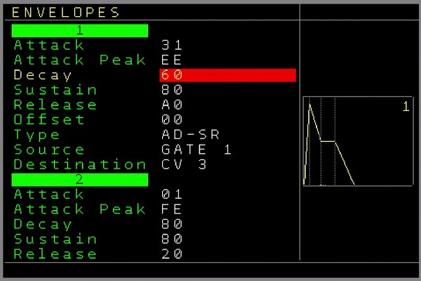Figure 21: Envelope Screen
In the envelope screen you can navigate between the 8 envelopes within it’s function. Using the UP/DOWN Button will jump directly to the next envelope. To change parameters use the usual SHIFT LEFT/RIGHT/UP/DOWN. All settings except of the Sources and Destinations will immediately be active. The Source and destinations will only be activated when pressing either the OK button on them or when leaving the envelope screen.

The following functions are available for each envelope:
Attack → Defines the Attack speed.
Attack Peak → Defines the maximum amplitude level of the attack phase.
Decay → Defines the decay speed.
Sustain → Defines the amplitude level of the sustain phase.
Release → Defines the release speed
Offset → Defines the start and the end level of the envelope. The Attack phase starts from this level and will either rise or fall to the Attack peak level. The Release phase ends on the offset level (also either by rising or falling, depending on the sustain level). Use the Offset to create more complex envelope curves, but be aware that an envelope will end on the offset level and it will stay there. Possibly a VCA may ‘stay open’ depending on the offset level and any waveforms can still be audible after the release phase if the offset is not set to zero.
Type → Defines way the envelope runs.
One Shot: Here the envelope only needs to be triggered/gated once and it will run the ADSR phases in one go: Attack → Decay → Sustain Level → Release. There is no pause at the sustain level and the release is being started directly after the decay phase reached the sustain level.
AD-SR: This will start the envelope with a Gate (or virtual gate generated internally → sources) signal and it stays in the sustain phase (after decay reached the sustain level) until the gate is released again. Keep also in mind here, if the gate was set, the release phase will be started immediately when the gate is reset. So if any phase was not finished, it will directly continue to release.
Loop: The envelope will keep looping (one flow as in the one shot way) the envelope as long as the gate is set.
Source: Defines the source from which the envelope can be triggered / gated.
Gate 1..6 will derive the trigger/gate from the tracks 1..6. ( for example, when playing a note on the track, a gate is (also) being set for the envelope, a note off will release the envelope if in AD-SR mode.
T7 Audio1,2 and T8 Audio 3,4: The start of a waveform or sample on track 7 or 8 (audio part 1,2,3,4) will ‘gate’ the envelope. If the sample is finished the gate is released.
A special reset gate command (***) in the note column of an audio track can release the gate before the sample/waveform is finished, which will start the release phase of the envelope while the sample continues to play.
A special note off command ( [ ] ) in the note column of an audio track can stop playback of the sample/waveform before it is finished and simultaneously start the release phase of the envelope if in AD-SR mode.
CV IN 1,2,3,4: The CV inputs can be used to set/reset the gate for the envelope.
ENV1..8 Start: The start of the selected envelope will also start this envelope. This can be used to have multiple envelopes start at the same time.
ENV1..8 End: When the selected envelope is finished, it will start this envelope. With that chained envelopes can be created.
Clone ENV 1..8: This will exactly clone the generated envelope so you can use it for multiple destinations. Note that all envelope curve settings have no effect here.
Destination: Defines the destination which the envelope should use/manipulate.
CV 1..6: The envelope will be routed to the CV outputs 1..6
MOD 1..6: The envelope will be routed to the MOD outputs 1..6
Volume 1..4: The envelope will act as a VCA on the selected audio channel (eg on samples/waves)
Pitch 1..4: The envelope will overrule the pitch of the selected audio channel
Bitcrush 1..4: The envelope will overrule the bitcrush of the selected audio channel
Distort 1..4: The envelope will overrule the distortion of the selected audio channel
Wavefold 1..4: The envelope will overrule the wavefold of the selected audio channel

The Source and the Destination settings can be activated by pressing either the OK button or by leaving the envelope screen. SHIFT+DELETE on them will set them to ‘none’.
If routed through an Automator, more manipulation of the envelope is available and these can then also be routed through all Automator destinations. Keep in mind that the rate (as in processing-rate/resolution) of the envelope will degrade to the Automators processing rate.
Besides the fixed sources, an envelope can also be gated through FX commands.
You can see an animation of the current selected envelope stages when it is running.
Envelopes and its settings can be also fired/started/changed from the patterns in runtime or from the mappings.

Project screen
The project screen contains some project related functions which can be different for each project. Its’ settings will be loaded and saved when loading/saving a project.
The following menu items are available:

Tempo Change the global tempo between 1 to 500 BPM. (SHIFT + LEFT to decrease, SHIFT + RIGHT to increase).
Additionally it contains a Nudge function. Nudging is what a DJ does…..or used to do ;-) ….to synchronize records with each other by pushing or shortly slowing down the record. Holding SHIFT+OK and then CURSOR UP/DOWN, will roughly nudge the sequencer forward and backward and with CURSOR LEFT/RIGHT it will finely nudge the sequencer forward and backward.
Swing adds a swing/groove to the global mainclock with a +- 1/64th precision. Please note that the clock outputs are also affected by the swing. Also the swing is only active for the Internal Clock and deactivated if used with any external clock.
Transpose Change the global transpose in semitones/octaves higher and lower the regular pitch. When changing the values with SHIFT+CURSOR LEFT/RIGHT, then the new transpose value will be set on a zero transition of the mainclock if the sequencer if it is running. Pressing OK will change the transpose value immediately. Holding OK while SHIFT+ CURSOR LEFT/RIGHT will also change the transpose immediately.
Scale Select a wide range of scales to scale/quantize notes. Press SHIFT+CURSOR LEFT/RIGHT to change the global selected scale or press OK to enter the → Scale Screen which allows to customize more scaling settings
Load Menu Opens a file browser to load a project
Save Save a project. An on-screen keyboard will appear to either save the current project (just press OK on the READY field) or enter a new project name and save it with pressing OK on the READY field. An existing project will be overwritten after a backup is being created into the backup folder (10 iterations).
Load Sample opens the sample-slot window.
Load Sampleblock and
Save Sampleblock are used to load and save complete sample blocks. A sample block are all 12 sample slots together. Here you can recall the whole block (eg replace all samples in one go). This can also be loaded nearly seamlessly while running a sequence using a command in the sample FX.
Sample block 000 is not supported, so every sample block must at least be named 1 and higher.

Track Assign enters the → Track Assign Screen screen. This is used to assign different track types to the tracks. For example a regular CV/Gate track can be set to be a Midi track, Trigger16 , CV16 or any other type to use it’s dedicated functionality.

Input / Record Setup Screen to set up all CV inputs for recording or live manipulation → Input / Record Setup Screen (CV Inputs/Gamepad)

MIDI / I2C Setup Screen to set up Midi related functions like input, recording, filtering, clock and more. Also the main I2C Port settings are in the → Midi / I2C Setup Screen

Mapping Setup Screen to set up all kind of mapping from source to destinations or to manipulate all kind of internal and external values with simple but usefull coding features. → Mapping Screen

Clock IN For the Main clock input setting. Those are:
- Internal - Sequencer runs from the internal clock at 24ppqn internally
- Mod. Clock24 - Sequencer runs from the Clock/Reset input with a resolution of 24ppqn
- Mod. Clock - Sequencer runs from the Clock/Reset input with 1/16 resolution
- Midi TRS-A - Sequencer runs from external Midi Clock from the TRS-A or regular DIN Midi Port as follower (Midi-IO Expander / TRS-A Midi expander / Multi-IO expander module needed)
- DIN-Sync – Sequencer runs from external DIN-Sync signals while the clock input is the Din-Sync clock signal and the reset input is the Din-Sync run/start/stop signal. The continue signal is not supported.
- Midi USB-DEV - Sequencer runs from external Midi Clock from the USB Device port as follower (Multi-IO expander module needed)
- Midi USB-HOST- Sequencer runs from external Midi Clock from the USB-Host port as follower (Multi-IO expander module needed)
If any external clock source is selected and the sequencer is playing, then the clock source can be directly changed to Internal by pressing SHIFT+DELETE. This option is used to switch seamless to the internal clock while maintaining the same BPM (best effort).

Clock Out For the clock output settings. Those are:
- MOD 1/16 → Standard modular clock with 1 clock per step
- DINSYNC24 → outputs 6 clocks per step. Same as DIN SYNC (Reset is high if started and low if stopped)
- DISABLED → disables the Clock output. The Clock and Reset outputs can be either used as additional Trigger/Gates or to generate a user defined clock from a sequence.

The settings to send Midi-Clock are in the → Midi / I2C Setup Screen

Edit Mode On/OFF. Avoids editing while for example playing live or demonstrating. No patterns can be changed when edit is off. However, playing live is still possible. Some extra functions with live playing are enabled when edit is turned off.

Live Cue points Amount of steps when a new pattern is being started (derived from main 64 step clock). So normally when triggering a new pattern it will be started when the old pattern sequence is finished. With the live quantisation, which you can enable by pressing start twice to trigger a new pattern, the new pattern will start from the next Live Cue point. You can see the live cue points on the top and the bottom of the sequencer in the main clock bar.

Midi clock out Decides wherever the midi clock/ start/stop is being sent or not.
Main clock Decides the amount of the main clock steps. It defines also the maximum length a pattern is playing. While the standard is 64 steps, less steps can be used for different rhythmic variations. By pressing the OK button (or holding while changing the values) on this field all tracks will be synchronized to current clock position. This works only well if tracks are equal, but not if they are odd groove settings which differ from the standard groove settings. Increasing/Decreasing using SHIFT+CURSOR LEFT/RIGHT will increase/decrease by by one. Increasing using SHIFT+CURSOR UP increases in the following step pattern: 2,4,8,16,32,64. Decreasing using SHIFT+CURSOR DOWN decreases in the following step pattern: 32,16,8,4,2,1.
New Project Choose if you want to start with a new empty Project. All values are reset to the default values.

Setup Screen

Here you set up the non-project related settings. Most settings will be automatically saved and loaded on power-up.

- Video Expander → Enables or disables the Video Expander functions. If no Video Expander is connected then this function should be turned off. If it is set to USB, then the Video Functions are disabled but a USB Keyboard connected to the Video Expander can be used. If the setting is set to CLONE then the Video Expander is fully initialized and able to clone the NerdSEQ screen. By pressing OK with an enabled Video Expander, the → Video Setup screen can be entered.
If you press SHIFT+OK then the Video Expander will receive a reset signal. You might want to use it if your USB Keyboard or HDMI output was not properly detected on startup.
- Midi Expander → defines which Midi Expander is connected to the NerdSEQ. For the older Midi-IO with the Gamepad and the TRS-A Midi Expander you would choose DIN/TRS-A and else the → Multi-IO Midi & I2C Expander . It is possible that you need a restart to be able to use all functions of the Multi-IO. This setting has to be done only once. Note that a Midi-IO or TRS-A Midi Expander will not work in Multi-IO settings and the other way around.
- Compact Sequencer → Clears and releases unused Patterns
- Compact Tables → Clears and releases unused and empty Tables. A release of unused but not empty tables must be done with the special → Nerd Screen / Menu Function in the → Table Screen.
- Compact Patch → Clears and releases unused Patches
- Key Press Delay - Time until the Key is being repeated
- Key Hold Repeat - how fast a key is being repeated (after the Key press delay)
- Navigation Wrap – Enable/Disable if the cursor should wrap back when reached the begin of end of a row/column
- Edit Steps → Decides how many steps the cursor should jump down after entering a value using SHIFT + UP in the pattern screen. Value 0 turns the edit steps off.
- Pattern Launch Type → Defines how patterns should be started/launched on the sequencer screen. The Setting ‘Normal’ is the standard setting where a new selected pattern will start when the current playing pattern has been finished, regardless of it’s length and state. (Except for if a new pattern is selected to be started on the next cue point)
If the Setting is set to ‘Sync’ then a new pattern is being started at the zero cross of the mainclock. Shorter or longer patterns will keep on playing or switch to the next one on the chain if finished, but on the zero cross (or cue point if set to be started there) the new selected pattern is always starting in sync.
- Auto Fill-In Trigger → When enabled, a trigger of the default trigger type (see below) will be automatically inserted when inserting a new note
- Auto Remove Trigger → When enabled, trigger will be removed when a note is being removed.
- Default Trigger Type → Defines the trigger type that is being used with several input modes (Euclidean, Launchpad ….)
- Trigger Delay Reach → Defines if the trigger delay setting of the first 6 tracks should affect only the trigger column (Column) or all trigger commands and autogate (Full)
- Reset FX on Seq stop → When enabled, Glide, Probability (Bitcrush, Distortion, Wavefold for Audio Tracks) effects will be automatically reset / turned off if the sequencer is being stopped
- Row Highlighting amount → Every X row in the pattern screen is highlighted (this setting saves and loads per project)
- Pattern Scroll → Turn on/off scrolling in pattern. Scrolling is a nice visual gimmick but makes editing while playing very difficult.
- New Pattern Length → Defines the default pattern length of a newly created pattern
- Default Groove Settings → Defines the default groove for new created patterns.
- Show Decimal Value – Shows the decimal value for most important hex values
- Screensaver → Here 4 different kind of screensavers are available. Use SHIFT+CURSOR UP/DOWN to switch between screensavers (Waves, Lines, Arrows, Blank) and SHIFT+LEFT/RIGHT to select the amount of minutes of an unused and stopped sequencer after the screensaver starts (Press OK to activate screensaver directly if not turned off)
- OK to enter Screens → Enables automagically entering the pattern/patch/table when pressing OK on a pattern number on the sequencer screen/pattern screen.
- Confirm Seq. Stop → Enable confirmation to really stop the sequencer when prompted to stop with pressing SHIFT+STOP.
- Clock IN Auto Start → If you use the MOD CLOCK (1/16 clock) or MOD-Clock 24 as the clock source then you need to start the sequencer yourself if this setting is set to off. If it is set to on then the sequencer will start automatically once the clock receives. It will stop the sequencer again after a timeout which can be set in the next setting:
- Clock IN Stop Timeout → If the former setting is enabled then you can set the amount of seconds without an incoming clock until the sequencer will be automatically stopped.
- Auto Gate on Note → Turn On/Off autogating. CV/Gate track: If a Note is filled in in the pattern screen but no trigger then the Autogate function will automatically set the Gate with the note. The gate can be reset again with a Note Off. On note changes the gate will be low for a specified amount of micro/milliseconds until it will be set again. A value entered in the trigger column always overrules the autogate function. If it’s turned off then no gate is generated, except if it is entered in the Trigger columns or through other ways, not automatically on a note.
- Auto Gate Timeout → If Autogate is turned on, then this sets the time the gate is off until it goes on again between notes.
- Play editing FX → If turned off, then the current FX value beneath the cursor/editing FX in patterns or tables will be skipped/not played. This to avoid an unintentional value change while editing. If active an ‘X’ is shown right below in the pattern or table screen if the cursor is on a FX value so you know this one is being skipped.
- User Interface Setup - Set up own color scheme and change font → User Interface Screen
- Sega Gamepad Settings enters the → Sega Gamepad Settings
- Calibrate enters the → Calibration screen to calibrate and test the NerdSEQ outputs
- Autosave Screensaver -> Does automatically save the project right before the screensaver is starting. (Replaces the old Backup function. Backups are now always enabled and a backup is being created on every save into the backup folder (10 iterations)
- Autoload last project → Loads the last saved project on the NerdSEQ startup automatically
- Backup folder → Show or hide the Backup folder in the Project Load filebrowser
- Expander Firmware update - Opens the → Expander Firmware Update Screen for the expanders (NSA, Video or Multi-IO)
- Debug - > turn on some debug output (internal use)
- Soft Reset -> Resets the NerdSEQ when needed (works only when Debug is ON)

Sample / Wave / Synthesis

The Audio Tracks are capable of sample playback, wave form generation (oscillators), generating synthesizer sounds (FM synthesis). Each of the four audio parts can be used for a different purpose, so sample playing, running oscillators and synthesizing can be used together. Every part has its own processing (Wavefolder, Bitcrush, Distortion) and mixing (Volume, Mute).
The final audio signals are routed through a (lofi) delay unit before it finally arrives at the Sample output jack on the frontpanel.
The audio signal after the volume process can further be used to Frequency Modulate one or more of the 4 oscillators/operators. This enables FM synthesis generation.
The pre-delay audio signal of audio track 7 can also be routed to overwrite the audio track 8 pre-delay part. It allows to have the same audio on both audio 7 and audio 8 outputs and in combination with different delay settings for both, a nice stereo effect can be generated.
Every unit and part of the audio flow can be manually manipulated in the → Track Setup or modulated through the Automators, envelopes and from the sequence.
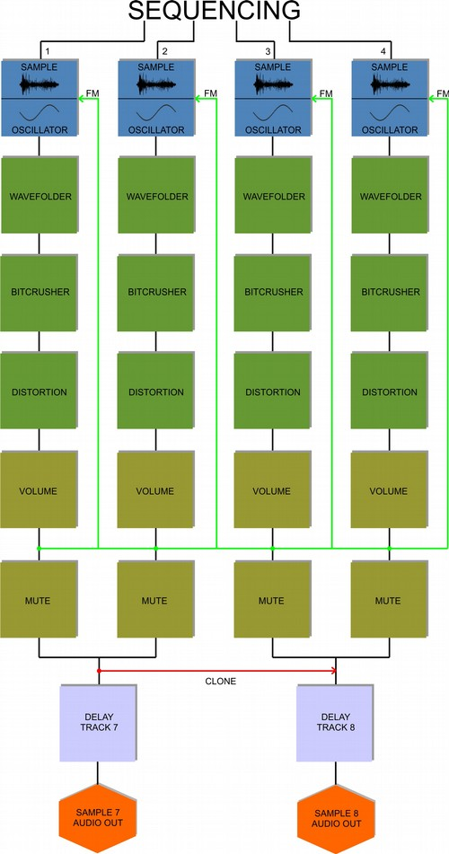
Internal audio flow and routing:

Sample Playback

Any audio part can be used to play back any previously loaded samples. These can be pitched and manipulated from the sequencer. Samples are stored internally using an 8bit resolution. To get the best audio results and lowest conversion noise, samples should be normalized well.

Synthesis

Beside of samples, each audio part contains of it own oscillator / operator. Each oscillator can generate sine, triangle, ramp, sawtooth, pulse and noise. Once an oscillator is started, it keeps running until it is stopped, either with the note-off function in the sequencer, or a manual stop. You can also cut the volume to silence them or apply an envelope to the volume. 2 oscillators can be played at the same time on one audio output, since each track has 2 audio parts. These can be separately sequenced from each other or the sequenced notes can be cloned so both parts play exactly the same notes. The cloned 2nd oscillator notes can be detuned by either semitones/octaves or finely de-tuned to get a wider soundscape. Different waveforms are also possible here.
The pulse wave has an additional setting to change the pulse width.
Both Oscillators (per track) can be hard-synced to each other. For each oscillator / wave 3 processing effects are available: Wavefold, Bitcrush and Distortion.
Each oscillator can also be Frequency Modulated by any other of the oscillators (or itself) and thus be used an FM operator. By connecting multiple operators to each other, acting as modulators and carriers, a wide range of FM sounds can be generated.
So for example Operator 1 (Carrier) van be modulated by Operator 2 and 3 (modulators), while Operator 3 can itself be modulated by Operator 1 or others. Many different 4 Operator FM algorithms can be created in that way. The volume of the operator acts as the ‘modulation index’ then. Note that the Modulator signal to modulate other operators is taken after the several processing options (Wavefold → Bitcrush → Distortion) and the volume process in the audio flow. This allows additional effects and variations for the modulations. Not only waves but also Samples can be used as Modulators (not as carriers). The better normalized the sample is the more effect it will have on the modulations.
Operators can also be muted so you can’t hear them in the modulated signal.
Also, the note cloning function can be used for proper key tracking of the operators. Transposing / Detuning them adds new harmonics to the sound.
Nearly all parameters from all operators/oscillators can also be controlled by the Automators, envelopes or the sequencer.
Examples of generating typical FM synthesis:

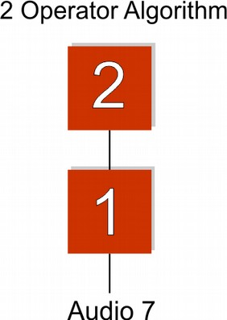
- Go to the → Track Setup
- Choose Sample/Wave 1
- Set Modulation Source to FM OP2 (which means this operator is being modulated by Operator 2)
- Choose Sample/Wave 2
- Set Muted to yes (otherwise you will hear the sound of oscillator/operator 2 on the audio output)
- Set Clone notes from to 1 (So the key is the same as the one from Operator 1. This will keep things harmonic in the first place)
- Make a sequence in the pattern screen while audio 1 is set to one of the waveforms (sine for the classic FM sounds)
- Play the sequence. Play around a bit with the Volume and the Clone coarse of Operator 2. OP2 will automatically start with a sine. This can of course be changed.

For now it is more a FM oscillator. Lets apply some envelopes to get a real FM synth voice:
- First you may want to set the volume of Operator 2 to a high value, because this makes the envelope more effective.
- Go to the → Envelope screen (double tap AUTOMATOR button)
- Choose envelope 1. Set to ‘One Shot’ (for now).
- Set the Source to T7 Audio 1 (where each note on of track 7 audio 1 will trigger the envelope)
- Set the Destination to Volume 1 (which then acts as a VCA for Operator 1)
- Press the OK button so the source/destination will be activated
- Change the envelope settings so the envelope sounds nice with your sequence
- Choose envelope 2. Set to ‘One shot’ as well. Set source to ENV1 Start (so it will always be triggered when envelope 1 is being triggered. (There are multiple ways to have it triggered by the first sample/wave/audio).
- Set the destination to Volume 2 (which then also acts as a VCA for Operator 2. The effect is, that it defines the ‘modulation index’ or the ‘deepness’ of the modulation).
- change the envelope parameters so they match the first envelope nicely
- to create more percussive sounds, you can set envelope 2 destination to Pitch 2.
The audio can be heard from audio/sample output 7. Since only 2 operators are used, you could add a 2nd version of it, the same with operator 3 and 4 (with it’s own envelopes). This will then output on sample/audio output 8. If you want them both to output from one audio output, then make this algorithm with operator 1+3 and Operators 2 + 4 instead. Turn off the mute of operator 2 and you will have a duophonic 2 operator synth on one audio output.

- Choose Sample/Wave 1 and set Modulation Source to FM OP2+4 (which means Operator 1 is being modulated by Operators 2 and 4)
- Choose Sample/Wave 2 and set Modulation Source to FM OP 3
- Mute Sample/Wave 4 if you don’t want to hear it from audio output 8
- set Clone notes to 1 on operators 2,3 and 4
(of course you don’t have to clone the notes from operator 1, but you would need to add an extra sequence for these non-cloned operators to achieve sequenced FM, which is really great for cool FM sounds, effects and music).
- again apply envelopes as needed.

If you clone the notes, nice additional variations can be created by using different ‘Clone coarse’ and ‘Clone fine’ settings.
Many different algorithms can be employed like this. Feeding operators back into the chain can generate nice unexpected results. Using the FM boost setting will create stronger FM sounds.

Keep in mind that when building algorithms, the audio from operators 1 + 2 will always be audible on audio output 7 and operators 3 + 4 on output 8 (unless muted).
This is visualized in the following algorithm where 3 operators are routed directly to the audio output. Since operators 1+2 will sound on audio output 7 here and Operator 3 on audio output 8, you would need to use an external mixer and mix audio output 7+8.

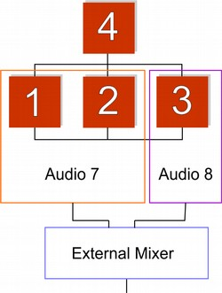

As for release V2.01, there are no algorithm or instrument presets, but these are planned with high priority for a later firmware.

Delay

Each audio track also has a delay unit (echo) as a last stage before the audio output.
The delay is a lo-fi delay implementation with 4 different timing possibilities:
- Short HQ → best quality but very short delay
- Lofi → lower quality, lower samplingrate but longer delay time
- More Lofi → lowest quality and samplingrate, but longest delay time
- Fast → Good quality, very short time (flanger kind of effect)
Additional delay parameters are:
- Delay time (where 0 is the shortest and 255 is the longest)
- Delay send → is the volume of the input (and so output) signal into the delay unit
- Delay feedback → is the intensity of the feedback into the delay unit. A setting of 15 means there is no loss in the volume and the delay signal stays in the delay-loop at full volume.
Note that because of the nature of the delay implementation (the delay time setting changes the size of the delay buffer) a change in the delay time can create audible artefacts, caused by old delay data in the delay buffer.
The delay settings can be changed in the → Track Setup for audio 7 and 8 or through the sequencer FX command.

Both audio outputs can have different delay settings and by cloning audio 7 to 8, you can create a nice stereo delay effect if these delay settings are only slightly different. Use the audio output 7 for the left and output 8 for the right channel then (or the other way around of course).

All current settings are saved and loaded with the project.

Load Sample window

The Load Sample window can be accessed from either the → Project screen or from the Nerd Menu on a sample track or in a sample pattern. It is used to add samples to the 12 slots.
Supported sample formats are:
- RAW 8bit unsigned
- WAV wave files in 8 or 16 bit, mono and stereo
Use the cursor up/down to navigate between the 12 slots. Press OK on one slot to open the file browser and choose a sample, press OK again to load the selected file into the slot. If there is not enough memory available it won’t load the sample. This also happens if there is too much fragmentation with the samples. Repeatedly loading, reloading and deleting samples can generate fragmentation. considering the limited memory and the embedded situation it is very tricky to defragment samples in real-time on the fly, so this is not implemented yet. For now in most cases it will refuse to load the sample.
So if the samples are extensively replaced, I suggest saving the project more regularly. Also in live situations I wouldn’t recommend extensive loading/reloading of samples. However, when powering on and reloading the project, the sample memory is automatically de-fragmented. Same if loading a sample block, the loaded data is de-fragmented.
Want to use longer samples? Use the old tracker tricks of using higher pitched samples and playing them back at a lower pitch setting which increases the sample time in favour of sample quality.
Sample-rate changing will be included in one of the next versions.

Samples can also be pre-listened by pressing SHIFT+LEFT (audio output 7) or SHIFT+RIGHT (audio output 8) in the sample browser. With this longer samples can be pre-listened. Keep in mind that while pre-listening a sample the navigation is turned off. Pre-listen can be stopped by pressing SHIFT+LEFT/RIGHT again. A pre-listen action halts all other samples playing on that audio track. However, the sequencer can run while pre-listening. By using SHIFT+ UP/DOWN the selected octave can be changed for pre-listening.

SHIFT+DELETE will remove the selected sample slot and memory again

Below is the sample-slot window with 4 loaded slots:

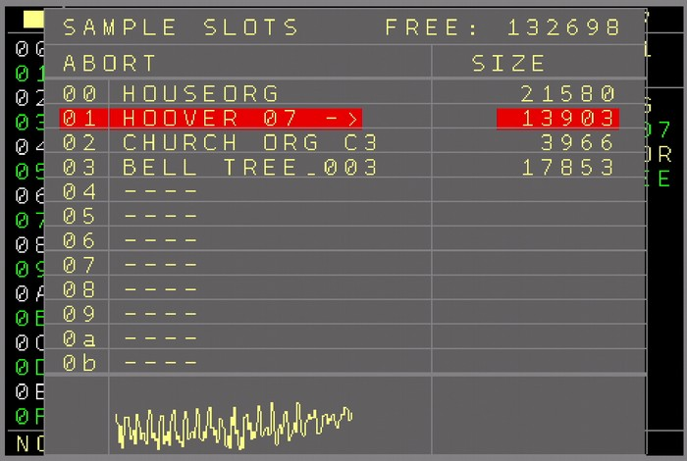Figure 22: Load Sample Window

Nerd Screen / Menu
The Nerd button opens a special function menu. Depending on the current position of the cursor, Sequencer or pattern screen and if a block is marked or not, different choices are available to manipulate the selection.

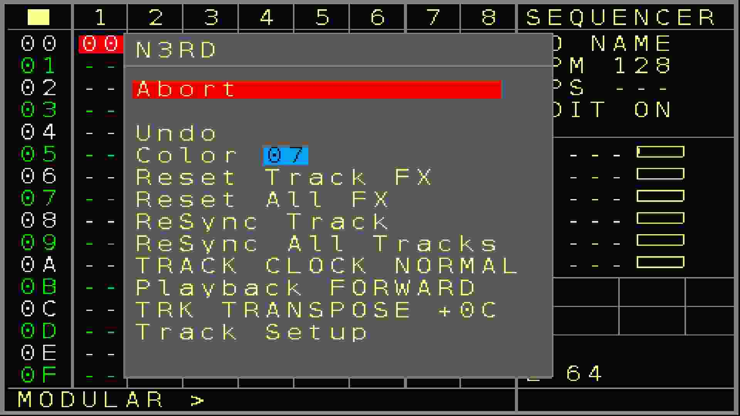
Figure 23: Nerd Screen/Menu
The current functions can be found in the sequencer screen:
If nothing is marked:
- Undo → The latest change in the sequencer screen can be undone so iif you accidentally deleted something it can be recovered. Keep in mind that only the last edit can be undone.
- Color → Sets the background color of the current cursor point. Change the color using SHIFT+CURSOR LEFT/RIGHT
- Note View → Sharp/Flat note view for the selected track
- Reset Track FX → Resets all FX / Current values of the tracks
- Reset All FX → Resets all FX / Current values of all tracks
- Resync Track – Resynchronizes the Track to the mainclock on the clock zero crossing
- Resync All – Resynchronizes all Tracks to the mainclock on the clock zero crossing
- Track Clock → Change clock dividers or multipliers of the track. If the player is playing then the changes are applied at the end of the pattern. If it is not playing, the changes are applied directly.
Press SHIFT+OK to execute the new clock selection directly (might result in a out-of-sync pattern). Change using SHIFT+CURSOR LEFT/RIGHT. By pressing SHIFT+OK on the menu setting, the new clock setting will be activated immediately. The clock will then be changed from the current stage on and not synchronized to the mainclock or patterns. If a Track is decoupled from the mainclock by setting the Track Clock to ‘Mapping’, then the value can’t be changed here but only in the Track Setup Screen of the Track. On the other side, if you want to set the Track Clock to ‘Mapping’ then you got to use the Track Setup Screen of the track.
- Playback → Changes the playback order of the track. Changing the value using SHIFT LEFT/RIGHT will activate it after the pattern is finished. Press OK to activate the new order directly. You can create a new pattern from the selected playback order by pressing SHIFT+OK.
For more information about the available playback order see the FX function Playback Order.
- Track Transpose → Changes the current transpose of the track. ( +- semitones). The transpose only works if track transposing is allowed in the → Track Setup Screen
Change using SHIFT+CURSOR LEFT/RIGHT/UP/DOWN
- Track Setup → Enters the track setup screen for the current track. (see → Track Setup Screen)

If an area or field is marked:
- Color → Sets the color of the marked area. Change the color using SHIFT+CURSOR LEFT/RIGHT
- Transpose Notes +1 → Transposes the notes (CV and MOD) in the pattern up by one semitone.
- Transpose Notes -1 → Transposes the notes (CV and MOD) in the pattern down by one semitone.
- Transpose Notes +12 → Transposes the notes (CV and MOD) in the pattern up by one octave.
- Transpose Notes -12 → Transposes the notes (CV and MOD) in the pattern down by one octave.
- Clock → Change clock dividers or multipliers of the marked tracks. It got the same functionality as if it was un-marked (see → Track Clock ).

The current functions in the pattern screen:
If nothing is marked:
- Undo The last change in the pattern screen (this pattern, not from others) will be reverted.
- Randomize range : Randomizes the current value if possible. The range of the randomized values are derived from the selected Range (see → Random Ranges Screen)
- Reset Track FX → Resets all FX / Current values of the track
- Playback – Same functionality as the → Playback function in the sequencer nerd Menu.
- Stop all Sound → will stop all sounds/gates, midi, modulators of the current track. When pressed while holding SHIFT, then all sounds of all tracks are being stopped.
- Edit Pattern Name → Opens a texteditor to add/ change the name of the current pattern
- Pattern Length → Sets the length of the current pattern between 1..64 steps. The sequencer will play the pattern only for the selected amount of steps. Also all jump and random jump functions will end up being within the selected length. SHIFT + CURSOR LEFT/RIGHT will increase/decrease by 1 step and SHIFT+CURSOR UP/DOWN will browse between these standard step amounts: 64,32,16,8,4,2,1
As you can change this value while the sequencer plays, it is possible to get ‘out of sync’ for the current track when changing the length. You can press the OK button to re-synchronize the track directly to the mainclock. Also changing the length while holding the OK button will directly re-synchronise the track while changing the length. Use this to create nice drum/synth fills in your live set.
This will currently work only well with regular groove settings and if there is no clock scale running on the track.
A default patternlength for new patterns can be set up in the Setup menu.
- Track Setup - Enters the → Track Setup Screen for the current track
- Export Pattern → Choose to export the current Pattern onto the SD card. The file menu appears with the current pattern number and name (if a pattern name is available). The name can be further edited and by selecting ‘ready’ the pattern is being saved onto the SD Card (project folder). Additionally the Project name and pattern type is being added.
- Import Pattern → Choose to import a Pattern from the SD Card. Through a file browser a former exported Pattern can be imported into the current Project. An imported Pattern will be imported into a new empty pattern. The new Pattern number will be shown after importing and can be used in tracks with the same pattern type.
If a block is marked:
Transpose +1 - Transposes the marked notes one semitone up
Transpose -1 - Transposes the marked notes one semitone down
Transpose +12 - Transposes the marked notes one octave up
Transpose -12 - Transposes the marked notes one octave down
Shift UP/Down – Using SHIFT + CURSOR UP/DOWN will shift the marked parts up and down including a wrap over.
Flip Rows – Flips the order of the marked parts around, up is down and down is up
Randomize Row order – Randomizes the order of the marked parts.
Randomize Values – Randomizes the marked values, if possible

The nerd-menu functions for a table screen:
- Preset xxxx → Insert presets into a table
- Edit Table name → Opens a texteditor to add/ change the name of the current table
- Release Table → erase and empty current table so it can be used for new tables again
See the → Table Screen part of the manual for more details on the Nerd Menu functions in the table screen
The nerd-menu functions for a patch screen:
- Edit Patch name → Opens a texteditor to add/ change the name of the current patch
The nerd-menu functions for a mapping screen:
- Export Mapping
- Import Mapping
These 2 allow to save and load the complete set of the mappings. You can define the name of the saved file. Mappings will be saved in the regular project folder.
This is a nice feature as users can create mappings on request or share their mapping work or to re-use special templates of different mappings.

The nerd-menu functions for the mapping screen:
- Threshold → Set a threshold value which can be used to compare against in the mappings using the CALC or SKIP functions.
- Export Mapping → Export a mapping onto the SD card.
- Import Mapping → Import a mapping from the SD card.
- Note View → Sharp/Flat note view in the mappings.
- Stop on Edit → If enabled the mapping will automatically pause if any destination parameter in the mappings is being edited.

The nerd-menu functions for the scale screen:
- Note View → Sharp/Flat note view in the scale screen

Input / Record Setup Screen (CV Inputs/Gamepad)

The NerdSEQ has recording facilities with flexible recording sources as well as live manipulations through the CV/Gate inputs. Recording can currently be done step-based. So only values for each step are being recorded. The needed parameters can be initialized in the Project screen → Input/Record Setup
The recording/ Live input screen is split in 3 main parts.

Live Input with the 1..4 Input definitions→ Assign the CV inputs to manipulate several destinations live.
5 menu items are available here:
- Live Input ON/OFF → Enable general Live input for the CV inputs. If turned OFF then the live input and so the assigned CV input parameters are disabled.
- Input 1..4 → While the CV inputs are the sources (0..10 Volt for CV and 0..5 Volt for Gates/triggers), the destinations can be set on the right side.
Possible Destinations are:
Transpose T1...T8 → Transposes the CV outputs of tracks 1..8 live while the CV input is quantized to note scaling. The middle point for the transposition is C-5 (5 Volt input), which means no transposition. Voltages below will transpose the output down and voltages over 5 Volt will transpose up. Note that transpose must be allowed (track settings) for the tracks to take effect.
Transpose All → same as track transpose, but it affects all tracks together (only tracks that allow transposing)
Pass to CV, MOD, TRIGGER 1..6 → The voltage of the CV input is passed (and overwriting) the CV, MOD output. If trigger is set up as destination, then a threshold will determine either a Trigger on or a trigger Off. Please be informed that the passthrough is updated with every change of the input and so the outputs are also updated which will overwrite a current playing sequence.
Quantize to CV, MOD, TRIGGER MOD 1..6→ The voltage of the CV input is quantized to note scaling and output to the destinations CV 1..6 or MOD 1..6. Only a change of the note will be passed through to the output. If Trigger is set up as destination, then a threshold will determine either a Trigger ON or a Trigger OFF.
Position X/Y/Start/Stop → ‘Etch A Sketch’ moving of the cursor in the sequencer screen.
‘Position X’ moves the cursor in the sequencer screen horizontally between the Tracks 1..8. The lowest CV value will position the cursor on Track 1, while the highest CV value will position it on Track 8, the rest linear in between.
‘Position Y’ moves the cursor vertically between the rows on the sequencer screen. The lowest CV values will position the cursor on Row 00 while the highest CV values will position the cursor on row FE. Other voltages linear in between the rows.
‘Position Start’ A trigger / gate on the CV input starts the pattern on the cursor position as next.
‘Position Stop’ A trigger / gate on the CV input initiates a stop of the track/pattern on the cursor position.
Audio 7..8 Gate / Trigger → Plays the last set/used sample on Track 7..8 if the gate is set or if set on trigger, triggers the sample.
Audio 7..8 Pitch → Defines the note of the sample which is being played through the Sample/Gate function.
Audio 7..8 Offset → Defines the start/offset position of the sample which is being played through the Sample/Gate function. (can be used to start different slices of the sample)
Audio 7..8 Slot → Defines the sample slot which is being played through the Sample/Gate function. If not defined, then the last played sample will play.
As explained earlier, if Live Input is turned off, then the input settings have no effect.
Destination types can be changed using SHIFT+CURSOR LEFT/RIGHT and destination numbers (eg tracks 1..8) can be changed using SHIFT+CURSOR UP/DOWN.
Input 1..4 Recording → Assign the CV inputs for recording
CV 1..6 Note → Records a note into the current playing step. Records only if in record mode and a pattern is playing on the track of the selected CV. The notes are filled in on change.
MOD 1..6 → Records a modulation value into the currently playing step. Records only if in record mode and a pattern is playing on the track of the selected MOD. Modulation values are entered on any change in voltage detected.
GATE 1..6 → Records Gates into the trigger column current playing step. FE for Gate ON and 00 for Gate OFF. Records only if in record mode and a pattern is playing on the track of the selected Gate.
TRIGGER 1..6 → Records triggers into the trigger column current playing step. Fills in a 40 as trigger value if a trigger happened on the CV input.
CV NOTE + GATE 1..6 → Records CV notes + Gates into the current playing step. It fills in a note only if a new Gate happened. This choice uses always 2 inputs, so the CV input below the current one is automatically chosen for being the Gate input. Additionally the Gate input detection can be delayed, so also sources which have a slew on the CV can record well (where the CV value is not stable yet when the Gate arrives) .
The delay value can be changed below the input setting.
This is the best choice if you want to record CV + Gate from a source like a keyboard.
It can only be used on the Input settings 1,2 and 3, as it always needs 2 inputs.
CV NOTE + TRIGGER 1..6 → Same as the CV NOTE + GATE 1..6 except for that here triggers are detected and recorded.

CURSOR CV → In combination with CURSOR GATE on another input. Records a note on the current cursor position. This places a note if in the pattern screen on the Note column if a new gate happened on the current cursor position. A Gate on (FE in the Trigger column) is being added, too. If the Gate is released on the same step, then the Gate on is being replaced by a trigger of 40. The cursor can be moved to another step and if the gate is being released there, a gate off (trigger column 00) is filled in.
If holding the gate for more than 1 second on the same step, then the note and the trigger value of the cursor will be deleted.
The sequencer doesn’t have to play or be in record mode. Edit Mode must be enabled though for it to work.
This allows editing notes in the pattern screen from a CV/Gate keyboard.

SAMPLE PITCH 7..8 → Selects the sample / note that should be recorded.

SAMPLE SLOT 7..8 → Selects the sample slot that should be used for a sample note record.

SAMPLE GATE 7..8 → Records Notes (defined by SAMPLE PITCH) with the selected Sample slot (defined by SAMPLE SLOT) into the current playing step. Records only if in record mode when a pattern is playing on the selected sample track. It fills in a note only if a new Gate happened. If no slot is selected, then the last slot is being used.

Sega Gamepad → Enable/Disable the recording of the assigned gamepad pads. The recording buttons can be assigned in the SETUP→ Sega Gamepad Settings. (Set button to Gate 1..6 or Trigger 1..6 record)

Once the recording sources/destinations are set up, you can press SHIFT+RECORD to enable recording. The selected pattern will start to play with recording enabled at the same time. You can then also start other patterns afterwards which are involved in the recording OR start the patterns first and press SHIFT+RECORD afterwards when you want to start recording.
SHIFT+RECORD will stop the recording while the pattern keeps playing. Stopping the sequencer (SHIFT+STOP) will also turn recording off.
Recorded values will be directly routed to the corresponding outputs as well. So looped recording/playing of a kind is possible.
If in Record mode the values can be deleted ‘on the fly’ by pressing and holding the TABLE (Record without shift) button while in the pattern screen. Any notes that are played while holding TABLE will be deleted from the currently playing sequencer step.
If the cursor is on the trigger column in a CV/Gate track on a playing/recording pattern, then triggers can be ‘tapped’ in using the OK button.

Midi / I2C Setup Screen

The Midi / I2C Setup screen contains a range of Midi and I2C settings to customise and setup up the Midi and I2C ports. On top of the screen you can see if the Multi-IO or one of the other Midi-Expanders is selected. It will show the Multi-IO Firmware Version if you got a Multi-IO Expander connected and enabled. Also with the Multi-IO you can see the USB-Host firmware on the bottom in the status-bar. The Multi-IO contains 2 different Firmwares for the Main part and the USB-Host part. Please check on the website if they are any new firmwares.

Setting of the Midi / I2C Setup Screen:
Midi Clock Out → Defines if and which Midi Ports send out the Start/Stop and Clock Transport commands. The settings are: TRS-A(DIN), Host, Device, TRS+Host, TRS+Device, Host+Device, TRS+Host+Device
Clock Send SPP → Defines if also the Song Position Pointer (SPP) should be send on sequencer start together with the Clock data. Please disable if the Midi Followers are not capable to process SPP data. This setting is disabled if no Midi clock output is selected.
Clock Receive SPP → Defines if the NerdSEQ should act on SPP receptions. It can move the playing sequence to a selected BAR etc defined by the leading Midi device. Like a DAW could play a Pattern or a Bar in a loop and the NerdSEQ would play the same loop at the same position. Disable it if it is not being used. You can enable this setting only if the NerdSEQ is set up as a Midi Clock follower.
Launchpad/Grid → Enable the different Launchpad types (Currently only Novation Launchpad are supported) for a NerdSEQ integration. See → Launchpad Integration
The different Launchpad versions (LP Mini, LP MK2, Pro / MK3 / X) can be selected to be controllerd via one of the Midi ports (TRS/DIN, USB-Host, USB-Device). Note that you might need a USB-Host converter if you are not using the USB-Host on the Multi-IO Expander. The Launchpad PRO/MK3/X got 2 modes to select from. One without the * in the name ( eg.PRO MK3-HOST) where you got to manually enable the Programmers Mode in the Launchpad (Mostly holding the Setup Button for a second and the orange button on the Launchpad. Else refer to your Launchpad Manual).
The one with the * (eg PRO MK3-Host*) will automatically initialize the Launchpad in Programmers mode (tested with several Launchpad devices). Be aware that this setting can’t be disabled on the Launchpad itself. So you would need to disable the Launchpad setting on the NerdSEQ again by navigating to the setting without a * and press the OK button. This is a Novation function which locks the Launchpad to the external device settings.
Midi CC Routing → Will bring you to the → Mapping Screen where you can map any Midi CC or NRPN input or output to any internal and external functionality.
Note IN Offset → As the Midi standard is pretty vague about which frequency for example a C on octave 3 should play and different manufacturers and use different octave offsets, this setting can be used to flexibly change the Midi note input offset, so the octaves always match well, regardless of the Midi input device. The setting can have a positive and negative offset.
Input Assign → Here you can have up to 16 different settings where you can connect different actions to selected Midi Input Channels/Ports.
On the left side (change with SHIFT+CURSOR UP/DOWN) you can select the different Sources. Holding the OK Button on an empty spot (----) will activate the Learn function and the next received Midi Message will automatically fill in the received Midi Port and Channel. You can also fill in the port/channel manually which also allows additional input types: Starting with the TRS/DIN Midi input Channels 1-16, if a Multi-IO is enabled then Host Input Channels 1-16 and Device Input Channels 1-16. Next would be TRS, Host, Device All Channels and All Midi which would accept the input from All midi channels. At last you can select the Mapping as a Source. With that you are able to record or play any mapping data (selected by the mapping destination GLOB→MREC = Global→ Row as Midi Record Source). Currently only the MOD column of a Modular Track is able to record/play the mapping data. You need to define which mapping row should be the record/play input in the Track Setup of a Modular Track (Midi → MOD function to any of the mapping rows which contains the GLOB-MREC destination). This would allow you for example to record only the Aftertouch information into the MOD column and much more.

On the right side you select the Destination for the Midi Data (change with SHIFT+CURSOR+LEFT/RIGHT). The following destinations are available:
- Transpose All → Selects the global transpose while Midi Note 60 means no transpose. Higher and lower values will transpose up or down relative to note 60.
- Track Select Record → The destination of the recording can be dynamically decided with this, depending on which track is selected (like the Track column in the sequencer screen. The cursor decides the selected destination track). This works in all screens and the last selected Track is being used.
- Step Input → (replaces the former Midi Step Channel setting)
It is used to edit notes directly in the pattern screens. To use it, the cursor must be on the note column of the pattern screen. Playing a note (for example on a midi keyboard) will insert a note at the cursor position. If the note is released on the same step as the note on, then a trigger (kill for midi tracks) is being inserted for a short note. If the note is released on another step, then a note off is being inserted. Holding the note for more than 1 second will remove the note at the cursor position.
The sequencer doesn’t have to play or be in record mode. Edit Mode must be enabled though for it to work. This allows to edit notes in the pattern screen from a Midi keyboard. Be aware that this is not the regular record mode to input midi data. Also if this is enabled together with the regular recording settings of the track then double notes might appear.
Start/Jump Row → Will launch a row defined by the Midi Note. Rows 0- 78 (120) are supported by the 120 possible Midi notes. Also the velocity control the way of launching. A Velocity of < 64 will put the selected row in the cue to be launched, pressing it again will toggle it so it can be launched by the cuepoints.
A Velocity > 64 executes the Jump function and so the playback will jump directly to the selected sequencer row in the currently playing pattern row of the new selected pattern. (Same as the OK Button if Edit Mode is disabled). If your midi controller is capable of it then you can define which functionality it should send out on a button press.
Mute/Solo → Will Mute/Solo the tracks where the function and track can be defined by the note and velocity. Note 48 – 55 will define the Track and a Velocity < 64 will Mute the Track while a Velocity bigger then 64 will Unmute the track.
Note 60 – 67 will define the Track again and a Velocity < 64 will Solo the Track while a Velocity bigger then 64 will Unsolo the track.
Merge to TRS → Merges the Source Data to be send out to the TRS Port. This is a kind of a thru function but keep in mind that this is a software thru function and it will not Pass all Midi Data to the destination. This applies also to the next 2 destinations.
Merge to Host → Merges the Source Data to be send out to the USB-Host Port. Merge to Device → Merges the Source Data to be send out to the USB Device Port.
TRACK 1..8 Input: Use the source to play a track (like a Midi→CV converter). Notes are routed to the CV Note, Note On/OFF go to the Trigger output On/OFF and the Modulation Wheel, Velocity or a Mapping Destination result is routed to the MOD output (if defined in the Track setup) on a modular track. Pitch bend bends the pitch of the destination track if possible.
For Midi tracks, the Midi data is passed through into the track midi channel.
For Trigger16 Tracks, all 16 Trigger outputs can be played through Midi notes, starting from note C-3. NOTE ON sets the Trigger and NOTE OFF resets the Trigger output. The next 8 notes will trigger the selected 8 Trigger Columns (either 1..8 or 9..16). From note C-5 the trigger outputs behave as triggers instead of a gate, so a note off will have no functionality.
For audio Tracks, the sample is being played on NOTE ON and stopped on NOTE OFF. The volume is defined by the velocity. Additionally the sample slot being played can be changed through the program change Midi command (0..11 for the 12 slots). For a CV16 and I2C track the Midi input is used to play into the 6 Note Columns.
TRACK 1..8 Record → Live records into the destination tracks. Note on fills in a note on the current recording step. If the Note was released on the same step, then a F0 is filled in on the trigger column. If the note is released on another step, then a note off is being inserted.
For audio tracks, the note is filled in, the velocity defines the sample volume. The last used sample slot is used for recording, the sample slot can be changed by using a program change command.
For TRIGGER16 tracks, triggers can be directly recorded into the drum-matrix. Starting from note C-3 all 16 drum-matrix values can be inserted in with a note on command.
For CV16 tracks, up to 6 voices can be recorded at the same time or is set up, up to 5 voices plus a dedicated envelope. The type of recording is set up in the CV16 Setup screen. For Midi Tracks, polyphonic Midi recording is possible. Up to 4 notes at the same time can be recorded as well as all Midi parameters like Program Change, Midi CC, Pitchbend, Aftertouch… Keep in mind that midi data will only be recorded as long as there is space in the FX column. If all 3 FX columns are filled in already, then the recording of the additional data is being ignored for this step.
TRACK 1..8 Transpose → Transposes the destination track (quantized to notes). Where note C-4 is the middle position which means no transposition. Higher notes transpose up and lower notes transpose the destination down. Be aware that the transpose only works if track transpose is allowed for the destination tracks.

Next would be the record/input filters. It allows the incoming Midi Data to be filtered out and avoid the recording of not-needed Midi Data. The following filters can be enabled/disabled:
Velocity (will fill in only a 127 or 0 if disabled), Polyphonic Aftertouch, Channel Pressure/Aftertouch, Program Change, Pitchbend, CC Controller Data.

If Midi is enabled, a little information about the incoming Midi data will be shown at the bottom of the screen. It will show if a Note on or Note off command or a Midi CC with the controller number is being received on the channel. This can be used to check if the input works generally.

Next would be the Basic I2C Port settings which defines the 2 I2C Port Modes on the Multi-IO Expander. These are like physical settings since a I2C port can be both Leader or Follower eg Output and Input. The 2 I2C port are named A and B and each can be set to the following modes:
Off → (will decouple the port and acts as invisible on the port)
First the follower modes:
16n → NS 1-16 Enables the use of a 16n faderbank (any 16n a-like faderbank should work as well as F8R) in leader mode and will copy the fader results into the I2c Slots 0-15 (I2C Ports are numbered from 0-15 but the 16n faders are numbered 1-16).
16n → NS 17-32 Same as before but the results will be copied to the I2C slots 16-31. Note that this would allow 2 16n in Leader Mode being connected on the 2 I2C ports feeding 32 different parameters
Teletype → NS Is not implemented yet. But there will be a NerdSEQ Operator in the Teletype to allow an interaction between both. For now a Teletype could be used to fill in the Slot Data using the 16n → 1-16/17-32 Mode/s (using command SC.CV and a IN Address of 0x31 (49))
For the follower modes it is necessary to select a receive address. For the 16n faderbank functions this should be 0x31.
Next they are the leader modes:
Out → Defines the port to be a output / leader. This allows sequencing multiple I2C devices such as the ER301, distingEX or a Just Friends. Please look into the → Multi-IO Midi & I2C Expander information and the → I2C / Multi-functional Track together with the → Track Setup.
Out Merge → Merges the Incoming Data from the other I2C port into this out port. Note that it might be better if the data is already directly splitted into another I2C Port since this is a soft-option which also adds a bit of latency. Also you might prefer to filter out only dedicated data and it is possibly a better Idea to pass only dedicated data to the output port. (eg using one I2C Input with Faders but send only faders 8 – 16 through to the other port. Things like this can be flexible managed in the Mapping Screen).
NS → 16n 1-16 is also a output/leader setting but it will also Poll the 16 faders of a 16n which is connected to the I2C port in follower Mode. It does the poll on the fixed 16n follower address of 0x34. More Data can be sent out on this port to also control other devices.
NS → 2x16n 1-32 / 3x16n 1-48 / 4x16n 1-64 is also a output/leader setting but it will Poll the faders of up to 4 connected 16n compatible faderboxes. This would allow up to 64 different faders to be connected on one port. Please note that the additional 16n need a different address to be able to work with it. I provide dedicated firmwares on the XOR Electronics Github (https://github.com/XORElectronics) where one can get the 16n Firmware with addresses 0x35, 0x36 and 0x37 for the additional 16n. The default 16n Address in follower Mode is 0x34.
You should be aware that polling the 16n created quite a amount of data and so it is not recommended to use also other followers on the same I2C port.
The Address is not in use if the I2C Port is in Leader Mode.
More information on the I2C Ports here → Multi-IO and I2C Additional Installation guide

Random Ranges Screen
The random ranges screen contains a set of 16 user definable ranges (minimum – maximum) which can be used for multiple sequencer functions.
Each range can be set from 0 to 100% and this range can be mapped from another function to generate a random value in between this range.
The ranges can be changed with SHIFT+CURSOR LEFT/RIGHT for the minimum and SHIFT+UP/DOWN for the maximum value.
As an example, take the MOD column. It can generate voltages/pitches from 0 to 10 volt. If you use the Random Range command in there “R 0” for range 0. And the Range 0 has a percentage of 0 – 100% then a random voltage between 0 to 10Volt is generated. If you would set the range to 30 – 90%, then a random voltage between 3 Volt and 9 Volt is being generated.
The random ranges can be applied to many functions, to the FX columns, to notes etc.

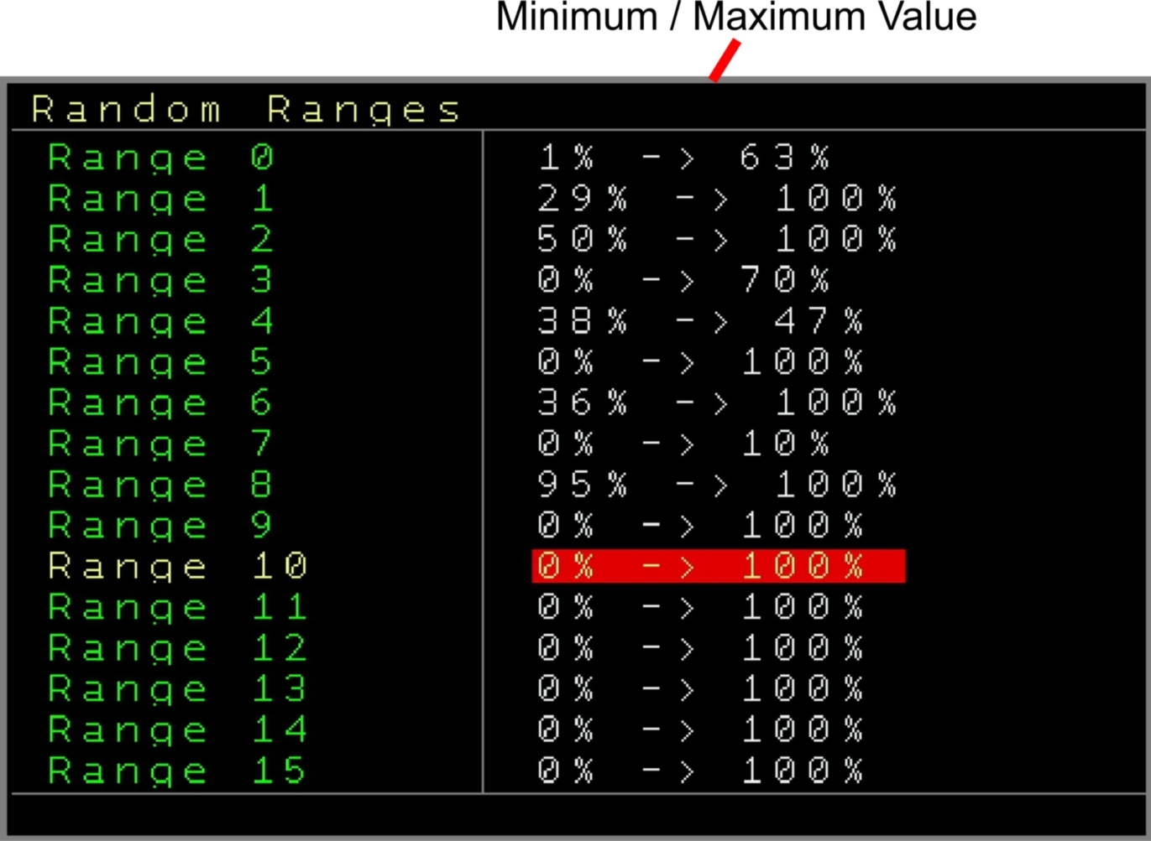Figure 24: Random Ranges Screen

Scale Screen
The scale screen allows the setup of ll scale behaviour (except for the table quantization which is its’ own scaling system for other purposes).
Here you can edit/change the different available scales including fine tuning, the global and track behaviour and also the behaviour of scaling for editing, input and output.

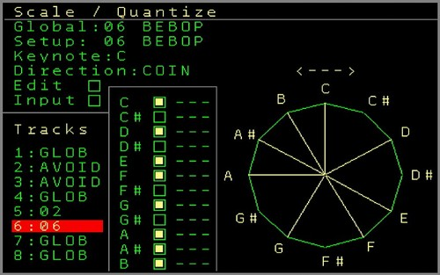

You can get to the scale screen through the → Project screen

In general they are 3 scale settings that define which if and which tracks are affected by the scaling. There is a global scale setting which applies to all tracks and there is a per-track scale definition which overrules the global scaling. Per track you can define if it should follow the global scaling (default), that you want to exclude a track from the scaling and a dedicated selected scale per track.

You got 90 different scale presets available:
Chromatic, 6 Tone Symmetric, Altered, Augmented Hepatonic, Augmented, Balinese,
Bebop, Bebop Locrian, Bebop Major, Bebop Minor, Composite Blues, Diminished, Dorian, Dorian B2, Double Harmonic Major, Egyptian, Enigmatic, Flamenco, Flat Sixth Pentatonic, Flat Third Pentatonic, Half-Whole Diminished, Harmonic Major, Harmonic Minor, Hirajosji, Hungarian Major, Hungarian Minor, Ichikosucho, In-Sen, Ionian Pentatonic, Iwato, Kafi Raga, Kumoijoshi, Lead Whole Tone, Locrian, Locrian 2nd, Locrian 6th, Locrian Major, Locrian Pentatonic, Lydian, Lydian 7th Pentatonic, Lydian 9th, Lydian Double-Harmonic, Lydian Diminished, Lydian Dominant Pentatonic, Lydian Dominant, Lydian Minor, Lydian Pentatonic, Major, Major Blues, Malkos Raga, Melodic Minor, Messiaens, Messiaens Mode4, Messiaens Mode5, Messiaens Mode6, Messiaens Mode7,
Minor Hexatonic, Minor, Minor 11th Pentatonic, Minor Bebop, Minor Blues, Minor Pentatonic, Minor 6th Diminished, Minor 6th Pentatonic, Mixolydian, Mixolydian B6, Mixolydian Pentatonic, Mystery 1, Neopolitan Major, Neopolitan Pentatonic, Oriental, Pelog, Pentatonic, Persian, Phrygian, Phrygian Major, Piongio, Prometheus, Prometheus Neopolitan, Purvi Raga, Ritusen,
Romanian Minor, Scriabin, Slocrian Pentatonic, Hepatonic, Todi Raga, Ultralocrian, Vietnamese, Whole Tone, Whole Tone Pentatonic.
You can create your own user scales as well.
On top of the screen you can see the current selected global scale. By default this is set to 00 Chromatic which includes all 12 notes within a western style octave. You can change the selected global scale using SHIFT+CURSOR LEFT/RIGHT/UP/DOWN.

The next rule is the setup scale. This is the current viewed scale and can differ with the global selected scale. In case you changed one of the scale presets (which you can see indicated on the right side) then you can revert the scale to the original by pressing SHIFT+DELETE.
Keynote: Defines the keynote of the scale. The scale will be transposed to the keynote relative to a plain C.
Direction: Changes the direction where the next matching scale note should be looked for. If set to UP then it will look for the next scale match higher than the current note. (Clockwise), Down would look it up Anti-Clockwise and if the setting is to coin then the coin decides if it should look clockwise or anti-clockwise for the next match.
Edit: If this is enabled then all note input (eg in the pattern screen) will allow to select only the notes within the scale. Disabled will allow the regular input of notes in the chromatic scale.
Input: This defines if input from externally (like a Midi Keyboard) should be automatically and already scaled when incoming. This is additionally to any output selected and it would already manipulate the incoming note stream. If disabled then the incoming stream is treated regular (which doesn’t mean that you still might hear the scaled output if it plays directly).
Then they are the track settings where you can set for each track if it should be scaled by the global settings, if it should avoid any scaling or to select a dedicated scale for that track only.

Scrolling further is the note editing where you can individually change the selected scale. This can be changed by enabling/Disabling notes within the scale (SHIFT+CURSOR UP/DOWN) Furthermore you can change also the fine-tune per note. (SHIFT+CURSOR LEFT/RIGHT)
The fine-tuned playback of notes works for Modular track notes, Audio Notes and I2C Notes but not for Midi.
You can see an indication of which notes are user-manipulated. SHIFT+DELETE in the 2nd Setup row will revert to the original scale.

On the right side you can see a chromatic circle diagram of the selected scale with on top an indicator of the direction.

The scales / user-scales are being saved and loaded with a project.

Mapping Screen
This screen can be entered through the → Project screen, the → Midi / I2C Setup Screen or by pressing SHIFT+NERD twice from within the most other screens.
The mapping screen is the main control-center to manipulate every internal and external parameter with every internal and external parameter. In the most basic usage you would define a source like for example one CV input (or a Midi CC or I2C parameter or even the internal result of one of the envelopes….) and map it to a parameter like the row probability for track 3, or the speed of one automator LFO or the decay phase of internal envelope 7....just to name a few...

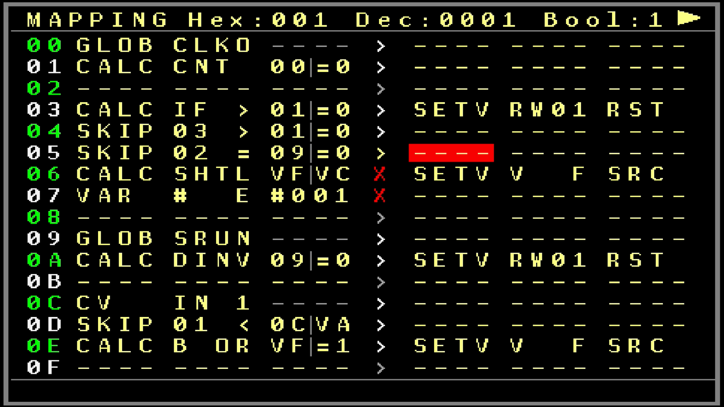

They are many sources and destinations to choose from, basically all parameters you can think of. (I am sure you still find something missing, I know you!!) On top of only mapping the data only, you can also manipulate all kind of data up to the point that you can create a kind of algorithm / code. Think of value manipulation, calculations, start an action if any value reaches a defined level, scale parameters, manipulate sequences or playback caused by other events, generative stuff. I for example created a bouncing ball with it or a turing machine and use it to excessively manipulate my sequences.

The mapping screen got 6 columns and 70 rows which each row can contain a source (3 columns → destination (3 columns) definition. Each of the 70 rows is being processed 1000 times per second (1kHz / each millisecond). More on the timing and on how to utilize it will be described further below.
The first 3 columns are to define the source part which is split into the Base, and extra 2 function parameters. Depending on the selected base a related function can be chosen and if needed also a 3rd type. One example would be, if I want to choose a Midi CC Input as a source which contains the Midi Channel (Channel 5) and the Controller number (Controller 14):
MCC CH 5 # 14
Midi CC Channel 5 Controller 14

Or another example for a source would be the current setting of the row probability of track 3:
TRCK TRK3 PRB8
Track Track 3 Row Probability

Some sources use only 2 parameters, some use 3. If a 3rd parameter is not available then the field is greyed out.
The columns 4-6 on the right side work in the same way but then for the destinations.
For example to use the release value of envelope 3 as destination you would use the following:
ENV # 3 RELS
Envelope Envelope 3 Release

As a full example of a row you could use CV Input 3 as a source and the MOD output 6 as a destination:
CV IN 3 ---- → CV PTCH MOD6
CV Input 3 Not used CV Pitch Output MOD6
In this example the CV input 3 will directly output to output MOD6 updated up to 1000 times per second. The updates of most of the values is happening ‘on change’. That means if the source value doesn’t change then the destination will not be updated. They are some exceptions for it which will be described with the dedicated mapping destinations. In the middle between the source and the destination you can see if a mapping row would regularly be executed by the mapping ‘>’ or excluded from the regular mapping ‘program’-flow ‘X’ (using the SKIP or XXMP/XLOD commands).

If you are with the cursor on the row, you can see on the top line of the screen the result of the source (in Hexadecimal and in Decimal (0 - FFF / 0 - 4095).
In this example you see the CV Input value changing when you change the input voltage.
The statusline shows always the exact description of the commands or if a parameter is missing for either the source or the destination depending on the cursor position.
On the top right side you can see a ‘play’ symbol. You can pause the processing of the mapping by pressing the OK button. With this you can edit in the mappings without the chance that any destination is changing parameters you want to (while browsing through it). You can also enable a setting in the Nerd-Menu (Stop on Edit: Yes) to always automatically pause the mapping execution when you edit any destination part. Leaving the mapping screen or pressing OK again will activate the mapping execution again. (With the exception of the variable screen)
Also at all times, also with a paused mapping, you can execute just the current row (where the cursor is) by pressing SHIFT+OK. That can help for debugging different lines since you could execute the lines one by one and check for the results. The row will always be executed regardless if the source value changed or not!
It is also possible to execute the rows from the sequencer patterns/tables/patches using the XMAP FX command, the Drummatix in the I2C/Multi patterns which allows even manipulation of mapping rows. Also here, the destinations are always executed, regardless if the source changed or not.
They are also mapping sources/commands which let you skip the execution of multiple rows, so you can avoid parts of the mapping to be executed and can run them only from the patterns. These advanced features will be described with all the available sources and destinations. Skipped/excluded rows are indicated in the middle of the row between the source and the destination.

A source definition can be used also in multiple rows to be used for multiple destinations.
The result of a Source, doesn’t matter how it is generated, will also always be saved into the current row as a kind of variable. This is important to know since this value can also be used for further processing or calculations (next to the regular variables).
You can leave empty spaces between different rows to get a better overview over function blocks.
SHIFT+DELETE will clear the current field (and the additional parameter fields). SHIFT+UP+DELETE will delete the whole row and shifts the part below upwards.
SHIFT+DOWN+DELETE will INSERT an empty row at the current position while shifting all other rows below down.
They are parameters/functions that relate to rownumbers and so to their results. These rownumbers will automatically be corrected on any shift up/down if necessary.

They are only basic copy+paste functions with the mappings at the moment. SHIFT+MARK in a row will copy the row into the clipboard and SHIFT+COPY in another row will paste the clipboard onto this row. More advanced Copy & Paste functions are planned for the next update.

It is good to know that they are 3 types of values that the sources can generate.
In most of the cases values between 0 and FFF (4095) are generated and so the related functions will scale to that range. For example the CV input got a range of 0-FFF (4095) anyways, but if you take a Midi CC value for example which got only 128 values, its’ range goes from 0 – 7F (127). Also this value is scaled from 0 – FFF as the source result (you could calculate this back easily using one of the source functions if you really want to work with the 128 values).
FFF / 4095 is also the maximum value for the mapping processing and so as another example, I2C input (using SC.CV command from like a 16n) got its range from 0 – 3FFF (16383). In this case the value is scaled down to match the mapping range.

Another type of values that a source can generate are booleans. That means it can generate a 0 or a 1. The input for that would be for example a gate input, where if the Gate is low (or 0 Volt) the result would be 0 and if the Gate is high (5 Volt) then the result would be a 1. This could be for example used to turn a function on or off. Or indeed for further processing.

The last type are the generation of dedicated values. For example, if you use a Midi Input with Notes as a source, it would result in the actually note number (0 – 127).

The destinations got the same thing that some work with the full range, some as a boolean or dedicated values.
All the type of values will be explained per source and destination.
As mentioned before the several rows do all store their results which work as a kind of variable or storage. On top of that they are also 16 variables which can be used to store and exchange values on demand. Both the row values and the variables can be used to perform further calculations and processing. The 16 variables go also their own → Variable Screen where you can see and manipulate the current values of all variables. You can get to the variable screen from the mapping screen by pressing the PATCH button. Note that a stopped mapping will stay stopped in the variable screen.
You can import or export mappings from the SD Card. Use SHIFT+NERD in the mapping screen to get to the Import / Export settings.

Lets get first to a list of all currently available Source and Destination types, a detailed explanation with examples will follow up after it:

Mapping Sources (list)
CV | CV Input1-4 | No additional parameter
 | CV Output 1-6
 | MOD Output 1-6
Trigger | Trigger/Gate Output 1-6 | No additional parameter
Track | Track 1-8 | Probability 0 – Probability 8 where the probability destination depends on the track type
 |  | Pattern row (resolution based on ticks)
 |  | Run/Stop status
 |  | Note from Column 1 – 8 (returns the last played note from that column)
 |  | Sequencer row of the selected track.
Automator | Slot 0 – 7 | No additional parameter
Envelope | Envelopes 1-8 | No additional parameter
Midi | TRS Channel1-16 | Notes
 | Host Channel 1-16 | Any note= gate on, No note on = gate off
 | Device Channel 1-16 | Velocity
 | Learn | Device channel 1-16
 |  | Pitchbend
 |  | Program Change
 |  | Gate from dedicated note
 |  | Velocity from dedicated note
 |  | Aftertouch from dedicated note
Midi CC | TRS Channel1-16 | Controller 0 - 127
 | Host Channel 1-16
 | Device Channel 1-16
 | Learn
Midi NRPN(14 bit) | TRS Channel1-16 | Controller 0 - 9999
 | Host Channel 1-16
 | Device Channel 1-16
 | Learn
I2C | SC.CV | Port 0 - 127
 | Learn
Set/Get Variable | Variable A-P | Get Source
 | Row 00 - 45 | Constant 0 - FFF
Calculate/Compute | Add | Two operands/parameters (Y and Z) with both:
 | Add with overflow | Constants 0-8
 | Subtract | Threshold
 | Subtract with overflow | Variable A-P
 | Multiply | Row 00 - 45
 | Multiply with overflow
 | Multiply * 0.1
 | Multiply * 0.1 with overflow
 | Divide
 | Divide (2nd parameter * 0.1)
 | Divide (2nd parameter * 0.1) w. overflow
 | Modulo Y MOD Z
 | Bitwise AND
 | Bitwise OR
 | Bitwise XOR
 | Leftshift (without carry)
 | Rightshift (without carry)
 | Logical AND
 | Logical OR
 | Logical XOR
 | IF (Y < Z)
 | IF (Y<=Z)
 | IF (Y>Z)
 | IF (Y>=Z)
 | IF(Y=Z)
 | IF(Y<>Z)
 | Latching Flipflop
 | Invert with raising Y vs. Z
 | Invert with falling Y vs. Z
 | Track & Hold
 | Sample & Hold
 | Pass Z or 0 if Y
 | Count raising Y
 | Logical invert Y
 | Bitwise invert Y
 | Rightshift Y with overflow Z bits
 | Leftshift Y with overflow Z bits
 | Increment Y
 | Decrement Y
 | Minimum value of Y vs. Z
 | Maximum value of Y vs. Z
 | Average value of Y and Z
 | Pitch value Y to Note Number
 | Note Number Y to Pitch value
 | Random value between Y and Z (including)
 | Range former Row between Y and Z
 | Force passing value Y if Z is true
 | Generate onetime Pulse if Y > Z
 | Signed Modulo Y MODS Z
Skip amount of rows | Following for 1-16 (X) rows | Two operands/parameters (Y and Z) with both:
 | X rows if Y < Z | Constants 0-8
 | X rows if Y <= Z | Threshold
 | X rows if Y > Z | Variable A-P
 | X rows if Y >= Z | Row 00 - 45
 | X rows if Y = Z
 | X rows if Y <> Z
Global | Current mainclock row | No additional parameter
 | Sequencer Started / Stopped
 | Clock input state
 | Clock output state
 | Reset input state
 | Reset output state
 | Random value
 | BPM / Tempo
 | Insert from sequencer value
 | Generate Pulse through other row
 | Current Mainclock ticks
External Input | PC Keyboard (w Video Expander) | Numpad 0 -9, DOT
 | Sega Gamepad | A, B, C, X, Y, Z, Start, Mode, Up, Down, Left, Right
 | Local Buttons | All NerdSEQ button states
Control | Execute following X Mapping rows
 | Exclusive execute mapping rows
 | Execute mapping rows after project load

Mapping Sources (detailed)

Below you can find more detailed information of the mapping commands.

Sources (first 3 columns) (If it is not further mentioned then the sources generate values between 0 and FFF (0 – 4095), so they are 1:1 or either up- or downscaled:
CV CV In/Output sources
IN1,IN2, IN3, IN4 Are the 4 CV Inputs of the NerdSEQ.
CV1 .. CV6 Are the real current CV output values.
MOD1 .. MOD6 Are the real current MOD output values.
TRIG Trigger/Gate Output Sources
TR1..TR6 Is the real state of the Trigger outputs (Values 0 or 1)
TRCK Track depended sources
TRK1..8 Is the track selection for the Track source.
PRB0..PRB7 → are the current probability percentages of the selected track. Which probability depends on which tracktype is being used. (eg Modular Track PRB0 would be the Note Probability)
PRB8 → is the current row probability percentage.
PTRW → is the current pattern row. It is based on the tick updates and generates so a finer resolution (eg 6 ticks/step)
PRUN → Indicates if a Pattern on the track is running or not ( 0 / 1 )
NOT1..NOT8 → If a note was played on the selected column of this track then the last played notenumber will be used as source.
SROW → returns the current playing sequencer row of the track. Combined with the destination GLOB>SROW this can be used to let the sequencer screen scroll automatically with the sequence of the track.
AUTM Automator Results as source.
SLT0...SLT7 Selected automator slot. The bipolar automator result values get an additional offset so they fit the 0 – FFF range.
ENV Current Envelope results as a source.
#1 .. #8 Selected envelope
MIDI Midi ‘events’ as a source
TC1..TC16 TRS-A/DIN Midi Input channels 1..16
HC1..HC16 USB Host Midi Input channels 1..16 (needs Multi-IO Expander)
DC1..DC16 USB Device Input channels 1..16 (needs Multi-IO Expander)
LRN If set to this then the next received Midi Note Event will define (learn) the input device and the channel and if needed also the note number.
You might want to set the 3rd column already to either Note or Gate or a specific note to learn also a note number or not. It doesn’t matter for which note you choose, the learn function will overwrite this to the learned note.)
NOTE → Generates a note number from a received note (0 – 127)
GATE → Will cumulate all amount of notes that are on and result in 0 if all notes are off.
VELO → Results in the velocity value of any played note (0 – 4095)
PRSR → Results in the channel pressure (channel aftertouch) of any played note (0 - 4095)
BEND → Results in the Pitch-Bend values of the channel (0-4095)
PGMC → Results in the Program Change values of the channel (0- 127)
C-0N to B-9N → If the selected note is on then the result will be 1 else 0. Use this if you want to turn on/off a function by a dedicated midi note
C-0V to B-9V → If the selected note plays then the velocity of this note is taken over as a result (0 – 4095)
C-0A to B-9A → Results in the polyphonic aftertouch for the selected note if available (0-4095)
MCC Midi Controllers (CC) as a source
TC1..TC16 TRS-A/DIN Midi Input channels 1..16
HC1..HC16 USB Host Midi Input channels 1..16 (needs Multi-IO Expander)
DC1..DC16 USB Device Input channels 1..16 (needs Multi-IO Expander)
LRN If set to this then the next received Midi CC event will define (learn) the input device and the channel.
# 0 to # 127 is the Controller number of the CC receive.
NRPN Midi NRPN ( Non Registered Parameter Number) as a source. These are like Midi CC but can have more than 128 controller parameters and the values up to 14 bit. In all cases 7 or 14 bit NRPN messages will be auto-detected and will be scaled to 0-FFF (0 - 4095)
TC1..TC16 TRS-A/DIN Midi Input channels 1..16
HC1..HC16 USB Host Midi Input channels 1..16 (needs Multi-IO Expander)
DC1..DC16 USB Device Input channels 1..16 (needs Multi-IO Expander)
LRN If set to this then the next received NRPN event will define (learn) the input device and the channel.
# 0 – 9999 is the NRPN parameter number / controller number
I2C I2C receptions as a source. Currently only the SC.CV command (0x10 or 0x11) is supported. The received 14 bit values are scaled to 12 bit (0 – FFF). Use this for example to directly receive your 16n faderbox or similar.
SCCV Receive SC.CV or compatible (like EX.CTRL) commands.
LRN Will learn the reception port with the next (or last) incoming I2C SC.CV Command.
#0 – 127 → is the selected portnumber for the reception
For a 16n and the first fader you would set it to I2C SCCV #0
VAR Sources and functions to use with the 16 Variables and the mapping rows
#A - #P Selected Variable A to P
RW00 – RW45 Selected mapping row 00 to 45
SRC → Will pass the value of the selected variable or row to the destination
#0 – FFF → Will set the selected variable or row to a fixed value. The result will also be passed to the destinations
CALC Calculations, Logical, Arithmetic and mapping control flow functions.
These can be used to manipulate several values or to create a basic program flow / algorithm
The 3rd column parameters are defining the 2 operands (Y and Z) which are involved in the calculations or the processing. It is split into 2 parts where the left 2 digits are to define the first operator and the last two digits on the right define the second operator. This is indicated with a ‘|’ between the operators. The operators can be chosen from these 4 sources: Constants ( =0 to =8 ) which define the values 0 to 8, Threshold (TH) which uses the selected threshold value (define in the Nerd-Menu of the mapping), the 16 variables (VA to VP) and the mapping row (00 to 45). For example if you want to involve row number 02 and variable A for any calculation then you would choose 02VA in the 3rd column.
Furthermore: A Gate on means that the value goes from 0 to a value higher than 0 and stays there. A Gate off means that the value goes to 0 or is 0. A pulse/trigger means that the value goes from 0 to any value higher 0 and then back to 0.
ADD Adds the first Operand Y with the 2nd Operand Z with a maximum resulf of FFF. As an example if you want to add a 3 to Variable B:
CALC ADD =3VB
The result would be for example 5 is variable B got 2 as a current value. Note that the result is used as the source values to be passed to the destination. It doesn’t change the variable in any way
ADD! Adds the first Operand Y with the 2nd Operand Z with overflow. If the result is higher than FFF then it will overflow and starts over from 0 (Result would be then the calculated result modulo FFF)
SUB Subtract: Operand Y minus Operand Z. If the result is smaller than 0 then the result will be 0
SUB! Subtract with overflow. Same as SUB but if the result is smaller than 0 then it will overflow and continues at FFF. (Result would be then the calculated result modulo FFF)
MUL Multiply Operand Y with Operand Z. No overflow.
MUL! Multiply Operand Y with Operand Z with overflow.
MUL. Multiply Operand Y with Operand Z and with 0.1 no overflow
MUL: Multiply Operand Y with Operand Z and with 0.1 with overflow
DIV Divide: Operand Y / Operand Z no overflow (Division by zero is invalid but will result in 0)
DIV. Divide: Operand Y / (Operand Z * 0.1). (Division by zero is invalid but will result in 0) No overflow
DIV: Divide: Operand Y / (Operand Z * 0.1). (Division by zero is invalid but will result in 0) with overflow
MOD Modulo: Operand Y MOD Operand Z
BAND Bitwise AND: Operand Y AND Operand Z
B OR Bitwise OR: Operand Y OR Operand Z
BXOR Bitwise XOR: Operand Y XOR Operand Z
LSFT Leftshift: Leftshift Operand Y with Operand Z times. Without carry.
RSFT Rightshift: Rightshift Operand Y with Operand Z times. Without carry.
LAND Logical AND. Operands are true if they are > 0. AND will happen between those 2 operands and the result is 0 or 1
L OR Logical OR. Like LAND, result is 0 or 1
LXOR Logical XOR. Like LAND, result is 0 or 1
IF < IF expression: If Operand Y is smaller than Operand Z then the result is 1 else the result is 0
IF<= IF expression: If Operand Y is smaller than or same as Operand Z then the result is 1 else the result is 0
IF > IF expression: If Operand Y is bigger than Operand Z then the result is 1 else the result is 0
IF>= IF expression: If Operand Y is bigger than or the same as Operand Z then the result is 1 else the result is 0
IF = IF expression: If Operand Y is the same as Operand Z then the result is 1 else the result is 0
IF<> IF expression: If Operand Y is bigger or smaller (not the same) as Operand Z then the result is 1 else the result is 0
LFLP Logical FlipFlop with a set (Operand Y) and a reset input (Operand Z). So if Operand Y is > 0 then the FlipFlop will be set (Result = 1) and if Operand Z is > 0 then the result is reset to 0. If both Y and Z are > 0 then the result is 0
FLG^ Result inversion on incoming raising flank/pulse. The raising edge detection happens when Operand Y was smaller than Operand Z and is getting the same or bigger than Operand Z. A raising edge detection will invert a 1 to a 0 and the other way around.
FLGv Result inversion on incoming falling flank/pulse. The same as FLG^ but then with a falling edge between Operand Y and Operand Z
T&H Track & Hold. Operand Y is the Gate and Operand Z is the value. As long as the Gate is high, then the value from Operand Z will be passed to the result. When the Gate is low, then the result will keep/freeze the last gated Operand Z value.
S&H Sample & Hold. Operand Y is the ‘trigger’ and Operand Z is the value. If Y was low and goes high, the value of Z is one time sampled and passed as the result. The result will stay until Y went low again and goes high for the next sample.
PASS Pass value or zero. This will pass the value of Operand Z if operand Y is > 0. But if the Operand Y is 0, then the result is also 0.
CNT Counter. Every trigger/pulse of Operand Y will be counted / added to the result. A trigger on Operand Z will reset the result value
DINV Logical Invert. The result is 1 if Operand Y is 0 and the result is 0 if Operand Y is > 0.
INV Bitwise Invert. The value of Operand Y will be bitwise inverted into the result
SHTR Right-Shift with carry. Operand Z is the amount of bits which are used for the shifting and the carry (If for example the bits are set to 8 then every rightshift will carry on on bit 7). The rightshift shifts Operand Y each time this is called.. An example for a series of 12 bit shifts would be: 0000 0000 0010 → 0000 0000 0001 → 1000 0000 0000 → 0100 0000 0000 and so on
SHTL Left-Shift with carry. The same as right shift but then left. Bits shifted out of the selected bit amount will be carried to bit 0.
INC Increment. Does increment Operand Y (Result = Operand Y + 1) No Overflow.
DEC Decrement. Does decrement Operand Y (Result = Operand Y – 1) No Overflow.
MIN Minimum function. The result is the lower/same value of Operand Y and Operand Z
MAX Maximum function. The result is the higher/same value of Operand Y and Operand Z
AVRG Average function. The result is the average value between Operand Y and Operand Z
P2NT Pitch to Note. Does convert a pitch value ( 10 Octave range 0 – FFF) into a note number (0 – 120). This can be used to feed CV NOTE destinations. This function is quantized so any value will snap to the nearest note (up or down).
NT2P Note to Pitch. Does convert a Note number (0 – 120) to the 10 octave Pitch range (0 – FFF). This can be used to feed CV pitch destinations
RNDM Generate random value between Operand Y and Z
RNGE Scale former row into a range between Operand Y and Z
FORC Force to pass the value of Operand Y to the destination if Operand Z is > 0. The destination is forced to be executed regardless if the source value changed or not. Use this command with caution as it is possible that it executes 1000 times per second which might be too much for the selected destination (eg Midi or Expanders).
PULS Generate a One time Pulse on a raising Operand Y getting bigger than Operand Z. Use this if you easily want to execute something only once on any ‘event’.
MODS Signed Modulo: Operand Y MODS Operand Z
SKIP Is a set of functions that allow to skip several mapping rows. This can be used to get a reduced execution pace of mapping rows, time related execution, conditional or ‘event’ related execution (for example if the CV Input 1 is higher than 5 Volt then it should skip the following 5 rows, else the 5 rows will be executed
The 3rd column acts again just as described in the CALC part of the mappings as a double source for 2 operands which are involved in the skipping decision.
The amount of rows to be skipped will be defined in the 2nd column. It is possible to skip up to 16 rows. The count starts from the next row. So for example if you have this command on row 02 and got skip 2 rows then it would affect rows 03 and 04. Row 05 would not be affected and regularly executed. If you need more rows, then add the same command with the same parameters and probably a different amount of rows again after the last skipping block (in the example it would be in row 05). The result can be used as well so if the rows end up to be skipped then the result is 1, else it is 0.
The live result of the skipped rows are visible in the middle of the mapping screen rows using the ‘>’ or ‘X’ indicator.
Listed for 1 to 16
as XX:
XX < Skip XX rows if Operand Y is smaller than Operand Z
XX<= Skip XX rows if Operand Y is smaller than or the same as Operand Z
XX > Skip XX rows if Operand Y is bigger than Operand Z
XX>= Skip XX rows if Operand Y is bigger than or the same as Operand Z
XX = Skip XX rows if Operand Y is the same as Operand Z
XX<> Skip XX rows if Operand Y is the not same as Operand Z
GLOB Global sources (uses only one parameter = 2nd column)
SQRW Results in the current Mainclock row/step.The result is scaled to FFF
SRUN Results in 1 if the sequencer is started and 0 if the sequencer is stopped
CLKI Results in the incoming Clock input state. (0 or 1)
CLKO Results in the outgoing Clock output state (0 or 1)
RSTI Results in the incoming Reset input state (0 or 1)
RSTO Results in the outgoing Reset output state (0 or 1)
RAND Generates a random value between 0 and FFF
BPM Results in the current selected or detected BPM
SEQV Select this row as source of a I2C/Multi pattern. If one of the → I2C / Multi-functional Track columns is selected as a Mapping source (set up in the → Track Setup then the sequenced values (Numbers 0-120 for notes, 0-FFF for pitch values) are used as the result. Note that the row which is selected must match with the mapping row of the SEQV command.
PULS Generate Pulse from XMAP commands (eg from sequencer)
TICK Results in the current mainclock ticks

EXT Are external input sources. Currently external key/button presses are used (0 = button/key not pressed, 1= button/key pressed)
KEYB Is the PC Keyboard input of the Video Expander
NUM0..9 → Are the Number Keys / Number Block
DOT → Is the decimal dot in the Number Block
SEGA → Are the Sega Gamepad buttons: A, B, C, X, Y, Z, Start, Mode, Up, Down, Left, Right. Note that the Sega Gamepad function must be enabled in the → Sega Gamepad Settings. Take also care for eventual double functionality of a button if it is defined in both the mappings and the gamepad setup.
BUTN Returns the status of the local NerdSEQ buttons:
CRUP → Cursor Up
CRDN → Cursor Down
CRLF → Cursor Left
CRRG → Cursor Right
STRT → Start
STOP → Stop
SHFT → Shift
OK → OK
UP → UP
DOWN → DOWN
SEQ → Sequencer/Mark
PTRN → Pattern/Copy
PTCH → Patch/Delete
TABL → Table/Record
AUTO → Automate/Nerd
PROJ → Project/Setup
CTRL Main controlling functions
XMAP 0 – 69 Rows → Will execute the following X rows of the mapping. This command can be only used using an external XMAP command (e.g. from a pattern FX, pattern playback). It allows to execute more than just one row. Also the rows are executed in a direct order without the possible latency of the regular mapping execution. This function is disabled if more than the available mapping rows are being executed.
XXMP Same as XMAP before except with the addition that the selected rows will never be executed from the regular mapping. The selected rows are kind of ‘encapsuled’ which you can also see with the indicator in the middle of the row. This would also be the preferred command to avoid any rows to be executed from the mappings itself.
XLOD Same as XXMP before. Additionally the selected rows will be automatically executed once time after the project loads. This can be used to apply any presets for some values or states in the NerdSEQ. Or for example to auto-start the sequencer after loading.

Mapping Destinations (list)
CV | Pitch | Local CV 1-6
 | Note | Local MOD 1-6
 |  | CV16 Expander 1-16, NSA 1-4
Trigger/Gate | Gate | Local Trigger 1-6
 | Trigger | Trigger16 1-16, NSA 1-4
 | Trigger value
 | Trigger force
 | Trigger value force
Track | Track 1-8 | Mute
 | Selected Track by cursor | Solo
 | Select Track by Variable A-P | Pattern order
 | Select Track by row 00-45 | Transpose
 |  | Trigger delay
 |  | Probability 1-9
 |  | CV glide
 |  | CV glide resolution
 |  | MOD glide
 |  | MOD glide resolution
 |  | Track Clock
 |  | Pattern start position (Not available yet)
 |  | Pattern length
 |  | Pattern row
 |  | Pattern tick
 |  | Pattern shift up
 |  | Pattern shift down
 |  | Track Re-Sync
 |  | Track reset
 |  | FX1 Overrule
 |  | FX2 Overrule
 |  | FX3 Overrule
 |  | FX4 Overrule
 |  | Start/Cue sequencer track in selected row (0 - FE)
 |  | Start/Cue all sequencer tracks in selected row (0 - FE)
 |  | Jump selected track to another sequencer row (0-FE)
 |  | Jump all tracks to another sequencer row (0-FE)
 |  | Stop / Cue-stop selected track
 |  | Set euclidean position/basepoint
 |  | Local trigger set euclidean
 |  | Drummatrix 1-16 Set euclidean
 |  | Pattern cursor position
 |  | Pattern note at cursor
 |  | Pattern note at step 00 – 3F (00 - 64)
 |  | Pattern value at column step 00 – 3F (00 – 64)
Automator | Slot 0 - 7 | If LFO:
 | Slot defined by Variable A-P | Start
 | Slot defined by result of Row 00-45 | Reset
 |  | Speed
 |  | Offset
 |  | Invert
 |  | Clock
 |  | Amplitude
 |  | Waveform
 |  | Bitrate
 |  | Phase
Envelope | Envelope 1 – 8 | Attack
 | Envelope defined by Variable A-P | Attack Peak
 | Envelope defined by result of Row 00-45 | Decay
 |  | Sustain
 |  | Release
 |  | Offset
 |  | Gate
 |  | Fire
 |  | Toggle
Midi Controller | TRS Channel 1 - 16 | CC Controller number 0 - 127
 | Host Channel 1 - 16 | NRPN (14 bit) Controller number 0 - 9999
 | Device Channel 1 - 16
I2C | For I2C Multi-IO Port A+B | Port 0 – 127 use selected port address
 | SC.CV (with slew)
 | SC.CV (no slew)
 | SC.CV (no slew not scaled)
 | SC.TR
Audio | Audio parts 1 - 4 | Change Pitch
 |  | Change Note
 |  | Gate/Play Osc / Sample
 |  | Stop Oscillator / Sample
 |  | Select Sample/Osc
 |  | Offset
 |  | Backwards
 |  | Delay type
 |  | Delay time
 |  | Delay send
 |  | Delay feedback
 |  | FM Boost
 |  | Volume
 |  | Glide
 |  | Mute operator
 |  | Clone notes from
 |  | Clone coarse
 |  | Clone fine
 |  | Modulation source
 |  | Pulse Width Modulation
 |  | Wavefold
 |  | Bitcrush
 |  | Distortion
Set Variable | Variable A - P | From source
 | Row 00 - 45 | Reset if source = true
Random Ranges | Random Range 0 - 15 | Minimum %
 |  | Maximum %
Global | Transpose
 | Swing
 | Tempo / BPM
 | Masterclock steps
 | Scale
 | Scale keynote
 | Resync tracks
 | Reset player
 | Row as Midi record source
 | Buttons | Sequencer/Mark
 |  | Pattern/Copy
 |  | Patch/Delete
 |  | Table/Record
 |  | Automate/Nerd
 |  | Project/Setup
 |  | Start
 |  | Stop
 |  | Shift
 |  | OK
 |  | Down
 |  | Up
 |  | Cursor Up
 |  | Cursor Down
 |  | Cursor Left
 |  | Cursor Right
 | Screens | Sequencer
 |  | Pattern
 |  | Patch
 |  | Table
 |  | Current Values
 |  | Automator
 |  | Envelope
 |  | Track Setup
 |  | Random FX
 |  | Mapping
 |  | Variable
 |  | Scaling
 |  | Nerd Menu
 |  | Project
 |  | Setup
 |  | Sample Select
 |  | Record Setup
 |  | Midi/I2C Setup
 |  | Screen Saver
 |  | Track Assign
 |  | Load Project
 |  | Save Project
 | Mode | Edit Mode
 |  | Record Mode
 |  | CV Input Live Mode
 |  | Pattern Scroll Mode
 |  | Set amount of Edit Steps
 | Set Sequencer Row | -
 | Set Scale Direction
CV16 | Envelope Settings 1-8: | CV 1-16, NSA 1-4
 | Glide Speed
 | Glide Resolution
 | Attack
 | Amplitude
 | Release
 | Fire Oneshot
 | Fire A/R
 | LFO Settings 1-8:
 | Type
 | Speed
 | Amplitude
 | Start
 | Reset
 | Stop LFO/Envelope
Table | Table 00 - 1F | Speed
 | Running Table on Track 1-8 | Type
 | Running Table on selected Track | Quantize
 |  | Chord
 |  | Range Low
 |  | Range High
 |  | Preset
 |  | Add Tick
Midi | TRS Channel 1 - 16 | Note On
 | Host Channel 1 - 16 | Note Off
 | Device Channel 1 - 16 | Note On, Note Off
 |  | Pitchbend
 |  | Program Change
 |  | Advanced Note On and Off on gate
 |  | Advanced Note On and Off on trigger
Dualchord | NSA1,2,3,4 | Note 1-8
 |  | Pitch 1-8
 |  | Wave On/Off 1-8
 |  | LFO 1-8 Speed
 |  | LFO 1-8 Amplitude
 |  | LFO 1-8 Offset
 |  | LFO 1-8 Phase
 |  | Stereo Deepness
 |  | Wave 1-8 PWM
 |  | Wave 1+2+3+4 PWM
 |  | Wave 5+6+7+8 PWM
 |  | Wave 1-8 Detune
 |  | Wave 1+2+3+4 Denetune
 |  | Wave 5+6+7+8 Denetune
 |  | Output 1-2 Spread
 |  | Waveform 1-8 Triangle, Sine, Saw, Pulse amount
 |  | Waveform 1+2+3+4 Triangle, Sine, Saw, Pulse amount
 |  | Waveform 5+6+7+8 Triangle, Sine, Saw, Pulse amount
 |  | Wave 1-8 Morph
 |  | Wave 1+2+3+4 Morph
 |  | Wave 5+6+7+8 Morph
 |  | Wave 1-8 Glide
 |  | Wave 1+2+3+4 Glide
 |  | Wave 5+6+7+8 Glide
 |  | Wave 1-8 Velocity
 |  | Wave 1+2+3+4 Velocity
 |  | Wave 5+6+7+8 Velocity
 |  | Set Preset
Skip amount of rows | Following for 1-16 (X) rows | Two operands/parameters (Y and Z) with both:
 | X rows if Y < Z | Constants 0-8
 | X rows if Y <= Z | Threshold
 | X rows if Y > Z | Variable A-P
 | X rows if Y >= Z | Row 00 - 45
 | X rows if Y = Z
 | X rows if Y <> Z
Video | Start/cue/stop shaders | Shaders 1-8
 |  | Selected or by value
 | Shader commands | Position X/Y, Time Amplify, Alpha
 | Shader Modulators | Modulators 1-8
 | Shader Envelope | Shader envelopes 1-8 Gate, Fire, Attack, Sustain, Release, Offset
 | Shader LFO | Shader LFOs 1-8 Start/Stop, Wave, Speed, Amplitude, Offset, Phase

Mapping Destinations (detailed)
The destinations in a mapping row use the columns 4, 5 and 6. In the same way as the sources the 4th column is the basis while the others are function parameters.
Nearly all destinations will only be executed if the source value changes with some exceptions. These exceptions will be mentioned in their function description.

CV General CV Ouput (Local and CV16 Expander) Destinations for Notes or Pitches. The defined CV outputs will be set to the notes/pitches
PTCH Sets the pitch defined by the source value 0-FFF.
NOTE Sets the pitch defined by the note value. (Accepts Numbers from 0 - 120)
CV 1..6 → Are the local CV outputs
MOD 1..6 → Are the local MOD outputs
1 – 1 → Is the destination for the CV16 expander. The first digit defines the selected expander NSA number 1-4 and the 2nd digit defines the output 1-16 on the selected expander
TRIG General Trigger / Gate Destinations for the local Trigger/Gate outputs and the Trigger 16 Expander
GATE Sets/ Resets the Gate of the selected output.
TRIG Fires a Trigger (Selected Default Trigger Type in → Setup Screen), if the source changed from 0 to something > 0
TVAL Sends the Trigger with the selected value (e.g. value FD for trigger toggle, see the trigger types in
the → Trigger).
Note that the value will be fired every time the source changes.
TRG* Fires a Trigger (Selected Default Trigger Type in → Setup Screen) with every execution of the row. You might want to limit this execution with the SKIP functions and fire the trigger only if you want to
VAL* Fires the Trigger defined by the value every time the row gets executed. Limit the execution as described with the TRG* function.

TRCK Track / Pattern related destinations
TRK1..8 Selected Track for the function
SLCT Select the track by cursor, e.g. in the sequencer screen via the track columns or within a pattern or the last selected track
VA..VP Select the track dynamically by a variable
RW00..RW45 Select the track dynamically by a row result
MUTE → Mute track if the value is > 0. Unmute if value is 0
SOLO → Solo the track if the value is > 0 .Unsolo if value is 0
PORD → Select Pattern order. The pattern order will be changed immediately. The selection of the 18 different pattern order types is handled with the Values 0 – FFF ( 0 = Normal order, FFF = Drunk order)
TPS → Transpose Track. The offset is in the middle 7FF. Transposing is 5 octaves down (Values 0 – 7FF) and 5 octaves up (values 800 – FFF)
TDLY → Changes the Trigger delay setting of the track (if available). Values 0 – FFF change from 0 – 16.9ms
PRB1..PRB8 → Changes the probability percentage of the track The selected probability is defined by the track type. For a modular track that is 1= Note probability, 2 = Trigger probability, 3 = MOD probability, 4= Table probability, 5,6,7,8 = FX 1..4 probability. Depending on the track type the selected probability is different. It will show the selection in the statusline. Values 0 – FFF for the probability values from 0 – 100%.
PRB9 → Row Probability.
GL C → Glide Speed for the Track CV output (if available)
GLCR → Glide Resolution for the Track CV output (if available)
GL M → Glide Speed for the Track MOD output (if available)
GLMR → Glide Resolution for the Track MOD output (if available)
TCLK → Track clock settings. Around 800 is the middle point with the regular track clock. Higher values are the multipliers and lower values are the dividers. The setting is being changed immediately.
PSTA → Current Pattern Start position (this function is not implemented yet)
LGTH → Changes the Pattern Length. This affects either the current playing pattern or the current selected pattern if you are in the pattern screen of the track.
PROW → Manipulates the row position of the current playing pattern of the track
TICK → Generate a tick for the selected pattern. This function is only working if the track clock is turned off, so it accepts the clock from this function here. The ticks are generated if the value before was 0, the new value is the amount of ticks that should be added. For example, if a track got the regular groove settings of 6 for each step, then you would iterate between 0 and 6 to move a step forward in the track. The iteration could be simple generated by a CV input with a trigger connected. Manipulate the result of this input with the CALC+PASS function where Operand Y uses the row of the CV Input and Operand Z uses a constant of 6. And the destination of the last would be TICK of the selected track.
SHUP → Pattern Shift UP. Shifts up the current playing pattern of the track on every 0 to value toggle of the source. The value defines also the amount of shift steps.
SHDN → Pattern Shift DOWN. The same as SHUP but then down.
SYNC → Initates a track re-sync which will happen once the Mainclock is running through the zero-cross
RSET → Track Reset. A pulse for this function will reset the track to its’ start position.
FX1..FX4 → Activate the overrule for the FX Values 1..4. Any filled in FX in the defined FX column will be always overruled by the mapping result value.
STRT → Start/Cue Sequencer Track. The values 0-FE define the row in the sequencer screen. Behaves as the start button.
STRW → Start/Cue Sequencer Row. The values 0-FE define the row in the sequencer screen. Behaves as SHIFT+ Start Button
JMPT → Jump to Sequencer Row. Jumps directly to another pattern in the selected sequencer row of the selected track (0 – FE) and keep on playing until the pattern is finished.
JMPR → Jump to Sequencer Row. Jumps all running tracks directly to another pattern in the selected sequencer row (0 – FE) and keep on playing until the pattern is finished.
STOP → Stops the selected Track (Cue stop). Behaves like the stop button
ECLP → Sets the euclidean start/base-position for the following euclidean commands
ECLD → Sets the euclidean values of the local trigger column for the current playing or current selected pattern if in pattern screen. The values 0 – FFF define the euclidean fill from 0 to the patternlength
EC1 to EC16 → Sets the euclidean values of the drummatrix columns if available (Trigger16/I2C/Multi Patterns/Tracks)
CRSR → Manipulates the cursor row in the pattern. This could be used to fill in values while externally ‘navigating’ around with the row.
CRNT → Inserts a Note and a Trigger (Selected Default Trigger Type in → Setup Screen) at the current cursor position in the pattern position. A value of 0 will remove the note and the triggerpoint.
NT00 to NT3F → Inserts a note and a triggerpoint into the selected or the playing pattern into the selected step/row. (00 – 3F / 0 – 63). A value of 0 will remove the note and the triggerpoint. As an example this could be used to insert a complete pattern on the fly using up to 64 faders or knobs or any other source.
CU00 to CU63 → Inserts a value at the current cursor position and the selected row.
AUTM Destination to manipulate automator functions and settings
SLT0..7 Selected automator slot.
VA..VP Select automator slot by variable
RW00..RW45 Select automator slot by row result
As for the Automator types, currently only the LFO automators are implemented to be manipulated from the mappings!
STRT → A value > 0 starts the Automator LFO
RST → Any change of the value will reset the LFO
SPED → Change the LFO Speed value
OFFS → Change the LFO Offset Value
INV → If value > 0 then the LFO wave will be inverted
CLCK → Select the clock source of the LFO
AMP → Set the amplitude ( 00 – F7 ) of the LFO
WAVE → Change the LFO waveform
BIT → Change the bitrate/resolution of the LFO
PHAS → Change the start phase of the waveform
ENV Destination to change the local envelope settings and to fire the envelopes
#1 to #8 Selected envelope
VA..VP Select envelope slot by variable
RW00..RW45 Select envelope slot by row result
ATK → Attack
ATKP → Attack Peak
DECY → Decay
SUST → Sustain
RELS → Release
OFFS → Offset
GATE → Sets the Gate to start the envelope. Value > 0 = Gate on, Value 0 = Gate off
FIRE → Fire/start the envelope (one shot)
TOGL → Toggles the envelope gate when receiving a pulse
MCON Send midi controller (CC) or NRPN 14 controller messages
TC1..TC16 TRS-A/DIN Midi Output channels 1..16
HC1..HC16 USB Host Midi Output channels 1..16 (needs Multi-IO Expander)
DC1..DC16 USB Device Output channels 1..16 (needs Multi-IO Expander)
#0 to #127 defines the Midi controller (CC) numbers where the values should be send to.
N 0 to 9999 → defines the controller numbers for the 14 bit NRPN message. The 12 bit value is upscaled to 14 bit.
I2C Send various I2C commands to the selected I2C Port and Address on the Multi-IO Expander
A CV SC.CV command with slew
ACVS SC.CV command without slew
ACVX SC.CV command, without slew, not scaled (exact value)
A TR SC.TR command
Same commands available for Multi-IO I2C Connector B
#0 - #127 defines the I2C packet port for the destination
AUDI Destination to change all kind of audio related parameters
#1 to #4 Defines the selected audio part. #1 and #2 are the first 2 waves/samples which usually output on the left audio output (sample 7, #3 and #4 are used for the audio parts for the right audio output (sample 8). The audiopart can be a sample or a waveform.
PTCH → Changes the pitch of the selected audio part for 10 octaves (0 – FFF)
NOTE → Changes the note (via note number 0 – 120) of the selected sample/waveform
GATE → Sets the gate of the selected audio part (0/1). The envelopes can be triggered by the gate for example, if connected. The sample / Waveform will start using the (last) selected pitch/note, sample/waveform and volume.
ONOF → Turns the selected audio part off (1) and resets its gate.
WAVE → Select either the sample or the waveform for the selected audio part (0 – 11 = Sample slots, 12=Sine, 13 = Triangle, 14 = Ramp, 15 = Sawtooth, 16 = Pulse, 17 = Noise
OFFS → Changes the offset of the selected sample ( 0 – FFF scaled to samplelength) or changes the pulsewidth of the pulsewave (800 = 50/50).
BACK → Switches from forward (0) to backward (1) playback of the sample
DLYT → Sets the delaytype of the Audio part 1&2 or 3&4. Types 0: SHORT HQ, 1: LOFI, 2: MORE LOFI, 3: FAST
DYTI → Sets the delay time of the Audio part 1&2 or 3&4.
DLYS → Changes the delay send parameter for 1&2 or 3&4
FDBK → Changes the feedback parameter for 1&2 or 3&4
BOST → Changes the FM Boost parameter (all audio) 0-4
VOLM → Changes the volume of the selected audio part
GLID → Changes the glide of the selected audio part
MUTE → Mutes the selected audio part (0 / 1)
CLON → Select audio part to clone notes from 0= OFF, 1-4 = parts
CORS → Select the Coarse difference for the note cloning (0-119 = negative coarse. 120 = same coarse, 121–240 positive coarse)
CFIN → Finetune of the coarse (0-119 = negative finetune. 120 = same tune, 121–240 positive finetune)
MSRC → Selected audio modulation source. 0 = none, 1= OP1, 2= OP2, 3= OP3, 4 = OP4, 5= OP1+2, 6= OP2+3, 7=OP3+4, 8 = OP1+3, 9= OP2+4, 10 = OP1+4, 11= OP1+2+3, 12=OP2+3+4, 13 = OP1+3+4, 14= OP1+2+4, 15= OP1+2+3+4
PWM → Pulsewidth Modulation setting for pulse waveform
WFLD → Wavefold settings for selected audio
BCSH → Bitcrush setting for selected audio
DIST → Distortion setting for selected audio
SETV Variable functions for the 16 variables
V A to V P Selected variables A to P
RW00 to RW45 Selected mapping row 00 to 45
SRC → The result of the source value will be stored into the selected variable/row. This is also one option to manipulate rows from outside the mapping execution
RST → The selected variable or row will be reset if the source result is > 0
RNDM Change the minimum and maximum values of the random ranges
RG0 to RG15 Selected range 0 to 15
LOW → Change the minimum % value of the selected range
HIGH → Change the maximum % value of the selected range
Invalid values will automatically be corrected (eg min >= max)
GLOB Global destinations to manipulate different parameters
TPS Global transpose settings. 0-7FF = negative transpose. 800 = no transpose, 801 – FFF = positive transpose
SWNG Swing setting. 0-7FF = Negative swing, 800 = No swing, 801-FFF = positive swing
TMPO Change the tempo/BPM 0 – FFF = 1 – 500 BPM
MCLK Change the amount of mainclock steps (0 – FFF) = 1-64 steps
SCAL Select global scale 0-FFF = Scale 0 - 89
SLKN Selected scale keynote 0-FFF = Keynote C to B
SYNC Resync all tracks command if true
RSET Reset player (reset playback rows to 0) if true
MREC Use row as Midi Record source (Mapping must be set up in the
→ Midi / I2C Setup Screen and this mapping row must be selected in the defined track (→ Track Setup Screen). It will be used as a record source to record into the MOD column of a modular track.
BUTN Buttons of the sequencer. If result > 0 then the button is getting pressed. If result = 0 then the button is not pressed. This allows for external control of the NerdSEQ buttons
SEQ → Sequencer/Mark button
PATN → Pattern/Copy Button
PTCH → Patch/Delete Button
TABL → Table/Record Button
AUTM → Automate/Nerd Button
PROJ → Project/Setup Button
STRT → Start Button
STOP → Stop Button
SHFT → Shift Button
OK → OK Button
DOWN → ‘Page’ down Button
UP → ‘Page’ up Button
C UP → Cursor up Button
CDWN → Cursor down Button
CLFT → Cursor left Button
CRGT → Cursor right Button
SCRN Changes to the selected screen if result is > 0 (if possible)
SEQ → Sequencer Screen
PATN → Pattern Screen
PTCH → Patch Screen
TABL → Table Screen
CVAL → Current Values Screen
AUTM → Automator Screen
ENV → Envelope Screen
TSET → Track Setup Screen
RDFX → Random FX Screen
MAPP → Mapping Screen
VAR → Variable Screen
SCAL → Scaling Screen
NERD → Nerd Menu
PROJ → Project Screen
SETP → Setup Screen
SMPL → Sample Select Screen
RSET → Record Setup Screen
MI2C → Midi/I2C Setup Screen
SSVR → Screen Saver Screen
TASS → Track Assign Screen
LOAD → Load Project Screen
SAVE → Save Project Screen
MODE EDIT → Enable/Disable Edit mode
RECORD → Enable/Disable Record mode
LIVE → Enable/Disable Live Mode for the CV Input
SCRL → Enable/Disable Pattern View Scroll Mode
EDTS → Set Edit Steps

SROW Current Sequencer Row
SDIR Set current Scale Direction (UP/DOWN/COIN)

CV16 Settings, manipulating and executing of CV16 related functionality
1-1 to 4-16 The 6th column (3rd destination column) is used to define the CV16 destination NSA1..4 CV, Output 1..16
GLCV → Glide Speed
GLCR → Glide Resolution
Settings and execution for all 8 Envelopes
EVxA → Envelope x Attack setting
EVxS → Envelope x Sustain/Amp setting
EVxR → Envelope x Release setting
EVxO → Execute Envelope in Oneshot Mode ( >0 = execute)
EVxX → Set Gate (start) Envelope X on >0, reset Gate on 0
If Envelopes have been started they take over the CV output function just as they would be started from the sequence
LFxT → LFO x Type (0 – 7, Sine, Triangle, Sawtooth, Ramp, Square, Noise, Random and Trigger)
LFxS → LFO x Speed
LFxA → LFO x Amplitude
LFxX → LFO x Start
LFxR → LFO x Reset !! The reset function does also apply for the envelopes)
STOP → Stop Envelope or LFO Modulator and give control back to the sequence (eg Notes)
TABL Settings for the tables
TB00 to TB1F Directly selected table
TRK1 .. TRK8 Currently running table on Track 1..8
TSEL Currently running table on selected track (cursor in sequencer screen, in pattern or last used track)
SPED → Table speed
TYPE → Table execution type (eg loop, one shot etc.)
QUTZ → Quantize settings ( None, Down, Up, Coin)
CHRD → Select/change Chord for table
RGLO → Random Range low
RGHI → Random Range high
PRST → Select and fill in table preset
TICK → Add 1 Table Tick on a Raising edge (or via XMAP)
MIDI Send to Midi
TC1..TC16 TRS-A/DIN Midi Input channels 1..16
HC1..HC16 USB Host Midi Input channels 1..16 (needs Multi-IO Expander)
DC1..DC16 USB Device Input channels 1..16 (needs Multi-IO Expander)
NTON → Note On with Velocity 127. Uses Note numbers 0 – 127. Please be aware that this sends only Note on and can cause ‘hanging’ notes if not used properly
NTOF → Note Off. Uses Note numbers 0 – 127.
NOTE → Sends a Note On (Velocity = 127) followed by a Note Off.
PBND → Sends PitchBend Data. 800 hex is the middle point.
PGMC → Sends a Program Change command (0-127)
NTGT → Sends a Midi Note On if the source goes from 0 to a value and a note off if the source goes from a value to zero. The note number is derived from the former row (0-127). A note off will always use the last used note on number. This destination will not be executed if it is placed on row 0.
NTTR → Sends a Midi Note On and Off if the source goes from 0 to a value (trigger). The note number is derived from the former row (0-127). This destination will not be executed if it is placed on row 0.

DUAL Dualchord Expander commands
NSA1,2,3,4 Defines the selected Dualchord NSA Channel
NOT1..8 → Changes (and starts) the selected wave 1..8 with the selected note 0-127
PTC1..8 → Changes (and starts) the selected wave 1..8 with the selected pitch 0-4095 / 0-FFF
OOF1..8 → Turns the selected wave off (0) or on ( anything other value)
L1..8SP → Sets the Speed of Dualchord LFO 1..8 (0-FFF). 0-C0 (192) change to a synchronized LFO (128,64,32,16,8,4,2,1 steps and 2x,3x,4x,5x,6x per step) and Higher than C0 (192) the speed of a free running LFO from the slowest to the fastest.
L1..8AM → Sets the amplitute of the Dualchord LFO 1..8
(0-100% scaled to 0..FFF)
L1..8OF → Sets the offset of the Dualchord LFO 1..8
(-50% to +50% scaled to 0-FFF, default midpoint at 800)

L1..8PH → Sets the phase of the Dualchord LFO 1..8 (0 – 360 degrees scaled to 0..FFF)
STEO → Sets the stereo deepness (0-100% scaled to 0-FFF)
W1..8PW → Sets the pulsewidth of the PulseWave 1..8 (Ratio from 100-0 to 0-100 scaled to 0-FFF, default midpoint 50-50 at 800)
WAPW → Sets the pulsewidth of the 4 PulseWaves 1,2,3,4 (Ratio from 100-0 to 0-100 scaled to 0-FFF, default midpoint 50-50 at 800)
WBPW → Sets the pulsewidth of the 4 PulseWaves 5,6,7,8 (Ratio from 100-0 to 0-100 scaled to 0-FFF, default midpoint 50-50 at 800)
W1..8DT → Sets the detune of the Waves 1..8 (-128 to +127 scaled to 0-FFF, default midpoint (no detune) at 800)
WADT → Sets the detune of the 4 Waves 1,2,3,4 (-128 to +127 scaled to 0-FFF, default midpoint (no denetune) at 800)
WBDT → Sets the detune of the 4 Waves 5,6,7,8 (-128 to +127 scaled to 0-FFF, default midpoint (no denetune) at 800)
ASPR → Sets the detune spread (detune between each waveform) of the 4 Waves 1,2,3,4 . (0-255 scaled to 0-FFF, no detune at 0) BSPR → Sets the detune spread (detune between each waveform) of the 4 Waves 5,6,7,8 . (0-255 scaled to 0-FFF, no detune at 0)
W1..8TR → Sets the triangle wave velocity of the Waves 1..8
(0-100% scaled to 0-FFF)
W1..8SI → Sets the sine wave velocity of the Waves 1..8
(0-100% scaled to 0-FFF)
W1..8SA → Sets the sawtooth wave velocity of the Waves 1..8
(0-100% scaled to 0-FFF)
W1..8PU → Sets the pulse wave velocity of the Waves 1..8
(0-100% scaled to 0-FFF)
WATR → Sets the triangle wave velocity of the 4 Waves 1,2,3,4
(0-100% scaled to 0-FFF)
WASI → Sets the sine wave velocity of the 4 Waves 1,2,3,4
(0-100% scaled to 0-FFF)
WASA → Sets the sawtooth wave velocity of the 4 Waves 1,2,3,4
(0-100% scaled to 0-FFF)
WAPU → Sets the pulse wave velocity of the 4 Waves 1,2,3,4
(0-100% scaled to 0-FFF)
WBTR → Sets the triangle wave velocity of the 4 Waves 5,6,7,8
(0-100% scaled to 0-FFF)
WBSI → Sets the sine wave velocity of the 4 Waves 5,6,7,8
(0-100% scaled to 0-FFF)
WBSA → Sets the sawtooth wave velocity of the 4 Waves 5,6,7,8
(0-100% scaled to 0-FFF)
WBPU → Sets the pulse wave velocity of the 4 Waves 5,6,7,8
(0-100% scaled to 0-FFF)
W1..8MO → Sets the morph value of the waves 1..8
(scaled to 0-FFF)
WAMO → Sets the morph value of the 4 waves 1,2,3,4
(scaled to 0-FFF)
WBMO → Sets the morph value of the 4 waves 5,6,7,8
(scaled to 0-FFF)
W1..8GL → Sets the glide amount of the waves 1..8
(scaled to 0-FFF)
WAGL → Sets the glide amount of the 4 waves 1,2,3,4
(scaled to 0-FFF)
WBGL → Sets the glide amount of the 4 waves 5,6,7,8
(scaled to 0-FFF)
W1..8VL → Sets the velocity of the waves 1..8
(0-100% scaled to 0-FFF)
WAVL → Sets the velocity of the 4 waves 1,2,3,4
(0-100% scaled to 0-FFF)
WBVL → Sets the velocity of the 4 waves 5,6,7,8
(0-100% scaled to 0-FFF)
PSET → Set preset 1-4
SKIP Got the same functionality as the SKIP functions of the mapping sources
VISU Visual functions in combination with the video expander
SHSL Visual Shader Select
NOSH → Stop shader now. Stops a current running shader directly.
SH1..8 → Start shader now
SHSL → Start shader that is selected by the source now CNOS → Cue stop shader. Will stop a running shader on the zero cross of the mainloop.
CSH1..8 → Cue shader. Starts the shader on a zero crossing
SHCU → Cue shader selected by the source value
SHAD Shader manipulation functions
POSX → Sets the X position of the shader (u_mouse.x) if supported
POSY → Sets the Y position of the shader (u_mouse.y) if supported
TAMP → Sets the shader time amplification
ALPH → Sets the shader alpha (u_alpha) if supported
MODS Shader Modulators
MD1..16 → Sets the modulation values (u_modulator1..16) of the shader (if supported)
SENV Shader Envelope Settings
E1..8GT → Shader Envelope 1..8 Gate
E1..8FI → Fire shader envelope 1..8
E1..8AT → Shader Envelope 1..8 Attack
E1..8SU → Shader Envelope 1..8 Sustain
E1..8RE → Shader Envelope 1..8 Release
E1..8OF → Shader Envelope 1..8 Offset
SLFO Shader LFO Settings
L1ST → Shader LFO 1 Start
L1WV → Shader LFO 1 Waveform
L1SP → Shader LFO 1 Speed
L1AM → Shader LFO 1 Amplitude
L1OF → Shader LFO 1 Offset
L1PH → Shader LFO 1 Phase

Variable Screen
The variable screen stores 16 user defined variables which can be mainly used for the mappings.
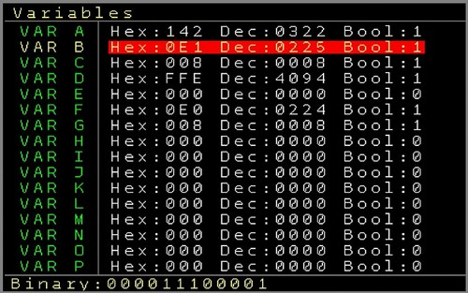
You can get to the variable screen from within the → Mapping Screen by pressing the PATCH Button. (Return to the mapping screen also with the PATCH button).

On the variable screen you can see 16 rows which are for the 16 variables A to P. Next to the names you see the current HEX, Decimal and Boolean value of the variables. If you are with the cursor on a variable you can see also the binary value of the selected variable. The current values change in an interval of 100ms. So if a variable runs fast it might be possible that you don’t see all steps in between.
The variables can be changed using SHIFT+ LEFT/RIGHT/CURSOR UP/DOWN or they can be reset to zero by using SHIFT+DELETE
If you paused the mapping screen before then the mapping execution will stay paused also in the variable screen.

User Interface Screen
This screen is dedicated to change the user interface colours and Font. There are 6 different Fonts available ranging from Solid to Geek.
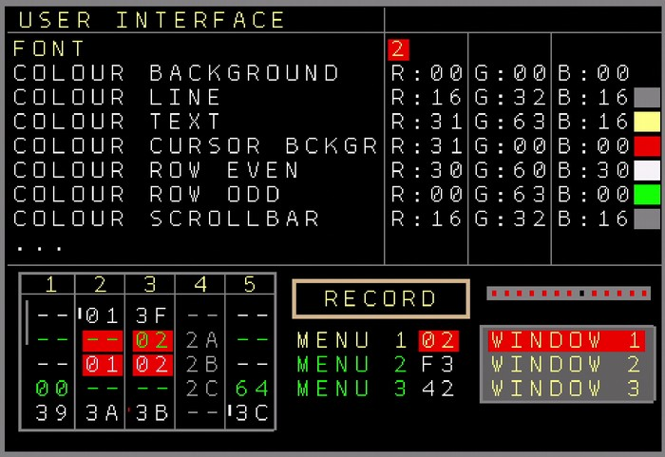Figure 25: User Interface Setup Screen
As for the Colours, you can change the following User Interface colours:
- Background, Lines, Text, Cursor Background, Even Rows, Odd Rows, Scrollbar, Play Cursor, Record frame, Muted Text, Windows Fill, Windows Lines, Clock Bars
All colours can be edited in their Red, Green and Blue components. On the right side you can view the selected colour values as well as examples of how the colours would look on the screen.
Choose Import or Export to import or export User Interface presets/skins onto/from the SD Card.

On the lower side of the screen examples of all screen components are visible.
Use the Save option to save the font and colour settings so they are recalled after a power cycle.
The Reset Colour option resets the colours to the original colour scheme.

Sega Gamepad Settings
This screen can be entered from the → Setup Screen. It is used to test and set up a connected Sega Gamepad (or compatible clones). The pad moving and button presses are visualized here.
Navigate to the button and change with SHIFT+LEFT/RIGHT to assign the gamepad buttons to several functions:
Gamepad Port On or Off. This will completely turn the Gamepad functionality off is you got no Gamepad or not connected Gamepad. This will free some resources. Please note that if you updated from an earlier version than V2.0 the port will be disabled once!
A (6 Button) Sega Gamepad is able to provide the following buttons: Start, A, B, C, X, Y, Z and Mode. Gamepads with additional buttons (like shoulder buttons) are available, but only the mentioned buttons are compatible with Sega systems.
These buttons can be assigned to the following functions:
Buttons of the NerdSEQ: Sequencer/Mark, Pattern/Copy, Patch/Delete,Table/Record, Automate/Nerd, Project/Setup, Start, Stop, Up, Shift, OK, Down
Additionally mappings:
Gate1..6 → Sets the local gates 1..6 when the button is pressed and releases it when the button is released.
Trigger 1..6 → Fires a Trigger on a button press
Trigger and Gate settings can also be recorded if the function is enabled in the record settings.
Sample 1..4 → Plays the selected sample (last played sample, last selected pitch) while sample 1 and 2 are played form Audio-output 7 and 3,4 are played from Audio-output 8.
Mute Track → Mutes the selected track (or drum part with Trigger16)
Solo Track → Solo the selected track (or drum part with Trigger16)
Jump Track → Jumps to the new selected pattern in a track on the same position where the sequencer was. ( Same as OK button if edit is disabled )
Jump Row → Jumps to the new patterns of the complete row
None → Nothing selected for the gamepad. Use this if you don’t need any function for this button.
It is also possible to use the gamepad button as a Mapping Source in the → Mapping Screen . This allows to connect a large set of functions to the Gamepad buttons, next to the ones described here. You would most likely set the Button to none here then.
The D-Pad is only usable for the general navigation and can’t be assigned to any other function in this screen. The settings are automatically saved by leaving the menu.

Midi Expander

You can add one of the Midi Expanders to your NerdSEQ which adds advanced Midi functionality to the NerdSEQ. Think about clocking in and output, to play and record from Midi (Midi→CV Conversion) Midi CC and NRPN control of all NerdSEQ parameters, polyphonic multi channel midi recording and sequencing, parameter, Program change or drum sequencing and much more.
All Midi Expanders got the same Midi functionality except for the Multi-IO which got 2 additional Midi ports where each port can be independently used. All the Midi (and I2C) features can be used all over the NerdSEQ and you refer to the different parts of the manual for the dedicated functionality (eg. Patterns, Automators, Midi Input Setup, Mapping … )

You can normally connect and use only one Midi Expander with one NerdSEQ. There is one exception and that is the Multi-IO which can be used also together with the regular Midi-IO Expander. The Midi ports of the Midi-IO Expander are disabled then but the Sega Gamepad Port can still be used. There is also a dedicated Sega-Gamepad Port Expander available.

Please be aware that you should never connect/disconnect an expander in a powered system. The expanders / NerdSEQ could suffer from electrostatic peaks when connected while the power is on!!

Midi-IO Expander
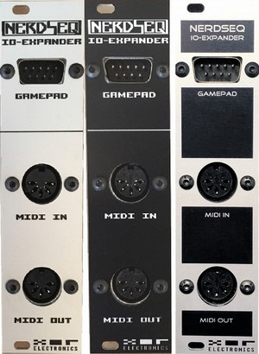
It enhances the NerdSEQ with a Midi-In, Midi Out (DIN5) port and a connector for a Sega Gamepad controller. A Sega Gamepad (Sega Genesis 6 Button Controller), which can be used for navigation, editing, live playing and further manipulations can be connected to the Gamepad Connector.

IO-Expander Installation
Connect the 12Pin ribbon cable header to the PAD-Midi port on the backside of the NerdSEQ. The expander is powered from the NerdSEQ. The NerdSEQ doesn’t scan the Midi-Interface, so it just works when connected. Be sure the power is turned off when connecting either
the Bus-Cable or the Sega Gamepad!!!

2HP TRS-A Midi-Expander
Smaller version of the Midi Expander without the Sega Gamepad port. It has 1 TRS-A input, 1 TRS-A output and a TRS-A Thru port which can be used as output as well. TRS-A is being used since it is the Midi standard. All other aspects of the standard are also respected (eg electrical specifications, opto-isolation etc).
Specifications:
- 2HP width
- Midi In/Out with the Midi standardized
TRS-A minijack connections.
- Additional port for Midi Thru/Out
- 3 Adapter cables to connect with
regular 5 Pin DIN Midi

2HP TRS-A Midi-Expander Installation:
Connect the 12Pin ribbon cable header to the PAD-Midi port on the backside of the NerdSEQ. The expander is powered from the NerdSEQ. Use the TRS-A to DIN Midi
cables which are included with the Expander if you need to connect to classic 5 pin
DIN Midi ports. Use an optional TRS-A to TRS-B Midi Adapter if you need
to connect to gear which uses TRS-B Midi connections.
The NerdSEQ doesn’t scan the Midi-Interface, so it just works when connected.
You need to use stereo-audio cables for the connection between different Midi gear. Mono patchcables don’t work with TRS Midi!

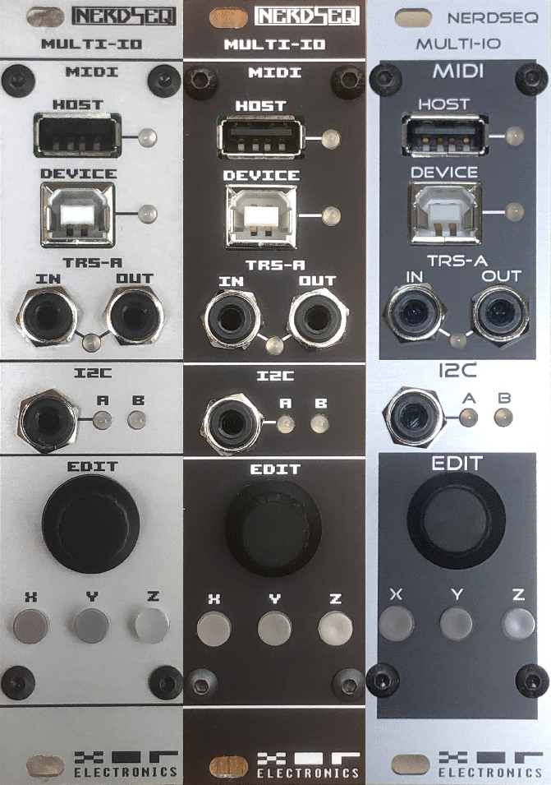
Multi-IO Midi & I2C Expander
The Multi-IO is the latest Midi Expander for the NerdSEQ which
contains 3 independent Midi Ports (TRS-A Midi in and out,
USB Host Midi and USB Device Midi). 2 free configurable I2C Ports (Leader/Follower) with both located as standard 3 pin-headers on the backside and one additional on the Frontpanel as a TRS Jack (For example to connect an external 16n directly on the front). Furthermore there is an encoder which can be used to ‘dial-in’ parameters/values
or notes. At last they are 3 buttons with which you can select new modes for a new way of data input together with the Edit encoder.

The TRS-A Midi can be used as a regular Midi Port (Adapter
cables for regular DIN Midi are included. TRS-A to TRS-B Adapters are optionally. The USB Host port can be used to directly connect a Launchpad or a Midi Master Keyboard. It is also capable to support hubs so both and more could be connected at the same time using a USB Hub. The port is specified for a current up to 500mA (at 5 Volt) but that also depends on your Rack capabilities.
The USB Device port can be directly connected to any modern computer and you will get a USB Midi Class Compliant USB Input and Output port on it.

Specifications:
- 3 independent Midi Ports on the Front: TRS-A, USB Host and USB Device Midi Port
- 2 I2C Ports, both on the backside and one additionally on the front with a TRS Jack
- I2C with selectable Pullup (none, 3.3V, 5V)
- Encoder to ‘dial-in’ notes and values
- 3 buttons to change input modes
- 6HP, 40mm deep
- Power: ~20mA (+12V) 0mA (-12V) 0mA (5V)
- Standard USB Host power up to 500mA at 5 Volt (limited to Rack power, equals to ~200mA on the +12V Rail)

Multi-IO and I2C Additional Installation guide
The Multi-IO needs basically 2 connections. One with the Eurorack Bus Board to be powered and another one with the NerdSEQ for the communications.
Also here, be sure that your Rack is always powered off when connecting any expanders to the NerdSEQ!!

The Multi-IO works only with the NerdSEQ Firmware V2.00 or higher and need to be enabled on the NerdSEQ before it works. You do that by entering the → Setup Screen and change the Midi-Expander setting to Multi-IO.

Connect the 10 pin connector to the Rack power bus. Connect the 12 pin cable from the Midi-Bus Port (the outside port) to the Midi-Pad port of the NerdSEQ. If needed connect the middle ‘Thru’ port to another Midi-IO Expander or to the Gamepad Expander. The ‘Thru’ port is only for the Gamepad functionality, so it won’t give more Midi functionality with the other Midi Expanders.
The I2C Pullup Jumpers should be using the 3.3 Volt position if no I2C gear is connected. Else please follow further I2C instructions of your connected gear and the tutorial in the NerdSEQ manual. If the other gear already got its own pullup resistors, then you can leave the jumpers open (remove the jumper or only connect one leg of it so you don’t lose it). So far all I2C gear should be fine using 3.3 Volt pullup resistors. Never hot-plug the I2C ports but connect any I2C gear only when both the expander and the gear is powered off. If you connect any of the I2C ports, be sure you connect your gear 1:1 = GND to GND, SCL to SCL and SDA to SDA. Mostly only one Pullup is needed in the I2C chain, so
check for sure if your gear got internal or enabled pullup already and that the voltages match.
You can chain multiple I2C gear in parallel together but with the basic rule that only one leader is allowed per chain.

Important for I2C is that you also here never ‘hot-plug’ any I2C gear together. That means never connect the I2C cables while the power is turned on. This rule applies always for all I2C Gear and all kind of connections (pin headers, TRS Jack). There is no isolation standard like with Midi so always be cautious when changing your I2C setup. Not following these rules can cause permanent damage to your gear or the Multi-IO Expander.
The Multi-IO got electrostatic and port protections on the I2C Ports, but there is still always a chance that something can go wrong.
I take no responsibility for any damage to your gear or the Multi-IO caused by using I2C in your setup.

If you are new to I2C then it is recommended to check out ‘A users guide to I2C’
Within the NerdSEQ you can choose for either port if it should be a leader or a follower → Midi / I2C Setup Screen
Typically if you translate this to Midi a ‘leader’ would be the Midi Out port and a follower would be the Midi In Port. So you usually connect one ‘Leader’ to one or multiple ‘Followers’.
The Leader sends or requests the Data and the Follower will respond to that request. With the NerdSEQ port you can always see on the Front LED if the communication works. That means in detail, if the Port is a Leader Port, you will see the indication of the communication only if the Follower also responds properly. If there is no response, for example caused by a wrong connection or a wrong address or malfunction/collision, then the LED will not show anything. Though you can always be sure the NerdSEQ tried to initiate the communication with the ports and addresses you specified. No LED = No proper communication.
The same the other way around, if you use a ‘follower’ port then you will see only an indication if a valid packet has been received on the correct address.
Some configuration examples:
NerdSEQ I2C (Leader) → ER301 (Follower, Address 0x31)
distingEX (Follower, Address 0x41)
Just Friends (Follower, Address 0x70)
Those can be all connected together on one leader port, if the addresses are different for every follower. Also for example multiple ER301 can be connected if they use a different address. Look up in the gears manual on how to change their receive addresses if you want to use multiple units.
NerdSEQ I2C (Follower, Address 0x31) ← 16n ‘Clones’ (Leader Mode)
All 16n clones ( like Sweet 16, Atov 16n, Michigan Synth Works F8R Fader Banks etc..) should work together with the NerdSEQ if they are configured well and use one of the latest firmwares. Things to consider when using the official 16n firmwares:
If the NerdSEQ is the follower then you need to set the 16n to leader mode. The NerdSEQ port need to be set to address 0x31. The 16n will scan the I2C port 10 seconds after it’s power on and if it doesn’t find any I2C device then it will deactivate the I2C communication. That means that you most of the times would need to power cycle the 16n once if you freshly set up the NerdSEQ I2C port to be used as 16n follower. The settings will be saved into the Multi-IO, so once it is set up it will work (also if you start a fresh project with the NerdSEQ, the default OFF configuration with Address 0x31 does also react on the 16n requests) if you power on everything together for example. If your 16n is an external device with external power, then you turn your rack on first and then the 16n. You don’t have to wait until the NerdSEQ is finished with its’ startup. Also be aware that the I2C setup can change with every project. So you might make a dedicated ‘template’ project file which got your I2C and Midi configuration already matching to your hardware setup.
I currently ‘forked’ the 16n sourcecode and will provide an alternative version which allows to use multiple 16n faderbanks on one I2C port and which won’t do the I2C scan after 10 seconds but assuming there is always the Multi-IO connected. That will help with the power-on behaviours.
Also as mentioned, multiple 16n can be connected. In the easy way, 2x 16n on each one I2C port. So you can have directly 32 faders working.
But you could also connect up to 4x 16n faderboxes on one I2C port of the NerdSEQ. All the 16n got to be set in follower mode then though and all need different addresses (either by compiling an alternative firmware using addresses 0x34, 0x35, 0x36 and 0x37) or using the upcoming pre-compiled firmwares which I will put up on github. The NerdSEQ can be set up like this already. The alternative firmwares for the 16n will follow up. In this configuration the NerdSEQ is polling each 16n fader independently will take over the new fader position on change.

Once the 16n is configured and working (LED indicator when you move the faders) then you can use these as a source for all kind of functionality in the → Mapping Screen
Note that even though it shows a 1 on the first fader, and 2 in the 2nd etc.. the real port which is being send from the 16n starts with 0. So for fader 1 you would set up I2C → SCCV → #0

NerdSEQ I2C (Follower) ← Teletype (Leader Mode)
There is no Teletype integration at the moment but this is planned after the upcoming Teletype Firmware release (V5.0). But it can be used already with the Teletype in a minimal way. The Teletype Commands SC.CV can be used already to change parameters in the NerdSEQ. The NerdSEQ port would then be set to be a follower, Address 0x31 (or 32, 33) and as a 16n input.

Other configurations as a 16n (follower) and a ER301(follower) for example together on one I2C port is also possible but not recommended. That’s because using a 16n in follower mode generates much traffic on the I2C port and even though this works, it means less available bandwidth and possibly slight latencies with the ER301 sequencing. It is like using multiple Midi Gear on only one Midi Port. So best practise is to have the gear that got to be sequenced on one I2C port and the faderboxes etc on the other port.

Multi-IO Functionality

Other than with the ‘classic’ Midi-IO and TRS-A Midi expanders the Multi-IO provides 3 Midi Ports. This means that all 3 ports can also receive and send independent Midi data. For example you could decide which of the ports should send out the Midi Clock data (like clock out on the TRS-A and the Host port but not on the device port). The Midi receive part can be flexible configured for each Midi Port and it’s dedicated channels for a large range of functionality, starting with Midi Note play, record, change parameters, launch patterns and much more. The USB Host port allows to directly connect different Launchpad devices which can be used then with the → Launchpad Integration . All modern (class compliant) Launchpad (LP Mini, MK2, MK3, Pro, X) devices are reported to work with it. The Host port allows also the use of a USB Hub (most hubs should work) so you can connect for example a Launchpad and use a Midi Master Keyboard on another channel at the same time. (keep always your Eurorack Power in mind, it might be needed that you got to use a powered USB Hub. The Multi-IO allows a 500mA current on the USB 5 Volt on it’s port (~200mA on the +12 Volt Rail of the Eurorack power).
So far all USB Host gear works, but please let me know if something doesn’t work for you. Please keep in mind that only class compliant gear is supported, so old midi gear which needs special drivers might not work.

The USB Device port is a standard class compliant Midi Device for your computer. If you connect it to your computer it will add a new Midi Port (XOR NerdSEQ) input and output port on your computer which you can use with your DAW or any other Midi capable software. Since it is class compliant it does work with all modern operating systems without the need of any drivers. The Multi-IO uses a very fast microcontroller so all device port traffic is so called ‘realtime’. This might not apply to your computer setup, operating system, DAW etc. So any latency or jitter on the USB Device port is always generated by the computer and they are many things that can influence this like the CPU, the type of USB Ports in the computer (internal hub, sharing ressources etc..), Audio Latency, Operating System, Software you use and so on.

The TRS-A Midi Ports are standard Midi ports following the Midi standard for it’s TRS and the electrical specification (opto-Isolation etc). There is an TRS input and an output jack which can be converted to a classic 5 Pin DIN Midi connector using the adapter cables which are delivered together with the Multi-IO. Since the Midi standard (TRS-A) is being used, all gear that uses TRS-B would need a special A to B adapter cable which you can get easily from your preferred music instrument shop or from the XOR Webshop.
You need to use stereo-audio cables for the TRS connection between different Midi gear. Mono patchcables don’t work with TRS Midi!
There is a LED indicator for each one of the Midi ports which shows the Outgoing (green) and incoming (red) Midi Data.

Next to the Midi Ports there is a I2C Port located on the front. This uses a widely used TRS connector for the I2C. The TRS configuration is TIP = SDA, RING = SCL and Shield = GND.
As far as I know they are no TRS-A / TRS-B issues here.
This is the same port as on the backside Port A. So you could use the Front jack together with the backside connection if your I2C configuration allows it. Also the pullup configuration is the one for Port A. The I2C connectivity has been described before. To connect any gear with it you need a stereo cable. Normal eurorack patchcables won’t work!
I can’t remind you enough: Never hotplug the I2C connectors. Don’t feed it with control voltages or something like that.
The Edit knob and the 3 function buttons X, Y, Z
The edit knob is an endless encoder ( No detent = no click ) which can be used for multiple purposes. The usecase depends on which button mode is selected.
If button mode X is active, then it works as a general purpose input knob. You can go onto every parameter and change its value in the same way as you would do it with the cursor keys. Regular turning of the knob does increment / decrement the value (like where you are with the cursor) in fine ways. Holding the X button and turning the knob will result in larger increments / decrements.
Button Mode Y works within a pattern and if active then turning the knob will insert a music note together with a trigger-point (Modular Tracks only). You can use the cursor to go to another step or maybe use the launchpad and directly select the step on the grid. It is a fast and another way to fastly create / dial in a sequence directly into the selected steps. If you hold the Y button and turn the knob, it will remove the Note and the Trigger point again at the selected position.
Button Mode Z also works within a pattern and it allows to insert trigger positions in the euclidean way. Turning the knob left hand will decrease the euclidean positions and turning right-hand will increase the euclidean positions. Please note that the euclidean startpoint will be at the selected cursor row. So you might want to go to position 1 for the euclidean input (or not).
Holding the Z button allows the trigger column to shift up/down. So a combination of using button Modes Y and Z will allow to insert interesting sequences in a fast way.
Please note that the knob and button XYZ functionality is incomplete (Y and Z only supported by modular tracks currently) and that more functionality and flexibility will be added.

Connections on the backside:
On the backside they are 3 boxed headers. One is marked power bus (10 pin) and it is for the general eurorack power. It needs this connection as it won’t be possible else to provide the current for the USB Host port. The one next to the I2C-B Port is marked ‘Midi Bus’ (12 pin) and it is the connection to the NerdSEQ ‘PAD-MIDI’ port. It goes directly into the NerdSEQ or if availabe first through the Video Expander.
The 3rd header in the middle is called Thru and it will allow to connect a dedicated Sega-Gamepad expander (available in the XOR Electronics webshop) or the classic Midi-IO Expander. This allows still the use of the gamepad functionality with the Multi-IO Expander. If you use the Midi-IO expander then its’ DIN Midi Ports are non functional. You use the TRS Ports on the Multi-IO Expander instead. (This is just for the case you still got the Midi-IO expander and still want to use the gamepad).

The I2C connectors are already mentioned → Multi-IO and I2C Additional Installation guide

All the Midi and I2C functionality is part of the whole system and can be used in many ways in the NerdSEQ. All functionality is available with all Midi Expanders if the hardware allows it (eg available ports).

ART Add-On for the Multi-IO

The ART Add-On for the Multi-IO adds the functionality to control/sequence ART compatible modules from TipTop (and possibly other brands in the future). It allows polyphonic sequencing of a modular setup through only one patch cable. The function set is very close to Midi.
To be able to sequence ART compatible modules via ART you need the ART-Add-On (and the Multi-IO Expander) for the NerdSEQ.

Specifications:
- 2 TipTop ART output ports
- 4 ART ports addressable
- 2HP, 20mm deep
- Available in black or grey
- Powered by the Multi-IO Expander ~1mA (+12V) 0mA (-12V) 0mA (5V)
- Needs the Multi-IO Expander

Installation guide:
The ART-Add-On need to be connected with 2x 3-pin Dupont cables to one of the 2 I2C ports and its 3,3/5Volt pullup jumper-pins.
For example if you would use I2C Port-A of the Multi-IO you would connect 1 cable with
the GND/SCL/SDA of the I2C-A jumpers to the GND/SCL/SDA jumpers on the ART Add-On. The
other cable would be connected to the jumper marked with 3,3 / 5 Pullup on the Multi-IO
to the same names jumpers on the Art-Add-On. Note that the connections must be 1:1 which
means GND to GND, SCL to SCL, SDA to SDA, 3,3V to 3,3V and 5V to 5V!!
Remove the pull-up jumper on the Multi-IO to be able to make the connection.
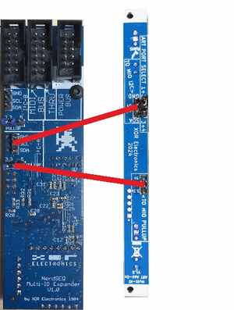Figure 27: Using I2C Port A
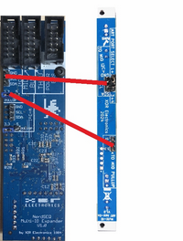Figure 26: Using I2C Port B
The 3rd jumper on the ART-Add-On defines the selected ART outputs 1+2 or 3+4.
You can connect 2 parallel ART-Add-On to get 4 full ART channels.
Please Note that the used I2C Port of the Multi-IO got to be set as an output
in the NerdSEQ. The port can be used in parallel with other I2C follower gear.

The I2C Ports can be shared with other I2C Followers.
The ART-Add-On needs at least the NerdSEQ firmware V3.0.

Sega Gamepad Expander (for Multi-IO or standalone)
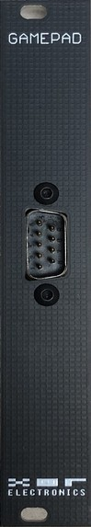
This is a standalone Sega Gamepad expander. If you don’t use Midi or don’t
have any Midi Interface connected then this still allows the use of the Sega Gamepad
features (Sega Genesis 6 Button Controller).
Also if you got the Multi-IO Expander then this can be connected to the
Multi-IO Thru port and adds also the Gamepad features for the Multi-IO Expander.

Specifications:
Width: 4HP
Deep: 25mm
Connected directly into the Multi-IO or NerdSEQ with the included 12 pin ribbon cable.
Be sure the power is turned off when connecting either
the Bus-Cable or the Sega Gamepad!!!

NSA (Nerd Sound Adapter) Expanders
You can use up to 4 NSA expanders with one NerdSEQ. All NSA Expanders are connected to the NSA port of the NerdSEQ, either directly or daisy chained from one to the next expander.

The current available expanders are:

More Triggers 16
Adds 16 more triggers/gates to the NerdSEQ. Next to all known trigger/gate functions there are many new functions and a nice drum-matrix screen when connected.
Specifications:
- 16 Trigger/Gate outputs
- Output levels are either 0 or 5 Volt
- 16 LED indicate the output status
- Totally integrated in NerdSEQ tracks
- Power: ~30mA (+12V) 0mA (-12V) 0mA (5V)

More Triggers 16 Installation
Connect the ribbon cable to one of the headers
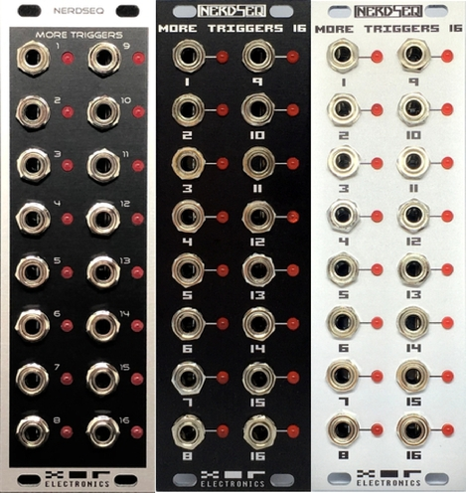Figure 28: Trigger16 Expanders
and to the NSA (Nerd Sound Adapter) header
on the NerdSEQ. Both headers on the expander
are equal, so it doesn’t matter which one is connected.
If you have multiple expanders, you connect the other
header to the next expander (daisy chained) and so on.

Each expander got to be set to it’s own channel.
It doesn’t matter which one as long as they are unique.
You got to use the jumper on the backside and change it
to the desired channel if needed.
You can freely route every channel to one or more
NerdSEQ tracks. On startup of the NerdSEQ, it will
detect the expander on it’s channel number.

CV16
Adds 16 more CV outputs for Notes, Pitches as well as 8 Envelopes and 8 LFO’s which can be routed to any of the outputs. Additional effects per CV output.
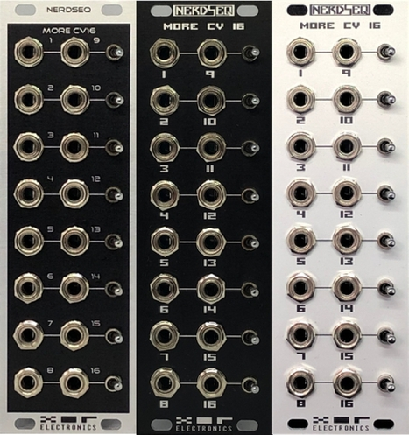Figure 29: CV16 Expanders
Specifications:
- 16 CV outputs
- CV voltages can be pitch or note scaled
- 8 different AHR Envelope types
- 8 different LFO types
- Glide settings for each CV output
- Output levels are -5/+5 Volt or 0-10 Volt
(offset selector in pairs of 2 outputs)
- Up to 4 Expanders possible per NerdSEQ
- Available in black, grey or black/grey
- Totally integrated in NerdSEQ tracks
- Power: ~75mA (+12V) ~35mA (-12V) 0mA (5V)

CV16 Expander Installation

Connect the ribbon cable to one of the headers
and to the NSA (Nerd Sound Adapter) header
on the NerdSEQ. Both headers on the expander
are equal, so it doesn’t matter which one is connected.
If you have multiple expanders, you connect the other
header to the next expander (daisy chained) and so on.

Each expander got to be set to it’s own channel.
It doesn’t matter which one as long as they are unique.
You got to use the jumper on the backside and change it
to the desired channel if needed.
You can freely route every channel to one or more
NerdSEQ tracks. On startup of the NerdSEQ, it will
detect the expander on it’s channel number.

Each output can generate Notes and Pitches from 0 to 10 Volt ( -5 / +5 Volt).
While the Notes can be used for polyphonic sequencing, all other modulations and pitches can be used to control many destinations. As in general with the expanders, they can be assigned to multiple tracks.

More Video-IO
The More Video-IO Expander adds a composite and a HDMI video output to the NerdSEQ as well as a USB connector, so a USB Computer Keyboard can be used.
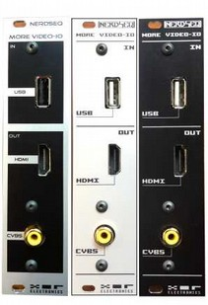Figure 30: More Video-IO Expander

Specifications:
- 6 HP width (42cm/1.64"deep)
- HDMI and composite video output
- USB Host for PC Keyboard
- NerdSEQ screen clone to bigger screens
- PC Keyboard with mapping for the authentic Tracker feeling
- Video synthesis with the use of GLSL shaders
- Expander uses fixed NSA slot 4
- Power: ~60mA (+12V) 0mA (-12V) 0mA (5V)
(without USB or HDMI connected)

More Video-IO Installation

Connect the ribbon cable to one of the 14 pin headers and to the NSA
(Nerd Sound Adapter) header on the NerdSEQ (or another NSA daisy chained
expander). Both 14 pin headers on the expander are equal, so it doesn’t
matter which one is connected. If you have multiple expanders, you connect
the other header to the next expander (daisy chained) and so on. There is
no channel selection on the ‘More Video-IO’ expander, but the channel is
always fixed to channel 4. Please be sure no other expander uses channel 4.

Connect the other 12 pin ribbon to the Midi port of the NerdSEQ. This port
is needed to get the USB connection working with the NerdSEQ. Use the second
12 pin Port to connect to one of the Midi Expanders. This port is also Daisy
chained, so It doesn’t matter which of the 2 ports is being used.
Be careful when inserting the 12 pin ribbon cable to not break the SD Card!!!!
Please note that you got to enable the Video Expander within the
Setup Screen of the NerdSEQ. From then it will be detected on startup.

The Expander detects on power on (or expander reset) if a HDMI cable/screen is connected and will automatically use the HDMI mode then. If no HDMI screen is connected then it will fall back to composite mode (if HDMI force is turned off, see further in the video configurations). Note that it is not possible to use HDMI and Composite at the same time. The HDMI connector is also not meant to be connected hot-plugged, so if possible please disconnect/connect only when the expander/NerdSEQ is powered off.
We take no responsibility to any damage to your screen or keyboard when using the Video Expander. Please use and handle it with the common sense!
In its’ basic use the expander can be used to clone the NerdSEQ screen onto a big screen. The video clone functionality is available since the NerdSEQ firmware V1.25. Video synthesis / shaders need at least the firmwares V3.0 for both the NerdSEQ and the Video Expander.
In the Setup Screen you can choose the Video expander to be disabled, enabled with USB function only and as the clone function. Once enabled the screen will be cloned onto the HDMI or Composite output.

The Video Synthesizer capabilities and functions are explained in the → Video Track / Video Shader Functions section.

Video Expander USB Keyboard functionality
A connected Computer Keyboard (PC Keyboard) allows easier editing as many functions of the NerdSEQ can be accessed from the Keyboard directly. It can be also used to insert or play notes directly since 2 note-octaves are directly mapped onto the keyboard. Notes can be played from the sequencer screen and the current track is being played from the keyboard (or multiple if tracks are set to poly-midi mode). Within the tracks notes can be played or edited using the keyboard.
Keyboard Layout:
Key | Function
Enter | Same as OK button on NerdSEQ
right ALT | Same as STOP button on NerdSEQ
Shift | Same as SHIFT button on NerdSEQ (use in combination with other keys)
Space | Same as START button on NerdSEQ
Tilde (~) | Edit ON/OFF. With SHIFT: Record ON/OFF
Tab | Toggle Automator screen parts. Toggle to CV16 functions in CV16 columns
Cursor Keys | Same as CURSOR UP/DOWN/LEFT/RIGHT on the NerdSEQ
Caps Lock | Inserts a Note OFF in the Note Columns if possible
CTRL+C | Toggle Mark Mode (copy to clipboard when unmarking)
CTRL+V | Copy/Paste (functionality and combinations the same as with the NerdSEQ buttons)
Delete | Same as SHIFT+DELETE on NerdSEQ (including Page UP/DOWN)
Backspace | Remove Pattern line and shift up
Insert | Insert empty pattern row and shift down
F1 | Sequencer Screen (with SHIFT: Track Assign Screen)
F2 | Pattern Screen
SHIFT+F2 | Scaling Screen
F3 | Patch Screen
SHIFT+F3 | Mapping Screen
F4 | Table Screen
SHIFT+F4 | Variable Screen
F5 | Current Values Screen (with SHIFT: Load Project)
F6 | Automator Screen (with SHIFT: Save Project)
F7 | Envelope Screen (with SHIFT: Load Sample)
F8 | Track Setup Screen (with SHIFT: Midi/I2C Setup screen)
F9 | Random Ranges Screen (with SHIFT: Video Project Screen)
F10 | Project Screen (with SHIFT: Sega Gamepad Mapping Screen)
F11 | Record Screen (with SHIFT: User Interface Screen)
F12 | Nerd Menu (with SHIFT: Setup Screen)
Left CTRL+F1..F8 | Mute / Unmute Track 1..8 (or Trigger columns on Trigger16 Pattern Screen)
Left ALT+F1..F8 | Solo / Unsolo Track 1..8 (or Trigger columns on Trigger16 Pattern Screen)
Print Screen | Load Project
Scroll Lock | Save Project
Pause | Load Sample
+ / - on Numblock | Increase / Decrease BPM
CTRL + / - on Numblock | Increase / Decrease Swing setting
Home | Keyboard Octave +1
End | Keyboard Octave -1
Number Block 0..9 and Dot | Can be freely defined as a source in the mapping screen
Regular Letter Keys | See below (Blue: Selected Keyboard Octave. Green: Octave+1. Pink: Octave+2

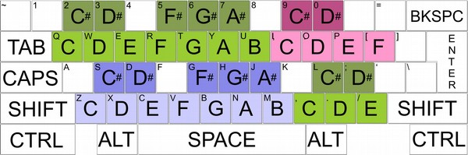

Special notes for the USB Keyboard use:
- Most USB Keyboards including Bluetooth ones are compatible. However, since this is an embedded system I can’t guarantee that all Keyboards will work well. If one doesn’t work it might worth a try to use an additional USB Hub (unpowered/powered) in between.
- Many simple USB Keyboards don’t allow multiple keys pressed at the same time. This might affect you if you want to play chords with multiple notes. Please note that this is an issue with the keyboard then. This is also a known issue with many gamers who use USB keyboards. But they are special Gamer USB Keyboards available which solve that issue, if needed.
- Please be sure you got both of the ribbon cables (12 pin and 14pin) connected well. A bad connection can cause problem on both sides, glitched in the video or problems with the USB keyboard input and/or general input problems caused by that. Also all other daisy chained connections like the midi expanders or other NSA can cause issues with a bad connection.
- Be sure you got enough ‘headroom’ with your rack power supply as your USB keyboard might also draw extra current

Dualchord

The Dualchord expander adds 2 times 4 oscillator waveforms to the NerdSEQ ecosystem.

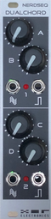
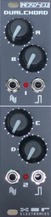
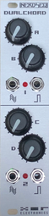
Hardware specifications:
- 2 audio outputs (+- 5 Volt)
- 2 Trigger/Gate outputs (0/5 Volt)
- 4 potmeter knobs
- 2 indicator LED
- 6HP, 35mm deep
- Available in black, grey or black/grey
- Power: ~100mA (+12V) 10mA (-12V) 0mA (5V)
- Expander for the NSA port of the NerdSEQ

Installation of the Dualchord:
Be sure the power of your rack is always turned off when connecting expanders to the NerdSEQ!!
Connect the ribbon cable to one of the headers and to the NSA (Nerd Sound Adapter) header
on the NerdSEQ. Both headers on the expander are equal, so it doesn’t matter which one is connected. If you have multiple expanders, you connect the other header to the next expander (daisy chained) and so on.
Each expander got to be set to it’s own channel. It doesn’t matter which one as long as they are unique. You got to use the jumper on the backside and change it to the desired channel if needed.
You can freely assign every Dualchord channel to one or more NerdSEQ tracks. On startup of the NerdSEQ, it will detect the expander on it’s channel number. The ‘Dualchord' expander needs the NerdSEQ Firmware V2.02 or later. It is being powered from the NerdSEQ.

General description

As mentioned the Dualchord is a multi-oscillator module which generates 4 independent digital oscillator waveforms for each of the 2 audio outputs. Each oscillator itself runs 4 waveforms (Sine, Triangle, Sawtooth and Pulse) at the same time (that means 32 waves running at the same time!!) which can be independently mixed for each individual oscillator.
Each oscillator got additional velocity, glide, detune, mix settings per waveform and pulsewidth settings for the pulse wave. Oscillator settings can be applied individual or combined. Morph functions allow to morph between different waveforms in every possible waveform combinations. A detune spread can generate supersaw-a-like sounds between the different oscillators. Many convenience modes are added to allow the usage of mono-phone, multi-oscillator mono-phone, para-phone or chord presets.
Next to individual outputs with each an own setting, the outputs can be also cloned and a stereo field can be generated by de-phasing or detuning the second output. With external mixing of the 2 outputs the 8 oscillators can be played in an 8 ‘voice’ paraphonic way.
2 Trigger/Gate outputs are available for each oscillator set which got all the trigger/gate tricks that are known from the NerdSEQ itself.
4 Knobs on the Dualchord can be freely assigned to any of the Dualchord functions for a direct manipulation of the Dualchord parameters (of course everything can be also manipulated from the NerdSEQ itself).
The Dualchord got also 8 LFOs (with triangle waveform) included which allow as well the manipulation of all internal Dualchord parameters. Each LFO can have its different setting, speed, phase, offset and amplitude and can be free running or synchronized to the NerdSEQ mainclock. For example 1 LFO phase takes 128,64,32,16,8,4,2,1 steps or multiple phases (2,3,4,5,6) per step.
The use-range of a Dualchord is very wide, its oscillators can be sharp for nice acid basslines, soft for smooth sounds, massive or thin. Mono or poly for multi-octave chords. Because of the many parameters it is a great drone generator but it is also, combined with a filter+envelope your cheesy 80’s analogue-ish synth pad friend. As usual an extensive Midi integration allows for mono/paraphonic playing of the oscillators.

A Dualchord pattern screen can control all 8 oscillators directly by notes, got 2 trigger columns and all functions can be easily set up but also manipulated through the FX functions. All of the Dualchord functions can be a destination of the NerdSEQ Automators and are also available as mapping destinations.

See the function blocks of the Dualchord below:

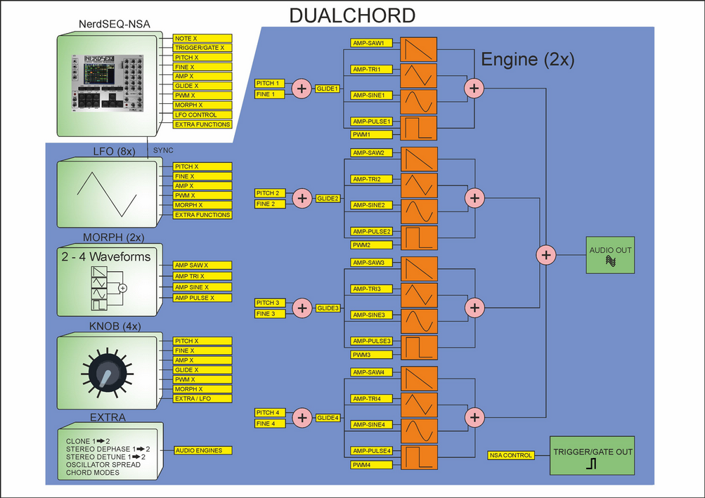

Expander Firmware Update Screen
You get here from the → Setup Screen .
As the most Expanders are smart devices with their own microcontroller it is possible that any Firmware might need an update for new functions or bugfixes. These expanders can easily be updated through the NerdSEQ.
The Expander Firmware update screen has the following functions:
- Rescan NSA → This will try to rescan connected expanders. This might be needed after a firmware update or if it was not recognized correctly in the begin, or if you don’t know which firmware is running on it. Be aware that expanders should only be connected while the power is off.
- Firmware File → Opens a file browser to select a firmware file for the update. For the update one must copy the firmware file into the /firmware folder of the SD card. All .nxp files are possible update files. Furthermore, a connected Video Expander can be updated too. It’s file extension is .vex and the NSA Type and Address is being inserted automatically.
- Expander type → Shows the expander type once the expander firmware has been loaded.
- NSA Address → If available. Set the channel of the expander that needs to be updated. It must match the channel which is selected with the jumper on the rear side of the expander.
- Update Now → If all was fine, then update now can be selected. It will check if the connected expander type is correct and more information. On success it will start to flash the firmware. Do not remove the SD Card or power off the NerdSEQ/Expander while updating. And do not worry if that happens either. If an expander is unresponsive in normal operation, you can try to flash it again. Just remove the power of the expander and connect it. Now you got less than a second to press the Update now button and it will flash the expander again.
If an update is executed successfully then it will be indicated and NerdSEQ rescans all NSA (if it was a NSA update). Here you can check the new version number. If something went wrong an error message is shown and NerdSEQ does not rescan the expanders. Try again or check out what the issue is.
Sometimes it might be also be necessary to power cycle the expander before it is recognized by NerdSEQ after flashing, even though if it showed a success message.
The update of the video expander looks slightly different and will finish with a restart of the video expander.
If you update the Multi-IO, then the update usually consists of 2 parts. One part for the main cpu and one part for the Host part. The CPU part will always be executed and you can choose after that if you want also continue with a Host update. After the Multi-IO update is finished the new Multi-IO version and Host version will be shown.

Launchpad Integration
A special feature is the integration of the Novation Launchpad (LP). It offers display and control of several of the NerdSEQ screens and functions. It works for all newer (class compliant) Launchpads including Launchpad Mini, MK2, MK3, Launchpad Pro and Launchpad Pro MK3, Launchpad X.
All launchpads can be connected via USB using the → Multi-IO Midi & I2C Expander
The Launchpad PRO devices can be alternatively connected using the regular Midi ports.

Beware that the LP integration is still Beta and incomplete and will be enhanced in future versions. I decided to release it already as it is mostly working well and it is very usable. (and initially on request of the Forum users, so please take it now ‘as is’. I expect some usage feedback with the Multi-IO Expander and will add more features then)
To use the LP Pro, connect the Midi Out of the Expander with Midi in of the LP and Midi Out of the LP with Midi in on the expander.
The LP functionality can be enabled/set up in the → Midi / I2C Setup Screen settings. Beware that it is possible that the LP also listens to other Midi Channels than Channel 1 and so Midi sequencing on channels 1..4 might interfere with the Launchpad.
Depending on the selected Launchpad and Launchpad Mode you got to initialize the Launchpad manually or not. Please read the extra instruction about that in the → Launchpad/Grid setup.
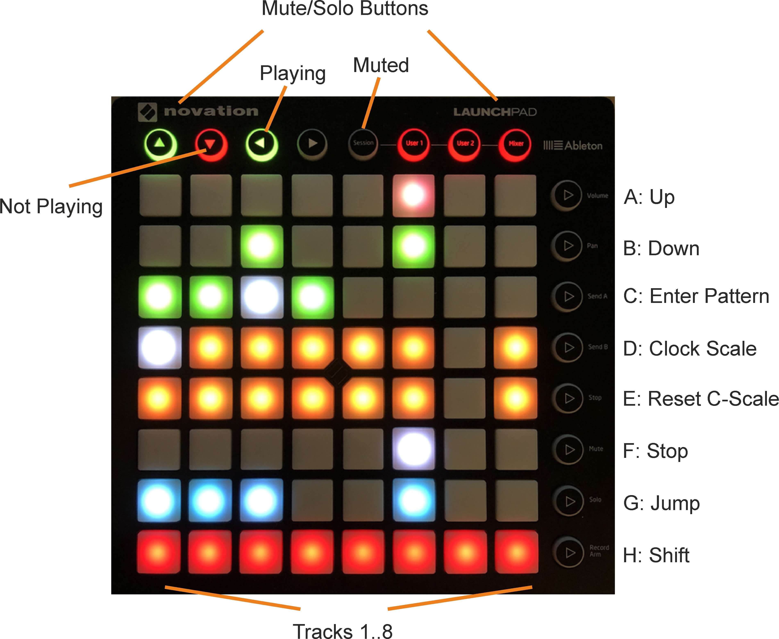
If the Launchpad is set up well it will show the same colours as the sequencer screen, once you enter the sequencer screen again. It only really makes sense to use the LP integration with colours as you can recognise the parts very easy on the NerdSEQ screen and the LP Pads. The LP will show the upper 8 rows of the Sequencer screen and follows the scrolling of the screen.
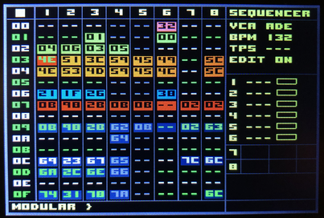
The following pictures show the Launchpad next to the sequencer screen of the NerdSEQ. As you can see the colours match on both, so you can easily recognize your pattern arrangements when using colours.

Next to the matching colour arrangement, you can see which tracks / patterns are playing. The current playing patterns are animated and indicated as white pads. Also the current clock position is shown as a white pad in the matrix.
The Pads in the matrix can be used to start the sequencer, start the pattern or to select the next pattern to play (same as the start button when on a pattern). While holding the SHIFT button and selecting a pattern in the matrix, the whole row will be started or selected to start next. (beware that for the LP explanation the SHIFT button is the one on the LP (Button H) and not the one on the NerdSEQ) Also this is the same function as if using SHIFT+START with the normal NerdSEQ keys. The Matrix Pads/Buttons also have more functions when combined with the buttons to the right.
The top row of the LP show the Mute/Solo buttons for the Tracks 1..8 as well as the current state of the buttons/tracks. Here green means the track is playing. Red means the track is not playing. And black or no colour at all indicates that the track is muted. You can Mute/Unmute the track by pressing one of the 8 top buttons. Combined with the SHIFT button you can Solo/Unsolo the track.
With Buttons A and B you can scroll Up and Down in the sequencer screen. Using the A or B together with SHIFT, you can scroll a Page (16 rows) up and down.
Button C combined with a Pattern pad from the Matrix will enter the Pattern.
Button D combined with a track from the matrix (column 1..8) will change the track clock scale (after the pattern is finished) in direction Dividers → Multipliers.
/7 → /6 → /5 → /3 → /32 → /16 → /8 -> /4 → /2 → Normal → *2 → *4 → *8 → *3 → *5 → *6 → *7
Together with the SHIFT buttons the clock scale will change in direction Multipliers → Dividers.
*7 → *6 → *5 -> *3 → *8 → *4 → *2 → Normal → /2 → /4 → /8 → /16 → /32 → /3 → /5 → /6 → /7
Button E combined with a Track from the matrix will set the track clock to normal (after the pattern has finished)
Button F combined with a Track from the Matrix will select the track to stop when the pattern is finished. Pressing it twice will stop the track immediately. (same function as regular STOP button)
SHIFT + F + a button in the matrix will stop the sequencer.
Button G combined with a button in the matrix will perform a jump to the new pattern if the selected track is playing. The jump is from the currently playing pattern to the selected pattern on the same step. (same function as using the OK button on the NerdSEQ if edit is turned off)
Together with the SHIFT button, the whole row will jump to the newly selected pattern row.
Keep in mind that these are only temporary jumps. If the pattern is finished, it will jump back to the original playing pattern.

Within patterns (either selected with the LP or with the NerdSEQ), the LP will have different functions.
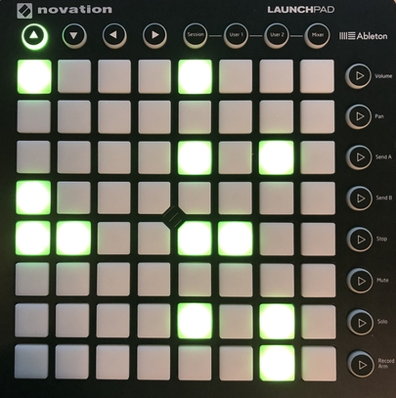Figure 31: Pattern Screen -> CV/Gate Track
In a Pattern Screen of a CV/Gate track you can insert or remove triggers. The matrix shows all 64 steps and by pressing a button you can insert or remove a trigger. Tapping Button H (SHIFT) will insert a trigger on the current playing position. Button D shifts all triggers one step UP (with overflow). Button E shifts all triggers one step DOWN (with overflow). Button F increments the triggers with the euclidean formular. Button G decrements the triggers with the euclidean formular.
The current cursor position is the euclidean startpoint.
In the top row you can see which track is selected.
Pressing the most top right button will move you back to the sequencer screen. (Subject to be changed)

The Trigger16 and the I2C/Multi Pattern Screen shows the current drum-matrix for the first 8 or the 2nd 8 drum-matrix columns.
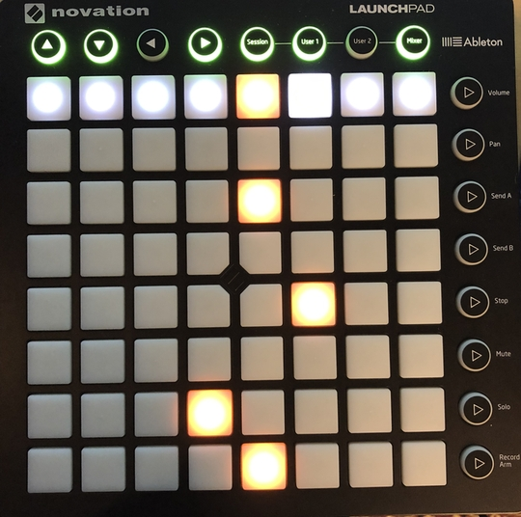Figure 32: Pattern Screen -> Trigger16 Track

Within the columns you can set or reset the drum matrix triggers for the current 8 steps. The buttons on the right define the steps/rows that are selected to be edited. So top is 1..8, 2nd is 9..16, 3rd is 17..24 and so on. If you are not changing the rows then the current selected row-button will toggle between the first 8 and the second 8 drummatrix columns. The top button row is to mute/solo the triggers.
Please keep in mind that the Trigger16 layout for the LP will change in a future release!!
Other patterns (like from the audio tracks) are not implemented yet.

Once more a reminder: The Launchpad integration is incomplete and subject to be changed in the future.
If you use the Multi-IO Expander then the Launchpad integration gets some small add-ons.
One does apply to Button Mode Y (on the Multi-IO). The you can select a step in the pattern screen through the Launchpad Grid and turn the encoder to change the steps value. This adds some nice on-the-fly dial in notes on the selected steps. With Button Mode Z which allows for the Trigger Euclidean input, the grid would select the startpoint/offset of the euclidean sequence.

Calibration
Calibration and testing of all inputs and outputs.
The NerdSEQ is ‘factory’ calibrated and the settings are saved on a EEprom. For a proper calibration you need a good multimeter, though for most cases a normal cheap 3,5 or 4 digit multimeters will do the job. You also need a small screwdriver to be able to change the potmeters on the backside.
Be sure that they are no automators or any other functions running when calibrating. The best is to calibrate after a reset of the NerdSEQ, so all settings are set to default.
Using Page Up/Down will jump over the different sections, so you can jump from the CV calibration to the Trigger test and at last to the manual input calibration.

To start a calibration you proceed the following:
  - Go to the calibration settings, choose the 2nd row: OUT CV1 0V
Set this parameter to 10, which will give you a small range lower than 10 for the calibration. Now connect the multimeter with the CV1 output. Set the CV Offset switch to the right position (below the CV outputs). Your multimeter should now be calibrated to exact 0 Volt by using Potentiometer POTI 2 on the rear of the module (the one closest to the centre). Once it is calibrated to 0 Volt, you change the Offset switch for CV to the left position which lets you calibrate the -5 Volt offset. For this you use the Potentiometer POTI 1 to calibrate the -5 Volt offset. When calibrated, check again the 0 Volt and the -5 Volt position to be sure they are correct.
  - Now you don’t need to touch the potentiometers any more so the NerdSEQ can be placed back in the rack. Switch the CV and MOD offset back to the right position (0 Volt).
  - Go to the next menu row OUT CV1 10 V. Change the value until it is exactly (or very close to) 10 Volt. After that you could proceed to the next value ( 9 Volt) or do a auto fill of the values 9V → 1V. For that press SHIFT+OK on OUT CV1 10 V which will interpolate all values for CV1 ( 9 Volt → 1 Volt ). Now the values for CV1 are interpolated and you can continue with the fine tuning for these values.
  - Now connect the Multimeter to the MOD1 output and choose the next row in the menu OUT MOD1 (0V). Change the value until the multimeter measures closest to 0 Volt. For your information, there is a possibility that you can’t reach the exact 0 Volt point. Since the resolution of the NerdSEQ is 10/4095 values, the finest voltage resolution is 0.0024 volt. So the value closest to 0 with a slight difference in the 3rd and 4th digits is absolutely OK.
  - Now choose the next Menu Row OUT MOD1 10V and change the setting until you measure exactly or very close to 10 Volt at the MOD1 output. Proceed again with all the in between values ( 9V – 1V) for the MOD1 output or use also here to interpolate first (SHIFT+OK) if wanted.
  - Connect your multimeter to the next output CV2 and choose the next row in the menu OUT CV2 0V and change the values again to get the 0 Volt.
  - Proceed with the measuring until you calibrated all CV and MOD outputs.
  - Next you can auto calibrate your inputs (after all outputs are calibrated well). For that you only have to connect the CV1 Output with the CV1 input. The CV2 output with the CV2 input, the CV3 output with the CV3 input and the CV4 output with the CV4 input.
Be sure your offset switches are set to the right and no automators or any other functions are running.
Choose Auto Calibrate Inputs which gives you a small explanation about what to do. Press OK to start the automatic input calibration.
  - Next you could test all the other outputs. The menu settings show you the expected voltages for the outputs.
  - In the top row you can find an extra save calibration option. In general the calibration settings will auto-save when you leave the calibration screen. A manual save is also possible in between.
  - Sample testing for audio output 7 and 8 will turn on a sine waveform which can be tested on the outputs.
  - beside to the autocalibrate function for the inputs, you can manually calibrate the input together with the voltage source (for example a CV keyboard) you are using. For that it makes most sense to follow these steps:
Of course, connect the CV input that you want to calibrate with your source.
Play a low note on the source (for example C-1). Choose the offset of the CV input row (Input X 1V). In the status bar you can read which note the NerdSEQ is measuring. Change the offset until the note matches the low note you played. Try to reach the note, the number next to it should as close as possible to zero. Play a very high note on the keyboard (for example C-8). Go to the range position of the calibration and change it until the status bar shows the note. Also here try to get the value as close as possible to zero. Repeat this a few times until the offset and range are as fine as possible.
Do the same for the other inputs. The CV inputs are matching the source then.
Without a source you can also use the CV outputs 1..4 again connected to the CV inputs 1..4 and manually calibrate. The outputs will automatically be set to either C-1 / 1V or C-9 / 9 Volt as the calibration reference. The result will most probably be the same as the auto-calibration.

Tips & Tricks, FAQ, PANIC
Some general tips and tricks, general pitfalls and beginner issues are described here. Be sure to register to the XOR Forum for further informations, questions and more tips and tricks.
- Notes do automatically set the Gate on the trigger output. So there is no need to add anything to the trigger column for that. Reset the gate again by adding a [ ] on another step in the note column (note off) or the kill command with a value for shorter gates. However, you can of course use the trigger commands to overrule the automatic gating or turn the autogate feature off in the setup.
- An expander never adds more tracks to the NerdSEQ. The amount of tracks is fixed to 6 regular tracks and 2 audio tracks. The 8 tracks can be assigned to the expanders and provide additional functionality when assigned and all functions of the local tracks (if used with tracks 1..6) will still be available!!
- Midi controller 78 will turn off all notes
- Since they are multiple possibilities to generate button/key presses on the NerdSEQ (local buttons/keys, sega gamepad, Computer Keyboard) it is possible that some interfere with each other. In the unlikely case that a key might get stuck because of that a shortcut can be used to release all keys. Hold the SEQUENCER, AUTOMATOR and STOP buttons together for that. You might also check if you got either the Sega or the Video USB Clone settings enabled but without the hardware (completely) connected. This can also cause ‘ghost’ button presses. Please disable the Sega or Video functions if they are not (completely) connected.

Firmware update

A new firmware can be reliably flashed into the NerdSEQ to fix bugs and add new features (and there will be a lot of new features!)
For that you need to put a new firmware file onto the SD card in the \firmware folder. Be sure the file is named ‘nerdseq.hex’. Check the troubleshoot on the forum if you have issues downloading the file with your browser. The latest firmwares are always available on the NerdSEQ website or on the forum.
When powering on the NerdSEQ (or after a software reset from the settings screen), you have to press and hold these 3 buttons (best pressed before powering up or just after the software reset):
SHIFT, COPY and CURSOR UP. ( Not the UP button!!! )
Keep holding the buttons until the bootloader appears, then release the buttons. NerdSEQ will check for the file for consistency, shows the new software version and asks if it should be flashed. Press SHIFT if you want it to be flashed. Once NerdSEQ has finished flashing you must check the status and press SHIFT again to start up the new version. The screen will show if the flashing was succesful. It is possible for the Progressbar and the percentage to go over the 100%. Don’t worry about that, if NerdSEQ indicates succesful flashing then the update went well!
That’s it. If the flashing is interrupted for some reason (power, SD card removal), then you can simply do it again (after power up). Entering the Bootloader mode after power up will always work!

It is possible that the firmware upgrade mode shows an SD card error. This can happen if the SD card was not recognized well first try, keep holding the keys and it will usually work well on the next try which will follow automatically. No worries here, just try it again.

Cheat Sheet
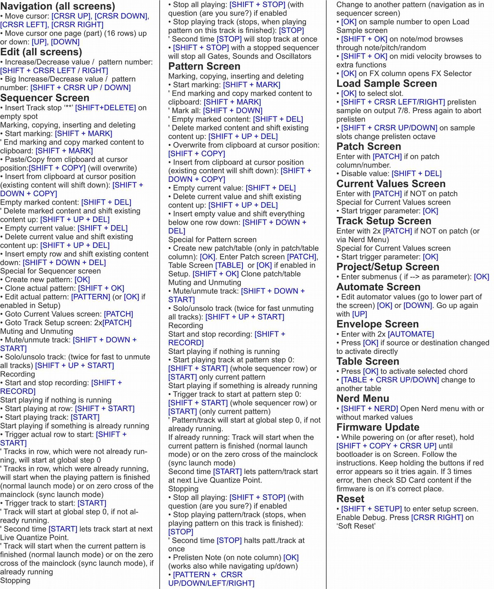

Disclaimer

This manual is made with the best effort to get it complete and correct. However, there can still be issues and incorrect or incomplete content. Also please note that the manual is always related to the latest stable Firmware Version of the NerdSEQ. There is an archive of manuals for older versions. One can not claim any features added by mistake in this manual. In advance I want to apologize for any problems that might come up by incorrect content or maybe wrong interpretations.
I appreciate any help to improve manual, so please inform me if something might be unclear or can be done better. In the end, I am a software developer, inventor and musician and the manual is just one of the many things I have to do.
Also I, XOR Electronics take no responsibility to any damage that occur to any gear or other possessions, the NerdSEQ or your body by using the NerdSEQ. Please use and handle it with the common sense.

Thanks for understanding and happy tracking!
Thomas Margolf

https://nl.wikipedia.org/wiki/Moduletracker
https://en.wikipedia.org/wiki/FastTracker_2
https://en.wikipedia.org/wiki/OctaMED
http://www.littlesounddj.com/lsd/
http://littlegptracker.com/
https://www.xor-electronics.com/forum/
https://en.wikipedia.org/wiki/Music_tracker
https://en.wikipedia.org/wiki/Hexadecimal
http://www.orthogonaldevices.com/er-301.html
https://www.whimsicalraps.com/products/just-friends
https://github.com/whimsicalraps/Just-Friends/blob/main/Just-Type.md
https://expert-sleepers.co.uk/distingEX.html
https://tiptopaudio.com/art/
https://en.wikipedia.org/wiki/Shader
https://www.shadertoy.com/
https://en.wikipedia.org/wiki/Gamepad#/media/File:Sega-Genesis-6But-Cont.jpg
https://llllllll.co/t/a-users-guide-to-i2c/19219
https://minimidi.world/
https://tiptopaudio.com/art/

